Discover Tropical Rainforests

**Student Handout**

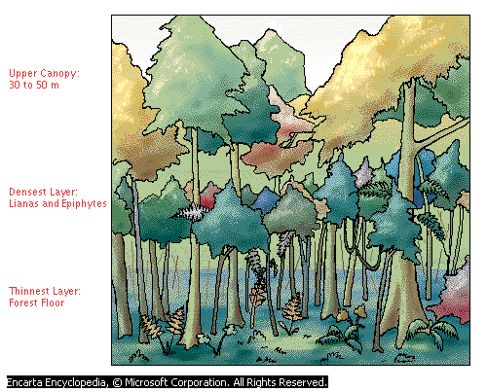

**Step 1: Research tropical rainforests**

1. What is a tropical rain forest? (Summarize what you learned from the video on rainforest plants. If you need to, you can watch the video again.)

___________________________________________________________________

___________________________________________________________________

___________________________________________________________________

___________________________________________________________________

1. Where are the world’s tropical rain forests located? For help with this, use the Ecoregions World Map in Microsoft Student.

___________________________________________________________________

___________________________________________________________________

___________________________________________________________________

___________________________________________________________________

1. What is the physical structure of a tropical rain forest? Use Map Trek to find this information. ____________________________________________________________________________________________________________________________________________________________________________________________________________________________________________________________________________
2. Describe the temperature, rain, and soil in a tropical rain forest. Use Map Trek in Microsoft Student for this. ___________________________________________________________________________________________________________________________________________________________________________________________________________________________________________________________________________
3. Describe the plant and animal life of a tropical rain forest. Use Map Trek or other Encarta tools to find this information.

_________________________________________________________________________________________________________________________________________________________________________________________________________

___________________________________________________________________

1. What is the economic value of tropical rain forests? Use Map Trek or other Encarta tools to help find this information.

____________________________________________________________________________________________________________________________________________________________________________________________________________________________________________________________________________

1. What is deforestation, and what are its consequences? Use Map Trek or other Encarta tools to find this information.

____________________________________________________________________________________________________________________________________________________________________________________________________________________________________________________________________________

1. Describe conservation efforts to save tropical rain forests. Use Map Trek or other Encarta tools to find this information.

____________________________________________________________________________________________________________________________________________________________________________________________________________________________________________________________________________

**Step 2: Summarize, organize, and present your research**

1. Summarize your research orally and organize it into a logical sequence that others can easily follow.
2. Use the summary of your research to create a five-minute multimedia presentation that you can present to the class.

For help creating a powerful presentation, follow the instructions for How to Access Tutorials and Templates for Presentations. To find these instructions in Microsoft Student, click **Homework Tools**, click **Other Homework Tools**, click **More**, and then click **Learning Essentials**.