Discover Tropical Rainforests **Tools**

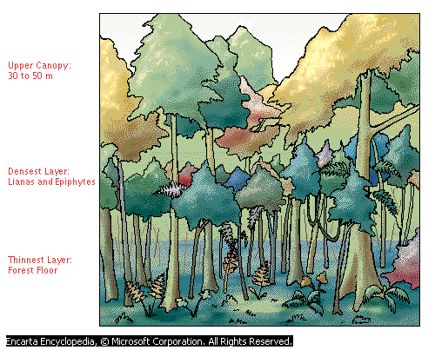

|  |  |
| --- | --- |
|  | How to Access the Tropical Rainforest Plants Video |
| 1. Launch Microsoft Student 2008. Type your search words (rain forest plants) in the search box at the top of the page.      1. Press **Enter** or click tool 7 | |
| The search results list displays the closest matches to the term you searched for. Results are divided into categories:   |  |  | | --- | --- | | * *Articles* | * *Dictionaries* | | * *Maps* | * *Web Links* | | * *Photos & More* ***(This includes the videos)*** | * *Quotations* |   The video will be listed under **Photos and More.**  **Hint**: to browse other videos, type “video” into the search box. Another way to find videos is to go to the Student Homepage>Discover and Learn>Games and Fun Stuff>Videos Folder. | |

**Other tools that are helpful in research projects like this include:**

|  |  |
| --- | --- |
| How to Use the Ecoregions World Map |  |
| 1. On any page of Encarta, click the **Homework Tools** button at the top. 2. Under **Geography Tools**, click **World Atlas** |  |
| 1. In the list on the right of map styles, scroll down and find **Ecoregions**. Click on it to open. | |

|  |  |  |
| --- | --- | --- |
| How to Navigate Ecoregions World Map | |  |
| You can use the following buttons to navigate the map. | | |
| **Button** | **Description** | |
| tool 1 | To move the map, click this button, and then drag the hand across the map. | |
| tool 2 | Drag the pointer over the globe in the direction you want to move the map. | |
| tool 3 | Click the plus and minus signs, or drag the slider, to zoom.  When you zoom in and out on the center of a map, the zoom tool slider displays the distance above the Earth from which the map is viewed. | |
| tool 4 | To select a part of the map for copying, printing, or magnification, click this button, and then drag a box around the area of the map that you want to use. | |
| tool 5 | View latitude-longitude information on an atlas map. | |
| tool 6 | Measure the distance between two or more points on an atlas map. | |
|  | Add a note to a location on the map. | |
| Map Legend | See what the map’s colors mean. | |

|  |  |
| --- | --- |
| How to Use Map Trek |  |
| 1. Click the **Homework Tools** button. Under **Geography Tools**, click **Map Treks**. |  |
| 1. Click on the Ecoregions File. | |