Designing and Deploying the Microsoft Office Business Scorecards Accelerator for Business Scorecards
Summary Technical White Paper

Published: July 2004

SUPPLEMENTAL END USER LICENSE AGREEMENT FOR MICROSOFT SOFTWARE COMPONENT

IMPORTANT: READ CAREFULLY - This Supplemental End User License Agreement ("Supplemental EULA") governs your rights to the software components that accompany this Supplemental EULA, including any online or electronic documentation (collectively referred to as "Supplemental Components"). The Supplemental Components are provided to update existing software and/or documentation that you previously licensed from Microsoft. BY INSTALLING, COPYING, OR OTHERWISE USING THE SUPPLEMENTAL COMPONENTS, YOU AGREE TO BE BOUND BY THE TERMS OF THE END USER LICENSE AGREEMENT THAT ACCOMPANIED THE SOFTWARE THAT THE SUPPLEMENTAL COMPONENTS UPDATE ("Software") (THE "Software EULA") AND THIS SUPPLEMENTAL EULA. IF YOU DO NOT AGREE TO THESE TERMS AND CONDITIONS, DO NOT INSTALL, COPY OR USE THE SUPPLEMENTAL COMPONENTS.

NOTE: IF YOU DO NOT HAVE A VALID LICENSE FOR THE SOFTWARE, YOU ARE NOT AUTHORIZED TO INSTALL, COPY OR OTHERWISE USE THE SUPPLEMENTAL COMPONENTS.

Capitalized terms used in this Supplemental EULA and not otherwise defined herein shall have the meanings assigned to them in the Software EULA.

General. The Supplemental Components are provided to update, supplement or replace existing software and/or documentation of the Software. Microsoft Corporation ("Microsoft") grants you a license to use the Supplemental Components under the terms and conditions of the Software EULA (which is hereby incorporated by reference) and the terms and conditions of this Supplemental EULA. To the extent the Software EULA is with an entity other than Microsoft, Microsoft licenses you the Supplemental Components under the same terms and conditions as the Software EULA as if Microsoft was the Licensor thereunder, except that the "Disclaimer of Warranties," "Exclusion of Incidental, Consequential and Certain Other Damages," and "Limitation of Liability and Remedies" sections in the Software EULA are replaced by the terms set forth below. To the extent that any terms in this Supplemental EULA conflict with any terms in the Software EULA, the terms of this Supplemental EULA control solely with respect to the Supplemental Components. Other than as expressly set forth herein with respect to the Supplemental Components, nothing herein shall modify the Software EULA.

IF YOU LICENSED THE SOFTWARE FROM MICROSOFT OR ANY OF ITS WHOLLY OWNED SUBSIDIARIES, THE LIMITED WARRANTY (IF ANY) INCLUDED IN THE SOFTWARE EULA APPLIES TO THE SUPPLEMENTAL COMPONENTS, PROVIDED THAT YOU LICENSED THE SUPPLEMENTAL COMPONENTS WITHIN THE TERM OF THE LIMITED WARRANTY SPECIFIED IN THE SOFTWARE EULA. HOWEVER, THIS SUPPLEMENTAL EULA DOES NOT EXTEND THE TIME PERIOD FOR WHICH THE LIMITED WARRANTY IS PROVIDED FOR THE SOFTWARE, NOR FOR THE SUPPLEMENTAL COMPONENTS. ALL OTHER DISCLAIMERS, EXCLUSIONS OF DAMAGES, AND LIMITATIONS OF LIABILITY AND REMEDIES SET FORTH IN THE EULA SHALL APPLY TO THE SUPPLEMENTAL COMPONENTS.

IF YOU LICENSED THE SOFTWARE FROM AN ENTITY OTHER THAN MICROSOFT OR ANY OF ITS WHOLLY OWNED SUBSIDIARIES, THE FOLLOWING TERMS AND CONDITIONS APPLY TO THE SUPPLEMENTAL COMPONENTS:

DISCLAIMER OF WARRANTIES. TO THE MAXIMUM EXTENT PERMITTED BY APPLICABLE LAW, MICROSOFT AND ITS SUPPLIERS PROVIDE THE SUPPLEMENTAL COMPONENTS AND SUPPORT SERVICES FOR THE SUPPLEMENTAL COMPONENTS AS IS AND WITH ALL FAULTS, AND HEREBY DISCLAIM ALL OTHER WARRANTIES AND CONDITIONS, EITHER EXPRESS, IMPLIED OR STATUTORY, INCLUDING, BUT NOT LIMITED TO, ANY (IF ANY) IMPLIED WARRANTIES, DUTIES OR CONDITIONS OF MERCHANTABILITY, OF FITNESS FOR A PARTICULAR PURPOSE, OF ACCURACY OR COMPLETENESS OF RESPONSES, OF RESULTS, OF WORKMANLIKE EFFORT, OF LACK OF VIRUSES, AND OF LACK OF NEGLIGENCE, ALL WITH REGARD TO THE SUPPLEMENTAL SOFTWARE, AND THE PROVISION OF OR FAILURE TO PROVIDE SUPPORT SERVICES FOR THE SUPPLEMENTAL COMPONENTS. ALSO, THERE IS NO WARRANTY OR CONDITION OF TITLE, QUIET ENJOYMENT, QUIET POSSESSION, CORRESPONDENCE TO DESCRIPTION OR NON-INFRINGEMENT WITH REGARD TO THE SUPPLEMENTAL COMPONENTS.

EXCLUSION OF INCIDENTAL, CONSEQUENTIAL AND CERTAIN OTHER DAMAGES. TO THE MAXIMUM EXTENT PERMITTED BY APPLICABLE LAW, IN NO EVENT SHALL MICROSOFT OR ITS SUPPLIERS BE LIABLE FOR ANY SPECIAL, INCIDENTAL, INDIRECT, OR CONSEQUENTIAL DAMAGES WHATSOEVER (INCLUDING, BUT NOT LIMITED TO, DAMAGES FOR LOSS OF PROFITS OR CONFIDENTIAL OR OTHER INFORMATION, FOR BUSINESS INTERRUPTION, FOR PERSONAL INJURY, FOR LOSS OF PRIVACY, FOR FAILURE TO MEET ANY DUTY INCLUDING OF GOOD FAITH OR OF REASONABLE CARE, FOR NEGLIGENCE, AND FOR ANY OTHER PECUNIARY OR OTHER LOSS WHATSOEVER) ARISING OUT OF OR IN ANY WAY RELATED TO THE USE OF OR INABILITY TO USE THE SUPPLEMENTAL COMPONENTS, THE PROVISION OF OR FAILURE TO PROVIDE SUPPORT SERVICES FOR THE SUPPLEMENTAL COMPONENTS, OR OTHERWISE UNDER OR IN CONNECTION WITH ANY PROVISION OF THIS SUPPLEMENTAL EULA, EVEN IN THE EVENT OF THE FAULT, TORT (INCLUDING NEGLIGENCE), STRICT LIABILITY, BREACH OF CONTRACT OR BREACH OF WARRANTY OF MICROSOFT OR ANY SUPPLIER, AND EVEN IF MICROSOFT OR ANY SUPPLIER HAS BEEN ADVISED OF THE POSSIBILITY OF SUCH DAMAGES.

LIMITATION OF LIABILITY AND REMEDIES. NOTWITHSTANDING ANY DAMAGES THAT YOU MIGHT INCUR FOR ANY REASON WHATSOEVER (INCLUDING, WITHOUT LIMITATION, ALL DAMAGES REFERENCED ABOVE AND ALL DIRECT OR GENERAL DAMAGES), THE ENTIRE LIABILITY OF MICROSOFT AND ANY OF ITS SUPPLIERS UNDER ANY PROVISION OF THIS SUPPLEMENTAL EULA AND YOUR EXCLUSIVE REMEDY FOR ALL OF THE FOREGOING (EXCEPT FOR ANY REMEDY OF REPAIR OR REPLACEMENT ELECTED BY MICROSOFT WITH RESPECT TO ANY BREACH OF THE LIMITED WARRANTY, IF ANY) SHALL BE LIMITED TO THE GREATER OF THE AMOUNT ACTUALLY PAID BY YOU FOR THE SUPPLEMENTAL COMPONENTS OR U.S.$5.00. THE FOREGOING LIMITATIONS, EXCLUSIONS AND DISCLAIMERS SHALL APPLY TO THE MAXIMUM EXTENT PERMITTED BY APPLICABLE LAW, EVEN IF ANY REMEDY FAILS ITS ESSENTIAL PURPOSE.

SI VOUS AVEZ ACQUIS VOTRE PRODUIT LOGICIEL AU CANADA ET SI VOUS AVEZ ACQUIS LA LICENCE POUR LE PRODUIT LOGICIEL D'UNE ENTITÉ AUTRE QUE MICROSOFT, LES DISPOSITIONS QUI SUIVENT S'APPLIQUENT:

DÉNI DE GARANTIES. Dans la mesure maximale permise par les lois applicables, le LOGICIEL SUPPLÉMENTAIRE et les services de soutien technique (le cas échéant) sont fournis TELS QUELS ET AVEC TOUS LES DÉFAUTS par Microsoft et ses fournisseurs, lesquels par les présentes dénient toutes autres garanties et conditions expresses, implicites ou en vertu de la loi, notamment (le cas échéant) les garanties, devoirs ou conditions implicites de qualité marchande, d’adaptation à un usage particulier, d’exactitude ou d’exhaustivité des réponses, des résultats, des efforts déployés selon les règles de l’art, d’absence de virus et de négligence, le tout à l’égard du LOGICIEL SUPPLÉMENTAIRE et de la prestation des services de soutien technique ou de l’omission d’une telle prestation. PAR AILLEURS, IL N’Y A AUCUNE GARANTIE OU CONDITION QUANT AU TITRE DE PROPRIÉTÉ, À LA JOUISSANCE OU LA POSSESSION PAISIBLE, À LA CONCORDANCE À UNE DESCRIPTION NI QUANT À UNE ABSENCE DE CONTREFAÇON CONCERNANT LE LOGICIEL SUPPLÉMENTAIRE.

EXCLUSION DES DOMMAGES ACCESSOIRES, INDIRECTS ET DE CERTAINS AUTRES DOMMAGES. DANS LA MESURE MAXIMALE PERMISE PAR LES LOIS APPLICABLES, EN AUCUN CAS MICROSOFT OU SES FOURNISSEURS NE SERONT RESPONSABLES DES DOMMAGES SPÉCIAUX, CONSÉCUTIFS, ACCESSOIRES OU INDIRECTS DE QUELQUE NATURE QUE CE SOIT (NOTAMMENT, LES DOMMAGES À L’ÉGARD DU MANQUE À GAGNER OU DE LA DIVULGATION DE RENSEIGNEMENTS CONFIDENTIELS OU AUTRES, DE LA PERTE D’EXPLOITATION, DE BLESSURES CORPORELLES, DE LA VIOLATION DE LA VIE PRIVÉE, DE L’OMISSION DE REMPLIR TOUT DEVOIR, Y COMPRIS D’AGIR DE BONNE FOI OU D’EXERCER UN SOIN RAISONNABLE, DE LA NÉGLIGENCE ET DE TOUTE AUTRE PERTE PÉCUNIAIRE OU AUTRE PERTE DE QUELQUE NATURE QUE CE SOIT) SE RAPPORTANT DE QUELQUE MANIÈRE QUE CE SOIT À L’UTILISATION DU LOGICIEL SUPPLÉMENTAIRE OU À L’INCAPACITÉ DE S’EN SERVIR, À LA PRESTATION OU À L’OMISSION D’UNE TELLE PRESTATION DE SERVICES DE SOUTIEN TECHNIQUE OU AUTREMENT AUX TERMES DE TOUTE DISPOSITION DU PRÉSENT EULA SUPPLÉMENTAIRE OU RELATIVEMENT À UNE TELLE DISPOSITION, MÊME EN CAS DE FAUTE, DE DÉLIT CIVIL (Y COMPRIS LA NÉGLIGENCE), DE RESPONSABILITÉ STRICTE, DE VIOLATION DE CONTRAT OU DE VIOLATION DE GARANTIE DE MICROSOFT OU DE TOUT FOURNISSEUR ET MÊME SI MICROSOFT OU TOUT FOURNISSEUR A ÉTÉ AVISÉ DE LA POSSIBILITÉ DE TELS DOMMAGES.

LIMITATION DE RESPONSABILITÉ ET RECOURS. Malgré les dommages que vous puissiez subir pour quelque motif que ce soit (notamment, tous les dommages susmentionnés et tous les dommages directs ou généraux), l’obligation intégrale de Microsoft et de l’un ou l’autre de ses fournisseurs aux termes de toute disposition du présent EULA SUPPLÉMENTAIRE et votre recours exclusif à l’égard de tout ce qui précède (sauf en ce qui concerne tout recours de réparation ou de remplacement choisi par Microsoft à l’égard de tout manquement à la garantie limitée) se limite au plus élevé entre les montants suivants : le montant que vous avez réellement payé pour le LOGICIEL SUPPLÉMENTAIRE ou 5,00 $US. Les limites, exclusions et dénis qui précèdent, s’appliquent dans la mesure maximale permise par les lois applicables, même si tout recours n’atteint pas son but essentiel.

Table of Contents
Executive Summary 6
Building Business Scorecards 7
Getting Started 7
Define Scorecard Scope 7
Business Intelligence Assessment 8
Iterative Design and Development 8
Design 8
Prototyping Scorecards 8
Test and Validate 8
Business Scorecards Architecture 9
Microsoft Analysis Services 10
Microsoft SQL Server 10
Windows SharePoint Services and SharePoint Portal Server 2003 10
Configuration and Scaling 10
Scorecard Development 12
Create the scorecard elements 12
Deploying Scorecards 13
Deploying a Standard View Web Part 13
Adding a Dimension Slicer Web Part 14
Conclusion 15
For More Information 16

The information contained in this document represents the current view of Microsoft Corporation on the issues discussed as of the date of publication. Because Microsoft must respond to changing market conditions, it should not be interpreted to be a commitment on the part of Microsoft, and Microsoft cannot guarantee the accuracy of any information presented after the date of publication.
This White Paper is for informational purposes only. MICROSOFT MAKES NO WARRANTIES, EXPRESS, IMPLIED OR STATUTORY, AS TO THE INFORMATION IN THIS DOCUMENT.
Complying with all applicable copyright laws is the responsibility of the user. Without limiting the rights under copyright, no part of this document may be reproduced, stored in or introduced into a retrieval system, or transmitted in any form or by any means (electronic, mechanical, photocopying, recording, or otherwise), or for any purpose, without the express written permission of Microsoft Corporation.
Microsoft may have patents, patent applications, trademarks, copyrights, or other intellectual property rights covering subject matter in this document. Except as expressly provided in any written license agreement from Microsoft, the furnishing of this document does not give you any license to these patents, trademarks, copyrights, or other intellectual property.
© 2004 Microsoft Corporation. All rights reserved.
Microsoft, Active Directory, the Office logo, Outlook and Windows are either registered trademarks or trademarks of Microsoft Corporation in the United States and/or other countries.
The names of actual companies and products mentioned herein may be the trademarks of their respective owners. Microsoft Corporation One Microsoft Way, Redmond, WA 98052-6399 USA
Executive Summary
Solution
Microsoft Office Business Scorecards Accelerator along with Microsoft Office SharePoint® Portal Server 2003 provide a powerful and easy-to-use performance management platform based on Microsoft technologies.
Benefits
- Easy-to-use portal/dashboard experience supporting personalization and analytics
- Business-user friendly environment for rapid prototyping
- Data-driven strategy maps
- Drill down and analysis through SQL Server Analysis Services
- Rich and extensible KPI and scorecard definitions framework with extensible architecture via web services
- Certification by Balanced Scorecard Collaborative
Products & Technologies
- Windows SharePoint Services
- Microsoft Office SharePoint Portal Server 2003
- Windows Server 2003
- Microsoft SQL Server 2000
- Microsoft SQL Server 2000 Analysis Services
- Microsoft Office Solution Accelerator for Business Scorecards

Traditional performance measures are insufficient to gauge performance and guide organizations in today’s rapidly changing, complex economic landscape. Organizations need to link performance measurement to strategy, and they must measure performance in ways that both promote positive future results and reflect past performance. Businesses constantly strive to achieve their institutional missions in the face of increasing competition and limited resources. They are making crucial short- and long-term decisions as they do so.
To aid decision making, business managers have begun using institutional and departmental scorecards, or "performance indicators," to both monitor performance and trigger improvement initiatives. Unfortunately, many of the resulting improvement initiatives stimulated by these top line indicators have been driven more by intuition than by fact. When these improvement initiatives are not supported by reliable data, they are sometimes misguided and fail to achieve the desired results. In addition, the people required to implement these initiatives do not have the necessary information to focus their efforts, let alone ensure those efforts will be sustainable. As a result, initiatives that are not supported by factual information to create deeper understanding can often be a waste of staff and monetary resources.
The Balanced Scorecard has continued to evolve and improve over the years. Creating a strategy focused organization (the phrase coined by the founders of the Balanced Scorecard methodology) is a significant, challenging culture change for many organizations. Success in achieving this change requires:
- Consistent executive support and involvement.
- Education, communication, and visibility of the strategy and measurements of its effectiveness throughout the organization.
- Constant feedback loops so that strategy is an every-day consideration.
- Tools to enable non-technical users to understand the key drivers of success.
- Translation of the strategy to operational terms so that alignment to strategy and implementation of it occur at all levels of an organization.
Many organizations that have successfully implemented the scorecards have achieved remarkable transformations in their financial performance, in many cases vaulting to the top ranks in their industry groups.
Many aspects of scorecard development and deployment depend on effective use of technology to be successful. Numerous software packages have been developed to help automate the scorecard, but it is very difficult to deliver the needed capabilities in a single software package. Therefore, the Microsoft Office Business Scorecards Accelerator has been developed to allow organizations to:
- Develop and deploy a scorecard economically using an existing infrastructure.
- Manage and display the data and knowledge pertinent to a scorecard methodology a customer chooses to implement.
- Facilitate analysis of measures so that prompt corrective action can take place.
- Communicate widely the metrics across the organization in a graphical representation of the key performance indicators.
- Distribute scorecards over the web utilizing Windows SharePoint technologies.
Building Business Scorecards
Businesses are inundated with demands for information needed to support administrative, academic, planning, regulatory, legislative, research and operational interests. Varying constituents at all levels require dynamic views of information and customized analysis capabilities. Requests for more on-demand, comprehensive capabilities steadily increase as constituents strive to make informed strategic and day-to-day decisions.
The Microsoft Office Business Scorecards Accelerator can help businesses measure, monitor, and manage department performance. Business Scorecards supports both the Balanced Scorecard methodology and custom-built scorecards, and provides a means for consolidating analysis data from multiple sources.
The Microsoft Office Business Scorecards Accelerator is a Web-based solution that enables organizations to build and deploy scorecards to communicate and measure strategy and gain insight into your organization's performance and goals. The Business Scorecards application, together with Windows Server 2003, Microsoft Office SharePoint Portal Server 2003 or Windows SharePoint Services and SQL Server 2000 Analysis Services, offer flexibility for presenting different views of scorecards.
Below are some recommended best practices when designing and deploying the Microsoft Office Solution Accelerator for Business Scorecards.
Getting Started
How do we communicate strategy through a complex, multi-faceted, decentralized global organization? How do we align our organization and minimize superfluous activities so that we’re all working efficiently to the same ends? How do we measure the effectiveness of our strategy and its implementation? How do we promote a culture of agility to respond to the rapidly changing business climate we face?
As business leaders wrestle with these questions each day, they confront the reality that, “If you can’t measure it, you can’t manage it.” In other words, effective performance management requires accurate performance measurement.
Leaders also understand that performance measurement itself is not enough. The value of measurement is that it identifies where action should be taken. So, effective performance measurement systems must be able to:
- Accurately reflect a business situation.
- Guide employees to take the right actions in situations where action is required.
- Gauge the effectiveness of those actions.
A performance measurement system, then, is a closed loop system that embodies situational analysis of information, corrective actions, and result evaluation.
The Balanced Scorecard is a proven performance measurement system. It is a comprehensive strategic performance management system and methodology. It is a framework for defining, refining and communicating strategy, for translating strategy to operational terms, and for measuring the effectiveness of strategy implementation.
Define Scorecard Scope
Companies wanting to implement a business scorecard solution should seek to clearly define the goals before embarking on a project. This includes project’s success criteria and identifies the ROI required, including expected ROI timeframes in order to maximize their chances of avoiding the issues during the development of the project. Additionally organizations need to be realistic about the amount of resource and effort required to successfully drive organizational change and impact management behavior, if they are to achieve significant benefits and dramatically improve their business performance management.
Business scorecard project leaders must ensure they have a clear understanding of the relative importance of and potential issues from the following factors; unarticulated company strategy definition, the role of technology, planning and project readiness and the challenges of moving from project to business-as-usual process during implementation if they are to successfully exploit the organization’s people & knowledge, to produce high-performance through creation of high-impact business scorecards.
Business Intelligence Assessment
Once you understand the goals of management using the scorecard, you need to design and define your logical and physical data requirements.
- Define your end user communities by their analysis preferences. How many people are in each community?
- Prototype key performance indicators within a scorecard.
- Are there existing data stores to support your organization’s KPIs: data warehouse(s), data mart(s), operational data store(s), other?
- Describe the flow of data from source system to each KPI.
- Define current technical standards.
- What development, testing, and production procedures do you have in place?
Iterative Design and Development
Design
During this phase, you decide the specific Key Performance Indicators (KPIs) that will be shown in the Scorecard. This part of the process involves not only defining your Scorecard objectives and KPIs, but understanding who your users are and their measurements, indicators, and goals.
Prototyping Scorecards
The scorecards views can actually be created even before all of the data issues and mappings have been resolved. When you create your scorecard, you enter sample data. This allows you to easily prototype the scorecard views and validate that the scorecards look and roll up as you expect them to and refine the layout that the customers will see while perhaps your data warehousing team is building and collecting the data to support the scorecards.
Test and Validate
Testing a Scorecard design, or a particular aspect of a KPI, provides valuable information and is a key part of a successful Scorecard.

Business Scorecards Architecture
The Microsoft Office Business Scorecards Accelerator has been designed to leverage existing technology investments while providing a vehicle for effectively communicating the company’s performance against goals. The Administration Guide that comes with the Business Scorecards Accelerator download, contains in-dept detail on the architecture of the solution.
Figure 1.0 is a logical diagram of the Business Scorecards architecture.
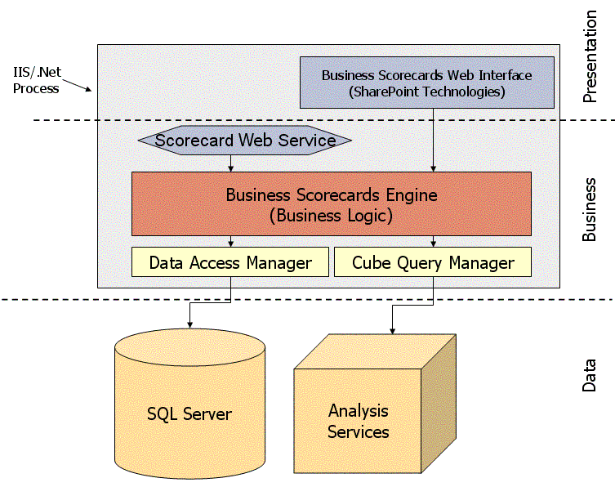
Figure 1.0
The data layer stores both scorecard metadata, such as the names of your scorecards and the location of the OLAP cubes they are mapped to, as well as the actual values for the KPIs being measured in your scorecard. A SQL Server 2000 database is used to store the metadata information while SQL Server 2000 Analysis Services OLAP cubes contain the business data that scorecards measure. There is one SQL Server database utilized for all scorecard metadata information. A scorecard can map to only one cube, but more than one scorecard can map to the same cube. The KPIs within a scorecard each maps to a valid cell reference, referred to as a tuple, within the cube. The KPI target values can map to either a tuple or a constant value.
In the Business layer, the Business Scorecards Engine manages all of the definitions, documents, and other metadata that comprises every scorecard. While scorecard metadata is stored in a SQL Server 2000 database created by default during setup, it is the Business Scorecards Engine that processes the mappings of the scorecards to their data sources. It is also the engine that presents scorecard information in SharePoint using web parts.
From within the Scorecard Development Environment, use Microsoft Office Visio to create a strategy map that graphically represents the relationships among scorecard elements. If you're working with a scorecard created in Scorecard Builder, Business Scorecards can generate the strategy map from the scorecard automatically. As an alternative, you can build the scorecard within the Strategy Map Builder module, adding elements created in Scorecard Elements or creating new elements directly.
Windows SharePoint Services or SharePoint Portal Server 2003 displays scorecards in the Presentation layer, with the Business Scorecards Web parts that are installed along with the application.
Microsoft Analysis Services
Online Analytical Processing (OLAP) is a technology that uses multidimensional structures to provide rapid access to data for analysis. An OLAP cube, provided by Microsoft SQL Server 2000 Analysis Services, is a set of data that is organized and summarized into a multidimensional structure defined by a set of dimensions and measures.
OLAP cubes provide the data that is mapped to the scorecards. Before beginning the process of mapping your scorecards to data sources, you should have a working knowledge of both SQL Server 2000 and SQL Server 2000 Analysis Services, or you should be partnered with a person or team in your organization that is familiar with the technologies.
Microsoft SQL Server
The SQL Server 2000 database engine is used to store the metadata information for the Business Scorecards Accelerator.
Windows SharePoint Services and SharePoint Portal Server 2003
Windows SharePoint Services is a component of the Windows Server 2003 infrastructure and provides team services and site support to programs in the Microsoft Office System. It also serves as a platform for application development.
Microsoft Office SharePoint Portal Server 2003 is a secure, scalable, enterprise portal server built upon SharePoint technologies that you can use to aggregate SharePoint sites, information, and applications into a single portal. All features included in Windows SharePoint Services are also available in SharePoint Portal Server 2003.
Note: Either Windows SharePoint Services or SharePoint Portal 2003 provides a great platform for delivering scorecards.

Configuration and Scaling
The server configuration is largely dependent upon your data warehousing and SharePoint needs. Depending on the scale of the data volumes, the security requirements, and the number of users who will be accessing the scorecards – you will likely explore different server configurations.
Single-Server Configuration
A single-server configuration has all required software on a single machine. Users with the required client software installed locally can access the server. The administrator should configure the machine so that the localhost can connect directly to the Microsoft SQL Server. This is a typical configuration to use in a development environment.
Two-Server Configuration
In a two-server configuration, Analysis Services and cube data reside on one server and all other required server software is on a separate server.

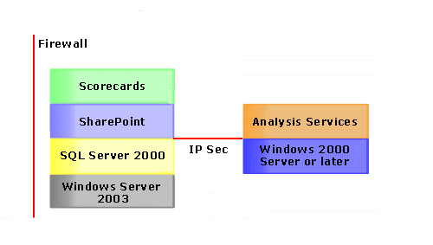
Three-Server Configuration
In a three-server configuration Analysis Services and SQL are on individual servers:
Server 1: Windows Server 2003, Windows SharePoint Services or SharePoint Portal 2003
Server 2: SQL Server
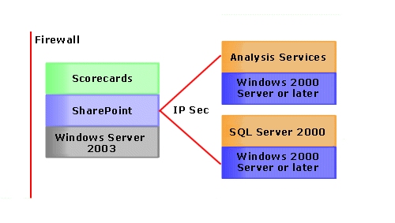
Server 3: SQL Server 2000 Analysis Services
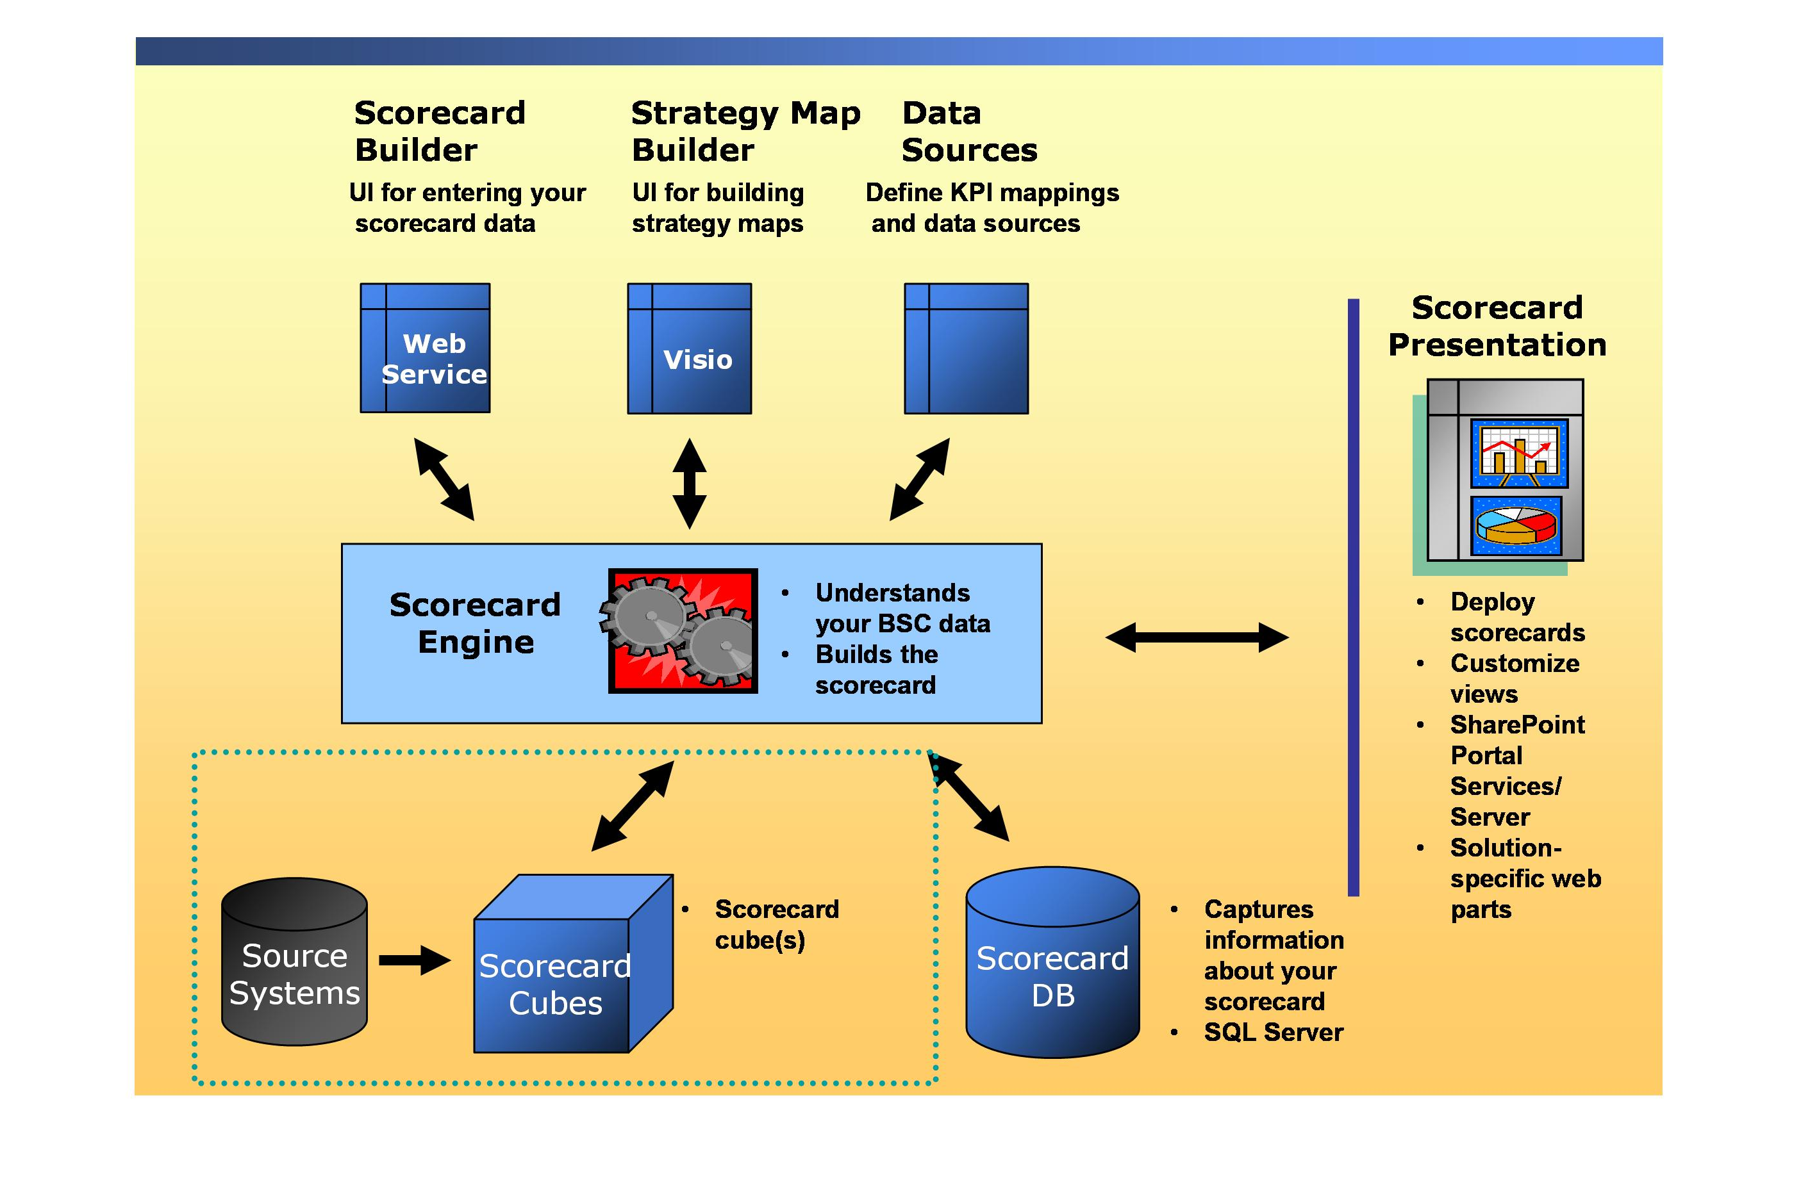
Scorecard Development
This slide represents the architecture of the Business Scorecards solution. Across the top are the different modules of the scorecard development environment. The development environment is fully integrated with both SharePoint Portal Server and or Windows SharePoint Services and offers a single interface to develop all of the components of your scorecard.
- In the top left, you will find the web interface that is used to prototype and develop scorecards.
- In the center is the Scorecards Engine. The engine understands the business scorecard data and builds the scorecard.
- The source systems and databases provide the data for the scorecard
- The scorecard metadata is stored in the Scorecard DB.
- SharePoint Portal Services or Windows SharePoint Services hosts the final scorecard views.
Create the scorecard elements
The following are some quick steps in getting a prototype scorecard up and running.
- Use Scorecard Elements to create the elements you will use on your scorecard. Alternatively, you can create the elements while you build the scorecard.
Note: Utilizing the scorecard Elements module will reduce the amount of time spent keying in data since the templates can be used in multiple scorecards. This is particularly useful if creating scorecards across all levels of the organization.
- Create a general scorecard for the purposes of creating a prototype to get the basic understanding of scorecard development using the tool.
- Create/Add some simple KPIs to the scorecard. If you wish to provide weighting or banding for your KPIs, please see the appropriate section in the Scorecard development help file provided with the scorecard solution.
- Click on Data Mappings and you will see your scorecard listed. Click on the dropdown of the scorecard and select “Preview Scorecard”.
Deploying Scorecards
Once a scorecard is defined in the Scorecard Development environment, it can be displayed using one of the six Scorecard Web Parts on a SharePoint page. The Scorecard Web Parts provide an easy to use interface for quickly creating graphical views of the scorecard results to be hosted in your SharePoint portal.
By default, the Scorecard web parts provides several presentation layouts. Each of these is called a scorecard view. In addition, there is a fourth view available for displaying the strategy map layout.
- The Single View - By default it shows a single indicator, in this case – a stop light – but you can also specify for the single view to display the children of the main item selected. These items will look similar to the standard view items in the next view.
- The Standard View – shows the full scorecard in hierarchical form. The fields included on the columns are configurable as are some of the display settings which we will cover in more detail later in this module. This provides a nice summarized snapshot of your scorecard
- The Custom View web part is the most flexible view of your scorecard. It allows you to nest dimensions (or members from a dimension) in the columns. The scorecard elements and their hierarchy are always displayed on the rows.
- The Theme and Initiative View lets you view the themes, the initiatives, or both the themes and initiatives associated with a scorecard. If a KPI group was added to a theme or initiative when the scorecard was created, the name and description (optional) of the KPI group will also appear.
- The Dynamic Gauge View is similar to a Single View. They both display the name of the view's associated scorecard and an indicator image, which graphically represents the status of the scorecard. The difference between the two views is that the Dynamic Gauge View contains a gauge that reflects banding settings. The location of the gauge will dynamically change to reflect the current rollup values.
- A Strategy Map View allows you to include a strategy map in your scorecard view. When creating a page with one or more views of a Balanced or General Scorecard, it may be useful to include a strategy map behind the scorecard. Use the Strategy Map View Web Part to include a strategy map that was built in the Scorecard Development Environment.
Deploying a Standard View Web Part
If you are familiar with SharePoint and using web parts – the scorecard web parts work like any other web part. Drag and drop to the page.
- Configuring involves setting the different options that affect scorecard content, analysis capabilities, and appearance. The scorecard configuration settings are accessed from the Modify Shared Web Part or Modify My Web Part menu item on the individual scorecard menu. The Standard and Single Scorecard views have the same settings. The Custom Scorecard and Strategy Map views have different options.
- The scorecard setting is used to specify which scorecard to display in this web part.
- The Time Values settings allow you to enable the use of a Time slicer for the scorecard and optionally initialize it using a single member.
- Selecting Enable Time Selection makes the Time slicer appear above the scorecard, allowing the user to dynamically interact with the scorecard view and modify the time period being viewed. When configuring the web part, you specify the time dimension to utilize and can also set a default time period to be displayed on this report. If no default is provided, the default member of the specified time dimension hierarchy will be used.
- Additional column settings give you control over the columns displayed on the scorecards. The settings are different for each scorecard view. These settings should look familiar. They reflect the information that you provided when you defined each KPI, or the levels above, such as a KPI Group, or an Objective and Perspective. Every column, with the exception of Previous, Current, Status and Trend, display the values as you entered them. For example weight will display the integer value you entered.
- There are also a number of formatting options available – from coloring, to general formatting as well as initial display options – such as expand first level only – which allows you to only show the first level of the scorecard versus the whole hierarchy.
Adding a Dimension Slicer Web Part
A dimension slicer is a separate scorecard Web Part which can be linked to one or more scorecard views that are based on the same data source. The Dimension Slicer is used to filter the scorecard data. This gives users the ability to interact with their scorecards and slice by any of the dimensions in the source cube. For a Dimension Slicer, you have the ability to set each dimension as visible or changeable, and define its default slice.
Implementing a dimension slicer is similar to implementing other web parts. You first add it, and then modify its settings. The only tricky part is that the dimension slicers must also be connected to one or more of the scorecards on the page.
- A dimension slicer has no effect on a scorecard unless it is connected to it. You connect a dimension slicer by selecting the scorecard views using the Scorecard Dimension Slicer Connections menu item.
Conclusion
A scorecard initiative represents a watershed event in an organization’s evolution. It is a challenging, inter-disciplinary process of cultural change. To be successful, an organization needs a defined, multi-faceted approach that embraces education, communication, scorecard development, and ongoing implementation.
“With the opening of the energy market in July 2004, there will be increased competition, and the margins will be getting thinner. So it is critical that we can lower our cost of service. The Microsoft Office Solution Accelerator for Business Scorecards helps us to examine our billing and call center processes and make improvements. As a result we estimate a 30% gain in efficiency.”

Ton van den Dungen
Manager Finance Division, ENECO Retail
ENECO Holding N.V.
Microsoft Office Business Scorecards Accelerator approach to scorecard development brings together:
- Portal technology to facilitate education, change, and communication.
- Strategy and metric management in conformance with the specifications put forth by the balanced scorecard collaborative, the consulting organization founded by the creators of the Balanced Scorecard.
- Analytic capabilities to bridge the gap between problem identification, as shown by out-of-tolerance measures, and analysis, to determine underlying opportunities for performance enhancement.
- Actionable and operational tools to enhance and work in conjunction with business intelligence tools.
- Information on best practices from scorecard development experts.
Organizations seeking to implement a scorecard solution are striving to become a strategy focused organization. Strategy focused organizations exploit the scorecards and technology to become more agile. These organizations attain incremental returns on their customers, processes, employees, and technologies. The Microsoft Office Business Scorecards Accelerator delivers these returns in a cost-effective, reliable, scalable manner.

For More Information
For more information about Microsoft products or services, call the Microsoft Sales Information Center at (800) 426-9400. In Canada, call the Microsoft Canada information Centre at (800) 563-9048. Outside the 50 United States and Canada, please contact your local Microsoft subsidiary. To access information via the World Wide Web, go to:
http://www.microsoft.com/
For information on the Microsoft Office Business Scorecards Accelerator http://www.microsoft.com/office/solutions/scorecards.
For information about SharePoint Products and Technologies, visit http://www.microsoft.com/sharepoint.
For any questions, comments, or suggestions on this document, or to obtain additional information about Microsoft Office Solutions, please send e-mail to: showcase@microsoft.com.
The information contained in this document represents the current view of Microsoft Corporation on the issues discussed as of the date of publication. Because Microsoft must respond to changing market conditions, it should not be interpreted to be a commitment on the part of Microsoft, and Microsoft cannot guarantee the accuracy of any information presented after the date of publication.
This White Paper is for informational purposes only. MICROSOFT MAKES NO WARRANTIES, EXPRESS, IMPLIED OR STATUTORY, AS TO THE INFORMATION IN THIS DOCUMENT.
Complying with all applicable copyright laws is the responsibility of the user. Microsoft grants you the right to reproduce this White Paper, in whole or in part, specifically and solely for the purpose of personal education.
Microsoft may have patents, patent applications, trademarks, copyrights, or other intellectual property rights covering subject matter in this document. Except as expressly provided in any written license agreement from Microsoft, the furnishing of this document does not give you any license to these patents, trademarks, copyrights, or other intellectual property.
© 2004Microsoft Corporation. All rights reserved.
Microsoft, Active Directory, Outlook, Visio, PowerPoint, SharePoint, Windows, and Windows Server are either registered trademarks or trademarks of Microsoft Corporation in the United States and/or other countries.

