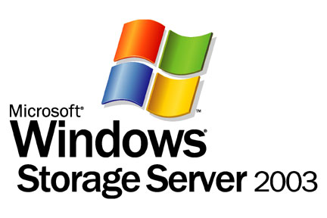

Introduction to Windows Storage Server 2003 Architecture and Deployment

Microsoft Corporation
Published: July 2003

Abstract
Microsoft Windows® Storage Server 2003 is the latest version of Windows Powered NAS. Built on the Microsoft® Windows Server™ 2003 operating system, Windows Storage Server 2003 is a dedicated file server that offers dependable storage while integrating seamlessly with the existing corporate network infrastructure. Easy to install and manage, Windows Storage Server 2003 offers outstanding economics. It enables substantial file server consolidation and provides one of the best platforms for simplified file sharing, backup and replication of businesses essential data.
This white paper introduces the reader to the new and enhanced features of Windows Storage Server 2003 file server and network attached storage (NAS) technologies.

The information contained in this document represents the current view of Microsoft Corporation on the issues discussed as of the date of publication. Because Microsoft must respond to changing market conditions, it should not be interpreted to be a commitment on the part of Microsoft, and Microsoft cannot guarantee the accuracy of any information presented after the date of publication.
This White Paper is for informational purposes only. MICROSOFT MAKES NO WARRANTIES, EXPRESS OR IMPLIED, AS TO THE INFORMATION IN THIS DOCUMENT.
Complying with all applicable copyright laws is the responsibility of the user. Without limiting the rights under copyright, no part of this document may be reproduced, stored in or introduced into a retrieval system, or transmitted in any form or by any means (electronic, mechanical, photocopying, recording, or otherwise), or for any purpose, without the express written permission of Microsoft Corporation.
Microsoft may have patents, patent applications, trademarks, copyrights, or other intellectual property rights covering subject matter in this document. Except as expressly provided in any written license agreement from Microsoft, the furnishing of this document does not give you any license to these patents, trademarks, copyrights, or other intellectual property.

The example companies, organizations, products, people and events depicted herein are fictitious. No association with any real company, organization, product, person or event is intended or should be inferred.
© 2003 Microsoft Corporation. All rights reserved.
Microsoft, Active Directory, Windows, and Windows NT are either registered trademarks or trademarks of Microsoft Corporation in the United States and/or other countries.
The names of actual companies and products mentioned herein may be the trademarks of their respective owners.

Contents
Introduction 1
Overview of Windows Storage Server 2003 2
What is Windows Storage Server 2003? 2
Advantages of Windows Storage Server 2003 2
The Basics: How NAS Works 4
File Serving Component 4
Hardware Component 4
Storing Component 4
Optimizing NAS 5
Windows Storage Server 2003 Features 6
Networking 6
File Serving 7
Storage 9
NAS Management Software 10
Performance 11
Integrated Snapshots 12
Improved End-User Experience 12
New Features in Windows Storage Server 2003 14
Volume Shadow Copy Service (VSS) 14
Virtual Disk Service (VDS) 15
Multipath I/O (MPIO) 16
Distributed File System (DFS) 17
NAS Deployment Scenarios 18
File Serving 18
Server Consolidation 20
Local and Remote Site Replication for Business Continuity 20
NAS-SAN Fusion 22
Summary 23
Related Links 24

Introduction
Development of technologies delivering storage over the network has revolutionized the availability, distribution and accessibility of storage resources. Attaching storage directly to the company network helps to eliminate or reduce the drawbacks business experience when using directly attached storage. These drawbacks include:
- Limited storage capacity and scaling constraints as data assets grow.
- Proliferation of computer hardware and software to meet increased storage capacity needs.
- Proliferation of hardware and software necessary to protect the data allocated to new storage.
- Increased management complexity for the system administrator(s) configuring and maintaining IT client and server systems.
- Poor or inconsistent protection of data on client desktops and laptops.
- Limited or laborious access to data, especially between company workgroups, departments and branches.
- Temporary or permanent loss of data resulting from hardware failures, data corruption or user error.
- Spiraling costs associated with capital expenditure, increased staffing, and production downtime resulting from data loss.
Network attached storage (NAS) is one solution to these challenges. NAS storage and file serving devices can be attached directly to the company intranet. Storage directly attached to the network becomes accessible to all computers that can access the network. NAS servers are designed for ease of deployment: they can be plugged directly into the network without disruption of services, management is minimal and simplified, and they are largely maintenance free. NAS devices are an ideal means by which to consolidate file servers and backup equipment and to expand storage capacity.
A second networked-storage solution is the installation of a storage area network (SAN). Unlike NAS solutions, these dedicated storage networks require considerably more planning to deploy, and their management is more complex. SAN solutions are ideal for database and on-line processing applications requiring rapid data access, but because SAN storage devices serve block-level data rather than files, the installation of a Fibre Channel network to transport the SCSI (Small Computer System Interface) commands is necessary.
A third storage network solution is a hybrid one: NAS devices can be attached to SANs. In this configuration, the NAS components necessary for filing are physically separated from the components necessary for storing: a NAS “head” or “gateway” (containing the filing functionality) attaches to the LAN network, and behind that lies the storage component—a “backend” SAN consisting of the Fibre Channel network (wiring and switches) and the storage disks.

Overview of Windows Storage Server 2003

What is Windows Storage Server 2003?
Microsoft® Windows® Storage Server 2003 is a network attached storage (NAS) operating system that enables original equipment manufacturers to build appliances that provide dedicated file serving capabilities and storage on the network. Windows Storage Server 2003 is built on top of Microsoft Windows Server™ 2003, which ensures that NAS devices built upon the Windows Storage Server operating system have all the performance and scalability benefits associated with Windows Server 2003.
A NAS appliance built Windows Storage Server 2003 is designed to perform without requiring a monitor, keyboard and mouse. Instead, this “headless” appliance is remotely managed through a Web-based user interface for the minimal configuration tasks required for setup. Unlike application servers which require proper planning to implement well, NAS devices built with Windows Storage Server 2003 are designed to be deployed in under 15 minutes, and can be attached directly to the company local area network (LAN) with no interruption to services. Once plugged in, these NAS devices require minimal maintenance.
Unlike proprietary solutions, Windows Storage Server 2003 works with standard hardware from multiple original equipment manufacturers (OEMs). This gives businesses maximum flexibility in choosing among vendors with the hardware solution that best meets their needs.

Advantages of Windows Storage Server 2003
Windows Storage Server 2003 is designed for simplicity, reliability and performance. NAS appliances built on Windows Storage Server operating system integrate seamlessly into the IT network to provide one of the most economical file serving and network attached storage solutions available to departmental and enterprise-sized businesses.
- Ease of Deployment. Depending on the expertise of the system administrator and the complexity of the computing environment, installation of an application or general purpose server can take anywhere from several hours to a day or more of work. Because Windows Storage Server 2003 comes preconfigured, other than using the web browser interface to set up users and shares, the only installation work necessary is plugging the device into the company LAN. In less than 15 minutes, gigabytes to terabytes of storage can be made available to users across multiple OS platforms.
- Simple Management. Windows Storage Server 2003 can be managed remotely though Terminal Services sessions or through a Web browser interface from any desktop on the network. Because Windows Storage Server 2003 uses the Windows operating system, administrators already familiar with Windows do not have to learn a new NAS operating system.
- Dependability. Windows Storage Server 2003 is designed to fully support redundant hardware components—disks, power supplies and fans—to provide continuous and uninterrupted availability should a hardware failure occur. And because NAS devices are designed this way, the potential points of hardware failure are fewer than with general purpose servers.
- Enhanced Data Protection. Through built-in point-in-time shadow technology, Windows Storage Server 2003 helps businesses keep their data online 24x7 year-round. Using the infrastructure provided by Windows Server 2003 Volume Shadow Copy Service (VSS), the system administrator can use point-in-time shadow copy technologies to make up to 512 snapshots per volume using NTBACKUP (of which 64 are reserved for Shadow Copies for Shared Folders). These shadow copy backups are available for rapid restores should the need arise. Unlike tape backups which can take hours to restore, these shadow copy backups can be restored in minutes.
The end user can also benefit from point in time imaging technologies, using the Shadow Copies for Shared Folders (SCSF) feature. SCSF enables users to restore accidentally deleted or overwritten files or entire folders without the need for IT intervention. A maximum of 64 SCSF per volume can be created.
- ISV Utility Support. NAS devices developed with Windows Storage Server 2003 include all of the benefits of application support available in Windows Server 2003. Critical ISV utilities, such as antivirus, backup, replication and disk quota software, are immediately available and supported in Windows Storage Server 2003. NAS devices not based on Windows Storage Server 2003 are not able to support these kinds of products without special versions, or those operational procedures must be performed from application servers on the NAS files and file.
- Robust Security. Because it can be integrated seamlessly with Active Directory services, Windows Storage Server 2003 can take advantage of the Windows security features such as data and file encryption, network authentication, secure network transport, and network wide group policies.
- Load Balancing and Server Fail Over. Windows Storage Server 2003 integrates effectively with the Distributed File System, enabling effective management of the servers and files on the business network. DFS works to provide a single hierarchical view all the servers and their shares. Replicating the data across multiple servers and keeping the data synchronized with File Replication Service (FRS) is an effective way to balance the network load. In the event that a server fails, DFS will automatically redirect clients to the closest available server.

The Basics: How NAS Works
This section provides a brief introduction to how the NAS server works, and is included to help provide the context for many of the NAS features available with Windows Storage Server 2003. Like all NAS servers, Windows Storage Server 2003 functionally and architecturally consists of three components: the filing system, the wiring (and related hardware), and the storage (disk). These components together provide the functionality necessary to fulfill client system application requests for data stored on the NAS device.
Application requests to read or write data are initiated by the client system, and can be directed to the storage local to the client (embedded or directly attached storage), or can be redirected over the network to the NAS device using network transport protocols. These I/O requests are then processed by the NAS operating system before being passed to the disk devices for storage.

File Serving Component
The process of storing and retrieving the data requested by user applications is known as file serving. File serving is under control of the operating system software.
- Application I/O requests (to read or write data) flow from client-side applications over the LAN to the NAS operating system (kernel), which queues and schedules the various client application requests. These requests then pass to the file system and the volume manager of the operating system.
- The file system portion of the operating system controls security and determines whether or not a file can be created, opened, written to. The file system also ensures that the file is addressed to the correct storage destination. The I/O request then passes from the file system through the Volume Shadow Copy Service layer (where it may or may not be processed) to the volume manager.
- The volume manager portion of the operating system readies the data for the specific device(s) it will be passed onto for storage. The Virtual Disk Service (see later section in this paper) is a component of the volume manager (but not a component of I/O requests).

Hardware Component
Having passed out of the operating system, the I/O request travels over the host bus to the host I/O controller, which is responsible for correctly addressing the appropriate storage device and correctly transferring the I/O request commands and data across the storage I/O bus to the storage device.

Storing Component
Having passed into the storage device, the application request (data) is stored on the appropriate physical or logical disk, as directed by the file system.

Optimizing NAS
Vendors can configure NAS hardware (and firmware) such that it is optimized for network file I/O processing and storage. These components include the NAS processor, memory and caching, and the storage devices. There are many different ways to optimize file serving, and the particular approaches taken are vendor specific.
The next section describes the networking, file serving and storage features in Windows Storage Server 2003 that drive these capabilities.

Windows Storage Server 2003 Features
This section highlights the networking, file serving and storing capabilities of Windows Storage Server 2003. This section provides feature highlights. For a summary of the major advances in Windows Storage Server 2003, see “Key Improvements Since Windows Powered NAS 2.0.”

Networking

Network Data Transmission Protocols
In order for clients to access storage on the NAS device, they must be connected to the local area network, and network transport must be enabled. Clients most commonly connect to the NAS server over Ethernet cabling using the TCP/IP protocol. Depending on the system platform, other protocol layers may also be necessary for network transport. Windows Storage Server 2003 provides support for network protocols used by not only Windows systems, but also by Unix and Apple systems (see Table 1), enabling networking across multiple platforms.
Table 1. Networking Protocols Supported by Windows Storage Server 2003
Network Protocols | Additional Information
TCP/IP | Used to connect hosts to the Internet.
AppleTalk | Networking protocol for Apple computers.
IPX | Internet packet exchange. (Administration through Remote Desktop.)
NetBEUI | NetBIOS Extended User Interface, used for Windows environments.
SNMP | Simple Network Management Protocol, internet standard for network management.
Telnet | Provides remote terminal access to host.
Fibre Channel | Transmits block-level data; most common in SAN configurations.
Ethernet | Physical network, transmits files; most common transport for NAS.

Network Security
Windows Storage Server 2003 uses the authentication services of Server 2003 to ensure that only those users with permission to access data can do so. An additional layer of protection is available through the data encryption capabilities of the Windows operating system (see Table 2). The NAS Windows Storage Server is able to support security features for Unix and Macintosh environments, as well as earlier Windows platforms.

Table 2. Security and Authentication Support in Windows Storage Server 2003.
Security and Authentication | Additional Information
Kerberos | Network authentication protocol for client server configurations.
SSL | Secure Socket Layer protocol, provides connection security for Web servers.
IPsec | Internet Protocol Security, provides encryption for network transmission.
Active Directory | Directory service for Windows OS, acts as central authority for network security.
Windows NT Domain | Administration (including security and authentication) of users, groups, servers etc in NT environments.
NTLM | Windows NT LAN Manager provides security for connections between NT clients and servers.
NIS | Network Information System (for Unix servers).
Apple UAM | User Authentication Module.

File Serving

File Sharing Protocols
File serving, as discussed earlier, is the process of opening, closing, reading and writing files. In order for file serving to be enabled over the network, file sharing protocols must be supported. These protocols enable clients to make requests and receive responses from remote devices, such as a NAS storage box.
Many NAS devices enable only simple file processing because they include support only for the standard file systems: the Common Internet File System (CIFS) and Network File System (NFS). In contrast, Windows Storage Server 2003, with its support for multiple file sharing protocols (Table 3), allows for complex multi-platform file processing. In addition to Windows clients, Windows Storage Server 2003 supports file processing for Unix, Macintosh, and Web HTTP clients, among others.

Table 3. File Sharing Protocols Supported in Windows Storage Server 2003
Protocols | Additional Information
SMB/CIFS | Enables Windows-based file sharing.
NFS | Enables Unix/Linux-based file sharing.  NFS 3.0 supported in Windows Storage Server 2003.
AppleTalk | Enables Apple file sharing.
HTTP | Enables web file sharing.
WebDAV | Enables desktop users to manage web based files using HTTP.
NetWare | Enables Novell-based file sharing.  Administration through Remote Desktop.

Supported Utilities and Applications
Although one of the advantages of NAS is that it is a dedicated file server and not overburdened with applications, the data on the server nevertheless requires protection from data corruption, and the possibility of hardware failure. Because it is based on Server 2003 operating system, Windows Storage Server 2003 is able to support anti-virus and backup utilities (see Table 4). In addition, Windows Storage Server 2003 seamlessly integrates with critical Windows features, such as DFS and FRS.
Table 4. Software Supported in Windows Storage Server 2003
Software Support | Additional Information
Anti-virus | Via third party software.
Backup | Via third party software.  Includes the backup utility NTBACKUP which uses VSS and SCSF to backup both system and user data with shadow copies.
Distributed File System (DFS) | Enables a single hierarchical mapping of all systems and shares on the network
File Replication Service (FRS) | Enables remote mirroring through replication  Synchronizes data¹
Internet Information Services (IIS) | Tool to host and manage web pages on intranet or internet.  Version 6.0 supported in Windows Storage Server 2003.
¹ Web UI support for Distributed File System (DFS) does not include or enable FRS scenarios.

Storage

Managing Storage Devices
Management and configuration of the storage disks (both physical and logical) is under control of the Virtual Disk Service (VDS). (See “New Features” for more information.) Allocation of disk space to users is performed through quotas, and can be managed through a user interface.
The Enterprise Edition of Windows Storage Server 2003 supports the Automated Deployment Service (ADS) as an optional add-on. ADS is a scriptable service enabling rapid and highly effective deployment of large numbers of new servers.
Table 5. Disk and Deployment Management Capabilities in Windows Storage Server 2003
Disk Management | Additional Information
Virtual Disk Service (VDS) | Includes sample code for volume management
Quota Management | Enables administrators to limit the storage accessible by each user.
Automated Deployment Services (ADS) | Enterprise Edition only. ADS enables administrators to perform script based administration of large scale deployments of Windows servers.  ADS replaces Multi-Device Manager (MDM) in WP NAS 2.0.

Ensuring Availability of Stored Data
A number of existing technologies have been enhanced and a number of new features have been added to Windows Storage Server 2003 to help keep a business’s data highly available. These technologies range from tools to ensure hardware components are operating effectively and at high performance, to technologies enabling hardware (MPIO) and software (clustering) redundancy, to data availability techniques for redundancy (VSS and RAID) and high performance (RAID—redundant array of inexpensive disks).
Table 6. Features Enhancing System Reliability and Data Availability
Reliability/  Availability | Additional Information
Volume Shadow Copy Service (VSS) | Enables up to 512 point-in-time copies per volume, of which 64 are reserved for Shadow Copies for Shared Folders if enabled on the volume.  This service replaces the Persistent Storage Manager (PSM) in WP NAS 2.0.
Clustering | Provides application failover.  Windows Storage Server 2003 Enterprise Edition supports up to 8 nodes (WP NAS 2.0 supports a maximum of 2 nodes).
Software RAID 0, 1, 5 | RAID types provide differing levels of data protection and redundancy.  VDS also enables hardware based RAID.
Multipath I/O (MPIO) | Enables high performance and high availability through multiple paths to storage.
System Monitoring | Monitors performance of the operating system. Allows system administrator to assess I/O performance with different devices.
Watchdog Timer | Detects system hangs; can be programmed to reboot system after a given time.

NAS Management Software
Depending on the complexity of the deployment scenario, the need for NAS management ranges from the minimal (plug and play) to the considerably more complex (see Table 5). Windows Storage Server 2003 provides a number of different interfaces to meet such management needs, including both local and web-based UIs (see Table 7).
Table 7. Management Interfaces in Windows Storage Server 2003
Management | Additional Information
Web User Interface (UI) | Enables administrators to remotely manage users, create shares, and control backups and similar tasks from any location on the network or internet.
Remote Desktop | Enables remote control of other systems for administration.
Key Improvements Since Windows Powered NAS 2.0
Windows Storage Server 2003 has been improved in a number of key areas relative to Windows Powered NAS 2.0. This section highlights improvements in the key areas of file serving performance, integrated snapshots, and the user interface.

Performance
As a dedicated file server, the speed with which NAS boxes can handle I/O read and write requests is a critical factor in overall performance of systems on the network. Windows-based NAS boxes communicate with client systems using the SMB (server messenger block) or CIFS (common internet file system) protocol for Windows-based systems. For Unix-based systems, the NFS (network file system) protocol is used.

SMB Performance
The industry standard in measuring SMB/CIFS file server performance for Windows Clients is NetBenchTM benchmarking software. File server performance is measured as throughput (megabits per second) versus number of clients.
Comparisons of Windows Storage Server 2003 and NAS 2.0 using the same hardware configurations directly capture improvements in the Windows operating system performance. These improvements stem from changes to the kernel (improved caching, buffering, and the like), as well as changes reflected in the use of SMB in 2003 versus CIFS in 2000. Differences between studies capture differences attributable to different hardware configurations.
In both internal MS benchmarks using NetBench and a commissioned 3rd party benchmark test, the performance of Windows Storage Server 2003 is greatly enhanced in comparison to NAS 2.0. In 3rd party Veritest comparison of file serving in Windows Storage Server 2003 and NAS 2.0, peak throughput on Windows Storage Server 2003 is 35-85% faster than Windows Powered NAS 2.0, depending on whether there are one, two, four or eight processors (see Figure 1). Internal Microsoft tests, using a different hardware configuration, put the overall throughput at 100% or above for each of the four processor configurations.

NFS Performance
The industry standard for measuring NFS file server performance for Unix clients is based on the Spec SFS benchmark program produced by the Standard Performance Evaluation Corporation. Spec SFS scores file server performance in terms of I/O throughput per second (IOPS). In internal MS tests using Spec SFS, file serving performance increased from 5040 IOPS in NAS 2.0 to 7500 IOPS in Windows Storage Server 2003, a 50% increase.
Figure 1. NetBench comparison of file serving performance in NAS 2.0 (Windows 2000 Server) and Windows Storage Server 2003 (Windows Server 2003).

Integrated Snapshots
In NAS 2.0, point-in-time imaging (snapshot) technology is only available through the integration of 3rd party advanced backup software. In Windows Server 2003, snapshot technology is part of the Volume Shadow Copy Service (VSS) and is fully integrated into the operating system, thus making it part of the Windows Storage Server 2003 package. Snapshot technology enables open file backups and fast restores. The technology is especially useful when the goal is the restoration of individual files, which can be done by the end user without the need for system administrator intervention.

Improved End-User Experience
Windows Storage Server 2003 has a number of enhanced user interfaces (UIs) for the end user and the system administrator. On the client side, the Previous Versions user interface (Shadow Copies for Shared Folders) allows end users to directly restore their own files in the event of accidental deletion, overwriting or file corruption (Figure 2). On the system administrator side, UIs for volume defragmentation, task scheduling, folder and share management, volume management, and UPS management make administration of storage much more convenient than before.
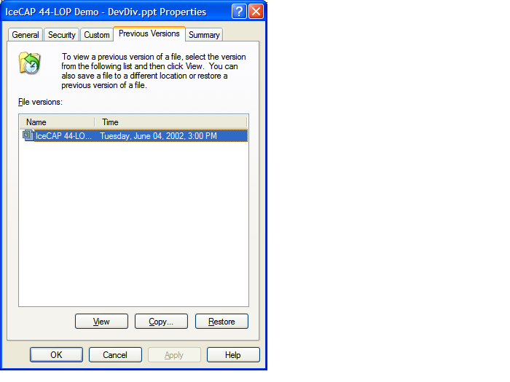
Figure 2. Client user interface used to restore previous versions of a file.

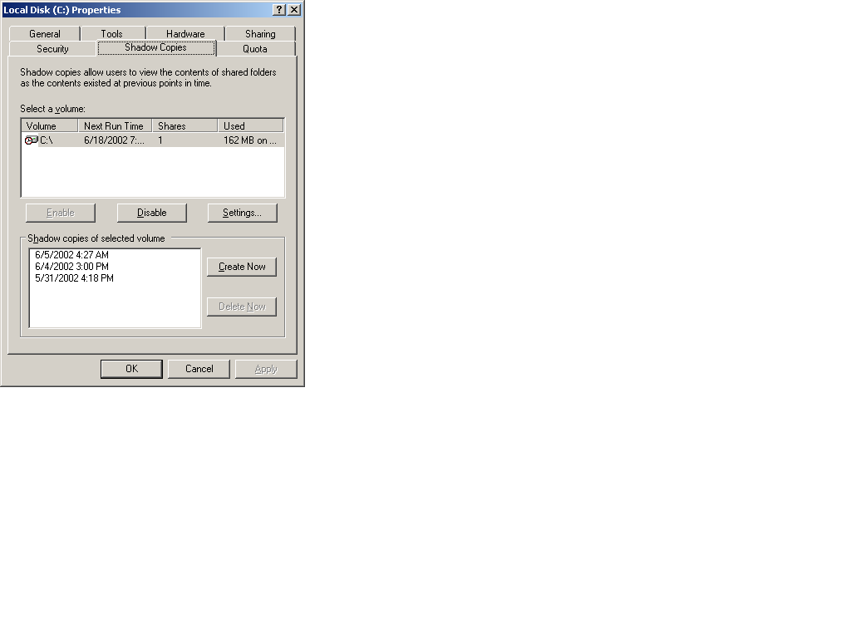
Figure 3. System administrator user interface for scheduling shadow copies.

New Features in Windows Storage Server 2003
The following are new features in Windows Storage Server 2003.
- Volume Shadow Copy Service
- Virtual Disk Service
- MPIO
- DFS

Volume Shadow Copy Service (VSS)
The Volume Shadow Copy Service (VSS) is an infrastructure that makes possible enhanced data protection though high fidelity backups, rapid data restores, and data transport.
VSS is a component of the operating system, and as such, is not directly accessed by users. Instead the Volume Shadow Copy Service coordinates with user applications, backup applications and storage hardware to enable the creation of point-in-time shadow copies of data on single or multiple volumes without significantly impacting performance.

High Fidelity Backups
Shadow copy creation is a highly effective means of protecting data with several advantages over traditional tape backups when the goal is not long-term archiving. Tape-based technologies are time-intensive to run, impose a considerable bandwidth burden on the local network, and can have data inconsistency issues if applications are open during the backup process. As a consequence, tape backups tend to be scheduled relatively infrequently and at times when applications are not in use (such as nights or weekends)—a strategy that can work reasonably well for companies that do not require 24x7 operations. In contrast, shadow copies can be created in seconds, without the impact on network traffic that tape backups impose. Additionally, because the shadow copy process allows open files to be backed up without data inconsistency issues, they can be scheduled at any time, and much more frequently than tape backups.

Fast Restores
In the event of data loss, shadow copy restoration offers significant advantage over tape restores. Because the shadow copies can be saved on storage arrays on site, they can be accessed directly, without the need to travel offsite to a tape data vault, locate and bring back a tape. Even more significantly, shadow copy restores takes only minutes to complete, while tape restores, depending on the type of backup (full, differential or incremental) and the amount of data, can take hours or even days to do correctly.

Shadow Copies for Share Folders
System administrators are not the only people to benefit from the fast restore functionality enabled by VSS. System administrators can activate Shadow Copy for Shared Folders, thereby enabling end users who overwrite or accidentally delete a file to restore a previous version of a file for themselves, rather than having to recreate the file or request that a system administrator do a high cost single file restore from tape.

Shadow Copy Transport
All of the functionality discussed above is provided with the in-box shadow copy technology on the operating system. The exception to this is shadow copy transport among systems—whether for backup, data mining, testing or fast restores—which requires a hardware provider on the SAN. In a direct attached storage configuration, this data transport between servers is physical. In a NAS-SAN configuration with pooled storage, data on the SAN can be accessed (through masking and unmasking) between servers. Although access to the storage pool is shared, each server can only access the specific LUNs (Logical Unit Number) assigned to it (since two servers cannot both write to the same volume without potentially causing data corruption). But using the hardware provider on the SAN, a point-in-time shadow copy can be virtually “transported” to another server for use, through the process of masking and unmasking.

Virtual Disk Service (VDS)
In order for a server to use new storage disks, they must first be made accessible to the server and then formatted for use. Virtual Disk Service (VDS) controls the process of making storage accessible to systems that need it. While it is irrelevant to application (or the user) how the data is stored—whether it is on a single physical disk or spanned across several disks (a logical unit), in terms of data protection and performance, the impact of how the data is stored is significant. Thus VDS can either present a physical disk or a logical disk to a server. Physical disks do not require the first two steps.
- Create logical units, assign number ids (these are now referred to as LUNs)
- Unmask LUNs to server
- Create partitions and volumes
- Format the file system
- Basic Disks. VDS is used to partition each physical disk and to create the volumes that can be mapped to drive letters for use. These volumes are known as “simple volumes” and do not span multiple disks. Basic disks are the legacy disks, predating Windows 2000 capabilities. They do not offer the same performance and data protection that dynamic disks offer.
- Dynamic Disks. VDS can be employed to create dynamic disks which can consist of either simple volumes or multi-partition volumes. Multi-partition volumes physically span more than a single disk but nevertheless are logically considered a single volume. Dynamic disks can be spanned, striped (RAID-0), mirrored (RAID-1) or stripped with parity (RAID-5), depending on the level of performance and data protection desired. VDS can be used to expand dynamic disks to make more space available to a volume.
Although many vendors provide NAS appliances preconfigured with RAID, system administrators might want to use VDS to customize the storage solution to meet specific data storage needs, whether relating to capacity, performance or data protection.
VDS can also be used to attach a NAS device to a back-end SAN. These NAS “heads” contain only the file serving capabilities; for highly scaleable and highly available pooled storage, they plug into a Fibre Channel SAN. Each storage unit on the SAN must have its storage configured and made accessible to the appropriate servers only. Since it is common for storage on the SAN to be from multiple hardware vendors, prior to Windows Server 2003 and Windows Storage Server 2003 it was necessary for the system administrator to configure each device using a vendor-specific storage management application. Not only did this mean using hardware-specific management utilities, it frequently meant that the system administrator had to physically go to each storage device to do each configuration.
Windows Storage Server 2003’s Virtual Disk Service helps alleviate these administration complexities in a NAS backend SAN configuration by providing a single management interface for multivendor storage devices. The system administrator can manage all storage devices directly from a single management console, and query and configuration operations are common across all managed devices.
In this scenario, VDS functionality is enabled through hardware vendor support. Each hardware vendor must supply a VDS “provider” for the storage hardware. The hardware provider translates the VDS standard APIs (application programming interface) into instructions specific to the storage device. With communication enabled between the Virtual Disk service and the storage hardware, the system administrator can now use a single storage management interface to communicate with multivendor storage devices.

Multipath I/O (MPIO)
Multiple or redundant paths between storage devices and the systems that use them enable persistent data availability and high I/O performance. In essence, these technologies provide for an alternate connection in case of failure of the primary I/O path, and, optionally, multiple paths to improve performance or balance loads.
MPIO software included in Windows Storage Server 2003 is not a feature of the operating system, but is supported through the Driver Development Kit (DDK). Multipathing allows a host to have up to 32 paths to access an external storage device, which facilitates failover and load balancing. Multipathing technology is critical in ensuring highly available data to businesses. In the past, multipathing was a solution only available to large scale enterprises; now this high availability solution is available to any organization using only Windows Storage Server 2003 (and Windows Server 2003) technologies.
Microsoft's MPIO delivers a standard and interoperable path for communication between storage products and Windows Server. With a platform upon which multiple third-party storage systems can reliably interoperate, businesses have greater choice when building a high-quality, highly available network storage system, and system administrators will have the flexibility to incorporate products from multiple vendors into a single, interoperable and highly available storage infrastructure.

Distributed File System (DFS)
The Distributed File System enables the system administrator to create single hierarchical mapping of all systems and shares on the network. By uniting files on different computers into a single namespace, users do not have to sort through a network of dozens of servers, each with their own separate directory structure, but instead see the files as if they resided on a single computer.
With the latest version of the server operating system, DFS has been enhanced to allow multiple DFS roots on a single server, thus reducing administrative and hardware costs of managing multiple namespaces and multiple replicated namespaces. In addition, DFS now delivers more reliable load-balancing, better file replication between DFS sites and servers, and closest-site selection for users accessing the network. Closest-site selection ensures that in the event of server failure or scheduled maintenance, users are automatically routed to another server on the network that has a replica of the data. For best performance and lowest cost, clients are rerouted to the site closest to them.

NAS Deployment Scenarios
The following are common NAS deployment scenarios.
- File Serving
- Server Consolidation
- Local and Remote Site Replication for Business Continuity
- NAS-SAN Fusion

File Serving
Businesses need reliable file servers that can provide highly available data at a reasonable cost. Off-the-shelf, general-purpose servers are not typically configured with fully redundant hardware components. Using a general-purpose server for file serving and running applications can compromise both tasks. In particular, file serving can be negatively impacted by the overhead associated with running applications, as well as by the risks of system crashes should an application fail. General-purpose servers have the additional disadvantage of being platform specific, necessitating a different file server to serve clients on different platforms.
In contrast, NAS filers confer a number of advantages. NAS appliances are designed for high reliability: they are built with redundant disks, NICs (for failover data paths), and power supplies. This redundancy of hardware components makes NAS devices highly reliable file servers helping to ensure highly available data.
Because NAS devices built on Windows Storage Server 2003 are dedicated file servers, they do not carry application overhead, and they are not vulnerable to application-related problems. Moreover, because Windows Storage Server 2003 supports multiple file sharing protocols, file serving to clients on Windows, Unix or Macintosh computers, and sharing between them, can be accomplished without the need for a specialized file server for each platform.
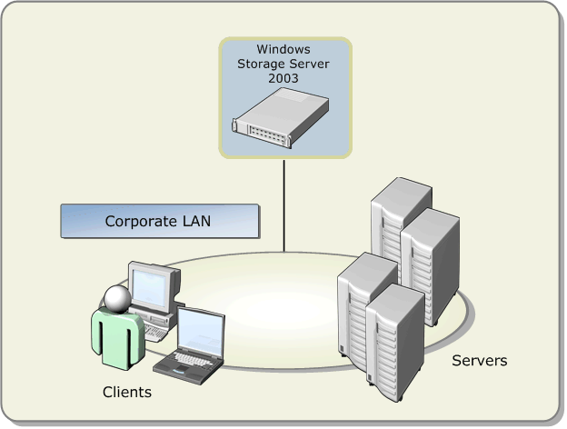
Figure 4. File serving between network clients and Windows Storage Server 2003.

Server Consolidation
As companies add more and more servers to meet demands for increased storage capacity, equipment, licensing, maintenance (power, space, servicing) and management costs all escalate.
Adding a Windows Storage Server 2003 based device to the network allows businesses to consolidate multiple file servers into a single more powerful NAS device. Given the broad file serving capabilities of Windows Storage Server 2003, even file servers running on different platforms (such as Unix or Novell) can be consolidated onto a NAS device, greatly simplifying management across systems. Related equipment, such as backup devices, can also be consolidated. System management is much simpler with fewer devices requiring space, servicing (such as applying patches or maintaining versioning), and backup and restore services. For every NAS device replacing multiple existing servers, the associated licensing costs are eliminated.

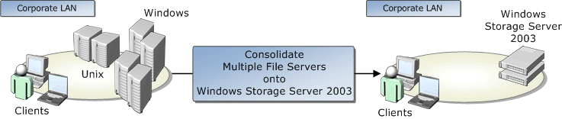
Figure 5. Consolidation of several multi-platform servers onto a single Windows Storage Server 2003 NAS device. This scenario enables the consolidation of tape drives into a single tape array.

Local and Remote Site Replication for Business Continuity
NAS servers using Windows Storage Server 2003 software technologies enable businesses to build fault tolerant solutions designed to keep data highly available.
NAS devices on a LAN can use the replication technologies to replicate data between one NAS device and another. In the event of network failure or the outage of a NAS device, a second NAS device can assume the identity of a nonfunctioning filer and continue serving files to clients without interruption of services. When the nonfunctioning NAS device returns, it takes back its identity, resynchronizes its data with the active NAS device, and resumes file serving.
This process of replication and failover also works on a wide area network (WAN). Replication and synchronization occurs over the WAN between NAS devices. Should one branch site succumb to disaster or be shut down for a planned outage, clients accessing that NAS device are redirected to a second NAS device at a different branch.
NAS devices are also useful to remote sites for a different reason. Branch offices often do not have the IT staffing expertise to effectively deploy general-purpose servers. Because they are so simple to deploy and maintain, NAS file servers are the perfect plug and play solution for these remote sites.

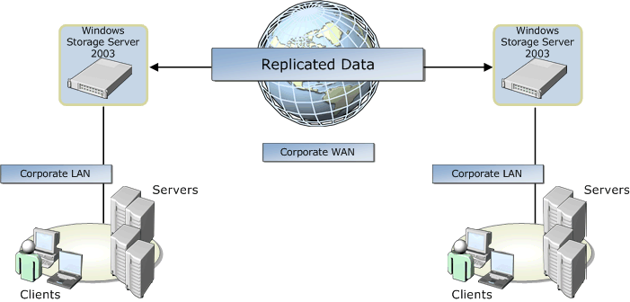
Figure 6. Replication of data between NAS Windows Storage Server 2003 devices deployed at different branch sites.

NAS-SAN Fusion
NAS devices can be seamlessly integrated into a storage area network, providing clients access to unlimited storage. In this configuration, NAS storage is separated from the NAS filing function and placed on the SAN. The NAS head now acts as a gateway to the SAN, controlling distribution of the data over the network and providing clients with maximum scalability and high-performance storage solutions.
NAS-SAN fusion also enables system administrators to move NAS backups off the LAN onto the storage network for highly efficient and extremely fast backups that do not impact LAN performance.

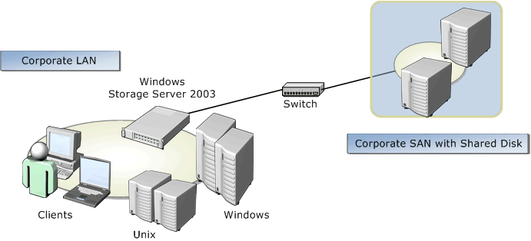
Figure 7. Windows Storage Server 2003 (NAS “head”) integrated into storage area network.

Summary
Windows Storage Server 2003 provides scalable, high performance storage solutions to businesses of all sizes. Built on the Windows Server 2003 operating system, this successor to Windows Powered NAS broadens usability and interoperability for both end users and system administrators. Using Shadow Copies for Shared Folders, end users are empowered to recover their own lost data without IT intervention, thereby improving their own efficiencies and helping the business save money. System administrators benefit from the seamless integration of Windows Storage Server 2003 into existing networks, multi-platform file-serving capabilities, and built-in point in time imaging capabilities for highly efficient backup and restores.

Related Links
See the following resources for further information:
- Microsoft Windows Network Attached Storage Home at http://www.microsoft.com/windows/storage/default.mspx
- Windows Server 2003 File Server, Web Server, and Active Directory Performance Testing (4/03) at www.veritest.com/clients/reports/microsoft
- Microsoft Windows Server 2003 vs. Linux Competitive File Server Performance Comparison (4/03) at www.veritest.com/clients/reports/microsoft

Microsoft, with its iSCSI initiator software released in June 2003, is enabling block transport over company intranets. See the Enterprise Storage Division white paper, “Microsoft Support for iSCSI” for details.
Any system designed to run an operating system.
Disks can be both physical and logical (virtual).
It is at this step that the data associated with the application request is converted from file format into the constituent granular blocks that are written to storage devices.
Software on the vendor hardware; not part of the OS.
SMB is Server 2003’s enhanced version of CIFS (native to Server 2000).
See the report at www.veritest.com/clients/reports/microsoft.
It is important to note that these performance improvements are seen only when upgrade client software is loaded onto the client systems.
For configuration details, see Windows Storage Server 2003 OEM training Guide.
Physical disks are divided into sectors; contiguous sectors are partitions. In the case of basic disks, the volumes are created within partitions, and are thus restricted to a single disk.
Volumes can span one or more partitions on the same or multiple disks. Dynamic disk types include RAID configurations, and can offer better performance and reliability than basic disks.
The number of servers that can be consolidated on a NAS device depends how powerful the server capabilities are, and how many clients are served. Microsoft tests have demonstrated that up to 25 Widows NT servers can be consolidated into a single NAS device.

