Application: The My namespace

New Concepts
When building applications with VB6, you have access to the VB runtime, a wide variety of COM objects, and a Win32 API for whichever version of the Windows operating system you’re running on. The first versions of the .NET Framework unified much of this functionality into a single mammoth set of classes known as the Base Class Library. Within the BCL there are classes to support accessing information about the underlying operating system. There are classes that allow you to easily access information about the hardware on the machine, there are also classes that allow you to easily communicate across the network between different applications, encrypt data, provide access to the registry, and more. Understanding the Base Class Library, and the wealth of functionality it offers, is important in order to become a competent .NET developer. A lack of knowledge about the Base Class Library can cause developers to reinvent the wheel, and construct classes that already exist. In some cases the functionality provided by the .NET Framework is so hidden or obscured by the size of the .NET Framework that things are overlooked. Numerous articles have been written that include their own home brewed algorithm to support actions that you could performed simply by knowing about such Framework classes as Path, or PasswordDeriveByes. In fact, many people will tell you that learning .NET isn’t so much about learning Visual Basic .NET or C#, but is really about learning the Base Class Library.
However, learning the Base Class Library is also a mammoth challenge, simply because it is so large. The classes that are used every day are just mixed in with other classes that you may never need. To make the common classes in the framework more discoverable, Visual Basic .NET now provides a “speed dial” namespace called My. By using My you have the ability to easily access computer, application, and user information, as well as obtain access to forms, and web services. It is important to understand that My is only accessible to you when writing Visual Basic.NET applications and is not directly available to you when using C#.
It is important to note that the My namespace goes beyond being a simple speed dial. In some cases, the classes in the My namespace provide more functionality than you easily find by simply searching through the various namespaces that make up the Base Class Library. For example the Folder object provides additional properties, such as Drive, that are not available on the System.IO.DirectoryInfo class. My also forced Microsoft to think of computer, application, and user as complete entities, and ask themselves “What should you be able to do with a computer?” The result was methods such as My.Computer.Network.Ping, which allows you to ping a computer on the network with a single line of code. You will now find that functionality previously available only by calling into COM libraries, or the Win32 API, are now easily accessible and discoverable through My.
The My namespace is broken down into a few areas of focus.
My Object Model
Object Description
My.Application | Contains information about the running application such as the title, current directory, and version. It also gives access to environment variables allowing you to easily write to the local application log, or write to a custom log, etc.
My.Computer | Provides access to information about the underlying platform and the hardware on the local machine that the application is running on. For instance, Registry, Printer, Keyboard, Screen, etc. are types of objects you can access through this class.
My.User | Contains information about the current user in terms of their display name, domain name, what groups the user is a member of, and so on.
My.WebServices | Allows you to easily access Web services that are added as Web References in your project.
My.Forms | A collection of all the instances of the forms in your current project. Allows you to easily show and hide forms without having to explicitly create an instance of the form in code.

As you can see, the My namespace gives you easy and direct access to functionality that you can use on a daily basis when building applications.

Code Walkthrough
In this section you’ll gain a good understanding of the My namespace by looking at a small sample application that explores some of the depth of My. The application has numerous tabs. Each tab focuses on a particular subsection of My.
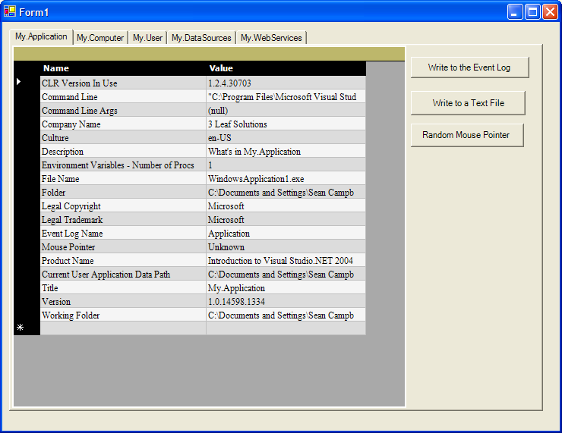
Figure 1
My.Application tab.

Fix image – remove My.Datasources – this is cut

My.Application
The first tab with the text My.Application displays a data grid that exposes the values for many of the properties that are part of the My.Application object. The code that populates this grid with data is as follows.
CLRVersionInUse is cut (you might see it in M2 bits, but it’s cut
myAppDS.MyApplication.AddMyApplicationRow("CLR Version In Use", _
My.Application.CLRVersionInUse.Major.ToString() & "." & _
My.Application.CLRVersionInUse.Minor.ToString() & "." & _
My.Application.CLRVersionInUse.Revision.ToString() & "." & _
My.Application.CLRVersionInUse.Build.ToString())
myAppDS.MyApplication.AddMyApplicationRow("Command Line", _
My.Application.CommandLine)
Dim cmds as String
For Each cmd as String in My.Application.CommandLineArgs
cmds &= “, “ & cmd
Next
myAppDS.MyApplication.AddMyApplicationRow("Command Line Args", _
cmds)
myAppDS.MyApplication.AddMyApplicationRow("Company Name", _
My.Application.CompanyName)
myAppDS.MyApplication.AddMyApplicationRow("Company Name", _
My.Application.CompanyName)
myAppDS.MyApplication.AddMyApplicationRow("Culture", _
My.Application.Culture.CurrentCulture.ToString())
myAppDS.MyApplication.AddMyApplicationRow("Description", _
My.Application.Description)
myAppDS.MyApplication.AddMyApplicationRow("Number of Procs", _
My.Application.EnvironmentVariables.Item("NUMBER_OF_PROCESSORS").Value)
myAppDS.MyApplication.AddMyApplicationRow("File Name", _
My.Application.FileName)
myAppDS.MyApplication.AddMyApplicationRow("Folder", _
My.Application.Folder.ToString())
myAppDS.MyApplication.AddMyApplicationRow("Legal Copyright", _
My.Application.LegalCopyright)
myAppDS.MyApplication.AddMyApplicationRow("Legal Trademark", _
My.Application.LegalTrademark)
myAppDS.MyApplication.AddMyApplicationRow("Event Log Name", _
My.Application.Log.EventLogName)
myAppDS.MyApplication.AddMyApplicationRow("Mouse Pointer", _
My.Application.MousePointer.ToString)
myAppDS.MyApplication.AddMyApplicationRow("Product Name", _
My.Application.ProductName)
myAppDS.MyApplication.AddMyApplicationRow("CUser Application Data Path", _
My.Application.SpecialFolders.CurrentUserApplicationData.ToString())
myAppDS.MyApplication.AddMyApplicationRow("Title", _
My.Application.Title)
myAppDS.MyApplication.AddMyApplicationRow("Version", _
My.Application.Version.Major & "." & My.Application.Version.Minor & "." & _
My.Application.Version.Revision & "." & My.Application.Version.Build)
myAppDS.MyApplication.AddMyApplicationRow("Working Folder", _
My.Application.WorkingFolder.ToString()
The code above is intentionally somewhat verbose. The code could have used reflection to iterate through the properties, but by listing them out in code, you can look at the application and get a better idea of what information is returned by a specific property. The individual value retrieved from a given property is added to a typed dataset. The MyApplication table in the typed dataset is then bound to the Datagrid on the My.Application tab. You can gather a great deal of information about your application simply by accessing properties that make up the My.Application object. The table below lists all of the properties and methods of the My.Application object.
My.Application
Property/Method Description
CommandLine | Returns the full command line – exe plus arguments.
CommandLineArgs | Returns a collection of command line arguments.
CompanyName | Returns the CompanyName information for the application that is specified in AssemblyInfo.vb.
Culture | Returns an instance of the culture object which let’s you determine the current culture of the application among other things.
Description | Returns the description information for the application that is specified in AssemblyInfo.vb.
Environment Variables | Enumerates the environment variables on the local machine.
FileName | Gives you the name of the assembly for the application.
Folder | Returns the folder where the application resides.
Exit | Shuts down the Application
LegalCopyright | Returns the legal copyright information for the application that is specified in AssemblyInfo.vb
Legal Trademark | Returns the legal trademark information for the application that is specified in AssemblyInfo.vb.
Log | Allows you to write to a custom text file log and the application log on the local machine.
MousePointer | Allows changing the mouse pointer for the given application.
ProductName | Returns the product name information for the application that is specified in AssemblyInfo.vb.
SpecialFolders | Returns an instance of the Special Folder object that gives you access to special folders such as the Desktop, Application Data, etc.
Title | Returns the title of the executing assembly
Version | Returns the version information for this assembly.
WorkingFolder | Returns the working directory for the application.

Scenarios for using My.Application when developing applications
My.Application provides you a great deal of functionality with much less code than when building applications with the .NET Framework 1.0/1.1 and/or Visual Basic 6. In this section we’ll look at some of the ways you can utilize My.Application. For example the code required to write to an Event Log has now been shortened to the following.
My.Application.Log.WriteEntry("Application Starting", _
EventLogEntryType.Information, 1000)
The code above will write an entry to the local Application EventLog. Previously if you wanted to write to the EventLog in the .NET Framework 1.0/1.1 it required multiple lines of code to do so. With Visual Basic 6, you had some limited logging functionality through the App object, but you could not specify an event ID, you could not write to the System, or Security log, or create your own custom logs.
Another example of the reduction of code brought about by using My\ in your application is when you contrast the lines of code necessary to generate a custom log for your application that writes out to a text file.
My.Application.Log.FileName = My.Application.Folder.ToString() & _
"\logfile.txt"
My.Application.Log.FileType = Monitoring.LogFileType.Xml
My.Application.Log.WriteEntry("Application Starting", _
EventLogEntryType.Information, _
1000)
With this code, the information will be written out to a custom XML log file, in addition to the Application event log. You can use the FileMaximumSize property of the My.Application.Log object to set the maximum file size. You can specify a log file type of XML or tab delimited using the My.Application.Log.FileType property, you can programmatically enabled or disable logging, and you can change log files while the application is running..
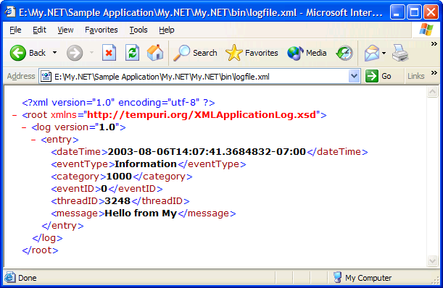
Figure 2
XML Log Output
In addition My.Application gives you direct access to a wealth of application level information in a single line of code. Some examples of where you could use these aspects of My.Application follow:
- Quickly determine the folder you application is currently placed in by using the Folder property
- Easily set the MouseCursor to default cursor types such as AppStarting, Help, etc.
- Get quick access to assembly metadata such as the Product Name, Company Name, and so on.

My.Computer
The next piece of My is the Computer object. The My.Computer object gives you access to information about the underlying platform and hardware that your application is running on. The second tab in the sample application extracts some of the more interesting property values you can retrieve from the My.Computer object.
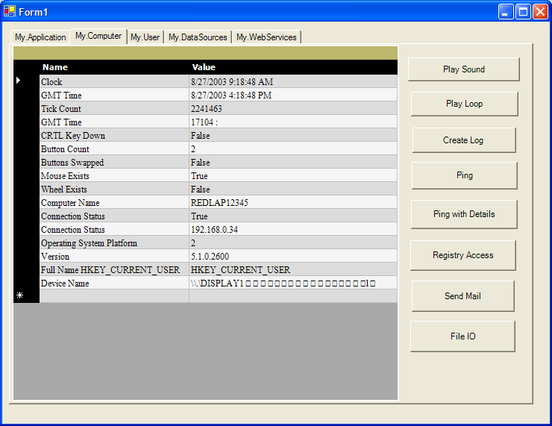
Figure 3
My.Computer tab
The code that populates this grid with data is as follows.
myAppDS.MyComputer.AddMyComputerRow("Clock", _
My.Computer.Clock.LocalTime)
myAppDS.MyComputer.AddMyComputerRow("GMT Time", _
My.Computer.Clock.GmtTime)
myAppDS.MyComputer.AddMyComputerRow("Tick Count", _
My.Computer.Clock.TickCount)
myAppDS.MyComputer.AddMyComputerRow("GMT Time", _
My.Computer.EventLogs.Item("Application").ReadEntries().Item(1).Message)
myAppDS.MyComputer.AddMyComputerRow("CRTL Key Down", _
My.Computer.Keyboard.CtrlKeyDown.ToString())
myAppDS.MyComputer.AddMyComputerRow("Button Count", _
My.Computer.Mouse.ButtonCount)
myAppDS.MyComputer.AddMyComputerRow("Buttons Swapped", _
My.Computer.Mouse.ButtonsSwapped)
myAppDS.MyComputer.AddMyComputerRow("Mouse Exists", _
My.Computer.Mouse.Exists.ToString())
myAppDS.MyComputer.AddMyComputerRow("Wheel Scroll Lines", _
My.Computer.Mouse.WheelScrollLines.ToString())
myAppDS.MyComputer.AddMyComputerRow("Wheel Exists", _
My.Computer.Mouse.WheelExists)
myAppDS.MyComputer.AddMyComputerRow("Computer Name", _
My.Computer.Name)
myAppDS.MyComputer.AddMyComputerRow("Connection Status", _
My.Computer.Network.ConnectionStatus)
myAppDS.MyComputer.AddMyComputerRow("Connection Status", _
My.Computer.Network.IPAddresses(0).ToString())
myAppDS.MyComputer.AddMyComputerRow("Operating System Platform", _
My.Computer.OperatingSystem.Platform)
myAppDS.MyComputer.AddMyComputerRow("Version", _
My.Computer.OperatingSystem.Version.Major & "." & _
My.Computer.OperatingSystem.Version.Minor & "." & _
My.Computer.OperatingSystem.Version.Revision & "." & _
My.Computer.OperatingSystem.Version.Build)
myAppDS.MyComputer.AddMyComputerRow("Full Name HKEY_CURRENT_USER", _
My.Computer.Registry.CurrentUser.FullName)
myAppDS.MyComputer.AddMyComputerRow("Device Name", _
My.Computer.Screen.DeviceName)
The code is similar to the code used to populate the grid on the My.Application tab in the application. A typed DataSet is populated with values from properties of the My.Computer object, and then bound to a grid.
Not all of the elements of My.Computer object are demonstrated by the data bound to the grid. The properties or methods that are not shown in the grid are listed in bold in the following table.
My.Computer
Property/Method Description
Clock | Allows you to access the current GMT time, local time, and a Tick Count.
EventLogs | Allows you to access local Event Log information as well as create and delete Event Logs.
FileSystem | Allows you to perform a variety of IO operations such as copying files and directories, moving files and directories, reading and writing to files. Typically in one line of code.
Keyboard | Allows you to determine the state of the keyboard and the state of various keys on the keyboard. You can determine if the CTRL key is pressed, the SHIFT key, the ALT key, if CAPS lock is on, or if SCROLL LOCK is on.
Mouse | Let’s you determine the state of the mouse and the specific hardware characteristics of the attached mouse such as the number of buttons, whether a mouse wheel is present, etc.
Name | Gives you the name of the local machine the application is running on.
Network | Gives you access to the IP Address information for the local machine, the local machine’s current connection status, as well as the ability to Ping addresses.
Operating System | Gives you access to Platform and Version information for the local computer.
Registry | Gives you easy access to the registry and the ability to read and write to registry keys.
Screen | Gives you access to all the monitors attached to the system and properties of those displays such as BitsPerPixel, WorkingArea, etc.

Scenarios for using My.Computer when developing applications
My.Computer gives you a great deal of access to the underlying platform that you can use in a variety of scenarios. For example you easily Ping network addresses using the Network property and its associated Ping and PingWithDetails methods.
Dim pingResult As Microsoft.VisualBasic.Net.PingResult = _
My.Computer.Network.PingWithDetails("www.3leaf.com")
If pingResult.PingSuccesses > 0 Then
Dim pingDetails As String = "Average Ping Time in MS: " & _
pingResult.AveragePingTimeInMilliseconds & vbCrLf & _
"Bytes Received: " & pingResult.BytesReceived.ToString() & vbCrLf & _
"IP Address: " & pingResult.IPAddress.ToString() & vbCrLf &_
"Ping Attempts: " & pingResult.PingAttempts.ToString() & vbCrLf & _ "Ping Successes: " & pingResult.PingSuccesses.ToString()
MessageBox.Show(pingDetails)
Else
MessageBox.Show("Ping of www.3leaf.com was not successful")
End If
In the code above the key line is My.Computer.Network.PingWithDetails(). This line of code returns a PingResult object that is populated with that data that is returned from a standard ping attempt. If at least one successful ping is recorded then the Average Ping Time in milliseconds, the number of bytes received, and the number of ping attempts, and the number of successes are displayed in a MessageBox. There is also a simple Ping method off of the My.Computer.Network property that returns true or false if the ping was successful. Being able to ping an address such as this makes it easy to determine whether your application is able to communicate with a particular server. You can also easily determine the network connection status by simply using My.Computer.Network.ConnectionStatus. The ConnectionStatus property returns a true or false depending on whether the computer has a current network connection.
Another good use of My.Computer in your applications is when you need access to the file system. My.Computer.FileSystem gives you better access to the file system with fewer lines of code when compared with the code required to perform the same actions in previous versions of Visual Basic.NET. With My.Computer.FileSystem you can perform the following actions in one line of code.
- Append text to a file.
- Read all the text in a file.
- Copy a folder while creating all the parent folders necessary to complete the path
- Moving a folder wile creating all the parent folders necessary to complete the path
You can also easily work with folders, files, and Drives through the types in the Microsoft.VisualBasic.FileIO namespace. These types are typically what is returned when working with the methods and properties that make up the My.Computer.FileSystem object.
For example here is all the code needed to append text to file with My.
My.Computer.FileSystem.AppendText(filePath, “Hello from " & _
My.Computer.FileSystem”)
If you wanted to read all the text from a file, you can accomplish this with the following code.
My.Computer.FileSystem.ReadAllText(filePath)
Copy and moving folders has also been made much easier.
My.Computer.FileSystem.CopyFolder(sourcePath, targetPath, True, True)
The code above will take the folder that is the sourcePath and copy it to the targetPath. The last two Boolean arguments specify that the targetPath will be overwritten if it is found and all the parent folders to create the targetPath will be created if that is necessary.
As mentioned previously many of the properties and methods of the FileSystem object return objects of type Drive, Folder, or File. These objects, found in the Microsoft.VisualBasic.FileIO namespace, expose many new properties and/or methods that make it easier to perform common programming tasks. For example, with one line of code, you can determine the drive that contains the MyDocuments folder.
My.Computer.FileSystem.SpecialFolders.MyDocuments.Drive.DriveName_
.ToString()
Possibly even more importantly, you can figure out the amount of free space on the drive containing My Document.
My.Computer.FileSystem.SpecialFolders.MyDocuments.Drive.FreeSpace _
.ToString()
It is also very easy to work with individual files and folders using the File object. For example with one line of code you can easily rename the file you are working with.
My.Computer.FileSystem.SpecialFolders.MyDocuments.Drive.FreeSpace _
.ToString()

My.User
The next piece of the My namespace is the User object. The My.User object allows you to obtain information about the currently logged in user such as their username, domain name, as well as an ability to query which groups they are in.
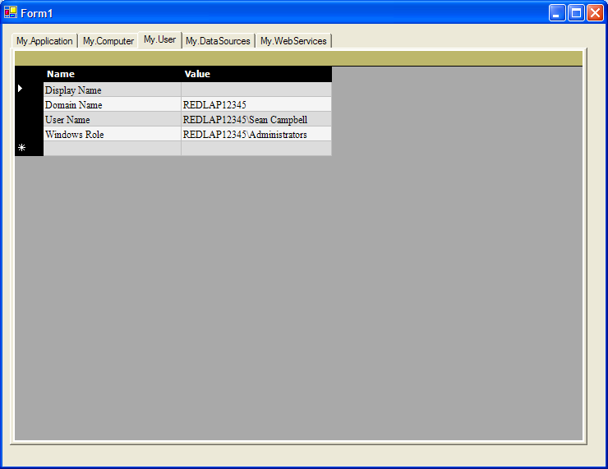
Figure 3
My.User tab
The code that populates this grid with data is as follows.
myAppDS.MyUser.AddMyUserRow("Display Name", _
My.User.DisplayName)
myAppDS.MyUser.AddMyUserRow("Domain Name", _
My.User.DomainName)
myAppDS.MyUser.AddMyUserRow("User Name", _
My.User.UserName)
myAppDS.MyUser.AddMyUserRow("Windows Role", _
My.User.WindowsRoles(0).ToString())
The code used to access current user information is quite simple. All you do is access the appropriate property off of the User object. The user object is composed of the following properties or methods.
My.User
Property/Method Description
DisplayName | Gives you access to the currently logged on users display name.
DomainName | Gives you access to the currently logged on users domain name if they are part of a domain.
IsInRole | Allows you to query whether the user is a member of a specific role.
UserName | Gives you access to the username for the currently logged on user.
WindowsRole | WindowsRole is a collection that contains all of the roles/groups that the logged on user account belongs to.

Scenarios for using My.User when developing applications
My.User gives you a good deal of information about the currently logged on user. In many ways My.User is an excellent example of the speed dial that My provides for the developer learning or using the .NET Framework.
In previous releases of the .NET Framework if you wanted to get access to information similar to that provided by the My namespace, you had to write code similar to the following.
Imports System.Security.Principal
Imports System.Threading.Thread
…
Dim winPrin as WindowsPrincipal = Thread.CurrentPrincipal
MessageBox.Show(winPrin.Identity.Name)
You also had the option of writing
MessageBox.Show(System.Threading.Thread.CurrentPrincipal.Identity.Name)
But with My you get the much more intuitive.
My.User.UserName
This is a classic example of how the My performs the function of a speed dial for the .NET Framework. Most developers when first exposed to the Framework would not natively assume that in order to get access to the currently logged on user account name they would have to either access Principal objects or access the current processes identity off of the executing thread for the application. Many developers would expect this information to be exposed at a higher level of abstraction. With My this type of information is easily and quickly accessible.

My.WebServices and My.Forms
As you’ll learn in later chapters there are three other significant areas of functionality that make up the My namespace. These are My.WebServices and My.Forms. Before concluding this section of the chapter however each one will receive a brief overview.
My.WebServices gives you the same easy access to web services that are referenced in your project that you have when accessing data sources.
dgOrders.DataSource = _
My.WebServices.Northwind.GetOrders().Tables("Orders")
In the code above you can see that you do not have to create an instance of the proxy class for the web service as you would have with the .NET Framework 1.0/1.1. In this way My.WebServices provides an easy speed dial to all of the Web References that are part of your project.
Last but definitely not least My.Forms brings back a significant programming enhancement for Visual Basic desktop application development that was lost temporarily with the advent of .NET. If you programmed previously in VB6 you know that the following code could be used to show one of the forms in your project.
Form2.Show
With the advent of the .NET Frameworks 1.0/1.1 you were unable to do this as easily. The following code is what was required when you attempted to show a form in the .NET Framework 1.0/1.1.
Dim frm1 as new Form1()
frm1.Show()
With My.Forms all of the forms in your project are easily accessible as part of this collection. In addition you also have an access to a default instance for all of the forms in your project without even using My.Forms. Therefore the following lines of code are equivalent.
My.Forms.Form2.Show()
Form2.Show()
You’ll see many more uses of this method of displaying forms throughout the book.
If you want to see an example of My.WebServices and My.Forms in action you can take a look at the appropriate tab in the sample application associated with this section of the chapter. Each of these however are covered in more detail later in the book.

Conclusion
The My namespace has four main uses to you as a developer. First it contains additional functionality that was previously not available to you in previous releases of the .NET Framework. Second it provides a valuable speed-dial in order to allow you to more quickly find and utilize .NET Framework Base Class Library functionality in your applications. Third, it fills in some gaps, and lets you think of things like the Computer as logical entities. Fourth, it brings back some things familiar coding syntax, such as Form1.Show.

