

Educator Tutorial Series
Analyzing Data Using Access
What you will do:
- Use Web Templates
- Import data from text files
- Ask questions of your data using queries
- Understand cross-tab queries
- Create a report
- Use Web forms
Databases are collections of data organized into forms and tables for easy access, management, and querying. Educators use databases every day to check accounting records, post student grades, access security systems, and register for seminars. Even your list of personal contacts and your computer financial program use databases.
Microsoft® Access® allows you to harness the power of a database to enable more effective use of data. Whether you are recording grades for your students, tracking attendance, doing research, or evaluating survey data, you can make more sense of the information by analyzing it within a database application.
In this hands-on session, you will learn to create simple databases and Web interfaces to view the contents of a database. You will also learn to import data from a variety of sources, such as text files from Web-based surveys, and then analyze it. This session will prepare you to work with data you collect from quizzes, tests, and surveys that you can create in Microsoft® FrontPage®.
Before You Begin
Access is a relational database management program. It allows users to create storage structures for data, to manipulate and analyze that data, and to format the data for output in printed reports or on the Web. It also integrates nicely with FrontPage 2000 to provide the data collection mechanism for data enabled Web pages.

Touring Access
Words to know:
Table—A storage structure for data that is composed of like columns of information (fields) and repeated in rows (records). Similar to a single worksheet in Excel.
Query— A question asked of the data contained in tables or other queries , for example,, “Which students passed the final?”
Form—A screen used to format the output of a query or table for display or to allow for data entry.
Report—Formatted output of data for printing; receives data from tables and queries.
Field—A column of data in a table (e.g. Last Name in a table of names and addresses).
Primary Key—The field on which a table can be related to another table to join the two together (e.g. your account number at your bank ties you to a table of transactions, loans, and personal data).
Cross-tab Report—Rotation of data to allow a more organized view of the information. Creates a spreadsheet like view of data.
Microsoft® Access 2000—The latest version of Microsoft’s desktop relational database management application. Allows simple database manipulation as well as full turnkey application creation. Seamless integration with the Microsoft Office family of applications.
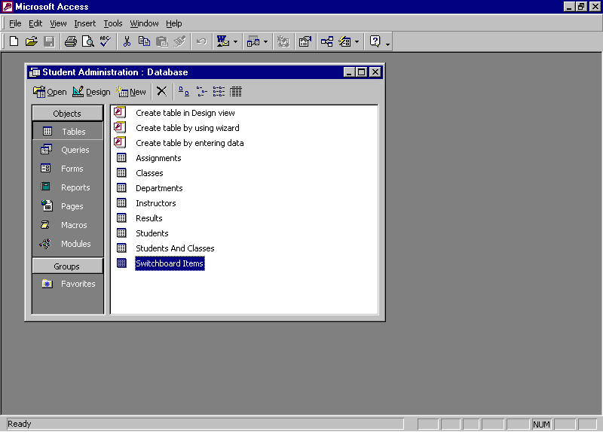
Before you start working with collected data, become familiar with the features of Access. The following illustration shows the Database Container:
Object Types
Existing Objects
Create New Object shortcuts
Status Bar
Database Container
Menu Bar
Toolbars
Window Sizing Buttons

Using Databases
You have collected data in your Access database from a Web-based survey and now you want to tabulate the results. You have also given a quiz and you want to summarize the grades which are contained in a text file and then enter them into your grade book. You will need to create a database that will import the students’ answers so that you can manipulate the data and create the reports.
To effectively use Access, it is important to understand the role of a database. A database is a collection of tables, queries, forms, reports, and program codes that make it easy to organize the interrelations of these objects. Tables are the containers for data that is arranged into rows (records) and columns (fields). Queries are questions that are asked of your data (for example, how many students failed the quiz). Forms are screens that are used to present or collect data in an organized manner (for example, the data entry screen that the registrars office completes for a new student). Reports format the output for printing (for example, a class schedule posted on a bulletin board). Macros and Modules are user programs that are written to automate functions or to create a complete database application. Access databases are relational databases, which means that they contain several tables that are linked together by special matching fields called primary keys. Complex data structures can be stored and accessed in the most efficient way possible. The term relational is derived from the fact that the tables are related to each other. If you want to examine Access databases further than this workshop permits, Microsoft has a series of step-by-step books and other reference material available. Just point your browser to http://mspress.microsoft.com and search for Access to find relevant titles and a brief synopsis of each.
Creating a Database
This section describes how to quickly create a database to store and analyze data. Databases can be very simple (like the one you will create) to very complex (like the one the IRS uses to keep track of tax records). Whole courses of study can be derived from the design and implementation of data stores. The files you will create are a foundation for your use of data and are meant to be a useful tool in your work. You will not be a database guru nor have a full-featured database when you complete this workshop, but you will have a good understanding of how to create a simple database and the extensibility of these tools.
The following illustration shows the dialog box that is presented to create a new database file:
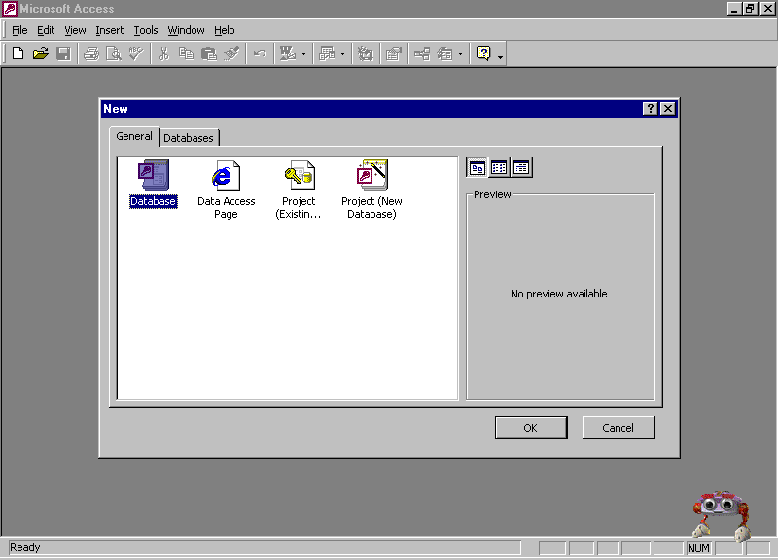

The sample files that come with Access are an excellent reference tool for developing more complex databases. Not only do you see the functionality that can be built into a database, but also you are given the features behind that functionality.

To create a new database
- Start Access. On the File menu, click New.
- Select Database from the General tab and then click OK.
- Choose a filename and location and then click Create. Your new database will be opened in the Database Container.
Importing Data
Data can exist in many different formats and repositories. Incorporating external data into a database is an essential time saving task. There is no need to rekey existing electronically stored data, you can just import it. Of course, Access can’t possibly read all of the different types of data formats that exist, but you can save data as a delimited text file in most applications. Delimited indicates that each section of data is separated or defined by some sort of special character. For example, the comma, the quote, and the space are very common delimiters. The data can then be interpreted from this file and imported into Access. This same method can be used to extract data from Access and into other database systems. You are going to import the results of a Web-based survey and then analyze the data to summarize the results.
Some file formats can be linked into Access, which leaves the data in its native format. Dbase and Excel data can be accessed in this way.

To import a delimited text file
- Click Get External Data from the File menu and then click Import.
- Select Text Files in the Files of type drop down list and navigate to the file you want to import (results.txt for the lab).
- Double-click the file.
-or-
Click once on the file and then click Import.
- The Import Text Wizard opens. Click Next to accept a delimited text file.
- Select the First Row Contains Field Names and then click Next. The data will be shown in the window.
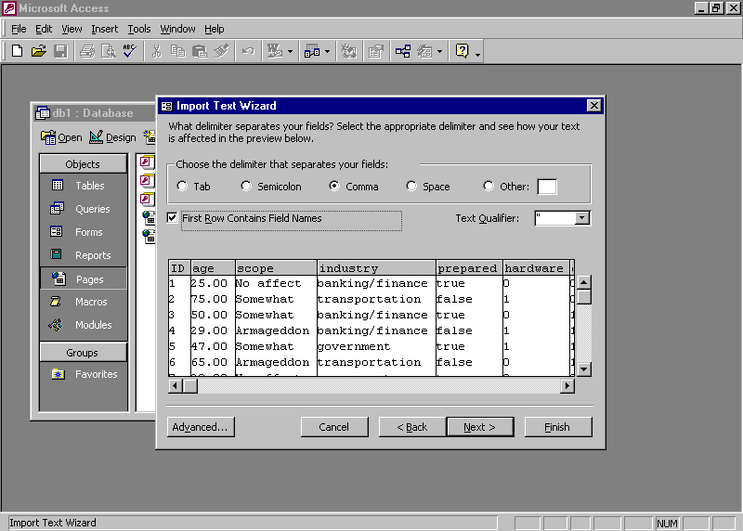
- Click Next, indicating that you want to store your data in a new table.
- Click Next to accept the field settings.
- Select No primary key and then click Next.
- Change the name of the table if you want and then click Finish. (Results will be fine for the lab.)
- Respond OK to the information box that notifies you that the import completed successfully.
You now have a new table listed in the Database Container that is named by your selection in step 9. (Any additional imports will be similar to this one.)
Using Queries
Queries allow you to ask questions of your data. The answer is called a dynaset. Dynaset is a term that describes the set of records that the query returns in response to the question asked of the data. The questions allow the distillation of a large quantity of data into easy to understand statements. A query of student test scores can show the students who correctly answered questions 2 and 10, or the number of students with perfect attendance.

To create a simple query
- Select Queries from the Objects list and then click New on the Database Container toolbar.
- Click Simple Query Wizard and then click OK.
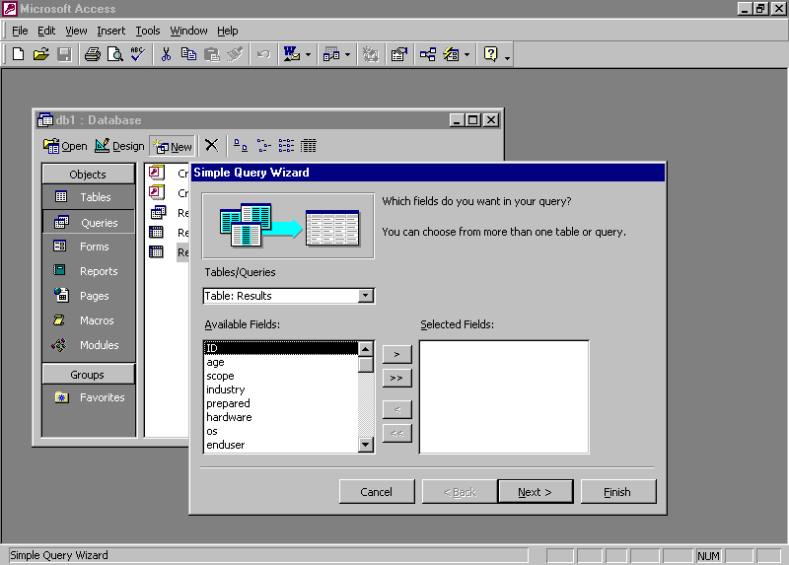
- Select the fields you want to be included in the query and click the > button.
- Click Next to move to the next screen, and then click Next a second time to produce a detail query.
- Click Finish to display the completed query.

To get specific with criteria
- After creating the query above, change to Design view by clicking Design View from the View menu.
-or-
Click Design View on the toolbar.
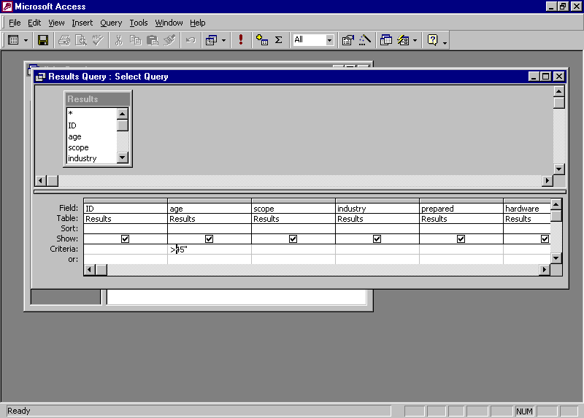
- Click the criteria line in the age column and type >45.
- Change to Datasheet view by clicking Datasheet View from the View menu.
-or-
Click Datasheet View on the toolbar.
- You will see the results of your query. Notice that all the ages of the survey respondents are greater than 45.
- Change back to Design view to revise your query.
- Save your query by clicking Save As from the File menu and then type a name in the space provided.
You can change the criteria in any of the columns of data by using the same steps. Think of the criteria as a statement that says “Where age (column) is equal to (operator) 50 (value).” In Structured Query Language (SQL) this is called the WHERE clause. Each criteria box you fill-in narrows down the list of records that will be returned by the query. Valid operators are In, Between, =, >, < or combinations of these commands.

To create a crosstab query
- Select Queries from the Objects list and then click New on the Database Container toolbar.
- Click Crosstab Query Wizard and then click OK.
- Click Next, indicating that you want to base your query on the results table.
- Double-click scope to select its contents as the row headings and then click Next.
- Double-click industry to select its contents as the column headings.
- Click Next to accept ID as the values for your cross-tab and to have a totals column.
- Select Modify the design and then click Finish to accept the default name Results_Crosstab.
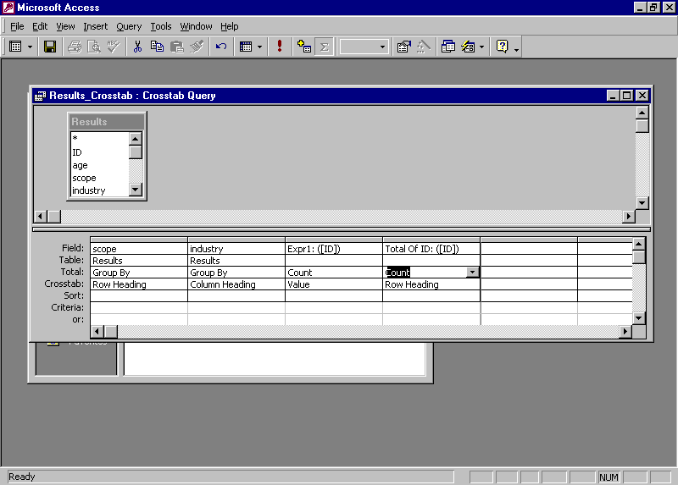
- Change the Total row under the last two columns from Expression to Count. This action makes the query fill the area of the spreadsheet with the numbers of occurrences at each location in the value section rather than try to evaluate an invalid expression. The most commonly used Total row selections are count and sum.
- Change to Datasheet view by clicking Datasheet View from the View menu.
-or-
Click Datasheet View on the toolbar.
- Save your query by selecting Save from the File menu.
-or-
Click Save on the toolbar.
When you view the output of a cross-tab query you can see that it creates a spreadsheet that contains the data you requested. Each unique item in the field chosen for row heading appears as a row heading and each unique item chosen for column heading appears as a column heading. The field chosen for the value is manipulated based on the total row setting and the values are displayed at each row/column intersection. This type of analysis is very useful for finding distributions. For example, if you have a table of student grades, a cross-tab query of the data will show the grade distribution and the average for each student and each graded item.
Using Reports
Now that you have tables and queries, you can format them for output to a printer. Reports allow you to customize the look of the data contained in a table or query. The data can be grouped, sorted, and manipulated to present the data in the most useful way for those who will be reviewing it.

To create a report
- Select Reports from the Objects list and then click New on the Database Container toolbar.
Use wizards to create the basic queries, forms, and reports. Examine these to develop your knowledge of these objects as they are a great stepping stone to a full understanding of these major Access components.
- Select Report Wizard and then, in the box at the bottom of the dialog box, select the table or query that will be providing the data. (Select Results for the lab.)
- Click OK to start the wizard.
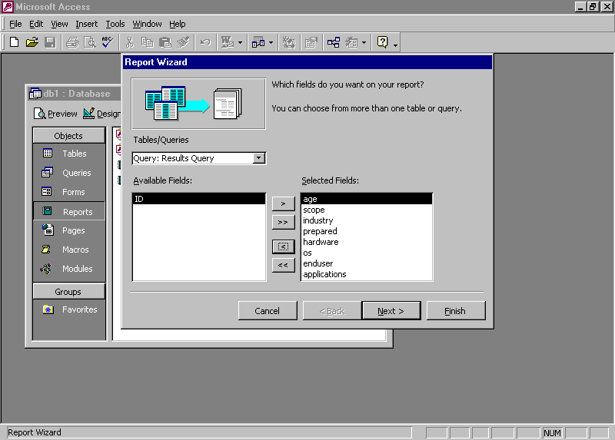
- Select age, scope, industry, prepared, hardware, os, enduser, and applications, and then click Next.
- Double-click age and then click Grouping Options.
- Under Grouping Options select 10s and then click OK.
- Click Next and select a field to sort by. (Select scope for the lab.)
- Click Next and choose the Layout and Orientation. (You can preview the affect of each by looking in the Preview window on the left.)
- Click Next and select a Style for your report. Click Next.
- Type a title and then click Finish. Your report will open in Print Preview, which will allow you to examine the proposed output before it is printed.
- Save your report by clicking Save As from the File menu. Type the name you want, and then click OK.
You can create a report from any query or table. To create a cross-tab report, select the appropriate cross-tab query in step 2.
Using Web Pages
In addition to making your data available to others by printing out reports, you can also create Web pages that display the contents of queries and reports. This will allow anyone with a browser to view your data in an organized manner.

To create data access pages
- Select Pages from the Objects list and then click New on the Database Container toolbar.
- Select Page Wizard and then click OK.
- Select the appropriate table or query. (Select Results_Crosstab for the lab.)
- Click the double greater than symbol to select all fields and then click Next.
- Click Next to continue past the screen that allows the grouping of records.
- Click Next to continue past the sorting selection.
- Enter an appropriate name for your page and then click Finish.
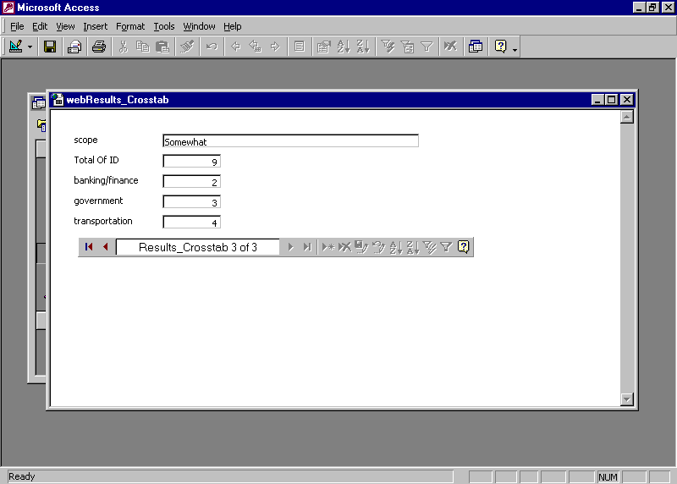
- Click Page View from the View menu to see the page as it will look in a browser.
Notice the navigation bar at the bottom of the data. It allows you to move quickly and easily through the records that are being displayed. You can also construct your own page from scratch but that will require knowledge of controls. Controls are the items that can be placed on a form to display contents of queries and tables, display graphics and text, and interact with the user. This is a more advanced topic outside the scope of this workshop, but there are plenty of reference materials on the subject.
Getting Help
You can get help from the Office Assistant or the online Help at any time while you are using Access. To open the Office Assistant, click Access Help on the Standard toolbar. To open the online Help, on the Help menu click Microsoft Access Help. If you have an Internet connection, you can also point to Office on the Web on the Help menu and choose from several resources that may be of interest to you such as Product News, Frequently Asked Questions, and Online Support. You can also go to www.microsoft.com/access for all of the latest information.

Information in this document, including URL and other Internet Web site references, is subject to change without notice. Companies, names and data used in examples herein are fictitious unless otherwise noted.
© 1999 Microsoft Corporation. All rights reserved.
Microsoft Corporation retains sole ownership of all published In and Out of the Classroom materials. Microsoft grants permission for educational institutions and Microsoft OEMS and Solution Partners to reproduce these materials for staff development purposes (only). Altering materials or reselling materials is strictly prohibited.
Microsoft, BackOffice, FrontPage, Microsoft Internet Explorer, and the Microsoft Internet Explorer logo, the Microsoft Office logo, NetMeeting, Outlook, PowerPoint, Where do you want to go today?, Windows NT, Windows, the Windows logo, and the Windows Start logo are either registered trademarks or trademarks of Microsoft Corporation in the United States and/or other countries.
Other product and company names mentioned herein may be the trademarks of their respective owners.

Acknowledgments
This workshop was created in partnership with Scott Sample and S&T Consulting, an information design and development firm: www.sakson.com
S&T Consulting project team: Sara Bosarge, Blake W. Bratt, Beth Harmon, Carolyn Emory, Amy Krzysiek, and Tonya Stumphauzer.

