Windows Azure
Customer Solution Case Study
 |  |  |   Software Startup Triples Productivity, Saves $500,000 with Cloud Computing Solution

Overview  Country or Region: United Kingdom  Industry: Manufacturing—High tech and electronics manufacturing  Customer Profile  Based in Guildford, England, sharpcloud provides a software-as-a-service solution that enables executives to plan strategy road maps with the ease and interactivity of social-networking sites.  Business Situation  For its service to be successful, sharpcloud needed to offer scalability to support major corporate users anywhere in the world—requiring a network of data centers far beyond its means.  Solution  sharpcloud developed and hosts its service on the Windows Azure platform, which helps manage the worldwide infrastructure so that sharpcloud can focus exclusively on enhancing its application service.  Benefits  - Boosts productivity 300 percent, saves U.S.$500,000  - Scales to support millions of users  - Reduces time-to-market, cost of development  - Enhances credibility with major corporations |  |  | “We wouldn’t exist if we had to build out this level of server capability ourselves. Windows Azure makes it possible for us to scale the service as needed, using—and paying—only for what we need.”  Sarim Khan, Chief Executive Officer and Co-Founder, sharpcloud
 |  |  | sharpcloud was founded on a revolutionary idea: to enhance strategy development efforts by using the interactive and collaborative tools familiar to people who use social networking sites. But turning that idea into a real service for corporate users required a global series of data centers—far beyond sharpcloud’s reach. By taking advantage of Microsoft partner programs and familiar Microsoft technology, sharpcloud developed and now hosts its solution on the Windows Azure platform. The company estimates that it is 200 to 300 percent more productive than it would have been on a competitive platform, saving up to U.S.$500,000 annually. Running on Windows Azure, sharpcloud has gained the confidence of major corporations such as Fujitsu, which finds that the sharpcloud service reduces its strategy planning time by 75 percent.
 |  |  | 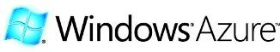

Situation
A major upside to the Internet is that it brings a global market of potential customers within the reach of every startup company, regardless of its location. However, having access to this global market also forces startups to compete against more established, better financed companies throughout the world. How are startups to meet this challenge?
“When you talk to the business community about the road maps that impact business strategy, you find that people have a very difficult time communicating their strategic plans.”
Sarim Khan, Chief Executive Officer and Co-Founder, sharpcloud

A British company formed in 2009, sharpcloud was founded on a seemingly simple but revolutionary idea: to apply highly visual and commonly used social-networking tools to the crucial corporate project of developing long-term road maps and strategy. To simplify deployment and speed adoption, sharpcloud would offer its solution as a service delivered to its customers over the Internet where and when needed through cloud computing.

“When you talk to the business community about the road maps that impact business strategy, you find that people have a very difficult time communicating their strategic plans,” says Sarim Khan, Chief Executive Officer and Co-Founder of sharpcloud. “They’re using presentations or spreadsheets that are static documents, that don’t let people collaborate. Yet people communicate and collaborate constantly in their personal lives, using dynamic social-networking tools, such as Facebook.”

Khan and his colleagues knew that the integration of social networking tools and corporate road-map development had to be not just highly visual, but also simple to deploy and use. Those requirements suggested a Web-based application using the Microsoft .NET Framework 3.5 and the Microsoft Silverlight 3 cross-platform browser plug-in, which could deliver streaming video and animation, plus other visual features, without requiring software other than a Web browser on an executive’s PC.

To support the global companies that sharpcloud envisioned as prime customers for its visual road-mapping tool, the company’s service would also have to be highly scalable, capable of supporting large numbers of users who could be dispersed anywhere around the world. But without a revenue stream, the company’s finances were too tight to build this level of scalability. It needed to devote all the financial resources it could to developing the most compelling service; buying and managing a server farm or, worse yet, data centers around the globe, was not an option.

sharpcloud found its solution in cloud computing, the same technology it was planning to provide to its customers. Initially, sharpcloud executives chose the Amazon Web Services platform because it seemed large, reliable, and capable of supporting the development and hosting of the sharpcloud solution.

Yet, as development continued, concerns emerged. sharpcloud was charged for developing its solution using live resources in the cloud; the alternative—developing the solution on local resources and then moving it to the cloud—was also problematic because the local and cloud tools and environments were not consistent. Code could look and function one way on the developer’s workstation but behave somewhat differently in the cloud environment. Also, sharpcloud spent time and money updating and maintaining the cloud-based Amazon servers, time and money that could have been focused on solution development.

Lastly was the question of security. As sharpcloud spoke with potential customers, the question kept emerging: how safe is my data? Amazon promised security but had no track record in this area. Potential customers had their doubts, and so did sharpcloud.
“The key for us has been the software and support available without licensing cost.”
Sarim Khan, Chief Executive Officer and Co-Founder, sharpcloud

Solution
In mid-2009, the sharpcloud solution was well under development. But the concerns over the Amazon Web Services platform led the company to reconsider its choice, so did the availability of an option that had not existed when sharpcloud selected Amazon. Since then, a beta version of the Windows Azure platform had become available. The Windows Azure platform is an Internet-scale cloud services platform that is hosted in Microsoft data centers. It includes an operating system and a set of developer services that can be used separately or together in a pay-as-you-go model. In Windows Azure, sharpcloud executives saw an answer to the growing concerns it had about Amazon, so the company switched its development and hosting solution to Windows Azure.

“Because we were already creating an application based on the .NET Framework and Silverlight, moving from Amazon to Microsoft was relatively straightforward,” says Andrew Britcliffe, Chief Software Architect and Co-Founder of sharpcloud. sharpcloud only had to rewrite a modest amount of code to ensure that its service and storage mechanism would communicate properly with the Windows Azure application programming interfaces.

sharpcloud continued developing the solution locally rather than in the cloud, using a local version of Windows Azure fabric, provided in the Windows Azure software development kit, as the design environment. Developers used the Microsoft tools—including the Microsoft Visual Studio Team System 2008 Team Suite development system and Microsoft Expression Blend design software—with which they were already familiar.

Joining Partner Programs
In addition to using Microsoft technologies, sharpcloud took advantage of Microsoft partner programs. For example, sharpcloud joined the Front Runner for Windows Azure Platform. Front Runner is an early adopter program for Microsoft solution partners. It provides technical resources, such as application support for Windows Azure from Microsoft development experts by phone and e-mail, as well as access to Windows Azure technical resources in one, central place. Once an application is certified as compatible with Windows Azure, the program provides additional marketing benefits. These benefits include a promotional toolkit, including a stamp and news release to use on marketing materials, a discount on Ready-to-Go campaign costs, and visibility on a Windows Azure Web site.

sharpcloud also joined the Microsoft BizSpark program for software startup companies. BizSpark unites startups with the resources—including software, support, and visibility—that they need to succeed. The program includes access to Microsoft development tools, platform technologies, and production and hosting licenses. Participants not only gain support from Microsoft professionals, but also from third-party network partners, such as incubators, advisors, and government agencies. The program also gives startup companies visibility into a global audience of potential investors, clients, and partners.

“The key for us has been the software and support available without licensing cost,” says Khan. “As a small startup, we have to maximize our investment, and these programs have certainly made our development budget go much further than it would have gone otherwise. We’ve also had good support from Microsoft with technologies including Windows 7 and Windows Server 2008 R2. And it’s stimulating to get a window into what other startups are doing with these technologies.”

Using sharpcloud
To use the sharpcloud service, executives and other users working within a Web browser, create a framework for their road map with a single click on the sharpcloud interface. They then define the various attributes and properties they want to track, such as benefit, cost, and risk. The next step is to add what sharpcloud calls “events” to the road map—technologies, trends, and anything else relevant to those who will explore or collaborate on the road map. These events can be assigned to categories for subsequent searching and can be defined by when they occur and for how long.
Figure 1. The sharpcloud application makes it possible for a team to view events and the relationships among them in a three-dimensional road map and to post comments for other team members to review.

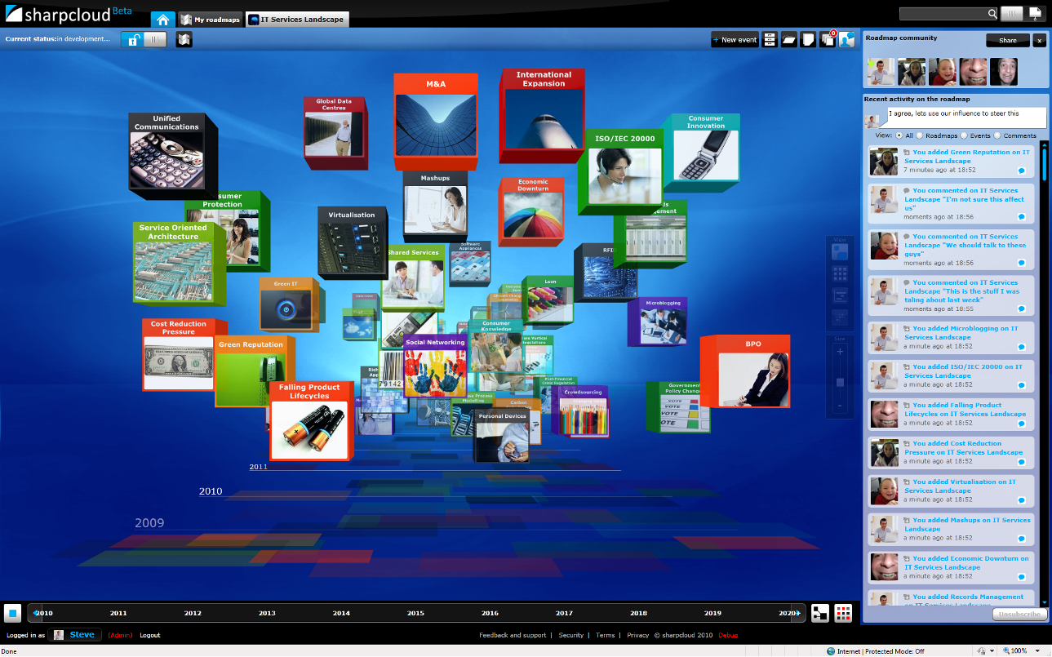

Once the road map is fully populated with events, executives can explore it by moving through a three-dimensional view that highlights the various categories of events and their attributes (Figure 1). At any point, executives can explore the details of an event and add information and media, such as streaming video. They can highlight and explore the relationships among events, such as dependencies and effects.

Social networking is a central aspect of sharpcloud. Users can publish road maps to a specified team with members located anywhere in the world, or publicly to everyone in an organization. People who use these road maps can change or add comments to any event. The application keeps a log of these changes and comments so that the creator can review the revisions.

Collaborating with Fujitsu
In addition to offering the sharpcloud service under its own name, the company has established a relationship with Fujitsu that is bringing the service to customers of that global technology provider. Fujitsu has taken the sharpcloud technology and made it the centerpiece of its FutureScape consultancy solution, which also includes strategy workshops and executive-level briefings. Fujitsu finds that the sharpcloud service has helped reduce the planning phase of major projects for its customers by 75 percent—from six months down to six weeks—and accelerated the overall rate of project development by about 30 percent.
“Partnering with sharpcloud was a bit of a departure for us, but with Windows Azure, we know they have the resources to deliver on their promises.”
Marc Silvester, Global Chief Technology Officer, Fujitsu

“We are a pretty big organization, and we’re used to partnering with other big organizations,” says Marc Silvester, Global Chief Technology Officer for Fujitsu. “So partnering with sharpcloud was a bit of a departure for us, but with Windows Azure, we know they have the resources to deliver on their promises. We believe that cloud computing will usher in a new era of more dynamic, instantaneous computing. We see it not just as a technology platform, but as an entrepreneurial environment that puts startup companies on a level playing field with the majors. sharpcloud is an example of that.”

Within a few months from the startup of sharpcloud, the technology is being used by government and large corporate users across the United States, Europe, and Asia.

Benefits
By making use of the Windows Azure platform, sharpcloud gained the scalability and security it needed for its service and brought that service to market quickly and cost effectively. Khan estimates that, without the burden of maintaining cloud servers, sharpcloud was 200 to 300 percent more productive than it would have been had it stayed on Amazon, saving the company U.S.$400,000 to $500,000 a year.

Scales to Support Millions
sharpcloud is a startup company that needed the technical resources and infrastructure of a vast enterprise in order to provide the global scalability that its customers would need to access the solution from anywhere in the world. Windows Azure provided this infrastructure at an affordable price.

The benefit to sharpcloud is incalculable, according to Khan. “Before Windows Azure, we could not have released our service and have it scale exponentially to a large number of potential users,” he says. “We wouldn’t exist if we had to build out this level of server capability ourselves. Windows Azure makes it possible for us to scale the service as needed, using—and paying—only for what we need.”

Reduces Time-to-Market, Cost of Development
Time-to-market was a crucial factor for sharpcloud, which intended to establish its reputation in part by being first to offer a social-networking development tool for road maps. Windows Azure provided advantages of agility and speed not only over traditional development methods, but also over the Amazon Web Services environment in which the company began to develop its service.

“The ability to expedite development on Windows Azure was a key difference from our experience with Amazon,” says Britcliffe. “Windows Azure just works, and you don’t have to worry or even think about it. Amazon requires a much higher degree of maintenance from its customers—we had to update servers and maintain the environment, and any time we spent doing that was time we weren’t spending on the development of our service.”
“If you’re using Microsoft tools to create a Microsoft-based service, it just makes sense to do so in a Microsoft-based cloud environment.”
Andrew Britcliffe, Chief Software Architect and Co-Founder, sharpcloud

Britcliffe also found that the Microsoft tools he used, most notably the Visual Studio 2008 development system, interoperated better with Windows Azure than it did with Amazon, leading to faster, smoother development. “If you’re using Microsoft tools to create a Microsoft-based service, it just makes sense to do so in a Microsoft-based cloud environment.”

sharpcloud used Windows Azure to expedite development in other ways, as well. For example, Britcliffe notes that Windows Azure supported the Agile development method that sharpcloud used to bring its service to market. “With Windows Azure, we could quickly deploy working instances of the service, get feedback from users, and create new iterations, without having to set up test and development servers.”

The ability to develop code locally, using Windows Azure development fabric, saved sharpcloud time and money. “Any time you’re using the cloud for development, you’re being charged for that time,” says Britcliffe. “With Windows Azure, we did our development work locally and only went to the cloud when we were running test versions of the application. It saved us a significant amount of money—very significant for a startup company.”

And because the fabric provided a consistent model of the cloud environment, Britcliffe could be confident that what he developed locally would look and run as expected when transferred to the cloud.

Enhances Credibility with Major Corporations
By using the Windows Azure platform, sharpcloud gained credibility with major corporations—its potential customers—that it would not have had otherwise. The relationship with Fujitsu is just one example of what Khan says is a broader response from the business community.

“With cloud computing, there’s almost always a concern about the security of the customer’s data,” says Khan. “Certainly, we were somewhat concerned about how our customers perceived their data security on Amazon. But with Microsoft, we’re not worried. And our potential customers aren’t worried. There’s a high degree of comfort with Microsoft in the corporate environment, and that comfort extends even to startups, like sharpcloud, that rely on Microsoft for cloud computing.”

For additional resources, please see: Windows Azure Learning Center
Windows Azure Platform
For More Information
For more information about Microsoft products and services, call the Microsoft Sales Information Center at (800) 426-9400. In Canada, call the Microsoft Canada Information Centre at (877) 568-2495. Customers in the United States and Canada who are deaf or hard-of-hearing can reach Microsoft text telephone (TTY/TDD) services at (800) 892-5234. Outside the 50 United States and Canada, please contact your local Microsoft subsidiary. To access information using the World Wide Web, go to:
www.microsoft.com

For more information about sharpcloud, call + 44 01483 565522, contact hello@sharpcloud.com, or visit the Web site at:
www.sharpcloud.com

This case study is for informational purposes only. MICROSOFT MAKES NO WARRANTIES, EXPRESS OR IMPLIED, IN THIS SUMMARY.

Document published March 2010

Software and Services  - Windows Azure Platform  - Windows Azure  - Microsoft Visual Studio  - Microsoft Visual Studio Team System 2008 Team Suite  - Microsoft Expression  - Microsoft Expression Blend 3 | - Services  - Microsoft Front Runner for Windows Azure Platform  - Microsoft BizSpark  - Technologies  - Microsoft .NET Framework 3.5  - Microsoft Silverlight 3

The Windows Azure platform provides an excellent foundation for expanding online product and service offerings. The main components include:
- Windows Azure. Windows Azure is the development, service hosting, and service management environment for the Windows Azure platform. Windows Azure provides developers with on-demand compute and storage to host, scale, and manage Web applications on the Internet through Microsoft data centers. In addition, Windows Azure serves developers’ connectivity needs through the following services.
- Windows Azure AppFabric. Windows Azure AppFabric enables users to build and manage applications more easily both on-premises and in the cloud.
- The AppFabric Service Bus connects services and applications across network boundaries to help developers build distributed applications.
- The AppFabric Access Control provides federated, claims-based access control for REST Web services.
- Microsoft SQL Azure. Microsoft SQL Azure offers the first cloud-based relational and self-managed database service built on Microsoft SQL Server 2008 technologies.
To learn more about the Windows Azure platform, visit:
www.windowsazure.com

