**How to create an HTML enabled version of a Microsoft FRx OLAP Pivot table/chart**

This document is intended to assist you in multi-step process of creating an HTML enabled version of an OLAP Pivot table/chart. The following steps are covered:

1 – Create a Microsoft FRx report in FRx instant!OLAP/Pivot chart format

2 – Convert the pivot table/chart into an interactive HTML file

3 – Publish the HTML file within Microsoft Office Outlook.

The HTML interactive file can be used in any HTML aware application, although our example focuses on publishing to Microsoft Outlook.

All steps below were done using the demo company, Fabrikam Works, Inc (FW), available with the Microsoft FRxinstallation. Output may vary based on the datasource/demo GL that you choose to use.

**1. Create a Microsoft FRx report in FRx instant!OLAP format (**GL IS 12month if using the VPC image)

1. Create building blocks for report Generation
   1. **Row Format**: any Income Statement (Incstmt) row format will work
   2. **Column Layout**: 12 months Actual and 12 months Budget (you may have to create this one as it is not a standard template). To create:
      1. 12 columns- Type: GL, Book Code: ACTUAL, Fiscal Year: BASE, Period Code: BASE-11, BASE-10, BASE-9, etc., Current Per/YTD: CUR
      2. 1 column – Type: DESC
      3. 12 columns – Type: GL, Book Code: Budget_Original, Fiscal Year: BASE, Period Code: BASE-11, BASE-10, BASE-9, etc., Current Per/YTD: CUR
      4. Use @Month as every month’s column header
   3. **Reporting Tree**: FbrkmWrkA or any multi-level tree not using security.
   4. **Catalog ID**: Give it ID: GL IS 12month and Description: 12monthActBud
2. Set “Detail Level” to “Financial” within the Catalog
3. On the “Output” tab choose “FRx instant!OLAP Microsoft local cube”
4. Key in a ‘12month’ in the “Cube Name” field under cube settings on the right
5. Enter a description of ‘12 months act and bud’ in “Cube Description” field
6. Under the tab “Report Option | Formatting | Rounding” choose Whole Dollars
7. Under Report Date, select Base Period 12, Base Year 2005
8. Save Catalog ID and Click “Generate:1

1 If you receive an error generating the Pivot table, you may need to apply the Office Hot fix for OLAP cubes. Directions for doing so are located on the Microsoft FRxinstallation CD under ‘FRxReporter | MS | Office_11_OLAP_Fix.’

**2. Convert Microsoft FRxreport from FRx instant!OLAP format into an interactive html file**

1. Find the OLAP cube file you generated, ie. **12month.cub,** in **io_data** directory and ‘open with Microsoft OfficeExcel (Ex: right click the file, select Open, choose Excel)
2. Build the Pivot Table by dragging items from PivotTable Field list to PivotTable Report
   1. Drag “Organization” into topmost horizontal header “Drop Page Fields Here” spot
   2. Drag “Financial Rows” into the leftmost vertical “Drop Row Fields Here” spot
   3. Drag “Book” into middle horizontal “Drop Column Fields Here” spot and then drag “Period” into the cell to the right of Book Code.

**NOTE**: The ‘Period’ dimension should display to the left of the ‘Book Code’ dimension

* 1. Drag “Amount” into “Drop Data Items here”

1. File | Save as
2. Browse to a location to save the file (we suggest io_data subdirectory), and give it the name 12Month.xls and Click Save
3. Click on the Chart Wizard  in the Microsoft Office Excel Toolbar
4. Right mouse click on the chart
5. Choose “Chart Type” and choose “3-D Column”, click OK
6. From the toolbar within Excel choose File | Save as web page
7. Choose “entire workbook” radio button and click Publish
8. Check “add interactivity with” Chart functionality
9. Check “AutoRepublish every time this workbook is saved” box
10. Click Publish again
11. You now have an OLAP cube/pivot table in an HTML format that can be used in any html aware application! 2

2 Actual and Budget books codes do not auto display simultaneously in a freshly generated html interactive cube. You must expand the + next to the dates to explode the other book code for display.

**3. Publish html pivot table to a financial dashboard in Microsoft Outlook**

1. Open Outlook and highlight the ‘Outlook Today’ folder/level
2. From the toolbar choose File | New | Folder.
3. Name the folder “Financial Dashboard” and click OK.
4. Right mouse click on the new ‘Financial Dashboard’ folder, and select Properties.
5. Select the Homepage tab
6. Click Browse and locate the HTML file that you created above
   1. By default, Microsoft FRx generates reports to the io_data subdirectory of the Microsoft FRx installation. Unless you changed the output path, this is where you will find the HTML file.

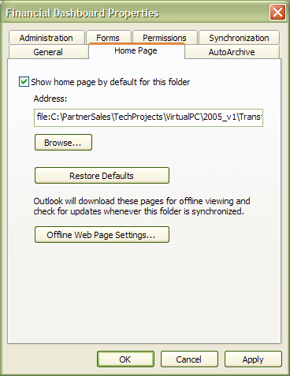

1. Click on the “Show home page by default for this folder” checkbox.
   1. If you do not you will be prompted by a warning message.
2. Click Apply and Click OK

**NOTE**: In certain cases you may receive a message with regard to offline settings.

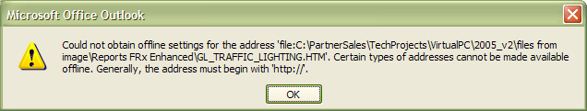

* 1. Click **OK** on this message
  2. Click **CANCEL** on the ‘Financial Dashboard Properties’ window. It will close and the ‘html’ file will still display in the right pane.
  3. The file will simply not be available to the individual when ‘offline’.

1. Select the Financial Dashboard folder in the left pane.
2. Your Microsoft FRx financial report/interactive pivot chart will display in the right window!

Congratulations! You’ve now built your first Financial Dashboard in Microsoft Outlook!

© 2007 Microsoft Corporation. All rights reserved. Microsoft, FRx, DrillDown Viewer and instant!OLAP are either registered trademarks or trademarks of Microsoft Corporation or the Microsoft group of companies. The names of actual companies and products mentioned herein may be the trademarks of their respective owners.