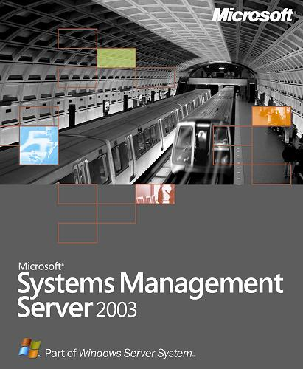

Microsoft® Systems Management Server (SMS) 2003 provides a comprehensive solution for addressing and resolving your change and configuration needs. With the addition of the Operating System Deployment Feature Pack, the Device Management Feature Pack, and the Administration Feature Pack, Systems Management Server 2003 will help you to:

- Deliver an end-to-end desktop operating system deployment and upgrade imaging solution

- Extend change and configuration management beyond the PC to Windows® CE-based and Windows Mobile™ devices

- Easily manage SMS 2003 site servers and accounts and efficiently transfer site settings in SMS 2003 environments

www.microsoft.com/smsserver
Effective and Efficient Management
Systems Management Server 2003 is Microsoft Corporation’s strategic solution for change and configuration management of Windows-based systems. As hardware and software assets constitute a large portion of the IT budget, corporations are becoming more focused on finding ways to reduce these costs while continuing to deliver valuable business capabilities. This includes deploying operating system images, managing mobile devices, and easing management tools operations. The additional functionality delivered by the Systems Management Server 2003 feature packs reduces the overall operational costs of managing and deploying software.

OS Deployment Feature Pack
Desktop administrators want to reduce the cost and effort of migrating software and operating systems (OSs) to existing or new desktops. The SMS 2003 OS Deployment Feature Pack will help desktop administrators create a Windows OS desktop image and deploy it in an automated manner, freeing up time for other pressing needs. By using the OS Deployment Feature Pack you can:
- Use the User State Migration Tool (USMT) or equivilant third-party migration tools to migrate and restore user, computer and SMS client state
- Utilize the Windows PE pre-boot environment
- Remove the need to delete the system partition by leveraging the file-based image format of Advanced Windows Imaging (WIM)
- Centralize the tracking and status reporting for OS deployment

The SMS 2003 OS Deployment Feature Pack runs on an SMS 2003 site server. Once installed, the administrator can use the SMS Administrator Console to add image packages to SMS collections for deployment to desktops. The Package Creation Wizard allows the administrator to configure the OS deployment experience by modifying settings, such as disk partitioning information, user and computer identity, and scripts. Administrators can then schedule mandatory advertisements to the targeted desktops to initiate migration and re-imaging without requiring user intervention. This capability provides a fully controllable image deployment process that minimizes the impact on the end user while helping reduce costs during deployment.

In conjunction with this, customers can also utilize the Microsoft Solution Acclerator for Business Desktop Deployment with zero touch install capabilities. This solution accelerator provides the Microsoft Solutions Framework best practices guidance and deployment considerations when using the SMS 2003 OS Deployment Feature Pack to manage the provisioning of desktop images. The guidance includes a project-based delivery solution for planning, testing, deploying, analyzing, and optimizing Windows XP desktop deployments. Deployment event and milestone logs can be monitored using Microsoft Operations Manager (MOM) 2005.

Device Management
Feature Pack
The use of personal digital assistants (PDA) and Windows-based devices continues to increase in the enterprise. The Device Management Feature Pack allows you to manage mobile devices as SMS clients just as you would manage your desktops and servers. The SMS 2003 Device Management Feature Pack lets administrators perform device discovery, collect hardware and software inventory, and distribute software to these devices. Using the Device Management Feature Pack, you can:
- Discover and collect inventory information from mobile and terminal based clients running Windows CE 4.2 or Windows Mobile™ 2003 software for Pocket PC and Pocket PC Phone Edition
- Through complementary partner offerings, discover and collect inventory from mobile and terminal clients running Windows CE 3.0, Pocket PC 2002 Software, and Windows Mobile software including Smartphones
- Distribute software updates and applications to these devices
- Support regional roaming scenarios for SMS package downloads by referring clients to local Distribution Points
- Enable password policy by enforcing secure passwords for these devices
- Deploy the SMS client software to devices with an ActiveSync® connection to a computer running the SMS Advanced Client
- Use http or secure http (https) to communicate with the SMS server infrastructure

The Device Management Feature Pack can be installed on any SMS 2003 site server and allows you to manage devices through any SMS Administrator console so that administrators can view and configure mobile devices. Businesses with Windows CE-based devices, such as terminals and PDAs, will benefit from the consistent and scalable method delivered by the Device Management Feature Pack, providing a single management infrastructure for servers, desktops, and devices.
For more information about Systems Management Server, visit http://www.microsoft.com/sms. For the latest management news and more information on Microsoft’s broad range of resources for managing your enterprise, visit http://www.microsoft.com/management.

TO ORDER:
To order Systems Management Server or other Microsoft products, or to receive a reseller referral in the United States or Canada, call (800) 621-7930, Dept. A334DS. Outside the United States and Canada, please contact your local Microsoft subsidiary. Customers who are deaf or hard-of-hearing can reach Microsoft text telephone (TTY/TDD) services by calling (800) 892-5234 in the United States or (905) 568-9641 in Canada.

© 2004 Microsoft Corporation. All rights reserved.This document is developed prior to the product's release to manufacturing, and as such, we cannot guarantee that all details included herein will be exactly as what is found in the shipping product. The information represents the product at the time this document was printed and should be used for planning purposes only. Information subject to change at any time without prior notice.This data sheet is for informational purposes only. MICROSOFT MAKES NO WARRANTIES, EXPRESS OR IMPLIED, IN THIS SUMMARY.
Microsoft, ActiveSync, Windows, the Windows logo, Windows Mobile, and Windows Server System are either registered trademarks or trademarks of Microsoft Corporation in the United States and/or other countries.
0601 Part No. 098-00000 (color)
Part No. 098-00000 (black and white)


Administration Feature Pack
Easing the administrative overhead of management tools is an important way to reduce overall operational costs in an enterprise. The Administration Feature Pack provides tools to help SMS administrators to increase the efficiency of performing distributed systems management tasks using SMS 2003. The Administration Feature Pack includes the Manage Site Accounts Tool, Transfer Site Settings Wizard, and the Elevated Rights Deployment Tool.

The Manage Site Accounts Tool is used to manage accounts and passwords used by one or more sites in a hierarchy, as well as the associated domain updates, allowing you to:
- Update those accounts and passwords for one or multiple target sites
- Replicate password changes to each target site using built-in replication in the same manner as changes would be made on a single site using the SMS Administrator console

The Transfer Site Settings Wizard is used to copy the settings from a source site to one or more target sites, including site configuration, package, and collection settings, allowing you to:
- Import and export configurations and settings from an XML file
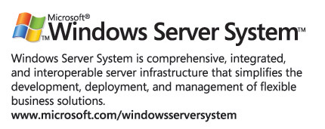
- Support offline or inactive sites automatically
- Enforce a settings policy for ongoing transfers
- Record and track the change status
The Elevated Rights Deployment Tool is used to help deploy applications that require local administrator rights after a system has been restarted. This tool allows you to:
- Run the installation program from the Elevated Rights Deployment Tool
- Create a preconfigured SMS package, program, program dependency settings, and an advertisement
- Run this tool once for each application that requires elevated rights after a system restart, such as the Microsoft Office 2003 System File Update.

Want Know More?
For information about Microsoft Systems Management Server 2003 Feature Packs, see: www.microsoft.com/smsserver

