
Microsoft Office Standard 2007
February 2006
Table of Contents

Cover is for
position only

Overview of Microsoft Office Standard 2007 1
Create High-Quality Documents 2
Work with Enhanced Security and Reliability 2
Find Menus, Commands, and Help More Easily 3
Organize Your Time and Communications 3
Create High-Quality Documents 4
New Results-Oriented Menus and Toolbars 4
Improved Advanced Formatting 5
New Charting and Graphics Tools 6
Improved Templates and New Fonts 7
Improved Office Styles 7
New Preview Galleries 9
New Custom Slide Layouts 9
Work with Enhanced Security and Reliability 11
Improved Office Outlook 2007 Junk E-Mail Filter 11
New Antiphishing Tools 12
Improved Document Recovery Tool 12
New Document Inspector 13
Find Menus, Commands, and Help More Easily 14
New Command Tabs 14
Improved Tutorials 15
Improved and Easy-to-Use Help 16
Improved ToolTips 16
Organize Your Time and Communications 17
New Ways to Easily Organize Appointments and Tasks 17
Improved Flexible Search to Help Find What You Need 19
New Inbox Autoconfiguration 20
New RSS (Really Simple Syndication) Aggregator 20
Summary 20
Resources 21
System Requirements 22

Overview of Microsoft Office Standard 2007

Welcome to Microsoft® Office Standard 2007, the exciting new suite of the familiar and widely used Microsoft Office system productivity software. Office Standard 2007 is the software suite that empowers home and small buisness users to manage e-mail and quickly and easily create great-looking documents, spreadsheets, and presentations. With improved menus and tools, enhanced graphics and formatting capabilities, new time-management tools, and more reliability and enhanced security, Office Standard 2007 makes it easier and more enjoyable for you to get things done.
Office Standard 2007—which includes Microsoft Office Word 2007, Microsoft Office Excel® 2007 spreadsheet software, the Microsoft Office Outlook® 2007 messaging and collaboration client, and the Microsoft Office PowerPoint® 2007 presentation graphics program—offers easy access to a comprehensive set of powerful tools and resources. The redesigned results-oriented menus and toolbars, one of the most significant visual makeovers in the history of the Microsoft Office system, help you access the commands you need while you work.
This guide provides an overview of new and improved features in Office Standard 2007. You will also see examples of Office Standard 2007 in action that demonstrate its powerful new capabilities.
Office Standard 2007 in Action
Francisco Chaves owns the Coho Winery in Northern California. His small sales and marketing staff has a very basic understanding of computers. He finds that the simplicity and functionality of Office Standard 2007 not only meets all of his sales and marketing needs, but improves his staff’s efficiency and productivity. Presently, they use Office PowerPoint 2007 to create sales presentations for distributors and restaurants. Office Outlook 2007 helps them store and track contacts and minimizes junk e-mail messages, so the staff can focus on important e-mail messages. Office Excel 2007 helps them track product and customer data as well as make projections for their annual output. For all correspondences and press releases, the staff relies on Office Word 2007.

Create High-Quality Documents
Office Standard 2007 simplifies the way home and small business users work with documents. The redesigned, results-oriented menus and toolbars help you to quickly and easily create high-quality documents, spreadsheets, and presentations. Enhanced graphics and formatting capabilities help make your user experience more enjoyable and productive.
- New! Results-oriented menus and toolbars make it easier to find and use the product features you use most to get the results you want.
- Improved! Formatting capabilities make it easier to consistently format documents.
- New! Text effects and diagram and graphics galleries give you the ability to preview and format items.
- Improved! Office Styles creates a consistent appearance across Office Word 2007 documents, Office Excel 2007 spreadsheets, and Office PowerPoint 2007 presentations.

Work with Enhanced Security and Reliability
Powerful new security features help home and small business networks stay operational so that users can work with confidence.
- Improved! A junk e-mail filter helps significantly reduce spam e-mail messages in Inboxes and protect against potentially harmful e-mail attachments.
- New! Antiphishing tools alert users to suspicious and potentially fraudulent e-mail messages so that they do not divulge private information unnecessarily.
- Improved! Automatic document recovery helps retrieve Microsoft Office system documents after a system crash.
- New! Document Inspector helps protect private information by automatically removing personally identifiable information, comments, and tracked changes from documents.

Find Menus, Commands, and Help More Easily
Office Standard 2007 offers improved menus and tools that significantly simplify how home and small business users access commands. Commonly used commands appear on the results-oriented menus and tools in a tabbed “ribbon” instead of in drop-down menus. In addition, with an enhanced Help system, including tutorials with step-by-step instructions, you can quickly find answers to your questions.
- New! Command tabs on the results-oriented “ribbon” display commonly used commands that previously appeared only in lengthy drop-down menus.
- Improved! Tutorials provide you with step-by-step instructions for common tasks.
- Improved! The easy-to-use Help system offers a smooth transition between the Help menu in the Microsoft Office system and Help on the Internet.
- Improved! ToolTips are context-sensitive, and they change automatically depending on the task you are trying to complete.

Organize Your Time and Communications
New features and enhancements in Office Outlook 2007 help home and small business users organize their daily schedules, tasks, and communications.
- New! Organizational tools such as the To-Do Bar bring tasks, calendar information, and flagged e-mail messages together into one location.
- Improved! A flexible search tool helps you quickly find information in any of the Office Outlook 2007 modules.
- New! Inbox autoconfiguration sets up and configures all of your e-mail accounts automatically.
- New! RSS (Really Simple Syndication) Aggregator sends headlines and Web content to you, so you won’t have to look for it.
Create High-Quality Documents
Microsoft Office Standard 2007 makes it easier than ever to format your documents, spreadsheets, and presentations. New and improved features such as enhanced graphics and advanced formatting capabilities help you deliver high-quality documents in quick time. In addition, new features in Office PowerPoint 2007 make it easier to share and reuse presentations, providing a more enjoyable experience.

New Results-Oriented Menus and Toolbars
The richer, redesigned menus and toolbars reflect an overall effort by Microsoft to deliver a more user-driven product. Rather than rethinking the product from a feature-oriented viewpoint, Microsoft focused Office Standard 2007 on the user’s results-oriented perspective. The end product delivers one of the most significant makeovers in the history of the Microsoft Office system. The new menus and toolbars are more intuitive and offer more easily accessible features. It is less about commands and more about results. At the same time, although the look is very new, its evolution from previous Microsoft Office system releases makes it extremely familiar.
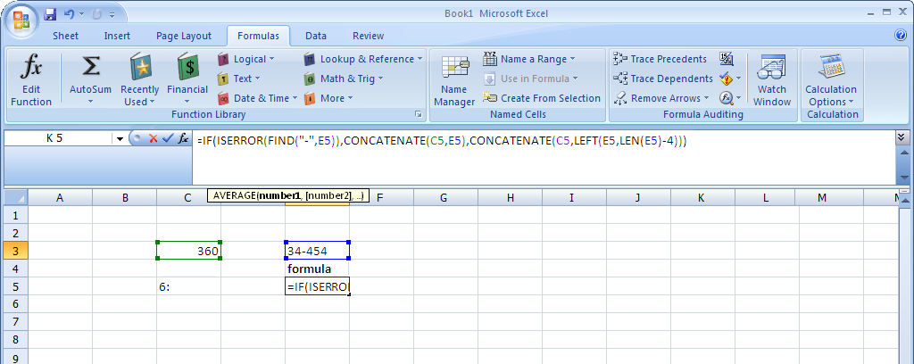
Figure 1: Office Excel 2007 task-based user interface
The new results-oriented menus and toolbars significantly simplify how you author documents by:
- Making the experience more predictable, with less complicated features and guesswork.
- Maximizing your workspace and being less intrusive by not popping up images and dialog boxes over your work.
- Putting a majority of the most commonly used commands on the first tab, so you do not have to dig for commands in lengthy drop-down menus.
Office Standard 2007 in Action
Michelle Alexander serves on the PTA board and volunteers at the zoo. She uses Office Standard 2007 to write letters to parents and design zoo flyers. Although comfortable with the menus in previous releases of the Microsoft Office system, she was frustrated with having to hunt down commands in the drop-down menus. With the redesigned results-oriented menus and toolbars in Office Standard 2007, all of the tools she needs automatically become available when and where she needs them. As a result, she can spend less time on formatting documents and more time doing what is important to her.

Improved Advanced Formatting
With the addition of more consistent numbering, bullet, and table features in Office Standard 2007, home and small business users no longer have to waste time formatting and reformatting their Office Word 2007 documents. Office Standard 2007 simplifies document formatting by:
- Creating and applying Quick Formats for text and tables with a single click.
- Quickly providing previews of your formatting changes in galleries.
- Maintaining formatting across Microsoft Office system programs when you copy text or tables from one program to another.
- Providing more consistent and stable bullet and number formatting.

New Charting and Graphics Tools
Improved graphics capabilities in Office Standard 2007 enhance home and small business users’ work by helping you to quickly produce better-looking documents, spreadsheets, and presentations. With Office Standard 2007, you can give your documents a more professional look by using rich design and typography tools, including:
- 3-D effects
- Shadows, glows, and blurs
- A gallery of many different standard chart and diagram types
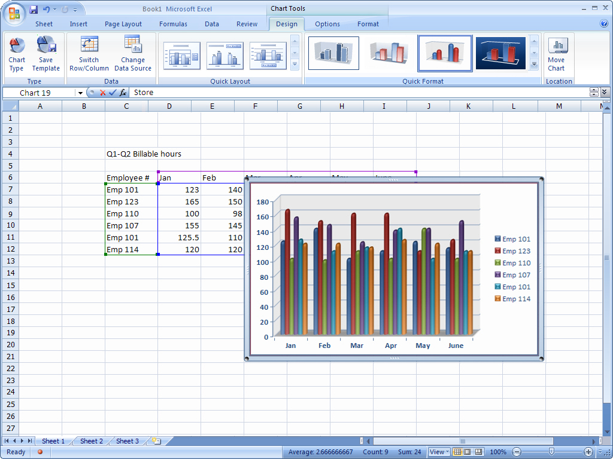
Figure 2: New charting tools in Office Excel 2007

Office Standard 2007 in Action
Jonas Hasselberg owns a small business, Trey Research, which specializes in analyzing industry trends. The company relies heavily on charts and graphs as a means of supplementing their reports. Jonas finds that Office Standard 2007 offers the most opportunities for spicing up his presentations. He uses effects such as shadows and glows for his Office PowerPoint 2007 presentations and his Office Word 2007 reports. He also takes advantage of the selection of diagram types to create variety within his presentations. He never thought designing the report would be one of the most interesting aspects of his job.

Improved Templates and New Fonts
New and improved out-of-the-box templates in Office Standard 2007 help home and small business users to create professional-looking documents more quickly and easily. You can either get started with the included templates or search the preformatted templates available at Microsoft Office Online. In addition, Office Standard 2007 includes new and improved fonts such as Cambria that make on-screen reading easier.

Improved Office Styles
Office Styles is an improvement that helps home and small business users maintain a consistent look among Office Word 2007 documents, Office Excel 2007 spreadsheets, and Office PowerPoint 2007 presentations. This predictability means that when you copy tables and objects between programs, the items maintain their appearance. As a result, working simultaneously with different programs becomes more consistent and less frustrating.
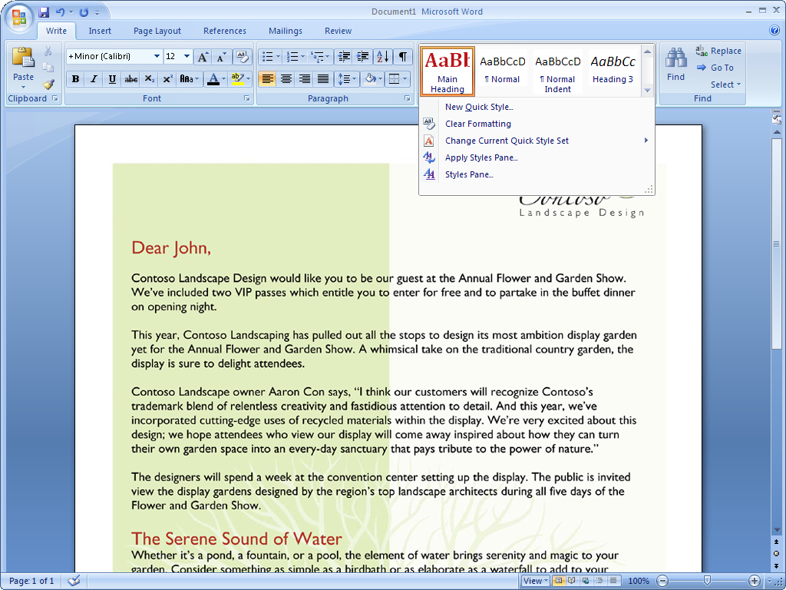
Figure 3: Quick Styles in Office Word 2007
Office Standard 2007 in Action
Joanna and Artur Rybka are considering an addition to their house. They use Office Excel 2007 to research and track the costs of such a decision. They also use Office Word 2007 documents and Office PowerPoint 2007 for design ideas and logistics. The new Office Styles in Office Standard 2007 helps ensure that all transferred information between programs maintains its appearance. As a result, Joanna and Artur can quickly shuffle information between different programs, knowing that what they see is what they will get. This helps them plan more efficiently and with greater confidence.

New Preview Galleries
We all want to create the highest quality documents possible in the shortest amount of time. Accomplishing this often requires experimenting with different styles and formats. Office Standard 2007 gives home and small business users the ability to quickly preview proposed changes to a document. You can actually view formatting choices right inside a document while you are working on it, without having to repeatedly search through drop-down menus. By test-driving proposed formatting, you can save time and experiment more easily. The end result is a quickly created document that looks the way you want it to look. These galleries can be found in Office Word 2007, Office Excel 2007, and Office PowerPoint 2007.
Office Standard 2007 in Action
Monica Brink wants to design a baby shower invitation for her sister. She knows the details of the event, but cannot decide on the design. With the formatting galleries in Office Standard 2007, she can preview different fonts simultaneously within her document before making a decision. For help with margins, she can quickly preview images of multiple options. She finds that these new preview features make her feel more comfortable experimenting with different looks.

New Custom Slide Layouts
The new Custom Slide Layouts feature in Office PowerPoint 2007 frees home and small business users from confining prepackaged layouts. Now you can quickly create and save information-rich layouts with multiple charts, tables, and text. You can then save these layouts as templates for future presentations.
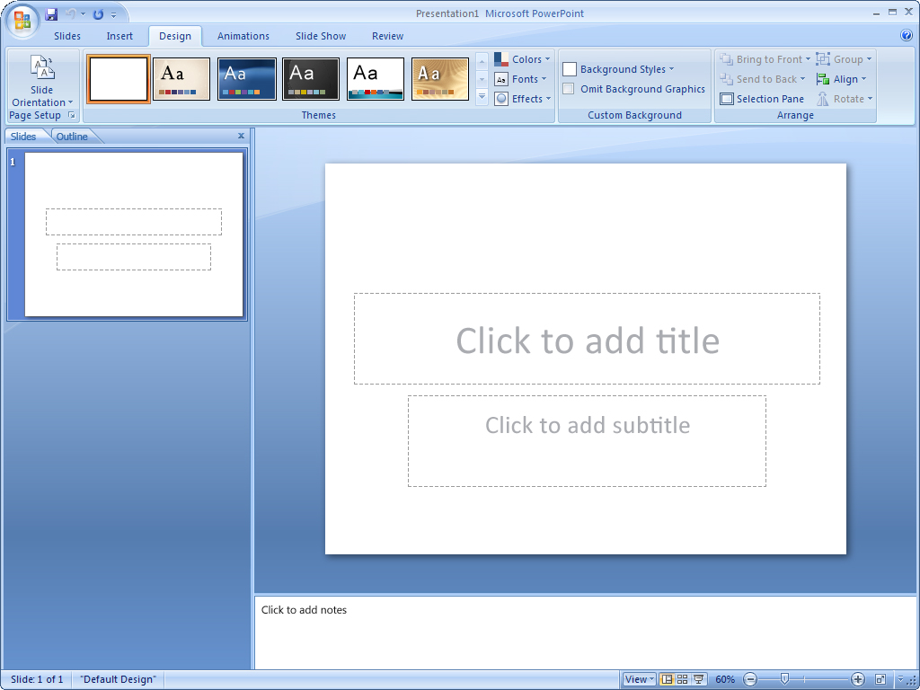
Figure 4: Custom Slide Layouts in Office PowerPoint 2007

Work with Enhanced Security and Reliability
Microsoft Office Standard 2007 offers new and improved features to home and small business users that can help increase security by reducing junk e-mail and “phishing” scams. In addition, tools such as Document Recovery and Document Inspector give you peace of mind by automatically recovering documents after a system crash and removing personally identifiable information from your documents before you share them with others.

Improved Office Outlook 2007 Junk E-Mail Filter
Junk e-mail is time-consuming, annoying, and potentially dangerous for home and small business users. To address the flood of junk e-mail, Office Outlook 2007 offers an enhanced junk e-mail filter that helps reduce the amount of spam sent to Inboxes and better protects your computer against viruses sent through e-mail. This enhanced security feature applies to both e-mail messages and their attachments.
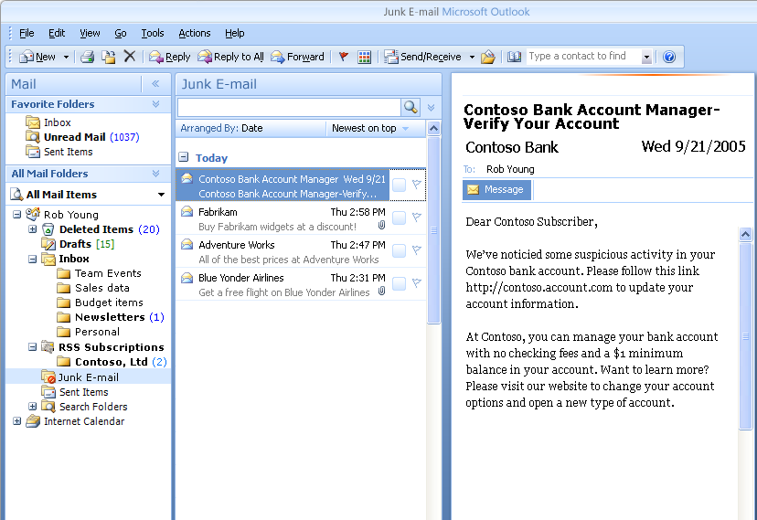
Figure 5: Junk e-mail filter in Office Outlook 2007
Office Standard 2007 in Action
David Barber used to feel like he never had enough time to sort through and separate junk e-mail messages from his important messages while checking e-mail at home. With the enhanced Office Outlook 2007 junk e-mail filter, the sorting is done for him. David also gets peace of mind knowing that when his kids are surfing the Internet, the family computer is better protected from viruses. Even with a powerful computer firewall, he knows that he can never have enough security.

New Antiphishing Tools
Office Outlook 2007 provides new enhancements that help protect personal information by alerting home and small business users to potentially fraudulent e-mail messages sent to their Inboxes. Fraudelent e-mail communications, known as “phishing,” attempt to trick you into providing bank, credit card, or other personal information. To provide more security, Office Outlook 2007 displays suspected phishing e-mail messages in plain text (no HTML or images), disables the hyperlinks, and provides a warning alert across the top of the message.

Improved Document Recovery Tool
The Document Recovery tool in Office Standard 2007 better protects home and small business user documents against sudden computer crashes. If a Microsoft Office system program encounters a problem or stops responding, you can now close the program in a controlled manner. The files you had open are analyzed for errors and, whenever possible, recovered. You can then view any repairs that were made to the files.

New Document Inspector
Office Standard 2007 Document Inspector provides an easy and efficient way for home and small business uers to help protect information. This tool automatically searches documents for comments, revisions, and tracked changes; headers and footers; and hidden text. You can delete your choice of personal information in a matter of seconds. When you distribute your documents, you can be more confident that no unwanted personally identifiable or other information is accidentally included.
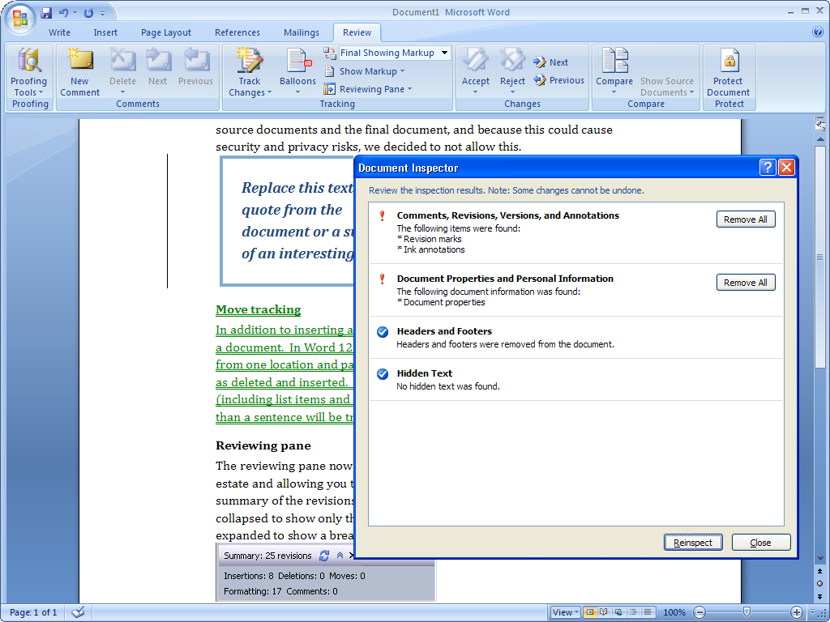
Figure 6: Document Inspector in Office Word 2007
Office Standard 2007 in Action
Martin Lotz is the Chief Financial Officer of A. Datum Corporation, a small software company situated in Boulder, Colorado. He has access to almost all personal company information. He uses the Document Inspector in Office Standard 2007 to help him search documents and automatically remove any personal information before sending them out. This helps ensure that his correspondence is free of any unwanted comments, hidden text, or personally identifiable information that he does not want to share with others.

Find Menus, Commands, and Help More Easily
Office Standard 2007 offers improved menus and tools that make document creation easier, faster, and more intuitive. The new design emphasizes user efficiency and feature discoverability, helping reduce the home and small business user’s frustration level by quickly finding relevant help for questions. Tutorials and templates help you get started and understand more about the software’s capabilities.

New Command Tabs
Most home and small business users only employ a small percentage of all of the commands available in Microsoft Office system programs. With the new results-oriented menus and toolbars in Office Standard 2007, you can learn more about the capabilities of the Microsoft Office system by using a set of command tabs that replace the previous drop-down menus. As a result, commonly used commands that were once buried are now available at your fingertips. You get access to the right tools when you need them, helping you learn more and get the results you want.
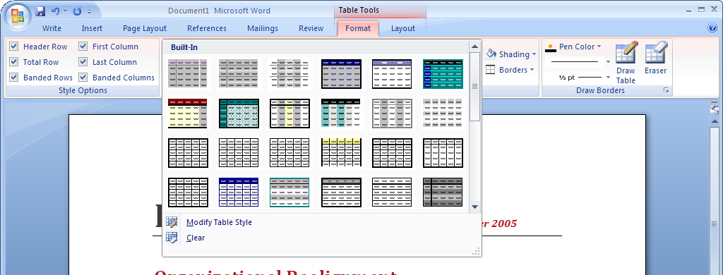
Figure 7: Formatting commands in Office Word 2007
Certain sets of commands are only relevant when objects of a particular type are being edited. These are known as contextual command tabs. The tabs automatically change depending on the task that you are trying to complete.
Office Standard 2007 in Action
Even as a multi-tasker, Naoki Sato never has enough time to finish everything she wants to on her home computer. As a result, she has never taken the time to discover all the functionality available in the Microsoft Office system. With hundreds of commands in Office Word alone, this means she has not benefited from capabilities that could simplify and improve her experience. With contextual command tabs in Office Standard 2007, she can get fast access to commands that relate to what she is doing at the moment. As a result, she can complete whatever she is working on faster than before.

Improved Tutorials
An improved Getting Started experience in Office Standard 2007 significantly reduces the learning curve for new home and small business users. Tutorials offer step-by-step instructions for using Microsoft Office system software. Getting Started brings to the surface additional Help options such as Office Online integration.

Improved and Easy-to-Use Help
Many home and small business users are tired of wasting time trying to find answers to functionality questions. Office Standard 2007 provides more direct links to Help content than ever before. Take advantage of the smooth transition between the Help menu in Office Standard 2007 and Help on the Internet (when connected).

Improved ToolTips
Office Standard 2007 offers larger, more informative ToolTips than previous Microsoft Office system suites. ToolTips provide quick access to information about a command directly from the command’s location. Popping up when you rest your mouse pointer on any menu item or command, the ToolTip often gives you enough information about a feature to help you quickly use it without further assistance. This capability gives you easy access to all of the functionality of the 2007 Microsoft Office system menus and tools. As a result, you can save time and become more productive.
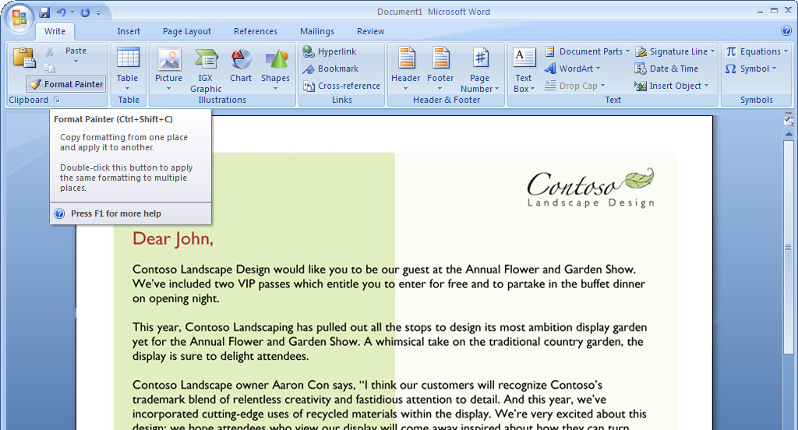
Figure 8: ToolTips in Office Standard 2007

Organize Your Time and Communications
Office Outlook 2007, included in Office Standard 2007, provides tools that help home and small business users organize their time and communications. Using flexible search capabilities and color categories, you can easily locate the information you want and need. Through new calendar viewing, publishing, and sharing capabilities, you can share calendars stored in OfficeOutlook 2007 with coworkers, friends, and family, no matter where they are located. A new To-Do Bar makes it easier for you to prioritize and control your time, so you can focus on more important matters.

New Ways to Easily Organize Appointments and Tasks
Office Outlook 2007 provides an effective and efficient way to organize information in one location. All of the tools home and small business users need to manage, prioritize, and sort tasks are integrated directly into Office Outlook 2007. Some of the new and improved organizational features include the following:
- Color categories help you quickly differentiate e-mail messages.
- New calendar views help you to compare two calendars side by side or one on top of the other.
- A new To-Do Bar brings together tasks, calendar information, and flagged e-mail messages in one place. Tasks completed on a particular day “stick” to that day and appear as part of a record of what you did on that day. Tasks not completed roll over to the next day and accumulate until you complete them.
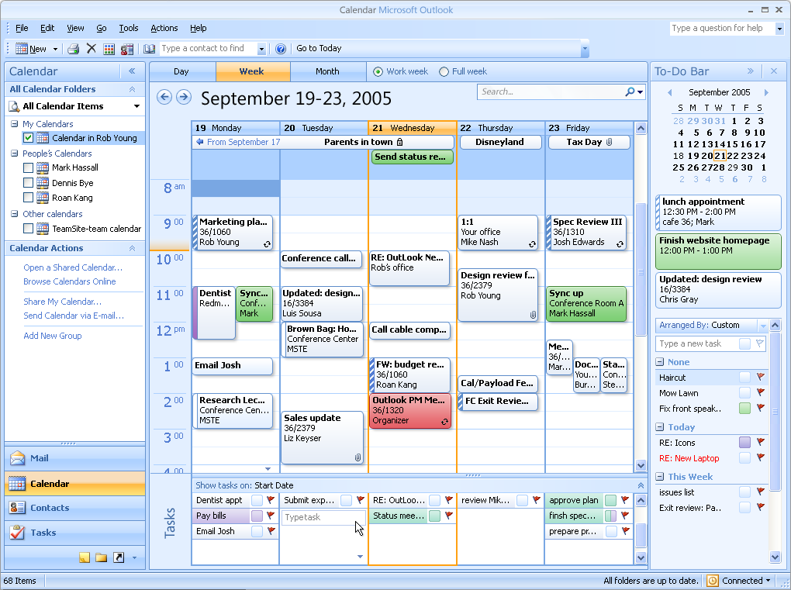
Figure 9: Calendar view in Office Outlook 2007
Office Standard 2007 in Action
Jay Jamison is the Schedule Coordinator at Adventure Works, a small outdoor tourist company. Jay relies on Office Outlook 2007 to help him manage trip dates, reservation deadlines, and meetings. He uses the Office Outlook 2007 To-Do Bar to help ensure that he never misses an appointment or deadline. He uses the new color category feature to differentiate his personal e-mail messages from work-related ones. New calendar publishing and sharing capabilities help everyone in the company to stay aware of important deadlines, trip dates, and schedules, too.

Improved Flexible Search to Help Find What You Need
Office Outlook 2007 provides a simple search tool that helps home and small business users quickly find information in any of the Office Outlook 2007 modules such as e-mail messages, calendars, and tasks. The search capability also includes the following:
- Search folders where you can save common searches and their results.
- Advanced search capabilities that save you time and hassle finding important e-mail messages.
- New calendar publishing and sharing capabilities that help you share any Office Outlook 2007 data with friends and family, no matter where they are located.
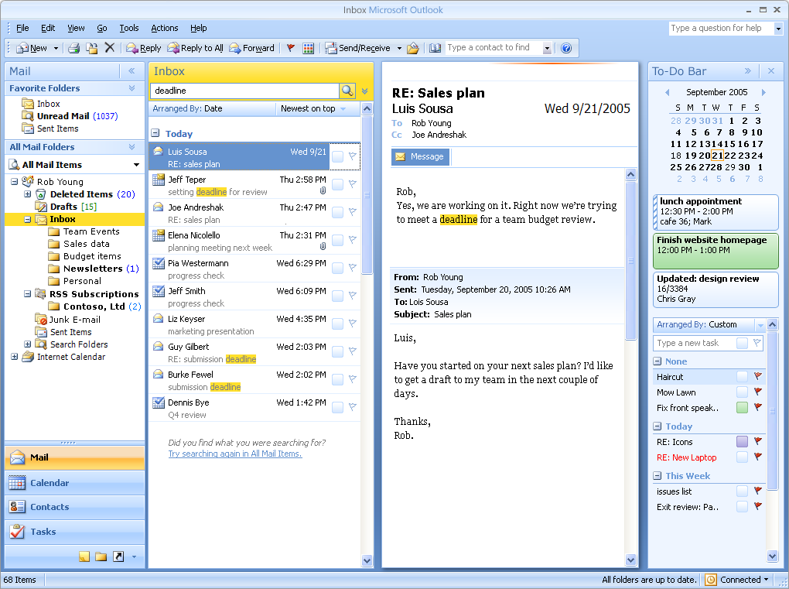
Figure 10: Mail search in Office Outlook 2007

New Inbox Autoconfiguration
A new feature in Office Outlook 2007 enables Post Office Protocol (POP), Internet Message Access Protocol (IMAP), and other e-mail account users to simply enter your account name and password, and Office Outlook 2007 then configures the account automatically. For example, if you enter your MSN® network of Internet services or Microsoft Hotmail® Web-based e-mail service address and password, Office Outlook 2007 automatically sets up that account for use in Outlook.

New RSS Aggregator
Many Web sites offer Really Simple Syndication (RSS) as a way for home and small business users to have headlines delivered directly to them. RSS aggregation is a new technology that provides you with an easy way to monitor multiple sources of news, blogs, and other Web-based content. Office Standard 2007 adds RSS reading and subscriptions directly into Office Outlook 2007. As a result, you can have a “news” folder that captures all of the RSS feeds that you subscribe to. This folder automatically updates periodically, bringing in new posts and information.

Summary
Microsoft Office Standard 2007 delivers a new and exciting software suite that provides home and small business users with all the essential tools they need to quickly and easily create great-looking documents, spreadsheets, and presentations. Focusing its efforts on results more than features, Microsoft has developed a suite of programs that make it easier and more enjoyable for you to get things done. You get the tools you need to quickly deliver the quality results you want. You can also coordinate your time and communications in a simpler, more efficient manner. The end result is that your computer tasks are a lot easier and more fun.

Resources

Additional information about Office Standard 2007 can be found at Office Online at http://office.microsoft.com. Office Online is your one-stop location on the Internet for everything related to Microsoft Office, including product information, support, updates, trials, and more.

Office Standard 2007 Overview
http://www.microsoft.com/office/preview/suites/standard/overview.mspx
Office Standard 2007 Demo
http://www.microsoft.com/office/preview/suites/standard/demo.mspx
Office Standard 2007 Top 10 Reasons to Upgrade
http://www.microsoft.com/office/preview/suites/standard/top10.mspx
Office Standard 2007 FAQ
http://www.microsoft.com/office/preview/suites/standard/faq.mspx
Office Standard 2007 Highlights Tab
http://www.microsoft.com/office/preview/suites/standard/highlights.mspx
Office Standard 2007 New Interface Tab
http://www.microsoft.com/office/preview/suites/standard/newui.mspx
System Requirements
For complete system requirements, visit www.microsoft.com/office/preview/beta/sysreq.mspx.
This document is developed prior to the product’s release to manufacturing, and as such, we cannot guarantee that all details included herein will be exactly as what is found in the shipping product. The information contained in this document represents the current view of Microsoft Corporation on the issues discussed as of the date of publication. Because Microsoft must respond to changing market conditions, this document should not be interpreted to be a commitment on the part of Microsoft, and Microsoft cannot guarantee the accuracy of any information presented after the date of publication. The information represents the product at the time this document was printed and should be used for planning purposes only. Information is subject to change at any time without prior notice.

This document is for informational purposes only. MICROSOFT MAKES NO WARRANTIES, EXPRESS OR IMPLIED, IN THIS DOCUMENT.

© 2006 Microsoft Corporation. All rights reserved.

Microsoft, Excel, Hotmail, MSN, the Office logo, Outlook, and PowerPoint are either registered trademarks or trademarks of Microsoft Corporation in the United States and/or other countries. All other trademarks are property of their respective owners.

http://office.microsoft.com
Additional service fees may apply for sharing calendars online.
Additional service fees may apply for sharing calendars online.

