Microsoft Office Standard 2007

September 2006



Table of Contents

Cover is for   
position only

Overview of Microsoft Office Standard 2007 1

Create High-Quality Documents 2

Work with Enhanced Security and Reliability 2

Find Commands and Help More Easily 3

Organize Your Time and Communications 3

Create High-Quality Documents 5

Microsoft Office Fluent User Interface 5

Improved Advanced Formatting 7

SmartArt Diagramming and Enhanced Charting Capabilities 8

Improved Templates and New Fonts 9

Improved Document Themes 9

Live Preview and Galleries 11

Save as PDF or XPS 11

New Custom Slide Layouts 12

Work with Enhanced Security and Reliability 13

Improved Office Outlook 2007 Junk E-Mail Filter 13

New Anti-Phishing Tools 15

Improved Document Recovery Tool 15

New Document Inspector 16

Find Commands and Help More Easily 17

New Command Tabs 17

Improved Tutorials 19

Improved and Easy-to-Use Help 19

Enhanced ScreenTips 19

Organize Your Time and Communications 20

New Ways to Easily Organize Appointments and Tasks 20

Improved Instant Search to Help Find What You Need 23

New Inbox Autoconfiguration 24

New RSS Aggregator 25

Summary 26

Resources 27

System Requirements 28

# Overview of Microsoft Office Standard 2007

Welcome to Microsoft® Office Standard 2007, the exciting new suite of familiar and widely used Microsoft Office system productivity software. Office Standard 2007 is the software suite that empowers home and small buisness users to manage e-mail and quickly and easily create great-looking documents, spreadsheets, and presentations. With the Microsoft Office Fluent™ user interface, enhanced graphics and formatting capabilities, new time-management tools, and more reliability and enhanced security, Office Standard 2007 makes it easier and more enjoyable for you to get things done.

Office Standard 2007—which includes Microsoft Office Word 2007, Microsoft Office Excel® 2007 spreadsheet software, the Microsoft Office Outlook® 2007 messaging and collaboration program, and the Microsoft Office PowerPoint® 2007 presentation graphics program—offers easy access to a comprehensive set of powerful tools and resources. The Office Fluent user interface, one of the most significant visual makeovers in the history of the Microsoft Office system, helps you access the commands you need while you work.

This guide provides an overview of new and improved features in Office Standard 2007. You will also see examples of Office Standard 2007 in action that demonstrate its powerful new capabilities.

Office Standard 2007 in Action

Francisco Chaves owns the Coho Winery in Northern California. His small sales and marketing staff has a very basic understanding of computers. He finds that the simplicity and functionality of Office Standard 2007 not only meets all of his sales and marketing needs, but improves his staff’s efficiency and productivity. Presently, they use Office PowerPoint 2007 to create sales presentations for distributors and restaurants. Office Outlook 2007 helps them store and track contacts and minimizes junk e-mail messages, so the staff can focus on important e-mail messages. Office Excel 2007 helps them track product and customer data and make projections for their annual output. For all correspondences and press releases, the staff relies on Office Word 2007.

## Create High-Quality Documents

Office Standard 2007 simplifies the way home and small business users work with documents. The redesigned Office Fluent user interface helps you quickly and easily create high-quality documents, spreadsheets, and presentations. Enhanced graphics and formatting capabilities help make your user experience more enjoyable and productive.

* **New! Results-oriented Office Fluent user interface** makes it easier to find and use the product features you use most to get the results you want.
* **Improved! Enhanced formatting capabilities** make it easier to consistently format documents.
* **New! Text effects** **and diagram and graphics galleries** give you the ability to preview and format items.
* **Improved! Document Themes** create a consistent appearance across Word documents, Excel spreadsheets, and PowerPoint presentations.
* **New! Save as Portable Document Format (PDF) or an XML Paper Specification (XPS) file[1]** option gives you the ability to share your documents, spreadsheets and presentations with people who may not have Word, Excel or PowerPoint.

## Work with Enhanced Security and Reliability

Powerful new security features help home and small business stay operational so that users can work with confidence.

* **Improved! A junk e-mail filter** helps significantly reduce spam e-mail messages in inboxes and helps protect against potentially harmful e-mail attachments.
* **New! Anti-phishing tools** alert users to suspicious and potentially fraudulent e-mail messages so that they do not divulge private information unnecessarily.
* **Improved! Automatic** **document recovery** helps retrieve Microsoft Office system documents if a system stops responding.
* **New! Document Inspector** helps protect private information by automatically removing personally identifiable information, comments, and tracked changes from documents.

## Find Commands and Help More Easily

Office Standard 2007 offers the Office Fluent user interface that significantly simplifies how home and small business users access commands. Commonly used commands appear on the Ribbon instead of in drop-down menus. In addition, an enhanced Help system, including tutorials with step-by-step instructions, enables you to quickly find answers to your questions.

* **New! Command tabs** on the Ribbon display commonly used commands that previously appeared only in lengthy drop-down menus.
* **Improved!** **Tutorials** provide you with step-by-step instructions for common tasks.
* **Improved! The easy-to-use Help system** offers a smooth transition between Help in the Microsoft Office system and Help on the Internet.
* **Improved! Enhanced ScreenTips** provide quick access to information about a command directly from the command’s location.

## Organize Your Time and Communications

New features and enhancements in Office Outlook 2007 help home and small business users organize their daily schedules, tasks, and communications.

* **New! Organizational tools** such as the To-Do Bar bring tasks, calendar information, and flagged e-mail messages together into one location.
* **Improved! Instant Search** helps you quickly find information in any of the Office Outlook 2007 modules.
* **New! Inbox autoconfiguration** sets up and configures all of your e-mail accounts automatically.
* **New! Really Simple Syndication (RSS) Aggregator** sends headlines and Web content to you, so you won’t have to look for it (additional fee-based RSS subscription required).

Create High-Quality Documents

Microsoft Office Standard 2007 makes it easier than ever to format your documents, spreadsheets, and presentations. New and improved features such as enhanced graphics and advanced formatting capabilities help you quickly deliver high-quality documents. In addition, new features in Office PowerPoint 2007 make it easier to share and reuse presentations, providing a more enjoyable experience.

## Microsoft Office Fluent User Interface

The Microsoft Office Fluent user interface reflects an overall effort by Microsoft to deliver a more user-driven product. Rather than rethinking the product from a *feature-oriented* viewpoint, Microsoft focused Office Standard 2007 on the user’s *results-oriented* perspective. The end product delivers one of the most significant makeovers in the history of the Microsoft Office system. The Office Fluent user interface is more intuitive and offers more easily accessible features. It is less about commands and more about results. At the same time, although the look is very new, its evolution from previous Microsoft Office system releases makes it extremely familiar.

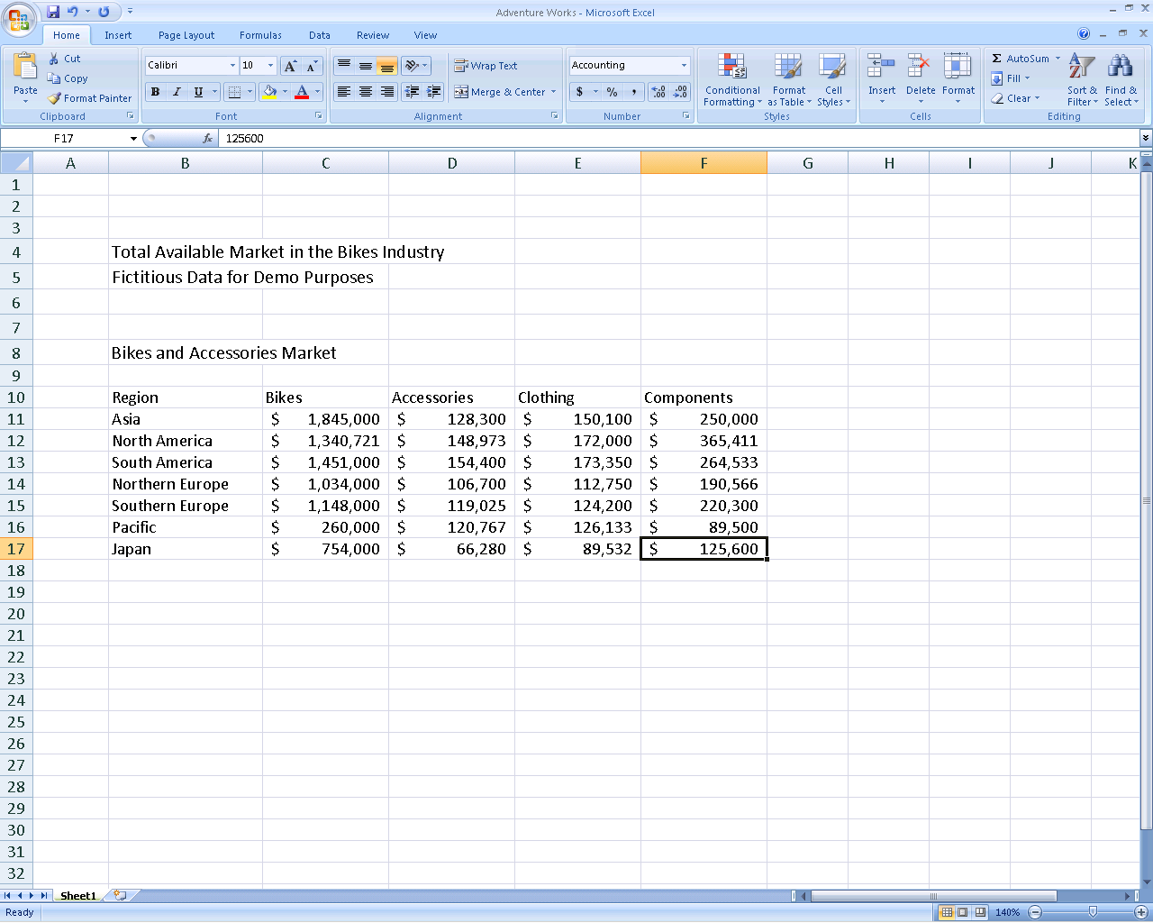

Figure 1: Office Excel 2007 task-based Office Fluent user interface

The Office Fluent user interface significantly simplifies how you author documents by:

* Making the experience more predictable, with less complicated features and guesswork.
* Maximizing your workspace and being less intrusive by not popping up images and dialog boxes over your work.
* Putting a majority of the most commonly used commands on the first tab, so you do not have to dig for commands in lengthy drop-down menus.

Office Standard 2007 in Action

Michelle Alexander serves on the PTA board and volunteers at the zoo. She uses Office Standard 2007 to write letters to parents and design zoo flyers. Although comfortable with the primary menus in previous releases of the Microsoft Office system, she was frustrated with having to hunt down commands in the drop-down menus. With the results-oriented Office Fluent user interface in Office Standard 2007, all of the tools she needs automatically become available when and where she needs them. As a result, she can spend less time on formatting documents and more time doing what is important to her.

## Improved Advanced Formatting

With the addition of more consistent numbering, bullet, and table features in Office Standard 2007, home and small business users no longer have to waste time formatting and reformatting their Office Word 2007 documents. Office Standard 2007 simplifies document formatting by:

* Enabling you to create and apply Quick Styles for text and tables with a single click.
* Providing previews of your formatting changes.
* Maintaining formatting across Microsoft Office system programs when you copy text or tables from one program to another.
* Providing more consistent and stable bullet and number formatting.

## SmartArt Diagramming and Enhanced Charting Capabilities

The new SmartArt™ diagramming and enhanced charting capabilities in Office Standard 2007 applications make it easy to create great-looking diagrams and charts. Just choose the chart type, the layout, and the format from visual galleries of predefined options. Or take a bulleted list and convert it to a compelling diagram with just a couple of clicks. You can also reuse content by saving your favorite charts as chart templates. In addition, the SmartArt graphics capabilities of the Microsoft Office system have been enhanced so you can easily use professional effects such as shading, reflections, glow, transparency, and other 3-D effects.

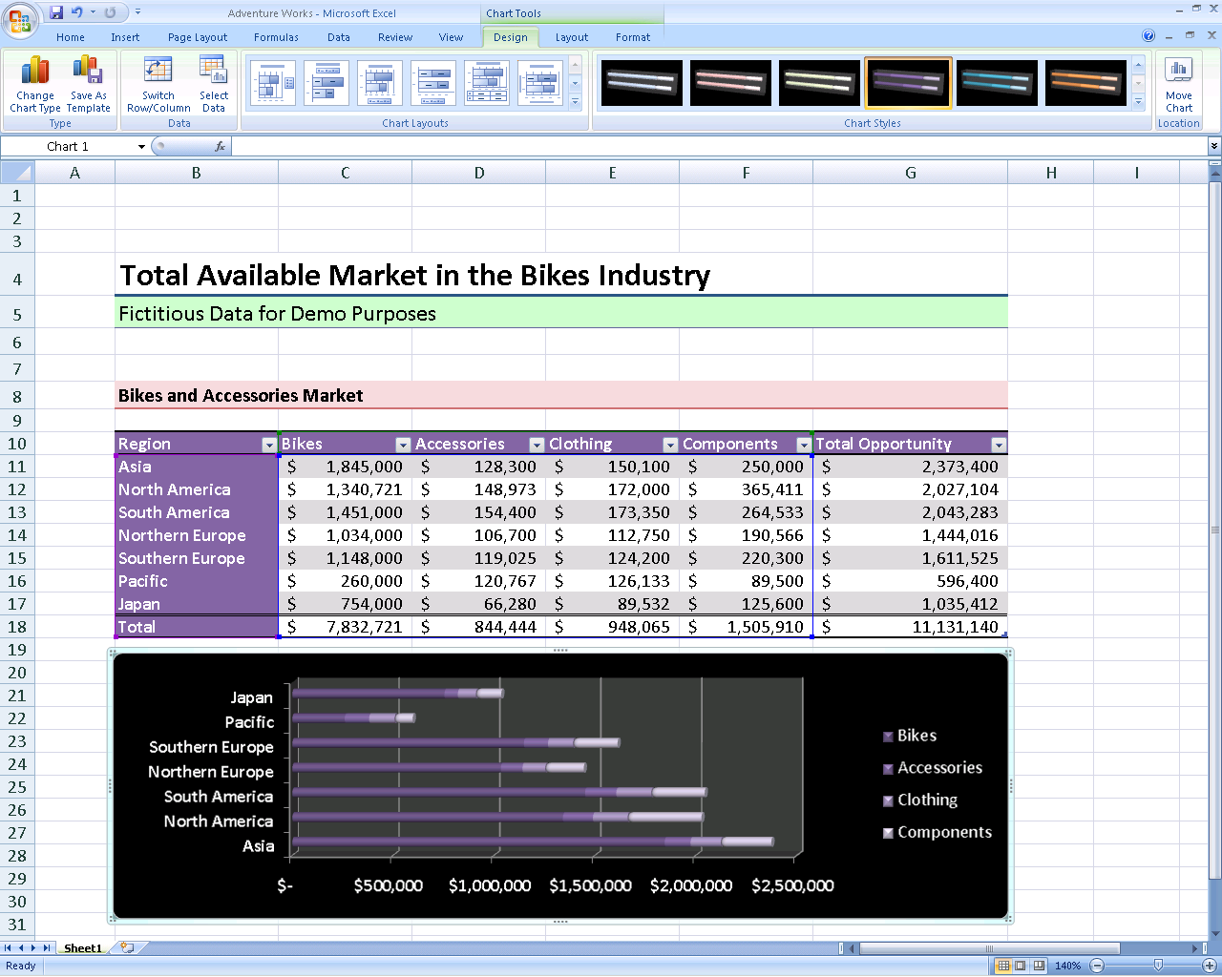

**Figure** **2: New charting tools in Office Excel 2007**

Office Standard 2007 in Action

Jonas Hasselberg owns a small business, Trey Research, which specializes in analyzing industry trends. The company relies heavily on charts and graphs to supplement its reports. Jonas finds that Office Standard 2007 offers the most opportunities for spicing up his presentations. He uses effects such as shadows and glows for his PowerPoint presentations and his Word reports. He also takes advantage of the selection of diagram types to create variety within his presentations. Designing reports is now one of the most interesting aspects of his job.

## Improved Templates and New Fonts

New and improved out-of-the-box templates in Office Standard 2007 help home and small business users to create professional-looking documents more quickly and easily. You can either get started with the included templates or search the preformatted templates available at Microsoft Office Online at <http://office.microsoft.com>. In addition, Office Standard 2007 includes new and improved fonts that make on-screen reading easier.

## Improved Document Themes

Document Themes is an improvement that helps home and small business users maintain a consistent look among Word documents, Excel spreadsheets, and PowerPoint presentations, so when you copy tables and objects between programs, the items maintain their appearance. As a result, working simultaneously with different programs becomes more consistent and less frustrating.

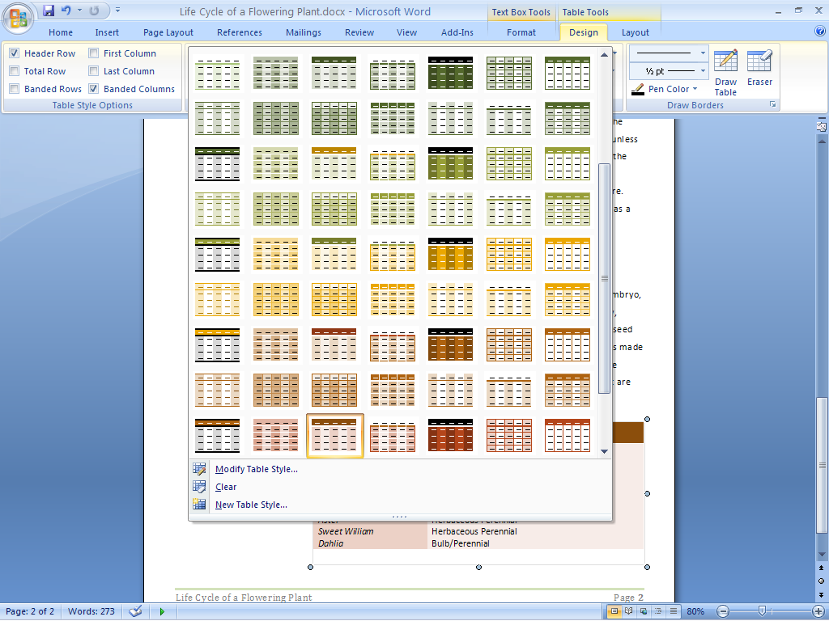

**Figure 3: Table Styles in Office Word 2007**

Office Standard 2007 in Action

Joanna and Artur Rybka are considering an addition to their house. They use Office Excel 2007 to research and track the costs of such a decision. They also use Office Word 2007 and Office PowerPoint 2007 for design ideas and logistics. Document Themes in Office Standard 2007 helps ensure that all transferred information between programs maintains its appearance. As a result, Joanna and Artur can quickly shuffle information between different programs, knowing that what they see is what they will get. This helps them plan more efficiently and with greater confidence.

## Live Preview and Galleries

Everyone wants to create the highest-quality documents possible in the shortest amount of time. Accomplishing this often requires experimenting with different styles and formats. Office Standard 2007 enables you to quickly preview proposed changes. With Live Preview, you can actually view formatting choices as you move your mouse pointer over choices in a gallery—without having to repeatedly search through drop-down menus. By test-driving your proposed formatting, you can save time and experiment more easily. The end result is a quickly created document that looks the way you want it to look. These galleries can be found in Office Word 2007, Office Excel 2007, and Office PowerPoint 2007.

## Save as PDF or XPS

Ensure broader distribution of your documents and presentations. New support for Portable Document Format (PDF) and XML Paper Specification (XPS) file formats helps ensure broader distribution of your documents with others.[2]* Now you can post your documents on the Internet or share them with others, knowing that users can view them regardless of the type of computer or programs they are using.

Office Standard 2007 in Action

Monica Brink wants to design a baby shower invitation for her sister. She knows the details of the event, but cannot decide on the design. With Live Preview in Office Standard 2007, she can preview different fonts simultaneously within her document before making a decision. For help with margins, she can quickly preview multiple options. These new preview features make experimenting with different looks more comfortable for Monica.

## New Custom Slide Layouts

The new Custom Slide Layouts feature in Office PowerPoint 2007 frees home and small business users from confining prepackaged layouts. Now you can quickly create and save information-rich layouts with multiple charts, tables, and text. You can then save these layouts as templates for future presentations.

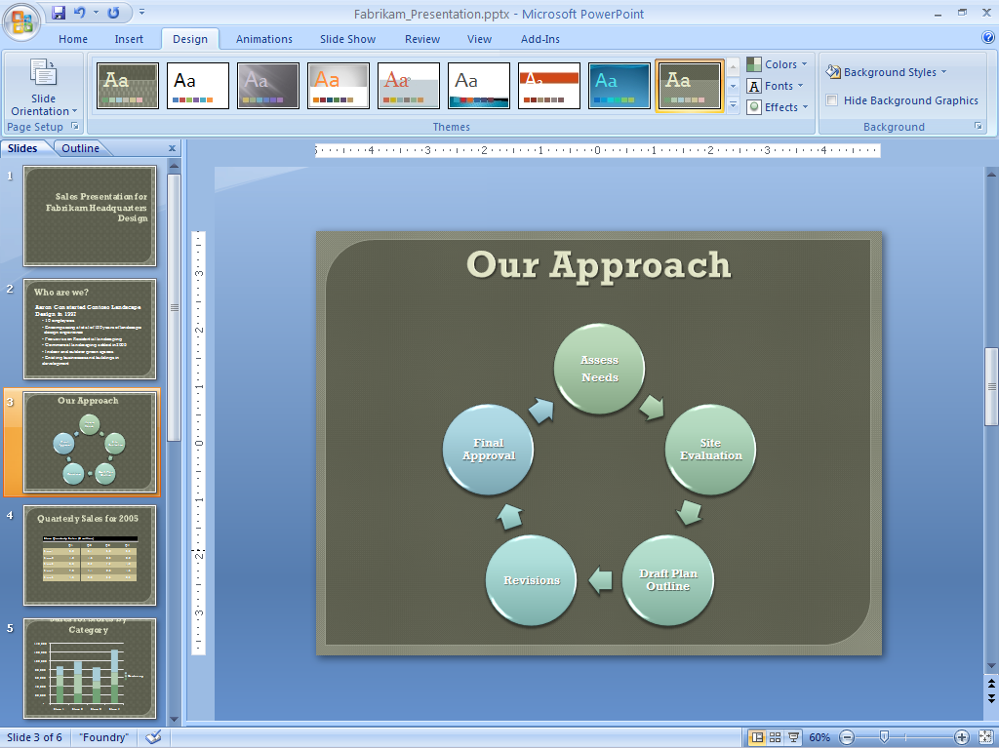

**Figure** **4: Custom Slide Layouts in Office PowerPoint 2007**

# Work with Enhanced Security and Reliability

Microsoft Office Standard 2007 offers new and improved features to home and small business users that can help increase security by reducing junk e-mail and “phishing” scams. In addition, tools such as automatic document recovery and Document Inspector give you peace of mind by automatically recovering documents after a system crash and removing personally identifiable information from your documents before you share them with others.

## Improved Office Outlook 2007 Junk E-Mail Filter

Junk e-mail is time-consuming, annoying, and potentially dangerous for home and small business users. To address the flood of junk e-mail, Office Outlook 2007 offers an enhanced junk e-mail filter that helps reduce the amount of spam sent to Inboxes and better protects your computer against viruses sent through e-mail. This enhanced security feature applies to both e-mail messages and their attachments.

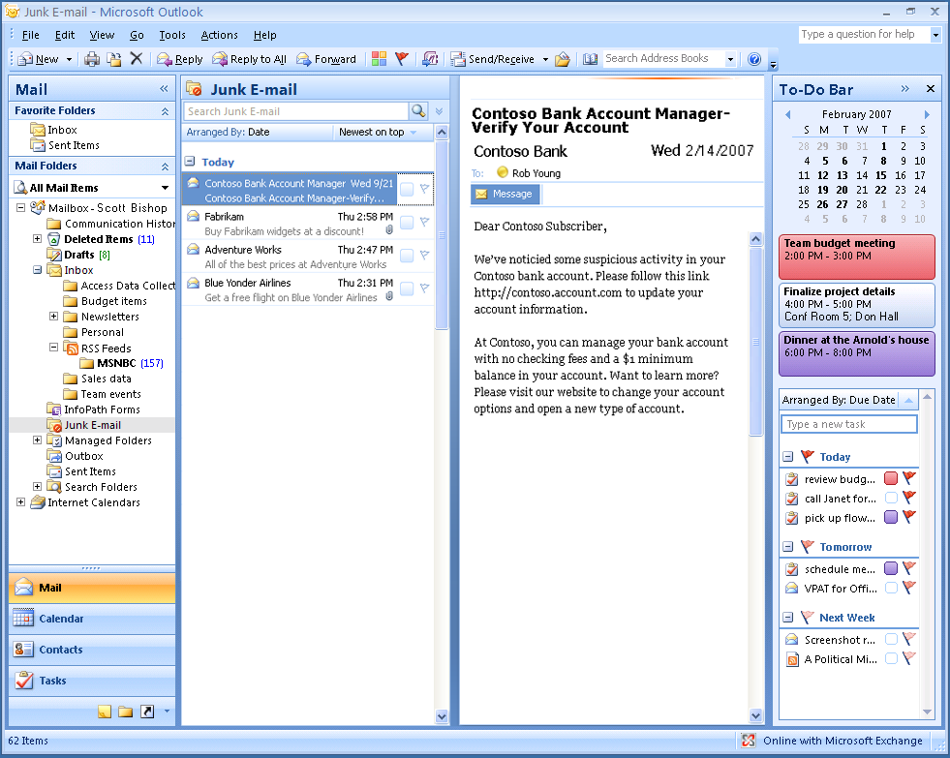

**Figure 5: Junk e-mail filter in Office Outlook 2007**

Office Standard 2007 in Action

David Barber used to feel like he never had enough time to sort through and separate junk e-mail messages from his important messages while checking e-mail at home. With the enhanced Office Outlook 2007 junk e-mail filter, the sorting is done for him. David also gets peace of mind knowing that when his kids are surfing the Internet, the family computer is better protected from viruses. Even with a powerful computer firewall, he knows that he can never have enough security.

## New Anti-Phishing Tools

Office Outlook 2007 provides new enhancements that help protect personal information by alerting home and small business users to potentially fraudulent e-mail messages sent to their inboxes. Fraudelent e-mail communications, known as “phishing,” attempt to trick you into providing bank, credit card, or other personal information. To provide more security, Office Outlook 2007 displays suspected phishing e-mail messages in plain text (no HTML or images), disables the hyperlinks, and provides a warning alert across the top of the message.

## Improved Document Recovery Tool

The automatic document recovery tool in Office Standard 2007 better protects documents in the event that a system fails. If a Microsoft Office system program encounters a problem or stops responding, you can now close the program in a controlled manner. The files you had open are analyzed for errors and, whenever possible, recovered. You can then view any repairs that were made to the files.

## New Document Inspector

Office Standard 2007 Document Inspector provides an easy and efficient way for home and small business uers to help protect information. This tool automatically searches documents for comments, revisions, and tracked changes; headers and footers; and hidden text. You can delete your choice of personal information in a matter of seconds. When you distribute your documents, you can be more confident that no unwanted information is accidentally included.

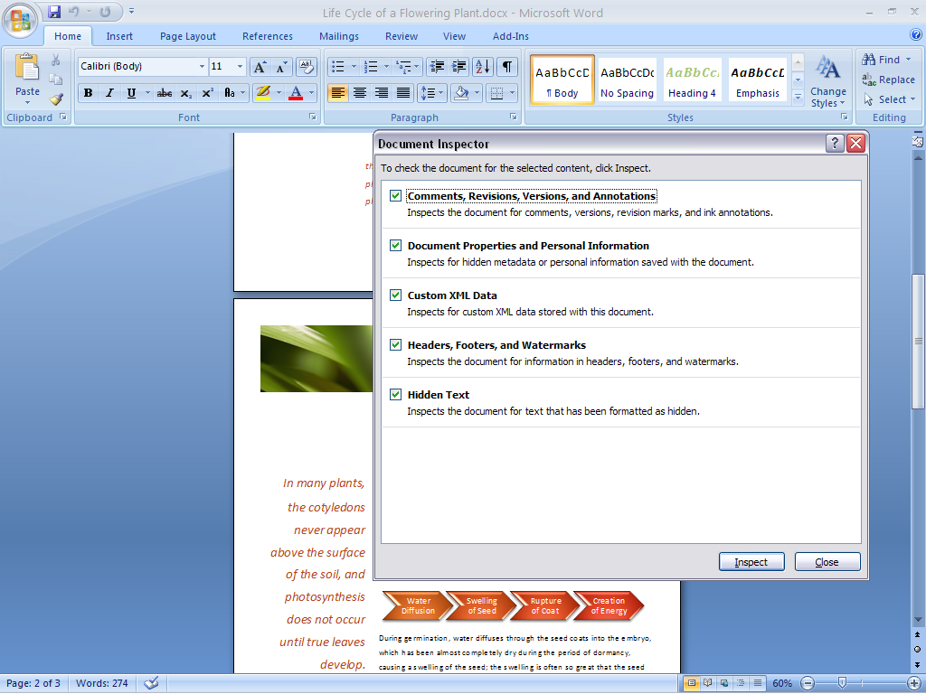

**Figure 6: Document Inspector in Office Word 2007**

Office Standard 2007 in Action

Martin Lotz is the Chief Financial Officer of A. Datum Corporation, a small software company situated in Boulder, Colorado. He has access to almost all personal company information. He uses the Document Inspector in Office Standard 2007 to help him search documents and automatically remove any personal information before sending them out. This helps ensure that his correspondence is free of any unwanted comments, hidden text, or personally identifiable information that he does not want to share with others.

# Find Commands and Help More Easily

Office Standard 2007 offers the Office Fluent user interface that makes document creation easier, faster, and more intuitive. The design emphasizes user efficiency and feature discoverability to help reduce the home and small business user’s frustration level by quickly finding relevant answers to questions. Tutorials and templates help you get started and understand more about the software’s capabilities.

## New Command Tabs

Most home and small business users only employ a small percentage of all of the commands available in Microsoft Office system programs. With the Office Fluent user interface in Office Standard 2007, you can learn more about the capabilities of the Microsoft Office system by using a set of command tabs that replace the previous drop-down menus. As a result, commonly used commands that were once buried are now available at your fingertips. Microsoft Office helps you learn more and get the results you want by giving you access to the right tools when you need them.

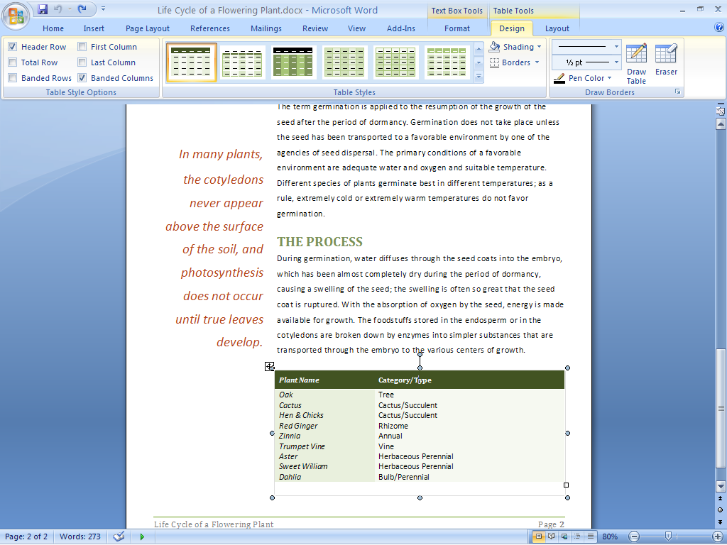

**Figure** **7: Formatting commands in Office Word 2007**

Certain sets of commands are only relevant when objects of a particular type are being edited. These are known as *contextual command tabs*. The tabs automatically change depending on the task that you are trying to complete.

Office Standard 2007 in Action

Even as a multitasker, Naoki Sato never has enough time to finish everything she wants to on her home computer. As a result, she has never taken the time to discover all the functionality available in the Microsoft Office system. With hundreds of commands in Word alone, this means she has not benefited from capabilities that could simplify and improve her experience. With contextual command tabs in Office Standard 2007, she can get fast access to commands that relate to what she is doing at the moment. As a result, she can complete whatever she is working on faster than before.

## Improved Tutorials

An improved Getting Started experience in Office Standard 2007 significantly reduces the learning curve for new home and small business users. Tutorials offer step-by-step instructions for using Microsoft Office system software. Getting Started brings to the surface additional Help options such as Office Online integration.

## Improved and Easy-to-Use Help

Many home and small business users are tired of wasting time trying to find answers to functionality questions. Office Standard 2007 provides more direct links to Help content than ever before. Take advantage of the smooth transition between Help in Office Standard 2007 and Help on the Internet (when connected).

## Enhanced ScreenTips

Office Standard 2007 offers larger, more informative ScreenTips than previous releases of the Microsoft Office system. ScreenTips provide quick access to information about a command directly from the command’s location. By popping up when you rest your mouse pointer on any command, the enhanced ScreenTip often gives you enough information about a feature to help you quickly use it without further assistance. This capability gives you easy access to all of the functionality of the 2007 Microsoft Office system user interface. As a result, you can save time and become more productive.

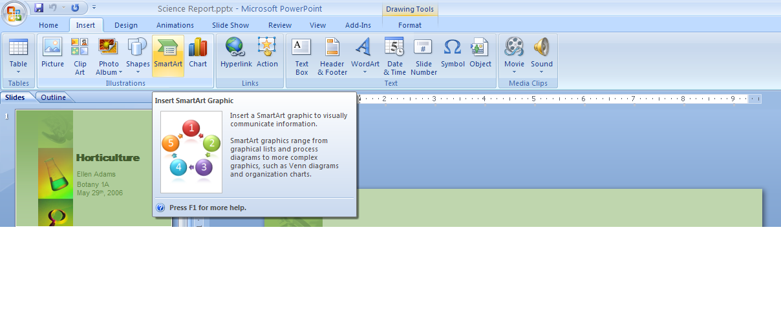

**Figure** **8: Enhanced ScreenTips in Office Standard 2007**

# Organize Your Time and Communications

Office Outlook 2007, included in Office Standard 2007, provides tools that help home and small business users organize their time and communications. Using Instant Search capabilities and Color Categories, you can easily locate the information you want and need. Through new calendar viewing, publishing, and sharing capabilities, you can share calendars stored in Office Outlook 2007 with coworkers, friends, and family, no matter where they are located.[3] A new To-Do Bar makes it easier for you to prioritize and control your time, so you can focus on more important matters.

## New Ways to Easily Organize Appointments and Tasks

Office Outlook 2007 provides an effective and efficient way to organize information in one location. All of the tools home and small business users need to manage, prioritize, and sort tasks are integrated directly into Office Outlook 2007. Some of the new and improved organizational features include the following:

* **Color Categories** help you quickly differentiate e-mail messages.
* **New calendar views** help you to compare two calendars side by side or one on top of the other.
* **A new To-Do Bar** brings together tasks, calendar information, and flagged e-mail messages in one place. Tasks completed on a particular day “stick” to that day and appear as part of a record of what you did on that day. Tasks not completed roll over to the next day and accumulate until you complete them.

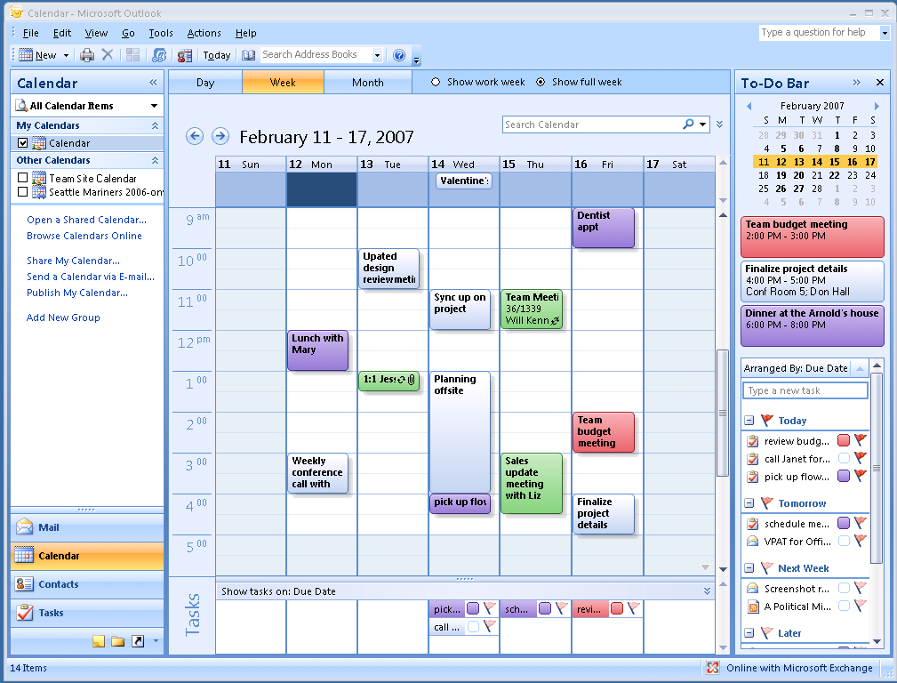

**Figure 9: Calendar view in Office Outlook 2007**

Office Standard 2007 in Action

Jay Jamison is the Schedule Coordinator at Adventure Works, a small outdoor tourist company. Jay relies on Office Outlook 2007 to help him manage trip dates, reservation deadlines, and meetings. He uses the To-Do Bar in Office Outlook 2007 to help ensure that he never misses an appointment or deadline. He uses new Color Categories to differentiate his personal e-mail messages from work-related ones. New calendar publishing and sharing capabilities help everyone in the company to stay aware of important deadlines, trip dates, and schedules.

## Improved Instant Search to Help Find What You Need

Office Outlook 2007 provides Instant Search that helps home and small business users quickly find information in any of the Office Outlook 2007 modules such as e-mail messages, calendars, and tasks. The search capability also includes the following:

* **Search folders** where you can save common searches and their results.
* **Advanced search capabilities** that save you time and hassle finding important e-mail messages.
* **New calendar publishing and sharing[4] capabilities** that help you share any Office Outlook 2007 data with friends and family, no matter where they are located.

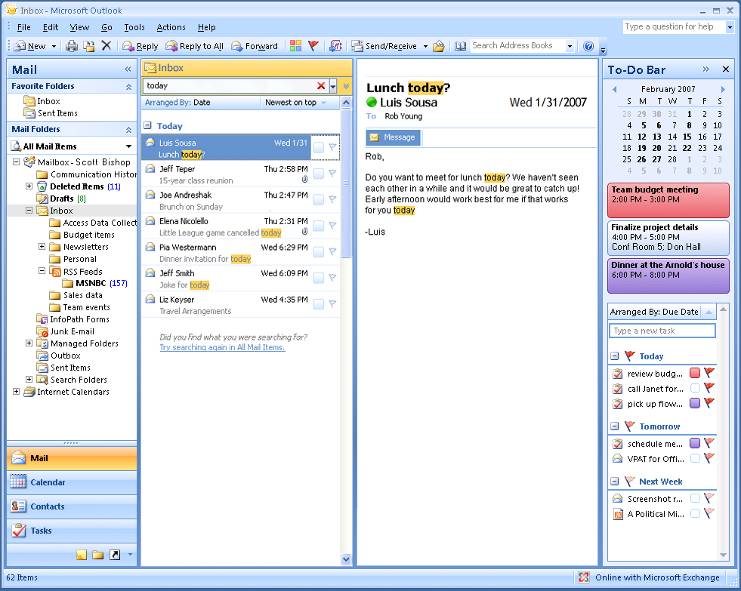

**Figure 10: Instant Search in Office Outlook 2007**

## New Inbox Autoconfiguration

A new feature in Office Outlook 2007 enables Post Office Protocol (POP), Internet Message Access Protocol (IMAP), and other e-mail account users to simply enter your account name and password, and Office Outlook 2007 then configures the account automatically. For example, if you enter your MSN® network of Internet services or Microsoft Hotmail® Web-based e-mail service address and password, Office Outlook 2007 automatically sets up that account for use in Outlook.

## New RSS Aggregator

Many Web sites offer Really Simple Syndication (RSS) as a way for home and small business users to have headlines delivered directly to them. RSS aggregation is a new technology that provides you with an easy way to monitor multiple sources of news, blogs, and other Web-based content. Office Standard 2007 adds RSS reading and subscriptions directly into Office Outlook 2007. As a result, you can have a “news” folder that captures all of the RSS feeds that you subscribe to. This folder automatically updates periodically, bringing in new posts and information. (Please note: A separate fee-based RSS subscription is required.)

# Summary

Microsoft Office Standard 2007 delivers a new and exciting software suite that provides home and small business users with all the essential tools they need to quickly and easily create great-looking documents, spreadsheets, and presentations. Focusing its efforts on results more than features, Microsoft has developed a suite of programs that make it easier and more enjoyable for you to get things done. You get the tools you need to quickly deliver the quality results you want. You can also coordinate your time and communications in a simpler, more efficient manner. The end result is that your computer tasks are a lot easier and more fun.

# Resources

For more information about Office Standard 2007, please visit <http://www.microsoft.com/office/suites/standard>.

Additional information about Office Standard 2007 is available at Office Online at <http://office.microsoft.com>. Office Online is your one-stop location on the Internet for everything related to Microsoft Office, including product information, support, updates, trials, and more.

System Requirements

For complete system requirements, visit

<http://www.microsoft.com/office/suites/standard>.

This document is developed prior to the product’s release to manufacturing, and as such, we cannot guarantee that all details included herein will be exactly as what is found in the shipping product. The information contained in this document represents the current view of Microsoft Corporation on the issues discussed as of the date of publication. Because Microsoft must respond to changing market conditions, this document should not be interpreted to be a commitment on the part of Microsoft, and Microsoft cannot guarantee the accuracy of any information presented after the date of publication. The information represents the product at the time this document was printed and should be used for planning purposes only. Information is subject to change at any time without prior notice.

This document is for informational purposes only. MICROSOFT MAKES NO WARRANTIES, EXPRESS OR IMPLIED, IN THIS DOCUMENT.

© 2006 Microsoft Corporation. All rights reserved. Microsoft, Excel, Hotmail, MSN, the Office logo, Outlook, PowerPoint, Fluent, and SmartArt are either registered trademarks or trademarks of Microsoft Corporation in the United States and/or other countries. All other trademarks are property of their respective owners. The example companies, organizations, products, domain names, e-mail addresses, logos, people, places, and events depicted herein are fictitious. No association with any real company, organization, product, domain name, e-mail address, logo, person, places, or events is intended or should be inferred.

1. The Save as PDF or XPS functionality is available as a free download from Office Online.
2. * You can save as a PDF or XPS file from a 2007 Microsoft Office system program only after you install an add-in. For more information, see [Install and use a PDF or XPS add-in](http://r.office.microsoft.com/r/rlidOOPDFXPSAddin?clid=1033)**.**
3. Additional service fees may apply for sharing calendars online.
4. Additional service fees may apply for sharing calendars online.