**Azure RampUp**

**Topic N: Setting up Accounts for Windows Azure**

[](http://msdn.microsoft.com/en-us/rampup/bb352986.aspx)

Ascend to new heights in your career

[**http://msdn.microsoft.com/rampup**](http://msdn.microsoft.com/rampup)

**Contents**

Introduction 3

Setting Up a Windows Azure Account 3

Setting Up a SQL Azure Account 5

Additional Resources 8

# Introduction

In order to be able to host your applications on the Azure Services platform, you will need to create a Windows Azure account and obtain the tokens necessary to create Windows Azure projects and/or SQL Azure database servers and databases. This document is intended to be an overview of account setup as well as guide to walk a developer through the process of gaining access to the platform and configuring it for your applications.

This document is separated into two sections: a walkthrough of the process of setting up a Windows Azure account, and a similar walkthrough for SQL Azure. It should be noted that accessing SQL Azure requires creating a Windows Azure account, although the developer does not need to follow the instructions for obtaining an invitation token.

# Setting Up a Windows Azure Account

In order to be able to deploy applications on the Windows Azure platform, you will need to request a token; this token will allow you to gain access to the Windows Azure portal and provision your applications’ compute and storage resources. This token will grant you access to create a project in the Windows Azure Project Management portal. To get your developer's invitation, you must visit the Microsoft Connect Web site and fill out the self-nomination form to request the token. This form requests some simple questions regarding your interests in Windows Azure and does not ask for any confidential information. If you have not registered with Connect before, a separate confirmation email will be sent to the email address that you have registered with your Windows Live ID. Once you complete the form, your token will then be sent to the email account registered for your Windows Live ID. Be aware that there may be a backlog of requests, so it may take some time to receive your token.

Once a token has been assigned to you, you are then able to log into the Azure Services portal. To do this, you will need a Windows Live ID. If you have not already created a live ID for yourself, you should click the “Sign Up” button to create one for yourself. Once you have signed into the portal, you may then enter your token so that you can provision your application. To access the portal, open your Web browser and navigate to <http://windows.azure.com>. If this is the first time you have accessed the Azure Services portal, you will be prompted to associate your Windows Live ID with your developer portal account. You should first review the Azure Services Privacy Statement, and if you agree with the contents, you can then click the “Accept” button. At this point, a new account will be created for you and you will be able to use your Windows Live ID to manage your Azure Services. You may then click the “Continue” button to proceed with the rest of your account setup.

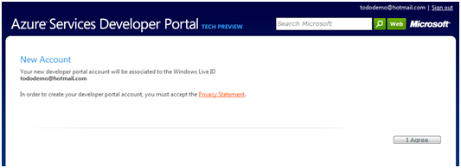

**Figure 1: Azure Services Account Creation**

At this point, you are ready to redeem the token you requested from the Connect site. After you receive the email containing your Azure Services invitation, you will need to redeem the token with your Azure Services account. By default, you are presented with the form to enter an invitation token after you create your Azure Services account.

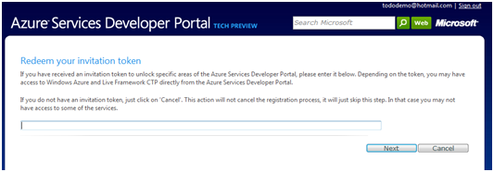

**Figure 2: Redemption of a Windows Azure Token**

If you skipped the step of redeeming a token when you first created the account, it is also accessible from the “Account” section of the portal and clicking the “Manage My Tokens” link.

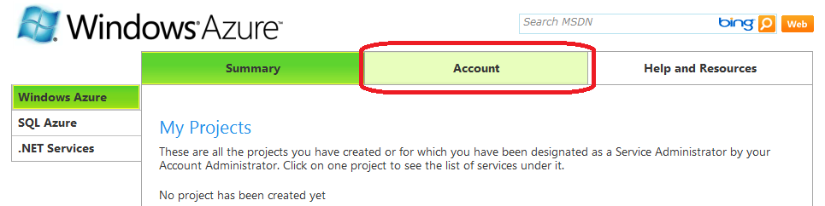

**Figure 3: Accessing the Account Section of the Azure Services Portal**

Currently all Windows Azure applications are listed under the PDC08 CTP project; once the service goes live, this will change and simply become the list of projects that you have provisioned.

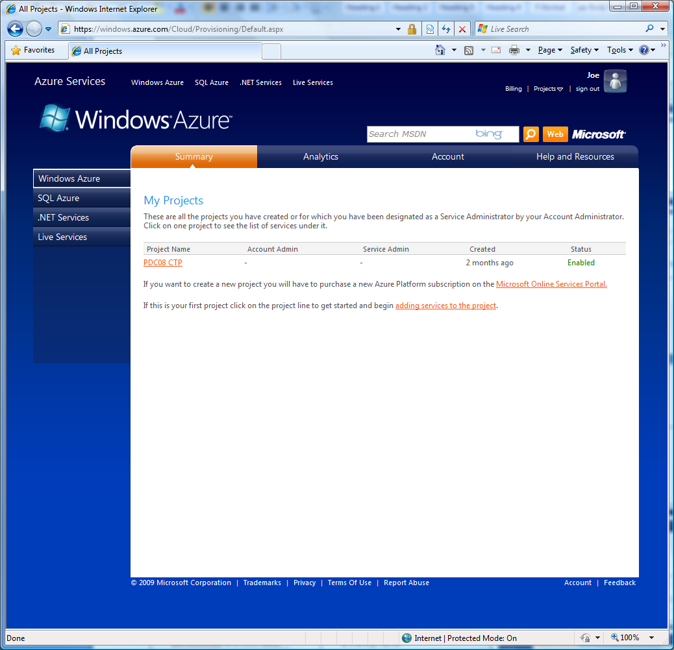

**Figure 4: The Windows Azure Project Management Screen**

# Setting Up a SQL Azure Account

Just as with Windows Azure, you will need to request an invitation token in order to be able to deploy databases on the SQL Azure platform. This token is what allows you to gain access to the SQL Azure management portal and provision your databases, and to obtain the invitation, you will need to fill out a self-nomination form that requests simple, non-confidential information. Once you complete the form, the invitation will be sent to the email account registered for your Windows Live ID. Again, be aware that there may be a backlog of requests, so it may take some time to receive your token. Once you have received the email containing the invitation token, you can redeem the token by signing into the Azure Services portal as described above and navigating to the SQL Azure section by clicking the “SQL Azure” link.

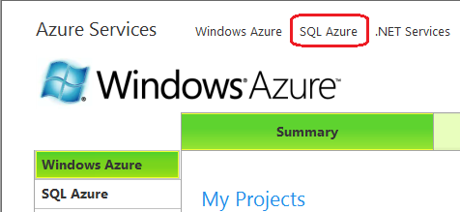

**Figure 5: Navigating to SQL Azure from the Azure Services Portal**

If this is the first time you have accessed the SQL Azure portal, you will be prompted to redeem your invitation token. with a license agreement that you must accept in order to begin using the service. After you accept the agreement, you will then be able to create an administrator account and create a database server.

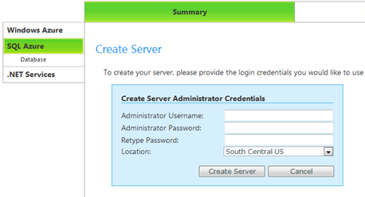

**Figure 6: Creating Administrator Credentials**

After you have created a server, you will find yourself presented with a list of databases on that server. Just as with the regular server edition of SQL Server, you will start with a master database, but little else. At this time, you can go proceed to create databases for your application. One important thing to note is that when you create a database you will be prompted for a maximum database size. This choice of maximum size determines which edition of SQL Server is to be used for the database; a maximum size of 1GB corresponds to the Web Edition, while the 10GB size corresponds to Business Edition. The difference between these two editions is a combination of this maximum database size, monthly price and access budget: currently, the Web Edition of SQL Azure is priced at $9.99 (US) per month with a maximum of 10 query hours per month, while the Business Edition is priced at $99.99 (US) per month with a maximum of 100 query hours per month.

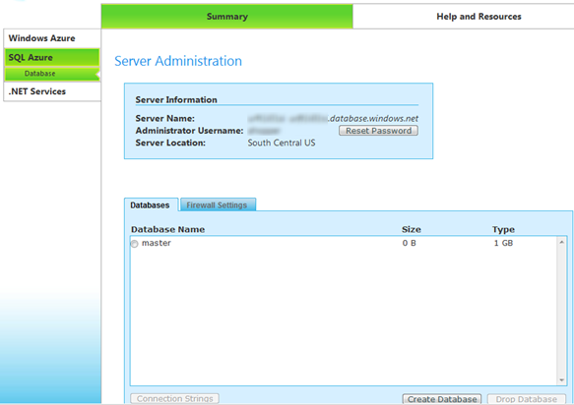

**Figure 7: The SQL Azure Server Adminstration Interface**

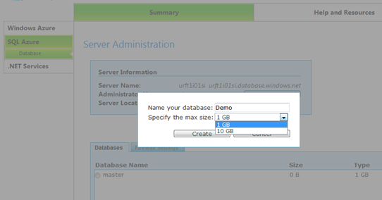

**Figure 8: Creating a SQL Azure Database**

Finally, you will need to configure the SQL Azure firewall to grant access to your databases. By default, your database server is locked down and the only access to it is through the SQL Azure portal. By configuring the firewall, you can grant access to the databases from specific ranges of IP addresses in cases where you intend to access the server from your own network. If you intend to access your database from Windows Azure Web or Worker Roles, you will also need to grant access to your database server by checking the “Allow Microsoft Services access to this server” checkbox.

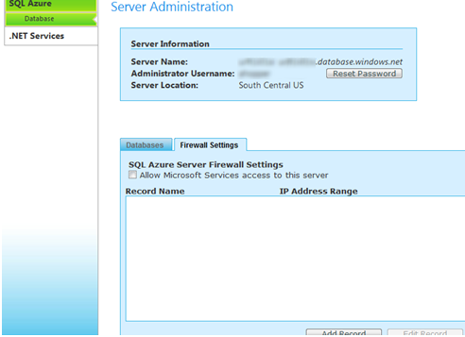

**Figure 9: Configuring Firewall Settings for Access**

After configuring the firewall, you are now able to access your databases from command-line tools such as sqlcmd or Sql Server Management Studio, use tools such as BCP to upload the contents of an existing database, and access your database from applications using client-access libraries such as ADO.NET, ODBC, or PHP.

# Additional Resources

Additional resources for learning about Windows and SQL Azure are listed below:

|  |  |
| --- | --- |
| **Resource** | **Location** |
| Windows Azure Developers Portal | <http://www.microsoft.com/azure/windowsazurefordevelopers/default.aspx> |
| SQL Azure Developers Portal | <http://msdn.microsoft.com/en-us/sqlserver/dataservices/default.aspx> |