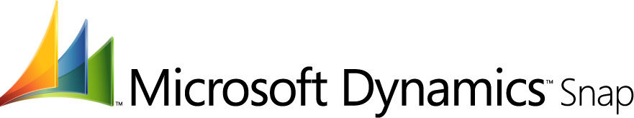

IMPACT
Microsoft Dynamics Snap Brochure

Increase productivity across your organization by providing access to Microsoft Dynamics™ information from within Microsoft Office®.

INTEGRATED
Empower Your People

At Microsoft, we are committed to helping you reach your potential. And yet, when you look at business management software and the way it is licensed and deployed, the only people who can benefit directly from the valuable information within these systems are the relatively small numbers of employees who are licensed to use it. That means you have a large number of workers that are not able to reach the information that is powering your business. Why would so much time and money be spent to empower only a small subset of employees? This is historically the way enterprise software has been sold due to the cost constraints of licensing more users coupled with the fact that many workers prefer to use Microsoft Office to carry out their daily jobs. Wouldn’t it be revolutionary to present companies with a way to unlock the power of their enterprise systems by providing access to the people who need it, where and when they want it?

Microsoft Dynamics Snap does just that—allows your people to increase their productivity by enabling them to interact with Microsoft Dynamics information from within the applications they are most familiar with—Microsoft Office. Why? Because helping you reach your potential is indeed our passion, and this is one of the things that we can do to help you get there.


Saving time and money is important to your business. Microsoft Dynamics Snap applications can help your people get timely and accurate data out of or into their Microsoft Dynamics applications without ever having to leave the Microsoft Office applications they're most familiar with. This helps save time, boost productivity, speed collaboration, and improve processes.

The following Microsoft Dynamics Snap applications are available today in Technical Pre-release and are distributed under the Microsoft Permissive License. Microsoft partners can easily extend and customize the applications, and even use components within applications they've developed.

- Business Data Search
- Business Data Lookup
- Custom Report Generator
- Timesheet management
- Vacation Management
- Expense Management
- Customer Journal


Realizing benefits is a snap!

Familiar – Minimal training required, employees will be able to access and incorporate vital business data using the Microsoft Office programs they already know.

Convenient -- Allows employees to accomplish tasks from within the Microsoft applications they use most frequently leading to more efficient work streams and timely results.

Controlled – Set user access privileges to specific Microsoft Dynamics data, to help ensure the right information is available to the right individuals to do their jobs effectively.

Accurate – Access real-time data directly from Microsoft Dynamics applications, helping to ensure data is current, and eliminating errors caused by rekeying.

Integrated – Maximize your current investment through innovative integration of Microsoft Dynamics and Microsoft Office solutions.

Microsoft Dynamics Snap Applications – Available Today!

Business Data Search delivers powerful search capabilities that allow an information worker to search for information across Microsoft business systems including Microsoft Dynamics CRM, Microsoft Dynamics AX and SharePoint Server portals from within Microsoft Office Outlook as simply as searching email.

Business Data Lookup allows an information worker to search for and insert Microsoft Dynamics AX or Microsoft Dynamics CRM data into a Microsoft Office Word document, Excel spreadsheet or Outlook email, all without ever having to leave the Microsoft Office interface. The document or spreadsheet that is created can also be attached to the Microsoft Dynamics record for later reference.

Custom Report Generator enables an information worker to extract, view and analyze data residing in Microsoft Dynamics AX or Microsoft Dynamics CRM as neatly formatted reports within Microsoft Office Excel. Creating a new report or editing an existing one is easy since the reports are generated from meta-data that defines what data to show, where to surface it and what formatting to apply.

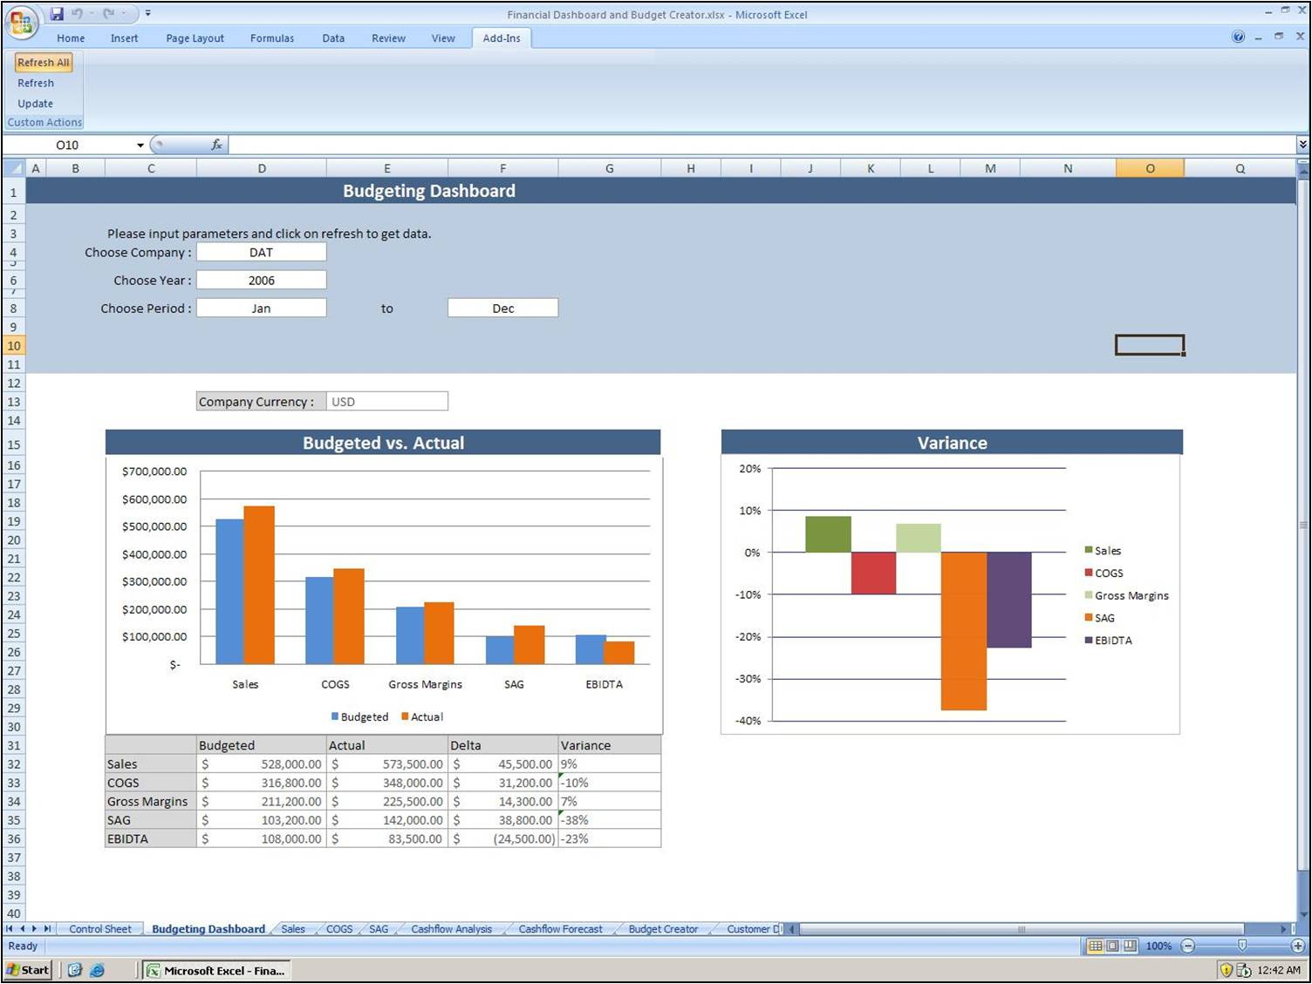
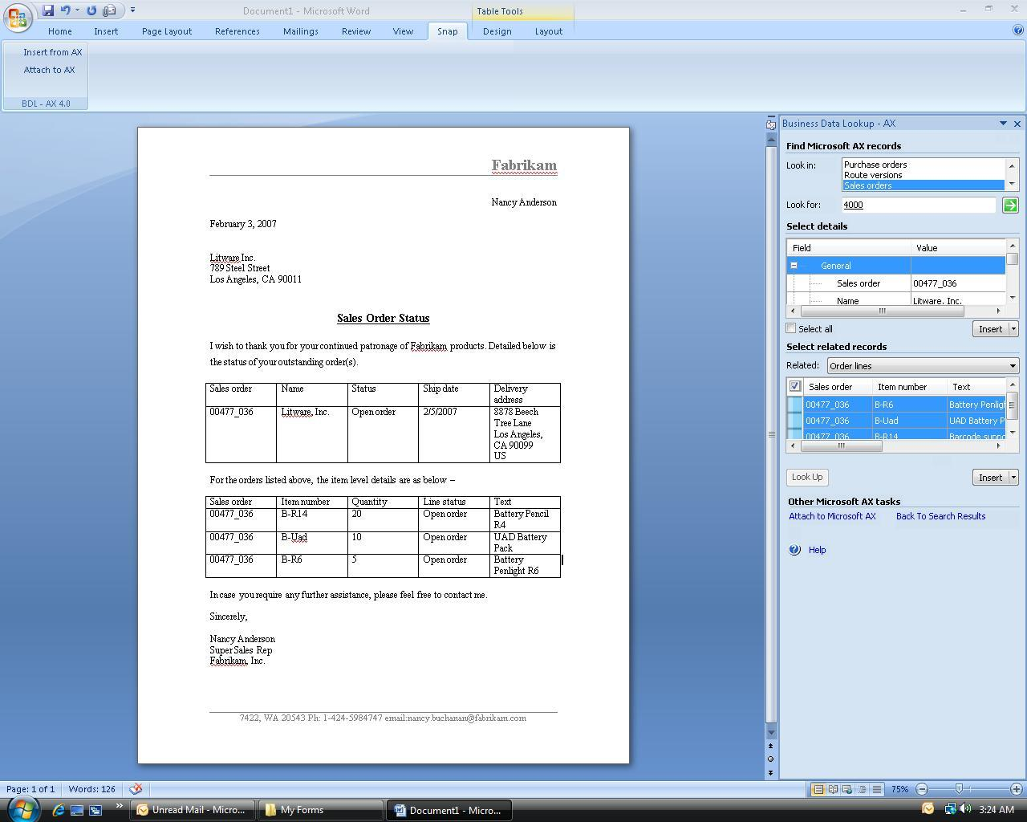
Easily find and insert Microsoft Dynamics data into documents with Business Data Lookup.

Custom Report Generator allows you to extract, view and analyze relevant data from Microsoft Dynamics in a neatly formatted Microsoft Office Excel report.
Timesheet Management allows an information worker to use their Outlook Calendar entries to submit timesheets without having to log into Microsoft Dynamics AX directly.

Vacation Management enables an information worker to use their Outlook Calendar to submit vacation requests without having to log into Microsoft Dynamics AX directly.

Expense Management allows an information worker to easily create, submit and approve or reject expense reports in SharePoint, without having to log into Microsoft Dynamics AX directly.

Customer Journal enables a salesperson to take an offline InfoPath record of all pertinent customer information to a sales meeting, access that information from their desktop, revise that information as needed, then synchronize their changes in the Microsoft Dynamics AX or Microsoft Dynamics CRM system once they are back online.

Visit us online at: http://www.microsoft.com/dynamics/product/snap.mspx

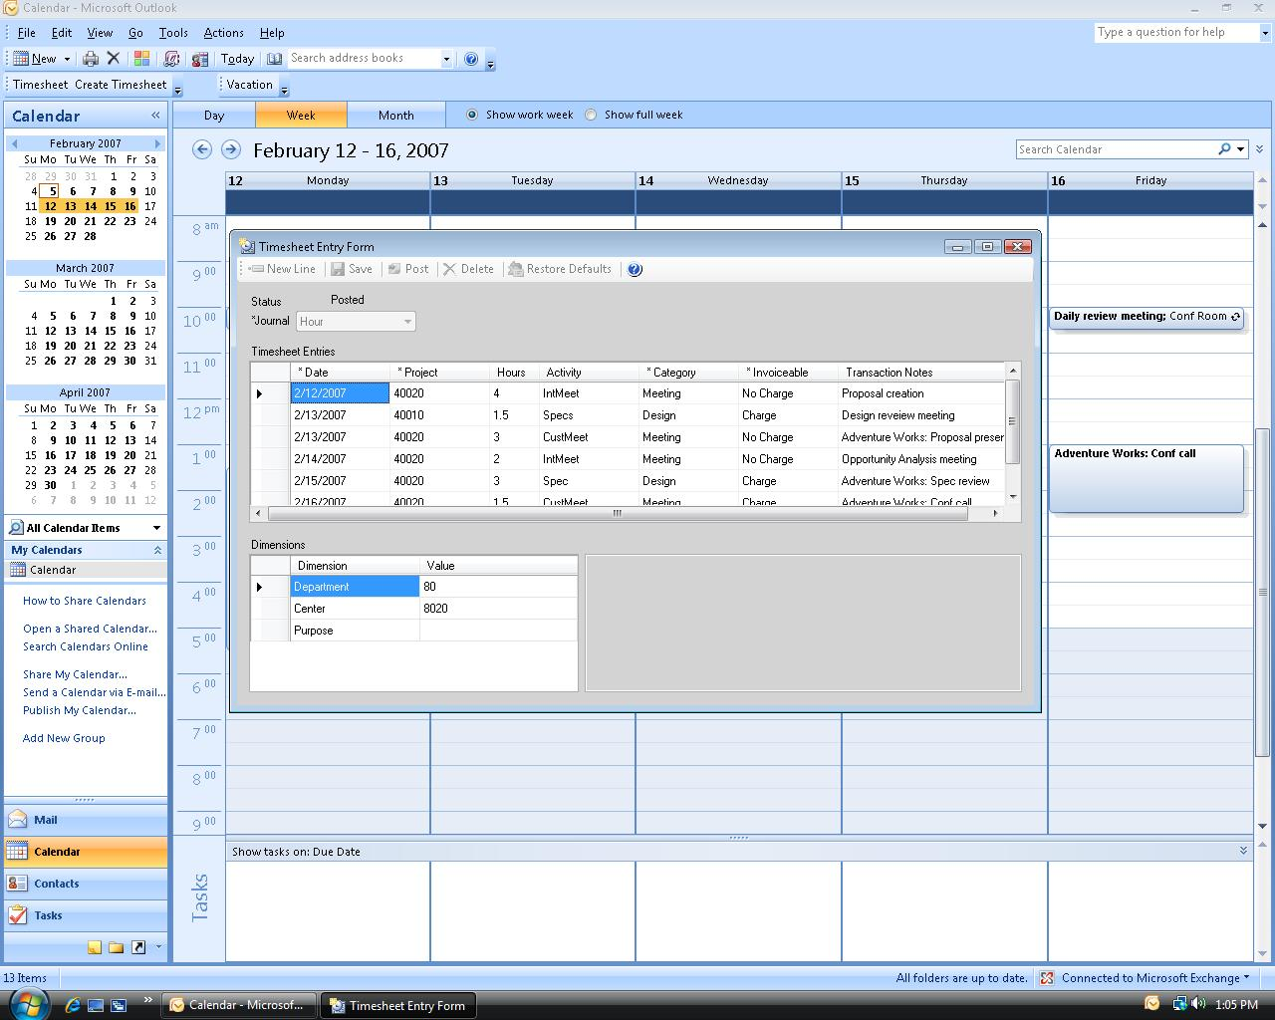
Create timesheets directly from Outlook calendar items with Timesheet Management.

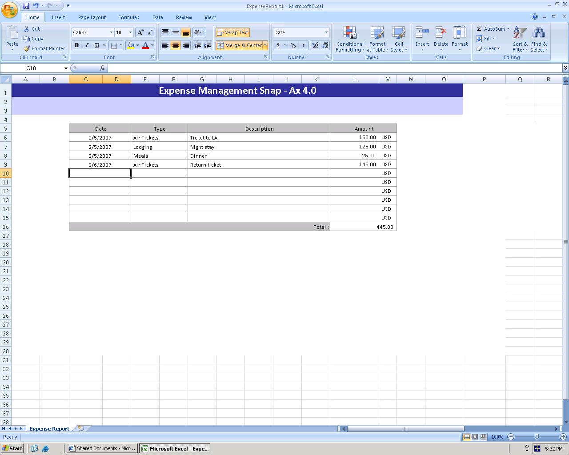

Expense Management--create, submit and approve or reject expense reports in SharePoint, without logging into Microsoft Dynamics AX.

This document is for information purposes only.
MICROSOFT MAKES NO WARRANTIES, EXPRESS, IMPLIED, OR STATUTORY, AS TO THE INFORMATION IN THIS DOCUMENT.

© 2005 Microsoft Corporation. All rights reserved.
Microsoft, The Microsoft Dynamics Logo, Microsoft, Microsoft Dynamics, Microsoft Dynamics AX, Microsoft Dynamics CRM, Microsoft Dynamics Snap, Microsoft Office, Microsoft Office Excel, Microsoft Office Outlook, Microsoft Office Word, SharePoint Server are either registered trademarks or trademarks of Microsoft Corporation or Microsoft Business Solutions ApS in the United States and/or other countries. Microsoft Business Solutions ApS is a subsidiary of Microsoft Corporation.

Microsoft Dynamics is a line of integrated, adaptable business management solutions that enables you and your people to make business decisions with greater confidence. Microsoft Dynamics works like and with familiar Microsoft software, automating and streamlining financial, customer relationship and supply chain processes in a way that helps you drive business success.

U.S. and Canada Toll Free 1-888-477-7989
Worldwide +1-701-281-6500
www.microsoft.com/dynamics

