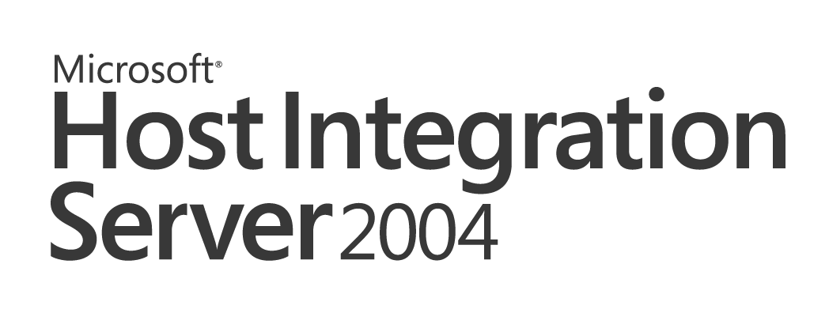

Integrating Enterprise Business Processes with Microsoft® Windows® Using
Host-Initiated Processing
Microsoft Host Integration Server 2004 Technical Article

Published: May 2004

Copyright
The information contained in this document represents the current view of Microsoft Corporation on the issues discussed as of the date of publication. Because Microsoft must respond to changing market conditions, it should not be interpreted to be a commitment on the part of Microsoft, and Microsoft cannot guarantee the accuracy of any information presented after the date of publication.
This White Paper is for informational purposes only. MICROSOFT MAKES NO WARRANTIES, EXPRESS OR IMPLIED, AS TO THE INFORMATION IN THIS DOCUMENT.
Complying with all applicable copyright laws is the responsibility of the user. Without limiting the rights under copyright, no part of this document may be reproduced, stored in or introduced into a retrieval system, or transmitted in any form or by any means (electronic, mechanical, photocopying, recording, or otherwise), or for any purpose, without the express written permission of Microsoft Corporation.
Microsoft may have patents, patent applications, trademarks, copyrights, or other intellectual property rights covering subject matter in this document. Except as expressly provided in any written license agreement from Microsoft, the furnishing of this document does not give you any license to these patents, trademarks, copyrights, or other intellectual property.
Unless otherwise noted, the example companies, organizations, products, domain names, e-mail addresses, logos, people, places and events depicted herein are fictitious, and no association with any real company, organization, product, domain name, email address, logo, person, place or event is intended or should be inferred.

© 2004 Microsoft Corporation. All rights reserved.
Microsoft, Active Directory, BizTalk, Outlook, Windows, and Windows Server are either registered trademarks or trademarks of Microsoft Corporation in the United States and/or other countries.
The names of actual companies and products mentioned herein may be the trademarks of their respective owners.

Table of Contents

Abstract 1
Introduction 1
IBM Legacy Application Processing Systems 2
Enhancement of Legacy Application Processing Systems 7
Integration Objectives 8
Using Host Initiated Processing 9
Conclusion 17

Abstract
This paper uses the example of communication between a central data center and multiple branch offices to describe how the Host-Initiated Processing (HIP) feature of Microsoft Host Integration Server 2004 enables such communication. It assumes that the external (branch office) sources of data are likely to be based on Windows-based computing solutions, while the central data center likely relies on legacy data storage systems. HIP makes it possible to bring data from external sources into the legacy batch processing flow without disrupting pre-defined automated processing schedules.
For the latest information, go to http://www.microsoft.com/hiserver.

Introduction
An important goal of a successful enterprise organization is to reduce costs and increase profitability. One approach to achieving this goal is to improve operating efficiencies and streamline the production process. A common obstacle to achieving this goal is the cost of integrating legacy data storage systems with newer, desktop systems often used at remote sites.
A typical enterprise organization might run its daily operations using “mission critical” applications composed of customized home-grown COBOL programs that run in an IBM MVS environment as either scheduled batch jobs or as online programs in CICS and IMS transaction programs. Such an organization faces the challenge of bringing data from external sources into the legacy batch processing flow without disrupting pre-defined automated processing schedules.
Those external sources are likely to be based on new Windows-based computing solutions, for example Microsoft SQL Server™ and BizTalk® Server that offer qualities such as performance, scalability, and reliability. Taking advantage of emerging Windows-based technologies and integrating them with legacy business processes can be daunting for most IT departments because the organization must invest in costly and complex development programs to build applications to achieve that integration.
Microsoft Host Integration Server 2004 offers a variety of tools that help you effectively and rapidly implement new integration solutions. The host-initiated processing (HIP) feature enables you to build applications that integrate resources like SQL Server databases, BizTalk orchestration schedules, BizTalk messaging, and Exchange Server with enterprise application processes that drive data acquisition from those Windows-based resources.
HIP is composed of three core features:
- Transaction Integrator Designer
Transaction Integrator enables you to build and deploy integrated business processes that are initiated from within IBM legacy batch processing jobs or CICS and IMS transaction manager environments so that they can easily and seamlessly access services and resources in the Microsoft Windows environment (for example, COM+, .NET, BizTalk Server).
- Transaction Integrator Manager
Use Transaction Integrator Manager to configure end-points, associate resources with requests, and define security and access rules. With TI Manager, you can easily integrate IBM client application programs and Windows services and resources.
- HIP Service
The HIP Service is a run-time service that manages the Windows communications end-point for accepting requests from programs in an IBM environment, presenting the request to a Windows resource, and returning the resulting information from the resource to the requesting IBM application program.
The following section describes a typical banking system that represents commonly used legacy implementation strategy for enterprise customers. The section illustrates how:
- Online and batch processing systems interact
- Remote sites and central data centers coordinate and integrate daily batches of data
- Knowledge workers use local and central data center services
The third section of this white paper describes how you can use HIP, along with other Microsoft technologies, to improve the overall data processing experience.

IBM Legacy Application Processing Systems
Today, enterprise organizations using IBM operating environments like MVS, CICS, and IMS need solutions for automatically incorporating data from remote sites and for integrating this information into existing business processing systems. Enterprise organizations are also interested in decoupling knowledge workers from constraints imposed by the data center’s schedules, resources, and computing capacity, especially when the processes are periodically run under control of an automated scheduling system.
The following three situations exemplify the need for solutions:
- Legacy batch processing systems need to routinely pull information from one or more remote sites.
- Existing batch processing systems or online transaction programs need to push periodic updates to the remote sites.
- Online transaction programs need to report, log, and/or notify knowledge workers of sales or business activity.
A typical enterprise organization uses a large IBM mainframe systems in a centralized data center that run MVS and z/OS and small and mid-range systems at remote sites that run OS/400, MVS, or z/OS.
The next four subsections of this white paper describe typical enterprise environment operations within a scenario of a banking system and the knowledge workers who interact with that system.

Legacy Online Activity
Figure 1 depicts an enterprise environment in which a central data center maintains the data store and legacy business rules in online processing systems. Daily transactions are collected and maintained in a data store for subsequent processing during off-peak hours. Businesses that typically operate under these rules include banks, insurance companies, subscription fulfillment firms and many others.
The figure illustrates a banking application for tellers, account officers, and a branch manager.
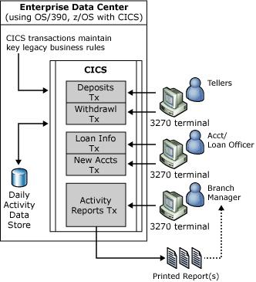
Figure 1. IBM legacy online transaction processing
Key activities illustrated include:
- Online bank teller activity occurs throughout the business hours using standard IBM 3270 terminal devices.
- Online loan officer activity occurs throughout the business hours using standard IBM 3270 terminal devices.
- Data is captured for later processing during off-peak hours. Legacy business rules are applied to the daily data captured during online entry.
- The branch manager requests periodic reports. These requests are made from standard IBM 3270 terminal devices to a CICS transaction. The reports are typically printed to an IBM 3270 printer at the remote location.
- The report is generated by the CICS transaction and sent to a standard IBM 3270 printer at the remote site. The branch manager can then review the printed report material.

Legacy Off-peak Batch Processing
Figure 2, continuing the banking application scenario, depicts the central data center that maintains the data store and legacy business rules in the batch processing system. The central data center uses the daily transaction activity from online processing and merges additional business data from branch offices.
When all daily activity is available, merging and final processing can continue. The final processing must be complete before the organization opens for business the next day. This makes the business processes very time sensitive.
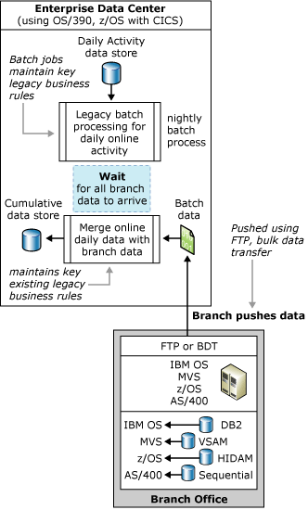
Figure 2. IBM legacy batch systems waiting for branch office data
The activities illustrated are:
- Data is collected from online activity processed during off-peak hours. Validation is performed by batch jobs which correlate and apply legacy business rules to this raw transaction data.
- The central data center includes the data from remote sites in the processing stream.
- The data center processing schedule is delayed until all the branch offices have delivered their daily data, typically through bulk data transfers (BDT), File Transfer Protocol (FTP), or file drop procedures. The length of the delay can be affected by geographic locations of the branch offices, staffing, and availability of the processing systems at the branch offices.
- Each branch office typically delivers its daily activity data through BDT, FTP, or file drop procedures that are manually initiated.
- Once all branch office data is available to the central processing system, the validated online activity data from the central data center and the remote site data are merged to produce a cumulative image of the daily activity.

Legacy Batch Processing Systems Update Branch Offices
Figure 3, continuing the banking application scenario, depicts subsequent business processes that occur after the cumulative data is available at the central data center.
Before the organization opens for business the following day, the data center must apply business rules to the cumulative data and must make the online systems available for the next day. Delays in this process can be expensive and can damage trust on the part of the branch offices.
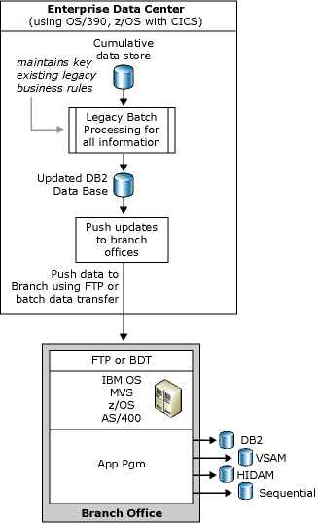
Figure 3. IBM legacy batch systems updating branch offices
The activities illustrated are:
- The cumulative data store is made available for continued processing. Legacy business rules are applied to the data through batch processing.
- Legacy business processes eventually update the central data center’s data repository.
- The final batch processing step is to distribute the information to the branch offices. This process is accomplished by techniques similar to those employed to initially receive the data from the remote sites (BDT, FTP or file drop).
- There can be logistics problems (from the central data center’s perspective) in getting the branch office data stores updated with accurate and timely information. The process can be affected by the reliability of the branch office operations staff and availability of their processing systems. If any one of the branch offices does not successfully receive and update the data stores, the business as a whole is adversely affected.
- Each branch office must receive the information and update its local data store.

Legacy Systems Handling Notification Requests
Additional work loads can be placed on the central data center’s processing capacity when knowledge workers request special information that is maintained in the central data center’s repositories. This information could be raw data, pre-processed data, or summarized reports.
In legacy processing systems there can be long delays between the time a request is made and the time the information can be delivered to the knowledge worker. These delays are typically due to limited central data center resources used to analyze the request and present the data or to limited processing capacity for handling special requests.
Figure 4, continuing the banking application scenario, depicts a typical delivery of information (such as sales forecast, financial updates, budget changes, and so on) to knowledge workers throughout the organization. Some of this information is ad-hoc in the sense that the knowledge worker can request the data on an as-needed or periodic basis.
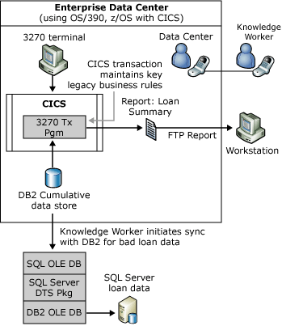
Figure 4. Manual process to handle notifications
The activities illustrated are:
- A knowledge worker calls the data center and makes a special request.
- The data center accepts the call, identifies the calling individual, and determines the nature of the request.
- The data center starts an online transaction to satisfy the request.
- The online transaction produces the requested information.
- Reports are sent to the requesting knowledge worker.
- The knowledge worker then begins a manual process to synchronize the data repository in the IBM environment (DB2) with the local repository (SQL Server). This allows the knowledge worker to produce custom reports that help improve the corporate processes (such as bad loans, mortgages, overdraft account, and so on).

Enhancement of Legacy Application Processing Systems
Currently, many enterprise organizations develop custom solutions to accomplish their integration goals. The typical solution involves developing batch application programs and jobs, online CICS and IMS application programs, and a combination of manual and automated scheduling processes. These custom application programs must take into account, and be programmed for, reliable data communications, accurate data conversion, source and target data mapping, and error recovery management.
The challenge for most organizations is to design and implement a comprehensive solution that is reliable and that seamlessly fits into the data center’s established legacy processing procedures and schedules. Technical issues surrounding this challenge include:
- Building customized reliable data transfer application programs and procedures.
- Allowing remote sites to use new emerging technologies (Windows, SQL Server, BizTalk Server, .NET, COM+) to improve operating efficiencies while maintaining compatibility with legacy data center processing procedures.
- Moving away from the manual scheduling procedure of legacy procedures to automated scheduling and automatic execution of new procedures associated with local or remote sites.
For organizations seeking the ease of use of the Windows Server operating environment, the use of .NET, COM, SQL Server and BizTalk Server are key to the organization’s ability to keep abreast of changing business needs, operating environments, and improved efficiency. An IT department needs a solution to ease the integration of these new technologies with the legacy business rules that are maintained in the enterprise centralized data center.
The HIP feature of Host Integration Server 2004 delivers a simple solution that enterprise organizations need to bridge the gap between the old and new technologies. HIP is highly scalable, high performing, robust, and easily administered for integrating legacy processing procedures with the Windows Server System environment.
The following section of this white paper describes how the use of HIP and .NET Integration can assist with these integration problems.

Integration Objectives
The objectives of this integration scenario that integrates legacy enterprise business processing systems and rules that are maintained in a centralized data center with remote site operations are:
- Use Microsoft technologies to improve site cost effectiveness, efficiency, and operations while allowing the central data center to maintain its investment in legacy business rules captured in the COBOL application programs.
- Provide seamless integration of existing data center processing procedures with new business systems written for Microsoft environments.
- Provide access to Microsoft Windows services through standard IBM operating systems, transaction manger facilities, and data sources that are familiar to individuals working in those IBM environments
- Allow the central data center to use less costly human resources to develop portions of the solution, reserving more expensive personnel resources to maintain the legacy systems and lend support to integration with new business rules on Microsoft Server platforms.
The next section describes how these objectives can be applied to assist an enterprise customer to improve business operations.

Providing Data Center and Remote Site Independence
The organization’s central data center is recognized as the reliable and secure place to maintain the corporate data. However, the task of satisfying special requests for data and information can be a timely and costly endeavor when performed by the staff at the data center itself. Remote sites are often better equipped for such tasks.
However, in cases where the remote sites are running small IBM systems (e.g. OS/400, OS/390, z/OS), the cost to maintain, enhance, and customize the application systems running there can be staggering. These costs include hardware, operating system software, and application systems. Perhaps the most costly are the human resources necessary to work on these legacy systems. The availability of knowledgeable COBOL programmer is low. People who can effectively and efficiently maintain MVS operating systems are rare, not to mention those who are competent in CICS and IMS system generation and maintenance.
The ability to quickly react to the customer needs is very difficult to achieve in the IBM operating environment. Using Microsoft technologies to run day to day business at remote sites allows those sites to improve their operating efficiency and enables them to gain flexibility, thereby establishing and providing a personal level of contact and support for their customers.
Integration of data between the data center and remote sites using Microsoft technologies must be seamless and efficient. Once this is accomplished the data center benefits from not dealing with special requests for information and the remote sites gain the flexibility to manage local business operations in a manner that is conducive to customer relations.

Using Host Initiated Processing
Insertion of host initiated processing (HIP) into the legacy business processing model can streamline the data centers operations with little impact on legacy system processing architecture.
The banking scenario described in the first half of this white paper can be improved by:
- Replacing legacy remote site operating environments with streamlined systems based on Microsoft technologies (Windows Server 2003, .NET Framework, COM+, SQL Server, BizTalk Server)
- Allowing the knowledge worker to subscribe, using the Transaction Integrator feature, to data and information that is maintained by the central data center and updated on a periodic basis
- Using HIP to systematically pull data from remote sites
- Using HIP to systematically update remote site data stores
- Using HIP to notify knowledge workers on information availability
- Using HIP to automatically deliver or synchronize custom data with the knowledge worker
The following subsections describe a system, like the one outlined in the first half of this white paper, that takes advantage of the capabilities of the Host Integration Server 2004 HIP feature.

Subscribing to Data Center Services
It is very time and resource intensive for a knowledge worker to repeatedly request data and/or information from a data center. The .NET Integration feature of Host Integration Server 2004 enables the knowledge worker to use Microsoft technologies to make such a request just one time. Once the request is made, the central data center can periodically deliver the information to the knowledge worker any time that it is available.
Figure 5 illustrates this process.
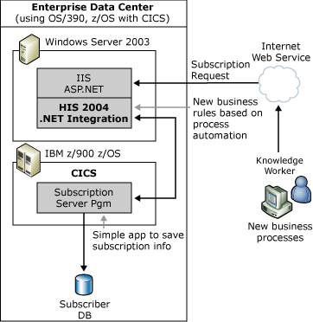
Figure 5. Subscribing to the central data center for notifications

The key activities illustrated in this figure are:
- The knowledge worker uses Microsoft technologies to manage customer relationships and business processes at the remote site.
- The knowledge worker uses the .NET Framework and the Host Integration Server 2004 .NET Integration Web Service to build new business rules and to subscribe to the central data center for periodic custom information updates and other organization notifications.
- The new business rules are based on the .NET Framework and Web Services that are part of the Host Integration Server 2004 .NET Integration feature.
- The Host Integration Server 2004 .NET Integration object executes a CICS subscription transaction that records the subscription request.
- The request is recorded to a subscriber data base for later use in the existing business processing system.

Legacy Online Activity
Figure 6 depicts an enterprise environment in which a central data center maintains the data store and legacy business rules in online processing systems. Daily transactions are collected and maintained in a data store for subsequent processing during off-peak hours. Businesses that typically operate under these rules are banks, insurance companies, subscription fulfillment firms and many others similar businesses.
The diagram illustrates a banking application for tellers, account officer, and a branch manager. This enhanced online transaction processing system uses HIP to automatically deliver report data to a Web site so that branch managers and knowledge workers can access the information using robust new technologies that provide high availability.
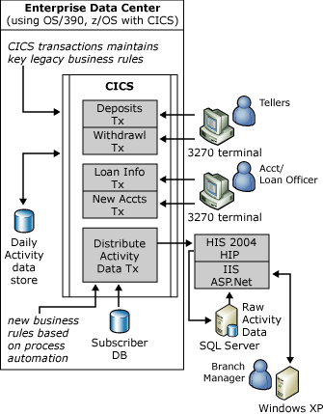
Figure 6. Online transaction processing
The key activities illustrated are:
- Online bank teller activity occurs throughout business hours using standard IBM 3270 terminal devices.
- Online account and loan officer activity occurs throughout business hours using standard IBM 3270 terminal devices.
- Data is captured for later processing during off-peak hours. Legacy business rules are applied to the daily data captured during the online entry.
- Based on subscription information provided at an earlier time, an online transaction constructs a report or raw data that is automatically delivered, using HIP, to a predefined Web site or Web service.
- Custom reports can be generated by a knowledge worker to meet customer needs. A branch manager can either view the requested reports through an easy-to-use Web service or gain access to raw data on the Web site. The availability of the data on the Web site is now independent from the central data center’s schedule.

Automated Accumulation of Business Data
While the process of subscribing to the central data center for updates is driven by the knowledge worker, the process of accumulating daily data from the remote sites should be under control of the central data center. The central data center’s control of the data acquisition process removes barriers to timely processing of all data by the organization as a whole.
The needs of remotes site are much different. They need to have their daily data available from the central data center when they need it, which is typically outside the normal business hours for the remote site.
The remote sites also need to have the freedom and flexibility to develop new business rules that improve the customer partnerships. The use of Microsoft technologies such as SQL Server, BizTalk Server, .NET Framework, and Web Services can help the remote sites achieve their specialized and responsive needs.
The HIP feature brings together these disparate processing models by providing a means to easily insert steps into a legacy batch processing systems that can retrieve data from an intelligent remote site and seamlessly present the data to an existing business process.
Figure 7 illustrates this integration.
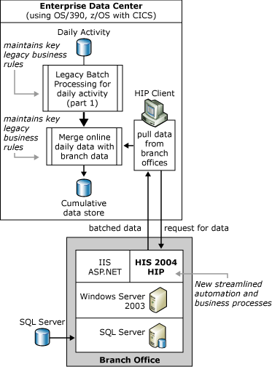
Figure 7. HIP Retrieving Data from Branch Office
The key activities illustrated are:
- The daily online activity data is presented to the batch processing system that is run during off-peak hours. Validation, correlation, and the merging of business rules are applied to this data in preparation for subsequent processing.
- A step (an application program), which acts as a HIP client, is inserted into the legacy batch processing system to retrieve data from each remote site. This application program can be written in languages that are comfortable to people who work in IBM environments (for example, COBOL). This step in the legacy batch processing system contacts each sites and retrieves the daily data.
- The central data center processing does not have to “wait” for the remote site to deliver the data.
- The remote site does not have to be attended.
- The HIP client accepts the request and activates the COM+ or .NET object and returns data in a form that is native to the legacy IBM operating environment (for example, COBOL copybook data constructs). This information is then presented to the existing batch processing system (usually in the form of a sequential file).
- The daily data from the central data center and the remote sites are merged into a cumulative data store that is maintained at the central data center.

Distribution of Information by Pushing Updates
Figure 8 depicts subsequent business processes performed on the cumulative data collected by the central data center. Before the organization opens for business the following day, the data center must apply its business rules against the cumulative data and make the online systems available for the next day of business.
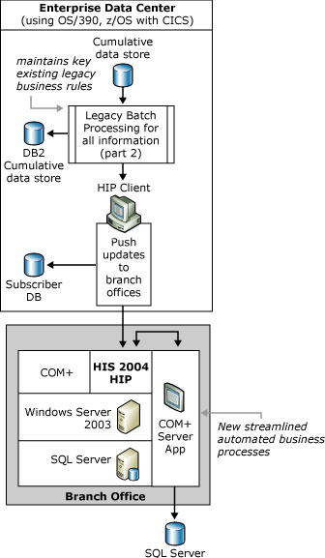
Figure 8. HIP Updating Data at a Remote Site
The key activities illustrated are:
- The cumulative data store is available for continued processing at the central data center. Legacy business rules are applied to the data and the central data store is updated.
- A batch processing step uses the information that was previously entered into the subscription database to distribute the updates to the remote sites.
The batch processing step eliminates the need for manual or attended operations at the remote site by using HIP to automatically push the updates to the Windows environments.
Each remote site uses a HIP server application to automatically receive the updates and apply them to the local data store.

Distribution of Information by Pulling Updates
Figure 9 depicts a process by which SQL Server uses notification messages to inform knowledge workers that product processing or requested data is available and to initiate the data synchronization process between central and remote site repositories.
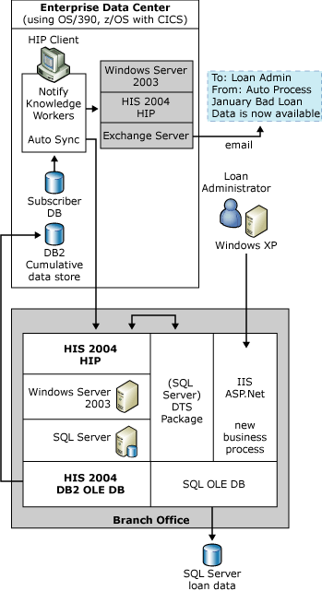
Figure 9. HIP Notification and Auto Sync Between DB2 and SQL
The key activities illustrated are:
- HIP is used to start two concurrent processes. This batch processing step sends a notification e-mail message to knowledge workers who previously subscribed for such messages. It also initiates the automatic synchronization of the updated DB2 data store on the IBM mainframe with the remote site SQL Server repository.
- The HIP client delivers a message, generated from a COBOL program, to a Windows COM or .NET object through HIP. This object interprets the message and delivers a message through Exchange Server to notify a set of knowledge workers that specific business processes have been completed.
- At the same time, the HIP client initiates a DTS Package in COM+ that uses the HIS DB2OLEDB and SQLOLEDB providers to automatically retrieve data from DB2 and update the SQL repository.
- Finally, the knowledge worker uses Web services to access the information in the updated SQL repository, independently of the central data center’s schedule and availability.

Conclusion
Host Integration Server 2004 Transaction Integrator (TI) and host-initiated processing (HIP) enable IBM legacy application developers, Windows application developers, Web publishers, and line-of-business managers with a means to access and integrate their mission critical business systems with new solutions built on top of Windows Server System platform in a bidirectional manner.

To learn more about Microsoft Host Integration Server, visit the Microsoft Windows Server System site at http://www.microsoft.com/hiserver.

