Overview  Country or Region: Australia  Industry: Professional services—Architecture, engineering, and related services  Customer Profile  WorleyParsons is a leading provider of engineering design and project services. The company’s 31,700 employees work from 114 offices in 37 countries.  Business Situation  WorleyParsons needed to update its Web site to reflect its current image and to simplify Web content management so that changes could be made to content without draining IT resources.  Solution  WorleyParsons used Microsoft® Office SharePoint® Server 2007 as the infrastructure for its new Web site. Now, content authors can update Web pages with minimal IT involvement and optimal results.  Benefits  - Simpler Web site management  - Better site design, higher Web traffic  - Accelerated deployment time  - More than 24 hours saved each week  - More reliable infrastructure |  |  | “With SharePoint Server 2007, I’ve been able to delegate site management tasks to other staff and the time it requires is very minimal.”  Gavin Wall, SharePoint and Collaboration Specialist and Corporate Development Team Lead, WorleyParsons
 |  |  | WorleyParsons, a provider of professional services to the energy, resource, and complex process industries, has grown substantially through a series of mergers and acquisitions. To best reflect its international presence, and to be able to publish information in a timely manner, the company had to replace its outdated Web site. WorleyParsons used Microsoft® Office SharePoint® Server 2007 as the foundation for its new Web site. In less than three months, the company launched a new global corporate site, with tools that allow users to seamlessly publish content to WorleyParsons.com—with minimal involvement from IT. The publishing process is so much simpler that the company saves three days of time each week among IT and marketing personnel responsible for the publishing process.
 |  |  | 

Situation
“Content changes were very time consuming. I spent about five hours a week helping to implement them.”
Gavin Wall, SharePoint and Collaboration Specialist and Corporate Development Team Lead, WorleyParsons

WorleyParsons [ASX:WOR], headquartered in Australia, is one of the world’s leading engineering design firms. Its 31,700 personnel provide engineering design and project services from 114 offices in 37 countries. In 2007, the company’s net profits after tax were AU$343.9 million (U.S.$219.2 million).

WorleyParsons has grown rapidly through a series of mergers and acquisitions that began when the company became publicly listed on the Australian Securities Exchange (ASX). With more and more offices and projects emerging around the world, it became increasingly important that the company be able to communicate its vision in a consistent manner to a growing customer base. “One of our biggest problems, content-wise, was that when the old WorleyParsons Web site was created it reflected an Australian company without a large global presence,” says Gavin Wall, SharePoint and Collaboration Specialist and Corporate Development Team Lead at WorleyParsons, who works from the company’s office in Perth, Western Australia. “We also weren’t conveying as professional an image as we wanted,” says Wall, who along with Chanel Jones, Marketing Coordinator in the WorleyParsons Corporate Marketing department, also located in Perth, is responsible for managing content updates to the corporate Web site.

Most importantly, the company needed to be able to quickly publish investor-related information to the site. “This is a rapidly changing area of WorleyParsons.com. We regularly post ASX announcements on the Investor Relations area of the site.” Wall and Jones previously published this information as a series of static Portable Document Format (PDF) files that were accessible through a long list of links. “It’s easy to publish a PDF file, but it wasn’t the most effective way to communicate our news to our audience.”

The technology behind the WorleyParsons Web site was also outdated. “It was a custom built, in-house solution,” says Wall. The Web servers ran the Windows® 2000 Server operating system, and the site was comprised of static Hypertext Markup Language (HTML), older Microsoft®.NET Framework–based code, and a flat file structure that used page ID numbers to map links among pages. There was no site hierarchy. Content was stored in a custom list based on Windows SharePoint® Services 2003, and for editing, was pushed into a page template as HTML on live, production Web servers.

“When editing content, I had to preview changes on the live site,” says Jones. “Little problems could easily become big problems if I made a mistake. It was not a user-friendly process.” Jones was the only non-IT person in the company of more than 31,000, who understood the full process for updating site content. She estimates that making changes to the site required almost eight hours of her time each week. “And I couldn’t delegate any of the tasks. It was a liability. It really limited our ability to react quickly and keep our communications to our customers up to date.” Jones relied on Wall and his Information Communications and Technology (ICT) team to help her implement each and every update.

“Content changes were very time consuming. I spent about five hours a week helping to implement them,” says Wall. “We needed a more automated, delegated authoring process that also ensured that changes were being made according to company standards,” says Wall. Another developer on the ICT team also spent one day a week, or more, maintaining code on the site. Between Jones and ICT, it wasn’t unusual for three days of staff time per week to be spent on content updates and site maintenance.
Wall and the ICT team wanted to implement a Web site that was more flexible, and more available. The site required time-consuming IT maintenance, and because it wasn’t hosted in a redundant fashion, it didn’t provide for high uptime. “We needed a site infrastructure that could better serve the business and extend to meet future needs,” says Wall.

Finally, WorleyParsons needed to launch a new site in less than three months. The company was in the midst of a brand refresh effort—an annual project that occurs in time with the publishing of the company’s annual report. “We planned to pull a lot of the content from the annual report into the new site, and to launch the site to coincide with the release of the annual report,” explains Jones.
“Most people in the company are familiar with Office SharePoint Server 2007. We knew that this would simplify the training process of future content owners.”
Chanel Jones, Marketing Coordinator, WorleyParsons

Solution
WorleyParsons decided to use Microsoft Office SharePoint Server 2007 as its new Web content management system. “WorleyParsons has a long history with SharePoint products and technologies,” says Wall. “We’ve used the tools internally for collaboration since they were first released.”

“Most people in the company are familiar with Office SharePoint Server 2007,” says Jones. “We knew that this would simplify the training process of future content owners.”

WorleyParsons uses Office SharePoint Server 2007 to manage its internal knowledge base, and to collaborate during the proposal-creation process. It also uses Office SharePoint Server 2007 for collaboration with external partners, and to manage an internal news site that aggregates announcements from the company’s widespread locations and makes them available from a centralized, Web-based interface. “The internal news system was our first foray into content management in Office SharePoint Server 2007,” says Wall. “It allowed us to flex the product’s muscles and gave us the confidence that we could successfully use the software to build and manage our external site.”

In May 2009, WorleyParsons engaged SSW, a Sydney-based IT consulting company and Microsoft Gold Certified Partner specializing in solutions built on the Microsoft .NET Framework. Office SharePoint Server 2007 is built on Microsoft ASP.NET 2.0, part of the .NET Framework. With the company’s annual report slated for release in early August, WorleyParsons had ten weeks in which to complete development and to deploy the new Web site. In this short time, the partner helped WorleyParsons create custom page layouts using prebuilt Master Pages and Page Layouts in Office SharePoint Server 2007. The partner also integrated into the templates a design guideline that was developed by the company’s brand consultant, WalterWakefield. This enables content owners—even if they are operating from different business groups across the company—to easily publish content while maintaining a consistent look and branding across the entire site. Finally, the partner also created reusable page elements, such as banner ads, that can be dropped into Web pages on an as-needed basis.

WorleyParsons uses out-of-the-box workflows in Office SharePoint Server 2007 to implement Web content updates. Content authors initiate changes, such as editing an existing page or creating a new page, from a document list in Office SharePoint Server 2007. Users edit content within the body of a page using a rich, Web-based editor. (See Figure 1.) This initiates a workflow process, which ensures that the changes are reviewed by the Strategic Marketing Team in Perth, Australia. The workflow automatically triggers e-mail messages to those involved in content review, notifying them their attention is required. Once approved and published by Strategic Marketing, the new content is published to the corporate Web site.
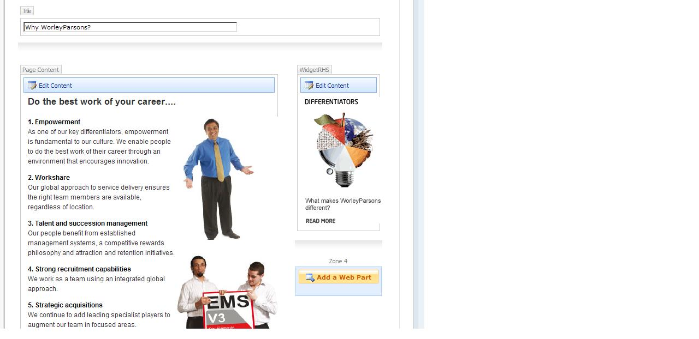

In early August, in time with the release of its annual report, WorleyParsons launched its new Web site.

The Web site infrastructure includes three Dell PowerEdge 1950 dual core servers with 4 gigabytes (GB) of memory running the Windows Server® 2003 R2 operating system. Office SharePoint Server 2007 runs on these servers. Two are dedicated front-end Web servers, and the third functions as the Office SharePoint Server 2007 search and indexing server. Dell PowerEdge 2950 quad core servers with 16 GB of memory, in a clustered configuration, connect to these servers, also running Windows Server 2003 R2; they function as the site’s database servers and use the Microsoft SQL Server® 2005 Enterprise Edition data management software.

WorleyParsons has yet to provide access to the new Web content management environment to all of its locations, but it has introduced Strategic Marketing in Australia to the new publishing system. In addition to being involved in the review process, employees at the head office in Sydney are in charge of uploading ASX announcements. Jones conducted a brief training session with the Sydney office, through a remote desktop sharing session using the Microsoft Office Communicator 2007 unified communications client. “I ran them through the lifecycle of creating a news page from scratch,” says Jones. “It’s really no more complicated than uploading a PDF, but with a more visually appealing result.”
Figure 1. WorleyParsons.com editing environment in Office SharePoint Server 2007.

Benefits
By using Office SharePoint Server 2007 for its customer-facing Web site, WorleyParsons has simplified Web content management processes companywide. Managing content on the new site requires significantly less time from IT, and from marketing. And, the image of WorleyParsons conveyed via the Web is much improved, resulting in an increase of visitors to the site. Finally, the new site infrastructure provides for easier IT maintenance, less downtime, and can scale to meet future needs.

Simpler Web Site Management
Managing site updates is much simpler for WorleyParsons with Office SharePoint Server 2007 than in its former, HTML-based environment. Jones no longer has to edit actual site code. The new site requires no knowledge of coding environments because it provides a Web-based editor that supports tables, and tools for checking spelling. Through the editing environment, Jones and other content authors can access reusable images and other content. Users edit directly within the context of a Web page, which accurately reflects how the page will look when posted to the live site. “In Office SharePoint Server 2007, page editing is very simple,” says Jones. “I can create a draft and see how the changes will look without having to edit live pages.” Of the remote training session she conducted with users in Sydney, Jones says, “It was a very smooth training session. These are people who are not familiar with complex Web site editing. They understood the process and used it almost instantly.”
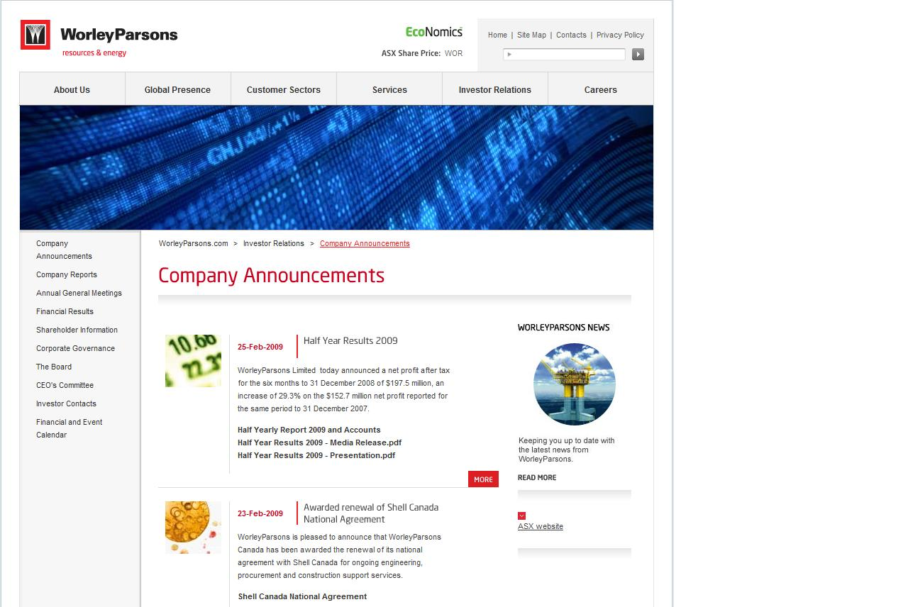

The newfound simplicity means that Jones is no longer the only non-IT person in the company who can make changes to the Web site. And the new environment also makes Web content management simpler for IT. In Office SharePoint Server 2007, the WorleyParsons authoring site is separate from the live, production Web site. “We’re able to do things we couldn’t easily do before,” says Wall, “Like quickly revert to an older draft of a Web page if necessary.” Also, maintaining the navigational structure of the site, that is, the relationships among inter-linked pages, is much simpler. “The new site has a structure that reflects the logical structure of the content. This makes maintaining the navigation much easier,” explains Wall. The site is no longer based on a series of static links that must be carefully maintained by IT.
“In Office SharePoint Server 2007, page editing is very simple.”
Chanel Jones, Marketing Coordinator, WorleyParsons

Better Site Design, Higher Web Traffic
The editing simplicity hasn’t sacrificed anything in the way of design; in fact, the new look and feel of the WorleyParsons Web site is greatly enhanced. Content authors have a number of different page layouts to choose from as they build Web pages. “There is a lot of variety,” says Jones. “We can easily choose different designs for different types of pages—but because they are all standardized, we know that all of the designs meet corporate branding requirements.”
Figure 2. Company Announcement page in Investor Relations area of WorleyParsons Web site.
The templates allow for a more interesting page layout. For instance, on the Investor Relations area of the Web site, ASX news announcements include an introductory paragraph, related links, and images. “It’s a much more professional look,” says Wall. “Much better than a long list to links of PDF files.” (See Figure 2.) In the month after the new site was launched, WorleyParsons experienced a 17 percent increase in unique visitors to the corporate Web site. Page views increased by 41 percent, and the time visitors spent on the site increased by 39 percent.

Accelerated Deployment Time
From start to finish, WorleyParsons built and deployed its new Web site in 10 weeks. “It was a massive achievement by all involved,” says Wall. The company’s familiarity with the Office SharePoint Server 2007 environment, and the ease of use of the new Web content management tools, helped Jones, Wall, and the ICT staff meet the deadline for launching the new site. “Because of our prior knowledge of SharePoint, we were able to easily populate the Web site with content during development, saving a significant amount of time,” says Jones.
“With Office SharePoint Server 2007, I save nearly a full day each week.”
Chanel Jones, Marketing Coordinator, WorleyParsons

More than 24 Hours Saved Each Week
Among Jones, Wall, and the rest of the ICT team, WorleyParsons saves approximately three days each week because Office SharePoint Server 2007 provides a much simpler Web content management environment. “Towards the end of the life of our old system, I was one of the only people familiar enough with it to successfully manage it. It required a great deal of my time. With Office SharePoint Server 2007, I’ve been able to delegate site management tasks to other staff and, the time it requires of them is very minimal.” Using the same platform—Office SharePoint Server 2007—for both WorleyParsons’s intranet and Internet presence, means that the company has one less system to maintain. “By eliminating the old Web platform, we’ve been able to reduce the number of systems in our IT catalogue of services,” says Wall. He claims that between himself and other System Administrators, the ICT team saves approximately two days each week. “The time it used to take us to administer the old site is time we can devote to other tasks.”

In addition, Jones saves almost eight hours of her time each week, due to the simplified editing process. “With Office SharePoint Server 2007, I save nearly a full day each week,” says Jones. “I manage content on both the external site and the intranet site. With both systems now based on SharePoint Server 2007, it’s much easier for me to get information out there faster. As a business, we can react much more quickly to change.”

More Reliable Infrastructure
In adopting Office SharePoint Server 2007 as its backbone for Web content management, WorleyParsons seized the opportunity to create a highly adaptable, highly available Web site infrastructure. “We’ve separated the search roles from the Web front-end,” says Wall, “and everything is load balanced with built-in redundancy. The configuration and the capacity of SharePoint Server 2007 and SQL Server provide us with a very scalable environment. We can perform maintenance with minimal downtime, we can support many more Web site visitors, we can customize workflows to meet changing business requirements, and we can add more functionality without causing a drain on our IT resources.”

Microsoft Office System
For More Information
For more information about Microsoft products and services, call the Microsoft Sales Information Center at (800) 426-9400. In Canada, call the Microsoft Canada Information Centre at (877) 568-2495. Customers who are deaf or hard-of-hearing can reach Microsoft text telephone (TTY/TDD) services at (800) 892-5234 in the United States or (905) 568-9641 in Canada. Outside the 50 United States and Canada, please contact your local Microsoft subsidiary. To access information using the World Wide Web, go to: www.microsoft.com

For more information about WorleyParsons products and services, call (+61) 2 8923 6866 or visit the Web site at: www.worleyparsons.com

The Microsoft Office system is the business world’s chosen environment for information work, providing the programs, servers, and services that help you succeed by transforming information into impact.

For more information about the Microsoft Office system, go to:
www.microsoft.com/office
Software and Services  - Microsoft Office  - Microsoft Office SharePoint Server 2007  - Microsoft Office Communicator 2007  - Technologies  - Microsoft .NET Framework 3.5 | - Microsoft Server Product Portfolio  - Windows Server 2003 R2  - Microsoft SQL Server 2005  Hardware  - Dell 1950 and 2950 PowerEdge server computers

This case study is for informational purposes only. MICROSOFT MAKES NO WARRANTIES, EXPRESS OR IMPLIED, IN THIS SUMMARY.

Document published June 2009

