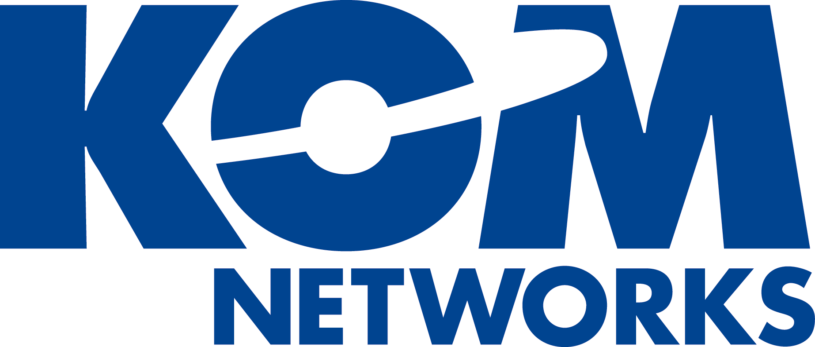
Tel: (613) 599-7205
Fax: (613) 599-7206
www.komnetworks.com
info@komnetworks.com


News Release

Hard Disk Archiving (e-WORM) for Windows Storage Server 2003 R2 unveiled at SNW

SAN DIEGO and OTTAWA– April 4, 2006: KOM Networks Inc., an innovative provider of Data Archiving solutions and Storage Management software, is showcasing its KOMworx e-WORM hard disk archiving software, designed to leverage customer investment in Microsoft Windows Storage Server 2003 R2, at the SNW Conference in San Diego, CA, from April 3rd to 6th 2006.

The KOMworx hard disk archiving (e-WORM) solution interoperates with Windows Storage Server 2003 R2 to transform standard disk hardware into non-rewriteable, non-erasable storage media, enabling companies to meet stringent compliance regulations such as HIPAA, SEC 17a-4, Sarbanes-Oxley, DoD 5015.2, and NASD.

Incorporating the familiarity and simplicity of the Windows environment, KOMworx brings a complete range of storage management capabilities to the Windows Storage Server 2003 R2, including transparent archiving, automated retention, policy driven ILM and dynamic capacity management. Like the Windows platform, KOMworx is hardware independent, and easily integrates with e-mail archiving, ECM, DMS and vertical applications in organizations such as hospitals and financial institutions.

“KOMworx brings additional value to customers using Windows Storage Server 2003 R2 by allowing them to implement long term archiving of fixed content data on Hard Disk, ensuring data security and data accessibility while maintaining Hard-Disk performance,” said Dr. Claude Lorenson, group product manager, Storage Technologies at Microsoft Corporation.
“The open systems architecture used by KOMworx provides significant advantages for customers wishing to capitalize on their investment in Windows, whether it be creating a Virtual Volume storage solution using their existing hardware of choice, or implementing a compliance strategy,” said Kamel Shaath, CTO of KOM Networks. “KOMworx adaptive design enables customers to combine various storage technologies, including hard disk, SAN and NAS, into a single global namespace that is easy managed through policies and a graphical user interface.”

About KOM Networks
KOM Networks, founded in 1969, is the world leader of innovative storage management software solutions. Pioneers of Data Protection & Retention, KOM Networks’ products provide Compliance, Archiving and Information Lifecycle Management (ILM) to over 10,000 installations globally. KOM Networks products are delivered through a worldwide network of value-added resellers, strategic partnerships and alliances.

KOM Networks’ easy-to-integrate products let you Simply Manage, Protect, and Serve STORAGE, The Way You Want It. For more information please visit www.komnetworks.com.

Contact information: KOM Networks, Marketing Department

Tel: +1 (613) 599-7205
Fax: +1 (613) 599-7206
Email: info@komnetworks.com
Website: www.komnetworks.com

About Microsoft
Founded in 1975, Microsoft (Nasdaq “MSFT”) is the worldwide leader in software, services and solutions that help people and businesses realize their full potential.

