

Enterprise Digital Media Solution Guide
Part Three: Infrastructure
Produced by:
Microsoft—Windows Digital Media Division
Hewlett-Packard—Industry Standard Server Group
Approach Inc.

March 2004

Applies to:
Microsoft® Windows Media® Encoder 9 Series
Microsoft Windows Media Services 9 Series
Microsoft Windows Media Player 9 Series
Microsoft Producer for PowerPoint® 2003
Microsoft Windows Media Digital Rights Manager 9 Series SDK
Hewlett-Packard ProLiant servers
Hewlett-Packard ProLiant Essentials software

Summary: This paper describes the technical architecture and design considerations for implementing an enterprise digital media solution that supports content creation, content distribution and management, playback, security, and networking. Three common enterprise scenarios are reviewed to help you understand what considerations are necessary when deploying a digital media solution comprised of products and technologies from Microsoft and Hewlett-Packard. This paper is written for persons who have experience designing IT solutions. (42 printed pages)

Legal Notice
This is a preliminary document and may be changed substantially prior to final commercial release of the software described herein.
The information contained in this document represents the current view of Microsoft Corporation on the issues discussed as of the date of publication. Because Microsoft must respond to changing market conditions, it should not be interpreted to be a commitment on the part of Microsoft, and Microsoft cannot guarantee the accuracy of any information presented after the date of publication.
This White Paper is for informational purposes only. MICROSOFT MAKES NO WARRANTIES, EXPRESS OR IMPLIED, AS TO THE INFORMATION IN THIS DOCUMENT.
Complying with all applicable copyright laws is the responsibility of the user. Without limiting the rights under copyright, no part of this document may be reproduced, stored in or introduced into a retrieval system, or transmitted in any form or by any means (electronic, mechanical, photocopying, recording, or otherwise), or for any purpose, without the express written permission of Microsoft Corporation.
Microsoft may have patents, patent applications, trademarks, copyrights, or other intellectual property rights covering subject matter in this document. Except as expressly provided in any written license agreement from Microsoft, the furnishing of this document does not give you any license to these patents, trademarks, copyrights, or other intellectual property.
© 2004 Microsoft Corporation. All rights reserved.
Microsoft, MS-DOS, Windows, Windows Media, Windows NT, Windows Server, Active Directory, ActiveSync, ActiveX, Direct3D, DirectDraw, DirectInput, DirectMusic, DirectPlay, DirectShow, DirectSound, DirectX, FrontPage, HighMAT, JScript, Microsoft Press, MSN, NetShow, Outlook, PowerPoint, Visual Basic, Visual C++, Visual InterDev, Visual J++, Visual Studio, WebTV, Win32, and Win32s are either registered trademarks or trademarks of Microsoft Corporation in the U.S.A. and/or other countries.
The names of actual companies and products mentioned herein may be the trademarks of their respective owners.
The information in this document is subject to change without notice. HP and the HP logo are registered trademarks of Hewlett-Packard Company.

Contents
Introduction 1
Taking an Infrastructure Approach 1
Content Creation and Capturing 2
Content Distribution and Management 3
Enterprise Scenarios 5
E-Learning for a Small Enterprise 5
Business Challenge 5
Opportunity 5
Solution 5
Broadcast Communications and E-Learning for a Medium Enterprise 8
Business Challenge 8
Opportunity 8
Solution 8
Sales and Marketing—Product Launch for a Large Enterprise 12
Business Challenge 12
Opportunity 12
Solution 12
Enterprise Digital Media Infrastructure 14
Content Creation 15
Studio Integration 15
Encoders 16
Content Distribution and Management 17
Origin and Edge Windows Media Servers 18
Load Balancing 18
Cluster 18
Cache vs. Proxy 18
Network Protocols and Design 19
RTSP 20
MMS 21
HTTP 21
UDP 21
TCP 21
Unicast and Multicast 22
Firewall Traversal 24
Security 24
Authentication 25
Authorization 25
Digital Rights Management (DRM) 26
Systems Management 26
Deployment and Migration 27
Scalability and Performance 27
Understanding Hardware Requirements for a Digital Media Infrastructure 27
Estimating Maximum Concurrent Usage 28
Planning the Cache Hit Ratio 29
Calculating Fault Tolerance 29
Enterprise Deployment 30
Phase 1—Requirements, Architecture, and Preliminary Design 30
Phase 2—Final Design, Build, Implementation, and Pilot 31
Microsoft and HP Technologies for Digital Media Solutions 32
Content Creation 32
Content Distribution and Management 33
Playback Experience 34
For Additional Information 34

Introduction
In today's always-on, dynamic, global environment, the demands on the (information technology (IT) infrastructure continue to grow. The demand for digital media-based solutions continues to increase from groups within the enterprise as enhanced communication and education capabilities are required. These requests vary from encoding ad-hoc video content to deploying a complete learning management system. For IT departments, these requests can be challenging as requirements are not always well-defined, and technology may not be well understood.
Microsoft® Windows Media® 9 Series is an end-to-end platform for creating, delivering, and playing digital media content over IP-based networks, including bandwidth conditions for dial-up and broadband Internet connections to leased wide area networks (WANs), local area networks (LANs), and campuses. When companies, educational institutions, and government agencies use Windows Media 9 Series, they can deliver digital media content for such items as e-learning, broadcast communications, entertainment, and educational programs. Windows Media 9 Series is a mature platform capable of large-scale deployment.
Microsoft and Hewlett-Packard (HP) provide software and hardware products that meet the demand for enterprise digital media solutions. These solutions use the following elements to facilitate the rapid and cost-effective deployment and operation of an enterprise-scale digital media infrastructure:
- Content creation, including capturing content
- Content distribution and management
- Playback experience, including media portals
- Networking protocols and design
- Security and digital rights management (DRM)
- Systems management
- Deployment and migration
This paper is Part Three of the Enterprise Digital Media Solution Guide series. Part One describes e-learning solutions and Part Two describes broadcast communications solutions.

Taking an Infrastructure Approach
To be effective, digital media for the enterprise should be capable of supporting a broad set of business needs and conditions. Implementing digital media to support a specific event, such as a CEO presentation, is typically a starting point for companies, but many of these implementations cannot effectively service the enterprise for the broader applications of broadcast communication or online learning across multiple business units. This paper suggests a systematic and comprehensive approach for creating an enterprise infrastructure for digital media that scales for business, education, and government applications.
Digital media represents a new class of enterprise application; one that is best implemented by designing it into the existing systems to ensure that deployment and subsequent operations are manageable and cost effective. Providing support for digital media is not as simple as increasing bandwidth; it requires the optimization of bandwidth and storage on a distributed basis across the network. You can design the network to centralize content or distribute content to the edge, reducing the impact on the network backbone. There is more than one correct solution, and the right solution will depend on the programs that access the content and the pre-existing network topology. An enterprise digital media solution will affect the infrastructure and might necessitate some reconfiguration of routers and switches and the addition of digital media servers and services.
Developing a digital media infrastructure is an incremental process and maintaining a broad perspective from the beginning is advantageous. The technology for supporting digital media is sometimes viewed as "simple" at the unit level. For example, some IT professionals configure an HP ProLiant server running Microsoft Windows Server™ 2003, Windows Media Services 9 Series, and Windows Media Player 9 Series, and find it easy to stream sample content. This type of pilot project can be helpful when demonstrating the technology to business users and technology decision makers, but it is not a sufficient example of a scalable enterprise infrastructure capable of delivering ongoing business value and growth.
Together, Microsoft and HP have created solutions to tightly integrate content production, distribution, and presentation into a highly scalable, flexible, and well-managed enterprise digital media infrastructure. Windows Media 9 Series and the HP ProLiant servers provide a stable and robust enterprise platform for deploying digital media solutions.
The following sections describe the key design elements to consider when deploying a digital media infrastructure.

Content Creation and Capturing
For authoring digital media content, Microsoft Producer for Microsoft Office PowerPoint® 2003 is a tool for easily capturing, synchronizing, and publishing audio, video, slides, and images. Enterprise content producers can create engaging and effective rich-media presentations that can be viewed on demand in a Web browser. Digital media professionals, e-learning specialists, sales and marketing professionals, and business users alike can use Producer to create digital media marketing materials, e-learning programs, company-wide broadcasts, and archives of live presentations, and then publish them to a Web server, shared network file, or a recordable CD.
For encoding digital media content, Microsoft Windows Media Encoder 9 Series is a powerful production tool for converting both live and prerecorded audio and video into Windows Media files or streams. The encoder's role in a digital media infrastructure is to convert audio and video content into a specialized digital format for distribution by the server and playback by the player element of the system.
HP offers several platforms based on unifying industry standards for low and high density encoding—from a single encoder, based on a single workstation or ProLiant server, to high-density encoder farms running on the HP ProLiant DL or BL servers. The server infrastructure requires reliable and scalable storage solutions. Digital media, from content creation through distribution, places increased demands for storage across the infrastructure, including distributed caching. Distributing caching is required to more effectively manage network bandwidth for content distribution.

Content Distribution and Management
Once a segment of digital media content is produced, it needs to be distributed to the intended audience in a timely and cost effective manner. Enterprises will want to manage this distribution process to ensure optimal use of storage and network bandwidth, while ensuring that the content is secure and highly available. The majority of the infrastructure work for distribution and management falls into the following areas:
- Origin servers. Audio and video content is hosted by origin servers. In a Windows Media 9 Series environment, the origin server is where content that is distributed throughout the enterprise originates. One origin server might adequately service smaller organizations or individual departments; multiple servers or server farms could support larger organizations by using server load balancing and failover. Web servers can also be considered origin servers because digital media programs are often a mix of digital media and Web elements. You can host the origin Web and digital media services on the same ProLiant server running Windows Server 2003 or on separate servers. As performance demands increase, hosting typically is handled by separate servers.
- Edge servers. By deploying edge servers running Windows Media Services 9 Series, you can provide content distribution and management across the enterprise. The use of edge servers is becoming more common in many data centers. The edge servers are designed to operate in a "lights-out" mode by using remote management policies and methods to facilitate effective and efficient distributed operations. Edge servers can perform the custom cache and proxy functions of the distributed digital media infrastructure and can be deployed on dedicated or nondedicated hardware.
HP developed a pretested reference configuration that provides a low risk, simple-to-deploy solution to get started. The solution, based on the leading server platform for streaming digital media workloads (IDC, August 2002) and Windows Server 2003 software, delivers:
- An industry-standard ProLiant platform with ProLiant Essentials management tools.
- A streaming media platform from Microsoft.
- Playback experience. To maintain a productive work environment, it is important to provide fast and easy access to work-related content while limiting distractions that might be caused by other types of content.
Windows Media Player 9 Series delivers fast and flexible deployment and playback options designed to maximize productivity for both the end user and the IT administrator in charge of deployment. The Enterprise Deployment Pack for Windows Media Player 9 Series makes it easy to customize settings. The deployment pack includes proxy configuration settings for Windows Media Player, automatic update options, and the ability to lock the Player into a custom user interface (skin) to limit access to more consumer-focused features. Additionally, the Player integrates into the new or existing Active Directory® directory service and Group Policy-based Windows networks. Windows Media Player 9 Series provides localized support for more than 26 languages and multilingual user interface (MUI) support.
- Network protocols and design. Corporate users can usually view on-demand digital media content with little or no modifications to the network because concurrent demand is typically low. However, for live broadcasts intended for a broad corporate audience, multicasting should be enabled for optimal bandwidth use. While multicasting is not a requirement, it can significantly conserve bandwidth used for such events as the concurrent audience size grows. To support multicasting, a multicast routing protocol, such as protocol-independent multicast, must be configured on the routers. If supported, switches should also be enabled to support multicasting.
- Security and digital rights management (DRM). Windows Media Services 9 Series includes built-in security features that integrate fully with Windows Server 2003 and provide enterprise-wide security that meets corporate security policies and standards. Using Windows Server 2003 security helps protect your digital media infrastructure and its content through Windows Media authentication and authorization plug-ins. You can control access to all computer resources and content by requiring users to authenticate and grant rights through access control lists (ACLs). The settings for these features are configured through familiar Windows administrative tools such as Active Directory Users and Computers, Microsoft Management Console (MMC), or Web management tools.
The Windows Media Rights Manager 9 Series Software Development Kit (SDK) can be very useful to organizations that need to further protect content from unauthorized use and illegal distribution. It provides a DRM platform for secure distribution of content. For example, an organization can use the Windows Media Rights Manager SDK to gather information about the people who request digital media or to make content licenses expire after a specific duration.
By using DRM, you can encrypt content and create a license key that is required to access the content. Business rules are created in association with the license keys that govern the rights users have to access content. After the content is protected through encryption, it can be distributed broadly. When users try to access protected content, an acquisition URL points to the license key that authenticates users and determines the content rights.
- Systems management. Windows Media hosted on HP ProLiant servers provides state-of-the-art systems management for digital media, including the WMS Windows Management Instrumentation (WMI) Event Handler plug-in for Windows Media Services. This plug-in enables enterprises to monitor specific aspects of server operations. After enabling and configuring this plug-in, you can receive local or remote notification of server events, including:
- Server. Reports server status or property changes.
- Client. Reports client-side events in Windows Media Player.
- Limit. Reports server limits whenever they are changed or reached.
- Playlist. Reports playlist-related events.
- Cache. Reports any events pertaining to cache activity.
- Publishing point. Reports changes in publishing point status or properties.
- Plug-in. Reports publishing point and server plug-in activity.
Windows Media Services provides support for Simple Network Management Protocol (SNMP)-based management consoles through an extensive set of SNMP objects. These objects are defined in the Windows Media Services SNMP management information base file, WMSSNMP.mib and require the Windows Server 2003 SNMP service. SNMP services are not installed by default in the Windows Server 2003 operating system or Windows Media Services. For more information about using SNMP, see Windows Media Services 9 Series Help.
The HP ProLiant platform focuses on delivering innovative technology based on industry standards. Additionally, the ProLiant Essentials Foundation and Value Packs extend functionality and support an adaptive infrastructure. The packs include the setup, management, and support tools to simplify the configuration and operation of ProLiant servers. For example, by using intelligent management technologies and automated provisioning tools, an IT administrator can rapidly deploy servers globally with a minimal amount of effort. Once the servers are configured, integrated hardware and software can minimize system downtime through redundancy and error-correcting mechanisms. You can download software updates automatically according to your requirements. Administrators can keep resources continuously available by using management and monitoring tools that automatically identify and resolve fault conditions. When conditions change, the administrator can pinpoint areas that need to be scaled up or down in response to changing needs.

Enterprise Scenarios
The following sections discuss three digital media scenarios. Each describes a business objective, an opportunity, and a proposed solution for small, medium, and large enterprises. These scenarios help describe typical applications of the technology along with a high-level view of the primary solution components.

E-Learning for a Small Enterprise
The following scenario illustrates how digital media provides a significant advantage for e-learning solutions in a small enterprise.

Business Challenge
A 500-person consulting firm with offices in five locations currently uses articles and instructor-led training classes as the primary means of knowledge transfer throughout the organization. The firm needs a more efficient and cost-effective way to capture and distribute the knowledge of subject matter experts about specific business topics; it wants to manage and distribute content better. The firm already has training rooms with audio-visual (A/V) equipment set up for recording training sessions.

Opportunity
The e-learning department can deploy a streaming solution to improve the overall efficiency of education, reduce costs, and increase employee opportunities to learn from experts. The managing director wants to increase knowledge sharing and have the solution scale to meet the demands of the business.

Solution
The firm creates an end-to-end process for capturing and distributing knowledge. By creating new business processes and enhancing the existing training facilities, the firm creates 30 percent more content for knowledge sharing and increases the accessibility of the information. The firm implements a simple content distribution solution and extends its intranet to accommodate the distribution and consumption of digital media-based e-learning content.
The framework for an enterprise digital media solution is made up of three areas: content creation, content distribution and management, and playback experience.

Content Creation
The company uses Producer for PowerPoint 2003 to author most of its digital media educational materials. The existing A/V training rooms are modified with additional equipment to support the process of encoding and publishing the content on the network. By connecting the microphone and video camera to a digital capture card in the encoder, the video is encoded on the fly as the subject matter expert delivers the presentation. Captured presentations, once ready, are saved to the master content repository on clustered file servers to make the content accessible through Windows Media servers. The following illustration shows the configuration of the training room.
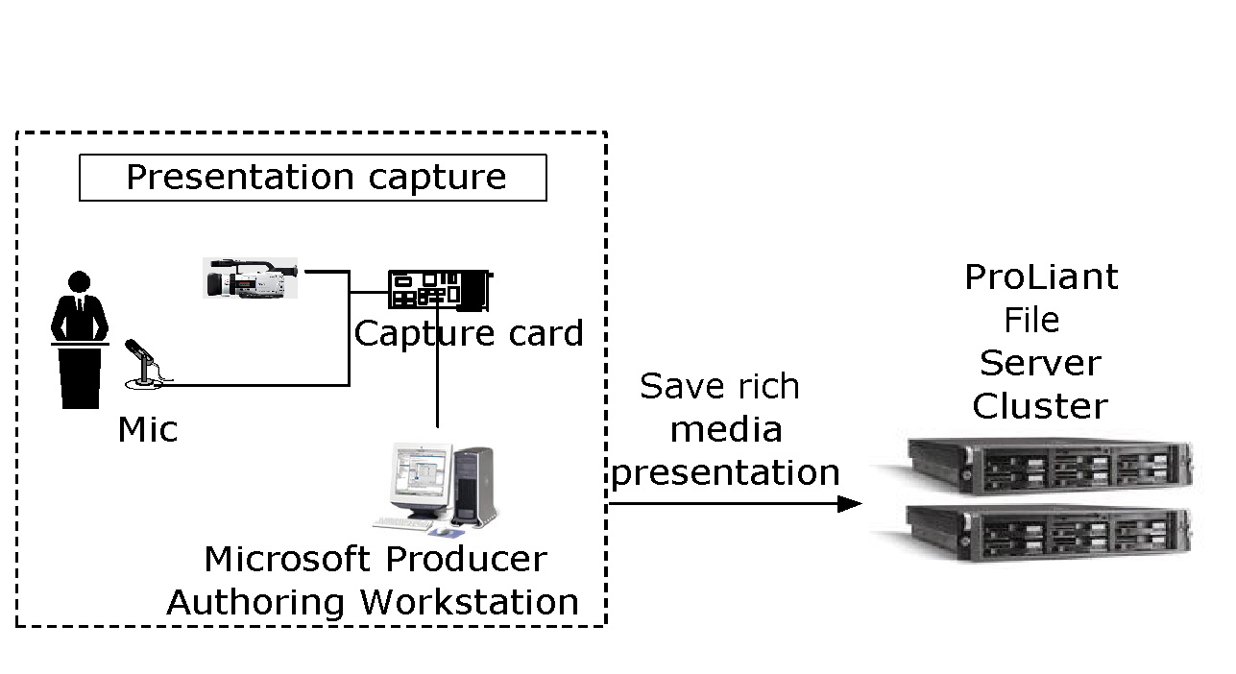
Figure 1. Capturing a presentation

Content Distribution and Management
To manage the distribution of content, the firm deploys two origin servers. One is a Windows Media server at the central office, and the other is a remote Web server that is running Windows Media Services 9 Series (single host) and handles requests from the larger sites of 75-100 users. For the origin Web server, the company extends the intranet that was running Internet Information Services (IIS) with the rich digital media services provided by Windows Media Services. Both origin servers retrieve the digital media presentation files through the shared storage of the ProLiant file server cluster's content repository. Subsequently, the origin servers respond to streaming and Web requests from local and remote users, and from downstream edge Windows Media servers.
Smaller sites traverse the frame-relay based WAN to retrieve content from the central site. The content was encoded at multiple bit rates to help ensure a quality experience and effective bandwidth management. Distributed files system (DFS) file replication in Active Directory is used on the Web and Windows Media servers to duplicate content across all servers. As the employee base at the smaller sites increases in size, it will be easy to add local servers where content can be staged. The following illustration shows this content distribution solution.
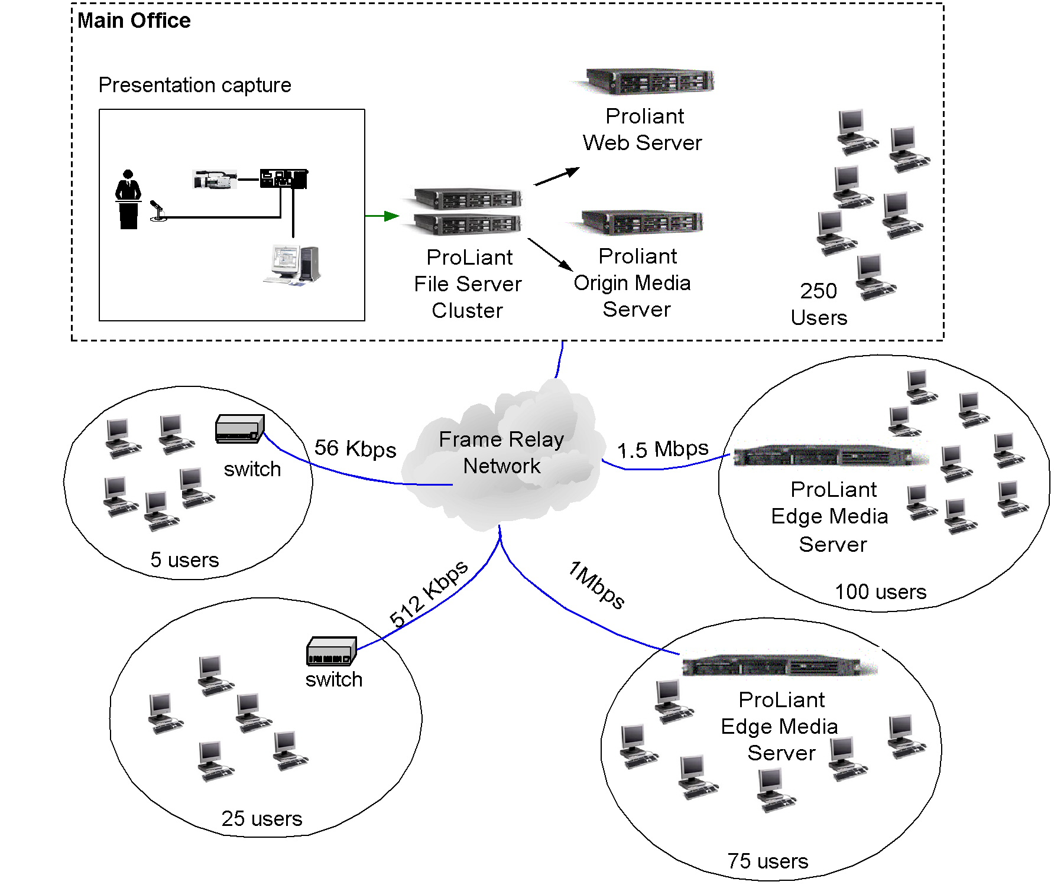
Figure 2. Small enterprise solution

Content Playback
The firm deploys Windows Media Player 9 Series to all of its desktop computers and also uses Internet Explorer with an embedded Player to view the rich-media content. The Producer-based content is experienced within the browser while on-demand personalized content is delivered to the Player by custom server-side playlists.

Security
Active Directory is used to authenticate users through NTLM or Kerberos support found within the Windows Media and Web servers. Authorization is set to allow access to content by authenticated users only who are permitted to download protected content onto laptops for offline learning.

Network
No changes were required.

Broadcast Communications and E-Learning for a Medium Enterprise
The following scenario illustrates how digital media provides a significant advantage for broadcast and e-learning solutions in a medium enterprise.

Business Challenge
A 10,000-person insurance company with offices in 15 locations specializes in automobile and homeowners insurance. The company wants to distribute best practices for claims agents who are on the road and claims counselors located at regional offices. The best practices consist of short 2 to 5-minute video segments used to demonstrate how agents and counselors should handle specific situations. The company's primary focus is handling claims and providing a positive experience for customers while going through the claims process. The company also wants to implement a solution to support live broadcasts for internal business communications. The live broadcasts include executive communications and previews of company television ads.

Opportunity
The customer service department can improve the quality of customer interactions by sharing best practices among claims agents. The e-learning department can increase the effectiveness of educating employees about complex subjects such as social interaction, customer service, and conflict resolution. Executives can inform and direct employee participation toward common business goals by using personal communications enabled by digital media. Business leaders want to allow employees to preview company television ads to help build company loyalty and alert employees to external client messages.

Solution
The insurance company deploys origin Windows Media and Web servers along with several edge Windows Media servers in each of its data centers to efficiently manage the distribution of video segments to all claims agents. It also builds a small custom module developed for Microsoft Exchange Server to coordinate sending online calendar requests with a link to the content. The scheduling component sends e-mail reminders to users to improve attendance. Users can also browse the company intranet for content.

Content Creation
To capture best practice content on a regular basis, the company built a ministudio at each division office, with two offices having a fixed ministudio and one portable ministudio. The fixed ministudios can be built at a fraction of the cost of a professional studio and require dedicated rooms. A portable ministudio also delivers a quick return on investment and can be moved quickly and easily from office to conference room to any other available quiet space. Ministudios are user friendly so virtually anyone can use the studio to create rich-media presentations. Business units can create content quickly and easily to support changing business needs.

Content Distribution and Management
Content in this scenario is managed through the use of edge Windows Media servers. And by using IP multicast, the content can be distributed to thousands of users without consuming all available bandwidth.
Edge Windows Media servers
Servers running Windows Media Services 9 Series are implemented across all sites for broad distribution of content. The content is pushed proactively to the edge in anticipation of a large number of users requesting the content. To facilitate this, the company uses DFS replication to copy content to edge servers during off-peak periods of network activity.
The design of the edge Windows Media server assumes that a maximum of 10 percent of users will concurrently access digital media services. This means that if a site has 1,000 users, a maximum of 100 users at any given time will request content. This concurrent capacity requirement applies only for on-demand scenarios. In this design, the edge Windows Media servers are limited by total bandwidth throughput of the network and not user connections because the servers are attached to 100BaseT Ethernet networks with a maximum bandwidth limit of 100 megabits per second (Mbps) on each server. This was found to be reasonable given the expected user concurrency of 10 percent, average stream size, and a maximum of 2,500 users at any given site. Figure 3 shows how origin servers and edge servers are distributed across a medium-sized enterprise.
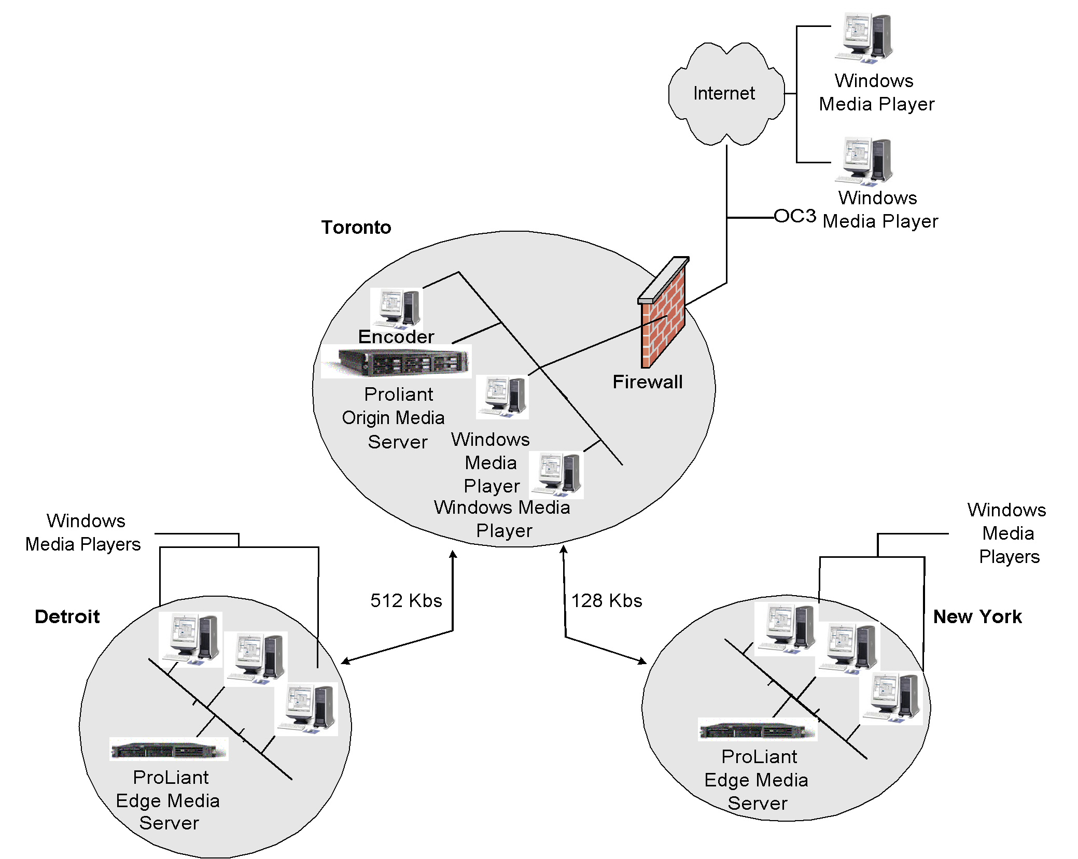
Figure 3. Origin Windows Media and Web and edge Windows Media server for medium enterprise
Network protocols and design (IP multicast)
The network is enabled to support multicast traffic. IP multicast is a component of the TCP/IP protocol standards and is an efficient way of transmitting identical information to multiple users at the same time. Multicast enables a single origin server to propagate multicast streams throughout the corporate network by using less bandwidth than unicast. Unicast requires each user to receive unique streams and therefore more bandwidth is used as each new user requests a stream. For live broadcast presentations that are accessed concurrently by many users, WAN circuits can quickly become saturated by unicast users receiving individual streams from the origin server. Multicast is chosen as a viable way to provide a good user experience of live broadcasts to many users concurrently, with a single stream helping to save the WAN for other uses.
The company's WAN has 128 kilobits per second (Kbps) and 512 Kbps circuits; therefore, streams are encoded at 100 Kbps and 300 Kbps for multicasting. The bandwidth used by the multicast stream over the WAN remains constant as one or more remote site users view the content. Two broadcast publishing points are created on the origin server for each bandwidth.
For users without multicast support, such as remote dial-up or virtual private network (VPN) users, the origin server's broadcast publishing point is enabled. This supports unicast rollover and dynamically streams the live broadcast over IP unicast to those users.
The following illustration shows this live broadcast scenario with multicast and unicast rollover.
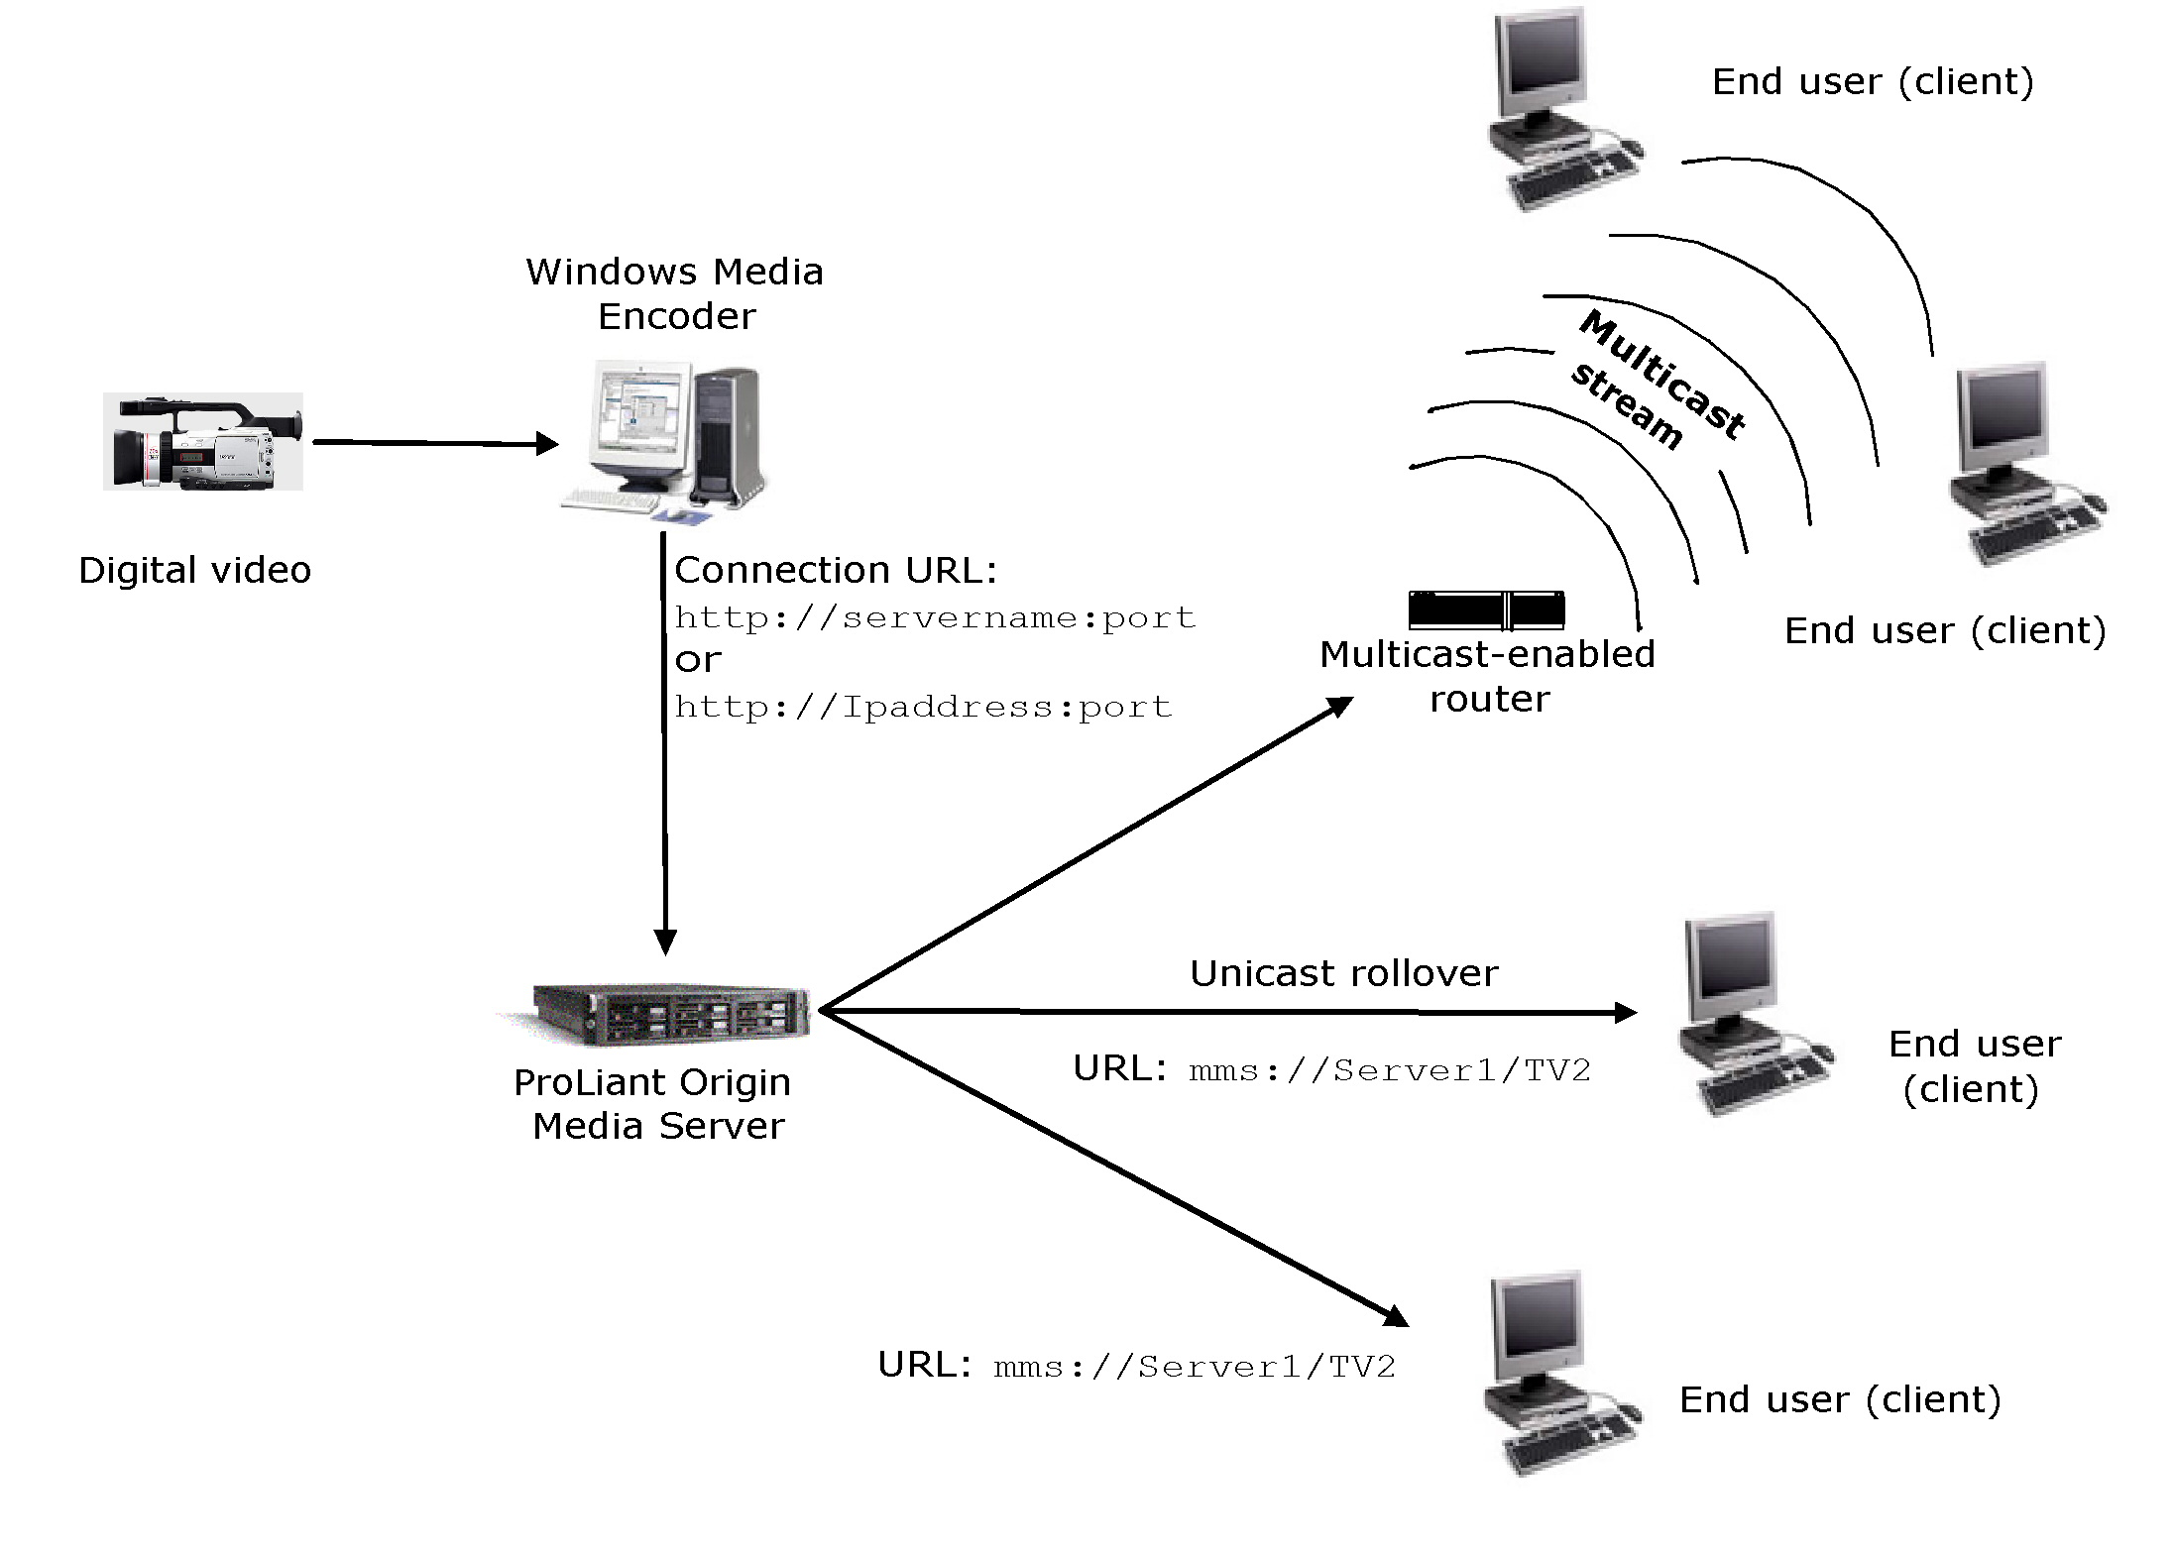
Figure 4. Live broadcast multicast with unicast rollover for medium enterprise
The rollover protocols that are used also depend on the version of Windows Media Player that users are using to receive content. Windows Media Player 9 Series rolls over to RTSPU, RTSPT, and then HTTP if enabled on the server. Previous Windows Media Player versions will roll to MMSU, MMST, and then HTTP if enabled.

Content Playback
Instead of implementing a digital media portal to access content, the company decided to use the messaging platform in Exchange Server to promote and manage event requests to users. The company wanted to promote discussions and use specific times to target specific groups for training. Multicasting prerecorded content let the company reduce aggregate bandwidth to a single stream, and at the same time deliver higher-quality video at a higher bit rate. Exchange Server was selected because system users were mainly task workers and not familiar with browsing an intranet for materials. Users wanted a program they were familiar with, and the IT group could use the existing Exchange Server asset at no incremental cost.
The training group responsible for making sure users view the various courses sends batch meeting requests to users through the server running Exchange Server a few days in advance of a scheduled session. The meeting request has a brief description of the content and a link (URL) to open the website hosting the content. Users can accept or decline the requests, depending on their availability. Over the course of a week, users are scheduled to view the content online. The meeting request with the event URL launches a calendar reminder 15 minutes prior to the start time.

Sales and Marketing—Product Launch for a Large Enterprise
The following scenario illustrates how digital media provides a significant advantage for broadcast solutions in a large enterprise.

Business Challenge
A 30,000-person manufacturing company with facilities in 100 locations needs to deploy a solution to capture and distribute product information as well as enable live corporate broadcasts. The sales staff needs training about key features and competitive differences for new products. The company needs to communicate general product information to customers, which will require distributing the information externally through the Internet. The company also wants to use its infrastructure investment for live executive broadcasts to deliver quarterly earnings reports and general human resource department communications.

Opportunity
Producing and delivering a high-quality training experience will improve general awareness and knowledge of products and educate employees about strategic business initiatives. Sales and marketing departments can deliver consistent and compelling messages to employees, partners, and customers through rich-media presentations. Customers will be able to go to the corporate website and view company products and services information. The corporate communications department will be able to deliver notices consistently and more frequently.

Solution
The company initiates several solution teams to deploy global edge Windows Media servers, develop business processes for creating business content, and design a studio to create high-quality audio and video content. Three solution teams work together to implement an end-to-end digital media infrastructure, including the studio and all of the required business processes leading to a long-term solution.

Content Distribution and Management
The company implements a multitier edge server network to manage the global distribution of rich-media content. The IT group designs the system to originate content near the center of the network but deliver it to users from edge servers. Pushing content closer to the edge of the network reduces congestion on the network backbone and delivers a better user experience. The following illustration shows a network configuration for distributing content across a large organization.

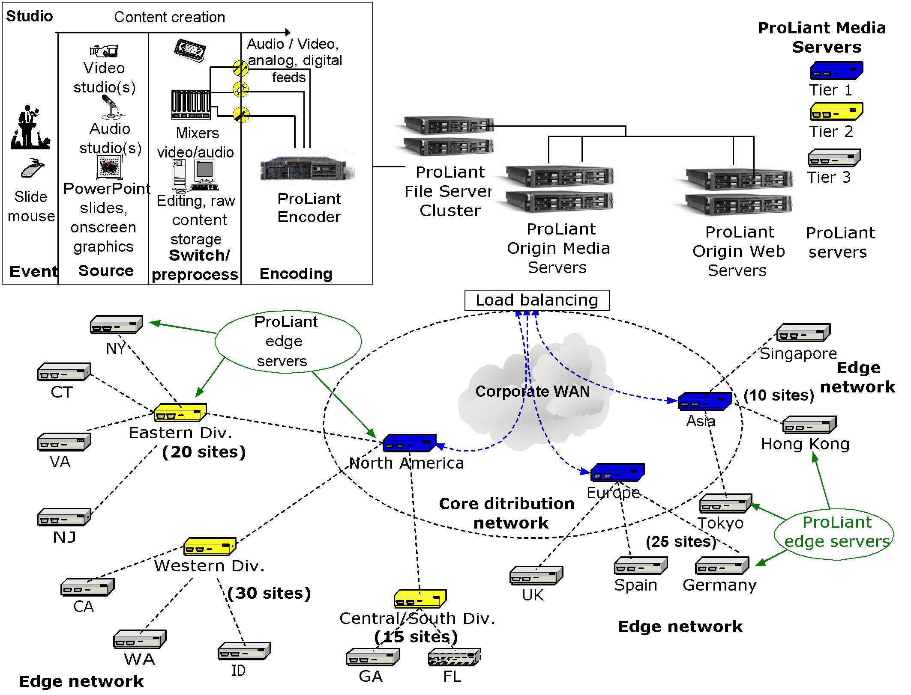
Figure 5. Distributing content across a large organization

Content Playback
On the corporate intranet, rich-media content that resides on the central origin server is integrated into the existing company portal. This provides easier browsing capabilities and helps employees select appropriate product information. The content is indexed and searchable by using keywords. The portal displays a thumbnail of the opening presentation, showing the speaker along with a 50-word abstract that describes the presentation. Content is further categorized by the line of business.
By using Microsoft Producer, marketing managers can publish finished rich-media presentations directly to staging servers. The media portal acts as a central catalog for employees to search for archived corporate communications or the latest presentation from product and marketing managers.

Enterprise Digital Media Infrastructure
Each enterprise has unique requirements for its deployment of the Windows Media platform. Windows Media 9 Series effectively delivers the features and scalability to meet the needs of any size organization. Windows Media may be considered a critical extension of the enterprise infrastructure that effectively supports a variety of business communication and e-learning scenarios. In general, you should consider the following items when incorporating Windows Media into your infrastructure:
- End-to-end architecture for content creation, distribution, and consumption
- Security for both content and Windows Media technologies
- Administrative and security roles
- Namespace and directory standards
- Windows Media technology hardware and software requirements
- Network topology, protocols, bandwidth, addressing, and flow
- Intranet, extranet, and Internet network layout and integration
- Firewall traversal
- Migration, phasing, and coexistence
- Operations and systems management
- Risk assessment
The most common requests for digital media solutions come from broadcast communications and e-learning initiatives. Regardless of the specific business needs, it may be beneficial to take a broad view of these requests with the expectation that once the organization experiences digital media, other business units will want to use the infrastructure for their own business applications. It can be advantageous to design the network and digital media infrastructure to adapt easily to future requests and growth. It is easier to expand the digital media infrastructure when the interdependent enterprise elements are prepared, such as network, site, support, and user workstations are prepared. For strategic planning, consider the following items:
- The use of digital media will increase over time as business units become familiar with the new enterprise service.
- Streaming may not be mission-critical now, but it will become critical to the business as company communications move to IP networks.
- This technology is strategic, so it is worth taking a long-term view when making decisions.

Content Creation
Content creation is at the heart of any digital media solution. An understanding of audio and video production techniques is required for creating the best quality content, including lighting, acoustics, video equipment, and so on. An important consideration is the location of the audio and video production suite. These suites can range from professional-grade studios to modified office spaces depending on the budget and standard of quality you are hoping to achieve.

Studio Integration
From an infrastructure perspective, studios can present an integration challenge. The challenges include the physical configuration of the studios and the conversion of audio and video from analog or digital source formats to the Windows Media 9 Series format for streaming. Some large organizations already have professional studios for producing video content, but others outsource video production or perhaps only have a minor investment in audio, video, and studio equipment. Regardless of the scale and level of sophistication, studio services are necessary for creating and delivering digital media content over the network.
Studios can be categorized into three types: professional, enterprise, and desktop.
- Professional. A professional studio is a broadcast-quality studio used to acquire and create audio and video. Professional studios are designed with a completely controlled authoring environment. Special lights, microphones, sound absorbing coverings, and low background noise increase the quality of the studio output. Professional studios can be costly, and are usually built only when an organization regularly generates large volumes of digital media content.
- Enterprise. Many enterprises have well-equipped dedicated and nondedicated studios. Nondedicated studios typically serve multiple purposes; they might double as a shared conference room, or a small office that contains equipment specifically for creating digital media. An enterprise studio might also be equipped with A/V equipment. These studios usually have a midrange camera and microphone configuration that is easy to use and reposition and are configured so that users can easily find and use the equipment to generate audio and video.
- Desktop. Desktop video cameras (Web cams) are very common today. Desktop configurations need little hardware and can generate reasonable quality output. However, desktop configurations are prone to many environmental problems, such as poor lighting, and unacceptable levels of background noise.
To design a studio for content capture, consider acoustics, lighting, audio, and video. Audio is often assumed the easiest component to capture or produce; however, it can be the most challenging. Ambient noise is difficult to eliminate, but steps can be taken to reduce it and improve audio quality. The studio should be insulated with a material to reduce noise reflection. High-quality directional microphones reduce ambient noise and are designed to cancel out background noise. You can also incorporate a digital voice processor and a mixer to control dynamic conditions to filter out noise.
Producing quality video is generally straightforward and achievable. There are many choices of cameras; however, an entry-level digital video camera will work well. Quality video production is primarily a factor of lighting. Video quality can be improved by taking the following steps:
- Use professional, low-wattage, color corrected fluorescent lighting
- Use dark-colored walls to control light reflection and balance the overall lighting
- Use a tripod to hold the camera steady and allow for height adjustment
- If a portable, LCD-based teleprompter is not available, position a monitor directly above or below the camera so the subject can read a transcript or PowerPoint slide while on camera
- Position the subject six feet or more from the camera to minimize any perceptible discrepancy in focus or eye contact
- Use an LCD flat-panel for preview
For more information about implementing a ministudio read, "Building a Mini-Studio for Creating Online Presentations with Microsoft Producer" at the Microsoft website (http://office.microsoft.com/downloads/2002/prstudio.aspx).

Encoders
Windows Media Encoder 9 Series is available to licensed users of the Windows operating system and is available from the Downloads page of the Microsoft website (http://www.microsoft.com/windows/windowsmedia/download/default.asp). Windows Media Encoder is the primary technology used for encoding content into Windows Media Format.
Encoding content in a production environment should be accomplished on a high-end computer with available CPU and memory, such as the dual-processor HP ProLiant DL360 G3. Using one computer for encoding is not adequate if a high volume of content is created. Encoders typically fall into one of two groups, those used for on-demand content encoding and those used for live encoding.
Encoding on-demand content can be accomplished as part of the post-production process, so the encoder can be located anywhere. The encoding process can also take place as the action is captured. For live broadcasts, the encoder should be dedicated to live encoding content only, and should not exceed 50 percent usage to maintain the best quality.
A video capture card is required to receive inputs from analog and digital sources. To ensure the best quality, use the best A/V inputs available as possible such as all digital audio/video inputs. Windows Media Encoder takes the digitized content from the capture card and encodes it to Windows Media Format. It is recommended that you use one CPU per capture card. A dual-processor ProLiant DL360 G3 or DL380 G3 can support two capture cards running concurrently.
To ensure the encoding process is not interrupted, use two ProLiant servers to provide encoder redundancy. The A/V source must be split between two encoders running on two separate ProLiant servers. The two encoders then can stream content to either a single origin server or dual origin ProLiant servers.

Quality
Content can be encoded at different quality and bandwidth levels depending on business and network requirements. You can create several encoder session files, allowing easy and consistent content production. The settings in each encoder session file are tuned according to the source of content (for example, video tape recorder or live capture) and target audience destination (bandwidth and location). Encoding quality factors include bandwidth, video size, frame rate, audio types (voice or mixed), and access method (live, on-demand, or downloadable). Quality is determined by many factors and is outside the scope of this document, but is usually guided by the source of content and connection speeds of the audience. For example, attempting to deliver a 300-Kbps stream over a 128-Kbps connection could saturate the connection and create a negative user experience. A 90-Kbps version of the same content would be much more satisfactory. And you could deliver both streams (300 Kbps and 90 Kbps) simultaneously using multiple bit rate (MBR) encoding.

Producer for PowerPoint 2003
Producer for PowerPoint 2003 lets users combine audio, video, PowerPoint slides, and still images into a rich-media presentation. Archived audio and video content can be imported into Producer, and new audio and video content can be captured directly by using the Producer Capture Wizard. Content authors can synchronize audio and video with slides and images by using the Capture Wizard or the Synchronize Wizard. They can directly manipulate digital media elements on the timeline. "Projects" can be saved in prepublished form, and content can be added or edited later. The project with the native content can be saved in a single pack-and-go file for easy transport to another computer.
Synchronizing PowerPoint slides is often a requirement when producing a live broadcast that includes a presenter (on stage or in a studio). Because the broadcast is live, interlacing the PowerPoint slide changes into the encoded stream is a bit more involved than creating on-demand content. For on-demand content, an authoring tool embeds the HTML commands in the stream in a post-production process. For a live broadcast, the HTML commands to change the PowerPoint slide must be initiated from the podium where the presenter stands, and then the slides are embedded into the encoded stream in real time. There are two ways to achieve this:
- A person in the production booth of the live event can use Windows Media Encoder to embed the HTML commands manually as they see the presenter change the slide.
- The presenter can use Online Broadcaster for PowerPoint. This is an add-in tool that allows the presenter to click through a PowerPoint slide deck, which sends DCOM calls to the encoder to embed the slide changes for the Web audience.

Content Distribution and Management
The distribution and management of digital media content are key elements of any enterprise digital media solution. Distribution and management are considered a common barrier to implementing these solutions. Creating an appropriate architecture requires the involvement of multiple IT groups including networking and server groups. Reviewing basic concepts associated with the distribution of digital media content will help highlight elements involved in edge Window Media server design. For the purposes of this paper, the edge Windows Media server is internal to the organization and deployed as part of the corporate infrastructure.

Origin and Edge Windows Media Servers
Origin servers are the source of the digital media content. A small number of centrally located origin servers simplifies the management of content. Windows Media Services running on ProLiant platforms act as origin servers, sourcing content for distributed caches. Digital media content cannot originate or source directly from a cache; the cache must be directed to get content from a Windows Media server.
There are three network layers to consider when designing a distribution scheme: the center or core where the origin servers and source content resides, the distribution hierarchy where content is moved from the center to the edge, and finally the edge where clients access content. The simple scheme for edge Windows Media servers is to move content from the origin servers directly to the edge. Large global networks use a two-tier distribution hierarchy before storing content on the edge. Windows Media Services 9 Series supports simple content caching as well as multitier hierarchies for large-scale deployments.

Load Balancing
You can use load balancing software to distribute client requests for content across several Windows Media servers grouped together. This is commonly referred to as a Windows Media server "farm." Load balancing typically occurs at a central location for origin servers or edge servers where load balancing and sever failover are desired. An IP load balancing solution can distribute requests across several edge Windows Media servers, providing additional capacity and resilience when required. IP load balancing will provide a single IP address for requests and will redirect the request to the most available Windows Media server. If a Windows Media server goes offline, the automatic failover redirects traffic to an available server for a seamless transition with no downtime.

Cluster
A server cluster is a group of independent computer systems, known as nodes, running an operating system such as Windows Server 2003, Enterprise Edition or Windows Server 2003, Datacenter Edition. The servers in a cluster work together as a single system to ensure that critical programs and resources remain available to users. By configuring a server cluster of file servers, you can also provide a reliable content repository for Windows Media and Web servers.

Cache vs. Proxy
A cache dynamically stores content close to where it will be used and helps lower the frequency that the same content must traverse the network. After the first client request is serviced and cached, subsequent requests are met by the cache. This reduces network congestion and improves the user experience. A proxy is a server that responds to specific client requests on behalf of the client. All traffic for a given application, in this case, digital media, must traverse the proxy. This is accomplished primarily to facilitate traffic control and management.

Network Protocols and Design
To dynamically optimize stream quality based on network conditions, Windows Media 9 Series technologies employ a feature known as intelligent streaming. With intelligent streaming, content is encoded at several different bit rates and then streamed at the best possible video and audio quality given the network connection. When Windows Media Services 9 Series and Windows Media Player 9 Series connect, they automatically determine the available bandwidth. The server then selects and distributes the video stream whose encoded bit rate is appropriate for that bandwidth. This feature enables organizations to encode streaming files that can be received at any destination within the enterprise, and allows the Windows Media server and Player to dynamically determine the best viewing experience for each user. Even under heavy network congestion, Windows Media Player 9 Series can provide the best viewing experience possible by "thinning" the video to the available bandwidth while preserving audio quality. The following illustration shows how intelligent streaming affects the viewer experience for three connection types.
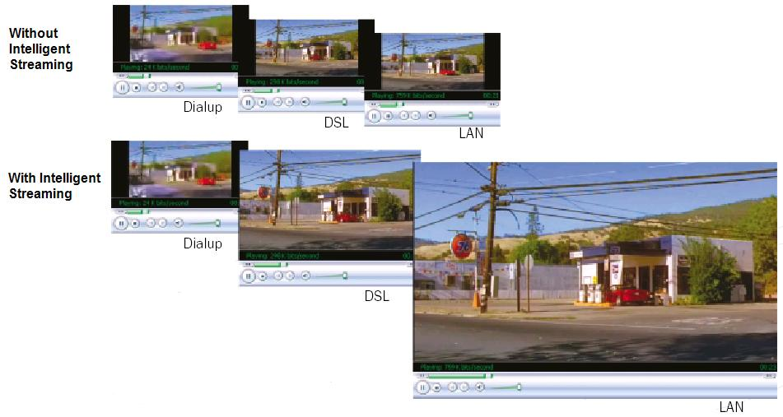
Figure 6. Intelligent streaming at common connection bandwidths
A network protocol is a standardized format for transmitting data between two devices. The type of protocol used can determine variables such as error checking, the data compression method, or the end-of-file acknowledgements. The Internet is comprised of millions of different networks running a wide array of applications with varying network requirements. Streaming digital media content reliably to clients depends on a set of several well-engineered protocols. The protocols used to stream Windows Media-based content are:
- Real Time Streaming Protocol (RTSP)
- Microsoft Media Server (MMS) protocol
- Hypertext Transfer Protocol (HTTP)
- Windows Media Services Multicast (MSB)
- Real Time Protocol (RTP)
Windows Media Services manages the use of protocols through control protocol plug-ins. Windows Media Services includes the WMS MMS Control Protocol plug-in, the WMS RTSP Control Protocol plug-in, the WMS HTTP Control Protocol plug-in, and the Multicast Data Writer plug-in. With the exception of the WMS HTTP Control Protocol plug-in, plug-ins are enabled by default. Multicast streaming and the WMS Multicast Data Writer plug-in are available only if Windows Media Services is running on Windows Server 2003, Enterprise Edition or Windows Server 2003, Datacenter Edition. Multicast streaming is not supported in Windows Server 2003, Standard Edition.
The control protocol plug-in receives the incoming client request, determines the action indicated by the request (for example, to start or stop streaming), translates the request into a command form, and then passes the command to the server. Control protocol plug-ins can also return notification information to clients if there is an error condition or a change of status. These control protocol plug-ins handle the high-level exchange of data. Underlying the protocols are networking protocols, such as User Datagram Protocol (UDP) and Transmission Control Protocol (TCP). The underlying protocols manage more fundamental tasks such as network connectivity and packet error correction. The MMS and RTSP protocols function in combination with both the UDP or TCP protocols; the HTTP protocol relies only on TCP, and the MSB protocol relies on UDP for digital media transport.

RTSP
RTSP can deliver content as a unicast stream. It is an application-level protocol created specifically to control the delivery of real-time data (audio and video content) and is implemented over a correction-oriented transport protocol. RTSP supports player control actions such as stopping, pausing, rewinding, and fast-forwarding of indexed Windows Media files. RTSP can support streaming content to computers running Windows Media Player 9 Series or Windows Media Services 9 Series. RTSP is a control protocol that works in tandem with the data delivery RTP to provide content to clients. The following illustration shows a server and client connection by using RTSP.
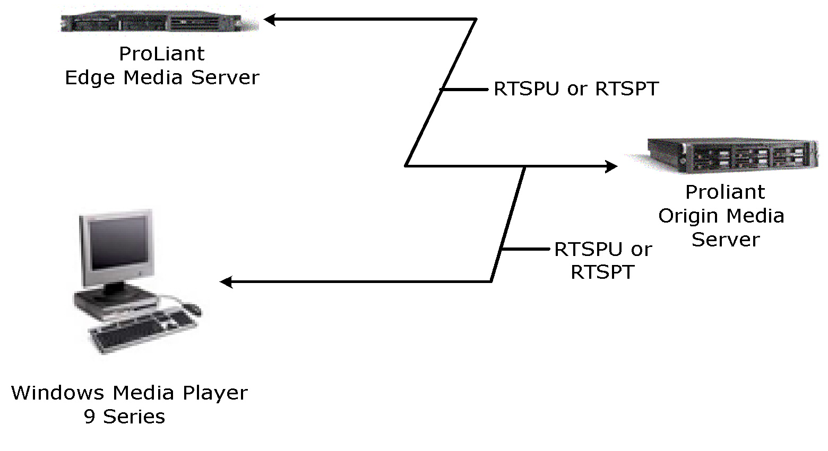
Figure 7. RTSP

MMS
MMS is a proprietary Microsoft protocol that provides signaling and data from the client to the server. MMST is TCP-based and MMSU is UDP-based. MMS was used by previous versions of Windows Media Services and Windows Media Player, and is supported by Windows Media Services 9 Series.

HTTP
HTTP is a TCP-based protocol used for distributing streams between Windows Media Encoder and Windows Media Services and for server-to-player streaming.

UDP
UDP is a connectionless transport protocol for IP networks. Applications that use UDP typically rely on other mechanisms to guarantee packet delivery. For streaming in "lossy" or low-bandwidth conditions, such as streaming over wireless networks, UDP may provide improved performance when used with the Fast Recovery feature of Windows Media Services. Fast Recovery uses forward error correction to support streaming over wireless networks such as wireless local area networks (WLANs), satellite connections, and mobile devices.

TCP
TCP is a connection or session-oriented protocol. TCP sessions ensure that packet delivery is completed without intervention by the application using the data. In most Windows Media 9 Series scenarios, TCP will provide a better overall user experience and greater scalability.

Protocol Rollover
Protocol rollover refers to the ability of Windows Media Services to choose the right protocol for a client depending on its environment. Protocol rollover is useful to support a variety of client versions, such as clients that connect through a firewall or clients that connect through different types of networks (wired/wireless). Protocol rollover works best if all the control protocol plug-ins (including the WMS HTTP Server Control plug-in) are enabled.
Windows Media Player uses protocol rollover to establish a connection to the server in a specific sequence, depending on whether Fast Streaming is used. If the first connection attempt between the server and the client is successful, no further action is taken. If that connection request is not successful, the client attempts to connect to the server by using another supported protocol. The client experiences a very small, usually unnoticeable period of latency during each protocol rollover attempt.
When Windows Media Player connects to content that has an MMS URL, (mms://), protocol rollover is used to obtain the most efficient connection type. The Player, using Fast Streaming, attempts to connect in this order: RTSPT (RTSP over TCP), RTSPU (RTSP over UDP), and finally HTTP. If the Player doesn't use Fast Streaming, it reverses the RTSP attempt order (RTSPU, then RTSPT) as shown in the following illustration.
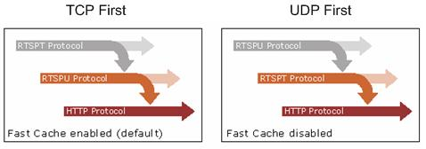
Figure 8. Protocol rollover
If IP traffic must traverse a firewall, the firewall must allow at least one protocol, RTSP, MMS, or HTTP streaming to traverse it in order for clients to receive content.

Unicast and Multicast
IP traffic can be classified by data-sending methods. With unicast, a distinct copy of the data is sent from the source to each client that requests it. With multicast, a single copy of the data is sent across the network, and those clients that request the data receive it.
Each method has strengths and weaknesses. Unicast sends an individual copy of the same data to each client that requests it. In streaming media terms, unicast is a one-to-one connection between the server and client—every client receives its own stream. This results in multiple copies of the same data being distributed across the network. Multicast transmission delivers content as a multicast stream from a broadcast publishing point on the server. Clients that receive content as a multicast stream receive it as a "best effort" network delivery through UDP datagrams.
Multicasting is more efficient in its bandwidth usage because multiple copies of data are not sent across the network. In streaming media terms, multicast is a one-to-many connection between the server and many clients. When a user requests a multicast stream, either by opening a multicast information file from a Web server or by clicking a link in an e-mail message, the network card on the computer listens to a particular IP address for the multicast. The client does not have to identify itself to the server originating the multicast. Any number of computers can receive a multicast transmission without impacting network bandwidth consumption because only one copy of the data is sent over the network. Streaming media across an enterprise network generates a considerable amount of traffic, so multicast is an affordable and effective solution.
The following illustration shows unicast and multicast bandwidth usage based on the number of clients. You can obtain significant savings in bandwidth when using multicast.
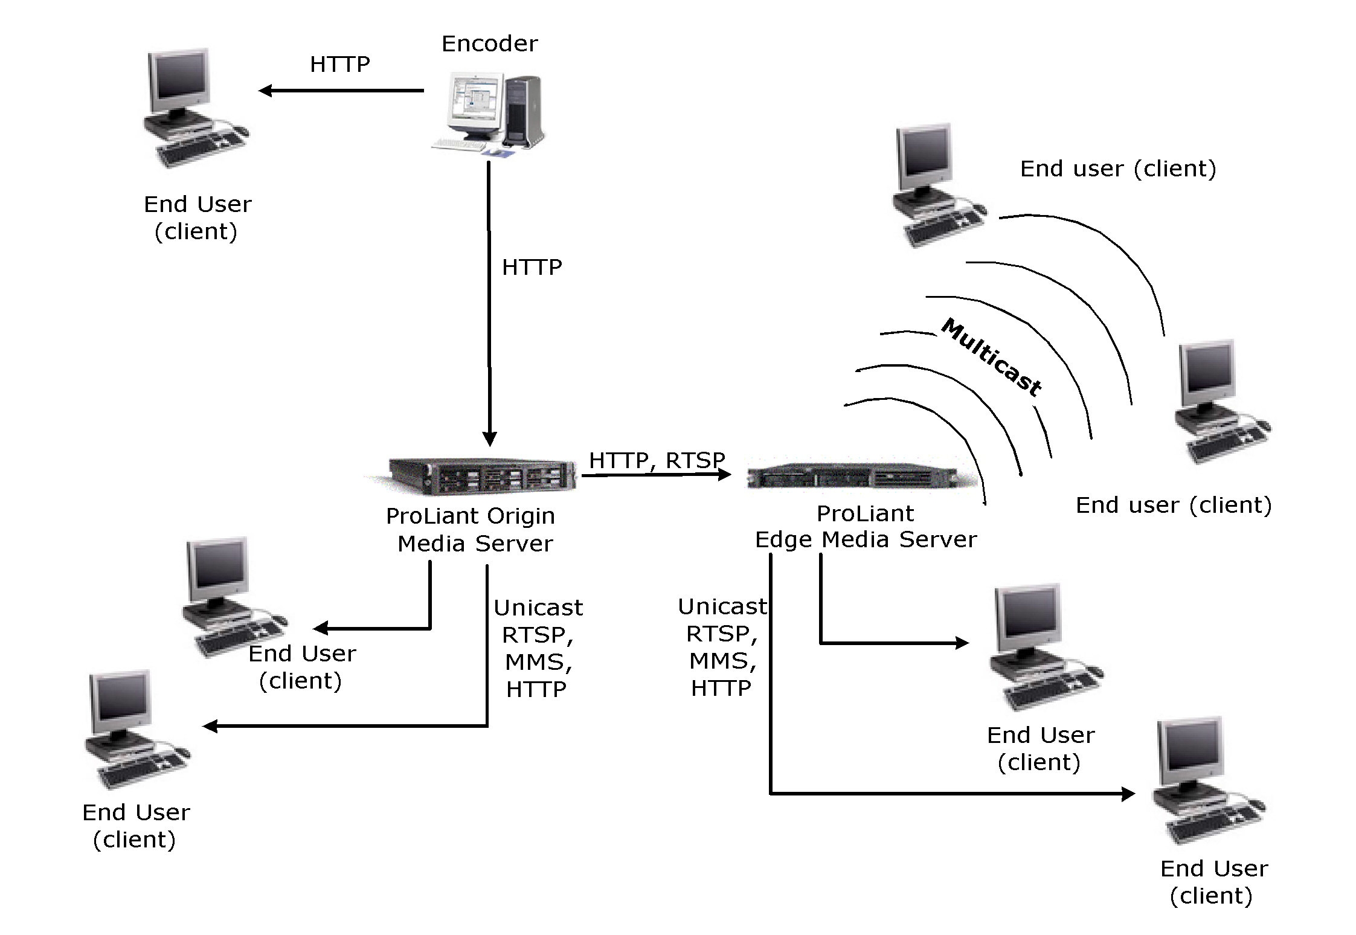
Figure 9. Unicast and multicast bandwidth usage
Multicasting does have its drawbacks. For example, users have no control of the data stream and cannot stop, pause, rewind, or advance it; users can only connect to the multicast stream or disconnect from it. Multicast streams must be scheduled rather than offered on-demand. In addition, multicast is not enabled by default. To enable multicast on your network, you might need to update routers and switches.
Another approach to enabling multicast is by using multicast tunneling techniques (for example, GRE, DVMRP, and MVPN) on capable routers. The techniques refer to the process of distributing multicast packets through a nonmulticast environment. For example, two segments on a network can have multicast support but the router between them does not pass multicast datagrams. In this situation, a solution is to tunnel the multicast between them.
When enabling a multicast across a WAN, consider the impact on the logical network as opposed to the physical network. A frame relay network can be viewed logically as the frame relay cloud and the individual permanent virtual circuits (PVCs). In the model where multiple PVCs come together into a central data center, those PVCs will terminate on a single physical port. It is common to have the aggregate bandwidth of the PVCs exceed the total port speed, which is possible because statistically the aggregate bandwidth of the PVCs rarely exceeds the port speed. However, in a multicast scenario, each PVC is treated as an individual WAN circuit requesting the multicast stream, possibly exceeding the total port speed. For WANs with dedicated circuits, this is not an issue.
Here are some additional things to keep in mind when multicasting:
- Look for network loop occurrences. These can be reduced by setting the proper time-to-live (TTL) value (hops) to its maximum within a given enterprise.
- Multicast is UDP-based and some packet loss is normal.
- Multicast is an intentional packet duplication, but duplication over the network segment can indicate a problem.
- Administrative scope range is 239.0.0.0 to 239.255.255.255 used for private networks.
- Mcast.exe is a utility provided by Microsoft to test multicasting. It simulates a multicast server and destination, exercising the routing protocols to propagate the multicast stream across the network. It is available from the Windows Server 2003 Resource Kit and the Windows Media Resource Kit (http://www.microsoft.com/learning/books/).

Firewall Traversal
Firewall traversal for Windows Media protocols can often use existing infrastructures and methods. Firewall traversal is well supported by most enterprise firewall products and is reasonable for administrators to manage. Instances of Windows Media Player can access Windows Media servers through HTTP (port 80) often requiring no configuration changes to existing firewall policies. Integrating firewall traversal into Internet proxy and edge server strategies can offer substantial performance improvements and may help reduce the overall load on the firewall and Internet gateway services. Other firewall traversal methods are available over UDP and TCP, which offer better performance, but may require firewall reconfiguration.
To assist in firewall transversal, the following protocols and ports are used by Windows Media 9 Series.
- RTSP TCP: server destination port is 554
- RTP: UDP dynamic source/destination ports (if RTSPU control protocol)
- MMS UDP: server destination port is 1755
- MMS TCP: server destination port is 1755
- HTTP: server destination port is 80
- Player source port: dynamic (1024-5000)

Security
Windows Media Services includes features that help make access to content more secure. Authentication and authorization mechanisms help to ensure the secure transfer of data from the encoder to a server, server to server, and client to server. It also includes support for HTTP Digest and for DRM that helps to ensure on-the-wire and persistent client-side security.

Authentication
Authentication is a fundamental aspect of security for a server running Windows Media Services 9 Series. It confirms the identity of any user trying to access resources on your Windows Media server. Windows Media Services includes authentication plug-ins that you can enable to validate user credentials. After users are authenticated, the authorization plug-in controls access to content. Windows Media Services authentication plug-ins fall into the following categories:
- Anonymous authentication. This category of plug-ins does not exchange challenge-and-response information between the server and a player. One example is the WMS Anonymous User Authentication plug-in.
- Network authentication. This category of plug-ins validates users based on logon credentials. Examples are the WMS Negotiate Authentication and WMS Digest Authentication plug-ins.

Authorization
To understand why connection attempts are either accepted or denied, consider the following distinction between authentication and authorization. Authorization is the process of verifying that the client is allowed to use resources found on a server. Authorization occurs after authentication is successful. During the authorization process, the server checks the user against the access permissions set for the resource to which the user is trying to use, such as a stream or file. Appropriate authentication and authorization plug-ins must both be selected to properly control the access to content. Windows Media Services 9 Series supports these authorization plug-ins:
- WMS NTFS ACL Authorization plug-in
- WMS IP Address Authorization plug-in
- WMS Publishing Point ACL Authorization plug-in

Digital Rights Management (DRM)
Another aspect of managing digital media content is handling the usage rights associated with a specific piece of content. With the increase in peer-to-peer file sharing and content piracy, the issue of copyright protection is a high priority for content creators, owners, and distributors. The Windows Media Rights Manager SDK provides a robust platform for DRM.
By using DRM, you can encrypt content and create a license key that is required to decrypt and view the content. Business rules associated with the license keys govern how users may access and use the content. Users access content through an acquisition URL that points to the license key server. The user is then authenticated, rights are determined, and the license is issued. The Windows Media Rights Manager SDK provides the leading DRM platform for secure distribution of content. The following illustration shows how content is protected by DRM.
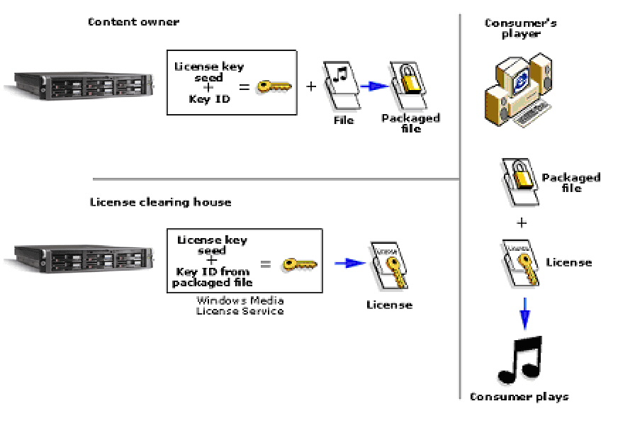
Figure 10. Digital rights management sequence

Systems Management
Using Windows Media Services, administrators can manage server resources by setting limits for a number of connection parameters. Limits set at the server level apply to all publishing points on that server. In addition, administrators can set bandwidth limits for each publishing point. However, if limits set for a publishing point exceed the limits set for a server, the server limits override the publishing point limits.
Windows Media Services 9 Series in Windows Server 2003 running on HP ProLiant servers can use the full 1 GB of Ethernet connections. To maximize the performance of Windows Media Services, dedicated network adapters should be used for content acquisition from a file server cluster (typically from content repository or live encoders), and dedicated network adapters for user access.

Deployment and Migration
Server deployment can be a time-consuming task, especially if you need to deploy hundreds of servers quickly and reliably. The Rapid Deployment Pack from HP is a server deployment product that facilitates the installation, configuration, and deployment of numerous servers using a GUI-based console with either scripting or imaging technology. It maximizes resources by providing a full server build from a remote console, automated server configuration on the fly, and installation of standard software sets based on server functions. Server configuration time is reduced, making it possible to scale server deployments to high volumes in rapid fashion. This enables you to quickly and easily adapt to changing business demands.

Scalability and Performance
Many constraints in the infrastructure can affect overall performance. Key areas to be aware of are:
- Understanding hardware requirements for a digital media infrastructure
- Estimating maximum concurrent usage
- Planning the cache hit ratio
- Calculating fault tolerance

Understanding Hardware Requirements for a Digital Media Infrastructure
When streaming content over a network, bottlenecks can occur anywhere in the encoding and distribution chain.
Component | Bottleneck | Comment
Encoding computers | CPU and memory constrained | Requires one CPU per capture card, scales linearly.
Origin servers | Disk and network I/O constrained | In most cases, I/O for digital media is the bottleneck for the server. However, monitor CPU use during complex processing such as server-side playlist processing.
Content delivery server | Disk and network I/O constrained | Requires fast disks and good network I/O throughput
Content server | Disk, network I/O, and constrained | Requires fast disks and good network I/O throughput.

Estimating Maximum Concurrent Usage
You need to determine the maximum number of users that will view on-demand content concurrently. It is unrealistic to design a solution that can handle 100 percent concurrency for on-demand content, for two reasons:
- If all users are viewing content at the same time, multicast is a better option.
- The number of times a solution will be required to handle very high levels of concurrency is usually too low to justify the investment in the infrastructure required to support it. Business users are more likely to spread their access to content over the entire business day. Maximum concurrencies can range from 8 percent to 15 percent of the total user population for large organizations, depending on the company and business requirements.
At a site that has 1,000 users with a maximum concurrency of 12 percent, the infrastructure would need to support 120 streams at any given time. If the standard bit rate of streamed content is 128 Kbps, then the total bandwidth use on the edge server would be 15,360 Kbps (15.3 Mbps). These numbers are important to understand when specifying how many edge and origin Windows Media servers to deploy and where they should be located.
HP provides a packaged solution tested and optimized for delivering Windows Media streams to viewers at the edge of a corporate network. The use of network attached storage enables easy growth of raw storage space as well as the clustering of multiple servers accessing common storage of digital media content.
A recent benchmark test of Windows Media Services 9 Series running on the HP ProLiant platform (HP ProLiant DL380 G3, dual 2.4 GHz Intel Pentium Xeon processors, 4-GB 200 MHz DDR SDRAM) showed the following results for on-demand streaming. Total client access was distributed evenly among 25 different stream files.
Stream bit rate | Maximum number of on-demand streams | Maximum number of broadcast streams | Program capacity in hours (*)
22 Kbps | 10,000** | 10,000 | 17,000
56 Kbps | 4,700** | 6,500 | 6,700
100 Kbps | 3,600** | 4,500 | 3,700
300 Kbps | 1,500** | 1,500 | 1,200
500 Kbps | 950 | 950 | 750
1 Mbps | 475 | 475 | 360
*Based on 160-GB content partition within a RAID 5 array composed of six 36.4-GB hard disks, with a separate 20 GB partition for the operating system and applications.
**Requires server namespace changes described in the article "Optimizing Microsoft Windows Media Services 9 Series" (http://www.microsoft.com/windows/windowsmedia/howto/articles/optimize_web.aspx).

Planning the Cache Hit Ratio
The cache hit ratio indicates how much content is retrieved from the edge Windows Media servers. This is an indication of how effective the cache is at reducing bandwidth requirements. Cache hit ratios should be in the 90 percent range, depending on the nature of the content. Some dynamic Web content cannot be cached and will reduce the hit ratio.

Calculating Fault Tolerance
HP provides a complete array of fault tolerance options to meet any availability requirement for digital media. The HP-Microsoft production server cluster consists of a loosely coupled collection of two or more independent Windows NT® Server, Windows 2000 Server, or Windows Server 2003 systems. Nodes in the cluster have the following characteristics:
- Every node is attached to one or more shared storage buses. Each shared storage bus attaches one or more disks. The disks store all of the cluster's configuration and resource data. Each disk can be owned by only one node at any point in time, but ownership can be transferred among nodes. The result is that each node has access to all cluster configuration data.
- Every node communicates with other nodes in the cluster through one or more physically independent networks, which are sometimes referred to as interconnects. Network adapters, referred to in server clusters as network interfaces, attach nodes to networks.
- Every node in the cluster is aware when another system joins or leaves the cluster.
- Every node in the cluster is aware of the resources that are running locally and of the resources that are running on the other cluster nodes.
- All nodes in the cluster are grouped under a common name, the cluster name, which is used for accessing and managing the cluster.
In any production environment, some form of fault tolerance is necessary to prevent prolonged service outages. For digital media, fault tolerance can be achieved in both the hardware and software.
At the hardware level, redundant network devices and redundant array of independent disks (RAID) disk configurations contribute to a fault-tolerant design. Generally, the same fault-tolerant design techniques apply to digital media as to other applications.
At the design level, there are ways to build an infrastructure that can handle unplanned outages and still support users. One technique is to use the Network Load Balancing service in the Windows operating system in conjunction with ProLiant and cluster failover capabilities. If one server fails from a planned or unplanned outage, Network Load Balancing or HP cluster services automatically remove the server from the cluster and redirect users to other servers in the cluster.
You can also use client and server-side playlists to provide fault-tolerance for users. If users try to connect to a server and the server is unavailable, they will be presented with a message. A playlist can contain multiple entries that specify multiple locations where users can connect to a stream. If Windows Media Player cannot connect to the server's first entry, the Player or the server will automatically and transparently roll over to the next server in the list and try to connect. If all of the servers fail to connect, then the Player will return a message to the user.

Enterprise Deployment
Deploying digital media presents many of the same infrastructure challenges that networking groups encounter when implementing more traditional Web services. However, these challenges are significantly increased with digital media due to the complexities introduced by the need for greater and more reliable bandwidth. The effects of network congestion and general latency on standard HTML content are not acceptable when streaming digital media. A careful and thorough deployment strategy will help ensure a quality user experience. You should consider the following guidelines and principles when embarking on a digital media deployment.
Most organizations have an established solution development process. As a result, the information presented in the next sections is a general framework intended to ensure that business and technology objectives are clearly aligned, solution designs are fully considered, and the production deployment of the solution is properly planned. The project team, analysts, and network designers should work together to define the system requirements and design the digital media infrastructure. They should work collaboratively with the business units to ensure that the solution adheres to both IT standards and business objectives. The project is often best defined and structured into two distinct phases:
- Phase 1—Requirements, architecture, and preliminary design
- Phase 2—Final design, build, implementation, and pilot

Phase 1—Requirements, Architecture, and Preliminary Design
The objective of Phase 1 is to define and document a preliminary design that can be used to plan for the final design and deployment that will be carried out in Phase 2. Phase 1 should conclude with a preliminary design with enough detail in the final solution for planning, budgeting, and resource purposes. Phase 1 can be carried out in three parts: system requirements, conceptual architecture, and preliminary design.
System requirements
The requirements team performs an assessment of the current network and determines the modifications required to create a digital media infrastructure. They should work closely with network administrators, infrastructure engineers, directory services, and security and application developers to capture the specific needs and constraints of each area. This is vital information when considering the design elements of the solution. Depending on the nature of the solution and the type of content to be streamed, the majority of requirements should focus on the network and related information systems, although business process issues may be addressed as well.
Conceptual architecture
The system requirements are used to produce a conceptual architecture for the digital media infrastructure. The conceptual architecture defines the design principles and guidelines for streaming on the network and building out the infrastructure. The architecture will be an important resource for future design changes and enhancements and is a necessary precursor for producing the preliminary design. It also helps ensure that the detailed designs adhere to the original principles and standards of the project.
Preliminary design
The preliminary design should provide the deployment plan with a vision of how the final solution will be implemented. It should specify the hardware, software, and services required to complete the deployment, and it should estimate the total cost to complete the project. Based on budget approvals, technical direction, solution capabilities, and overall approval to proceed, the detailed design and solution deployment is then performed in Phase 2.
Phase 1 deliverables
Phase 1 should conclude with the delivery of the system requirements document, the conceptual architecture document, and the preliminary design document. The architecture and design documents should contain the logical and physical diagrams needed to describe the solution.

Phase 2—Final Design, Build, Implementation, and Pilot
Phase 2 implements the production of the digital media infrastructure. The scope of Phase 2 is determined in detail at the completion of Phase 1 and is based on the detailed requirements from Phase 1. Conceptually, Phase 2 will deliver the following: the initial digital media infrastructure designs, a lab for system testing, production deployment, and a production system testing/production pilot.
Final digital media infrastructure designs
Final designs are used to make modifications and changes to the network, establish new network standards, purchase new equipment, plan tests, and set up lab and pilot configurations.
Lab for system testing
To ensure that the production deployment goes as planned, the solution configuration is first tested in a controlled lab environment. Although the entire design is not created in the lab, a broad cross-section of components is configured and tested sufficient enough to predict proper functionality, and then performance is configured and tested.
Production deployment
This is the point when all physical changes to the network are implemented. Hardware is configured and located, and all software is installed according to the design specifications.
Production system testing/production pilot
Prior to deployment to the entire enterprise, a representative sample of the deployed solution is tested under controlled, but real-world conditions. Production content is used under real-world production conditions. The results are carefully monitored to validate that the solution is performing properly and any last-minute modifications are made before making the solution generally available.

Microsoft and HP Technologies for Digital Media Solutions
Microsoft and HP provide a comprehensive set of technologies and products to deliver a digital media solution for the enterprise. Together, Microsoft and HP are committed to develop and deliver premier streaming media solutions and have the proven expertise to deliver leading edge, industry-standard solutions for the creation, hosting, distribution, management, and experience of digital media. These solutions enable a new breed of corporate communication to be delivered through the Internet and enterprise intranet. Windows Media 9 Series is a leading platform for creation, distribution, and playback of digital media files. Key Microsoft and HP building blocks to the digital media enterprise are described in the following topics.

Content Creation
Microsoft and HP offer a number of tools for creating compelling text and graphics for streaming with Windows Media 9 Series.
- Windows Media Encoder 9 Series. Windows Media Encoder 9 Series is a powerful tool for enterprise content producers who want to take full advantage of the Windows Media 9 Series platform. For converting both live and prerecorded content, the encoder provides control and flexibility, the highest quality audio and video at any bit rate, and powerful levels of extensibility and automation.
You can capture content from the encoder with frame accurate control, and the encoder allows you to initiate and protect live broadcasts. To meet the demands of a broad range of production environments, the encoder provides advanced capture abilities, powerful server integration for live broadcasts, and more flexibility to optimize compression for a wide range of delivery scenarios.
- Windows Media Encoder 9 Series SDK. This set of Application Programming Interfaces (APIs) makes it easy for a developer to script the behavior of the encoder itself. This is an easy way to build a powerful digital media creation application on top of Windows Media Encoder 9 Series, and is ideal for building batch encoding tools or simplified encoding applications for end users.
- Producer for PowerPoint 2003. Designed for business users and enterprise media professionals, Producer is an add-on for PowerPoint 2003. It helps you capture, synchronize, and publish audio, video, slides, and images, resulting in engaging rich-media presentations viewable on demand in a Web browser.
- Producer for PowerPoint 2003 Resource CD. This resource CD is a "one-stop shop" for relevant new tools, white papers, technical questions, and usage tips. It contains the Producer software, sample templates, a template editor, white papers, best practices, and other supporting documentation.
- Windows Media JumpStart 9 CD. This resource CD includes the Windows Media Player 9 Series, Windows Media Encoder 9 Series, Windows Media 9 Series SDKs, software, demos, how-to white papers, and bonus materials.
- HP Digital Content Creation (DCC). Availability and performance of professional graphics is a key factor in customers' workstation decisions. Under the HP Leadership Graphics Program, HP provides the fastest access to the best graphics capability in the industry at varying performance and price points. HP recommends the HP Workstation xw4000 for the entry level, the HP Workstation xw5000 for additional graphics capabilities, and the HP Workstation xw8000 as the most expandable model for editing, decoding, and encoding audio and video content.

Content Distribution and Management
Microsoft and HP offer a variety of solutions for deploying and managing streamed content in small, medium, or large environments.
- Windows Media Services 9 Series. A service of Windows Server 2003 that is used for streaming audio and video content to clients over an IP-based network. These clients may be other computers or devices that play back the content by using a Windows Media Player, or they may be Windows Media servers that act as a proxy or cache for redistributing content. Clients may also be custom applications that have been developed by using the Windows Media 9 Series SDK.
- Windows Media 9 Series SDK. A collection of individual SDKs available for each platform component: Windows Media Services, Windows Media Format, Windows Media Encoder, Windows Media Player, and Windows Media Rights Manager.
HP has server platforms and infrastructure products designed to support digital media deployments.
- ProLiant BL servers. HP is leading the expansion of the blade server market with the HP ProLiant BL blade servers. This industry standard approach enables HP to accelerate the delivery of cost-effective, compatible, and widely available blade server architectures. The ProLiant BL blade servers are power-efficient, ultra-dense and optimized for rapid deployment and provisioning. They are ideal for space-constrained enterprises seeking increased density and scalability.
- ProLiant DL servers. The HP ProLiant DL servers are ideal for multi-server deployments and deployments with external attached storage. The DL 360 and DL 380 have become the leading platform for Windows Media deployments. HP has developed technical guides that provide detailed instructions for installing, configuring, and managing Windows Media Services. These density optimized rack servers are engineered for flexibility and manageability.
- ProLiant ML servers. For growing businesses running sophisticated small applications and branch offices of larger organizations that need a platform for single-function solutions, the ProLiant ML server is an Intel Pentium Xeon or Pentium 4-based ProLiant that delivers ProLiant reliability together with the best-in-class data protection and management to simplify ownership. ProLiant ML servers should be used when more in-the-box storage is required and/or more PCI cards are required.
- ProLiant Essentials Software. The ProLiant Essentials Foundation Pack contains the essential software every customer needs to install, configure, and manage ProLiant servers as part of an adaptive infrastructure and comes with every ProLiant server. The ProLiant Essentials Foundation Optional Value Pack software provides offerings that selectively extend the functionality of an adaptive infrastructure to address specific business problems and needs.
- HP StorageWorks and ENSA-x. HP has two products to meet the high throughput needs of Windows Media servers and master content repositories. The HP StorageWorks modular Storage Area Network (SAN) Array 1000 (MSA 1000) is a 2-GB Fibre Channel storage system for the entry-level to midrange SANs. And Enterprise Network Storage Architecture extended (ENSA-x) builds upon years of successful innovation and consistent delivery of network storage solutions to the market. ENSA-x is the evolution of the storage utility vision, where the right information is accessible to anyone, anytime, anywhere. This architecture is designed to put customers in control by allowing them to adapt their storage infrastructure to their business environment through automation and active intelligent management. It is an end-to-end business-centric, adaptive storage architecture that is controllable, resilient, and extensible, from storage to the application. It is policy-based and application aware. These capabilities are achieved through active intelligent management technologies that provide predictable quality of service levels and further enable the enterprise storage utility.

Playback Experience
Microsoft and HP offer several software and hardware products that enable your users to experience the best of Windows Media 9 Series.
- Windows Media Player 9 Series. A full-featured player that delivers fast and simple playback of digital media without sacrificing customization features. Windows Media Player 9 Series delivers flexible deployment and playback options designed to maximize productivity for both the end-user and the IT administrator in charge of deployment. With localized support for over 26 languages including Multiple Language UI (MUI), the Player is designed for today's multinational organizations.
When Windows Media Player 9 Series is used with the other Windows Media 9 Series components, the user receives the best possible digital media experience. For example, when combined with Windows Media Services 9 Series, the Player can deliver instant-on/always-on streaming to broadband users with Fast Streaming. Behind the scenes, Windows Media Services can also deliver personalized content that has been dynamically arranged in server-side playlists. All that users know is that they are getting exactly the content they want—more reliably and without waiting for long periods of buffering.
- Enterprise Deployment Pack for Windows Media Player 9 Series. Provides a build environment that makes it easy for network administrators to centrally manage, configure, and deploy Windows Media Player 9 Series. Administrators can specify desired Player policies and preferences, as well as locking down a desired Player "skin," which can limit access to consumer-oriented features that are deemed unsuitable for enterprise usage. You can deploy the customized .msi file through Active Directory or through any software management system.
- HP desktop and notebook computer management solutions. A management agent is included as part of the factory-loaded image on selected desktop and notebook computers. This agent enables communication with the AX Deployment Server (formerly Altiris eXpress), which can be used to complete a new hardware deployment or personality migration to a new operating system by using an easy-to-follow wizard.
- HP Comm Station Pro. PC comm stations provide a single point of access for audio while improving accessibility to universal serial bus (USB) devices. The easy-to-use, space-saving business accessories include computer headsets that can be used for both telephone and Windows Media-based applications. The computer headset integrates with a telephone, allowing you to listen to digital media files and messages or make telephone calls—all from a single device.

For Additional Information
This paper discussed three business scenarios intended to demonstrate how Microsoft and HP products and technology can meet the demands for digital media in the enterprise. It also reviewed the technology components required to deliver an enterprise solution, including the implementation of edge Windows Media servers, a media portal, and options for content capture.
For more information about the business benefits and scenarios for using digital media in broadcast communications and e-learning, see the Windows Media website for additional papers in this series:
- Enterprise Digital Media Solution Guide Part One: E-Learning
- Enterprise Digital Media Solution Guide Part Two: Broadcast Communications
For more information, see the following information resources:
Microsoft Online Resources
The Windows Media website has a large selection of resources to help you get started, with everything from "How to's" and business justifications to case studies:
- Windows Media 9 Series page at the Microsoft website (http://www.microsoft.com/windowsmedia).
- Windows Media 9 Series Deployment Guide page at the Microsoft website (http://www.microsoft.com/windows/windowsmedia/enterprise/TechResources/default.aspx).
- Windows Media Download Center page at the Microsoft website (http://www.microsoft.com/windows/windowsmedia/download/default.asp).
- Producer for PowerPoint 2003 page at the Microsoft website (http://www.microsoft.com/windows/windowsmedia/technologies/producer.aspx).
- Windows Media 9 Series on the Enterprise page at the Microsoft website (http://www.microsoft.com/windows/windowsmedia/enterprise.aspx).
- "Rapid Economic Justification (REJ)" white paper at the Microsoft website (http://www.microsoft.com/windows/windowsmedia/enterprise/AboutWM/BusinessValue/default.aspx).
Microsoft Consulting Services and Partners
- Microsoft Consulting Services (MCS) has an international presence and the expertise to help you implement an enterprise digital media solution, whether nationwide or worldwide. For more information, see the MCS website (http://www.microsoft.com/business/services/mcs.asp).
- Microsoft has Windows Media Service Providers with specific product and services expertise in broadcast communication. For more information, see the Service Provider page at the Microsoft website (http://www.microsoft.com/windows/windowsmedia/service_provider/programs/wmsp.asp).
- Microsoft has over 32,000 Certified Partners worldwide that can also help you get started. For more information, see the Microsoft website (http://www.microsoft.com/windows/windowsmedia/partner.aspx).
HP Online Resources
- HP and Microsoft Streaming Media Solutions page at the HP website (http://h71028.www7.hp.com/enterprise/cache/5197-0-0-0-121.aspx).
- ProLiant server page at the HP website (http://www.compaq.com/products/servers/platforms/index.html).
- ProLiant Clusters for Microsoft page at the HP website (http://h18004.www1.hp.com/solutions/enterprise/highavailability/microsoft).
- Digital Content Creation (DCC) Workstation page at the HP website (http://www.hp.com/workstations/segments/dcc/).
- ProLiant Essentials page at the HP website (http://h18000.www1.hp.com/products/servers/proliantessentials).
- Storage Solutions page at the HP website (http://thenew.hp.com/country/us/eng/prodserv/storage.html).
HP Services
- HP Services has the expertise to help your business deploy enterprise solutions. For more information, see the HP Services page at the HP website (http://www.compaq.com/services/).
- Rich Media Services page at the HP website (http://h30046.www3.hp.com/solutions/solutionhome.php?topiccode=RICHMEDIA&regioncode=NA&langcode=USENG).
- Mobile and Media Systems Lab page at the HP website (http://www.hpl.hp.com/research/cp/cmsl/publications/streaming/index.html).
Approach Services
Approach jointly authored this paper with Microsoft and HP. Approach has the expertise to help you develop and deploy Windows Media solutions in the enterprise. For more information, visit the Approach website (http://www.approach.com) or send e-mail to digitalmedia@approach.com

