

Enterprise Digital Media Solution Guide—Part Two: Broadcast Communications
Produced by:
Microsoft—Windows Digital Media Division
Hewlett-Packard—Industry Standard Server Group
Approach Inc.

March 2004

Applies to:
Microsoft® Windows Media® Encoder 9 Series
Microsoft Windows Media Services 9 Series
Microsoft Windows Media Player 9 Series
Microsoft Producer for PowerPoint® 2003
Microsoft Windows Media Digital Rights Manager 9 Series SDK
Hewlett-Packard ProLiant servers
Hewlett-Packard ProLiant Essentials software

Summary: Describes scenarios and benefits for deploying digital media technology for broadcast communications. The paper identifies what to consider when deploying a digital media solution comprised of products and technologies from Microsoft and Hewlett-Packard. It also provides the infrastructure requirements for broadcast communications and is intended for business and technical decision-makers. (24 printed pages)

Legal Notice
The information contained in this document represents the current view of Microsoft Corporation on the issues discussed as of the date of publication. Because Microsoft must respond to changing market conditions, it should not be interpreted to be a commitment on the part of Microsoft, and Microsoft cannot guarantee the accuracy of any information presented after the date of publication.
This White Paper is for informational purposes only. MICROSOFT MAKES NO WARRANTIES, EXPRESS OR IMPLIED, AS TO THE INFORMATION IN THIS DOCUMENT.
Complying with all applicable copyright laws is the responsibility of the user. Without limiting the rights under copyright, no part of this document may be reproduced, stored in or introduced into a retrieval system, or transmitted in any form or by any means (electronic, mechanical, photocopying, recording, or otherwise), or for any purpose, without the express written permission of Microsoft Corporation.
Microsoft may have patents, patent applications, trademarks, copyrights, or other intellectual property rights covering subject matter in this document. Except as expressly provided in any written license agreement from Microsoft, the furnishing of this document does not give you any license to these patents, trademarks, copyrights, or other intellectual property.
© 2004 Microsoft Corporation. All rights reserved.
Microsoft, MS-DOS, Windows, Windows Media, Windows NT, Windows Server, Active Directory, ActiveSync, ActiveX, Direct3D, DirectDraw, DirectInput, DirectMusic, DirectPlay, DirectShow, DirectSound, DirectX, FrontPage, HighMAT, JScript, Microsoft Press, MSN, NetShow, Outlook, PowerPoint, Visual Basic, Visual C++, Visual InterDev, Visual J++, Visual Studio, WebTV, Win32, and Win32s are either registered trademarks or trademarks of Microsoft Corporation in the U.S.A. and/or other countries.
The names of actual companies and products mentioned herein may be the trademarks of their respective owners.
The information in this document is subject to change without notice. HP and the HP logo are registered trademarks of Hewlett-Packard Company.

Contents
Introduction 1
What is Digital Media? 1
What is Streaming? 1
Broadcast Communication Scenarios 4
Corporate Communications—Strategic Announcement 4
Business Challenge 5
Opportunity 5
Solution 5
Marketing—Product Launch 9
Business Challenge 9
Opportunity 9
Solution 9
Benefits of Broadcast Communications with Digital Media 11
Changing How We Communicate 12
Understanding Return-on-Investment Factors 12
Cost Factors 13
Additional Reference Materials 13
Solution Requirements 14
Content Creation 14
Content Distribution and Management 15
Playback Experience 15
Implementation Considerations 16
Microsoft and HP Technologies for Digital Media Solutions 16
Content Creation 16
Content Distribution and Management 17
Playback Experience 18
For Additional Information 19

Introduction
Business leaders are looking for faster and more effective ways to communicate within their organization. They are responding to the pressures of rapid growth, mergers and acquisitions, and shorter innovation cycles. Digital media technology has emerged as an important means for improving business communications processes.
Beginning with two common scenarios within broadcast communications—a CEO strategic announcement and a sales product release—this paper explores the paradigm shift taking place in the area of business communication, the increased value being realized, and how digital media can meet emerging communication needs. Finally, it identifies the Microsoft® and Hewlett-Packard (HP) products and technologies available to build cost-effective and reliable digital media broadcast communication solutions.
This paper is Part Two of the Enterprise Digital Media Solution Guide series. Part One describes e-learning solutions, and Part Three details the technology considerations for both broadcast communications and e-learning enterprise applications.

What is Digital Media?
Digital media refers to audio and video content that has been encoded (digitally compressed). Encoding content involves converting audio and video input into a digital media file such as a Windows Media file. After digital media is encoded, it can be easily manipulated, distributed, and rendered (played) by computers, and is easily transmitted over computer networks.

What is Streaming?
Streaming is a method of delivering digital media content across a network. Streaming occurs when a computer or device begins to receive content from a server and begins to play the content before the entire file has been transferred. Streaming uses bandwidth more efficiently than downloading because it sends data over the network only at the speed that is necessary for the client to render it properly. This helps prevent the network from becoming overloaded and helps maintain system reliability. There is typically a delay between the time the stream is received by the player and the point at which it begins playing because the player must first accumulate an amount of content into a "buffer" in case there are delays or gaps in the stream. Because data streaming and rendering occurs at the same time, streaming also enables you to deliver live content.
A streaming media system based on Microsoft Windows Media® 9 Series and HP ProLiant servers typically consists of a server running an encoder (such as Windows Media Encoder 9 Series), a server running Windows Media Services 9 Series, and client computers running Windows Media Player 9 Series. The encoder enables you to convert both live and prerecorded audio, video, and computer screen images to Windows Media Format. The server running Windows Media Services, called a Windows Media server, enables you to distribute the content over a network. Users view and listen to the content you distribute by using a player, such as Windows Media Player.
In a typical scenario, a user clicks a link on a Web page to request content. The Web server redirects the request to the Windows Media server and opens the player on the user’s computer. At this point, the Web server no longer plays a role in the streaming media process and the Windows Media server establishes a direct connection with the player and begins streaming the content directly to the user. The following illustration shows the streaming sequence when a user requests content from a Web page.
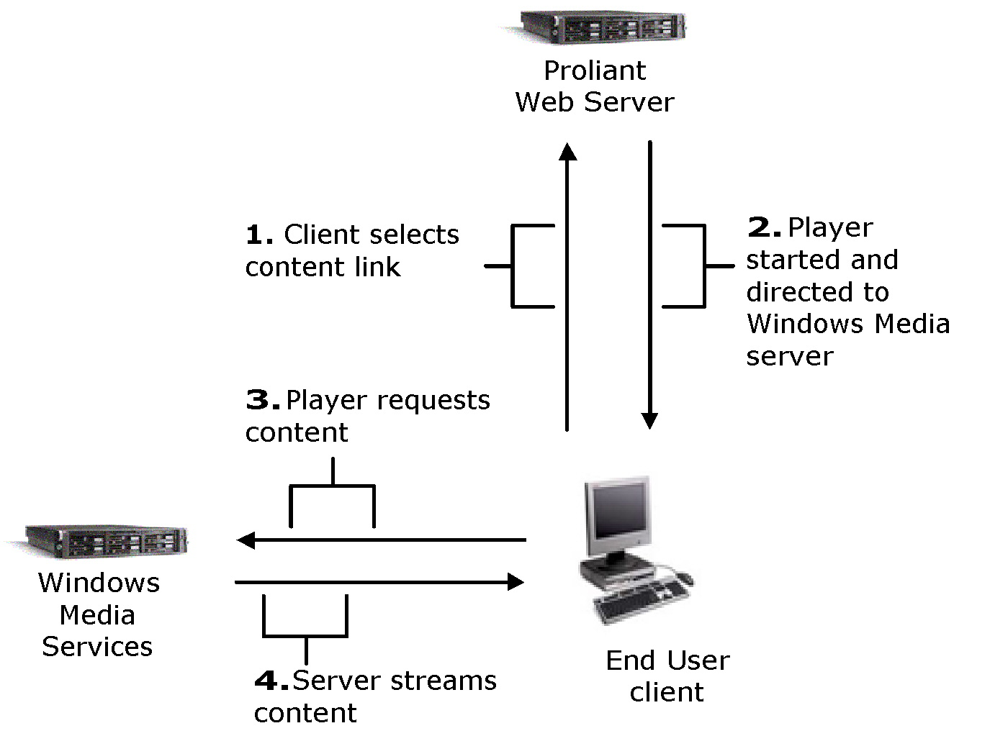
Figure 1. End user streaming sequence
The Windows Media server can stream content from several different sources. Prerecorded content can be stored locally on the server or retrieved from a networked file server. Live events can be captured by using a digital recording device and processed through an encoder before being sent to the Windows Media server for broadcast. A Windows Media server can also distribute content streamed from a publishing point on a remote Windows Media server. The following illustration shows examples of content sources.
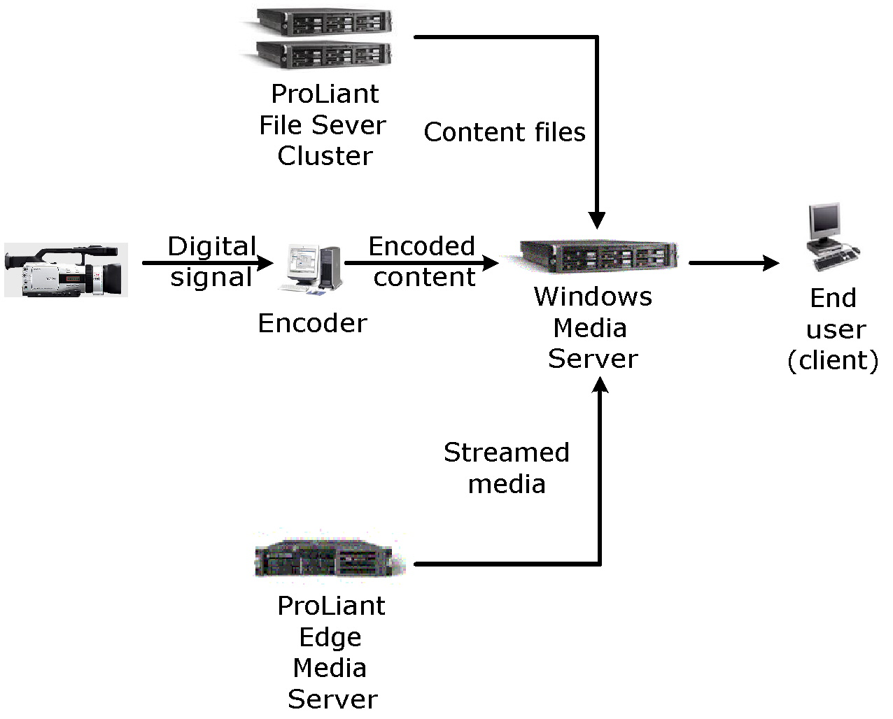
Figure 2. Sources of streaming

Broadcast Communication Scenarios
Business communications are at the center of effective strategic management, planning, and control. Leaders are using digital media solutions to develop, manage, and enhance relationships with key stakeholders. Digital media technology enables companies to continuously refine and position key message points; develop and update public relations materials for investor relations; manage the press release process more effectively; and deliver a more consistent message to employees internally.
Two scenarios are discussed in the following sections that illustrate how digital media provides a significant advantage for the communication of information to employees, customers, vendors, and news media. Digital media can deliver critical information about key business events to a larger audience more quickly and cost-effectively as compared to traditional communications methods. The two scenarios are:
- Strategic announcements in corporate communications
- Product launch for marketing

Corporate Communications—Strategic Announcement
Motivating an individual, team, or an organization is a tremendous challenge for corporations particularly during global economic downturns. Business environment obstacles such as rapid market changes, mergers, retrenchment, consolidation, and systemic changes also affect performance. These factors can fragment employees and promote myopic perspectives that inhibit group and employee community development. In this climate, communications professionals must call upon their communications skills and best practices to help build a community.
In the past CEOs could be anonymous. Now, in the best cases, CEOs are the embodiment of the company brand. This requires that CEOs be charismatic, articulate, and visionary communicators both internally and externally. Increasingly, corporate communications professionals are responsible for enhancing their CEO's media skills, helping the CEO be considered a good communicator with a vision, in tune with employees, smart with the media, and credible with investors. Executive broadcasts enable an executive to deliver important messages to their constituents on a repeated basis, connecting with employees and motivating, inspiring, and informing to build a shared sense of purpose.
Digital media solutions make it possible to reach employees through a video broadcast over an IP-based network while making it affordable for any size company. In the past, executive broadcasts were usually reserved for companies that had a satellite distribution network or closed circuit television network. Now, digital media provides an additional range of distribution options that takes advantage of the enterprise network, increasing the reach to remote offices and employees. This section describes a scenario in which digital media is used to communicate a reorganization plan to employees of a multinational company.

Business Challenge
The CEO and executive team of a company need to communicate a reorganization plan to its 30,000 employees spread across 60 locations in three countries.

Opportunity
The CEO and executive team want to communicate the strategic plan and describe reorganization to all employees within a one week period. The CEO envisions the executive broadcast to involve the entire leadership team, ensuring that a consistent message is delivered throughout the company. The CEO and executive team expect this initial broadcast to become the beginning of an ongoing "process" for two-way communication within the company, not a one-time "event."
The CEO wants the message to inform, motivate, inspire, and direct employee participation toward common goals. The executive team plans to detail and reinforce the strategic plan with repeated communication. The communication is delivered directly to employees at their computer, with executives unconcerned about the message becoming diluted or altered as it descends the corporate hierarchy.

Solution
The framework for an enterprise digital media solution is made up of three areas. By considering the specific requirements of each area, you can enhance the quality, scalability, manageability, and reliability of the resulting solution.

Content Creation
The company enhanced their existing video production studio by deploying a series of encoders and servers that can stream a broadcast across the network. In the initial broadcast, the CEO address is recorded in the studio, edited, and then closed captioning is added. At the time of the event, the final address is multicast at scheduled times to the appropriate offices. In addition, the regional offices built an inexpensive ministudio to capture content from local executives.
The studio creates closed captions by using the Synchronized Accessible Media Interchange (SAMI) standard, which makes it easier to include captioning in digital media content. Content is authored to include multiple languages in the closed caption and multiple language audio tracks so viewers get the information they need in the language of their choice.
All content, live and prerecorded, is encrypted with digital rights management (DRM) to protect content from unauthorized use and illegal distribution. Authorized employees are granted a license that permits viewing of the address for the next 60 days but prevents copying and redistribution of the address. The following illustration describes how content is protected by using DRM.
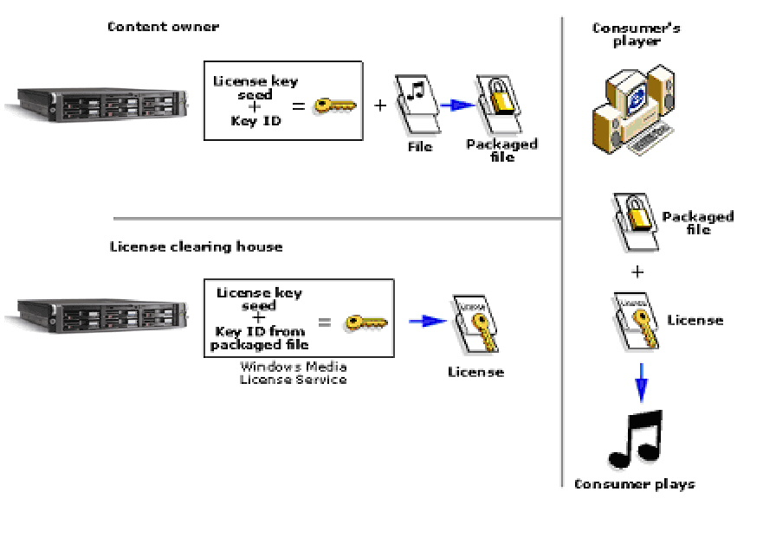
Figure 3. Digital rights management sequence

Content Distribution and Management
To reach employees across all locations, the company implements a distributed network of servers running Windows Media Services 9 Series on an HP ProLiant platform and enables multicasting on 90 percent (%) of the network. This network of origin and edge servers is enabled with a cache/proxy plug-in to ensure proper content placement and redirection of content requests for all network segments and viewers.
The live stream from the studio is multicast across the network globally. The Internet Protocol (IP)-based distribution of content becomes a complimentary method to existing forms of delivery. The following illustration shows an example of multicast and unicast distribution.
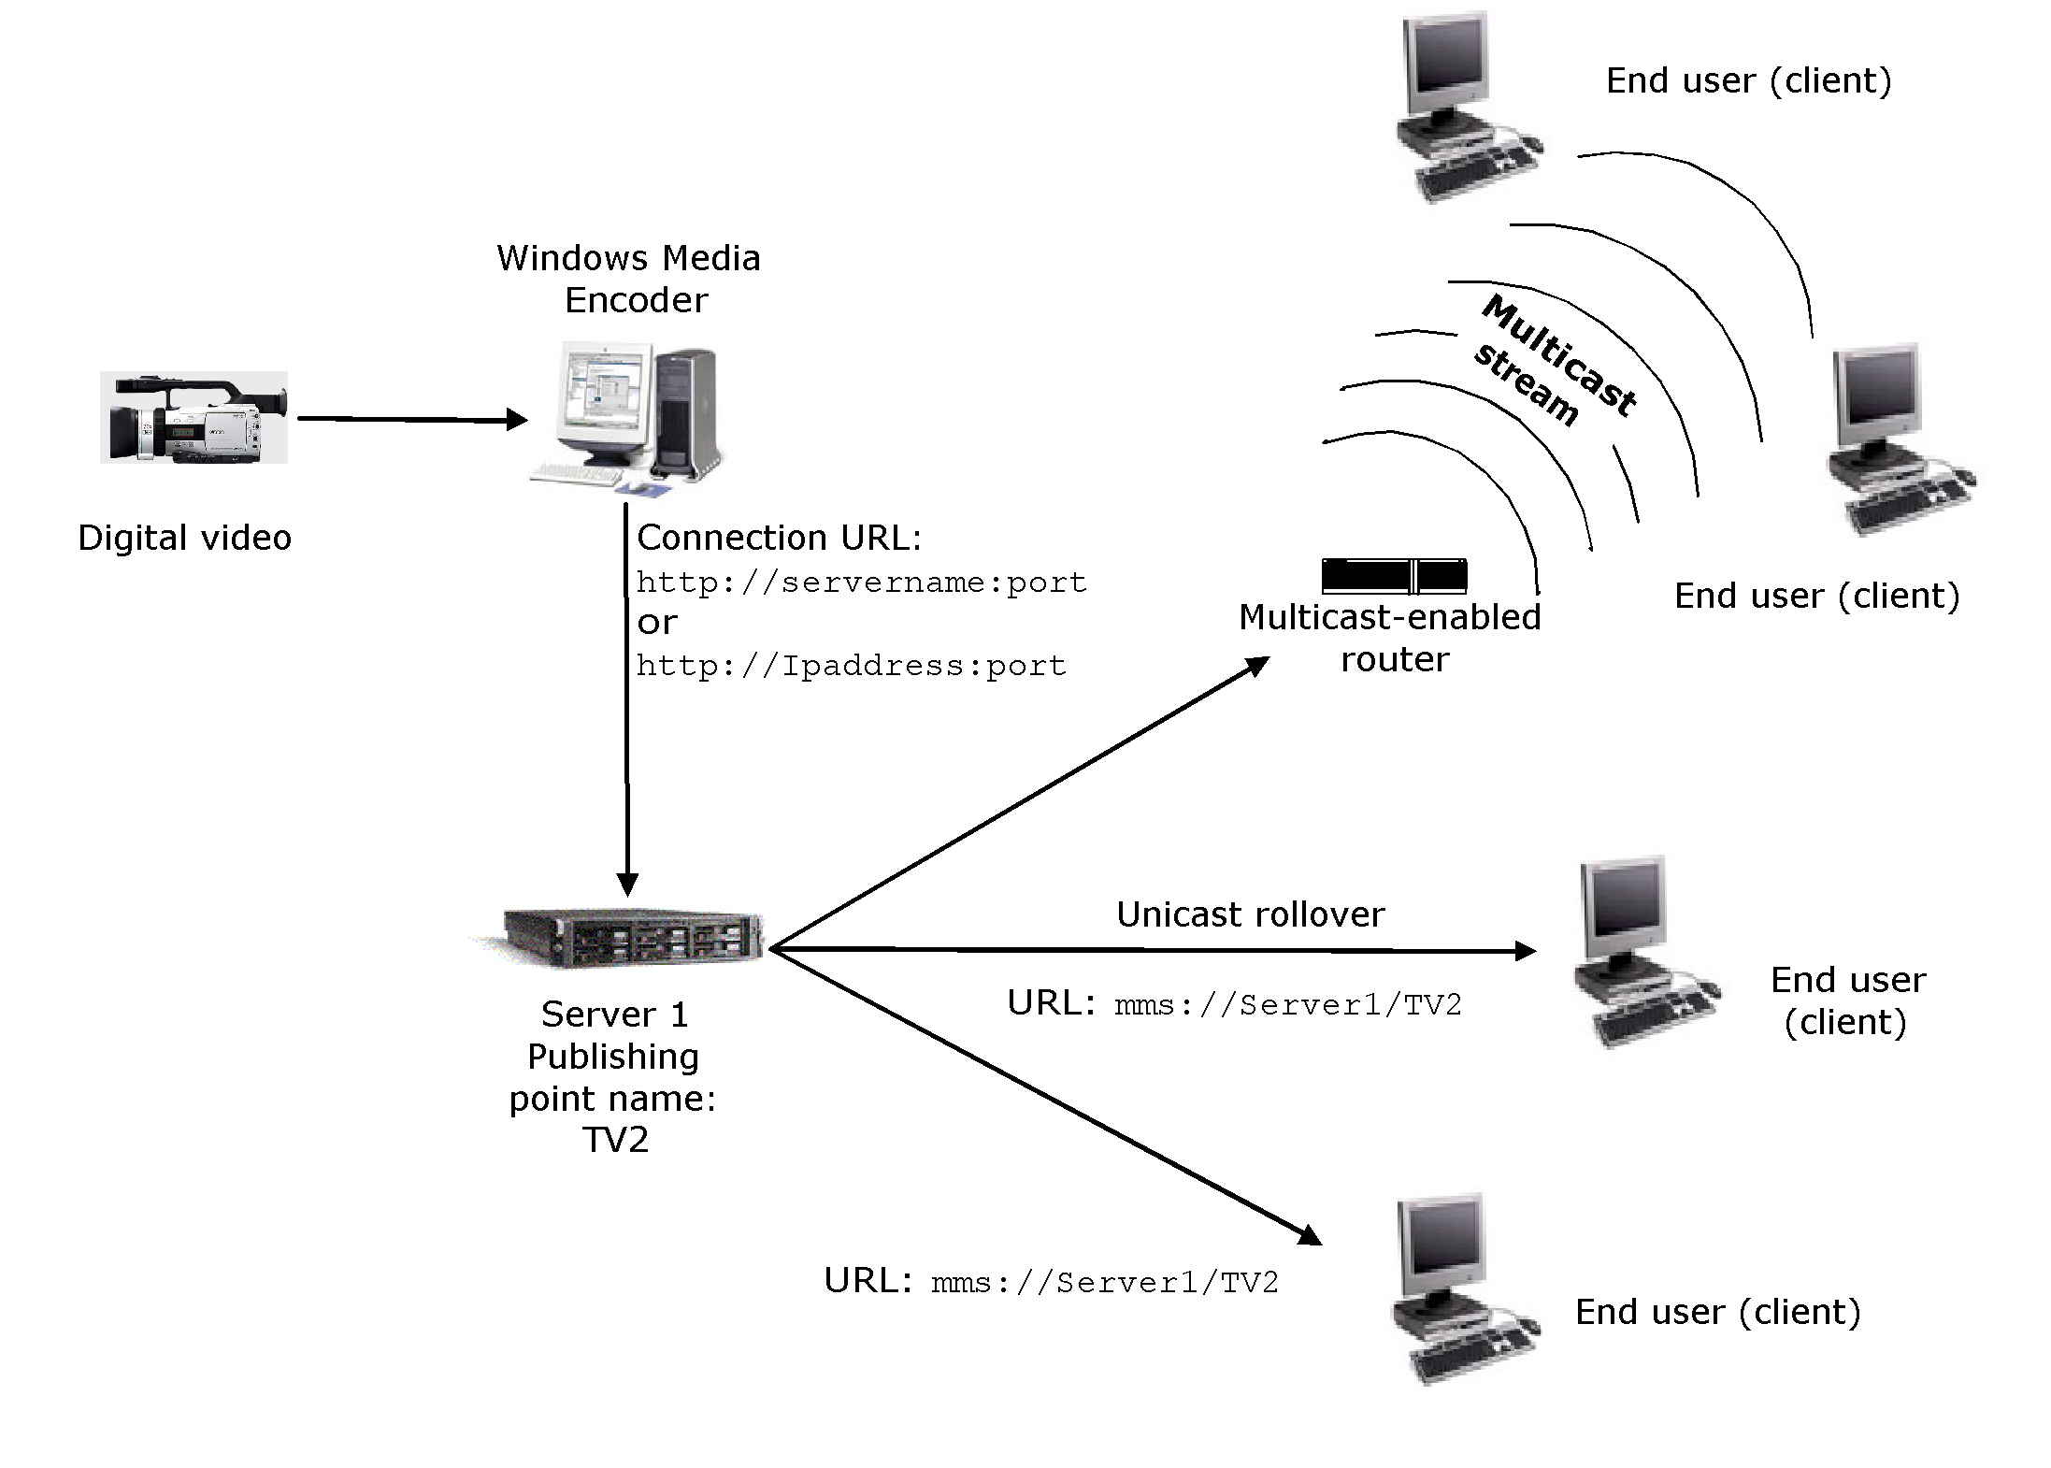
Figure 4. Multicast and unicast distribution
The event producer invites employees to register for the broadcast through e-mail and also promotes the event on the corporate intranet. Upon registration, reminders are created in the employee online calendars. The broadcast is monitored and logged to track who has viewed it. At the start of the broadcast, employees receive a calendar reminder to view the address. When the event starts, viewers have video and audio streamed live to their computer.

Playback Experience
To accommodate all users, the executive team announcement is offered live, in scheduled broadcasts, and on demand.
Live
After a viewer selects a link in the calendar reminder or from the company intranet, the viewer's browser displays Windows Media Player 9 Series embedded in a Web page that contains the company brand and links to related information, such as a call-in phone number. Viewers select from multiple language options when viewing closed captioning. For the chief financial officer's (CFO) portion of the address, slides and other visual information are synchronized with the digital media stream, creating a fully-integrated digital media experience. For this event, the executive team chooses to support a moderated chat feature on an event Web page that enables viewers to send in questions that the speakers can respond to in real time. As soon as the presentation is finished, the audio, video, and associated slides are archived and stored for repeat broadcast and on-demand viewing.
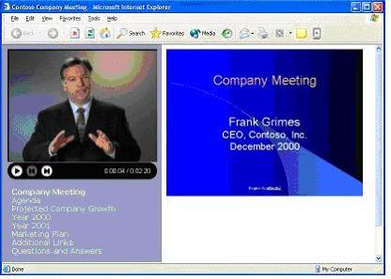
Figure 5. Live CEO announcement
Scheduled Broadcast or On Demand
For viewers who could not watch the initial address, the event is programmed to broadcast twice a day, in the morning and afternoon, for the next month. Registration creates calendar reminders and a moderated chat is provided within the repeat broadcast. After the month of programmed repeat broadcast, viewers can view the event on demand from the sales intranet.
Viewer Survey, Feedback, and Statistics
The CEO and executive team recognize the importance of employee feedback. Employees can provide real-time feedback by using "point-in-time" polling during the broadcast and through an "event" survey that requests ratings on the presenters and content. The "point-in-time" polling results update and display in real time and the "event" survey findings are quantified. The survey and the moderated chat provide multiple channels for employee feedback.
Content logging reports identify which viewers attended which portions of the address. Over 60 percent of the company views the live CEO broadcast, generating a better understanding of the strategic plan and awareness of the reorganization. Within one month, nearly 90 percent of the company has viewed the CEO broadcast, aligning the company with the new plan and structure. Future broadcasts are scheduled by the executive team to further define and describe the plan to achieve the strategy. The broadcast was completed with a small incremental cost, using the prior investment in the studio, network, and digital media servers.

Marketing—Product Launch
Communicating the latest product information across a company is a continuous challenge as new products get launched. Increasing the amount of print media or brochures for internal distribution can be too expensive and using simple Web pages or e-mails is often not enough. In addition, the requirements for internal communications about new products may be different than for external customers.
By using digital media, you can announce a new product to a widely dispersed and varied audience with remarkable timing and accuracy. Consistent messages are delivered across language and cultural boundaries. Resource use increases because the subject matter expert's broadcasts are stored for later reference. Content stays consistent, and less time traveling means that sales staff has more time to focus on strategic and business goals. All of these benefits mean more effective use of the marketing department's resources. This section describes a scenario in which digital media is used to introduce a new product line to its global partners.

Business Challenge
The Executive Vice President of Sales for a medium-size international company must quickly and cost-effectively introduce its new line of products to its distributors and resellers located around the world.

Opportunity
Adapt the product introduction to the language and culture of each of their direct sale forces, distributors, and OEMs. Significantly reduce travel and lodging costs while increasing product awareness and knowledge.

Solution
The framework for an enterprise digital media solution is made up of three areas. Considering the specific requirements of each area will enhance the quality, scalability, manageability, and reliability of the resulting solution.

Content Creation
The company enhanced its existing studio by deploying a series of encoders and digital media servers that can stream a live broadcast across the network. The marketing and product management team use Microsoft Producer for Microsoft Office PowerPoint® 2003 to synchronize video, audio, and PowerPoint content, highlighting the key differences between the old and new products.
The studio creates closed captions with the Synchronized Accessible Media Interchange (SAMI) standard, which makes it easier to include captioning in digital media content. Content is authored to include multiple languages in the closed caption and multiple language audio tracks so viewers get the information they need in the language of their choice. The studio also defines markers within the presentation to enable quick scanning of product features.
The proprietary content is encrypted with the Microsoft Windows Media® Rights Manager 9 Series Software Development Kit (SDK) to protect it from unauthorized use and illegal distribution. The studio packages the content onto CDs for salespersons that travel frequently and use disconnected laptop computers. Authorized employees are granted a renewable license that permits them to play the presentation for one week but prevents them from copying and redistributing the video and audio portions.

Content Distribution and Management
To reach employees across all locations, the company implements a distributed network of servers running Microsoft Windows Media Services 9 Series and enables multicasting on the network. The content is prepositioned at regional offices by pushing the content out to edge servers through the network. The presentations are distributed during off hours to conserve bandwidth during the day. Within 24 hours, the content is populated locally at each site, which enables employees to view the high-quality video on their computer so as not to impact the wide area network (WAN) during business hours. The presentation is also placed on the extranet for viewing by its nonemployee distributors and agents.
Access to the content is tracked. Because the content is available on demand, users can watch the online presentations more than once if they require a second look or just a refresher on one topic. The following illustration shows how content is distributed to end users by using an edge server.
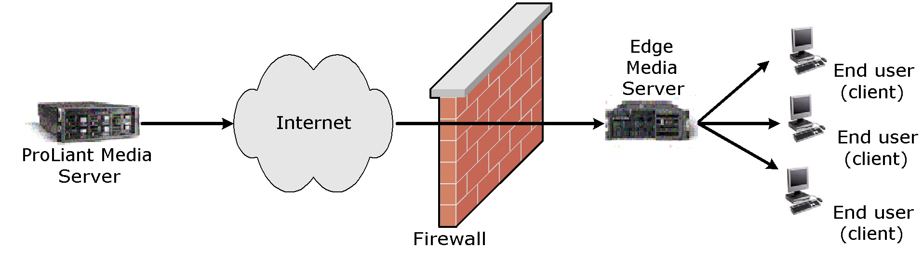
Figure 6. Content distribution
The event producer uses e-mail to invite audience members to register for the broadcast. The product launch is also promoted on the distributor extranet. Upon registration, reminders are created in the employee online calendars and in e-mail. Five minutes prior to the start of the broadcast, registered viewers receive a calendar or e-mail reminder to view the presentation.

Playback Experience
To accommodate all users, the product announcement is offered live, as scheduled broadcasts, and on demand.
Live
After selecting the link in the calendar reminder or from the company extranet, the viewer's browser presents Window Media Player 9 Series embedded in a Web page, with synchronized slides and links to product brochures and industry reviews. Viewers select from multiple language options when viewing closed captioning.
Repeat Broadcast or On Demand
For viewers who could not watch the initial launch, the event is programmed to broadcast twice a day, in the morning and afternoon, for the next two weeks. Calendar reminders are created in attendee e-mail programs when they register and a moderated chat is provided within the repeat broadcast. After the two weeks of programmed repeat broadcast, the event is viewed on demand from the company intranet and distributor extranet.
Viewer Survey, Feedback, and Statistics
Content logging reports list which viewers attended which portions of the launch. Within two weeks 90 percent of the sales channel has been updated on the new product information, preparing them to drive new sales. The marketing group is confident the product information has been consistently delivered and is able to respond to feedback given during the initial broadcast.

Benefits of Broadcast Communications with Digital Media
Digital media for broadcast communications is a key tool for any size company due to the availability and effectiveness of the technology. Until recently, the use of video broadcasts had been limited to larger companies because of the expense required. Audio and video can now be delivered by using industry-standard servers, combining the power of audio and image with the reach of IP networks. Corporations can take advantage of the Internet and their intranet investments to more effectively communicate to their employees, reaching larger audiences more quickly at a lower cost.
The benefits of digital media include:
- Increased reach, by delivering content directly to the employee's computer.
- Ability to track and monitor the delivery of communications, for measured results.
- Ability to deliver a personal message with the use of audio and video.
- Audio and video presentations are more engaging than printed materials or static websites, which contributes to an increased level of comprehension.

Changing How We Communicate
By using digital media technology, companies can easily position and deliver communications over the company intranet. Presentations are stored for repeat broadcast and on-demand access on a company's network. Companies can also deliver communications to external parties over the Internet for truly limitless reach. Because digital media can be indexed and easily updated, employees can discover relevant and current content.
With digital media technology, companies are recognizing the value that they obtain by employing this technology as a new communication format. They can create video and audio communications with the personality of the presenter, which enhances understanding and retention of the message.

Understanding Return-on-Investment Factors
Digital media simplifies communication paths and dramatically increases the speed of information dissemination. By deploying a reliable Windows Media 9 Series solution hosted by managed HP ProLiant servers, companies can use the Internet and intranet to efficiently distribute information and promote understanding within a target audience. Managers and employees no longer need to be present in the same physical space, at the same time, to produce learning content. The alternative to the physical constraints of in-person training methods reduces overhead, expenses, and time delays.
With digital media, the availability of information increases and the cost of distribution decreases. The availability of current content leads to better operational support by providing more accurate and relevant information. For example, access to up-to-date company information helps employees stay informed and connected, enabling them to deliver better product and customer service support. The implementation of corporate communications helps companies to establish informational synergies and economies of scale, promoting consistency, efficiency, and effectiveness.
Expenses for implementing a digital media communication infrastructure are justifiable through the cost avoidance of items such as:
- Travel expense and time loss
- Reproduction of print materials
- Facilities, including building, staff, and maintenance
Although these savings are immediate and substantial, there are long-term benefits that provide additional return:
- Increased retention and productivity
- Broadened reach of communicators
- Shorter cycle times due to increased speed of information dissemination

Cost Factors
Providing the user with a quality corporate communications experience begins with planning the content production. The audio and video streams are captured, encoded, and readied for delivery. The encoded file is stored on a Windows Media server where it is managed and staged for delivery by using industry-standard HP ProLiant servers to proxy/cache servers located at the "edge" of the network. Finally, users can view and interact with the content through their client device.
Cost elements vary for each company, but the costs can be generalized and are predictable, based on the following factors. Solution costs break down into three areas:
- Network. The network costs are a function of the number of office locations and the capacity of the network. There are options when preparing the network infrastructure. For example, a solution that uses low-bit-rate video that is distributed on demand during nonbusiness hours reduces the need to increase the capacity of the central network and wide area network (WAN). However, this requires additional storage at local sites. Conversely, if content is distributed on demand across the corporate network during business hours, storage needs at the local site are reduced. However, capacity of the central network and WAN will need upgrades.
- Server. The server costs include the HP ProLiant servers, the ProLiant Essentials software, and the software licensing costs for the Microsoft Windows® operating system running on each hardware component. There is no incremental cost for any of the Windows Media 9 Series components as they are either integrated into the operating system or obtained through a no-cost download from the Windows Media Download page at the Microsoft website (http://www.microsoft.com/windows/windowsmedia/download/default.asp). The number of servers is dependent upon the network topology, number of locations, and the type of distributed architecture design.
- Content. Content costs are a function of the volume of content generated, the quality requirements, and the number of bit rates that must be supported. The bit rate at which content is encoded determines the bandwidth required to stream. It is typical to require that content be encoded at low, medium, and high bit rates (56 kilobits per second (Kbps), 128 Kbps, and 256 Kbps respectively) to support the various network connections. Modifying studio environments or creating ministudios will also require additional hardware, such as a video camera, microphone, channel mixer, teleprompter, capture card, and lighting.

Additional Reference Materials
The following case studies, which are available on the Microsoft website, highlight the return on investment of broadcast communication solutions:
- Marathon Ashland Petroleum LLC (http://www.microsoft.com/windows/windowsmedia/archive/casestudies/map/default.aspx)
- Roche Diagnostics (http://www.microsoft.com/windows/windowsmedia/archive/casestudies/roche/default.aspx)
- General Mills (http://www.microsoft.com/windows/windowsmedia/archive/casestudies/generalmills/default.aspx)
- "Rapid Economic Justification" white paper on the Business Value for the Enterprise page at the Microsoft website (http://www.microsoft.com/windows/windowsmedia/enterprise/AboutWM/BusinessValue/default.aspx)

Solution Requirements
The framework for an enterprise digital media solution is made up of three areas. Considering the specific requirements of each area will enhance the quality, scalability, manageability, and reliability of the resulting solution.
- Content creation
- Content distribution and management
- Playback experience

Content Creation
Companies should address video production needs if they are creating original content in a professional studio setting. This is not dealt with in this paper; however, it is a consideration when implementing a digital media solution.
Digital media content creation involves a set of guidelines, processes, and tools that enable personnel to efficiently create and prepare digital media content. There are four primary infrastructure requirements for creating content:
- Capture. Capture is the process of converting an audio or video input into a compressed or uncompressed digital format, such as WAV or AVI. The digital format may be archived as a file, fed directly to an encoder, or both.
- Encoding. Encoding is the process of digitizing audio and video input into a compressed format at the desired bit rate and quality. This is typically one seamless process in which a digital input from a camera, tape, file, or other digital source is encoded into Windows Media Format that can be archived or streamed, or both.
- Storage. Content production groups generally want to maintain their own libraries of content during the various phases of production. Often, multiple versions of a content element will exist to facilitate review and simultaneous work by several groups, similar to when a large document is written. Scalable and reliable networked and internal server storage is essential.
- Authoring tools. One value of digital media comes from the integration and synchronization of multiple digital media formats to make compelling rich-media presentations. Rich-media authoring tools simplify the content creation process by allowing drag-and-drop functionality in a graphical user interface. Two examples are Producer for PowerPoint 2003 and Windows Movie Maker, which are both intended as end user programs. Distributing the content creation process out to end users will help increase the rate at which content is published and also reduce the burden on IT and digital media groups.
- Development tools. Development tools, typically in the form of Software SDKs are intended for developers to program custom solutions. There are situations where it will be desired to create more sophisticated content for special events, such as integration of Macromedia Flash or dynamic HTML (DHTML) into a presentation. The use of existing authoring programs may be preferred if content creation is an ongoing business process because using development resources to create digital media presentations can be costly and time consuming.

Content Distribution and Management
Once a segment of digital media content is produced, it needs to be distributed to the intended audience in a timely and cost effective manner. Enterprises will want to manage this distribution process to ensure optimal use of storage and network bandwidth, while ensuring that the content is secure and highly available. The majority of the infrastructure work for distribution and management falls into three areas:
- Replication. As content is produced and made available to end users, a large amount of hard disk storage is required. Although storage solutions can be implemented in a variety of ways, a common implementation is to use one central repository and many smaller cache servers on the edge. Content can be proactively scheduled for distribution to specific locations within the enterprise, ensuring availability and improving viewing quality while minimizing WAN expense.
- Redirection. As viewers request content, the cache/proxy server redirects the content request to the preferred server when appropriate.
- Digital media tools. Windows Media technologies enable you to control the format of the content, how it is assembled, how it is streamed, how it is secured, and the options for playback. They play a vital role in determining implementation and support of an enterprise solution.
When designing a storage solution, consider the access requirements, as this will often dictate the solution with the appropriate bandwidth for retrieving stored content from hard disks. Typical options include Network-Attached Storage (Windows-based NAS), clustered Windows file servers or a Storage Area Network (SAN) based on a fiber channel storage system, connecting multiple hosts to central storage through a 2-gigabyte (GB) fiber channel.

Playback Experience
Users can play content by using a standalone player or a player embedded within a Web page. The content can be located on a computer or a portable device. A user may be directed to a digital media portal to locate materials for viewing. Once the content is located, the user expects a quick and easy way of viewing it. The Windows Media 9 Series SDKs offer numerous opportunities to design the perfect user experience for the intended audience.
- Instant-on/always-on streaming. Windows Media Player 9 Series has eliminated the long buffering "wait" prior to steaming content when connected to a server running Windows Media Services 9 Series.
- Audio/video quality. Experience the best quality audio and video at any connection speed with Windows Media Audio and Video 9 Series codecs. Variable-bit-rate (VBR) audio and new compression delivers MPEG Audio Layer-3 (MP3) quality at half the size, while delivering the best quality video at the smallest download sizes or streaming speeds when compared to other formats.

Implementation Considerations
The most important decision in implementing a digital media solution is selecting the right technology and delivering a cost-effective solution that meets the business need. A unique challenge enterprises face is identifying clear owners for the solution. Digital media attracts stakeholders from many business units, and several factions within IT. This often makes decision-making more difficult because many business units will provide funding, and the networking, infrastructure and desktop groups each will participate in the design.
Other key decisions include:
- Delivering an initial solution that is sure to get a few early wins. The business requirements will evolve quickly as users experience these new applications. It's best not to over-engineer the first version.
- Selecting an infrastructure provider with broad offerings that scale. Using a variety of vendors may increase the expenses of custom integration over that of contracting with fewer vendors for the solution.
- Selecting a digital media platform that will grow and scale as your business needs demand it. The applications of digital media are developing fast, so allow for rapid growth.
- Developing business processes to drive the creation, distribution, and consumption of digital media content.

Microsoft and HP Technologies for Digital Media Solutions
Microsoft Windows Media 9 Series and HP provide a comprehensive set of technologies and products to deliver a digital media solution for the enterprise. Together, HP and Microsoft committed to develop and deliver premier streaming media solutions and have the proven expertise to deliver leading edge, industry-standard solutions for the creation, hosting, distribution, management, and experience of digital media. These solutions enable a new breed of corporate communication to be delivered via the Internet and enterprise intranet. Windows Media 9 Series is a leading platform for creation, distribution, and playback of digital media files. Key Microsoft-HP building blocks to the digital media enterprise are described here.

Content Creation
Microsoft and HP offer a number of tools for creating compelling text and graphics for streaming with Windows Media 9 Series.
- Windows Media Encoder 9 Series. Windows Media Encoder 9 Series is a powerful tool for enterprise content producers who want to take full advantage of the Windows Media 9 Series platform. For converting both live and prerecorded content, the encoder provides control and flexibility, the highest quality audio and video at any bit rate, and powerful levels of extensibility and automation.
You can capture content from the encoder with frame accurate control, and the encoder allows you to initiate and protect live broadcasts. To meet the demands of a broad range of production environments, the encoder provides advanced capture abilities, powerful server integration for live broadcasts, and more flexibility to optimize compression for a wide range of delivery scenarios.
- Windows Media Encoder 9 Series SDK. This set of Application Programming Interfaces (APIs) makes it easy for a developer to script the behavior of the encoder itself. This is an easy way to build a powerful digital media creation application on top of Windows Media Encoder 9 Series, and is ideal for building batch encoding tools or simplified encoding applications for end users.
- Producer for PowerPoint 2003. Designed for business users and enterprise media professionals, Producer is an add-on for PowerPoint 2003. It helps you capture, synchronize, and publish audio, video, slides, and images, resulting in engaging rich-media presentations viewable on demand in a Web browser.
- Producer for PowerPoint 2003 Resource CD. This resource CD is a "one-stop shop" for relevant new tools, white papers, technical questions, and usage tips. It contains the Producer software, sample templates, a template editor, white papers, best practices, and other supporting documentation.
- Windows Media JumpStart 9 CD. This resource CD includes the Windows Media Player 9 Series, Windows Media Encoder 9 Series, Windows Media 9 Series SDKs, software, demos, how-to white papers, and bonus materials.
- HP Digital Content Creation (DCC). Availability and performance of professional graphics is a key factor in customers' workstation decisions. Under the HP Leadership Graphics Program, HP provides the fastest access to the best graphics capability in the industry at varying performance and price points. HP recommends the HP Workstation xw4000 for the entry level, the HP Workstation xw5000 for additional graphics capabilities, and the HP Workstation xw8000 as the most expandable model for editing, decoding, and encoding audio and video content.

Content Distribution and Management
Microsoft and HP offer a variety of solutions for deploying and managing streamed content in small, medium, or large environments.
- Windows Media Services 9 Series. A service of Windows Server™ 2003 that is used for streaming audio and video content to clients over an IP-based network. These clients may be other computers or devices that play back the content by using a Windows Media Player, or they may be Windows Media servers that act as a proxy or cache for redistributing content. Clients may also be custom applications that have been developed by using the Windows Media 9 Series SDK.
- Windows Media 9 Series SDK. A collection of individual SDKs available for each platform component: Windows Media Services, Windows Media Format, Windows Media Encoder, Windows Media Player, and Windows Media Rights Manager.
HP has server platforms and infrastructure products designed to support digital media deployments.
- ProLiant BL servers. HP is leading the expansion of the blade server market with the HP ProLiant BL blade servers. This industry standard approach enables HP to accelerate the delivery of cost-effective, compatible and widely available blade server architectures. The ProLiant BL blade servers are power-efficient, ultra-dense and optimized for rapid deployment and provisioning. They are ideal for space-constrained enterprises seeking increased density and scalability.
- ProLiant DL servers. The HP ProLiant DL servers are ideal for multi-server deployments and deployments with external attached storage. The DL 360 and DL 380 have become the leading platform for Windows Media deployments. HP has developed technical guides that provide detailed instructions for installing, configuring, and managing Windows Media Services. These density optimized rack servers are engineered for flexibility and manageability.
- ProLiant ML servers. For growing businesses running sophisticated small applications and branch offices of larger organizations that need a platform for single-function solutions, the ProLiant ML server is an Intel Pentium Xeon or Pentium 4-based ProLiant that delivers ProLiant reliability together with the best-in-class data protection and management to simplify ownership. ProLiant ML servers should be used when more in-the-box storage is required and/or more PCI cards are required.
- ProLiant Essentials Software. The ProLiant Essentials Foundation Pack contains the essential software every customer needs to install, configure, and manage ProLiant servers as part of an adaptive infrastructure and comes with every ProLiant server. The ProLiant Essentials Foundation Optional Value Pack software provides offerings that selectively extend the functionality of an adaptive infrastructure to address specific business problems and needs.
- HP StorageWorks and ENSA-x. HP has two products to meet the high throughput needs of Windows Media servers and master content repositories. The HP StorageWorks modular Storage Area Network (SAN) Array 1000 (MSA 1000) is a 2-GB Fibre Channel storage system for the entry-level to midrange SANs. And Enterprise Network Storage Architecture extended (ENSA-x) builds upon years of successful innovation and consistent delivery of network storage solutions to the market. ENSA-x is the evolution of the storage utility vision, where the right information is accessible to anyone, anytime, anywhere. This architecture is designed to put customers in control by allowing them to adapt their storage infrastructure to their business environment through automation and active intelligent management. It is an end-to-end business-centric, adaptive storage architecture that is controllable, resilient, and extensible, from storage to the application. It is policy-based and application aware. These capabilities are achieved through active intelligent management technologies that provide predictable quality of service levels and further enable the enterprise storage utility.

Playback Experience
Microsoft and HP offer several software and hardware products that enable your users to experience the best of Windows Media 9 Series.
- Windows Media Player 9 Series. A full-featured player that delivers fast and simple playback of digital media without sacrificing customization features. Windows Media Player 9 Series delivers flexible deployment and playback options designed to maximize productivity for both the end-user and the IT administrator in charge of deployment. With localized support for over 26 languages including Multiple Language UI (MUI), the Player is designed for today's multinational organizations.
When Windows Media Player 9 Series is used with the other Windows Media 9 Series components, the user receives the best possible digital media experience. For example, when combined with Windows Media Services 9 Series, the Player can deliver instant-on/always-on streaming to broadband users with Fast Streaming. Behind the scenes, Windows Media Services can also deliver personalized content that has been dynamically arranged in server-side playlists. All that users know is that they are getting exactly the content they want—more reliably and without waiting for long periods of buffering.
- Enterprise Deployment Pack for Windows Media Player 9 Series. Provides a build environment that makes it easy for network administrators to centrally manage, configure, and deploy Windows Media Player 9 Series. Administrators can specify desired Player policies and preferences, as well as locking down a desired Player "skin," which can limit access to consumer-oriented features that are deemed unsuitable for enterprise usage. You can deploy the customized .msi file through Microsoft Active Directory® or through any software management system.
- HP desktop and notebook computer management solutions. A management agent is included as part of the factory-loaded image on selected desktop and notebook computers. This agent enables communication with the AX Deployment Server (formerly Altiris eXpress), which can be used to complete a new hardware deployment or personality migration to a new operating system by using an easy-to-follow wizard.
- HP Comm Station Pro. PC comm stations provide a single point of access for audio while improving accessibility to universal serial bus (USB) devices. The easy-to-use, space-saving business accessories include computer headsets that can be used for both telephone and Windows Media-based applications. The computer headset integrates with a telephone, allowing you to listen to digital media files and messages or make telephone calls—all from a single device.

For Additional Information
For a better understanding about the infrastructure requirements, see the white paper "Enterprise Digital Media Solutions Guide—Part Three: Infrastructure," which is the third paper in this series.
Microsoft Online Resources
The Windows Media website has a large selection of resources to help you get started, with everything from "How to's" and business justifications to case studies:
- Windows Media 9 Series page at the Microsoft website (http://www.microsoft.com/windowsmedia).
- Windows Media 9 Series Deployment Guide page at the Microsoft website (http://www.microsoft.com/windows/windowsmedia/enterprise/TechResources/default.aspx).
- Windows Media Download Center page at the Microsoft website (http://www.microsoft.com/windows/windowsmedia/download/default.asp).
- Producer for PowerPoint 2002 page at the Microsoft website (http://www.microsoft.com/windows/windowsmedia/technologies/producer.asp).
- Windows Media 9 Series on the Enterprise page at the Microsoft website (http://www.microsoft.com/windows/windowsmedia/enterprise.aspx).
- "Rapid Economic Justification (REJ)" white paper on the Business Value for the Enterprise page at the Microsoft website (http://www.microsoft.com/windows/windowsmedia/enterprise/AboutWM/BusinessValue/default.aspx).
Microsoft Consulting Services and Partners
- Microsoft Consulting Services (MCS) has an international presence and the expertise to help you implement an enterprise digital media solution, whether nationwide or worldwide. For more information, see the MCS website (http://www.microsoft.com/business/services/mcs.asp).
- Microsoft has Windows Media Service Providers with specific product and services expertise in broadcast communication. For more information, see the Service Provider page at the Microsoft website (http://www.microsoft.com/windows/windowsmedia/service_provider/programs/wmsp.asp).
- Microsoft has over 32,000 Certified Partners worldwide that can also help you get started. For more information, see the Microsoft website (http://www.microsoft.com/windows/windowsmedia/partner.aspx).
HP Online Resources
- HP and Microsoft Streaming Media Solutions page at the HP website (http://h71028.www7.hp.com/enterprise/cache/5197-0-0-0-121.aspx).
- ProLiant server page at the HP website (http://www.compaq.com/products/servers/platforms/index.html).
- ProLiant Clusters for Microsoft page at the HP website (http://h18004.www1.hp.com/solutions/enterprise/highavailability/microsoft).
- Digital Content Creation (DCC) Workstation page at the HP website (http://www.hp.com/workstations/segments/dcc/).
- ProLiant Essentials page at the HP website (http://h18000.www1.hp.com/products/servers/proliantessentials).
- Storage Solutions page at the HP website (http://thenew.hp.com/country/us/eng/prodserv/storage.html).
HP Services
- HP Services has the expertise to help your business deploy enterprise solutions. For more information, see the HP Services page at the HP website (http://www.compaq.com/services/).
- Rich Media Services page at the HP website (http://h30046.www3.hp.com/solutions/solutionhome.php?topiccode=RICHMEDIA&regioncode=NA&langcode=USENG).
- Mobile and Media Systems Lab page at the HP website (http://www.hpl.hp.com/research/cp/cmsl/publications/streaming/index.html).
Approach Services
Approach jointly authored this paper with Microsoft and HP.Approach has the expertise to help you develop and deploy Windows Media solutions in the enterprise. For more information, visit the Approach website at (http://www.approach.com) or send e-mail to digitalmedia@approach.com

