

Enterprise Digital Media Solution Guide
Part One: E-Learning
Produced by:
Microsoft—Windows Digital Media Division
Hewlett-Packard—Industry Standard Server Group
Approach Inc.

March 2004

Applies to:
Microsoft® Windows Media® Encoder 9 Series
Microsoft Windows Media Services 9 Series
Microsoft Windows Media Player 9 Series
Microsoft Producer for PowerPoint® 2003
Microsoft Windows Media Digital Rights Manager 9 Series SDK
Hewlett-Packard ProLiant servers
Hewlett-Packard ProLiant Essentials software

Summary: Describes scenarios and benefits for deploying digital media technology for e-learning. The paper identifies what to consider when deploying a digital media solution comprised of products and technologies from Microsoft and Hewlett-Packard. It also provides the infrastructure requirements for e-learning solutions and is intended for business and technical decision-makers. (25 printed pages)

Legal Notice
The information contained in this document represents the current view of Microsoft Corporation on the issues discussed as of the date of publication. Because Microsoft must respond to changing market conditions, it should not be interpreted to be a commitment on the part of Microsoft, and Microsoft cannot guarantee the accuracy of any information presented after the date of publication.
This White Paper is for informational purposes only. MICROSOFT MAKES NO WARRANTIES, EXPRESS OR IMPLIED, AS TO THE INFORMATION IN THIS DOCUMENT.
Complying with all applicable copyright laws is the responsibility of the user. Without limiting the rights under copyright, no part of this document may be reproduced, stored in or introduced into a retrieval system, or transmitted in any form or by any means (electronic, mechanical, photocopying, recording, or otherwise), or for any purpose, without the express written permission of Microsoft Corporation.
Microsoft may have patents, patent applications, trademarks, copyrights, or other intellectual property rights covering subject matter in this document. Except as expressly provided in any written license agreement from Microsoft, the furnishing of this document does not give you any license to these patents, trademarks, copyrights, or other intellectual property.
© 2004 Microsoft Corporation. All rights reserved.
Microsoft, MS-DOS, Windows, Windows Media, Windows NT, Windows Server, Active Directory, ActiveSync, ActiveX, Direct3D, DirectDraw, DirectInput, DirectMusic, DirectPlay, DirectShow, DirectSound, DirectX, FrontPage, HighMAT, JScript, Microsoft Press, MSN, NetShow, Outlook, PowerPoint, Visual Basic, Visual C++, Visual InterDev, Visual J++, Visual Studio, WebTV, Win32, and Win32s are either registered trademarks or trademarks of Microsoft Corporation in the U.S.A. and/or other countries.
The names of actual companies and products mentioned herein may be the trademarks of their respective owners.
The information in this document is subject to change without notice. HP and the HP logo are registered trademarks of Hewlett-Packard Company.

Contents
Introduction 1
What is Digital Media? 1
What is Streaming? 1
E-Learning Scenarios 4
Sales and Marketing—Product Training 4
Business Challenge 5
Opportunity 5
Solution 5
Human Resources—Compliance Training 8
Business Challenge 8
Opportunity 8
Solution 8
Benefits of E-Learning with Digital Media 11
Changing How We Teach 11
Understanding Return-on-Investment Factors 12
Additional Benefits of Digital Media E-Learning 12
Cost Factors 13
Additional Reference Materials 14
Solution Requirements 14
Content Creation 14
Content Distribution and Management 15
Playback Experience 16
Implementation Considerations 16
Microsoft and HP Technologies for Digital Media Solutions 17
Content Creation 17
Content Distribution and Management 18
Playback Experience 19
For Additional Information 20

Introduction
Conducting business is more competitive and complex than ever before. Organizations are continuously challenged to deliver new and innovative products faster, with higher quality and better customer service. Keeping a company's workforce trained and prepared is critical to remain competitive. Motivating an individual, a team, or an organization is a tremendous challenge for corporations particularly during global economic downturns. Business environment obstacles such as rapid market changes, mergers, retrenchment, consolidation, and systemic changes also affect performance. Digital media is an effective means to communicate, listen, and provide learning opportunities to the enterprise. Learning groups are at the forefront of this challenge, looking for innovative ways to train more employees quickly, with better quality content and at a lower cost.
This paper takes an introductory look at e-learning and how digital media can make an immediate impact on improving learning initiatives. It is intended for learning and technology decision makers and begins by describing two business scenarios for e-learning. With these two scenarios, the paper explores the complementary role of digital media in e-learning and the increased value being realized. Finally, it identifies the Microsoft® and Hewlett-Packard (HP) products and technologies available to build cost-effective and reliable digital media learning solutions.
This paper is Part One of the Enterprise Digital Media Solution Guide series. Part Two describes broadcast communications solutions, and Part Three details the technology considerations for both broadcast communications and e-learning enterprise applications.

What is Digital Media?
Digital media refers to audio and video content that has been encoded (digitally compressed). Encoding content involves converting audio and video input into a digital media file such as a Windows Media file. After digital media is encoded, it can be easily manipulated, distributed, and rendered (played) by computers, and is easily transmitted over computer networks.

What is Streaming?
Streaming is a method of delivering digital media content across a network. Streaming occurs when a computer or device begins to receive content from a server and begins to play the content before the entire file has been transferred. Streaming uses bandwidth more efficiently than downloading because it sends data over the network only at the speed that is necessary for the client to render it properly. This helps prevent the network from becoming overloaded and helps maintain system reliability. There is typically a delay between the time the stream is received by the player and the point at which it begins playing because the player must first accumulate an amount of content into a "buffer" in case there are delays or gaps in the stream. Because data streaming and rendering occurs at the same time, streaming also enables you to deliver live content.
A streaming media system based on Microsoft Windows Media® 9 Series and HP ProLiant servers typically consists of a server running an encoder (such as Windows Media Encoder 9 Series), a server running Windows Media Services 9 Series, and client computers running Windows Media Player 9 Series. The encoder enables you to convert both live and prerecorded audio, video, and computer screen images to Windows Media Format. The server running Windows Media Services, called a Windows Media server, enables you to distribute the content over a network. Users view and listen to the content you distribute by using a player, such as Windows Media Player.
In a typical scenario, a user clicks a link on a Web page to request content. The Web server redirects the request to the Windows Media server and opens the player on the user's computer. At this point, the Web server no longer plays a role in the streaming media process and the Windows Media server establishes a direct connection with the player and begins streaming the content directly to the user. The following illustration shows the streaming sequence when a user requests content from a Web page.
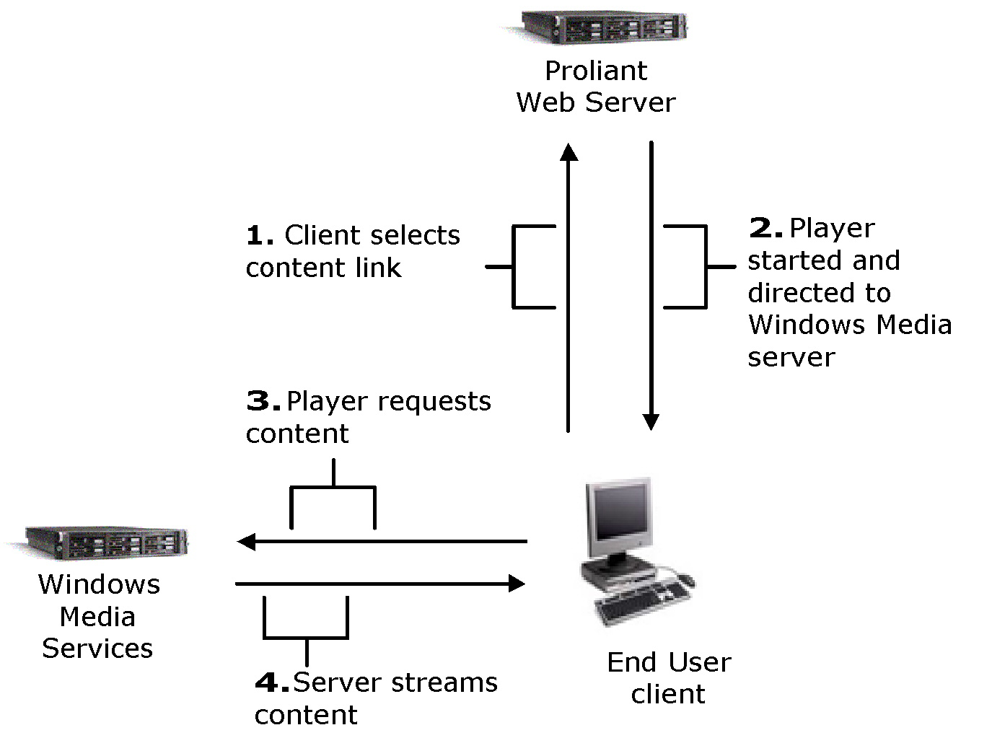
Figure 1. End user streaming sequence
The Windows Media server can stream content from several different sources. Prerecorded content can be stored locally on the server or retrieved from a networked file server. Live events can be captured by using a digital recording device and processed through an encoder before being sent to the Windows Media server for broadcast. A Windows Media server can also distribute content streamed from a publishing point on a remote Windows Media server. The following illustration shows examples of content sources.
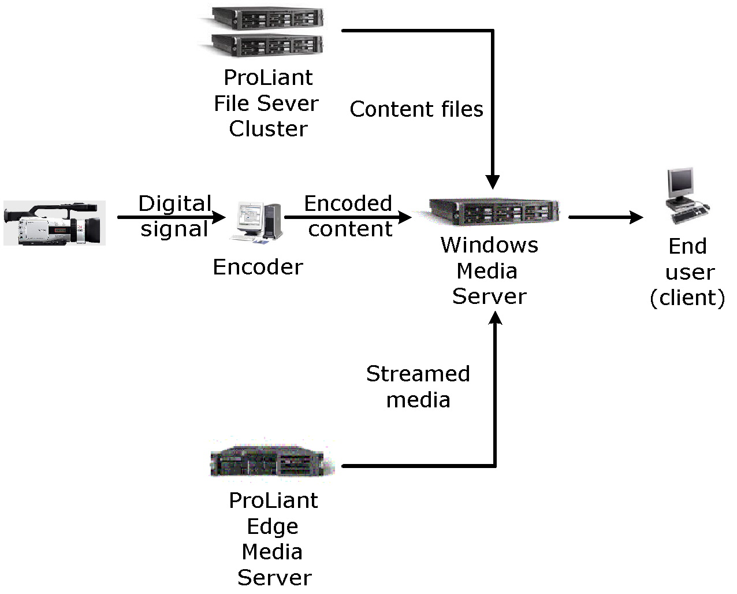
Figure 2. Sources of streaming

E-Learning Scenarios
Motivating an individual, a team, or an organization is a tremendous challenge for corporations particularly during global economic downturns. Business environment obstacles such as rapid market changes, mergers, retrenchment, consolidation, and systemic changes also affect performance. It is at these times that employees might feel overworked, uninterested in their jobs, distrustful of management, apprehensive about the future, and unmotivated through lack of recognition or rewards. They might become reluctant to share information, hoard knowledge, fear negative consequences, or feel threatened about sharing insights and opinions. In these times, it is imperative to define and implement effective processes to communicate, listen, and provide learning opportunities to the enterprise. Digital media distinguishes itself as a valuable tool that can be used in a variety of settings to reach and engage employees.
Activity within areas such as sales and marketing, customer service, merger and acquisition, or compliance is intense. The fast pace requires flexible knowledge and skill development that is driven by the individual. For example, carrying out a sales and marketing strategy depends on critical information reaching employees and partners quickly in order to connect people and skills to improve knowledge, services, and profitability. Learning must be relevant and fit within the context of employees' job roles and functions. Trends point toward increasingly dispersed yet collaborative workforces, shorter product lifecycles, and continuing complexity. These issues and trends present professionals with challenges that, when addressed, have a significant impact on the bottom line.
Learning and development leaders struggle to find time to take proactive steps to implement online learning systems, partially due to the focus on reactive responses to environmental factors. Now, more than ever, organization effectiveness and learning and development leaders are increasing their role as strategic business partners by seeking to continually expand the ability to develop and manage their employees to achieve superior performance. It is a complex issue to manage employees that are anchored to performance objectives and at the same time methodically develop their skills, abilities, and knowledge efficiently and effectively. This complexity is intensified by the expansion of organizations as they extend their relationships with employees, customers, partners, and suppliers.
The following two scenarios illustrate how digital media provides a significant advantage for the e-learning solutions for employees, customers, and suppliers. Digital media can deliver relevant courseware to a specific audience quickly, cost-effectively, and complimentary to instructor-based training.

Sales and Marketing—Product Training
Sales, marketing, and customer service depend on continuous product training to function effectively and keep up with changes in the marketplace. Improving product training is key to enabling a company to stay ahead of its competition, while providing customers with the quality and service they expect. Quicker dissemination of product information cuts the time-to-market and provides for better customer support of new products. Digital media can provide the means for just-in-time learning about the features of new products for the remote sales force and customer service representatives, allowing familiarization of new products while maintaining critical schedules. You can track and monitor training use to determine the current product knowledge of the sales and field personnel. This section describes a scenario in which digital media is used to train a large sales force.

Business Challenge
A 1,200-person global sales force located across multiple time zones needs to be trained for the key features and competitive differentiators of a new product release.

Opportunity
The Vice President of Sales expects the product offering to provide an opportunity to increase sales by gaining the market share in an emerging market. The V.P. also wants to take advantage of the company's "six-month head start" as compared to their closest competition.

Solution
The framework for an enterprise digital media solution is made up of three areas: content creation, content distribution and management, and playback experience. By considering the specific requirements of each area, you can enhance the quality, scalability, manageability, and reliability of the resulting solution.

Content Creation
Company product managers and design engineers create presentations for a newly redesigned product. The product managers and design engineers contribute to an active library of content, addressing the details of the new product by using video in Microsoft Producer for Microsoft Office PowerPoint® 2003 to provide an overview of the product and its positioning. The company enhances their existing studio by deploying a series of encoders and Windows Media servers that can stream classes across the network. Three regional offices build a ministudio inexpensively to produce ad hoc content about regional sales successes.
The studio creates closed captions with the Synchronized Accessible Media Interchange (SAMI) standard, which makes it easier to include captioning in digital media content. Content is authored to include multiple languages in the closed caption and multiple language audio tracks so viewers get the information they need in the language of their choice.

Content Distribution and Management
To reach employees across all locations, the company implements a distributed network of servers running Windows Media Services 9 Series on an HP ProLiant platform and enables multicasting on 90 percent (%) of the network. This network of origin and edge servers is enabled with a cache/proxy plug-in to ensure proper content placement and redirection of content requests for all network segments and viewers.
The live stream from the studio is multicast across the network globally. The Internet Protocol (IP)-based distribution of content becomes a complimentary method to existing forms of delivery. The following illustration shows an example of multicast and unicast distribution:
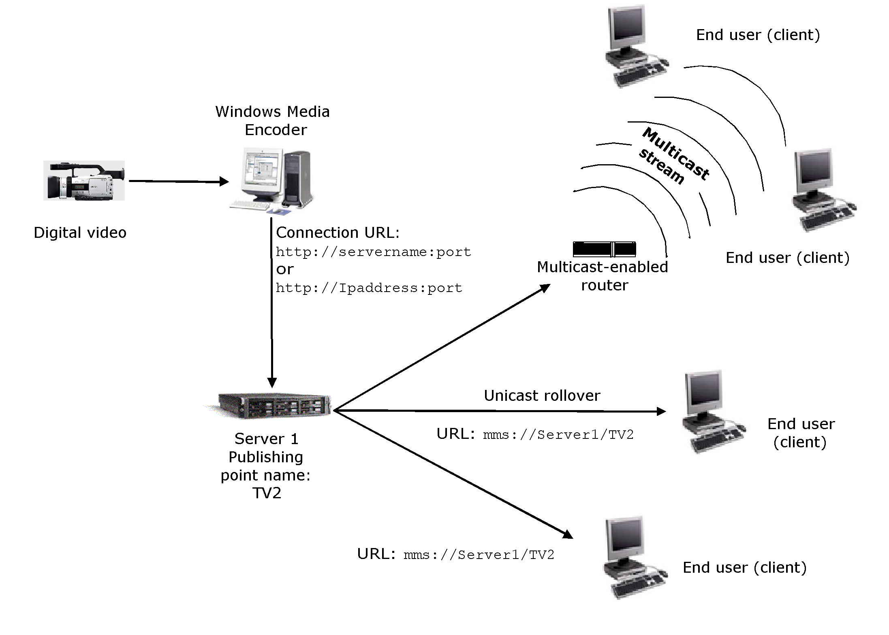
Figure 3. Multicast and unicast distribution
The event producer invites employees to register for the broadcast through e-mail and also promotes the event on the corporate intranet. Upon registration, reminders are created in employee online calendars. Two weeks before the new product launch, the series of six presentations is published on the company intranet and extranet for the sales force to review. The product managers send e-mails with direct URLs to the presentations, making it as easy as "point and click" to watch. All of the presentations are monitored and logged to track who has reviewed the information. At the start of the broadcast, employees receive a calendar reminder from their e-mail program to view the presentation. When the event starts, viewers have video and audio streamed live to their computer.

Playback Experience
To accommodate all users, the online training will be offered live, in scheduled broadcasts, and on demand.
Live
After a viewer selects the link in the calendar reminder or from the company intranet, the viewer's browser presents Windows Media Player 9 Series embedded in a Web page, including links to product information. The presentation slides and other visual information are synchronized with the digital media stream, creating a fully-integrated digital media experience. The presentation includes a mock sales process to convey to the field sales force how the new product should be positioned and sold. The design engineers use a digital video camera to record a series of videos for the new product in which they discuss the design changes and demonstrate the new modifications. The video presentation allows the designers themselves to show field personnel how to articulate the product features.
For this event, the sales team chooses to support a moderated chat feature on the event Web page, which enables viewers to send in questions that the speakers can respond to in real time. As soon as the presentation is finished, the audio, video, and associated slides are archived and stored for repeat broadcast and on-demand viewing.
Scheduled Broadcast or On Demand
For viewers who could not watch the initial event, it is programmed to broadcast twice a day, in the morning and afternoon for the next month. On-demand viewers can review specific points by fast-forwarding or rewinding the presentation to the slides that contain key points. Registration creates calendar reminders and a moderated chat is provided within the repeat broadcast. After the month of programmed repeat broadcast, viewers can view the event on demand from the sales intranet.
Viewer Survey, Feedback, and Statistics
Viewers can provide real-time feedback by using "point-in-time" polling during the broadcast and through an "event" survey that requests ratings on the presenters and content. The "point-in-time" polling results update and display in real time and the "event" survey findings are quantified. The survey and the moderated chat provide multiple channels for employee feedback.
Content logging reports list which viewers attended which portions of the training. Over 70 percent of the audience views the live training, generating a better understanding of the product positioning and sales plan. Two days before the product launch, the reports show that 95 percent of the sales force has viewed all of the content, confirming that they are ready to drive demand and increase sales. To reinforce retention, the six presentations are stored for on-demand access from virtually any of the company sites. The training was completed with a small incremental cost, using the prior investment in the studio, network, and Windows Media servers.

Human Resources—Compliance Training
Compliance training is necessary in any industry that is regulated, so offering appropriate, reliable, and accurate training is critical for organizations. Tracking learners and assessing their results is in many instances mandatory, requiring the reporting of attendance and results. For example, safety training and compliance rely heavily on training employees who may need to demonstrate knowledge of health and safety standards. A workforce that is knowledgeable about safety issues can help to reduce liability and damages, satisfy compliance requirements, and increase productivity because knowledgeable workers have less downtime due to injury. Failing to report that employees received government-mandated training can result in penalties and lawsuits. Digital media-based e-learning about corporate policies and safety procedures enables targeted training tailored specifically for those who need it. Employees receive current information as well as simulations of particular safety standards. Using digital media, employees can review new safety standards whenever they have questions or concerns and then return quickly to their tasks. Because the content has been digitized, it can be distributed to any desktop or laptop computer on the network or remotely through a virtual private network (VPN). This kind of access to safety information contributes to the success of an organization and provides a competitive advantage. This section describes a scenario in which digital media is used to provide employees with important safety training.

Business Challenge
A global manufacturing company needs to increase safety and productivity ratings at all facilities by reducing personal injuries and damage to equipment and facilities.

Opportunity
Create a strong safety culture for employees and a connection to the company's strategic business model.

Solution
The framework for an enterprise digital media solution encompasses three areas: content creation, content distribution and management, and playback experience. Considering the specific requirements of each area will enhance the quality, scalability, manageability, and reliability of the resulting solution.

Content Creation
To ensure relevant workplace safety training, the company produces content specific to itself. Professional instructors are hired to produce a series of educational content pieces on safety in the workplace. The instructors use Microsoft PowerPoint to capture their curriculum while the information technology (IT) group uses a digital video camera to capture video of the workplace, illustrating safety issues. After all of the core content is created, it is integrated into several rich-media presentations, synchronizing PowerPoint slides with the video. Because all materials are produced by using digital content, it is easy to maintain the curriculum over time and make revisions.
The proprietary content is encrypted with the Microsoft Windows Media Digital Rights Manager 9 Series Software Development Kit (SDK) to protect it from unauthorized use and illegal distribution. The studio packages the content onto CDs for employees to use at home and for those who travel frequently and use disconnected laptop computers. Authorized employees are granted a renewable license that permits viewing of the training for the next 30 days but prevents copying and redistribution of the video and audio portions of the training. The following illustration describes how content is protected by digital rights management (DRM).
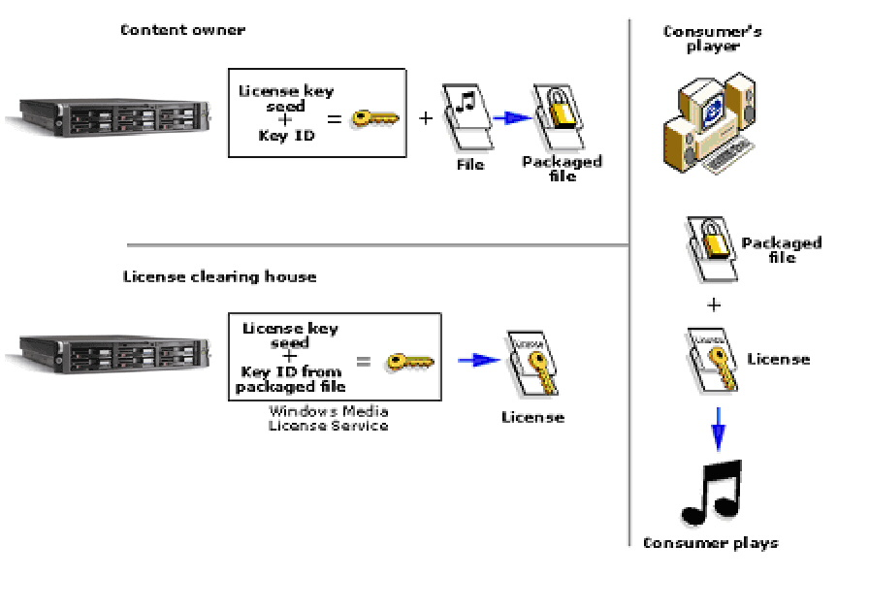
Figure 4. Digital rights management sequence

Content Distribution and Management
To reach employees across all locations, the company implements a distributed network of servers running Windows Media Services 9 Series and enables multicasting on the network. The content is prepositioned at regional offices by pushing the content out to edge servers through the network. The presentations are distributed during off hours to conserve bandwidth during the day. Within 24 hours, the content is populated locally at each site, which enables employees to view the high-quality training video on their computer so as not to impact the wide area network (WAN) during business hours. All employee access to the content is tracked for compliance reasons, to ensure that everyone has had the proper training about safety. Because the content is available on demand, employees can watch the online presentations more than once if they require a second look or just a refresher on one topic. The following illustration shows how content is distributed to end users using an edge server.
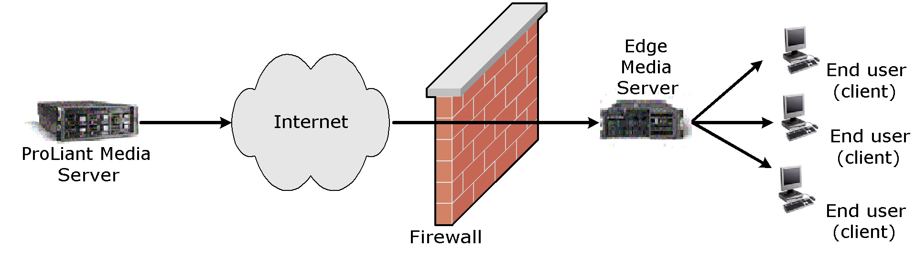
Figure 5. Content distribution
The event producer uses e-mail to invite audience members to register for the broadcast. Upon registration, reminders are created in the employee online calendars and in e-mail. Five minutes prior to the start of the broadcast, registered viewers receive a calendar or e-mail reminder to view the presentation.

Playback Experience
To accommodate all users, the online training will be offered live, as scheduled broadcasts, and on demand.
Live
After selecting the link in the calendar reminder or from the company extranet, the viewer's browser presents Windows Media Player 9 Series embedded in a Web page with synchronized slides and links to safety job aids and concerns. Viewers select from multiple language options when viewing closed captioning.
Repeat Broadcast or On Demand
For viewers who could not watch the initial safety training, the event is programmed to broadcast twice a day, in the morning and afternoon, for the next two weeks. Calendar reminders are created in the employees' e-mail programs when they register and a moderated chat is provided within the repeat broadcast. After the two weeks of programmed repeat broadcast, the event is viewed on demand from the company intranet.
Viewer Survey, Feedback, and Statistics
Content logging reports list which viewers attended which portions of the address. After six months, more than three-quarters of the target audience viewed the online compliance training and completed the required testing. Additionally, consistency is assured, as manufacturing plants across the world experience the same training and the employees can review the training on demand; a culture of safety is enhanced through digital media delivery of safety tips, supporting the enterprise's safety vision.

Benefits of E-Learning with Digital Media
Supplementing conventional training with digital media e-learning can lead to savings in time, effort, and dollars. Digital media is quickly emerging as an effective and efficient learning aid in the industry. As a result, many learning and development professionals are turning to digital media content as a primary means of improving their organization's learning experience.
The benefits of digital media include:
- Enables visual imagery, which facilitates retention. Most people tend to remember 70 percent to 80 percent more of what they see than what they read. Live and on-demand scenarios bring the learning event closer to the participant.
- Enables learning organizations to broaden their reach by providing participants with greater and more flexible access to the material.
- Enables instructional designers, implementers of adult learning theories, and performance support specialists to capture their expertise, reducing instructor and content variation and inaccuracy.
- Provides an efficient means of delivering educational content to a large and dispersed audience. Because most corporate networks and desktop computers are already equipped with voice and video capabilities, digital media solutions typically require little additional equipment.

Changing How We Teach
Digital media technology is more than a simple content resource; it can change the teaching and learning model. Digital media and the intranet enable new learning modes and learning communities that enhance employee growth and development. Learners can interact with subject matter experts and each other, attend live classes, or become a member of a discussion group focused on an immediate learning need.
Companies recognize the value they obtain by using digital media technology as a new instructional design presentation format. Learning content is easily delivered over the company intranet. Presentations are stored for repeat broadcast and on-demand access on a company's network. Because digital media can be indexed and easily updated, learners can discover relevant and current content. Learning retention can be increased because auditory and visual learning preferences are easily accommodated through the use of digital media presentations. The most effective learning outcomes will fulfill the requirements of both individual learners and the company.

Understanding Return-on-Investment Factors
Digital media simplifies communication paths and dramatically increases the speed of information dissemination. By deploying a reliable Windows Media 9 Series solution hosted by managed HP ProLiant servers, companies can use the Internet and intranet to efficiently distribute information and promote understanding within a target audience. Managers and employees no longer need to be present in the same physical space, at the same time, to produce learning content. The alternative to the physical constraints of in-person training methods reduces overhead, expenses, and time delays.
In the competitive business environment, a company's ability to develop and to capitalize on intangible assets, such as worker knowledge, has become a decisive factor in its performance. By creating and maintaining a central repository of information, knowledge in the enterprise can be better managed and the quality of its learning tools enhanced. Top management is able to align its training and learning with the company mission, strategic vision, and culture.
Expenses for implementing a digital media e-learning infrastructure are justifiable through the cost avoidance of items such as:
- Travel expense and time loss
- Reproduction of course materials
- Facilities, including building, staff, and maintenance
Although these savings are immediate and substantial, there are long-term benefits that provide additional return:
- Increased knowledge retention and productivity
- Lower per-user costs of training
- Shorter cycle times due to increased speed of information dissemination

Additional Benefits of Digital Media E-Learning
In addition to the benefits listed in the previous section, the new style of digital media-based learning also offers other, less obvious advantages.
Flexibility and Accessibility
Individuals can access learning content at any time from any location. Digital media allows employees to take charge of their own training by accessing a library of video-on-demand content. Employees can access both critical institutional knowledge or policies and their own training sessions in accordance with their immediate knowledge needs and work schedules. E-learning offers learners a risk-free setting, enabling them to make mistakes and experiment with new ideas without risk, and allowing for reflection and review. Interactive simulations make learning more interesting and engaging, resulting in increased retention.
Adaptability for Complex Topics
Training on complex topics or processes is an area traditionally left to small-group, hands-on classroom training. In the past, these areas needed expert instructors and special training facilities. These topics are challenging because students find it difficult to visualize complex concepts when they are just presented verbally or in writing. Simply porting an existing course to an online environment can often make the situation worse because students cannot clarify their understanding with the instructor. However, careful use of multimedia or digital media can improve the learning process. By introducing audio and video-enabled digital media content, students can process complex information more effectively.
Socialization
Creating content using digital media technology enables instructors to present complex topics more effectively than the instructor's words alone. For example, in an engineering setting, engineers can record a video of a nuclear reactor turbine engine while it is being serviced during the yearly outage. Because access to the turbine is limited to once a year, a video with the accompanying engineer's commentary is very valuable for year-round use. In a chemical course, an engineer may need to observe the results of mixing chemicals together. In many cases, the reaction may not complete until after the class, preventing the engineer from experiencing the entire reaction. Using digital media technology, the same reaction can be captured and edited into a condensed version, enabling the engineer to experience the entire chemical reaction process.
Performance-Based Training
Human Resource and Learning professionals frequently take on the role of performance consultants within their organizations. Performance-based training involves assessing the effectiveness of individuals and organizational structures, diagnosing the causes of performance problems, and recommending interventions to improve the situation. Using digital media technologies to diagnose call-center problems, present solutions, and measure results can have an immediate effect on organizational performance. Data is easier and cheaper to collect with focus groups and interactive surveys conducted online. Training can be more easily focused on problem areas.

Cost Factors
Providing the end-user with a quality e-learning experience begins with defining the learning objectives and planning the content production. The audio and video streams are captured, encoded, and readied for delivery. The encoded file is stored on a Windows Media server, where it is managed and staged for delivery using industry-standard ProLiant servers to proxy/cache servers located at the "edge" of the network. Finally, the end-user can view and interact with the content through their client device.
Cost elements vary for each company, but the costs can be generalized and are predictable, based on the factors listed below. Solution costs break down into three areas:
- Network. The network costs are a function of the number of office locations and the capacity of the network. There are options when preparing the network infrastructure. For example, a solution that uses low-bit-rate video that is distributed on demand during nonbusiness hours will reduce the need to increase the capacity of the central network and WAN. However, this requires additional storage at local sites. Conversely, if content is distributed on-demand across the corporate network during business hours, storage needs at the local site will be reduced. However, capacity of the central network and WAN will need upgrades.
- Server. The server costs include the HP ProLiant servers, the ProLiant Essentials software, and the software licensing costs for the Microsoft Windows® operating system running on each hardware component. There is no incremental cost for any of the Windows Media 9 Series components as they are either an optional component of the operating system or obtained through a no-cost download from the Windows Media Download page at the Microsoft website (http://www.microsoft.com/windows/windowsmedia/download/default.asp). The number of servers is dependent upon the network topology, number of locations, and the type of distributed architecture design.
- Content. Content costs are a function of the volume of content generated, the quality requirements, and the number of bit rates that must be supported. The bit rate at which content is encoded determines the bandwidth required to stream. It is typical to require that content be encoded at low, medium, and high bit rates (56 kilobits per second (Kbps), 128 Kbps, and 256 Kbps respectively) to support the various network connections. Modifying studio environments or creating ministudios will also require additional hardware, such as a video camera, microphone, channel mixer, teleprompter, capture card, and lighting.

Additional Reference Materials
The following case studies, which are available on the Microsoft website, highlight the return on investment of digital media-centered e-learning solutions:
- Mercedes-Benz USA (http://www.microsoft.com/windows/windowsmedia/archive/casestudies/mbusa/default.aspx)
- The Wharton School of the University of Pennsylvania (http://www.microsoft.com/windows/windowsmedia/archive/casestudies/wharton/default.aspx)
- Rapid Economic Justification white paper on the Business Value for the Enterprise page at the Microsoft website (http://www.microsoft.com/windows/windowsmedia/enterprise/AboutWM/BusinessValue/default.aspx)

Solution Requirements
The framework for an enterprise digital media solution is made up of three areas. Considering the specific requirements of each area will enhance the quality, scalability, manageability, and reliability of the resulting solution.
- Content creation
- Content distribution and management
- Playback experience

Content Creation
Companies should address video production needs if they are creating original content in a professional studio setting. This is not dealt with in this paper; however, it is a consideration when implementing a digital media solution.
Digital media content creation involves a set of guidelines, processes, and tools that enable personnel to efficiently create and prepare digital media content. There are four primary infrastructure requirements for creating content:
- Capture. Capture is the process of converting an audio or video input into a compressed or uncompressed digital format, such as WAV or AVI. The digital format may be archived as a file, fed directly to an encoder, or both.
- Encode. Encoding is the process of digitizing audio and video input into a compressed format at the desired bit rate and quality. This is typically one seamless process in which a digital input from a camera, tape, file, or other digital source is encoded into Windows Media Format that can be archived, streamed, or both.
- Storage. Content production groups generally want to maintain their own libraries of content during the various phases of production. Often, multiple versions of a content element will exist to facilitate review and simultaneous work by several groups, similar to when a large document is written. Scalable and reliable networked and internal server storage is essential.
- Authoring tools. One value of digital media comes from the integration and synchronization of multiple digital media formats to make compelling rich-media presentations. Rich-media authoring tools simplify the content creation process by allowing drag-and-drop functionality in a graphical user interface. Two examples are Producer for PowerPoint 2003 and Windows Movie Maker, which are both intended as end user programs. Distributing the content creation process out to end users will help increase the rate at which content is published and also reduce the burden on IT and digital media groups.
- Development tools. Development tools, typically in the form of SDKs are intended for developers to program custom solutions. There are situations where it will be desired to create more sophisticated content for special events, such as integration of Macromedia Flash or dynamic HTML (DHTML) into a presentation. The use of existing authoring programs may be preferred if content creation is an ongoing business process because using development resources to create digital media presentations can be costly and time consuming.

Content Distribution and Management
Once a segment of digital media content is produced, it needs to be distributed to the intended audience in a timely and cost effective manner. Enterprises will want to manage this distribution process to ensure optimal use of storage and network bandwidth, while ensuring that the content is secure and highly available. The majority of the infrastructure work for distribution and management falls into three areas:
- Replication. As content is produced and made available to end users, a large amount of hard disk storage is required. Although storage solutions can be implemented in a variety of ways, a common implementation is to use one central repository and many smaller cache servers on the edge. Content can be proactively scheduled for distribution to specific locations within the enterprise, ensuring availability and improving viewing quality while minimizing WAN expense.
- Redirection. As viewers request content, the cache/proxy server redirects the content request to the preferred server when appropriate.
- Digital Media tools. Windows Media technologies enable you to control the format of the content, how it is assembled, how it is streamed, how it is secured, and the options for playback. They play a vital role in determining implementation and support of an enterprise solution.
When designing a storage solution, consider the access requirements, as this will often dictate the solution with the appropriate bandwidth for retrieving stored content from hard disks. Typical options include Network-Attached Storage (Windows-based NAS), clustered Windows file servers or a Storage Area Network (SAN) based on a fiber channel storage system, and connecting multiple hosts to central storage through a 2-gigabyte (GB) fiber channel.

Playback Experience
Users can play content by using a standalone player or a player embedded within a Web page. The content can be located on a computer or a portable device. A user may be directed to a digital media portal to locate materials for viewing. Once the content is located, the user expects a quick and easy way of viewing it. The Windows Media 9 Series SDKs offer numerous opportunities to design the perfect user experience for the intended audience.
- Instant-on/always-on streaming. Windows Media Player 9 Series has eliminated the long buffering "wait" prior to streaming content when connected to a server running Windows Media Services 9 Series.
- Audio/video quality. Experience the best quality audio and video at any connection speed with Windows Media Audio and Video 9 Series codecs. Variable-bit-rate (VBR) audio and new compression delivers MPEG Audio Layer-3 (MP3) quality at half the size, while delivering the best quality video at the smallest download sizes or streaming speeds when compared to other formats.

Implementation Considerations
The most important decision in implementing a digital media solution is selecting the right technology and delivering a cost-effective solution that meets the business need. A unique challenge enterprises face is identifying clear owners for the solution. Digital media attracts stakeholders from many business units, and several factions within IT. This often makes decision-making more difficult because many business units will provide funding, and the networking, infrastructure and desktop groups each will participate in the design.
Other key decisions include:
- Delivering an initial solution that is sure to get a few early wins. The business requirements will evolve quickly as users experience these new applications. It's best not to over-engineer the first version.
- Selecting an infrastructure provider with broad offerings that scale. Using a variety of vendors may increase the expenses of custom integration over that of contracting with fewer vendors for the solution.
- Selecting a digital media platform that will grow and scale as your business needs demand it. The applications of digital media are developing fast, so allow for rapid growth.
- Developing business processes to drive the creation, distribution, and consumption of digital media content.

Microsoft and HP Technologies for Digital Media Solutions
Microsoft and HP provide a comprehensive set of technologies and products to deliver a digital media solution for the enterprise. Together, Microsoft and HP are committed to develop and deliver premier streaming media solutions and have the proven expertise to deliver leading edge, industry-standard solutions for the creation, hosting, distribution, management, and experience of digital media. These solutions enable a new breed of corporate communication to be delivered through the Internet and enterprise intranet. Windows Media 9 Series is a leading platform for creation, distribution, and playback of digital media files. Key Microsoft and HP building blocks to the digital media enterprise are described in the following topics.

Content Creation
Microsoft and HP offer a number of tools for creating compelling text and graphics for streaming with Windows Media 9 Series.
- Windows Media Encoder 9 Series. Windows Media Encoder 9 Series is a powerful tool for enterprise content producers who want to take full advantage of the Windows Media 9 Series platform. For converting both live and prerecorded content, the encoder provides control and flexibility, the highest quality audio and video at any bit rate, and powerful levels of extensibility and automation.
You can capture content from the encoder with frame accurate control, and the encoder allows you to initiate and protect live broadcasts. To meet the demands of a broad range of production environments, the encoder provides advanced capture abilities, powerful server integration for live broadcasts, and more flexibility to optimize compression for a wide range of delivery scenarios.
- Windows Media Encoder 9 Series SDK. This set of Application Programming Interfaces (APIs) makes it easy for a developer to script the behavior of the encoder itself. This is an easy way to build a powerful digital media creation application on top of Windows Media Encoder 9 Series, and is ideal for building batch encoding tools or simplified encoding applications for end users.
- Producer for PowerPoint 2003. Designed for business users and enterprise media professionals, Producer is an add-on for PowerPoint 2003. It helps you capture, synchronize, and publish audio, video, slides, and images, resulting in engaging rich-media presentations viewable on demand in a Web browser.
- Producer for PowerPoint 2003 Resource CD. This resource CD is a "one-stop shop" for relevant new tools, white papers, technical questions, and usage tips. It contains the Producer software, sample templates, a template editor, white papers, best practices, and other supporting documentation.
- Windows Media 9 Series Jumpstart CD. This resource CD includes the Windows Media Player 9 Series, Windows Media Encoder 9 Series, Windows Media 9 Series SDKs, software, demos, how-to white papers, and bonus materials.
- HP Digital Content Creation (DCC). Availability and performance of professional graphics is a key factor in customers' workstation decisions. Under the HP Leadership Graphics Program, HP provides the fastest access to the best graphics capability in the industry at varying performance and price points. HP recommends the HP Workstation xw4000 for the entry level, the HP Workstation xw5000 for additional graphics capabilities, and the HP Workstation xw8000 as the most expandable model for editing, decoding, and encoding audio and video content.

Content Distribution and Management
Microsoft and HP offer a variety of solutions for deploying and managing streamed content in small, medium, or large environments.
- Windows Media Services 9 Series. A service of Windows Server™ 2003 that is used for streaming audio and video content to clients over an IP-based network. These clients may be other computers or devices that play back the content by using a Windows Media Player, or they may be Windows Media servers that act as a proxy or cache for redistributing content. Clients may also be custom applications that have been developed by using the Windows Media 9 Series SDK.
- Windows Media 9 Series SDK. A collection of individual SDKs available for each platform component: Windows Media Services, Windows Media Format, Windows Media Encoder, Windows Media Player, and Windows Media Rights Manager.
HP has server platforms and infrastructure products designed to support digital media deployments.
- ProLiant BL servers. HP is leading the expansion of the blade server market with the HP ProLiant BL blade servers. This industry standard approach enables HP to accelerate the delivery of cost-effective, compatible, and widely available blade server architectures. The ProLiant BL blade servers are power-efficient, ultra-dense and optimized for rapid deployment and provisioning. They are ideal for space-constrained enterprises seeking increased density and scalability.
- ProLiant DL servers. The HP ProLiant DL servers are ideal for multi-server deployments and deployments with external attached storage. The DL 360 and DL 380 have become the leading platform for Windows Media deployments. HP has developed technical guides that provide detailed instructions for installing, configuring, and managing Windows Media Services. These density optimized rack servers are engineered for flexibility and manageability.
- ProLiant ML servers. For growing businesses running sophisticated small applications and branch offices of larger organizations that need a platform for single-function solutions, the ProLiant ML server is an Intel Pentium Xeon or Pentium 4-based ProLiant that delivers ProLiant reliability together with the best-in-class data protection and management to simplify ownership. ProLiant ML servers should be used when more in-the-box storage is required and/or more PCI cards are required.
- ProLiant Essentials Software. The ProLiant Essentials Foundation Pack contains the essential software every customer needs to install, configure, and manage ProLiant servers as part of an adaptive infrastructure and comes with every ProLiant server. The ProLiant Essentials Foundation Optional Value Pack software provides offerings that selectively extend the functionality of an adaptive infrastructure to address specific business problems and needs.
- HP StorageWorks and ENSA-x. HP has two products to meet the high throughput needs of Windows Media servers and master content repositories. The HP StorageWorks modular Storage Area Network (SAN) Array 1000 (MSA 1000) is a 2-GB Fibre Channel storage system for the entry-level to midrange SANs. And Enterprise Network Storage Architecture extended (ENSA-x) builds upon years of successful innovation and consistent delivery of network storage solutions to the market. ENSA-x is the evolution of the storage utility vision, where the right information is accessible to anyone, anytime, anywhere. This architecture is designed to put customers in control by allowing them to adapt their storage infrastructure to their business environment through automation and active intelligent management. It is an end-to-end business-centric, adaptive storage architecture that is controllable, resilient, and extensible, from storage to the application. It is policy-based and application aware. These capabilities are achieved through active intelligent management technologies that provide predictable quality of service levels and further enable the enterprise storage utility.

Playback Experience
Microsoft and HP offer several software and hardware products that enable your users to experience the best of Windows Media 9 Series.
- Windows Media Player 9 Series. A full-featured player that delivers fast and simple playback of digital media without sacrificing customization features. Windows Media Player 9 Series delivers flexible deployment and playback options designed to maximize productivity for both the end-user and the IT administrator in charge of deployment. With localized support for over 26 languages including Multiple Language UI (MUI), the Player is designed for today's multinational organizations.
When Windows Media Player 9 Series is used with the other Windows Media 9 Series components, the user receives the best possible digital media experience. For example, when combined with Windows Media Services 9 Series, the Player can deliver instant-on/always-on streaming to broadband users with Fast Streaming. Behind the scenes, Windows Media Services can also deliver personalized content that has been dynamically arranged in server-side playlists. All that users know is that they are getting exactly the content they want—more reliably and without waiting for long periods of buffering.
- Enterprise Deployment Pack for Windows Media Player 9 Series. Provides a build environment that makes it easy for network administrators to centrally manage, configure, and deploy Windows Media Player 9 Series. Administrators can specify desired Player policies and preferences, as well as locking down a desired Player "skin," which can limit access to consumer-oriented features that are deemed unsuitable for enterprise usage. You can deploy the customized .msi file through Microsoft Active Directory® or through any software management system.
- HP desktop and notebook computer management solutions. A management agent is included as part of the factory-loaded image on selected desktop and notebook computers. This agent enables communication with the AX Deployment Server (formerly Altiris eXpress), which can be used to complete a new hardware deployment or personality migration to a new operating system by using an easy-to-follow wizard.
- HP Comm Station Pro. PC comm stations provide a single point of access for audio while improving accessibility to universal serial bus (USB) devices. The easy-to-use, space-saving business accessories include computer headsets that can be used for both telephone and Windows Media-based applications. The computer headset integrates with a telephone, allowing you to listen to digital media files and messages or make telephone calls—all from a single device.

For Additional Information
For a better understanding about the infrastructure requirements, see the white paper "Enterprise Digital Media Solutions Guide—Part Three: Infrastructure," which is the third paper in this series.
Microsoft Online Resources
The Windows Media website has a large selection of resources to help you get started, with everything from "How to's" and business justifications to case studies:
- Windows Media 9 Series page at the Microsoft website (http://www.microsoft.com/windowsmedia).
- Windows Media 9 Series Deployment Guide page at the Microsoft website (http://www.microsoft.com/windows/windowsmedia/enterprise/TechResources/default.aspx).
- Windows Media Download Center page at the Microsoft website (http://www.microsoft.com/windows/windowsmedia/download/default.asp).
- Producer for PowerPoint 2003 page at the Microsoft website (http://www.microsoft.com/windows/windowsmedia/technologies/producer.asp).
- Windows Media 9 Series on the Enterprise page at the Microsoft website (http://www.microsoft.com/windows/windowsmedia/enterprise.aspx).
- "Rapid Economic Justification (REJ)" white paper on the Business Value for the Enterprise page at the Microsoft website (http://www.microsoft.com/windows/windowsmedia/enterprise/AboutWM/BusinessValue/default.aspx).
Microsoft Consulting Services and Partners
- Microsoft Consulting Services (MCS) has an international presence and the expertise to help you implement an enterprise digital media solution, whether nationwide or worldwide. For more information, see the MCS website (http://www.microsoft.com/business/services/mcs.asp).
- Microsoft has Windows Media Service Providers with specific product and services expertise in broadcast communication. For more information, see the Service Provider page at the Microsoft website (http://www.microsoft.com/windows/windowsmedia/service_provider/programs/wmsp.asp).
- Microsoft has over 32,000 Certified Partners worldwide that can also help you get started. For more information, see the Microsoft website (http://www.microsoft.com/windows/windowsmedia/partner.aspx).
HP Online Resources
- HP and Microsoft Streaming Media Solutions page at the HP website (http://h71028.www7.hp.com/enterprise/cache/5197-0-0-0-121.aspx).
- ProLiant server page at the HP website (http://www.compaq.com/products/servers/platforms/index.html).
- ProLiant Clusters for Microsoft page at the HP website (http://h18004.www1.hp.com/solutions/enterprise/highavailability/microsoft).
- Digital Content Creation (DCC) Workstation page at the HP website (http://www.hp.com/workstations/segments/dcc/).
- ProLiant Essentials page at the HP website (http://h18000.www1.hp.com/products/servers/proliantessentials).
- Storage Solutions page at the HP website (http://thenew.hp.com/country/us/eng/prodserv/storage.html).
HP Services
- HP Services has the expertise to help your business deploy enterprise solutions. For more information, see the HP Services page at the HP website (http://www.compaq.com/services/).
- Rich Media Services page at the HP website (http://h30046.www3.hp.com/solutions/solutionhome.php?topiccode=RICHMEDIA&regioncode=NA&langcode=USENG).
- Mobile and Media Systems Lab page at the HP website (http://www.hpl.hp.com/research/cp/cmsl/publications/streaming/index.html).
Approach Services
Approach jointly authored this paper with Microsoft and HP. Approach has the expertise to help you develop and deploy Windows Media solutions in the enterprise. For more information, visit the Approach website at (http://www.approach.com) or send e-mail to digitalmedia@approach.com

