Windows Live Academic Search (Beta)

Reviewers Brief

May 2006

Overview
Welcome to Windows Live™ Academic Search, a powerful research aid designed to help researchers, university faculty, librarians and students quickly and effectively conduct research across a range of academic journals. With a next-generation user interface and key sorting tools, Windows Live Academic Search can help customers find information quickly and have enhanced control over, and focus in, their search experience.

Windows Live Academic Search, currently in beta, was created in collaboration with the academic research industry association CrossRef and more than 10 leading publishers. Two goals of this collaboration have been to help ensure that the copyrights of content providers are protected and to provide customers with a trusted source of authoritative information from known publishers. In this beta, released April 11, 2006, Windows Live Academic Search provides in-depth content in computer science, electrical engineering and physics, and supports English-language research in Australia, Germany, Italy, Japan, Spain, the United States and the United Kingdom. The beta release is available at http://academic.live.com in the U.S. and via Windows Live Search in other countries. Additional markets and subject content will be added throughout the beta period.

Windows Live Academic Search is the latest in a series of search verticals from Microsoft Corp. offering a deep subcategory within which customers can conduct powerful searches to find the information they are looking for in less time. This reviewers brief will explore the key capabilities and features delivered by the Windows Live Academic Search beta service.

Key Customer Benefits
While collaborating with the research industry to develop Windows Live Academic Search, Microsoft received significant feedback from the research community and learned how existing academic search offerings could be improved. Two goals were identified as a result: to help protect and honor copyrights of content providers and to provide researchers with faster and more direct access to trusted sources. In addition, customers wanted key improvements to existing primary research search services that could benefit them in their work. Key customer benefits provided by Windows Live Academic Search include these:
- Information about a search result before leaving the search results page. Windows Live Academic Search uses the preview pane feature, built for Windows Live Search, which allows customers to see the available details of a result by simply hovering their mouse over the result.
- Flexibility of criteria while performing a search. Windows Live Academic Search will include Windows Live Search Macros functionality, from Windows Live Search, which enables customers to create and share macros that provide more finely tuned, customized search results.
- Search tools that complement research activity rather than distract from it.
Windows Live Academic Search was built with a citation export feature, accessible from the preview pane, which supports citations in two major bibliographic formats. Windows Live Academic Search includes direct links to the official published versions and live author links to quickly find associated results by clicking on the author’s name.
- Control over search results. Windows Live Academic Search enables users to group and sort results by author, journal, conference and date, rather than just delivering a flat list of search results. The richness slider, carried over from Windows Live Search, allows customers to control the amount of information displayed in the search results.

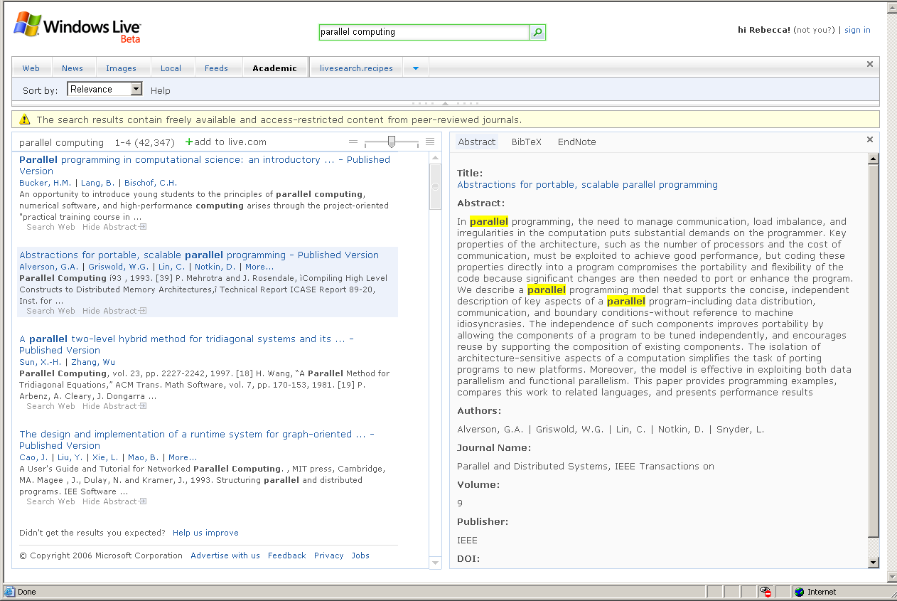
Preview Pane
Search Results
Sort Menu
Citation Export
Abstract

Example of the Windows Live Academic Search beta

Academic Research Industry Collaboration
In developing Windows Live Academic Search, Microsoft worked closely with the academic research industry association CrossRef and more than 10 leading publishers to understand customer needs, to help ensure the publishers’ copyrights are protected, and to provide research customers with a trusted source of information.

CrossRef (http://www.crossref.org) is an independent publishing industry association with a mandate to efficiently and reliably connect users to primary research content online. CrossRef provides a citation-linking network infrastructure that covers millions of articles and other content items from several hundred scholarly and professional publishers, and the only full-scale implementation of the Digital Object Identifier (DOI) system to date.

At the beta debut, Windows Live Academic Search indexes approximately 6 million records from over 4,300 journals and 2,000 conferences, including full-text and metadata-only records from a broad range of sources. More will be added over time. The following is a partial list of Windows Live Academic Search content collaborations:
- Peer-reviewed content from leading scholarly societies, including the Institute of Electrical and Electronics Engineers, and the Association for Computing Machinery
- Content from the three largest physics publishers of peer-reviewed material: the American Institute of Physics, the American Physical Society and the Institute of Physics
- Research content from world-leading publishers John Wiley & Sons Inc and Reed Elsevier, the largest science, technology, medicine publisher in the world
- Published content from Blackwell Publishing, Nature Publishing Group, the Online Computer Library Center (OCLC) and Taylor & Francis Group
- Link resolvers from Serials Solutions and Openly Informatics, a division of OCLC

About Windows Live Search
Windows Live Search is a cornerstone of the Windows Live strategy, enabling Microsoft to capitalize on recent investments made in search to deliver an entirely new search experience — one that is more than an engine, toolbar or search page.

Debuting in beta form in March 2006, Windows Live Search is a unified search service designed to answer a customer’s questions with precision via simple viewing and organization tools, customization options, and specific deep-search categories to help users quickly find what they are looking for — whether it is on the Web, on a PC, or within a local community or geography.

The Windows Live Search strategy is built upon three core fundamentals that Microsoft research has shown are important to consumers:
- Make search precise and simple. Help people find answers to their questions with simple tools, deep vertical categories, and a user interface design that is easy to use.
- Provide a unified search service. Help people find what they need regardless of its form or where it is stored or who created it, and give them tools to find what they need from wherever they happen to be — desktop, Web, phone or local community.
- Make search personal. Provide information that can be customized for a person’s own unique needs by allowing them to make it relevant to where they live and the communities in which they socialize — whether real or virtual.

The Windows Live Search beta provides deep subcategories within which a customer can conduct an equally powerful search. These vertical searches, easily accessed from the scope bar, make it easier for customers to control their results across the vast landscape of Internet content types and categories while offering the same rich customer experience for viewing and organizing results.

Vertical search categories are available for Web searches, news searches, image searches, local searches, RSS feeds, new search macros and Windows Live Academic Search for searching academic publications.

About Windows Live
The Microsoft Windows Live strategy is to deliver a new set of personal Internet services and software that is designed to bring together in one place all the relationships, information and interests people care about most. Windows Live services will also include enhanced safety and security features for customers to use across their PC, devices and the Web.
Designed to put the individual in control by offering complete choice and customization, Windows Live is designed to unify information, relationships and interests in a meaningful and efficient experience that is simple, helps enrich consumers’ lives and save time.

Conclusion
By working closely with the research industry to develop Windows Live Academic Search, Microsoft has been able to deliver a powerful research tool that really raises the bar for academic search offerings and is a win-win solution for content providers and customers.

With its helpful user interface features such as the preview pane, richness slider, abstract view, direct links and live author links, and key sorting tools such as sort by and group by, customers can find information quickly and have control and flexibility over their search experience. Features such as search macros, citation export and support for RSS feeds, as well as international support, will help ensure that Windows Live Academic Search is a useful tool for researchers worldwide which fully complements their research activities and helps them do what they care about most.

Windows Live Academic Search Features at a Glance
Windows Live Academic Search was built to serve as a powerful research aid by providing innovative interface, organization and research features to help customers find information faster. Key features designed in response to customer feedback are the following.

Key Features | Feature Description | Benefits
Features available across the Windows Live Search Platform
Preview pane | Hovering a mouse over the result instantly displays a preview of information about it including author, publication, date, issue and volume number, and the abstract or a portion of it (whichever available). | Previews results enable an easy glance at relevancy and drastically reduce the chances of clicking on an irrelevant result.  The pane can help customers decide whether to click on a result based on whether they (or their institution) subscribe to the site.

Richness slider | This allows customers to control the amount of information viewable in the results. | It gives customers more control and choice over search results.
RSS support | RSS feeds associated with a chosen site or topic can be delivered to the customer’s Live.com page, alerting them when new information is available. | It enables customers to stay informed about the latest development in their field of study or on any research topic they choose.
Windows Live Search Macros (available by mid-2006) | More focused, refined searches can be created and shared by defining custom parameters on which to search. For example, a professor can create a macro for student use that only searches through a specific set of journals pertinent to the class. | More flexibility and customization in performing searches yields more finely tuned, precise search results. Trust in results is increased by limiting a search to a defined list of source sites.
Features specific to Windows Live Academic Search
Citation export | This feature allows citations from two major bibliographic formats, BibTeX and EndNote, to be cut and pasted directly from the preview pane. | This helps customers quickly compile citations for referenced articles and stay focused on their research.
Direct links | Hyperlinks in a result link directly to the official published version. | This provides seamless access to the full text of an article for customers on the network of an institution that subscribes to the full text.
Live author links | Hyperlinks on an author’s name automatically connect to articles associated with that author. Users simply click on the author’s name. | This allows customers to quickly find other research published by or associated with the same author.
Sort by | Customers can sort results by author, journal, conference and date via a convenient drop-down menu. | This allows customers to organize results quickly to see the most important ones without having to scroll and click through multiple pages of results.

#########
Microsoft and Windows Live are either registered trademarks or trademarks of Microsoft Corp. in the United States and/or other countries.
The names of actual companies and products mentioned herein may be the trademarks of their respective owners.

For more information, press only:
Rapid Response Team, Waggener Edstrom Worldwide, (503) 443-7070, rrt@waggeneredstrom.com

