A Guide to MSN® Search and the MSN Search Toolbar

June 2005

For more information, press only:
Rapid Response Team
Waggener Edstrom
(503) 443-7070
rrt@wagged.com

The information contained in this guide relates to a prerelease software product that may be substantially modified before its first commercial release. Accordingly, the information may not accurately describe or reflect the software product when first commercially released. This guide is provided for informational purposes only, and Microsoft makes no warranties, express or implied, with respect to this guide or the information contained in it.

© 2005 Microsoft Corp. All rights reserved.

Microsoft, MSN, the MSN logo, Hotmail, Encarta, Outlook, Windows, Windows Media, PowerPoint, OneNote and Halo are either registered trademarks or trademarks of Microsoft Corp. in the United States and/or other countries.
The names of actual companies and products mentioned herein may be the trademarks of their respective owners.

Contents

An Introduction to MSN Search 1
The MSN Search Engine 3
Large Index, Regularly Refreshed 3
Delivering Precise Results and Real Answers 4
Delivering Direct Answers and Search Verticals 4
Results That Make a Difference 9
Powerful Search Tools 9
Refining Search Results 9
MSN Search Toolbar With Windows Desktop Search 16
Flexible installation and configuration choices 16
Getting Results 17
Managing Web search and online information experiences 19
MSN Search Deskbar 20
MSN Search Toolbar for Microsoft Office Outlook 22
MSN Search Toolbar for Microsoft Windows Explorer 23
MSN Search Toolbar for Microsoft Internet Explorer 24
MSN Search Toolbar Suite Indexing Status Indicator and Settings 25
Other “On-Ramps” to MSN Search 26
MSN Search Home Page — Simple and Fast, Yet Powerful 26
Convenient Access to MSN Search From MSN Messenger 27
Summary 28
Exercises and Walk-Throughs 29
Better Results 29
Best Search Tools 31
MSN Search Features at a Glance 38
System Requirements 40
Helpful Links and Resources 40

An Introduction to MSN Search
Delivering the Power of Internet and Desktop Search to Customers
Efforts to help customers find digital information have gone through many changes over the years, including those geared at the desktop computer experience, corporate intranet and those aimed at the broader expanse of the Internet. The MSN® network of Internet services and Microsoft Corp., over their history, have delivered various forms of search to address these needs

In the area of Internet search today, MSN provides the fast MSN Search portal, which includes convenient access to vertical content categories and sites such as Hotmail® and MSN.com, while delivering easy access to search capability through the MSN Toolbar. MSN has heavily invested in innovative ways of integrating search with other popular services such as MSN Hotmail, MSN Messenger, MSN Music and MSN Encarta® Premium to deliver the most value to customers. In addition, MSN has made recent investments in capabilities for providing fast searching of e-mail, files and desktop data in the Microsoft® Office Outlook® 2003 messaging and collaboration client through the acquisition in summer 2004 of Lookout Software LLC.

Microsoft has also been active in the area of local file search over the years, providing customers with easy access to information stored in applications, in e-mail and on their local hard drives. Microsoft invests billions of dollars annually in Microsoft Research investigating new ways of delivering more powerful and convenient customer experiences, and in areas such as information retrieval to explore different approaches for helping computer customers unlock the power of information more seamlessly.

The combination of these key foundations, the talented MSN development staff and Microsoft’s legacy of understanding consumer software development places MSN in a unique position to deliver new search experiences to hundreds of millions of customers, seamlessly bringing together the Internet, desktop computer and application search.

With the reintroduction of MSN Search in July 2004, MSN launched an exciting new phase in the evolution of its Internet search offering. With this interim update to MSN Search, MSN delivered an easy-to-use and fast-loading search home page, easier-to-read results, and clearer differentiation between algorithmic results and sponsored advertising content. In addition, MSN discussed efforts under way to provide recommended content based on community viewing habits, which were initially introduced in the MSNBC Newsbot. Finally and most importantly, MSN provided a glimpse into the new foundation for the future of MSN Search with the early availability of the Technology Preview, a beta release of the entirely new MSN algorithmic search engine.

At the time of these announcements, many people wondered whether there was still room for innovation and growth in the Internet search space. Some wondered why Microsoft was making the costly investment to build its own search service. MSN believes that Internet search is actually in an early stage of its evolution, with tremendous opportunity for innovation and for creating new and empowering experiences so customers can more easily and quickly find the information they’re looking for and act on that information in a more integrated, seamless way.

The goal of MSN in undertaking the development of its own algorithmic search engine was to create the flexible and powerful foundation for innovation required to enable the next era of Internet search. MSN and Microsoft are working to make searching the Internet and local PC a more integrated part of people’s daily lives and to deliver information to customers more seamlessly.

MSN Search strives to empower customers to find what they want faster by delivering new and innovative technology and experiences in several key areas:
- All-new MSN search engine
- Exciting new desktop search experiences
- Flexibility and convenience for performing searches
- More precise results and delivery of real answers

In this reviewers guide, these areas will be explored further to look at specific technologies and experiences that MSN is delivering to help fulfill these goals, providing customers with a richer search experience that incorporates more than just the Web — including convenient and powerful search tools and better, fresher results. This guide is also designed to help you explore the many new features and capabilities of MSN Search. As you read through this guide, look for the information icon (), which highlights important features and details in MSN Search.

The MSN Search Engine
According to MSN consumer research, today customers on the Internet spend an average of 11 minutes culling through results of searches they’ve performed looking for specific information. Within most search engines, the usual search yields pages and pages of links to documents. These results typically include limited summary information, making it difficult for the customer to determine if the information is actually relevant to the search without following each link and scanning the subsequent pages. All too often, the information provided in the results also points to links that are outdated or no longer active. This is what customers have come to expect and accept as the Internet search experience today, and while this has proved to be a significant improvement over the static directories and lists of the past, customers in focus groups consistently say they want a better experience.

The new version of MSN Search has set out to change those expectations by working to deliver the most relevant, up-to-date, high-quality results from the broadest set of sources, providing customers with the best content and precise answers as quickly as possible. This is achieved through the combination of powerful search engines on both the Internet and desktop, search entry interfaces that are easy to use and understand, and more relevant results utilizing broad information from the Internet, existing high-quality MSN digital information services and the customer’s own desktop.

Large Index, Regularly Refreshed
Beginning with the flexibility and power of the new MSN Search algorithmic crawling and indexing engine, MSN set out to build one of the largest, highest-performance and highest-quality indexes of content for its customers. With more than 5 billion documents in the index today, and more being added continually, MSN has amassed one of the broadest collections of content available for Internet search customers.

- While the quantity of documents in an index is important in ensuring that a comprehensive set of information is available for customer queries, the quality and freshness of the information are equally if not more important. Providing customers with the freshest data available is an important goal for MSN, which is why the 5-billion-item document index is refreshed frequently. Customers benefit from a fresh and comprehensive snapshot of the Internet that provides them with the most up-to-date and current content.

Current events such as new product introductions can have a significant effect on search results. To achieve the most relevant and accurate results, a search engine must regularly and rapidly refreshing its index. This also helps minimize the presentation of dead links, so that customers get to the most relevant, timely and accurate data as quickly as possible.

With a large and evolving index that is frequently and rapidly refreshed, MSN Search customers can be assured that if the information they’re looking for is available on the Internet, they will likely find it on MSN Search.

Delivering Precise Results and Real Answers
MSN has made significant investments in creating a state-of-the-art search engine to serve as the foundation for MSN Search. MSN has also spent a substantial amount of time listening to customers to ensure real customer feedback is playing a substantial role in driving development efforts. This includes building easier ways to access MSN Search, to ensure the service is available where customers want it, and technology to better understand customers’ questions and queries, delivering precise answers quicker.

With the previous update to MSN Search in July 2004, MSN took the initial steps toward providing clearer and more easily understood search results. Those initial steps included the clear separation of algorithmic and advertising results and the removal of paid inclusion advertising, both of which helped make answers easier to identify on the results page.

Now that MSN has invested in the creation of its own algorithmic search engine, an entirely new phase of providing better, more precise answers and results has been made possible. With the freshest and broadest selection of content and the ability to deliver direct answers, MSN Search is poised to provide customers with dramatic improvements to their search experience.

MSN has made investments in providing better results in areas such as spelling corrections, providing alternate suggestions, and displaying better and clearer error messaging. For search results to be truly effective and beneficial to customers, many other things can and should be done to enhance the search results experience. The following section will provide an overview of other areas where MSN is investing to provide the most effective results to customers.

Delivering Direct Answers and Search Verticals
Over the years, MSN has invested in the development of extensive online properties that deliver value to customers during their time online. Customers experience this value through the compelling information and communications services that make up the MSN network. With leading educational services such as MSN Encarta Premium, industry-leading news content from MSNBC, and the recent introduction of the MSN Music service, MSN is providing customers with a broad set of valuable services to help them have a better experience online.

MSN Search is taking search results to a new level with the integration of information from these reliable and relevant information resources. Customers will now find that they can get real answers to their questions, not just rows of Web pages, and that when looking for specific things such as music and artist information, they will receive exactly that.

Introduction to Direct Answers From Encarta
Direct Answers from Encarta is a new MSN Search technology that looks in real time for patterns in queries to determine if the customer is asking a specific question that can be answered with a factual answer instead of just links to other pages.

The technology recognizes the syntax for questions for which Encarta has factual answers. The matching of questions to answers for MSN Search has been kept strict so that when an answer is provided there is a very high confidence that the answer relates to a factual question. At times, when a limited set of words is provided in a question being asked, methods are implemented that make assumptions about the query in an attempt to appropriately answer.

Below are some limited examples of Direct Answers from Encarta to help demonstrate the top level categories and breadth of abilities provided by the technology:

Category | Sample Query
Dictionary | - define fast  - definition of spanakopita  - What does emu mean?
Calculator | - Basic math operators (numerical and language)  - 8 * 8  - seven times twenty  - 5+3/2-(6*2-4)  - Exponents and roots  - 3^4  - four cubed  - 10 to the 3rd  - sqrt 9  - 4th root of 37  - Factorials  - 5!  - nine factorial  - Modulo  - 5%4  - 20 modulo 9  - Percentages  - 2% of 25  - 45 percent of 240  - Logarithms (base e and base 10)  - ln 50  - log 45  - Trigonometry functions  - cos 45 degrees  - (sin 100) * 50  - arc tan 25  - Mathematical constants  - speed of light  - speed of sound  - what is e  - pi
Equation Solver | - 2x + 5 = 10  - solve q ^ 2 - 4 = 9  - (2y^2)+(4y-10) = 9
Conversion Tool | - Distance  - How many inches in a mile?  - centimeters in 2 feet  - micrometers in 10 miles  - What is a micrometer?  - Weight  - 10 pounds in grams  - How many kilograms in 170 pounds?  - number of picograms in a gram  - What is a picogram?  - Time  - seconds in a day  - How many days in a fortnight?  - What is a millisecond?  - Volume  - How many pints in 18 quarts?  - cups in a liter  - Temperature  - What is 63 degrees F in C?  - 100 deg Celsius in Kelvin  - What is 500 Kelvin in Fahrenheit?
Facts Lookup | - Geographical locations  - What is the population of Europe?  - population density of California  - Brazilian GDP  - Height of Mount Everest  - population of Chicago  - life expectancy of women in Japan  - depth of Atlantic ocean  - What is the capital of Kansas?  - length of the Nile  - total area of the Great Lakes  - What is the mass of Jupiter?  - height of the Washington Monument  - world population  - Historical figures  - vice president of George Washington  - What is Michelangelo known for?  - Who killed Abraham Lincoln?  - Who shot Abraham Lincoln?  - facts about Albert Einstein  - party of Jimmy Carter  - Animals  - What is the lifespan of a dolphin  - size of a bear  - ant facts  - giraffe habitat  - What are alligator feeding habits?  - Sorting queries  - Largest city population in the world  - What country has the 2nd largest population?  - Second tallest mountain height in the world  - What is the 3rd longest river length?  - Date-based queries  - What was the population of France in 1980?  - U.S. unemployment rate in 1995  - Seattle population in 1990  - What was the US population in 1950?  - Assumed indicator queries  - How tall is Mount Fuji?  - How high is the Washington Monument?  - How big is Lake Erie?  - How long is the Columbia River?  - How big is China?  - How large is California?

With Direct Answers from Encarta, customers will begin to see for themselves the true potential of an Internet search. No longer do they need to be satisfied with sifting through pages and pages of results; now they receive the benefit of seeing real answers, from a trusted source prominently displayed inline with the other, broad data resources returned as a result of their question.

Direct Answers From MSN Music
In September 2004, MSN introduced MSN Music, a new online music service designed to provide customers with more choices and powerful tools to help them easily discover, locate and acquire music.

During the design of MSN Music, one of the lessons MSN learned was that customers frequently utilize Web search functionality while attempting to locate information on specific artists or find music. MSN Music now incorporates flexible search functionality within the music service itself to help customers find music and artists, delivering on the commitment of MSN to develop more ways to help customers locate music content and interact with the service.

- MSN Search now delivers inline music results when it is determined that a customer has initiated a search for music-related information. In addition, MSN Search now makes it easy not only to locate rich information on artists, but also to acquire music by those artists. When a customer’s search is determined to be an artist-, album- or song-related query, MSN Search will present a Direct Answer from MSN Music with information that is distinctly separate from the broader Internet results that are also presented.

The resulting information enables customers to learn more about the artists or play music samples from the MSN Music site. Below is an example of what a search for a specific artist would provide, including contextually appropriate sponsored site information:

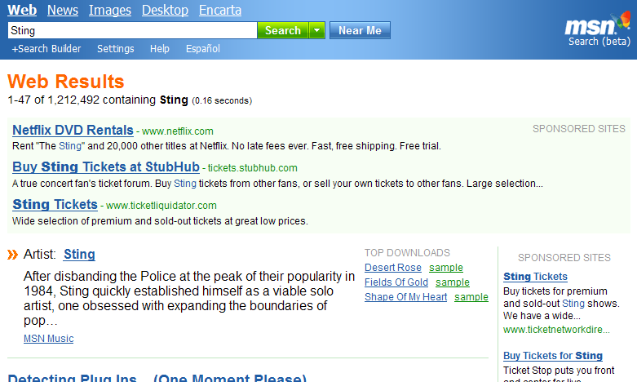
MSN Search Direct Answer from MSN Music

With Direct Answers from MSN Music in MSN Search, customers can quickly find information on artists, albums and songs that interest them; it also provides them with quick and easy access to streaming song samples and easy acquisition of music through the MSN Music service.

Direct News Answers
Another way that MSN Search provides customers with direct information is through highlighting news-related topics in broad searches that customers perform. When a customer enters a query on a topic for which there is current, prominent coverage on news sites, MSN Search looks at more than 4,800 sources of online news and delivers direct news answers to customers at the top of the broader algorithmic results.

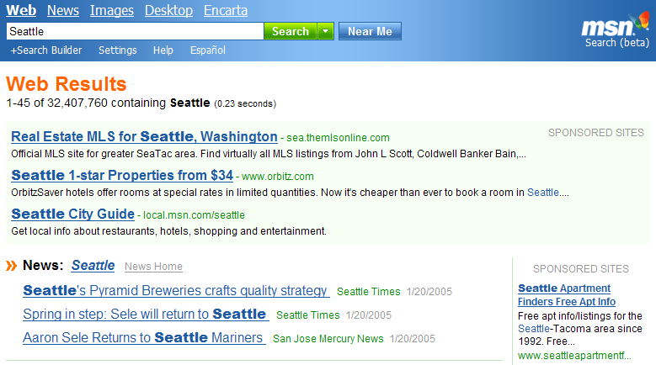
Direct News Answers shown inline

Results That Make a Difference
Delivering precise, easy-to-understand results and, wherever possible, real answers to questions helps customers get to the information they’re looking for more quickly and provides them with exciting new ways of using search as a valuable resource.

As presented in this section, the investments MSN has made in providing customers with a different and better search experience are evident through the results they see in the new MSN Search. With the introduction of results-oriented features such as Direct Answers from Encarta and MSN Music, search begins to make the migration from being a tool that provides somewhat generalized answers to one that can deliver specific information and precise answers to questions.

Powerful Search Tools

Refining Search Results
Beyond working to deliver the basics for a clean, easy-to-use and easy-to-understand results experience, MSN is working to provide more innovative and advanced features for customers. MSN Search tools are designed to put users in control and give them more flexibility to refine and target their queries and results.

Search Near Me
- With the release of the new MSN Search, customers have two options when performing queries from the primary MSN Search page. They can either initiate a standard, broad search that primarily relies on the relevancy and ranking engine to provide the most suitable results, or they can choose to receive results that are more geographically relevant to them through the new search mode from MSN called Search Near Me.

With Search Near Me, customers will find that results they receive will be more closely related to where they are located, through geographic location awareness. Achieving this proximity is no simple task; it involves significant efforts, individually tagging each item in the index based on the geographic subject matter of the content, which then helps determine their geographic relevancy. In addition, MSN employs methods to better understand the geographic location of the customer performing the query using the Search Near Me mode. With these geographically related features, customers benefit by receiving improved search results based on their current approximate location. Of course it’s also important that the customer be able to refine these settings, or adjust them based on roaming scenarios if they’re looking for results in a geographic location where they are not currently located.

With the Search Near Me mode, the system uses three methods to determine the most appropriate results to provide. The Settings page in MSN Search enables customers to manually specify their location by city, state and country. Once established, this setting will act as the primary factor in determining what results are presented for a Search Near Me query. The example below illustrates the settings page within MSN Search where adjustments can be made to location.


MSN Search Settings for geographic location used in Search Near Me queries

In addition, if the customer has not specified a location in the Settings, Search Near Me attempts to provide the best approximation through reverse IP look-up technology to help improve the search results presented to the customer. Finally, a customer can override the Settings page and the IP address information by entering an MSN Search query that contains a specific alternative, such as “hotels in Seattle.”

Customers interested in a more geographically relevant search experience may use the MSN Search Near Me mode of performing queries, which utilizes a set of advanced technologies to help them find results closer to them, or they can use the standard Search mode from the MSN Search home page to receive broader, less geographic-centric results.

Search Builder
- Search Builder, designed with the more sophisticated search customer in mind, is an advanced feature of MSN Search that provides powerful options for building and defining queries with specific and refined criteria. A customer who uses Search Builder to create a search query is provided with multiple input tuning options. These tuning options are subject to change as more customer feedback is received on this feature. Current query input options include these:

- Search terms performs the query based on all words, any words, the exact phrase of the wording, or none of the words in the search terms input box.
- Site/Domain enables customers to either include search results from only a specific site or domain or exclude a specific site domain from results. For example, to include only a specific domain, a customer would enter www.msn.com and select the “Find only Web pages from this site or domain” option.
- Links to enables the search query to include only pages in the results that link to a specific Web domain. This feature is useful if a customer is looking for information related to a specific organization or company. An example would include performing a query for third party sites that have support or knowledge base information related to a specific company.
- Country/Region provides a way of specifying to return only Web page results from a certain country. Options are provided through a prepopulated drop-down list.
- Language includes only Web pages written in a specific language in the search results. Options are provided through a prepopulated drop-down list.
- Results ranking provides equalizing tuners in the Results ranking section that empower customers to manually tune the settings of the algorithmic results they receive from their queries. While the categories of adjustable settings may change over time, the following are currently available:
  - Document date. An adjustment to this slider provides query results that are either more recently revised or more static. Perhaps a customer is interested in finding a feature overview of a specific product. By moving the slider to a more “static” setting, they would be more likely to find documents that have been unmodified for a longer period than those that are updated frequently, such as price modifications.
  - Popularity. The popularity slider allows customers to find query results that have proved more or less popular with the Web community.
  - Match. Adjustments to this slider determine whether query results will more closely or loosely match the search terms entered. If customers are certain of phrasing and word conjunction in their search terms, they will receive more specific and less random results by adjusting this setting closer to “exact match.” However if they are uncertain that they’re looking for the right terms, a setting of “approximate match” is more likely to include the results they’re looking for.

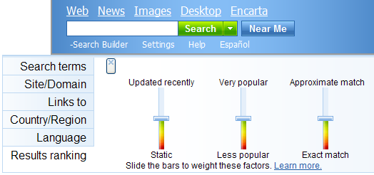
Results ranking fine-tuning in Search Builder

- Saved query criteria. Because Search Builder includes all the search parameters of the query in the URL string, it’s easy for customers to save the intricate search definitions that they have created so they can easily reuse them or use them as a base to define other queries. They can drag the URL to their desktop to create a shortcut, save it in their browser favorites, or easily send the string to someone else in e-mail or via instant messaging.

MSN Search RSS Feeds
- MSN Search now delivers the convenience of RSS feed capabilities so that customers can subscribe to MSN Search RSS feeds of their queries. Once subscribed to a query, they will receive updated top 10 results for those queries through their RSS reader or aggregator. Customers can have any number of MSN Search RSS feeds and view them all in their RSS reader without needing to rerun their search queries. With the recent addition of an RSS aggregator module in My MSN (http://my.msn.com) customers can easily view the updated results for their search queries without needing to re-enter the query information and without leaving their customized My MSN page. Below is an example of what an MSN Search RSS feed looks like in a customized My MSN RSS aggregation module.


My MSN RSS module with MSN Search RSS Feed results

Domain Collapsing
MSN Search now delivers grouped, consolidated results in a collapsed view when multiple results are returned from a single domain. This helps provide a more concise presentation of information when customers receive the results of their queries. For example, if a customer makes a query for a certain product, that product may have multiple pages of information related to it on a single domain, such as the manufacturer or a retailer’s site. It makes sense to consolidate those single domain results and notify the customer that this has taken place.

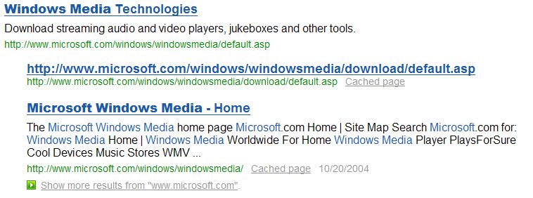
MSN Search domain collapsing example
As with many of the features in MSN Search, domain collapsing settings are adjustable from the MSN Search Settings page. Below is an example of the settings that customers can adjust based on their preferences.

MSN Search Settings for domain collapsing

By collapsing the domain’s results, customers will be able to see the top results from that site as well as results from other sites. They can also easily expand the collapsed results by clicking on “see more results from.” By taking a less-is-more approach with domain collapsing, MSN strives to deliver the most concise possible results for customers.

With convenient and powerful features such as domain collapsing, Search Near Me, Search Builder and MSN Search RSS feeds, MSN Search customers will begin to discover the new possibilities and greater satisfaction available through a richer and more convenient search results experience. MSN empowers customers with the tools and features to have greater control over the presentation and specificity of results based on their needs.

Search Verticals
MSN Search also now delivers information and results from two new vertical categories, news and images, to help customers quickly find specific information. These categories can be accessed directly from the home page when initiating a search.

News Search and Newsbot
MSN Search delivers news information in two significant ways, according to the customer’s choice. First, customers can simply enter a search term and select the news vertical category from the MSN Search home page. This will present the customer with news results in a traditional search query representation of links to stories and their source. The results consist of an index of news from more than 4,800 sources worldwide. This is an easy way for customers to receive news-only results on a single topic quickly and easily.

Alternatively, customers can access a rich, personalized news experience through the Newsbot (http://newsbot.msnbc.msn.com), which brings together many news sources through MSN Search technologies. This online search capability is comprehensive enough to satisfy avid news readers, while the personalization automatically provides readers with stories tailored to their interests. This personalization is accomplished using collaborative filtering, which highlights the most popular and recommended stories based on customers’ personal reading habits and interests. Stories and images are then organized and grouped by categories for the customer, to provide the most enjoyable viewing experience.

Today, Newsbot delivers headlines in seven categories of news and information and suggests news stories to consumers based on what they have read previously. It also provides readers with recommended links to the hottest news stories at any given hour. Specific features include the following:
- Around-the-clock crawling of stories from virtually every major news organization around the globe, including the Web sites of major newspapers and leading television and cable news Web sites, as well as regional stories from the online publications of 50 metropolitan news organizations around the United States
- News headlines clustered in seven categories — U.S. news, world news, sports, entertainment, business, science and health, and technology — to make it easy to compare coverage from different publications
- Access to the complete text of each story by clicking on the link to the publisher’s site, which accompanies each headline

For the news junkie or just the person looking for a more personalized news experience, Newsbot delivers something for everyone through the depth and the individual, dynamic experience it provides.

MSN delivers access to news directly through the MSN Search home page, toolbar and the News link. Through these convenient entry points, customers can quickly get to the specific news they’re after or enjoy a dynamically created news experience tailored to their interests and reading habits.

Image Search
MSN Search delivers new functionality making it easy to find images online. Whether it’s a historic reference or the buzz photo of the day, MSN works to help ensure that the images people are looking for are available and easy to find. MSN has amassed an index of more than 400 million high-quality images. The new MSN Search service ensures that images are added to the index as quickly as possible through its rapid Web-crawling technologies.

To help ensure that customers have the highest-quality images available to them, the index of images is editorially monitored. Customers also can adjust their SafeSearch settings, from the MSN Search home page settings, to help filter out explicit content. By default, the setting works to filter out explicit images; on the most stringent setting, it attempts to filter out all explicit search results.

To find image-only content, customers simply go to the MSN Search page, enter words or phrases related to what they’re looking for, and click on Images on the page. This will present them with a view of the images MSN has made available, including a representation of the image, specifics on size and the file name. Customers can then browse through the images or filter the results based on a variety of options such as size (large, medium and small) and color or black-and-white images.

MSN Search also delivers highlights of the most searched-for images. This helps customers discover new images based on current events or interests of the MSN community.

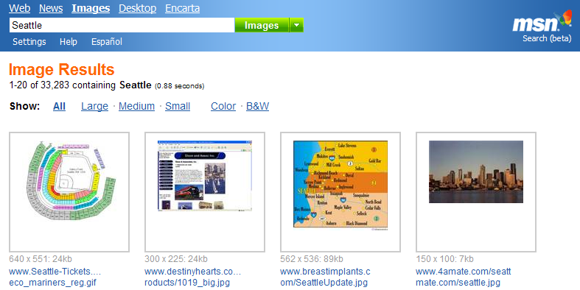
MSN Search image results

With the new MSN Search image query option, customers can quickly and easily locate a variety of image types and sizes to suit their needs.

Enabling customers to easily search for information in vertical categories such as news or images helps them get more quickly to the specific results they are searching for. By delivering comprehensive data sources to power those queries, they benefit by finding the precise and optimal information they’re after more quickly.

MSN Search Toolbar With Windows Desktop Search
Search, Browse and Find Faster
While having an extensive and fresh repository of information available on the Internet on which search queries can be conducted is certainly important, it’s equally important to ensure that customers have access to all the information that could prove most relevant to them, such as information stored on their desktop computers. Having all this information available is not very valuable if there aren’t easy and convenient ways for initiating searches and if results aren’t presented in a meaningful form that quickly provides relevant answers and information.

MSN has invested heavily in incorporating convenient and easy to access Web and desktop search capabilities into the applications and features that customers use every day, to provide them with a seamless search experience.

With the launch of MSN Search this year, MSN delivered search entry points that are easily accessible from the local computer desktop, e-mail applications, the MSN.com home page, the My MSN personalized Web experience, Microsoft Internet Explorer browser software, and even within MSN Messenger. One of the most exciting new additions to this collection is the MSN Search Toolbar with Windows® Desktop Search, which empowers customers to easily locate information relevant to them, regardless of location, that they may have long ago forgotten about or considered lost.

Flexible Installation and Configuration Choices
During the beta period for the MSN Search Toolbar, MSN gathered significant feedback from customers regarding the overall offering and enhancements that would help increase their satisfaction. One area where this customer-driven feedback was incorporated is in the installation and overall configuration options for the toolbar.

During installation customers will find that they have the flexibility to choose things like which toolbars will be displayed, whether to make MSN Search their default search engine, the specific items that will be indexed down to the individual folder level and whether or not to start the Windows Desktop Search when signing in.

Once installation is complete and customers begin using the MSN Search Toolbar features, they have even more extensive customization options. They can choose whether to dock or “float” the MSN Search Deskbar by simply dragging it to their desktop; they can choose where to locate their index file; they can choose which buttons are displayed on the MSN Search Toolbar for Internet Explorer. They can even choose which search engine they would like to use when searching the Web. Flexibility and customization were key design goals in creating the MSN Search Toolbar so customers could access the features when and in what way they found most convenient.

- The MSN Search Toolbar includes a broad set of powerful tools to help customers easily find digital information, whether it is on the Internet, their computer, or on home and corporate network shares they access. The MSN Search Toolbar delivers powerful new desktop search capabilities, with various entry points including these:
- MSN Search Deskbar
- MSN Search Toolbar for Microsoft Office Outlook
- MSN Search Toolbar for Microsoft Windows Explorer
- MSN Search Toolbar for Microsoft Internet Explorer

- This exciting set of tools enables new experiences for customers searching across not only the Internet but also local and network hard drive files, applications and e-mail. With this set of entry points, customers can easily locate virtually any type of document, media file or e-mail item on their local PC, by using the full-text search capabilities in the MSN Search Toolbar. This includes the ability to search all Outlook (version 2000 and newer) items, including all calendar appointments, contacts and tasks; Outlook Express (version 6.0 and newer) e-mail contents and attachments; all Microsoft Office documents; and even Adobe PDF files. For rich-media files such as AVI, Windows Media®, JPG or MP3, the MSN Search Toolbar also indexes the metadata associated with those files for richer, more relevant search results. The MSN Search Toolbar even includes MSN Messenger saved conversations in its search results. There are more than 200 file types currently indexed, including some of the most popular ones:
- Outlook 2000 and newer: E-mail, Contacts, Calendar, Tasks and Notes
- Outlook Express E-mail
- Microsoft Office: Word, Excel, PowerPoint® and OneNote®
- Plain-text files
- MSN Messenger conversation logs
- Adobe PDFs
- Web page HTM
- Media files and metadata for WMA, MP3, GIF, JPG, BMP and AVI

However the file types that can be indexed upon initial installation of the MSN Search Toolbar are just the beginning. Customers can also download custom add-ins for indexing additional file types and extending the functionality of the toolbar. Because the toolbar delivers this open architecture, the types of files it can index is virtually unlimited. Developers can create their own add-ins so proprietary file types can be indexed by their customers and by corporate clients.

Information on all the supported file types and creating support for additional file types can be found at http://toolbar.msn.com, using the links at the bottom of that page.

From within all the entry points for the MSN Search Toolbar, customers can easily select to search either the Internet or local desktop for the information they want. Any terms entered into the text entry box on any of the toolbars are added to a history list of terms previously entered, making it quick and easy to refer to previous terms and rerun queries. Customers can also easily clear the history of their searches.

Getting Results
Indexing and finding information with search tools is only part of the challenge. The information in the index has limited value unless it can be presented to customers in a meaningful way that enables them to quickly and easily assess and make use of it. Exciting features in the Windows Desktop Search results window for the MSN Search Toolbar that deliver on this include the following:
- Easy refinement of results and fast sorting
- Rich presentation of results including thumbnails and Preview Pane view
- Interactive capabilities such as context-sensitive right-click menu items for results and ability to concurrently select multiple items
- Full drag and drop capabilities from the results window

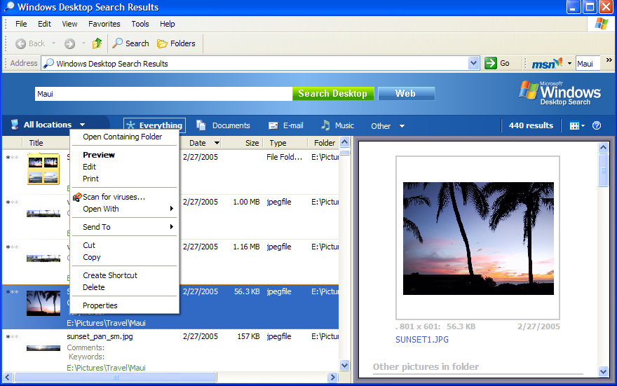
MSN Search Toolbar PC search results window with right-click file context menu open

Customers will find that searches of the local desktop using the MSN Search Toolbar features will bring up a single, convenient results view that empowers them to easily refine their query with a mouse click based on the location of the information (all locations, files, Outlook, etc.) and type of information (everything, documents, e-mail, multimedia, favorites, folders or programs).

The search results page shows all the information related to the desktop query performed, including items with related metadata, and each of the results has a corresponding graphical icon to help customers determine the document type and relevancy ranking. By having this information on a single page, customers can easily sort the results by clicking on the column headings and choosing to sort by rank, title, author, date, size or folder location. The views of this information are customizable as well. Customers can choose to show small or large icons for the results, and many of these icons show actual graphical thumbnail views of the document; for example, a PowerPoint document will show a snapshot of the first slide in the presentation and a JPEG graphic file will show a thumbnail of the actual image.

Customers also have the ability to deeply interact with items in the search results window. For example if a Windows Media music file is shown in the results window, they can right-click on its icon to see context menus for such things as playing the file. If they see an e-mail message or a calendar scheduling item in the results, they can right-click on it to see menu items contextually appropriate to the items such as forwarding, replying or accepting a meeting.

To make it even easier for customers to find exactly what they’re looking for as quickly as possible, the MSN Search Toolbar provides an optional large preview pane for items that appear in search results. This preview pane view is fully customizable, and the customer can choose whether to show it as well as choose to display it alongside the list of results or below them. For certain file types such as Microsoft PowerPoint, the preview pane will even show capabilities inherent to that program if it is installed on the local machine. A preview of a PowerPoint presentation will show an outline view and enable the customer to flip through slides as well as view a preview of the slides.

The items in the results window can also be directly dragged and dropped into e-mail or onto the Windows desktop or other locations. The rich capabilities that customers expect from a Windows experience are available to them via the results provided by the MSN Search Toolbar.

In the Windows Desktop Search results window, multiple items can be selected using conventional methods such as the traditional Ctrl key and mouse click. Of course those items can be directly accessed and opened by simply clicking on them as well.

Finally, the Windows Desktop Search results window provides links to search the Web so the customer can easily expand a search from resources on the PC or network to the entire Web.

The Windows Desktop Search results window gives customers the flexibility and power they need to not only find the information they’re searching for, but also to have rich interactions with those results once they have found them. Extensive and flexible indexing capabilities, when coupled with the dynamic results window, help customers locate the information they’re looking for and apply to their particular needs quickly and efficiently.

Managing Web Search and Online Information Experiences
- Tabbed browsing. Tabbed browsing is an exciting new feature included with the MSN Search Toolbar for Internet Explorer. Customers asked MSN for better ways to manage their online information access and search experience, and MSN is excited to deliver this feature in response. With the tabbed browsing feature, customers who have the MSN Search Toolbar enabled in Internet Explorer can easily create tabs that allow them to quickly move across Internet sites they’d like to access. They also can also elect to have MSN Search results displayed to them in a separate new tab rather than having an additional Internet Explorer window pop up.

The tabbed browsing feature also includes functionality called My Tabs. My Tabs are a convenient way for customers to designate a set of Web sites that they would regularly like to open simultaneously. For example, a customer who each day visits an online portal such as MSN.com, a shopping site and an online banking site may like to establish these visits as a My Tabs routine. He or she would open these pages as individual tabs and then select the Set Current Pages as My Tabs option from the My Tabs button on the MSN Search Toolbar for Internet Explorer. After setting a My Tabs routine, customers can reopen those pages whenever they want, all at once, by selecting the My Tabs button on the toolbar; they can either select Open My Tabs, to open their tabs in addition to the currently open tabbed Web pages, or choose Close All Tabs and then Open My Tabs to have only their My Tabs routine open, as shown below. A customer who closes Internet Explorer and would then like to reopen it and restore his or her last viewed tabs can now use the Open Last Viewed Tabs menu item on the My Tabs button as well.

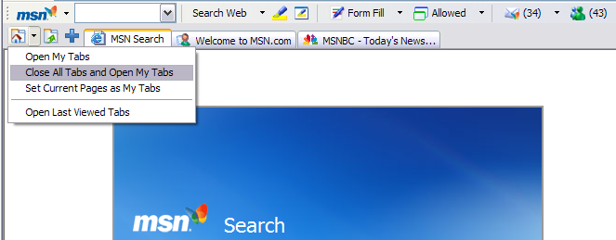
MSN Search Toolbar My Tabs button options

The tabbed browsing toolbar also includes a button that enables customers to open search result links in their own tabs. This feature is useful for organizing search results and quickly accessing them.

The final button on the tab toolbar is the new tab button. Customers simply click on the + button to create new tabs so they can display additional Web sites that they’d like to see as tabs. Once the tab is open, they simply enter the URL as they normally would to visit a Web site in that new tab and add it to any tabs they already have open.

The MSN Search Toolbar delivers tabbed browsing functionality to help customers easily access search results and sites on the Web within a single occurrence of Internet Explorer, enabling them to move between sites and search results quickly. Customers will find that creating a My Tabs routine will save them time and energy when opening sets of frequently visited Web sites.

MSN Search Deskbar
The MSN Search Deskbar provides customers with instant search access to information on their local desktop, including their e-mail, documents and media, as well as information on the Web. The MSN Deskbar also provides convenient access to services such as MSN Hotmail and MSN sites such as MSN.com and My MSN.

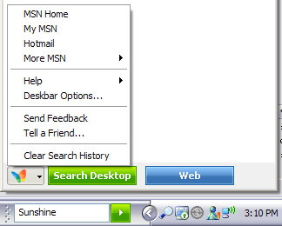
MSN Search Deskbar with quick access menu expanded

For Windows customers who have their taskbar visible on their desktop, the MSN Search Deskbar provides always-present easy access to desktop and web searching, regardless of what activity they’re doing on their desktop.

- Movable and dockable Deskbar. The MSN Search Deskbar is also fully movable and dockable so that customers can make it available wherever it will be must usable to them – top, bottom, left, right or even floating on the desktop. To relocate the deskbar customers simply “grab” the dotted handle on its left edge with their mouse cursor with a left click and hold and drag it off the taskbar and onto the desktop or to the area they would like to dock it.

The MSN Deskbar delivers innovative functions such as “word wheeling” and “aliases.” These functions truly improve the productivity of the Microsoft Windows experience for customers by enabling them to find and access information, as well as applications, quicker.

- Word wheeling. Word wheeling functionality enables customers to start typing search terms into the MSN Search Deskbar query entry box and immediately begin to see filtered search results based on the text being entered. For example, a customer typing “motor” into the text box will automatically see a list of results on their hard drive that contain the word “motor” in the name, metadata or other fields, in addition to any applications that contain the word “motor.”

Below is an example of word wheeling functionality; as customers enter text into the MSN Search Deskbar it is dynamically looked up on their local desktop, and the results are provided on the fly in a categorized breakdown.

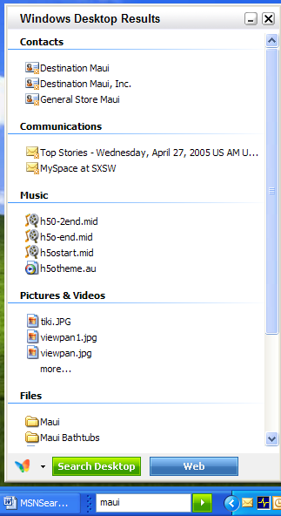 | 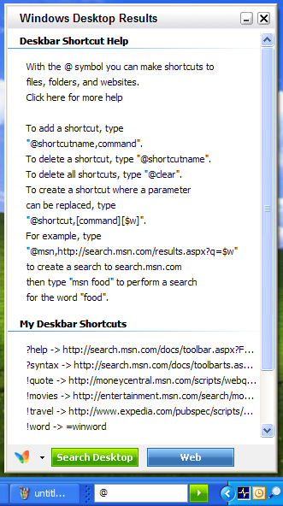
MSN Search Deskbar with categorized word wheeling results displayed | MSN Search Deskbar aliases Help accessed by typing @

Another feature of the MSN Search Deskbar is aliases, which enable customers to assign shortcut keystrokes to any program or actions across their desktop. Customers can create a set of keys to launch applications, common Web sites, or common actions on their PC. Customers can type “@” into the Deskbar to get a list of commonly used alias shortcuts and begin customizing their Deskbar experience.

Word wheeling and aliases are two features that help customers get to the information they are looking for more quickly and get more done through convenient, easy-to-use and access features.

MSN Search Toolbar for Microsoft Office Outlook
Microsoft Office customers now have powerful new functionality available to them for finding information quickly on their local PC or on the Internet through the MSN Search Toolbar for Microsoft Office Outlook. The MSN Search Toolbar for Outlook enables customers to have quick, one-click search capability across all of Outlook without having to launch a separate application. Customers can immediately and easily see a list of results from Outlook items (including e-mail messages, attachments, contacts, calendar appointments, tasks, etc.) or expand the scope of the results to files across their PC. While search capabilities have been available in Office and Outlook for quite a while, those searches generally have been limited to information related to Microsoft Office or Outlook. With the new MSN Search Toolbar for Outlook, customers now have the power to find e-mail messages, calendar items, contacts, PC documents and media files, while also having immediate access to the entire Internet. The MSN Search Toolbar for Outlook also enables customers to broaden or refine their search to the entire computer, Outlook or the Web through a simple drop-down list.

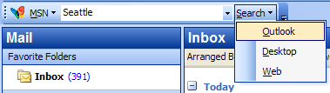
MSN Search Toolbar for Microsoft Office Outlook with Search menu expanded

As with the MSN Deskbar and all toolbars in the MSN Toolbar Suite, the Outlook toolbar provides a convenient drop-down list of previous search queries, helping customers easily locate prior or often-used search terms which is dynamically populated as searches are performed and can be cleared at any time.

MSN Search Toolbar for Microsoft Windows Explorer
The MSN Search Toolbar also extends the power of desktop and Internet search to Windows Explorer to provide convenient access to the powerful search functionality MSN delivers. As with all the toolbars, the MSN Search Toolbar for Microsoft Windows Explorer keeps a convenient history of searches that have been performed dynamically building the list in a drop-down view. However, there is also a history generated in the folder navigation window of Explorer, which enables customers to easily rerun their queries by simply clicking on previous entry, demonstrating how true integration with applications and desktop features can provide more convenience to customers.

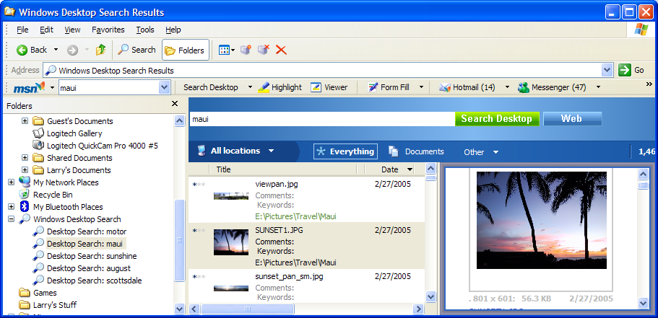
MSN Search Toolbar for Microsoft Windows Explorer

Customers also receive the benefits of the rich search results presentation within Windows Explorer when using MSN Search Toolbar. In the same way that they can access all the various functionality in the stand-alone results windows they can also do so here and also easily drag files to folders or simply open them.

Instead of searching folder and trees in the traditional Windows Explorer, customers can now use the MSN Toolbar for Windows Explorer to quickly look across their entire machine for any item related to their search phrase or words and get information quickly about the files they locate.

MSN Search Toolbar for Microsoft Internet Explorer
The MSN Toolbar was originally released in March 2004 as a free download. The toolbar made it easy to quickly perform searches in Internet Explorer while viewing any Web page, and now with the newest version of the MSN Search Toolbar, customers can search not only the Web and various vertical categories but also their local and network hard drives as well as e-mail. The drop-down search query entry box in the toolbar provides an easy way to access the history of searches that have been performed using the toolbar; the history can also be easily cleared for privacy.

Besides incorporating powerful Windows Desktop Search technology, some of the other features of the MSN Search Toolbar for Microsoft Internet Explorer includes these other features:

- Easy access to MSN Communication services such Hotmail, MSN Messenger and MSN Spaces
- Tabbed browsing
- Pop-up blocking
- Search terms highlighting and viewer for easy location of terms
- Form fill capabilities with integrated protection

Providing convenient, easy access to commonly used MSN communication tools and properties such as Hotmail, MSN Messenger and My MSN gives customers single-click access to communication on-ramps. Also, if they are logged into MSN Messenger, customers will now see the number of new e-mail messages in their Hotmail Inbox and the number of Messenger contacts who are online. And by selecting the Spaces button they can directly blog about the Web page they’re currently on or go to their MSN Space to add other information to it. The MSN Search Toolbar provides convenient ways for customers to easily access communication and information services.

Not only does the MSN Search Toolbar deliver features to help customers easily find the information that they are interested in on their desktop or the Web and access the services and information that they want, it also provides powerful tools for improving the experience of Internet browsing and information access.

The new tabbed browsing features, mentioned previously in this document, are one of the powerful MSN Search Toolbar features that help customers get more out of their time on the Web. In addition, MSN delivers features to help protect customers while they are online, such as the built-in pop-up blocking capabilities of the toolbar, to help give them a hassle-free Web-surfing experience.

Customers also have available the Form Fill feature to easily fill in common forms on the Web, including those at e-commerce sites. The feature has a master password to provide customers with more security for their personal information, such as site passwords or credit card information, and the feature must have password validation before it is available for use.

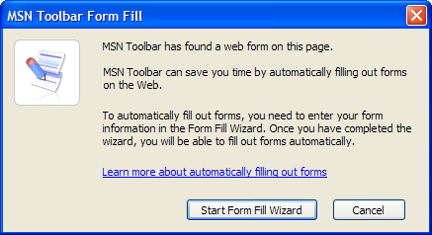
MSN Search Toolbar Form Fill dialog box

- While performing searches using the MSN Search Toolbar, customers may use the convenient highlighting feature, which not only highlights the search keywords in various colors on the results page but also provides thumbnail windows, allowing them to quickly scroll through and locate results.

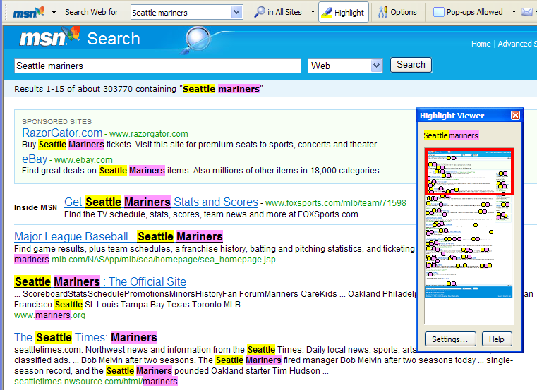
MSN Toolbar Form Fill dialog box

MSN Search Toolbar Suite Indexing Status Indicator and Settings
The convenient indexing status indicator helps keep customers apprised of indexing activities occurring on their local PC and also puts them in complete control of what is indexed and the amount of their computer’s resources that are allocated for indexing activities. The indexer also monitors PC CPU usage so that if more computing cycles are needed by another application or process, the indexer will release them until they are made available again. If a customer needs more computing power for a certain computer task, she can pause indexing or change the settings to give indexing a higher or lower priority. The customer also has the ability to stipulate whether only a portion of the hard drive(s) should be indexed and whether e-mail should be included in the indexing. Locations not included in the indexing process will not be included in search results presented using the MSN Search Toolbar tools.

The MSN Search Toolbar provides the comprehensive set of tools that customers need to effectively access and organize all the digital information they have available to them on the Internet and on their local PCs. The various toolbars make it easy to access search functionality where and when customers want it, whether on the desktop, in applications, in e-mail or from the Web browser. Customers don’t need to leave the application they’re in and go to a separate Web browser just to do a search. Not only do the tools enable powerful new search capabilities, they provide results that are easy to understand and use. This means customers can find important information they may have long forgotten about and quickly be able to access it.

Other “On-Ramps” to MSN Search
The MSN Toolbar Suite delivers a powerful and convenient way of initiating searches from just about any location on the Microsoft Windows desktop. For customers who enjoy using the more traditional approach of initiating searches through a home page or who are looking for ways to access MSN Search while on the go, MSN has great news as well.

MSN Search Home Page — Simple and Fast, Yet Powerful
Earlier in 2004, MSN Search delivered a new, cleaner, faster-loading home page that provides customers with an improved entry point to MSN Search and helps them get to their answers more quickly. With the launch of the all-new MSN Search and its extended features, there is a revised home page to take full advantage of the new functionality. The new home page delivers a streamlined, lightweight look and feel, while providing powerful categorization options, easy access to vertical searches and sites such as MSN and Hotmail, and new modes of searching such as Search Near Me and Search Builder. The MSN Search home page is available anywhere there is a Web browser installed with an Internet connection by simply going to http://search.msn.com.

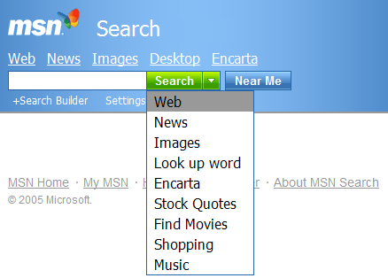
MSN Search Home Page

Customers will benefit from a fast-loading search page that provides an easy-to-understand interface yet delivers added richness through quick access to category lists that help customers home in on the answers they’re after.

The home page delivers convenient access to desktop search tools and the latest news, as well as the ability to quickly locate images. Customers simply enter their search keywords or phrase, and then click the appropriate choice to provide refined results to their query.

- Customizing the search experience begins with the Settings option on the new home page, where customers can set and save their preferences and access Help resources. Settings options include the following:
- Display. Displays interface language preference
- Results. Includes items such as the quantity of results displayed for search results and the grouping of results (clustering)
- SafeSearch. Provides filtering capabilities for explicit content and images
- Location. Enables more personalized results; customers get answers more quickly by setting a geographic location and using the Search Near Me mode.
- Search Language. Allows customers to limit their search results to pages in a specific language or set a broad search in all languages

The MSN Search home page redesign delivers ease and convenience while incorporating powerful new search capabilities. Customers receive the benefit of having the MSN Search experience available to them whenever they want it through a standard Internet-connected Web browser.

Convenient Access to MSN Search From MSN Messenger
As MSN looks at ways of providing broader access to customers through MSN Search, deeper integration will occur not only in the various online services but also in frequently used community applications such as MSN Messenger, which has more than 135 million customers. MSN Messenger provides new search integration features to make it easier for customers to quickly perform searches without ever leaving MSN Messenger.

- Within MSN Messenger, customers can now initiate searches directly from the primary MSN Messenger contact list window. Customers simply enter their search term, and the results are displayed in a new browser window. MSN Messenger also provides another implementation of search through right-click functionality, enabling searches on words or phrases located in the actual conversation window. If a customer is having an instant messaging conversation with another person, she can right-click on text she is about to send via IM or on text that is already in the sent and received box of the IM conversation.

 |  | 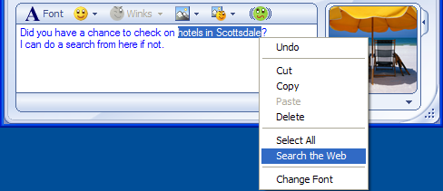
Main MSN Messenger contact window with  MSN Search integration |  | Right-click search capabilities in MSN Messenger

With this broad, major update to MSN Search, customers receive the benefit of having a wide variety of new ways to initiate search queries and get the answers they’re after more quickly. With convenient access to MSN Search available in nearly every aspect of the way customers use their computers — from the desktop, in applications, in Web browsing or in IM conversations — MSN Search provides the quick and easy entry points into search that they need to get their answers quickly. The powerful, new MSN Search algorithmic engine provides relevant search results for customers from one of the broadest indexes online today with the most up-to-date information.

Delivering a robust infrastructure and on-ramps to search were critical goals for this release of MSN Search. However, it is equally important that customers not only have an extensive set of data to query against with easy-to-use entry points, but also that they have clear and relevant results presented to them so they can locate and act on answers more quickly. Providing real answers and more personalized query results will help deliver new levels of customer satisfaction and the best possible search experience.

Summary
With this release of MSN Search, significant strides have been made in improving and delivering new value to the overall Internet and desktop search experiences. While search has existed in many forms since the introduction and evolution of the PC and Internet, both of which are still in their early developmental stages, there is much room for improvement across the experiences.

MSN has set out to deliver the enabling technologies and features to customers so they can begin to realize the potential of the next generation of search. With the customer first and foremost in mind and investments being made in the areas of an entirely new search engine, a suite of desktop tools, convenient entry points with easy categorization tools, and an overall experience that delivers better results and real answers, MSN is excited to deliver the end-to-end enablers for new search experiences.

The MSN team hopes all customers will enjoy the benefits, ease of use and power of discovery exposed with the new offerings from MSN Search.

Exercises and Walk-Throughs

Better Results
Note: Each exercise begins on the MSN Search home page, http://search.msn.com.

Delivering on the Basics
This exercise will demonstrate how domain collapsing can provide clearer results to customers, along with suggestions for alternate search queries and possible spelling corrections.

- Type Microsoft Windows Meda (intentionally misspelling it), then click on Search.
- Above the results, there will be an item which says “Were you looking for Microsoft Windows Media?” This demonstrates the suggestion and spelling correction capabilities of the new MSN Search engine.
- Within the first few results will be information from the Microsoft.com domain. These results will be collapsed, consolidated to help call out results from a single domain and provide greater visibility to results from other domains.
- Note that there is a link in the collapsed results that says “Show more results from www.microsoft.com.” Click on that link to see all results from that specific domain.

Direct Answers
These exercises will demonstrate how MSN Search provides real answers to questions through the utilization of the deep and authoritative content of Encarta, instead of just providing rows of links to pages where customers must then search out their answers.

Dictionary-type queries
- Type “what is the meaning of life,” then click on Search.
- Above the algorithmic results, there will be an item that says “Definition: life existence in the physical world.” There are also links to the full definition and Encarta Answers for more information.

- Type “what is the spanakopita,” then click on Search.
- Above the algorithmic results, there will be an item that says “Definition: spanakopita spinach and feta cheese pie.” There are also links to the full definition and Encarta Answers for more information.

Fact lookup-type queries
- Type “Height of Mount Everest,” then click on Search.
- Above the algorithmic results, there will be an item that says “Answer: Mount Everest, Asia: elevation, max: 29,035 ft.” There will also be links to learn more about Mount Everest, Asia and Encarta Answers for more information.

- Type “Length of the Nile river,” then click on Search.
- Above the algorithmic results, there will be an item that says “Answer: Nile, Africa: length: 4,160 mi.” There will also be links to learn more about Nile, Africa and Encarta Answers for more information.

- Type “what is the population of Europe,” then click on Search.
- Above the algorithmic results, there will be an item that says “Answer: Europe: Population, total: 729,075,181.” There will also be links to learn more about Europe and Encarta Answers for more information.

Conversion tool queries
- Type “how many inches in a mile,” then click on Search.
- Above the algorithmic results, there will be an item that says “Answer: 1 mile = 63,360 inches.” There will also be a link to Encarta Answers for more information.

- Type “How many days in a fortnight,” then click on Search.
- Above the algorithmic results, there will be an item that says “Answer: 1 fortnight = 14 days.” There will also be a link to Encarta Answers for more information.

- Type “How many pints in 18 quarts,” then click on Search.
- Above the algorithmic results, there will be an item that says “Answer: 18 quarts = 36 pints.” There will also be a link to Encarta Answers for more information.

Calculation queries
- Type “5+3/2-(6*2-4),” then click on Search.
- Above the algorithmic results, there will be an item that says “Answer: 5+3/2-(6*2-4) = -1.5.” There will also be a link to Encarta Answers for more information.

- Type “40 percent of 240,” then click on Search.
- Above the algorithmic results, there will be an item that says “Answer: 40%of 240 = 96.” There will also be a link to Encarta Answers for more information.

- Type “325 divided by eight,” then click on Search.
- Above the algorithmic results, there will be an item that says “Answer: 325/8 = 40.625.” There will also be a link to Encarta Answers for more information.

- Type “(sin 100)*50,” then click on Search.
- Above the algorithmic results, there will be an item that says “Answer: (sin 100)*50 = -25.318282.” There will also be a link to Encarta Answers for more information.

- Type “speed of sound,” then click on Search.
- Above the algorithmic results, there will be an item that says “Answer: speed of sound at sea level = 340.29 meters/second.” There will also be a link to Encarta Answers for more information.

Equation solver queries
- Type “solve q^2-4=9,” then click on Search.
- Above the algorithmic results, there will be an item that says “Answer: q^2-4=9 = q=-3.605551.” There will also be a link to Encarta Answers for more information.

- Type “2x+5=10,” then click on Search.
- Above the algorithmic results, there will be an item that says “Answer: 2x+5=10 = x=2.5.” There will also be a link to Encarta Answers for more information.

- Type “2(pi)+x=53,” then click on Search.
- Above the algorithmic results, there will be an item that says “Answer: 2(pi)+x=53 = x=46.716815.” There will also be a link to Encarta Answers for more information.

Active Results
MSN Search also provides convenient access to direct information on topics such as music, delivering active results that allow customers to listen to music or go to information on an artist or album.
- Type “Sting,” then click on Search.
- Above the algorithmic results, there will be an item that says “Artist: Sting,” then provides some brief summary information.
- To the right of this summary information are links related to artists, such as Top Downloads. Click on one of the results; a 30-second music clip should begin playing, if Windows Media Player or a compatible player is installed.

Best Search Tools

Note: Each exercise begins at the MSN Search home page, http://search.msn.com.

MSN Search Near Me
These exercises will demonstrate how MSN Search Near Me provides customers with a new level of personalization and relevant results based on a determination of their approximate location, based either on their IP address or the information they’ve provided in their MSN Search Settings.
- Type “fire station,” then click on the Search button.
- The results presented will be based purely on the algorithmic results from the MSN Search engine. Scroll through them to review the links and summary info.
- Now, with “fire station” still in the query entry box, click on the Near Me button next to the Search button.
- The results presented now will be based on approximate geographic location of the machine the query is being made from. Scroll through them to review the links and summary info to see how they differ from the previous, non-location-specific query results.

Search Builder
These exercises will demonstrate how the Search Builder tool in MSN Search enables customers to use variables to fine-tune their queries to help them get to exactly the answers and information they want.

- Click on the Search Builder option at the bottom of the search entry box.
- The Search Builder will expand to show tabs for entering variables. The first option is the Search terms for the query. Enter “Halo® 2,” select “This exact phrase” from the drop-down list, and then click on Add to Search. The search terms will be added to the query box.
- Click on the Site/Domain tab. Leave the radio button on “Find only Web pages from this site or domain” option selected. Enter “www.microsoft.com” into the box below those options, then click on the Add to Search button.
- Click on the Results ranking tab. Move the last graphical slider, for update frequency, to the highest setting, Updated Recently. Move the first slider, for match of terms, to the exact match setting.
- Now click on the Search button to execute the search. Within the query box “"Halo 2" site:microsoft.com {frsh=100} {mtch=0}” will now appear, showing the variables that were used for the complex query.
- Scroll through the list of results. The first results should have a date indicating their recent update, and all entries will be only from the Microsoft.com Web domain.

More Than Just the Web
MSN Toolbar Suite
The MSN Toolbar Suite provides powerful new tools for not only searching the Web but also easily locating a wide variety of document and files types on local PCs, as well as e-mail contents such as e-mail messages, contacts, calendar items, notes and tasks. With the MSN Toolbar Suite customers can easily locate digital content, regardless of whether it is online or stored locally, that may help them find the information and answers they’re after. They also have many options for sorting and refining results on the fly.

Note: As a prerequisite for these exercises, the MSN Toolbar Suite will need to be installed from http://toolbar.msn.com, and ample time should be allowed to complete indexing of the local desktop machine and contents.

Note: Each exercise begins at the MSN Search home page, http://search.msn.com.

MSN Deskbar Options
- Ensure that the MSN Deskbar is visible in the Windows taskbar.
- Click on the butterfly on the left-hand side of the Deskbar to see an expanded list of quick links customers can use to go to various online areas. Select MSN Home from the list. This will launch a new browser window; in it, go to MSN.com.
- Click on the Deskbar butterfly again to access the quick link menu and select Options from the menu, then Deskbar Options from the fly-out menu. This will open the MSN Toolbar Suite Options page.
- On the Options page, select Desktop Search from the listed items.
- On the Desktop Search options page, notice that there are options for choosing the amount of computer resources to allocate to file indexing activities. Adjust the slider to change the resource allocation.
- Also on this page, note the options for choosing what to search:
  - E-mail and all hard drives
  - E-mail and My Documents folder only
  - Custom: Includes Desktop, My Documents, My E-mail, local hard drives and any network connected drives
- Click on Custom in the “Where would you like to search” option, then choose the Select… button. Once Select is clicked, a dialog box will open with the custom choices. Cancel out of this screen.
- At the main options screen, ensure that the E-mail and all Hard Drives option is selected.
- From the main MSN Toolbar Suite Options window, select OK to close the Options window.

Indexing Status
- In the Windows system tray, you will see a small magnifying-glass icon. This is the indexing status indicator. Right-click on it and look at the options, including Snooze Indexing. Clicking on Indexing Options will go to the Options page described in the prior steps.

Finding Information With the MSN Deskbar
- To begin looking for files, media and e-mail contents on the local machine, simply begin typing a term into the MSN Deskbar text entry section to the right of the butterfly, such as a city name (“New York,” for example).
- As the term is entered into the MSN Deskbar, the word wheeling functionality will begin to dynamically pull up results that have been indexed and segment them into categories, such as Mail and Communications or Other. As more text is entered into the Deskbar, the list of results will be dynamically refined.
- Note that the Deskbar word wheeling page also has options to switch from a desktop search to a Web search with one click.
- At any time as text is entered, customers can hit Enter on their keyboard to bring up an MSN Desktop Search Results page. Hit Enter on the keyboard to bring up a results page for the terms that you previously entered into the Deskbar.
- The MSN Desktop Search Results page will appear in an Internet Explorer window. The items displayed in the results window include rich metadata and icons that accurately reflect the content type. Often, rich media files, such as pictures or video files, will have their content displayed in the title column. The results window provides options for refining the location (Anywhere, Hard Drives, Outlook and Outlook Express) and the digital content type (Everything, Documents, Multimedia, Communications and More). The columns in the results window can also be easily sorted by clicking on the column headings. Clicking on any of these, or combinations of these, will enable you to quickly sort and refine the results. Click on some of the options now to see the refinement and sorting options in action.
- The MSN Desktop Search Results page also enables customers to easily take results from the window and open them directly or perform common tasks such as dragging them to the desktop or to applications. In addition, within the results window, customers can select multiple files or items by simply holding down the CTRL key and clicking on multiple items. Try this now to drag multiple items or open them directly.

Easy Access to Search From the Browser With the MSN Toolbar for Internet Explorer
- Like the MSN Deskbar, the MSN Toolbar for Internet Explorer includes easy access to various online destinations. To see these, simply click on the MSN butterfly logo. A drop-down list of destinations and access to the toolbar options will appear.
- Explore the toolbar options for determining what icons appear on the toolbar and the options for the Form Fill, Highlight Viewer and Pop-up Blocker features. When you are done, click on Cancel to dismiss the dialog box. The toolbar options can also be accessed by clicking on the pliers and screwdriver icon on the toolbar.
- While the MSN Toolbar has been available for several months, the new version of the toolbar, included with the MSN Toolbar Suite, now delivers the same desktop search functionality that the MSN Deskbar does. Notice that the toolbar has buttons for Web and desktop searching. Enter a term into the toolbar, then click on the Desktop button.
- The results for searches using the toolbar and the desktop deliver the same consistent appearance as the results presented from the MSN Deskbar. They can easily be refined and sorted in the same manner. Try this with the results of your search.

MSN Deskbar User Tips
The following “tips” are for the MSN Deskbar component of the MSN Toolbar Suite. They demonstrate advanced features such as creating shortcuts for searches, launching applications and executing searches.

Customers can not only search for files but to launch applications, documents, files and Web sites through the Deskbar. The following steps show how:
  - Web site. Type a URL into the Deskbar, such as http://www.msn.com, then hit Enter.
  - Files. From the Deskbar, normal word-wheeling functionality can be used to find files containing keywords in their names or metadata; however, to access a file directly, customers who know the path of a file, such as c:\data\research.doc, can type it and hit Enter to open it using the Deskbar.
  - Network shares. Customers can also use the Deskbar to access network shares by entering them into the Deskbar. An example would be to enter a UNC network share such as \\data\reports, then hit Enter. Doing so would open a folder showing the contents of that share.
  - Directly launching applications. Applications can be launched directly from the Deskbar using the “=” symbol as well. An example would be to enter =notepad into the Deskbar, then hit Enter, which will launch Microsoft Notepad.

Customers can also create custom Deskbar shortcuts so that they can quickly and easily access any application, document, file or Web page.
  - Creating a shortcut in the Deskbar. To create a shortcut Notepad, for example, customers would do the following:
- In the Deskbar, type @note,=notepad (no spaces) and hit Enter.
- This will associate note with the =notepad command used to start Notepad via the Deskbar. After entering this, every time a customer types note, instead of searching, it will launch Notepad.

Advanced Tips

Customers can make shortcuts to Web sites and searches of those sites.
  - In this example a customer goes to the Microsoft.com Web site frequently to search for Microsoft documents.
  - The customer can use the Deskbar to create a shortcut to directly search Microsoft.com (or any search site):
- After performing a query on Microsoft.com for the term “Office,” the search URL looks like this: http://search.microsoft.com/search/results.aspx?st=b&na=88&View=en-us&qu=office
- To create a shortcut to Microsoft.com type (with no spaces) the following:@ms,http://search.microsoft.com/search/results.aspx?qu=$w&View=en-us, then hit the Enter key.
- The $w in the new Web shortcut string indicates that it is a Web parameter that’s passed along with the shortcut.
- Now, a customer can just type ms Excel in the Deskbar and it will launch a search for Excel at Microsoft.com.

What if I have created a shortcut using a term that I’d like to search my local hard drive or e-mail for instead?
  - If a shortcut has been created for the same term that a customer would like to perform a local desktop search on, the customer can do the local search by putting the term in quotation marks, such as “Excel.”

How are shortcuts deleted after they’re created?
- Customers can simply type @<insert appropriate shortcut name here> and hit Enter, which will delete that specific shortcut. In the example above in which the ms shortcut was created, it could be deleted by typing @ms and hitting Enter.

- Keystroke shortcut for searching the Web for a term (instead of the local desktop) from the Deskbar. By default the Deskbar searches the computer desktop and e-mail. Customers who want to search the Internet instead can select the Web Items button attached to the word wheel of results, or they can simply hit the Shift-Enter keys simultaneously.

- Keyboard shortcut for executing searches from the Deskbar. By default a keyboard shortcut is set in the Options toolbar for performing desktop searches using the CTRL+ALT+M keystroke combination. This can be changed in the Options toolbar by the customer for any keyboard combination desired.

- Changing the preferred location of the Deskbar on the desktop. The MSN Deskbar can be relocated from the Windows Taskbar to anywhere on the customer’s Windows desktop or to the left, right or top of the desktop. To do so the customer would perform the following steps:
  - Unlock the Taskbar by right clicking on it and uncheck the Lock the Taskbar option on the right-click menu.
  - Grab the dotted vertical line, using a left-click and drag of the mouse, next to the Deskbar butterfly icon as shown in the graphic. Move the MSN Deskbar to the desktop.



  - This creates a floating Deskbar as shown below. By right clicking on the window border of the Deskbar, it can be designated to be Always on Top as shown in the graphic.

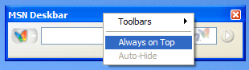

  - The Deskbar can also be docked to the top, left or right of the Windows desktop. Simply drag it to the desired location. Then right click on it to set whether it is Always on Top or Auto-Hidden when not in use. Below are examples of it docked to the top and right of the Windows desktop.

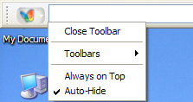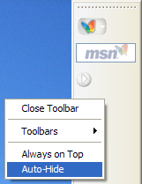
MSN Deskbar docked at top MSN Deskbar docked at right

Vertical Searches
MSN Search provides easy and convenient ways to locate specific information such as images and news content. With easy ways to search for specific categories of content, customers can get to exactly what they’re after much more quickly.

Images
- Starting at the MSN Search home page (http://search.msn.com), type “Seattle,” then click on the word “Images” directly above the search query entry box. This will execute an image-specific query.
- The results presented include a variety of images — specific choices and methods for refining the results. Click on Large, Medium or Small to narrow down the choices.
- Notice also that customers can refine their image results to only color or black-and-white.

News
- Starting at the MSN Search home page (http://search.msn.com), type a current news term such as “presidential election” then click on the word “News” directly above the search query entry box. This will execute a news-specific query.
- The results presented include a variety of news stories, pulled from more than 4,800 sources.

MSN Search Features at a Glance

Key Features | Feature Description | Benefits
Better Results
All new algorithmic results engine | Large index: more than 5 billion items and growing  Rapid crawl rate  The basics, such as:  - spelling correction  - suggestions  - domain collapsing | Customers have access to one of the largest indexes of content on the Internet, which is frequently refreshed to provide them with broad and up-to-date information.  Customers will encounter fewer dead links in their query results.  Customers automatically receive assistance when queries may be incorrectly entered. Results are easier to read and access.
Direct Answers | Results provided by the deep and authoritative resources of Microsoft Encarta | Customers receive actual answers to their questions, not just rows of results from somewhat random sources.
Direct Actions | Queries on topics such as music, return results with contextual activities, such as playing a clip of music | Customers can act directly from results instead of going through multiple clicks to get to what they want.

Best Search Tools
Search Near Me | New mode of searching delivers more personalized, location-related results | Customers receive results that are more relevant to them based on location.
Search Builder | Powerful tools for creating extremely refined query criteria | Customers can fine-tune queries to get to exactly what they want.
New Search home page | Simple design and easy access to vertical categories | A fast-loading page helps customers quickly get to specific content categories.

Search Verticals
News | Delivers news-specific results from more than 4,800 sources | Customers can quickly access a comprehensive list of up-to-date news content.
Newsbot | Collaboratively filtered, personalized news experience | Customers get to the news content that interests them in more quickly.
Images | Delivers image-specific, categorized results from more than 400 million images | Customers have access to an extensive selection of high-quality images with easy refinement options such as size and color or black-and-white.

More Than the Web
MSN Toolbar Suite  MSN Deskbar  MSN Toolbar for Microsoft Office Outlook  MSN Toolbar for Microsoft Internet Explorer | With the MSN Toolbar Suite, customers have new, convenient capabilities for easily locating information not only on the Internet, but also their local desktops and applications. | Finding long forgotten e-mail messages or virtually any file is easy through any of the toolbar offerings. Customers do not need to leave their current applications to initiate a search.  Customers can also easily refine searches, sort results with just a click of mouse, and drag and drop results to applications or locations.

System Requirements
MSN Search
- Internet Explorer versions that support scripting (version 5.01 or later)
- Experience on other browsers may vary, depending on their technical capabilities and limitations.

MSN Toolbar Suite
- Pentium 233MHz processor or better (500MHz recommended)
- Microsoft Windows XP operating system or Windows 2000 Service Pack 3 or greater
- Minimum 128MB of RAM (256MB recommended)
- 500MB of hard disk space recommended. Index size depends on how much content is indexed on the local hard drive.
- 1024x768 resolution screen recommended
- MSN Desktop Search requires Microsoft Outlook 2000 or later or Microsoft Outlook Express 6.0 or later to index and search e-mail.
- Microsoft Internet Explorer 5.01 or later must be installed; it does not need to be the default browser.
- Pop-up Blocker requires Microsoft Internet Explorer 5.5 or later.

Helpful Links and Resources
Primary MSN Search:
http://search.msn.com

MSN Toolbar Suite:
http://toolbar.msn.com

MSN Toolbar Suite additional Ifilter files for indexing additional file types on the desktop:
http://channel9.msdn.com/wiki/default.aspx/Channel9.DesktopSearchIFilters

MSN Sandbox testing and beta hosting area:
http://sandbox.msn.com

