
Snap-Ins
Snap-Ins

Microsoft Dynamics Snap

Snap-ins developed for Microsoft Office

Help increase productivity by enabling Microsoft® Office users to interact with Microsoft Dynamics™ business information as they create documents, collaborate and manage their calendar – all without leaving Microsoft Office.

The Microsoft Dynamics Snap-Ins were developed to give your organization an easy, intuitive way to extend customer, sales, project, manufacturing and other business-critical data to your users by letting them access all of this within Microsoft Office rather than through a separate application user interface.

Business Processes That Are Familiar to Your People
- Familiar. Employees will be able to access and incorporate vital business data using the Microsoft Office programs they already know.
- Convenient. Enter timesheets and time-off requests through the Microsoft Office Outlook® Calendar, submit it for approval, and update Microsoft Dynamics data automatically.
- Controlled. Set user access privileges to specific Microsoft Dynamics data, helping ensure that the right information is available to the right individuals to do their jobs most effectively.
- Accurate. Access real-time data directly from Microsoft Dynamics applications, ensuring that data is current and virtually eliminating errors caused by re-keying.
- Easy. Select the Microsoft Dynamics data you need to complete forms or letters and insert them with a single click.
- Productive. There is no need for employees to attend training to learn new applications; users simply access the Microsoft Dynamics data they need using Microsoft Office Word, Microsoft Office Excel® and Outlook.
- Integrated. Maximize your existing investment through integration of Microsoft Office and Microsoft Dynamics solutions.
- Extensible. Use shared source code to enhance or customize the shipped solutions or to use them as examples for building new composite applications.
- Downloadable. Go to http://www.gotdotnet.com to download these applications and begin increasing productivity in your organization today.

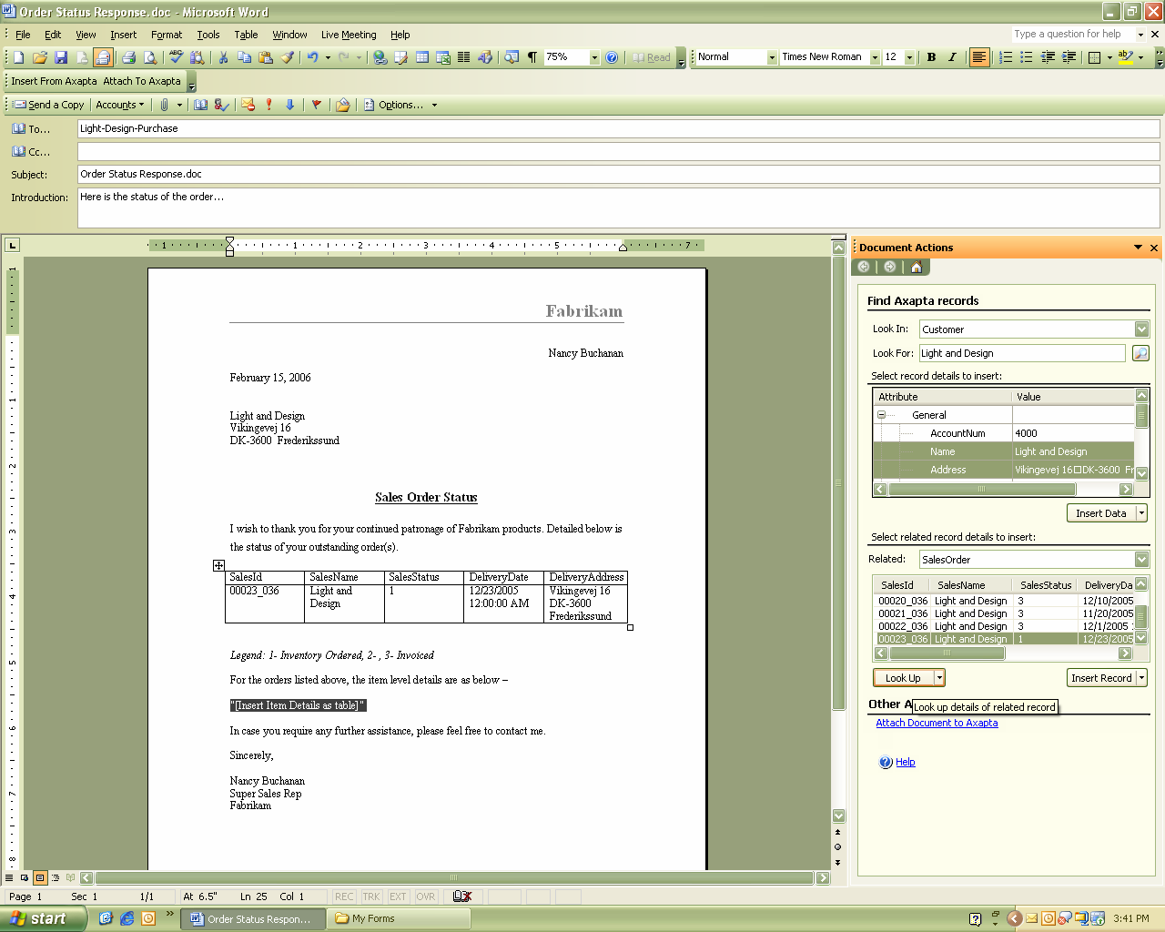
Easily look up and insert Microsoft Dynamics data into documents.

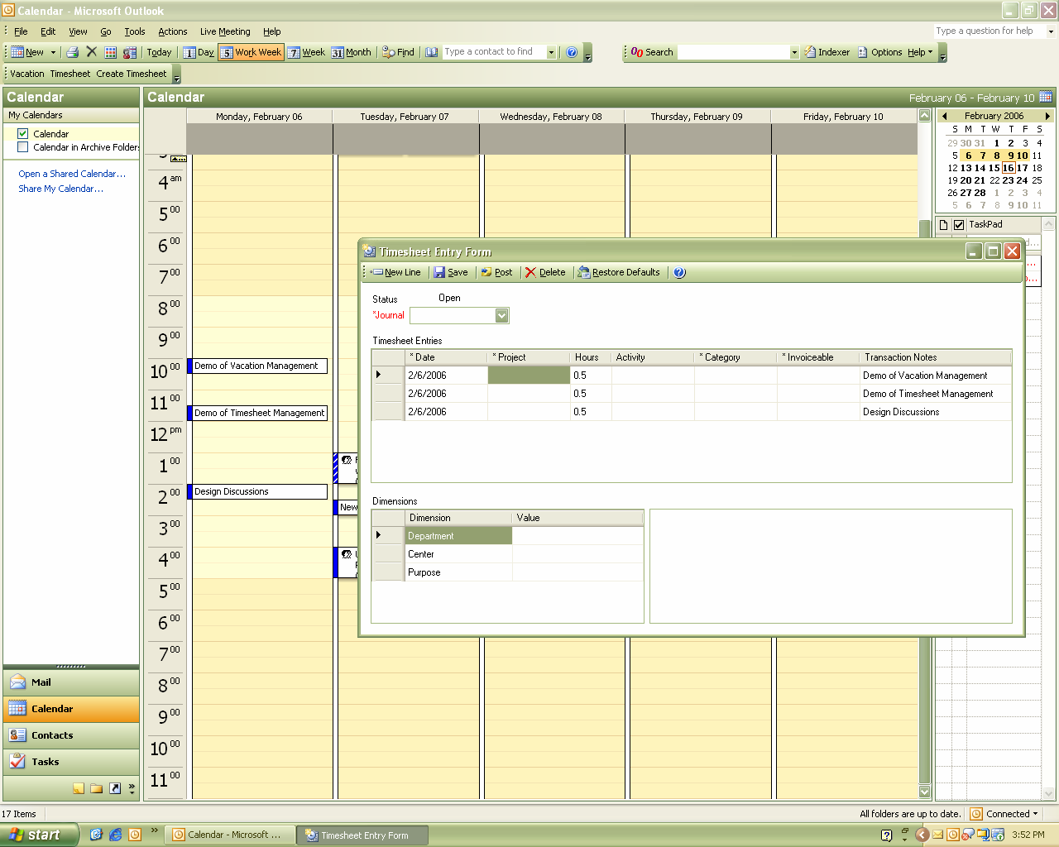

Create timesheets directly from Office Outlook Calendar items.

Pull data from your Microsoft Dynamics AX and Microsoft Dynamics CRM solutions and insert it into Microsoft Office spreadsheets, e-mail messages, business forms and letters.



Snap-Ins | Features
Business Data Lookup Snap-In (developed for Microsoft Dynamics AX) | This integrates Microsoft Dynamics AX information with Microsoft Office. From Word, Excel and Outlook, business workers can browse, search and insert Microsoft Dynamics AX data via a Task Pane interface. For example, a salesperson responding to a customer request for order status can open the Business Data Lookup Task Pane in Word, locate the Microsoft Dynamics AX sales order information, copy the relevant data into the Word document, and e-mail it to the customer. The information is accurate and up to date, and the user didn’t need to leave Office to capture and insert it. After completing the Word document, the user can swiftly attach the document to the customer’s record in Microsoft Dynamics AX, again without leaving Office.
Business Data Lookup Snap-In  (developed for Microsoft Dynamics CRM) | This integrates Microsoft Dynamics CRM information with Microsoft Office. From Word, Excel and Outlook, business workers can browse, search and insert Microsoft Dynamics CRM data via a Task Pane interface. For example, a sales manager who wants to review the latest campaign to analyze customer contacts and response distributions can open the Business Data Lookup Task Pane from within Excel, then copy the relevant CRM information to her workbook for analysis. She can then easily share the analysis with others in the organization.
Timesheet Snap-In  (developed for Microsoft Dynamics AX) | The Timesheet Snap-In allows users to use Outlook to view or submit time entries for tasks that are performed periodically. This solution integrates Microsoft Dynamics AX time entries with Outlook appointments and meetings, automatically filling in the data and helping track changes the user makes to linked appointments or meetings. This saves users the time and trouble of correlating those tasks, and helps significantly reduce the possibility of errors. This solution is very useful for Dynamics AX customers that work in service industries or have a requirement for employees to track allocation of their time across multiple internal projects.
Vacation Management Snap-In  (developed for Microsoft Dynamics AX) | This allows users to submit vacation requests using Outlook. It triggers an e-mail notification to the approver, who can view details of the request along with the requestor’s vacation history, and approve or reject the request.

For more information about Microsoft Dynamics, visit http://www.microsoft.com/dynamics/default.mspx.
This document is for information purposes only. MICROSOFT MAKES NO WARRANTIES, EXPRESS, IMPLIED, OR STATUTORY, AS TO THE INFORMATION IN THIS DOCUMENT.

© 2006 Microsoft Corp. All rights reserved.

Microsoft, the Microsoft Dynamics logo, Microsoft Dynamics, Outlook and Excel are either registered trademarks or trademarks of Microsoft Corp. in the United States and/or other countries.
The names of actual companies and products mentioned herein may be the trademarks of their respective owners.

