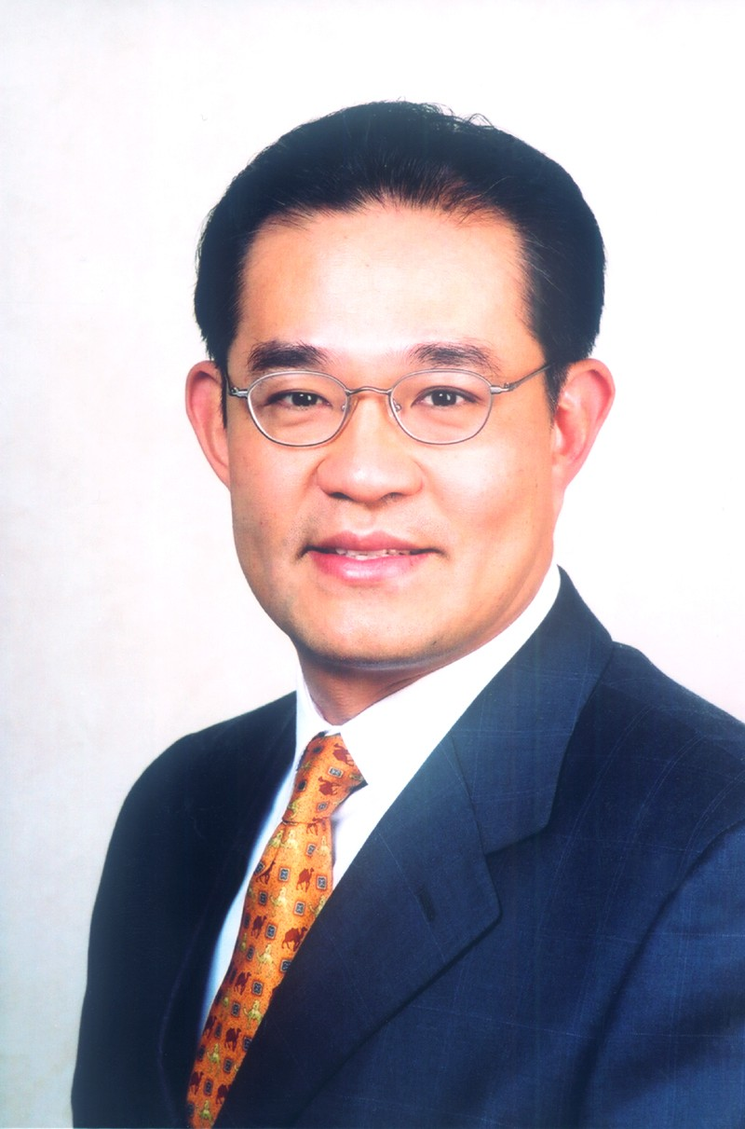

Timothy Chen
Corporate Vice President and CEO
Greater China Region
Microsoft Corp.

Timothy Chen joined Microsoft Corp. in September 2003 as corporate vice president and CEO of the Greater China Region, responsible for overseeing Microsoft’s overall business operations and company strategy in China, including a unified strategy that includes all Microsoft® business units operating in China as well as governance across all Microsoft businesses operating in Greater China.

Before joining Microsoft, Chen was chairman and president of Motorola Inc.’s China subsidiary. He was appointed corporate vice president of Motorola, chairman and president of Motorola (China) Electronics Ltd., in September 2001. From June 2000 until September 2001, Chen was CEO of 21CN Cybernet Corp. Ltd., looking after its business in Hong Kong and Mainland China. From 1992 until he joined Cybernet, Chen held various positions with Motorola, serving as the general manager and being responsible for marketing and sales operations for Motorola’s Greater China Cellular Infrastructure Division. Before Motorola, Chen worked for Lucent Technologies (then AT&T Inc.) in the United States as a research and development manager and marketing manager.

Chen received an MBA from the University of Chicago and two master’s degrees in computer science and mathematics.

#########
Microsoft is a registered trademark of Microsoft Corp. in the United States and/or other countries.
The names of actual companies and products mentioned herein may be the trademarks of their respective owners.

