

Microsoft’s Software Protection Platform: Innovations for Windows Vista™ and Windows Server® “Longhorn”
Microsoft® Windows® Family of Operating Systems

White Paper — October 2006

This is a preliminary document and may be changed substantially before final commercial release of the software described herein.
The information contained in this document represents the current view of Microsoft Corp. on the issues discussed as of the date of publication. Because Microsoft must respond to changing market conditions, it should not be interpreted to be a commitment on the part of Microsoft, and Microsoft cannot guarantee the accuracy of any information presented after the date of publication.
This white paper is for informational purposes only. MICROSOFT MAKES NO WARRANTIES, EXPRESS OR IMPLIED, IN THIS SUMMARY.
Complying with all applicable copyright laws is the responsibility of the user. Without limiting the rights under copyright, no part of this document may be reproduced, stored in, or introduced into a retrieval system, or transmitted in any form, by any means (electronic, mechanical, photocopying, recording or otherwise), or for any purpose, without the express written permission of Microsoft Corp.
Microsoft may have patents, patent applications, trademarks, copyrights or other intellectual property rights covering subject matter in this document. Except as expressly provided in any written license agreement from Microsoft, the furnishing of this document does not give you any license to these patents, trademarks, copyrights or other intellectual property.
© 2006 Microsoft Corp. All rights reserved.
Microsoft, Windows Vista, Windows Server, Windows, the Windows logo, Internet Explorer and ActiveX are either registered trademarks or trademarks of Microsoft Corp. in the United States and/or other countries.
The names of actual companies and products mentioned herein may be the trademarks of their respective owners.
Microsoft Corp. • One Microsoft Way • Redmond, WA 98052-6399 • USA

Table of Contents
Software Piracy 1
Microsoft Genuine Software Initiative (GSI) 1
Education 1
Enforcement 2
Engineering 2
What GSI Means for Customers and Products 2
Software Protection Platform 2
Reserving Features for Customers of Genuine Windows Vista 3
Common Scenarios 7
Windows Product Activation 8
Activation Policies and Reduced Functionality Mode 12
Conclusion 15

Software Piracy
Software piracy is problem that is increasing in size every year, despite a range of efforts to combat it. In May 2006, the Business Software Alliance, a leading software industry forum, reported that 35 percent of all software installed worldwide during 2005 was pirated or unlicensed. Piracy on this scale continues to create great challenges for Microsoft Corp., and also affects consumers, partners and the broad industry.
While the financial impacts on the software industry and the consumers who are defrauded by counterfeit software are serious, there are also impacts that go beyond dollars. Many consumers who end up with a counterfeit copy of Microsoft® software are unwitting victims of a crime. They believe they purchased a properly licensed copy, often have documents to back this up, and yet their copy of Windows®, Office or Windows Server® is not properly licensed. In addition, counterfeit software is increasingly becoming a vehicle for the distribution of viruses and malware that can target unsuspecting users, potentially exposing them to corruption or loss of personal or business data and identity theft.
For these reasons, Microsoft continually invests in technologies and programs to help protect consumers and businesses from the risks and hidden costs of counterfeit and unlicensed software.
Microsoft Genuine Software Initiative (GSI)
The Genuine Software Initiative (GSI) focuses the company’s many activities and investments directed at combating software counterfeiting and other forms of software piracy into a single coordinated effort. The initiative focuses on increasing investments across three strategic areas: education, engineering and enforcement.

Education
Microsoft is raising customers’ and resellers’ awareness about the risks of counterfeit software to enable them to better protect themselves and ensure their software licensing is in order. Microsoft Web sites such as http://www.howtotell.com provide detailed information about and examples of counterfeit software. Other sites such as http://www.microsoft.com/piracy provide more general information about software piracy and how it affects consumers, software resellers and the software industry.
In addition to Web sites such as those, Microsoft also actively support numerous software and intellectual property industry associations such as BASCAP, the BSA and AGMA, which are active in educating the public and working with policy makers to encourage respect for intellectual property and preventing gray market and counterfeiting of products.

Enforcement
Microsoft actively supports government officials and law enforcement agencies in taking action against software counterfeiters. Already this year, thousands of reports of counterfeit software have been filed by consumers through the Microsoft Windows Genuine Advantage Web site, as well as by e-mail to piracy@microsoft.com. These reports have contributed directly to numerous civil actions that have been filed against software pirates around the globe. More information about recent actions to protect the broad community of software and PC resellers and consumers can be found online at http://www.microsoft.com/piracy/partners.

Engineering
Microsoft is continuing to invest in anti-counterfeiting technologies and product features that protect its intellectual property and alert consumers to the presences of counterfeit software. Key among these and among the most obvious to end users are the physical anti-counterfeiting devices and features such as the variety of Certificates of Authenticity Microsoft produces as well as unique technology such as the edge-to-edge holographic media many Microsoft products ship on.
Also within this pillar of the GSI are engineering efforts aimed at enabling the software to better protect itself against theft or tampering as well as technology that can alert users when their software may not be genuine.

What GSI Means for Customers and Products
Overall, Microsoft is committed to educating consumers and software resellers to better protect themselves from counterfeit software and other forms of software piracy, and to help consumers know how to ensure that their software licensing is in order. Microsoft invests in technologies that make piracy more difficult, alert consumers to the presence of counterfeit software, increase genuine differentiation, and improve software asset and license management. Further, the company supports the legitimate software channel by helping make sure there is a level playing field for providing genuine Microsoft products. Customers and partners who choose genuine Microsoft software can expect the following:
- All updates and enhancements
- Innovative technologies to help protect them against the security and reliability risks associated with counterfeit software
- Support from Microsoft and industry partners for their software
- Peace of mind knowing their copy of Microsoft software is genuine
- Improved software asset management for corporations

Software Protection Platform
Microsoft is developing and now releasing the first new technologies that form part of the Software Protection Platform (SP Platform). The platform will help fight piracy, protect consumers from the risks of counterfeit software, and better enable volume license customers to manage their software assets. The Software Protection Platform brings together new anti-piracy innovations, counterfeit detection practices and tamper resistance into a complete platform that provides better software protection to programs that use it.
Over time and with new versions, every Microsoft product will adopt SP Platform as a way to activate their products, and the upcoming releases of Windows Vista™ and Windows Server “Longhorn” are the first two products to ship with this technology included. The SP Platform has been under development for several years and will be available as part of Windows Vista and the next version of Windows Server, code-named “Longhorn,” via a documented application programming interface.
The SP Platform is the technology that protects Windows Vista and Windows Server “Longhorn” from tampering, counterfeiting and other abuses. The SP Platform introduces changes in how Windows Vista and Windows Server “Longhorn” activate, validate as genuine, and behave when tampered or hacked. This paper outlines the changes and provides recommendations for customers interested in learning more about their options.

Reserving Features for Customers of Genuine Windows Vista
In addition to providing protection from counterfeit software and improving the activation experience, the Software Protection Platform also has a set of technologies to determine whether a copy of Windows Vista is genuine or not. When Windows Vista detects an invalid product key, tampered license files, attempts to hack products activation or other indications that the software is not or is no longer genuine Microsoft software, it will display messages to the user and some functionality will be affected. Once in a non-genuine state, certain designated features will be disabled and the system may be required to reactivate and/or perform a successful validation to restore those features or prevent further loss of functionality. If the system is required to reactivate, a 30-day grace period will be provided, after which time the system will be moved into a reduced functionality mode (described below) if it fails to activate.
With Windows XP, Microsoft was limited in the type of differentiated experience that it could deliver to genuine customers. Additional programs and updates — for example Internet Explorer® 7, Windows Defender and other popular downloads from the Microsoft Download Center — are reserved for customers of genuine software only. With Windows Vista, the SP Platform is deeply integrated into the product and is responsible for validating that a copy of Windows is genuine, allowing local differentiation from within the operating system. In addition, an online validation tool will be required to access designated content, downloads and updates. If the validation process within Vista or the online validation tool determines that a copy of Windows Vista is non-genuine, some product features will be disabled. The user will not lose access to their personal data for this reason, nor is personal data transferred to Microsoft. However, it will be obvious to users, and anyone else viewing their PC, that their PC experience is not equivalent to that of users running a genuine copy of Windows Vista.
Following are details about features that are reserved for customers who use genuine Windows, which taken together provide a more productive, more secure and overall better user experience.
Windows Aero
Windows Aero™ builds on the Windows Vista user experience and provides a well-designed, high-performing desktop experience. The Windows Aero experience includes the translucent glass effect, featuring dynamic reflections and smooth animations. The glass windows create an open, lightweight environment and, more important, help you better focus on your content, rather than on the surrounding interface.
Two new Windows Aero features, Windows Flip and Windows Flip 3D, offer new ways to confidently manage the windows on your desktop so you can see them in a new, visually striking, convenient way. Beyond the new graphics and visual polish, the Windows Aero desktop experience performs as elegantly and professionally as it looks, with smoother window handling, increased graphics stability, and virtually glitch-free visuals. All of which give you a simple, comfortable and high-quality experience.
Windows Aero is reserved for genuine Windows Vista customers. Below Following is a screenshot of the user experience when Windows Aero attempts to load on a PC determined to be non-genuine.

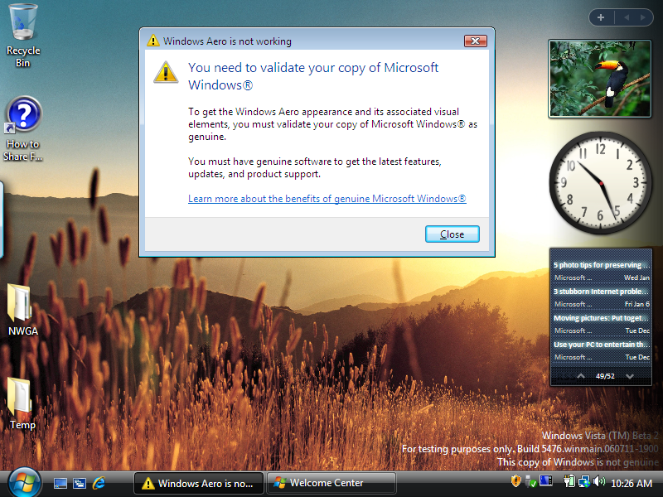
In this case, the validation failure takes place each time the user logs on to the system. The reminder is designed to be clear and consistent, while providing a link for more information about how to resolve the problem.
Windows Defender
An important benefit to customers running a genuine copy of Windows Vista is the full functionality of Windows Defender, which helps protect their computer against malicious software, including spyware, and other unwanted software. Windows Defender will remove all classes of malware and spyware detected only from genuine copies of Windows Vista. To help protect the greatest number of PCs in the Windows computing ecosystem, Windows Defender will remove critical threats from even non-genuine copies of Windows.
Below is a screenshot of the experience for users attempting to run Windows Defender on a non-genuine copy of Windows Vista. As can be seen here, Windows Defender will continue to detect all items contained in its definition set, but because the copy of Windows is non-genuine and the detected threat is non-critical, Windows Defender will not remove it.
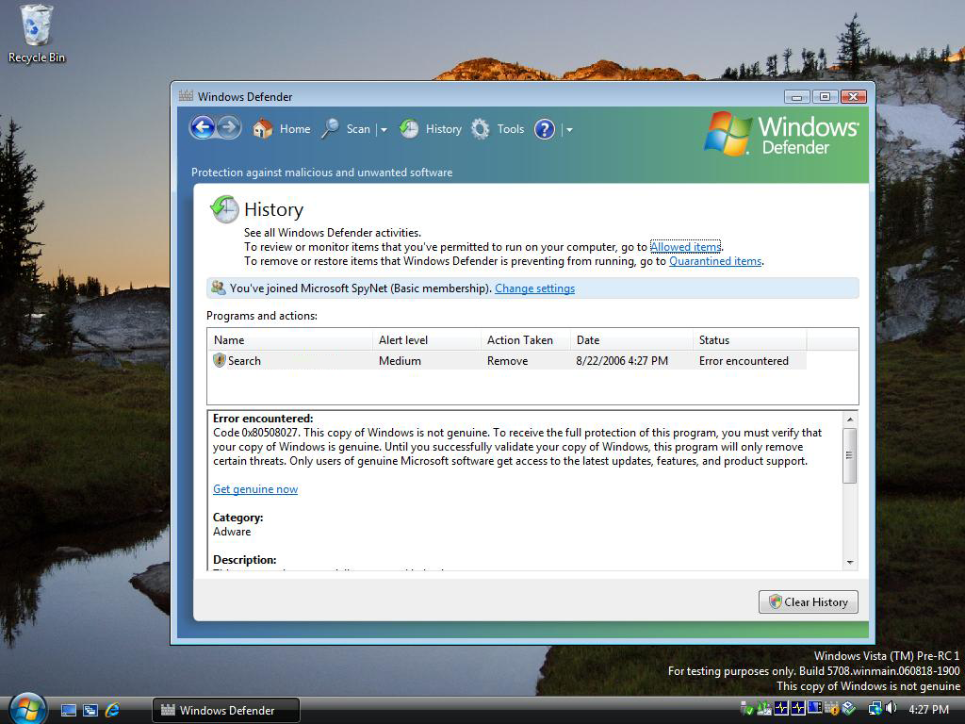

Windows ReadyBoost
Adding system memory (or RAM) is often the best way to improve a PC's performance. More memory means applications can run without the user needing to access the hard drive. However, upgrading memory is not always easy. One needs to know the type of memory required, purchase the memory, and open the computer to install the memory. Also, some machines have limited memory expansion capabilities, preventing users from adding RAM even if they are willing to do so.
Windows Vista introduces a new concept in boosting system performance. Windows ReadyBoost™ lets users use a removable flash memory device, such as a USB thumb drive, to improve system performance without opening the box. Windows ReadyBoost can improve system performance because it can retrieve data kept in flash memory more quickly than it can retrieve data kept on the hard disk, helping decrease the time you need to wait for your PC to respond. Combined with SuperFetch™ technology, this can help drive impressive improvements in system responsiveness.
Windows ReadyBoost is reserved only for users of genuine Windows Vista. Below is an image of the user experience when a system that is determined to be non-genuine attempts to access Windows ReadyBoost.

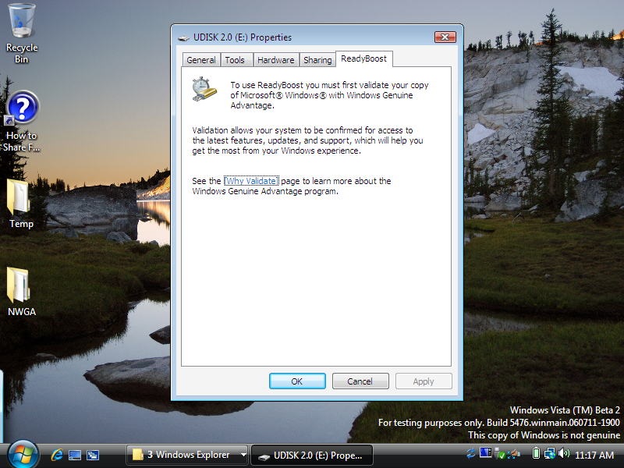
In this instance, the user has inserted a supported USB memory device and asked to improve performance using the extra memory on that device. The error message explains the requirement for genuine Windows and how the user experience can be improved by using genuine Windows. A link is provided to get more information or fix the problem.
Download Center, Windows Update, and other updates and new releases
Similar to the Windows XP experience, users with a non-genuine copy of Windows will not be able to access the many valuable Windows downloads and updates that will be available for Windows Vista. New releases of applications such as Windows Media® Player and Internet Explorer will be reserved for genuine Windows customers. However, users of non-genuine Windows Vista will be able to receive critical security updates via Automatic Updates.
Following is a screenshot of the user experience when trying to access Windows Update with a non-genuine copy of Windows Vista.
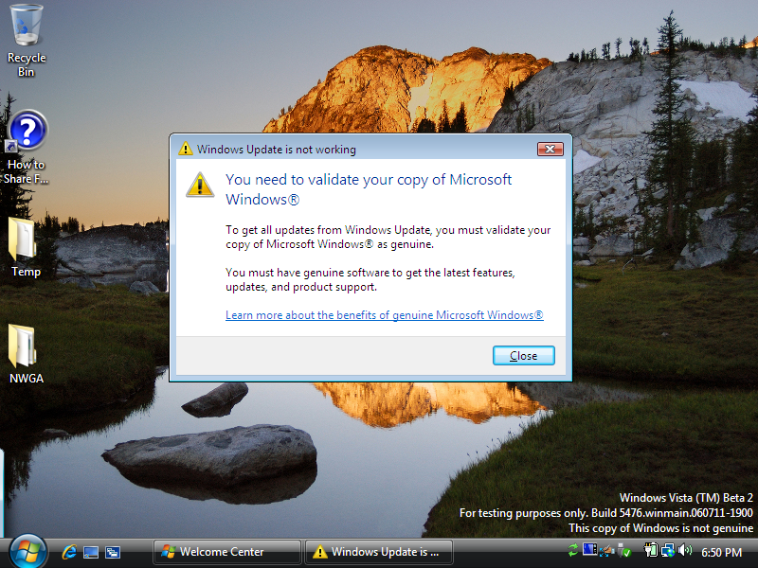

Persistent Notification
In addition to select features being disabled, Windows Vista will also notify users if their copy of Windows is determined to be non-genuine. The bottom right portion of their screen will display a persistent message that reads “This copy of Windows is not genuine.” An example of this can be seen in each of the preceding screenshots.

Common Scenarios
To help better illustrate how Windows Vista will behave if a system is determined to be non-genuine, or fails to activate, two common scenarios are outlined below.
First, a user obtains a copy of Windows Vista from a street vendor or other non-authorized source. To work around product activation, the copy of Windows Vista comes with a hack that tampers with license files and bypasses product activation. In this scenario, the Software Protection Platform will detect that the license files have been compromised and will set the system to a non-genuine state. In that state, the user will have the non-genuine experience described above. The user will be able to go online to learn more about how the computer got into that state and learn about possible remedies if they are a victim of piracy.
A second scenario stems from experience with Windows XP in which Microsoft learned that some range or set of keys will be abused or stolen and used for piracy purposes. In many cases of piracy, an unknowing customer will be sold a copy of Windows Vista with one of these keys provided to activate that copy. If the key is already blocked by Microsoft, the user will not be able to activate the copy of Windows, and the system will be moved into reduced functionality mode after 30 days. If the key has not yet been blocked by Microsoft, the system can activate and the user can use the copy of Windows Vista. However, if at some point the key were to be blocked and the user attempted to access content or downloads that required validation, there key would be identified as blocked, the system would be placed in a non-genuine state, and the user have the non-genuine experience outlined above. In addition, the user might be asked to reactivate; failure to do so within the 30-day grace period would cause the system to be moved into reduced functionality mode.

Windows Product Activation
The SP Platform introduces new changes into the product activation experience. For Windows Vista, there are three basic types of activation: OEM, volume and retail. More details about activation for Windows Server “Longhorn” will be released in the coming months and with other products in the coming years.
Windows OEM Activation
OEM Activation for Windows Vista is a software protection technology for the Windows Vista operating system that improves upon System-Locked Preinstallation, which is available for Microsoft Windows XP operating systems. OEM Activation helps prevent the copying of legitimately licensed Windows Vista software onto non-licensed computers by associating the Windows operating system to the firmware of the physical computer.
In Windows XP, Microsoft started an initiative in the original equipment manufacturer (OEM) channel called System-Locked Preinstallation, to combat illegally installed copies of Windows while at the same time allowing OEMs to pre-activate Windows machines on the factory floor. OEM Activation for Windows Vista improves on this initiative, making the process easier for OEMs and making it much harder for pirates to crack the system by ensuring that Windows Vista SKUs licensed to an OEM will function only on that OEM’s hardware. With this innovation, counterfeiters attempting to use Windows media improperly will be unable to install and activate the product using media intended for recovery and reinstall that is distributed by an OEM.
Advantages of OEM activation include persistent activation, activation without connecting to any activation provider, and the ability for OEMs to use custom media images. (The recovery media is also activated.) Additional requirements for the customer are the need to maintain recovery media specific to each OEM system configuration versus having a generic image to use across all hardware.
It is important to note that organizations can also provide system images created from volume license media for an OEM to image; however, these systems must be activated either by retail or volume activation options discussed later in this document.
Volume Activation 2.0
Volume Activation 2.0 is a new requirement in Windows Vista and Windows Server “Longhorn” requiring activation of each Windows Vista or Windows Server “Longhorn” license acquired under a volume licensing agreement. When designing and building the new volume activation technologies, Microsoft focused on two goals: first, to close significant piracy loopholes (volume license keys represent the majority of keys involved in Windows piracy); and second, to improve the volume customer experience. Volume Activation 2.0 is designed to provide increased protection and management of customer volume license keys in managed and non-managed environments as well as provide flexible deployment options for customers. The process is transparent for end users, and the Volume Activation 2.0 solution works in a variety of customer environments. It enables the following:
- Enhanced volume key protection
        - Centralized management and protection of volume license keys
        - Lower probability of keys leaking
        - Less risk of re-keying entire organization
- Flexible deployment options
        - Comprehensive range of product activation options
        - Robust and scalable solution
        - Centralized and controllable infrastructure
        - No end-user involvement needed
- Peace of mind
        - Better security checking for genuine software
        - Clear road map to future software asset management tools
        - Transparent Microsoft privacy policy on activations

Volume Activation 2.0 provides a simple and security-enhanced activation experience for enterprise customers, while addressing issues associated with volume licensing in previous versions of Windows and reducing risks of leakage to both Microsoft and its customers. Volume Activation 2.0 will provide system administrators with the ability to centrally manage and protect product keys, as well as several flexible deployment options to activate the computers in their environment no matter what the size. forwarding the future, it will provide the basis for an easy-to-use, comprehensive, integrated activation process that will support Microsoft and third-party applications. It is also the starting point for a strong software asset management system that will deliver immediate and future benefits.

Volume Activation 2.0 Options
This section describes each activation method and provides information to help organizations decide which method best suits their systems’ requirements. There are two types of keys that can be used with Volume Activation 2.0, and three ways to activate client PCs:
- Multiple Activation Key (MAK)
  - MAK Proxy Activation
  - MAK Independent Activation
- Key Management Service (KMS) Key

Multiple Activation Key
All customers who have valid license agreements with Microsoft are eligible to receive a MAK (pronounced ‘mack’) key with a limited number of activations associated to it. Each MAK can activate a specific number of machines and behaves much like a traditional retail activation key, requiring activation with Microsoft but allowing multiple activations. They may be used to activate any volume edition of Windows Vista.
The MAK may be obtained from MVLS or eOpen (depending on the user’s volume licensing program). As each machine contacts a Microsoft activation server, the allowed activation count is decremented. Activation may be performed over the Internet or by telephone. Users may check the number of remaining activations online and request additional activations as needed.
Advantages of MAK activation include the ability to automate key assignment and activation, availability of online reports regarding key utilization via Microsoft Operations Manager (MOM) or special deployment tools provided, and no requirement to periodically renew activation. Additional requirements include the need to request additional activations when the number of activations passes the preset limit, the need to manage the installation of MAK keys (automated by Business Desktop Deployment (BDD) 2007), and the potential need to manually activate systems using a telephone when no Internet connection is available.
There are two ways to activate machines using a MAK key:
- MAK Proxy Activation is a scalable solution that enables a centralized activation request on behalf of multiple machines with one machine connected to Microsoft.
- MAK Independent Activation requires that each machine individually connect and activate against Microsoft.

Key Management Service Key
A KMS Key is used to enable the Key Management Service on a machine controlled by an organization’s IT professional. KMS usage is targeted for managed environments where more than 25 machines are consistently connected to the organization’s network. Machines running Windows Vista activate by connecting to a central Windows Vista client or Windows Server “Longhorn” running the KMS service.
After initializing KMS, the KMS activation infrastructure is self-maintaining. Users can install a KMS key and enable the KMS service on Windows Vista systems or on systems running Microsoft Windows Server “Longhorn”. The KMS service can also easily be co-hosted with other services on the same machine. There is no extra software to download or install. Microsoft is developing a solution to support KMS on Windows Server 2003, with availability scheduled for spring 2007. A single KMS service can support hundreds of thousands of KMS clients. It is expected that most organizations will be able to operate with just two KMS machines for their entire infrastructure (one main KMS machine and one backup machine for redundancy).
A KMS service must have at least 25 physical Windows Vista clients or five physical Windows Server “Longhorn” servers connect to it before any can activate (note that virtual clients do not count toward the 25). Clients must renew their activation by connecting to the KMS machine, which is a local machine, at least once every 180 days to stay activated. Clients not yet activated will attempt to connect with the KMS service every two hours (value configurable). Once activated, they will attempt to renew their activation (locally) every seven days (value configurable) and if successful will renew their 180-day activation life span. Clients locate the KMS service using one of the two methods:
- Auto-Discovery, in which a client machine uses domain name service records to automatically locate a local KMS service.
- Direct-connection, where a user enters the machine name and port where the KMS service resides on their network.

Clients have a 30-day grace period to complete activation. Clients not activated within this time period will go into Reduced Functionality Mode (RFM), which is described later in this paper.
As mentioned above, machines activated with KMS periodically try to renew their activation. If they are unable to connect to a KMS machine for more than 180 days, they enter a 30-day grace period, after which they enter RFM until a connection can be made with a KMS machine, or until a MAK is installed and the system is activated online or via telephone. This feature prevents systems that have been removed from the organization from functioning indefinitely without adequate license coverage.
Machines operating in virtual machine environments can be activated using KMS but do not contribute to the required 25 machine minimum for KMS activation.

Deciding Which Volume Activation Method to Use
There are five key steps in deciding which Volume Activation 2.0 methods should be used in a particular environment. The first is preparation: understanding Volume Activation 2.0 using the Business Desktop Deployment guide, understanding how target environments are configured, and understanding how the users will connect to the network. The second step is to map computers to Volume Activation 2.0 solutions. For example, in environments where there are fewer than 25 clients, or in situations where client PCs do not connect to the network for more than 210 days, MAK Proxy or MAK Independent are the preferred solutions. The third step is to install KMS to ensure activation for any machines without a MAK. The fourth step is to set up reporting for ongoing maintenance and troubleshooting as needed. These reports can be generated by the provided MOM pack or Volume Activation Management Tool, as well as any third party application. The last step is to prepare the support center by making sure support scripts are available to the Help Desk. For example, steps to convert from KMS to MAK, and handle activation warning messages as included in the BDD guide.
As with Windows XP, customers can still purchase pre-installed and pre-activated OEM SKUs from their OEM of choice. Unless re-imaged, these PCs do not require further activation.
While these new methods for activating volume licensed products may require some additional planning and management, each method provides its own benefits and advantages.

Better Software Compliance
Administrators will be able to generate reports on Windows Vista Volume Activation 2.0 using a provided reporting tool, a Microsoft Operations Manager pack, or non-Microsoft license auditing tools. These tools utilize published properties and events. By knowing the number of activated machines in their environment, administrators can monitor volume activations and know when to request additional activations. Information on how to request additional activations may be found on MVLS and eOpen.

Better License Management Tools
Using the BDD 2007 best-practice methodology and tools, which include full technical guidance on Volume Activation 2.0, administrators can prepare reference systems for image capture. Windows can be activated using scripts after systems are imaged, providing automation of activation and reducing administrative effort. These new capabilities allow better control of activation keys.
It is recommended that businesses consider additional planning to support deployment with either the KMS or MAK solutions; however, once configured the overhead required to manage either solution should be minimal. Some early adopters of this technology have seen additional benefits to both solutions beyond the improvements in activation. These include improved tracking of installations, the opportunity the required checkback for KMS activated systems offers for IT departments to touch the systems at predictable intervals, and improved anti-tampering technology.

Activation Policies and Reduced Functionality Mode
As with Windows XP, after initial installation and the conclusion of the grace period, product activation will be required. Failure to activate will result in the copy of Windows Vista being placed in Reduced Functionality Mode. It should be noted that in all versions of product activation, the software can be used for a grace period without entry of a product key. Once a copy of Windows Vista has moved into RFM, the user will be presented four options at their next logon attempt. They are listed below:

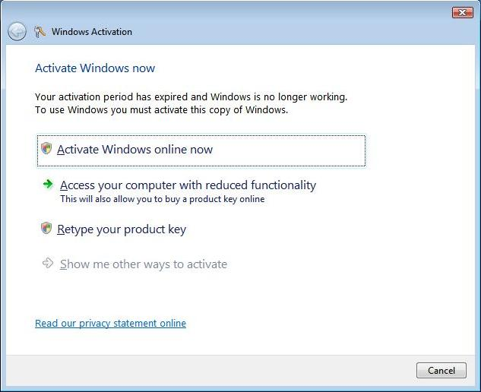

- Users who already have a product key but have not activated their machine should click “Activate Windows online now.”
- By choosing “Access your computer with reduced functionality,” the default Web browser will be started and the user will be presented with an option to purchase a new product key. There is no start menu, no desktop icons, and the desktop background is changed to black. The Web browser will fully function and Internet connectivity will not be blocked. After one hour, the system will log the user out without warning. It will not shut down the machine, and the user can log back in. Note: This is different from the Windows XP RFM experience, which limits screen resolution, colors, sounds and other features.
- If the user has acquired another product key (either through eligibility for a MAK or purchasing a key online), they can use the new key to activate by choosing “Retype your product key.”
- If no Internet connection is detected, then “Show me other ways to activate” will be available; the user can select this option to follow steps to activate via telephone. This option won’t be active if an Internet connection is present on the system.

A copy of Windows Vista can go into RFM under two scenarios. First, if any of the following events occurs for the given license type:
- Retail user (or corporate user with MAK):
  - Failure to activate within the grace period (i.e., 30 days after installation)
  - Failure to renew activation within three days of a major hardware replacement
- OEM user (or corporate user with OEM-sourced activated image, i.e. non-volume license bits):
  - Failure to activate within three days of switch to non-OEM motherboard
- Corporate or enterprise user using KMS:
  - Failure to activate with KMS within 30 days of installation
  - Failure to renew activation with KMS within 210 days of previous activation
  - Failure to renew activation with KMS within 30 days of hard drive replacement

Second, a copy of Windows Vista may be required to reactivate for the following reasons, and failure to successfully reactivate during the 30-day grace period will cause the copy of Windows Vista to go into RFM:
- The activation process has been determined to have been tampered with or worked around, or other tampering of license files is detected.
- A leaked, stolen or prohibited product key is detected, and blocked by Microsoft product activation servers.

Product keys may be prohibited for any of the following reasons: The product key is abused, stolen or pirated; the product key is seized as a result of anti-piracy enforcement efforts; the keys are beta or test keys and have been disabled; there were manufacturing errors in the keys; or the keys have been returned. When a copy of Windows enters Reduced Functionality Mode as a result of this scenario, the user is notified of this status via a message such as the one shown below showing five elapsed days of the notification period.

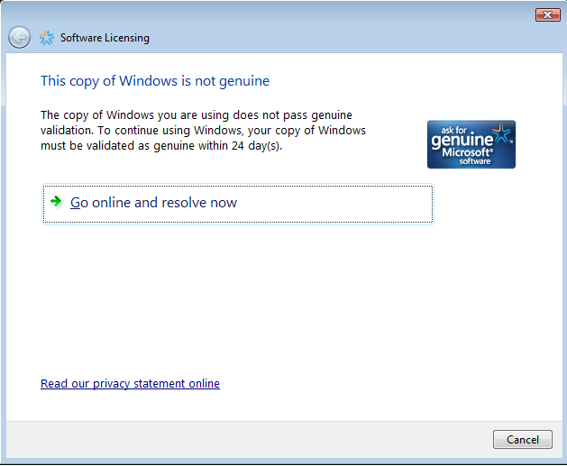

A user will always have a 30-day grace period to resolve the situation. During the 30-day grace period, reminders will pop up to inform users that they must activate within the specified time period, or else they will lose Windows functionality. During the last three days of the grace period, these reminders are shown to users with increasing frequency, as shown in the image below.

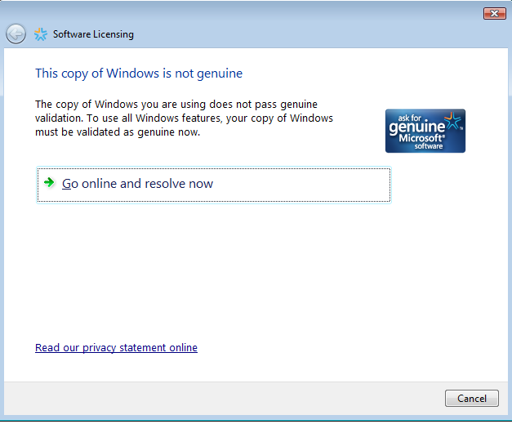

Exiting Reduced Functionality Mode
In the event that a system is placed into RFM, there are several remedies available. First, the user can simply follow the prescribed activation process and options described above. These include entering a new product key, obtaining a new product key, or re-entering the original product key. Volume licensing customers can return to normal Windows operating mode by connecting to a KMS service to automatically renew the activation or obtain a MAK. Finally, if the system is in RFM because of hardware changes, the user can restore the original hardware configuration. At any time in the process, users can contact Microsoft support for additional help.

Conclusion
Software piracy is a persistent and evolving crime. Each year consumers, businesses and industry as a whole are harmed by counterfeit software. With the upcoming release of Windows Vista and Windows Server “Longhorn,” Microsoft has increased its investments to help address this challenge. Windows Vista and Windows Server “Longhorn” will be among the first products from Microsoft to take advantage of the new Software Protection Platform, an innovative platform from Microsoft that strengthens anti-piracy technologies to help better protect customers and improve the overall licensing experience. Customers, from the individual consumer to the largest enterprise, will benefit from the innovations in the SP Platform and from the technologies that help to protect against the risks of counterfeit software.

See http://www.microsoft.com/presspass for Microsoft’s recent announcement about the results of a forensic analysis of counterfeit media.
Business Action to Stop Counterfeiting and Piracy (BASCAP) is an International Chamber of Commerce initiative. More information can be found online at http://www.bascap.com.
The Business Software Alliance (BSA) promotes a safe and legal digital world. Find more information at http://www.bsa.org.
The Alliance for Gray Market and Counterfeit Abatement (AGMA) addresses gray market and counterfeiting of goods in the technology industry. Find more information at http://www.agmaglobal.org.
Windows Aero is available in Windows Vista Home Premium, Windows Vista Ultimate and Windows Vista Business.

