Microsoft Publisher 2000
Product Enhancement Guide

For the latest information, please see http://www.microsoft.com/publisher/.

Overview of New Features
Publisher 2000 is a business desktop publishing program that enables you to easily create professional-looking marketing materials. The release of Publisher 2000 offers more design options with over 2,000 professionally designed publication templates and hundreds of design elements for easy to mix and match within their publications. A flexible wizard model allows you to work the way you want, and automated design expertise helps you achieve professional results without design expertise. Stronger Office integration and a complete print-to-Web publishing solution enable you to deliver professional-looking results.

Easy to Learn and Use
Publisher 2000 looks and works like Microsoft Office applications, enabling users to get right to work on their publications without a steep learning curve.

 | Feature | Description
Improved | A fully integrated Office application | Publisher 2000 includes familiar menus, toolbars and shortcuts — AutoFormat, Office Assistant, Spell It, AutoFit Text, multilevel Undo, a shared dictionary, Personal Menus, the Office File Open and File Save dialog boxes and Clip Gallery — just like all the Office applications.
New | Automatic bullets and numbering | Publisher 2000 automatically creates bulleted and numbered lists, just like Word does.
Improved | Mail Merge | Publisher allows easy mail merges within a publication using Word, Outlook, Excel, Works and other common address books and databases.
New | File Open and File Save | Publisher uses the same File Open and File Save dialog box as Office 2000, allowing users to view 50 percent more files with less visual clutter, and provides links to the last 20 to 50 documents that were worked on.
New | Shared Designs | Some Publisher designs are shared across Office: For example, users can create a document in Word and a presentation in PowerPoint that share the same look as a brochure created in Publisher.
Improved | Office Assistant | Office Assistant in Publisher 2000 functions outside a window, taking up less screen space. It also provides the option of linking to a special Microsoft Web site for additional help if it can’t answer a question.
Improved | Clip Gallery | Shared across all Office 2000 applications, new searching tools such as “Find More Like This” allow users to organize their own images by creating custom categories. Publisher also allows users to add their own content, and drag and drop multiple images from Clip Gallery directly into their publications.
Improved | Personal information | Publisher 2000 builds a Personal Profile of information for you. This information is automatically applied to future publications to eliminate the time-consuming process of adding name, address, phone number and logo information to each new publication. Publisher allows for multiple profiles to be stored and used at any time.
Improved | Page navigation | Visual page navigation makes it easier for you to navigate between pages in your publication.
Publisher 98 | AutoFit Text | This feature automatically adjusts headlines, captions and text within design elements to make the content fit without changing the publication layout.
Improved | Zooming and scrolling with the IntelliMouse pointing device | Publisher 2000 uses the standard Office-style intuitive way to zoom and scroll through a user’s publication using Microsoft IntelliMouse®.
New and Improved | Save As | This feature allows users to save their publications to a Publisher 98, HTML or PostScript file format for easy file sharing.

Professional Results With No Design Expertise
Publisher 2000 works like a designer in a box by providing intuitive, automated design expertise, from step-by-step wizards that help you set up your publications to IntelliSense-based features such as smart objects that recognize your needs and automatically provide the desired result.

 | Feature | Description
Expanded | Wide variety of publications | Publisher 2000 can automatically create newsletters, fliers, brochures, postcards, Web sites, catalogs, booklets, forms, letterhead, business cards, signs, greeting cards, invitations, calendars, and specialty items such as menus, banners, labels, awards, gift certificates, advertisements, programs and more. All of Publisher 2000’s designs are based on extensive document research and are appropriate to the particular publication type you need. They also are all completely customizable.

Expanded | Design Sets | Ten new professional design sets, for a total of more than 40 sets of professionally designed looks can be applied across all publication types.
New | Quick Publication  Wizard | A new publication type with professional designs and layout options for easy single-page publications that can be used for a variety of needs.
New | Catalog Wizard | This new publication type lets you set up multipage catalogs and booklets with numerous layouts.
New | Flip Horizontal, Flip Vertical | This feature allows you to flip any graphical element.
 | Web site Wizard | A step-by-step wizard helps users set up a dynamic multipage Web site. It also provides predesigned Web forms that are easily customizable, page and navigation bar options, as well as sounds and animated GIFs for a high-impact Web site.
Intro in Publisher 98 | AutoConvert | This feature allows you to reuse your content by automatically converting a newsletter or brochure to a Web site, or vice versa, with a click of a button.
Improved | Catalog | Publisher 2000 provides an easy-to-browse starting point for the more than 2,000 professionally designed publication templates.
Expanded | High-quality content | Publisher 2000 includes more than 15,000 clip art images, including 1,700 photos, 600 animated GIFs, and 90 sounds. Also includes 200 True Type Fonts and 425 Design Gallery objects.
Improved | Color Schemes and Custom Color Schemes | Publisher 2000 includes more than 60 professionally coordinated Color Schemes to apply to any publication. Color Schemes are also completely customizable, so users can create and save their own schemes, including using PANTONE® Colors.
Improved | Smart recoloring | Publisher 2000 smartly recolors clip art and graphics to another color or another color plus black to allow you to create unique graphics, or to convert existing graphics to one and two colors for more economical commercial printing.
Expanded | Smart objects | Smart objects are automated design objects within a publication. You can choose a new design option for objects such as headers, snipes, or calendars without changing the look of your entire publication. Publisher smartly applies the changes across multiple pages in a publication or Web site.
 | Design Checker | The Design Checker helps identify design problems — such as too many colors or fonts, or images that are too large for viewing on the Web — and recommends solutions.
New | Measurements toolbar | Publisher 2000 provides advanced text editing functionality, such as shrinking, growing and rotation, for users who want more control over their text.

Complete Publishing Solution From Print to Web
Publisher provides several printing options, each suited to different users’ needs. Publisher 2000 allows users to print to a desktop printer, at a commercial printer or a local copy shop, or to publish to the World Wide Web.

 | Feature | Description
New | Pack and Go Wizard | This convenient wizard packs all information, fonts, graphics and essential elements across multiple disks for efficient travel and successful printing at a local copy shop or commercial printer.
New | Commercial printing support | Publisher 2000 provides full support for commercial printing, including automatic conversion to spot or process (CMYK) color with automatic color separations. In addition, advanced tools such as trapping, graphic link management and font lists provide commercial printers with the complete control they need to offer cost-effective printing solutions.
New | Automatic four-color process (CMYK) conversion | This feature provides you with the flexibility to print your publications in full four-color process at a commercial printer. This is especially beneficial if you need larger-quantity print runs or higher-quality printing.
New | PANTONE® Process Color System | A standard ink-matching system allows users and printers to designate a specific color to match during printing.
Improved | Spot color | Spot color enables more cost-effective commercial printing by creating or converting your publications to one, or two colors plus black.
New | Trapping | A commercial printer can set a publication to automatically trap an entire publication or on a per-object basis. A printer can use the default trap settings or can modify those settings based on equipment needs.
New | Font embedding | Publisher 2000 automatically embeds all publication fonts, ensuring that you get the appropriate font in a printed publication regardless of where it is printed. It also provides complete information on all font licensing rights for a user’s prepress bureau.  Note: All fonts included with Publisher 2000 include full font embedding rights.
New | Graphics Manager | Publisher 2000 provides commercial printers with a list of all image file properties, i.e., name and file type (TIFF, GIF, etc.) and status (linked or embedded) of all graphics in a publication, ensuring that all elements will print correctly.
Improved | Create Web site from current publication | The feature allows a user to save a copy of any publication as HTML, and automatically converts images to JPEG and GIF format. To view the Web site, users can choose Web Page Preview to preview their Web site in their default Web browser.
New | Save as Web Page | Users can save a publication in HTML directly to a Web server — just like in Office 2000.

New and Improved Features in Detail

Easy to Learn and Use

A Fully Integrated Office Application
Publisher 2000 looks and works like other Microsoft Office applications, enabling users to get right to work on their publications without a steep learning curve. It includes similar menus, toolbars and shortcuts, including AutoFormat, and Spell It, just like Word does. Office Assistant, multiple level Undo, Personalized Menus and a common Clip Gallery all work the same, and many share the same code, saving users time and hard disk space for more efficient performance.

In addition, integration between the applications makes it easy for users to incorporate elements from their Word document, Excel spreadsheet or PhotoDraw graphic into their Publisher publication.

Automatic Bulleting and Numbering
Publisher 2000 expands typing ease with automatic bulleting and numbering. Simply start typing, and Publisher 2000 senses when they are typing a bulleted or numbered list and automatically applies the correct format. To discontinue numbering or bulleting, you can easily override the sequence with a backspace, then continue typing, just as they would in Word.

Mail Merge
The Mail Merge feature has been updated in Publisher 2000 so you can more easily merge Publisher publications with your Outlook contact lists through the Mail Merge Wizard. You can also sort and filter your lists and to preview the results before printing.

In addition, users can still utilize Mail Merge with other existing address books such as a Word document, an Excel spreadsheet, an Access database and more.
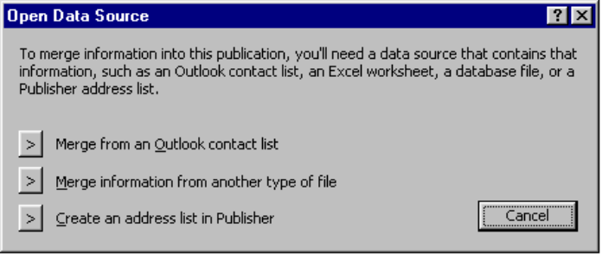

File Open and File Save
The most commonly used dialog boxes in any Office application, File Open and File Save, have undergone many improvements in Office 2000, and Publisher 2000 shares these changes. These updates include easier access to more files, decreased clutter and one central location of files among all most often-used files regardless of the application they were created in. A command bar has been added for common file management tasks such as copying, moving and deleting files. The Places bar, an Outlook-like well of icons, is provided for often-used document folders to help insulate users from the persistent confusion of a hierarchical directory structure. One of these icons points to the Recent Files folder, a collection of shortcuts with up to 50 of your most recently accessed documents. Web Folders points to Web servers for easy placement of files on an intranet or the Internet. The new dialog boxes also take a cue from the navigation method now familiar to millions of users through their Web browsers and include a Back button, which lets users easily return to recently visited folders regardless of their location in the directory structure.

Shared Designs
To create compelling, graphically rich and consistent documents, Publisher 2000 shares some designs with Word, PowerPoint, Access, Outlook and FrontPage. These Shared Designs include design elements, backgrounds, color definitions, bullets and text formatting such as font type, size, format and color.

Office Assistant Out of the Box
Publisher 2000 includes the revamped Office Assistant shared across all Office 2000 applications. Office Assistant now works out of the box, which means there is no window around it so it takes up less screen space, blends in more naturally with users’ work and is more visually appealing. Office Assistant is also more intelligent. It monitors users’ actions and produces the right help topic or tool automatically. If it can’t find the answer to users’ question, it now provides the option of linking to a special Microsoft Web site where additional information is available. Users are also given the option of telling Microsoft what they were trying to ask and what kind of response was expected, so that Microsoft can continue to improve the Assistant in the future. Office Assistant can also be turned off completely if a user chooses.

Clip Gallery
The Clip Gallery in Publisher 2000, shared across Office 2000 applications, provides several advanced tools to make it easier to find and manage graphics files. By using a combination of keyword, color and wavelet algorithms, the Clip Gallery search tools help you locate just the right graphics image without indexing. The “Find More Like This” tool locates images similar to the current graphic. For example, if a user has an image of a dog selected, additional images of dogs will appear, sorted by relevance.

Clip Gallery supplies many standard categories; however, it also allows you to create custom categories for organizing images any way they like. Images can be added to categories from virtually any source and include keywords to make finding them faster. Images are passed through to Publisher in their original format rather than being automatically converted to a bitmap.

Other improvements make Clip Gallery easier to use. It now supports drag-and-drop functionality to move images directly into your publication. You can leave Clip Gallery open while you are creating a publication and select graphics as you go, rather than having to reopen it each time. The Clip Gallery can also optionally display in a much smaller window, letting you see more of their publication while selecting an image. And when they click on any shape, a pop-up control provides the most common tasks, such as adding the clip to a publication or searching for more like it.

Microsoft Clip Gallery Live is one of the most frequently visited sites at http://www.microsoft.com/clipgallerylive and is shared among Microsoft Office applications. In user studies, Microsoft found that customers have a difficult time finding the perfect piece of clip art. In fact, entire newsgroups are dedicated to finding sources for clip art. Clip Gallery Live delivers a continually fresh supply of content, so you are only one click away from just what they are looking for.

Clip Gallery Live is an integrated extension of the Clip Gallery, where you can access additional indexed clip art images as well as photos, backgrounds, sounds and motion clips for use in publications and other documents. Publisher 2000 has online links to Clip Gallery Live, which can automatically install downloaded content into appropriate categories in the Clip Gallery. This makes it easy for users with Internet access to store the content, find it and reuse it later.

Personal Information
Publisher users tend to use the application in four primary situations: small businesses, volunteer organizations, departments and for personal use. To save you time and effort setting up your publications, Publisher 2000 automatically creates a Personal Profile of information the first time you launch the application. You enter your name, address, phone and fax numbers, and other information, and this information is automatically applied to your publications when you use any Publisher template. You can also choose to have the same Color Scheme applied across all your publications and to have your logo automatically added as part of your Personal Profile.
You can save up to four different Personal Profiles and apply them with or without changes to any publication. In addition, Publisher 2000 makes editing your Personal Profile easy by providing access to it from the Edit menu or by automatically updating it based on changes within a publication.

Page Navigation
Page navigation in Publisher 2000 has been enhanced to make it more visual and intuitive. Users are presented with page thumbnails at the bottom of the screen that make switching back and forth between pages much simpler than before. Multiple-page publications such as catalogs and newsletters are presented in book spreads, enabling users to work across both pages easily.

Publisher 2000 adopts the standard Office-style intuitive way to zoom and scroll through a publication using Microsoft IntelliMouse. Zooming is controlled by the user holding the Control button and rolling the wheel on the mouse, while scrolling is accomplished by the user simply rolling the wheel on the mouse.

Users may also quickly zoom in and out of their publications by simply pressing the F9 button on their keyboard, by using the zooming controls on the toolbar or by typing an exact zoom value in the Zoom control box.


AutoFit Text
Chances are you will want to create publications that accommodate you content, rather than having to redesign a layout to fit your copy. Publisher 2000 includes AutoFit Text, which automatically fits text to your layout in appropriate design areas such as headlines, mastheads, sidebars and captions. When you type a long headline or caption, Publisher automatically resizes the text to fit the space provided, retaining the integrity of the publication’s design. You still retain complete control over their text and have the ability to turn off AutoFit Text, set it to fit best in the text frame provided, or set it to automatically shrink when overflowing.

Save As Options
Publisher 2000 provides you with multiple ways to save their publications based on your needs. If you need to share a publication with others who are using Publisher 98, you can choose to save your Publisher 2000 publications to a Publisher 98 file format. In addition, Publisher 2000 makes it easy to create HTML publications by using the common document opening and saving practices your already know. You can also save your publications directly to a Web server, just as your would to your hard drive, from the Save dialog box. And your can preview publications in your default Web browser by clicking on the Web Preview button, or from the File menu.

Publisher 2000 also allows for easy saving to PostScript, a standard printing file format, through the standard Save dialog box.

Professional Results With No Design Expertise
User research shows that small businesses need to convey not only a professional image but an image that is unique. Publisher 2000 provides high-quality content, easy-to-use tools, and professional designs and design elements, which enable them to quickly create unique, professional-looking publications that look great printed or posted to the World Wide Web.

Wide Variety of Publications
Publisher 2000 includes more than 2,000 professionally designed publication templates that span a wide variety of publication types. You can automatically create newsletters, fliers, brochures, postcards, Web sites, catalogs, signs, invitations, greeting cards, business cards, letterhead, envelopes, business forms, banners, calendars, advertisements, awards, gift certificates, labels, “with compliments” cards, menus, programs, paper airplanes and origami projects. All templates are uniquely appropriate for the publication type and are completely customizable so it is easy to create a unique, professional look.

All publication types included are based on user needs and requests, including two publication types new to Publisher 2000: Catalogs and Quick Publications.

Design Sets
One of the biggest challenges that small businesses face is projecting a consistent image across all business communications and ensuring that materials look unique and professional. Publisher 2000 provides 20 Master Style Design Sets, professionally designed looks that can be applied a variety of publication types from business cards and brochures to Web sites, forms, gift certificates, letterhead and more. They provide a consistent, professional appearance with which a small business or organization can build a consistent identity.

Publisher 2000 includes specialized sets of designs such as the Business Design Sets, Special Event Sets, Fund-raiser Sets, Restaurant Sets and Holiday Sets, We’ve Moved Sets and Special Paper Sets – a total of more than 40 Design Sets.

Publisher 2000 Design Sets were tested with small businesses worldwide to find the right mix of design styles that encompass a wide array of business identities. The effort resulted in distinctive designs to fit most small-business needs. Once users select the look they want, Publisher provides additional guidance to help them achieve an identity that is uniquely theirs by making it easy to change elements such as the Color Scheme or fonts, or to add their logo or incorporate additional custom elements.

Quick Publication Wizard
Quick Publication Wizard, new to Publisher 2000, enables users to quickly create single-page publications for any use. Users start from more than 50 design options in the Catalog that range from standard Design Set options to fun and thematic designs such as Jungle and Pansies. Color Schemes can be applied to any design, and page layout options, such as “large picture at the top” and “sidebar heading, picture at the top,” enable you to change the picture and text layout independent of the design. Layouts are designed for you to quickly add their content and have a completed publication — whether a flier or a poster — in a matter of minutes.
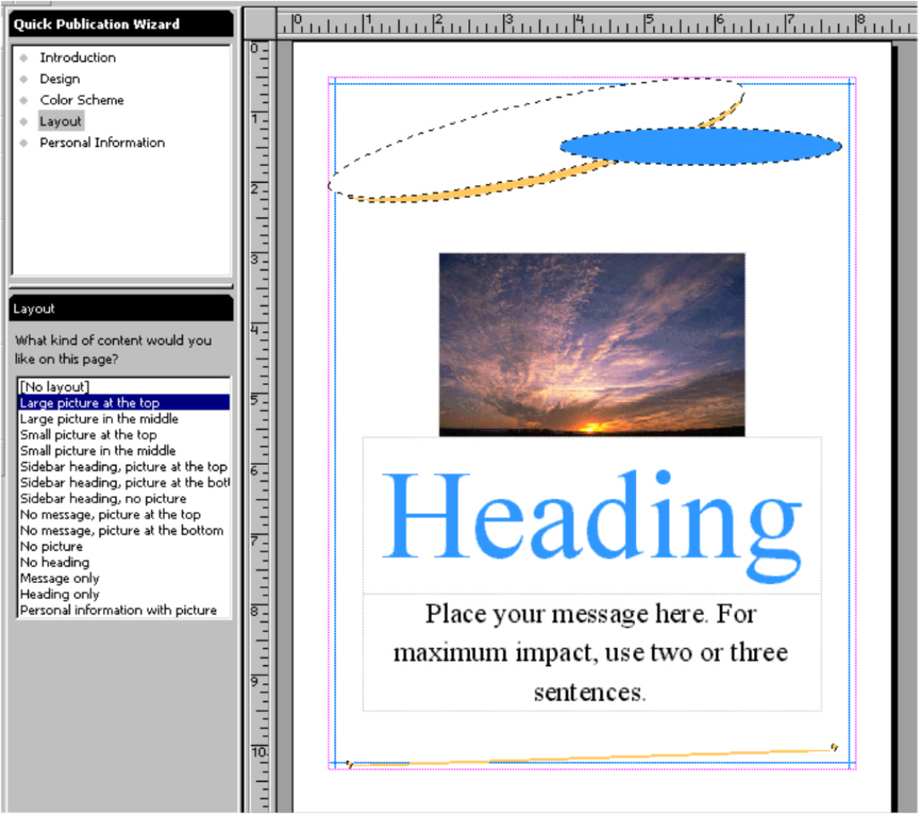

Quick Publication designs, layouts and Color Scheme options are also available when users start from a blank publication, providing them with design help if they choose.
One page publication created using the Quick Publication Wizard.

Catalog Wizard
Based on an increasing number of user requests, Publisher 2000 includes a new Catalog Wizard that provides more than 20 catalog publication templates to help users create multipage catalogs and booklets. The wizard also provides you with page option templates to aid them when setting up pages such as featured items, calendars and various layout options.

Web Site Wizard
Many small businesses want to create their own Web sites but are limited by the complexity of creating the site themselves or by the cost of hiring someone to create one for them. Publisher 2000 solves this problem by generating HTML automatically to eliminate the difficult part of Web page creation. You can create professional-looking layouts without having to write complicated HTML tables or learn about Cascading Style Sheets. Creating a Web site in Publisher 2000 is the same as creating any other publication.

Publisher 2000 provides a “create and go” Web publishing solution by automating the entire Web design process. Starting from the Web Site Wizard, you select a Web site design, then insert pages, text, hyperlinks or design elements — even change the background and add sounds — that are optimized for viewing on the Web. Once the layout is complete, you can preview the Web site in your Web browser. HTML is generated in the background.

AutoConvert
The Publisher development team conducted an extensive research project in which they collected and analyzed more than 5,000 pieces of sample output for content, size, layout and a variety of additional criteria. They discovered that users were using the same content in virtually all of the publication types they created. Consequently, Publisher 2000 allows you to easily reuse their content without having to reenter the information. You can convert your existing newsletter or brochure into a Web site with a click of a button. Publisher automatically lays out all the information into a Web site, complete with hyperlinks based on your existing content, and Web design elements such as an attractive Web background, navigation bars and animated GIFs. The Web site shares the look of a brochure. Users can also convert a Web site into a brochure or newsletter. Theoretically, with just two clicks of a mouse, you could create three publications by converting a brochure to a Web site, then converting that Web site to a newsletter. All three would share the same content and design.
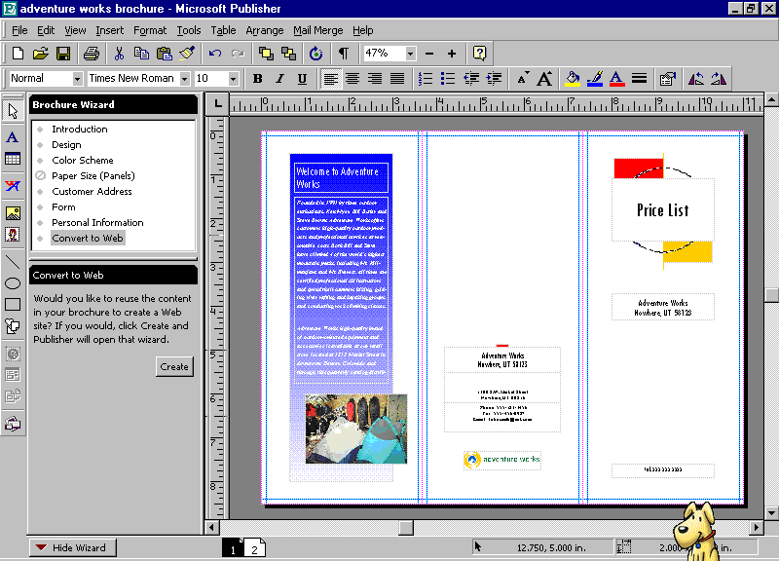

Catalog
Catalog is a visual browsing point for the more than 2,000 publication templates included in Publisher 2000, as well as the starting point for any blank or existing publication. Catalog enables you to view the publication templates in a variety of ways, making it easy for you to quickly find the publication type and design you need.

Three tabs that let you choose how you want to start a new publication separate the Catalog. Choose a publication by Publication Wizard type (such as by brochure, newsletter or Web site), Publication Design (such as by business or special event Design Set), or a Blank Publication already set up in the page format of their choice. You can also start from an existing publication. After clicking on a publication template, Publisher launches the wizard attached to that publication, which walks them through the creation of the publication and sets it up for your specific needs.

Publisher 2000 Content
The enhanced and expanded Publisher 2000 content collection provides more diversity in style and tone to meet the needs of the broad customer base, from small businesses to home users.

Publisher 2000 includes more than 15,000 images including clip art, Web images, animated gifs, sound, and digital stock photographs. In addition you can choose preformatted design elements from the Design Gallery and choose from more than 200 True Type Fonts.

Design Gallery
Design Gallery includes a collection of hundreds of professionally designed, coordinated elements such as mastheads for newsletters, text styles for pull quotes, or different looks for tables of contents. These elements can be mixed and matched to create thousands of different publications. In Publisher 2,000 Design Gallery is expanded to include 23 categories and more than 400 objects, all of which have also been optimized for viewing on the World Wide Web. These elements are flexible enough to enable the creation of versatile publications and Web sites while still providing the professional design expertise to enable you to maintain a professional look. You can add your own elements to the Design Gallery, such as a logo or identity elements, for easy retrieval.

Many Design Gallery elements are already included as placeholders in publication templates and offer you the flexibility to click on them and change to a different design of the same type of element, enabling easy publication customization.

Color Schemes and Custom Color Schemes
Color can be one of the most important elements in establishing an identity for a business or organization. Publisher users want the ability to differentiate themselves easily, and they also want guidance with color selection. To satisfy these needs, Publisher 2000 includes more than 60 sets of professionally coordinated Color Schemes.

You can apply a Color Scheme to any publication, then carry that scheme across all their publications by adding it to your Personal Profile of information. Color Schemes are customizable, and users can name and save unlimited numbers of custom Color Schemes. You can also use PANTONE® Colors in your custom color schemes.
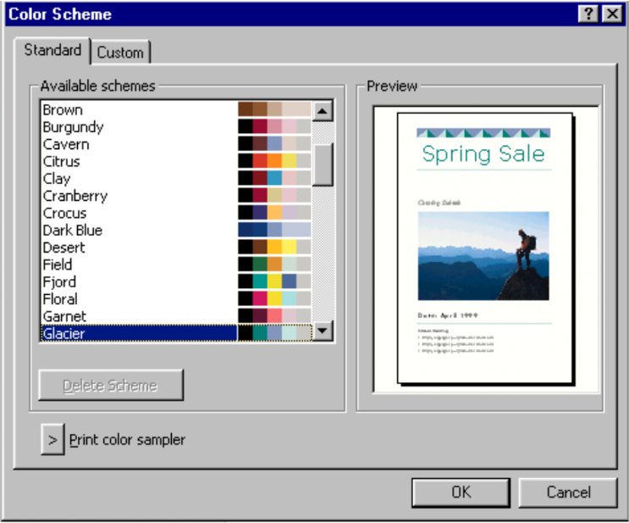

Smart Recoloring
Recoloring clip art is a commonly desired task. It not only helps you create more unique images, but also allows them to print an image in color when doing spot color printing. Publisher 2000 has improved its image recoloring by presenting you with the spot color palette when the spot color mode has been selected, enabling you to select a color from various shades of an already-specified spot color to ensure retention of the correct color palette. You may also choose to recolor an image with the more than 16 million colors available in Windows. Publisher 2000 has taken recoloring images to a new level by allowing users to recolor images in two colors: you can choose a specified color and can apply black to the portions of the image that were originally black.
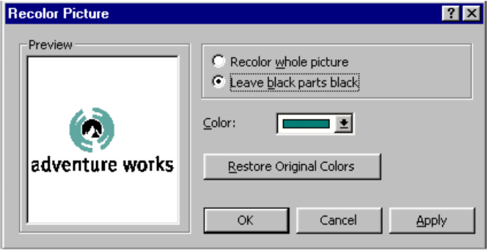

Smart Objects
Smart objects save you time by anticipating the task you want to accomplish and automating, completing or simplifying it for you. For example, one smart object automates fliers with phone number tear-off sections. You enter information into one tear-off panel, and Publisher automatically copies that information to the rest of the tear-off panels. If you resize the checkers in the Publisher checker-design style, the squares will automatically resize proportionately. If they change the name of a Web page, Publisher automatically updates the title and navigation bars on all the appropriate Web site pages. Smart objects are available as additional design help deeper within a publication. For instance, if you click on a catalog design header element, a wizard appears letting you know that more design options for that header are available. Users can then select a different design, and that header is automatically applied across all pages of the catalog.

Complete Publishing Solution From Print to Web

Complete Printing Solution
The importance and prevalence of color and the use of images has grown tremendously over the past few years. As desktop publishing software has become easier to use and imaging software has emerged, users are creating more sophisticated publications and require more sophisticated ways to print them. Users do not want to learn about the complexities of various printing options, however; they simply want Publisher files to provide them with the options they need, with no additional learning curve on their part. Publisher 2000 provides end users with simple solutions to receive high-quality output, and provides commercial printers with the complex tools they require to offer customers cost-effective printing solutions.

Pack and Go Wizard
Many users need the ability to send a large file to a printer. Publisher 2000 addresses this problem by providing the Pack and Go Wizard. With it, you are able to pack their publication across multiple disks and ensure that all fonts and images are embedded so they print properly. The Pack and Go Wizard may be used to transport files to another printer, a local copy shop or a commercial printer.

Commercial Printing Support
You may find you need to print higher-quality publications or to obtain longer, more economical print runs. Publisher 2000 provides a complete printing solution for you, enabling you to achieve economical high-quality results with commercial printers. You simply pack a publication using the Pack and Go Wizard, and Publisher provides all the tools a commercial printer needs for easy conversion to process (CMYK) or spot color film. In addition, advanced tools such as trapping, linking and embedding, all conveniently located under the Commercial Printer Tools menu item, provide commercial printers and service bureaus with the complete control they need to cost-effectively print film to exact specifications. These features enable you to get the cost-effective output solutions you need without having to learn about the commercial printing process.

Automatic Four-Color Process Conversion
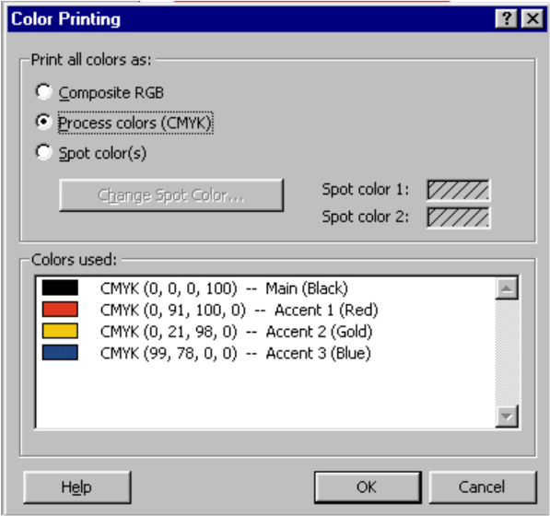
Publisher 2000 publications can be converted to four-color process (CMYK) with a click of a button under the Commercial Printer Tools menu. If you understand color and printing, you can convert your publications or have your commercial printer or service bureau convert the publication for you. All elements including images are automatically converted to CMYK for easy film output. (Note: This color conversion uses ICM 2.0 on Windows 98 and Windows NT® Workstation 5.0 operating systems using Linotype Hell, which is the same color conversion available on Macintosh systems.)

PANTONE Process Color System
Publisher 2000 includes support for the PANTONE® Process Color System, a standard ink-matching system that printers use. Publisher users or printers can easily specify a PANTONE color to be used in any publication. If a publication is printed using spot colors with PANTONE colors selected, the specified PANTONE colors will output to film for easy two- and three-color printing. If the publication is set up for process (CMYK) color printing, you can match a specific PANTONE color to an element such as a logo by selecting the appropriate color from the PANTONE color palette. The correct color will automatically be applied to the element using the CMYK values set by PANTONE.
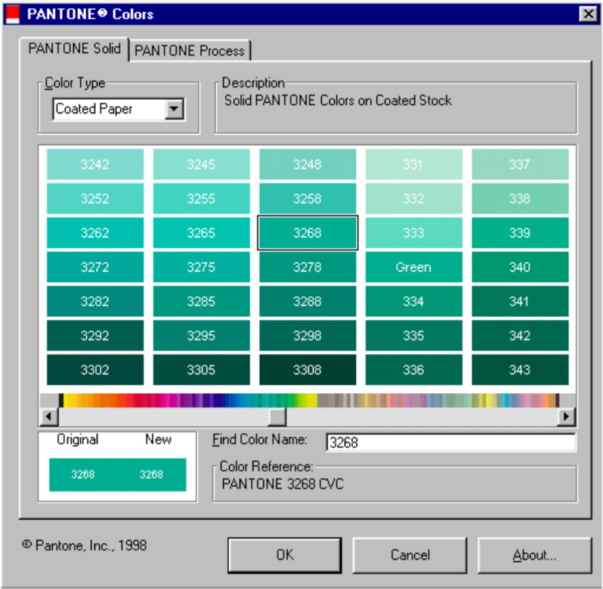

Spot Color Printing
A more economical way to print your publication is to use one, two or three colors. Publisher 2000 automatically converts any publication to spot color mode with the click of a button. Publisher intelligently recolors all images to black or one of the designated spot colors, so you can see how the colors will be applied. Full support for the PANTONE Process Color System also enables you to designate a specific ink color to be used when printing your publication, ensuring that you achieve the desired color result when printing.

Trapping
Trapping is the slight, intentional overlapping of the edges of different colors in a publication to compensate for minor variations in color registration on a printing press. Trapping is something that you should leave to your printer. Publisher 2000 provides commercial printers and prepress professionals with complete control over a publication’s trapping settings, enabling them to set the publication not to trap at all, to use Publisher’s default trapping settings based on industry standards, or to specify their own custom trapping settings. Trapping can be set for the overall publication or for individual objects within a publication. In addition, Publisher includes an automatic Reset All Settings button to enable printers and service bureaus to automatically reset traps that a user may have set. 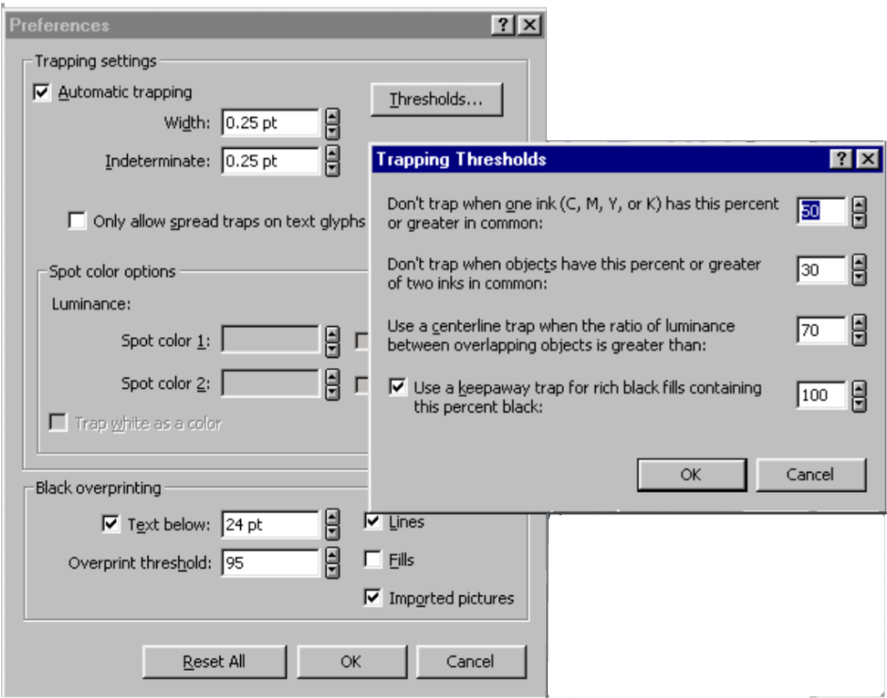

Font Embedding
According to commercial printers, missing fonts is one of the most significant problems in transferring electronic files. Publisher 2000 ships with more than 200 True Type Fonts, all of which have full embedding and printing licensing rights. Fonts are automatically embedded in Publisher files, ensuring that when you provides a file to a printer for output, it can be printed with the correct fonts in place. Font status can be checked in the Fonts dialog box under the Commercial Printing Tools menu. It displays all fonts used in the publication, their status (linked or embedded) and their licensing rights. Printers and service bureaus may also choose to substitute fonts within this dialog box.

Graphics Manager
Graphics Manager provides printers and service bureaus with complete information about all graphical elements included in a publication. This includes the image’s name, type, status (linked or embedded) and placement. The status of an image can be changed directly from within Graphics Manager. This enables printers to create a link to an embedded object and export that image to another application for imaging enhancements, such as color retouching and color separation, while retaining the integrity of the original embedded object.
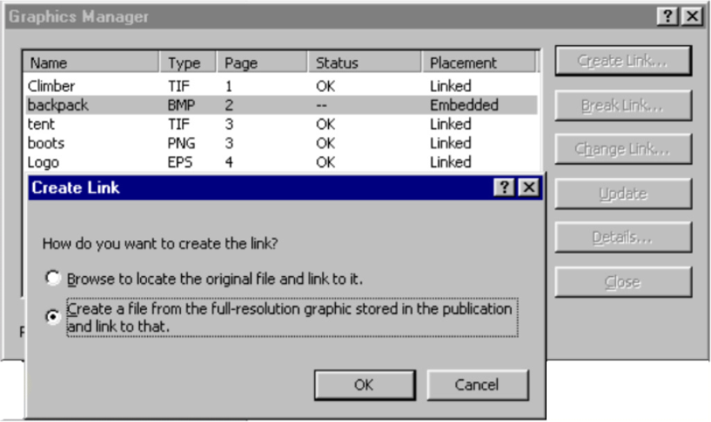

Easy Web Publishing
Using Publisher 2000, it is as easy to create a Web site as it is to create a brochure or newsletter. You work with all the same tools and assistance.

Publisher 2000 includes advanced Web functionality, such as support for Cascading Style Sheets, Web forms, the ability to insert custom HTML, hyperlink ToolTips and single-page preview. In addition, more than 1,000 Web art elements have been added to Publisher 2000, including Web backgrounds, animated GIFs, music clips, and professionally designed Web Design Gallery elements.

You may save any publication to a Web page by using the familiar Office Save As Web Page method. This converts the complete publication to HTML for easy posting and viewing on the Web. In addition, Publisher 2000 allows you to preview any Web page in Microsoft Internet Explorer or other compatible Web browser to ensure that all links and graphics appear as they should prior to posting.

#########
Microsoft, the Office compatible logo, IntelliSense, Windows, FrontPage, PowerPoint, PhotoDraw, Picture It!, IntelliMouse and Windows NT are either registered trademarks or trademarks of Microsoft Corp. in the United States and/or other countries.
Other product and company names herein may be trademarks of their respective owners.

© 1998 Microsoft Corp. All rights reserved.
This document is for informational purposes only. MICROSOFT MAKES NO WARRANTIES, EXPRESS OR IMPLIED, IN THIS DOCUMENT.

