Microsoft® Project 2000 for Windows®
Product Enhancements Guide

October 1999

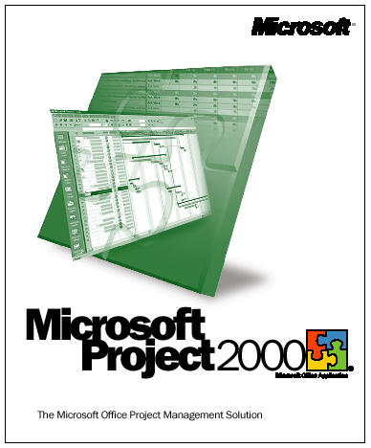

Contents

Introduction 1
Overview of New Features 2
Improve team productivity by involving team members and other stakeholders in project management 2
Increase the usefulness of Microsoft Project data for users 3
Extend project management across the organization 6
Features in Detail 8
Improve team productivity by involving team members and other stakeholders in project management 8
Collaborative Planning With Microsoft Project Central 8
Personal Gantt Chart 8
New Task 9
Task Delegation 9
Show Microsoft Outlook Tasks 9
View Nonworking Time 9
Workgroup 9
Collaborative Tracking With Microsoft Project Central 10
Timesheet 10
Actual Hours and Percent Complete Tracking 10
Auto-Accept Rules 10
Status Reports 11
Administration Module 11
Easy Access to Project Information 12
Views 12
Offline Capabilities 13
Increase the usefulness of Microsoft Project data for users 14
Flexible Viewing 14
Grouping 14
Outline Codes 15
Graphical Indicators 17
Network Diagram 18
Fiscal Year in Timescale 20
Task Outline Level 21
Roll Up Gantt 21
Flexible Analysis 21
Task Calendars 21
Materials Resources 22
Deadline Dates 22
Cross-Project Critical Path 22
Custom Fields: Value Lists 22
Custom Fields: Formulas 23
OLE DB 23
Estimated Durations 24
Month Duration Unit 24
Contoured Resource Availability 24
Leveling 24
Task and Project Priority 24
Work Breakdown Structure (WBS) 25
Clear Baseline 25
Easier Reporting 25
Scaling and Printing 25
Copy Picture 26
Enhance User Confidence 26
HTML Help 26
Adaptive Menus 26
Tooltips 27
Templates 27
Variable Row Height 27
In-Cell Editing 27
Fill Handle 27
AutoSave 28
Office Server Extensions Support 28
Single Document Interface 28
Project Open and Save 28
Hyperlinks 29
Default Save Format and Path 29
Accessibility 29
Extend project management across the organization 30
Improve Capacity and Performance 30
Database Performance 30
Resource Pooling 31
Inserted Projects 31
Keep Users Up and Running 31
Install on Demand 31
Roaming User Support 31
Microsoft Windows Terminal Server Support 31
Pluggable Language User Interface 31
Events 32
Event 32
Description 32
COM Add-Ins 32
Visual Basic for Applications 33

Introduction

Microsoft® Project 2000 is the sixth Windows® operating system-based release of what has grown to be the world’s most popular project management software. It represents a new milestone for Microsoft Corp.’s project management offerings. Microsoft Project’s installed base, which is well over 3 million users worldwide, includes a wide variety of user types, ranging from general knowledge workers to expert project managers. Microsoft Project 2000 is the result of an enormous research and development effort focused on this entire spectrum of customers and offers major feature additions and enhancements. Microsoft Project 2000 provides knowledge workers with the flexibility to collaboratively plan and track projects and deliver the results their business demands. It is the single planning tool needed in an organization.
In addition, a new companion product, Microsoft Project Central, is being introduced to work closely with Microsoft Project 2000. Microsoft Project Central is a Web-based collaboration tool, allowing two-way communication between everyone involved in a project and also allowing data access to anyone, even those without Microsoft Project 2000 on their desktops. With Microsoft Project 2000, Microsoft Project Central will make project management a much more accessible activity for a broader user audience than ever.
This product enhancements guide is designed to assist in your evaluation of Microsoft Project 2000 and Microsoft Project Central. The first section, Overview of New Features, provides a quick tabular list of the new and improved functionality in this release. The second section provides a detailed breakout of each feature, with accompanying screen shots where appropriate. To assist you in evaluating this product, features are grouped according to Microsoft’s design goals:
- Improve team productivity by involving team members and other stakeholders in project management
- Increase the usefulness of Microsoft Project data for users
- Extend project management across the organization

Overview of New Features

Improve team productivity by involving team members and other stakeholders in project management

Microsoft Project Central will improve an organization’s productivity by involving everyone in project planning and tracking. Even team members without Microsoft Project 2000 can view and interact with project information using Microsoft Internet Explorer browser software (version 4.x or later) or a browser module for Microsoft Project Central (a Win32® API-based application shipped with the product for those using other browsers).

 | Feature | Description
 | Collaborative Planning With Microsoft Project Central
New | Personal Gantt Chart | This renders Gantt views like those in Microsoft Project to outline each team member’s own tasks across multiple projects.
New | New Task | Team members can create tasks; the project manager can approve those new tasks before adding them to the project plan.
New | Task Delegation | Once assigned by the project manger, tasks may be delegated from leads to team members or from peer to peer. Delegation can be disabled.
New | Show Microsoft Outlook® Tasks | Team members can show entries from their task list in the Outlook messaging and collaboration client so they can see all their project and nonproject tasks in a single location.
New | View Nonworking Time | Team members can report nonworking time to the project manager or can report nonproject time, such as vacation or sick leave.
Improved | Workgroup | Project managers can assign task responsibilities and track project status across workgroups to keep the project on track. Users can use e-mail alone, or with Microsoft Project Central, they can exchange project information at a Web site on their intranet or the Internet.
 | Collaborative Tracking With Microsoft Project Central
Improved | Timesheet | This is where team members can see their assignments across projects, enter updates and easily send them to the project manager.
Improved | Actual Hours and Percent Complete Tracking | Team members can track and report actual hours spent on each assigned task. Or, they can simply estimate what percentage of the task is complete when it’s difficult or unnecessary to track the actual number of hours spent on each task..

 | Collaborative Tracking With Microsoft Project Central (continued)
New | Auto-Accept Rules | Managers can reduce time spent in administrative activities by establishing rules to automatically accept actual hours, percent complete or any information in a custom field.
New | Status Reports | Users can create custom report formats and request and receive team member status updates that Microsoft Project Central automatically rolls into a group report.
New | Administration Module | This provides project administrators with more control over definitions of nonproject time, views, formatting styles and security to ensure consistency in project-management approaches and organization structure.
 | Easy Access to Project Information
New | Views | Senior executives, managers and team members can access different views of projects, such as View Your Portfolio, View Your Project and View Assignments.
New | Offline Capabilities | Team members can take their timesheets and status reports offline and continue working on them from wherever they are.

Increase the usefulness of Microsoft Project data for users
Users can group, sort and filter their data based on the specific needs of their project to create exactly the views and reports they need.

 | Feature | Description
 | Flexible Viewing
New | Grouping | Users can quickly categorize and view rolled-up task and resource information in any way they need.
New | Outline Codes | Users can define their own outline codes instead of having to tie them to the outline structure of their project. They can use their custom outline codes to create alternate hierarchical structures for tasks or resources (e.g. with outline codes based on cost or job codes).
New | Graphical Indicators | Users can associate graphical indicators with the data in a custom field, so a particular image can be displayed in place of the actual data to easily spot potential problems.
Improved | Network Diagram | Formerly the PERT Chart, this view lets users customize network diagrams with new filtering and layout options, increased formatting features and enhanced box styles.
New | Fiscal Year in Timescale | Users can independently set the use of the fiscal year for both major and minor timescales to display data in the specific timescale combination they need.
 | Flexible Viewing (continued)
Improved | Rollup Gantt | Users can display Gantt bars for all subtasks on a single task summary line. They can also display all Gantt bars rolled up for a summary task without having to select bars individually to roll them up to the summary task bar.
 | Flexible Analysis
Improved | Task Outline Level | It is now much easier to expand and collapse the task outline structure from the Show button on the Formatting toolbar.
New | Task Calendars | Task-specific calendars let users create schedules that affect only selected tasks.
New | Materials Resources | Users can specify consumable resources such as lumber or concrete and assign them to tasks.
New | Deadline Dates | Users can remind the team of deadlines and alert them visually if deadlines cannot be met.
Improved | Cross-Project Critical Path | Users can calculate the critical path within each inserted project or across all inserted projects to see a single critical path for the overall master project.
New | Custom Fields: Value Lists | Users can employ user-defined pick-lists to restrict the values that can be entered into a custom field and simplify data entry with just a mouse click.
New | Custom Fields: Formulas | Users can add custom formulas for arithmetic calculations, conditional testing and functions to be applied to custom field data.
New | OLE DB | With OLE DB (read only), other applications can access Microsoft Project data, making it much easier to integrate project data across the enterprise.
New | Estimated Durations | Users can indicate that the duration of a given task is tentative by simply entering the duration followed by a “?” and return to the task at a later time to enter a confirmed duration.
New | Month Duration | Microsoft Project now supports months as a unit of duration.
New | Contoured Resource Availability | Users can create plans that incorporate time-phased resource availability information. For example, they can show that a resource’s availability increases from 50 percent to 100 percent from one period of time to another.
Improved | Leveling | Users can gain better control and faster performance when leveling resources by taking advantage of new scheduling features such as Task Calendars, a wider range of priority values, project-level priority and contoured resource availability.
 | Flexible Analysis (continued)
Improved | Task and Project Priority | Now there are 1,000 unique priority levels for tasks. The ability to assign project priority levels is new in Microsoft 2000.
Improved | Work Breakdown Structure  (WBS) | Users can format and number their WBS to ensure consistency and meet their project’s unique needs.
New | Clear Baseline | This clears the baseline or interim plan data for selected tasks or an entire project.
 | Easier Reporting
Improved | Scaling and Printing | Users can print documents more efficiently and easily with new printing and scaling options and improved behavior of existing options.
Improved | Copy Picture | Users can create higher-quality images with larger allowable sizes and better scaling.
 | Enhanced User Confidence
Improved | HTML Help | HTML Help is Microsoft's new standard for help systems. It provides easier interaction with procedural help and the application at the same time. Microsoft Project 2000 also allows users to add their own content to the existing help system.
New | Adaptive Menus | Just as in Microsoft Office 2000, only the items that users use most often are prominently featured on the menu. Menus are easily expanded to reveal all commands and also expand automatically based on IntelliSense® technology rules.
Improved | Tooltips | More Tooltips now help users to discover features more easily.
New | Templates | Microsoft Project Templates are easy to create and access.
New | Variable Row Height | Users can drag the row line between tasks to set individual rows to differing row heights.
New | In-Cell Editing | Users can view the context of a task while editing it.
New | Fill Handle | Users can select the cells they want to populate, and the fill-handle feature makes fill up or down operations much easier.
New | AutoSave | Microsoft Project can automatically save users’ work at a chosen time interval so they won’t lose valuable data if their computer inadvertently shuts down.

 | Enhanced User Confidence (continued)
New | Office Server Extensions Support | Users can save to Web servers just as they save to network locations. For workgroup users, this feature provides another way to share Microsoft Project files globally.
New | Single Document Interface | Similar to Microsoft Office 2000 applications, Microsoft Project 2000 supports the Single Document Interface. Since each open project is an entry on the task bar, switching between individual projects is no different from switching between mail messages or Web pages.
Improved | Project Open and Save | The Open and Save dialog boxes have Microsoft Office 2000 look and functionality.
Improved | Hyperlinks | The new Microsoft Office 2000 Hyperlink dialog box is easier to use with the option of linking to frequently browsed pages or frequently used files.
New | Default Save Format and Path | Users can specify a default save format (such as Microsoft Project 98) and default save path to easily save project data where and how they  want it.
New | Accessibility | Microsoft Project now supports third-party accessibility aids through Microsoft Active Accessibility® programming interfaces.

Extend project management across the organization
Microsoft Project 2000 has the tools users need to seamlessly manage projects across multiple teams, departments or organizations.

 | Feature | Description
 | Improve Capacity and Performance
Improved | Database Performance | Database changes have been made to improve performance and access to data.
Improved | Resource Pooling | Using a resource pool over the network has substantially improved performance.
Improved | Inserted Projects | Users can create master projects with confidence that links to subprojects will be maintained if they move a project.

 | Keep Users Up and Running
New | Install on Demand | Microsoft Project 2000 only installs the components users need — when they need them.
New | Roaming User Support | Enhanced portability gives users the ability to log on to any machine in a networked environment and maintain their own personal settings and preferences.
New | Windows Terminal Server Support | Microsoft Project can run on Terminal Server.
New | Pluggable Language User Interface | A single executable worldwide makes deployment easy in multinational companies.
Improved | Events | Microsoft Project 2000 provides many new application-level events for task, resource and assignment actions. This makes it easier for project managers to control what happens and what users see when attempting certain operations.
New | COM Add-ins | Similar to Microsoft Office 2000, Microsoft Project 2000 supports COM Add-ins to extend Microsoft Project functionality.
Improved | Visual Basic® for Applications (VBA) | Microsoft Project Object Model continues to provide even more ways to customize.

Features in Detail

Improve team productivity by involving team members and other stakeholders in project management

Collaborative Planning With Microsoft Project Central

Microsoft Project Central is a Microsoft Project 2000 companion product that enables collaborative planning among team members, project managers and other stakeholders. The objective of this tool is to help team members deliver against their commitments and also relieve project managers from the burden of administrative work. The benefits of this product are these:
- Team members can plan and deliver against their work better. They can view a day-by-day work plan and their own task Gantt Chart in the context of their projects, enter actual hours for project tasks and nonworking time, and inform project managers of vacation or other calendar exceptions. With the permission of project managers, they can also add tasks and delegate tasks to others on the team.
- Project managers can keep project progress information up to date. Project managers can set up auto-accept features so they can designate what information can be automatically updated and what information they need to review before updating a project. Project managers can request status reports from team members, which can be rolled up into one report.
- Senior managers can get a concise, action-oriented view of project information. Senior managers and other stakeholders can view project summaries and get “stoplight" indicators, so they can better assess the progress of projects. They can then drill into details as desired.

In summary, Microsoft Project Central is a place where everyone can go to get project information.

Personal Gantt Chart
Team members can see their own tasks presented graphically in the Microsoft Project Central Gantt Chart view. It is simple to customize this view by re-ordering the columns, filtering for specific tasks, and grouping by project name, start date, or other task characteristics. This view can also be modified to show entries from the task list in Microsoft Outlook, so team members have one place to go to see all of their tasks.

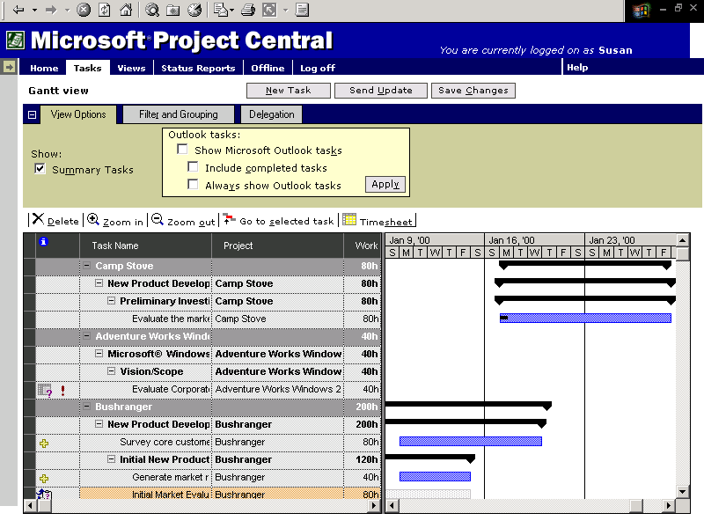
Fig. 1. Personal Gantt Chart in Microsoft Project Central

New Task
If a team member realizes that an important task has not been included in the project, it can be added using the New Task feature, accessible from the Personal Gantt or Timesheet views. The team member specifies which project the task will be part of, the outline level and the task that would be the parent of the new task (if applicable), the name of the task and its duration. There is also a field for comments. This allows a team member to help the project manager flesh out a project plan. These new tasks are not updated in the project until the project manager approves them.

Task Delegation
If enabled by the administrator, a Microsoft Project Central user has the ability to delegate a task to another team member. This way, a project manager can assign a group of tasks to a functional manager, then the functional manger can decide appropriate team members to do the tasks and make those assignments via Microsoft Project Central. Whoever delegates the task can decide whether to remain an intermediate manager for that task; the project manager is notified of all task delegations.

Show Microsoft Outlook Tasks
Team members can show entries from their task list in Microsoft Outlook so they can see all their project and nonproject tasks in a single location. This feature allows them to identify any potential conflicts in their project and nonproject tasks and report them in advance to the project manager so the schedule can be modified or tasks can be reassigned.

View Nonworking Time
Team members can import nonworking time, such as vacations or holidays, or nonproject time, such as training or recruiting, from Microsoft Outlook to Microsoft Project Central and view it along with their working time to see their complete schedule in a single location. Team members can also use Microsoft Project Central to report planned nonworking time and nonproject time to the project manager so it can be added to the master project plan and tasks can be scheduled more accurately.

Workgroup
From Microsoft Project 2000, a manager can define which fields are included and which can be edited in a TeamAssign message, on a per-project basis. This gives a project manager direct control over what information a team member can see and edit.

Collaborative Tracking With Microsoft Project Central

Timesheet
From the Timesheet, a team member can update hours, task percent complete or any field that can be edited, including custom fields for any task. This provides a simple interface for everyone involved in a project to send updated information to the project manager.

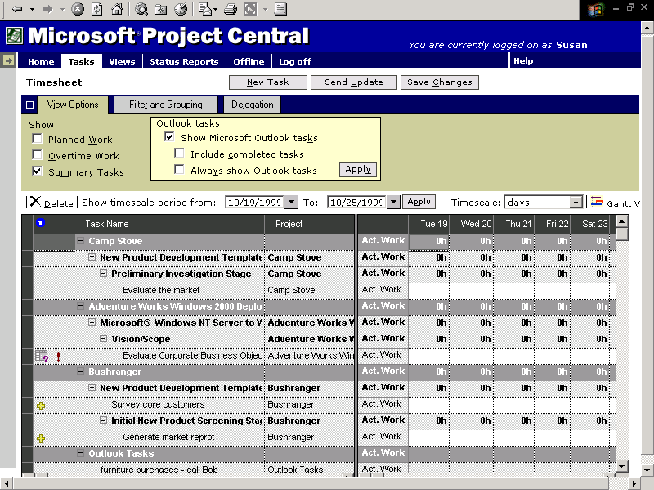
Fig. 2. Microsoft Project Central Timesheet

Tasks in the timesheet can be filtered and grouped just like in the Personal Gantt, allowing team members to organize their data and see it the way they want. When hours are entered in the grid, the remaining work field is automatically reduced — unlike in previous versions, where this calculation had to be done manually. Remaining work can also be directly edited from the grid so that a team member can let the project manager know that the duration of a task has changed. This view can also be modified to show entries from the task list in Microsoft Outlook, providing a single point of entry for busy people.

Actual Hours and Percent Complete Tracking
Microsoft Project Central lets team members track their progress on tasks at whatever level of detail they prefer, or need, on the project. Team members can track actual hours spent on each assigned task when projects require precise project tracking. Or, they can simply estimate what percent of the task is complete when it’s difficult or unnecessary to track the actual number of hours spent on each task. Team members can then report their actual hours or percentages of tasks completed directly to the project manager via Microsoft Project Central.

Auto-Accept Rules
The manager can define rules for simple updating of the project plan (e.g., task updates from experienced resources can be set to update the project without review). If a manger is concerned about slippage, rules can be set to update the project without review only if reported hours are within budgeted hours, for example. Rules can be set based on the contents of any field, including custom fields.

Status Reports
It is simple for a manager to request custom text-based status reports to enhance and simplify team communication. The project manager can define custom report formats with sections such as “Major achievements,” or “Objectives.” Each section can also contain textual prompts written by the manager to help the team member fill out the report. Regular intervals can be set for the reports to be due, or they can be sent out individually at the discretion of the manager. A team member will have an indicator showing when their status reports are due; a graphical indicator will show if any reports are past due. Once a team member has completed a status report, Microsoft Project Central can easily combine all individual reports into a single group report for the entire team if the manager has set them up to be merged. The manager can decide if all reports are automatically merged or if reports from specific team members require review before merging. This process creates one overall team report showing important information, including who wrote the comments and when.

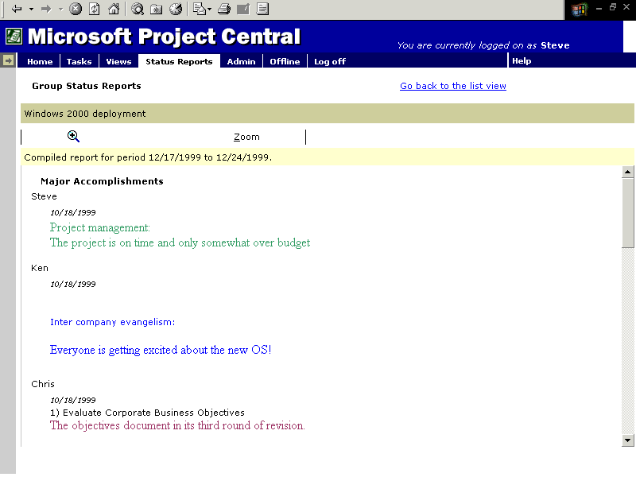
Fig. 3. Microsoft Project Central status reports

Administration Module
Team communication starts with the project manager. Using the Administrator Module in Microsoft Project Central, the administrator will be able to add and remove user accounts, set database options and clean up the Microsoft Project Central database, and control access to the Microsoft Project Central site. The administrator can customize the appearance of Microsoft Project Central pages by adding a company logo or hyperlinks to other Web sites or files. Nonproject time categories such as vacation, sick leave or work not related to the project are defined here. Once these definitions are set, this type of time can be tracked along with project time so that project managers have a complete view of a resource’s time, and Microsoft Project Central can be used as a complete timesheet solution.

In addition, Gantt bar formatting is done from this module; the administrator can set Gantt bar styles by category, such as critical and noncritical and milestone. Security can be set to require Windows NT® operating system Authentication, Microsoft Project Central authentication (with or without password), or a mix of both types, which is the default behavior. Account creation can be restricted to prevent duplicate name problems. This is where the administrator can define roles and categories of people involved in the project. Roles limit available functionality; categories limit views of project data. This makes it possible to limit who can see resource cost data, for example.

A category is a mapping of users to projects and views. For each category, administrators can specify the users that belong to that category, the projects those users can see, and the views with which they can look at the portfolio of projects, individual projects and resource assignment information. Examples of categories include Executive Manager, Project Manager, Resource Manager and Team Member. Examples of different views of assignment data are a spreadsheet type view or a resource Gantt view. Viewers can switch between view types using the data for which they have access.

Everyone who uses Microsoft Project Central has a role assigned to him or her. By default, the role assigned is team member; the administrator can change the role for any Microsoft Project Central user. The following table shows the three roles in Microsoft Project Central, along with some of the associated functionality and data access.

Role | Sample functionality
Administrator | Set up and customize site, set security, define roles and categories; access to all project data
Manager | Assign tasks, track hours, define status reports; access to view projects set by administrator, set up rules
Team member | View tasks, enter work complete, fill out status reports; access to view projects set by administrator. By default, has access to view all projects in which they have assigned tasks.

Easy Access to Project Information

Views
There are three kinds of views available in the Microsoft Project Central Views feature: View Your Portfolio, View Your Project and View Assignments. Grouping and filtering are available in most views.

View Your Portfolio is used to see a high-level representation of predefined portfolios of projects. This is a great view for all members of an organization to see an overview of all project status. The Microsoft Project Central Administrator defines who can see what information:

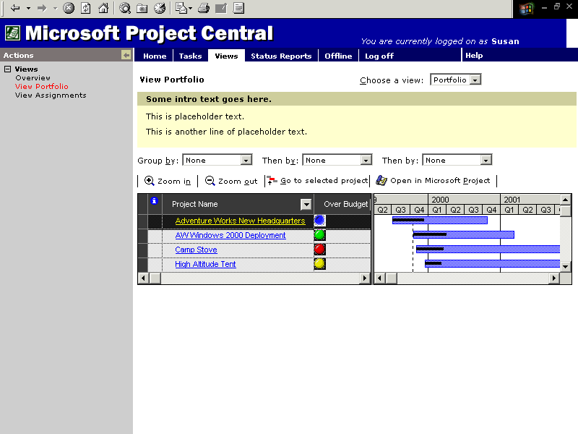
Fig. 4. View Your Portfolio Page in Microsoft Project Central

View Your Project shows detailed project information, so that with the permission of the administrator, anyone in an organization can see live, dynamic information about a specific project.

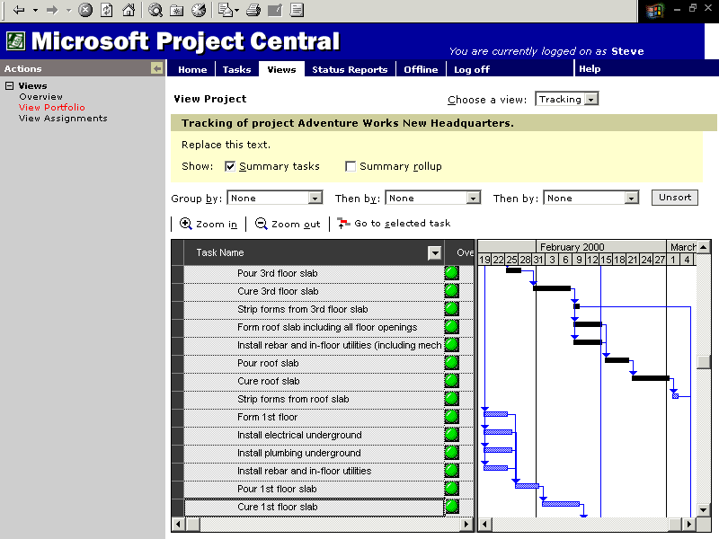
Fig. 5. View Your Project in Microsoft Project Central
View Assignments allows a resource manager to see the relationships between resources and their tasks and get an understanding of resource workloads. This will facilitate understanding of human resource needs and availability.

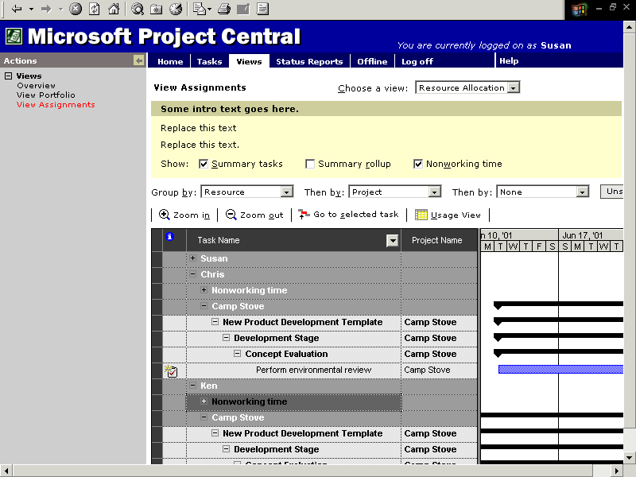
Fig. 6. View Assignments in Microsoft Project Central

Offline Capabilities
For team members who cannot always be connected, Microsoft Project Central includes offline capabilities. This allows the team member to view a Personal Gantt or view and edit their Timesheet and Status Reports. If team members travel with a laptop, they can fill in the Timesheet or Status Report on the road, then update the project when they return to the office.

Increase the usefulness of Microsoft Project data for users

Flexible Viewing
Model your project schedule based on the specific types of tasks and resources involved in your project, and organize data to meet your project’s needs

Grouping
Grouping allows a project manager to view tasks or resources in groups that they define and see rolled-up totals. Grouping can be done in most task and resource views, with the exception of the Calendar, Network Diagram, Relationship Diagram, Resource Graph and form views. Multiple criteria groups are easily created from the simple grouping interface, where the color, pattern and font of the grouping bands can be customized, along with defining sort order, allowing a project manager to see project data the way they want. Here a grouping showing “% complete,” then task priority is created in the Customize Group By dialog box:
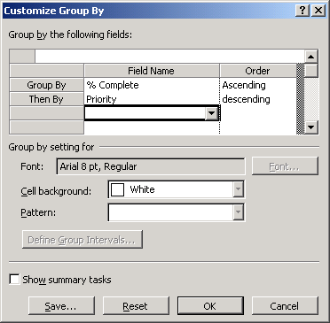
Fig. 8. Tasks or resources can be grouped by user-defined criteria
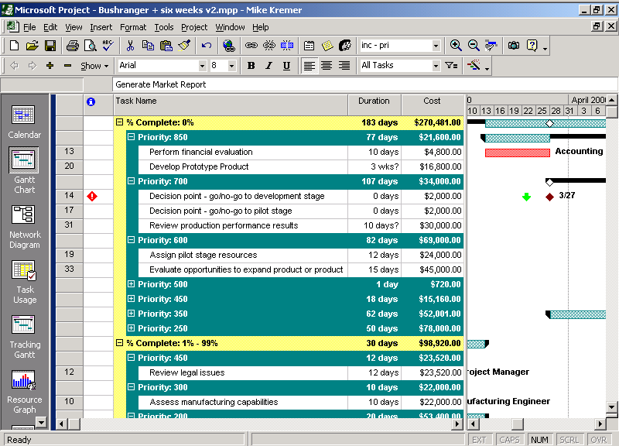
Fig. 9. Task list grouped by percent complete and then by priority
Here, cost data is rolled up by group; now it is simple to see how much will be spent on tasks not yet started and how much the most important of those tasks will cost.

Since Grouping creates its own summaries, regular summary tasks are not displayed by default. Some project managers assign fixed costs or resources to a summary task; in this case there is an option to “Show summary tasks” in grouping. If a filter is applied before a grouping, then only the filtered tasks are grouped and only the information of the filtered tasks appears in the rolled-up group summaries. Group summary rows show rolled-up data such as cost.

For many fields, such as cost and date, it is simple to define intervals for the purposes of grouping. Each field may have different grouping criteria available. This is especially useful when the criteria could have many entries and, therefore, create many groups. For example, users can group on task duration by week
or costs by $2,000 increments:

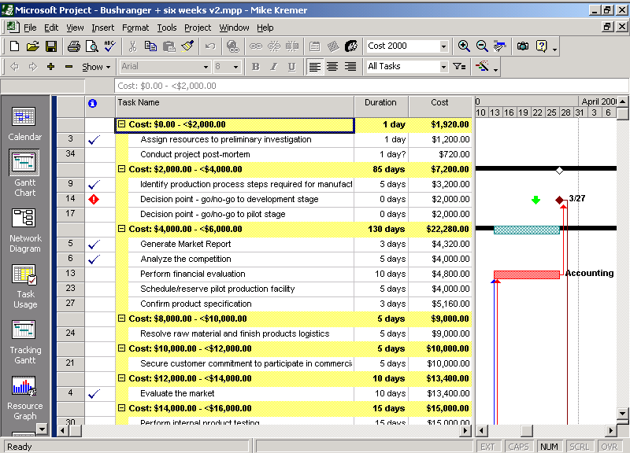
Fig. 10. Task list grouped by cost increments
If grouping is used within a master project, the tasks are grouped across projects, allowing for rich project portfolio analysis. Once settings for a group have been created, they can be saved, displayed in the menu and shared with other projects so that important methods of looking at data can be implemented companywide.

Outline Codes
Outline codes are displayed in new custom outline code fields that allow users to view their tasks or resources in different user-defined hierarchical structures from the standard work breakdown structure. One or more tasks or resources can be assigned to the same outline code so that they are grouped together. For example, a project manager may want to assign company cost codes to each task to create a hierarchical view of tasks by cost code.

Another use is to create an organizational breakdown structure (OBS), so that tasks can be assigned to different organizational groups within the company. Outline codes can easily be shared across projects using the Fields tab in the Organizer dialog box (Tools menu) or using the Import Outline Code button in the Outline Code Definition dialog box (the Outline Code Definition dialog box can be accessed by Choosing Customize from the Tools menu, and then choosing Fields; in the Customize Fields dialog box, users select a custom outline code field, and then click on Define Outline Code). Project managers can define the sequence (letters, uppercase or lowercase, numbers), length (specific number or any), and separators (comma, period, plus sign, or a separator chosen by the user) for outline codes to ensure code uniformity in the project plan.

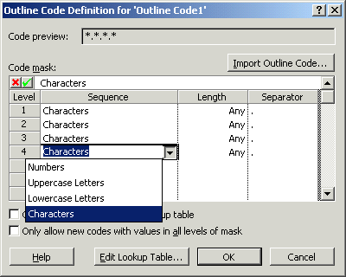
Fig. 11. Defining a custom outline code
Project managers can require that users choose values from a lookup table. If this option is not set, any entered values will be added to the lookup table. The lookup table can have “friendly” descriptions for each outline level:

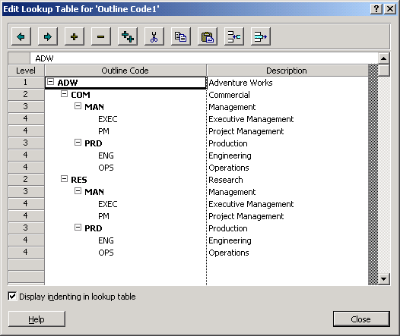
Fig. 12. Custom Outline Code Lookup Table
Once an outline code structure has been defined, the codes can be grouped in or out of sequence. First, in sequence:
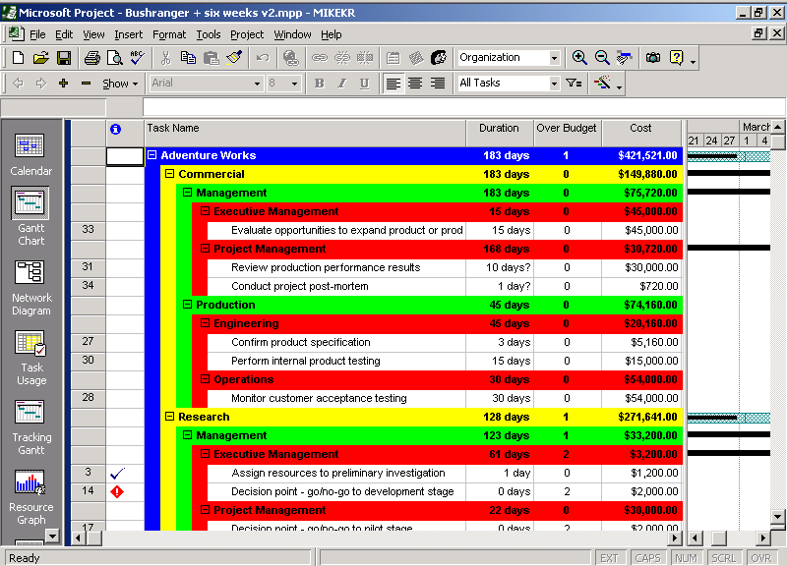
Fig. 13. Task list grouped by outline code in sequence
The following is grouped by Outline code level 4, then by level 2 from the lookup table above, showing functional groups, then by organizational part. Note the friendly descriptions on the grouping bands:

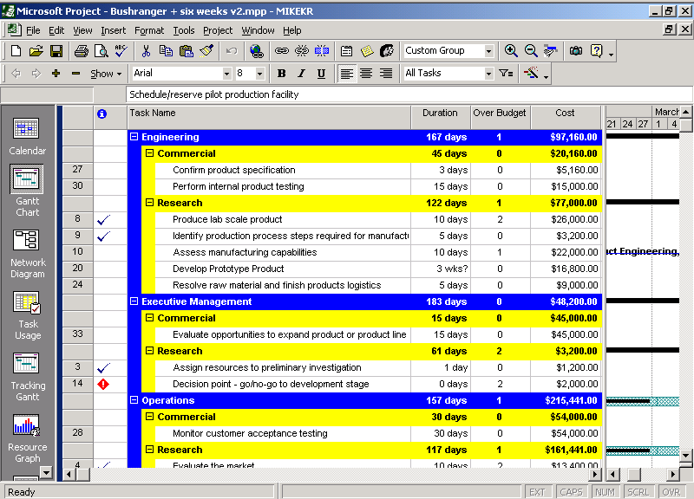
Fig. 14. Task list grouped by outline code, by level

Graphical Indicators
Many customers have requested a method to display alerts when aspects of a project are not going as planned; this is sometimes known as “stoplight” reporting. Microsoft Project 2000 now has many graphical indicators that can be assigned to display when values in custom fields extend past a predefined range or for any other user-defined criteria. They can be displayed based on custom formula calculation results, value list selections, or just based on the value typed in.

Using the example from above, the following scheme can be applied to create a stoplight report:

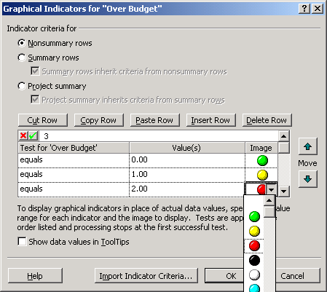
Fig. 15. Using graphical indicators to create a stoplight report

Stoplight reports are an easy way to quickly identify the trouble spots in a project.

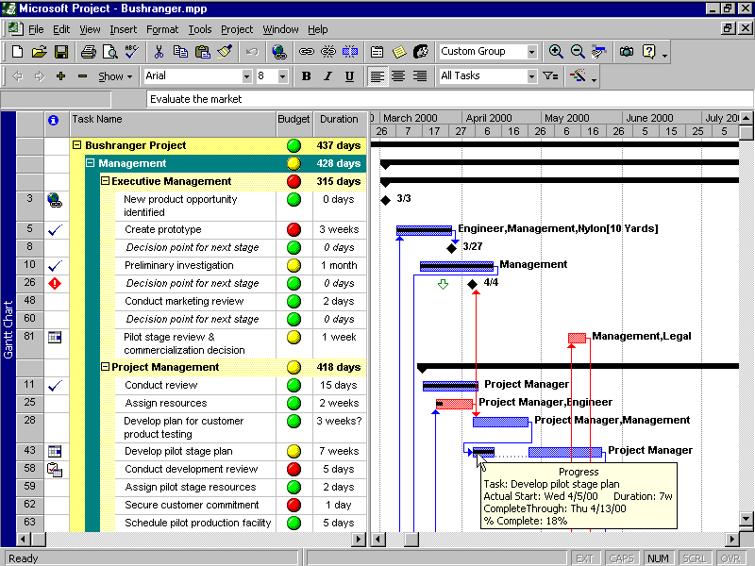
Fig. 16. Gantt Chart with graphical indicators for budget stoplight report

Network Diagram
Formerly known as the PERT Chart, the Network Diagram has undergone substantial changes. Nodes representing summary tasks have outline symbols that can be used to expand or collapse all subtasks, just as in the Gantt Chart view. It is now possible to filter the view using the same criteria available elsewhere in Microsoft Project 2000.

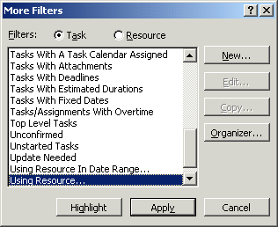
Fig. 17. Filter information in the Network Diagram

Filtered tasks are yellow and critical tasks are red. This is a highlight filter (filtered tasks are highlighted, not displayed separately):

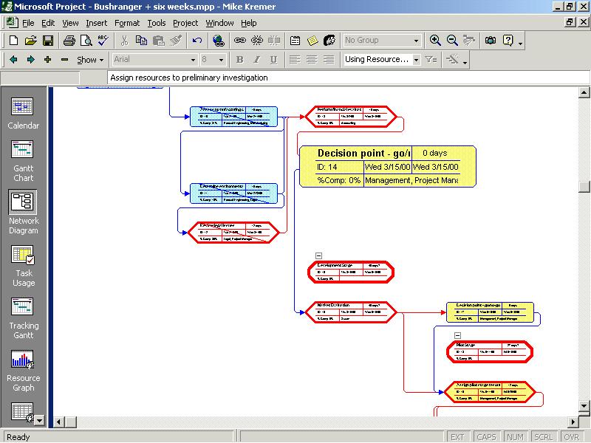
Fig. 18. A Network Diagram with the Using Resource Filter applied
Nodes now have substantial formatting options and can be formatted individually or by task type. Shape, color, number of included fields, cell height, font and labels are examples of attributes easily manipulated.

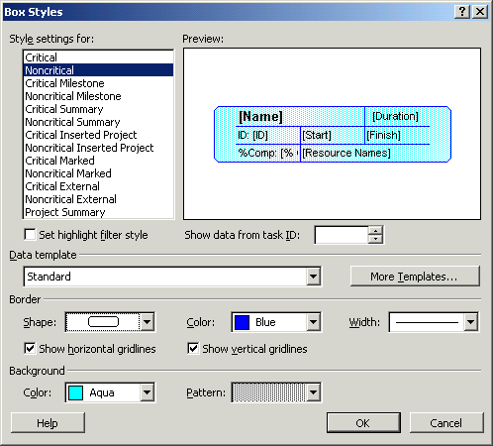
Fig. 19. Select box styles and formatting options for the Network Diagram
There are a number of new node layout options, such as the new automatic layout that ensures nodes are properly arranged at all times, including during filtering, expand and collapse, and inserting new tasks; multiple layout schemes that offer a choice of the overall “pattern” of nodes in the view, including three time-based arrangements that group tasks in columns by starting day, week or month; more control over layout details, such as space between nodes and the alignment of nodes in rows and columns; and when laying out nodes in manual layout mode, a selective layout of only the selected nodes is available, laying out just the nodes that are “downstream” from the current node, as are auto-alignment capabilities for selected nodes.

Fig. 20 below shows the range of layout options now available in Microsoft Project 2000:

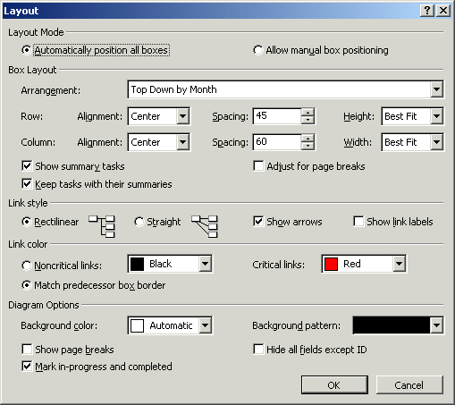
Fig. 20. Layout options for the Network Diagram

Fiscal Year in Timescale
Microsoft Project 2000 now offers the ability to independently set the use of the fiscal year for both major and minor timescales. This is useful for companies that do not use the standard calendar year for their fiscal year, allowing them to see how their projects fit their fiscal timing:
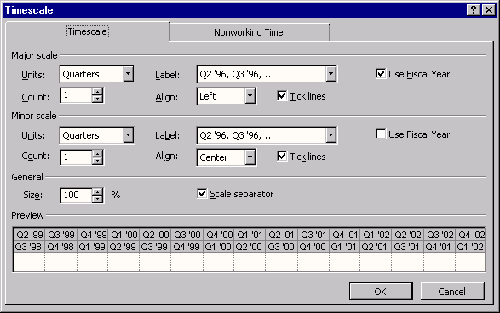
Fig. 21. Using the fiscal year in a timescale
This is the result:

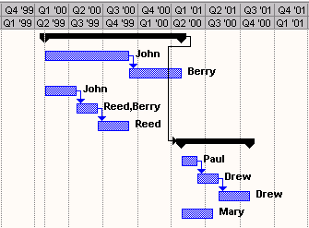
Fig. 22. Gantt Chart using the fiscal year in the timescale

Task Outline Level
Microsoft Project 2000 now allows users to expand and contract outline levels more efficiently. They can select the outline level to which they would like to display their tasks. To do this, users click on Show from the Formatting tool bar and then click on the desired outline level. This option can also be found on the Project menu by pointing to Outline, then pointing to Show Subtasks and clicking on the desired outline level.

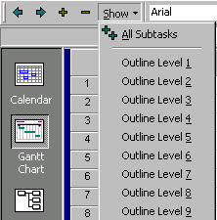
Fig. 23. Users can expand and collapse outline levels easily

Roll Up Gantt
In Microsoft Project 2000, users can set the Always Roll up Gantt Bars feature so that collapsed summary tasks show as multiple Gantt bars. This overrides individual task roll-up settings, so it’s good for forcing a whole view into rolled-up state. Users can also choose the Hide Rollup Bars When Summary Expanded feature so that summaries don’t show the rolled-up bars when they are expanded:

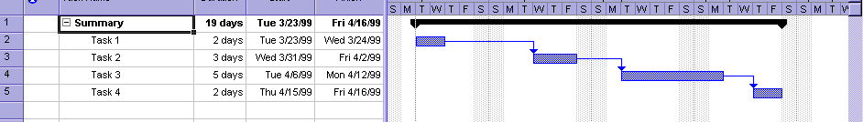
Fig. 24. Roll up Gantt bars in the summary task
When the summary task is collapsed, it looks like the example in Fig. 25:

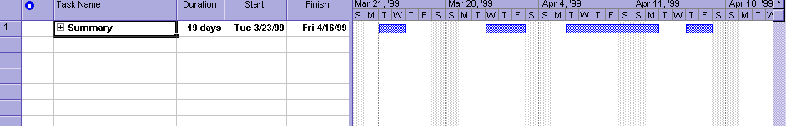
Fig. 25. Rolled-up Gantt bars with summary task collapsed

Flexible Analysis

Task Calendars
Sometimes a project manager needs to schedule a task that can only occur on certain days, or that cannot occur at specified times during the week. Microsoft Project 2000 now includes the ability to create task-specific calendars, making scheduling of such tasks quick and easy. If an assignment involves a task with a task calendar and a resource with a resource calendar, Microsoft Project 2000 uses the intersection of the two calendars for scheduling by default. Users can create a new calendar by selecting Change Working Time from the Tools menu.

Materials Resources
While it is possible to manage material resources using previous versions of Microsoft Project, Microsoft Project 2000 makes doing so much easier. There is now a new field to designate this type of resource. Materials can be assigned a fixed or variable rate. For example, pouring a foundation would take a specific amount of concrete no matter what the duration of the task, but gasoline to run a generator might be tracked in gallons per hour. Cost per use of a material resource is charged only once, irrespective of units. This makes it much easier to track the use and costs of materials through the life of a project. One way to access this functionality is through the Resource Sheet.

Deadline Dates
Tasks may now include a deadline date that allows an indicator to be displayed if a task will be finished after the deadline. This is useful in a situation where a manager would like to set a constraint and a deadline on a task. A deadline date has little impact on scheduling; tasks with constraint set to As Late As Possible (ALAP) will not be scheduled beyond their deadline dates. A deadline is set in the General tab of the Task Information dialog box.

Cross-Project Critical Path
In Microsoft Project 98, a master project with multiple inserted projects and cross-project links could only display multiple critical paths internal to each project. Microsoft Project 2000 has the capability to calculate and display a single critical path for tasks across all inserted projects. This helps a project manager track the important tasks across a group of projects.

Custom Fields: Value Lists
A manager can now define a list of possible values for a custom field. When data must be entered into the cell, a dropdown list provides quick, easy access to the predefined entries. Value lists can also be easily copied between fields in the same project or from project to project using Tools|Organizer, so that once one is created, it can be shared around the organization and among project managers. Possible values for a field can be limited to those in the list or set to accept new values. Once a new value is entered, it is automatically added to the value list:

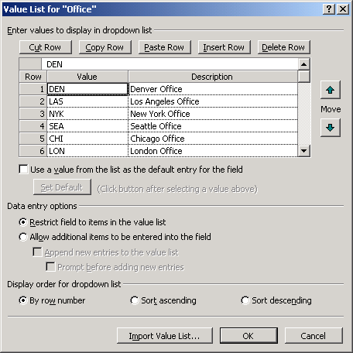
Fig. 26. Defining a value list for a custom field

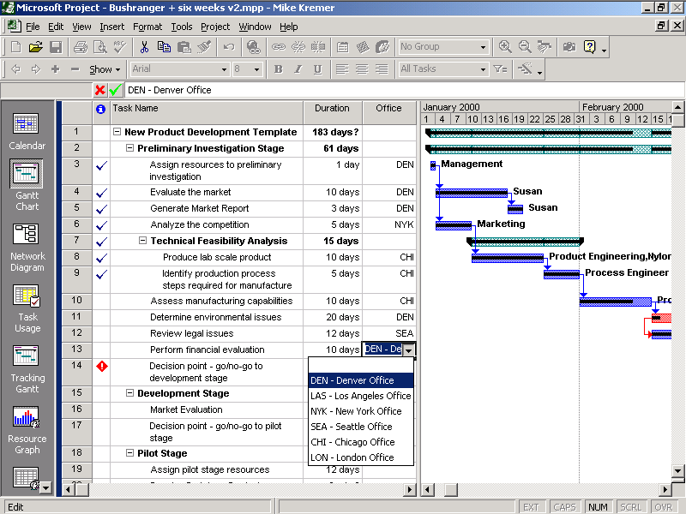
Fig. 26a. Using a value list for a custom field to enter data

Custom Fields: Formulas
Many project managers need to perform calculations on different data stored in Microsoft Project. In previous versions, this required the data to be exported to another application like Microsoft Excel. Now they have the ability to create custom fields with values returned from formulas performed on other fields. User-defined calculations can now be a part of any custom field; project managers can operate on numbers, flags, dates, costs, durations and text; reference any other Microsoft Project field; and utilize native Visual Basic functions. Formula syntax is the same as that for Microsoft Access:

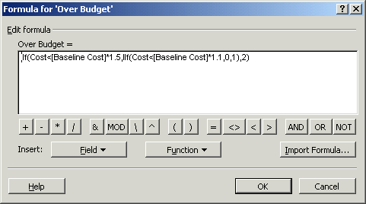
Fig. 27. Using formulas in custom fields
This formula will result in a 0, 1 or 2 in the custom field for each task. A 0 corresponds to a task within budget, a 1 means the task is somewhat over budget, and a 2 means the task is quite over budget. While such numbers can be very useful for watching the financial progress of a project, graphical indicators take this capability even further.

OLE DB
OLE DB is a specification for a set of data access interfaces designed to enable a multitude of data stores in an enterprise to work together seamlessly. Microsoft Project 2000 is a read-only OLE DB provider, making it possible for other applications to easily access Microsoft Project’s data so it is much easier to integrate project data in the enterprise. For example, the OLE DB provider allows the creation of Data Access Pages reports. These reports are Web-based, dynamic reports that allow the viewer to drill down on the live underlying project data.

Estimated Durations
All new tasks are automatically created with estimated durations by default to signal that a duration has not yet been entered. This is denoted by a “?” after the duration. Users can enter a different duration followed by a “?” to denote that this duration value is not certain. This allows a duration to be entered that is only an estimate, and it is easily recognized as such so that users know to come back later and confirm it or change it when they have a concrete value. Tasks with estimated durations are easily found using the new Tasks With Estimated Durations filter, or by a quick visual scan for question marks in the duration column.

Month Duration Unit
Microsoft Project 2000 supports months as a unit of duration. Typing in “3 mo, mon or month” in the duration field is recognized as three months. The user defines how many days constitute a month in the Calendar tab of the Options dialog box (Tools menu). Since high-level planning is often done in terms of months, it is now much easier to assign durations using the predefined month instead of converting months to weeks.

Contoured Resource Availability
Microsoft Project 2000 includes the ability for a resource’s availability to be contoured. This feature is useful in defining the available units over time for an individual or resource group.

Contoured resource information can be set period by period:

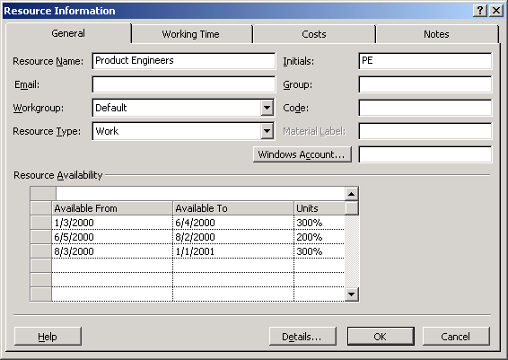
Fig. 28. Setting contoured resource information by period
For example, one resource may be defined as “Product Engineers.” The number of Product Engineers available during the project may fluctuate, due to the varying workload of the subcontractor supplying them. This fluctuation in resource availability is easily modeled with this new feature. In previous versions of Microsoft Project there was no way to model this situation. Many customers have requested this feature.

Leveling
Users had little control over how projects were leveled in previous versions of Microsoft Project. Many new features have made significant improvements to Microsoft Project 2000’s leveling capabilities. Task Calendars and Contoured Resource Availability are taken into account, along with priority; the Project Priority field is considered before the Task Priority field. A manager has the option to clear all leveling before doing a leveling operation, or leveling can be done starting from the current schedule, giving users more control.

Task and Project Priority
In previous versions of Microsoft Project, task priorities could be set to one of 10 values. To provide greater detail for priorities, Microsoft Project 2000 allows users to set priorities between 1 and 1,000, where 1 is the lowest priority task and 1,000 is the highest.

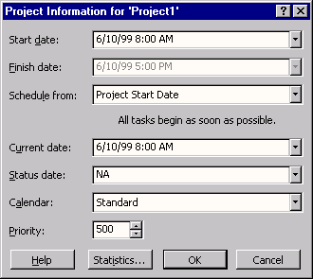
Fig. 29. Setting priorities with greater detail
One benefit of setting a project-level priority is that users can now better control how resource leveling adjusts tasks within each project when they are using a shared resource pool with multiple projects.

Work Breakdown Structure (WBS)

A work breakdown structure (WBS) is a collection of codes that corresponds to the hierarchical structure for the tasks in a project. A custom WBS code prefix can be defined for all codes within a project, along with the sequence, length and separator for each level:

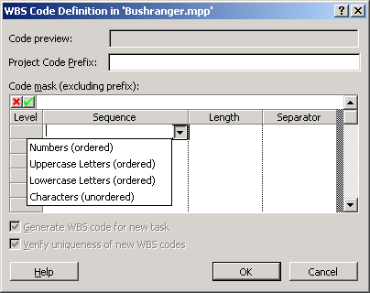
Fig. 30. Defining custom WBS codes
Codes can be characters, numbers or a friendly name, such as “development” and “test”. Microsoft Project can be set to automatically generate a code for any new task based on the structure and outline level. Upon entering a new task, the WBS codes of existing tasks are not automatically renumbered; however, a manager has the option to renumber the WBS for a selection of tasks or the whole project. This is particularly useful in a master project; the subprojects can retain their unique prefix to easily identify which project they come from.

Clear Baseline
In Microsoft Project 98 there was no easy way for users to clear baseline data from a project, especially the time-phased baseline data. With Microsoft Project 2000 it’s easy to delete baseline or interim plan data for selected tasks or an entire project.

Easier Reporting

Scaling and Printing
Microsoft Project 2000 users can now set the paper size from the Print dialog box. Print scaling has been improved, so that in many cases, setting a file to fit to a certain number of pages will not create a lot of unused white space. Print settings will now be retained with the file, so that it will not be necessary to re-enter printer name, timescale range and other settings. From the Page Setup dialog box in Headers, Footers or Legends, users can add project-level fields. For example, suppose a user wants to include the Budgeted Cost of Work Performed (BCWP) field for the entire project on the header of their printed project. They would use the Page Setup dialog box as follows:

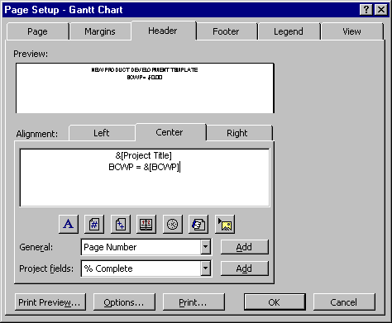
Fig. 31. Adding project-level fields to headers or footers

Copy Picture
The Copy Picture command in Microsoft Project 2000 has been improved. It now includes better picture quality, increased size and better scaling. If the picture a user is copying is particularly large and will not fit well into another document, Microsoft Project 2000 will alert the user and give the option to make changes before saving or pasting.

Enhance User Confidence
Easy to learn and easy to use because it works like Microsoft Office

HTML Help
Like Microsoft Office 2000, Microsoft Project 2000 uses a new Help engine. The content coverage of Help is equal to or greater than Microsoft Project 98, and HTML Help introduces a whole new look. The Microsoft Project 2000 Help structure includes a Help home page when users launch Microsoft Project 2000. They can access all parts of Help from this home page. There is also a new map with a project-management-based outline. Help topics have been written in a goal-based format, using a sequential and effective branching order based on what users want to accomplish. Many customers have asked for the ability to customize the help files. It is much easier to incorporate company-specific files and pointers to internal and external sites in Microsoft Project 2000. It is possible to point to custom information from the Help menu, or via the new Help Customization Tool. The Microsoft Answer Wizard Builder is part of the Microsoft Office 2000 Resource Kit and allows users to integrate their own terms and content with the Microsoft Project 2000 Answer Wizard.

Adaptive Menus
Adaptive menus are a unique solution to a long-term problem — how can users focus on just the things they need and use? When Microsoft Project 2000 is first started, the application menus will contain those commands that are used most often, so infrequently used commands do not immediately clutter the menu. At the bottom of each menu is a button that expands the menus to the full selection of choices. In addition, the menu will automatically expand based on IntelliSense rules (e.g., timing or hovering). As menu commands are used, they are “promoted” and displayed. Unused menu commands eventually are “demoted” and not displayed on personal menus.

Tooltips
Microsoft Project 2000 now includes more tooltips. For example, hovering over the timescale shows a tooltip with the date. Pointing to a cell in which the column width is too narrow to completely display the full cell contents will bring up the complete cell contents, such as when a task name is too long for the name field.
Similarly, in the Network Diagram, if a user is in ID-only mode or has a high-zoom level set to see a complete view of a large project (thus causing each node to be too small to see any content), hovering over any node pops up the full-sized, fully formatted box.

Templates
Similar to Microsoft Office 97 and 2000, Microsoft Project 2000 allows users to easily base a project on a template. When users click New from the File menu, they see the File New dialog box where they can pick an existing template from the Project Templates tab as the basis for their new project.

Commonly used project templates include those shown in the figure below:

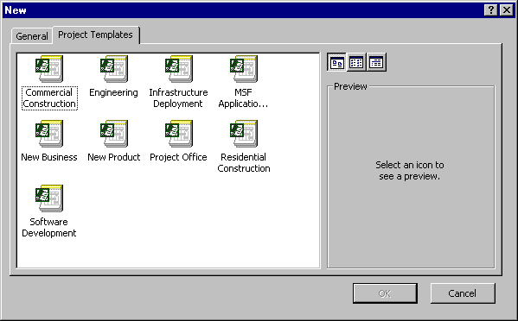
Fig. 32. Using predefined templates to set up a project plan
It is easy to create custom templates using File|Save|Template and have them accessible in the Templates tab. When users create a template from an existing Microsoft Project file, they have the option to delete existing baseline values, actuals, resource rates or fixed costs:

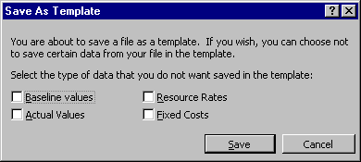
Fig. 33. Creating custom templates

Variable Row Height
Individual row height is now easily manipulated by dragging the row line between tasks to the desired height, for single or multiple rows. Anything in a cell that is too wide will automatically wrap in a heightened row.

In-Cell Editing
Like Microsoft Excel data, Microsoft Project 2000 data can now be edited in place as well as on the edit bar. This is enabled in most views, but not in the Network Diagram.

Fill Handle
When it is necessary to populate a number of adjacent cells with the same data, Fill Handles make fill up or down operations easier. In Microsoft Project 98, a Fill Handle could be used to populate cells only in a time-phased view. In Microsoft Project 2000, this functionality has been extended to tables, such as the left-hand portion of the Gantt Chart view.

AutoSave
Microsoft Project 2000 can now automatically save a project file at specified intervals. This option can be set to save only the active project or save all open project files. Another option gives a prompt before automatic saving occurs:

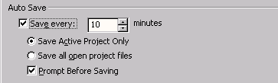
Fig. 34. Using AutoSave to save a project regularly

Office Server Extensions Support
In previous versions of Microsoft Project, saving a project to a Web site could be tricky, if not impossible. In Microsoft Project 2000, saving to Web servers that have Microsoft Office or FrontPage® extensions is simple. This feature is similar to the functionality in Office 2000. Files can be stored remotely via Web Folders, which are file-based shortcuts to Web servers. Microsoft Project 2000 now supports this type of publishing with all file formats.

Single Document Interface
Similar to Microsoft Office 2000 applications, Microsoft Project 2000 supports the Single Document Interface. This interface exposes each project as an individual entry on the Windows task bar and in the Alt-Tab list. By using this feature, switching between individual projects is no different from switching between mail messages or Web pages today. In Windows 95, SDI is only available if Internet Explorer 4.0 or above is installed with Web Integration settings.

Project Open and Save
A command bar has been added for common file management tasks, such as copying, moving and deleting files. The Places bar, an Outlook-like well of icons, is provided for often-used document folders to help insulate users from the persistent confusion of a hierarchical directory structure. The Web Folder place points to a Web server location for easy placement of files on an intranet or the Internet. The new dialog boxes also take a cue from the navigation method now familiar to millions of users through their Web browsers by including a Back button. This lets users easily return to recently visited folders, regardless of their location in the directory structure. To improve access to projects in a database, the Import/Export Format dialog box is enhanced to provide better display of projects in the database, better navigation among these projects, and allow simple maintenance operations such as rename and delete for projects in the database:

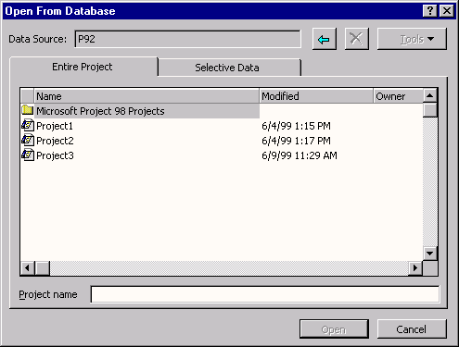
Fig. 35. Improved file management features

Hyperlinks
Microsoft Office 2000 offers an improved and consistent hyperlink interface to make it easier to manage hyperlinks in Office documents. Users can create different kinds of links, such as jumps or e-mail triggers, without knowing HTML. They can easily specify the text displayed in their hyperlink and create links to new files as well as to multiple files from the same source.

Using the new Microsoft Office 2000 Hyperlinks dialog box makes inserting hyperlinks much easier:

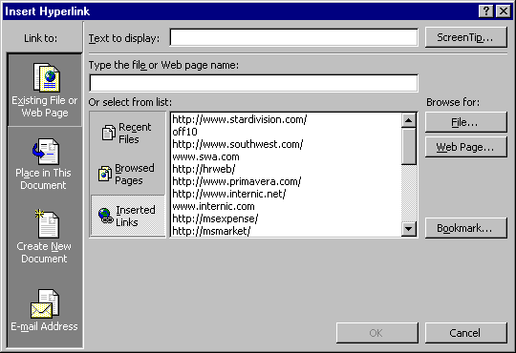
Fig. 36. Inserting hyperlinks easily

Default Save Format and Path
Microsoft Project 2000 allows users to specify the default directory to which they will save their files, user templates and workgroup templates. It also allows them to specify the default format when saving a project. This feature is found under Tools|Options on the new Save tab.

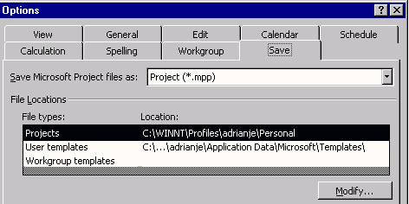
Fig. 37. Specifying the default save format and path
In Microsoft Project 2000, users can save to the native Microsoft Project 98 MPP file format, and with the new default-save-format feature, they can specify Microsoft Project 98 format as their default file type. This allows them to easily exchange projects with users who have not yet upgraded to Microsoft Project 2000 as long as they do not utilize new Microsoft Project 2000 features. When users create a project in Microsoft Project 2000 and save time-phased baseline data, it will be discarded when saving as Microsoft Project 98. When users import a Microsoft Project 98 file, save to baseline and save again as Microsoft Project 98, no time-phased data is lost.

Accessibility
Microsoft Project 2000 now has improved accessibility. The User Interface is now consistent with Control Panel Settings. In particular, high-contrast display support is improved. This means that most screen elements such as the window background color are now based on user-defined control panel settings. Microsoft Project 2000 also has added support for Microsoft Active Accessibility (MSAA). This allows third-party accessibility aids, such as screen-readers and voice-input utilities, to interact with Microsoft Project 2000 through MSAA.

Extend project management across the organization

Improve Capacity and Performance

Faster performance: better support for expanded resource pools and larger multiproject consolidations

Database Performance
Substantial changes have been made to the database capabilities in Microsoft Project 2000 that primarily focus on improving performance. The schema have been simplified, reducing 38 tables to 21. Field names follow a standard naming convention and are unique across all tables. By default, assignment time-phased data is stored as compressed binary data in the database. If a manager would rather have access to time-phased data in the database, it can be saved in expanded form using a much simpler structure, similar to what is seen in the Resource Usage or Task Usage view in Microsoft Project Central. Microsoft Project supports the following databases through ODBC:
- Microsoft Access 2000
- Oracle Server, version 8.0 server and client
- Microsoft SQL Server™ 7.0

Microsoft Project 2000 can also make the ODBC connection automatically when writing to and reading from Microsoft Access 2000 databases when users directly select Project Database or Microsoft Access Database as the file type in the File Open and File Save dialog boxes.

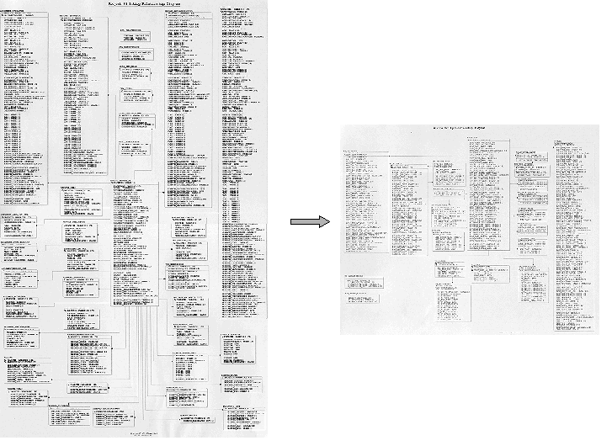
Fig. 37. The schema change from Microsoft Project 98 to Microsoft Project 2000

Resource Pooling
Performance of resource pools, especially over a network, can slow performance in Microsoft Project 98. In Microsoft Project 2000, opening a master project that has subprojects connected to a resource pool will no longer give an alert, asking how to open the resource pool, for each inserted sharer. Whatever setting the user chooses for the first such sharer will be applied to all the sharers in the master project, even if they are using different pools. When users close or save a master project that includes inserted projects connected to a read-only resource pool, they will be prompted for pool updating only once per pool, rather than once for each sharer. Other architectural changes have made vast improvements in resource pool performance.

Inserted Projects
Microsoft Project 2000 now stores the relative path to linked projects. This gives users the ability to move linked and inserted projects without the need to resave them to a new location from within Microsoft Project. Additional architectural changes will increase the speed with which Microsoft Project 2000 executes some master project and inserted project operations and reduce their use of memory.

Keep Users Up and Running

Reduce expenses by leveraging Microsoft Project 2000 features designed to reduce cost of ownership

Install on Demand
Like Microsoft Office 2000 applications, Microsoft Project 2000 uses the Windows Installer technology. This technology installs only needed files and makes Microsoft Project 2000 much more resilient. In the past, a missing or changed file may have meant that Microsoft Project would not run. Now, if a critical file is missing, instead of presenting a cryptic error message, the installer technology re-installs what’s missing. The installer technology also means that features can be set to be installed on their first use or “just in time.” An example of this is the spelling checker. If installed for first use, the spelling checker components will not be installed until the first time the user starts the spelling checker. Along with installing features on demand, the installer technology can keep track of features that are unused and remove them.

Roaming User Support
Enhanced portability gives users the ability to log on to any machine in a networked environment and maintain their own personal settings and preferences. This allows users to keep working productively in Microsoft Project 2000 from wherever they happen to be if the organization’s network servers have been configured to enable roaming.

Microsoft Windows Terminal Server Support
While most Windows-based programs run well on Windows Terminal Server, Microsoft Project 2000 is optimized for the environment. Microsoft Project 2000 cleanly separates user and machine data that is stored in the registry. This helps ensure that it runs correctly across different sessions. In addition, Microsoft Project 2000 will not store user data in global locations, will not include hard-coded path names in the registry, and will use the Temp directory to store nonpersistent data.

Pluggable Language User Interface
For companies that support users in multiple countries and languages, installing and maintaining the various versions of Microsoft Project was a challenge. Not only were the basic program files different, they often weren’t compatible, making it hard or even impossible for users on different language systems to work together and share files.

Microsoft Project 2000 makes life much easier for multinational companies and users by using a single worldwide executable with pluggable user interface languages for German, French, Italian and Japanese. Microsoft Project 2000 users have the option of switching between these languages. Also, many of the other supported languages will have the option of switching to English. There is only one set of Microsoft Project 2000 files to manage for any system, making deployment and administration much simpler. Settings in a separate resource DLL, as well as features available in the operating system, determine the enabling of locale-specific features.

Events
Events, accessible via VBA, can be used to gain tighter control of Microsoft Project 2000 usage when deploying it across an organization. For example, users can track separate events when a new task, resource or assignment is created, changed or deleted, or use new Cancel parameters to disallow certain user edits to a project file. Many new Events have been added in Microsoft Project 2000:
Event | Description
ProjectBeforeTaskDelete | Occurs when a task is deleted
ProjectResourceDelete | Occurs before a resource is deleted
ProjectBeforeAssignmentDelete | Occurs before an assignment is removed
ProjectBeforeTaskChange | Occurs before a change to a task field’s value
ProjectBeforeResourceChange | Occurs before the user changes some resource field’s value
ProjectBeforeAssignmentChange | Occurs before the user changes some assignment field’s value
ProjectBeforeTaskNew | Occurs before one or more tasks are created
ProjectBeforeResourceNew | Occurs before one or more resources are created
ProjectBeforeAssignmentNew | Occurs before one or more assignments are added
ProjectBeforeClose | Occurs immediately before any open project closes
ProjectBeforePrint | Occurs immediately before any open project is printed
ProjectBeforeSave | Occurs immediately before any open project is saved
ProjectCalculate | Occurs after the project is calculated

COM Add-Ins
Like Microsoft Office 2000 applications, Microsoft Project 2000 allows users to create COM Add-ins — secure, fast code that can be compiled as DLLs and can be easily incorporated into custom applications. COM Add-ins are components that can be developed in Microsoft Visual Basic, Visual C++® or Visual J++® development systems. Microsoft Project and Microsoft Office programmability provide an extensibility interface so add-ins written in these languages can be connected and disconnected from Microsoft Project 2000. Microsoft Office 2000 COM Add-ins introduce an entirely new developer market to Microsoft Project. Moreover, the addition of Visual Basic (or Visual C++ or Visual J++) into the Microsoft Project developer's toolbox provides almost limitless possibilities for the depth and breadth of customized solutions on top of Microsoft Project 2000 and Office 2000. Users can write COM Add-ins that work in multiple office applications. Because the add-ins are compiled into a DLL, users of an add-in cannot see or modify the underlying code.

Visual Basic for Applications
Significant improvements to the Microsoft Project Object Model have been implemented in Microsoft Project 2000. Many of the new features like custom grouping and outline codes have new methods associated with them. Other methods have been improved to add capabilities. There are new methods, such as Application.Run, that allow users to easily call procedures in Microsoft Project from other Automation controllers and to pass variables to the procedures. There are new objects and associated collections like Task Dependencies, which allow users to programmatically access and change all predecessor and successor task properties.

#########

© 1999 Microsoft Corp. All rights reserved.
The information contained in this document represents the current view of Microsoft Corp. on the issues discussed as of the date of publication. Because Microsoft must respond to changing market conditions, it should not be interpreted to be a commitment on the part of Microsoft, and Microsoft cannot guarantee the accuracy of any information presented after the date of publication.
This document is for informational purposes only. MICROSOFT MAKES NO WARRANTIES, EXPRESS OR IMPLIED, IN THIS DOCUMENT.
Microsoft, Windows, Win 32, Outlook, IntelliSense, Active Accessibility, Visual Basic, Windows NT, FrontPage, Visual C++ and Visual J++ are either registered trademarks or trademarks of Microsoft Corp. in the United States and/or other countries.
Other product and company names herein may be trademarks of their respective owners.

