Licensing Update

Microsoft Product List for Volume Licensing – New, User-Friendly Format 2
MSDN Subscriptions – FPP – DVD rebate expires 6/30/04 4
Microsoft® Office Live Meeting Online Services in Microsoft Volume Licensing 4

Microsoft Product List for Volume Licensing – New, User-Friendly Format
Are you familiar with the Microsoft Product List for Volume Licensing? If you are not, it is a resource you should familiarize yourself with, as well as use and share with others in your organization. If you are familiar with the Product List, you should take a look at the new easier-to-use format introduced with the June 2004 edition. You can find it at www.microsoft.com/
licensing.

Redesigned with feedback from analysts, partners and customers, the Microsoft Product List is now a more intuitive and clear document with hotlinks that go directly to the information needed. The new Product List, which is now table driven, makes it faster to locate vital information while reducing redundancy.

The Microsoft Product List provides monthly information about Microsoft software and Online Services licensed through Microsoft Volume Licensing programs. The information described in the Microsoft Product List includes:
- Availability of new products
- Discontinuation of products
- Available promotions
- Point values
- Product migration paths
- Software Assurance (SA) benefits
- Other Notes and information specific to products
- Appendices filled with information on special terms, SA renewal, and programs.

How to use the Microsoft Product List:
Open the June 2004 Product List and familiarize yourself with the Chart Key on page 8 before finding the information you need in the tables or in the Product Notes in the back.

Step 1:
Locate the product you want information about in the table that begins on page 9 of the Product List.
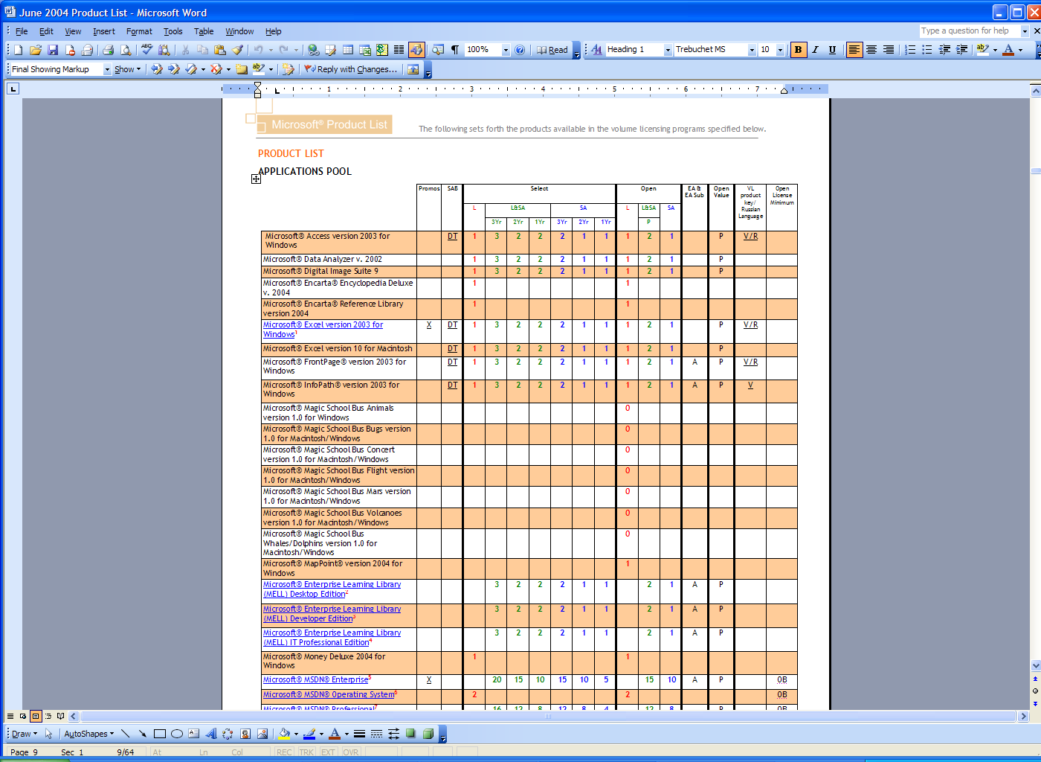

Step 2:
Review the information in the columns for available promotions, Software Assurance benefits, point counts, program availability, etc.

Step 3:
Some products also have a footnote regarding additional information. If applicable, “click” on the footnote (or the product name in the table*) which will bring you directly to the applicable text; or refer to the identified footnote in the pages that follow the table for that additional information. Additional information includes details regarding migration offerings or eligibility criteria as illustrated in the example below.

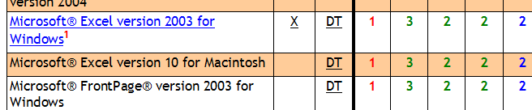

*You may need to hold down the “CTRL” key while pressing the product name link.

Once you have navigated to the Product Notes, you can navigate back to the table by “double clicking” the footnote number.

Step 4:
For more information about Software Assurance benefits and Software Assurance acquisition and renewal, see Appendices 3 and 4.

Other Great Resources
You may also want to review the Product Use Rights (PUR) document. The PUR is produced quarterly and provides information about the latest use rights for Microsoft Products under Microsoft Volume Licensing programs. You can find the PUR by going to www.microsoft.com/licensing .

MSDN Subscriptions – FPP – DVD rebate expired 6/30/04
- The rebate for selecting DVD media with MSDN Subscriptions product sold in FPP expires on 6/30/04.
- Product purchased after that date will not be eligible for the rebate.
- Coupons for product purchased prior to 6/30/04 will be accepted until 7/31/04.

Affected SKUs
 |  |  | DVD Rebate | Expires | Coupons Must Be Received By
MSDN Universal | New | 534-02125 | $ 300 | 6/30/2004 | 7/31/2004
 | Renewal/Upgrade | 534-02127 | $ 300 | 6/30/2004 | 7/31/2004
MSDN Enterprise | New | 389-00155 | $ 200 | 6/30/2004 | 7/31/2004
 | Renewal/Upgrade | 389-00157 | $ 200 | 6/30/2004 | 7/31/2004
MSND Professional | New | 388-01893 | $ 110 | 6/30/2004 | 7/31/2004
 | Renewal/Upgrade | 388-01895 | $ 110 | 6/30/2004 | 7/31/2004
MSDN Operating Systems | All | G71-00010 | $ 80 | 6/30/2004 | 7/31/2004

Please note that the renewal rebates for MSDN Operating Systems and MSDN Library are not affected.
MSDN Operating Systems | All | G71-00010 | $ 200
MSDN Library | All | 318-00436 | $ 100

Microsoft® Office Live Meeting Online Services in Microsoft Volume Licensing

Online Services in Microsoft Volume Licensing
Microsoft is pleased to add Microsoft Office Live Meeting to the growing list of online services available though Microsoft Volume Licensing programs. Different from software with bits installed on customer devices, online services have components that are hosted by Microsoft’s data centers, and are available on a subscription basis.

Microsoft Office Live Meeting
Microsoft Office Live Meeting is a hosted web conferencing service that enables users to communicate and collaborate with anyone, anywhere - with just a PC, an internet connection, and a telephone. From small collaborative meetings to large scale presentations with thousands of people, Microsoft Office Live Meeting is the perfect solution for all online meeting needs. With rich interactivity and the ability to show and share anything on a user’s PC, users can conduct effective meetings with anyone in the world while avoiding the cost and all the hassles of business travel. With less time wasted, teams can become more productive, make more informed decisions, and resolve issues more quickly.

Key Features and Benefits
- Real-time collaboration
Share, collaborate and discuss your projects in real time. All attendees can view the same information at the same time, as if everyone were gathered around one table. Interactive tools such as the electronic whiteboard let you mark up files, create flowcharts and more.
- Application and desktop sharing
Show and share visuals, applications, web pages, files or software to participants in real time. Meeting attendees can see exactly what you are doing – including your mouse movements and keyboard inputs. You can also give control of the application or desktop to a remote participant.
- Rich interactivity
Attendees can respond to multiple choice questions with real-time polling, or provide spontaneous feedback to the presenter through the virtual seating chart. Questions can be submitted, and presenters can use the Q&A Manager to reply publicly to everyone in the audience or privately to the person who submitted the question.
- Ease of use
All you need is a phone, a PC and an Internet connection. Simply log on, set up a meeting, upload your presentation and you’re set. Plus, as a hosted service, Microsoft Office Live Meeting is extremely easy to get up and running without having to deploy additional hardware or update your network infrastructure.
- Significant return on your investment
Less travel means less downtime. You don’t need to leave your desk to share ideas with others and you can meet more frequently, at a fraction of the cost. Productivity is increased while expenses dwindle.
- Easy access to previous meetings
Save your meeting content and enable remote participants to print it. Or record it with the audio and visuals synchronized so that team members can access the information they need—even after the meeting has ended.
- Perfect for groups of all sizes
Microsoft Office Live Meeting is designed to accommodate groups of 2 up to thousands. It’s perfect for small collaborative meetings as well as large events and seminars. Meeting controls can be customized based on the number of participants and level of interactivity desired.
- Seamless integration
Microsoft Office Live Meeting can be tightly integrated with your existing business processes and systems as well as third party applications. For instance, it can be linked with your company’s directory service, or tied into your intranet portal, providing easily accessible and pertinent meeting information.
- Reliability you can count on
With up to 99.99% uptime availability, Microsoft Office Live Meeting consistently provides smooth presentations. Its reliable hosting infrastructure reduces potential single points of failure so meetings can continue even in the toughest situations.
- Enhanced security
With nine levels of security, including 128-bit encryption, Microsoft Office Live Meeting allows you to store presentations in a secure, hosted environment.

For more information, please visit: http://www.microsoft.com/licensing/resources/downloads/
default.mspx#XSLTsection128123121120120.

