
Financial Statement Translation

Microsoft Dynamics™ SL

Benefits
- Take control of your finances
Define default values, selection options,
and control information, including the
default balance sheet and rate types
used to automatically calculate monthly
translation gain or loss. Other options
control the level of detail posted to
Microsoft Dynamics SL General Ledger and the number of periods for which the worksheets should be maintained.

- Translate currency efficiently
Translate and consolidate month end
financial data more powerfully by
performing routine tasks automatically.
Microsoft Dynamics SL Financial Statement Translation can automate
the calculation of translation/re-measurement of gains and losses, historical exchange rates, multi-tiered translations, and multi-level consolidations.

- Master complex information
Perform in-depth translation definition
and worksheet inquiries using a variety
of screens and reports, in addition to any of the Microsoft Dynamics SL General Ledger inquiry screens, to see how currency translation affects your business. A variety of extended reporting options can be used,
including the ability to sort and
select on any field in a report.

- System-wide integration
Create an adjusted set of books in your
local currency to conform to Generally
Accepted Accounting Principles (GAAP)
requirements, and then translate your
statements to your parent company’s
reporting currency for consolidation,
comparison, and roll-up financial reporting.

Isolate, evaluate, and eliminate the impact of currency fluctuations on your business operations with Microsoft Dynamics SL Financial Statement Translation. This flexible and integrated module helps you dramatically improve month-end close processes by performing necessary currency translations and automatically calculating gains/losses due to rate fluctuations.

Define
default values,
selection options, and control information, including the default balance sheet and
rate types.

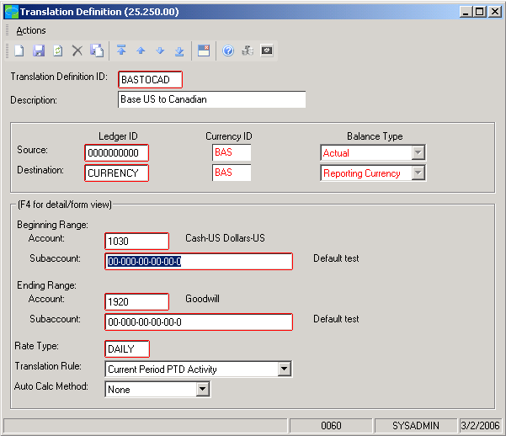

Are

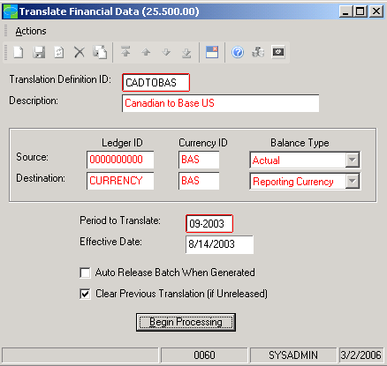

Translate
and consolidate month-end financial data more powerfully by automatically performing routine tasks.



FEATURES

BENEFITS

Dependable Controls | Maintain a complete audit trail of the translation process. Specify criteria  to control report content and focus on the information you require.
Adaptable Setup | Define the currencies, rate types, exchange rates, and translation gain  and loss accounts used in the translation process.
Central Repository | Maintain all currency and exchange rate data in a single location for  accuracy and reliability.
Financial Application Data Sharing | Create an adjusted set of books in your local currency to conform to  GAAP requirements. Translate statements to a parent company’s reporting  currency and then transfer statements to your parent company for  consolidation, comparison, and financial reporting.
Standards Compliance | Produce statements to comply with the Financial Accounting Standards  Board (FASB) Statement 52, Foreign Currency Translation, and with the  International Accounting Standards Board (IASB) Statement 125.
Corporate Reporting | Translate books into other currencies for corporate reporting. Perform  an unlimited number of translations and re-measurement at a single  installation.
Flexible Rules Definition | Define financial statement translation rules and exchange rates used to  create the Reporting Currency set of books from the Local Currency set  of books.
Flexible Location | Perform month-end financial statement translation in either the actual  subsidiary or in a central location.
Fast and Accurate Computation | Automatically compute the translation gain or loss amount and report  it to the Reporting Currency set of books.
Streamlined Calculation | Automatically calculate historical rates for inventory and cost of goods  sold with the Bi-monetary Inventory processing feature, which eliminates  the need to maintain these historical exchange rates manually.
Multi-tiered Translation | Re-measure a Local Currency set of books and consolidate different  currencies at different rates–and then to any number of Reporting Currencies. If you are a business entity that owns entities and operates in various currencies, take  advantage of multi-level consolidations.
For more information about Microsoft Dynamics™ SL, visit: http://www.microsoft.com/dynamics/sl

This document is for information purposes only.
MICROSOFT MAKES NO WARRANTIES, EXPRESS, IMPLIED, OR STATUTORY, AS TO THE INFORMATION IN THIS DOCUMENT.

© 2005 Microsoft Corporation. All rights reserved.
Microsoft, The Microsoft Dynamics Logo, are either registered trademarks or trademarks of Microsoft Corporation or Microsoft Business Solutions ApS in the United States and/or other countries. Microsoft Business Solutions ApS is a subsidiary of Microsoft Corporation.

