A Demonstration of FullArmor AppPortal for Windows Azure

AppPortal is a Software + Service offering built on top of Windows Azure that provides scalable App-V virtual application deployment and management. Designed for the enterprise market, the deployment can be centrally managed, self service enabled or a combination of both. AppPortal can optionally run on-premise utilizing Windows Server and SQL Server with integration with System Center Configuration Manager.

Administrators may define “Self service catalogs” of applications that users can pick from to deploy to their devices using the AppPortal User Portal. This demonstration walks through two parts:

1. An administrator uploading an application and putting into a self service catalog.
2. A user finding the application in the catalog and deploying it to the device.

You’ll need Silverlight on any machine you use to test AppPortal, which may be found here:

<http://silverlight.net/getstarted/silverlight3/>

## Creating a Catalog with an Application

Using your web browser, browse to <http://azureappportal.cloudapp.net>. If you need to install Silverlight to continue, please do so. If you browse to this site with Silverlight installed, you will see the login screen that looks like this:

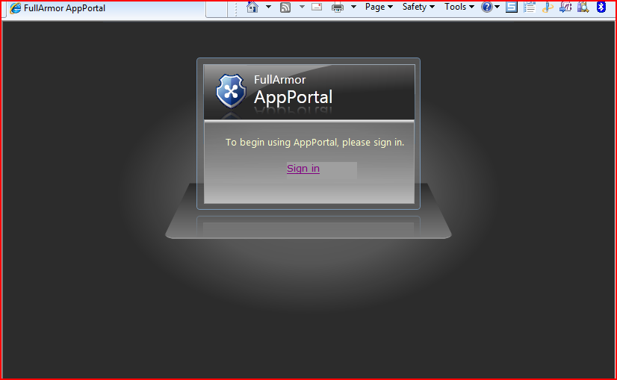

Click on the “Sign in” link in order to sign in via live id. The credentials to sign in as an administrator are:

[azurecontestadm@hotmail.com](mailto:azurecontestadm@hotmail.com)

oberon!6

AppPortal will take you to the home page, which looks like this:

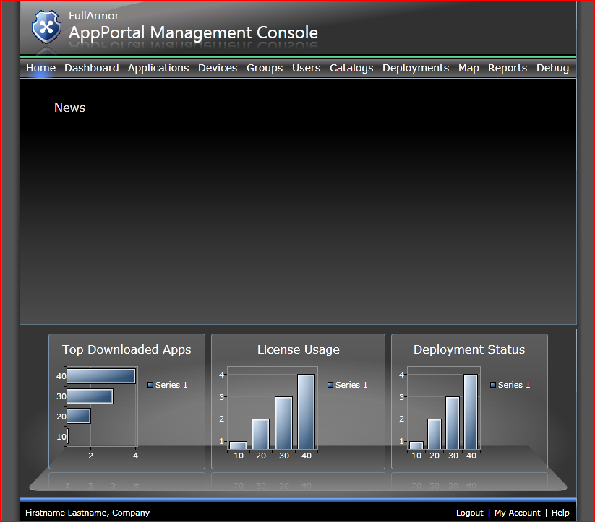

Click on the “Applications” tab.

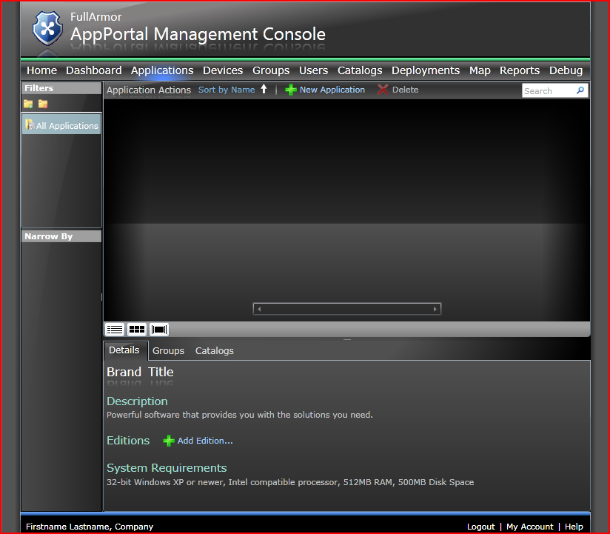

Click “New Application”. On the first page, select “standard application”, then click next.

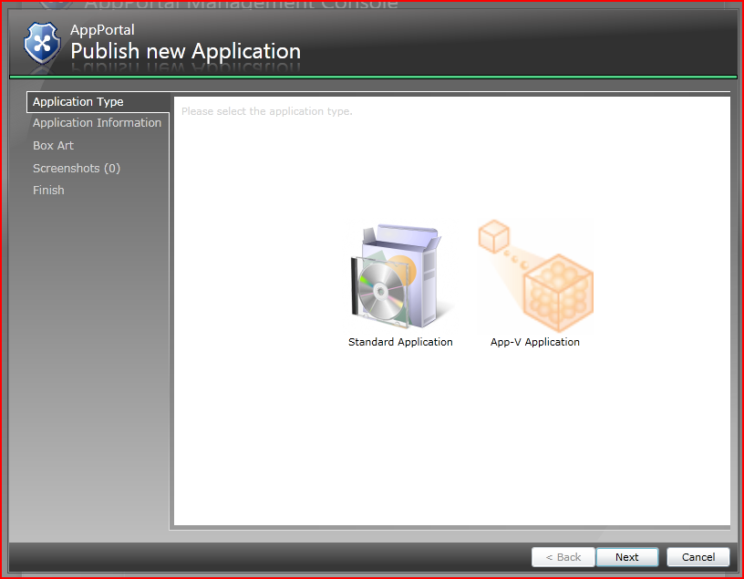

On the next page, fill in the details about your application and then click “next”.

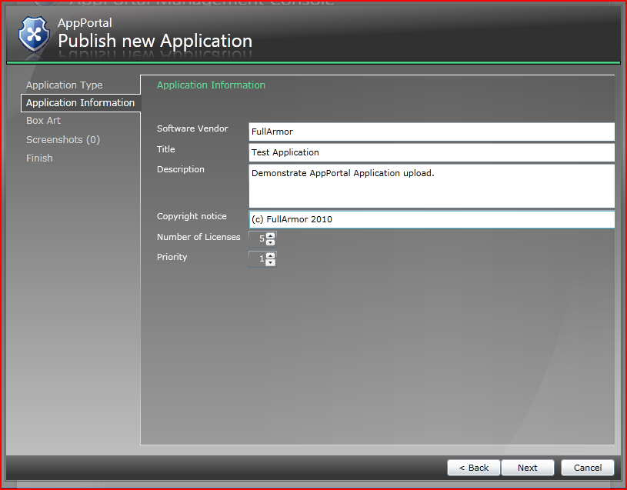

Next, pick box art to represent your application:

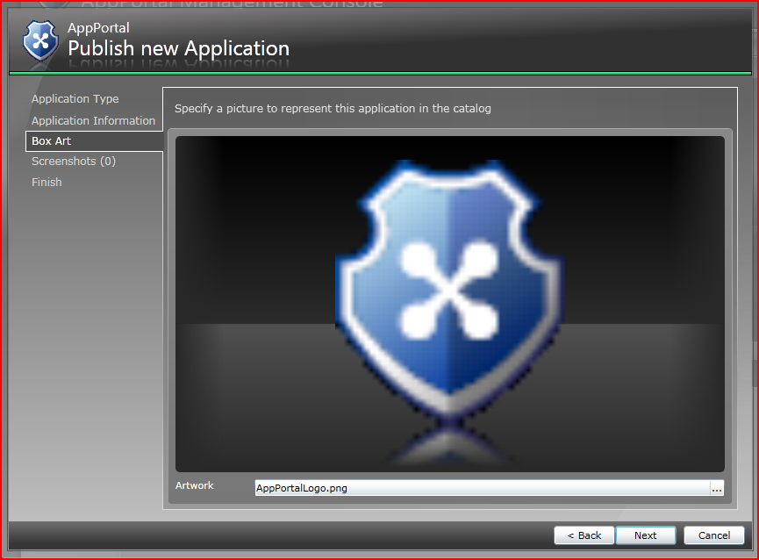

On the next page, add as many screenshots as you wish:

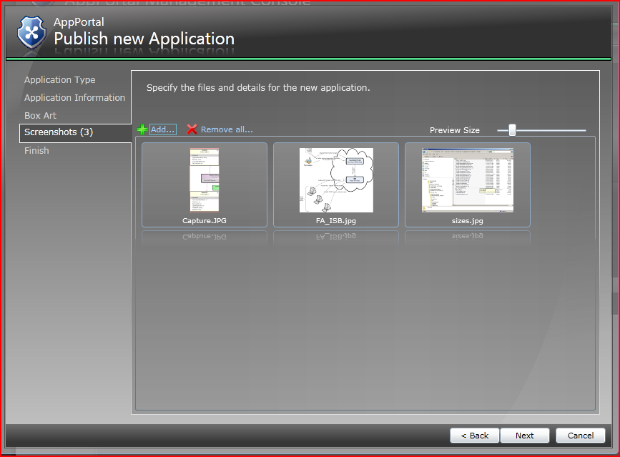

On the next page, click finish to create an application container for a managed AppPortal application and begin uploading the details so far.

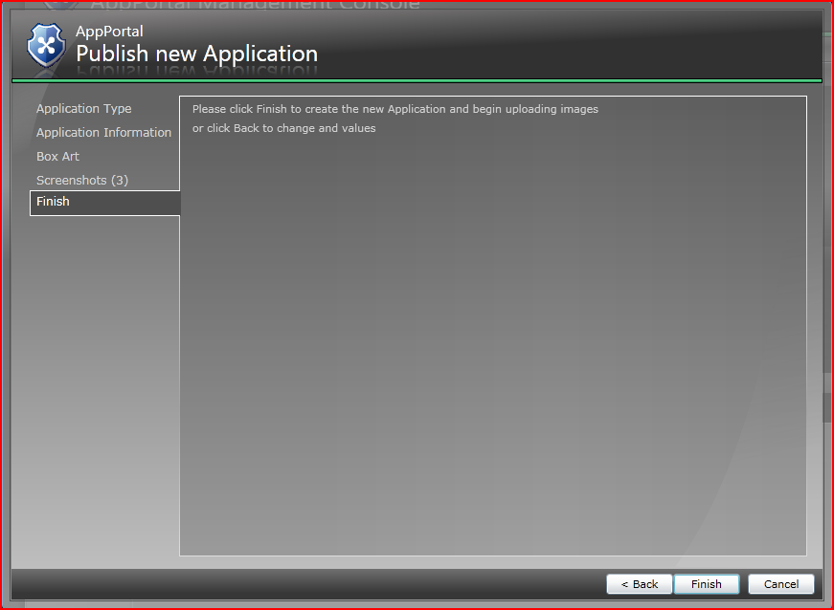

While your box art and screenshots upload, AppPortal will display progress:

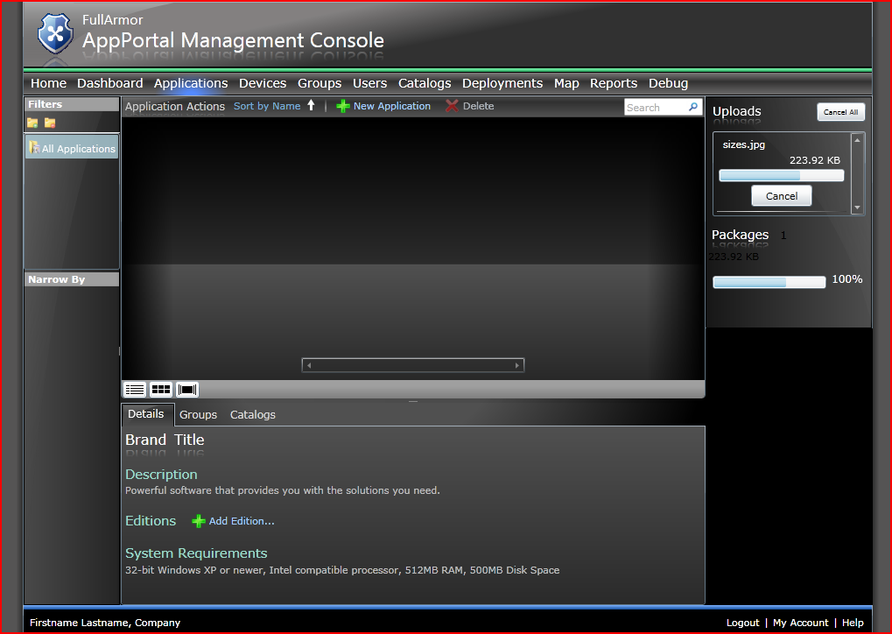

Then your application will appear in the list of managed applications:

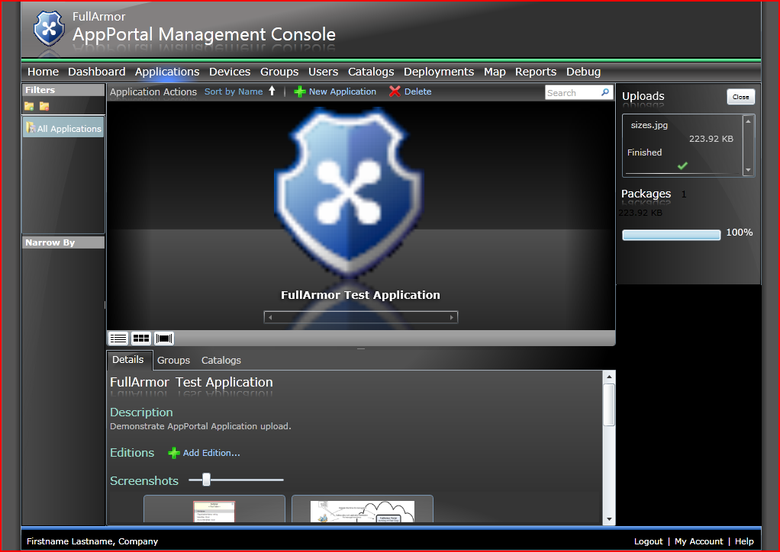

Click on the “Add Edition” action to upload the appropriate installation binaries.

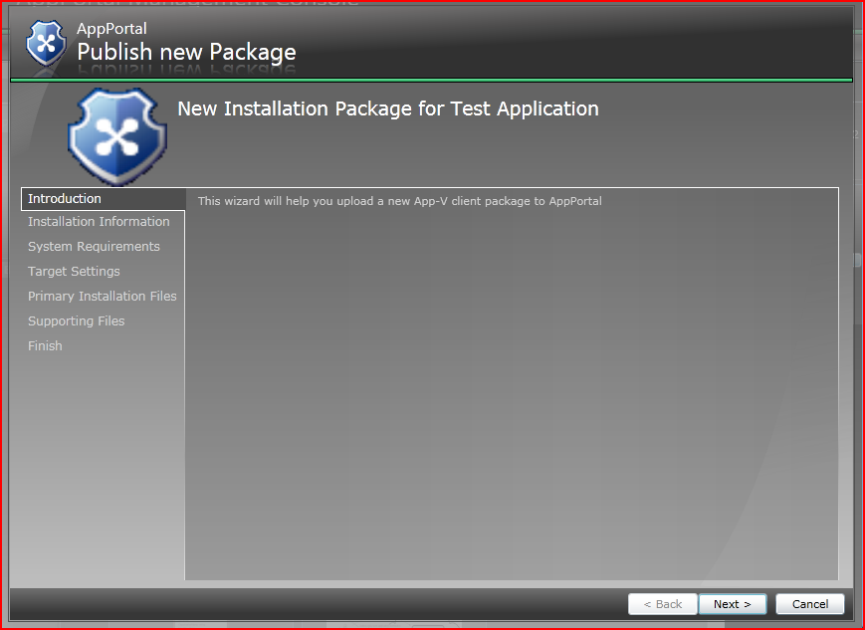

Fill in the package details, for example:

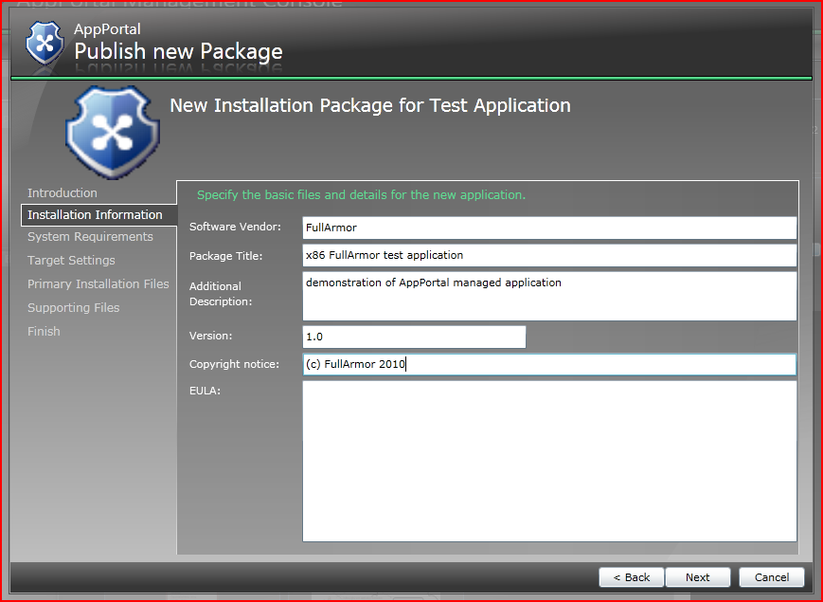

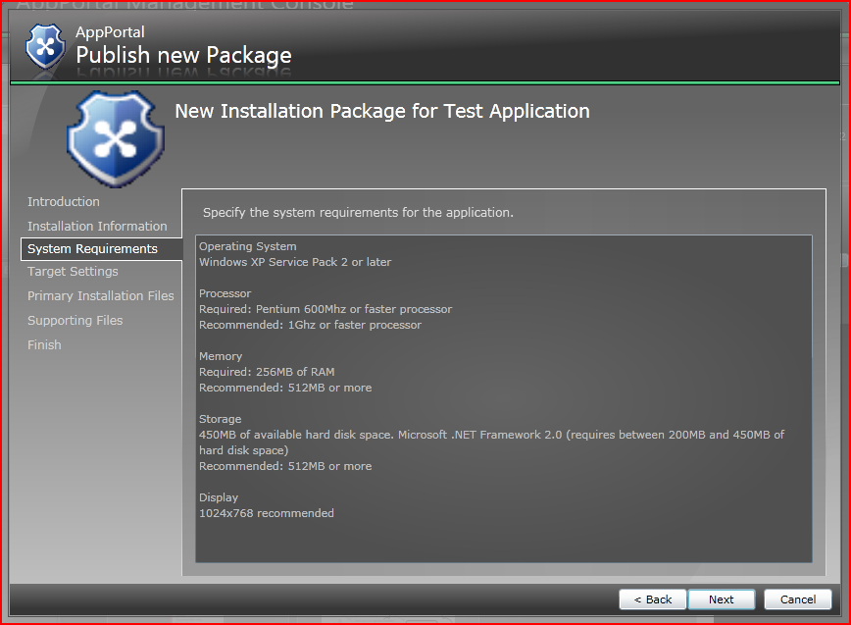

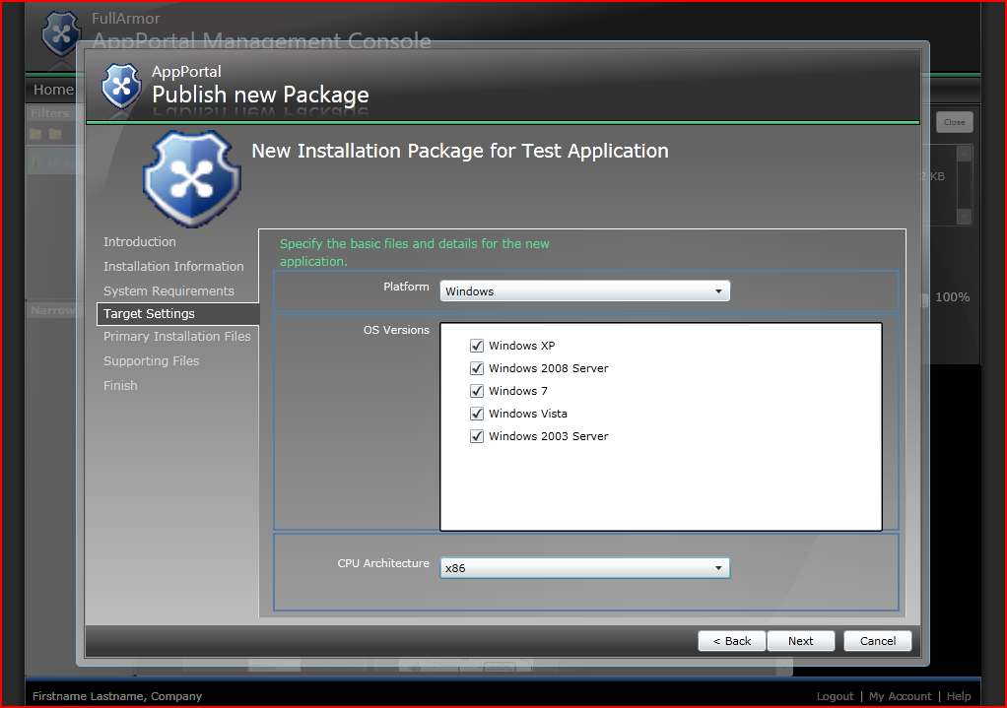

Then, select an msi file to install the application:

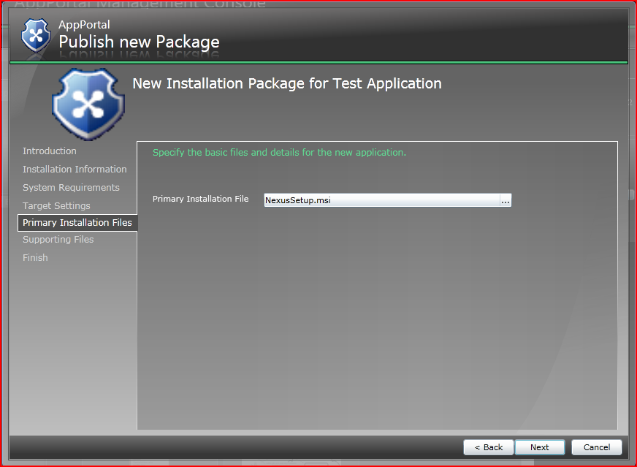

Most of the time you won’t need any supporting files for your installation, but if the msi you uploaded expects other files to be present, you may use the following page to upload them; otherwise, just click “next”.

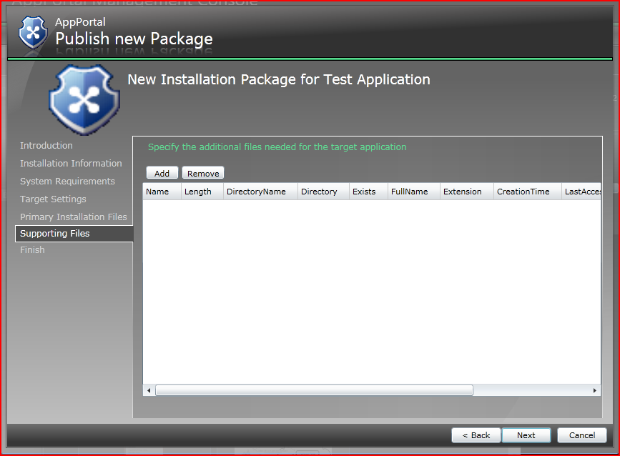

Click “Finish” to complete the process to add an edition.

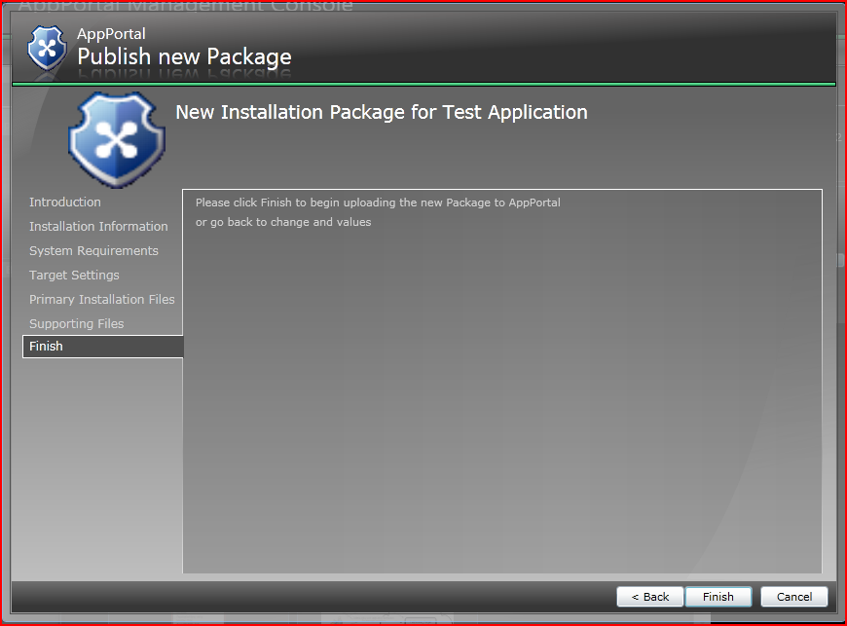

AppPortal will now upload your msi package and display progress. Wait for the upload to complete.

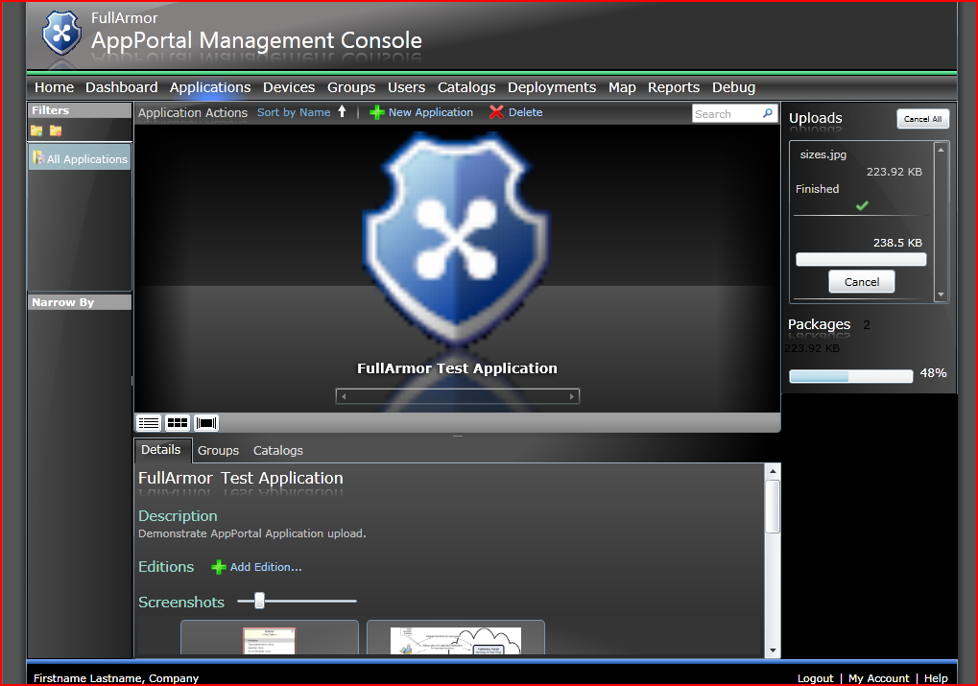

Now click “Catalogs” to go to the catalog tab, and click “Add” to add a new self-service deployment catalog.

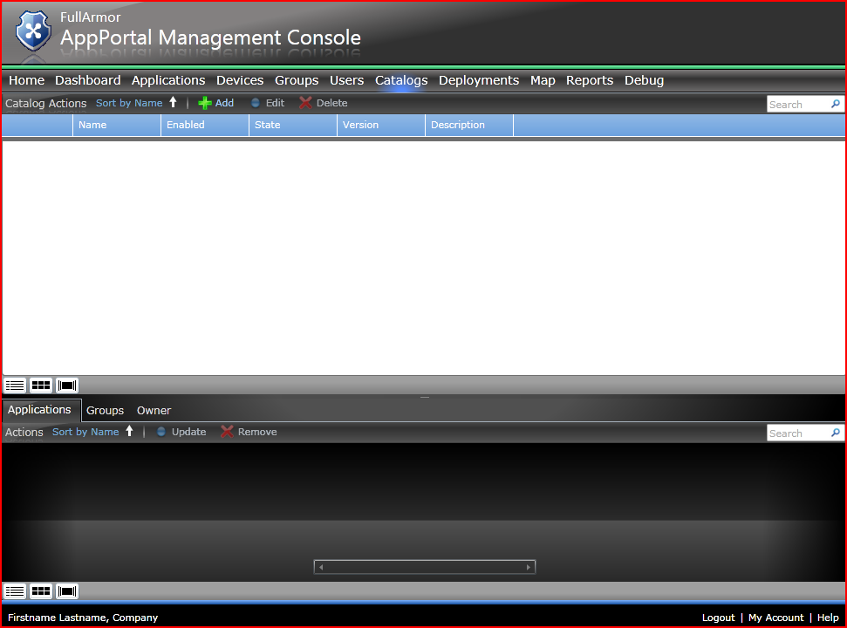

Provide a name and description for the catalog on this page (use a different name than pictured).

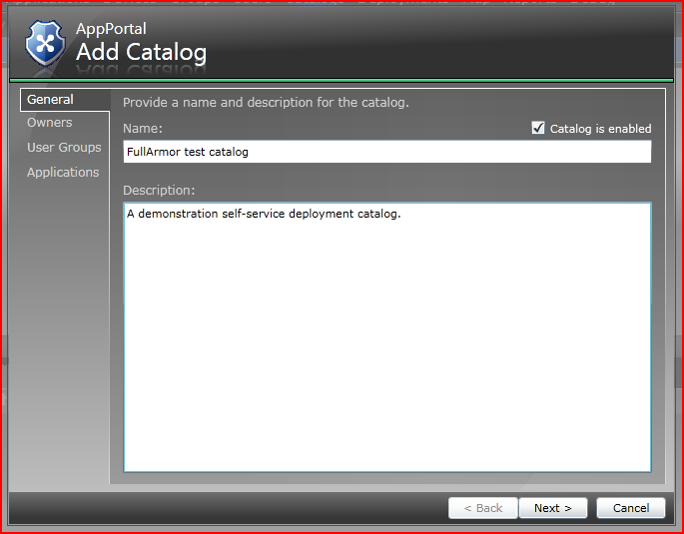

Then click “Next”

For the purposes of this demonstration, we won’t need any additional owners for the catalog, so click “Next” on this page:

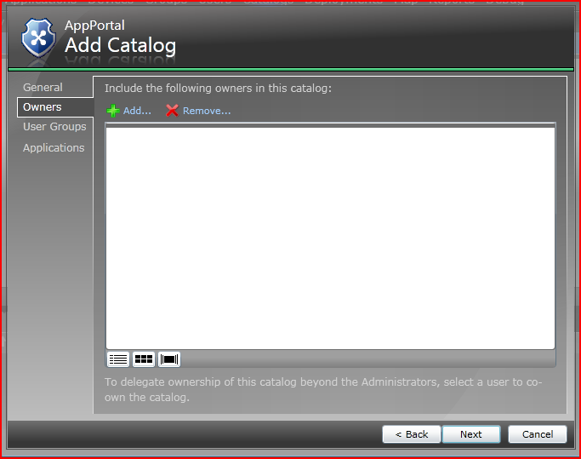

On the user groups page, click “Add”

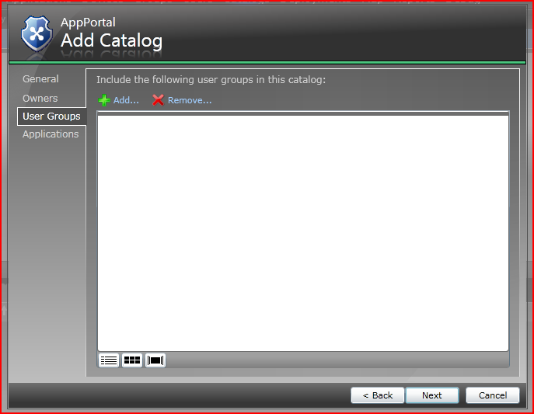

Select the user group named “Test Group” and then click OK.

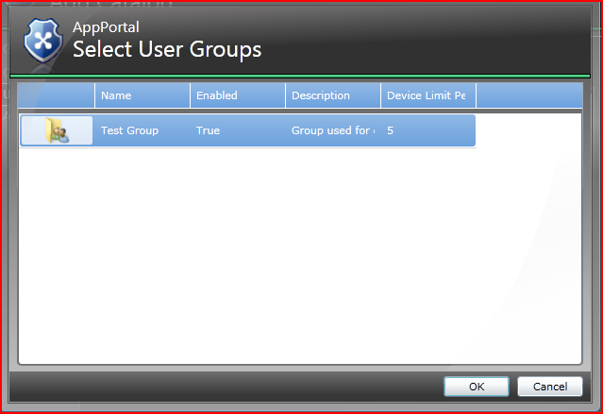

On the final page, click “Add” to add your application to the catalog:

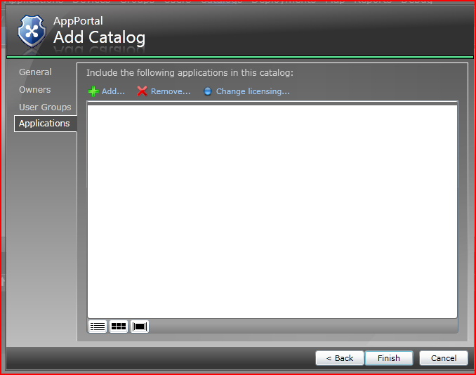

Pick the test application that you created and click “OK”

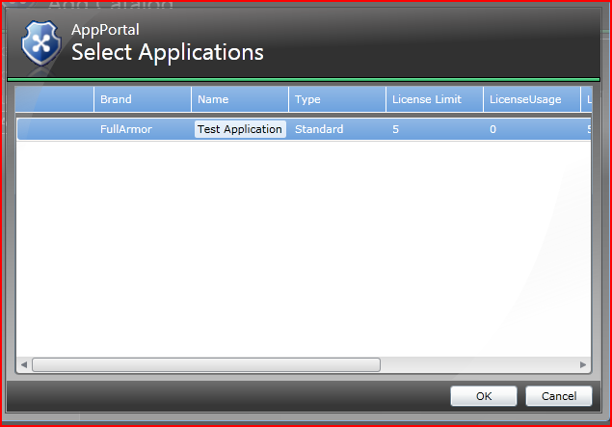

Now you can click “Finish”

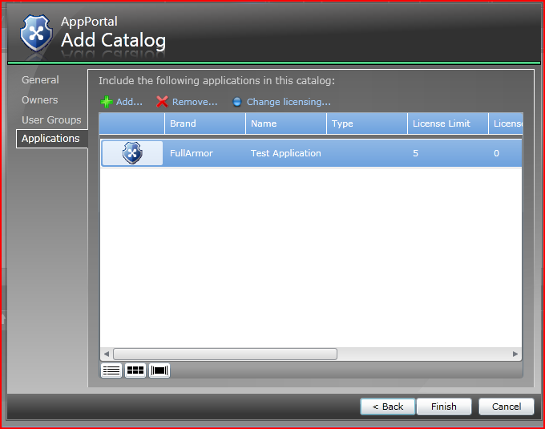

For the next part of the demonstration, we’ll log into AppPortal as a user and use self-service deployment to deploy the application that you uploaded. Click on “logout”.

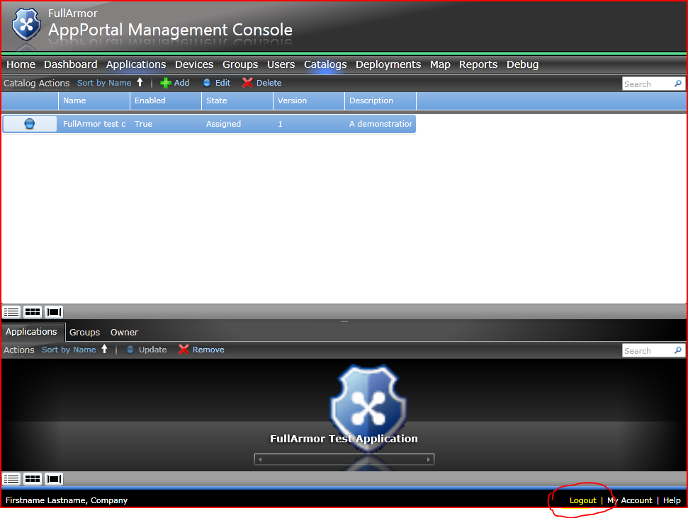

Next, we will install the agent on a device for an AppPortal user who wants to be able to deploy applications from AppPortal.

## Getting the latest AppPortal Agent bits

You can download the latest Agent installer using the following link:

<http://tinyurl.com/AppPortalAgents>

The following page is displayed:

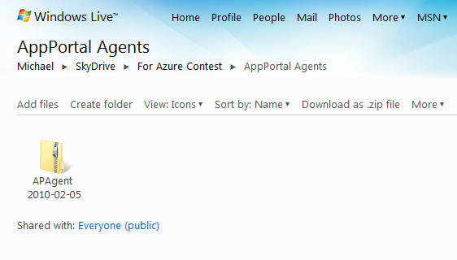

Click on the folder icon with the latest time stamp value. Then download the AppPortal Agents zip file.

## Selecting a end-point machine

AppPortal supports the following Windows operating system as endpoints:

* Windows XP
* Windows Vista
* Windows 7

## Running the Agent installer

Select the correct installer for your machine. **Use AppPortalInstaller_x64.msi** for 64-bit Windows, and **AppPortalInstaller_x86.msi** for 32-bit Windows.

Using an account that has rights to install software, run the Agent installer. There are no options to decide on when installing the Agent.

## Registering the Agent with AppPortal

Launch the Agent Console. From **Start Menu | All Programs**, open the **FullArmor AppPortal** folder and run **the Agent Portal Console**. The following screen is displayed:

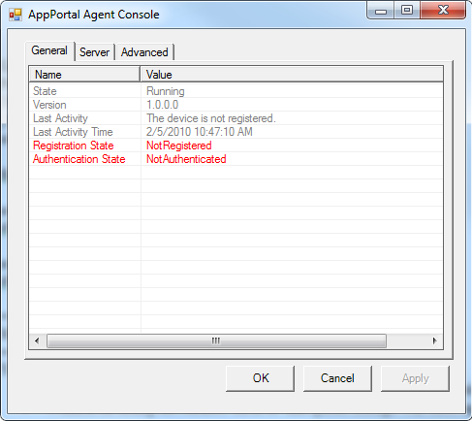

Select the **Server** tab. The following screen is displayed:

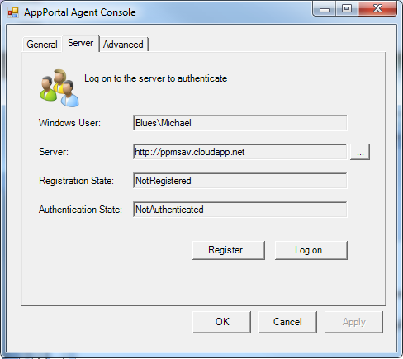

Hit the **Register** button. Doing so will bring up the Agent Registration wizard.

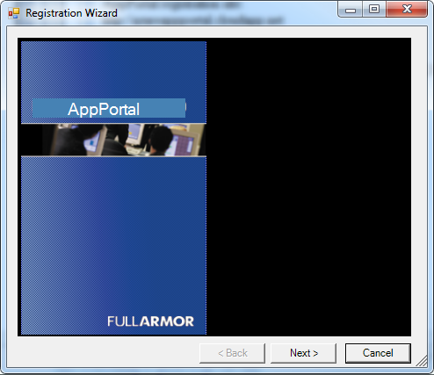

Hit **Next**.

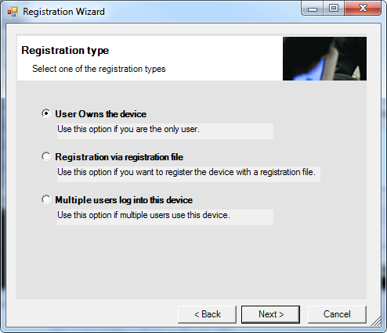

Select the first option: **User Owns the device**. Select **Next**.

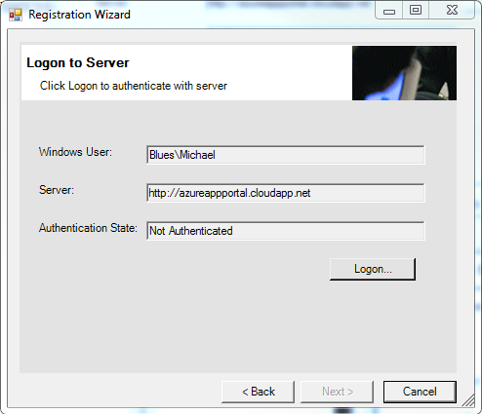

Hit the **Logon** button. A window is displayed allowing the user to authenticate using their Windows Live ID account.

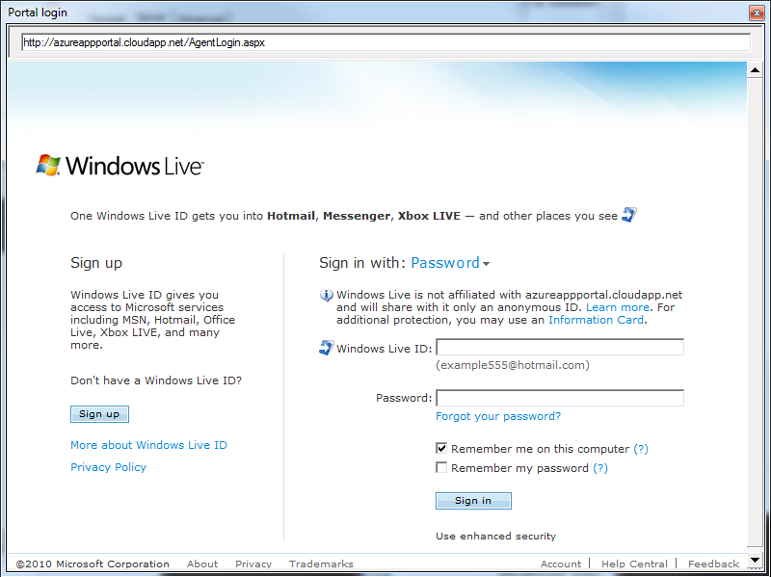

Log in with the AppPortal user account:

[azurecontestusr@hotmail.com](mailto:azurecontestusr@hotmail.com)

oberon!6

.

The Agent Registration Wizard responds with the following screen where the “Authentication State” is **Authenticated**:

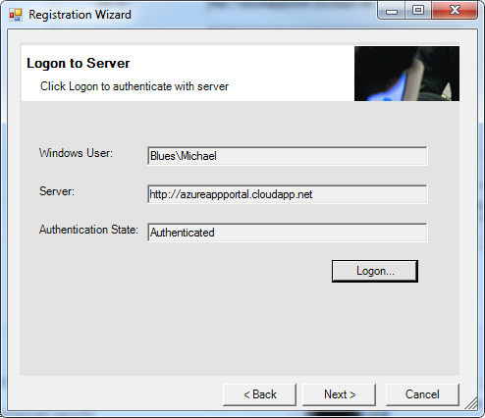

## Self Service Deployment

Navigate back to AppPortal <http://azureappportal.cloudapp.net> , then sign in using these credentials:

[azurecontestusr@hotmail.com](mailto:azurecontestusr@hotmail.com)

oberon!6

This will take you to the AppPortal user console, which looks like this:

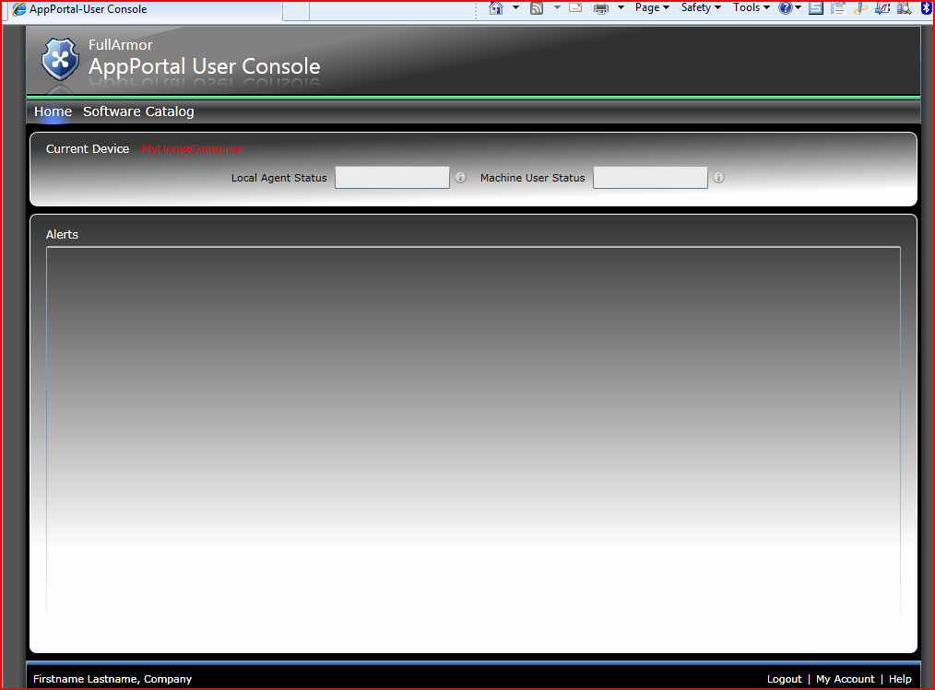

Click on “Software Catalog”. If the catalog doesn’t appear yet, use refresh (F5) in your browser to check for updates to the list.

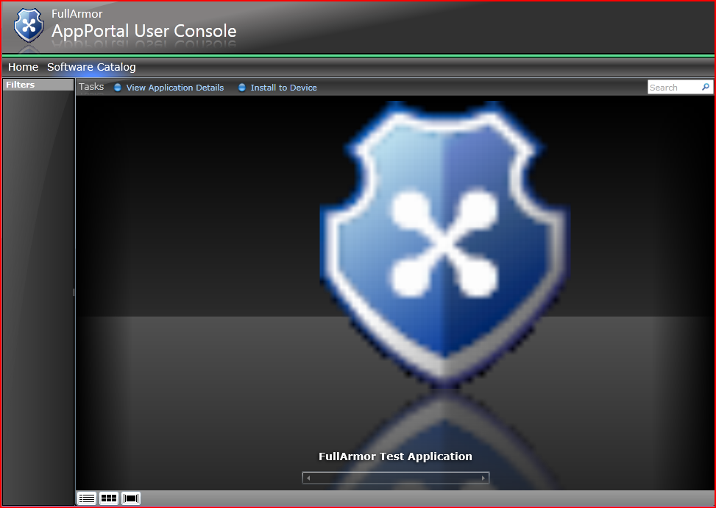

Select your application and then click “Install to Device”.

Within the next few minutes, the AppPortal agent will install the selected application.