______________________________________________________
Microsoft® System Center Essentials 2007 Overview
Beta 2 (September 2006)
Summary
Microsoft® System Center Essentials 2007 (Essentials 2007) is a new management solution in the System Center family of IT systems management products. Essentials is specifically designed for IT professionals working in midsize businesses who often face IT challenges similar to those of larger enterprises – troubleshooting end-user problems, automating management tasks, managing multiple systems, and diagnosing and resolving IT problems. This paper provides an overview of Essentials 2007, which is specifically designed and built to help IT professionals in midsize businesses address these management challenges.
Table of Contents
Overview 3
Unified Experience 3
Single Solution 3
Single Console 4
Proactive Management 6
Accelerates Troubleshooting and Problem Resolution 6
Automates System Updates and Data Collection 7
Increased Efficiency 8
Simple to Use 8
Simple to Deploy and Maintain 11
Next Steps 13

Overview
System Center is the Microsoft family of systems management products and solutions focused on providing IT professionals with the tools and knowledge to help manage their IT infrastructure. The System Center management tools and technologies help you make operations more efficient, reduce troubleshooting time, and improve your planning capabilities. Historically, the System Center products have been targeted at IT professionals working in larger enterprise IT environments, where specialization is the rule rather than the exception.
However, we recognize that things are different in the IT world of midsize businesses. Many IT pains that midsize businesses experience are related to IT management and include troubleshooting end-user problems, automating management tasks, managing multiple systems, and diagnosing and resolving IT problems. Most of these midsize organizations currently have to use a variety of tools to manage their IT environments. Most of these tools are “point” solutions rather than comprehensive management tools. Some of these tools are no more than re-packaged enterprise IT management tools, which can be complex and difficult to learn. Most IT professionals have little spare time to learn and take advantage of these enterprise tools. The tools that are fairly easy to use tend to be narrow in scope and limited in functionality. Based on this type of customer and partner feedback, Microsoft is developing System Center Essentials 2007 (Essentials 2007), a proactive and unified management solution that enables IT professionals in midsize organizations to more efficiently update, monitor, and troubleshoot their IT environments.
To help you directly address these pain points, Essentials 2007 provides:
- Proactive monitoring, troubleshooting and asset tracking to help keep your IT environment secure and up to date.
- A unified solution with a single console for managing your servers, clients, hardware, software, and IT services.
- Efficient execution of complex management tasks such as troubleshooting end-user issues, monitoring, and server and client software deployment

Unified Experience
Essentials 2007 provides a single solution with a single console for managing your servers, clients, hardware, software, and IT services for a more unified experience.

Single Solution
This unified approach helps optimize the experience of performing a broad set of tasks across your entire IT environment (see Figure 1). Essentials 2007 simplifies the complexity inherent in using multiple IT management tools or tools specifically designed for enterprise IT environments.
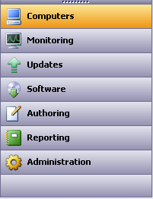
Figure 1

Unified Reporting
Unified reporting, based on the SQL 2005 reporting engine, is provided to help you easily run, review, save, print or e-mail information about the status of your IT environment. Essentials 2007 provides you with preconfigured reports upon installation to cover your reporting needs. These reports include asset inventory, status of your IT environment, capacity planning, software deployment, and update compliance. You can even configure Essentials 2007 to e-mail you a comprehensive daily status report first thing in the morning.

Expert Knowledge
With Essentials 2007, you get a breadth of expert knowledge for managing your important platforms, applications and workloads. This knowledge includes support and diagnostic information for Windows Server and Client operating systems, Active Directory, Office, Exchange, SQL, and IIS.

Single Console
Essentials 2007 provides a single console from which you can view and manage your servers, clients, hardware, software, and IT services.

Overview Pages
Many IT professionals currently have to open several different screens to check the overall state of their IT environment. The unified console provides single-screen overview pages with summary information, common tasks, alerts and reports, allowing you to quickly check the status of your IT environment (see Figure 2).
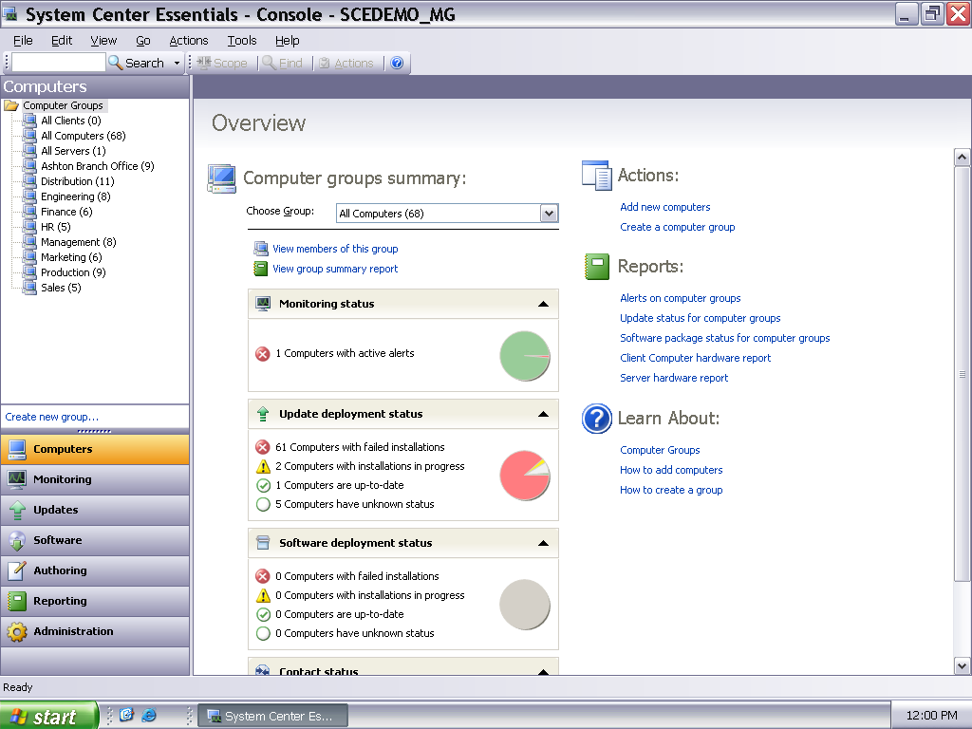
Figure 2
From these pages, you can quickly get status information to fix any IT issues you might see. Logically organized “spaces” or panes have been created for each management area. You can also customize the views to suit your needs. Diagram views of your IT environment are also provided, from which you can perform tasks or get more detailed information (see Figure 3).

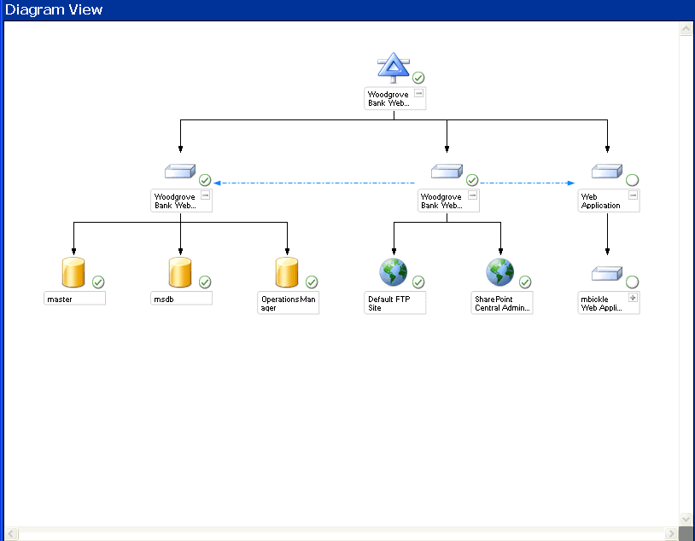
Figure 3

Central Distribution of Updates and Software
Using the same central console from which you monitor your IT environment, you can assess, configure and distribute updates, and install software to groups and computers you want to target.

Proactive Management
System Center Essentials 2007 enables you to proactively manage your IT environment, keeping your system up to date with tools that accelerate problem resolution and enable automation of system updates and data collection.

Accelerates Troubleshooting and Problem Resolution
Troubleshooting end-user issues can be frustrating and time-consuming without adequate tools and diagnostic information. Sometimes, little problems become big issues before you are notified so you can begin investigating the cause of the problem. Essentials 2007 is a self-managing solution that notifies you as soon as a problem occurs, then helps you proactively diagnose and fix it, accelerating problem resolution.

Integrated Troubleshooting
Many IT professionals find troubleshooting very time-consuming and manual. This task is often performed over the phone, via e-mail or using Remote Desktop Connection. Essentials 2007 enables you to receive notification of any problems and troubleshoot more efficiently and effectively by offering integrated problem resolution for clients, servers and services.like Exchange Server.
With Essentials 2007, you get:
- Support and diagnostic information for Windows server and client operating systems, Active Directory, Office, Exchange, SQL, IIS, DPM, and CRM
- Definitive information right in the console that will help you prevent and solve problems with your IT resources
- In-line links to click and “fix it now”
- Notification of problems via e-mail, pager, or SMS text message

Self-managing
Essentials 2007 is a self-managing solution that can alert you to performance problems or when updates are required for your IT environment. Essentials 2007 automatically checks for new updates available and applicable to your IT environment and provides notification and access reports on update deployment progress to help you quickly troubleshoot any update deployment issues.

Automates System Updates and Data Collection
Essentials 2007 automates system updates and data collection for your IT environment, so it’s more secure and up to date.

Secure and Up To Date
Upon installation, Essentials 2007 allows you to immediately assess, configure and patch your IT environment without interrupting your users or network service. The provided configuration wizard allows you to easily set the update behavior for clients and servers on your network. You can define update parameters, such as which products to patch and types of updates to push out, or simply install immediately “on demand.” Essentials 2007 also supports automatic deployment of updates for Microsoft operating systems, hardware updates, drivers, and software applications–both Microsoft and non-Microsoft. Because Essentials 2007 checks for new updates applicable to your environment and provides notifications, you can make appropriate and timely update decisions.

Asset Visibility and Inventory
Essentials 2007 automates the collection of software and hardware inventory so you can review assets for optimum configuration and compliance. You can perform searches, filter, and run reports on your inventory to generate updated lists of all installed software applications and hardware inventory attributes for compliance and inventory reports. Inventory is also visible to you “in context” within the management console, to help you in troubleshooting and diagnostic decision-making situations (see Figure 4).
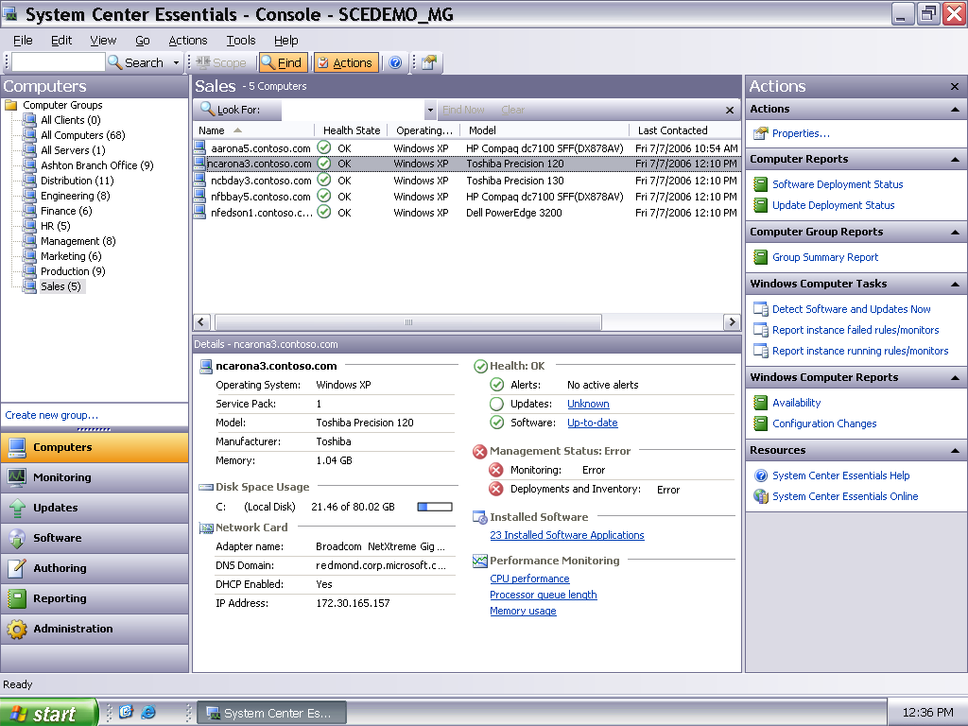
Figure 4

Increased Efficiency
Essentials 2007 is easier to deploy and maintain, helping simplify complex management tasks for increased IT efficiency. So, you can more efficiently perform management tasks like troubleshooting end user issues, monitoring, and server and client software deployment.

Simple to Use
Essentials 2007 simplifies complex management tasks, such as packaging and deploying software, Web site monitoring and configuring policies.

Easy Update Configuration
The provided update configuration wizard allows you to easily set the update behavior for clients and servers on your network. You can define update parameters for which products to patch and types of updates to push out, or simply install immediately “on demand.” Using the wizard, you can quickly and correctly set the initial update configuration for your IT environment by entering the following information:
- Enter your proxy information (for example, Port 80)
- Select the applications and versions you want to update, such as Exchange 2000, Office XP, Windows XP SP2, and so on
- Select language or languages for your updates
- Select types of updates you want, like critical security updates
- Select download, install and approval preferences
Once updates are configured, you can manually or automatically deploy updates for Microsoft operating systems, hardware updates, third-party updates, drivers, and Microsoft and non-Microsoft software applications to more effectively manage the security of your IT environment (see Figure 5).
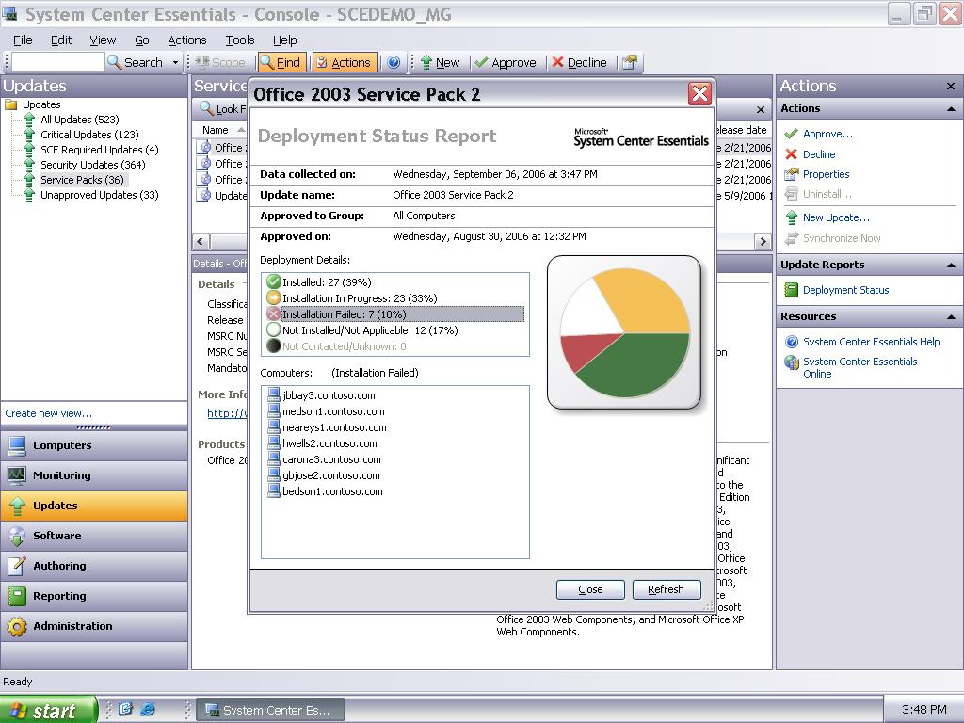
Figure 5

Simple Software Deployment
A simple wizard quickly steps you through the process of deploying software by creating a package and targeting installation on clients and servers in your network. You can deploy MSI (Microsoft Installer) and non-MSI applications, drivers, Microsoft and non-Microsoft QFEs. You can accurately target your software installations by grouping computers and defining command-line configurations. You don’t have to create a “snapshot” of an install image on a separate computer or use complicated command-line syntax to designate a silent install as you do with some IT management tools. Using the wizard, you can simply browse to an .msi or .exe package, walk through a three-step process, and deploy it to clients and servers in your IT environment. The wizard takes care of the complex parts of the process while allowing you to specify where the software is installed, set an install deadline, track progress or troubleshoot the installation (see Figure 6).
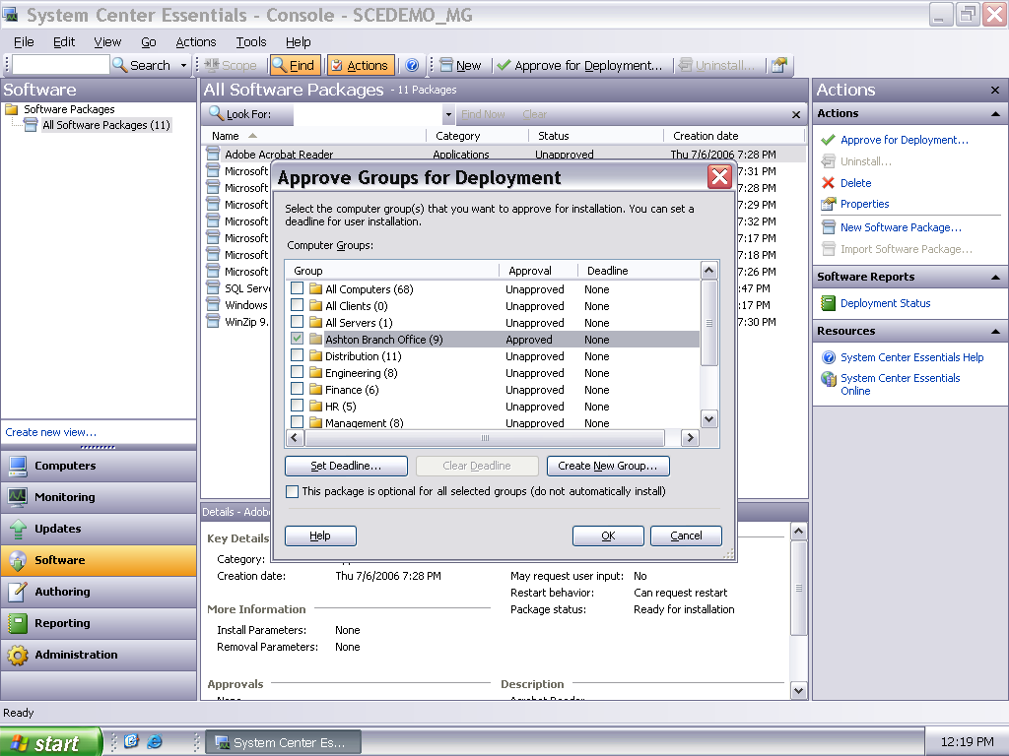
Figure 6

Simple to Deploy and Maintain
Essentials 2007 uses simple wizards to help you quickly deploy the product and configure security settings, group policy, updates and discover assets.

Quick Product Install and Configuration
Using a simple installation wizard, you can be up and running in less than an hour (see Figure 7). There is no need to worry about configuring Group Policy, installing databases, or configuring security settings. More specifically, during installation and setup:
- Group Policy is created and configured
- Certificates are configured and deployed automatically
- SQL Server 2005 Express, with reporting, is installed by default unless you select an existing SQL Server 2005 database to use
Also, if you’re currently using Windows Server Update Services, MOM 2005, or MOM 2005 Workgroup Edition, you can easily upgrade and migrate to Essentials 2007. Windows Server Update Services will automatically be upgraded during installation.
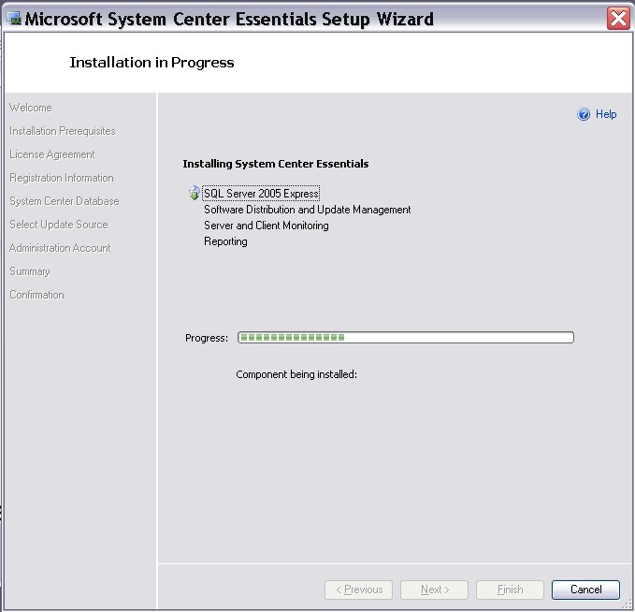
Figure 7

Automatic Discovery of Computers and Devices
The Computer and Device Management Wizard quickly steps you through the process of selecting the computers and devices to be managed in your IT environment (see Figure 8). As new clients or other machines come online, like a new laptop joining your domain, you can select to have Essentials 2007 start managing it right away.

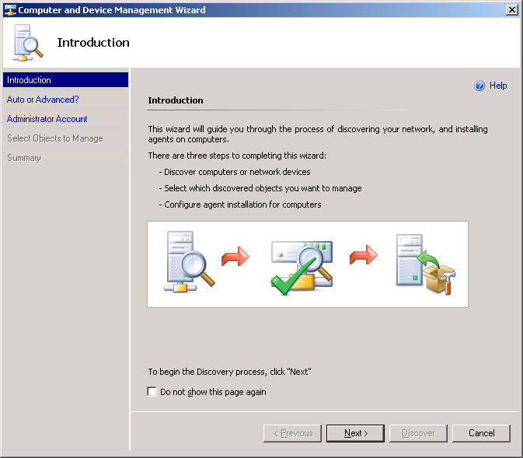
Figure 8

Customized Monitoring
You can add monitoring without being an expert by using provided templates. For example, using the provided wizard, you can create monitoring for your Web site, database or file share. You can also custom-configure monitoring options to suit the organization of your IT environment by business unit, location, and/or job function.

Next Steps
If you are an IT professional working in a midsize business and experiencing challenges with troubleshooting end-user problems, automating management tasks, managing multiple systems, and diagnosing and resolving IT problems, then Essentials 2007 can help you address those challenges. Designed from the ground up for your environment and specific management needs, System Center Essentials 2007 provides a more unified management experience because it enables you to better secure, update, monitor and troubleshoot from a single console, so you can efficiently and proactively manage your IT environment. To get the latest product information and download System Center Essentials 2007 Beta 2, please visit http://www.microsoft.com/sce .

