# Microsoft® Hohm™ Fact Sheet for Utilities

**June 2009**

**What is Microsoft Hohm?**

Microsoft Hohm is a free online beta application that helps customers save energy and money. With Microsoft Hohm customers can better understand their usage, get recommendations and start saving. As with any recommendation engine, Microsoft Hohm will provide increasingly more accurate and relevant suggestions for energy conservation as its users contribute home energy input and feedback.

Hohm uses advanced analytics licensed from Lawrence Berkeley National Laboratory and the U.S. Department of Energy to give customers highly personalized energy-saving recommendations. These recommendations are tailored to customers’ specific household circumstances, including home features and use of appliances and systems. Customers will also be able to compare their energy usage with that of others in their area. In this beta version, the Microsoft Hohm team will learn from its users and communities and will make improvements to the site and analytics. Hohm helps utilities better serve their customers by providing clear insight into energy consumption, allowing them to make more informed decisions to help save energy and money.

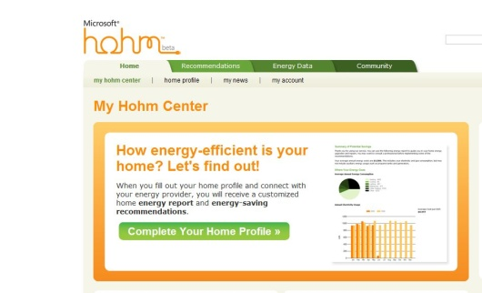**How does Microsoft Hohm work?**After signing up for Microsoft Hohm with their Windows Live ID and postal code, customers simply enter some information about their home (occupants, appliances and systems) and receive their energy report with personalized recommendations. The more information they provide, the more accurate and relevant the recommendations will be. As a default, Hohm will base its recommendations on local and national averages.

Alternatively, customers who use one of the Hohm-partnered utility companies can choose to automatically upload their energy usage data into the application in the near future.

The Microsoft Hohm recommendations will also be refined as the beta application evolves with feedback from users, their communities and the energy industry.

**What is the relationship between Microsoft Hohm and the utility company?**Microsoft Hohm partners with utilities around the country to make it easier for consumers to access their energy usage data. Customers of a Hohm-partnered utility company can choose to automatically upload their energy usage data into the application via a security-enhanced protocol. They can access their historical usage and tariff information from their local utility to help maximize the accuracy and effectiveness of the application.

Using Microsoft Hohm can help utilities meet the increasing regulatory requirements for energy conservation by promoting utility conservation programs with customers. Utilities can also leverage Hohm to encourage customers reduce or spread their energy consumption during peak periods. Microsoft Hohm helps utilities demonstrate their environmental responsibility.

**How does Microsoft Hohm compare to the energy-saving recommendation applications that utilities provide?**

Many utilities already have their own recommendation applications, and others have plans to deploy them soon. Microsoft Hohm offers a choice to users as to how they track and manage their energy usage as well as obtain recommendations. This choice is analogous to the banking industry, where most banks have their own account management experiences for customers via the bank Web site, and choose to support third-party applications through automated data feeds.

According to a recent utility consumer survey from Gartner Inc. (conducted with households in the U.S. and U.K.), 80 percent of consumers in the U.S. would participate in an energy program if one were offered by providers. Microsoft Hohm looks forward to partnering with utilities and together offering the anticipated value to consumers. (“Utility Consumer Survey: Energy Efficiency, Do They Care and Why?” Zarko Sumic, May 6, 2009)

**What is the anticipated impact of Microsoft Hohm on the utility conservation programs?**

Microsoft Hohm is a low-cost way for utilities to help achieve their conservation goals put in place by local utilities and regulators. Specifically, Hohm will enable partner utilities to monitor reported changes their customers make and the resulting impact on their energy consumption. Utilities can also leverage Microsoft Hohm to promote their rebate and conservation programs.

**On average, how much money will Microsoft Hohm help consumers save on their energy bills?**

The financial savings varies widely based on the information customers provide on their Microsoft Hohm profile, the characteristics of their household and the changes they implement. Customers are encouraged to run the Hohm application to determine the potential savings for their household. Note that this beta version of Hohm will be evolving over time, so initial recommendations may not optimal.

**How can I get Microsoft Hohm?**

Hohm is an online Microsoft application available at no cost to anyone in the United States with Internet access and a modern Internet browser (e.g., Internet Explorer 7 or later, Firefox, Safari). It can be accessed from the Web site at [www.microsoft-hohm.com](http://microsoft-hohm.com).

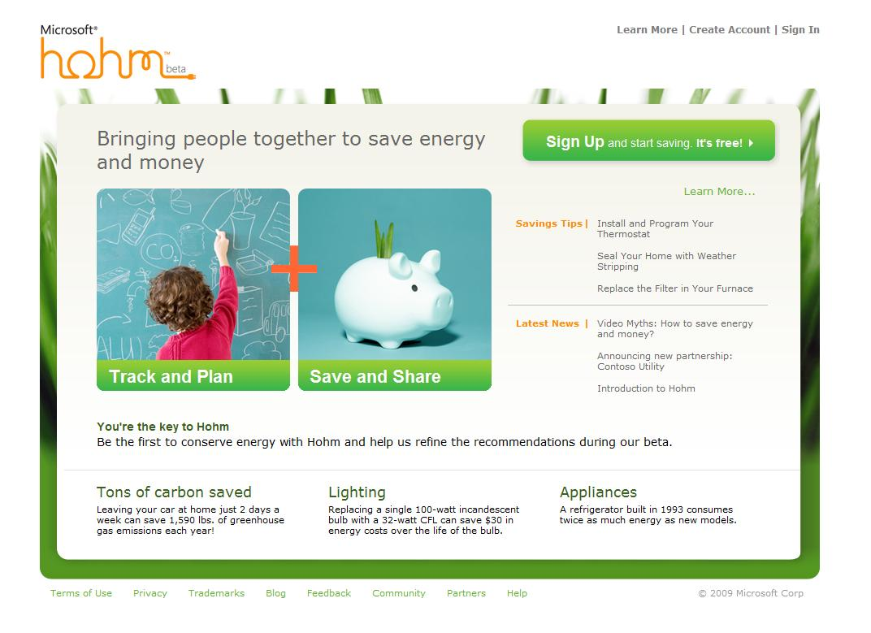

**Who is Microsoft Hohm for? Who do you expect will find it useful?**

Microsoft Hohm is for any residential consumers of energy wishing to save money and reduce their impact on the environment.

For more information contact us at [hohmutil@microsoft.com](mailto:hohmutil@microsoft.com).

For press only: Rapid Response Team, Waggener Edstrom Worldwide, (503) 443-7070, [rrt@waggeneredstrom.com](mailto:rrt@waggeneredstrom.com)

This document describes a preliminary release of a program that bears the name Microsoft Hohm. Information in this document is subject to change without notice and is provided for informational purposes only. Microsoft Corp. makes no warranties, either express or implied. Provision of third-party products, services, content or sites does not imply Microsoft’s endorsement thereof.

© 2009 Microsoft Corp. All rights reserved.