
Customer: Vielife
Web Site: www.vielife.com
Country or Region: United Kingdom
Industry: Professional Services

Customer Profile
Vielife, based in the United Kingdom, provides health and well-being consultancy. Its clients include a number of high-profile public and private sector organisations.

Software and Services
- Microsoft Server Product Portfolio
- Windows Server 2003
- Technologies
- Microsoft .NET Framework 3.0
For more information about other Microsoft customer successes, please visit: www.microsoft.com/resources/casestudies
Based in the United Kingdom, Vielife provides a unique health service to enterprises and individuals worldwide. It’s Web-based offering reports on health problems, weaknesses, or trends and provides the tools to best address them. To improve its services and make better use of employees’ time, Vielife deployed the Windows® platform. Vielife now delivers greater business value faster and is much more responsive to customer needs.

Business Needs
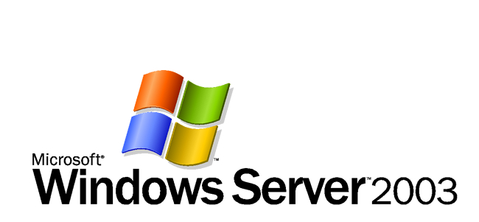

Vielife online health and wellbeing assessment and behaviour change tools provide preventative steps through engaging reports and recommendations. It develops and implements health programmes to position its clients as an employer or healthcare provider of choice.

To achieve this, the Vielife research team, until recently, would gather and analyse large amounts of client data received through customers completing online forms. The team would then produce reports on the overall health of a company and its population. These reports are a vital part of the Vielife offering.

The company’s mixture of existing systems and manual processes, however, was complicating the reporting process. Vielife required a solution that could refresh the underlying technology architecture to facilitate a completely automated analysis of data across an organisation.

For this reason, Vielife began specifying its automated reporting system in early 2006. Damian Stafford, Chief Technology Officer, Vielife, says: “Our core business offering was already performing very well. We didn’t want to change the product, just carry on improving it.

“Extending the automation of our reporting to clients would help us produce reports faster and with more accuracy, freeing our research staff to contribute to our goals in ways more sophisticated than simply producing reports. We needed managed rules to drive analytical processes and shape how we reported on data, as well as to improve the look, feel, and design of our reports.”

Solution
After evaluating a number of solutions on the market, including Linux, Vielife decided to create a new infrastructure based on Microsoft® technologies. To gain more control over its system and the ability to adapt it as necessary, Vielife deployed Microsoft .NET Framework 3.0 as the basis for a new development environment.

“We sought a highly personalised user experience and the end-to-end integration of back-office tools that manage workflow and rules,” Stafford says. “This is easily achieved using Windows owing to the prevalence of its Office toolset and the familiarity of business users with those tools. Because of this, Microsoft was selected ahead of Linux and other solution providers.” The Windows .NET platform allows Web services to be created and exposed more easily and faster than on other platforms. This makes integration with customers’ systems more cost effective.

“We’ve found .NET to be a very reliable framework with which to create our own functionality,” Stafford says. “And our automated reporting process uses some of the new features in the 2007 Microsoft Office system, using the new XML capabilities of Microsoft Word® to deliver and present data straight into Word so that business users can work with it using tools they’re familiar and comfortable with.”

Because the rules-based system can be edited in a simple spreadsheet, users can change the system behaviour and the content provided by the automated reporting system. “Most people in our office are familiar with Microsoft technology,” Stafford says. “So we have integrated Microsoft end-user tools with our processes. What’s more, our market has a high level of confidence in businesses that use systems based on Windows.”
Benefits
Since Vielife has moved to a platform based on Windows, it has built a robust and flexible environment. The technology is familiar to employees—speeding up adoption time and increasing productivity. By automating many of the manual tasks associated with data gathering, the .NET environment shortens the time it takes to create reports for customers. “The existing usability of the Microsoft product range and the changes made in the 2007 Microsoft Office system make it quite compelling technology,” Stafford says. “The software modules in .NET are really good, too. It has matured nicely as a software platform.”

- Automated solution means the business completes tasks in minutes instead of days.
- Rapid creation of reports for customers with reduced risk of manual error.
- Improved integration with customer systems helps boost customer service.
- System capable of meeting the company’s future needs.
- Seamless integration with other Microsoft tools saves development time and costs.
- Reliable performance achieves availability target of 99 per cent each month in 2006.
- Improved support for Web services helps customers interact with the group with ease.
- Add greater value to client reports by providing more in-depth analysis.
- System is flexible for high responsiveness to market needs and delivers a highly personalised user experience.
- High adaptability meets the specific needs of clients and clients’ users.

