

Step-by-Step Guide for Creating and Testing Connection Manager Profiles in a Test Lab
Microsoft Corporation
Published: May, 2005
Author: Microsoft Corporation

Abstract
This guide describes how to create and test Connection Manager profiles for connections that use dial-up over a modem, virtual private network (VPN) connections with Point-to-Point Tunneling Protocol (PPTP), VPN with Layer Two Tunneling Protocol and Internet Protocol security (L2TP/IPsec), and VPN with Extensible Authentication Protocol (EAP) in a test lab using five computers. This guide offers only step-by-step procedures, not a conceptual overview. It is intended for enterprise-level administrators who have experience managing remote access connections, administering the Active Directory® directory service, and operating a test lab.

Information in this document, including URL and other Internet Web site references, is subject to change without notice. Unless otherwise noted, the example companies, organizations, products, domain names, e-mail addresses, logos, people, places, and events depicted herein are fictitious, and no association with any real company, organization, product, domain name, e-mail address, logo, person, place, or event is intended or should be inferred. Complying with all applicable copyright laws is the responsibility of the user. Without limiting the rights under copyright, no part of this document may be reproduced, stored in or introduced into a retrieval system, or transmitted in any form or by any means (electronic, mechanical, photocopying, recording, or otherwise), or for any purpose, without the express written permission of Microsoft Corporation.

Microsoft may have patents, patent applications, trademarks, copyrights, or other intellectual property rights covering subject matter in this document. Except as expressly provided in any written license agreement from Microsoft, the furnishing of this document does not give you any license to these patents, trademarks, copyrights, or other intellectual property.

© 2005 Microsoft Corporation. All rights reserved.

Microsoft, Active Directory, Windows, and Windows Server are either registered trademarks or trademarks of Microsoft Corporation in the United States and/or other countries.

All other trademarks are property of their respective owners.

Contents
Step-by-Step Guide for Creating and Testing Connection Manager Profiles in a Test Lab 7
Configuring the Lab for Testing Connection Manager Profiles 7
DC1 9
IAS1 20
IIS1 23
VPN1 25
CLIENT1 28
Configuring and Testing a Dial-Up Profile 29
DC1 29
IAS1 30
IIS1 31
VPN1 36
CLIENT1 53
Configuring and Testing a PPTP Profile 58
DC1 58
IAS1 59
IIS1 60
VPN1 61
CLIENT1 70
Configuring and Testing an L2TP/IPsec Profile 73
DC1 73
VPN1 78
IAS1 81
CLIENT1 81
Configuring and Testing an EAP-TLS Profile 83
DC1 83
IAS1 84
VPN1 85
CLIENT1 88
Summary 90
See Also 90

Step-by-Step Guide for Creating and Testing Connection Manager Profiles in a Test Lab
This guide describes how to create and test Connection Manager profiles for connections that use dial-up over a modem, virtual private network (VPN) connections with Point-to-Point Tunneling Protocol (PPTP), VPN with Layer Two Tunneling Protocol and Internet Protocol security (L2TP/IPsec), and VPN with Extensible Authentication Protocol-Transport Level Security (EAP-TLS) in a test lab using five computers. This guide offers only step-by-step procedures, not a conceptual overview. It is intended for enterprise-level administrators who have experience managing remote access connections, administering the Active Directory® directory service, and operating a test lab.
Note:
The following instructions describe configuring a test lab to test the relevant scenarios. To clearly separate the services provided on the network and to show the desired functionality, you need a minimum of four servers.
In addition, these test lab configurations reflect neither best practices nor a desired or recommended configuration for a production environment. For example, the test lab uses the same computer as a domain controller, a Domain Name System (DNS) server, and a Dynamic Host Configuration Protocol (DHCP) server. In a production environment, you should not run other services on a domain controller. These test lab configurations, including IP addresses and all other configuration parameters, are designed to work only on a test lab network.

Configuring the Lab for Testing Connection Manager Profiles
To follow the steps in this guide, you will need to configure five computers in a specific topology. Each computer in the lab has specific hardware and operating system requirements, which are specified in the subsections below.
To set up this test lab, you will need the following hardware and software.
• Four computers that are capable of running the 32-bit versions of the Microsoft® Windows® Server™ 2003 with Service Pack 1 (SP1) operating system.
• One server, named DC1, will be the domain controller.
• One server, named IAS1, will be the RADIUS server.
• One server, named IIS1, will be the Web and file server.
• One server, named VPN1, will be the Routing and Remote Access server. This server must also have two network adapters, a modem and a floppy disk drive or USB port that supports a USB flash drive.
• One computer, named CLIENT1, that is capable of running Microsoft Windows XP Professional with Service Pack 2 (SP2) and that has a modem and a floppy disk drive or a port that supports a USB flash drive.
• Two network hubs or Layer 2 switches.
• One operating system disc for Windows Server 2003 with SP1, Enterprise Edition.
• Three operating system discs for Windows Server 2003 with SP1, Standard Edition.
• One operating system disc for Windows XP Professional with SP2.
The following figure shows the network topology for this lab.
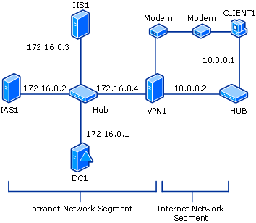

As shown in this figure, one segment of the test lab network represents a corporate intranet, and another segment represents the Internet. Connect all computers on the intranet segment to a common hub or Layer 2 switch. Connect all computers on the Internet segment to a separate common hub or Layer 2 switch.
In addition, Windows Firewall is set up and configured on the computer acting as the Remote Authentication Dial-In User Service (RADIUS) server (IAS1), the Web and file server (IIS1), and the client computer (CLIENT1). Windows Firewall should not be turned on or configured on either the domain controller (DC1) or the VPN server (VPN1). On the VPN server, the Windows Firewall/Internet Connection Sharing (ICS) service should be disabled.
The following subsections describe how you will set up the basic infrastructure. To reconstruct this test lab, configure the computers in the order presented. Additional sections of this guide describe the specific configuration steps required for testing dial-up, PPTP, L2TP/IPsec, and EAP-TLS connections.

DC1
As part of setting up the basic infrastructure for the test lab, configure DC1 as the domain controller, the DNS server, and the DHCP server for a domain that is named example.com.
Perform basic installation and configuration on DC1
1. Install Windows Server 2003 with SP1, Enterprise Edition, and configure the computer as a stand-alone server named DC1.
2. Configure the connection to the intranet segment with the IP address of 172.16.0.1 and the subnet mask of 255.255.255.0.
Configure DC1 as a domain controller
1. To start the Active Directory Installation Wizard, click Start, click Run, type dcpromo.exe, and then click OK.
2. In the Welcome to the Active Directory Installation Wizard dialog box, click Next.
3. In the Operating System Compatibility dialog box, click Next.
4. Verify that Domain controller for a new domain option is selected, and then click Next.
5. Verify that Domain in a new forest is selected, and then click Next.
6. Verify that No, just install and configure DNS on this computer is selected, and then click Next.
7. On the New Domain Name page, type example.com, and then click Next.
8. On the NetBIOS Domain Name page, confirm that the Domain NetBIOS name is EXAMPLE, and then click Next.
9. Accept the default Database and Log Folders directories, as shown in the following figure, and then click Next.
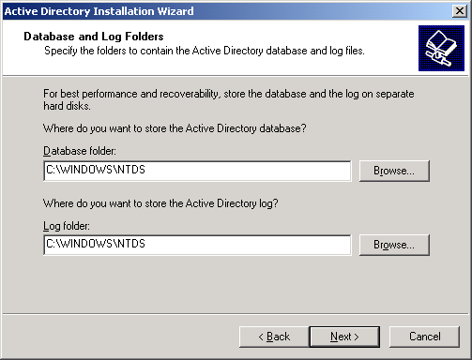

10. In the Shared System Volume dialog box, shown in the following figure, verify that the default folder location is correct. Click Next.
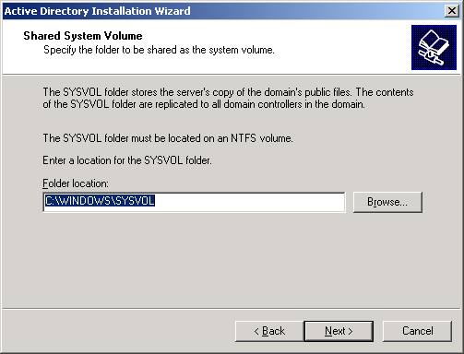

11. On the Permissions page, verify that the Permissions compatible only with Windows 2000 or Windows Server 2003 operating systems check box is selected, as shown in the following figure. Click Next.
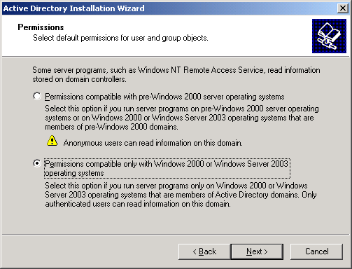

12. On the Directory Services Restore Mode Administration Password page, leave the passwords blank, and then click Next.
13. Review the information on the Summary page, and then click Next.
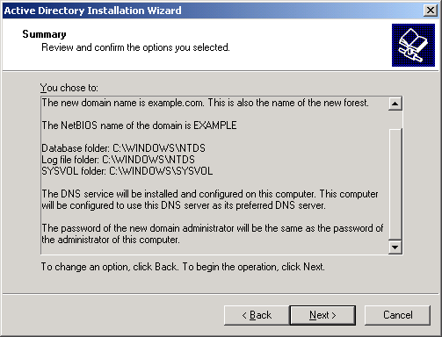

14. On the Completing the Active Directory Installation Wizard page, click Finish.
15. When prompted to restart the computer, click Restart Now.
Raise the domain functional level
1. Open the Active Directory Domains and Trusts snap-in from the Administrative Tools folder, and then right-click the domain computer dc1.example.com.
2. Click Raise Domain Functional Level, select Windows Server 2003 on the Raise Domain Functional Level page, and then click Raise, as shown in the following figure.
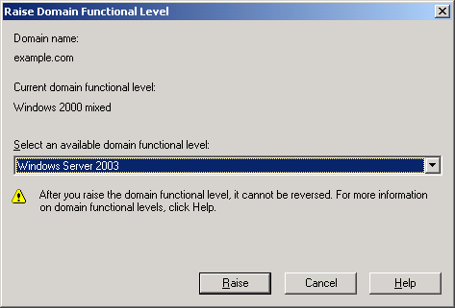

Install and configure DHCP
1. In Control Panel, double-click Add or Remove Programs, and then install DHCP as a Networking Services component.
2. Open the DHCP snap-in from the Administrative Tools folder.
3. Click Action, and then click Authorize to authorize the DHCP service.
4. In the console tree, right-click dc1.example.com, and then click New Scope.
5. On the Welcome page of the New Scope Wizard, click Next.
6. On the Scope Name page, type CorpNet in Name. This is shown in the following figure.
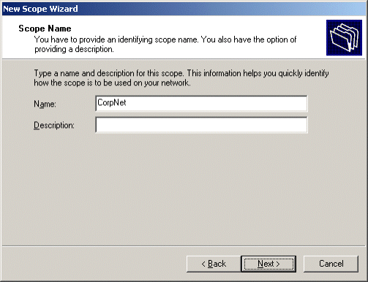

7. Click Next. On the IP Address Range page, type 172.16.0.10 in Start IP address, type 172.16.0.100 in End IP address, and then type 24 in Length. This is shown in the following figure.
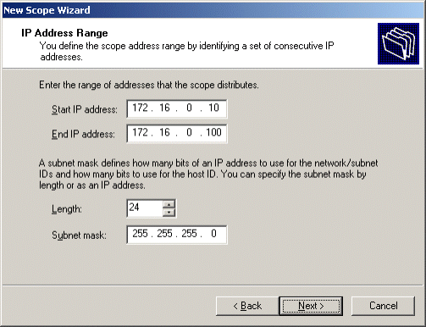

8. Click Next. On the Add Exclusions page, click Next.
9. On the Lease Duration page, click Next.
10. On the Configure DHCP Options page, click Yes, I want to configure these options now. This is shown in the following figure.
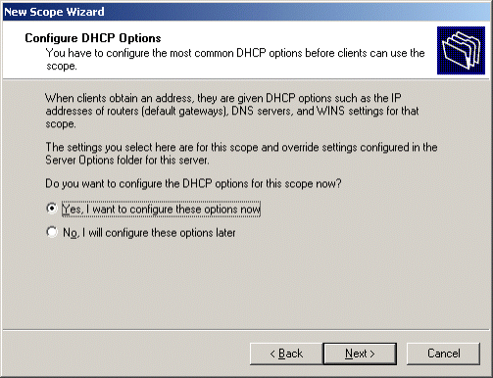

11. Click Next. On the Router (Default Gateway) page, click Next.
12. On the Domain Name and DNS Servers page, type example.com in Parent domain. Type 172.16.0.1 in IP address, and then click Add. This is shown in the following figure.
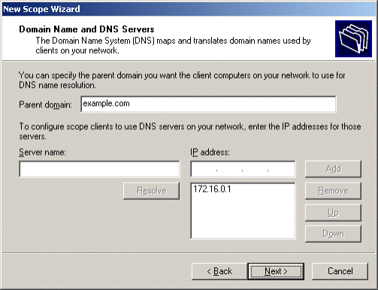

13. Click Next. On the WINS Servers page, click Next.
14. On the Activate Scope page, click Yes, I want to activate this scope now. This is shown in the following figure.
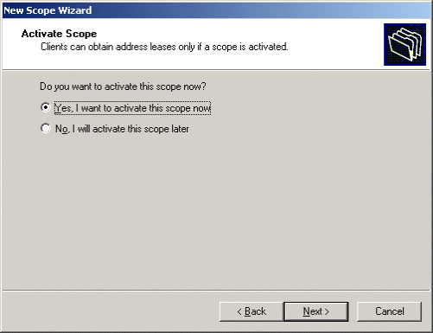

15. Click Next. On the Completing the New Scope Wizard page, click Finish.
Add computers to the domain
1. Open the Active Directory Users and Computers snap-in.
2. In the console tree, double-click example.com.
3. Right-click Users, point to New, and then click Computer.
4. In the New Object – Computer dialog box, type IAS1 in Computer name, and then click Next.
5. In the Managed dialog box, click Next.
6. In the New Object – Computer dialog box, click Finish.
7. Repeat steps 3 through 6 to create additional computer accounts for IIS1 and VPN1.

IAS1
As part of setting up the basic infrastructure for the test lab, configure IAS1 as the RADIUS server that provides authentication, authorization, and accounting for VPN1.
Perform basic installation and configuration on IAS1
1. Install Windows Server 2003 with SP1, Standard Edition, and configure the computer as a member server named IAS1 in the example.com domain.
2. For the intranet local area connection, configure the TCP/IP protocol with the IP address of 172.16.0.2, the subnet mask of 255.255.255.0, and the DNS server IP address of 172.16.0.1.
Install and configure Internet Authentication Service
1. In Control Panel, double-click Add or Remove Programs, click Add/Remove Windows Components, and then install Internet Authentication Service (IAS) as a subcomponent of Networking Services.
2. Click Start, point to Administrative Tools, and then click Internet Authentication Service.
3. Right-click Internet Authentication Service, and then click Register Server in Active Directory.
4. When the Register Internet Authentication Server in Active Directory dialog box appears, click OK.
5. When the Server registered dialog box appears, click OK.
6. In the console tree, right-click RADIUS Clients, and then click New RADIUS Client.
7. On the Name and Address page of the New RADIUS Client wizard, type VPN1 in Friendly name, type 172.16.0.4 in Client address (IP or DNS), and then click Next.
8. On the Additional Information page, type the same shared secret for VPN1 in both Shared secret and in Confirm shared secret.
9. Click Finish.
Configure Windows Firewall on IAS1
1. In Control Panel, double-click Windows Firewall.
2. In the Windows Firewall dialog box, click the Exceptions tab.
3. Click Add Port, and in the Add a Port dialog box add the following port exceptions.

Name | Port Number | Protocol
Legacy RADIUS | 1645 | UDP
Legacy RADIUS | 1646 | UDP
RADIUS Accounting | 1812 | UDP
RADIUS Authentication | 1813 | UDP

Note:
You must click Add Port on the Exceptions tab for each port exception.
4. Verify that the four port exceptions you added are selected on the Exceptions tab, as shown in the following figure.
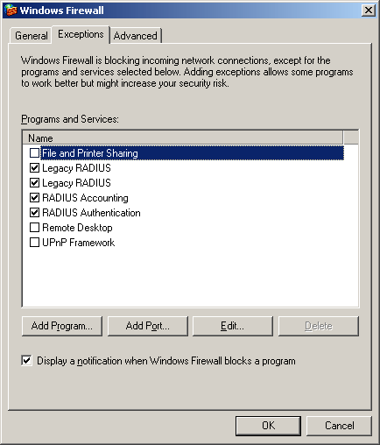

5. Click the Advanced tab, and then click Settings for Security Logging.
6. In the Log Setting dialog box, select Log dropped packets and Log successful connections. Note the path and file name in Name.
Please refer to the log file in case you need to add more ports to the exception list. The log file also allows you to view packets dropped by Windows Firewall and successful TCP connections.
7. Click OK twice to close Windows Firewall.

IIS1
As part of setting up the basic infrastructure for the test lab, configure IIS1 as a Web server and a file server for the example.com domain.
Perform basic installation and configuration on IIS1
1. Install Windows Server 2003 with SP1, Standard Edition, and configure the computer as a member server named IIS1 in the example.com domain.
2. Configure the connection to the intranet segment with the IP address of 172.16.0.3, the subnet mask of 255.255.255.0, and the DNS server IP address of 172.16.0.1.
Install and configure IIS
1. Install Internet Information Services (IIS) as a subcomponent of the Application Server component.
2. Create a file in Notepad that contains the text shown in the following figure.
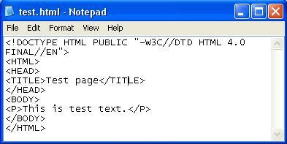

3. Save the file as C:\inetpub\wwwroot\test.html, where C is the drive on which the operating system is installed.
4. Right-click test.html in the inetpub\wwwroot folder, and then click Properties.
5. Click the Security tab, and then click Add.
6. Click Locations, select IIS1, as shown in the following figure, and then click OK.
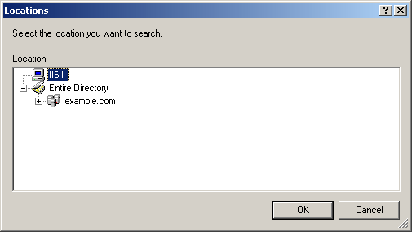

7. In the Select Users or Groups dialog box, type Users, and then click Check Names. Check Names should find the user IIS1\Users, as shown in the following figure.
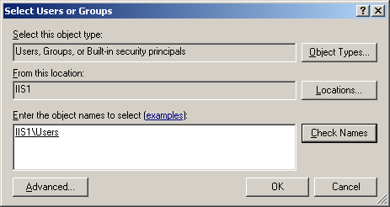

8. Click OK.
9. Accept the default Permissions, and then click OK again.
10. Start Internet Explorer on IAS1. If the Internet Connection Wizard prompts you, configure Internet access through a LAN connection.
11. In Internet Explorer, type http://IIS1.example.com/test.html in Address. You should see the text that you specified in the body of your text file: This is test text.
Configure a shared folder on IIS1
1. On IIS1, use Windows Explorer to create a new share for the root folder of the C drive using the share name ROOT with the default permissions, where C is the drive on which your operating system is installed.
2. To determine whether file sharing is working correctly, on IAS1, click Start, click Run, type \\IIS1\ROOT, and then click OK. You should see the files in the root folder of the C drive on IIS1.
Configure Windows Firewall on IIS1
1. Click Start, point to Control Panel, and then click Windows Firewall.
2. In the Windows Firewall dialog box, click the Exceptions tab.
3. Select File and Print Sharing, and then click Add Program.
4. In the Add a Program dialog box, select Internet Explorer, and then click OK.
5. Click Add a Port.
6. In the Add a Port dialog box, type World Wide Web Publishing Service for the Name, type 80 for the Port number, select TCP as type of traffic the port handles, and then click OK.
7. Make sure that File and Print Sharing, Internet Explorer, and World Wide Web Publishing Service are all selected in the Exceptions dialog box, and then click the Advanced tab.
8. Click Settings for Security Logging.
9. On the Log Setting dialog box, select Log dropped packets and Log successful connections. Note the path and file name in Name.
10. Click OK twice to close Windows Firewall.

VPN1
As part of setting up the basic infrastructure for the test lab, configure VPN1 as a remote access server. VPN1 must have two network adapters and a modem.
Perform basic installation and configuration on VPN1
1. Install Windows Server 2003 with SP1, Standard Edition, and configure the computer as a member server named VPN1 in the example.com domain.
2. Rename the connection to the intranet segment to CorpNet.
3. Rename the connection to the Internet segment to Internet.
4. Configure the CorpNet connection with the IP address of 172.16.0.4, the subnet mask of 255.255.255.0, and the DNS server IP address of 172.16.0.1.
5. Configure the Internet connection with the IP address of 10.0.0.2 and the subnet mask of 255.255.255.0.
6. If Windows does not configure the modem automatically, click Start, point to the Add Hardware wizard, and then configure the modem.
Configure Routing and Remote Access
1. Click Start, point to Administrative Tools, and then click Routing and Remote Access.
2. In the console tree, right-click VPN1, and then click Configure and Enable Routing and Remote Access.
3. On the Welcome to the Routing and Remote Access Server Setup Wizard page, click Next.
4. On the Configuration page, Remote access (dial-up or VPN) is selected by default. Click Next.
5. On the Remote Access page, select both the VPN and Dial-up check boxes, and then click Next.
6. On the VPN Connection page, click the Internet interface in Network interfaces, and then click Next.
7. On the IP Address Assignment page, Automatically is selected by default. Click Next.
8. On the Managing Multiple Remote Access Servers page, click Yes, set up this server to work with a RADIUS server, and then click Next.
9. On the RADIUS Server Selection page, type 172.16.0.2 in Primary RADIUS server, type the shared secret in Shared secret, and then click Next.
10. On the Completing the Routing and Remote Access Server Setup Wizard page, click Finish.
11. When a message about configuring the DHCP Relay Agent appears, click OK.
Configure DHCP Relay Agent
1. In the Routing and Remote Access console tree, double-click VPN1, double-click IP Routing, and then right-click DHCP Relay Agent, as shown in the following figure.
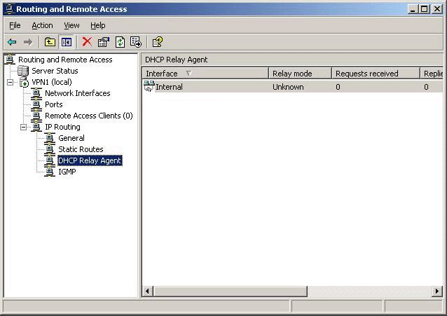

2. Click Properties.
3. In the DHCP Relay Agent Properties dialog box, type 172.16.0.1 in Server address, and then click Add. The server address will be added to the list, as shown in the following figure. Click OK.
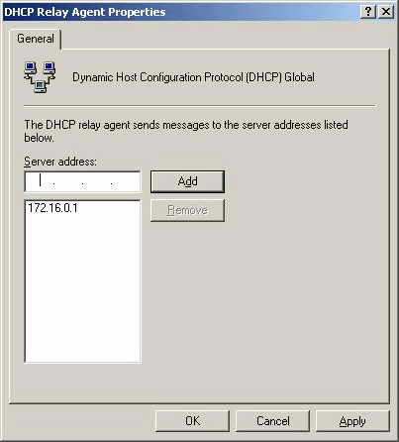

Disable the Windows Firewall/Internet Connection Sharing (ICS) service
1. Click Administrative Tools, and then click Services.
2. In the Services details pane, right-click Windows Firewall/Internet Connection Sharing (ICS) service, and then click Properties.
3. If the service Startup Type is either automatic or manual, set it to Disabled.
4. Click OK to close the Windows Firewall/Internet Connection Sharing (ICS) dialog box, and then close the Services page.

CLIENT1
As part of setting up the basic infrastructure for the test lab, configure CLIENT1 as a standalone computer on a separate network segment. CLIENT1 must have a modem.
Perform basic installation and configuration on CLIENT1
1. Install Windows XP Professional with SP2, and configure the computer as a standalone computer named CLIENT1.
Note:
Installing Windows XP Professional with SP2 on CLIENT1 automatically installs and turns on Windows Firewall. Leave Windows Firewall turned on. You will not need to add any firewall exceptions to CLIENT1 for this scenario.
1. Configure the connection to the Internet segment with the IP address of 10.0.0.1 and the subnet mask of 255.255.255.0.
2. If Windows does not configure the modem automatically, start the Add Hardware wizard, and then configure the modem.

Configuring and Testing a Dial-Up Profile
This section describes how to configure the test lab for dial-up access and phone book distribution, create a Connection Manager profile for dial-up access, and install and test this profile on the client computer.

DC1
To configure the test lab for dial-up access, create an appropriate user account and an appropriate group on DC1.
Create a user account for dial-up connections
1. Open the Active Directory Users and Computers snap-in.
2. In the console tree, double-click example.com.
3. Right-click Users, point to New, and then click User.
4. In the New Object – User dialog box, type DialUser in First name and DialUser in User logon name. Click Next.
5. In the New Object – User dialog box, type a password you created, and then confirm it in Password and Confirm password.
6. Clear the User must change password at next logon check box, select the Password never expires check box, and then click Next.
7. In the New Object – User dialog box, click Finish.
Create a group for dial-up connections
1. In the Active Directory Users and Computers console tree, right-click Users, point to New, and then click Group.
2. In the New Object – Group dialog box, type DialUsers in Group name, and then click OK.
3. In the details pane, double-click DialUsers.
4. In the DialUsers Properties dialog box, click the Members tab, and then click Add.
5. In the Select Users, Contacts, Users, or Groups dialog box, type DialUser in Enter the object names to select, and then click OK.
6. In the Multiple Names Found dialog box, click OK.
7. Click OK to save changes to the DialUsers group.

IAS1
To configure the test lab for dial-up access, configure IAS1 with an appropriate remote access policy for dial-up access.
Create a remote access policy for dial-up connections
1. Click Start, point to Administrative Tools, and then click Internet Authentication Service.
2. In the console tree, right-click Remote Access Policies, and then click New Remote Access Policy.
3. On the Welcome to the New Remote Access Policy Wizard page, click Next.
4. On the Policy Configuration Method page, type Dial-up remote access to intranet in Policy name, and then click Next.
5. On the Access Method page, select Dial-up, and then click Next.
6. On the User or Group Access page, click Group, and then click Add.
7. Click Locations and choose example.com. Click OK.
8. In the Select Groups dialog box, type DialUsers in Enter the object names to select.
9. The DialUsers group in the example.com domain is added to the list of groups on the User or Group Access page. Click Next.
10. On the Authentication Methods page, the MS-CHAP v2 authentication protocol is selected by default. Click Next.
11. On the Policy Encryption Level page, clear the Basic encryption and Strong encryption check boxes, leaving Strongest encryption checked, and then click Next.
12. On the Completing the New Remote Access Policy Wizard page, click Finish.

IIS1
As part of setting up the basic test lab infrastructure for dial-up access, configure IIS1 as a phone book server.
Install Connection Point Services (CPS)
1. Click Start, point to Control Panel, and then click Add or Remove Programs.
2. Click Add/Remove Windows Components, click Management and Monitoring Tools, as shown in the following figure.
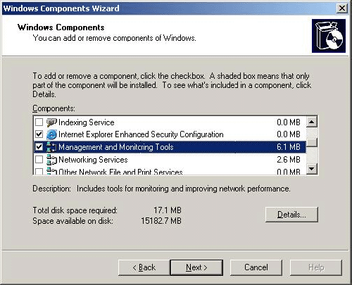

3. Click Details, select the Connection Point Services check box, as shown in the following figure, click OK, and then click Next to install CPS.
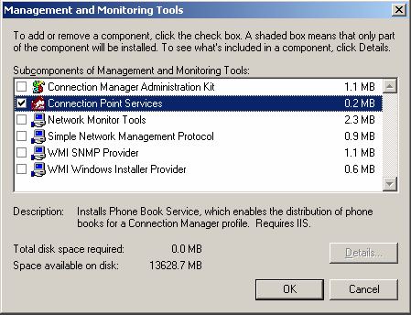

4. When a message asks whether to enable PBS requests, as shown in the following figure, click Yes.
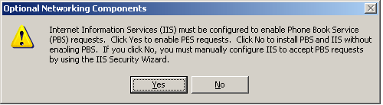

Configure a user account and permissions for posting phone book data
1. Create a local user account, called Post, for posting phone book data, and then clear the User must change password at next logon check box.
2. Make the Post user account a member of the Guests group. Do not make this account a domain user account.
3. Open Windows Explorer, double-click Program Files, right-click Phone Book Service, and then click Properties.
4. In the Phone Book Service Properties dialog box, click the Security tab, and then click Advanced.
5. Clear the Allow inheritable permissions from the parent to propagate to this object and all child objects check box.
6. Click Remove to remove all users from Group or User Names, and then click OK.
7. Click Add, and then add the Post user account with Read & Execute and Write permissions, as shown in the following figure. Click OK.
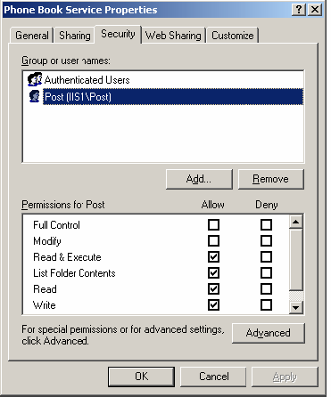

8. Open Internet Information Services (IIS) Manager.
9. In the console tree, double-click IIS1, double-click FTP Sites, right-click Default FTP Site, and then click Properties.
10. In the Default FTP Sites Properties dialog box, click the Security Accounts tab, and verify that the Allow anonymous connections check box is cleared, as shown in the following figure. If a warning message appears when you clear the check box, click Yes. Click OK.
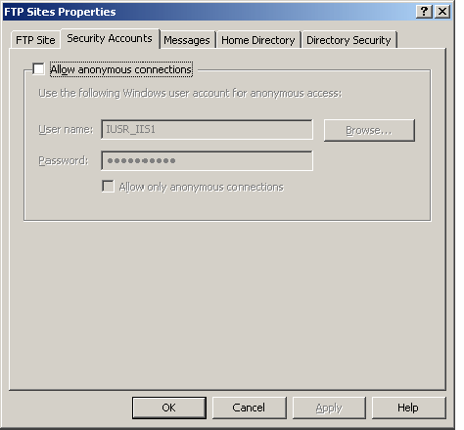

11. In the console tree, double-click Default FTP Site, right-click PBSData, and then click Properties.
12. On the Virtual Directory tab, select the Write check box, as shown in the following figure.
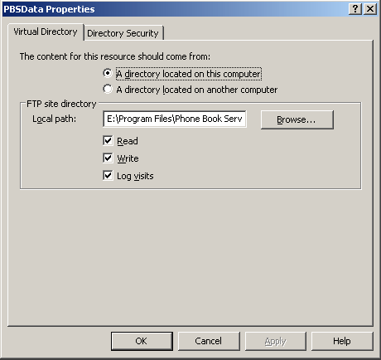

13. To activate the changes, click OK.
Configure Windows Firewall on IIS1
1. In Control Panel, double-click Windows Firewall.
2. In the Windows Firewall dialog box, click the Exceptions tab.
3. Select File and Print Sharing, and then click Add Program.
4. In the Add a Program dialog box, select Internet Explorer, and then click OK.
5. Click Add a Port.
6. In the Add a Port dialog box, type World Wide Web Publishing Service for the Name, type 80 for the Port number, select TCP as the type of traffic processed by the port, and then click OK.
7. Verify that File and Print Sharing, Internet Explorer, and World Wide Web Publishing Service are all selected in the Exceptions dialog box, and then click the Advanced tab.
8. Click Settings for Security Logging.
9. In the Log Setting dialog box, select Log dropped packets and Log successful connections. Note the path and file name in Name.
10. Click OK twice to close Windows Firewall.

VPN1
To configure the test lab for dial-up access, install Connection Manager Administration Kit (CMAK) and Phone Book Administrator on VPN1. Next, create a phone book and post it to the phone book server, and then create a dial-up Connection Manager profile.
Install Connection Manager Administration Kit (CMAK)
1. Click Start, point to Control Panel, and then click Add or Remove Programs.
2. Click Add/Remove Windows Components, click Management and Monitoring Tools, and then click Details.
3. Select the Connection Manager Administration Kit check box, as shown in the following figure, and then install CMAK.
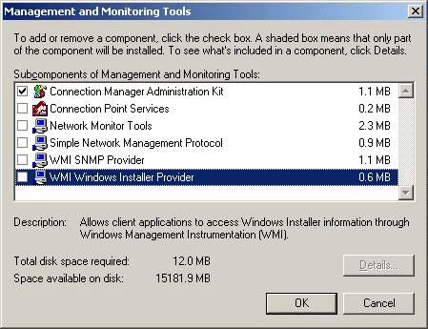

Install Phone Book Administrator
1. Using Windows Explorer, locate the installation disc used to install Windows Server 2003 with SP1, Standard Edition on your computer.
2. Locate the support\pba folder and install PBA by double-clicking pbainst.exe, as shown in the following figure.
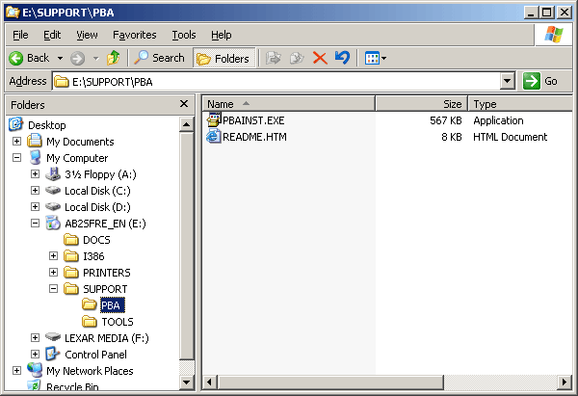

3. Click Yes when prompted to install Phone Book Administration.
4. When the installation finishes, click OK.
Create a phone book
1. Click Start, point to All Programs, point to Administrative Tools, and then click Phone Book Administrator.
2. On the File menu, click New Phone Book.
3. In the Add New Phone Book dialog box, type DialCorp in New phone book name, as shown in the following figure.
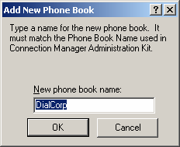

4. Click OK to add the DialCorp phone book, as shown in the following figure.
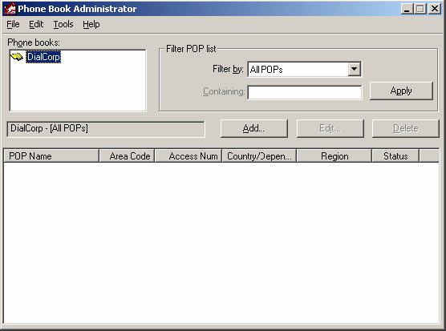

5. Click Add.
6. In the Add POP - DialCorp dialog box, click the Access Information tab, and then type Local Dial to CorpNet in POP name.
7. In Country/Dependency, select the country or dependency in which your test lab is located.
8. If the phone number for your modem on VPN1 requires an area code, type it in Area code. Otherwise, type a space in Area code.
9. In Access number, type the phone number for the modem that is installed on VPN1.
10. In Status, click In Service, as shown in the following figure.
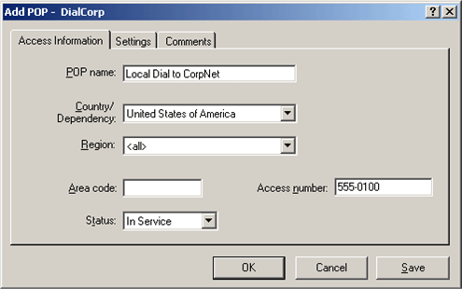

11. Click the Settings tab. In Dial-Up Networking entry, type Dial-up to CorpNet, as shown in the following figure, and then click OK.
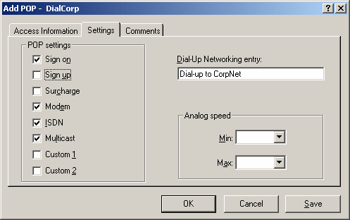

Post the phone book
1. On the Tools menu, click Options.
2. In the Options - DialCorp dialog box, type IIS1.example.com in Server address, type Post in User name, and then enter the password for the Post account, as shown in the following figure. Click OK.
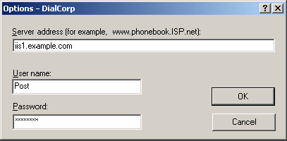

3. On the Tools menu, click Publish Phone Book to open the Publish Phone Book - DialCorp dialog box, as shown in the following figure.
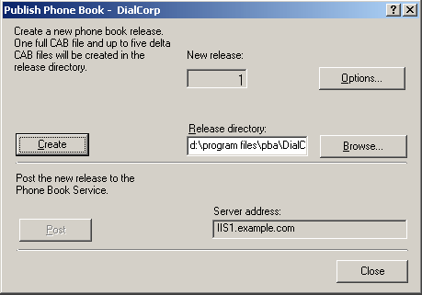

4. Click Create.
5. When the phone book has been created, the Post button is activated, as shown in the following figure.
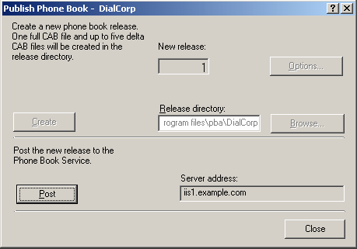

6. Click Post to post the phone book.
7. After the phone book has been posted, click Close, and then close PBA.
Create the DialCorp profile with CMAK
1. Click Start, point to Administrative Tools, and then click Connection Manager Administration Kit.
2. On the Welcome to the Connection Manager Administration Kit Wizard page, click Next.
3. On the Service Profile Selection page, verify that New profile is selected, and then click Next.
4. On the Service and File Names page, type Dial-up to CorpNet in Service name and type DialCorp in File name, as shown in the following figure. Click Next.
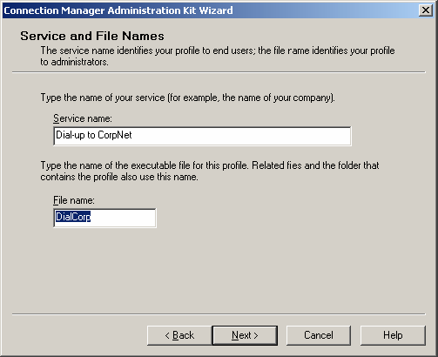

5. On the Realm Name page, click Next.
6. On the Merging Profile Information page, click Next.
7. On the VPN Support page, click Next.
8. On the Phone Book page, click Browse, and then browse to DialCorp.pbk. This file will be under Program Files\PBA.
9. Right-click the DialCorp.pbk file, and then click Open. The name of the file will appear in Phone book file, as shown in the following figure. Click Next.
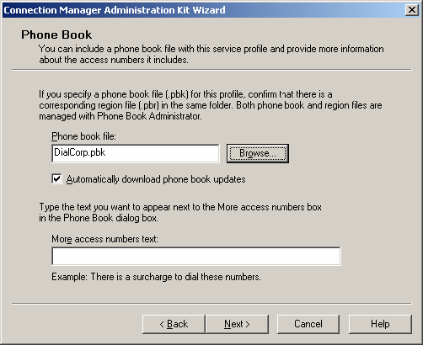

10. On the Phone Book Updates page, type iis1.example.com in Connection Point Services server, as shown in the following figure. Click Next.
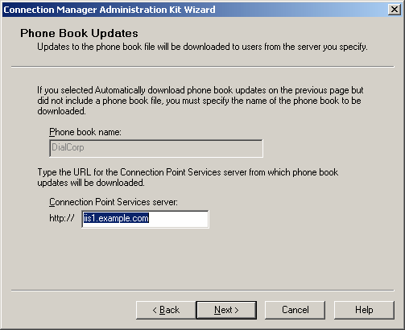

11. On the Dial-up Networking Entries page, click Edit, as shown in the following figure.
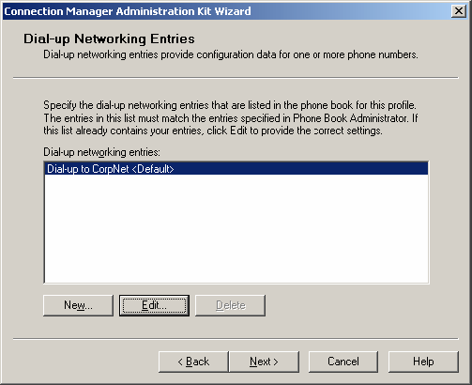

12. In the Edit Dial-up Networking Entry dialog box, click the Security tab. In Security settings, click Use advanced security settings, as shown in the following figure. Click Configure.
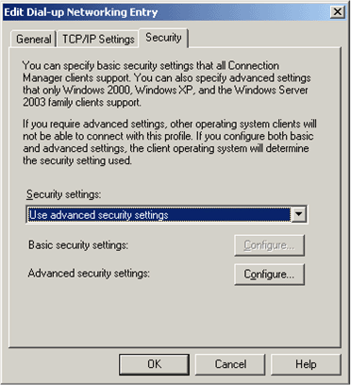

13. In the Advanced Security Settings dialog box, under Authentication Methods, clear all check boxes except for Microsoft CHAP Version 2 (MS-CHAPv2), as shown in the following figure.
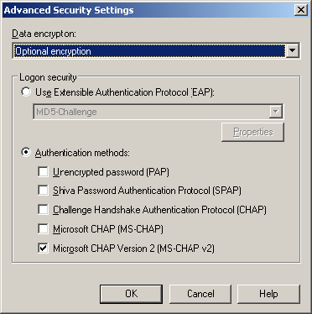

14. Click OK twice to return to the Dial-up Networking Entries page, and then click Next.
15. On the Routing Table Update page, click Next.
16. On the Automatic Proxy Configuration page, click Next.
17. On the Custom Actions page, click Next.
18. On the Logon Bitmap page, click Next.
19. On the Phone Book Bitmap page, click Next.
20. On the Icons page, click Next.
21. On the Notification Area Shortcut Menu page, click Next.
22. On the Help File page, click Next.
23. On the Support Information page, type For help connecting, contact the Support Desk., as shown in the following figure. Click Next.
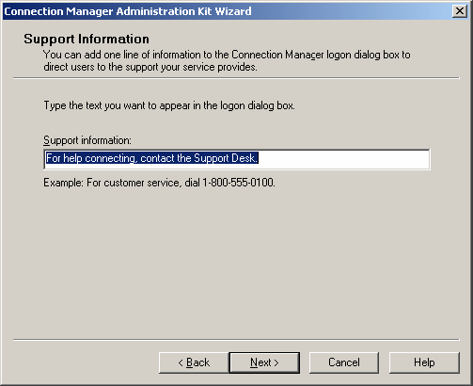

24. On the Connection Manager Software page, click Next.
25. On the License Agreement page, click Next.
26. On the Additional Files page, click Next.
27. On the Ready to Build the Service Profile page, select the Advanced Customization check box, as shown in the following figure, and then click Next.
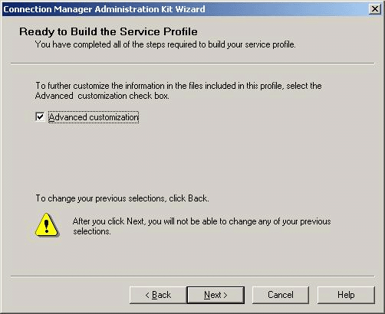

28. On the Advanced Customization page, click Connection Manager in Section name, type HideDomain in Key -name, and type 0 in Value, as shown in the following figure.
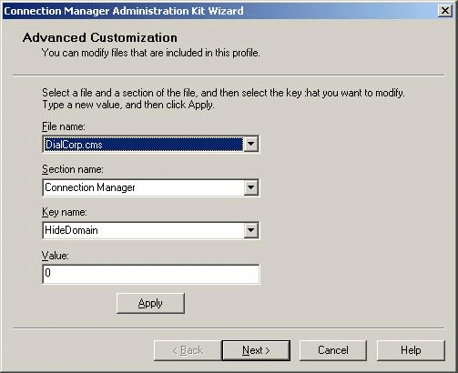

29. Click Apply, and then click Next. A command prompt window will open and close as the profile is created.
30. When the Completing the Connection Manager Administration Kit Wizard page appears, as shown in the following figure, click Finish.
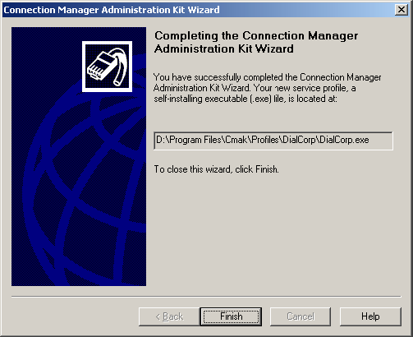

Prepare to distribute the DialCorp profile
1. In Windows Explorer, open \Program Files\Cmak\Profiles\DialCorp, as shown in the following figure.
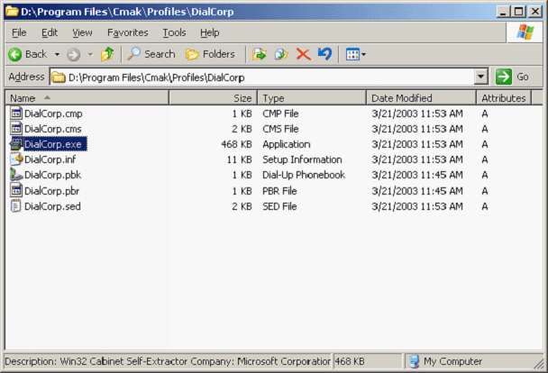

2. Copy DialCorp.exe to a floppy disk or to the USB flash drive.
Add more POPs (service types) for testing phone book updates
1. Open PBA, and then add several more POPs to the DialCorp phone book.
2. Post the phone book again, as described in the earlier procedure "Post the phone book."

CLIENT1
To configure the test lab for dial-up access, install the DialCorp profile on CLIENT1.
Install the DialCorp profile on CLIENT1
1. Insert the floppy disk or USB flash drive containing the DialCorp profile file into the floppy disk drive or port of CLIENT1.
2. Open Windows Explorer, and browse to the floppy drive or port, as shown in the following figure.


3. Double-click DialCorp.exe. When asked whether you want to install the profile, as shown in the following figure, click Yes.


4. In the Dial-up to Corpnet dialog box, verify the Make this connection available for button is selected.
5. When prompted for whom to make this connection available, verify that My use only is selected. Click OK.
Connect to CorpNet using the DialCorp profile
1. On the Dial-up to CorpNet logon screen, type DialUser in User Name, the DialUser account password in Password, and EXAMPLE in Logon domain, as shown in the following figure. Click Properties.
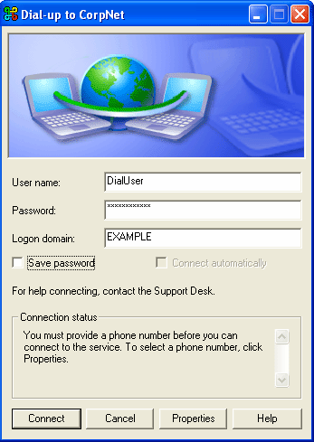

2. On the General tab, click Phone Book, as shown in the following figure.
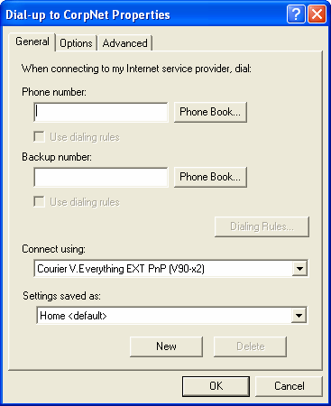

3. In the Phone Book dialog box, in Access numbers, click Local Dial to CorpNet, as shown in the following figure. Click OK.
Note:
You will not be able to click OK until after you click Local Dial to CorpNet. Note that you have only one POP to choose from, even though you added several more POPs after you created the profile.
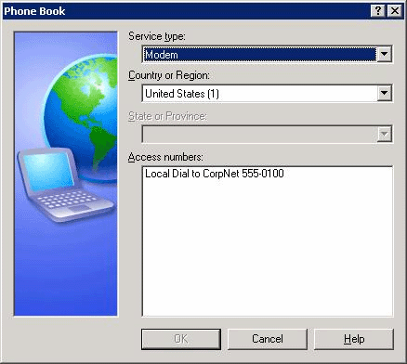

Test connectivity and automatic phone book updates
1. When the connection to CorpNet is complete, open a Web browser.
2. In Address, type http://IIS1.example.com/test.html. You should see the text you typed in text.html, as shown in the following figure.


3. Click Start, click Run, type \\IIS1\ROOT, and then click OK. You should see the files in the root folder on IIS1.
4. Right-click the connection icon in the notification area, and then click Disconnect.
5. In Network Connections, open Dial-up to CorpNet, and then click Properties.
6. In the Dial-up to CorpNet Properties dialog box, click Phone Book.
7. In Access numbers, you should see the POPs you added to the phone book after you created the profile.

Configuring and Testing a PPTP Profile
This section describes configuring the example.com domain for VPN access, creating a PPTP Connection Manager profile that does not require dial-up access (also known as a VPN-only profile), and installing and testing this profile on the client computer.

DC1
To configure the test lab for PPTP access, configure an appropriate user account and an appropriate group on DC1.
Create a user account for VPN connections
1. Open the Active Directory Users and Computers snap-in.
2. In the console tree, right-click Users, point to New, and then click User.
3. In the first New Object – User dialog box, type VPNUser in First name, type VPNUser in User logon name, and then click Next.
4. In the second New Object – User dialog box, type a password in Password and Confirm password.
5. Clear the User must change password at next logon check box, select the Password never expires check box, and then click Next.
6. In the third New Object – User dialog box, click Finish.
Create a group for VPN connections
1. In the Active Directory Users and Computers console tree, right-click Users, point to New, and then click Group.
2. In the New Object – Group dialog box, type VPNUsers in Group name, and then click OK.
3. In the details pane, double-click VPNUsers.
4. Click the Members tab, and then click Add.
5. In the Select Users, Contacts, Computers, or Groups dialog box, type VPNUser in Enter the object names to select, and then click OK.
6. In the Multiple Names Found dialog box, click OK. The VPNUser user account is added to the VPNUsers group.
7. Click OK to save changes to the VPNUsers group.
Update group policy on DC1
• At a command prompt, type gpupdate to update Group Policy on DC1.

IAS1
To configure the test lab for PPTP access, configure IAS1 to allow the VPNUsers group to access the intranet segment from the Internet segment.
Create a remote access policy for VPN connections on IAS1
1. Open the Internet Authentication Service snap-in.
2. In the console tree, right-click Remote Access Policies, and then click New Remote Access Policy.
3. On the Welcome to the New Remote Access Policy Wizard page, click Next.
4. On the Policy Configuration Method page, type VPN remote access to intranet in Policy name, and then click Next.
5. On the Access Method page, click VPN, and then click Next.
6. On the User or Group Access page, click Group, and then click Add.
7. In the Select Groups dialog box, type VPNUsers in Enter the object names to select, and then click OK. The VPNUsers group in the example.com domain is added to the list of groups on the Users or Groups page.
8. On the User or Group Access page, click Next.
9. On the Authentication Methods page, the MS-CHAPv2 authentication protocol is selected by default. Click Next.
10. On the Policy Encryption Level page, clear the Basic encryption and Strong encryption check boxes, leaving only Strongest encryption selected, and then click Next.
11. On the Completing the New Remote Access Policy Wizard page, click Finish.
Update group policy on IAS1
• At a command prompt, type gpupdate to update Group Policy on IAS1.

IIS1
To configure the test lab for PPTP access, configure IIS1 to allow members of the DialUsers group to download a Connection Manager profile.
Configure share permissions
1. Right-click the folder that you shared in the dial-up section, and click Sharing and Security.
2. Add the DialUsers group to the list of users, and give the group read and change permissions.

VPN1
To configure the test lab for PPTP access, create a PPTP VPN profile in CMAK on VPN1.
Create the PPTPCorp profile
1. Open the Connection Manager Administration Kit wizard, and click Next.
2. On the Service Profile Selection page, click New Profile if necessary, and then click Next.
3. On the Service and File Names page, type PPTP To CorpNet in Service name, type PPTPCorp in File name, as shown in the following figure, and then click Next.
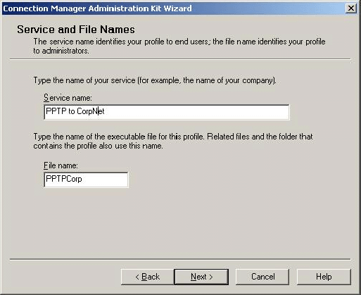

4. On the Realm Name page, click Add a realm name to the user name.
5. If Suffix is not already selected, click Suffix.
6. In Realm name, type @example.com, as shown in the following figure, and then click Next.
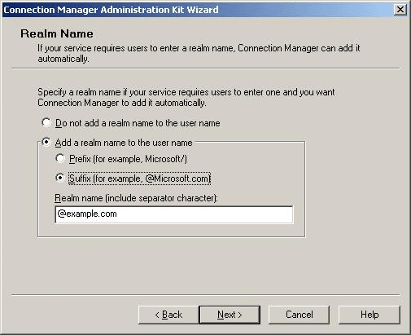

7. On the Merging Profile Information page, click Next.
8. On the VPN Support page, select the Phone book from this profile check box.
9. In VPN Server name or IP Address, click Always use the same VPN server, type 10.0.0.2 for the server name, as shown in the following figure, and then click Next.
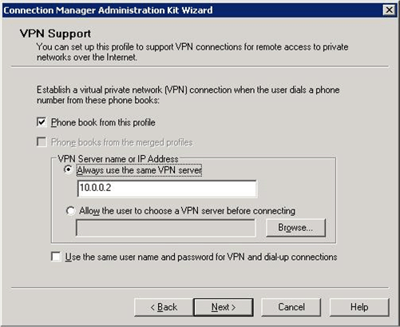

10. On the VPN Entries page, click Edit.
11. In the Edit Virtual Private Networking Entry dialog box, click the Security tab.
12. In Security settings, click Use advanced security settings, as shown in the following figure, and then click Configure.
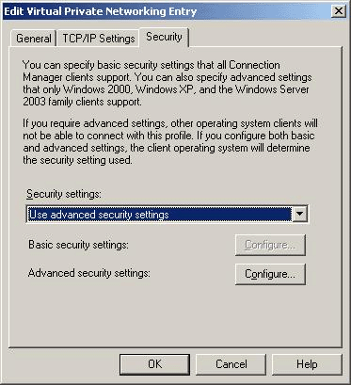

13. In the Advanced Security Settings dialog box, click Authentication methods, and then clear the Microsoft CHAP check box.
14. In VPN strategy, click Only use Point to Point Tunneling Protocol (PPTP), as shown in the following figure, and then click OK twice.
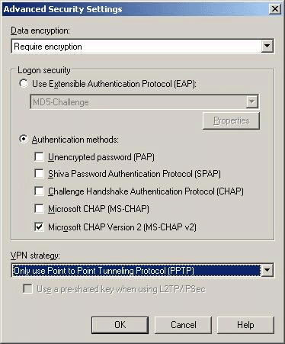

15. On the VPN Entries page, click Next.
16. On the Phone Book page, clear the Automatically download phone book updates check box, as shown in the following figure, and then click Next.
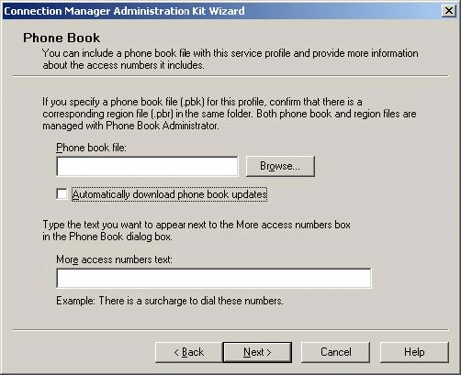

17. On the Dial-up Networking Entries page, click Next.
18. On the Routing Table Update page, click Next.
19. On the Automatic Proxy Configuration page, click Next.
20. On the Custom Actions page, click Next.
21. On the Logon Bitmap page, click Next.
22. On the Phone Book Bitmap page, click Next.
23. On the Icons page, click Next.
24. On the Notification Area Shortcut Menu page, click Next.
25. On the Help File page, click Next.
26. On the Support Information page, type For help connecting, contact the Support Desk., and then click Next.
27. On the Connection Manager Software page, click Next.
28. On the License Agreement page, click Next.
29. On the Additional Files page, click Next.
30. On the Ready to Build the Service Profile page, select the Advanced customization check box, as shown in the following figure, and then click Next.
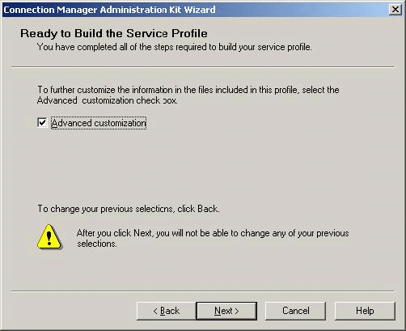

31. On the Advanced Customization page, click Connection Manager in Section Name, click Dialup in Key Name, and then type 0 in Value, as shown in the following figure. Click Apply.
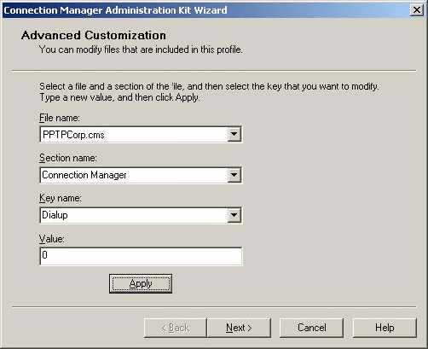

32. On the Advanced Customization page, click Connection Manager in Section name, click HideDomain in Key name, and then type 1 in Value, as shown in the following figure. Click Apply, and then click Next.
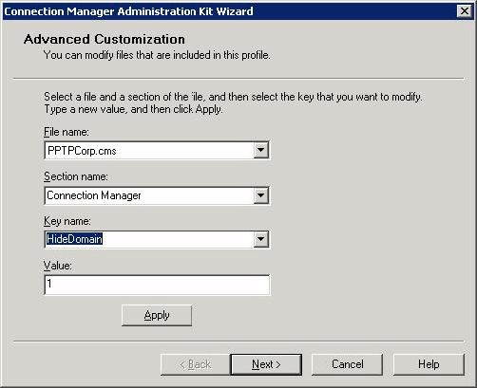

33. When the Completing the Connection Manager Administration Kit Wizard page appears, note the path of the completed profile, as shown in the following figure, and then click Finish.
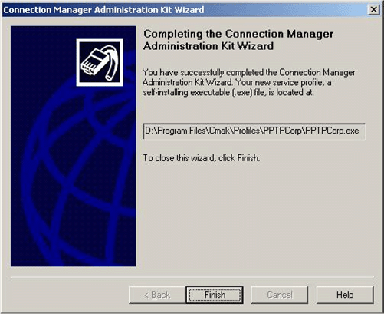

Prepare the PPTPCorp profile for distribution
1. Open to the Program Files\Cmak\Profiles\PPTPCorp folder.
2. Copy PPTPCorp.exe to the shared folder on IIS1.

CLIENT1
To configure the test lab for PPTP access, install the PPTP profile on CLIENT1 from the shared folder on IIS1.
Connect to CorpNet and install the PPTPCorp profile
1. Use the Dial-up to CorpNet profile to connect to the network.
2. When connected, open the IIS1\ROOT shared folder, double-click PPTPCorp.exe, and then click Open.
3. When prompted to install the PPTP to CorpNet profile, as shown in the following figure, click Yes.


4. When prompted for whom to make this connection available, verify that My use only is selected, and then click OK.
5. When the profile has finished installing, disconnect the Dial-up to CorpNet connection, and open the PPTP to CorpNet connection.
Connect to CorpNet using the PPTPCorp profile
1. On the PPTP to CorpNet logon screen, type VPNUser in User name and the password for the account in Password, as shown in the following figure.
Note:
Do not type a domain name in User name. You configured this profile to hide the Domain box and to automatically append the domain name to the user name. If you type a domain name in User name, the domain name will be appended twice, which will cause problems with accessing network resources and could prevent access altogether.
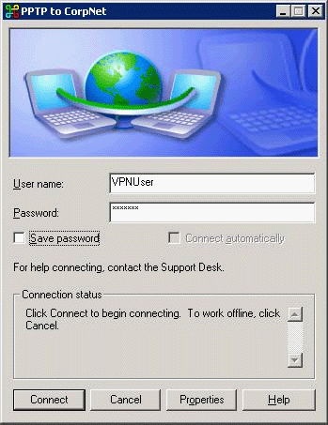

Test PPTP connectivity and permissions
1. When the connection is complete, open a Web browser.
2. In Address, type http://IIS1.example.com/test.html. You should see the text that you typed in text.html.
3. Click Start, click Run, type \\IIS1\ROOT, and then click OK. You should see the contents of the root folder on IIS1.
4. Try to copy PPTPCorp.exe to CLIENT1. You should not be able to do so.
5. Right-click the connection icon in the notification area, and then click Disconnect.

Configuring and Testing an L2TP/IPsec Profile
To make a VPN connection with L2TP/IPsec, you must have a computer certificate on the VPN client computer and one on the VPN server. You can use CMAK to configure a profile that allows the VPN client computer to obtain and install a certificate with minimal user interaction. This section describes how to configure the example.com domain so that computers can automatically obtain these certificates over the network, how to configure the client computer to use these certificates, and how to create a VPN-only L2TP/IPsec Connection Manager profile that uses these certificates. To do this in the test lab, you must first install IIS on DC1, because IIS1 cannot distribute or issue the certificates that you will create for this test lab.
Note:
Version 2 certificates are not available on, or distributable by, Windows Server 2003 with SP1, Standard Edition, but they are distributable by Windows Server 2003 with SP1, Enterprise Edition.
Because this test lab does not actually connect to the Internet, you must use the dial-up profile to connect to the intranet segment so that the client computer can obtain a certificate from the certification authority that you will install on DC1. In a production environment, the profile could be configured to first dial an Internet service provider (ISP) for Internet access before making a VPN connection to the intranet (known as a double-dial profile), or the profile could be configured as a VPN-only profile.
This test lab scenario also requires manual installation of a certificate chain on CLIENT1. For information about building Connection Manager profiles that automatically install certificates and certificate chains for the user, see "Network Access Quarantine Control in Windows Server 2003" in "See Also."

DC1
To configure the test lab for L2TP/IPsec access, install IIS and Certificate Services on DC1, configure certificate settings, create a user for L2TP/IPsec access, and update Group Policy.
Install IIS on DC1
• Use Add/Remove Windows Components to install IIS on DC1.
Install Certificate Services and configure the certification authority
1. When IIS finishes installing, click Add/Remove Windows Components.
2. In Windows Components, select the Certificate Services check box.
3. Click Yes when warned about not changing the name or domain membership of this computer, and then click Next.
4. On the CA Type page, click Enterprise root CA, and click Next.
5. On the CA Identifying Information page, type Example Root CA in Common name for this CA, as shown in the following figure, and then click Next.
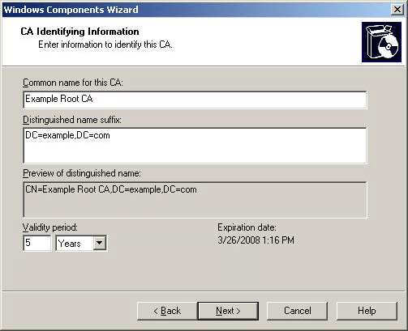

6. On the Certificate Database Settings page, click Next.
7. When asked whether to temporarily stop IIS, click Yes.
8. When asked whether to enable ASP pages, click Yes.
9. On the Completing the Windows Components Wizard page, click Finish.
Configure certificate templates
1. Click Start, click Run, and then type certtmpl.msc to open Certificate Templates.
2. In the details pane, right-click the Authenticated Session template, and then click Duplicate Template.
3. On the General tab, type Authenticated Session for WebEnroll in Template display name, as shown in the following figure.
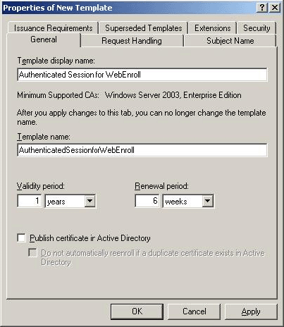

4. On the Security tab, click Authenticated Users in Group or User Names. In Permissions for Authenticated Users, the Read check box is selected by default. Select the Enroll and Autoenroll check boxes, as shown in the following figure, and then click OK.
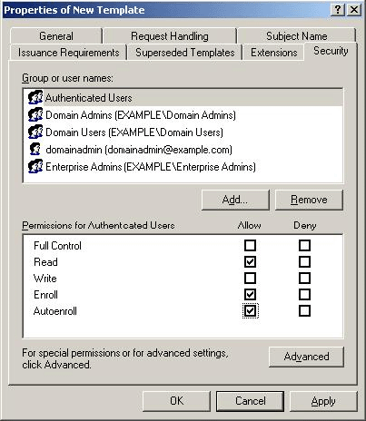

5. In the details pane, right-click the RAS and IAS Server template, and click Properties.
6. On the Security tab, click Authenticated Users in Group or user names, select the Enroll and Autoenroll check boxes, and then click OK.
Configure the certification authority to issue the new certificates
1. Click Start, point to Administrative Tools, and click Certification Authority.
2. Double-click Example Root CA. Right-click Certificate Templates, point to New, and then click Certificate Template to Issue as shown in the following figure.
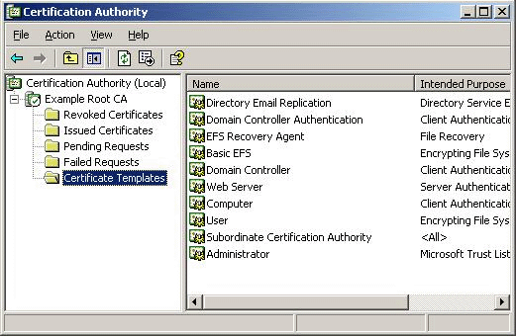

3. In the Enable Certificate Templates dialog box, hold down the CTRL key, and then click Authenticated Session for WebEnroll and RAS and IAS Server.
4. Release the CTRL key, and click OK.
Configure autoenrollment of certificates
1. Open the Active Directory Users and Computers snap-in.
2. In the console tree, right-click the example.com domain, and then click Properties.
3. On the Group Policy tab, click Default Domain Policy, and then click Edit.
4. In the console tree for Group Policy Object Editor, open Computer Configuration, open Windows Settings, and then open Security Settings.
5. Click Public Key Policies.
6. In the details pane, right-click Autoenrollment Settings, and then click Properties.
7. Click Enroll certificates automatically, and then select both check boxes, as shown in the following figure. Click OK.
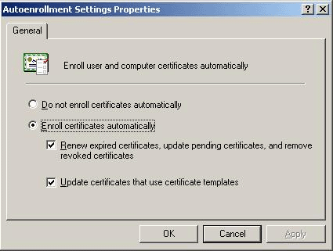

8. Close Group Policy Object Editor.
Create a user account
1. Open the Active Directory Users and Computers snap-in.
2. Create a user account called RemoteUser, just as you did for VPNUser.
3. Add RemoteUser to both the DialUsers group and the VPNUsers group.
Update Group Policy on DC1
• At a command prompt, type gpupdate to update Group Policy on DC1.

VPN1
To configure the test lab for L2TP access, install the appropriate certificate on VPN1, and create an L2TP/IPsec VPN profile.
Update Group Policy on VPN1
• To immediately update Group Policy and request a computer certificate, type gpupdate at a command prompt.
Restart IPsec Policy Agent and Routing and Remote Access
1. Click Start, point to Administrative Tools, and then click Services.
2. In the details pane, point to IPsec Policy Agent, point to Action, and then click Restart.
3. In the details pane, point to Routing and Remote Access, point to Action, and then click Restart.
Create the L2TPCorp profile
1. Open the Connection Manager Administration Kit wizard, and then click Next.
2. On the Service Profile Selection page, click New profile, and click Next.
3. On the Service and File Names page, type L2TP To CorpNet in Service name, type L2TPCorp in File name, and click Next.
4. On the Realm Name page, click Add a realm name to the user name. If Suffix is not already selected, click Suffix. In Realm name, type @example.com, and then click Next.
5. On the Merging Profile Information page, click Next.
6. In VPN Support, select the Phone book from this profile check box.
7. In VPN Server name or IP Address, click Always use the same VPN server, type 10.0.0.2, and then click Next.
8. On the VPN Entries page, click the default entry, and then click Edit.
9. Click the Security tab. In Security settings, click Use advanced security settings, and then click Configure.
10. In Authentication Methods, clear the Microsoft CHAP check box.
11. In VPN strategy, click Only use Layer Two Tunneling Protocol (L2TP).
12. Click OK twice, and then click Next.
13. On the Phone Book page, clear the Automatically download phone book updates check box, and then click Next.
14. On the Dial-up Networking Entries page, click Next.
15. On the Routing Table Update page, click Next.
16. On the Automatic Proxy Configuration page, click Next.
17. On the Custom Actions page, click Next.
18. On the Logon Bitmap page, click Next.
19. On the Phone Book Bitmap page, click Next.
20. On the Icons page, click Next.
21. On the Notification Area Shortcut Menu page, click Next.
22. On the Help File page, click Next.
23. On the Support Information page, type For help connecting, contact the Support Desk., and then click Next.
24. On the Connection Manager Software page, click Next.
25. On the License Agreement page, click Next.
26. On the Additional Files page, click Next.
27. On the Ready to Build the Service Profile page, select the Advanced customization check box, and then click Next.
28. On the Advanced Customization page, in Section name, click Connection Manager.
29. In Key name, click HideDomain.
30. In Value, type 1, and then click Apply.
31. On the Advanced Customization page, in Section name, click Connection Manager.
32. In Key name, click Dialup.
33. In Value, type 0. Click Apply.
34. Click Next, and then wait for the profile to finish building.
35. When the Completing the Connection Manager Administration Kit Wizard page appears, click Finish.
Prepare the L2TPCorp profile for distribution
1. Open the \Program Files\Cmak\Profiles\L2TPCorp folder.
2. Copy L2TPCorp.exe to a floppy disk or to the USB flash drive.

IAS1
Update Group Policy on IAS1
• Click Start, click Run, and then type gpupdate to update Group Policy.

CLIENT1
To set up the test lab for L2TP/IPsec access, configure CLIENT1 with the necessary certificates and install the L2TPCorp profile.
Install the Authenticated Session for WebEnroll certificate on CLIENT1
1. Use the Dial-up to CorpNet profile to connect to the network. Type RemoteUser in User name, and then type the password for the RemoteUser account in Password.
2. When connected, open a Web browser, and then type http://dc1.example.com/certsrv.
3. When prompted, type RemoteUser in User name, and then type the password for the RemoteUser account in Password to connect to the Web site.
4. Click Request a certificate.
5. Click advanced certificate request.
6. Click Create and submit a certificate request to this CA.
7. Click Authenticated Session for WebEnroll, and select the Store certificate in the local computer certificate store check box. Do not change the other settings.
8. Click Submit.
9. Click Yes to approve the request for a certificate.
10. When the request is finished processing, click Install this certificate.
11. Click Yes to approve the installation of the certificate.
12. After the certificate has been installed, disconnect Dial-up to CorpNet.
13. In the Microsoft Management Console (MMC) window, add Certificates for the local computer. Add Example Root CA to the Trusted Root Certification Authorities, as shown in the following figure.
Note:
For more information about how to avoid manual configuration of certificates on a client computer, see "Network Access Quarantine Control in Windows Server 2003" in "See Also."
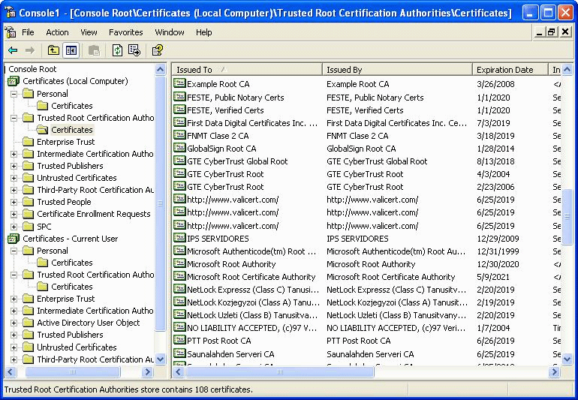

Connect to CorpNet using the L2TPCorp profile
1. Install the L2TP to CorpNet profile on CLIENT1.
2. On the Connection Manager logon screen, type RemoteUser in User name, and then type the password for the account in Password.
3. Click Connect.
Test L2TP/IPsec connectivity and permissions
1. After making the connection to the intranet segment, open a Web browser.
2. In Address, type http://IIS1.example.com/test.html. You should see the text that you typed in text.html.
3. Click Start, click Run, type \\IIS1\ROOT, and then click OK. You should see the files in the root folder on IIS1.
4. Right-click the connection icon in the notification area, and then click Disconnect.

Configuring and Testing an EAP-TLS Profile
To make an EAP-TLS VPN connection, you must have a user certificate on the client computer and a computer certificate on the IAS server.

DC1
To configure the test lab for EAP-TLS testing, configure DC1 to issue a user template, configure Active Directory for auto-enrollment of user certificates, and then add VPNUser to the DialUsers group.
Configure a User certificate on DC1
1. Click Start, click Run, and then type certtmpl.msc to open Certificate Templates.
2. In the details pane, click the User template.
3. On the Action menu, click Duplicate Template.
4. In Template Display Name, type VPNUser, and verify that the Publish certificate in Active Directory check box is selected.
5. Click the Security tab.
6. In Group or user names, click Domain Users.
7. In Permissions for Domain Users, select the Enroll and Autoenroll check boxes, and then click Apply.
8. In Group or user names, click Authenticated Users.
9. In Permissions for Authenticated Users, select the Enroll and Autoenroll check boxes, and then click OK.
Configure the certification authority to issue the new certificate
1. Open Certification Authority.
2. In the console tree, open Certification Authority, open Example Root CA, and then open Certificate Templates.
3. On the Action menu, point to New, and then click Certificate Template to Issue.
4. Click VPNUser, and then click OK.
Configure Active Directory for autoenrollment of user certificates
1. Open the Active Directory Users and Computers snap-in.
2. In the console tree, right-click the example.com domain, and then click Properties.
3. On the Group Policy tab, click Default Domain Policy, and then click Edit.
4. In the console tree for Group Policy Object Editor, open User Configuration, open Windows Settings, and then open Security Settings.
5. Click Public Key Policies.
6. In the details pane, right-click Autoenrollment Settings, and then click Properties.
7. Click Enroll certificates automatically.
8. Select the Renew expired certificates, update pending certificates, and remove revoked certificates and Update certificates that use certificate templates check boxes, and then click OK.
Configure group membership and update Group Policy
1. Open the Active Directory Users and Computers snap-in and add VPNUser to the DialUsers group.
2. Type gpupdate at a command prompt to update Group Policy on DC1.

IAS1
To configure the test lab for EAP testing, configure IAS1 with a computer certificate and for EAP authentication.
Update Group Policy on IAS1 for certificate autoenrollment
• Type gpupdate at a command prompt to update Group Policy on IAS1. This step autoenrolls IAS1 with the computer certificate.
Edit the VPN remote access policy
1. Open the Internet Authentication Service snap-in.
2. In the console tree, click Remote Access Policies.
3. In the details pane, double-click VPN remote access to intranet.
4. In the VPN remote access to intranet Properties dialog box, click Edit Profile.
5. On the Authentication tab, click EAP Methods.
6. In the Select EAP Providers dialog box, click Add.
7. In the Add EAP dialog box, click Smart Card or other certificate, and then click OK.
8. Click Edit.
9. If the properties of the computer certificate that was issued to the IAS1 computer appear in the Smart Card or other Certificate Properties dialog box, IAS has an acceptable computer certificate installed to perform EAP-TLS authentication. Click OK three times.
10. When prompted to view Help, click No.
11. Click OK to save changes to the remote access policy, allowing it to authorize VPN connections using the EAP-TLS authentication method.
12. Type gpupdate at the command prompt to update Group Policy.

VPN1
To configure the test lab for EAP access, install the appropriate certificate on VPN1, and create an EAP profile.
Update Group Policy on VPN1 for certificate autoenrollment
• Type gpupdate at a command prompt to update Group Policy on VPN1.
Create the EAPCorp profile
1. Open the Connection Manager Administration Kit wizard, and then click Next.
2. On the Service Profile Selection page, click Existing Profile, click L2TPCorp, as shown in the following figure, and then click Next.
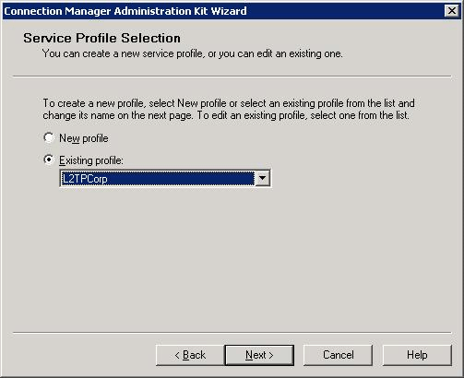

3. On the Service and File Names page, type EAP To CorpNet in Service name, type EAPCorp in File name, and then click Next.
4. On the Realm Name page, click Add a realm name to the user name.
5. If Suffix is not already selected, click Suffix.
6. In Realm name, type @example.com, and then click Next.
7. On the Merging Profile Information page, click Next.
8. On the VPN Support page, select the Phone book from this profile check box, click Always use the same VPN server, type 10.0.0.2, and then click Next.
9. On the VPN Entries page, click the default entry, and then click Edit.
10. Click the Security tab. In Security settings, click Use advanced security settings, and then click Configure.
11. On the Advanced Security Settings page, under Logon security, click Use Extensible Authentication Protocol (EAP), and then click Smart Card or other certificate (encryption enabled).
12. In VPN strategy, click Try Point to Point Tunneling Protocol First, as shown in the following figure, and then click Properties.
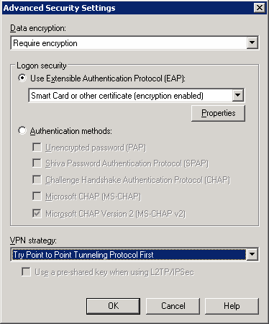

13. In the Smart Card or other Certificate Properties dialog box, click Use a certificate on this computer, and then select Use simple certificate selection (Recommended).
14. Click Validate server certificates.
15. In Connect to these servers, type dc1.example.com.
16. In Trusted Root Certification Authorities, click the Example Root CA check box.
17. Click OK three times, and then click Next.
18. On the Phone Book page, click Next.
19. On the Dial-up Networking Entries page, click Next.
20. On the Routing Table Update page, click Next.
21. On the Automatic Proxy Configuration page, click Next.
22. On the Custom Actions page, click Next.
23. On the Logon Bitmap page, click Next.
24. On the Phone Book Bitmap page, click Next.
25. On the Icons page, click Next.
26. On the Notification Area Shortcut Menu page, click Next.
27. On the Help File page, click Next.
28. On the Support Information page, type For help connecting, contact the Support Desk., and then click Next.
29. On the Connection Manager Software page, click Next.
30. On the License Agreement page, click Next.
31. On the Additional Files page, click Next.
32. On the Ready to Build the Service Profile page, click Next.
33. When the Completing the Connection Manager Administration Kit Wizard page appears, click Finish.
Prepare the EAPCorp profile for distribution
1. Open the \Program Files\Cmak\Profiles\EAPCorp folder.
2. Copy EAPCorp.exe to a floppy disk or to the USB flash drive.

CLIENT1
To configure the test lab for EAP access, install a user certificate and the EAPCorp profile on CLIENT1.
Request and install a User Certificate on CLIENT1
1. Use the Dial-up to CorpNet profile to connect to the network. Type VPNUser in User name, and then type the password for the VPNUser account in Password.
2. When connected, open a Web browser, and then type http://dc1.example.com/certsrv. Click Request a certificate.
3. When prompted, type VPNUser in User name, and then type the password for the VPNUser account in Password to connect to the Web site.
4. Click User Certificate, and click Submit.
5. Click Yes to approve the request for a certificate.
6. When the request is finished processing, click Install this certificate.
7. Click Yes to approve the installation of the certificate.
8. When the certificate has been installed, disconnect Dial-up to CorpNet.
Connect to CorpNet using the EAPCorp profile
1. Install the EAPCorp profile on CLIENT1.
2. On the Connection Manager logon screen, type VPNUser in User name, type the password for the account in Password, and then click Connect.
3. In the Connect EAP to CorpNet dialog box, click VPNUser@example.com, and then click OK, as shown in the following figure.
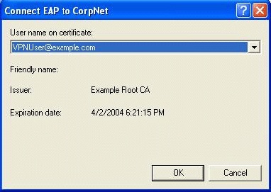

4. In the Validate Server Certificate dialog box, click OK to accept the connection to IAS1.example.com, as shown in the following figure.


Test EAP connectivity and permissions
1. Open a Web browser. In Address, type http://IIS1.example.com/test.html. You should see the text that you typed in text.html.
2. Click Start, click Run, type \\IIS1\ROOT, and then click OK. You should see the contents of the root folder on IIS1.
3. Right-click the connection icon in the notification area, and then click Disconnect.
4. Open Certificates.
5. Verify that Example Root CA was added to the list of Trusted Root Certification Authorities.
6. Verify that the VPNUser certificate was added to the personal certificates store.

Summary
This guide described in detail the steps required to configure Connection Manager profiles for connections using dial-up, PPTP, L2TP/IPsec, and EAP-TLS in a test lab with five computers simulating an intranet and the Internet.

See Also
Virtual Private Networks for Windows Server 2003
Network Access Quarantine Control in Windows Server 2003
Windows Server 2003 Web site

