Step by Step Tutorials for Microsoft Windows 98 Accessibility Options
Table of Contents
Overview 3
Display and Readability 3
Sounds and Speech 3
Keyboard and Mouse 3
Accessibility Wizard 4
Using Assistive Technology 4
Using the Accessibility Options Component 5
Installing Accessibility Options 5
Starting and Using the Magnifier 7
Quick Reference: Setting Magnifier Options 8
Step by Step: Starting and Setting Magnifier Options 9
Exiting the Magnifier 10
Using the Accessibility Wizard 11
Starting and Using the Accessibility Wizard 11
Setting Options for People with Vision Impairments 14
Setting Options for People with Hearing Impairments 15
Setting Options for People Who Have Difficulty Using the Keyboard or Mouse 16
Setting Administrative Options 20
Restoring Default Settings 22
Using the Control Panel to Set Accessibility Options 23
How to Use the Control Panel at a Glance 23
Quick Reference: Using the Accessibility Options Icon 25
Step by Step: Using the Accessibility Options Icon 26
Accessing the Keyboard Tab 26
Changing the StickyKeys Settings 27
Changing the FilterKeys Settings 29
Changing the ToggleKeys Settings 33
Accessing the Sound Tab 35
Changing the SoundSentry Settings 36
Using the ShowSounds Option 37
Accessing the Display Tab to Change the High Contrast Scheme 38
Accessing the Mouse Tab and Changing MouseKey Settings 41
Using MouseKeys with the Keypad 44
Accessing the General Tab 46
Turning On Support for SerialKey Devices 47
Setting Sound and Visual Notification Options 49
Step by Step: Using the Display Icon 49
Accessing the Appearance Tab 49
Selecting the Scheme You Want to Use 51
Changing the Way Individual Screen Elements Look 52
Saving Your Changes As a New Scheme 54
Accessing the Effects Tab to Change Icon Size 55
Accessing the Settings Tab to Change Screen Font Size 57
Accessing the Background Tab to Change How Your Desktop Looks 59
Quick Reference : Using the Mouse Icon 61
Step by Step: Using the Mouse Icon 62
Accessing the Pointers Tab to Change How Your Mouse Pointer Looks 62
Accessing the Motion Tab 64
Changing the Mouse Pointer Speed 65
Displaying and Adjusting Pointer Trails 66
Quick Reference : Using the Passwords Icon 67
Step by Step: Using the Passwords Icon 68
Accessing the User Profiles Tab to Enable You to Use Your Settings on a Computer Others Also Use 68

Overview
Make computers easier and more comfortable to use with accessibility options in Microsoft® Windows 98.

Display and Readability
Windows 98 includes options to increase visibility of items on the computer screen including:

- Screen Elements—choose the combination of font styles, colors and sizes that are easy to view.
- Icon Size—make icons larger for visibility, or smaller for increased screen space.
- Font Size—choose a font that's easily viewed on screen.
- Wallpaper—select a pattern that's comfortable to view.
- Magnifier—enlarge a section of your screen in a separate window.

Sounds and Speech
Windows 98 includes options to make computer sounds easier to hear or distinguish—or, you can choose visual alternatives to sound. Options you can adjust include:

- ShowSounds—display captions for speech and sounds.
- SoundSentry—display visual warnings for system sounds.
- Notification—choose sound or visual notification when turning accessibility features on or off.

Keyboard and Mouse
In Windows 98 you can choose a number of options to make your keyboard and mouse faster and easier to use including:

- Pointer schemes—choose size and color options for better visibility.
- Pointer Speed—set how fast the mouse pointer moves on screen.
- Pointer Trails —follow the pointer motion on screen.
- StickyKeys—allow pressing one key at a time (rather than simultaneously) for key combinations.
- FilterKeys—ignore brief or repeated keystrokes and slow down the repeat rate.
- ToggleKeys—hear tones when pressing certain keys.
- MouseKeys—move the mouse pointer using the numerical keypad.

Accessibility Wizard
The Accessibility Wizard can help new users quickly and easily set up groups of accessibility options that address visual, hearing and dexterity needs all in one place. The Accessibility Wizard asks questions about accessibility needs. Then, based on the answers, it configures utilities and settings for individual users. The Accessibility Wizard can be run again at any time to make changes, or changes can be made to individual settings through Control Panel. To learn about the Accessibility Wizard, see:

- Opening the Accessibility Wizard

Using Assistive Technology
If you use assistive technology, be sure to contact your assistive technology manufacturer to check compatibility with Windows XP and to learn how to adjust your settings to optimize compatibility.

Using the Accessibility Options Component
The Accessibility Options component comes with Windows 98. While it is loaded automatically onto your computer during Windows 98 Setup, you'll need to install it before you can access the Accessibility Options. Once installed, you can access it any time you want.
The two features of this component are the Accessibility Wizard and the Magnifier.

Installing Accessibility Options
If you installed Windows 98 with a compact disc, you will be prompted to insert it into your computer. Following the installation, you will be asked to restart your computer. You should shut down any programs you have open (except Windows 98) before beginning this procedure.

 | Mouse actions | Keyboard actions
1 | On the Start menu:  - Point to Settings.  - Click Control Panel. | Display the Start menu by pressing CTRL+ESC (or the Windows logo key).  - Move to Settings by pressing S.  - Select Control Panel by pressing C.
2 | In Control Panel:  - Double-click the Add/Remove Programs icon. | In Control Panel:  - Press TAB to move the focus to an icon.  - Move to the Add/Remove Programs icon by using the arrow keys.  - Press ENTER.
3 | In the Add/Remove Programs dialog box:  - Click the Windows Setup tab. | In the Add/Remove Programs dialog box, to move to the Window Setup tab:  - Press SHIFT+TAB.  - Press the RIGHT ARROW key.
4 | In the Windows Setup dialog box:  - Click the Accessibility check box. | In the Windows Setup dialog box:  - Select Accessibility by pressing TAB+A.  - To select the check box, press SPACE BAR.
5 | Click OK. | Press ENTER.
6 | In the Systems Settings Change dialog box, click Yes to restart your computer. | In the Systems Settings Change dialog box, press ENTER to restart your computer.

Starting and Using the Magnifier
The Magnifier component that comes with Windows 98 can make the computer screen easier to read for people who have low vision, or for whenever magnifying screen elements would be helpful. The Magnifier works by displaying an enlarged section of your screen in a narrow window along the top of your screen.
The Magnifier allows you to:
- Magnify an area of the screen up to nine times the standard display size.
- Follow the mouse cursor, the keyboard focus, the text editing focus, or any combination of these three.
- Invert colors for contrast.
- Toggle high contrast display for the entire screen.
- Resize and relocate the display area.
When the Magnifier is on, the magnified area is merely a display and not itself an active area. The active focus for cursor, keyboard, and other input devices is always in the unmagnified area.
Note The Magnifier is not intended to be a replacement for full-featured magnifiers. For a partial list of Windows-based magnification utilities, see http://www.microsoft.com/enable.
Quick Reference: Setting Magnifier Options
Setting Options Procedures  If the Magnifier is already running:  - Select the Magnifier program button on the taskbar.  - Select or clear the check boxes for options that best meet your need.  If the Magnifier is not already running:  - On the Start menu:  - Select Programs.  - Select Accessories.  - Select Accessibility.  - Select Magnifier.  - Click or press ENTER.  - Select or clear the check boxes for options that best meet your needs. | 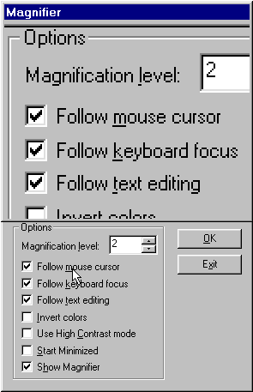

Step by Step: Starting and Setting Magnifier Options
Before you begin
If the Magnifier does not appear on the Programs menu or one of its submenus, you will need to install Accessibility Options. See Installing Accessibility Options.

 | Mouse actions | Keyboard actions
1 | On the Start menu:  - Click Programs.  - Point to Accessories.  - Point to Accessibility.  - Click Magnifier.  A narrow window, showing a magnified portion of the screen, will appear along the top of the screen. | Display the Start menu by pressing CTRL+ESC (or press the Windows logo key).  - Move to Programs by pressing the UP ARROW.  - Move to Accessories by pressing the UP ARROW or DOWN ARROW keys.  - Press ENTER.  - Move to Accessibility. Press ENTER.  - Move to Magnifier. Press ENTER.  A narrow window, showing a magnified portion of the screen, will appear along the top of the screen.
2 | In the Magnifier Settings dialog box:  - Change the level of magnification you see by typing a number from 1 to 9 in the Magnification level box.  Or:  - Use the box’s arrows to select the number you want. | In the Magnifier Settings dialog box:  - If the Magnification level box is not highlighted, press ALT+L.  - Change the level of magnification you see by typing a number from 1 to 9 in the Magnification level box.

 | Mouse actions | Keyboard actions
3 | Select or clear the Options check boxes that best meet your needs. | Select or clear the Options check boxes that best meet your needs by pressing ALT+the underlined letter of those options. Your choices are:  - To Follow the mouse cursor, press M.  - To Follow keyboard focus, press K.  - To Follow text editing, press T.  - To Invert Colors, press I.  - To Use High Contrast mode, press C.  - To Start Minimized, press S.  - To Show Magnifier, press H.
4 | When you are finished, click OK. | When you are finished, press ENTER.

Exiting the Magnifier
Once the Magnifier is on, the Magnifier Settings button appears in the Windows taskbar. Exiting the Magnifier requires you to access that button, and select the Exit option.

 | Mouse actions | Keyboard actions
1 | Select the Magnifier Settings button on the Windows taskbar. | Press ALT+F6 until the Magnifier Settings button is selected.
2 | In the Magnifier Settings dialog box, click Exit. | In the Magnifier Settings dialog box, press ALT+X.

Using the Accessibility Wizard
The Accessibility Wizard groups accessibility features in categories designed to help people with visual, hearing, or mobility impairments. A fourth option helps network administrators set accessibility options for many computers and/or for more than one user on one computer.
The Accessibility Wizard will step you through several pages that enable you to set the accessibility options you want. To use the wizard, you must first select the text size you are most comfortable reading. Then you select from among the four options.
Regardless of which options you choose, you must work through the wizard from the beginning. Once you have selected a category, you will see only those pages that relate to the type of disability—or disabilities—you have selected. Or, you may see only the pages for administrative options.
Starting and Using the Accessibility Wizard

 | Mouse actions | Keyboard actions
1 | On the Start menu:  - Click Programs.  - Point to Accessories.  - Point to Accessibility.  - Click Accessibility Wizard. | Display the Start menu by pressing CTRL+ESC (or the Windows logo key).  - Move to Programs by pressing P.  - Move to Accessories by pressing the UP ARROW or DOWN ARROW key. Press ENTER.  - Move to Accessibility, then press ENTER.  - Move to Accessibility Wizard, then press ENTER.
2 | On the Welcome to Accessibility Wizard page:  - Click the smallest text you can read.  - Click Next. | On the Welcome to Accessibility Wizard page:  - Select the smallest text you can read by using the UP ARROW and DOWN ARROW keys.  - Press N.

 | Mouse actions | Keyboard actions
3 | On the Text Size page, the Change the font size check box should already be selected.  - If it is not selected, click this option.  - If you want to use Microsoft Magnifier, click that option. For more information about the Magnifier, see Putting the Magnifier to Use.  - Click Next. | On the Text Size page, the Change the font size check box should already be selected.  - If it is not selected, press C.  - If you want to use the Microsoft Magnifier, press U. For more information about the Magnifier, see Putting the Magnifier to Use.  - Press N.
4 | On the Set Wizard Options page:  - Click the statements that apply to you.  - Click Next. | On the Set Wizard Options page, select the statements that apply to you by pressing the appropriate letter(s):  - For I am blind or have difficulty seeing things on screen, press L.  - For I am deaf or have difficulty hearing sounds from the computer, press D.  - For I have difficulty using the keyboard or mouse, press K.  - For I want to set administrative options, press A.  - When you are finished, press N.

Note: You can restore the default settings on the Set Wizards Options page by clicking the Restore Default Settings button or by pressing ALT+R.
To continue
To complete the Accessibility Wizard, see one or more of the sections that follow:
- Setting Options for People with Vision Impairments
- Setting Options for People with Hearing Impairments
- Setting Options for People Who Have Difficulty Using the Keyboard or Mouse
- Setting Administrative Options

Setting Accessibility Wizard Options
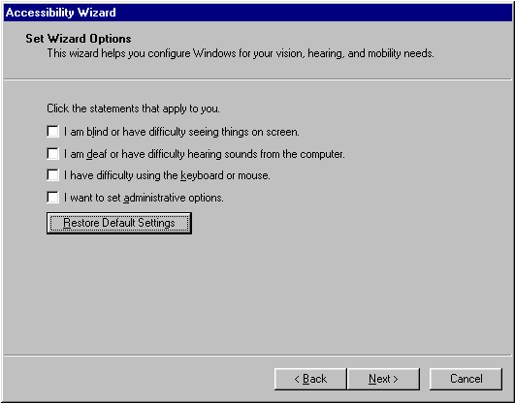

Setting Options for People with Vision Impairments
Using the Accessibility Wizard options for vision, you can:
- Increase (or decrease) the size of the scroll bar and window borders.
- Increase (or decrease) icon sizes.
- Change the color scheme.
Before you begin
The following procedure assumes you have completed the Accessibility Wizard through to the Set Wizard Options page. See Starting and Using the Accessibility Wizard.
Be sure you have selected the I am blind or have difficulty seeing things on screen option on that page.

 | Mouse actions | Keyboard actions
1 | On the Scroll Bar and Window Border Size page:  - Click the options that best meet your needs.  - Click Next. | On the Scroll Bar and Window Border Size page:  - Select the options that best meet your needs by using the RIGHT ARROW and LEFT ARROW keys.  - Press N.
2 | On the Choose Icon Size page:  - Click the option that best meets your needs.  - Click Next. | On the Choose Icon Size page:  - Select the options that best meet your needs by using the RIGHT ARROW and LEFT ARROW keys.  - Press N.
3 | On the Choose Color Scheme page:  - Click the option that best meets your needs.  - Click Next. | On the Choose Color Scheme page:  - Select the options that best meet your needs by using the RIGHT ARROW and LEFT ARROW keys.  - Press N.
4 | On the Completing the Accessibility Wizard page:  - Look over the list of changes you have made.  - If you are satisfied, click Finish.  - If you’d like to change your options, click Back until you are at the appropriate page. | On the Completing the Accessibility Wizard page:  - Look over the list of changes you have made.  - If you are satisfied, press ENTER.  - If you’d like to change your options, press B until you are at the appropriate page.

Setting Options for People with Hearing Impairments
Using the Accessibility Wizard options for hearing, you can:
- Display visual warnings for system sounds (SoundSentry)
- Show captions for speech and sounds (ShowSounds).
Before you begin
The following procedure assumes you have completed the Accessibility Wizard through to the Set Wizard Options page. See Starting and Using the Accessibility Wizard.
Be sure you have selected the I am deaf or have difficulty hearing sounds from the computer option on that page.

 | Mouse actions | Keyboard actions
1 | On the SoundSentry page:  - Click Yes to see warnings for operating system sounds.  - Click Next. | On the SoundSentry page:  - To see warnings for operating sounds, press Y.  - Press N.
2 | On the ShowSounds page:  - Click Yes to see captions for speech and sounds whenever possible.  - Click Next. | On the ShowSounds page:  - To see captions for speech and sounds whenever possible, press Y.  - Press N.
3 | On the Completing the Accessibility Wizard page:  - Look over the list of changes you have made.  - If you are satisfied, click Finish.  - If you’d like to change your options, click Back until you are at the appropriate page. | On the Completing the Accessibility Wizard page:  - Look over the list of changes you have made.  - If you are satisfied, press ENTER.  - If you’d like to change your options, press B until you are at the appropriate page.

Setting Options for People Who Have Difficulty Using the Keyboard or Mouse
Using the Accessibility Wizard options for mobility, you can elect to change the way the keyboard reacts to certain types of keystrokes. The changes you can select are:
- Press one key at a time instead of pressing and holding two or three keys simultaneously (StickyKeys).
- Have the keyboard ignore repeated keystrokes (BounceKeys, which is one of theFilterKeys).
- Hear a sound when you press the "locking" keys (CAPS LOCK, NUM LOCK, or SCROLL LOCK) (ToggleKeys).
- Get extra keyboard help.
- Use the numeric keypad instead of a mouse to navigate (MouseKeys).
You can also change the mouse cursor, mouse button settings, mouse speed, and mouse trails.
Note You can also turn on StickyKeys, FilterKeys, and MouseKeys using options found in the Windows 98 Control Panel. See Using the Accessibility Options Icon, in Using the Control Panel for Accessiblity Options.
Before you begin
The following procedure assumes you have completed the Accessibility Wizard through to the Set Wizard Options page. See Starting and Using the Accessibility Wizard.
Be sure you have selected the I have difficulty using the keyboard or mouse option on that page.

 | Mouse actions | Keyboard actions
1 | On the StickyKeys page:  - Click Yes to press keys in key combinations one at a time.  - Click Next. | On the StickyKeys page:  - Press Y to press keys in a key combination one at a time.  - Press N.
2 | On the BounceKeys page:  - Click Yes to have the computer ignore repeated keystrokes.  - Click Next. | On the BounceKeys page:  - Press Y to have the computer ignore repeated keystrokes.  - Press N.
3 | On the ToggleKeys page:  - Click Yes to have the computer play a sound when you press the CAPS LOCK, NUM LOCK, or SCROLL LOCK keys.  - Click Next. | On the ToggleKeys page:  - Press Y to have the computer play a sound when you press the CAPS LOCK, NUM LOCK, or SCROLL LOCK keys.  - Press N.
4 | On the Extra Keyboard Help page:  - Click Yes to have keyboard help displayed when it’s available.  - Click Next. | On the Extra Keyboard Help page:  - Press Y to have keyboard help displayed when it's available.  - Press N.
5 | On the MouseKeys page:  - Click Yes to use the numeric keypad instead of the mouse.  - Click Next.  Note If you selected No, go to step 7. If you selected Yes, go to step 6. | On the MouseKeys page:  - Press Y to use the numeric keypad instead of the mouse.  - Press N.  Note If you selected O (for No), go to step 7. If you selected Y (for Yes), go to step 6.

 | Mouse actions | Keyboard actions
6 | On the MouseKeys Onset page:  To use MouseKeys when the NUM LOCK key is on, click On, otherwise click Off.  To adjust MouseKeys pointer speed:  - Move the Top Speed slider by clicking and dragging it.  - Move the Acceleration slider by clicking and dragging it.  - Click Next. | On the MouseKeys Onset page:  To use MouseKeys when the NUM LOCK key is on, press O, otherwise press F.  To adjust MouseKeys pointer speed:  - Move to the Top Speed slider by pressing T.  - Adjust the speed by using the arrow keys.  - Move to the Acceleration slider by pressing A.  - Adjust the speed by using the arrow keys.  - Press N.
7 | On the Choose a Mouse Cursor page:  - Click the icon that shows the size and color you want.  - Click Next. | On the Choose a Mouse Cursor page:  - Move to the icon that shows the size and color you want by using the arrow keys.  - To select the Current cursor, press C.  - Press N.
8 | On the Mouse Button Settings page:  - Select whether to change how the mouse buttons function by clicking Right-handed or Left-handed.  - Click Next. | On the Mouse Button Settings page:  - Select whether to change how the mouse buttons function by pressing R for Right-handed or L for Left-handed.  - Press N.
9 | On the Mouse Speed page:  - Move the Mouse Pointer Speed slider by clicking and dragging it.  - Click Next. | On the Mouse Speed page:  - Adjust the mouse pointer speed by using the arrow keys.  - Press N.

 | Mouse actions | Keyboard actions
10 | On the Mouse Trails page:  - If you want your mouse pointer to leave a trail, click the Yes.  - Click Next. | On the Mouse Trails page:  - If you want your mouse pointer to leave a trail, press Y.  - Press N.
11 | On the Completing the Accessibility Wizard page:  - Look over the list of changes you have made.  - If you are satisfied, click Finish.  - If you’d like to change your options, click Back until you are at the appropriate page. | On the Completing the Accessibility Wizard page:  - Look over the list of changes you have made.  - If you are satisfied, press ENTER.  - If you’d like to change your options, press B until you are at the appropriate page.

Setting Administrative Options
Using the Accessibility Wizard administrative options, you can:
- Turn off some of the keyboard and high contrast features.
- Make your accessibility settings the default settings.
- Apply your accessibility settings to another computer by saving your settings to a file.
Depending on which accessibility setting you previously selected, your first page will either be the Set Automatic Timeouts page or the Default Accessibility page.
Before you begin
The following procedure assumes you have completed the Accessibility Wizard through to the Set Wizard Options page. See Starting and Using the Accessibility Wizard.
Be sure you have selected the I want to set administrative options option on that page.

 | Mouse actions | Keyboard actions
1 | On the Set Automatic Timeouts page:  - To keep the settings you have selected on after the computer has been idle for a while, click Leave accessibility features on.  - To set automatic time outs, click Turn off StickyKeys, FilterKeys, ToggleKeys, and High Contrast features after the computer has been idle for.  - Adjust the time by clicking the arrow and selecting the number of minutes you want.  - Click Next. | On the Set Automatic Timeouts page:  - To keep the settings you have selected on after the computer has been idle for a while, press L.  - To set automatic timeouts, select Turn off StickyKeys, FilterKeys, ToggleKeys, and High Contrast features after the computer has been idle for by pressing T.  - Adjust the time by pressing M and then using the UP ARROW and DOWN ARROW keys to select the number of minutes you want.  - Click Next.
2 | On the Default Accessibility page:  - To make your accessibility settings the default, click Yes.  - Click Next. | On the Default Accessibility page:  - To make your accessibility settings the default, press Y.  - To move to the next page, press N.

 | Mouse actions | Keyboard actions
3 | On the Save Settings to File page:  - To save your settings to a file, click Save Settings.  - In the Save As dialog box, select where you’d like the file to be.  - Click Save.  - Click Next. | On the Save Settings to File page:  - Move the focus to Save Settings, by pressing TAB.  - Press ENTER.  - In the Save As dialog box, select where you’d like the file to be.  - Press ALT+S.  - Press ENTER.
4 | On the Completing the Accessibility Wizard page:  - Look over the list of changes you have made.  - If you are satisfied, click Finish.  - If you’d like to change your options, click Back until you are at the appropriate page. | On the Completing the Accessibility Wizard page:  - Look over the list of changes you have made.  - If you are satisfied, press ENTER.  - If you’d like to change your options, press B until you are at the appropriate page.

This page is intentionally blank

Using the Control Panel to Set Accessibility Options
The Control Panel in Windows 98 controls most of the operating system's accessibility features. You can turn the accessibility features on or off, and customize the keyboard, sound, display, and mouse operations to meet your needs.

How to Use the Control Panel at a Glance
The Control Panel has four icons that will help you adjust your accessibility settings. Within each icon is a grouping of related features that you access through tabs on dialog boxes.
The following lists the tabs to use, by the icon under which they are found:

Accessibility Options Icon
Tab Name | What You Can Access
Keyboard | StickyKeys, FilterKeys, ToggleKeys
Sound | SoundSentry, ShowSounds
Display | Screen contrast (high contrast)
Mouse | MouseKeys
General | SerialKey support, sound and visual notification

Display Icon
Tab Name | What You Can Access
Appearance | Scheme, screen elements
Settings | Screen font size
Background | Wallpaper
Effects | Icon size

Mouse Icon
Tab Name | What You Can Access
Pointer | Pointer appearance
Motion | Mouse pointer speed, mouse pointer trails

Passwords Icon
Tab Name | What You Can Access
User Profiles | Personal settings

This page left blank intentionally.
Quick Reference: Using the Accessibility Options Icon
Start Menu Procedures  - Click the Start menu or press CTRL+ESC.  - Select Settings.  - Select Control Panel. | 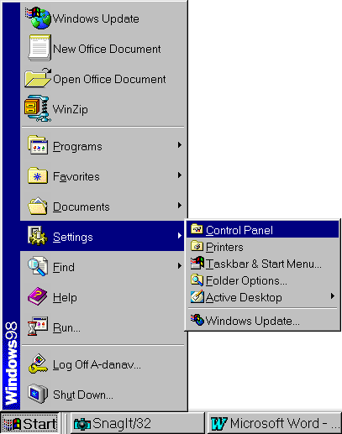
Control Panel Procedures  - Select the Accessibility Options icon. | 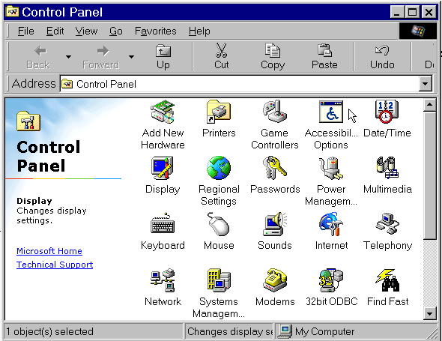

Step by Step: Using the Accessibility Options Icon
The Accessibility Options feature in Windows 98 has five tabs from which you can select. The tabs are: Keyboard, Sound, Display, Mouse, and General.
You can use keyboard shortcuts to turn on some features. You can also elect to see and/or hear a status indicator which lets you know when an accessibility option is in use.
The procedures for changing the settings on each tab are described on the pages that follow.

Accessing the Keyboard Tab
The Keyboard tab enables you to:
- Change settings for using StickyKeys, FilterKeys (which includes BounceKeys, SlowKeys, and RepeatKeys), and ToggleKeys.
- Elect to see extra keyboard help while you are working, if it is available.
Before you begin
The procedure for accessing the Keyboard tab from the Control Panel is outlined below. The procedures for using this tab's options follow this procedure, and assume you have already opened Control Panel and accessed this tab.

 | Mouse actions | Keyboard actions
1 | On the Start menu:  - Point to Settings.  - Click Control Panel. | Display the Start menu by pressing CTRL+ESC (or the Windows logo key).  - Move to Settings by pressing S.  - Select Control Panel by pressing C.
2 | In Control Panel:  - Double-click Accessibility Options. | If the focus is not on Control Panel, press TAB.  - Move to Accessibility Options by using the arrow keys.  - Press ENTER.
3 | In the Accessibility Properties dialog box, make sure you are on the Keyboard tab. | In the Accessibility Properties dialog box, make sure you are on the Keyboard tab. If you are not:  - Move to the Keyboard tab by pressing SHIFT+TAB.

To continue
To use the options in the Keyboard tab, see:
- Changing the StickyKeys Settings
- Changing the FilterKeys Settings
- Changing the ToggleKeys Settings

Changing the StickyKeys Settings
StickyKeys is designed for people who have difficulty holding down two of more keys at a time. When a shortcut requires a key combination, such as CTRL+P, StickyKeys will enable you to press one key at a time instead of pressing them simultaneously.
Use StickyKeys if you want to use the SHIFT, CTRL, or ALT key by pressing one key at a time.

Use the shortcut
Once you have decided to use StickyKeys, you can elect to use the StickyKeys shortcut to turn this feature on or off.
To use the shortcut
- Press SHIFT five times.

Use the status indicator
You can choose to be notified when this option is in use by seeing a status icon.
The status icon is three rectangular boxes, each representing one of the three "modifier" keys that are used in key combinations: SHIFT, CTRL, or ALT. When you hold down a modifier key, its corresponding rectangle changes appearance

You can also choose to hear a sound when one of the modifier keys is pressed.
Before you begin
This procedure assumes you have already opened Control Panel and accessed the Keyboard tab. See Accessing the Keyboard Tab.

Accessibility Properties:  Keyboard tab | Settings for StickyKeys dialog box
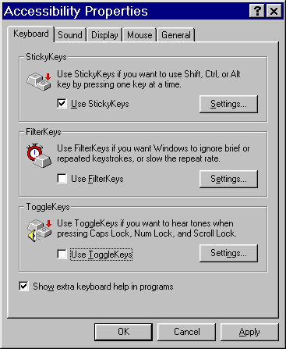 | 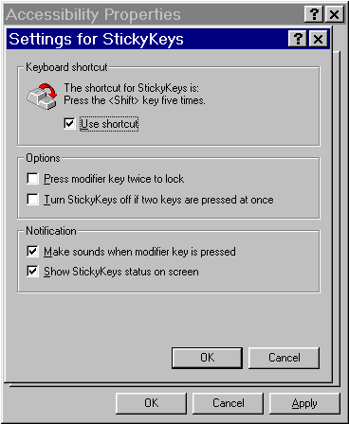

 | Mouse actions | Keyboard actions
1 | On the Keyboard tab:  - Click the Use StickyKeys check box. | On the Keyboard tab:  - To select the Use StickyKeys check box, press U.
2 | To use the shortcut and access other settings:  - Click Settings. | To use the shortcut and access other settings:  - Display Settings by pressing S.
3 | In the Settings for StickyKeys dialog box:  - Click the Use shortcut check box. | In the Settings for StickyKeys dialog box:  - Select Use shortcut by pressing SPACEBAR.
4 | To receive a sound or visual notification:  - Click the appropriate check box. | To receive a sound or visual notification:  - Select the appropriate check box by pressing either ALT+M for a sound, or ALT+S for a visual status.
5 | Click OK. | Press ENTER.

Changing the FilterKeys Settings
Windows 98 includes features designed to work either separately or in combination to address problems related to keyboard sensitivity. These features are grouped together as FilterKeys and are known separately as BounceKeys, SlowKeys, and RepeatKeys.
When FilterKeys is on, the computer ignores brief or repeated keystrokes, or slows the repeat rate.

Use the shortcut
Once you have decided to use FilterKeys, you can elect to use the FilterKeys shortcut to turn this feature on or off.
To use the shortcut
- Press the RIGHT SHIFT key for eight seconds.

Use the status indicator
You can choose to be notified when this option is in use by seeing a status icon.
The status icon is a stop watch.

You can also choose to hear a sound when this feature is in use.
Before you begin
This procedure assumes you have already opened Control Panel and accessed the Keyboard tab. See Accessing the Keyboard Tab.

Settings for FilterKeys: Ignore repeated keystrokes | Advanced Settings for FilterKeys: Adjusting the timing
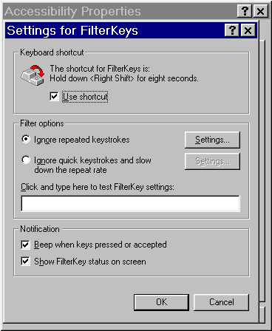 | 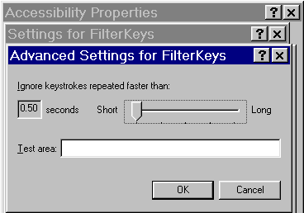  Notification  ⬅ You can select sound and visual notification when using FilterKeys.

 | Mouse actions | Keyboard actions
1 | On the Keyboard tab:  - Click the Use FilterKeys check box. | On the Keyboard tab:  - To select the Use FilterKeys check box, press F.
2 | To use the shortcut and access other settings:  - Click Settings. | To use the shortcut and access other settings:  - Display Settings by pressing E.
3 | In the Settings for FilterKeys dialog box:  - Click the Use shortcut check box. | In the Settings for FilterKeys dialog box:  - Select Use shortcut by pressing U.
4 | To receive a sound or visual notification:  - Click the appropriate check box. | To receive a sound or visual notification:  - Select the appropriate check box by pressing either ALT+B for sound or ALT+H for a visual status.
5 | To ignore repeated keystrokes by using the BounceKeys:  - Click the Ignore repeated keystrokes check box. | To ignore repeated keystrokes by using the BounceKeys:  - Choose Ignore repeated keystrokes by pressing ALT+O.
6 | To control which repeated keystrokes to ignore:  - Click Settings. | To control which repeated keystrokes to ignore:  - Select Settings by pressing ALT+S.
7 | In the Advanced Settings for FilterKeys dialog box:  - Move the slider to adjust the timing.  - You can test the timing rate by clicking Testing area and then typing in the space provided. | In the Advanced Settings for FilterKeys dialog box:  - Use the arrow keys to adjust the timing.  - You can test the timing rate by pressing T and then typing in the space provided.
8 | Click OK. | Press ENTER.

Settings for FilterKeys:  Ignore quick keystrokes and slow down the repeat rate | Advanced Settings for FilterKeys: Adjusting the timing for RepeatKeys and SlowKeys
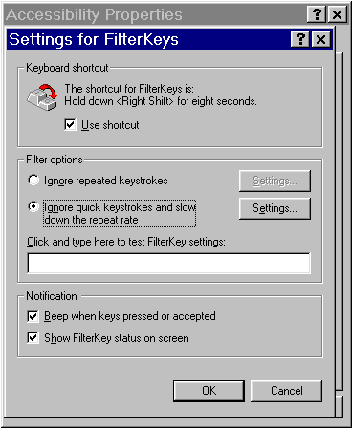 | 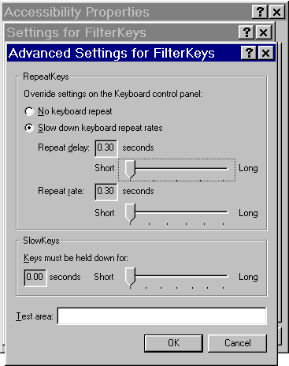

 | Mouse actions | Keyboard actions
9 | To ignore brief keystrokes or slow the repeat rate with RepeatKeys and SlowKeys:  - Click the Ignore quick keystrokes and slow down the repeat rate check box. | To ignore brief keystrokes or slow the repeat rate with RepeatKeys and SlowKeys:  - Select Ignore quick keystrokes and slow down the repeat rate by pressing ALT+N.
10 | To control the repeat rate:  - Click Settings. | To control the repeat rate:  - Press ALT+E.
11 | In the Advanced Settings for FilterKeys dialog box:  - Click your desired options.  - Adjust the timing using the sliders.  - You can test the timing rate by clicking Testing area and then typing in the space provided. | In the Advanced Settings for FilterKeys dialog box:  - Select your desired options by pressing the underlined letter.  - Use the arrow keys to adjust timing.  - You can test the timing rate by pressing T and then typing in the space provided.
12 | Click OK, then click OK again. | Press ENTER, then press ENTER again.

Changing the ToggleKeys Settings
ToggleKeys provide sound cues when pressing the CAPS LOCK, NUM LOCK, and SCROLL LOCK keys.

Use the shortcut
Once you have decided to use ToggleKeys, you can elect to use the ToggleKeys shortcut to turn this feature on or off.
To use the shortcut
- Press the NUM LOCK key for five seconds.
Before you begin
This procedure assumes you have already opened Control Panel and accessed the Keyboard tab. See Accessing the Keyboard Tab.

Accessibility Properties: Keyboard tab | Settings for ToggleKeys dialog box
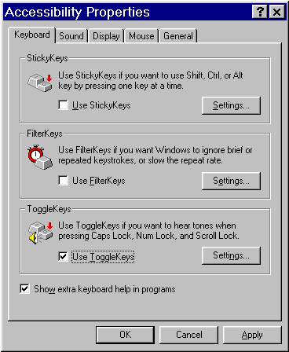 | 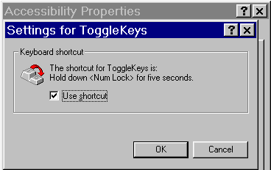
Show extra keyboard help in programs
⬅ Select the check box if you would like to have additional keyboard help shown in programs.

 | Mouse actions | Keyboard actions
1 | On the Keyboard tab:  - Click the Use ToggleKeys check box. | On the Keyboard tab:  - To select the Use ToggleKeys check box, press T.
2 | To use the shortcut:  - Click Settings. | To use the shortcut:  - Display Settings by pressing N.
3 | In the Settings for ToggleKeys dialog box:  - Click the Use shortcut check box. | In the Settings for ToggleKeys dialog box:  - Select Use shortcut by pressing S.
4 | Click OK, then click OK again. | Press ENTER, then press ENTER again.

Accessing the Sound Tab
The Sound tab enables you to change settings for using the SoundSentry and ShowSounds features.
Before you begin
The procedure for accessing the Sound tab from the Control Panel is outlined below. The procedures for using this tab's options follow this procedure, and assume you have already opened Control Panel and accessed this tab.

 | Mouse actions | Keyboard actions
1 | On the Start menu, point to Settings.  - Click Control Panel. | Display the Start menu by pressing CTRL+ESC (or the Windows logo key).  - Move to Settings by pressing S.  - Select Control Panel by pressing C.
2 | In Control Panel:  - Double-click Accessibility Options. | If the focus is not on Control Panel, press TAB.  - Move to Accessibility Options by using the arrow keys.  - Press ENTER.
3 | In the Accessibility Properties dialog box, make sure you are on the Sound tab. | In the Accessibility Properties dialog box, make sure you are on the Sound tab. If you are not:  - Move to the Keyboard tab by pressing SHIFT+TAB.  - Then move to the Sound tab by pressing the RIGHT ARROW key.

To continue
To use the options in the Sound tab, see:
- Changing the SoundSentry Settings
- Using the ShowSounds Option
This page is intentionally blank

Changing the SoundSentry Settings
SoundSentry allows you to change the settings to generate visual warnings, such as a blinking title bar or a screen flash, whenever the computer you are using generates a sound.
You will be able to choose visual warnings (for example, a flashing border) for sounds made by windowed programs and for sounds made by full screen text programs.
Before you begin
This procedure assumes you have already opened Control Panel and accessed the Sound tab. See Accessing the Sound Tab.

Accessibility Properties: Sound tab—SoundSentry and ShowSounds | Settings for SoundSentry
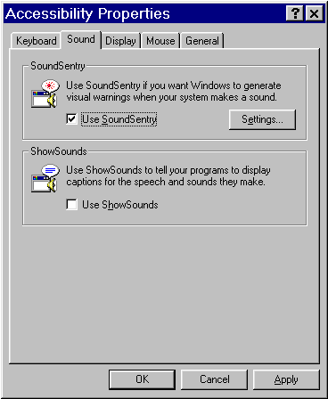 | 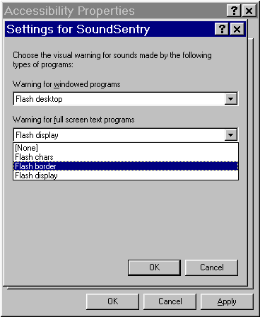

 | Mouse actions | Keyboard actions
1 | On the Sound tab:  - Click the Use SoundSentry check box. | In the Sound tab:  - Select the Use SoundSentry check box by pressing ALT+S.
2 | To select the type of warning you want:  - Click Settings. | To select the type of warning you want:  - Display Settings by pressing E.
3 | In the Settings for SoundSentry dialog box, to see a list of options for Warning for windowed programs:  - Click the arrow.  - Click your desired option.  To see a list of options for Warning for full screen text programs:  - Click the arrow.  - Click your desired option. | In the Settings for SoundSentry dialog box, to see a list of options for Warning for windowed programs:  - Press the DOWN ARROW and UP ARROW keys to move through the list.  To move to the Warning for full screen text programs option:  - Press ALT+F.  To see a list of options:  - Press the DOWN ARROW and UP ARROW keys.
4 | Click OK, then click OK again. | Press ENTER, then press ENTER again.

Using the ShowSounds Option
When ShowSounds is on, you can see captions for speech or other sounds that are part of your computer program.
Before you begin
This procedure assumes you have already opened Control Panel and accessed the Sound tab. See Accessing the Sound Tab.

 | Mouse actions | Keyboard actions
1 | On the Sound tab:  - Click the Use ShowSounds check box. | On the Sound tab:  - Select the Use ShowSounds check box by pressing ALT+H.
2 | Click OK. | Press ENTER.

Accessing the Display Tab to Change the High Contrast Scheme
The Display tab enables you to change settings for using High Contrast color schemes. You can select from among several high contrast color schemes that can make the screen easier to see. Some of the schemes also change fonts for easier reading.

Use the shortcut
Once you have decided to use High Contrast settings, you can elect to use the High Contrast shortcut to turn this feature on or off.
To use the shortcut
- Press the LEFT ALT+LEFT SHIFT+PRINT SCREEN keys.
 | Mouse actions | Keyboard actions
1 | On the Start menu:  - Point to Settings.  - Click Control Panel. | Display the Start menu by pressing CTRL+ESC (or the Windows logo key).  - Move to Settings by pressing S.  - Select Control Panel by pressing C.
2 | In Control Panel:  - Double-click Accessibility Options. | If the focus is not on Control Panel, press TAB.  - Move to Accessibility Options by using the arrow keys.  - Press ENTER.
3 | In the Accessibility Properties dialog box, make sure you are on the Display tab. | In the Accessibility Properties dialog box, make sure you are on the Display tab. If you are not:  - Move to the Keyboard tab by pressing SHIFT+TAB.  - Then move to the Display tab by pressing the RIGHT ARROW key.
4 | On the Display tab:  - Click Use High Contrast. | On the Display tab:  Select Use High Contrast by pressing ALT+U.

Accessibility Properties:  Display tab | Settings for High Contrast
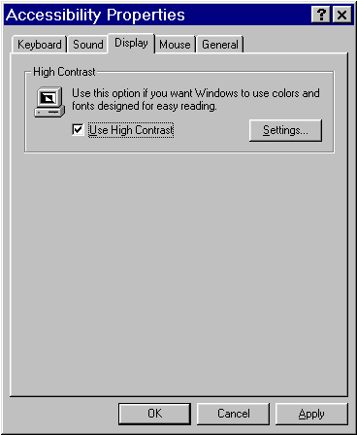 | 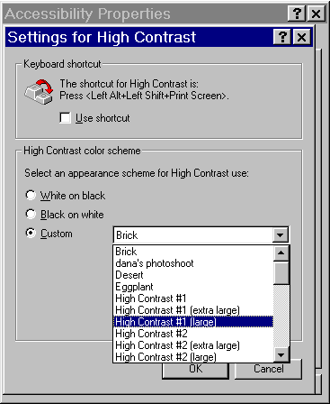

 | Mouse actions | Keyboard actions
5 | To use the shortcut and access other settings:  - Click Settings. | To use the shortcut and access other settings:  - Display Settings by pressing S.
6 | In the Settings for High Contrast dialog box:  - Click the Use shortcut check box. | In the Settings for High Contrast dialog box:  - To activate the shortcut, press U.
7 | The default High Contrast color scheme is White on black. To select a another option:  - Click Black on white or Custom.  Note If you selected Custom, go to step 5, otherwise, go to step 6. | The default High Contrast color scheme is White on black. To select a another option:  - For Black on white, press B, or for Custom, press C.  Note If you selected Custom, go to step 5, otherwise, go to step 6.

 | Mouse actions | Keyboard actions
8 | To customize the High Contrast color scheme:  - Click the Custom arrow to see a list of options.  - Use the scroll bar to move through list.  - Click the scheme you want to use. | To customize the High Contrast color scheme:  - Move through the list by pressing the UP ARROW or DOWN ARROW keys.  - Press ENTER when you've decided on the color scheme.
9 | Click OK. | Press ENTER.

Accessing the Mouse Tab and Changing MouseKey Settings
The Mouse tab enables you to use MouseKeys when you want to use the numeric keypad to control the pointer.
If you want to use the numeric keypad for data entry as well as for navigation, you can set the MouseKeys to be activated by pressing NUM LOCK.
You can also increase or decrease the pointer speed.

Use the shortcut
Once you have decided to use MouseKeys, you can elect to use the MouseKeys shortcut to turn this feature on or off.
To use the shortcut
- Press LEFT ALT+LEFT SHIFT+NUM LOCK.

Use the status indicator
You can choose to be notified when this option is in use by seeing a status icon.
The status icon is a mouse device.

 | Mouse actions | Keyboard actions
1 | On the Start menu:  - Point to Settings.  - Click Control Panel. | Display the Start menu by pressing CTRL+ESC (or the Windows logo key).  - Move to Settings by pressing S.  - Select Control Panel by pressing C.
2 | In Control Panel:  - Double-click Accessibility Options. | If the focus is not on Control Panel, press TAB.  - Move to Accessibility Options by using the arrow keys.  - Press ENTER.
3 | In the Accessibility Properties dialog box, make sure you are on the Mouse tab. | In the Accessibility Properties dialog box, make sure you are on the Mouse tab. If you are not:  - Move to the Keyboard tab by pressing SHIFT+TAB.  - Then move to the Mouse tab by pressing the RIGHT ARROW key.

Accessibility Properties:  Mouse tab | Settings for MouseKeys
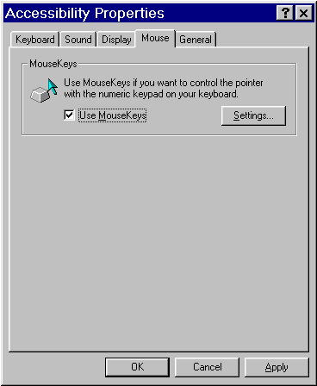 | 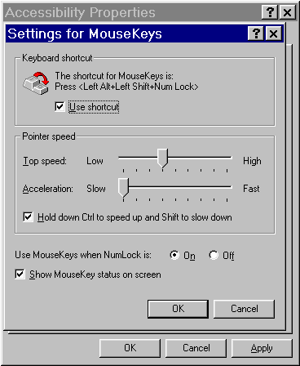

 |  | Mouse actions |  | Keyboard actions
4 | On the Mouse tab:  - Click Use MouseKeys. |  | On the Mouse tab:  - Select Use MouseKeys by pressing ALT+M.
5 | To use the shortcut and access other settings:  - Click Settings. |  | To use the shortcut and access other settings:  - Display Settings by pressing S.
6 | In the Settings for MouseKeys dialog box:  - Click the Use shortcut check box. |  | In the Settings for MouseKeys dialog box:  - Select Use Shortcut by pressing U.
7 | To adjust the pointer speed:  - Move the sliders for Top speed and Acceleration. |  | To adjust the pointer speed:  To adjust Top speed, press T, then use the RIGHT ARROW and LEFT ARROW keys to make changes.  To adjust Acceleration, press A, then use the RIGHT ARROW and LEFT ARROW keys to make changes.

 |  | Mouse actions |  | Keyboard actions
8 | To adjust the pointer speed at any time when using MouseKeys:  - Select the Hold down CTRL to speed up and SHIFT to slow down check box. |  | To adjust the pointer speed at any time when using MouseKeys:  - Select Hold down CTRL to speed up and SHIFT to slow down by pressing H.
9 | To use the NUM LOCK key to switch between MouseKeys and the standard keyboard:  - Click Off if you use the numeric keypad for data entry, otherwise click On. |  | To use the NUM LOCK key to switch between MouseKeys and the standard keyboard:  - To use the numeric keypad for data entry, press F, otherwise press N.
10 | To receive a visual notification:  Click the Show MouseKey status on screen check box. |  | To receive a visual notification:  - Select the Show MouseKey status on screen check box by pressing S.
11 | Click OK, then click OK again. |  | Press ENTER, then press ENTER again..

Using MouseKeys with the Keypad
When MouseKeys is on, you use some keys to accomplish tasks by pressing them. For other tasks, you press and hold keys. You can also use the NUM LOCK key to switch between using MouseKeys and the standard keyboard.
When MouseKeys is on, you can use the following keys to accomplish the following tasks:

To | Press
Move the mouse pointer | The arrow keys
Click | 5
Double-click | + (plus sign)
Lock the mouse button | INS
Release the mouse button | DEL
Left mouse click | / (slash)
Right mouse click | - (minus sign)
Both mouse clicks | * (asterisk)

To drag and drop an object
- Place the pointer on the object and then press INS to begin dragging. Move the object to its new location, and then press DEL to release it.
To cause the pointer to "jump" across large sections on the screen
- Hold down CTRL while using the movement keys (any numeric keypad key except 5).
To move the mouse a single pixel at a time for greater accuracy
- Hold down SHIFT while using the movement keys (any numeric keypad key except 5).

Using the NUM LOCK key
You can use NUM LOCK to change the MouseKeys control pad back to the numeric keypad and vice versa.
This is especially useful with a laptop or notebook computer that does not have a separate numeric keypad. On these computers, the numeric keypad is usually overlaid on top of the standard QWERTY keyboard. The NUM LOCK feature will turn the right-hand portion of the keyboard into a number pad with the key equivalents noted on the front edge of each key.
You may still use the regular mouse along with the MouseKeys.
Note If the Mouse Keys feature is on, but NUM LOCK is in the opposite setting, the MouseKeys icon in the taskbar shows that MouseKeys is off.

Accessing the General Tab
The General tab enables you to turn on SerialKeys support so that you can attach an alternative input device (for example, an augmentative communication device). You can also elect to be notified whenever a shortcut key has been pressed, and you can choose to have accessibility features automatically turned off after they have been idle for awhile.
Before you begin
The procedure for accessing the General tab is outlined below. The procedures for using this tab's options follow this procedure, and assume you have already opened Control Panel and accessed this tab.

 |  | Mouse actions |  | Keyboard actions
1 | On the Start menu:  - Point to Settings.  - Click Control Panel. |  | Display the Start menu by pressing CTRL+ESC (or the Windows logo key).  - Move to Settings by pressing S.  - Select Control Panel by pressing C.
2 | In Control Panel:  - Double-click Accessibility Options. |  | If the focus is not on Control Panel, press TAB.  - Move to Accessibility Options by using the arrow keys.  - Press ENTER.
3 | In the Accessibility Properties dialog box, make sure you are on the General tab. |  | In the Accessibility Properties dialog box, make sure you are on the General tab. If you are not:  - Move to the Keyboard tab by pressing SHIFT+TAB.  - Then move to the General tab by pressing the RIGHT ARROW key.

To continue
To use the options for the General tab, see:
- Turning On Support for SerialKey Devices
- Setting Sound and Visual Notification Options

Turning On Support for SerialKeys Devices
SerialKeys devices allow alternative access to keyboard and mouse features. People who use augmentative speech devices or other alternative devices, for example, can have access to keyboard and mouse features.
Before you begin
This procedure assumes you have already opened Control Panel and accessed the General tab. See Accessing the General Tab.

Accessibility Properties: General tab | Settings for SerialKeys dialog box
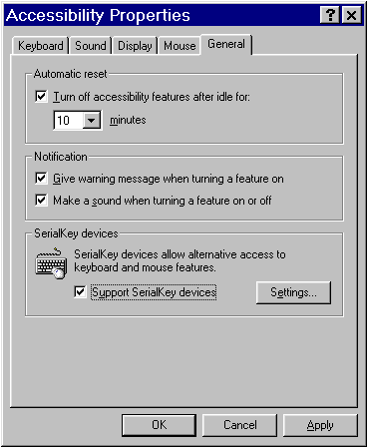 | 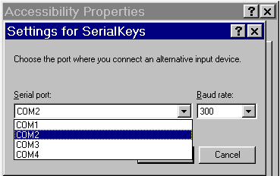

 | Mouse actions | Keyboard actions
1 | On the General tab:  - Click Support SerialKeys devices. | On the General tab:  - Select Support SerialKeys devices by pressing ALT+U.
2 | To adjust the settings for SerialKeys devices:  - Click Settings. | To adjust the settings for SerialKeys devices:  - Display Settings by pressing E.
3 | In the Settings for SerialKeys dialog box, to see a list of Serial port options:  - Click the arrow.  - Click your desired option. | In the Settings for SerialKeys dialog box, to see a list of Serial port options:  - Press the DOWN ARROW and UP ARROW keys to move through the list.
4 | Click OK, then click OK again. | Press ENTER, then press ENTER again.

Setting Sound and Visual Notification Options
You can set notification options to provide sound and visual notification when turning accessibility features on or off.
Before you begin
This procedure assumes you have already opened Control Panel and accessed the General tab. See Accessing the General Tab.

 | Mouse actions | Keyboard actions
1 | On the General tab:  - Click the Notification option check box that best meets your needs. | On the General tab:  - For the Notification option that best meets your needs, press ALT+the underlined letter.
2 | Click OK. | Press ENTER.

Step by Step: Using the Display Icon
Four tabs in the Display feature have options you can use to make the screen display easier to see: Appearance, Settings, Effects, and Background.
The procedures for changing the settings on each tab are described on the pages that follow.

Accessing the Appearance Tab
The Appearance tab enables you to:
- Adjust the size and color of most screen elements, such as window text, menus, icons, and window borders.
- Select from a variety of high contrast color schemes.
- Change the way all of the screen elements look simulateously or just individual screen elements.
- Create new schemes by naming and saving your individual settings.
Before you begin
The procedure for accessing the Appearance tab from the Control Panel is outlined below. The procedures for using this tab's options follow this procedure, and assume you have already opened Control Panel and accessed this tab.

 | Mouse actions | Keyboard actions
1 | On the Start menu:  - Point to Settings.  - Click Control Panel. | Display the Start menu by pressing CTRL+ESC (or the Windows logo key).  - Move to Settings by pressing S.  - Select Control Panel by pressing C.
2 | In Control Panel:  - Double-click the Display icon. | If the focus is not on Control Panel, press TAB.  - Move to the Display icon by using the arrow keys.  - Press ENTER.
3 | In the Display Properties dialog box:  - Click the Appearance tab. | In the Display Properties dialog box:  - Move to the Background tab by pressing SHIFT+TAB.  - Move to the Appearance tab by pressing the RIGHT ARROW key.
To continue
To use the Appearance tab, see:
- Selecting the Scheme You Want to Use
- Changing the Way Individual Screen Elements Look
- Saving Your Changes As a New Scheme

Selecting the Scheme You Want to Use
Use schemes to change the appearance of many screen elements simultaneously. The screen elements in each scheme are colors, sizes, and formats.
Before you begin
This procedure assumes you have already opened Control Panel and accessed the Appearance tab. See Accessing the Appearance Tab.

Display Properties: Appearance tab, selecting a Scheme
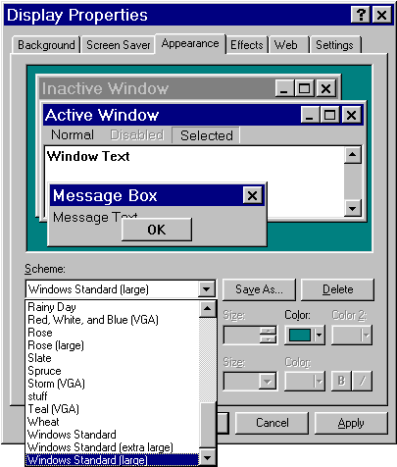

 | Mouse actions | Keyboard actions
1 | On the Appearance tab:  - Click the Scheme arrow to see a list of options.  - As you click an option, a preview of what that scheme would like like appears. | On the Appearance tab:  - Move to the Scheme list by pressing the TAB key.  - Use the UP ARROW and DOWN ARROW keys to preview what a scheme will look like.
2 | Select the scheme you want. | Select the scheme you want.
3 | Click OK. | Press ENTER.

Changing the Way Individual Screen Elements Look
You can adjust the size and color of most screen elements, such as window text, menus, icons and window borders. You can also create new schemes and name and save your individual settings (see Saving Your Changes As a New Scheme).
Before you begin
This procedure assumes you have already opened Control Panel and accessed the Appearance tab. See Accessing the Appearance Tab.
Appearance tab: Selecting an Item | Changing an item's font, size, and color
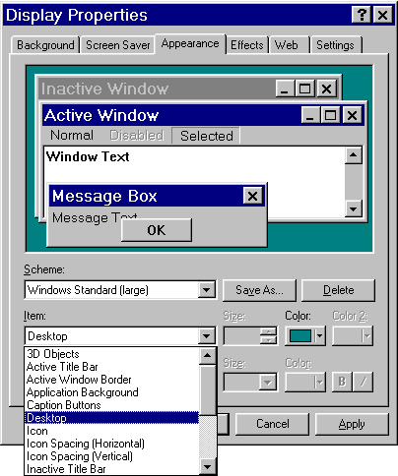 | 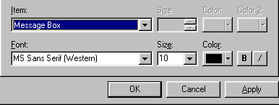

 | Mouse actions | Keyboard actions
1 | On the Appearance tab:  - Click an element in the Item list. | On the Appearance tab:  - Highlight the Item list by pressing ALT+I.  - Use the UP ARROW and DOWN ARROW keys to find the item you want to change.
2 | In the Size and Color boxes:  - Change the settings of the item you selected, as appropriate.  Note You can also change the type, size, and color of some fonts. | Move to the Size and Color boxes by pressing ALT+ the underlined letter.  - Select the settings you want by using the UP ARROW and DOWN ARROW keys.  Note You can also change the type, size, and color of some fonts.
3 | Click OK. | Press ENTER.

Saving Your Changes As a New Scheme
Once you've made changes to an item, you can save those new settings as a new scheme, customized and named by you.
Before you begin
The procedure assumes you have already opened Control Panel and accessed the Appearance tab. See Accessing the Appearance Tab.
 | Mouse actions | Keyboard actions
1 | On the Appearance tab:  - Select Save As. | On the Appearance tab:  - Move to Save As by pressing ALT+V.
2 | In the Save Scheme dialog box:  - Type a name for your scheme.  - Click OK. | In the Save Scheme dialog box:  - Type a name for your scheme.  - Press ENTER.
3 | In the Display Properties dialog box:  - Click OK. | In the Display Properties dialog box:  - Move to OK by pressing the TAB key.  - Press ENTER.

Accessing the Effects Tab to Change Icon Size
The Effects tab enables you to change the size of your icons.
Display Properties: Effects tab
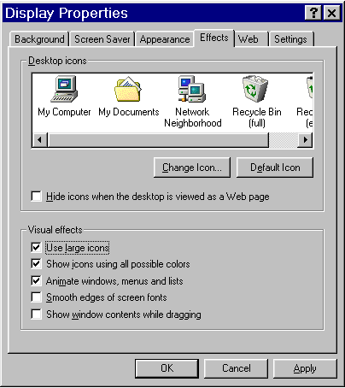

 | Mouse actions | Keyboard actions
1 | On the Start menu, point to Settings.  - Click Control Panel. | Display the Start menu by pressing CTRL+ESC (or the Windows logo key).  - Move to Settings by pressing S.  - Select Control Panel by pressing C.
2 | In Control Panel:  - Double-click the Display icon. | If the focus is not on Control Panel, press TAB.  - Move to the Display icon by using the arrow keys.  - Press ENTER.

 | Mouse actions | Keyboard actions
3 | In the Display Properties dialog box:  - Click the Effects tab. | In the Display Properties dialog box:  - Move to the Background tab by pressing SHIFT+TAB.  - Move to the Effects tab by pressing the RIGHT ARROW key.
4 | On the Effects tab, in the Visual effects area:  - Click the Use large icons check box. | On the Effects tab, in the Visual effects area:  - Move to the Use large icons check box by pressing ALT+L.  - Select the check box by pressing SPACEBAR.
5 | Click OK. | Press ENTER.

Accessing the Settings Tab to Change Screen Font Size
The Settings tab enables you to easily change your font size for such items as the menu bar and dialog boxes, including the dialog boxes in the online Help system.
You have three main size choices: Small, Large, or Other. If the large font is not large enough, you can change the font size by selecting Other.
Display Properties: Settings tab | Changing the Display Properties: Font sizes
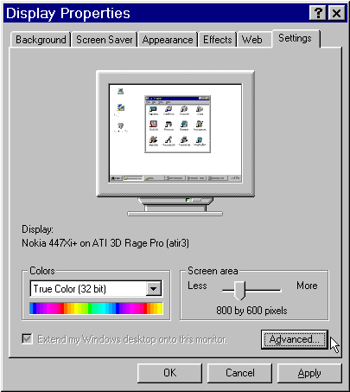 | 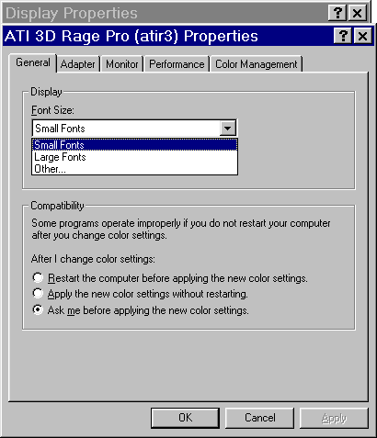

 | Mouse actions | Keyboard actions
1 | On the Start menu:  - Point to Settings.  - Click Control Panel. | Display the Start menu by pressing CTRL+ESC (or the Windows logo key).  - Move to Settings by pressing S.  - Select Control Panel by pressing C.
2 | In Control Panel:  - Double-click the Display icon. | If the focus is not in Control Panel, press TAB.  - Move to the Display icon by using the arrow keys.  - Press ENTER.
3 | In the Display Properties dialog box:  - Click the Settings tab. | In the Display Properties dialog box:  - Move to the Background tab by pressing SHIFT+TAB.  - Move to the Settings tab by pressing the RIGHT ARROW key.
4 | On the Settings tab:  - Click Advanced. | On the Settings tab:  - Select Advanced by pressing ALT+D.
5 | On the General tab of the dialog box that follows:  - Select Small Fonts, Large Fonts, or Other in the Font Size box.  - Click OK.  Note If you chose Other, go to step 6, otherwise go to step 7. | On the General tab of the dialog box that follows:  - Select Small Fonts, Large Fonts, or Other by using the DOWN ARROW or UP ARROW keys in the Font Size box.  - Press ENTER.  Note If you chose Other, go to step 6, otherwise go to step 7.
6 | If you chose Other, the Custom Font Size dialog box appears.  - In Scale fonts to be select one of the provided sizes or type a font size from 20 percent to 500 percent of normal size. | If you chose Other, the Custom Font Size dialog box appears.  - Move to Scale fonts to be by pressing S.  - Use the UP ARROW and DOWN ARROW keys to select one of the provided sizes, or type a size from 20 percent to 500 percent of normal size.
7 | Click OK, then click OK again. | Press ENTER.  - Move to OK by pressing TAB.  - Press ENTER.

Accessing the Background Tab to Change How Your Desktop Looks
The Background tab enables you to change how your desktop looks. You can change the background color, pattern, or wallpaper.
Display Properties: General tab
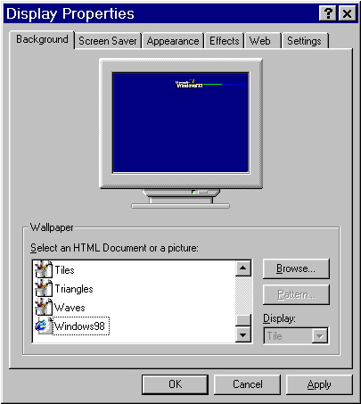

 | Mouse actions | Keyboard actions
1 | On the Start menu:  - Point to Settings.  - Click Control Panel. | Display the Start menu by pressing CTRL+ESC (or the Windows logo key).  - Move to Settings by pressing S.  - Select Control Panel by pressing C.
2 | In Control Panel:  - Double-click the Display icon.  The Display Properties dialog box appears. The Background tab will be showing, and the Wallpaper list will be highlighted. | If the focus is not on Control Panel:  - Press TAB.  - Move to the Display icon by using the arrow keys.  - Press ENTER.  The Display Properties dialog box appears. The Background tab will be showing, and the Wallpaper list will be highlighted.

 | Mouse actions | Keyboard actions
3 | Select the Wallpaper that best fits your needs.  - If you have wallpaper saved in another file:  - Click Browse.  - Type the file name.  - Click Open. | Use the UP ARROW and DOWN ARROW keys to move through Wallpaper list.  - Select the Wallpaper that best fits your needs by pressing ENTER.  - If you have wallpaper saved in another file:  - Press ALT+B to Browse.  - Type the file name.  - Move to Open by pressing TAB.  - Press ENTER.
4 | To select how your wallpaper is displayed on your monitor:  - In the Display box select Center, Tile, or Stretch. | To select how the wallpaper is displayed:  - Press ALT+D.  - Use the UP ARROW and DOWN ARROW keys to move through list.
5 | Click OK. | Press ENTER.

Quick Reference : Using the Mouse Icon
Start Menu Procedures
- Click the Start menu or press CTRL+ESC.
- Select Settings.
- Select Control Panel.

Control Panel Procedures  - Select the Mouse icon. | 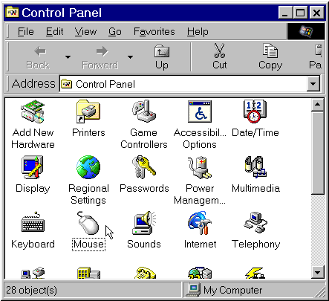

Step by Step: Using the Mouse Icon
Two tabs in the Mouse icon have options you can use to make the mouse easier to see and work with: Pointers and Motion.
The procedures for changing the settings on each tab are described on the pages that follow.

Accessing the Pointers Tab to Change How Your Mouse Pointer Looks
The Pointers tab enables you to change the mouse pointer size and adjust the high-contrast settings.
Mouse Properties: Pointers tab
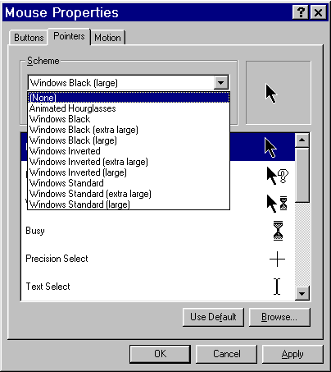

 | Mouse actions | Keyboard actions
1 | On the Start menu:  - Point to Settings.  - Click Control Panel. | Display the Start menu by pressing CTRL+ESC or (the Windows logo key).  - Move to Settings by pressing S.  - Select Control Panel by pressing C.
2 | In Control Panel:  - Double-click the Mouse icon. | If the focus is not in Control Panel:  - Press TAB.  - Move to the Mouse icon by using the arrow keys.  - Press ENTER.
3 | In the Mouse Properties dialog box:  - Click the Pointers tab. | In the Mouse Properties dialog box:  - Move to the Background tab by pressing SHIFT+TAB.  - Move to the Pointers tab by pressing the RIGHT ARROW key.
4 | On the Pointers tab, in the Scheme list:  - Click the arrow to see your options.  - Click the scheme that best meets your needs  Note A preview of your selection will appear in the lower box. | On the Pointers tab:  - Highlight the Scheme list by pressing ALT+S.  - Move through the list by using the UP ARROW and DOWN ARROW keys.  Note A preview of your selection will appear in the lower box.
5 | Click OK. | Press ENTER.

Accessing the Motion Tab
The Motion tab enables you to:
- Speed up or slow down mouse pointer speed.
- Show and adjust the length of pointer trails.
Before you begin
The procedure for accessing the Motion tab from the Control Panel is outlined below. The procedures for using this tab's options follow this procedure, and assume you have already opened Control Panel and accessed this tab.

 | Mouse actions | Keyboard actions
1 | On the Start menu:  - Point to Settings.  - Click Control Panel. | Display the Start menu by pressing CTRL+ESC, or the Windows logo key.  - Move to Settings by pressing S.  - Select Control Panel by pressing C.
2 | In Control Panel:  - Double-click the Mouse icon. | If the focus is not on Control Panel, press TAB.  - Move to the Mouse icon by using the arrow keys.  - Press ENTER.
3 | In the Mouse Properties dialog box:  - Click the Motion tab. | In the Mouse Properties dialog box:  - Move to the Buttons tab by pressing SHIFT+TAB.  - Move to the Motion tab by pressing the RIGHT ARROW key.

To continue
To use the Motion tab, see:
- Changing the Mouse Pointer Speed
- Displaying Pointer Trails

Changing the Mouse Pointer Speed
You can adjust the speed at which your mouse pointer moves on the screen.
Before you begin
The procedure below assumes you have already opened Control Panel and accessed the Motion tab. See Accessing the Motion Tab.

Mouse Properties:
Motion tab
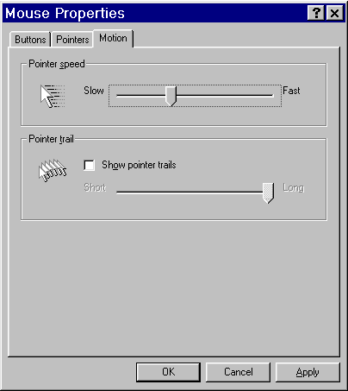

 | Mouse actions | Keyboard actions
1 | On the Motion tab, in the Pointer speed area:  - Adjust the speed by moving the slider. | On the Motion tab:  - Move to the Pointer speed area by pressing ALT+S.  - Adjust the speed by pressing the LEFT ARROW or RIGHT ARROW keys to move the slider.
2 | Click OK. | Press ENTER.

Displaying and Adjusting Pointer Trails
You can add a trail to the mouse pointer, which makes it easier to see on Liquid Crystal Display (LCD) screens. You can also change the length of the pointer trail.
Before you begin
The procedure below assumes you have already opened Control Panel and accessed the Motion tab. See Accessing the Motion Tab.

 | Mouse actions | Keyboard actions
1 | On the Motion tab, in the Pointer trail area:  - Click the Show pointer trails check box. | On the Motion tab:  - Move to the Show pointer trails check box by pressing ALT+T.  - To select the check box, press SPACEBAR.
2 | To adjust the length of the pointer trails, move the slider. | To adjust the length of the pointer trails:  - Move to the slider by pressing TAB.  - Then press the LEFT ARROW or RIGHT ARROW keys.
3 | Click OK. | Press ENTER.

Quick Reference : Using the Passwords Icon
Start Menu Procedures
- Click the Start menu or press CTRL+ESC.
- Select Settings.
- Select Control Panel.

Control Panel Procedures  - Select the Passwords icon. | 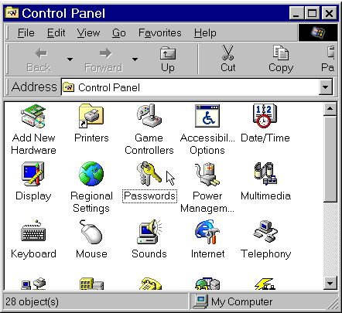

Step by Step: Using the Passwords Icon
If you use a computer that is also used by others, you may want to save your personal accessibility settings so that when you log on to the computer after someone else has used it, the Windows operating system will automatically switch to your settings.
You do this in one tab of the Passwords icon: User Profiles.

Accessing the User Profiles Tab to Enable You to Use Your Settings on a Computer Others Also Use
You can change the settings so that when you log on to the Windows operating system with your password, Windows will automatically switch to your personal settings.

Password Properties: User Profiles tab
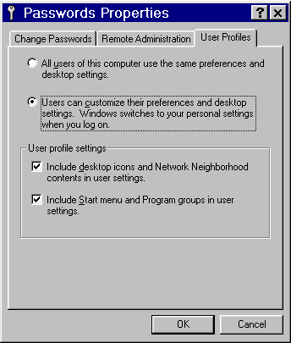

 | Mouse actions | Keyboard actions
1 | On the Start menu:  - Point to Settings.  - Click Control Panel. | Display the Start menu by pressing CTRL+ESC (or the Windows logo key).  - Move to Settings by pressing S.  - Select Control Panel by pressing C.
2 | In Control Panel:  - Double-click the Passwords icon. | If the focus is not on Control Panel, press TAB until it is.  - Move to the Passwords icon by pressing the arrow keys.  - Press ENTER.
3 | In the Passwords Properties dialog box:  - Click the User Profiles tab. | In the Passwords Properties dialog box:  - If the focus is not on the Change Passwords tab, press TAB until it is.  - Press the RIGHT ARROW key until the User Profiles tab is highlighted.
4 | In the User Profiles tab:  - Click Users can customize their preferences and desktop settings. | In the User Profiles tab:  - Select Users can customize their preferences and desktop settings by pressing C.
5 | Click OK. | Press ENTER.

