Improving Contact Center Productivity and Cross-Channel Customer Experience by Using Microsoft Customer Care Framework
White Paper for IT and Technical Professionals
Published: February 2006
For the latest information, please see http://www.microsoft.com/customercare.


Abstract:
Customer service satisfaction has become the single most influential factor affecting acquisition and retention of customers—directly affecting business bottom lines. Businesses are challenged to keep operational costs down, even with increased volumes of customer service transactions. A welcome trend, self-service options for customers are on the rise, but system-integration requirements to facilitate new services and accommodate the growing number of transactions have become significantly more complex. This paper provides an overview of the Microsoft® Customer Care Framework, an architecture that supports developing efficient and versatile customer service applications for deployment within contact centers and self-service channels.

Contents
Introduction 1
Challenge 2
Quick Delivery of the Right Information 3
Smart Client Technology 4
Application Integration Efficiencies 5
CCF Overview 7
Client Component Modules 8
Middle-Tier Components 11
CCF Administrative and Management Features 15
CCF Scalability and High-Availability Features 17
CRM Integration 18
Beyond the Contact Center 19
Self-Service Portal Framework 19
Conclusion 21

Introduction
Customer care provides a critical business function that directly affects revenue and substantially influences how customers perceive the value that they receive from the business. Telephone communication is still the most prevalent mode of customer interaction with a business. For this reason, contact centers bear significant responsibility for engendering customer satisfaction and maintaining the financial well-being of the company. However, contact centers are also increasingly facing traffic from instant messaging and e-mail interaction channels.
More often, however, customers expect to be able to serve themselves when they want to access account information and conduct service transactions of any kind. When it is accomplished easily and efficiently, self-service is an enabling and gratifying experience. This is a welcome trend for the service provider, financial institution, and other business sectors because the costs of providing self-service are significantly lower than traditional contact center–based customer care.
The investments made in customer care technology today must balance the objectives of optimizing contact center performance, reducing operating costs, and expanding the ways in which customers can interact effectively with a company. Optimally, any new platform should have the ability to take advantage of all of these requirements. The most effective way to actualize contact center efficiencies is to provide agents with ready access to the information and applications necessary to run on behalf of the customer in a highly efficient way. Making the information and service functions directly available to customers through self-service delivery channels should also be an intrinsic capability of the platform.

Challenge
Engineering a high level of functional versatility in a contact center is far from trivial. With increased volumes of customer service transactions and the accelerated introduction of new products and service plans, the functional demands on line-of-business (LOB) operational support systems (OSSs) and business support systems (BSSs) have grown dramatically. As a result, the system integration requirements to facilitate the rapid introduction of new services and accommodate the growing volume of transactions have become significantly more complex.
In response to these challenges, Microsoft has created the Microsoft® Customer Care Framework (CCF), a Service Oriented Architecture (SOA) and software building block that accelerates an organization’s ability to develop highly efficient and versatile customer service applications platform with multichannel integration capabilities through Web services. CCF helps ensure that a customer care infrastructure will be agile and flexible, enabling agents and customers to access service information in highly effective ways, no matter where and how that information is maintained.
The design and organization of CCF demonstrates best practices and methodologies for building adaptable and scalable applications for performance-critical enterprise functions. CCF extensively uses the Microsoft .NET Framework and Microsoft Windows Server System™ integrated server software, blending smart client and SOA methods to create a technology infrastructure that readily accommodates continuous change and growth. CCF was designed to:

- Significantly reduce the time for an agent to execute a customer’s service or support requests.
- Improve agents’ ability to be effective and provide a satisfying customer experience.
- Allow continuous reconfiguration and modification to accommodate the ongoing introduction of new products and service plans without disrupting operations and increasing developmental overhead.
- Be easily deployable and maintainable with a low total cost of ownership (TCO).
- Scale transparently and cost-effectively.
- Support multichannel delivery of customer service functions.
- Take advantage of existing investments in contact center and LOB application, Customer Relationship Management (CRM) infrastructures.

Quick Delivery of the Right Information
CCF automates the delivery of customer information to an agent prior to and during a call session, which is the key to improving productivity and customer satisfaction. By immediately acknowledging the customer’s identity and conveying information about the customer's service and account, the agent is empowered to control the call session and make the customer’s interaction a highly gratifying experience. Being able to access the right information in timely manner gives the agent the opportunity to promote and market additional services. To facilitate an optimal interaction between the customer and agent, CCF provides the following capabilities.
When an agent receives a call, CCF passes information obtained from the customer’s initial interaction with an interactive voice response (IVR) system or voice portal to the CCF client module, Agent Desktop. The Agent Desktop starts the relevant supporting applications by using the customer information as the parameters for the application methods. In turn, these applications access information from OSS/BSS LOB systems that have been exposed as Web services. In addition, the workflow steps to execute a particular customer service function are presented to the agent. All of this takes place automatically, without the intervention of the agent. Furthermore, it takes place in a fraction of the time it would take for the agent to collect the customer’s identifying information, start the support applications, and type the relevant information.
Having this context information available to any application running on the Agent Desktop saves the agent and customer a significant amount of time and effort in conducting the business of the call by eliminating the need to manually launch information and retype information. Context sharing also facilitates the orchestration of business process workflow, involving multiple applications, such as ordering new services. Context sharing is accomplished by the ability of CCF to share information among multiple applications. In addition, the call state and context information persist in the CCF database that resides in the middle tier. Therefore, the call, in addition to the state of the applications supporting the call, can be transferred to another agent or resumed at a later time.
CCF makes these efficiencies possible by delivering smart client technology to the desktop and a robust application integration engine (Microsoft BizTalk® Server with support from Microsoft SQL Server TM) in the middle tier, both of which make extensive use of XML to maximize process automation.

Smart Client Technology
The CCF smart client is a desktop application that provides the user with a rich and highly responsive interactive experience by using local resources and intelligently connecting to distributed data sources. Because the CCF client was developed through and runs on top of the .NET Framework, the CCF client offers the following features and benefits.
Dynamic sharing of customer information among multiple applications. This is known as shared context, and it automates contact center workflow tasks such as starting applications, accessing and updating information sources, and routing calls to appropriate parties. Shared context eliminates much of the manual activity that an agent must engage in during a call session. By actively directing and assisting the agent in the execution of the transaction, shared context increases the productivity of the agent.
Intuitive and highly responsive user experience. The CCF client takes advantage of the Microsoft .NET user interface classes and local hardware to provide a rich and effective user experience.
“One-touch” installation and transparent updates from a server. The smart client assemblies are initially downloaded and installed just once, through any distribution channel. Subsequent updates take place automatically and transparently by means of the Updater Application Block solution based on the .NET Framework. The Updater Application Block provides a "pull model" solution for automatically downloading application updates from a central location. It is designed for organizations that want the rich functionality of Microsoft Windows® Forms applications with the centralized manageability of Web-based applications, and that do not have the infrastructural requirements for "push model" solutions, such as Microsoft Systems Management Server (SMS). Using the Updater Application Block to download application updates overcomes the "sandbox" security limitations of downloading Windows Forms applications through a browser, while still maintaining control and security over the application update process.

Application Integration Efficiencies
The Microsoft Customer Care Framework puts the customer care organization on the path to a service-oriented world. One challenge in this process is to create effective business processes that unite disparate systems into a coherent whole. The CCF Business Application Aggregation module can use BizTalk Server to integrate back-office systems (that is, LOB OSS/BSS systems) in order to unlock the data and business processes inherent in these systems. Accessing and integrating these systems has historically been a time-consuming and labor-intensive task because earlier OSS/BSS systems consist of thousands of program modules, databases, and pieces of data. Developing extended programmatic capabilities or attempting to make information available in ways that are not defined in these systems has required programming point-to-point interfaces, resulting in tightly coupled and highly specific functions that exist and run in the form of procedural code.
In addition, the CCF Business Application Aggregation module provides capabilities for information workers to monitor running processes, interact with trading associates and perform other business-oriented tasks. The following sections address these capabilities in some additional detail.

Enterprise Integration and Business Process Management
BizTalk Server provides the basis for enterprise integration and business process management that embody the integration and automation capabilities of XML and Web services technologies. The Microsoft Customer Care Framework uses BizTalk Server to provide workflow and data abstraction. BizTalk Server alleviates the inefficiencies of application integration development by elevating the integration process from the program layer to the information (message) and transport layer. By separating data from the applications that use it and then exposing this data in XML form (by means of XML metadata to give it meaning and structure), the data can be consumed by any application or customer interaction channel capable of parsing and interpreting XML. This is a very powerful benefit of XML Web services because it allows common data in XML form to be shared by different applications and customer interaction channels without regard for where they reside, how they were originally developed, or what platform they run on.
Enterprise Single Sign-On (E-SSO)
Customer care representatives typically rely on several different applications and are likely to face the challenge of dealing with several different security domains. Accessing an application on a Windows-based system may require one set of security credentials, whereas accessing an application on an IBM mainframe may require different credentials, such as a Resource Access Control Facility (RACF) user name and password. Dealing with this profusion of credentials is hard for users, and it can be even harder for automated processes. To address this problem, BizTalk Server includes Enterprise Single Sign-On (E-SSO).
Enterprise Single Sign-On (E-SSO) isn’t a mechanism that enables people to have one logon for all applications. Instead, Enterprise Single Sign-On provides a way to map Windows user identification to non-Windows user credentials. This service can simplify business processes that use applications on diverse systems.
Business Activity Monitoring
It’s not hard to think of different ways that an information worker might want to look at a business process. A contact center manager might need to see how many orders are being processed each day, or how many service request tickets are being generated each day, for instance; a sales manager might want an hourly update on what product groups are being ordered. Meeting these diverse needs requires a general framework for tracking the status of a particular business process. This framework is exactly what the Business Activity Monitoring (BAM) component in BizTalk Server provides.
To summarize, the role of the CCF Business Application Aggregation layer is to help customer care organizations meet the challenges of creating an efficient and agile contact center and a seamless cross-channel experience for customers while relying on the underlying diverse systems. The module’s foundation is the BizTalk Server engine, which provides core messaging, orchestration, transformation capabilities, and additional business functions.

CCF Overview
CCF, as illustrated in Figure 1, is organized into the client-tier and middle-tier components. The client applications run on the Microsoft Windows XP Professional operating system and consist of four logical modules: the Agent Desktop, the Computer Telephony Integration (CTI) application programming interface (API), the Real Time Communication (RTC) Service module, and the Application Integration Framework (AIF). All of the modules are written in the C# programming language (except a small portion of CTI module, which is written in C++), are .NET-managed code, and run in the .NET Framework runtime. The middle-tier components are a set of Web services interfaces between AIF components on the client side and the Windows Server System–based integrated server infrastructure software that provides database, business logic, and application integration functions.
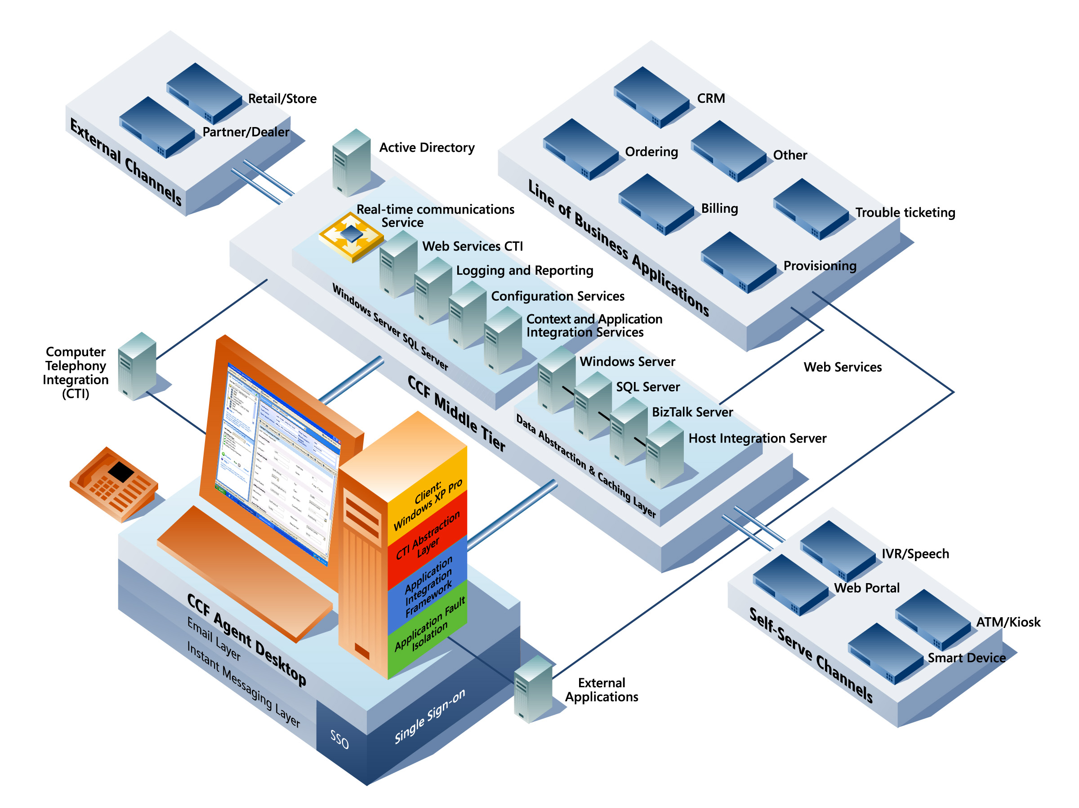
Figure 1. The Customer Care Framework architecture

Client Component Modules
The CCF client component consists of four modules, as described in the following text.
Agent Desktop module. The Agent Desktop module is a workflow-driven user interface shell that actively guides and prompts an agent through workflow tasks and uses the context of the task steps to automatically access information and applications needed to execute those tasks, as shown in Figure 2 below. The proactive direction and assistance that the Agent Desktop provides represent an important and effective innovation for improving the efficiency of contact center personnel and their ability to serve customers. While running on the Windows XP Professional operating system, the Agent Desktop can replace the Windows XP Professional user interface entirely when the agent computer is turned on. In addition, Agent Desktop provides the following features and functions:
- Direct access to call control functions that are exposed through the CTI abstraction layer, such as answer, transfer, conference, hold, and hang-up.
- Automatic customer information look-up and selection through Automatic Number Identification (ANI). Customer information is automatically received when an agent answers a call from an IVR system.
- Call activity display and application state management. The Session Explorer panel displays a list of active customer sessions that the agent is handling. Whenever an agent chooses a customer session that is still in progress, the Agent Desktop automatically restores the presentation and the state of all applications supporting that call.
- Instant help and coaching. The skills routing database keeps track of which employees have expertise in a given subject and monitors their availability for real-time instant messaging communication by using the integrated RTC module.
- Workflow management with automatic application starting and call transfer. The Agent Desktop presents the workflow steps that an agent needs to follow and can automatically start the applications needed to support the process steps. If a step in the process needs to be continued by another agent or at a later time, the entire call context, including the state of the supporting applications and other information, can be automatically transferred to the agent or restored later.
- Network-based application deployment and configuration by storing all configuration information on the network. If an agent’s workstation fails, the agent can log back on from another workstation to restore his or her applications and operating state.
- Call center statistics and alerts. The Agent Desktop can be configured to display alerts or statistics according to customer requirements for various groups of users.
- Integrated authentication and authorization for agent roles and applications by means of Enterprise Single Sign-On (E-SSO) and the Active Directory® directory service.
- Applications running on the Agent Desktop are fault tolerant because separate and isolated process threads and application domains were implemented.
- The state of the Agent Desktop continually persists to the Middle-Tier Context Services module, facilitating complete recovery of the client state from any other agent computer on the network.
The methods and interfaces for these functions are exposed as Web services. The source applications can therefore be located anywhere and are loosely coupled, allowing for the flexible modification and extensibility of the contact center processes. The Agent Desktop also communicates with the CTI layer and the AIF, the other two client modules.
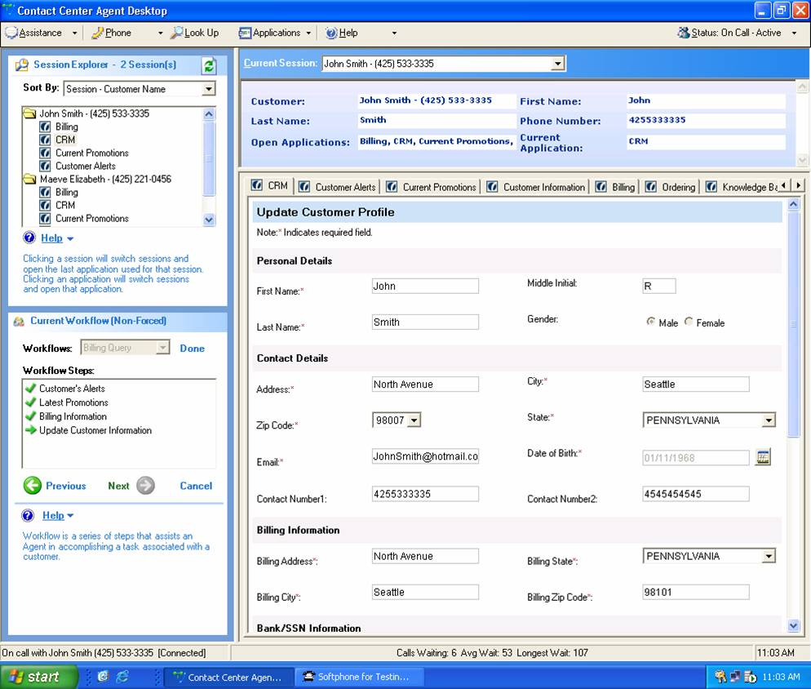
Figure 2. The Agent Desktop user interface shell that actively guides and prompts an agent through workflow tasks
CTI module. Consistent with its overall design philosophy, Customer Care Framework CTI APIs are exposed as Web services, which facilitates easy integration with most automatic call distribution (ACD) and Private Branch Exchange (PBX) systems. The traditional telephony API (TAPI) and Telephony Services API (TSAPI) are also supported. The Agent Desktop can support the following CTI capabilities through the Web services or traditional TAPIs:
- Answer incoming calls
- Hold/unhold calls
- Transfer calls
- Conference calls
- Hang up calls
- Display ANI (caller ID) information
- Display dialed-number identification service (DNIS)—the number called by the customer—information
- Type a telephone number for dialing
- Conduct automatic extension dialing through an Active Directory look-up
In addition, the Web services CTI interface helps route call control information directly to the CCF server. The CTI module can then establish session context and use that context to load applications and retrieve information used on the Agent Desktop.
RTC module. This module uses the real-time communication features of Microsoft Live Communications Server and those built into Windows XP Professional—including instant messaging and Remote Assistance—to accelerate the resolution of complicated calls. The framework also provides presence information, in addition to the Instant Help and Coaching service, which enables an agent to find the skilled resources needed to resolve a customer problem quickly. Through a drop-down list on the Agent Desktop, an agent can choose a support topic, and the Instant Help and Coaching service automatically establishes a connection to an appropriate and available specialist to provide assistance to the agent. If the support specialist is authorized to do so, the specialist can access the same applications as the agent, in the same state and with the same customer context information. The agent and support specialist can then set up an instant messaging or application sharing session to resolve the issue—without ever putting the customer on hold. The specialist can also use Remote Assistance to directly control the agent’s desktop in order to facilitate the resolution of the customer’s requirement, again without requiring the agent to put the call on hold or hand it off, giving the customer a more efficient and satisfactory experience. If, however, the agent and the specialist agree that it would be preferable to hand off the call, the CCF AIF will transfer the application state and context information about the call to the specialist’s desktop with the call itself.
AIF module. The AIF module is the core presentation integration framework behind CCF Agent Desktop. It serves as a front-end container that hosts and manages the applications that the Agent Desktop presents. A hosted application is any program that has been adapted to run within the CCF AIF container environment and hence is able to communicate with other hosted applications in the same container environment. This container provides the following services for the Agent Desktop:
- Launches applications in a specific state, based on customer context information
- Identifies the customer within the application with which the agent is working
- Shares customer context information among applications and allows the applications to interact with each other
- Logs all actions and changes of customer context information that the applications execute
- Tracks and stores the current application state or applies a previously saved application state
- Invokes the CCF single sign-on Web service at the proper time to support Agent Desktop Single Sign-On (ESSO)
The applications that can be hosted through the CCF host interface wrapper are Web applications, Windows Forms controls, Microsoft Win32® API applications, ActiveX® controls, Citrix applications, Java Swing applications, and TN3270 terminal emulation applications. Packaged or custom applications (such as the Microsoft Office System programs) that can be driven by .NET scripting can run under the control of the AIF container by wrapping the applications with the AIF generic external application wrapper. This wrapper emulates hosted application behavior through scripting.
The AIF container provides the mechanism for sharing context information among hosted applications in addition to synchronizing this context information to the Context and Persistence Service module running on the middle tier. The AIF stores and maintains context information as structured XML information, which all hosted applications share and update. Interactions between the AIF container and the middle-tier applications to persist and manage application state, contexts, actions, sessions, and workflow steps are executed through Web service interfaces.

Middle-Tier Components
The CCF middle tier consists of a set of Web services interfaces between the AIF and the following Windows Server System–based applications.
SQL Server. SQL Server is an enterprise-class database management system that provides server-based data persistence services for the Agent Desktop, AIF, and BizTalk Server. SQL Server has a comprehensive set of tools for application development; extract, transform, load (ETL); business intelligence and analysis services; XML integration; Internet queries; and notification services. It also has low implementation and maintenance. In addition, SQL Server has built-in self-tuning and dynamic self-configuring features for optimizing database performance, along with numerous graphical tools and wizards for designing, configuring, and monitoring databases. SQL Server has built-in clustering capabilities for scaling and high-availability performance.
SQL Server Reporting Services is a comprehensive, server-based component for creating, managing, and delivering reports to employees throughout the enterprise. SQL Server Reporting Services augments the business intelligence capabilities of SQL Server by adding rich report reporting functionality, enabling business users to receive real-time production reporting to help make better decisions every day.
SQL Server Reporting Services enables business users to create their own ad hoc reports when they want them. Personnel in the IT department no longer need to be involved when new reports are needed, freeing them to work on other high-priority tasks. Business users are also more likely to take advantage of the database when they can access information themselves rather than going through the IT department. These reports provide a great supplement to standardized reports that are produced each month.
Ad hoc reporting capabilities enable users to investigate and resolve issues immediately. For example, a user who receives a notification that the average cost to produce an item has risen above its profitable level can immediately investigate the cause of the higher cost.
Active Directory. Active Directory is a directory service built into the Microsoft Windows Server™ operating systems that provides a single point of management for Windows-based user accounts, clients, servers, and applications. It acts as an integration point for bringing systems together and consolidating management tasks. Active Directory acts as the central authority for network security, letting the operating system readily verify a user's identity and control the user's access to network resources. Active Directory improves password security and management by providing single sign-on to network resources with integrated, high-powered security services that are transparent to end users. It supports a number of authentication mechanisms used to prove identity upon logon to the Windows operating system, including Kerberos, X.509 certificates, and smart cards. After a user is authenticated and logged on, all resources in the system are protected and access is granted or denied based on a single authorization model. In addition, Active Directory natively supports a fully integrated public key infrastructure and Internet security-enhanced protocols, such as Lightweight Directory Access Protocol (LDAP) over Secure Sockets Layer (SSL). This support helps organizations extend selected directory information beyond their firewalls to extranet users and e-commerce customers.
BizTalk Server. The Business Application Aggregation Module (BAAM) of CCF provides developers and architects with a reference implementation architecture, sample code, and development guidelines for using XML, Web services, and .NET technology to efficiently and cost-effectively integrate OSS and BSS applications with the CCF client. The BizTalk Server–based BAAM facilitates the following application integration development tasks:
- Creating Web services wrappers to expose the methods of earlier applications and integrating those resources in a loosely coupled asynchronous manner
- Orchestrating business processes
- Providing a caching mechanism for efficiently accessing earlier application data
- Binding Web services artifacts used by the runtime environment
BizTalk Server has been tightly integrated with the Microsoft Visual Studio® development system to provide a consistent development interface for all of its design-time functions that will be familiar and available to the largest developer population in the world. Because BizTalk Server is based on industry-standard XML technologies, protocols, and concepts, and is implemented within advanced and feature-rich development environment, it enables additional gains in productivity and efficiency at every stage of the enterprise integration cycle: development, deployment, and maintenance. Developers can use BizTalk Server to create solutions that are robust, security enhanced, scalable, and enterprise ready. BizTalk Server provides numerous development and operational benefits:

- Significant reduction in procedural coding by eliminating the need to know and write to custom APIs
- Facilitation of “loose coupling” of application components on a highly distributed basis
- Integration of any information source and application functionality, no matter where it resides, into a managed process
- Extensibility and reuse of both application components and entire applications
As shown in Figure 3 below, BizTalk Server is used to visually model and implement highly sophisticated business processes that incorporate extensive rule sets; logic contingencies; branching functions; atomic, consistent, isolate, and durable (ACID) transactions; long-running interactions with compensation mechanisms; and correlation capabilities. Because the orchestration directly generates an executable runtime assembly of the process, the ambiguity and recursive revision cycles that are inherent to the conventional development paradigm of interpreting and translating the intent of a specification are eliminated. The result is significant software development efficiencies and life-cycle maintainability. CCF specifically takes advantage of the following BizTalk Server functionality:
- Business Activity Monitoring (BAM). A service that enables management to capture and analyze near real-time information and statistics about agent transaction. BAM visualizes agent transactions as a series of click stream events that can be inspected individually or aggregated for analysis through SQL Server business intelligence tools. BAM enables management to specify and examine any set of operational, procedural, and performance factors for measuring agent productivity and efficacy with a high degree of granularity.
- BizTalk Web Services Publishing Wizard. A tool for creating the Web services artifacts that BizTalk Server uses to access external Web services. This wizard significantly reduces the time and effort required to expose LOB applications as Web services and access them asynchronously.
- BizTalk Adapter Framework. A high-level API framework for developing specialized transports that communicate with the BizTalk Server messaging engine. BizTalk Server has built-in adapters for Hypertext Transfer Protocol (HTTP), BizTalk Message Queuing (MSMQT), Simple Mail Transfer Protocol (SMTP), Simple Object Access Protocol (SOAP), and Structured Query Language (SQL) protocol. Hundreds of additional adapters are available for BizTalk Server to help it easily integrate with numerous platforms, packaged applications, and data formats.
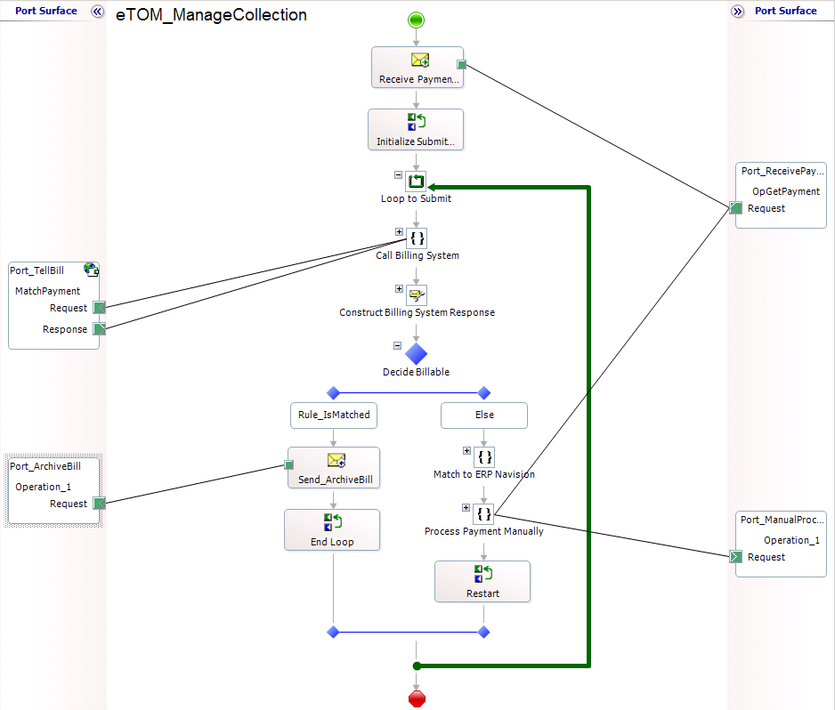
Figure 3. BizTalk Server visually modeling business processes (example)

Microsoft Host Integration Server. A server that provides network, application, and data-level interfaces to a wide assortment of heterogeneous computing platforms and applications. It offers developers a robust set of adapters and tools for efficiently connecting to systems that have diverse architectures and that use earlier networking and transactional processing protocols. Among its numerous out-of-the-box facilities, Host Integration Server supports:
- Gateway support for host-to-Internet or host-to-intranet design models.
- Object-oriented programmatic access to relational databases and flat-file data on mainframes, AS/400, UNIX, Windows Server, and Microsoft Windows NT® Server–based systems.
- Drag-and-drop integration between Microsoft Transaction Server and Component Services with the IBM Customer Information Control System (CICS) and Information Management System (IMS) transaction systems.
Microsoft Content Management Server. Powered by .NET-connected technology, Content Management Server is a comprehensive solution for building, deploying, and maintaining high-availability, content-rich Web sites. It is tightly integrated with Visual Studio .NET and SQL Server, so it can easily support the presentation requirements of complex transaction-based interactions. Consistent with all Microsoft servers, it has built-in support for Web services.
Microsoft Speech Server. A flexible and integrated speech platform, Speech Server provides voice interface capabilities to CCF. It can either operate as a stand-alone voice response system for self-service applications or integrate with existing ACD systems in a contact center. A key value of Speech Server is that it dramatically reduces the cost and complexity of developing and deploying speech applications, making the technology more accessible to a broader range of enterprise customers. Microsoft offers a single solution that combines Web technologies, speech-processing services, and telephony capabilities. Speech Server helps companies to unify their Web and telephony infrastructures and extend existing or new Microsoft ASP.NET Web applications for speech-enabled access from telephones, mobile phones, Pocket PCs, and Smartphones.
A unified platform and Services Oriented Architecture CCF, along with Speech Server, uses existing and new Web-based solutions, giving customers consistent and simultaneous access over any customer contact channel, including speech-enabled self-service over the telephone.
The integration of CCF and Speech Server further demonstrates the commitment of Microsoft to addressing the unique needs of enterprise contact centers. This integration means faster, easier deployment and administration of CCF-based solutions that include speech-enabled IVR applications.

CCF Administrative and Management Features
CCF also incorporates the following tools and resources that facilitate the efficient deployment and administration of CCF systems.
Administration User Interface (AUI). The AUI simplifies the process of creating and maintaining CCF system environments. It is implemented as a Microsoft Management Console (MMC) plug-in that allows administrators to remotely configure and manage CCF system environments efficiently and correctly. (See Figure 4, CCF Administrator Console.) The AUI is a wizard-like facility that interacts with Web services that in turn access SQL Server database tables. The Web services enforce consistency and perform integrity checking on configuration settings. The AUI enables administrators to:
- Access the Windows Authorization Management store to create new Agent principals (identities) and map them to groups.
- Map applications, skill sets, and channels to groups.
- Build and configure Agent Desktop configurations.
- Add and configure hosted and nonhosted applications to the Agent Desktop.
- Define workflows and workflow steps.
In addition, SMS is used to automate and centrally manage the installation of, and updates to, Agent Desktop. As the number of deployments grows, organizations require a more efficient and centralized approach to managing Agent Desktop images. SMS provides a comprehensive solution for installation and configuration management, enabling organizations to distribute and update software to users quickly and cost-effectively.
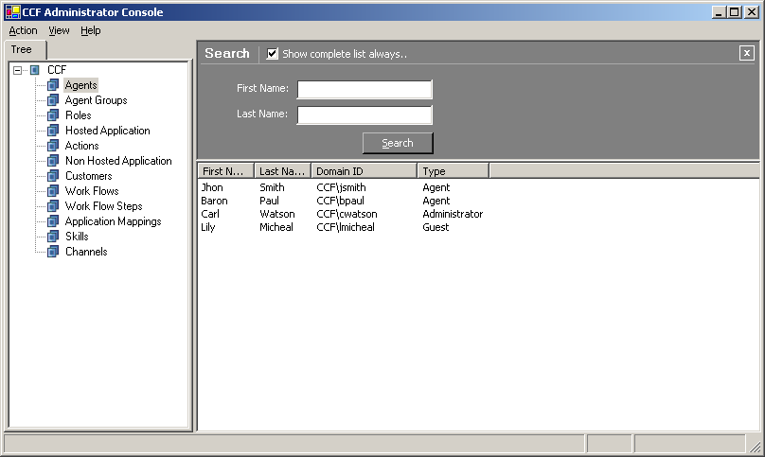
Figure 4. CCF Administrator Console

Enterprise Single Sign-On. Based on the Kerberos version 5.0 authentication protocol standardized by the Internet Engineering Task Force, E-SSO is the extension that enables users to be authenticated to any enterprise resource that they are authorized to access automatically without multiple logons. A client obtains a ticket (representing its network credentials) from the E-SSO Key Distribution Center (KDC), and it presents that ticket to a server when establishing connections. This ticket is cached, so when the user tries to connect to a server, E-SSO checks the ticket cache for a valid ticket for that server. If one is not available, the initial ticket for the user is sent to the KDC along with a request for a ticket for the specified server. That session ticket is added to the cache, and it can be used to connect to the same server until the ticket expires. In addition to users, E-SSO credentials can be assigned to applications and other resources. E-SSO is becoming the standardized distributed authentication method among Windows Server System products.
Microsoft Enterprise Instrumentation Framework (EIF). For enterprise applications in a production environment, EIF provides a unified event logging and diagnostic tracing service. EIF enables developers to consistently instrument enterprise applications, which are increasingly decoupled and distributed, and use a "white-box" approach to monitoring and diagnosing application health, faults, or other conditions. A CCF logging class function routes error and tracing events to EIF by using a custom SQL Server sink, along with default Event Log and Windows Management Instrumentation (WMI) sinks. The SQL Server event database provides aggregated event logging for comprehensive analysis and reporting.

CCF Scalability and High-Availability Features
CCF is designed to scale. The CCF architecture is highly modular so that components can be organized into separate logical entities that can be added and extended when and where needed. Capable of load-balancing and clustering, this architecture allows components to scale easily and cost-effectively, while providing carrier-grade availability and fault-tolerant performance. By separating processing functions into multiple logical and physical tiers, resources can be assigned and configured based on operational requirements with fine-grained precision. A host instance is the physical deployment of a logical host on a server. Any number of hosts can be mapped as host instances to any number of servers. The database tier can also scale out through the addition of multiple physical database instances within a server group.
Because SQL Server databases are critical shared resources of CCF, the ability to fail over is a basic requirement. Cluster services provide a fully integrated, out-of-the box solution for building a Microsoft SQL Server 2000 infrastructure that meets the high-availability demands of a service provider data-center environment. MSCS presents multiple instances of a SQL Server 2000 database as a single system. In conjunction with a robust physical storage system (that is, a redundant array of independent disks [RAID]), MSCS provides automatic and redundant server failover.
This design, known as a "share-nothing" architecture, allows both servers to connect to a common physical disk subsystem, but only one server owns and controls the disk storage at any given time. For example, when Server A is active, it has full control over the disk subsystem. Server B is fully operational, but in a passive state, ready to take ownership of the shared storage if the other node fails. MSCS runs on both nodes and constantly monitors each server to help ensure that all resources are behaving normally. In the event that a serious hardware or unexpected error occurs, all resources fail over to the remaining node without human intervention. Monitoring tools, such as those that Microsoft Operations Manager provides, will immediately detect this failover.

CRM Integration
Optimizing sales objectives is the rationale for deploying Customer Relationship Management (CRM) systems in most organizations. CRM systems provide the tools and methodologies for developing sales programs with formalized goals and the capability of tracking the performance of the activities meant to drive the attainment of those goals. CRM systems provide the analytic facilities to qualify and quantify program variables, sales processes, advertising and marketing activities, and the performance of sales personnel. One important function of CRM systems is the creation of aggregate customer profiles from various LOB information sources and the sales cycle history documented in the CRM system itself. These comprehensive customer profiles provide sales personnel with information, alerts, and context that enable them to effectively address and market to the customer.
An organization can take advantage of the value of the aggregate customer profile information in a CRM system by making the information available for use in the context of a contact center operation. Many CRM system vendors have recognized this fact and have added contact center functionality to their systems as optional modules. However, these modules are tightly coupled to the respective CRM system and often lack the comprehensive feature set and optimized performance refinements of a system such as CCF that was developed for the operational efficiency of a contact center.
The particular strength of CCF that distinguishes it from CRM vendor-specific contact center solutions is that it is built from integration technology, on both the client tier and the middle tier. This facilitates the creation of composite applications that can access any information source or application, including a CRM system. If the CRM vendor has exposed the methods and interfaces of its system as Web services, CCF can use the BizTalk Web Services Publishing Wizard to incorporate those methods or interfaces into a managed composite application or workflow in hours. Furthermore, the CCF AIF can incorporate the CRM application user interface directly in the Agent Desktop and use its context to drive a sequence of processes.
In this way, CCF can use the CRM-generated aggregate customer profile to drive additional contact center efficiencies or to expedite the creation of self-service channels for direct access by customers.

Beyond the Contact Center
CCF was originally designed to be a highly versatile contact center application development and operating solution. Its primary function was to make contact center agents as productive and responsive as possible. CCF goes beyond this original design and operational specification by providing development and production facilities for making customer information and service management directly available to customers.
Today, many customers expect to be able to serve themselves when they want to access information and conduct transactions of any kind. When customers can do this easily and efficiently, self-service is an enabling and gratifying experience. This is a welcome trend for any provider of services because the costs of providing direct-access customer service are significantly lower than traditional call center–based customer care. Consequently, a fundamental objective of CCF is to provide the resources and capabilities that facilitate the creation and operation of diverse self-service channels.

Self-Service Portal Framework
The CCF Self-Service Portal Framework (see Figure 6 below) capitalizes on the highly flexible middle-tier information aggregation capabilities of BizTalk Server to facilitate the creation of direct-to-customer, self-service channels of communication. Based on proven enterprise design patterns and a set of guidelines, the Self-Service Portal Framework enables content managers and developers to easily populate portal channels with customer-specific content. The framework consists of three components: the Self-Service Presentation tier, the Self-Service Portal Web Services tier, and Microsoft Content Management Server 2002.
The Self-Service Presentation tier is based on Microsoft SharePoint® Portal Server and Web Part technologies. The CCF Portal Framework provides three types of Web Parts: Page Web Parts, Content Web Parts, and User Control Web Parts. Page Web Parts are page templates with profile and tracing capabilities. Content Web Parts are used to embed content from Content Management Server. User Control Web Parts enable ASP.NET user controls to be embedded in SharePoint pages.
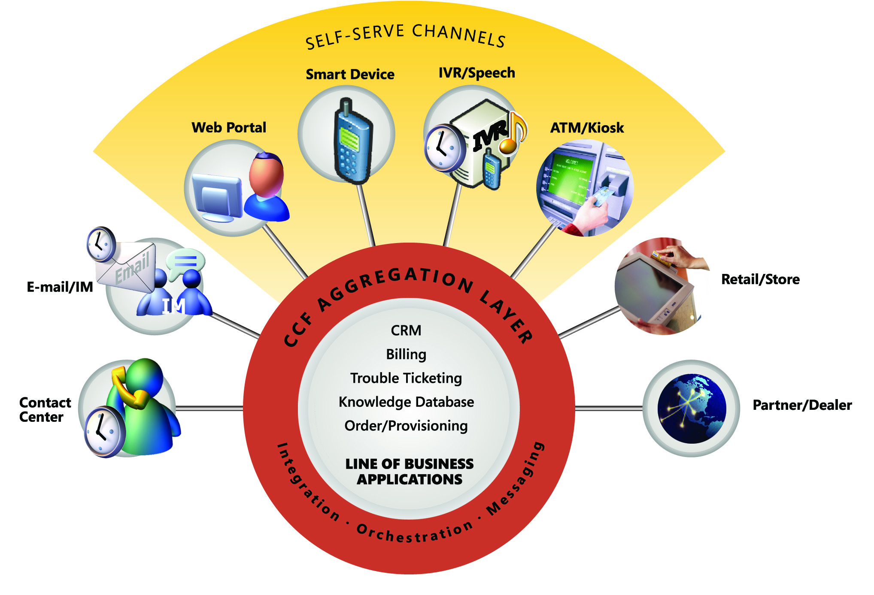
Figure 6. Self-service channel versus traditional channels
The Self-Service Portal Web Services tier is a group of extensible Web services that connect the portal presentation tier to the CCF middle-tier business logic, workflows, and data access components. The capabilities of the Self-Service Portal Web Services tier enable developers to efficiently create common self-service functions, such as:
- Maintaining user account registration, authentication, and authorization.
- Presenting user account and service profile information.
- Generating targeted alerts and promotional information based on profiles.
- Providing access to billing information.
- Offering service orders, trouble-ticket generation, and status checking.

Conclusion
The CCF is based on the Microsoft .NET Framework and Windows Server System, representing the Microsoft commitment to providing a broad, highly advanced, and complementary set of technologies for building enterprise IT infrastructures. The combined capabilities of CCF, Microsoft Visual Studio .NET, BizTalk Server, SQL Server, SharePoint Portal server, Live Communications Server, Speech Server, and Host Integration Server provides a development and run-time environment for creating effective and feature-rich contact center and customer self-service applications that can meet and exceed the demanding operational criteria of telecommunication service providers.
The constituent CCF components are mature, third-generation products that incorporate refinements and improvements that have been derived from the feedback of large user populations and the considerable research and development resources at Microsoft. And because the architectural support for high availability and scalability is “baked-in” to these components, they provide a logical foundation on which to build mission-critical applications.
For developers of contact center applications, CCF not only provides value in terms of the functionality, performance metrics, and economic return on investment of the underlying technologies. CCF also offers significant development and integration efficiencies derived from the highly effective architectural design, advanced methodologies, and prebuilt and configured components that it incorporates.

For more information, see: www.microsoft.com/customercare.



The information contained in this document represents the current view of Microsoft Corporation on the issues discussed as of the date of publication. Because Microsoft must respond to changing market conditions, it should not be interpreted to be a commitment on the part of Microsoft, and Microsoft cannot guarantee the accuracy of any information presented after the date of publication.
This white paper is for informational purposes only. MICROSOFT MAKES NO WARRANTIES, EXPRESS OR IMPLIED, IN THIS
DOCUMENT.
Complying with all applicable copyright laws is the responsibility of the user. Without limiting the rights under copyright, no part of this document may be reproduced, stored in, or introduced into a retrieval system, or transmitted in any form or by any means (electronic, mechanical, photocopying, recording, or otherwise), or for any purpose, without the express written permission of Microsoft Corporation.
Microsoft may have patents, patent applications, trademarks, copyrights, or other intellectual property rights covering subject matter in this document. Except as expressly provided in any written license agreement from Microsoft, the furnishing of this document does not give you any license to these patents, trademarks, copyrights, or other intellectual property.
© 2006 Microsoft Corporation. All rights reserved.
The example companies, organizations, products, domain names, e-mail addresses, logos, people, places, and events depicted herein are fictitious. No association with any real company, organization, product, domain name, e-mail address, logo, person, place, or event is intended or should be inferred.
Microsoft, Active Directory, ActiveX, BizTalk, SharePoint, Visual Studio, Windows, Windows NT, Windows Server, Windows Server System, and Win32 are either registered trademarks or trademarks of Microsoft Corporation in the United States and/or other countries.

