

Microsoft® Customer Care Framework 2005 .NET 2.0 Edition

Microsoft Corporation
Published: September 2006
Version: 2.6

Abstract
Microsoft Customer Care Framework (CCF) 2005 .NET 2.0 Edition enables an increase in contact center efficiency, improved agent productivity, reduction in operating costs, and improvement in the quality of customer service. CCF 2005 .NET 2.0 Edition offers multi-channel integration capabilities via web services, and desktop level application integration through information sharing and interaction between different Line of Business applications. CCF allows enterprises to accelerate enhancement of the customer care environment by utilizing Microsoft core technologies and by providing a reference architecture and software building blocks that leverage the technology and their current systems.
CCF delivers better information faster to service representatives, and does it faster through the use of XML Web Services. The flexible CCF architecture builds on top of the Microsoft platform and integrates with existing systems. This enables contact center operators to reduce their total cost of ownership (TCO) and accelerate their return on investment (ROI) The vision and unified architecture that drives CCF 2005 .NET 2.0 Edition provides numerous components and Web services that springboard off of XML and other, familiar Microsoft technologies. Microsoft CCF will help drive a shift in the customer care landscape toward multiple-channel communication and customer self service.

This is a preliminary document and may be changed substantially prior to final commercial release of the software described herein.
The information contained in this document represents the current view of Microsoft Corporation on the issues discussed as of the date of publication. Because Microsoft must respond to changing market conditions, it should not be interpreted to be a commitment on the part of Microsoft, and Microsoft cannot guarantee the accuracy of any information presented after the date of publication.
This document is for informational purposes only. MICROSOFT MAKES NO WARRANTIES, EXPRESS OR IMPLIED, AS TO THE INFORMATION IN THIS DOCUMENT.
Complying with all applicable copyright laws is the responsibility of the user. Without limiting the rights under copyright, no part of this document may be reproduced, stored in or introduced into a retrieval system, or transmitted in any form or by any means (electronic, mechanical, photocopying, recording, or otherwise), or for any purpose, without the express written permission of Microsoft Corporation.
Microsoft may have patents, patent applications, trademarks, copyrights, or other intellectual property rights covering subject matter in this document. Except as expressly provided in any written license agreement from Microsoft, the furnishing of this document does not give you any license to these patents, trademarks, copyrights, or other intellectual property.
© 2006. Microsoft Corporation. All rights reserved.
The names of actual companies and products mentioned herein may be the trademarks of their respective owners.

Contents
Contents 1
Overview of Microsoft Customer Care Framework 2005 .NET 2.0 Edition 3
New Features in Microsoft Customer Care Framework 2005 4
Table 1: Microsoft Customer Care Framework Feature Comparison 5
Key Benefits of Microsoft Customer Care Framework 2005 7
Cost Savings and Increased Productivity 7
Customer Satisfaction and Revenue Opportunity 7
Integration with Microsoft Customer Care Framework 2005 8
Self-Service Portal Framework: 11
Multi-Channel Email, Chat, Voice, and Speech: 12
Partner Solutions with Microsoft® Customer Care Framework 2005 16
System Requirements 17
CCF Server 17
CCF Database Server 17
Agent Desktop Client 17
Other Optional Components 18
Summary 19
Additional Resources 19

Overview of Microsoft Customer Care Framework 2005 .NET 2.0 Edition
Microsoft Customer Care Framework 2005 .NET 2.0 Edition (CCF) provides the software components and best practices used to write, develop and test customer care solutions based on proven Microsoft technology. It is based on a Service Oriented Architecture (SOA). This encapsulates, manages and interoperates with core systems such as CRM, billing, order management, and other custom applications. The framework also promotes synchronization between self-service solutions (Portals, Speech/Interactive Voice Recognition (IVR)) and contact centers by providing a unified architecture for all customer care channels. Earlier versions of CCF originated from successful customer engagement and asset builds. Customer Care Framework 2005 now increases contact center efficiency by delivering better information, and delivering it faster to service representatives through its use of automation and XML Web services interfaces.
CCF provides the call center agent with single sign-on to multiple applications, a 360° unified view of customer information, and a user friendly interface. The CCF server can push customer content information from multiple databases to the agent desktop. The platform seamlessly integrates with underlying business applications without requiring changes to existing systems, and avoids costly and time consuming ‘rip-and-replace’ of existing systems.
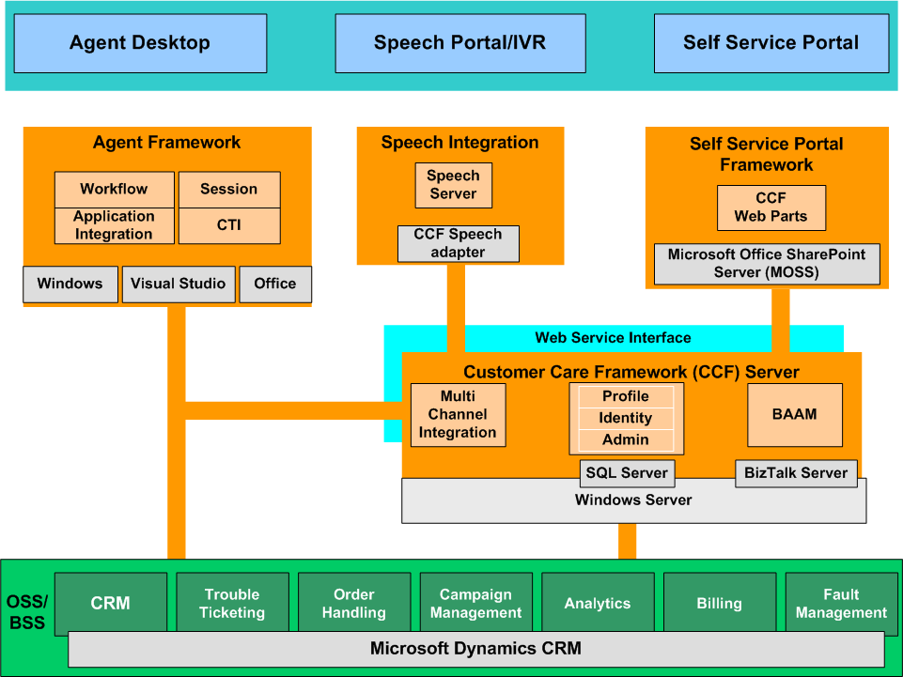
Figure 1: CCF High Level Architecture

New Features in Microsoft Customer Care Framework 2005 .NET 2.0 Edition
Significant new features and enhancements such as the expansion of customer interaction channels, a ASP.NET-based Self-Service Web Portal, and additional technical developments have been included in Microsoft Customer Care Framework 2005 .NET 2.0 Edition.
Expansion on customer interaction channels and their integrations provides new contact communication channels (Web chat, email, and self service) between customers and call center representatives. These new channels enhance the ability of customer care organizations to shift support activities from traditional phone calls to multiple channels such as Web chat and email.
Customer Care Framework 2005 .NET 2.0 Edition provides a framework technology that leverages the security, personalization, and profile infrastructures from Windows® .NET Framework 2.0 and specifically ASP.NET. Based on this framework, portal content managers or developers can easily manage and populate customer specific content and integrate with customer enterprise systems.
Technical Enhancements include Agent Desktop Workflow such as invoking hosted applications at the action level. This actively guides an agent through workflow using the context of the task steps to automatically access information and applications needed to execute those tasks.

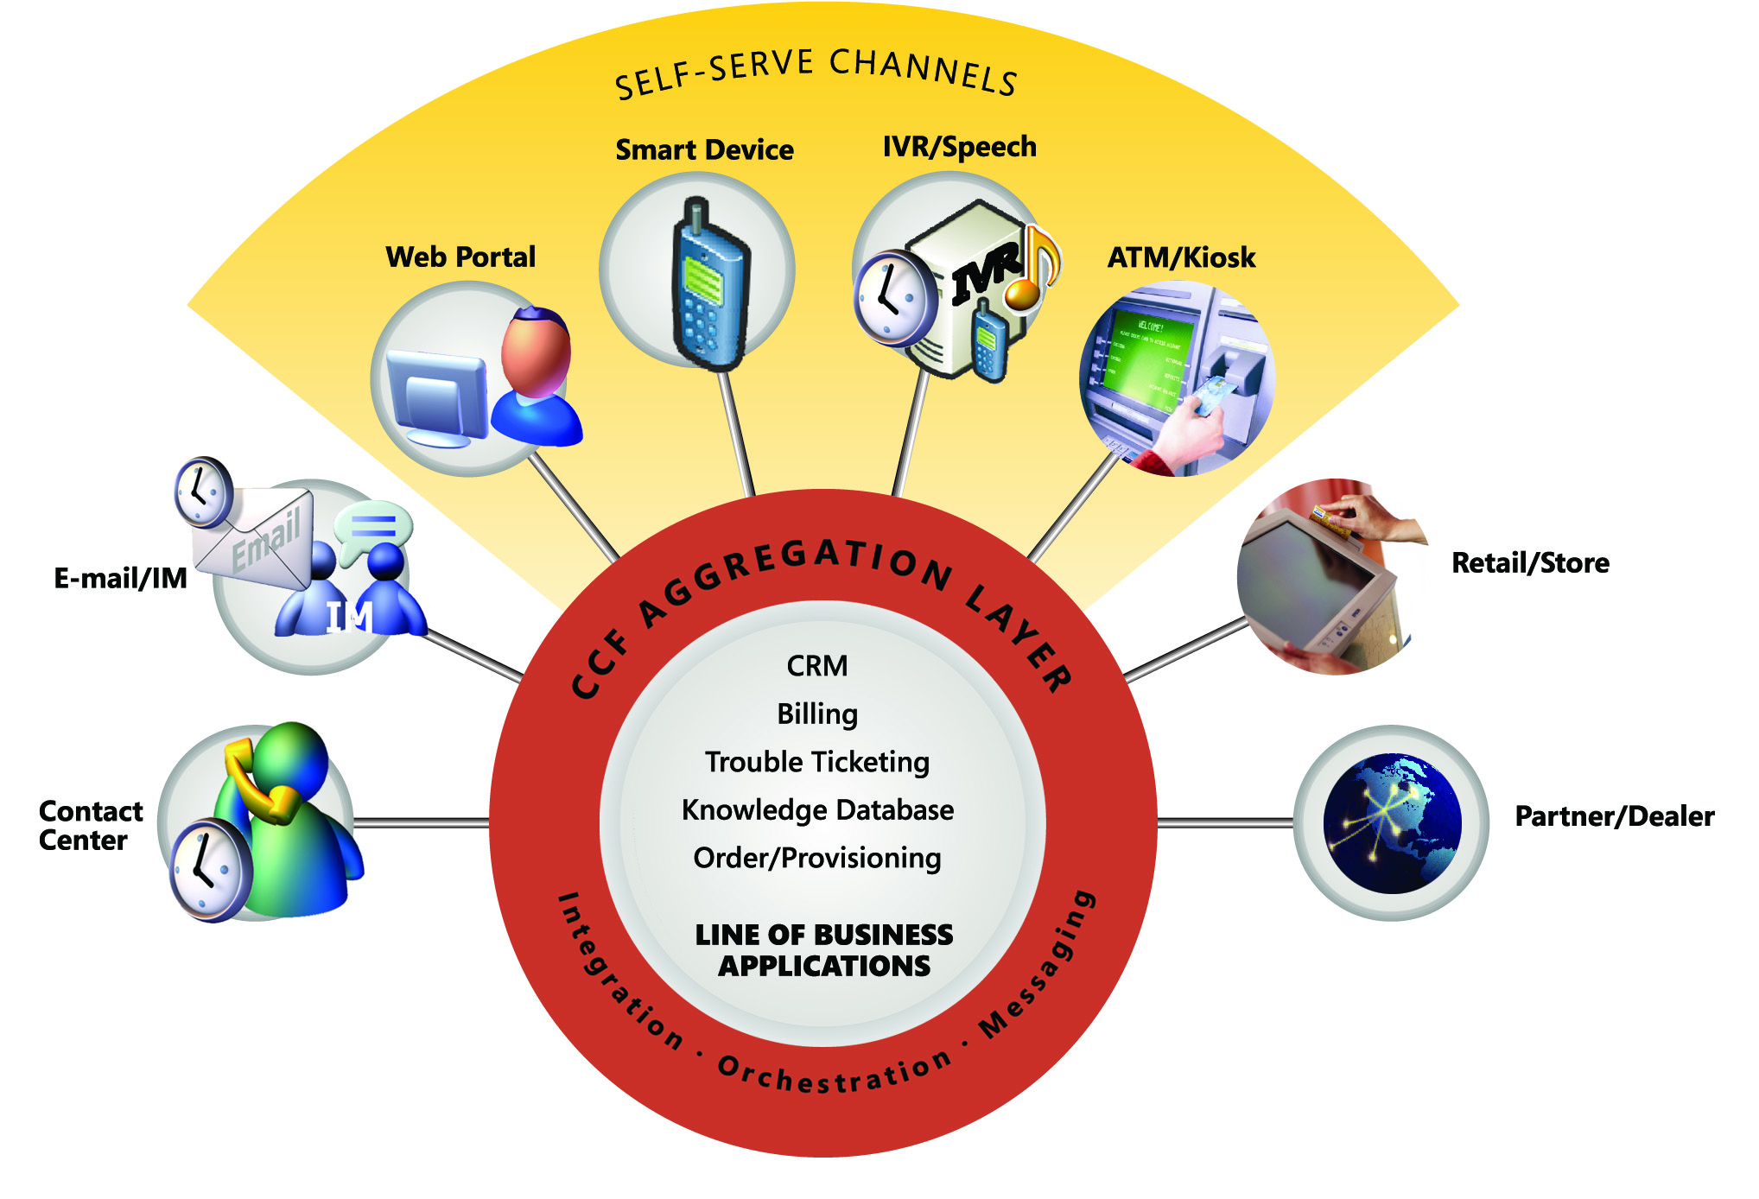
Figure 2: CCF Access features

Table 1: Microsoft Customer Care Framework Feature Comparison
KEY:  = Feature Included  = Improved in CCF 2005 .NET 2.0 Edition  = New in CCF 2005 .NET 2.0 Edition | Customer Care Framework Version 2.0 | Customer Care Framework  2005
Multi Channels Support
Computer Telephony Integration
Web Chat
Email
Integration with speech enabled IVRs
Self-Service Portal
Agent Desktop
Toolbar
Application Integration Framework
Multiple Sessions Control
Computer Telephony Integration (CTI)
Agent Desktop Workflow
Instant Coaching and Help
Application State Recovery
Application Fault Isolation,
Audit Trail, Single Sign-On
Hosted Controls
Next & Back Feature
Server Enhancement
Simplified Extensibility
Application Authorization
Session Management
Web Service CTI, Scalable Deployment
Business Application Aggregation Module
Administration and Reporting
Admin Console
Configuration Driven
MS SQL Reporting
Audit Trail (Logging) and Reporting

Key Benefits of Microsoft Customer Care Framework 2005
CCF 2005 .NET 2.0 Edition enables service providers or enterprises to create a converged infrastructure that can streamline management of an increasing number of diverging business operations. CCF 2005 .NET 2.0 Edition provides the solution to transform and expand call center operations and reduce costs while improving the quality of customer service.

Cost Savings and Increased Productivity
CCF 2005 .NET 2.0 Edition can increase contact center agent productivity, by pre-fetching customer information from CTI or IVR, and sharing it between different applications. This “intelligent sharing” eliminates redundancy and dramatically reduces the time agents must spend searching and entering data to complete a call. CCF 2005 .NET 2.0 Edition also provides numerous components and features for multi-channel and self-service customer care. The potential cost saving and productivity benefits include:

- Accelerating the time to solution and enabling the realization of the benefits of an integrated agent desktop in minimal time and at a lower TCO.
- A Customized User Interface accesses multiple data sources to provide the highest possible Customer Service Representative (CSR) efficiency and lower Average Handle Time.
- Agent single sign-on speeds information retrieval by eliminating the inefficiency of signing on and off of multiple systems to gain access to all of a customer’s relevant information.
- Providing the ability to continuously streamline operations by analyzing CSR usage patterns and work flow.

Customer Satisfaction and Revenue Opportunity
CCF’s integrated agent desktop can enable contact center operators to dramatically improve the quality of service through increased access to customer information and reduced call duration. By focusing on those two key objectives, contact center operators can realize improved customer satisfaction and potential revenue opportunities through the purchase of additional products and/or services.

- Increased customer satisfaction through first call resolution. Quick access to customer information improves the time-to-resolution by enabling a 360 degree view of customer information meeting all customers’ needs, and utilizing a minimum number of screens.
- Shorter calls result in more satisfied customers. Customers whose inquiries or issues are resolved quickly will more likely be satisfied and loyal, leading to increased customer satisfaction and retention.

- More choices mean more loyal customers. If a customer can choose when and how to have their needs met and can count on a high-quality, consistent experience every time, regardless of channel, they will be more satisfied, and more loyal in the long term.

- Increased revenue per customer. Satisfying customers with consistent, quick resolution to inquiries creates an opportunity to cross-sell and up-sell products and services. CCF provides immediate visibility to the customer portfolio to facilitate targeted selling efforts.

Integration with Microsoft Customer Care Framework 2005 .NET 2.0 Edition
Engineering a high level of functional versatility in customer care is far from trivial. With the increased volumes of customer service transactions and the accelerated introduction of new products and services, the functional demands on line-of-business (LOB) applications have grown dramatically. The system integration requirements to facilitate the rapid introduction of new services and accommodate the growing volume of transactions have become significantly more complex.
The design and organization of CCF demonstrates best practices and methodologies for building adaptable and scalable applications for performance critical enterprise functions. CCF extensively uses the Microsoft .NET Framework Version 2.0 and Microsoft Windows Server System™ integrated server software, blending object-oriented architecture and service-oriented architecture methods to create an infrastructure that readily accommodates continuous change and growth.
CCF’s flexible architecture supports both front and back-end integration approaches. Unlike other Enterprise Application Integration (EAI) projects that require extensive middle-tier business logic and data integration which is costly and time consuming, CCF can be implemented in a relatively short time using front-end integration techniques and leveraging back-end systems.
Scenarios and Examples

Integrated Agent Desktop:
The Integrated Agent Desktop (IAD) application will be used by Customer Service Representatives (CSRs) to serve customers. When a customer calls and initiates a web chat, or sends an e-mail, the interaction gets routed to a CSR. The CSR can access all of the customer information through the CCF agent desktop, which offers an integrated view of the customer with workflow, context/session management, and seamlessly integrates with the existing information systems to answer customer queries.
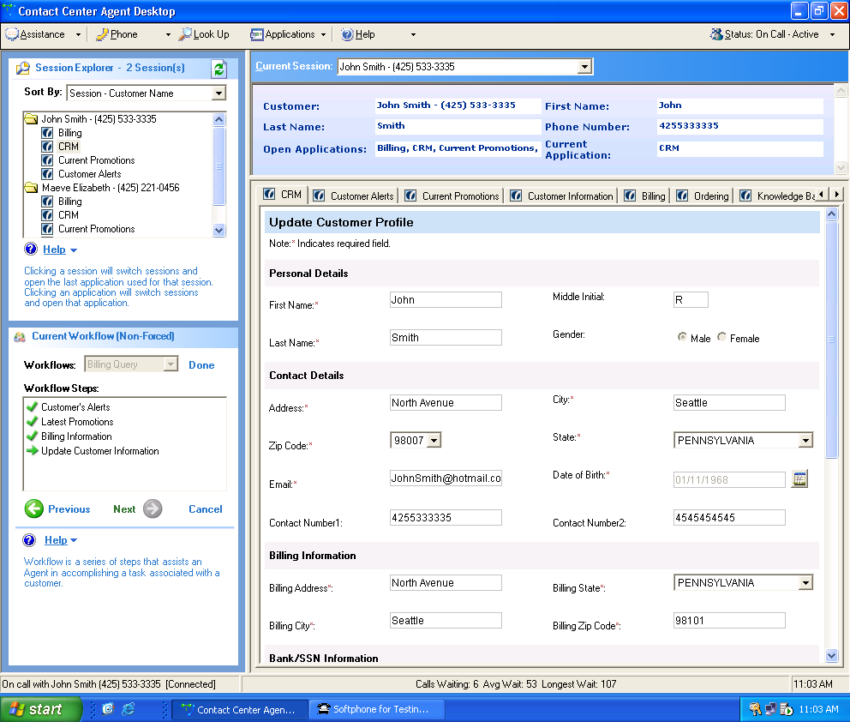
Figure 3: CCF Agent Desktop

Agent Desktop module: A workflow-driven, user interface shell that actively guides and prompts an agent through workflow tasks and uses the context of the task steps to automatically access information and applications needed to execute those tasks. The proactive direction and assistance provided by the Agent Desktop represents an important and effective innovation for improving the efficiency of contact center personnel and their ability to serve customers. While running on the Windows XP Professional operating system, the Agent Desktop can replace the Windows XP Professional user interface entirely when the agent computer is turned on. In addition, Agent Desktop provides the following features and functions:

- A smart client application a with rich and highly responsive user interface that dynamically shares customer information among multiple applications.
- Direct access to call control functions that are exposed through the CTI abstraction layer, such as answer, transfer, conference, hold, and hang-up.
- Multiple call activity display and an application state management. The Session Explorer panel displays a list of active customer sessions that the agent is handling. Whenever an agent chooses a customer session that is still in progress, the Agent Desktop will automatically restore the presentation and state of all applications supporting that call.
- Workflow management with automatic application launching and call transfer. The Agent Desktop presents the workflow steps an agent needs to follow and can automatically launch the applications needed to support the process steps. If a step in the process needs to be continued by another agent or at a later time, the key call context, including the state of the supporting applications and information can be automatically transferred to the agent or restored later.
- Network-based application deployment and configuration is handled by storing all configuration information on the network. In the event that an agent’s workstation fails, the agent’s applications and operating state can be restored by having the agent log back on from another workstation.
- “Call center statistics and alerts. The Agent Desktop can be configured to display alerts or statistics per customer requirements for various groups of users.
- Integrated authentication and authorization for agent roles and applications using Enterprise Single Sign-On (SSO) and the Active Directory® directory service.
- CCF supports application fault isolation. Additionally, separated process threads and application domains can be implemented.
- The state of the Agent Desktop persists to the Middle-Tier Context Services module, facilitating complete recovery of the client state from any other agent computer on the network.
- Automatic customer information can be automatically received by an Automatic Number Identification (ANI), an IVR system or some other mechanism.
- Customer information can be received instantly by an Automatic Number Identification (ANI) system, IVR system, some other mechanism.
- It allows agents to request real time help with pre-configured skill areas such as Billing or Order Handling
  - The web service provides the hook to plug-in optimal routing mechanism
  - Inter-agent IM can be either peer-to-peer or through Microsoft Office Live Communication Server (LCS)
The CCF Agent Desktop communicates with the CCF Server exclusively using Web services. This means that the source applications can be located anywhere and are loosely coupled, allowing for the flexible modification and extensibility of the contact center processes.

Self-Service Portal Framework:
The CCF Self-Service Portal Framework capitalizes on the highly flexible middle-tier information aggregation capabilities. This facilitates the creation of direct–to-customer, self-service channels of communication. Based on proven, enterprise design patterns and a set of guidelines, the Self-Service Portal Framework makes this easy. It allows content managers and developers to populate portal channels with customer-specific content. This framework includes three tiers: the Self-Service Presentation tier, the Self-Service Portal Web Services tier, as well as existing Line of Business (LOB) applications.
The Self-Service Presentation tier is based on Microsoft ASP.NET 2.0. CCF portal framework provides three types of web parts: Page web parts, Content web parts and User Control web parts. Page web parts are page templates with profile and tracing capabilities. Content web parts are used to embed content from the Microsoft Content Management Server. User controlled web parts allow ASP.NET user controls to be embedded in web pages
The Self-Service Portal Web Services tier is a library of pre-built Web service interfaces that connect the portal presentation tier to the CCF middle-tier. This middle tier includes business logic, workflows, and data access components. The capabilities of the ASP.NET tier allows developers to efficiently create common, self-service functions such as:
- Maintaining user account registration, authentication, and authorization
- Presenting user account and service profile information
- Generating targeted alerts and promotional information based on profile
- Providing access to billing information
- Offering service order, trouble-ticket generation, and status checking.

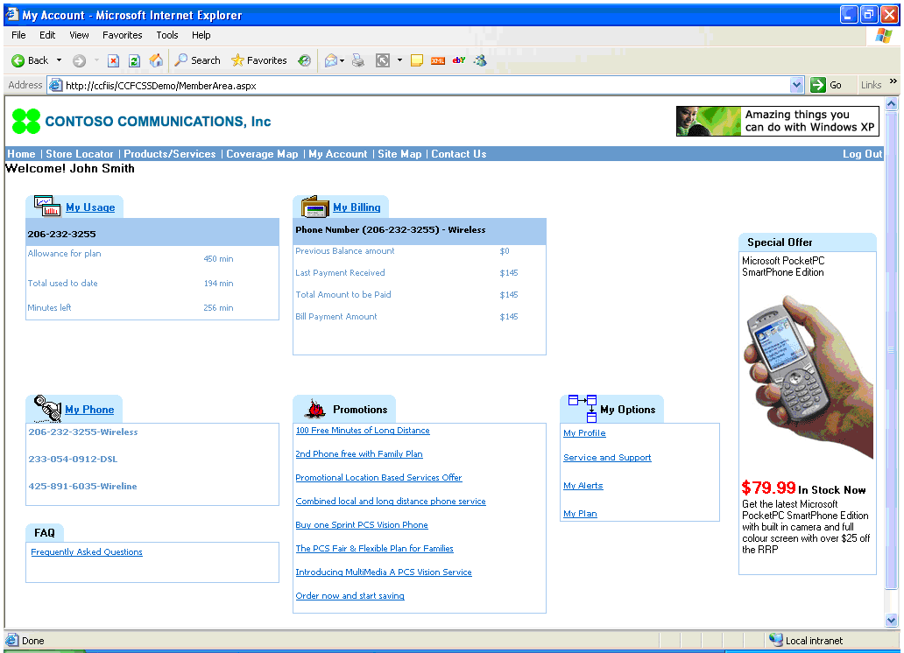
Figure 4: Customer Self Service Portal

Multi-Channel Email, Chat, Voice, and Speech:
Multi-Channel Support Web Services
CCF treats all customer interaction channels in a uniform manner, both in terms of technical architecture as well as agent experience. The Multi-Channel Support Web Services allow CCF to smoothly integrate communication channels such as telephony, customer-to-agent chat, or email. Regardless of the channel, the CCF integration architecture remains the same.
Email and Chat Integration:
CCF 2005 .NET 2.0 Edition supports email and chat channels. CCF does not provide the channel itself and it also does not route email and IM. Rather, CCF focuses on channel integration capabilities via web services and desktop level application integrations. The following steps explain CCF email integration:
- Customer sends an email via Email Web Part within customer web portal. The web part will collect context info from web portal environment and send through email channel.
- Email and context info arrives at Email Server
- The email is first processed by any 3rd party Email Response and Management Server (ERMS) for analysis and auto response.
- ERMS invokes CCF Server Email web service to pass on context and routing info. A CCF session is created.
- Based on the routing info, CCF Server pushes the session context info to the proper agent desktop.
- CCF Agent Desktop uses context info to invoke the Email Client API so that the Email Client can retrieve the corresponding email.
- Agent composes a reply email and sends it through ERMS
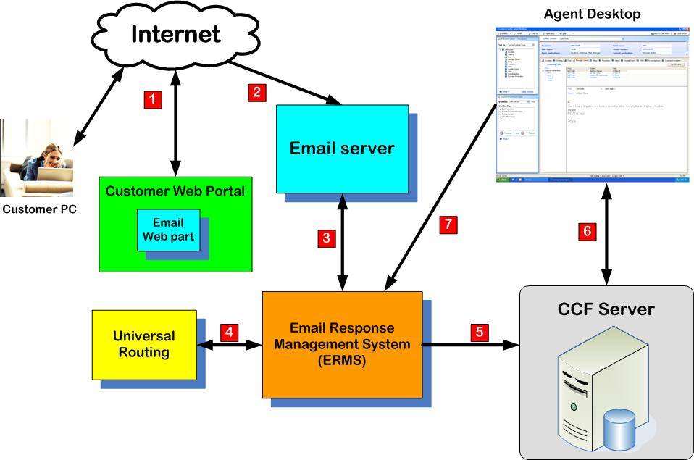
Figure 5: CCF Email channel integration. Similar architecture for Chat.
Computer Telephony Integration (CTI):
- CTI integrates the voice infrastructure with the software infrastructure within a contact center
- Client-Based (Implemented on Agent Desktop):
  - Supports Telephony Application Programming Interface (TAPI), Telephony Server Application Programming Interface (TSAPI). This handles most existing phone switches, including many IP telephony systems.
  - Can be extended for switches that do not support those two standards.
  - A CTI Abstract Layer (managed code) encapsulating protocol specifics is called by other components of CCF.

Microsoft Speech Server Integration:
- MS Speech Server provides the platform and tools to build Speech Enabled IVR apps.
- IVR Apps are not part of CCF and usually custom developed for each customer.
- IVR Apps interface with CCF Web services for authenticating users, logging customer interaction info, accessing business data, etc.
- IVR apps can also transfer the call to an agent via CTI Server which passes call information and customer context to CCF via CCF CTI web service.

Integration with and the Windows Server System
CCF puts the customer care organization on the path to a service-oriented world. One challenge in this process is creating effective business processes that unite disparate systems into a coherent whole. The CCF Business Application Aggregation Module (BAAM) can leverage the Microsoft BizTalk Server to integrate applications such as Operational Support System (OSS)/Basic Service Set (BSS) systems in order to unlock the data and business processes inherent in these systems. Accessing and integrating these systems has historically been a time-consuming and labor intensive task. This is because legacy OSS/BSS systems consist of thousands of program modules, databases, and data. Developing extended programmatic capabilities or attempting to make information accessible in ways that are not defined in these systems has required programming point-to-point interfaces, resulting in tightly coupled and highly specific functions that exist and execute in the form of procedural code.
In addition, the CCF Business Application Aggregation module also provides capabilities for information workers to monitor running processes, interact with trading partners, and perform other business-oriented tasks. These capabilities are addressed in some additional detail in the sections below.
Enterprise Integration and Business Process Management
The Microsoft BizTalk Server provides the basis for Microsoft enterprise integration and business process management that embodies the integration and automation capabilities of XML and Web services technologies. CCF utilizes BizTalk Server to provide workflow and data abstraction. BizTalk Server provides application integration development by elevating the integration process from the program layer to the information (message) and transport layer. By separating information from the applications that use it and exposing this data in XML form (using XML metadata to give it meaning and structure), the data can be consumed by any application or customer interaction channel capable of parsing and interpreting XML. This is a very powerful benefit of XML Web services, as it allows common data in XML form to be shared by different applications and customer interaction channels without regard for where they reside, how they were originally developed, or what platform they run on.
Enterprise Single Sign-On
Customer care representatives typically rely on several different applications and are likely to face the challenge of dealing with several different security domains. Accessing an application on a Windows system may require one set of security credentials, while accessing an application on a mainframe may require different credentials, such as a Resource Access Control Facility (RACF) username and password. Dealing with this profusion of credentials is difficult for users, and it can be even more difficult when using automated processes. To address this problem, BizTalk Server includes Enterprise Single Sign-On.
Enterprise Single Sign-On provides a way to map a Windows user ID to non-Windows user credentials. This service can make things simpler for business processes that use applications on diverse systems.
Business Activity Monitoring
It’s not hard to think of different ways that an information worker might want to look at a business process. A contact center manager might need to see how many orders are being processed each day, or how many service request tickets are being generated each day, while a sales manager might want an hourly update on what product bundles are being ordered. Meeting these diverse needs requires a general framework for tracking what’s going on with a particular business process. This is exactly what the Business Activity Monitoring (BAM) component in BizTalk Server provides.
The role of the CCF Business Application Aggregation layer is to help customer care organizations meet the challenges of creating an efficient and agile contact center as well as a seamless cross-channel experience for customers while relying on the underlying diverse systems. The module leverages the BizTalk Server BAM component, which provides core messaging, orchestration, and transformation capabilities; and additional business functions.

Example of CCF Integration with Microsoft CRM
Microsoft Dynamics Customer Relationship Management (CRM) service module provides the customer and agent hosted applications for CCF. CCF integrates Microsoft screens as a group of web applications and uses CRM’s email channel to trigger CCF session creation and screen pop.
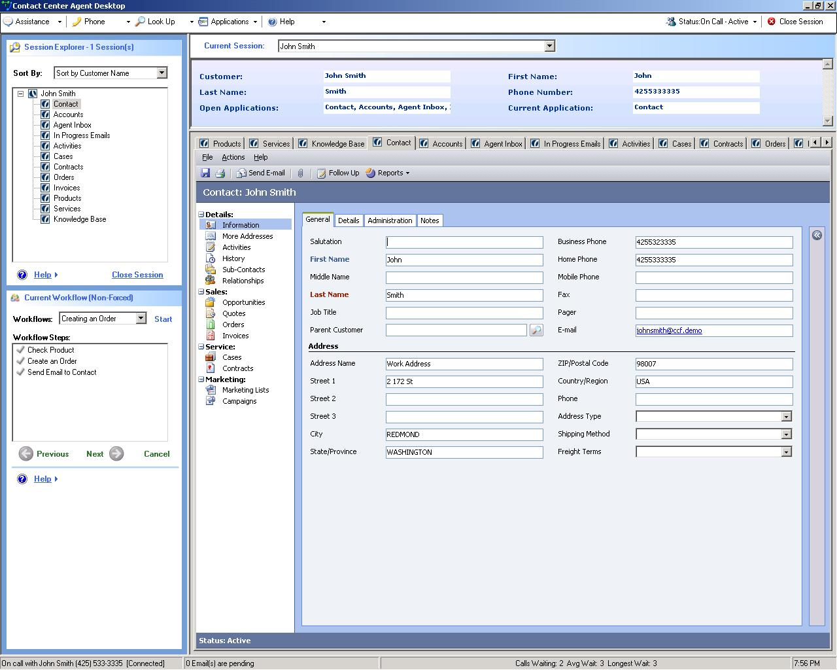
Figure 6: Microsoft CRM and CCF Integration

Partner Solutions with Microsoft® Customer Care Framework 2005 .NET 2.0 Edition
Microsoft Customer Care Framework 2005 .NET 2.0 Edition provides a flexible platform for various contact center and customer care solutions. The following solutions have been developed and deployed by system integrators, ISV partners or Microsoft Consulting Services.
- Integrated agent desktop with task automation, soft phone, agent scripting and balance score card,
- Knowledge portal: pre-built components for knowledge portal
- CTI integration: Pre-built 3rd party CTI connection
- Web self service portal utilizing CCF Business Application Aggregation Module
- Chat: Web chat integration with CCF agent desktop
- OSS/BSS integration: CCF pre-integrated with OSS system
The following table shows how CCF can be used to develop the complete end-to-end customer care solution:
Table 2: Possible Partner Solutions
Scenarios | Solution
Integration Tools | - IDE  - Legacy application emulator  - LOB application adapters
Contact Center Agent Desktop Enhancement | - Knowledge portal  - Agent scripting  - Agent workflow  - Workforce management  - Balance score card  - Escalation management  - On-demand training  - Up sell/campaign management  - CTI integration
Self service portal | - Speech enabled self service  - Line of business adapter
Multi Channels | - Multimedia routing and queuing engine  - Email analysis and response system  - Chat management  - Speech/IVR integration

System Requirements

CCF Server
To use Microsoft® Customer Care Framework 2005 .NET 2.0 Edition Server, you need:
- Software:
  - Microsoft Windows Server 2003 Standard, Enterprise or Datacenter Editions and ASP .NET 2.0
- Additional items or services required to use certain features:
  - IIS 6.0 and ASP.NET enabled and configured
  - SQL 2000 Client with latest SQL Server Service Pack
  - For Microsoft Enterprise Single Sign-On: Microsoft BizTalk Server or Microsoft Host Integration Server is required
  - If the Authorization Manager is to be configured with Active directory as the store type, the operating system for this machine must be Windows Server 2003 SP1
  - It must be a member of a Windows Domain
- Hardware recommendation:
  - Server with a Pentium 4 compatible 3.0 GHz or higher processor, Dual Pentium 4-compatible 3.0 GHz recommended
  - 1 GB of RAM or above, 2 GB of RAM recommended
  - Dual 36 GB Ultra2 SCSI hard drives recommended
  - 100-megabits per second (Mbps) network interface card (NIC) is recommended

CCF Database Server
To use Microsoft® CCF 2005 .NET 2.0 Edition as a database server, you need:
- Software:
  - Microsoft Windows Server 2003 Standard, Enterprise or Datacenter Editions.
  - SQL Server 2000 SP3a or later
- Additional Requirements
  - It must be a member of a Windows domain
- Hardware recommendation:
  - Server with a Pentium 4 compatible 3.0 GHz or higher processor, Dual Pentium 4-compatible 3.0 GHz recommended
  - 2 GB of RAM or above, 4 GB of RAM recommended
  - Dual 36 GB Ultra2 SCSI hard drives recommended
  - 100 megabits per second (Mbps) network interface card (NIC) is recommended

Agent Desktop Client
To use CCF Agent Desktop Client you need:
- Software:
  - Microsoft Windows XP SP2 or later
  - NET Framework version 2.0 and any subsequent service packs
- Additional items or services required to use certain features:
  - Internet Explorer 6.0 or higher
  - Client must be a member of a Windows domain.
- Hardware recommendation:
  - PC with a Pentium III compatible 550 MHz or higher processor, Pentium 4-compatible 3.0 GHz recommended
  - 500 MB of RAM or above, 1 GB of RAM recommended
  - Super VGA (800x600) resolution monitor, (1024X768) resolution is recommended
  - 100 megabits per second (Mbps) network interface card (NIC) is recommended

Other Optional Components
For Microsoft SQL Reporting Server system requirements, refer to:
http://www.microsoft.com/sql/technologies/reporting/default.mspx
For Microsoft BizTalk Server system requirements, refer to:
http://www.microsoft.com/biztalk/default.mspx
For Microsoft Windows SharePoint Services system requirements please refer to:
http://www.microsoft.com/windowsserver2003/techinfo/sharepoint/sysreqs.mspx
For Microsoft SharePoint Portal Server system requirements, refer to:
http://www.microsoft.com/office/sharepoint/prodinfo/sysreq.mspx
For Microsoft Speech Server system requirements, refer to: http://www.microsoft.com/speech/evaluation/requirements/default.mspx

Summary
Microsoft® Customer Care Framework 2005 enables dramatic improvements in contact center efficiency by delivering better information faster to service representatives through the use of XML Web services. In contrast to alternative approaches, Microsoft® Customer Care Framework 2005 delivers a solution that is quickly deployed and provides a satisfying user experience.

The flexible CCF architecture allows an enterprise to add customer-centric applications to the system, while delivering a single view of the customer and protecting the enterprise’s investment in legacy applications. It additionally provides “best in class” TCO with fast ROI by utilizing SOA Web Services.

The multi-channel alternatives such as speech/IVR, chat/instant messaging, e-mail, and self service are all on a single platform using Microsoft Technologies, extend opportunities to expand offers and services to newer and larger markets, directly contributing to an organization’s top-line growth.

The CCF auditing and reporting capabilities provide the analytical tools to help managers to optimize their contact centers to provide better customer service, greater customer insight and best possible resource management. Such improved customer data quality further facilitates an enterprise’s ability to build and manage customer loyalty.

The CCF ecosystem provides applications such as knowledge enabled service resolution, escalation, agent scripting and others to provide greater efficiencies and avenues for cost control and revenue growth to enterprises.

Additional Resources
For more information, visit
- Microsoft® Customer Care Framework: http://www.microsoft.com/serviceproviders/solutions/ccf.mspx
- Microsoft® Windows SharePoint Services and
Microsoft® Office SharePoint Portal Server: http://www.microsoft.com/sharepoint
- Microsoft® Windows Server: http://www.microsoft.com/windowsserversystem
For detailed system requirements and help planning, deploying and maintaining your Customer Care Framework environment, please visit the Microsoft® Customer Care Framework Deployment Resources Center.

© 2006. Microsoft Corporation. All rights reserved

