Microsoft business solutions–Axapta Marketing Automation
Microsoft® Business Solutions−Axapta® Marketing Automation gives you the insight to create targeted, personalized campaigns across all communication channels:

Key Benefits:
- Increase the effectiveness of marketing activities

- Easily gather and use customer feedback

- Measure profitability of campaigns
Microsoft Business Solutions−Axapta Marketing Automation makes campaign planning, execution and analysis easy by placing all relevant marketing information at your fingertips. Campaigns can be based on back office and front office information and are easily organized, executed, tracked and analyzed.
Microsoft Axapta Marketing Automation lets your entire business work with the same user-friendly application—from accounting, production and logistics to sales and marketing. And most features can be set up to match your business processes, so the software conforms to your company practices, not the other way around.
Microsoft Axapta Marketing Automation is part of our Sales and Marketing solution, which includes Sales Force Automation, Sales Management and Telemarketing.

Increase the effectiveness of marketing activities
The key to successful direct marketing is to give your contacts the information they need—how and when they need it. With Microsoft Axapta Marketing Automation, determining the right information for the right customers is simple - the product guides you every step of the way.
Quickly plan and execute personalized campaigns using a campaign window that consolidates all the information and functionality needed to communicate via direct sales, call centers, e-mail, fax, the Internet and mobile devices.
Defining and selecting a campaign target group is both the most difficult and the most important phase of campaign planning. Microsoft Axapta Marketing Automation lets you segment your target audience into meaningful profiles to facilitate personalized campaigns targeted at specific customers’ needs.
Selection criteria are based on information in the Microsoft Axapta Database and results can be modified and filtered to meet your exact requirements. These selections can be saved and re-used in future campaigns. You can also import address lists from third party vendors through the import function in Microsoft Axapta Sales Force Automation.
Campaigns are organized in a hierarchical structure, indicating relationships between different marketing efforts. In order to keep the process as simple as possible, one employee has overall responsibility for each campaign, but numerous employees can be assigned tasks within multiple campaigns.
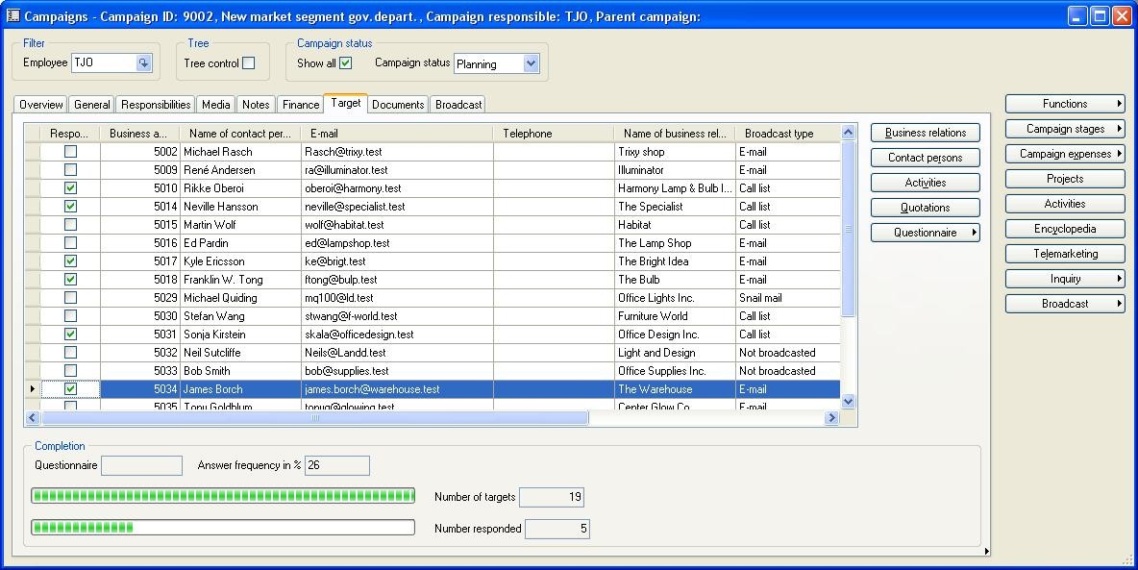

Plan and execute any number of marketing campaigns to groups of customers, vendors or other external companies
Follow your campaign responses from manual or automatic sources

Tailor your campaign to suit individual needs by allowing distribution by post, e-mail, call lists or internet based questionnaires

Easily gather and use customer feedback
Learn from your customers using questionnaires. Web-based functionality lets you design, publish and process questionnaires quickly and easily.
The Internet also makes it faster and easier for customers to respond to questionnaires. Marketing Automation saves Internet reponses directly into the Microsoft Axapta Database, from where the information is immediately available to you.
When responses start flowing in, users have complete details on the target group and can easily see who has replied and the answers that were given to particular questions. Easy-to-use answer registrations are designed to enable effective follow up. Customer responses can be used to get market insight and a head start on planning for future demands.
Access relevant information on a specific target available from all parts of your business

Monitor income and expenses on your campaigns by integrating with Project

Integration between sales, marketing and customer service departments is key to meeting customer expectations. By enabling resources from one department to be relayed to a common encyclopedia, these departments can use a wider scope of information and are better equipped to support each other.

Measure the profitability of campaigns
Monitor return on investment (ROI) by linking a campaign with a project, and view response rates, revenue, costs and the work put into your marketing efforts. Income and expenses related to each campaign can be laid out in the campaign form allowing the cost of the campaign to be quickly compared with the revenue it has generated.

Microsoft Business Solutions–Axapta
Microsoft Axapta Marketing Automation is part of Microsoft Business Solutions–Axapta, a customizable, scalable and global Enterprise Resource Planning (ERP) solution that supports connectivity with your business community and provides you with a fast and powerful way to gain competitive advantage.

For more information about Microsoft Axapta
To learn more about Microsoft Axapta, contact your local Microsoft Business Solutions office or Microsoft Certified Business Solutions Partner, using the following Web address. They have the expertise to meet your specific business needs.

About Microsoft Business Solutions
Microsoft Business Solutions, a division of Microsoft, offers a wide range of integrated, end-to-end business applications and services designed to help small, midmarket and corporate businesses become more connected with customers, employees, partners and suppliers. Microsoft Business Solutions' applications optimize strategic business processes across financial management, analytics, human resources management, project management, customer relationship management, field service management, supply chain management, e-commerce, manufacturing and retail management. The applications are designed to provide insight to help customers achieve business success. More information about Microsoft Business Solutions can be found at www.microsoft.com/BusinessSolutions.

Address:
Microsoft Business Solutions
Frydenlunds Allé 6
2950 Vedbaek
Denmark
Tel +45 45 67 80 00
Fax +45 45 67 80 01
www.microsoft.com/BusinessSolutions

Key Features | Description
Easy to use | - Intuitive layout and structure  - User-adjustable menu  - User-adjustable layout of master files and journals  - Windows commands include ‘copy and paste’ to and from Axapta  - Advanced sorting and filter options  - Built-in user help including an integrated manual  - Option to e-mail, phone and fax directly from Axapta  - Application can be run in different languages
Campaign Overview | - Create campaigns based on the selection of table fields in any table related to your business relations  - Campaign administration and distribution  - Campaign window with all relevant information at your fingertips  - Connection between campaigns and questionnaire, projects and Web response  - Correspond with large groups of existing or potential customers or vendors by broadcasting the campaign via e-mail, Web, fax, letter, call lists  - All common campaign reports available
Marketing Encyclopedia | - Common repository for all of your sales and marketing collateral  - Exchange sales and marketing knowledge  - Review sales material such as information on product line, products and price lists  - Categorize sales and marketing materials for quick access  (that is, product line, white papers, graphics, and videos)  - Access information in the encyclopedia which supports Web links, audio/video clips, presentations and graphical software  - Track competitor information and trends by launching competitor Web sites for review

System Requirements
To obtain all of the features mentioned in this fact sheet,  the following modules and technologies are required: | - Microsoft Business Solutions− Axapta 3.0  - Microsoft Business Solutions− Axapta Trade  - Microsoft Business Solutions− Axapta Project I  - Microsoft Business Solutions− Axapta Sales Force Automation  - Microsoft Business Solutions− Axapta Marketing Automation  - Microsoft Business Solutions− Axapta Questionnaire I  - Microsoft Business Solutions− Axapta Enterprise Portal Framework (for web responses)  - Microsoft Business Solutions− Axapta Questionnaire for Enterprise Portal (for web responses)  - Microsoft Internet Information Server (for web responses)
1 October, 2003
The information contained in this document represents the current view of Microsoft Corporation on the issues discussed as of the date of publication. Because Microsoft must respond to changing market conditions, it should not be interpreted to be a commitment on the part of Microsoft, and Microsoft cannot guarantee the accuracy of any information presented after the date of publication. This document is for informational purposes only. MICROSOFT MAKES NO WARRANTIES, EXPRESS, IMPLIED OR STATUTORY, AS TO THE INFORMATION IN THIS DOCUMENT. Complying with all applicable copyright laws is the responsibility of the user. Without limiting the rights under copyright, no part of this document may be reproduced, stored in or introduced into a retrieval system, or transmitted in any form or by any means (electronic, mechanical, photocopying, recording, or otherwise), or for any purpose, without the express written permission of Microsoft Corporation. Microsoft may have patents, patent applications, trademarks, copyrights, or other intellectual property rights covering subject matter in this document. Except as expressly provided in any written license agreement from Microsoft, the furnishing of this document does not give you any license to these patents, trademarks, copyrights, or other intellectual property. © 2003 Microsoft Business Solutions ApS, Denmark. All rights reserved. Microsoft and Axapta are either registered trademarks or trademarks of Microsoft Corporation, Great Plains Software, Inc., FRx Software Corporation, or Microsoft Business Solutions ApS or their affiliates in the United States and/or other countries. Great Plains Software, Inc., FRx Software Corporation, and Microsoft Business Solutions ApS are subsidiaries of Microsoft Corporation. The names of actual companies and products mentioned herein may be the trademarks of their respective owners. The example companies, organizations, products, domain names, email addresses, logos, people and events depicted herein are fictitious. No association with any real company, organization, product, domain name, e-mail address, logo, person, or event is intended or should be inferred.

