

Measuring the Business Value of Enterprise Real-Time Communication
Microsoft Corporation
Published: January, 2005
Version: 1.1

Abstract
Instant messaging and presence provide a faster way to resolve business issues in today’s workplace. This white paper summarizes recent studies demonstrating the specific financial and operational impact of Microsoft’s real-time communication solution, based on Microsoft® Office Live Communications Server. Live Communications Server connects co-workers, partners, suppliers, and customers in real time, enabling them to share critical and time-sensitive information. Key benefits include:
- Increased Individual and Team Productivity
- Cost Savings
- Enterprise-Grade Technology
- Enhanced Security
This report was prepared for business and information technology (IT) leaders who are connecting processes, people, and information to add value to their enterprise.

The information contained in this document represents the current view of Microsoft Corporation on the issues discussed as of the date of publication. Because Microsoft must respond to changing market conditions, it should not be interpreted to be a commitment on the part of Microsoft, and Microsoft cannot guarantee the accuracy of any information presented after the date of publication.
This white paper is for informational purposes only. MICROSOFT MAKES NO WARRANTIES, EXPRESS OR IMPLIED IN THIS DOCUMENT.
Complying with all applicable copyright laws is the responsibility of the user. Without limiting the rights under copyright, no part of this document may be reproduced, stored in, or introduced into a retrieval system, or transmitted in any form or by any means (electronic, mechanical, photocopying, recording, or otherwise), or for any purpose, without the express written permission of Microsoft Corporation.
Microsoft may have patents, patent applications, trademarks, copyrights, or other intellectual property rights covering subject matter in this document. Except as expressly provided in any written license agreement from Microsoft, the furnishing of this document does not give you any license to these patents, trademarks, copyrights, or other intellectual property.
© 2005 Microsoft Corporation. All rights reserved.
Microsoft, the Microsoft logo, the MSN logo, the Office logo, Active Directory, Outlook, PowerPoint, MSN, SharePoint, Visio, Windows, Windows Server, and Windows Server System are either registered trademarks or trademarks of Microsoft Corporation in the United States and/or other countries.
The names of actual companies and products mentioned herein may be the trademarks of their respective owners.

Contents
Contents 3
Introduction 5
Overview of Live Communications Server 7
Real-Time Communications 7
Presence Awareness 8
Integration with the Microsoft Office System 9
Working across Firewalls 10
Public Instant Messaging Connectivity 12
Driving Value in the Enterprise 13
Project Management 14
Customer Service 15
Education 16
Lowering Infrastructure Costs 18
E-Mail 18
Long Distance 18
Conference Calls 19
Security and Privacy 19
Technically Robust 21
Enterprise Grade 21
Scalable and Reliable 21
Platform for Extensibility 22
Conclusions and Recommendations 23
Business Value Methodology 24
Traditional Measures to Assess the Value of IT Investments 24
Author 26

Introduction
Instant messaging (IM) is the capability to transfer text messages in real time over the Internet or a corporate network. It also provides presence information—knowing if someone is online and available to communicate.
Industry analysts estimate that workers in over 85 percent of businesses use some form of instant messaging to communicate both internally and externally. Frequently, employees have adopted public instant messaging (such as MSN Messenger, AOL® Instant Messenger™, Yahoo! Messenger) on their own, which provides little or no security. Recognizing both the value and risks of public instant messaging, organizations are turning to enterprise-ready systems such as Microsoft® Office Live Communications Server to achieve highly secure communications and to take advantage of additional features, such as:
- Enterprise-wide scalability
- Interoperability with the Microsoft Office System, Microsoft Windows Server™ operating system, and line of business applications
- Voice and video conferencing
- Message archiving
Live Communications Server offers instant access to team members, partners, suppliers, and customers across geographies, time zones, and organizational boundaries. This means timely information can flow rapidly and efficiently, reducing costs and enabling better, faster decision-making.
In 2004−2005, Microsoft studied deployments and resulting benefits at 11 companies in six industries (see Table 1). The studies demonstrate that Live Communications Server consistently delivered positive business value.
Live Communications Server Analysis Results
Live Communications Server deployments show consistent operational improvement and a rapid return on investment.
Value Measures | Results
Internal Rate of Return (IRR) | Fair Isaac: 246 percent
Payback | Texas Tech: 8 months
Cycle Time | Fair Isaac:  delays by 100 hours per year per individual
Reduced Conference Call Expense | Siemens:  $95 per conference call
Productivity Improvements | Intel:  $25,000,000 in saved time over three years
Table1
Regardless of industry (see Table 2), organizations deploying Live Communications Server experience increased employee/team productivity through improved responsiveness, decreased delays, and better information sharing. Similarly, organizations find that instant messaging reduces other communication infrastructure costs like e-mail, long distance telephone, and teleconferencing.
Organizations Participating in Live Communications Server Studies
Studies at 11 organizations demonstrate that Live Communications Server consistently provides value across industries.
Information Technology |  | Telecommunications |  | Diversified
Intel |  | Aliant |  | Siemens
Fair Isaac |  | MCI |  | Lockheed Martin
Unisys |  | Telecom Italia
Manufacturing |  | Education |  | Professional Services
Weyerhaeuser |  | Texas Tech University |  | Avanade
Table 2

Overview of Live Communications Server
Live Communications Server provides enterprise-ready instant messaging and presence awareness and serves as a platform for real-time collaboration connecting people, information, and business processes, all within a familiar user environment. The capability to discover if others are available and contact them in real-time improves organizational productivity and creates measurable business value.

Real-Time Communications
“We can exchange information much faster than over e-mail or even a telephone call, and make decisions on projects much more quickly.”
Dr. Maurizio Salvi
Infrastructure Servers Manager
Telecom Italia

Instant messaging enables users to create a private chat room with another individual or group of individuals to communicate in real time over the Internet or through a private network. Analogous to a telephone conversation, instant messaging is in real time using text-based or voice-based communications.
Unlike e-mail, messages are delivered instantly—users do not have to wait for messages to download from a server. Because of this real-time interaction, instant messages capture the nuances of communication often missing in e-mail messages. By its nature, IM encourages efficient communication through quick, short, and informal conversations facilitated by optional spelling, grammar, and use of word abbreviations.
Live Communications Server supports one-to-one as well as multi-party conversations. Group meetings and discussions can include up to 32 participants. When text messaging is not sufficient, users can immediately initiate audio or video conversation through their computer.
Real-time instant messaging is enhanced by the rich information sharing capabilities of Live Communications Server. The whiteboard functionality enables users to write as they would on a physical whiteboard. Users can also paste content from other applications into the whiteboard. Control of the whiteboard can be passed to other participants in the conversation. Users can share the application they are working in or transfer files in the same way they attach files to e-mail messages, without breaking the conversation.
“Most of us don’t make blind calls anymore. We set up calls using instant messaging, which helps us get away from having voice mail messages pile up.”
Alex Cameron
IT Infrastructure Planner
Aliant

When traditional communications methods come up short, instant messaging significantly decreases the time required to communicate with colleagues, eliminating lost productivity caused by calling and e-mailing without making contact. With Live Communications Server, employees look at their IM contact list to identify who is online. After identifying their contact’s status, they send an instant message with a question, or even a request to meet. In fact, many IM users find that IM with online presence awareness decreased the time needed to find and connect with colleagues (see Exhibit 1).
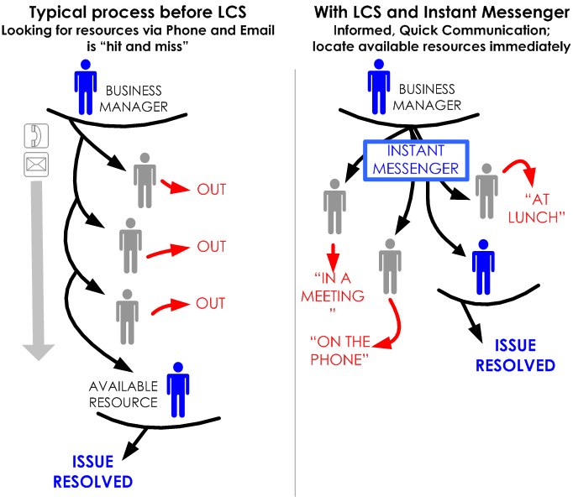

Exhibit 1: Enhanced Responsiveness through Presence Awareness

Presence Awareness
Presence awareness enables people to see contacts inside and outside of the organization, identify who is online, and immediately contact them—thereby increasing the likelihood that the intended communication will yield positive results. For example, Live Communications Server enables users to display their status (away, idle, busy, and so on) to other users. Users can also determine who is offline or unavailable. By right-clicking the name of a user who is offline, a user can see if a contact is available via other forms of communication such as e-mail or telephone.
When information workers can see their colleagues on Live Communications Server, they can immediately get the answers to quick questions involving work issues. Cutting through the e-mail clutter and less invasive than a phone call, Live Communications Server allows users to obtain the exact information needed to keep business processes moving forward. For example, if you reach your colleague’s voice mail, you know the person is not answering their phone, but you do not know everything you need to reach them. In fact, they might be sitting near their phone engrossed in another task. If the person could share their level of availability, you could instantly know if it was appropriate to interrupt them with your call.
“We use instant messaging whether we’re buried in a pricing spreadsheet or working on a presentation. It is a tremendous time saver to be able to keep focus on a particular topic while sharing that information in real time.”
Tracey Reuck
Senior Infrastructure Consultant
Weyerhaeuser Company

Integration with the Microsoft Office System
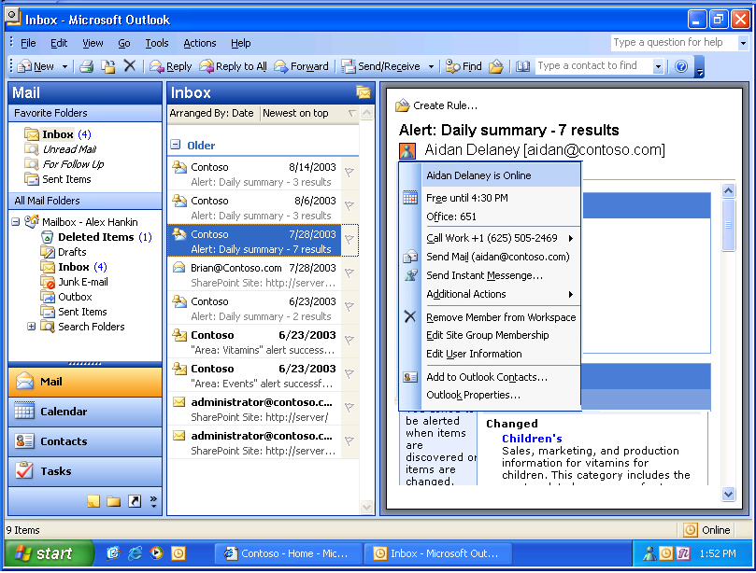
Integrated with the Microsoft Office System, Live Communications Server 2005 significantly enhances the productivity software. Presence icons automatically appear next to people’s names in several leading Microsoft products (see Exhibit 4 and Table 3) and can be integrated into other applications, such as enterprise line of business applications. This information makes it clear when and where you can reach your colleagues at a moment’s notice.
Exhibit 2: Presence within Microsoft Office Outlook
Integrated presence with the Microsoft Office System is unique to Live Communications Server. Rather than forcing people to break their concentration to get a piece of information, Live Communications Server provides in-context communication to keep the team on task and increase their productivity. Presence status is threaded throughout the Microsoft Office environment, enabling workers to instantly find and communicate with people from within familiar programs such as Microsoft Office Outlook® messaging and collaboration client, Microsoft Office Excel, and Microsoft Office Word.
Powered by Live Communications Server
Microsoft Products with Presence
Feature | Application
Instant Messaging | Microsoft Windows® Messenger
Collaboration | Microsoft Office SharePoint® Portal Server  Microsoft Windows SharePoint Services  Microsoft Office Live Meeting
Communication | Microsoft Office Outlook  Microsoft Exchange Server 2003
Productivity | Microsoft Office Excel  Microsoft Office Word  Microsoft Office PowerPoint®  Microsoft Office Visio®  Microsoft Office Publisher
Table 3
Online documents and presentations show the author’s name plus a presence icon indicating if that employee is online, busy, at lunch, or away from the office. By simply clicking the name and sending an instant message, the user can ask questions and collaborate on related work. Users can conduct all of this communication directly in the application so they remain focused and do not interrupt their workflow.

Working across Firewalls
The capability to establish instant messaging between organizations (known as Federation) is a unique and critical driver of business value with Live Communications Server. Federation enables users from separate companies to add each other to contact lists, see each other’s presence, and IM each other across firewalls, just as easily as if they are part of the same company.
The IT manager provides lists of approved users to another region, network forest, or company and communication may ensue. This is especially useful for acquisitions or companies with more than one geographic center.
With the new Federation feature, different organizations can share authenticated, encrypted instant messaging and presence information between organizations. This enables collaboration to take place between suppliers, customers, partners, and different divisions of the same organization. Often companies will have separate networks for new acquisitions, geographically dispersed groups, and different business units. With Federation (see Exhibit 3), all these teams can be instantly connected.
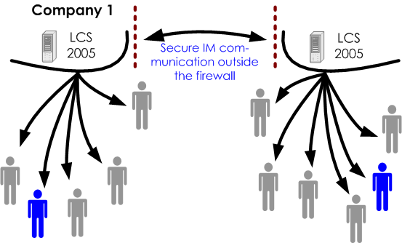
Exhibit 3: Federation with Live Communications Server

The capability to provide the most important contacts with informal and real-time communications is a critical driver of business value. With Federation, users can coordinate plans, share information, or simply stay in closer communication with critical contacts. Customers and suppliers appreciate the ability to get in contact directly and rapidly. Companies such as Intel believe that it will become common for customers to demand that suppliers connect via IM.
Federation delivers business value in three principal areas:
- Supply Chain Management – Faster flow of information between suppliers and customers facilitates the efficient procurement and allocation of resources.
- Customer Service – Customers have real-time access to key suppliers and business partners. Instant messaging users can see online status information as well as securely send messages across the firewall.
- Sales – Time-sensitive business development situations can be enhanced by opening additional channels of communication. For example, while contracts are negotiated, sales teams can get critical input from legal, operations, and other departments.
As organizations deploy instant messaging, demand for outside connectively grows immediately.

Public Instant Messaging Connectivity
Just as Federation connects companies directly, Live Communications Server has the capability to connect securely with public IM networks. Frequently, important outside contacts are not on Live Communications Server or other enterprise systems but use the public networks. Live Communications Server enables users of MSN®, AOL Instant Messenger, and Yahoo! to extend the business value of Federation to partners that do not have enterprise IM capability.
Connecting to the public IM with a high level of security is important to many organizations. “The next phase of IM development will be to connect with users outside our network,” said J. Stalcup, Director of Network Services at Texas Tech University. “I am really looking forward to the interoperability with MSN, AOL, and Yahoo. Many of our students show up with IM accounts on other networks, and we want them to be able to access Texas Tech IM.”
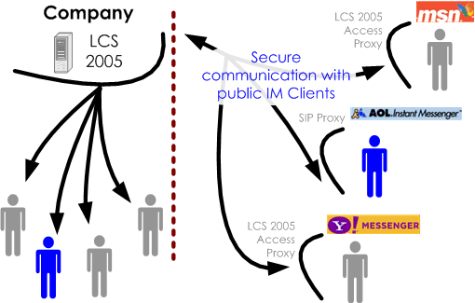

Exhibit 4 Live Communications Server Connects to Public IM Clients

Driving Value in the Enterprise
Operational groups that share information and communicate internally or externally improve their performance by using Live Communications Server. Both internally and externally, instant messaging is effective at contacting and resolving questions. Better communication and faster answers equate to lower expenses and accelerated businesses processes.
“At least four or five times each day, I share PowerPoint documents with others. There is the ability to exchange control of applications back and forth, so we can jointly author documents. Together, we’re able to make real progress by collaborating on a single document.”
Rick Strong
Senior IT Architect
Aliant

Live Communications Server enhances workforce productivity by eliminating communications delays and providing rich information sharing tools. The improved flow of information enables teams and individuals to execute their work more efficiently. Organizations that deploy Microsoft Office Live Communications Server have experienced measurable impact to business processes, and, ultimately, the bottom line through faster responsiveness and improved decision-making and information-sharing.
Live Communications Server decreases delays by connecting workers so they can get quick answers to their questions. By scanning their contact lists, workers know who is online and can make contact immediately. Rather than sending an e-mail or voice-mail message, they can move on to another contact. When co-workers have accurate information about team members’ availability, they do not waste time trying to contact them. This translates into increased productivity and frequently reduces costs as well. Asynchronous communications such as e-mail and voice-mail, with their unavoidable delays, are used only as a last resort.
Workers in and out of meetings find instant messaging to be an effective tool to accelerate getting answers and making decisions. Used in meetings, participants can contact colleagues outside the meeting without leaving or disrupting the meeting, and resolve issues and get answers before the meetings end. Out of meetings, faster answers shorten decision cycles, accelerate projects, and reduce the turnaround time for tasks.
With presence technology, Live Communications Server offers instant access to team members, partners, suppliers, and customers across multiple geographies, time zones, and organizational boundaries. This means timely information can flow rapidly and efficiently, enabling better, faster decision-making.
“Live Communications Server has allowed us to improve our responsiveness by allowing us to quickly get the information we need to make decisions. It has made us more nimble.”
Mark Pautsch
Chief Information Officer
Fair Isaac

During 2004, workers were surveyed to understand their experience making decisions with Live Communications Server (see Exhibit 5). Overwhelmingly, respondents indicated that their ability to make decisions had increased the use of instant messaging and presence awareness. Better, faster decisions lead to improved customer service, faster resolution of customer and internal issues, and lower costs through greater productivity.
Live Communications Server seamlessly integrates presence awareness with the Microsoft Office System and Microsoft Windows Server System™ integrated server software—delivering unprecedented information sharing capabilities. While working in Office programs (see Table 3), users can see who is logged on and begin collaborating in real time on spreadsheets, documents, and other files without ever leaving the application.
Percentage of Surveyed Users Accelerating Decision-Making with
Live Communications Server

Results represent the percentage of users who agree or strongly agree based on responses from Live Communications Server users surveyed during 2004.

Exhibit 5

Project Management
Operations at an increasing number of organizations require employees to collaborate across geographic boundaries. Instant messaging and presence awareness eliminate these distance barriers by allowing employees to see who is available and contact them instantly. Faster, more effective communications can help projects be completed faster and on time.
Aerospace manufacturer Lockheed Martin is constantly looking for ways to collaborate internally, improve service, and maintain its leadership role in a highly competitive market. “Collaboration is a key business driver in Lockheed Martin,” said Massimo Villinger, Chief Technology Officer for Lockheed Martin. “Having IM and presence capabilities integrated within our existing enterprise infrastructure was very appealing. For Lockheed, Live Communications Server has simplified basic daily collaboration activities for highly dispersed teams.”
Unysis is another company that has adopted Live Communications Server to improve operations and increase employee productivity. “Instant messaging and presence information are aiding productivity by allowing people to immediately get answers to questions that could otherwise become blocking issues,” said Bruce E. Guyton, North America Operations Manager for Unysis. “Instant messaging facilitates group projects because it makes it so easy for people to initiate or join a conversation whenever information, guidance, or any other type of communication is needed.”
High-profile, time-sensitive situations like product development are well suited for adding instant messaging as an alternative communication channel. Live Communications Server benefits from these situations by giving team members the ability to make faster decisions, decrease delays, and increase individual and team productivity. Live Communications Server is essential to the successful, on-time launch of products such as FICO Expansion Score, an online credit program released in July 2004. Given six weeks to develop and execute the launch of this program, the team found instant messaging to be critical for finding people, communicating answers, and making decisions quickly.
The launch team, dispersed across the U.S., relied on Live Communications Server to communicate with the developers in California to resolve fixes and changes; senior management was kept abreast of team progress through instant messaging as the launch deadline approached. “Live Communications Server made it easier for us to make critical dates on this project,” said Greg Johnson, Vice President of Technology Strategy, Fair Isaac. “It is more flexible than the phone because it allows communication with multiple people on multiple topics.”

Customer Service
Live Communications Server is changing the standard for internal and external customer service. With the capability to extend beyond the firewall, internal help desks and customer service operations centers have found that using instant messaging improves the speed and quality of communications by:
- Decreasing the duration of customer service calls
- Increasing the number of calls per customer service representative
- Reducing callbacks through getting answers via IM
- Increasing customer satisfaction
Aliant found Live Communications Server to be the ideal tool to improve customer service. Aliant had developed an in-house application allowing simple text messaging for call centers. Known as Heads Up, the application was limited to communication within each call center but not between locations, and it could not accommodate growth. In fact, Heads Up could only handle a maximum of 200 users, making it inappropriate for enterprise use.
Aliant wanted to move away from brick-and-mortar call centers and establish virtual call centers that would provide service to consumers and businesses throughout eastern Canada. The company needed a more sophisticated network-based system designed to supply instant communications across the enterprise.
Aliant deployed Live Communications Server to ensure that customer service representatives could communicate questions and get answers in real time. Aliant has already experienced improved customer service because of the speed with which agents resolve problems. Contact center agents can track down customer information in the call history logs, send out alerts for fast answers from other agents, and determine the most appropriate agent to handle a call—all without putting customers on hold. Calls that would typically take several minutes and even require callbacks can be handled almost instantaneously.
When employees do not connect, not only are important processes delayed, but they may not be able to fill the time waiting with productive work. These productivity benefits impact numerous business processes at Fair Isaac.
Recently, new employees coming online in remote Singapore and Kuala Lumpur offices had trouble accessing the Fair Isaac corporate network. By using instant messaging, Director of Networks and Communications, James Casurella was able to resolve the problem quickly from the Minnesota home office. Casurella contacted key IT staff in Asia and the United States in a joint IM conversation to determine a fix for the issue. Within a few hours, the new employees were able to access the network. Prior to the security-enhanced IM capabilities provided by Live Communications Server, it could have taken days to get the users up and running. “I solve problems like this every week. IM easily saves me and my team each one hour every week by connecting me with colleagues to solve problems or make decisions,” comments Casurella.
Fair Isaac employees were able to eliminate an average of six project delays each week. By eliminating these delays, the average worker was able to decrease the time required to complete his or her tasks by 100 hours per year.
For Weyerhaeuser, finding an instant messaging solution for customer service was a priority. One of Weyerhaeuser’s largest customers requested that they provide instant messaging communications between sales staff and the customer for faster and better information transfer. The company’s Building Materials group required the ability to communicate with key customers in real time. The customer already was communicating in real time with several Weyerhaeuser competitors. Weyerhaeuser deployed Live Communications Server to maintain competitiveness and provide value-enhanced service to it customers.

Education
At Texas Tech, sharing information was hampered by the volume of e-mail messages, nearly 68 million daily. Students, faculty, and staff were overwhelmed and the effectiveness of e-mail as a communication tool was significantly reduced. Faculty and staff needed the ability to connect quickly with their colleagues, get answers, and share information in real time.
Exhibit 6: Increased Student-Teacher Interaction at Texas Tech

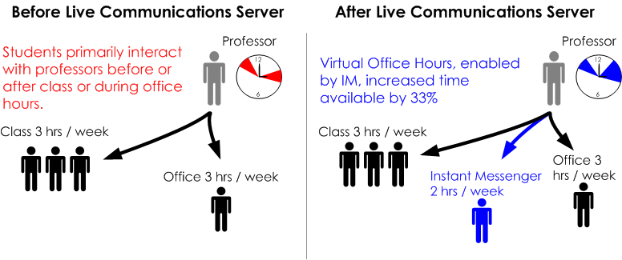

Deployment of Live Communications Server delivered the rich, real-time communications channels required to connect the campus, increase user productivity, and improve quality of interaction among students and faculty. Sam Segran, Chief Information Officer at Texas Tech, comments, “Live Communications Server has been a great service that has helped us connect our campus. We estimate payback on our investment in 8 months due to increased productivity from our faculty and staff.”
Increased productivity and decreased delays mean that faculty and staff can do more with fewer resources. The Texas Tech Web development group, for example, is using Live Communications Server to help execute the development process. Charged with building and maintaining Internet presence for the departments, the group now is operating with three developers instead of five and doing the same volume of work due to improved communication and information sharing through IM.
Using IM to communicate has proven to be as effective as physical meetings. Psychology instructor Kathy Stalcup augments her physical office hours with virtual office hours (see Exhibit 9). She asks students to clearly communicate their question or describe their problem in IM and share the program or attach a copy of their work using file sharing. She then reviews both while the student waits for her comments.
Frequently Ms. Stalcup can identify the nature of the student’s difficulties and suggest a solution more easily since the student is communicating in writing. Quickly resolving issues allows students to advance in the curriculum when they might otherwise be lost. “IM allows me to see and answer questions about the students’ work,” said the teacher. “IM is very focused and requires students to think and prepare before they ask their questions. When they send me their question and work using IM, I can almost always identify what is causing their confusion.”

Lowering Infrastructure Costs
Organizations deploying Live Communications Server realize business value through lower total cost of ownership of their communications infrastructure. Workers use presence to determine availability of their contacts, increasing the chance that they will reach someone. Fewer calls result in less e-mail, and long voice-mail messages are avoided. Reduced e-mail traffic reduces the need for network resources, storage, and support, and, ultimately, lower costs.

E-Mail
“We also found that IM reduces the load on other communications channels. When people get fewer calls and e-mails, they respond better and faster, and we can reduce storage and support costs.”
Intel
May 2004
MCI

Live Communications Server complements e-mail by adding real time communications for critical business situations. E-mail messages are more appropriate and used effectively when the sender:
- Doesn’t need an answer immediately
- Requires a record or paper trail of the discussion
- Must receive a reply
- Knows that the other person is busy
Additionally, with no attachment size limit, Live Communications Server can easy handle the transfer of large files. E-mail programs frequently limit the size of files allowed to be transferred on the network.
Unisys anticipates reduced loads on e-mail server computers because fewer e-mail messages will be sent within the company, and because of a reduction in attachments as employees use instant messages to execute file transfers.
“We see people trying to attach files that are several megabytes in size, and these messages overburden our e-mail system,” said Kenneth R. Spacht, Senior Business Analyst, Unysis. “You can avoid this traffic by taking advantage of the file-transfer capabilities of IM. I’ve used file transfer to send complete images of CDs, and it works just fine.”
For Telecom Italia, instant messaging has had a positive effect on e-mail server loads. ”Employees’ use of Live Communications Server instant messaging and file transfer services has also reduced the load on the company’s e-mail servers. As employees send fewer messages and files by e-mail, we won’t need as much storage space on our servers,” said Dr. Maurizio Salvi, Infrastructure Services Manager, Telecom Italia.

Long Distance
As companies expand around the globe, many are using instant messaging to communicate effectively with colleagues in diverse geographies. In the past, instant messaging was perceived as a novelty more suited to consumer-grade personal communications than to business use. Today, however, many organizations see instant messaging as a means to increase the momentum of their businesses by exchanging information cost-effectively among worldwide locations.
For many, IM is preferable to the telephone; it offers a higher chance of connecting and is less disruptive to the receiver. Even when a phone call is more appropriate, workers frequently check availability before making calls. “Most of us don’t make blind calls anymore,” said Alex Cameron, IT Infrastructure Planner, Aliant. “We set up calls using instant messaging, which helps us get away form having voice mail messages pile up.”
Siemens has estimated that IM will decrease the cost of telephone infrastructure. The ease and familiarity of Live Communications Server will also give employees an incentive to use IM technology. Siemens estimates that each instant message costs approximately 15 cents per message versus voice communications, which on average cost about $1 each. This represents a tremendous savings for a company like Siemens with over 300,000 employees.

Conference Calls
Live Communications Server’s built-in voice, video conferencing, and group IM capabilities are a significant source of potential cost savings. Initiated from the worker’s desktop with no additional cost, this allows people to share information and even hear and see colleagues.
For Telecom Italia, video conferences held through IM have helped employees communicate faster and more effectively. “When I can see my colleagues face as we converse, we understand each other better,” said Dr. Maurizio Salvi, Infrastructure Services Manager, Telecom Italia.
Similarly, Siemens believes that conducting voice conferences through Live Communications Sever will improve productivity and lower costs. Users save time (less organization) and money (minimal costs) with virtual meetings (see Table 4).
“We know that it [Live Communications Server] provides an excellent means of helping IT departments get control over the cost of communications transactions. We may be able to save nearly $100 or more in a four-person conference call through the elimination of audio conferencing fees, document collaboration session fees, and the time saved in setting up these types of communications," said Tim Miller, Director of Product Planning, Siemens.

Security and Privacy
Microsoft designed Live Communications Server to address specific business requirements for heightened security in today’s computing environments. In accordance with the Microsoft company-wide Trustworthy Computing initiative, Live Communications Server provides many new features and enhancements to improve reliability, manageability, and security.
A key benefit for IT managers using Live Communications Server is the control of sensitive corporate information. When end-users have public IM clients at work, conversations are exposed rather than encrypted. These public IM services do not provide logging or archive capabilities, making it impossible to comply with any applicable regulations such as the Sarbanes-Oxley Act (financial services) and the Health Insurance Portability and Accountability Act (HIPAA).
Live Communications Server works seamlessly with existing Microsoft infrastructure elements such as Microsoft Windows Active Directory® services and Microsoft Windows Server 2003. This makes it easy for the IT manager to consolidate network, server, and IM user resources, giving them more security and control over the network.
Siemens Estimated Conference Call Time and Cost Savings
Cost savings for four-person conference calls with Live Communications Server.
Activity | Productivity Gain | Cost Savings
Conference call organizer does not have to provide conference bridge, call-in numbers, or send e-mail messages to check availability. | 15 minutes saved per conference call
Participants don’t need to check e-mail messages for call-in info and procedures; no sorting large files in e-mail. | 5 minutes saved per conference call for each participant
No audio conferencing fees. |  | $30 saved per conference call
No document collaboration session fees. |  | $65 saved per conference call
TOTAL SAVINGS | 25 minutes saved per conference call | $95 saved per conference call
Table 4
Security is a primary business value driver for corporations today. “As more of our people started to use instant messaging to communicate with Unisys colleagues at different sites, we began to worry about sending clear-text [unencrypted] messages across the global Internet,” comments Kenneth R. Spacht, Senior Business Analyst, Unisys. “We need to protect our confidential information, and Live Communications Server will help us do that.”
At Aliant, employees were using public IM. “About half of our employees were using some form of instant messaging, and, therefore, exposing us over the Internet, but we didn’t want to prevent instant messaging because we recognized its business value,” said Rick Strong, Senior IT Architect at Aliant.

Technically Robust

Enterprise Grade
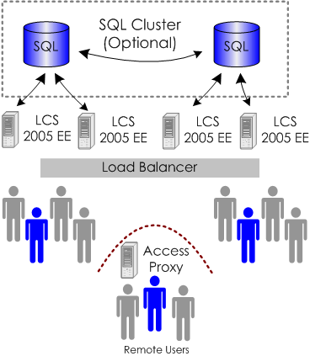

IT managers will appreciate the numerous Live Communications Server improvements in administration, security, scalability, reliability, and functionality. It fits smoothly into an existing Microsoft infrastructure as part of the Microsoft Windows Server System™ and the Microsoft Office System. By directly lowering the costs of managing a real-time communications infrastructure, Live Communications Server makes it easier to deliver cutting-edge communication services to all end-users.

Scalable and Reliable
Microsoft built Live Communications Server to scale with the enterprise. Individual servers have 50 percent more capacity than the 2003 version, supporting up to 15,000 concurrent active users.
Exhibit 7: Live Communications Server Enterprise Edition Architecture

Additionally, Microsoft Office Live Communications Server Enterprise Edition is designed to take advantage of a clustered architecture configuration (see Exhibit 7). It consists of a pool of servers connected to a separate, shared Microsoft SQL Server database. This two-tier architecture enables Live Communications Server Enterprise Edition to deliver substantial improvements in availability, scalability, performance, and data recovery including:
- All user data is stored on a SQL 2000 back-end server; can use a new or existing SQL server database.
- Front-end/back-end server architecture offering fail-over support.
- Supports over 100,000 concurrent users per server pool.
“Unysis has experienced great success with the new clustered architecture,” comments Kenneth R. Spacht, Senior Business Analyst, Unisys. “Clustered nodes running SQL Server 2000 give us the high availability we need to help ensure that IM is always available for our people. On the front end, the server pools, in addition to providing high availability and scalability, and enable server software upgrades to be implemented on a server-by-server basis without interrupting end-user services.”

Platform for Extensibility
“Our previous solution couldn’t grow as we needed it to. With Live Communications Server, we will be able to offer our employees and our customers better service”
Guna D. Gunasekar
Advisory Engineer
MCI

Extensibility—the capability to interconnect and share information and functionality with other information technology systems—is native to Live Communications Server. Its architecture uses the industry-standard protocols Session Initiation Protocol (SIP) and SIP for Instant Messaging and Presence Leveraging Extensions (SIMPLE), and includes a rich set of application programming interfaces (APIs). Microsoft supports these standards because of their broad potential in future communications—a potential that goes far beyond instant messaging. Corporate telephony systems such as PBX and PSTN, video conferencing, interactive voice responses, voice over Internet Protocol (VoIP), and other solutions can all integrate with Live Communications Server using these protocols.
Live Communications Server offers both client and server software development kits (SDKs) to encourage innovative uses of real-time communications information. There is a library of information online at the Microsoft Office Developer Center at http://msdn.microsoft.com/office/understanding/livecomm/default.aspx.

Conclusions and Recommendations
Microsoft Office Live Communications Server delivers improved business efficiencies, increased productivity, and cost savings in an enterprise-grade platform. With standard protocols, advanced deployment and management tools, a strong partner ecosystem, and innovative client features, Live Communications Server is the clear choice for competitive organizations.
Business decision-makers should examine their information sharing needs to identify if real-time connectivity would benefit individual employees, teams, customers, or suppliers. Specifically, Live Communications Server immediately enhances business operations in situations where:
- Productivity is negatively affected by failed attempts to connect and share information.
- Internal teams are dispersed and use e-mail or the telephone as a primary method of communication.
- External communications with customers and suppliers are time sensitive.
Technology decision-makers should review their current communications infrastructures to identify:
- Use of public instant messaging within the organization.
- Significant intra-company long-distance and international call volume.
- Use of voice or video conferencing within the organization.
- Rising volume of e-mail messages and increased storage requirements.
- Regulatory requirements related to text communications archiving.

Business Value Methodology
This white paper summarizes the results of 11 business value studies in the U.S. Studies were conducted by Microsoft Corporation in 2004−2005.
To measure the business value, Navigant Consulting, Inc., used its Value Impact Analysis (VIA) methodology to quantify the benefits and costs of using Microsoft® Office Live Communications Server solutions. The VIA methodology was formed by leveraging a unique amalgamation of business experience and skills including strategy, process management, finance, and information technology.
The VIA methodology produces a business value study that is process oriented and, therefore, distinct and separate from other business analyses. While the VIA study is technology driven, its principal focus is on business productivity and process change. Specifically, how productivity and process change impacts business groups and organizations.
The VIA methodology incorporates four critical steps, including:
- Evaluating and understanding the unique customer opportunity.
- Identifying the key performance metrics and improvement goals.
- Analyzing business processes.
- Leveraging financial modeling tools to measure costs and benefits.
The focus on business process change in the VIA methodology has several benefits for organizations participating in the studies, including:
- Companies receive a clear map outlining the direct relationship between the technology investment and the business process improvements.
- Benchmarks are established for continued monitoring of business process improvements.
- Traditional financial measures are based on clear and supportable measurements that allow business and IT managers to make supported business cases for their investments.
The business value studies provide data that supports Microsoft’s goal to deliver financial value through Microsoft Office System solutions.

Traditional Measures to Assess the Value of IT Investments
The business value studies summarized in this white paper used three standard financial methods to measure the value of IT investments.
Payback Period
Payback period is the length of time it takes to recover the initial cost of an investment, in this case, information technology. This is calculated by adding all expected monetary benefits of deploying the solution until the total equals the initial outlay. The sum of years or months over which the project returns the initial cash outflow is the payback period.
Net Present Value
In the simplest terms, net present value (NPV) is the difference between deployment costs and the value of deployment over a three-year period, adjusted for risk and the time-value of money. If NPV is positive, the proposal is a good candidate for investment.
Internal Rate of Return
The internal rate of return (IRR) is simply the expected return on the money invested for a specific project. If the IRR is greater than the firm’s cost of capital, then deploying the Microsoft Office Live Communications Server will add shareholder value.

Author
Navigant Consulting, Inc. (NYSE: NCI) A specialized independent consulting firm providing litigation, financial, restructuring, strategic, and operational consulting services to large companies, government agencies, and legal counsel facing the challenges of uncertainty, risk, distress, and significant change. The company focuses on industries undergoing substantial regulatory or structural change and on the issues driving these transformations. "Navigant" is a service mark of Navigant International, Inc. Navigant Consulting, Inc. (NCI) is not affiliated, associated, or in any way connected with Navigant International, Inc., and NCI's use of "Navigant" is made under license from Navigant International, Inc.

