

Updates to Deploying Secure 802.11 Wireless Networks with Microsoft Windows

Microsoft Corporation
Published: August 2004
Updated: May 2005

Abstract
This white paper contains updates for changes in IEEE 802.11 standards and their implementation in Microsoft® Windows® XP, Windows Server™ 2003, and Windows 2000, as described in the Microsoft Press® book titled Deploying Secure 802.11 Wireless Networks with Microsoft Windows, by Joseph Davies (ISBN 0-7356-1939-5).

The information contained in this document represents the current view of Microsoft Corporation on the issues discussed as of the date of publication. Because Microsoft must respond to changing market conditions, it should not be interpreted to be a commitment on the part of Microsoft, and Microsoft cannot guarantee the accuracy of any information presented after the date of publication.
This document is for informational purposes only. MICROSOFT MAKES NO WARRANTIES, EXPRESS OR IMPLIED, AS TO THE INFORMATION IN THIS DOCUMENT.
Complying with all applicable copyright laws is the responsibility of the user. Without limiting the rights under copyright, no part of this document may be reproduced, stored in or introduced into a retrieval system, or transmitted in any form or by any means (electronic, mechanical, photocopying, recording, or otherwise), or for any purpose, without the express written permission of Microsoft Corporation.
Microsoft may have patents, patent applications, trademarks, copyrights, or other intellectual property rights covering subject matter in this document. Except as expressly provided in any written license agreement from Microsoft, the furnishing of this document does not give you any license to these patents, trademarks, copyrights, or other intellectual property.
© 2004 Microsoft Corporation. All rights reserved.
Microsoft, Active Directory, Microsoft Press, Windows, the Windows logo, and Windows Server are either registered trademarks or trademarks of Microsoft Corporation in the United States and/or other countries.
The names of actual companies and products mentioned herein may be the trademarks of their respective owners.

Contents

Global Changes 1
Chapter 2: Wireless Security 2
Chapter 3: Windows Wireless Client Support 3
Changes to the Wireless Network (IEEE 802.11) Policies Group Policy Extension in Windows Server 2003 Service Pack 1 6
Using the Wireless Network (IEEE 802.11) Policies Group Policy extension in a Windows 2000 Active Directory Domain 7
Windows XP SP2 Support for WPA2 8
Chapter 4: RADIUS, IAS, and Active Directory 9
Chapter 5: EAP 10
Corrections to Page 115 10
PEAP with MS-CHAP v2 Operation 10
Chapter 10: Intranet Wireless Deployment Using PEAP-MS-CHAP v2 16
Chapter 12: Secure Wireless Networks for the Home and Small Business 17
Updated Manual Configurations for Windows XP SP2 17
Using a Wireless AP with WEP and a Wireless Network Adapter Driver that Supports WZC Service 17
Using a Wireless AP with WPA and a Wireless Network Adapter Driver that Supports WZC Service 19
Configuring the Initial Client on an Ad Hoc Network 20
Configuring Additional Clients on an Ad Hoc Network 21
Using a Wireless AP with WPA2 and a Wireless Network Adapter Driver that Supports WZC Service 22
The New Wireless Network Setup Wizard 23
Using the Wireless Network Setup Wizard to Configure a Wireless Network 24
XML Files Stored on the UFD 29
Correction to Page 268 29
Correction to Page 270 30
Chapter 14: Troubleshooting the Windows Wireless Client 31
Improvements in Reporting the Status of a Wireless Connection 31
Appendix B: Wireless ISPs and Windows Provisioning Services 33
Wireless Provisioning Services Overview 33
Components of a WPS Infrastructure 33
Example New Account Connection Process 37
WPS Deployment Resources 38
WPS Updates 38
Appendix C: Setting Up Secure Wireless Access in a Test Lab 39
Summary 40
Related Links 41

Global Changes
Throughout the entire book, please keep the following changes in mind:
- Microsoft 802.1X Authentication Client, a free download for computers running Windows 2000 Service Pack 3, is now included in Windows 2000 Service Pack 4 (SP4). You do not need to install a separate download to obtain Microsoft 802.1X Authentication Client functionality if Windows 2000 SP4 is installed. This includes both the 802.1X authentication client functionality for computers running Windows 2000 Professional and Windows 2000 Server and the enhancements to the Internet Authentication Service (IAS) for computers running Windows 2000 Server.
- The Wireless update rollup package for Windows XP, a free download for computers running Windows XP with Service Pack 1 (SP1), is now included in Windows XP Service Pack 2 (SP2). You do not need to install a separate download to obtain Wi-Fi Protected Access (WPA™) functionality if Windows XP SP2 is installed.
- Windows Server 2003 Service Pack 1 also includes support for WPA.
- Wi-Fi Protected Access 2 (WPA2™) is now available with the Wi-Fi Protected Access 2 (WPA2)/Wireless Provisioning Services Information Element (WPS IE) update for Windows XP with Service Pack 2, a free download from Microsoft.

Chapter 2: Wireless Security
For the most current version of the information in this chapter, see IEEE 802.11 Wireless LAN Security with Microsoft Windows XP.
For detailed information about how WPA encryption and data integrity works, see Wi-Fi Protected Access Data Encryption and Integrity.
For information about WPA2 security features, see Wi-Fi Protected Access 2 (WPA2) Overview.

Chapter 3: Windows Wireless Client Support
The primary user interface for connecting to wireless networks for Windows XP SP2 and Windows Server 2003 Service Pack 1 is the new Choose a wireless network dialog box, as shown in Figure 1.
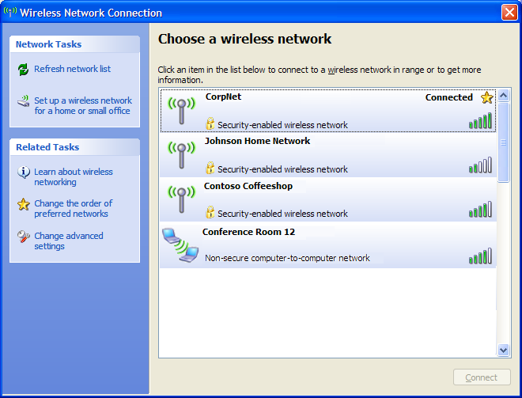
Figure 1 The new Choose a wireless network dialog box
You can view the Choose a wireless network dialog box by clicking on the Wireless networks detected message in the notification area of the desktop, or by right-clicking the wireless connection icon in the notification area or in the Network Connections folder, and then clicking View Available Wireless Networks. The Choose a wireless network dialog box displays the following for each detected wireless network:
- The type of wireless network
An antenna icon indicates an infrastructure mode wireless network. The icon with two wireless client computers indicates an ad hoc mode wireless network. An icon for the logo of a wireless Internet service provider indicates that the wireless network uses Wireless Provisioning Services (WPS) to automate and secure registration.
- The wireless network name
- The wireless network signal strength
- Whether the wireless network has security enabled (the lock icon and the "Security-enabled wireless network" label)
- The status of the wireless network to which the wireless client is connected (the "Connected" label)
- Whether the wireless network is a preferred network (the star icon)
From the Choose a wireless network dialog box, you can also do the following:
- Perform another scan of wireless networks within range by clicking the Refresh network list network task
- Start the Wireless Network Setup Wizard by clicking the Set up a wireless network for a home or small office network task
- Display the Wireless Networks tab of the wireless connection to change the order of preferred networks and perform other advanced configuration settings by clicking the Change the order of preferred networks related task
- Display the properties of the wireless connection by clicking the Change advanced settings related task
The new Choose a wireless network dialog box replaces the Connect to Wireless Network dialog box in Windows XP with no service packs installed (page 36) and the dialog box with the name of the wireless connection in Windows XP with SP1 and Windows Server 2003 with no service packs installed (page 42).
In Windows XP SP2 and Windows Server 2003 Service Pack 1, the Wireless Networks tab (shown in Figure 2) has been modified.
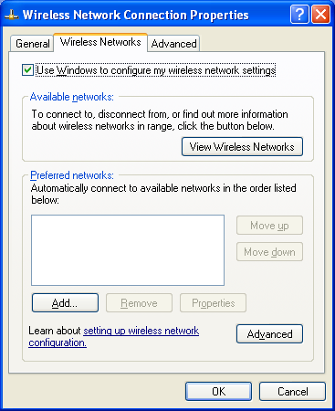
Figure 2 The new Wireless Networks tab
The Available Networks list on the Wireless Networks tab in Windows XP SP1, Windows Server 2003 with no service packs installed, and Windows XP with no service packs installed has been replaced with a View Wireless Networks button, which displays the new Choose a wireless network dialog box.
When you click Add or Properties for a preferred wireless network, Windows XP SP2 or Windows Server 2003 Service Pack 1 displays the Wireless network properties dialog box, as shown in Figure 3.
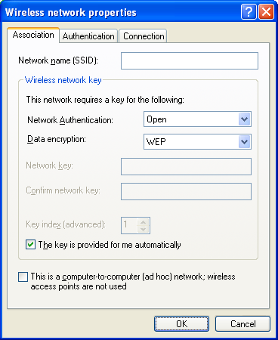
Figure 3 The new Wireless network properties dialog box
The Association tab includes the changes provided with the WPA Wireless Security Update in Windows XP, which include the Network Authentication drop-down box to configure the authentication method and the Data encryption drop-down box to configure the encryption method. These settings are already described on page 47 and 48 of the book. If the wireless network adapter and its driver support WPA, then you can select WPA authentication and encryption options. If the Wi-Fi Protected Access 2 (WPA2)/Wireless Provisioning Services Information Element (WPS IE) update for Windows XP with Service Pack 2 is installed and the wireless network adapter and its driver support WPA2, you can select WPA2 authentication options from the Network Authentication drop-down box.
Windows XP SP2 and Windows Server 2003 Service Pack 1 include a new Connection tab for a wireless network, as shown in Figure 4.
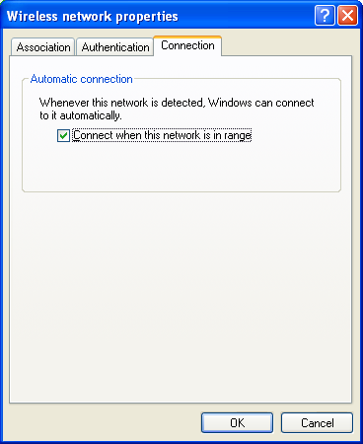
Figure 4 The new Connection tab for a wireless network
The Connect when this network is within range check box specifies whether you want the wireless client to automatically connect to this network when it is in range (the default setting) or you want to connect to this network on demand, by double-clicking on it from the Choose a wireless network dialog box.
In the Network Connections folder, the Status dialog box for a wireless connection has been modified to show the name of the wireless network to which the connection is connected and provides a View Wireless Networks button to display the Choose a wireless network dialog box.
Figure 5 shows the new wireless network adapter Status dialog box.
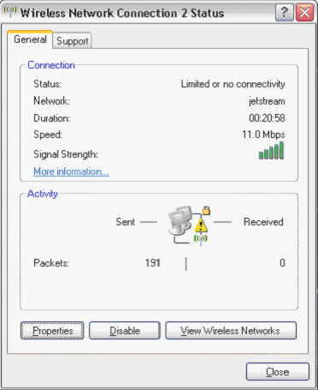
Figure 5 The new Status dialog box for a wireless connection

Changes to the Wireless Network (IEEE 802.11) Policies Group Policy Extension in Windows Server 2003 Service Pack 1
Pages 49-55 are a discussion of the Wireless Network (IEEE 802.11) Policies Group Policy extension in Windows Server 2003 with no service packs installed. The note on page 53 describes how Microsoft was investigating the inclusion of WPA authentication and encryption options for the Wireless Network (IEEE 802.11) Policies Group Policy extension in Windows Server 2003 Service Pack 1. For Windows Server 2003 Service Pack 1 or for Windows Server 2003 with no service packs installed and the 811233 update, the Network Properties tab (displayed in Figure 3-16 in the book) has been updated as shown in Figure 6.
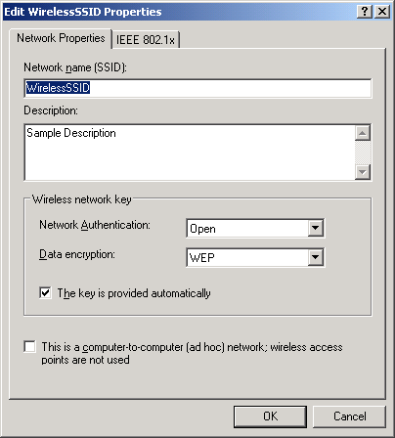
Figure 6 The new Network Properties tab for the Wireless Network (IEEE 802.11) Policies Group Policy extension
The Wireless network key area of the Network Properties tab has the following changes:
- It has been renamed Wireless network key (from Wireless network key (WEP)).
- The Network authentication (Shared mode) checkbox has been replaced with a Network Authentication drop-down box with the following selections: Open, Shared, WPA-None, WPA, WPA-PSK
- The Data encryption (WEP enabled) checkbox has been replaced with a Data encryption drop-down box that has the following selections: Disabled, WEP, AES, TKIP
These changes allow you to configure the same authentication and encryption options and in the same way as on the Association tab when configuring a wireless network on a WPA-capable Windows wireless client computer. The new authentication and encryption options for the Wireless Network (IEEE 802.11) Policies Group Policy extension are supported by computers running Windows XP with SP1, Windows XP with SP2, Windows Server 2003 with no service packs installed, and Windows Server 2003 with Service Pack 1.

Using the Wireless Network (IEEE 802.11) Policies Group Policy extension in a Windows 2000 Active Directory Domain
To get the new Wireless Network (IEEE 802.11) Policies Group Policy extension in a Windows 2000 Active Directory domain, the Active Directory schema must be updated to include the new extension. To update the Windows 2000 Active Directory schema, you must install at least one domain controller in your Windows 2000 Active Directory domain that runs either Windows Server 2003 with no service packs installed or Windows Server 2003 with Service Pack 1 (for WPA authentication and encryption settings). Once this is complete, you must use the Group Policy snap-in from any domain member computer running either Windows Server 2003 with no service packs installed or Windows Server 2003 with Service Pack 1 to configure Wireless Network (IEEE 802.11) Policies settings.

Windows XP SP2 Support for WPA2
For information about WPA2 support in Windows XP SP2, see Wi-Fi Protected Access 2 (WPA2) Overview and the Wi-Fi Protected Access 2 (WPA2)/Wireless Provisioning Services Information Element (WPS IE) update for Windows XP with Service Pack 2.

Chapter 4: RADIUS, IAS, and Active Directory
The following are additional resources for Internet Authentication Service (IAS):
- For information about how to configure RSA ACE/Server to provide a secure authentication solution for virtual private network (VPN) and Windows XP 802.1X wireless clients running Microsoft Windows XP SP1 with the Protected Extensible Authentication Protocol (PEAP) update installed, see the Enterprise Deployment of Wireless and Remote Access with RSA SecureID and Microsoft Internet Authentication Service white paper.
- For information about how to obtain and install a WLAN Server Certificate from VeriSign, Inc., on IAS Remote Authentication Dial-in User Service (RADIUS) servers to enable password-based authentication for wireless connections using PEAP with Microsoft Challenge Handshake Authentication Protocol version 2 (MS-CHAP v2), see the Obtaining and Installing a VeriSign WLAN Server Certificate for PEAP-MS-CHAP v2 Wireless Authentication white paper.
- For information about how to deploy IAS SQL Server logging with Microsoft SQL Server 2000 and SQL Server Desktop Engine (MSDE 2000), see the Deploying SQL Server Logging with Windows Server 2003 Internet Authentication Service (IAS) white paper.
- For information about deploying Wireless Provisioning Services (WPS) in a Wireless Internet Service Provider (WISP) network that allows you to provide pay-per-use, monthly service and long-term Internet access to new and existing customers through wireless access points deployed in public areas, see the Deploying Wireless Provisioning Services (WPS) Technology white paper.
- For additional information about IAS in Windows Server 2003, see the Windows Server 2003 Internet Authentication Service Web site.
- For additional information about IAS in Windows 2000 Server, see the Internet Authentication Service for Windows 2000 Server Web site.

Chapter 5: EAP
The following are updates to the information in Chapter 5:
- Windows XP with SP2 does not include support for EAP-MD5 CHAP for wireless connections (page 106).
- For information about the efforts of the Institute of Electrical and Electronic Engineers (IEEE) and the Internet Engineering Task Force (IETF) to address secure wireless access and a comparison of PEAP with other standards-based and proprietary wireless authentication schemes, see the The Advantages of Protected Extensible Authentication Protocol (PEAP) white paper.

Corrections to Page 115
The first supporting paragraph for step 9 on page 115 should be:
The RADIUS server derives the per-client unicast session key and the signing key from the keying material that is a result of the EAP-TLS authentication process. Next, the RADIUS server sends a RADIUS Access-Accept message containing an EAP-Success message and the MS-MPPE-Send-Key and MS-MPPE-Recv-Key attributes to the wireless AP.
The yellow highlight shows the corrections.

PEAP with MS-CHAP v2 Operation
This section updates the "PEAP with MS-CHAP v2 Operation" section in Chapter 5 (pages 121-123) with additional details about the PEAP-MS-CHAP v2 authentication process.
The PEAP authentication process occurs in two parts. The first part is the use of EAP and the PEAP EAP type to create an encrypted TLS channel. The second part is the use of EAP and a different EAP type to authenticate network access. This section examines PEAP with MS-CHAP v2 operation, using as an example, a wireless client that attempts to authenticate to a wireless access point (AP) that uses a RADIUS server for authentication and authorization.
The following steps are used to create the PEAP TLS channel:
- Association and request for identity
If the wireless AP observes a new wireless client associating with it, the wireless AP transmits an EAP-Request/Identity message to the wireless client. Alternately, when a wireless client associates with a new wireless AP, it transmits an EAP-Start message. If the IEEE 802.1X process on the wireless AP receives an EAP-Start message from a wireless client, it transmits an EAP-Request/Identity message to the wireless client.
- EAP-Response/Identity from the wireless client
The wireless client transmits an EAP-Response/Identity message containing the computer or the user name.
The wireless AP forwards the EAP-Response/Identity message to the RADIUS server in the form of a RADIUS Access-Request message.
- EAP-Request from the RADIUS server (Start PEAP)
The RADIUS server sends a RADIUS Access-Challenge message containing an EAP-Request message with the EAP-Type set to PEAP, requesting a start to the PEAP authentication process.
The wireless AP forwards the EAP message to the wireless client.
- EAP-Response from the wireless client (TLS Client Hello)
The wireless client sends an EAP-Response message with the EAP-Type set to PEAP, indicating the TLS client hello.
The wireless AP forwards the EAP message to the RADIUS server in the form of a RADIUS Access-Request message.
- EAP Request from the RADIUS server (RADIUS server’s certificate)
The RADIUS server sends a RADIUS Access-Challenge message containing an EAP-Request message with the EAP-Type set to PEAP, and includes the RADIUS server’s certificate chain.
The wireless AP forwards the EAP message to the wireless client.
- EAP-Response from the wireless client (Cipher suite, TLS complete)
The wireless client sends an EAP-Response message with the EAP-Type set to PEAP, and includes the cipher suite and an indication that TLS authentication message exchanges are complete.
The wireless AP forwards the EAP message to the RADIUS server in the form of a RADIUS Access-Request message.
- EAP-Request from the RADIUS server (Cipher suite, TLS complete)
The RADIUS server sends an EAP-Request message with the EAP-Type set to PEAP, and includes the cipher suite and an indication that TLS authentication message exchanges are complete.
The wireless AP forwards the EAP message to the wireless client.
Figure 6 shows the authentication process that creates the encrypted PEAP channel.
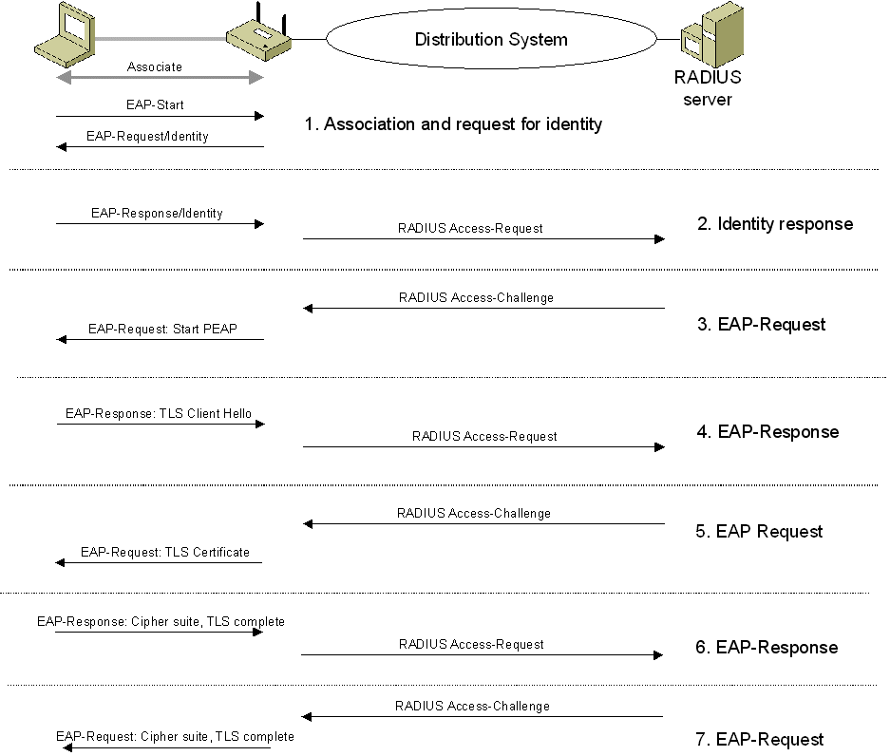
Figure 6 Authentication process for the PEAP channel
At the end of the PEAP negotiation, the RADIUS server has authenticated itself to the wireless client. Both nodes have determined mutual encryption and signing keys for the TLS channel, using public key cryptography, not passwords.
After the PEAP TLS channel is created, the following steps are used to authenticate the wireless client credentials with MS-CHAP v2:
- EAP-Request/Identity from the RADIUS server
The RADIUS server sends an EAP-Request message for the identity of the wireless client in the form of a RADIUS Access-Challenge message.
The wireless AP forwards the EAP message to the wireless client.
- EAP-Response/Identity from the wireless client
The wireless client transmits an EAP-Response/Identity message containing the computer or the user name.
The wireless AP forwards the EAP-Response/Identity message to the RADIUS server in the form of a RADIUS Access-Request message.
- EAP-Request from the RADIUS server (MS-CHAP v2 challenge)
The RADIUS server sends a RADIUS Access-Challenge message containing an EAP-Request message with the EAP-Type set to EAP-MS-CHAP v2, containing the MS-CHAP v2 challenge for the wireless client.
The wireless AP forwards the EAP message to the wireless client.
- EAP-Response from the wireless client (MS-CHAP v2 response and challenge)
The wireless client sends an EAP-Response message with a response to the RADIUS server's challenge and a challenge for the RADIUS server.
The wireless AP forwards the EAP message to the RADIUS server in the form of a RADIUS Access-Request message.
- EAP Request from the RADIUS server (MS-CHAP v2 response and success)
The RADIUS server sends a RADIUS Access-Challenge message containing an EAP-Request message with the EAP-Type set to EAP-MS-CHAP v2, containing a response to the wireless client's challenge and an indication of the success of the wireless client's response to the RADIUS server's challenge.
The wireless AP forwards the EAP message to the wireless client.
- EAP-Response from the wireless client (MS-CHAP v2 acknowledgement)
The wireless client sends an EAP-Response message with the EAP-Type set to EAP-MS-CHAP v2, containing the MS-CHAP v2 Acknowledgement message, indicating that the RADIUS server's response to the wireless client's challenge is correct.
The wireless AP forwards the EAP message to the RADIUS server in the form of a RADIUS Access-Request message.
- EAP-Success from the RADIUS server
The RADIUS server derives the per-client unicast session key and the signing key from the keying material that is a result of the PEAP authentication process. Next, the RADIUS server sends a RADIUS Access-Accept message containing an EAP-Success message and the MS-MPPE-Send-Key and MS-MPPE-Recv-Key attributes to the wireless AP.
The wireless AP uses the key encrypted in the MS-MPPE-Send-Key attribute as the per-client unicast session key for data transmissions to the wireless client (truncated to the appropriate WEP key length). The wireless AP uses the key encrypted in the MS-MPPE-Recv-Key attribute as a signing key for data transmissions to the wireless client that require signing (truncated to the appropriate WEP key length).
The wireless client derives the per-client unicast session key (the same value as the decrypted MS-MPPE-Send-Key attribute in the RADIUS message sent to the wireless AP) and the signing key (the same as value as the decrypted MS-MPPE-Recv-Key attribute in the RADIUS message sent to the wireless AP) from the keying material that is a result of the PEAP authentication process. Therefore, both the wireless AP and the wireless client are using the same keys for both the encryption and signing of unicast data.
The wireless AP forwards the EAP-Success message to the wireless client. The EAP-Success message does not contain the per-station unicast session or signing keys.
- Multicast/global encryption key to the wireless client
The wireless AP derives the multicast/global encryption key by generating a random number or by selecting it from a previously set value. Next, the wireless AP sends an EAPOL-Key message to the wireless client containing the multicast/global key that is encrypted using the per-client unicast session key.
The Key field of the IEEE 802.1X EAPOL-Key message is RC4-encrypted using the per-client unicast session key and portions of the message are signed with HMAC-MD5 using the per-client unicast signing key.
Upon receiving the EAPOL-Key message, the wireless client uses the per-client unicast session key to verify the signed portions of the EAPOL-Key message and decrypt the multicast/global key. Next, the wireless LAN network adapter driver indicates the per-client unicast session key, the per-client unicast signing key, and the multicast/global key to the wireless LAN network adapter. After the keys have been indicated, the wireless client begins protocol configuration using the wireless adapter (such as using DHCP to obtain an IP address configuration).
When the wireless AP changes the multicast/global key, it generates and sends EAPOL-Key messages to its connected wireless clients. Each EAPOL-Key message contains the new multicast/global key encrypted with the particular wireless client’s per-client unicast session key.
Figure 7 shows the MS-CHAP v2 authentication process that occurs within the encrypted PEAP channel.
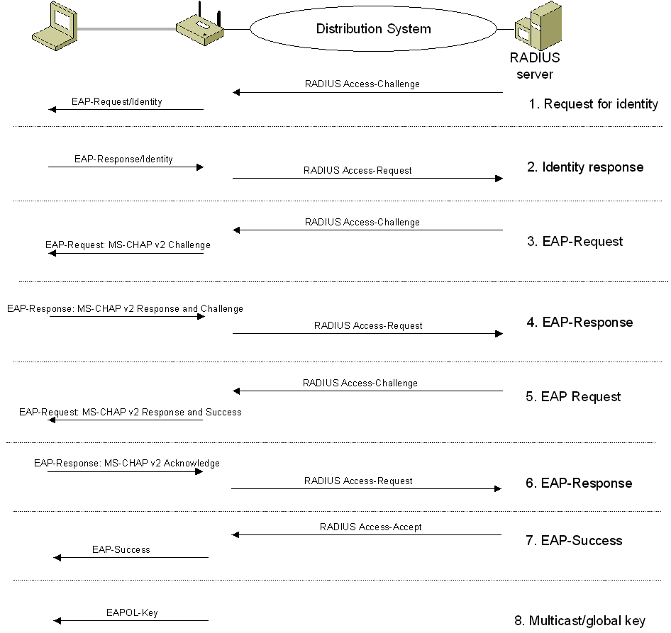
Figure 7 MS-CHAP v2 authentication process within the PEAP channel
At the end of this mutual authentication exchange, the wireless client has provided proof of knowledge of the correct password (the response to the RADIUS server challenge string), and the RADIUS server has provided proof of knowledge of the correct password (the response to the wireless client challenge string). The entire exchange is encrypted through the TLS channel created in the first part of the PEAP authentication.
If PEAP-Transport Layer Security (TLS) is used, a TLS authentication process occurs in the same way as EAP-TLS, except that the EAP messages are encrypted using the TLS channel.

Chapter 10: Intranet Wireless Deployment Using PEAP-MS-CHAP v2
The following are updates to the information in Chapter 10:
- For information about how to obtain and install a WLAN Server Certificate from VeriSign, Inc., on IAS RADIUS servers to enable password-based authentication for wireless connections using PEAP Microsoft Challenge Handshake Authentication Protocol version 2 (MS-CHAP v2), see the Obtaining and Installing a VeriSign WLAN Server Certificate for PEAP-MS-CHAP v2 Wireless Authentication white paper.

Chapter 12: Secure Wireless Networks for the Home and Small Business
The content of this chapter, including the updates in the "Updated Manual Configurations for Windows XP SP2" section of this white paper, describe how to manually configure your wireless AP and computers running Windows XP. If you are using a computer running Windows XP with SP2, you can greatly simplify the configuration of strong security for wireless networks in the home or small office by using the new Wireless Network Setup Wizard.
This new wizard in Windows XP with SP2 steps you through the configuration of wireless network settings and then writes that configuration as a set of Extensible Markup Language (XML) files on a Universal Serial Bus (USB) flash drive (UFD). You then plug the UFD into other wireless devices in the home or small office that support Windows Connect Now (formerly known as Windows Smart Network Key [WSNK]). All of the wireless devices that support Windows Connect Now automatically read the settings from the XML files stored on the UFD and configure themselves with the same settings as the computer on which the Wireless Network Setup Wizard was initially run.
This is the recommended method of configuring wireless AP-based wireless networks in a home or small office, especially if you are using other computers running Windows XP with SP2 or wireless network devices (such as wireless APs or wireless printers) that support Windows Connect Now.
For more information, including a step-by-step example with screen shots, see "The New Wireless Network Setup Wizard" section of this white paper.

Updated Manual Configurations for Windows XP SP2
The following sections contain updated sections for manual configuration of computers running Windows XP with SP2 for the following:
- Using a wireless AP with WEP and a wireless network adapter driver that supports WZC Service
- Using a wireless AP with WPA and a wireless network adapter driver that supports WZC Service
- Configuring the initial client on an ad hoc network
- Configuring additional clients on an ad hoc network

Using a Wireless AP with WEP and a Wireless Network Adapter Driver that Supports WZC Service
Use the following procedure (inserted at the top of page 271) to configure Windows XP SP2 for your WEP-based infrastructure mode wireless network when the wireless network adapter supports Wireless Auto Configuration (the Wireless Zero Configuration [WZC] service):
- Install your wireless network adapter in Windows XP SP2. This process includes installing the proper drivers for your wireless network adapter so it appears as a wireless connection in Network Connections.
- When the computer is within range of the wireless AP operating in your home or small business, Windows XP should detect it and prompt you with a Wireless networks detected message in the notification area of your taskbar.
- Click the notification message. If you are not notified, right-click the wireless network adapter in Network Connections and click View Available Wireless Networks. In either case, you should see a Choose a wireless network dialog box with the name of your wireless network.
- Double-click your wireless network name. Windows XP will attempt to connect to your wireless network.
- Because Windows XP has not been configured with the WEP encryption key for your wireless network, the connection attempt will fail and Windows XP will prompt you with a dialog box. Type the WEP key in Network key and Confirm network key, and then click Connect.
- If the status message for your wireless network in the Choose a wireless network dialog box is Connected, you are done. If the status message for your wireless network in the Choose a wireless network dialog box is Authentication did not succeed, click Change the order of preferred networks in the list of Related tasks. From the Wireless Networks tab of properties of your wireless network adapter, click the name of your wireless network in Preferred networks, and then click Properties.
- In Network Authentication, click Open. In Data encryption, click WEP. In Network key and Confirm network key, type the WEP encryption key as configured on the wireless AP.
- In Key index, select the key index corresponding to the encryption key memory position as configured on the wireless AP.
- Click OK to save changes to the wireless network.
- Click OK to save changes to the wireless network adapter.
Figure 8 shows an example of a Windows XP SP2 Wireless network properties dialog box for a home wireless network with the following configuration:
- SSID is HOME-AP
- Open system authentication is enabled
- WEP is enabled
- The WEP encryption key is 104 bits long, in hexadecimal format, using key index 1 (the first encryption key position), and consists of the sequence "8e7cd510fba7f71ef29abc63ce"
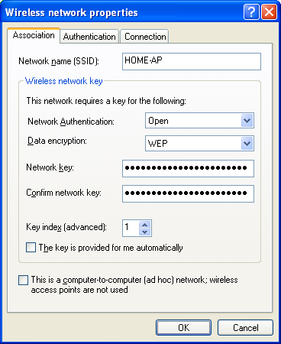
Figure 8 Example properties of an infrastructure mode wireless network using WEP for Windows XP SP2

Using a Wireless AP with WPA and a Wireless Network Adapter Driver that Supports WZC Service
Use the following procedure (inserted just after Figure 12-5 on page 273) to configure Windows XP SP2 for your WPA-based infrastructure mode wireless network when the wireless network adapter supports Wireless Auto Configuration:
- Install your wireless network adapter in Windows XP SP2. This process includes installing the proper drivers for your wireless network adapter so it appears as a wireless connection in Network Connections.
- When the computer is within range of the wireless AP operating in your home or small business, Windows XP should detect it and prompt you with a Wireless networks detected message in the notification area of your taskbar.
- Click the notification message. If you are not notified, right-click the wireless network adapter in Network Connections and click View Available Wireless Networks. In either case, you should see a Choose a wireless network dialog box with the name of your wireless network.
- Double-click your wireless network name. Windows XP will attempt to connect to your wireless network.
- Because Windows XP has not been configured with the WPA preshared key for your wireless network, the connection attempt will fail and Windows XP will prompt you with a dialog box. Type the WPA preshared key in Network key and Confirm network key, and then click Connect.
- If the status message for your wireless network in the Choose a wireless network dialog box is Connected, you are done. If the status message for your wireless network in the Choose a wireless network dialog box is Authentication did not succeed, click Change the order of preferred networks in the list of Related tasks. From the Wireless Networks tab of properties of your wireless network adapter, click the name of your wireless network in Preferred networks, and then click Properties.
- In Network Authentication, click WPA-PSK. In Data encryption, click TKIP.
- In Network key, type the WPA preshared key as configured on the wireless AP. In Confirm network key, retype the WPA preshared key.
- Click OK to save changes to the wireless network.
- Click OK to save changes to the wireless network adapter.
Figure 9 shows an example of a Windows XP SP2 Wireless network properties dialog box for a home wireless network with the following configuration:
- SSID is HOME-AP
- WPA with preshared key authentication is enabled
- TKIP is enabled
- A WPA preshared key
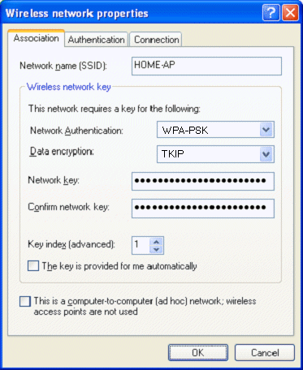
Figure 9 Example properties of an infrastructure mode wireless network using WPA-PSK with Windows XP SP2

Configuring the Initial Client on an Ad Hoc Network
The following procedure (inserted just after Figure 12-7 on page 277) configures Windows XP SP2 on the initial wireless client for your ad hoc mode wireless network when the wireless network adapter driver supports Wireless Auto Configuration:
- Install your wireless network adapter in Windows XP SP2. This includes installing the proper drivers for your wireless network adapter so that it appears as a wireless network adapter in Network Connections.
- Because there might not be any wireless networks in your home or small business location, you might not be prompted with a message in the notification area of your taskbar.
- Right-click the wireless network adapter in Network Connections, and then click Properties. Click the Wireless Networks tab.
- From the wireless network adapter properties dialog box, click Add under Preferred networks.
- On the Association tab, type the name of your ad hoc wireless network in Network name (SSID).
- Select the This is a computer-to-computer (ad hoc) network check box and clear the The key is provided for me automatically check box.
- In Network Authentication, click Open. In Data encryption, click WEP.
- In Network key, type the WEP key. Retype the WEP key in Confirm network key.
- In Key index, select 1.
- Click OK to save changes to the wireless network.
- Click OK to save changes to the wireless network adapter.
Figure 10 shows an example of a Windows XP SP2 Wireless network properties dialog box for a home ad hoc wireless network with the following configuration:
- SSID is HOME-AD HOC
- Open system authentication is enabled
- WEP is enabled
- Ad hoc mode is enabled
- The WEP encryption key is 104 bits long, in hexadecimal format, using key index 1 (the first encryption key position), and consists of the sequence "19a8bce753ed4e6a410b730fa4".
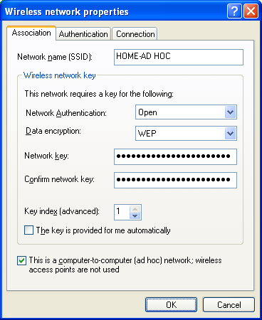
Figure 10 Example properties of an ad hoc mode wireless network for Windows XP SP2

Configuring Additional Clients on an Ad Hoc Network
The following procedure (inserted just after step 10 on page 279) configures Windows XP SP2 as an additional client for your ad hoc mode wireless network:
- Install your wireless network adapter in Windows XP SP2. This includes installing the proper drivers for your wireless network adapter so that it appears as a wireless network adapter in Network Connections.
- Once the computer is within range of the initial wireless client in your home or small business, Windows XP should detect it and prompt you with a Wireless networks detected message in the notification area of your taskbar.
- Click the notification message. If you are not notified, right-click the wireless network adapter in Network Connections and click View Available Wireless Networks. In either case, you should see a Choose a wireless network dialog box with the name of your wireless network.
- Double-click your ad hoc wireless network name. Windows XP will attempt to connect to your ad hoc wireless network.
- Because Windows XP has not been configured with the WEP encryption key for your ad hoc wireless network, the connection attempt will fail and Windows XP will prompt you with a dialog box. Type the WEP key in Network key and Confirm network key, and then click Connect.
- If the status message for your wireless network in the Choose a wireless network dialog box is Connected, you are done. If the status message for your wireless network in the Choose a wireless network dialog box is Authentication did not succeed, click Change the order of preferred networks in the list of Related tasks. From the Wireless Networks tab of properties of your wireless network adapter, click the name of your ad hoc wireless network in Preferred networks, and then click Properties.
- In Network Authentication, click Open. In Data encryption, click WEP.
- In Network key and Confirm network key, type the WEP encryption key as configured on the initial Windows XP wireless client.
- In Key index, select the key index number that matches the key index position of the initial Windows XP wireless client.
- Click OK to save changes to the wireless network.
- Click OK to save changes to the wireless network adapter.

Using a Wireless AP with WPA2 and a Wireless Network Adapter Driver that Supports WZC Service
This new procedure describes how to configure Windows XP SP2 for your WPA2-based infrastructure mode wireless network when the wireless network adapter supports Wireless Auto Configuration:
- Install your wireless network adapter in Windows XP SP2. This process includes installing the proper drivers for your wireless network adapter so it appears as a wireless connection in Network Connections.
- Install the Wi-Fi Protected Access 2 (WPA2)/Wireless Provisioning Services Information Element (WPS IE) update for Windows XP with Service Pack 2.
- When the computer is within range of the wireless AP operating in your home or small business, Windows XP should detect it and prompt you with a Wireless networks detected message in the notification area of your taskbar.
- Click the notification message. If you are not notified, right-click the wireless network adapter in Network Connections and click View Available Wireless Networks. In either case, you should see a Choose a wireless network dialog box with the name of your wireless network.
- Double-click your wireless network name. Windows XP will attempt to connect to your wireless network.
- Because Windows XP has not been configured with the WPA2 preshared key for your wireless network, the connection attempt will fail and Windows XP will prompt you with a dialog box. Type the WPA2 preshared key in Network key and Confirm network key, and then click Connect.
- If the status message for your wireless network in the Choose a wireless network dialog box is Connected, you are done. If the status message for your wireless network in the Choose a wireless network dialog box is Authentication did not succeed, click Change the order of preferred networks in the list of Related tasks. From the Wireless Networks tab of properties of your wireless network adapter, click the name of your wireless network in Preferred networks, and then click Properties.
- In Network Authentication, click WPA2-PSK. In Data encryption, click AES.
- In Network key, type the WPA2 preshared key as configured on the wireless AP. In Confirm network key, retype the WPA2 preshared key.
- Click OK to save changes to the wireless network.
- Click OK to save changes to the wireless network adapter.

The New Wireless Network Setup Wizard
For a home or small office, there are two recommended choices for authentication and encryption:
- Open system authentication with WEP encryption, referred to hereafter as open system/WEP
- WPA with preshared key (PSK) authentication with Temporal Key Integrity Protocol (TKIP) encryption, referred to hereafter as WPA-PSK/TKIP
You should use open system/WEP only if all of your network devices do not support WPA. Microsoft strongly recommends using WPA-capable wireless devices and WPA-PSK/TKIP. Because there is typically no central authentication server in the home or small office, someone in the home or small office must do one of the following:
- For open system/WEP, they must choose a strong WEP key and configure all of the computers and wireless devices to use open system authentication, WEP encryption, and the same strong WEP key.
- For WPA-PSK/TKIP, they must choose a strong WPA-PSK and configure all of the computers and wireless devices to use WPA-PSK authentication, TKIP encryption, and the same strong WPA-PSK.
Note A strong key is one that uses a random set of hexadecimal digits (for the WEP key) or characters (for the WPA-PSK) for the largest possible key size.
In either case, wireless network setup can be complicated for the novice user because each wireless device has a different method of configuring authentication and encryption settings. For example, a wireless AP might use a wizard or a set of Web browser pages to configure a specific authentication method, encryption method, and the WEP key or WPA-PSK. For computers running Windows XP with SP2 or Windows XP with SP1, you configure authentication, encryption, and either a WEP key or WPA-PSK on the Wireless network properties dialog box for a specific wireless network, available from Wireless Networks tab for the properties of the wireless LAN adapter in the Network Connections folder.
To make the configuration of a WEP key or WPA-PSK much easier, Windows XP with SP2 and Windows Server 2003 with Service Pack 1 supports Windows Connect Now, a new feature of wireless devices that automates wireless network configuration. Windows XP with SP2 and Windows Server 2003 with Service Pack 1 support Windows Connect Now through updates to the wireless client software and a new Wireless Network Setup Wizard.
Note The new Wireless Network Setup Wizard does not support the configuration of a WPA2 preshared key.
The Wireless Network Setup Wizard steps you through the configuration of wireless network settings—a wireless network name, the authentication and encryption method, and a strong WEP key or WPA-PSK—and then writes that configuration as a set of Extensible Markup Language (XML) files on a Universal Serial Bus (USB) flash drive (UFD). You then plug the UFD into other wireless devices in the home or small office that support Windows Connect Now. All of the wireless devices that support Windows Connect Now automatically read the settings from the XML files stored on the UFD and configure themselves with the same settings as the computer on which the Wireless Network Setup Wizard was initially run.
This new feature of Windows XP SP2, Windows Server 2003 with Service Pack 1, and other wireless devices, which have a USB port and support Windows Connect Now, greatly simplifies the configuration of strong security for wireless networks in the home or small office.

Using the Wireless Network Setup Wizard to Configure a Wireless Network
To run the new Wireless Network Setup Wizard on a computer running Windows XP with SP2 or Windows Server 2003 with Service Pack 1, you can do one of the following:
- Click the Set up a wireless network for a home or small office network task in the Choose a wireless network dialog box
- Click the Wireless Network Setup task or icon in the Network and Internet Connections folder in Control Panel
- Click the Wireless Network Setup task or icon in the My Network Places window
- Click Start, point to Programs, point to Accessories, point to Communications, and then click Wireless Network Setup
- Click the Wireless Network Setup task in the new Windows Provisioning Services Wizard
When you run the Wireless Network Setup Wizard, it displays the Welcome to Wireless Network Setup Wizard page, as shown in the following figure.
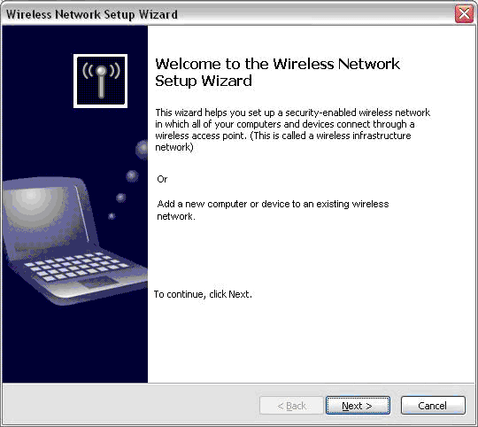
Click Next. You should see the Create a name for your wireless network page, as shown in the following figure.
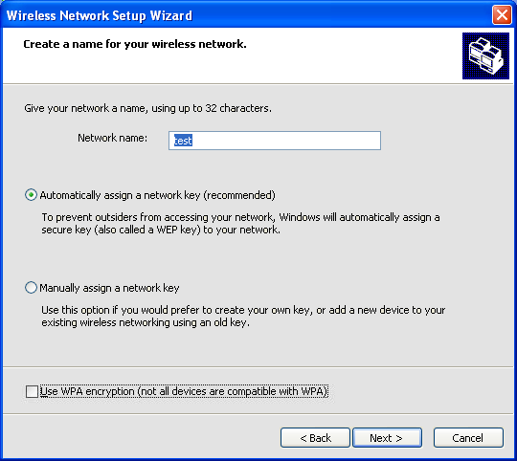
On this page, you specify the name of your wireless network (also known as the Service Set Identifier [SSID]), whether or not to have the Wireless Network Setup Wizard automatically create a strong network key, and whether or not to use WPA.
If you want the Wireless Network Setup Wizard to create a strong network key and you clear the Use WPA encryption checkbox, the Wireless Network Setup Wizard creates a strong WEP key. If you want the Wireless Network Setup Wizard to create a strong network key and you select the Use WPA encryption checkbox, the Wireless Network Setup Wizard creates a strong WPA-PSK. Click Next.
Assuming that you want the Wireless Network Setup Wizard to automatically assign a network key, the Wireless Network Setup Wizard displays the How do you want to set up your network? page, as shown in the following figure.
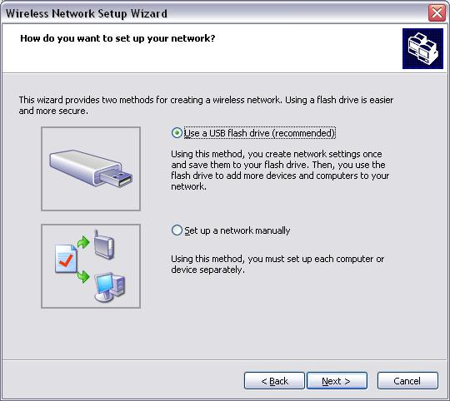
If you select Use a USB flash drive, the Wireless Network Setup Wizard prompts you to insert your UFD so that it can create the XML files for the wireless network configuration, which includes the wireless network name, authentication and encryption methods, and the WEP key or WPA-PSK. If you select Set up a network manually, the Wireless Network Setup Wizard prompts you to print the wireless network settings so that you can take the printed wireless network configuration to each wireless device for manual configuration. Click Next.
Assuming that you want to use a UFD, the Wireless Network Setup Wizard displays the Save settings to your flash drive page, as shown in the following figure.
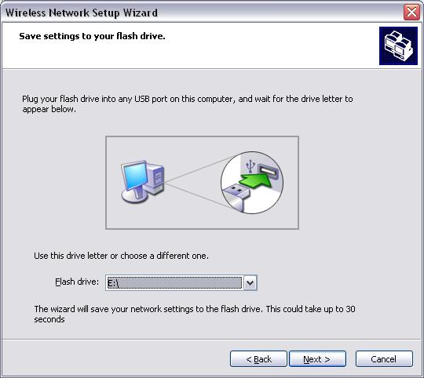
When you plug your UFD into a USB port of the computer, the Wireless Network Setup Wizard automatically displays the drive letter assigned to the UFD in Flash drive. Click Next.
The Wireless Network Setup Wizard writes the wireless network settings as XML files on the UFD and then displays the Transfer your network settings to your other computers or devices page, as shown in the following figure.
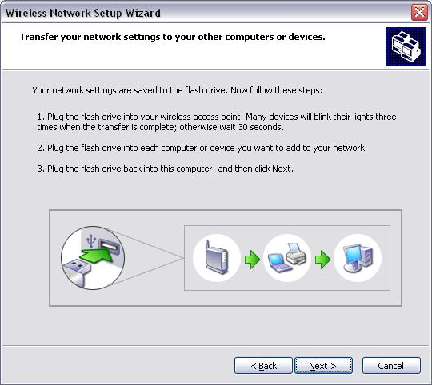
Remove the UFD from the computer and plug it into every other wireless device that supports Windows Connect Now, such as wireless APs and network printers, and other wireless computers running Windows XP with SP2 or Windows Server 2003 with Service Pack 1. When you plug the UFD into a Windows Connect Now-capable wireless device, it flashes its status light three times to indicate that it has configured itself with the wireless network settings stored on the UFD. When you plug the UFD into a computer running Windows XP with SP2, the Wireless Network Setup Wizard runs and asks you if you want to join the wireless network. If you accept, the Wireless Network Setup Wizard creates a wireless profile and connects the computer to the home network. As a rule of thumb, you should configure your wireless AP first, then the other computers running Windows XP with SP2 or Windows Server 2003 with Service Pack 1 and other wireless devices.
When you are done configuring your other computers and wireless devices with the UFD, plug it back into the computer on which the Wireless Network Setup Wizard was initially run, and then click Next on the Transfer your network settings to your other computers or devices page.
The Wireless Network Setup Wizard displays the The wizard completed successfully page, as shown in the following figure.
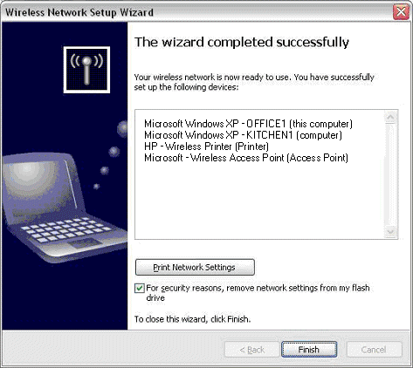
Under You have successfully set up the following devices, the Wireless Network Setup Wizard lists the wireless computers and devices that have been configured by the Wireless Network Setup Wizard and the UFD. To remove the wireless network settings including the WEP key or WPA-PSK from the UFD, select the For security reasons, remove network settings from my flash drive checkbox (selected by default). If you want to use the UFD to configure additional wireless computers or devices a later time, clear this checkbox. Click Finish.
This example of the Wireless Network Setup Wizard was used to perform an initial configuration of a wireless network with an automatically assigned WEP key or WPA-PSK. You can also use the Wireless Network Setup Wizard to do the following:
- Configure a new Windows Connect Now-capable device after the Wireless Network Setup Wizard has been run. In this case, the Windows Network Setup Wizard guides you through rewriting the current wireless network settings to a UFD, which you plug in to the new wireless device or computer.
- Configure a wireless network with a manually specified WEP key or WPA-PSK. You do this by selecting the Manually assign a network key option on the Create a name for your wireless network page.
- Print the current wireless network settings for wireless devices that do not support Windows Connect Now or computers running older versions of Windows that do not support execution of the setup file stored on the UFD. You can do this by selecting Set up a network manually on the How do you want to set up your network? page.
- Reconfigure your wireless network settings. Although the Wireless Network Setup Wizard creates strong keys, it is a good idea to change them every couple of months to keep eavesdroppers from collecting encrypted traffic and using cryptographic tools to crack the WEP key or WPA-PSK. When you run the Wireless Network Setup Wizard again, it asks whether you want to keep the existing settings or create new ones. If you specify that you want to create new settings, the Wireless Network Setup Wizard displays the Create a name for your wireless network page and you configure your wireless network in the same way as the initial configuration. The Wireless Network Setup Wizard automatically assigns a new set of strong keys.

XML Files Stored on the UFD
Whenever you run the Wireless Network Setup Wizard to create new wireless network settings and click Next on the Save settings to your flash drive page, it writes the following files to the UFD:
- \Autorun.inf
Launches the \Smrtntky\Setupsnk.exe file when the UFD is plugged into a computer running Windows. If there is an existing Autorun.inf file, the Wireless Network Setup Wizard renames it to Autorun.fcb. If the For security reasons, remove network settings from my flash drive checkbox on the The wizard completed successfully page is selected and you click Next, the Wireless Network Setup Wizard removes its files and renames Autorun.fcb back to Autorun.inf.
- \Smrtntky\Setupsnk.exe
An executable file that runs from the Autorun.inf file. If the computer is running Windows XP with SP2, then Setupsnk.exe runs the Wireless Network Setup Wizard and creates a wireless profile with the settings stored in the \Smrtntky\Wsetting.wcf file. If the computer is running Windows XP with SP1 or Windows XP with no service packs installed, Setupsnk.exe prompts you to print the \Smrtntky\Wsetting.txt file, which contains the wireless network settings. If the version of Windows does not enumerate the UFD as a fixed drive, then Setupsnk.exe does not execute automatically.
- \Smrtntky\Wsetting.wfc
An XML file that contains the settings for the wireless network as configured from the Create a name for your wireless network page of the Wireless Network Setup Wizard, including your wireless network name, the authentication and encryption method, and either an automatically assigned or manually configured WEP key or WPA-PSK.
- \Smrtntky\Wsetting.txt
A text file that contains the equivalent wireless network settings in the \Smrtntky\Wsetting.wcf file, which is displayed for computers running versions of Windows prior to Windows XP with SP2 or Windows Server 2003 with Service Pack 1.
- \Smrtntky\Device\xxxxxxxx.wcf
A device configuration file that contains XML-formatted information about the computer on which the Wireless Network Setup Wizard was initially run, including the computer name and the version of Windows XP. The filename is the ASCII representation of the hexadecimal digits of the last 4 bytes of the wireless network adapter's MAC address. For example, for a computer with a wireless network adapter with the MAC address 00-AA-A3-8C-3D-0F, the name of the file is A38c3d0f.wfc.
As the UFD is plugged into computers and wireless devices, each computer running Windows XP with SP2 and each Windows Connect Now-capable wireless device writes its own device configuration file to the \Smrtntky\Device folder on the UFD. When you click Next on the Transfer your network settings to your other computers or devices page, the Wireless Network Setup Wizard reads the device configuration files from the \Smrtntky\Device for the current wireless network setup and displays the configured wireless devices in the You have successfully set up the following devices list on the The wizard completed successfully page.

Correction to Page 268
The second bullet on page 268 should be:
- Your computer is running Windows XP (SP1 and later) or Windows Server 2003, and your wireless network adapter driver supports the WZC service
The yellow highlight shows the correction.

Correction to Page 270
The last bullet on page 270 should be:
- The WEP encryption key consists of the sequence 8e7cd510fba7f71ef29abc63ce and uses key index 1 (the first encryption key position).
The yellow highlight shows the correction.

Chapter 14: Troubleshooting the Windows Wireless Client
The following are updates to the information in Chapter 14:
- Windows XP and Windows Server 2003 supports detailed logging for various components to troubleshoot the wireless authentication process. You can enable logging for specific components or for all components by using the netsh ras set tracing command. Windows XP SP2 and Windows Server 2003 Service Pack 1 now includes tracing for the Wireless Zero Configuration service, which is responsible for detecting and attempting to connect to preferred wireless networks. To see the Wireless Zero Configuration service logs, type netsh ras set tracing * enabled at a command prompt to enable logging for all components. Disable and then enable your wireless network connection in the Network Connections folder. Then, view the Wzcdlg.log and Wzctrace.log files in the SystemRoot\Tracing folder. To disable tracing for all components, type netsh ras set tracing * disabled at a command prompt.
- To make the wireless connection state more meaningful and to better inform you of the capabilities of the connection, the reporting of the status of the wireless connection process has been enhanced, as described in the following section.

Improvements in Reporting the Status of a Wireless Connection
When a wireless client running Windows XP with SP2 or Windows Server 2003 with Service Pack 1 attempts a wireless connection, it goes through the following authentication states, which are indicated in the Choose a wireless network dialog box, as the status of the wireless connection in the Network Connections folder, and in the new wireless connection Status dialog box:
- Validating identity
Credentials are required for connecting to the wireless network.
- Attempting to authenticate
Credentials are being exchanged with the wireless network to authenticate a wireless connection.
- Authentication did not succeed
The credentials for connecting to the wireless network were not valid and authentication has failed.
- Connected
The credentials for connecting to the wireless network are valid.
Once authentication has succeeded, a wireless client running Windows XP with SP2 or Windows Server 2003 with Service Pack 1then attempts to obtain a valid IP address configuration and goes through the following states, which are indicated in the Choose a wireless network dialog box, as the status of the wireless connection in the Network Connections folder, and in the new wireless connection Status dialog box:
- Acquiring network address
An IP address configuration is being obtained using the Dynamic Host Configuration Protocol (DHCP).
- Limited or no connectivity
A DHCP server was not contacted and an Automatic Private IP Addressing (APIPA) address from the range 169.254.0.0/16 was assigned. This state is not shown for wireless ad-hoc networks, which typically do not have DHCP servers. Instead, the status of the connection is displayed as “Connected.”
- Connected
A DHCP server was contacted and a valid IP address configuration was obtained.
These improvements give the user and the network troubleshooter more information about how the wireless connection is progressing, from the initial association to the allocation of a valid IP address.
If the wireless connection obtains an APIPA address, Windows warns you with the following message in the notification area of the desktop: "The connection has limited or no connectivity. You might not be able to access the Internet or some network resources. For more information, click this message." When you click on the message, Windows displays the Support tab of the Status dialog box for the wireless connection, from which you can view additional details or attempt to repair the connection.
Additionally, the wireless connection icon in the notification area has been updated to have a slightly different look than other networking icons. Windows XP SP2 and Windows Server 2003 Service Pack 1 shows the connection in the following states:
- Disconnected The normal wireless connection icon is displayed with an overlaid red "X".
- Connecting (authenticating and obtaining an IP address) The normal wireless connection icon is displayed with an animated amber ball moving back and forth.
- Warning (APIPA address configuration) The normal wireless connection icon is displayed with an overlaid yellow yield symbol.
- Connected (authenticated and valid IP address obtained) The normal wireless connection icon is now animated, showing when traffic is sent or received.

Appendix B: Wireless ISPs and Windows Provisioning Services

Wireless Provisioning Services Overview
Wireless Provisioning Services (WPS) are enhancements that are included in Windows XP SP2 and Windows Server 2003 Service Pack 1. WPS extends the wireless client software included with Windows XP and the Internet Authentication Service (IAS) included with Windows Server 2003 to allow for a consistent and automated configuration process when connecting to the following:
- Public wireless hotspots that provide access to the Internet.
- Private organization wireless networks that provide guest access to the Internet.
This section describes the infrastructure and process when a wireless client initially connects to a public wireless hotspot that is providing access to the Internet.
When a wireless client connects to a public wireless hotspot, it might already be an existing customer of the wireless Internet service provider (WISP). If they are not, the user of the wireless client is faced with the challenge of performing the following:
- Configuring network settings to connect to the WISP network.
- Providing identification and payment information to the WISP.
- Obtaining connection credentials.
- Reconnecting to the WISP network after valid credentials has been obtained.
WPS is designed to simplify, automate, and standardize initial sign-up and subscription renewal so that the user does not have to perform a different set of steps for each wireless provider to which they want to connect.

Components of a WPS Infrastructure
The set of components needed for WPS is the following:
- WPS-enabled wireless clients
- Wireless APs that support either virtual local area networks (VLANs) or Internet Protocol (IP) filtering
- Access controller
- Provisioning server
- Active Directory® directory service domain controller
- IAS server
- DHCP server
These components are shown in Figure 11.
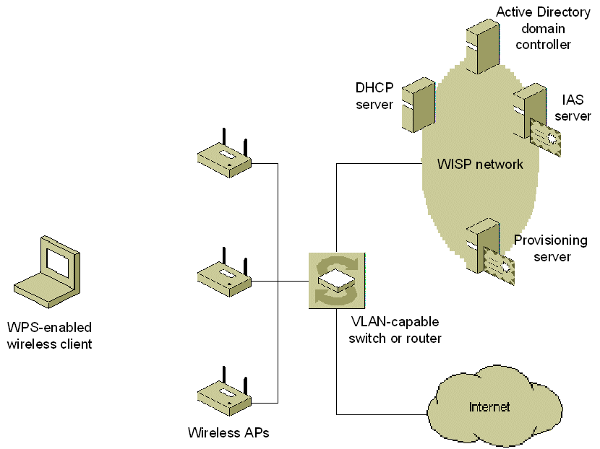
Figure 11 Components of a WPS infrastructure

WPS-Enabled Wireless Clients
WPS-enabled wireless clients are computers running Windows XP Home Edition with SP2, Windows XP Professional with SP2, Windows Server 2003 with Service Pack 1, or Windows XP Tablet PC Edition with SP2.

Wireless APs that Support Either VLANs or IP Filtering
The wireless APs that are used for WPS must support either:
- VLANs
With VLANs, the traffic from the wireless client can be tagged with a VLAN ID to identify whether it is authenticated, in which case the traffic is forwarded to the Internet VLAN, or not, in which case the traffic is forwarded to a provisioning resources VLAN that contains the set of servers used for configuring the wireless client. The access controller uses the VLAN ID to determine how to switch the traffic.
- IP filtering
As an alternative to VLAN support, the wireless AP must have the ability to filter traffic from individual wireless clients based on the destination IP address or tag traffic for filtering by an access controller. IP filtering allows the wireless AP to confine the traffic of unauthenticated clients to a specific set of resources on the network.
Both IP filtering the use of VLANs provide a way of isolating the traffic of unauthenticated wireless clients to a specific set of servers from which the wireless client is configured and valid connection credentials are obtained.
The support for VLANs or IP filtering is in addition to support for 802.1X and RADIUS.
It is also recommended that wireless APs have virtual AP support, in which a single physical wireless AP can act as if it were multiple wireless APs by broadcasting multiple SSIDs with separate security configurations. With virtual AP support, WISPs can easily migrate their existing public hotspots from using the Universal Access Method (UAM), a Web browser-based sign-up process, to WPS.
The wireless AP is configured as a RADIUS client to the IAS server on the WISP network.

Access Controller
The access controller is a device that performs routing and either filtering or VLAN switching for packets coming from and going to the wireless APs. If packet filtering is being used, the access controller uses the tags placed on the frames to perform packet filtering. If VLANs are being used, the access controller uses the VLAN ID of packets coming from the wireless APs to switch the packets to:
- A provisioning resources VLAN
The provisioning resources VLAN allows unauthenticated wireless clients access to the DHCP and provisioning servers, allowing them to connect to receive a DHCP configuration, provide identification and payment information, and receive connection credentials to connect as an authenticated wireless client.
- An Internet VLAN
The Internet VLAN provides access to the Internet. Only customers who have created and paid for accounts and have authenticated themselves with valid credentials are switched to this VLAN for Internet access.
The IP filters or the specific VLAN ID for the traffic of the unauthenticated (the provisioning resources VLAN) or authenticated (the Internet VLAN) wireless client are provided via vendor-specific RADIUS attributes in the RADIUS Access-Accept message sent from the IAS server.

Provisioning Server
The provisioning server is configured with the following components:
- Secure HyperText Transfer Protocol (HTTPS)-based Web server
A Web server, either Internet Information Services (IIS) or a third-party Web server, must be deployed using HTTPS.
- Web application
The HTTPS-based Web server is configured with a WPS-based Web application that processes information provided during customer sign-up or subscription renewal. When a customer uses the WPS sign-up wizard on the wireless client to create and pay for a WISP account, the customer types identification and payment information, such as name, address, and credit card information. This information is converted by WPS to an XML document and sent to the provisioning server.
The Web application on the provisioning server must be capable of accepting and processing the XML documents containing the wireless client user information. For example, for new customers, the Web application must dynamically create an account in Active Directory. For subscription renewals, the Web application must dynamically update account and payment information.
- XML master and sub-files
The provisioning server maintains the XML master and sub-files that provide the wireless client with all the configuration information needed to access the network, create an account, submit payment information, and ultimately access the Internet. The XML data also contains WISP branding content, WISP hotspot locations, and help information.

Active Directory Domain Controller
An Active Directory domain controller is used to store the user accounts database for active customers. When a customer performs the initial sign-up process, the Web application on the provisioning server creates a new account in Active Directory and adds the user account to the appropriate groups.
Instead of Active Directory, a WISP can use a Lightweight Directory Access Protocol (LDAP)-based database that supports dynamic creation of user accounts.

IAS Server
IAS, the Windows implementation of a RADIUS server and proxy, is used as a RADIUS server to authenticate and authorize users connecting to the WISP network. IAS is configured with remote access policies to allow the following:
- Guest authentication and access to the provisioning resources for wireless clients that do not yet have an account and valid connection credentials.
- Access to the Internet for wireless clients that do have an account and valid connection credentials.
The IAS server must be running Windows Server 2003 with Service Pack 1, which includes a new Protected Extensible Authentication Protocol (PEAP) type known as PEAP-Type-Length-Value (TLV). PEAP-TLV is defined in the Internet draft titled "A Container Type for the Extensible Authentication Protocol (EAP)" (draft-hiller-eap-tlv-0x.txt), and provides IAS with the ability to send the location of the provisioning server to wireless client computers in the form of a Uniform Resource Locator (URL). With the URL of the provisioning server, WPS on the wireless clients can download the provisioning XML files and begin the initial sign-up or subscription renewal process.
To provide server-side PEAP authentication to wireless client computers, the IAS server uses a computer certificate, stored in the Local Computer certificate store of the IAS server. The IAS computer certificate contains the Server Authentication purpose in the Enhanced Key Usage property of the certificate and is typically issued by a public, third party certification authority (CA), such as VeriSign, Inc.
A public, third party certificate is typically used because in order for the Windows XP wireless client to validate the IAS server certificate, it must have the root CA certificate of the issuing CA of the IAS server computer certificate stored in its Trusted Root Certification Authority certificate store. Windows XP already includes the root CA certificates of many public, third party certificates in the Trusted Root Certification Authority certificate store.
If you install IAS on the Active Directory domain controller, the computer must have a computer certificate. If the IAS server and the Active Directory domain controller are different computers, only the IAS server needs a computer certificate.

DHCP Server
The DHCP server must be able to assign valid IP addresses to the wireless client computers that are connecting either as guests or as authenticated clients that are accessing the Internet.

Example New Account Connection Process
The following example describes the WPS process for a new customer at a Wi-Fi hotspot location. When a new customer connects to a WISP, signs up for a new account, and accesses the Internet, the entire process occurs in the following phases:
- Phase 1: The client discovers the WISP network at a Wi-Fi hotspot.
- Phase 2: The client authenticates as a guest.
- Phase 3: The client is provisioned and a new account is created.
- Phase 4: The client is authenticated using the new account credentials accesses the Internet.

Phase 1: The Client Discovers the WISP Network at a Wi-Fi Hotspot
A customer starts their WPS-capable wireless client within range of a wireless AP at the Wi-Fi hotspot. The wireless network adapter informs Windows XP Wireless Auto Configuration of the existence of the WISP wireless network name, also known as its SSID. Windows XP notifies the customer that a new wireless network is available. The customer views the WISP wireless network information and decides to connect.

Phase 2: The Client Authenticates as a Guest
Because this is a new wireless network, Wireless Auto Configuration uses PEAP-Transport Layer Security (TLS) guest authentication to connect to the WISP network. For PEAP-TLS guest authentication, the wireless client passes a null user name and no certificate to the IAS server.
The IAS server authorizes the new client as a guest. After PEAP-TLS authentication, PEAP-TLV is used to send the URL of the provisioning server to the wireless client. In the final RADIUS Access-Accept message, RADIUS attributes contain either the VLAN ID of the provisioning resource VLAN ID or the set of IP filters used to confine the traffic from the wireless client to the resources needed for provisioning.
The wireless client computer then requests and receives an IP address configuration from the DHCP server.

Phase 3: The Client is Provisioned and a New Account is Created
From the URL received via PEAP-TLV, the wireless client connects to the provisioning server. WPS on the wireless client downloads the XML master file and the appropriate sub files. Based on the information in these files, the WPS sign-up wizard is run, allowing the customer to configure identification and payment information, create an account, and receive valid credentials.
The information configured by the customer is converted by WPS into an XML document, which is sent to the provisioning server. Once payment is verified and sign-up information is completed successfully, the Web application creates a user account in Active Directory (or other LDAP-capable user account database) and adds the account to the appropriate groups.
The provisioning server creates an XML document containing the new account credentials and sends it to WPS on the wireless client computer. WPS stores the wireless network, account, and credential information in a profile.

Phase 4: The Client is Authenticated Using the New Account Credentials and Accesses the Internet
Wireless Auto Configuration disassociates from the wireless AP of the WISP, reassociates, and then attempts authentication. Because there is now a profile that matches the WISP wireless network, Wireless Auto Configuration retrieves the information from the profile and authenticates using PEAP-Microsoft Challenge Handshake Authentication Protocol version 2 (MS-CHAP v2) and the user account and password credentials stored in the profile.
Based on the valid credentials sent by the wireless client, the IAS server authenticates and authorizes the connection request against the new account in Active Directory. Based on the user account properties and the matching remote access policy settings, the IAS server sends an Access-Accept message to the wireless AP containing either the VLAN ID of the Internet VLAN or a new set of IP filters that allow the wireless client computer to access the Internet.
After the authenticated connection is accepted, the wireless client uses DHCP to request and receive an IP address configuration. After DHCP configuration, the wireless client can access Internet resources.

WPS Deployment Resources
For additional information about deploying WPS in a Wireless Internet service provider (WISP) network that allows you to provide pay-per-use, monthly service and long-term Internet access to new and existing customers through wireless access points deployed in public areas, see the Deploying Wireless Provisioning Services (WPS) Technology white paper.
To facilitate easier WPS deployment, Microsoft has released the Wireless Provisioning Services (WPS) Authoring Tool, a free download that generates XML files for WPS-based Wi-Fi hotspot deployments. See Using the Wireless Provisioning Services (WPS) Technology Authoring Tool for information about how to use the WPS authoring tool.

WPS Updates
The Wi-Fi Protected Access 2 (WPA2)/Wireless Provisioning Services Information Element (WPS IE) update for Windows XP with Service Pack 2, a free download for computers running Windows XP with SP2, includes support for the WPS information element (IE), a newly defined 802.11 IE that solves the hidden SSID problem for WISPs and provides a way for wireless APs to advertise additional SSIDs in the broadcast Beacon and Probe Request frames. For more information, see the Wi-Fi Protected Access 2 (WPA2)/Wireless Provisioning Services Information Element (WPS IE) update for Windows XP with Service Pack 2.

Appendix C: Setting Up Secure Wireless Access in a Test Lab
Use the following procedure (page 368) to configure CLIENT1 if it is running Windows XP SP2:
- Log off and then log on by using the WirelessUser account in the example.com domain.
- Wait until you are prompted with a Wireless networks detected message in the notification area of your taskbar.
- Click the Wireless networks detected message. If you are not notified, right-click the wireless network adapter in Network Connections and click View Available Wireless Networks. In either case, you should see a Choose a wireless network dialog box with the name of your wireless network.
- Double-click your wireless network name. Windows XP will attempt to connect to your wireless network.
- If the status message for your wireless network in the Choose a wireless network dialog box is Connected, you are done. If the status message for your wireless network in the Choose a wireless network dialog box is Authentication did not succeed, click Change the order of preferred networks in the list of Related tasks. From the Wireless Networks tab of properties of your wireless network adapter, click the name of your wireless network in Preferred networks, and then click Properties.
- Click the Association tab. In EAP type, select Protected EAP (PEAP). Click OK to save changes to the wireless network. Click OK to save changes to the wireless network adapter.
Continue with step 7 on page 369.

Summary
The changes in 802.11 standards and its implementation in Windows XP, Windows Server 2003, and Windows 2000 include inclusion of WPA, WPA2, WPS, the Wireless Network Setup Wizard, and new wireless configuration dialog boxes in Windows XP SP2 and Windows Server 2003 Service Pack 1 and the inclusion of Microsoft 802.1X Authentication Client in Windows 2000 SP4. These changes are not reflected in the Microsoft Press book titled Deploying Secure 802.11 Wireless Networks with Microsoft Windows by Joseph Davies.

Related Links
See the following resources for further information:
- Microsoft Windows Wi-Fi Web site at http://www.microsoft.com/wifi
- Deploying Secure 802.11 Wireless Networks with Microsoft Windows at http://www.microsoft.com/MSPress/books/4883.asp

For the latest information about Windows Server, see the Windows Server 2003 Web site at http://www.microsoft.com/windowsserver2003.

