

MS_logo_KTechnical Overview of Windows® HPC Server 2008 R2 Beta 1

White Paper

Published November 2009

**Abstract**

Windows**®** HPC Server 2008 R2, scheduled for final release in 2010, is designed to provide a powerful combination of ease-of-use, low ownership costs, and performance. This white paper provides an overview of the Windows**®** HPC Server 2008 R2 *Beta 1* release, including a list of new features, an overview of the Microsoft**®** HPC solution (including hardware and software requirements), and an overview of key capabilities in the areas of deployment, system management, job scheduler, runtime for Service Oriented Architectures (SOA), message-passing interface (MPI) and networking, Microsoft Office Excel**®** 2010 support, and security.

This is a preliminary document and may be changed substantially prior to final commercial release of the software described herein. The information contained in this document represents the current view of Microsoft Corporation on the issues discussed as of the date of publication. Because Microsoft must respond to changing market conditions, it should not be interpreted to be a commitment on the part of Microsoft, and Microsoft cannot guarantee the accuracy of any information presented after the date of publication.

This white paper is for informational purposes only. MICROSOFT MAKES NO WARRANTIES, EXPRESS, IMPLIED, OR STATUTORY, AS TO THE INFORMATION IN THIS DOCUMENT.

Complying with all applicable copyright laws is the responsibility of the user. Without limiting the rights under copyright, no part of this document may be reproduced, stored in or introduced into a retrieval system, or transmitted in any form or by any means (electronic, mechanical, photocopying, recording, or otherwise), or for any purpose, without the express written permission of Microsoft Corporation.

Microsoft may have patents, patent applications, trademarks, copyrights, or other intellectual property rights covering subject matter in this document. Except as expressly provided in any written license agreement from Microsoft, the furnishing of this document does not give you any license to these patents, trademarks, copyrights, or other intellectual property.

© 2009 Microsoft Corporation. All rights reserved.

Microsoft, Excel, PowerShell, SQL Server, Visual Studio, Windows, Windows Server, and Windows Vista are either registered trademarks or trademarks of Microsoft Corporation in the United States and/or other countries.

The names of actual companies and products mentioned herein may be the trademarks of their respective owners.

Contents

Introduction 1

What’s New in Windows HPC Server 2008 R2 3

Elements of the Microsoft HPC Solution 6

General Characteristics 7

Hardware Requirements 8

Supported Processors 8

Multiprocessor Support 8

Memory Requirements 8

Disk Space and Volumes 8

Network Interface Cards 8

Software Requirements 8

Head Node and Broker Nodes 9

Compute Nodes 9

Database 9

Administrator Tools 10

Supported Network Topologies 10

Deployment 12

Graphical Deployment Tools 12

Windows Deployment Services 12

Node Templates 12

Windows Server 2008 and Windows Server 2008 R2 Compute Nodes 13

Diskless Boot 13

Deployment Validation Tools 13

System Management 14

Graphical Administration Console 14

Windows PowerShell and Command-line Scripts 15

Monitoring at Scale 16

Enhanced Heat Map with Overlay View 16

Additional Filtering Criteria 18

Customizable Tabs 18

Location-based Grouping 18

Extensible Reporting 19

Built-in Reports 19

Reporting Extensibility 20

Diagnostics 20

Built-in Diagnostics 20

Extensible Diagnostic Framework 21

Job Scheduling 22

Interfaces 22

Policies 23

Job Workflows 23

SOA Runtime 25

When SOA Can Be Useful—and How it Works on a Cluster 25

Building SOA-Based HPC Applications 25

Fire-and Recollect Programming Model 26

Durable Sessions 26

Finalization Hooks 26

Improved Java Interoperability 26

Running SOA-Based HPC Applications 26

Message Resilience 27

High-Availability Broker Nodes (Broker Restart/Failover) 27

Managing SOA-Based HPC Applications 27

Easier Setup and Configuration 27

Enhanced Monitoring 27

Improved Diagnostics 28

Correlated Tracing 28

Networking and MPI 29

Microsoft Message Passing Interface (MS-MPI) 29

NetworkDirect 29

Easier Troubleshooting of MPI Applications 30

Tuning Wizard for LINPACK (“Lizard”) 31

Microsoft Office Excel Support 33

Speeding-Up Excel Workbooks using an HPC Cluster 33

Using Excel as a Cluster SOA Client 33

Running Excel User Defined Functions on an HPC Cluster 34

Running Excel Workbooks on an HPC Cluster 34

Additional Benefits of Running Excel Calculations on a Cluster 35

Security 36

Conclusion 37

Additional Resources 37

# Introduction

Windows® HPC Server 2008 R2 is the third version of the Microsoft® solution for high performance computing (HPC). Built on Windows Server® 2008 R2 64-bit technology, Windows HPC Server 2008 R2 efficiently scales to thousands of nodes and integrates seamlessly with Windows-based IT infrastructures, providing a powerful combination of ease-of-use, low ownership costs, and performance.

Compared to the previous version, Windows HPC Server 2008 R2 delivers significant improvements in several areas, including:

* **Improved scalability**—with out-of-the-box support for deploying, running, and managing clusters of 1,000 nodes or more.
* **New configuration and deployment options**—such as diskless boot, mixed-operating system version (Windows Server 2008 and Windows Server 2008 R2) clusters, and support for a remote head node database.
* **Improved system management, diagnostics, and reporting**—including an enhanced heat map with multiple customizable tabs, an extensible diagnostic framework, and the ability to create richer custom reports.
* **Improved support for service-oriented architecture (SOA) workloads**—including a new fire-and-recollect programming model, finalization hooks, improved Java interoperability, automatic restart and failover of broker nodes, and improved management, monitoring, diagnostics, and debugging.
* **Message-passing interface (MPI) and networking enhancements**—including optimizations for new Intel “Nehalem”-based processors, enhanced support for RDMA over Ethernet and Infiniband, improved MPI debugging, and a pushbutton LINPACK optimization wizard.
* **New ways to speed-up Microsoft Office Excel® workbooks—**such as support for running Excel user-defined functions and Excel workbooks on the nodes of an HPC cluster.

Through these enhancements, Windows HPC Server 2008 R2 makes it easier than ever for companies to benefit from high-performance computing. System administrators can more easily deploy and manage powerful HPC solutions, developers can more easily build applications, and end users can more easily access those solutions from their Windows-based desktops.

The remainder of this document provides a technical overview of Windows HPC Server 2008 R2 Beta 1, with topics addressed in the following order:

* A list of new features in Windows HPC Server 2008 R2.
* Solution architecture, hardware requirements, software requirements, and supported network topologies.
* An overview of each of the key functional areas of the product—including deployment, system management, job scheduler, SOA runtime, MPI and networking, Microsoft Office Excel support, and security.

**Note: This document provides a description of Windows HPC Server 2008 R2 *as of Beta 1*. Functionality may change prior to commercial release.**

# What’s New in Windows HPC Server 2008 R2

Released in 2008, Windows HPC Server 2008 included several new features, including Windows Deployment Services-based node provisioning, support for NetworkDirect, an enhanced Job Scheduler, a management console based on the Microsoft System Center 2007 user interface, and support for Windows PowerShell™ scripting. Windows HPC Server 2008 R2 builds on many of those innovations, delivering significant new features and functionality in many areas:

**Deployment**

* Efficient deployment of more than1,000 nodes
* Diskless, iSCSI network boot of compute nodes
* Backwards compatibility with Windows HPC Server 2008 node templates
* Support for compute nodes based on Windows Server 2008 and Windows Server 2008 R2 (including mixed-version clusters)
* Support for remote HPC databases

**System Management – including Diagnostics and Reporting**

* A customizable monitoring heat map, with at-a-glance viewing of system status for upwards of 1,000 nodes
* Location-based node grouping, which allows administrators to view, categorize and batch operations on compute nodes based on their locations
* Color-coded heat map overlays, with prioritized parameter display
* Multiple, customizable tabs for different views of heat maps and other system data
* An extensible diagnostic framework for implementing custom diagnostics
* The ability to change diagnostic parameters at runtime
* A richer reporting database and enhanced API for building custom reports

**Job Scheduling**

* Support for larger clusters, more jobs, and larger jobs—including improved scheduling and task throughput at scale
* Just-in-time parametric sweep expansion, which improve performance for creating large parametric task sweeps
* New service-balanced scheduling policy optimized for SOA and other dynamic workloads
* A new user interface and API for viewing and reporting job progress
* Command line and API support for prep and release tasks that run before and after a job to prepare and cleanup nodes
* A simplified user interface and experience for troubleshooting jobs
* An improved Job and Node Template Editor

**Service-Oriented Architecture (SOA) Runtime**

* Fire and recollect programming model support
* Hooks for adding finalization logic to services, which enable developers to add logic to perform cleanup before a service exits
* Improved interoperability with Java client applications
* New capabilities for managing SOA applications—in the areas of setup and configuration, monitoring, diagnostics, and event tracing
* Broker node auto-restart and persisted storage of calculation results
* Fail-over across broker nodes in the event of a hardware failure

**Networking and Message-Passing Interface (MPI)**

* Support for new networking options—including RDMA over Ethernet (iWARP) from Intel and RDMA over Infiniband quad data rate (40 Gbps) hardware
* Optimization of shared memory implementations for new Intel “Nehalem”-based processors
* Improved MPI debugging capabilities (provided in Visual Studio® 2010)
* A pushbutton LINPACK optimization wizard (“Lizard”)

**Excel Support**

* Support for running Excel user-defined functions (UDFs) on a cluster
* Support for running Excel workbooks on a cluster

In addition to the above new features and capabilities, because it’s based on the latest version of the Windows Server operating system, Windows HPC Server 2008 R2 also enables organizations to take advantage of the many enhancements in Windows Server 2008 R2, including:

* Performance improvements in the areas of SMB support, input/output, and thread scheduling
* Support for more logical processors (256 versus 64)
* Deployment related enhancements, such as support for multiband multicast in the Windows Deployment Services transport

# Elements of the Microsoft HPC Solution

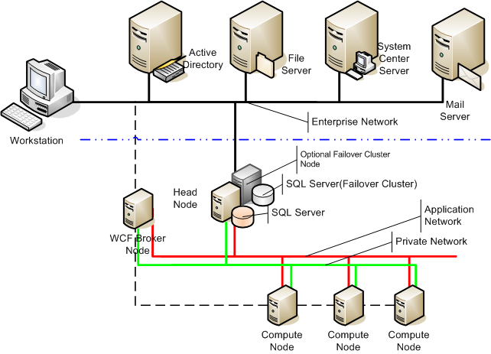Windows HPC Server 2008 R2 combines the underlying stability and security of Windows Server 2008 R2 with the features of Microsoft HPC Pack 2008 R2 to provide a robust, scalable, cost-effective, and easy-to-use HPC solution. A basic Windows HPC Server 2008 R2 solution is composed of a cluster of servers, with a single head node (or a primary and backup head node in a highly available configuration) and one or more compute nodes (see Figure 1). The head node controls and mediates all access to the cluster resources and is the single point of management, deployment, and job scheduling for the cluster. Windows HPC Server 2008 R2 can integrate with an existing Active Directory® directory service infrastructure for security and account management; and can use Microsoft System Center Operations Manager for data center monitoring.

Figure 1. A basic Windows HPC Server 2008 R2 solution.

***Note:*** *Windows HPC Server 2008 R2 is designed solely for use with HPC applications and should not be used as a general-purpose infrastructure server.*

## General Characteristics

General characteristics of the Windows HPC Server 2008 R2 solution are provided in Table 1.

|  |  |  |
| --- | --- | --- |
| Feature | Implementation | Benefits |
| Operating system | Windows Server 2008 and/or Windows Server 2008 R2 (Head node is R2 only, compute nodes can be both) | Inherits security and stability features from Windows Server 2008 and Windows Server 2008 R2. |
| Processor type | x64 (AMD64 or Intel EM64T) | Large memory model and processor efficiencies of x64 architecture. |
| Node deployment | Windows Deployment Services | Image-based deployment, with full support for multicasting and diskless boot. |
| Head node redundancy | Windows Failover Clustering and SQL Server® Failover Clustering | Provides a fully redundant head node and scheduler (requires Windows Server 2008 R2 Enterprise and SQL Server Standard Edition). |
| Management | Integrated Administration Console | Provides a single user interface for all aspects of node and job management, grouping, monitoring, diagnostics, and reporting. |
| Network topology | Network Configuration Wizard | Fully automated Network Configuration Wizard for configuring the desired network topology. |
| Application network | MS-MPI | High-speed application network stack using NetworkDirect. Shared memory implementation for multicore processors. Highly compatible with existing MPICH2 implementations. |
| Scheduler | Job Manager Console | GUI is integrated into the Administration Console or can be used standalone. Command line interface supports Windows PowerShell scripting and legacy command-line scripts from Windows Compute Cluster Server. Greatly improved speed and scalability. Support for SOA applications. |
| Monitoring | Integrated into Administration Console | New heat map provides at-a-glance view of cluster performance and status for up to 1,000 nodes. |
| Reporting | Integrated into Administration Console | Standard, prebuilt reports and historical performance charts. Additional reports can be created using SQL Server Analysis Services. |
| Diagnostics | Integrated into Administration Console | Out-of-the-box verification and performance tests, with the ability to store, filter, and view test results and history. An extensible diagnostic framework for creating custom diagnostics and reports. |
| Parallel runtime | Enterprise-ready SOA infrastructure | Windows HPC Server 2008 R2 provides enhanced support for SOA workloads, helping organizations more easily build interactive HPC applications, make them more resilient to failure, and more easily manage those applications. |

Table 1. Windows HPC Server 2008 R2 features.

## Hardware Requirements

Hardware requirements for Windows HPC Server 2008 R2 are similar to those for the x64-based editions of the Windows Server 2008 R2 Standard operating system.

### Supported Processors

Supported processors include AMD Athlon 64, AMD Opteron, AMD Phenom, Intel Pentium with Intel EM64T, Intel Core 2 Duo with Intel EM64T, and Intel Xeon with Intel EM64T.

### Multiprocessor Support

The number of sockets supported depends on which operating system is used:

* Windows Server 2008 HPC Edition, Windows Server 2008 R2 HPC Edition, Windows Server 2008 Standard Edition, and Windows Server 2008 R2 Standard Edition support up to four sockets per server.
* Windows Server 2008 Enterprise Edition and Windows Server 2008 R2 Enterprise Edition support up to eight sockets per server.

### Memory Requirements

The head node and compute nodes require a minimum of 512 megabytes (MB) of RAM, and support a maximum of 128 gigabytes (GB) of RAM.

### Disk Space and Volumes

Minimum disk space required for setup is 50 GB. A single system volume is required for head and compute nodes. Redundant array of independent disks (RAID) is supported but not required. The system volume must be Master Boot Record (MBR). Additional volumes can be MBR or GUID Partition Table (GPT).

*Note: Diskless nodes will have different requirements, the details of which are beyond the scope of this document.*

### Network Interface Cards

At least one network interface card (NIC) is required on the head node and each of the compute nodes. If a private network is used, the head node requires at least two NICs, and compute nodes require at least one NIC. Each node may also require a high-speed NIC for an application network. All nodes must have the same network hardware.

## Software Requirements

Windows HPC Server 2008 R2 is a two-DVD package. The first DVD contains the setup for Windows Server 2008 R2 HPC Edition (a 64-bit version of Windows Server 2008 R2 that is restricted to HPC workloads), and the second DVD contains Microsoft HPC Pack 2008 R2, which provides the additional interfaces, tools, and management infrastructure.

### Head Node and Broker Nodes

Building the head node for a Windows HPC Server 2008 R2 solution involves installing Windows Server 2008 R2 on the server, joining the server to an Active Directory domain, and then installing HPC Pack 2008 R2. The operating system for the head node can be any of the following:

* Windows Server 2008 R2 HPC Edition
* Windows Server 2008 R2 Standard x64 Edition
* Windows Server 2008 R2 Enterprise x64 Edition

Broker nodes also require one of the above Windows Server 2008 R2 editions.

### Compute Nodes

Compute nodes can run either Windows Server 2008 or Windows Server 2008 R2. Specific versions of Windows Server that are supported include:

* Windows Server 2008 R2 HPC Edition
* Windows Server 2008 R2 Standard x64 Edition
* Windows Server 2008 R2 Enterprise x64 Edition
* Windows Server 2008 HPC Edition
* Windows Server 2008 Standard x64 Edition
* Windows Server 2008 Enterprise x64 Edition

### Database

Windows HPC Server 2008 R2 uses Microsoft SQL Server 2008 as a data repository for the head node. An existing SQL Server 2008 installation can be used, or the HPC Pack 2008 installer will install SQL Server 2008 Express (which is included on the HPC Pack 2008 R2 DVD).

*Note: If cluster size is greater than 100 nodes, Microsoft recommends using SQL Server 2008 Standard Edition or higher instead of SQL Server 2008 Express.*

#### Head Node Failover Clustering

Windows HPC Server 2008 R2 can take advantage of the failover clustering capabilities provided in Windows Server 2008 R2 Enterprise and some editions of Microsoft SQL Server to provide high-availability failover clustering for the head node. With clustering, in the event of a head node failure, the Job Scheduler will automatically—or manually, if desired—fail over to a second server. Job Scheduler clients see no change in the head node during the failover and fail-back processes, helping to ensure uninterrupted cluster operation. SQL Server Standard Edition or Enterprise Edition is required for head node failover clustering.

#### Remote Head Node Database

Windows HPC Server 2008 R2 adds support for a remote head node database, enabling organizations to take advantage of an existing enterprise database. A remote database is not supported when using SQL Server 2008 Express.

### Administrator Tools

During installation of the HPC Server 2008 R2 Pack, the Administration Console and job scheduling console are automatically installed on the head node. These same components can also be installed on other computers, as may be desired to support remote cluster management or job submission. Supported operating systems for installation of the remote components include:

* Windows Server 2003 with Service Pack 2 (SP2) or Windows Server 2003 R2 (32-bit or x64 versions)
* Windows Server 2008 or Windows Server 2008 R2 (32-bit or x64 versions)
* Windows XP Professional with SP3 (32-bit edition)
* Windows XP Professional with SP2 (x64 edition)
* Windows Vista® Business, Enterprise, and Ultimate editions with SP1
* Windows 7 Professional, Enterprise, and Ultimate editions

## Supported Network Topologies

Windows HPC Server 2008 R2 supports five different network topologies, each with one to three network interface cards per node, enabling organizations to configure their HPC solutions to suit their unique needs. The Network Configuration Wizard (see Figure 2) simplifies the process of configuring the desired network topology.

The five network topologies that are supported include:

1. **Compute nodes isolated on a private network.** The head node has two NICs, one connected to the enterprise network and the other to the private network, and may provide network address translation (NAT) for the compute nodes. The compute nodes have a single NIC, and are connected only to the private network.
2. **All nodes on both enterprise and private networks.** The head nodes and compute nodes each have two NICs, one connected to the enterprise network and one connected to the private network.
3. **Compute nodes isolated on private and application networks.** The head node has three NICs, one connected to the enterprise network, one connected to the private network, and one connected to the application network. Each compute node has one NIC connected to the private network and one connected to the application network. The head node may perform NAT between compute nodes and the enterprise network.
4. **All nodes on enterprise, private, and application networks.** Each node has three NICs. One NIC is connected to the enterprise network, one is connected to a private, dedicated cluster-management network, and one is connected to a high-speed, dedicated application network.
5. **All nodes only on enterprise network.** In this limited networking scenario, where each node has only a single NIC, the use of Windows Deployment Services to deploy compute nodes is not supported, and each compute node must be manually installed and activated.

**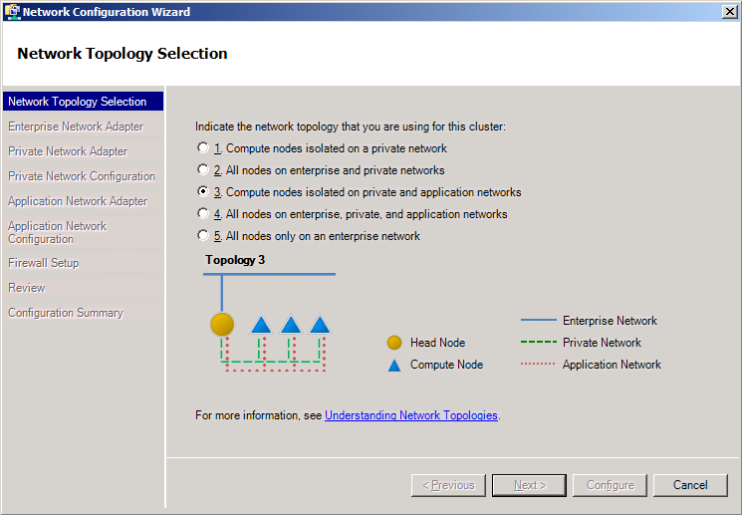Note:** In topologies 1 and 3 above, where the compute nodes are isolated on a private network, network address translation (NAT) between the private and enterprise networks can be performed by the head node or a separate server.

Figure 2. Cluster topologies supported by Windows HPC Server 2008 R2.

# Deployment

One challenge to the adoption of HPC solutions lies in the deployment of large clusters. It’s not hard to deploy a four-node cluster—someone just has to insert the DVD and press ENTER at each node and then add the nodes to the cluster. Configuration is easy, and the time involved isn’t significant. But when deploying clusters of a few hundred or few thousand nodes, manual installation is tedious and error-prone. And as cluster scalability continues to improve, the challenges associated with manual deployment can only increase.

With a design goal of supporting the deployment of 1,000 nodes in less than an hour, Windows HPC Server 2008 R2 builds on the capabilities provided by the Windows Deployment Services transport to simplify and streamline the deployment and updating of cluster nodes. Graphical deployment tools are integrated into the Administration Console, including Node Templates for easily defining the configuration of compute nodes. New features in Windows HPC Server 2008 R2—such as support for Windows Server 2008-based and mixed-version clusters, mixed version clusters, and diskless boot—provide additional flexibility, enabling organizations to easily deploy solutions that are optimized to meet their needs.

## Graphical Deployment Tools

Deployment tools are integrated into the graphical Administration Console, allowing system administrators to quickly select nodes for deployment and easily monitor deployment progress. A To Do List shows the steps necessary to complete the configuration of a compute cluster, including defining the desired network topology, configuring automatic deployment (including image creation), and adding compute nodes to the cluster.

## Windows Deployment Services

Windows HPC Server 2008 R2 uses the Windows Deployment Services transport in Windows Server 2008 R2, using Windows Imaging Format (WIM) files and multiband multicast to rapidly deploy compute nodes in parallel. Other advantages of this approach include driver integration and updating, as well as support for non-uniform compute node deployment.

## Node Templates

Node Templates in Windows HPC Server 2008 R2 provide an easy way to define the desired configuration of compute nodes, with each Node Template including the base operating system image, drivers, configuration parameters, and, if desired, additional software. A Node Template Generation Wizard guides the administrator through the process of creating Node Templates, including support for injecting drivers into images. An improved Template Editor provides advanced configuration capabilities, including configuring Node Templates for automatic application deployment.

Here’s how the process works: Windows Deployment Services running on the head node discovers compute nodes as they are turned on. Preinstalled compute nodes can be added to the cluster by importing a node list, or the administrator can choose to select nodes interactively as the Administration Console displays the discovered nodes. During either unattended or interactive deployment, the node is imaged and configured and applications are deployed according to the Node Template.

## Windows Server 2008 and Windows Server 2008 R2 Compute Nodes

Windows HPC Server 2008 R2 supports the deployment of compute nodes and broker nodes based on Windows Server 2008 or Windows Server 2008 R2, including mixed-version clusters.

## Diskless Boot

Diskless booting of compute nodes, a new feature in Windows HPC Server 2008 R2, is provided through support for iSCSI boot from a storage array. This mechanism uses DHCP reservations for mapping to disk and leverages the storage vendor’s mechanism for creating differencing disks for compute nodes.

## Deployment Validation Tools

The Administration Console includes diagnostic tests that can be used post-deployment to detect common problems, monitor node loading, and view job status across the cluster. In addition, the new “Lizard” (LINPACK Wizard) in Windows HPC Server 2008 R2 enables administrators to heavily load the cluster—thereby providing an efficient mechanism for detecting issues related to configuration and deployment, networking, power, cooling, and so on.

# System Management

Another major challenge that organizations can face is the management and administration of HPC clusters. This has traditionally been a departmental or organizational-level challenge, requiring one or more dedicated IT professionals to manage and deploy nodes. At the same time, users submitting batch jobs are competing for limited HPC resources.

Windows HPC Server 2008 R2 is designed to facilitate ease-of-management. It provides a graphical Administration Console that puts all the tools required for system management at an administrator’s fingertips, including the ability to easily drill down on node details such as metrics, logs, and configuration status. Support for the Windows PowerShell scripting language facilitates the automation of system administration tasks. An enhanced “heat map” view provides system administrators with an “at a glance” view of cluster status, including the ability to define tabs with different views of system health and resource usage. Other new management-related features in Windows HPC Server 2008 R2 include additional criteria for filtering views, support for location-based node grouping, a richer reporting database for building custom reports, and an extensible diagnostic framework.

## Graphical Administration Console

Based on the Microsoft System Center 2007 user interface, the Administration Console in Windows HPC Server 2008 R2 integrates every aspect of cluster management. The Administration Console has five navigation panes:

* **Configuration,** which includes the To Do List, Network Configuration Wizard, and Node Template Generation Wizard.
* **Node Management,** which is used to monitor node status and initiate node-specific actions such as deployment, bringing nodes offline or online, and adding or removing nodes.
* **Job Management,** which provides control of job scheduling and status.
* **Diagnostics,** which allows administrators to select a node or group of nodes and run diagnostic tests to validate network connectivity, job execution, configurations, performance, and so on—including the ability to view the progress of tests and view past test results.
* **Charts and Reports,** which displays standard reports in support of both scheduled and on-demand reporting.

The Administration Console also provides support for pivoting between these navigation panes for effective contextual monitoring. For example, when using the Job Management pane to view a job that has failed, an administrator can easily pivot to the Node Management Pane to view the status of the nodes upon which that job ran. Similarly, from the Node Management pane, the administrator can select a set of nodes and pivot to the Diagnostics pane to view the diagnostics that have run on the nodes. Furthermore, operations that are performed using the graphical Administration Console also can also be performed from the command line using Windows PowerShell (discussed next).

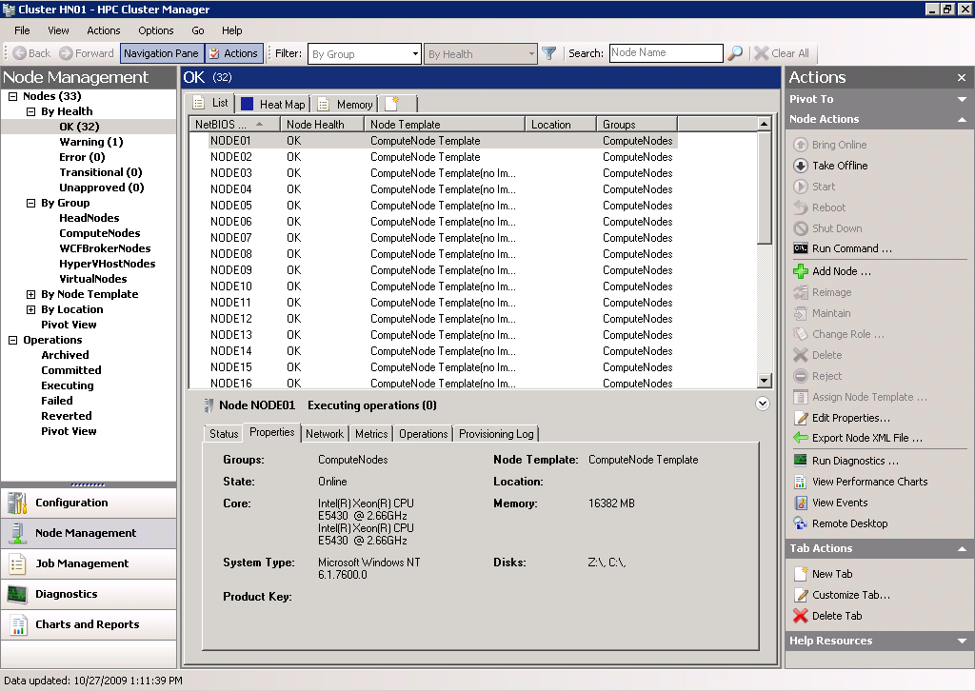Figure 3. The Administration Console.

## Windows PowerShell and Command-line Scripts

Windows HPC Server 2008 R2 supports Windows PowerShell as a scripting language and shell for managing clusters and jobs, providing more than 80 cmdlets for job submission and monitoring, deployment, diagnostics, and node management functions. An admin-focused scripting language with consistent syntax and utilities, Windows PowerShell accelerates automation of system administration tasks and helps improve an organization’s ability to address its unique system management challenges.

Windows PowerShell works with Microsoft .NET objects and supports Windows Management Instrumentation (WMI), combining the power of an object-oriented language with the ease-of-use of an interactive shell. For example, a system administrator could use simple PowerShell script to get a list of all nodes with more than 1 GB of free disk space, or to group together all nodes with at least eight processors and submit a job to that group of nodes.

Windows HPC Server 2008 R2 also maintains compatibility with existing Windows Compute Cluster Server 2003 command-line scripts.

## Monitoring at Scale

The Node Management pane within the Administration Console is used to monitor node status and initiate node-specific actions. New node management-related features in Windows HPC Server 2008 R2 include an enhanced heat map with overlay view, additional filtering criteria, customizable tabs, and location-based node grouping.

### Enhanced Heat Map with Overlay View

The Heat Map view (see Figure 4) resides within the Node Management pane. In Windows HPC Server 2008 R2, the heat map has been enhanced to provide an at-a-glance view of system health and performance for clusters upwards of 1,000 nodes. System administrators can define and prioritize up to three metrics (as well as minimum and maximum thresholds for each metric) to build customized views of cluster health and status.

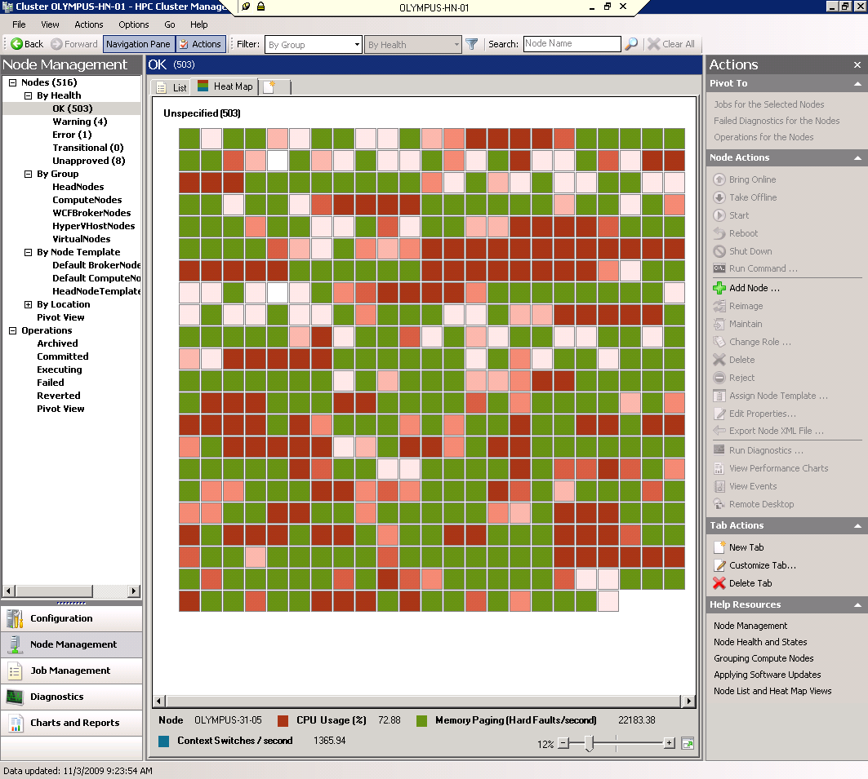Figure 4. The Heat Map view gives instant feedback on the health of the cluster.

Here’s how it works: Each node in the cluster is represented individually in the heat map for up to three performance counters. Each counter is assigned a color range (for example, light red to dark red) to represent the performance counter’s value at that instance. With the “stacked” heat map view, up to three performance counters can be viewed for each node at once. With the “overlay” heat map view, only one performance counter’s color is shown at any one time, as determined by the priority ordering for the counters assigned by the administrator. In both viewing modes, the administrator can identify nodes with outlier performance counters at-a-glance, thereby helping to facilitate effective monitoring.

### Additional Filtering Criteria

When managing large clusters, it can be helpful for system administrators to filter views of compute nodes by certain criteria. Windows HPC Server 2008 R2 adds to the filtering options provided in the previous version with additional filtering options, including advanced filtering by Node Group, Node State, and a node’s physical location.

### Customizable Tabs

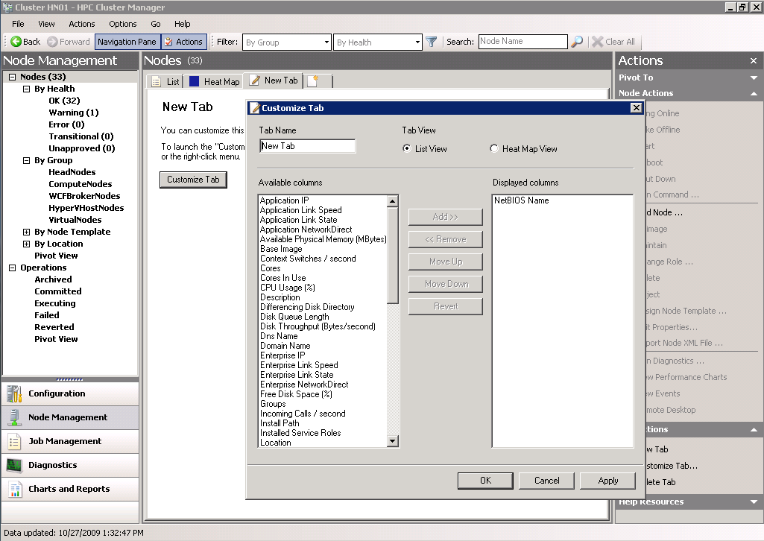Administrators now can create multiple, customizable tabs within the Node Management pane—as may be desired to view different types of parameters. For example, a system administrator could configure one tab to provide a heat map view of networking parameters, a second tab to provide a heat map view of job usage, and a third tab to provide a list view of failed operations.

Figure 5. Customizable tabs.

### Location-based Grouping

System administrators sometimes need to view the nodes in a cluster according to their physical location. For example, an administrator may want to see the heat map for a set of nodes contained within a single rack, as required to view performance metrics that may indicate a power or cooling issue. Windows HPC Server 2008 R2 enables administrators to define up to three levels of hierarchy within the physical layout of an HPC cluster—for example, grouping together nodes in different chassis—and then view compute nodes based on their locations within that hierarchy.

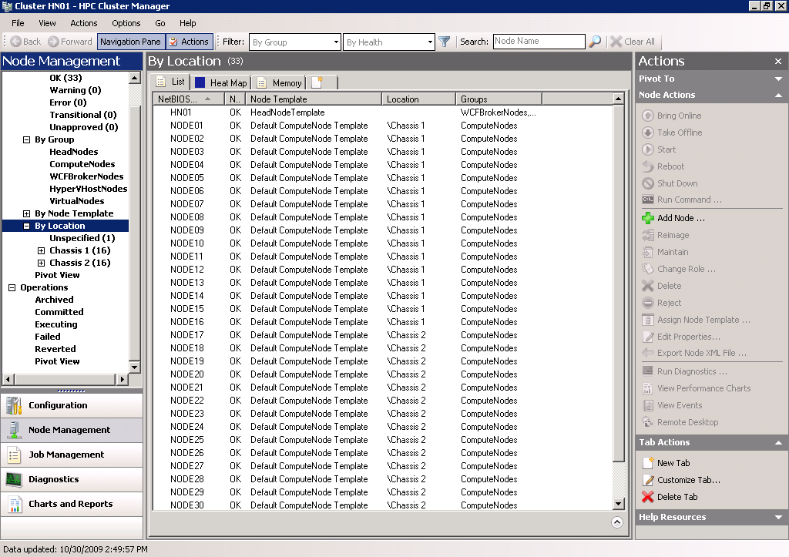Figure 6. Location-based node grouping.

## Extensible Reporting

Windows HPC Server 2008 R2 provides both built-in reports and an extensible reporting framework, which allows for the development of custom reports using tools such as SQL Server Reporting Services.

### Built-in Reports

Windows HPC Server 2008 R2 provides a set of prebuilt reports and charts to help system administrators understand system status, usage, and performance. Accessed through the Reports and Charts tab on the Administrator Console, these prebuilt reports span four main categories: node availability, job resource usage, job throughput, and job turnaround.

### Reporting Extensibility

In response to customer demand for more detailed reports, Windows HPC Server 2008 R2 collects far more data than its predecessor, including node attributes, node event history, job configurations, job task summaries, job state and statistics, and job allocation history. The data is stored in the head node database and can be exported to a separate reporting database or data warehouse for reporting. Tools such as SQL Server Reporting Services or Microsoft Office Excel can be used to create custom reports and graphs for scenarios such as daily operational analysis, charge-back reporting, cluster utilization and analysis, and capacity planning. The data is made available through predefined database views so that administrators can easily build their own reports. Node performance metric history can also be retrieved using PowerShell commands.

## Diagnostics

In the past, cluster administrators often had to write and maintain custom scripts for troubleshooting. Windows HPC Server 2008 R2 eases this pain through a set of commonly-used diagnostics tests, as well as a new extensible diagnostic framework to give system administrators a comprehensive, easy-to-use set of diagnostic tools.

### Built-in Diagnostics

Windows HPC Server 2008 R2 provides a set of prebuilt diagnostic reports to help system administrators verify that their clusters are working properly, along with a systematic way of running the tests and storing and viewing results. This significantly improves an administrator’s experience in verifying deployment, troubleshooting failures, and detecting performance degradation. Cluster administrators can view a list of these diagnostic tests, run them, change diagnostic parameters at runtime, and view the results using the Diagnostics tab in the Administration Console or by using Windows PowerShell™ commands.

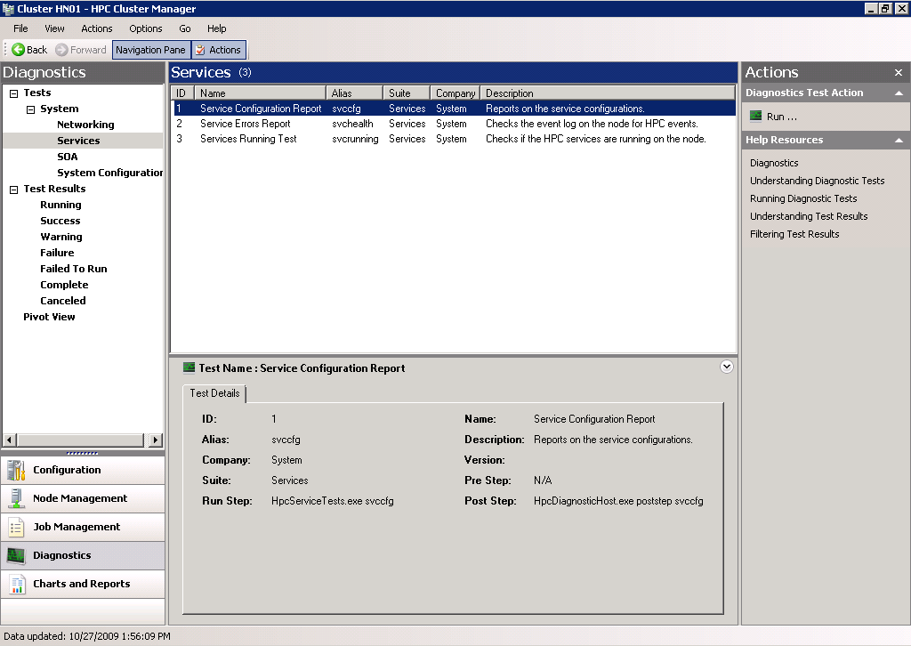Figure 7. Diagnostic Pane.

### Extensible Diagnostic Framework

New in Windows HPC Server 2008 R2, an extensible diagnostic framework enables cluster administrators, developers, and HPC industry partners to easily create custom diagnostic tests—as may be required to verify that custom and/or third-party hardware or software is working correctly. Independent hardware and software vendors can use this capability to create their own diagnostic tests, which cluster administrators can add to the list of out-of-the-box diagnostic tests in Windows HPC Server 2008 R2 and run in the same way as the built-in diagnostic tests—thereby helping to reduce support calls and increase customer satisfaction.

# Job Scheduling

The Job Scheduler queues jobs and their associated tasks, allocates resources to the jobs, initiates the tasks on the compute nodes, and monitors the status of jobs and tasks. In Windows HPC Server 2008 R2, the Job Scheduler has been enhanced to support larger clusters, more jobs, and larger jobs—including improved scheduling and task throughput at scale. It includes new policies for greater flexibility and resource utilization, and is built to address both traditional batch jobs as well as newer service-oriented applications.

With the Windows HPC Server 2008 R2 Job Scheduler, jobs are considered to be resource requests and tasks specify what to do with those resources once they are obtained. Using the graphical Administration Console or any of several other interfaces (see Interfaces below), users can easily schedule jobs, allocate resources needed for the job, and change the tasks and properties associated with the job. Jobs can be single tasks or multiple tasks, can span multiple cores or nodes, and can specify whether or not they require exclusive access to nodes.

The Job Scheduler also includes built-in support for parametric sweeps, customized policies for filtering jobs at submission and activation times, and heterogeneous clusters. The Job Scheduler is Non-Uniform Memory Architecture (NUMA)-aware and multicore-aware, allowing for the intelligent scheduling of jobs on large clusters of multicore nodes at the processor core, processor socket, and compute node levels.

## Interfaces

The Job Scheduler supports both command-line and graphical interfaces. The graphical interface is provided through the Job Scheduling tab of the Administration Console or through the HPC Job Manager, a graphical interface for use by end-users submitting and managing jobs. Other supported interfaces include:

* Command line (cmd.exe)
* Windows PowerShell 2.0
* COM and .NET application programming interfaces to support a variety of languages, including VBScript, Perl, Fortran, C/C++, C#, and Java.
* The Open Grid Forum’s HPC Basic Profile Web Services Interface, which supports job submission and monitoring from many platforms and languages.

The Windows HPC Server 2008 R2 interfaces are fully backwards compatible, allowing job submission and management from Microsoft Compute Cluster Server and Windows HPC Server 2008 interfaces.

Windows HPC Server 2008 R2 also provides a new user interface for showing job progress (see Figure 8), and an enhanced API that enables developers to report more detailed job progress status to their HPC applications.

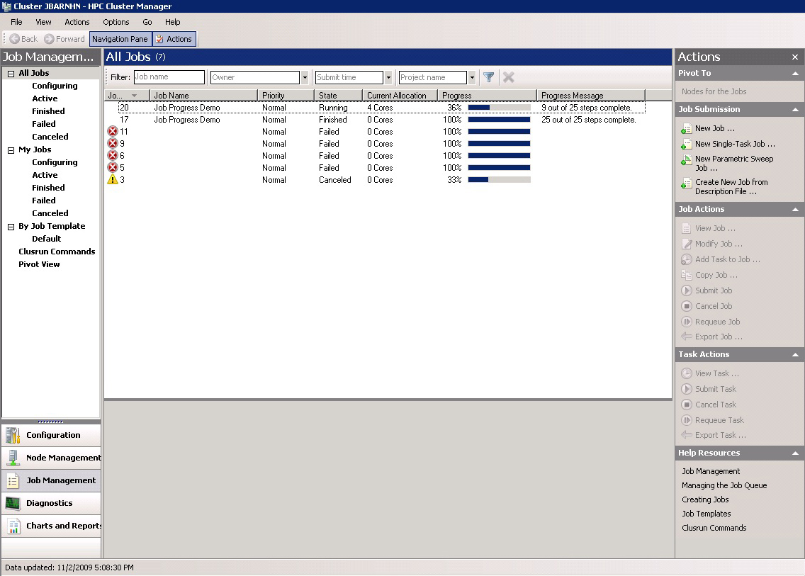Figure 8. Job progress display.

## Policies

Scheduling policies determine how resources are allocated to jobs. Windows HPC Server 2008 R2 provides the ability to switch between traditional first-come, first-serve scheduling and a new service-balanced scheduling policy designed for SOA/dynamic (grid) workloads, with support for preemption, heterogeneous matchmaking (targeting of jobs to specific types of nodes), growing and shrinking of jobs, backfill, exclusive scheduling, and task dependencies for creating workflows.

## Job Workflows

The Job Scheduler supports basic tasks, such as those that are executed from the command line, as well as parametric sweeps. Just-in-time parametric sweep expansion, a new feature in Windows HPC Server 2008 R2, improves performance for creating large parametric task sweeps by creating individual parameter sweep steps as needed rather than at submission time.

Windows HPC Server 2008 R2 also introduces prep and release tasks—tasks that are run before and after a job. Prep tasks are guaranteed to run once on each node in a job before any other tasks, as may be required to support setup or validation of node before job is run. Release tasks are guaranteed to run once on each node in a job after all other tasks, as may be required to clean up or transfer files after the job.

# SOA Runtime

With the number and size of problems being tackled on ever-larger clusters continuing to grow, organizations face increased challenges in developing HPC applications. Not only must these applications must be built quickly, but they must run efficiently and be managed in a way that optimizes application performance, reliability, and resource utilization.

One approach to meeting these challenges is a service-oriented architecture (SOA)—an approach to building distributed, loosely coupled applications in which functions are separated into distinct services that can be distributed over a network, combined, and reused. Windows HPC Server 2008 R2 provides enhanced support for SOA workloads, helping organizations more easily build interactive HPC applications, make them more resilient to failure, and more easily manage those applications—capabilities that open the door to new application scenarios in areas such as financial trading and risk management.

## When SOA Can Be Useful—and How it Works on a Cluster

HPC applications submitted to compute clusters are typically classified as either message intensive or embarrassingly parallel. While message-intensive applications comprise sequential tasks, embarrassingly parallel problems can be easily divided into large numbers of parallel tasks, with no dependency or communication between them. To solve these embarrassingly parallel problems without having to write low-level code, developers need to encapsulate core calculations as a software modules. A SOA approach to development makes this encapsulation not only possible but easy, effectively hiding the details of data serialization and distributed computing.

With Windows HPC Server 2008 R2, tasks can run interactively as SOA applications. For interactive SOA applications, in addition to a head node and one or more compute nodes, the cluster also includes one or more Windows Communication Foundation broker nodes. The broker nodes act as intermediaries between the client application and the Windows Communication Foundation hosts running on compute nodes, load-balancing the client application’s requests and returning the results to it.

## Building SOA-Based HPC Applications

One attractive aspect of SOA applications is the ability to develop them quickly, without having to write a lot of low-level code. To achieve this, developers need to be able to easily encapsulate core calculations as software modules that can be deployed and run on the cluster. These software modules identify and marshal the data required for each calculation and optimize performance by minimizing the data movement and communication overhead.

Microsoft Visual Studio provides easy-to-use Windows Communication Foundation service templates and service referencing utilities to help software developers quickly prototype, debug, and unit-test SOA applications, with Windows Communication Foundation effectively hiding the complexity of data serialization and distributed computing.

### Fire-and Recollect Programming Model

A fire-and-recollect programming model—sometimes called fire-and-forget—is a common approach to building long-running SOA applications. The SOA runtime in Windows HPC Server 2008 R2 adds support for fire-and-recollect programming, enabling developers to implement reattachable sessions by decoupling requests and responses.

### Durable Sessions

Another new feature in the Windows HPC Server 2008 R2 is the ability to implement durable sessions, where the SOA runtime persists requests and their corresponding responses on behalf of the client.

### Finalization Hooks

The SOA runtime in Windows HPC Server 2008 R2 also adds support for finalization hooks, enabling developers to add logic to perform cleanup before a service exits.

### Improved Java Interoperability

With Java sample code provided in the Windows HPC Server 2008 R2 Software Development Kit (SDK), developers can more easily write Java-based client applications that communicate with .NET services—and enjoy the same level of functionality provided with clients based on the .NET Framework and Windows Communication Foundation.

## Running SOA-Based HPC Applications

In addition to developing SOA applications quickly, organizations must be able to run those applications efficiently, securely, and reliably. The SOA runtime in Windows HPC Server 2008 R2 helps organizations meet those needs through features such as low-latency round-trips for efficiently distributing short calculation requests, end-to-end Kerberos authentication with Windows Communication Foundation transport-level security, and dynamic allocation of resources to service instances. Windows HPC Server 2008 R2 also provides several new features to help organizations more reliably run their SOA applications, including support for broker restart/failover and message persistence.

### Message Resilience

In the case of a temporary broker node failure or a catastrophic failure of the cluster, the SOA broker nodes will persist calculation requests and results. The session can continue without lost requests or results after the cluster recovers and the broker nodes are restarted.

### High-Availability Broker Nodes (Broker Restart/Failover)

Furthermore, the SOA runtime in Windows HPC Server 2008 R2 adds support for automated broker failover, enabling organizations to preserve computation results in the event of a failure—an essential requirement for nonstop processing of mission-critical applications. Configured using Microsoft Message Queuing (MSMQ) on remote storage and failover broker nodes, the cluster will migrate active sessions on failed broker nodes to healthy ones, thereby enabling nonstop processing.

## Managing SOA-Based HPC Applications

Organizations running SOA applications on a cluster need to be able to manage and monitor those applications in one place—in a way that maximizes application performance, reliability, and resource usage. Windows HPC Server 2008 R2 provides comprehensive tools for managing SOA applications through service resource usage reports and runtime monitoring of performance counters, including the number and status of outstanding resource calls and the resources used by those services.

Windows HPC Server 2008 R2 also includes new capabilities designed to facilitate system management for SOA applications, including: easier setup and configuration; simpler monitoring; new diagnostic tests for common problems; and correlated tracing.

### Easier Setup and Configuration

Windows HPC Server 2008 R2 provides several new features that aid in setup and configuration, including:

* Out-of-the-box setup of the cluster head node as a broker node.
* Support for broker nodes in Node Templates.
* Service configuration in a single place using the Administrator Console.

### Enhanced Monitoring

Monitoring-related enhancements provided by Windows HPC Server 2008 R2 include:

* The ability to monitor a session as a single job rather than managing separate broker and service jobs—including through the command line interface.
* A job manager progress bar, which eliminates the need to track counters to view session progress.
* A Session page in the job dialog, showing session progress in detail.
* More counters for monitoring broker node performance.
* Easily enabling full capture of service host output.

### Improved Diagnostics

Windows HPC Server 2008 R2 provides new diagnostic capabilities for SOA applications, helping administrators more easily detect issues and determine whether they are environmental or application related—and helping developers more easily diagnose application issues. Those capabilities include:

* Enhanced environmental tests, including out-of-the-box support for diagnosing common environmental issues.
* The ability to implement custom diagnostic tests using the new diagnostic framework (previously described under System Management).

### Correlated Tracing

Tracing-related improvements in Windows HPC Server 2008 R2 include:

* Configuration of tracing through new context menu options, including the ability to configure trace levels—thereby eliminating the need to manually edit Windows Communication Foundation configuration files.
* Log records which are designed to be easily correlated using the Service Trace Viewer.

# Networking and MPI

A message-passing interface (MPI) is the application interface between the nodes of an HPC cluster, providing a portable and powerful mechanism for interprocess communication among hundreds or thousands of processors working in parallel.

## Microsoft Message Passing Interface (MS-MPI)

Windows HPC Server 2008 R2 uses the Microsoft Message Passing Interface (MS-MPI), a portable, flexible, interconnect-independent API for messaging within and between HPC nodes. MS-MPI is based on the Argonne National Laboratory open-source MPICH2 implementation, and is compatible with the MPI2 standard.

MS-MPI can run over Gigabit Ethernet, 10 Gigabit Ethernet, and high-performance networking hardware such as InfiniBand, iWARP Ethernet, and Myrinet—or any other type of interconnect that provides a Winsock Direct, NetworkDirect, or TCP/IP interface. MS-MPI includes application support (bindings) for the C, Fortran77, and Fortran90 programming languages. With Windows HPC Server 2008 R2, organizations also can take advantage of new interconnect options, such as support for RDMA over Ethernet (iWARP) from Intel and new RDMA over Infiniband quad data rate (40 Gbps) hardware.

MS-MPI is optimized for shared memory communication to benefit the multicore systems prevalent in today’s HPC clusters. MS-MPI in Windows HPC Server 2008 R2 introduces optimization of shared memory implementations for new Intel “Nehalem”-based processors, with internal testing by Microsoft showing up to a 20 to 30 percent performance improvement on typical commercial HPC applications.

For more detailed information on MS-MPI see [*Using Microsoft Message Passing Interface*](http://go.microsoft.com/fwlink/?LinkId=55930) (on the Microsoft TechNet Web site at <http://go.microsoft.com/fwlink/?LinkId=55930>).

## NetworkDirect

MS-MPI can take advantage of NetworkDirect—a remote direct memory access (RDMA)-based interface—for superior networking performance and CPU efficiency. As shown in Figure 9 (next page), NetworkDirect uses a more direct path from MPI applications to networking hardware, resulting in very fast and efficient networking. Speeds and latencies are similar to those of custom, hardware-native interfaces from hardware providers.

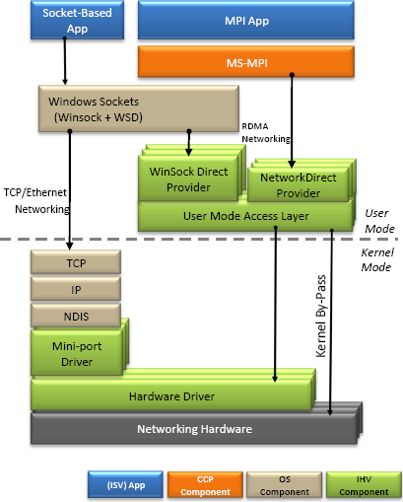Figure 9. NetworkDirect architecture.

## Easier Troubleshooting of MPI Applications

MS-MPI integrates with Event Tracing for Windows to facilitate performance-tuning, providing a time-synchronized log for debugging MPI system and application events across multiple computers running in parallel. In addition, Microsoft Visual Studio® 2008 includes a MPI Cluster Debugger that works with MS-MPI. Developers can launch their MPI applications on multiple compute nodes from within the Visual Studio environment, and Visual Studio will automatically connect the processes on each node, enabling developer individually pause and examine program variables on each node.

Improvements in the upcoming Visual Studio 2010 release will further help developers build parallel programs that efficiently take advantage of HPC clusters—especially when using Microsoft’s latest Visual Studio 2010 programming models for node-level concurrency. Key enhancements include:

* **F5 Experience for MPI Cluster Debugger.** Applications built using MS-MPI can be deployed and debugged on the cluster via the usual F5 keystroke in Visual Studio, without having to do any prep work on the cluster nodes. Using a simple interface in the Project Properties page and a rich Node Selector dialog, developers can pick the deployment configuration they prefer and debug multiple processes concurrently on multiple nodes, just like when debugging a single process on a client machine. When done debugging, cleanup on the cluster’s compute nodes is also done automatically for the developer without them having to manually connect to each node to perform such tasks. A video showing the MPI Cluster Debugger in action can be found at <http://channel9.msdn.com/posts/DanielMoth/VS2010-MPI-Cluster-Debugger-launch-integration/>
* **Hybrid parallel applications that take advantage of node-level concurrency.** Applications that use the Parallel Patterns Library (PPL) built on top of the Concurrency Runtime can benefit from increased debugging support for the task-based programming model through two new windows, which support both managed and native task models as well as traditional threading programming models:
* **Parallel Tasks,** which shows a list of all tasks and their properties (such as thread assignment and status, including deadlock detection). A video showing the Parallel Tasks window in action can be found at <http://channel9.msdn.com/posts/DanielMoth/Parallel-Tasks--new-Visual-Studio-2010-debugger-window/>
* **Parallel Stacks,** which shows multiple call stacks in a single view, coalescing the call stack segments that are common across threads—including the ability to switch to any stack frame with a single click. A video showing the Parallel Stacks window in action can be found at <http://channel9.msdn.com/posts/DanielMoth/Parallel-Stacks--new-Visual-Studio-2010-debugger-window/>

## Tuning Wizard for LINPACK (“Lizard”)

A new feature for Windows HPC Server 2008 R2, the Tuning Wizard for LINPACK (“Lizard”) is a pushbutton, standalone executable that enables administrators to easily measure computational performance and efficiency for an HPC cluster. Furthermore, because it heavily loads the cluster, the Lizard can be a valuable tool for break-in and detecting issues related to configuration and deployment, networking, power, cooling, and so on.

The Lizard calculates the performance and efficiency of an HPC cluster by automatically running the LINPACK Benchmark several times, analyzing the results of each run and automatically adjusting the parameters used for the subsequent LINPACK run. Eventually, the Lizard determines the parameters that provide optimal LINPACK performance, which is measured in terms of billions of floating-point operations per second (GFLOPS) and percentage efficiency that was achieved at peak performance. After running the Lizard, administrators can review the LINPACK results and save both the results and the parameters that were used to achieve them to a file.

Administrators can run the Lizard either in express tuning mode or in advanced tuning mode. In express tuning mode, the Lizard starts the tuning process immediately, using default values for LINPACK parameters. In advanced tuning mode, administrators can provide specific values to use when the tuning process starts, and can also configure how the tuning process is run.

The Lizard can be downloaded at:

<http://www.microsoft.com/downloads/details.aspx?displaylang=en&FamilyID=3313856b-02bc-4bdd-b8b6-541f5309f2ce>

*Note: The Lizard does not tune the performance of the cluster itself—it only optimizes the parameters that determine LINPACK results on the cluster.*

# Microsoft Office Excel Support

Microsoft Office Excel is a critical business application across a broad range of industries. With its wealth of statistical analysis functions, support for constructing complex analyses, and virtually unlimited extensibility, Excel is clearly a tool of choice for analyzing business data. However, as calculations and modeling performed in Excel become more and more complex, Excel workbooks can take longer and longer to calculate, thereby reducing the business value provided.

For example, insurance companies must calculate reserve requirements on an ongoing basis—a task that is often performed using Excel, which provides an excellent framework for constructing complex policy analyses, managing data, and creating reports. However, as the number of policies increases and new jurisdictional and regulatory factors are incorporate into calculations, the time to perform those calculations grows. It’s not uncommon for complex reserve requirements calculations involving tens or hundreds of thousands of individual policies to take days or weeks to complete. Companies that perform financial portfolio modeling using Excel face similar challenges.

Windows HPC Server 2008 R2 enables organizations to take advantage of HPC clusters to reduce calculation times for Excel workbooks by one or more orders of magnitude, scaling close to linearly as nodes or cores are added. Faster calculation times give business users and decision makers more information in less time, enabling more thorough analysis, faster access to important information, and better informed decisions. In addition, running Excel workbooks on an HPC cluster provides unique benefits in terms of reliability, resource utilization, and accounting and auditing support.

## Speeding-Up Excel Workbooks using an HPC Cluster

Windows HPC Server 2008 R2 supports three different approaches to calculating Excel workbooks on an HPC cluster: using Excel as a cluster SOA client, running Excel user defined functions (UDFs) on a cluster, and running Excel workbooks on a cluster. Using Excel as a cluster SOA client was possible with earlier versions of Windows HPC Server. Running Excel UDFs and Excel workbooks on a cluster are new capabilities, both of which require a combination of Windows HPC Server 2008 R2 and Office Excel 2010.

### Using Excel as a Cluster SOA Client

Visual Studio Tools for Office provides a programming environment that is integrated with Excel and other Office products. Using Visual Studio Tools for Office, developers can write custom code to run Excel calculations on an HPC cluster utilizing SOA calls. Visual Studio Tools for Office supports the client libraries for Windows HPC Server 2008 R2, enabling the integration of Excel with any service or application that runs on the cluster.

### Running Excel User Defined Functions on an HPC Cluster

User-defined functions (UDFs) are a well-established mechanism for extending Excel, enabling functions that are contained in Excel extension libraries (XLLs) to be called from spreadsheet cells like any standard Excel function. Excel 2010 extends this model to the HPC cluster by enabling UDFs to be calculated on an HPC cluster by one or more compute nodes. If a long-running workbook includes multiple independent calls to defined functions and these functions contribute to the overall processing time, then moving those calculations to the cluster can result in significant overall performance improvement. As far as users are concerned, there is no difference between a desktop function and a function running on the cluster—except for better performance.

### Running Excel Workbooks on an HPC Cluster

Many complex, long-running workbooks run iteratively—that is, they perform a single calculation over and over, using different sets of input data. Such workbooks might include complex mathematical calculations contained in multiple worksheets, or they might contain complex VBA applications. When a workbook runs iteratively, the best option for parallelizing the calculation can be to run the entire workbook on the cluster.

Windows HPC Server 2008 R2 supports running Office Excel 2010 instances on the compute nodes of an HPC cluster, so that multiple long-running and iterative workbooks can be calculated in parallel to achieve better performance. Many workbooks that run on the desktop can run on the cluster—including workbooks that use Visual Basic for Applications, macros, and third-party add-ins. Support for running Excel workbooks on a cluster also includes features designed to run workbooks without user interaction, providing a robust platform for calculating Excel models without requiring constant oversight.

Although this approach can be used to calculate many workbooks on a cluster, some development is required. When workbooks run on the desktop, calculation results are inserted into spreadsheet cells. Because running Excel workbooks on a cluster uses Excel processes running on cluster nodes, the user or developer must define what data is to be calculated and how to retrieve the results. A macro framework is provided that can handle much of this work, and developers can customize the framework or write their own code to manage calculations and results, providing for virtually unlimited flexibility.

*Note: Running Excel workbooks on a cluster is limited in functionality with Windows HPC Server 2008 R2 Beta 1, supporting only workbooks with simple VBA, macros, and cell dependencies. For example, the Beta 1 macro framework only supports a Calculate macro, not macros for management of data collection and results-handling.*

## Additional Benefits of Running Excel Calculations on a Cluster

In addition to faster calculation speeds, running Excel calculations on an HPC cluster can provide several additional benefits, including:

* **Reliability.** A complex Excel workbook that calculates in hours or days on a desktop PC is vulnerable to accidents, power outages, and hardware failures. On an HPC cluster, if an individual compute node fails, depending on calculation scope, calculations can be run on the remaining nodes—meaning that they will complete even in the event of hardware failure or other failure. *(Note: Excel support is dependent on the SOA runtime and associated features in Windows HPC Server 2008 R2, with the same limitations with respect to failover and nonstop processing.)*
* **Shared Resources.** With an HPC cluster installed on an organization’s network, all authorized users in the organization can take advantage of the cluster. A single cluster can support multiple users and Excel applications while providing a central point for resource management.
* **Scalability.** Compute nodes can be added to an HPC cluster at any time to increase available computing power. As users, calculations, and utilization increases, the cluster can be scaled as needed to meet the needs of an organization.
* **Accounting and Auditing.** Windows HPC Server 2008 R2 provides comprehensive reporting, accounting, and auditing tools, enabling organizations to obtain visibility into which calculation models are being run and insight into the performance of specific applications.

# Security

Because HPC clusters are being adopted by a broad range of mainstream companies for mission-critical applications, security and integration with existing infrastructure is important. Windows HPC Server 2008 R2 helps meet these needs by using Active Directory to support system administration and running jobs.

Through support for Active Directory, Windows HPC Server 2008 R2 enables systems administrators to apply and audit security policies using existing, familiar Active Directory mechanisms—and enables compute jobs to access network resources such as file or database servers in the security context of the user. The scheduler runs each job under the context and credentials of the submitting user, not as a super user or administrator, with user credentials encrypted and stored with the job only until its completion. Job management-related communications take place over encrypted and authenticated channels, with the user’s credentials known only to the scheduler and the node manager process on the compute nodes—not to processes or applications started on the user’s behalf—to further isolate credentials and protect their integrity. This additional level of security integration with Active Directory is a unique benefit provided by MS-MPI when compared with the reference MPICH2 implementation.

Integrated patch management built into Windows HPC Server 2008 R2 is another key security-related (and stability-related) feature, in that it allows cluster administrators to schedule and deploy updates to groups of nodes with assurance that patch deployment won’t interfere with running jobs. Windows HPC Server 2008 R2 also supports the use of existing enterprise patch deployment tools.

Windows HPC Server 2008 R2 also inherits security features that are a part of Windows Server 2008 R2, such as Network Access Protection, Role Management, Network Policy Management, and an integrated, bidirectional Windows Firewall for enterprise-facing networks.

# Conclusion

For organizations seeking to take advantage of high performance computing, Windows HPC Server 2008 R2 efficiently scales to thousands of nodes and integrates seamlessly with Windows-based IT infrastructures, providing an unmatched combination of ease-of-use, low ownership costs, and performance. New capabilities provided in the latest version of the product can help companies across mainstream industries to more easily take advantage of parallel computing, making it easier than ever to build, run, and manage both traditional HPC workloads and new interactive SOA applications.

## Additional Resources

For more information about Microsoft Windows HPC Server 2008 R2, visit the following Web sites:

* <http://www.microsoft.com/hpc>
* <http://windowshpc.net>

For more information about Microsoft System Center, Windows Server 2008 R2, and other Microsoft server products and tools, visit the following Web sites:

* <http://www.microsoft.com/windowsserver2008>
* <http://www.microsoft.com/systemcenter>
* <http://www.microsoft.com/servers>