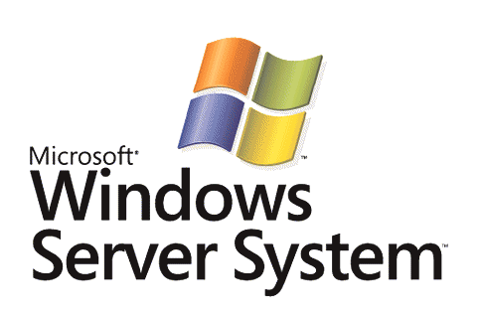

Quality of Service in Windows Server "Longhorn" and Windows Vista

Microsoft Corporation
Published: February 2006

Abstract

Quality of Service (QoS) in the Microsoft® Windows Server™ "Longhorn" (now in beta testing) and Windows Vista™ (now in beta testing) operating systems helps alleviate network congestion issues while optimizing traffic to the available bandwidth by providing centralized management of traffic sent by network hosts. By using QoS in a Windows Server "Longhorn" and Windows Vista environment, an IT department can define flexible policies deployed through Active Directory® directory service Group Policy objects to prioritize or throttle outbound network traffic without requiring modifications to existing applications. QoS policies apply to outbound traffic based on any or all of the following conditions: sending application, source or destination IP address, protocol, and source or destination port. This paper is intended for IT planners and analysts who are evaluating Windows Server "Longhorn" and Windows Vista, enterprise IT architects who focus on Active Directory and Group Policies, and network architects responsible for network performance and cost control.

This is a preliminary document and may be changed substantially prior to final commercial release of the software described herein.
The information contained in this document represents the current view of Microsoft Corporation on the issues discussed as of the date of publication. Because Microsoft must respond to changing market conditions, it should not be interpreted to be a commitment on the part of Microsoft, and Microsoft cannot guarantee the accuracy of any information presented after the date of publication.
This White Paper is for informational purposes only. MICROSOFT MAKES NO WARRANTIES, EXPRESS, IMPLIED OR STATUTORY, AS TO THE INFORMATION IN THIS DOCUMENT.
Complying with all applicable copyright laws is the responsibility of the user. Without limiting the rights under copyright, no part of this document may be reproduced, stored in or introduced into a retrieval system, or transmitted in any form or by any means (electronic, mechanical, photocopying, recording, or otherwise), or for any purpose, without the express written permission of Microsoft Corporation.
Microsoft may have patents, patent applications, trademarks, copyrights, or other intellectual property rights covering subject matter in this document. Except as expressly provided in any written license agreement from Microsoft, the furnishing of this document does not give you any license to these patents, trademarks, copyrights, or other intellectual property.
Unless otherwise noted, the example companies, organizations, products, domain names, e-mail addresses, logos, people, places, and events depicted herein are fictitious, and no association with any real company, organization, product, domain name, email address, logo, person, place, or event is intended or should be inferred.
© 2006 Microsoft Corporation. All rights reserved.
Microsoft, Active Directory, Windows, Windows Server, and Windows Vista are either registered trademarks or trademarks of Microsoft Corporation in the United States and/or other countries.
All other trademarks are property of their respective owners.
Contents
IT Challenges with Network Performance 1
QoS in Windows Server "Longhorn" and Windows Vista 2
QoS Example Scenario 3
Prioritization of a LOB Application 3
Configuring QoS Policy 6
Launching the QoS Policy Wizard 6
The QoS Policy Wizard 7
Editing a QoS Policy 9
Configuration Requirements and Early Deployments 11
Summary 13
Related Links 14

IT Challenges with Network Performance
IT departments must balance network performance against costs. As business applications and data access become more distributed, employee productivity is more affected by network performance. The challenge for IT departments is to provide predictable service levels in a cost-effective manner. As with other valued and limited resources, the vision for the network is to provide differentiated, prioritized levels of service, such that important network traffic gets serviced. For IT, the result should be the ability to offer differentiated network service levels based on the application’s specific need and priority to the business.
Today, most enterprise networks have little, if any, traffic prioritization in place. Most network traffic is delivered on a "best effort" basis with traffic for line of business (LOB), real-time, and all other applications competing on an equal basis for network bandwidth. At the same time, users and applications with specific network performance requirements may require preferential service levels.
IT managers are aware of these emerging issues. A recent Forrester study found that 87% of IT managers identify end-to-end performance as one of the top three challenges they face and 25% identify WAN performance as one of their top three challenges.
In Windows XP, Windows Server 2003, and Windows 2000, QoS functionality was made available through the Generic QoS (GQoS) application programming interface (API). Applications have to be written or modified to use the GQoS API to prioritize their traffic. With Windows Server "Longhorn" and Windows Vista, IT departments can prioritize traffic and manage sending rates for any networking application.

QoS in Windows Server "Longhorn" and Windows Vista
QoS in Windows Server "Longhorn" and Windows Vista allows an IT department that wants to manage traffic to offer better end-user experiences, control bandwidth costs, or negotiate finer service levels with bandwidth providers or business departments. IT departments will be able to centrally manage network bandwidth sent by computers running Windows Server "Longhorn" or Windows Vista, regardless of the application and across an entire Active Directory infrastructure. Because the traffic management is occurring at the network layer, applications do not need to be written or modified to use GQoS APIs, allowing traffic management for existing applications.
QoS in Windows Server "Longhorn" and Windows Vista allows IT departments to prioritize or manage the sending rate for outgoing network traffic based on the following conditions:
- Sending application
- Source or destination Internet Protocol version 4 (IPv4) or Internet Protocol version 6 (IPv6) addresses
- Protocol (Transmission Control Protocol [TCP], User Datagram Protocol [UDP], or both)
- Source or destination ports (TCP or UDP)
QoS policies are applied to a user or computer account as part of a Group Policy object (GPO) that is linked to an Active Directory container such as a domain, site, or organizational unit (OU). As part of Group Policy, QoS policies in Windows Server “Longhorn” and Windows Vista leverages your existing Active Directory management infrastructure.
To define the priority of traffic, you can configure a QoS policy to mark outbound network traffic with a specific Differentiated Services Code Point (DSCP) value, as defined in RFC 2474. This DSCP value allows classification at the Internet Protocol (IP) level, which routers can use to decide what queue in which to place the packet and what traffic shaping behavior should be applied. The IT department may determine that for specific DSCP values, routers place packets into a high-priority, best effort, or lower than best effort queue. Therefore, mission-critical network traffic gets preference and is not delayed by other lower-priority traffic.
To manage the use of bandwidth, you can configure a QoS policy with a throttle rate for outbound traffic. With throttling, a QoS policy will limit the aggregate outgoing network traffic to a specified rate. Both DSCP marking and throttling can be used together to manage traffic effectively.
For example, to give higher priority to time-dependent Voice over IP (VoIP) traffic, a QoS policy can specify the DSCP value of 46 for the VoIP application, allowing routers to place those packets in a low-latency queue. As another example, to prevent a set of Web servers from monopolizing network bandwidth for HyperText Transfer Protocol over Secure Sockets Layer (SSL) traffic, a QoS policy in a GPO that is linked to the Web server's OU can specify a throttle rate of 512 kilobytes per second (KBps) for TCP port 443 traffic.

QoS Example Scenario
After QoS policies are deployed, users and IT departments will see important benefits. The following are some examples of traffic that can be managed with QoS in Windows Server "Longhorn" and Windows Vista:
- Latency sensitive traffic
VoIP and video streaming software can be successfully deployed. Voice and video can be marked with DSCP values to ensure sufficient service levels without having to overprovision your network (install more bandwidth than is needed).
- WAN link traffic
Different types of traffic over WAN links can be given a higher priority. For example, because the traffic for an enterprise resource planning (ERP) application for branch offices is given a high priority over the WAN link, a branch office sales manager accessing and entering ERP data can benefit from a consistently fast response time, even when the WAN link is loaded with other traffic.
- Bulk data transfer traffic
With traffic throttling, bulk data transfers do not use all the available bandwidth and you not need to delay bulk data transfers to avoid daytime hours.
- Critical use traffic
You can mark traffic corresponding to critical uses for prioritized delivery. For example, you can specify that traffic between the customer response team and the customer LOB servers are marked with high priority, which can help reduce call times with customers.
As these examples illustrate, even for relatively simple QoS policies, QoS can provide significant benefits or address IT traffic management issues. As traffic management requirements become more complex, managing QoS centrally and flexibly through Group Policy becomes more important.

Prioritization of a LOB Application
This section describes how an IT department can implement QoS prioritization with Windows Server "Longhorn" and Windows Vista. The example is a mission-critical ERP application, but the methods described can be applied to other types of applications.
In this scenario, an IT department needs to provide preferential network performance for an important set of users and their mission-critical applications and to minimize WAN link costs. The IT department is using DSCP values to classify network traffic and has configured the routers with the DSCP values to provide prioritized delivery of DSCP-marked traffic.
The company-wide ERP application is hosted on several servers running Windows Server "Longhorn" in the data center, which are members of an Active Directory OU. The client-side component for the ERP application is installed on desktop computers running Windows Vista. The server hosting the LOB application sends data to and receives data from the desktop client computers. Although many groups of users within the company access the ERP application, the Finance group requires prioritized delivery of traffic because they depend on the ERP application when interacting with customers over the phone.
The IT department creates a QoS policy named Server LOB that specifies a medium-priority DSCP value of 26 for any application, any source or destination IPv4 or IPv6 address, and any protocol. The Server LOB policy is applied only to the LOB servers by linking the GPO containing the Server LOB policy to the OU containing only the LOB servers. This QoS policy may later be edited to include the ERP server application's port numbers, which will only set the DSCP to 26 for the ERP application's traffic. However, the initial Server LOB policy sets the medium-priority DSCP value whenever a computer to which this policy applies sends network traffic.
To ensure that the Finance group can support customers in real time, a separate QoS policy needs to classify these users' traffic with a high priority. However, the policy should apply only when members of the Finance group use the ERP application. Therefore, the IT department defines a QoS policy named Client LOB that will set the DSCP to 34 for the traffic that is sent by the ERP application's client-side executable, Erpclient.exe. A GPO is created containing the Client LOB policy and linked to the Finance group's OU.
A separate backup application is running on all desktops. To ensure the backup application traffic does not over-utilize network bandwidth, a QoS policy named Backup is created. This QoS policy specifies a DSCP value of 10 based on the executable name for this backup application, Backup.exe. A GPO is created containing the Backup policy and linked to all the desktop computers in the domain. As a result, when the backup application sends data, the backup traffic is marked with the low-priority DSCP value—including backup data from the Finance users' desktops.
Note that traffic not defined within a QoS policy has a DSCP value of 0. The IT department configures the routers to place traffic with a DSCP value of 0 in a best effort queue.
Table 1 summarizes the QoS policies for this example.
Policy name | DSCP value | Throttle rate | OUs to which the policy is applied | Description
Default [no policy] | 0 | None | [None] | Best effort (default) treatment for unclassified traffic.
Backup | 10 | None | All desktop computers | Marks bulk backup data with a low-priority DSCP value.
Server LOB | 26 | None | OU for ERP server computers | Marks ERP server traffic with a medium-priority DSCP value.
Client LOB | 34 | None | OU for Finance client computers | Marks ERP client traffic from Finance department client computers with a high-priority DSCP value.
Table 1 QoS policies for this scenario

Figure 1 shows the configuration for this scenario.
Figure 1 A prioritization scenario for a LOB application
With QoS policies defined and deployed through Group Policy, outbound network traffic gets the policy-specified DSCP value. Routers perform preferential treatment based on these DSCP values by placing the traffic in different queues. The routers are configured with four queues: high priority (DSCP value of 34), medium priority (DSCP value of 26), best effort (DSCP value of 0), and low priority (DSCP value of 10). When traffic arrives at the router, it is placed in the queue corresponding to its DSCP value.

Configuring QoS Policy
After the QoS strategy has been determined, configuring QoS policies in your Active Directory infrastructure with Windows Server "Longhorn" is easy and consists of creating QoS policies within GPOs and linking the GPOs to the appropriate Active Directory container. QoS policies apply to both User Configuration and Computer Configuration Group Policy settings.
If there are multiple QoS policies, the most specific QoS policy is applied. For example, if there is a policy that specifies a host IPv4 address (192.168.4.12) and another that specifies an IPv4 address prefix (192.168.0.0/16), the policy that specifies the host IPv4 address is applied. If both Computer Configuration and User Configuration QoS policies are defined to the same level of specificity, the User Configuration QoS policy is applied instead of the Computer Configuration QoS policy.
The following section describes how to create a QoS policy with the QoS Policy wizard in the December Community Technology Preview (CTP) or later beta versions of Windows Server "Longhorn" and Windows Vista.

Launching the QoS Policy Wizard
To create a QoS policy, edit a new or existing GPO from the Group Policy Management Console (GPMC) tool. GPMC will then open the Group Policy Object Editor shown in Figure 2. The QOS Policies node is available from either Computer Configuration\Windows Settings or User Configuration\Windows Settings in the Group Policy Object Editor.
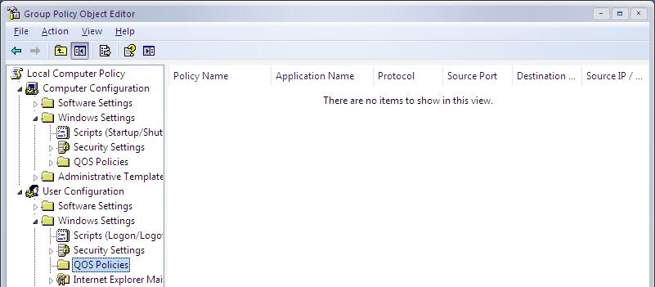
Figure 2 QOS Policies nodes in the Group Policy Object Editor
To create a new QoS policy with the QoS Policy wizard, right-click either QOS Policies node, and then click Create a new policy. A QoS policy in Computer Configuration\Windows Settings\QOS Policies applies to computers, regardless of the user that is currently logged on. You typically use computer-based QoS policies for server computers. A new QoS policy in User Configuration\Windows Settings\QOS Policies applies to users after they have logged on, regardless of which computer they have logged onto.

The QoS Policy Wizard
The first page of the QoS Policy wizard allows you to specify a policy name and configure the treatment of outgoing traffic. The subsequent QoS Policy wizard pages allow you to configure the conditions under which this treatment should be applied. Figure 3 shows an example of the first page of the QoS Policy wizard.
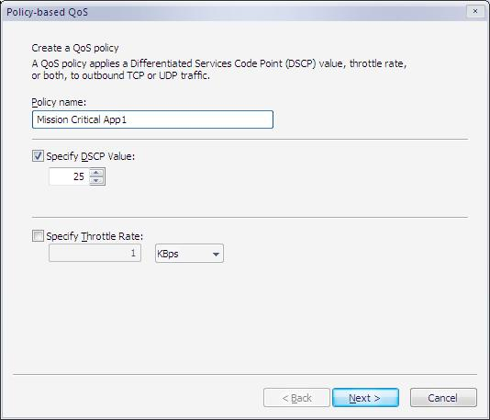
Figure 3 An example of the first page of the QoS Policy wizard.
On the first page, do the following:
- Type the QoS policy name, which must be unique to the QOS Policies node in which the policy is being created.
- Optionally enable DSCP marking and configure the DSCP value. The DSCP value must be between 0 and 63.
- Optionally enable traffic throttling and configure the throttle rate. The throttle rate value must be greater than 1 and you can specify units of kilobytes per second (KBps) or megabytes per second (MBps).
Figure 4 shows an example of the second page of the QoS Policy wizard.

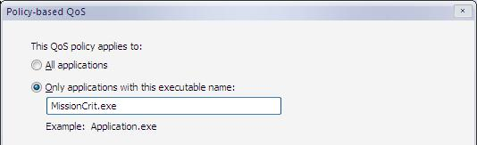
Figure 4 An example of the second page of the QoS Policy wizard
The second page of the wizard allows you to specify whether the policy is for all applications or a specific application as identified by its executable name. When you click All applications, the traffic management settings specified on the first page of the QoS Policy wizard are for all applications. When you click Only applications with this executable name, the traffic management settings specified on the first page of the QoS Policy wizard are for a specific application. You must type the executable file name and the executable name must end with an “.exe”.
Figure 5 shows an example of the third page of the QoS Policy wizard.
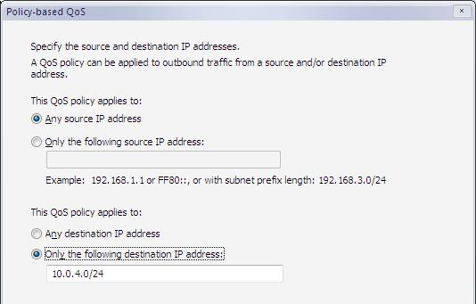
Figure 5 An example of the third page of the QoS Policy wizard
The third page of the QoS Policy Wizard allows you to specify that the traffic management settings specified on the first page of the QoS Policy wizard are for the following:
- All source IPv4 or IPv6 addresses or specific source IPv4 or IPv6 addresses
- All destination IPv4 or IPv6 addresses or specific destination IPv4 or IPv6 addresses.
If you select Only for the following source IP address or Only for the following destination IP address, you must type one of the following:
- An IPv4 address, such as 192.168.1.1
- An IPv4 address prefix using network prefix length notation, such as 192.168.1.0/24
- An IPv6 address, such as 3FFE:FFFF::1
- An IPv6 address prefix, such as 3FFE:FFFF::/48
If you click both Only for the following source IP address and Only for the following destination IP address, both addresses or address prefixes must be either IPv4 or IPv6-based.
Figure 6 shows an example of the fourth page of the QoS Policy wizard.
Figure 6 An example of the fourth page of the QoS Policy wizard
The fourth page of the QoS Policy wizard allows you to specify that the traffic management settings specified on the first page of the QoS Policy wizard are for the following:
- TCP traffic, UDP traffic, or both
- All source ports or a specific source port
- All destination ports or a specific destination port.
Specific source or destination port numbers must be in the range 0 to 65535.
To complete the creation of the new QoS policy, click Finish on the last page of the QoS Policy wizard. When completed, the new QoS policy is listed in the details pane of the Group Policy Object Editor.
To apply the QoS policy settings to users or computer, link the GPO in which the QoS policies are located to an Active Directory container, such as a domain, a site, or an OU.

Editing a QoS Policy
To edit a QoS policy, right-click on the policy name in the details pane of the Group Policy Object Editor, and then click Edit existing policy. The Group Policy Object Editor displays the Edit an existing QoS policy dialog box. Figure 7 shows an example.
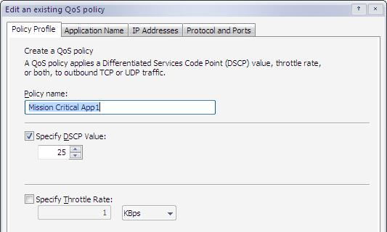
Figure 7 Example of the Edit an existing QoS policy dialog box
To delete a QoS policy, right-click on the policy name in the details pane of the Group Policy Object Editor, and then click Delete policy.

Configuration Requirements and Early Deployments
To deploy QoS policies, you must have the following:
- An Active Directory domain controller running Windows Server "Longhorn," Windows Server 2003, or Windows 2000 Server.
- A computer running either Windows Server "Longhorn" or Windows Vista to configure QoS policies (with the Group Policy Object Editor) and link them to Active Directory containers (with the Group Policy Management Console).
After QoS policies are configured and GPOs are linked to Active Directory containers, computers running Windows Server "Longhorn" or Windows Vista automatically download the GPOs and apply the QoS policy settings for outgoing traffic.
Figure 8 shows an example of QoS policy deployment.
Figure 8 An example of QoS policy deployment
Although a complete analysis of the use of different routing queues is beyond the scope of this paper, the following traffic classes with different DSCP values might facilitate further discussion within your organization:
- Real-time and latency-sensitive traffic (VoIP and video conferencing)
- Administration and control traffic (traffic between domain controllers)
- Mission critical business applications (customer database access traffic)
- Best effort traffic (DSCP 0) (all other traffic)
- Bulk data transfers (file backup traffic) (you may decide to group this traffic with the best effort traffic)
The number of traffic classes and DSCP values may not equal the number of network router queues. For example, your organization may choose to have different classes for administration and control traffic and mission critical business application traffic but have both classes of traffic use the same router queue. Different DSCP values would allow you to analyze different classes of traffic without configuring queues, either for reporting purposes or for future planning of routing queues.
Once your traffic has been classified, you can begin configuring QoS policies and deploying them to server and desktop computers through GPOs.
The following is a checklist for deploying QoS policies in a test lab using the December CTP or later beta versions of Windows Server "Longhorn" and Windows Vista:
- Create a test lab with a domain that reflects your production domain.
- Configure a set of QoS policies and assign them to Active Directory containers in the test lab domain. For testing purposes, configure different QoS policies to throttle some traffic and mark other traffic with a DSCP value.
- Verify throttling behavior. Verify DSCP marking by using a packet sniffer program such as Microsoft Network Monitor.
- View how the QoS policies are deployed through GPOs with the GPMC.
- Configure and enable test lab router queues for DSCP-marked traffic.
- Test the effects of queued traffic. You can measure queued traffic behavior with router tools. Redesign queues and QoS policies as needed.

Summary
QoS policies in Windows Server "Longhorn" and Windows Vista allow IT staff to either prioritize or manage the sending rate for outgoing network traffic and can be confined to specific applications, specific source and destination IPv4 or IPv6 addresses, and source and destination TCP or UDP ports. For prioritized traffic, the routers in the network infrastructure can place DSCP-marked packets in different queues for differentiated delivery. Because the throttling and priority marking is taking place at the network layer, applications do not need to directly support QoS capabilities. QoS policy settings are part of User Configuration or Computer Configuration Group Policy and are configured with the Group Policy Object Editor and linked to Active Directory containers with the Group Policy Management Console.

Related Links
See the following resources for further information:
- Windows Server 2003 Group Policy Technology Center at http://www.microsoft.com/grouppolicy
- Enterprise Management with the Group Policy Management Console at http://go.microsoft.com/fwlink/?LinkID=8630
- Windows Vista Web site at http://www.microsoft.com/windowsvista/
- Microsoft Windows Server “Longhorn” Beta 1 Web site at http://www.microsoft.com/windowsserversystem/windowsserver/bulletins/longhorn/beta1.mspx
During the beta of Windows Server "Longhorn" and Windows Vista, you can send QoS-related questions and issues to qosinfo@microsoft.com.
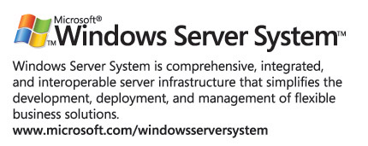
For the latest information about Windows Server System, see the Windows Server System Web site at http://www.microsoft.com/windowsserversystem.

