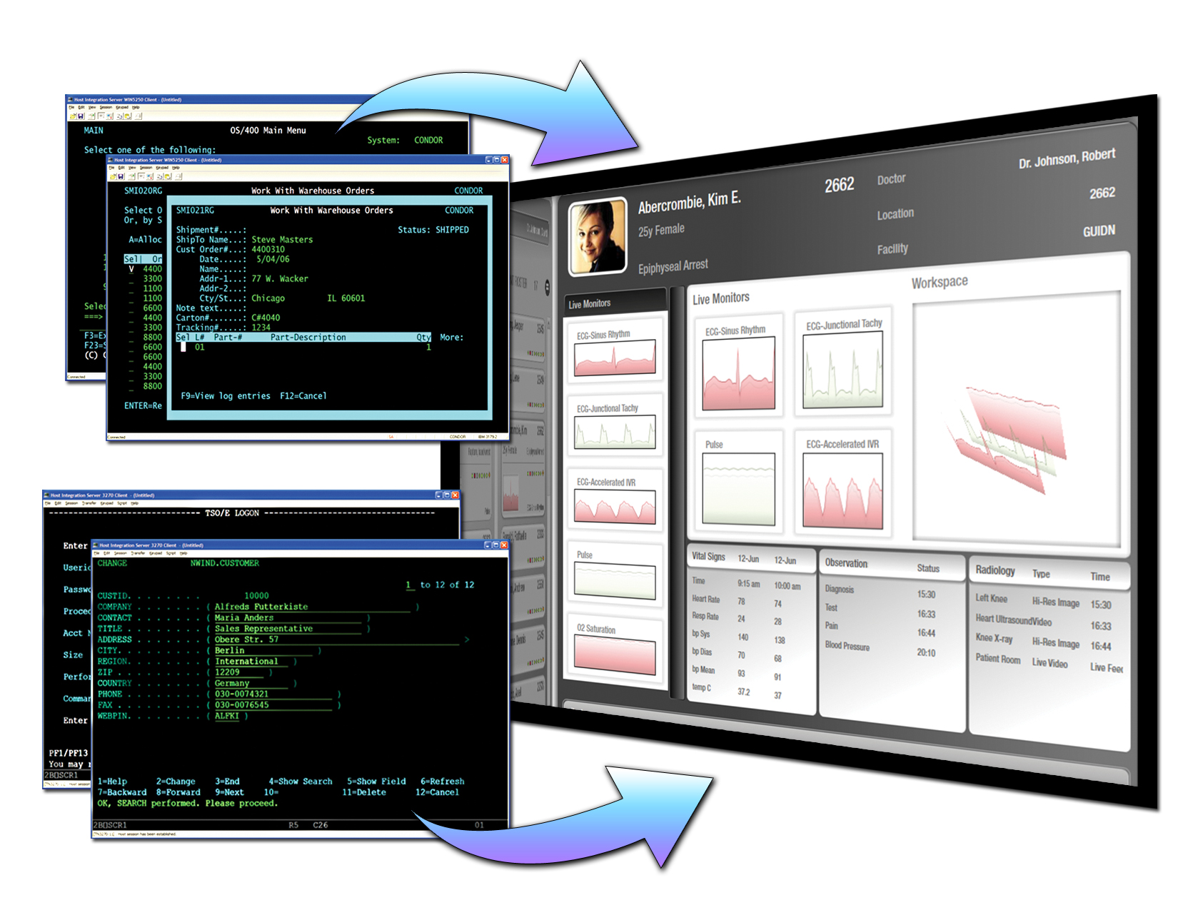

Microsoft Operations Framework for Legacy Modernization
White Paper

Published: November 2006
For the latest information, please see www.microsoft.com/mainframe

Contents
Microsoft Operations Framework for Legacy Modernization 1
Contents 2
Introduction 3
Audience 4
Team Model for Operations 4
Service Management Functions 5
Process Roadmap 6
Availability Management 6
Capacity Management 6
Change Management 7
IT Service Continuity Management 8
Job Scheduling 8
Release Management 9
Security Management 9
Service Level Management 9
Storage Management 10
System Administration 10
Microsoft Solution Matrix 11
Microsoft Solution Matrix 12
Microsoft Solution Matrix (Cont.) 13
Summary 13
Appendix A: Additional Relevant Third-Party Products 14
Application Development 14
Change Management and Release Management 14
Job Scheduling 15
Security Management 15

Introduction
The Microsoft® Operations Framework provides guidance and best practices for more effectively managing an IT environment that is based on Microsoft software. This white paper is designed for organizations that are moving workloads from a mainframe to system running Microsoft technologies. It provides a bridge between established best practices in the mainframe environment and those in an environment based on the Windows® operating system.
The phases of an IT project are depicted in Figure 1, “The IT Life Cycle.” The diagram illustrates the best practices for each of the phases and shows the areas in which the Microsoft Operations Framework (MOF) and the Microsoft Solutions Framework (MSF) apply. MOF is based on the Information Technology Infrastructure Library (ITIL) and industry practices for operations and support. MOF adopted and adapted ITIL by adding specifics for Microsoft software. Microsoft has authored or co-authored many recent ITIL publications. For mainframe operations professionals, MOF can serve as a roadmap in the operational transition to Microsoft software.
MSF describes best practices for planning, building, and deploying software. This set of processes and roles focuses on projects and solution design. It applies to both software development and system and solution engineering. MSF and MOF overlap in the deployment phase when new solutions are deployed to an operating environment and placed into operation. They overlap again in the plan phase where operations staff provide feedback to improve future versions of solutions.
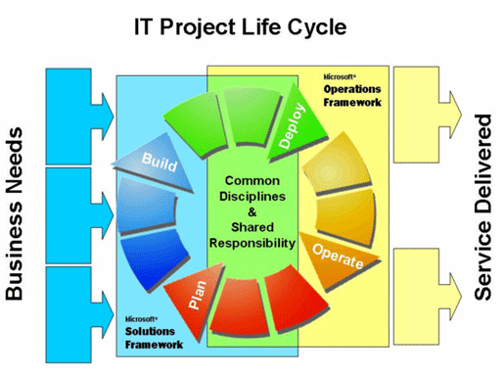
Figure 1. The IT project life cycle with Microsoft Operations Framework and Microsoft Solutions Framework.
Microsoft Operations Framework for Legacy Modernization (MOF/LM) focuses solely on the principal practices relevant to operating and supporting migrated applications and does not discuss tools for planning or migrating those applications.

Audience
MOF/LM applies to mainframe operations professionals whose role will transition to operations on Windows® operating system–based systems with the migration of the IT solution. This includes:
- Operations managers
- System programmers and database administrators
- System operators and administrators
Individuals involved in assessing and planning application migration also will have an interest in MOF/LM because it will describe products for Windows-based systems in terms of management functions and the service levels that can be delivered through optimized practices.

Team Model for Operations
When looking at legacy operational migration to Windows software it is prudent to start with an understanding of the MOF Team Model. The MOF Team Model organizes the activities of IT operations into distinct role clusters that represent areas, or functional roles, within IT operations where particular staff members or groups are performing activities toward a shared goal or a similar mission of service. Further, it describes role clusters with corresponding responsibilities and best practice guidance for a distributed environment. When applied to a mission critical infrastructure within the scope of MOF/LM the following role clusters have been identified.
- Architecture
- Sustained Engineering
- Deployment
- Support
- Operations
These roles are an adaptation of organization clusters found in the ITIL Information and Communications Technology (ICT) Infrastructure Management publication. At Microsoft IT, for example, roles—most notably, the Sustained Engineering role—are assigned for each application, each hardware model, and each group of server settings (for example, database-tuning parameters). The Sustained Engineering role also is assigned for each MOF process described in Figure 2. These roles do not imply or suggest an organization chart or a set of job titles because these vary widely by organization. Instead, IT organizations will implement roles based on the size of the group, the scope and boundaries of the systems, geographic locations, the resources available to the team, and the specialties and experiences of individual staff.
Role clusters of the Team Model define the general categories of activities and processes, common ways to identify roles and responsibilities, and the common goals of each specialist function team that are required for a successful operations management organization. Most importantly, assigning the roles as described in the previous paragraph allows the assignment of clear and separate accountability. As defined in MSF, function teams are teams that exist within a role. They are the result of a team or project being so large that it requires the individuals within a role to be grouped into teams based upon their function.

Service Management Functions
Now that we have a better idea of the team model and roles, let us explore the service functions with in the MOF Process Model. The MOF Process Model contains 21 service management functions (SMFs), not to be confused with the term System Management Facility that is familiar to mainframe professionals. These functions were adopted from ITIL and adapted through the addition of prescriptive guidance about Microsoft technologies. Mainframe professionals will recognize many of these functions as operational areas for which procedures are defined within the mainframe data center. The SMFs are divided into the quadrants they directly support; Figure 2 depicts the 21 SMFs and their arrangement in these quadrants. The graphic represents the continuous flow through the quadrants to form the basis for continual process improvement.
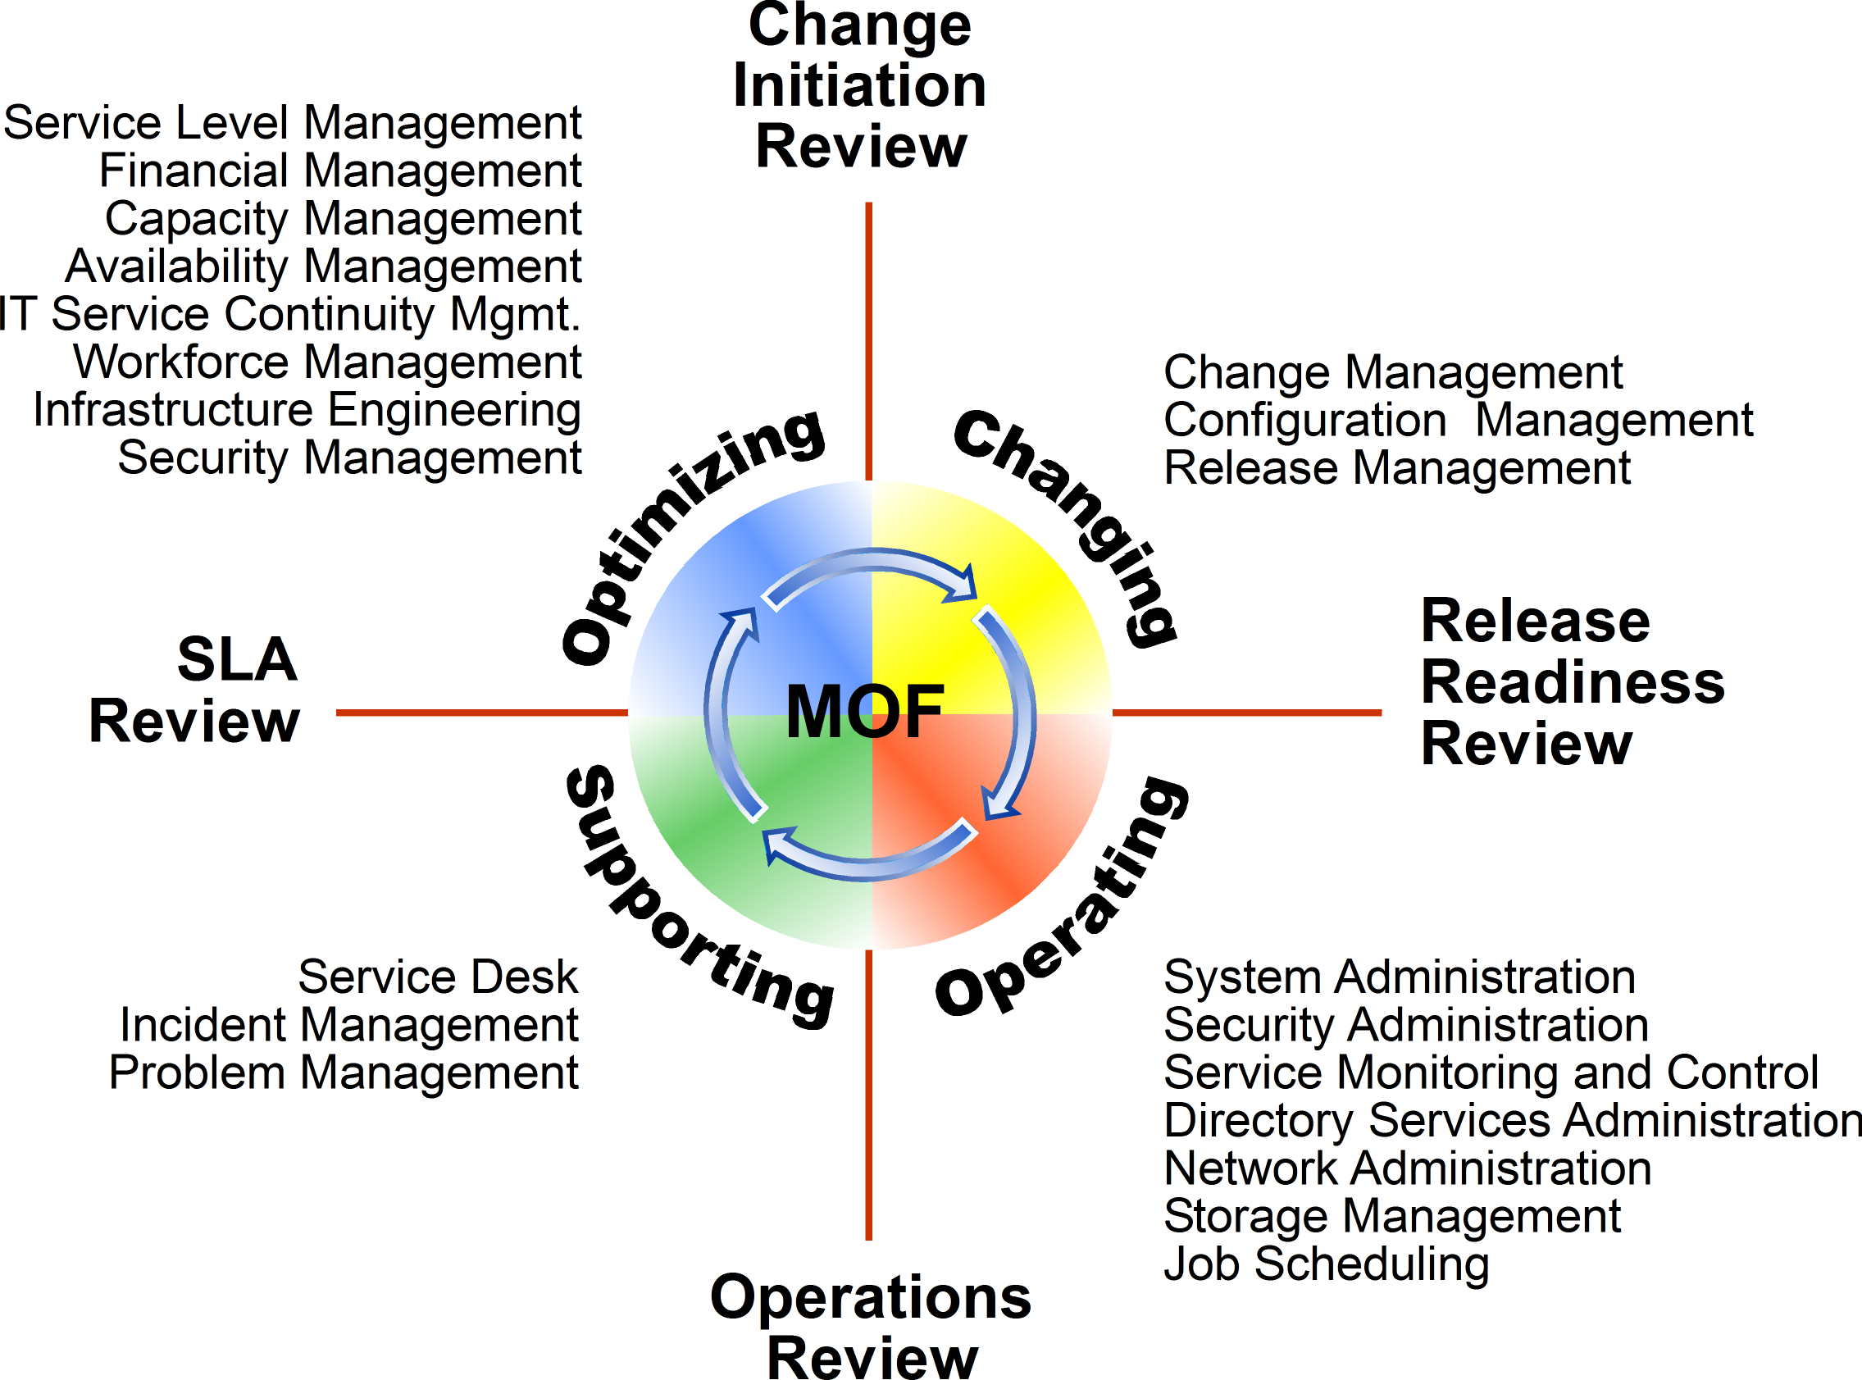
Figure 2. The Microsoft Operations Framework Process Model, showing Service Management Functions with associated operational quadrants.
Because MOF is formed from the core tenants of ITIL, it can be applied across platforms. The concepts and processes prescribed in the Change Management SMF, for example, are valid for all technology platforms. By incorporating feedback and best practices from Microsoft IT, customers, and Microsoft Partners, Microsoft has significantly increased the value of MOF for Microsoft technology. Additionally, MOF Consulting and Training offers several ways to introduce MOF to the enterprise, including training workshops, assessment programs, and implementation assistance. Information on consulting services can be provided by your sales team or Technical Account Manager.
For complete information about MOF, visit the Web site at www.microsoft.com/MOF.

Process Roadmap
In this section, each subsection for a particular service management function attempts to compare or map the process for the mainframe with the process for a Windows-based system. This is not an exhaustive list. Nevertheless, the following twelve service management functions where chosen since they are common to most enterprise applications and should provide a good foundation for addressing most operations questions that may arise when evaluating a mainframe-to-Windows platform migration.
See Figures 4 and 5 for a list of tools commonly used to support these processes and a mapping of mainframe processes and tools to Microsoft and third party tools.

Availability Management
Get the white paper: www.microsoft.com/technet/itsolutions/cits/mo/smf/smfavamg.mspx
The Availability Management SMF addresses the planning and ongoing improvement of availability. The Availability Manager is accountable for establishing a service level objective (SLO) that aligns with customer needs for a given service. The Availability Manager engages IT service providers to assess known risks or points of failure. Mitigation strategies, often using automated failover technologies, are then created to align to the customer’s SLO and budget.
Associated Mainframe Tools
IBM Tivoli, OMEGAMON, NetView, and CA NetMaster
Microsoft software is as capable of meeting customer demands for availability as the mainframe. This is demonstrated when SLOs are applied across all of the components that comprise the target service and when operating level agreements (OLAs) are built between the teams that support those components.

Capacity Management
Get the white paper: www.microsoft.com/technet/itsolutions/cits/mo/smf/smfcapmg.mspx
Capacity management involves the planning, measuring and monitoring of system capacity in support of delivering a service. On the mainframe, this task is accomplished through the management of system resources and CP allocation. In contrast, the distributed technologies of the Windows platform require a process-focused approach to capacity management.
Associated Mainframe Tools
IBM Performance Reporter and Service Level Reporter
The Capacity Manager is accountable for building a capacity plan to track customer requirements and system capacities and to monitor usage trends. When implemented correctly, a well-maintained Capacity Plan allows an enterprise to manage system costs tightly by capitalizing on the just-in-time availability of hardware. This approach is beneficial for systems running Microsoft software because future computing power will be less expensive than current computing power. Further, delaying equipment purchases until absolutely necessary helps lower IT costs. This is in contrast to the acquisition of hardware for the mainframe, which carries longer lead times and high price points per unit, forcing some enterprises to keep extra hardware components on hand.

Change Management
Get the white paper: www.microsoft.com/technet/itsolutions/cits/mo/smf/smfchgmg.mspx
Change management processes on the mainframe are well known for having mature discipline. But because the Windows platform is a distributed system, it historically has not been operated with the same approach to order and control. The Change Management SMF addresses this issue with prescriptive guidance for controlling and managing change on Windows-based systems. The core tenants of change management are documentation, approval, tracking, and review.
Associated Mainframe Tools
IBM Tivoli, CA AllFusion Endevor, and Serena ChangeMan
Change management, in its simplest form, outlines a process that manages all changes that could affect the delivery of a managed service. It begins with the creation of a change request that documents the change along with the systems and services targeted. Then the change is reviewed by a Change Advisory Board; if approved, the process moves to development and deployment. When properly managed with a supported change management process the Windows platform has been proven to deliver high levels of service availability.

Configuration Management
Get the white paper: www.microsoft.com/technet/itsolutions/cits/mo/smf/smfcfgmg.mspx
For mainframe systems, configuration management often takes the form of simple asset management. Driving reliability for distributed Windows-based systems requires configuration-management discipline that accounts for all components and systems that are required to deliver a stated service to a customer and end users. The Configuration Management SMF takes the well-known process of tracking hardware assets and introduces the concept of configuration items (CIs). A CI is any IT component that can be defined and managed under configuration management.
Associated Mainframe Tools
IBM z/OS, Hardware Configuration Manager (HCM), Portfolio Manager, and
Asset Manager
The power of configuration management comes from the configuration management database (CMDB). The CMDB tracks the relationships between unique CIs. Calculating the impact of a change or researching the root cause of a failure is possible by understanding how CIs support each other to deliver a service.
Configuration management also accounts for software asset management. Microsoft Systems Management Server (SMS) can query and track installed software and associated configurations, and this data can be incorporated into the CMDB to track the relationship between software and hardware. License Manager can be added to SMS to enable the management and metering of software licenses for the enterprise.
While mainframe systems benefit from a mostly closed environment, Windows-based systems can be managed on a per-service basis. Capitalizing on a CMDB, an IT department can manage service availability, capacity, and reliability end to end—just as it could with a mainframe system. A properly maintained CMDB can ease operations and create a single console view into distributed Windows-based systems.

IT Service Continuity Management
Get the white paper: www.microsoft.com/technet/itsolutions/cits/mo/smf/smfsrcmg.mspx
More commonly known as disaster recovery, IT Service Continuity Management is the process of planning for service recovery in the event of an unexpected event or natural disaster. The only difference between service continuity for the mainframe and the Windows platform is the equipment and recovery methods. MOF promotes a concept called the definitive software library (DSL) that is a unified, controlled environment where a copy of all installed programs and software should reside. Maintaining a reliable backup of this repository, in addition to a backup of system data, enables off-site recovery.
Associated Mainframe Tools
IBM Tivoli System Automation for GDPS/PPRC HyperSwap Manager and CA Fast Recovery

Financial Management
Get the white paper: www.microsoft.com/technet/itsolutions/cits/mo/smf/smffinmg.mspx
Successful financial management is independent of the IT platform and enables business spending to correlate with the value of IT services. Microsoft technologies accommodate many hardware configurations and allow virtual partitioning, which can be used to isolate user activity and track individual resource consumption. The remainder of the financial management process depends on the financial model in practice and could include direct chargeback models, cost reporting, or cost allocation.
Associated Mainframe Tools
IBM Tivoli Decision Support and System Management Facilities, CA Unicenter NeuMICS Resource Management, CA-JARS, and CA-PMA Chargeback
Solid financial management is critical to managing the cost of running Windows-based systems. For example, some organizations mistakenly purchase too much equipment and drive rapid server growth because system acquisition is inexpensive. However, financial management should create a cost model that accounts for the full cost of running an individual system. Components such as network, data center, and support staff costs all should be considered.

Job Scheduling
Get the white paper: www.microsoft.com/technet/itsolutions/cits/mo/smf/smfjobsc.mspx
Microsoft technologies support several job scheduling tools, including a scheduler built into the Windows Server® operating system. The critical component of job scheduling management is the logging and management of failures. Windows Server supports integrated logging, which allows job failures to be recorded and reported.
Associated Mainframe Tools
CA-7 Job Management, Unicenter CA-11 Jobstart and Tracking, CA-Scheduler and CA-Jobtrac
The Job Scheduling Manager is accountable for documenting and managing the scheduling process. This includes working with Availability Management and Capacity Management systems to coordinate off-peak times with low-priority and after-hours jobs.

Release Management
Get the white paper: www.microsoft.com/technet/itsolutions/cits/mo/smf/smfrelmg.mspx
Release management on the mainframe focuses on the release tools or system software. With Microsoft technologies, release management focuses on coordinating releases, integrated testing, and validated rollback plans.
Associated Mainframe Tools
IBM z/OS and WebSphere Application Server
The Release Management SMF outlines a release process with five main steps: release planning, release building, acceptance testing, release preparation, and release deployment. This flow ensures that the bits being deployed are validated for system functionality and user acceptance. The release manager oversees this process and manages the logistics of release deployment including resource coordination. Coupled with a release management process, Microsoft technologies have proven to be agile in the rapid deployment of new systems and with updates to existing systems. This capability enables the Windows platform to keep up with the rapidly changing demands of today’s businesses.

Security Management
Get the white paper: www.microsoft.com/technet/itsolutions/cits/mo/smf/mofsmsmf.mspx
Microsoft technologies support several levels of security and still allow granular access to appropriate resources. Unlike the centralized mainframe, Windows security management must support a centralized and distributed model. Hence, when both the back-end and front-end systems are running Microsoft software, security measures and encryption flow from keystroke to database commit and back again for a complete solution.
Associated Mainframe Tools
eTrust CA-ACF2 Security and CA-Top Secret Security, IBM Tivoli Security Administrator for RACF, and IBM Encryption Facility

Security management processes involve the establishment of security policy and a way to manage it. Security is a deliverable of all platforms and technologies and should be managed as a consolidated security plan. Security Managers are responsible for communication of, education of, and compliance with all security issues.

Service Level Management
Get the white paper: www.microsoft.com/technet/itsolutions/cits/mo/smf/smfrelmg.mspx

Service Level Management (SLM) aims to negotiate and manage an agreement, between a customer and IT, which states a targeted level of service. SLM should target the the level of service that provides value to the business but that avoids excessive hardware purchases.
Associated Mainframe Tools
IBM Tivoli Business Systems Manager and Tivoli OMEGAMON
The Service Level Management function must align closely with the Availability Management and Capacity Management function to ensure that components are in place to meet stated SLAs. Additionally, SLM is required to work with Financial Management function to provide costs for budgeting cycles. Microsoft employs SLM internally and delivers 99.99 percent availability 24 hours a day, 7 days a week for its messaging service. This level of availability is achieved even when time allotted for maintenance and upgrades is included.

Storage Management
Get the white paper: www.microsoft.com/technet/itsolutions/cits/mo/smf/smfstomg.mspx
Storage management practices are the same on the Windows-based and mainframe systems. Storage Managers work with Capacity Management software to coordinate storage capacities according to the overall capacity plan for the enterprise. Microsoft technologies support most mainstream network attached storage systems and storage area networks. Associated management and storage allocation tools run on Microsoft software and allow for the rapid allocation and provisioning of storage on demand.
Associated Mainframe Tools
IBM Tivoli Storage Manager, DFSORT, DFSMS, and Mainstar

System Administration
Get the white paper: www.microsoft.com/technet/itsolutions/cits/mo/smf/smfsysad.mspx
The System Administration SMF maps closely to the daily work tasks of a mainframe operator. This SMF, as depicted in Figure 3, is the top of the pyramid when it comes to IT operations. System Administration manages the process and guidance of all administration tasks, including print and output management. System Administration allows each discipline to employ the tools appropriate for the task. However, System Administration Managers are responsible for driving efficiency into operations by working with all areas to reduce duplication of tasks, tools, and staff.
Associated Mainframe Tools
IBM CICS, IBM IMS, CA-IDMS, and HP NonStop Pathway

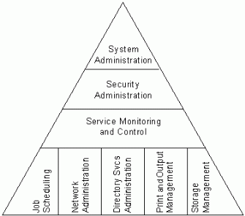

Figure 3. The system administration function defined.

Microsoft Solution Matrix
Mainframe environments typically utilize a wide-range of infrastructure utilities. Similarly, MOF/LM places emphasis on describing practices that involve an extensive portfolio of Microsoft and third-party tools and utilities. These products can be deployed in support of a mainframe modernization project. Microsoft is continually developing its portfolio of operations, systems management, and migration tools. Figures 4 and 5 on the following page provide a high-level mapping of the tools and processes used for specific SMFs between mainframe and Windows-based systems.
Additional white papers and documentation: http://technet.microsoft.com/en-us/default.aspx

Microsoft also collaborates with and supports several third-party tools. More information can be found in Appendix A: “Additional Relevant Third-Party Products.” The options listed illustrate the flexibility and choices available for administrating Windows-based systems, Use this to begin research into other relevant products that can support your mainframe modernization project— many more exist. Hence, this is not an exhaustive list but a representative list of solutions selected for example.

Microsoft Solution Matrix
Figure 4. Microsoft solution matrix for legacy modernization.

Microsoft Solution Matrix (Cont.)
Figure 5. Microsoft solution matrix for legacy modernization.

Summary
Microsoft Operations Framework for Legacy Modernization outlines a framework that can be tailored to meet the specific requirements of an enterprise that is considering migrating from the mainframe to a system running Microsoft technologies, and it provides guidance on the key factors to consider prior to implementation of a mainframe modernization project.
Finally, MOF/LM substantiates Microsoft technologies as a credible alternative to the mainframe while also demonstrating a growing ecosystem of third-party infrastructure products that support enterprise-ready solutions for Windows-based systems.
Additional white papers and case studies: www.microsoft.com/mainframe

Appendix A: Additional Relevant Third-Party Products

Application Development
Acucorp | Development and deployment products to extend COBOL legacy applications to Windows Server.
Fujitsu | Development and deployment products to extend mainframe COBOL, CICS, VSAM, DB2, and JCL legacy applications to Windows Server and Microsoft .NET technologies.
Micro Focus | Development and deployment products to extend mainframe COBOL, CICS, VSAM, DB2, and JCL legacy applications to Windows Server and .NET technologies.

Availability Management
AVIcode | Enterprise application monitoring solutions for the.NET Framework.
Stratus Technologies | Fault-tolerant enterprise hardware software for Windows Server.
SunGard | Software that helps the continuity of enterprise systems.

Change Management and Release Management
IBM Rational ClearCase Change Management | Software to manage software development assets.
Serena ChangeMan DS | Software for managing distributed software applications, from development to deployment.
Serena Dimensions | An enterprise change management solution for Windows-based and mainframe systems that provides process control, versioning, baseline management, issue management, release and build management, and workflow management.
Serena PVCS Professional | A change and configuration management software suite that includes version management, issue and workflow management, and build capabilities.

Job Scheduling
BMC CONTROL-M | Production and scheduling that capitalizes on the capabilities of Windows technologies such as Windows clustering, job objects, and authorization mechanisms.
CA Cybermation | Event-driven job scheduling for multiple platforms
CA Unicenter AutoSys Job Management | Job management software that includes centralized real-time monitoring and programmable error recovery.
Tidal Enterprise Scheduler. | Enterprise-class scheduler with job automation.

Security Management
Sentinal | Software that monitors IT systems for security and compliance events.
The information contained in this document represents the current view of Microsoft Corporation on the issues discussed as of the date of publication. Because Microsoft must respond to changing market conditions, it should not be interpreted to be a commitment on the part of Microsoft, and Microsoft cannot guarantee the accuracy of any information presented after the date of publication.
This white paper is for informational purposes only. MICROSOFT MAKES NO WARRANTIES, EXPRESS OR IMPLIED, IN THIS
DOCUMENT.
Complying with all applicable copyright laws is the responsibility of the user. Without limiting the rights under copyright, no part of this document may be reproduced, stored in, or introduced into a retrieval system, or transmitted in any form or by any means (electronic, mechanical, photocopying, recording, or otherwise), or for any purpose, without the express written permission of Microsoft Corporation.
Microsoft may have patents, patent applications, trademarks, copyrights, or other intellectual property rights covering subject matter in this document. Except as expressly provided in any written license agreement from Microsoft, the furnishing of this document does not give you any license to these patents, trademarks, copyrights, or other intellectual property.

