

Windows® SharePoint® Services 3.0
Evaluation Guide

Microsoft Corporation
Published: April 2008

Abstract
This Evaluation Guide is designed to give you a solid understanding of the design goals and feature set for Windows SharePoint Services 3.0 and a familiarity with the implementation of this technology in Windows Server 2003 and Windows Server 2008. It provides an overview of the solutions and benefits enabled by Windows SharePoint Services as well as descriptions of new and improved features in the areas of collaboration, storage and security, deployment and management, user interface, and platform extensibility. It also provides a hands-on tour of the main feature areas of Windows SharePoint Services and includes useful information for administrators and developers.
The ultimate goal of this guide is to aid the reader in performing a thorough and effective evaluation of Windows SharePoint Services. This guide is intended for anyone who is interested in learning more about Windows SharePoint Services and wants hands-on experience.

The information contained in this document represents the current view of Microsoft Corporation on the issues discussed as of the date of publication. Because Microsoft must respond to changing market conditions, this document should not be interpreted to be a commitment on the part of Microsoft, and Microsoft cannot guarantee the accuracy of any information presented after the date of publication.
This document is for informational purposes only. MICROSOFT MAKES NO WARRANTIES, EXPRESS OR IMPLIED, AS TO THE INFORMATION IN THIS DOCUMENT.
Complying with all applicable copyright laws is the responsibility of the user. Without limiting the rights under copyright, no part of this document may be reproduced, stored in or introduced into a retrieval system, or transmitted in any form or by any means (electronic, mechanical, photocopying, recording, or otherwise), or for any purpose, without the express written permission of Microsoft Corporation.
Microsoft may have patents, patent applications, trademarks, copyrights, or other intellectual property rights covering subject matter in this document. Except as expressly provided in any written license agreement from Microsoft, the furnishing of this document does not give you any license to these patents, trademarks, copyrights, or other intellectual property.
© 2005–2008 Microsoft Corporation. All rights reserved.
Microsoft, Active Directory, Excel, FrontPage, InfoPath, MSDN, OneNote, Outlook, PowerPoint, SharePoint, Visual Studio, Windows, the Windows logo, Windows NT, and Windows Server are either registered trademarks or trademarks of Microsoft Corporation in the United States and/or other countries.
The names of actual companies and products mentioned herein may be the trademarks of their respective owners.

Table of Contents
Introduction 7
Who Should Consider Windows SharePoint Services? 8
Why Upgrade to Windows SharePoint Services 3.0? 8
Resources Available for Evaluating Windows SharePoint Services 8
How to Use This Guide 9
Overview of This Guide 9
Windows SharePoint Services Overview 10
Collaborate Easily and Effectively 10
Get Started Quickly 10
Deploy a Manageable Infrastructure 11
Provide a Foundation for Web-Based Applications 11
Top 10 Benefits 11
Features at a Glance 13
Collaboration 13
Collaboration and Community 13
Alerts, Notifications, and RSS Support 15
Integration with Familiar Office Applications 15
User Interface and Navigation 16
Application Templates 17
Storage and Security 17
Repository and Metadata 17
Authentication and Authorization 19
Versioning 19
Information Recovery 19
Indexing and Searching 20
Deployment and Management 20
Deployment Model 20
Management Features 20
Site Model 21
Platform Extensibility 21
Object Model and Application Programming Interfaces (API) 22
An Administrator’s Perspective 24
Architectural Overview 24
Operating System and Database Services 24
Deployment Scenarios 25
Single-Tier Implementation (Single Server) 25
Two-Tier Implementation (Small Farm) 25
Three-Tier Implementation (Medium or Large Farm) 26
Planning and Design Support 27
Migration 27
Pros and Cons of the Three Approaches for Upgrading to Windows SharePoint Services 3.0 27
In-place Upgrade 27
Gradual Upgrade 27
Database Migration 28
Administrative Tasks and System Management 28
Administrative Tasks 28
Systems Management 30
Backup and Restore 30
Recycle Bin 30
Performance Management 30
Security Management 30
Authentication Providers 31
Manage Permissions through Policies 31
Install Your Evaluation Server 31
Deploy Windows SharePoint Services on a Single Server 32
Hardware and Software Requirements 32
Windows SharePoint Services on Windows Server 2003 32
Configure the Server as a Web Server 32
Enable IIS and Configure It to Use IIS 6.0 Worker Process Isolation Mode 32
Install the Microsoft .NET Framework 2.0 33
Download and Install the .NET Framework 2.0 33
Verify that Microsoft ASP.NET 2.0 is Enabled in IIS 33
Configure IIS for ASP.NET 2.0 33
Restart IIS 33
Download and Install the .NET Framework 3.0 34
Windows SharePoint Services on Windows Server 2008 34
Install Windows SharePoint Services with Windows Internal Database 35
Add the SharePoint Site to the List of Intranet Sites 36
Configure Proxy Server Settings to Bypass the Proxy Server for Local Addresses 36
After You Install Windows SharePoint Services with Windows Internal Database 36
Upgrade from Windows SharePoint Services 2.0 SP2 to Windows SharePoint Services for Evaluation Purposes 37
An End User Perspective 38
Windows SharePoint Services Tour 38
Explore a Windows SharePoint Services Site 38
Exercise 1: Explore a Home Page 38
Exercise 2: Create a SharePoint List or Library 39
Exercise 3: Create an 40
Exercise 4: View and Modify Document Settings for Version Control 41
Exercise 5: Sign Up for an Alert 42
Exercise 6: Modify a Document from a SharePoint Site 43
Exercise 7: View an RSS Feed 45
Exercise 8: Upload a Document to a SharePoint Site 45
Exercise 9: Create a SharePoint Team Site 46
Exercise 10: Add a Web Part to a SharePoint Site 47
Exercise 11: Configure a Web Part 48
Exercise 12: Upload a Document to a SharePoint Site 48
Exercise 13: Create a Folder 49
Exercise 14: Create and Populate a List 50
Exercise 15: Create a Custom List from an Excel Workbook 51
Windows SharePoint Services Integration with Microsoft Office 52
Exercise 1: Add an Appointment to a SharePoint Calendar 52
Exercise 2: Work with a SharePoint Calendar in Office Outlook 2007 53
Exercise 3: Add an Appointment to a SharePoint Calendar from Office Outlook 2007 54
Exercise 4: Work Offline with Document Libraries in Office Outlook 2007 54
Exercise 5: Create a Document Library from within Office Outlook 2007 55
Exercise 6: Create a Document Library from Within Office Word 2007, Office Excel 2007, or Office PowerPoint 2007 56
A Developer's Perspective 58
Architectural Improvements Based on Microsoft ASP.NET 2.0 58
Getting Started with the Windows SharePoint Services Object Model 59
Feature Framework 59
Developer Scenarios 61
Site Columns 61
Folder Metadata 61
List Indexing 62
Cross-List Queries 62
List Items 62
Workflows 63
Property Bags 63
Web Service Enhancements 63
Change Log 63
Change Log Functionality 63
Change Log Security 64
Change Log Freshness 64
Event Enhancements 64
Work Items and Timer 65
For More Information 66
Appendix A—Hardware and Software Requirements 67
Appendix B—Application Templates for Windows SharePoint Services 3.0 68
Appendix C—Considerations in the Evaluation of Windows SharePoint Services 3.0 under Windows Server 2008 69
Manageability 69
Internet Information Services 7.0 70
IIS 7.0 Modular Architecture 70
Virtualization with Hyper-V 70
Security 71
Performance and Reliability – Enhancements and Management 72
Summary 74
Introduction
Welcome to the evaluation guide for Windows® SharePoint® Services 3.0. The goal of this guide is to help you gain sufficient knowledge and understanding to evaluate Windows SharePoint Services.
Windows SharePoint Services is a versatile technology supported under Windows Server™ 2003 and Windows Server 2008 that enables organizations and business units of all sizes to increase the efficiency of business processes and improve team productivity. With tools for collaboration that help people stay connected across organizational and geographic boundaries, Windows SharePoint Services gives people access to documents and information they need. With a familiar, Web-based interface and close integration with everyday tools including the Microsoft® Office system of productivity programs, Windows SharePoint Services is easy to use and can be deployed rapidly. Users can create workspaces and then publish, store, share, and keep track of information, workflow, and documents.
Built on Windows Server 2003, Windows SharePoint Services also gives organizations a cost-effective foundation platform for building Web-based business applications that can scale easily to meet the changing and growing needs of business. Robust administrative controls for managing storage and Web infrastructure give IT departments a cost-effective way to implement and manage a high-performance collaboration environment. The Windows Server 2008 architecture extends these values further by providing significant enhancements in manageability, security, and reliability.
Windows SharePoint Services gives IT professionals the tools they need for server administration and application extensibility and interoperability. Windows SharePoint Services helps organizations by enabling:
- Teams to stay connected and be more productive by providing access to the people, documents, and information they need.
- Collaboration solutions to be deployed more easily and integrate with everyday, familiar tools such as Microsoft Office.
- IT staff to more easily manage, control, and secure information resources using a highly scalable infrastructure with powerful administration services.
- Increased business process efficiency by making it easy to create versatile Web applications and workflow solutions using a cost-effective, highly extensible platform.
These benefits are further described in the Why Use Windows SharePoint Services? section of this guide. The Top 10 Benefits section highlights the most important ways Windows SharePoint Services can help organizations make better use of business information and processes.
Features at a Glance details the new and enhanced features for this release of Windows SharePoint Services, including:
- Collaboration
- Storage and Security
- Deployment and Management
- User Interface
- Platform Extensibility
With this knowledge, you will be able to properly evaluate the versatile Windows SharePoint Services platform and readily describe its capabilities to your colleagues, clients, and business partners.
A separate evaluation guide is available for Microsoft Office SharePoint Server 2007. Solution developers, IT professionals, technical business decision-makers, journalists, and analysts can read each guide independently of each other. You can download the Office SharePoint Server 2007 evaluation guide from http://go.microsoft.com/fwlink/?LinkId=83060.

For those interested in the Search functionality provided by Office SharePoint Server 2007, there’s a search specific evaluation guide as well. You can download the Office SharePoint Server 2007 for Search evaluation guide from http://go.microsoft.com/fwlink/?LinkID=79614.
Who Should Consider Windows SharePoint Services?
Windows SharePoint Services is a technology that enables people to collaborate in browser-based workspaces while providing a manageable infrastructure and extensible application platform for improving the efficiency of business processes. A variety of audiences benefit from the enhanced collaboration and productivity enabled by Windows SharePoint Services:
- Organizations, business units, and teams seeking increased team productivity and access to the people, documents, and information they need.
- Organizations of any size that want to start tactical implementation of collaboration tools, standardize existing infrastructure, or invest in strategic use of collaboration systems that integrate well with existing line-of-business applications.
- IT departments seeking better control over and security of company data, while adding value and efficiency to lines of business.
- Developers creating rich and scalable Web-based applications.
Why Upgrade to Windows SharePoint Services 3.0?
Windows SharePoint Services 3.0 offers many new and enhanced features that help business organizations of all sizes further improve individual and team productivity, and the efficiency of their business processes. These new and improved features help employees implement and manage workspaces and team sites more easily without help from IT, simplify and improve the management and maintenance of documents stored on SharePoint sites, and provide more robust and easy-to-use collaboration tools to encourage information-sharing within the organization. Windows SharePoint Services 3.0 also provides IT departments with enhanced control of company resources and a more flexible and robust foundation for building new, Web-based applications and services that can connect to and capitalize on existing line-of-business applications.
Resources Available for Evaluating Windows SharePoint Services
Many resources are available to help you evaluate Windows SharePoint Services, including the following:
- Documentation for Windows SharePoint Services to help you install the product.
- The SharePoint Products and Technologies Web site at http://www.microsoft.com/sharepoint, which offers a variety of white papers and other resources.
- The Microsoft MSDN® Web site at http://msdn.microsoft.com/sharepoint, which offers numerous technical resources for developers about SharePoint Products and Technologies.
- The Microsoft TechNet Web site at http://www.microsoft.com/technet/windowsserver/sharepoint, which provides a clearinghouse of resources to help you deploy, maintain, and support Windows SharePoint Services.
- Test Drive hands-on labs for Windows SharePoint Services, which can be found at http://office.microsoft.com/sharepointtechnology.
Microsoft encourages you to use these resources as aids in evaluating and installing Windows SharePoint Services.

How to Use This Guide
Overview of This Guide
This guide has the following sections. For best results, review them in order, as each section builds on concepts presented in preceding sections.

Windows SharePoint Services Overview
This section highlights key features of Windows SharePoint Services, and describes how these features can benefit organizations that build and manage content-rich Web sites.

Top 10 Benefits
This section identifies the top 10 business and technical benefits that organizations can realize by deploying and using Windows SharePoint Services.

Features at a Glance
This section provides information to help you understand, describe, and evaluate the new and enhanced features of Windows SharePoint Services. This section will be of interest to anyone who plans, builds, deploys, or manages business solutions using Windows SharePoint Services.

An Administrator’s Perspective
This section describes the logical architecture of Windows SharePoint Services and provides information needed to plan, build, deploy, and manage a Windows SharePoint Services solution. This section also includes step–by-step instructions for installing Windows SharePoint Services in a single-server environment so that you can evaluate its features.
Note: Even if you are a business user or developer, you can use the installation instructions from this section to help you evaluate the features described in the subsequent sections.

A Business User’s Perspective
This section provides information and step-by-step instructions for working with Windows SharePoint Services from an end-user’s perspective.
Windows SharePoint Services Tour
This section provides step-by-step instructions for configuring and demonstrating each new feature of Windows SharePoint Services.
A Developer's Perspective
This section introduces the tools and concepts that developers use to design and develop custom solutions using Windows SharePoint Services.
For More Information
This section provides links to sources of further information about Windows SharePoint Services, such as white papers, community sites, and the Windows SharePoint Services Support Web site.
Windows SharePoint Services Overview
This section provides information that will help you understand and evaluate the benefits of Windows SharePoint Services.
Collaborate Easily and Effectively
Windows SharePoint Services helps teams stay connected and productive by providing easy access to the people, documents, and information they need to make more informed decisions and get their jobs done. Enhancements in Windows SharePoint Services make it easier than ever to share documents, track tasks, use e-mail effectively, and share ideas and information.
Implementing Windows SharePoint Services allows you to:
- Provide workspaces for teams to coordinate schedules, organize documents, and participate in discussions—within the organization and over the extranet.
- Author and manage documents easily, and help ensure their integrity with enhanced features, including the option to require document checkout before editing, the ability to view past revisions and restore to previous versions, and the ability to set document-specific security.
- Help people and teams stay on task with a variety of communication features that let users know when actions are required or important changes are made to existing information or documentation, including announcements, sophisticated alerts, surveys, and discussion boards.
- Provide creative forums for brainstorming ideas, building knowledge bases, or simply gathering information in an easy-to-edit format with new templates for implementing weblogs (also known as blogs) and wikis (Web sites that team members can quickly edit without any technical expertise).
- Keep mobile users productive with enhanced support for offline synchronization through the new features in Microsoft Office Outlook® 2007 for managing document libraries, lists, calendars, contacts, tasks, and discussion boards when offline, and to synchronize changes when reconnected to the network.
Get Started Quickly
Windows SharePoint Services makes it easy for IT departments to implement a dependable, scalable collaboration infrastructure with minimal administrative time and effort. Close integration of Windows SharePoint Services with familiar tools for authoring, publishing, organizing, and finding information, including the Microsoft Office system, helps users get up to speed quickly.
Using Windows SharePoint Services enables you to:
- Simplify the creation and navigation of workspaces with improved user interface and site creation tools in Windows SharePoint Services that provide easy-to-use templates, professional-looking site themes, and the ability to rearrange site navigation from within the browser.
- Make it easy for users to get up to speed quickly by providing integration with familiar productivity tools such as those found in the Microsoft Office system. Users can create workspaces, post and edit documents, and view and update calendars on SharePoint sites, all while working within Microsoft Office system files and programs.
- Helps users organize calendars, tasks, contact lists, discussion boards, and meetings through enhanced integration with Office Outlook 2007.
- Customize Windows SharePoint Services using new application templates that provide solutions for building workflows that address specific business processes.
- Implement a collaboration environment with minimal administrative time and effort and flexible deployment options.
Deploy a Manageable Infrastructure
Windows SharePoint Services gives you more control over the security of your organization’s information resources. Enhanced administrative capabilities make business units less dependent on your company’s IT department for site provisioning, implementation, backup, and support. Whether you’re a contributor to a team site, a site owner, or a server administrator, Windows SharePoint Services provides better administrative controls for managing content, users, and sites so that individuals and project teams can operate more efficiently and effectively.
Using Windows SharePoint Services allows you to:
- Make business information more secure with enhanced administrative controls that decrease the cost and complexity of site provisioning, management, support, operations, and backup and restore.
- Give your IT department better control over your organization’s infrastructure with new and improved services for controlling access to information and setting policies for site creation.
- Enable security to be set at the site collection, site, list, library, folder, and item level.
- Empower site managers and teams by enabling them to initiate and control their own self-service workspaces and tasks and to manage the participation and access of others—all without compromising security and within parameters set by IT.
- Provide a more robust document storage environment with document storage, recycle bin item retrieval, and version control features.
- Manage and configure Windows SharePoint Services easily by using a Web browser or command-line utilities, and enable a variety of custom and third-party administration solutions using the .NET Framework.
Provide a Foundation for Web-Based Applications
With Windows SharePoint Services, IT professionals can tailor or extend the Windows SharePoint Services foundation to create new, efficient Web-based tools and services specific to the organization, department, business process, or industry vertical. Through a highly customizable and extensible platform, companies can capitalize on existing IT investments and valuable information stored in enterprise systems by tying these new tools and services to existing line-of-business applications.
You can produce Web-based applications that allow you to:
- Manage business documents more easily with enhanced document library support and a common repository for document storage.
- Use the Windows SharePoint Services platform to build rich, flexible, and scalable Web-based applications and Web sites specific to your organization’s needs.
- Take advantage of integration with Office SharePoint Server 2007 to offer enterprise-wide functionality for records management, search, workflows, portals, and personalized sites.
- Use Office SharePoint Designer 2007 to quickly and easily customize SharePoint sites and build reporting tools and applications tailored to specific tasks without writing new code.
Top 10 Benefits
Here is a list of 10 ways Windows SharePoint Services can bring the most value to your organization:
1. Improve team productivity with easy-to-use collaborative tools.
Windows SharePoint Services connects people with the information and resources they need. Users can create team workspaces, coordinate calendars, organize documents, and receive important notifications and updates through communication features that include announcements and alerts. In addition, new templates are available for creating blogs and wikis, and mobile users can take advantage of convenient offline synchronization capabilities.
2. Easily manage documents and help ensure integrity of content.
Windows SharePoint Services has enhanced document management capabilities, including the option to activate required document checkout before editing, the ability to view revisions to documents and restore to previous versions, and control over document- and item-level security.
3. Get users up to speed quickly.
User interface improvements in Windows SharePoint Services include enhanced views and menus that simplify navigation within and among SharePoint sites. Integration with familiar productivity tools, including programs in the Microsoft Office system, makes it easy for users to get up to speed quickly. For example, users can create workspaces, post and edit documents, and view and update calendars on SharePoint sites, all while working within Microsoft Office system files and programs.
4. Deploy solutions tailored to your business processes.
While standard workspaces in Windows SharePoint Services are easy to implement, organizations seeking a more customized deployment can get started quickly with application templates for addressing specific business processes or sets of tasks. Appendix B provides a list of available templates that you can download.
5. Build a collaboration environment quickly and easily.
Easy to manage and easy to scale, Windows SharePoint Services enables IT departments to deploy a collaborative environment with minimal administrative time and effort, from simple, single-server configurations to more robust enterprise configurations. Because deployment settings can be changed easily, less preplanning is required, and companies can get started even faster.
6. Reduce the complexity of securing business information.
Windows SharePoint Services provides IT with advanced administrative controls for increasing the security of information resources, while decreasing cost and complexity associated with site provisioning, site management, and support. Take advantage of better controls for site life-cycle management, site memberships and permissions, and storage limits.
7. Provide sophisticated controls for securing company resources.
IT departments can now set permissions at the document or item level, and site managers, teams, and other workgroups can initiate self-service collaborative workspaces and tasks within these preset parameters. New features enable IT workers to set top-down policies for better content recovery and easier site administration for users, groups, and team workspaces.
8. Take file sharing to a new level with robust storage capabilities.
Windows SharePoint Services supplies workspaces with document storage and retrieval features, including check-in/check-out functionality, version history, custom metadata, and customizable views. New features in Windows SharePoint Services include recycle bin functionality for easier content recovery, and improved backup and restoration.
9. Easily scale your collaboration solution to meet business needs.
Quickly and easily manage and configure Windows SharePoint Services using a Web browser or command-line utilities. Manage server farms, servers, and sites using the Microsoft .NET Framework 3.0, which enables a variety of custom and third-party administration solution offerings.
10. Provide a cost-effective foundation for building Web-based applications.
Windows SharePoint Services exposes a common framework for document management and collaboration that can be used to build flexible and scalable Web applications, intranet solutions, and Web sites that meet the specific needs of the organization. Integration with Office SharePoint Server 2007 further expands these capabilities to offer enterprise-wide functionality for records management, search, workflows, portals, and personalized sites.
Features at a Glance
Features at a Glance provides information that will help you understand, describe, and evaluate the new and enhanced features of Windows SharePoint Services. This section will be of interest to anyone who plans, builds, deploys, or manages business solutions using Windows SharePoint Services.
For hands-on experience using Windows SharePoint Services, try out the exercises in the Windows SharePoint Services Tour section.
Collaboration
Windows SharePoint Services helps teams stay connected and productive by providing easy access to the people, documents, and information they need to make more well-informed decisions and get the job done.
Windows SharePoint Services accomplishes this by providing:
- Collaboration and community
- Alerts, notifications, and RSS support
- Integration with familiar Office applications
- User interface and navigation
- Application templates

Collaboration and Community
Feature area | Features
Real-time presence and communication  Enhanced | The enhanced real-time presence smart tag icon, displayed virtually everywhere a person’s name appears in the system, tells users whether a person is online and available for a telephone or audio conference call, instant messaging, or two-way video conversation.
Mobile device access  New | Windows SharePoint Services provides new capabilities that allow lists to be rendered appropriately on mobile devices. When a user browses to a Windows SharePoint Services site by using a mobile device, their Web browser will be re-directed to a mobile-specific version of the site that renders site content and lists in a format that is most suitable for the device.
Standard site templates  New and Enhanced | Windows SharePoint Services includes the following standard site templates, in addition to the application templates available for download on the Microsoft Web site. For more information about the application templates for Windows SharePoint Services, see Appendix B—Application Templates for Windows SharePoint Services.  Team site  Document workspace  Blank site  Blog  Wiki  Meeting workspaces (five workspace types)
Wikis  New | A wiki is a new site template in Windows SharePoint Services that makes it easy to create, edit, link, and restore an individual Web page. People can use wikis as creative forums to brainstorm ideas, manage knowledge bases, create designs or instruction guides, or simply gather information in an easy-to-edit format. Wikis are easy to create, modify, and annotate, and can track contributions and changes.  Key features include:  Fast and easy page creation  Easy and automatic linking  Version differences  WYSIWYG (what you see is what you get) Web page editing  The ability to leverage existing SharePoint functionality, including search, navigation, alerts, and custom fields.  You can learn more about wikis in this whitepaper: http://www.microsoft.com/downloads/details.aspx?FamilyId=6224AA0B-2EB5-4780-8161-C8C94D86B9E9&displaylang=en
Blogs  New | Blogs provide a publishing-oriented experience for a single user or a team. Windows SharePoint Services includes a site template that supports:  Article posting  Reader comments  Article and comment management  Archive views  RSS feed generation  You can learn more about blogs in this whitepaper: http://www.microsoft.com/downloads/details.aspx?FamilyId=6224AA0B-2EB5-4780-8161-C8C94D86B9E9&displaylang=en
People and Groups list  New | People and Groups offer a unified place to find, communicate with, and manage people and their permissions, including support for custom fields such as Department, Office Number, and Area of Focus, in addition to the New Person field type. The Person field type creates rich displays of lists of people including support for a People Picker for browsing a list of users.  Member Group provides:  Reuse of groups across sites  Distribution list for the members of the site
Calendars  Enhanced | Calendars have been enhanced with richer calendar views, expanded support for recurring events, and all-day events.
E-mail integration  New | Document libraries, blogs, discussion boards, calendars, and announcements can be enabled to receive new postings via e-mail. In addition, extensible support is provided for custom e-mail handlers in Windows SharePoint Services.  Similar to the functionality provided by public folders in Microsoft Exchange Server, e-mail-enabled discussion boards support:  A highly scalable, topic-based architecture  Unified experience for both e-mail and Web-based discussions  One-step creation of Active Directory® directory service distribution lists as part of the site creation process  Unified SharePoint group and Active Directory management functions  Additionally, discussion boards, document libraries, task, contacts and calendars can be synchronized between Windows SharePoint Services and Office Outlook 2007.
Task coordination  New | The new Project Tasks List template provides lightweight task management functionality including Gantt charts for visualization of task relationships and status.
Surveys  Enhanced | Surveys now include conditional branching as well as support for inserting page breaks in long surveys such as annual employee satisfaction or customer satisfaction surveys.
Document collaboration  Enhanced | Improvements to SharePoint document libraries include:  The ability to check out documents locally  Offline document library support in Office Outlook 2007  Major and minor version numbering and tracking  Support for multiple content types  Policy, auditing, and workflow functionality  Tree view support  Each of these is described in detail later in this Features at a Glance section.
Issue Tracking  Enhanced | The Issue Tracking List template has been updated to use the enhanced versioning and version-history storage features of Windows SharePoint Services.

Alerts, Notifications, and RSS Support
Feature area | Features
Alert filtering  New | Filters are supported to highlight relevant alerts.
Richer alert information  Enhanced | More information about the item that has changed is included in the alert.
Alert customization  New | Additional platform features are provided for custom formatting, events, and alerts.
Task notifications  Enhanced | Task notifications are now sent automatically when a user is assigned a task. There is no need for the user to subscribe to the notification in advance.
RSS (Really Simple Syndication) feeds  New | By integrating RSS feeds for each SharePoint list, Windows SharePoint Services provides an efficient mechanism for users to retrieve information using RSS-enabled programs such as Windows Internet Explorer 7 and Office Outlook 2007. For example, users can subscribe to a document library in their RSS client application, and they will automatically discover new or amended documents.  Additionally, blogs and wikis can be RSS feed sources.

Integration with Familiar Office Applications
Feature area | Features
Integration with 2007 Office Suites  Enhanced | Windows SharePoint Services integrates with smart client tools through a set of web services and documented application interfaces. Users can readily adopt these new tools because of their similarity to other familiar environments, such as the Microsoft Office system.  For example, users of Microsoft Office Word 2007, Microsoft Office Excel® 2007, Microsoft Office PowerPoint® 2007, Microsoft Office InfoPath® 2007, Microsoft Office Project 2007, and Microsoft Office OneNote® 2007 can directly interact with information stored in SharePoint sites without having to manually download the content.  Users can create workspaces, post and edit documents, and assign tasks, all while working on documents stored in SharePoint sites.
Integration with Office Outlook 2007  Enhanced | With Office Outlook 2007, users can view calendars and contact lists stored on SharePoint sites, and create and manage sites for editing documents and organizing meetings.  Office Outlook 2007 and Windows SharePoint Services support a new set of significantly enhanced functionality including:  Read/write access to SharePoint items including calendars, tasks, contacts, discussions, and documents  Synchronization of offline support of document library and lists  Ability to check out and edit documents when offline  Roll-up views of calendars and tasks across multiple lists and sites  Unified view of personal and SharePoint tasks in Office Outlook 2007
Integration with Office SharePoint Designer 2007  New | Office SharePoint Designer 2007, based in part on Microsoft FrontPage® technology, will provide tools for rich customization of sites, and creating reporting tools and application templates, without any coding.
Platform for Office SharePoint Server 2007  Enhanced | Office SharePoint Server 2007 is an integrated suite of easy-to-use server applications that help people and teams improve their efficiency and effectiveness.  Office SharePoint Server 2007 connects sites, people, and business processes, facilitating knowledge sharing with ready-to-go, enterprise-wide functionality for records management, search, workflows, portals, personalized sites, and more.  Office SharePoint Server 2007 is built on and extends the capabilities of Windows SharePoint Services by providing highly flexible organization and management tools for SharePoint sites, and by making it possible for teams to publish information to the entire organization.

User Interface and Navigation
Feature area | Features
Consistent user experience  Enhanced | Windows SharePoint Services implements many new and enhanced features that make the Windows SharePoint Services user interface more uniform—providing a consistent user experience.
Rights-trimmed user interface  New | Users can see only the features that they have the rights to use. Previously, Windows SharePoint Services did not inform users that they were not allowed to perform a function until they clicked its link.
Automatic breadcrumb bar  New | Provides quick navigational context for the user—creating a greater sense of “place” within a SharePoint site.
Quick Launch bar  Enhanced | Available on all view pages and is more easily customizable.
Top navigation bar  Enhanced | Available on all view pages and is more easily customizable.
View improvements  Enhanced | Ability to page forward and backward in addition to improved user interface for sorting and filtering.
Descriptive Actions menu  New | The Actions menu provides task-based descriptions of the actions that can be performed on a particular SharePoint list or document library.
Simplified Web Part user interface  Enhanced | Simplified user interface for browsing, selecting, and adding Web Parts to a Web Part page. The Web Part catalog is presented as a scrollable list, which means there is no more paging forward and backward through the Web Part catalog.
Accessibility  Enhanced | Windows SharePoint Services provides enhanced compliance with Web standards.

Application Templates
Feature area | Features
Application templates  Enhanced | While standard workspaces in Windows SharePoint Services are easy to implement, organizations seeking a more customized deployment can get started quickly with application templates for addressing specific business processes or sets of tasks.  A new set of application templates are available for Windows SharePoint Services. They highlight aspects of task coordination and offer some preconfigured workflows. The application templates provide customers with a baseline for deploying Windows SharePoint Services in context of business processes and sets of tasks. A rich ecosystem of solution providers uses the application templates as the basis for deeper horizontal and vertical solutions.  A complete list of the application templates can be found in Appendix B—Application Templates for Windows SharePoint Services.
Storage and Security
Windows SharePoint Services provides many new and enhanced features related to the implementation and management of storage and security. These include:
- Repository and Metadata
- Authentication and Authorization
- Versioning
- Information Recovery
- Indexing and Searching
Repository and Metadata
Feature area | Features
Document libraries  Enhanced | Improvements to SharePoint document libraries include:  The ability to check out documents locally  Offline document library support in Office Outlook 2007  Major and minor version numbering and tracking  Support for multiple content types  Policy, auditing, and workflow  Tree view support  Each of these is described in detail later in this Features at a Glance section.
Folders in lists  New | Folders, a popular feature in Windows SharePoint Services 2.0 Service Pack 2 document libraries, are now also available in lists. Folders enable further segregation of content within a single list, adding another level of versatility.
List indexing  New | By indexing a column and storing it as a simple name/value pair in a separate database, access to specific items in large lists is significantly improved. These kinds of performance improvements help SharePoint lists to become true data stores, capable of supporting external applications as well as simple team sites.
Large list indexing and cross-list indexing  New | The performance of large lists and cross-lists can be improved through the use of indexes on specific list column properties, which significantly increases the capacity and performance of a Windows SharePoint Services list compared to previous versions.
List item enhancements  Enhanced | Several new enhancements related to list items have been introduced in Windows SharePoint Services:  Per-item and per-folder security  Versioning  Required checkout
Metadata  Enhanced | Users can extend document libraries and lists with custom column properties.  The practical number of column properties that a list or document library can have has been significantly increased due to performance and scalability improvements in Windows SharePoint Services lists.  Additionally, the authoring environment of the Microsoft Office system is integrated with document information panels provided by Windows SharePoint Services.
Content types  New | Content types are reusable definitions of document types across your organization. A single document library can store content with multiple document types.  A content type is used to define a group of documents that share a common set of attributes, including:  Document templates  What’s on the “New” menu  Metadata specific to the content type  Shared column property templates  Custom InfoPath forms in Microsoft Office system applications  Enterprise-defined policies  Common workflows  Content types are different from traditional file types (which map to physical file formats like Word documents or Excel worksheets). Content types are used to define and implement business documents such as functional specifications, budget planning worksheets, or new product concept presentation.
Policies, auditing, and compliance  New | Repositories in Windows SharePoint Services support the following policy, auditing, and compliance features:  Highly customizable policies  Workflow process to define expiration  Access control and security  Information rights management capabilities for document libraries  Tracking and auditing  Logging of all actions on sites, content, and workflows  Sites for storing or archiving enterprise-approved content types  Note: Office SharePoint Server 2007 builds on these concepts to deliver additional Enterprise Content Management policies and compliance features.
Workflow-enabled business applications  New | Windows SharePoint Services hosts Windows Workflow Foundation to enable customized creation of workflow solutions and use of structured workflows on document library and list items. Office SharePoint Designer 2007 can be used to design and configure custom workflow solutions with the support for Windows Workflow Foundation in Windows SharePoint Services.  Ready-to-use workflow templates are available with Office SharePoint Server 2007, and a new set of application solutions for Windows SharePoint Services is downloadable from the Microsoft TechNet Web site.
Tree view support  New | Tree view controls are now supported for navigating document libraries in a manner similar to the file system.
Append-only and multivalue lookup fields  New | Append-only fields enable a user to append text to a field without being able to modify the existing content of the field. This is useful for logging and tracking applications.  Multi-valued lookup fields enable multiple values to be selected from another list field.

Authentication and Authorization
Feature area | Features
Web application security policies  New | An authentication zone is identified with a SharePoint (Internet Information Services) Web application. The same content (document libraries and lists) can be made available to multiple zones (such as intranet and extranet). Access control lists (ACLs) can have a mix of users from different authentication providers.
Pluggable authentication  New | Each authentication zone can have a pluggable, custom authentication provider in addition to the default support for Windows Basic, Digest, NTLM, Forms, and Kerberos authentication methods.
Folder and item-level access controls  New | Windows SharePoint Services extends group or role-based access controls from sites, document libraries, and lists to individual folders, documents, and list items.

Versioning
Feature area | Features
Item versioning  Enhanced | Previous versions of Windows SharePoint Services supported versioning only on document library items. With Windows SharePoint Services, versioning is now supported for all SharePoint items. For example, a task item, or discussion item can now retain a version history of the edits made to the item, and previous versions can be restored if an incorrect edit has been made to the item.
Version history  Enhanced | Changes to the item are shown in the version history. In addition, support is provided for “append-only” comment fields.
Major and minor version tracking  Enhanced | Tracking of both major version numbers and minor version numbers is supported in Windows SharePoint Services.

Information Recovery
Feature area | Features
Recycle bin  New | Enables a user to easily restore an item that was deleted accidentally. Administration tools are also available to manage the life cycle of deleted items in the recycle bin.
Backup/restore support for VSS (Volume Shadow Copy Service)  Enhanced | Windows SharePoint Services backup and restore functionality is enhanced with the support for Volume Shadow Copy Service (VSS), a feature of Windows Server 2003 and Windows Server 2008 operating systems.

Indexing and Searching
Feature area | Features
Consistent search experience  New | Windows SharePoint Services and Office SharePoint Server 2007 use a common implementation of Microsoft Search. However, Windows SharePoint Services Search is limited to showing results from the site and all of its subsites.
Deployment and Management
The deployment and management of Windows SharePoint Services installations have been improved for configurations ranging from single servers and small server farms to very large server farms. The deployment and management feature areas include:
- Deployment model
- Management features
- Site model
A key management feature in Windows SharePoint Services is a new policy framework for secure delegation of roles and rights, reducing IT management requirements and empowering site owners and users with more self-service features.
Deployment Model
Feature area | Features
Support for side-by-side upgrade  New | Supports gradual upgrade of large, complex environments.
Migration  New | Provides support for migrating between multiple operating environments (for example, development, user acceptance test, pre-production, and production).  Two main modes of migration are supported:  Full  Incremental  These modes provide a high degree of flexibility, because they support the export of objects as large as an entire Web, down to an individual list item.  In addition, the new migration features in Windows SharePoint Services include:  Full fidelity on content migration  Fine-grain scope selection from site collections to individual list items  Conflict resolution  Object ID retention  Dependencies  Users and security information  Re-parenting capability.
Configuration management  Enhanced | Built on the infrastructure and services provided by ASP.NET 2.0, Windows SharePoint Services supports a centralized Web configuration management object model.

Management Features
Feature area | Features
Administration user interface  Enhanced | The administration Web pages have been reorganized and redesigned based on feedback from the many customers who deployed Windows SharePoint Services 2.0 SP2 in their organizations.
Delegation  Enhanced | In Windows SharePoint Services, delegation gives SharePoint site owners a more secure, scalable, and centrally managed set of administration rights.
Re-parenting  New | Re-parenting is the ability to dynamically rearrange a hierarchy of SharePoint sites. Previously, in Windows SharePoint Services 2.0 SP2, a site needed to be backed up and deleted from its current location and then restored under a new parent site in the SharePoint site hierarchy.  Windows SharePoint Services supports re-parenting a Web without having to migrate the data. Instead, a developer can simply rename the Web URL through the object model, and then call the Update method on the Web object.
Provisioning  Enhanced | Provisioning is a core component of Windows SharePoint Services that:  Enables users to choose their own template.  Defines a shared Web application.  SharePoint sites can be provisioned in two ways:  Through site templates (*.stp files) that are typically user-created  Through Site definitions that are developer-created and stored on a Web server file system
Monitoring  Enhanced | Windows SharePoint Services provides a Microsoft Operations Management (MOM) package to support centralized monitoring and management of configurations ranging from single servers and small server farms to very large server farms.

Site Model
Feature area | Features
Extensible site and list templates  Enhanced | In Windows SharePoint Services, site and list templates can be created in Microsoft Visual Studio® 2005.
Sub-site promotion  New | An existing sub-site can be promoted (repositioned) within the logical hierarchy of SharePoint sites (SharePoint site collection) to which it belongs.
Quick Launch and top-level navigation customization  Enhanced | The Quick Launch and top-level navigation bars in Windows SharePoint Services can be easily reordered and managed.
Support for ASP.NET version 2.0  New | Windows SharePoint Services uses the reliability, scalability, and functionality of ASP.NET 2.0. This includes support for the ASP.NET 2.0 Web Part model (with added backward compatibility support for Windows SharePoint Services 2.0 SP2 Web Parts).  Each Web page in a SharePoint site references an ASP.NET version 2.0 master page. Master pages provide centralized control of the layout and style of all the pages in a SharePoint site. Each site has a master page gallery that the site owner can use to customize the look of all of the pages on the site.
Platform Extensibility
The following feature areas highlight the platform extensibility features in Windows SharePoint Services that developers can use to create, customize, and extend business solutions created in Windows SharePoint Services.
Further details can be found in the section A Developer’s Perspective of this evaluation guide as well as in the Windows SharePoint Services software development kit (SDK) available for download in the Microsoft Download Center (http://www.microsoft.com/downloads).
Object Model and Application Programming Interfaces (API)
Feature area | Feature description
Object model  Enhanced | All object model changes in Windows SharePoint Services are highly backward-compatible with Windows SharePoint Services 2.0 SP2. However, you should be aware that your old code, although it will compile, may not behave as expected in the new object-model hierarchy.  The Administration object model (Microsoft.SharePoint.Administration) has been completely re-factored for greater extensibility. There is now a hierarchical object store.
Feature framework  New | Windows SharePoint Services contains a new structure called a “feature.” A feature is an end-user-oriented container of one or more elements. An “element” is an atomic Windows SharePoint Services concept.  The feature is defined in an XML format, similar to other existing SharePoint structures. Each feature definition is a set of XML files. Many items that were previously contained within a site definition in Windows SharePoint Services 2.0 SP2 are now able to fit as an element.  In Windows SharePoint Services, a SharePoint site definition is transformed into a list of features plus a layout page and a master page. This enables any template-based site to be transformed using any other site template.
Visual Studio Integration  Enhanced | Web Part development has been improved by the integration between Windows SharePoint Services and Visual Studio 2005. Web Parts are now based on the ASP.NET WebPart class, and Windows SharePoint Services provides a Visual Studio template to help you get started. Additionally, it is now a simple task to use the debugging tools provided by Visual Studio to debug Web Parts.
Source Control  Enhanced | Windows SharePoint Services provides enhanced source control, with the ability to check in major and minor versions of items and documents. As a developer, you have full access to the source control functionality of Windows SharePoint Services through the object model.
Extensible field types  Enhanced | Extensible field types enable you to use enterprise data structures within Windows SharePoint Services by creating your own controls, which are exposed as simple fields within a list or document library by Windows SharePoint Services.
Site columns  Enhanced | Site columns provide a central, reusable model for column definition. When you create a site column, each list that uses this column has the same definition, and you do not have to reproduce the column in each list.  Site columns provide a way for end-users to pick from a predefined set of columns which might be useful in their list. So, not only can they be used to define columns centrally for well-known list templates, but they provide users with a path to use special columns which can have custom meanings.
Content type settings  Enhanced | Content types are a core concept used throughout Windows SharePoint Services. Content types are designed to help users organize their SharePoint content in a more meaningful way. A content type is a reusable collection of settings that can be applied to certain categories of content. Content types enable you to centrally manage and reuse the metadata and behaviors of a document or item type. For example, you can associate workflows and events to a content type, rather than having to add workflows and events to multiple documents or libraries.
Folder metadata  Enhanced | Users and developers can now assign metadata to a folder. This creates a rich content holder that contains child content, while appearing as more than a container. Essentially, this enables the folder to function as a separate, but fully functional, item type.
Cross-list queries  New | With cross-list queries, you can use the SPQuery object to query all the lists within a Web or site collection. Previously, you had to enumerate through the parent objects to obtain a collection of SPLists, query the list to return the items, and then build your own collection of list items from the multiple lists.
Workflow  New | In Windows SharePoint Services, a workflow enables you to attach a business process to items in SharePoint Products and Technologies. This process can control almost any aspect of an item in SharePoint Products and Technologies, including the life cycle of that item. For example, you could create a simple workflow that routes a document to a series of users for approval. Typically, a site designer or developer will create specific workflows. Site designers can use Office SharePoint Designer 2007 to create workflows by using the Workflow Wizard environment, and developers can use Visual Studio 2005 to create more powerful and complex workflows.
Property Bags  New | Property Bags are now supported on several major objects: SPWeb, SPFile, SPFolder, and SPListItem.
Web Service enhancements  Enhanced | Windows SharePoint Services expands several existing Web Services, increasing the number of methods provided through the Lists, SiteData, UserGroup, WebPartPagesWebService, and Webs services. More information is available in the section A Developer’s Perspective near the end of this evaluation guide, and in the Windows SharePoint Services SDK.
Change log  New | The change log is a repository storage feature in Windows SharePoint Services that provides item change tracking services that are useful, for example, for data synchronization between Windows SharePoint Services and external applications. Developers have access to the change log through code.  Office Outlook 2007 is an example of an external application that uses the change log to synchronize documents and list items for offline access.
Event enhancements  Enhanced | Events fall into two major categories:  List events—core events, including changes, additions, and removals of list items and list columns (schema changes)  Simple site events—deletion of sites and site collections  Events are either synchronous “before” events, denoted by the “XYZing” name format, or asynchronous “after” events, denoted by the “ABCed” name format.
Job service  New | The Job service in Windows SharePoint Services provides facilities for setting up a timed job that executes:  After a definable time interval.  During a certain time period in the hour, day, week, month, or year.  The Job service also provides a facility for distributing work among servers in a farm; for example, based on a request to create a site (that originates from a Web interface), a one-time job may run as soon as is reasonable on an indexing server.
Migration API  New | Windows SharePoint Services supports a new Microsoft.SharePoint.Upgrade namespace to support upgrade and migration. More information about this namespace is available in the Windows SharePoint Services SDK.
Forms built on the XML industry standards  Enhanced | Forms created with Office InfoPath 2007 are based on XML schemas that you define to control the structure of the data captured by the form.

An Administrator’s Perspective
This section provides an architectural overview, and then describes Windows SharePoint Services from an administrator’s perspective.
Architectural Overview
Windows SharePoint Services is the versatile technology platform that implements the Platform Services and Collaboration feature areas of Microsoft SharePoint Products and Technologies. Office SharePoint Server 2007 builds on the technologies in Windows SharePoint Services to provide the following applications and services:
- Portal
- Search
- Enterprise Content Management (ECM)
- Business Forms and Integration
- Business Intelligence
This architecture is illustrated in Figure 1.
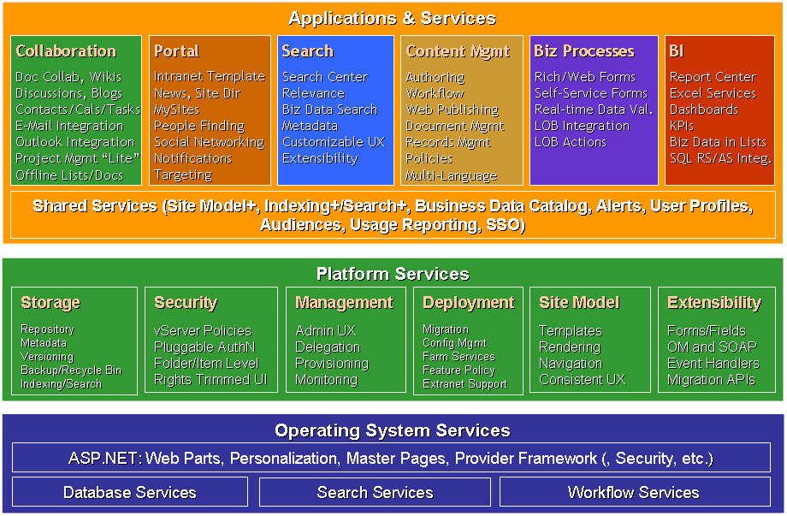Figure 1. Microsoft SharePoint Products and Technologies architecture

Operating System and Database Services
Windows SharePoint Services is built on the technologies and services introduced under Windows Server 2003 and extended in Windows Server 2008. Its data repository is supported under Microsoft SQL Server™ 2005 (as well as SQL Server 2000).
The core and development platform operating system services include:
- Microsoft .NET Framework 3.0 which includes:
ASP.NET 2.0 master pages, content pages, and Web Parts
Pluggable service-provider models for personalization, membership, navigation, and security
Database access services
- Internet Information Services (IIS)
- Windows Workflow Foundation
- Windows desktop indexing and search services
SQL Server is the relational database used for storing all content, data, and configuration information used by Windows SharePoint Services. Windows Internal Database is included as a default part of the installation. Windows Internal Database uses SQL Server technology as a relational data store for Windows roles and features only, such as Windows SharePoint Services, Active Directory Rights Management Services, UDDI Services, Windows Server Update Services, and Windows System Resources Manager.
Deployment Scenarios
Windows SharePoint Services version 3.0 offers flexible deployment options across a range of platform configurations and topologies, both single and multiple tiers. This means that you can implement the right solutions to support your current and future requirements.
Single-Tier Implementation (Single Server)
For a small business or departmental group you can deploy Windows SharePoint Services on a single server. This configuration can utilize either Windows Internal Database or SQL Server 2005 databases, dependent on the existing database strategy or requirements. This architecture is illustrated in Figure 2.
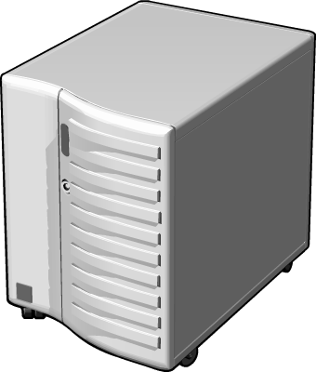
Figure 2. Single Server Architecture

The single server can also house the Windows SharePoint Services Search services and Web servers. This configuration offers ease of installation and management. In addition, you can scale this topology to meet the growing demands of your organization.

Two-Tier Implementation (Small Farm)
Should your capacity planning indicate that loading will exceed the capabilities offered by a single server or you need to implement your solution using IT-managed databases, you can implement a solution over two tiers. Within this scenario you can split the database server from the Web servers and search services. This offers additional load management flexibility, since additional Web servers can be added to handle additional usage. This architecture is illustrated in Figure 3.
Figure 3. Two-Tier Architecture

Three-Tier Implementation (Medium or Large Farm)
A three-tier implementation uses multiple Web servers to support high usage or large volumes of data, with dedicated application servers providing search facilities and other features. Separate SQL Server 2005 servers provide database services, in either a single server or failover cluster. In this topology the configuration, content, and administration content databases are distributed to separate SQL servers or SQL Server clusters. This would most commonly be the case for large farms. A three- tier topology supports a larger user community because it can improve database services, and application services such as search and indexing performance, provides very large data capacity, and provides extensible load balancing across applications and solutions. This architecture is illustrated in Figure 4.

Figure 4. Three-Tier Architecture

All of the topologies can scale up or out by the addition of internal or external hardware, such as additional processors or clustered servers. You can also introduce additional hardware to improve performance.
Planning and Design Support
Microsoft provides a rich set of worksheets to help you plan and design your Windows SharePoint Services implementation. These take you through the planning and design steps for a successful implementation. The worksheet will support you as you:
- Determine organization and user needs
- Plan Web site structure and publishing
- Plan for content and search
- Plan site and content security
- Plan communication
- Plan for site creation and maintenance
- Plan for and design security
All planning and design worksheets for these tasks are at Planning worksheets for Windows SharePoint Services.
Migration
Many organizations are planning to upgrade their current Windows SharePoint Services implementations to derive the benefits of the new and enhanced features and performance improvements. The flexibility of Windows SharePoint Server topologies and configurations mean that different organizations will employ one of a variety of migration approaches. The main three options are:
- In-place upgrade: The Windows SharePoint Services executable file identifies an existing Windows SharePoint Services 2.0 installation and then upgrades all the sites at one time when you install Windows SharePoint Services.
- Gradual upgrade: You can select individual or groups of sites for the upgrade. You can also roll back the changes if any problem related to site functionality occurs, because this approach does not overwrite the Windows SharePoint Services 2.0 installation.
- Database migration: You can create a new Windows SharePoint Services implementation and then import the Windows SharePoint Services 2.0 site databases except for the configuration database. You then need to add the databases to a new stand-alone or server farm installation.
Pros and Cons of the Three Approaches for Upgrading to Windows SharePoint Services 3.0
There are advantages and disadvantages for each of these approaches, which are dependent on your migration environment. You should account for each of these during your migration planning.
In-place Upgrade
Advantages
This is the most common and easiest approach, which:
- Allows sites to retain their original URLs. This helps users to continue to access the site with the same URL that they used to access the site before the upgrade.
- Updates existing databases and servers by using the existing hardware.
Considerations
- Needs an offline environment.
- Does not allow users to access sites when an upgrade is in progress.
- Provides no scope to revert to the Windows SharePoint Services 2.0 site because the old version is overwritten with the new version, and the content databases are changed.

Gradual Upgrade
Advantages
- Allows a more granular approach. You can upgrade at the site-collection level.
- Reduces impact on users because only the site collections that are currently being upgraded are offline.
- Allows sites to retain their original URLs.
- Allows sites to revert to the Windows SharePoint Services 2.0 sites.
- Uses the existing hardware.
Considerations
- Requires three times the storage capacity of the original server because it runs both Windows SharePoint Services 2.0 and 3.0 simultaneously on the same server.
- Needs to create Domain Name System (DNS) entries to be used to redirect URLs during the upgrade.
- Requires extra storage in SQL Server, because it maintains a copy of Windows SharePoint Services 2.0 even after the upgrade.
- Does not support Windows SharePoint Services 2.0 scalable hosting mode.
Database Migration
Advantages
- Database is independent of server farm hardware.
- Retains the Windows SharePoint Services 2.0 environment after the upgrade.
Considerations
- Requires additional configuration to retain the original URLs of the sites.
- Requires twice the amount of SQL Server online storage space than that of the current SQL Server being upgraded.
Administrative Tasks and System Management
Windows SharePoint Services 3.0 simplifies administration by providing a single, consistent interface for system administration and by providing the flexibility to delegate tasks. From this interface you can manage both system functionality and perform administrative functions, such as creating and configuring sites and implementing site features.
An administrator can also manage operational aspects of Windows SharePoint Services and application elements, such as backup and e-mail integration.
Administrative Tasks
Windows SharePoint Services 3.0 provides a unified interface where you can manage the key administration tasks including those that can be seen in Figure 5.
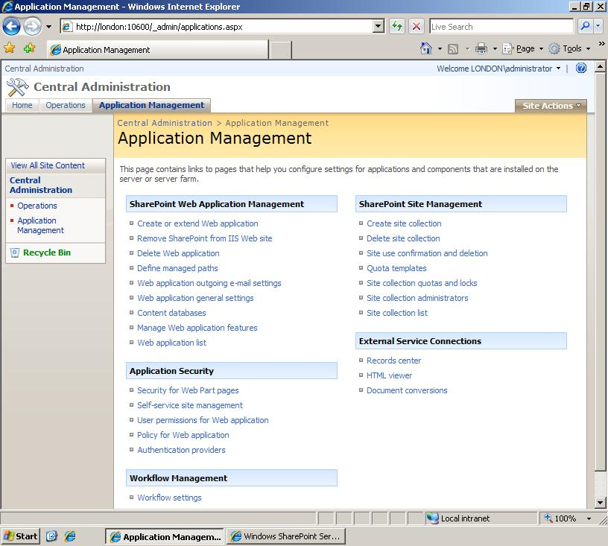
Figure 5. Application Management panel within the Windows
SharePoint Services 3.0 Central Administration interface.

Features. Windows SharePoint Services provides collections of logically related elements or functionality in modular groups called features. These help to reduce the administrative overhead for system managers and can streamline deployment of solution functionality. Features offer ease of deployment and management when compared to configuration options available in previous versions of SharePoint technologies. Administrators can use this proven practice to deploy solution features centrally and to delegate feature management to departmental administration roles, if necessary.

Site Provisioning. Architecturally, Windows SharePoint Services has a three-tier administration model. This makes it easier for IT organizations to differentiate administrative roles and assign administrative responsibilities.
- Tier 1 tasks include the administration of features and functionality for centrally managing the server farm. A tier 1 administrator might be responsible for creating new Web applications and site collections, managing incoming and outgoing e-mail settings for the farm, and managing server farm topology.
- Tier 2 tasks include the administration of features and functionality for managing shared services across a server farm.
- Tier 3 tasks include the administration of features and functionality for managing sites within a server farm. For example, a tier 3 administrator might create new lists on a site, configure access permissions for users, and modify site hierarchy.
Windows SharePoint Services provides a range of site collection and site templates which you can use to quickly create collaborative and meeting sites, including Wiki and blog sites.

Quota Management. You can use quotas to check and limit site storage. This is important in the overall management of your deployment. Windows SharePoint Services provides a flexible quota-management system that allows you to set limits on site and site-collection data sizes. You can send warning e-mails to site owners when site storage reaches a specified threshold limit. You can also automatically stop users from adding additional data to a site if storage reaches the site's maximum limit.

Self-Service Site Creation. Self-Service Site Management allows users to create and manage their own top-level Web sites without needing to use an IT administrator. When you turn on Self-Service Site Management for a Web application, users can create their own top-level Web sites under a specific path. By default this path is /sites/, although you can include other paths as required.
Systems Management
Windows SharePoint Services provides an overview of systems management functions within the Central Administration interface. In addition to this it also integrates with existing systems management tools, such as performance monitor.
Backup and Restore
The backup and restore options are located in Central Administration, on the Operations page. You can back up the entire farm or elements of the farm, such as a single content database. The Select Component to Backup page presents you with a hierarchy to select elements that you want to backup. When you select the Farm level, you can back up the entire Windows SharePoint Services environment, including content databases, configuration files, Shared Services Providers, and search indexes. The interface highlights your selections so you are always aware of what you are about to back up. If you want a more granular backup, you can select component check boxes to back up elements of the farm. Restore uses the same consistent interface.
You can use the stsadm command to run backup and restore commands from a command prompt. You can use these commands with a script to create your own backup schedule. The stsadm -o backup command can back up either site collections or the entire farm.
Recycle Bin
The new Recycle Bin feature allows users to replace data objects that they have inadvertently deleted. The administrator manages the Recycle Bin settings in the Web application settings page. You can choose to have the recycle bin available to all applications, and you can specify the number of days that the deleted data is maintained. There are two stages in the recycle process. The first stage of the Recycle Bin is available to all users and provides a site-level view of deleted content, but users can only retrieve items that they deleted. The second stage is the administrator level, or Site Collection Recycle. Only administrators can access this stage.
Performance Management
In addition to the existing counters in the performance monitor, Windows SharePoint Services provides additional, application-specific counters that you can implement to assess system- intensive activities, such as searching and indexing, which are high-value functions for users.
Security Management
Just as each company is different, so the security requirements of each for its Windows SharePoint Services implementations are different. From the Central Administration interface you can manage a range of security features, both at farm and application levels.
From the Operations page you can manage security features for the entire farm.
The Security Configuration menu enables you to:
- Set the accounts for individual services.
- Implement Information Rights Management.
- Specify antivirus checking for uploading and downloading documents.
(This requires that an antivirus agent be installed on each server.)
- Block file types, based on extensions.
- Manage the Administrator group.
At the application level you can configure a range of application-specific security features.
You can secure user access for a range of permissions, such as use of Web Parts, self-service site creation, and Web application access.
Windows SharePoint Services can also integrate with the wider authentication management and security policies of your organization.
Authentication Providers
You can select the appropriate approach for your business security requirements. Windows SharePoint Services supports “pluggable,” non-Windows based authentication, which may be a benefit within some environments. The broad range of authentication options provides ongoing flexibility as well as security for your implementation. These include:
- NTLM (Windows-integrated) authentication
- Kerberos (Windows-integrated) authentication
- Anonymous authentication
If anonymous access is allowed for the Web application, then site administrators can decide whether to:
  - Grant anonymous access to a site.
  - Grant anonymous access only to lists and libraries.
  - Block anonymous access to an entire site.
- Basic authentication
- ASP.NET Forms
Windows SharePoint Services supports non-Windows-based identity systems by integrating with the pluggable ASP.NET forms authentication system. ASP.NET authentication works with identity management systems that implement the MembershipProvider interface.
- Single Sign-On
Single sign-on authentication enables users to access multiple system resources without having to provide authentication credentials more than once.
You can use a mix of authentication models, which enables you to implement intranets, extranets and Internet solutions. For example, you might authenticate office-based users by using the Kerberos protocol, to take advantage of delegated authentication with downstream services, while using NTLM for remote workers to allow them to access solutions over the Internet from non-trusted client computers. You could also implement anonymous authentication so that content consumers can access the published versions of your content over the Internet.
Manage Permissions through Policies
You might want different users or groups to have different levels of access to sites within Web applications. For example, a financial company with both banking and investment branches might want to limit the access of its investment branch to resources in its banking branch. Using the Application Management interface you can add users to zones and set permission levels such as Full Control, Full Read, Deny Write, or Deny All access.
Install Your Evaluation Server
This section provides steps for installing an evaluation server.
Note: This document covers using the Single Server option and installing Windows SharePoint Services with Windows Internal Database.
Deploy Windows SharePoint Services on a Single Server
The quickest way to get started with Windows SharePoint Services is to install it on a single server computer. Then you can set up a small-scale installation to host several Web sites, without performing many steps. When you install Windows SharePoint Services on a single server, you can choose between the following options:
- Using the Single Server option during Setup, you can install Windows SharePoint Services and publish a working Web site with Windows Internal Database in minutes.
When you install Windows SharePoint Services using the default settings, the Setup program automatically installs Windows Internal Database and uses it to create the database for your Web sites. You don't have to perform any other configuration steps to create the database. This installation scenario offers you the ability to host several Web sites without much overhead.
- Using the Farm option during setup, you can install Windows SharePoint Services to work with an existing installation of SQL Server 2000 Service Pack 3 or later.
This installation scenario enables you to support a larger set of Web sites. When you use this method, you must perform additional steps to configure SQL Server and Windows SharePoint Services to work together. Consider using SQL Server instead of Windows Internal Database if you anticipate supporting more than 10 large, active Web sites. You can also use SQL Server on a remote server to handle larger-scale installations.
Hardware and Software Requirements
Before you install and configure Windows SharePoint Services, you should check to make sure you meet the hardware and software requirements.
The recommended hardware and software requirements for Windows SharePoint Services can be found in Appendix A—Hardware and Software Requirements.

The preparations of the server platform differ slightly between Windows Server 2003 and Windows Server 2008. These procedures are covered separately here.

Windows SharePoint Services on Windows Server 2003
Before you can install Windows SharePoint Services, you must install and configure Internet Information Services (IIS), Microsoft .NET Framework 2.0, and Microsoft .NET Framework 3.0. The following procedures guide you through installing and configuring these prerequisites.
Configure the Server as a Web Server
IIS is not enabled by default in Windows Server 2003. To make your server into a Web server, you must turn on IIS.
Enable IIS and Configure It to Use IIS 6.0 Worker Process Isolation Mode
- Click Start, click All Programs, click Administrative Tools, and then click Manage Your Server.
- On the Manage Your Server page, click Add or remove a role.
- In the Preliminary Steps pane, click Next.
- In the Server Role pane, click Application server (IIS, ASP.NET), and then click Next.
- In the Web Application Server Options pane, select Enable ASP.Net and then click Next.
- In the Summary of Selections pane, click Next.
- In the This Server is Now an Application Server pane, click Finish.
- Click Start, click All Programs, click Administrative Tools, and then click Internet Information Services (IIS) Manager.
- In Internet Information Services Manager, click the plus sign (+) next to the server name, and then right-click the Web Sites folder and select Properties.
- In the Properties dialog box, click the Service tab.
- In the Isolation mode section, verify that the Run WWW service in IIS 5.0 isolation mode check box is not selected, and then click OK.
Note: The Run WWW service in IIS 5.0 isolation mode check box is only selected if you have upgraded to IIS 6.0 on Windows Server 2003 from IIS 5.0 on Windows 2000 Server. New installations of IIS 6.0 use IIS 6.0 worker process isolation mode by default.
Install the Microsoft .NET Framework 2.0
Windows SharePoint Services requires version 2.0 of the .NET Framework. Follow the instructions below to install the .NET Framework.
Download and Install the .NET Framework 2.0
- From the Microsoft Download Center Web site, on the Microsoft .NET Framework Version 2.0 Redistributable Package (x86) page, click Download, and then click Run to install dotnetfx.exe.
- On the Welcome to Microsoft .NET Framework Version 2.0 Setup page, click Next.
- On the End-User License Agreement page, read the license agreement, select the I accept the terms of the License Agreement check box, and then click Install.
Note: If you see an error message that says you need to close the Download process first, click Ignore to continue with the installation.
- On the Setup Complete page, click Finish.
Verify that Microsoft ASP.NET 2.0 is Enabled in IIS
- Click Start, click All Programs, click Administrative Tools, and then click Internet Information Services (IIS) Manager.
- In Internet Information Services Manager, click the plus sign (+) next to the server name, and then click the Web Service Extensions folder.
- In the Web Service Extensions pane, verify that ASP.NET v2.0.50727 is allowed.
Configure IIS for ASP.NET 2.0
If you are using an existing IIS Web site to run Windows SharePoint Services, you must enable ASP.NET version 2.0 for that IIS Web site. If you choose to allow the setup process to create a new IIS Web site for you, ASP.NET version 2.0 is automatically configured for the new IIS Web site and you do not need to perform this procedure.
- Click Start, click All Programs, click Administrative Tools, and then click Internet Information Services (IIS) Manager.
- In IIS Manager, locate the Web site you want to configure to use ASP.NET version 2.0.
- Right-click the Web site, and then click Properties.
- On the ASP.NET tab, in the ASP.NET version box, select 2.0.50727.
- Click Apply, and then click OK.
Restart IIS
- Click Start, and then click Run.
- In the Open box, type cmd.exe, and then click OK.
- At the command prompt, type iisreset.exe, and then press ENTER.
- Type exit, and then press ENTER to exit Command Prompt.
Download and Install the .NET Framework 3.0
- From the Microsoft Download Center Web site, on the Microsoft .NET Framework Version 3.0 Redistributable Package (x86) page, click Download, and then click Run to install dotnetfx3setup.exe.
- On the Microsoft .NET Framework 3.0 Setup page select the I have read and ACCEPT the terms of the License Agreement radio button, and then click Install.
- Click the Microsoft .NET Framework 3.0 Setup balloon.
- On the Setup Complete page click Exit.
Your Windows Server 2003 environment is now ready for the installation of Windows SharePoint Services 3.0. Skip directly to the section entitled Install Windows SharePoint Services with Windows Internal Database
Windows SharePoint Services on Windows Server 2008
To install Windows SharePoint Services on Windows Server 2008 you must add the Web Server role to the server and enable several features. When you first install Windows Server 2008 and log on as an administrator, you will be presented with the Initial Configuration Tasks dialog. If this dialog does not appear:
- From the Start menu, select Run (or open a command prompt).
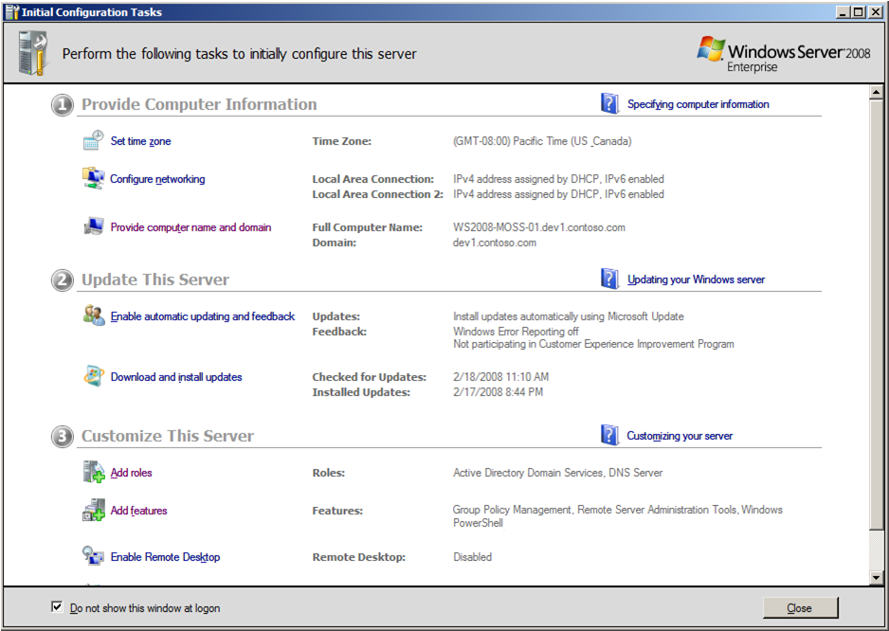
- Type oobe and hit Enter.

Figure 6. Windows Server 2008 - Initial Configuration Tasks
You will now see the Initial Configuration Tasks dialog. Follow this procedure:
- Under Customize This Server, click Add roles.
- Select Web Server (IIS).
- From the prompt requesting Windows Process Activation Services click Add Required Features.
- From the Select Server Roles page, click Next.
- From Web server (IIS) click Next.
- From Select Role Services, select the following:
  - Application Development:
    - ASP.NET
      - From Add role services and features required for ASP.Net click Add Required Role Services.
    - .NET Extensibility (this will be already selected)
    - ISAPI Extensions (already selected)
    - ISAPI Filters (already selected)
  - Health and Diagnostics
    - HTTP Logging (already selected)
    - Request Monitor (already selected)
  - Security
    - Basic Authentication
    - Windows Authentication
    - Digest Authentication
    - Request Filtering (already selected)
  - Management Tools
    - Select all services
- Click Next.
- From Confirm Installation Selections click Install.
- From Installation Results click Close.
- From the Initial Configuration Tasks dialog, click Add features
- Select SMTP Server and click Add Required Features at the prompt.
- Click Install.
- From Installation Results click Close.
- From Initial Configuration Tasks, click Add features.
- Install .NET Framework 3.0 Features and all sub-features contained within it.
Your server will now be configured to begin the installation of Windows SharePoint Services.

Install Windows SharePoint Services with Windows Internal Database
Because you are installing to a single, stand-alone server, you can run the Setup program using the Single Server option, accepting all the defaults. In the default installation, Windows Internal Database is installed as part of the Setup program.
- From the product download, run SharePoint.exe.
- Click I accept the terms of this agreement, and then click Continue.
- Click Basic.
- When the installer has completed, click Close.
- On the SharePoint Products and Technologies Configuration Wizard page, click Next.
- On the SharePoint Products and Technologies Configuration Wizard dialog, click Yes.
- When the Configuration Successful screen appears, click Finish.
The home page of your new SharePoint site opens.
If you see an access denied error message, you might need to enter your user name and password before the home page can display.
If you see a proxy server error message, you might need to add the site to the list of intranet sites or configure your proxy server settings to bypass the proxy server for local addresses before you can see the home page. Use the following procedures to configure these settings.
Add the SharePoint Site to the List of Intranet Sites
- In Internet Explorer, on the Tools menu, click Internet Options.
- On the Security tab, in the Select a Web zone to view or change security settings box, click Local intranet, and then click Sites.
- In the Local intranet dialog box click Advanced.
- Clear the Require server verification (https:) for all sites in this zone check box.
- In the Add this Website to the zone box, type the URL of your site, and then click Add.
- Click Close to close the Local intranet dialog box.
- Click OK to close the Local intranet dialog box.
- Click OK to close the Internet Options dialog box.
- On the Internet Explorer toolbar, click Refresh.
NOTE: If the page still does not appear, and you see a proxy server error, continue with the following procedure.
Configure Proxy Server Settings to Bypass the Proxy Server for Local Addresses
- In Internet Explorer, on the Tools menu, click Internet Options.
- On the Connections tab, in the Local Area Network (LAN) Settings area, click LAN Settings.
- In the Proxy Server area, select the Bypass proxy server for local addresses check box.
- Click OK to close the Local Area Network (LAN) Settings dialog box.
- Click OK again to close the Internet Options dialog box.
- On the Internet Explorer toolbar, click Refresh.
After You Install Windows SharePoint Services with Windows Internal Database
After Setup finishes, you have a new Web site that is extended with Windows SharePoint Services. Your browser window opens to the home page of your new Web site, and you can start adding content right away, or you can customize the site or set administrative options by using Central Administration. Some actions you can take to start working with your site are:
- Adding users to the site.
- Customizing the home page and other pages in the site.
- Creating lists or document libraries and adding content.
You can also use SharePoint Central Administration to configure additional settings for your server. For example, you can:
- Configure incoming e-mail settings. Incoming e-mail enables your users to send content to your SharePoint site through e-mail, or to send an e-mail message to all members of your SharePoint site.
- Configure e-mail alert settings. When you configure these settings, users can sign up to receive e-mail alerts that notify them of changes to the site.
- Configure antivirus protection settings. If you have installed an antivirus application that is compatible with Windows SharePoint Services, you can configure options to scan documents as they are uploaded to or downloaded from your SharePoint sites.
For more information about any of these tasks, see the Task list on the home page of SharePoint Central Administration.
Upgrade from Windows SharePoint Services 2.0 SP2 to Windows SharePoint Services for Evaluation Purposes
If you currently have a Windows SharePoint Services 2.0 evaluation environment, you can upgrade it to Windows SharePoint Services to perform your evaluation exercises.
You should adhere to the guidance from the following location to perform an upgrade:
http://technet2.microsoft.com/windowsserver/WSS/en/library/91046a84-57a1-40cb-a32c-ff3395073dc91033.mspx

An End User Perspective
This section enables you to evaluate Windows SharePoint Services from the perspective of an end user.
Windows SharePoint Services Tour
Windows SharePoint Services provides a lot of rich functionality. In this section, we will explore just a few of the things you can do as an end user by exploring a handful of the out-of-the-box applications. Windows SharePoint Services provides pre-built SharePoint site templates with which you can quickly and easily create a professional site or workspace for collaborating with colleagues. For example, you might create a site to manage a department or project.
Templates are available for a variety of interesting and useful sites and pages, including:
- Blogs. A blog (short for weblog) consists of frequent short comments, called posts. The posts are displayed in order, starting with the most recent comment, with the blogger’s name and the date attached. Some possible uses for a blog are:
An executive's journal for sharing his thoughts and vision.
A community for building customer relationships.
An informal site where teams can share news and tips.
With just a few clicks, you can create a blog, post a comment, subscribe to blog updates, and customize the blog. You can enable the blog to accept comments, or you can turn comments off for a specific post or for the entire blog.
- Wiki sites. A wiki site can be quickly set up to enable a group to brainstorm ideas, collaborate on a team design, build an encyclopedia of knowledge, or just gather daily information in a format that's easy to create and modify (Wiki wiki means quickly in Hawaiian). Team members can contribute to a wiki from their browser—they don't need a word processor or special technical knowledge.
- Surveys. Windows SharePoint Services provides more flexible surveys, including more robust questions and better control over the layout.
You can set up questions to appear conditionally, based on a response to a previous question in the survey. For example, if you are seeking feedback from convention attendees, you can first ask which sessions they attended and then display only questions about those sessions. You can insert page breaks to better organize the survey, and you can include more survey questions. (Although there are no built-in restrictions to the number of questions you can include, you might be limited by the size of your database and bandwidth resources.)
- Gantt charts. You can create a Project Tasks list, which includes a Gantt chart. A Gantt chart is a visual overview of the project that you can use to monitor dates and the progress of team tasks.
Explore a Windows SharePoint Services Site
The exercises in this Windows SharePoint Services tour show you some of the new ways to work with the Windows SharePoint Services technology:

Exercise 1: Explore a Home Page
The most common SharePoint site is a team site, through which team members can collaborate and communicate. The SharePoint Team Site template includes a document library and basic lists such as Announcements, Contacts, Events, and Quick Links.
- Start Internet Explorer to display the default team site. New security measures in Windows SharePoint Services eliminate clutter by helping to ensure that each SharePoint site user sees only the parts of the site that he or she has access to.
If other sites are available from this one, you access them from the navigation bar at the top.
You access this site’s document libraries and lists from the Quick Launch bar on the left side of the window. You can add any items you like to the Quick Launch bar, including text and images.
You can quickly locate specific items by using the site-wide Search function. Various types of information such as announcements, calendars, links, and discussion boards are presented on the home page in Web Parts. The SharePoint site administrator can format and position each Web Part without affecting its content.
- On the Quick Launch bar, click Shared Documents. The contents of the default document library are displayed.
You can share many types of files such as Word documents, Excel workbooks, and PowerPoint presentations (collectively referred to as documents) with team members by adding them to a SharePoint document library. You can add existing documents or create new documents from within a document library.
Each document library supports the creation of one or more types of document. Documents you create from within a document library are automatically added to it. You specify the default document type while creating the document library. If your team uses custom document templates, you can also make these available from the document library.
To create a new document from within a SharePoint document library, simply select the type of document you want to create from the New menu.
- On the Quick Launch bar, click Tasks. The contents of this list are displayed. This is the same information that is displayed on the home page in the Tasks Web Part.
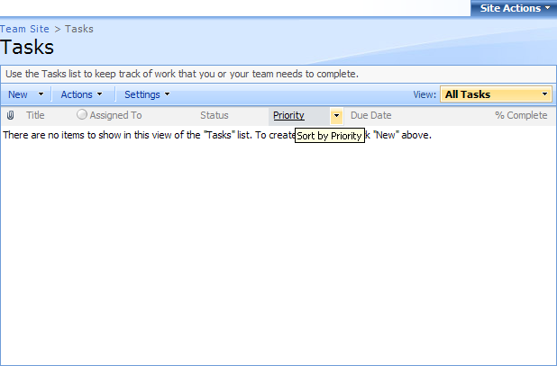
Figure 7. The Tasks list.

Exercise 2: Create a SharePoint List or Library
Windows SharePoint Services provides many standard document libraries and lists. You can use these as-is, modify them to fit your needs, or create your own from scratch.
- Start Internet Explorer to display the default team site.
- On the Quick Launch bar, click View All Site Content. The All Site Content page provides access to all document and picture libraries, lists, surveys, sites, and workspaces that are linked to the site, as well as access to the Recycle Bin.
- At the top of the All Site Content page, click Create. The Create page is displayed. From this page, you can create a new document library, picture library, list, custom list, survey, or Web page.
Note: Contributor rights are required for some site actions, but even an invited member can create new site elements. As a result, the Windows SharePoint Services technology fosters a highly collaborative environment.
- Hover over a few of the elements that interest you. A description of the element is displayed at the top of the Create page.
- In the Libraries section, click Document Library. The New Document Library page is displayed.
- In the Name box, type the name that you want to give the document library.
- In the Description box, type the description of the document library.
- In the Create a version each time you edit a file in this document library? area, select Yes.
- In the Document Template box, select a default document format for your library. If you want to create and store different types of documents in your library, select None.

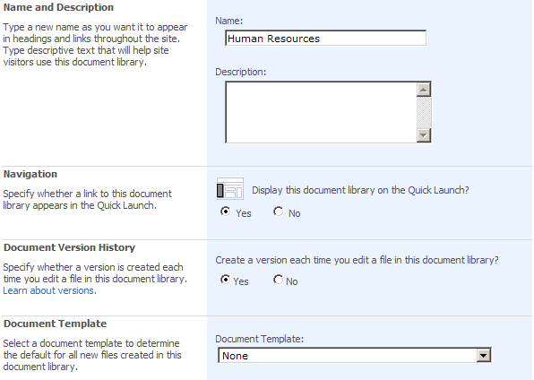
Figure 8. Creating a new document.

- Click Create. The new document library opens, ready for you to add documents to it.
You can export a copy of a document library from a SharePoint site to Office Outlook 2007. You can preview documents, spreadsheets, and presentations in the Outlook message pane, and work with local copies of the documents on your computer.

Exercise 3: Create an Announcement
- Start Internet Explorer to display the default team site.
- At the bottom of the Announcements Web Part, click Add new announcement. The Announcements: New Item page is displayed.
- In the Title box, type Special Employee Health Club Offer.
- In the Body box, type The local health club is offering a 20 percent discount on annual memberships for employees purchasing new memberships or renewing by the end of this month.
You can format the text of your announcement by using the formatting buttons above the Body box. You can attach files to the announcement by clicking the Attach File button on the toolbar.
- To the right of the Expires box, click Date Picker, and then click the last day of the month.

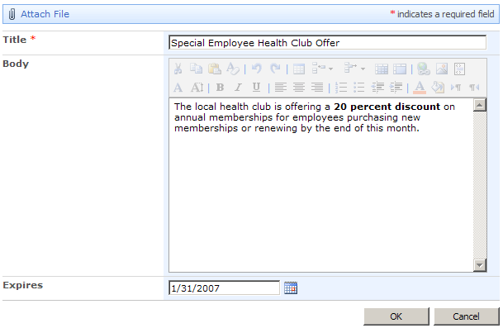
Figure 9. Creating a new announcement.

- Make any additional changes you want, and then click OK. The new announcement appears in the Announcements list.


Figure 10. New announcement as shown in the Announcements Web Part.

Exercise 4: View and Modify Document Settings for Version Control
By default, only the current version of a document is available to site users in a document library. However, if your organization is concerned about version control, you can choose to retain previous versions in the library. Site users can then view previous versions to locate lost content or to discover the source or date of a particular change.
- Start Internet Explorer to display the default team site.
- On the Quick Launch bar, click Shared Documents.
- On the Settings menu, click Document Library Settings. The Customize Shared Documents page is displayed.
From this page, you can make changes to the general settings, permissions and policies, communications, columns, and views of the selected document library. Changes you make on this page do not affect the entire site.
Note: Notice the many types of changes you can make from the Customize page. You might want to explore the options on this page on your own.
- In the General Settings list, click Versioning Settings. You now see the Document Library Versioning Settings page for the Shared Documents document library. From this page, you can specify whether:
New and changed documents must be approved by a specific person before they are available from the site.
Windows SharePoint Services retains prior versions of updated documents.
Site users can see draft documents that haven’t been declared final.
Users must check out documents before editing them.
Users can create multiple types of content from the New menu.
Each of these options is useful when developing content in a collaborative environment.
Note: The Content Approval option is part of the new Windows Workflow Foundation functionality. If you use Office SharePoint Designer 2007 to create and manage SharePoint sites, you can attach workflows to document libraries and lists. These workflows monitor events and conditions within the library or list and then take action, such as routing a file for approval or sending an e-mail message.
- In the Document Version History area, select the Create major versions option. You can select the version options that fit best with the expected frequency of document updates. You can also specify how many previous versions of a document should be retained.
- In the Require Check Out area, select the Yes option.

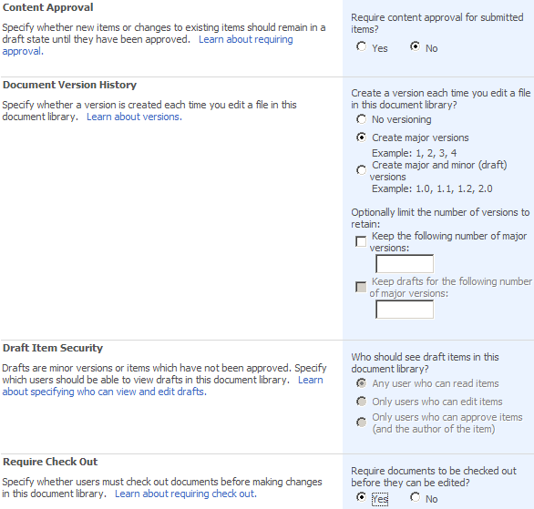
Figure 11. Configuring document library versions settings.

- On the Document Library Versioning Settings page, click OK.
Exercise 5: Sign Up for an Alert
Alerts are a very useful part of the Windows SharePoint Services technology. You can sign up to receive an alert when a change is made to the contents of a document library. This technique keeps you up to date with the document updates that you need to know about so you don’t have to constantly check the library.
- Start Internet Explorer to display the default team site.
- On the Quick Launch bar, click Shared Documents.
- On the Actions menu, click Alert Me. The New Alert page is displayed.
If you retain the default settings, you will be notified when any type of change is made to any document within the selected document library. You can change the settings to restrict the alerts to certain types of changes. You can also specify whether notifications should be sent immediately, daily, or weekly.
- On the New Alert page, click OK. An e-mail message notifies you when the alert has been created.

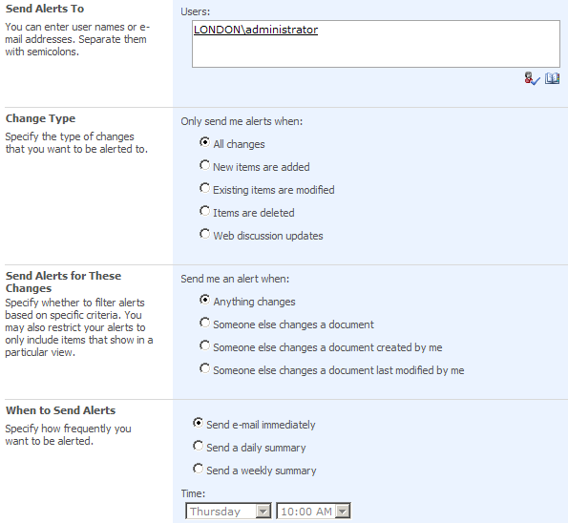
Figure 12. Creating a new alert.

- Start Outlook, and display the Inbox. The alert notification appears in the Inbox.

Exercise 6: Modify a Document from a SharePoint Site
You can easily check out a document from a SharePoint site, make changes to it, and then check it back in to make your modified version available to all site members.
- Start Internet Explorer to display the default team site.
- On the Quick Launch bar, click Shared Documents.
- In the document library, click a document, click the arrow that appears to the right of the document name, and then click Check Out. When you check out a document, you can choose to work with an online or offline copy of the document.
- In the Microsoft Internet Explorer message box, with the Work Offline check box selected, click OK. The document is now checked out to you. Other users will not be able to edit the document until you check it back in.
- In the document library, click the same document, click the arrow that appears to the right of the document name, and then click Edit in Microsoft Office Word.

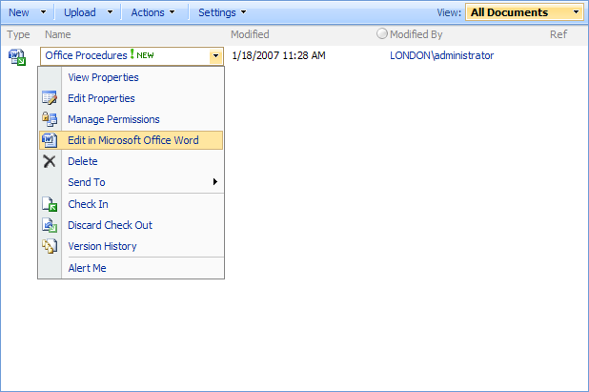
Figure 13. Editing a document.

- In the Microsoft Internet Explorer message box that asks you to confirm that you want to open the file, click OK. Office Word 2007 starts and displays the selected document. The Document Management task pane on the right side of the screen displays the open document’s status. Separate tabs display information about site members, tasks, documents, and links.
- Scroll down the document.
- Select the word and change it to Ongoing.
- In the Document Management task pane, click Check In. The Check In dialog box appears.
- In the Comments box, type Corrected spelling error. Then click OK.

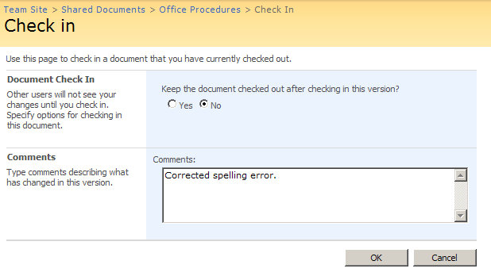
Figure 14. Checking-in a document.
Note: You have the option of checking in the current version and then checking it out again. Using this option helps ensure that current information is available to site users while you are still developing the final content.
The Document Management task pane now shows the status of the document as read-only. You can open the document for more editing by clicking Edit Document on the Server Document bar at the top of the Word workspace.
- On the Word File menu, click Close. The Shared Documents page now shows the modification date and time, as well as any check-in comments.
If you enabled versioning in Exercise 4, you have now created Version 2 of the Music Market document. If you signed up for e-mail alerts in Exercise 5, you will receive one now.

Exercise 7: View an RSS Feed
Many news sites, blogs, and other online information providers use Really Simple Syndication (RSS) to automatically feed information to subscribers. With Windows SharePoint Services, every SharePoint list is RSS-enabled. If you have an RSS reader (such as in Office Outlook 2007 or Internet Explorer 7), you can view the RSS feed for a document library or list. Changes to the list content will appear in your RSS reader.
- Start Internet Explorer to display the default team site.
- On the Quick Launch bar, click Shared Documents.
- On the Actions menu, click View RSS Feed. The RSS Feed page for the selected document library is displayed. The page provides links to each document in the library and shows the current status of each one.
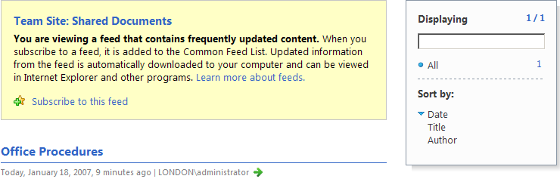
Figure 15. An RSS feed for a SharePoint document library displayed within Internet Explorer 7.

- In the text below the page title, click Subscribe to this RSS feed.
- Start Office Outlook 2007.
- In the All Mail Items list in the Navigation Pane, click RSS Subscriptions. Outlook 2007 displays the Shared Documents document library information.

Exercise 8: Upload a Document to a SharePoint Site
Information that is important to an organization, a business unit, or a project team is often stored on an individual’s computer. To facilitate the easy sharing of information, you can make files available to other SharePoint site users.
- Start Internet Explorer to display the default team site.
- On the Quick Launch bar, click Shared Documents.
- On the Upload menu, click Upload Document. You see the Upload Document page for the selected document library.
- In the Upload Document area, click the Browse button.
- In the Choose File dialog box, browse to the document you want to upload, and then click Open.
Note: If a document with the same name already exists in the document library, selecting the Overwrite Existing File(s) check box automatically overwrites the existing version with your local version.
- On the Upload Document page, click OK. The selected document is added to the document library.
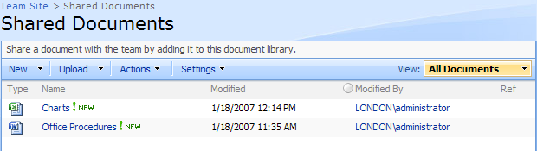
Figure 16. A list of new documents within a SharePoint document library.

Exercise 9: Create a SharePoint Team Site
As a security measure, Windows SharePoint Services allows each site user to see only those actions he or she has permission to perform. Provided you have permission to create sites and workspaces, you can easily add new sites and workspaces to your organization’s primary SharePoint site.
- Start Internet Explorer to display the default team site.
- In the upper-right corner of the home page, click Site Actions, and then click Create. The Create page is displayed.
Note: The Site Actions tab appears only if the user has permission to create sites, create pages, edit pages, or manage site settings. The Site Actions list includes only the actions that the user is allowed to perform.
- In the Web Pages list, click Sites and Workspaces. You see the New SharePoint Site page.
- In the Title and Description area, type Marketing Team in the Title box and This is a central collaboration point for all marketing campaigns in the Description box.
- In the Web Site Address area, type marketing in the URL name box.
Note: The name you type here is added to the end of the parent site’s Web address. After creating the site, you can change the title and description, but you can’t change the URL without deleting and recreating the site. So take care when choosing the URL.
- In the Template Selection area, click Team Site in the Select a template list.
The available templates vary based on how the Windows SharePoint Services technology is installed. The wide variety of prebuilt templates will fit most needs, but custom templates can also appear in this list. Notice the new Wiki Site and Blog templates.
- In the Permissions area, leave selected the Use same permissions as parent site option. With this option, changes to the parent site’s permissions are quickly reflected on this sub-site.
- On the New SharePoint Site page, click Create.
Note: If you selected the Use Unique Permissions option in step 6, you are now asked to set up groups for the visitors, members, and owners of the new site.
- SharePoint displays the new Marketing Team site.
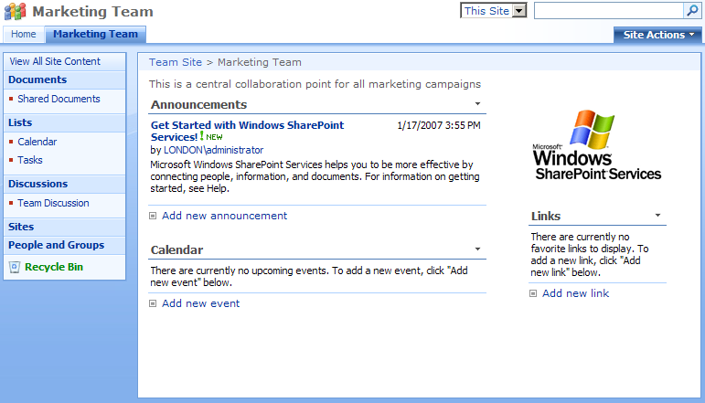
Figure 17. The default home page of a new SharePoint team site.

Exercise 10: Add a Web Part to a SharePoint Site
Web Parts are ASP.NET server controls that display content defined by a site administrator or site user. You can easily add, configure, move, and close Web Parts.
- Start Internet Explorer to display the default team site.
The Announcements, Calendar, and Links areas that appear on this site’s home page are standard Web Parts created by the Team Site template. Each Web Part displays a view of its corresponding list.
- Click the arrow at the right end of the Announcements Web Part header and then click Close to hide the Web Part.
Closing a Web Part does not delete the associated list. Depending on your permissions, you might be able to customize the Web Part display of only your personal view of the site, or you might be able to customize the views of all site visitors.
- In the upper-right corner of the page, click Site Actions, and then click Edit Page.
The page switches to Design Mode, as indicated by the Exit Edit Mode button under the Site Actions button. In Design Mode, you can add new Web Parts and remove or update existing Web Parts on the page.
The logo appearing in the upper-right corner of the page is displayed by a Site Image Web Part.
- In the upper-right corner of the Site Image Web Part, click the X to remove the logo from the page. The current page is organized in Left and Right columns. You can also add a Center column.
- At the top of the Left column, click Add a Web Part. The Add Web Parts To Left dialog box opens.
Note: This technique is new in Windows SharePoint Services and provides a much simpler way of adding Web Parts than in previous versions.
- In the Lists and Libraries list, select the Shared Documents check box, and then click Add.
The Shared Documents Web Part appears at the top of the Left column.
- At the top of the Right column, click Add a Web Part. The Add Web Parts To Right dialog box opens.
- Scroll to the end of the list, select the Page Viewer check box, and then click Add. The Page Viewer Web Part appears at the top of the Right column.
- In the upper-right corner of the page, click Exit Design Mode. The new Web Parts appear on the site. By default, each appears at the top of its column. You can easily move Web Parts within or between columns.
- In the upper-right corner of the page, click Site Actions, and then click Edit Page.
- Click the Page Viewer Web Part header, and when the pointer becomes a four-headed arrow, drag the Web Part to the top of the Left column.
- In the upper-right corner of the page, click Exit Design Mode to return to the standard view of the site’s home page.

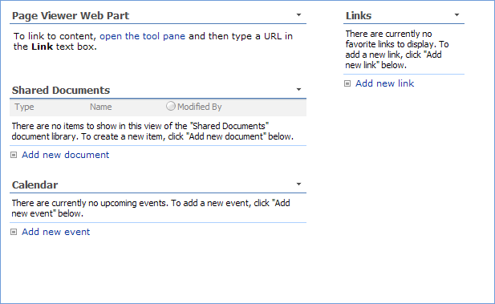
Figure 18. A variety of Web Parts displayed on a SharePoint site page.

Exercise 11: Configure a Web Part
After you add a Web Part to a page, you can easily configure it to display the content you want.
- Complete Exercise 3 to add a Page Viewer Web Part to the default team site home page.
- Click the arrow at the right end of the Page Viewer Web Part header, and then click Modify Shared Web Part. The Page Viewer Web Part pane opens. You can display a Web page, folder, or file in this type of Web Part.
- With the Web Page option selected, type http://office.microsoft.com in the Link box, and click OK. A portion of the Office Online Web page appears in the Page Viewer Web Part.

Exercise 12: Upload a Document to a SharePoint Site
If you want to make a document that you have created on your own computer available to other people, you can easily share it by uploading it to a SharePoint site.
- Start Internet Explorer to display the default team site.
- On the Quick Launch bar, click Shared Documents.
- On the Upload menu, click Upload Document. SharePoint displays the Upload Document page for the selected document library.
- In the Upload Document area, click the Browse button.
- In the Choose File dialog box, browse to the file that you want to upload, and then click Open.
Note: If a document with the same name already exists in the SharePoint document library, selecting the Overwrite Existing File(s) check box automatically overwrites the existing version with your local version.
- On the Upload Document page, click OK. SharePoint adds the selected document to the document library.
The Windows SharePoint Services technology enables you to define access rights for individual documents. To control who can access a document after you have uploaded it, display the document library, click the document, click the arrow that appears to the right of the document name, and then click Manage Permissions.

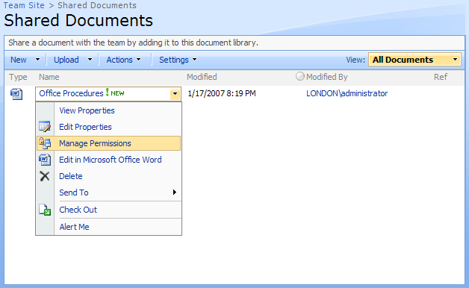
Figure 19. The Manage Permissions option for a document on a SharePoint site.

Exercise 13: Create a Folder
Document libraries can contain folders as well as files. Just as you can set permissions for a document, you can set permissions at the folder level. For example, you might want to restrict access to a folder containing sensitive financial data.
- Start Internet Explorer to display the default team site.
- On the Quick Launch bar, click Shared Documents. The Shared Documents document library is displayed.
- On the New menu, click New Folder. You now see the Shared Documents: New Folder page.
- In the Name box, type a name for the new folder, and then click OK. You can add documents to the folder the same way you add them to a top-level content library.
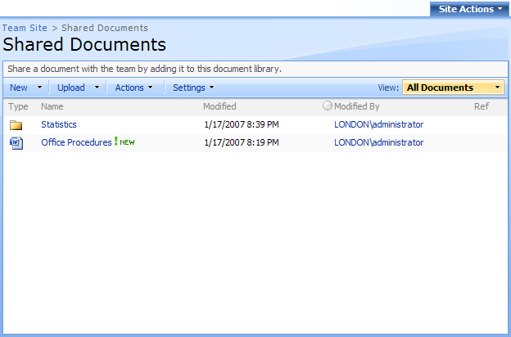
Figure 20. A list of documents and folders within a SharePoint document library.

Exercise 14: Create and Populate a List
Windows SharePoint Services provides many types of lists, each of which is configured to store a specific type of content. SharePoint sites created from prebuilt templates automatically include appropriate lists. You can delete the lists you don’t need and add new lists.
- Start Internet Explorer to display the default team site.
- In the upper-right corner of the page, click Site Actions, and then click Create. The Create page is displayed. Notice the variety of lists you can create.
- In the Communications, Tracking, and Custom Lists lists, click each type of list to view a description at the top of the page.
- In the Communications list, click Contacts. You see the New page.
- In the Name and Description area, type Employees in the Name box and Employee after-hours contact information in the Description box. By default, a link to this list will appear on the Quick Launch bar.
- On the New page, click Create. The Employees contact list is displayed.
- On the New menu, click New Item. The Employees: New Item page is displayed. Notice the fields created as part of the contact list.
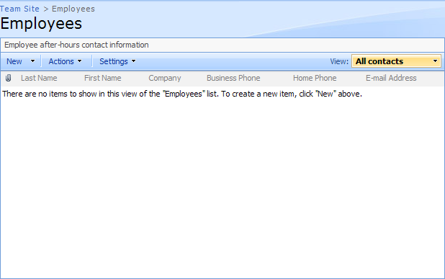
Figure 21. A new Employees list on a SharePoint site.

Note: If the default fields created by a list template don’t meet your needs, you can add, edit, or delete fields. To do this, display the list, and then click the Settings menu.
- Type your own information into the contact list fields, and then click OK. The Employees list displays your contact information. You can attach files to contact list items. For example, you might want to attach a photo or resume.

Exercise 15: Create a Custom List from an Excel Workbook
Windows SharePoint Services supports larger, more versatile lists than previous versions. If you have already entered a list of information in an Excel worksheet, you don’t have to retype the data in a SharePoint list. You can import the Excel data as a SharePoint list to make it easily available to team members.
- Start Internet Explorer to display the default team site.
- In the upper-right corner of the page, click Site Actions, and then click Create. The Create page is displayed. Notice the variety of ways in which you can create custom lists.
- In the Custom Lists list, click each type of list to view a description at the top of the page.
- In the Custom Lists list, click Import Spreadsheet. You see the New page.
- In the Name and Description area, type a name for the list in the Name box and a brief description in the Description box.
- In the Import from Spreadsheet area, click the Browse button.
- In the Choose File dialog box displaying your My Documents folder, click an existing Excel spreadsheet, and then click Open.
- On the New page, click Import. The selected workbook opens in Excel, and the Import to Windows SharePoint Services List dialog box appears.
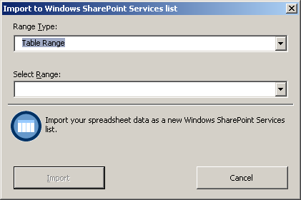
Figure 22. Importing spreadsheet data into a SharePoint list.

- At the bottom of the Excel workspace, click the sheet tab you want. Excel selects the table on that worksheet and enters the corresponding information in the Import to Windows SharePoint Services List dialog box.
- In the Import to Windows SharePoint Services list dialog box, click Import.

Windows SharePoint Services Integration with Microsoft Office
Smart client programs, such as the Microsoft Office system can be easily integrated with Windows SharePoint Services by means of a set of Web Services and documented application interfaces. For example, Word, Excel, PowerPoint, InfoPath, Project, and OneNote can all work with information stored on SharePoint sites. While working in a Microsoft Office system client application, users can interact with Windows SharePoint Services to create workspaces, post and edit documents, and assign tasks on SharePoint sites. In Office Outlook 2007, users can view calendars and contact lists stored on SharePoint sites and can create and manage sites for organizing meetings.
The exercises in this Windows SharePoint Services tour show you some of the new ways to work with the Windows SharePoint Services technology.

Exercise 1: Add an Appointment to a SharePoint Calendar
The Calendar Web Part is a default part of a SharePoint site that is based on the Team Site template. You can add appointments, tasks, and reminders to the SharePoint calendar, and they will be visible to all site users. To receive notifications about team meetings and activities, site users can subscribe to the calendar.
- Start Internet Explorer to display the default team site. The Calendar Web Part on the home page lists upcoming meetings.
- On the team site home page, click the Calendar Web Part title. The calendar for the current month is displayed. You can change the period the calendar displays by clicking Day, Week, or Month in the upper-right corner. In the upper-left corner, a date-picker displays the months of the year (when you’re in Month view) or the days of the month (when you’re in Day or Week view). Click any day or month to display that time period. SharePoint displays the current date under the date-picker. You can click the date to see more information.
- On the menu bar above the calendar, click New, and then click New Item. Add an appointment for any time next Monday.

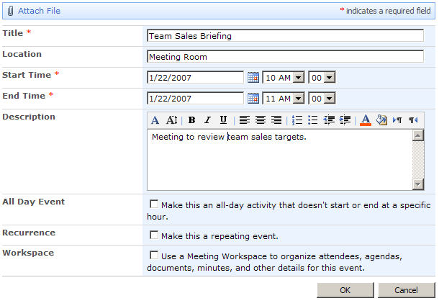
Figure 23. Creating a new item on a SharePoint calendar.

- Above the Calendar page title, click Team Site. The new appointment is shown in the Calendar Web Part.

Figure 24. New calendar appointment as shown on a SharePoint site.

Exercise 2: Work with a SharePoint Calendar in Office Outlook 2007
When Office Outlook 2007 is integrated with Windows SharePoint Services, it’s easy to manage all your calendar information, including information from calendars stored on a SharePoint site, from one location. You can display a SharePoint calendar either within Outlook or from the SharePoint site.
- Start Outlook, and display the Calendar.
- Start Internet Explorer, and display the default team site.
- On the team site home page, click the Calendar Web Part title. The Calendar is displayed.
- On the Actions menu, click Connect to Outlook.
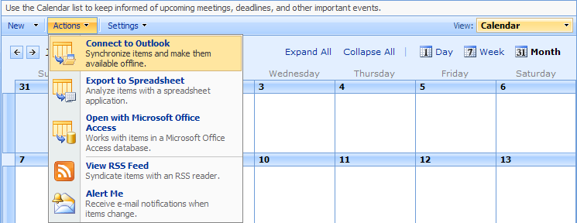
Figure 25. Connecting a SharePoint calendar to Office Outlook 2007.

Outlook displays your calendar and the default calendar side by side.
You can view multiple calendars side by side or in overlay mode, in which the contents of the calendars appear on top of each other. This makes it easy to locate scheduling conflicts between multiple calendars.
- In Outlook, click the arrow on the default calendar tab. Outlook displays your calendar and the default calendar in overlay mode. You can switch between the calendars by clicking their tabs. To return to side-by-side mode, click the arrow on either calendar tab.
You can work with the SharePoint calendar as you would with your regular Outlook calendar. Any changes you make to the SharePoint calendar in Outlook are reflected in the calendar when it is viewed on the SharePoint site.

Exercise 3: Add an Appointment to a SharePoint Calendar from Office Outlook 2007
When you display a SharePoint calendar in Outlook, you can add appointments to it in the same way that you would add appointments to your personal Outlook calendar.
- Complete Exercise 2 to display the SharePoint calendar in the Outlook Calendar component.
- On the SharePoint calendar, create an appointment for any time next Tuesday.
- On the Tools menu, click Send/Receive, and then click Send/Receive All.
- Start Internet Explorer to display the default team site.
Note: If the default site is already open, click the Refresh button on the Internet Explorer toolbar.
The new appointment is shown in the Calendar Web Part.
You can convert a nonrecurring appointment to a team meeting by dragging it from your Outlook calendar to the SharePoint calendar. You can also drag tasks from your Outlook tasks list to the SharePoint calendar.

Exercise 4: Work Offline with Document Libraries in Office Outlook 2007
You can export a copy of a document library from a SharePoint site to Office Outlook 2007. You can then preview documents, worksheets, and presentations in the Outlook 2007 message pane, or work with local copies of the documents on your computer.
- Start Outlook 2007.
- Start Internet Explorer to display the default team site.
- On the Quick Launch bar, click Shared Documents.
- On the Actions menu, click Connect to Outlook 2007.

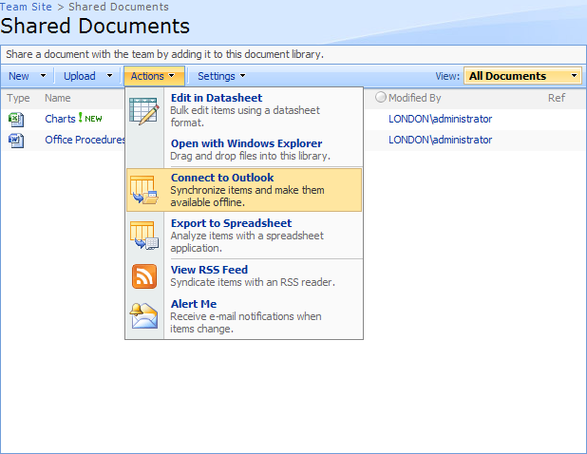
Figure 26. Connecting a Document Library to Office Outlook 2007.

Outlook 2007 creates and displays the default—the Shared Documents folder. In this folder, each of the document library items appears as an Outlook 2007 item.
- Click an item from the folder once. The document opens and appears in the message preview pane. The preview pane enables you to preview many kinds of documents, including PowerPoint slides.
- Double-click an item from the folder. You can open the document or save it on your local computer.
- In the Opening Mail Attachment dialog box, click Open.
Word opens the selected document as a read-only file. The document status appears on the Document Action Bar above the workspace.

Exercise 5: Create a Document Library from within Office Outlook 2007
If you are working in Outlook 2007 and you need to create a new workspace for collaborating with colleagues about a specific topic, you don’t need to stop work and move to a SharePoint site to do the setup work. You can create and populate a document workspace from within Outlook 2007.
- Start Outlook 2007.
- Create a new e-mail message. In the To box, type denis@adatum.com (or your e-mail address), and in the Subject box, type Office Procedures.
Note: For the purposes of this exercise, you are sending the e-mail message to yourself.
- In the message header, click the Attach button.
- In the Insert File dialog box displaying your My Documents folder, click Office Procedures, and then click Insert.
- On the Write tab, in the Message Options group, click Attach File, and then click Attachment Options. Outlook 2007 displays the Attachment Options task pane.
- Select the Shared attachments option.
- In the Create Document Workspace at drop-down list, click the default Web site.
- On the File menu, click Send. A document workspace containing the shared attachment is created on the SharePoint site. In Outlook 2007, you receive an e-mail with a link to the document workspace.
- With the Office Procedures Document Workspace e-mail message selected in the Inbox, in the preview pane, click the link to the document workspace. Internet Explorer starts, displaying the new document workspace. The e-mail message recipient appears in the Members list.

Exercise 6: Create a Document Library from Within Office Word 2007, Office Excel 2007, or Office PowerPoint 2007
If you want to create a workspace for collaborating with colleagues about the document you’re working in, you don’t need to stop work and move to a SharePoint site to do the setup work. You can create and populate a document workspace from within Office Word 2007, Office Excel 2007, or Office PowerPoint 2007.
- Start Word, and from your My Documents folder, open a Word, Excel, PowerPoint, or other Microsoft Office document.
- On the File menu, click Publish, and then click Create Document Workspace. Word displays the Document Management task pane.

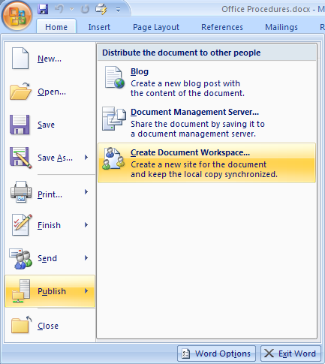
Figure 27. Creating a Document Workspace from within Office Word 2007.

- In the Document Workspace name box, change the name to Invitations.
- In the Location for new workspace drop-down list, click the default Web site.
- On the Document Management task pane, click Create.
A document workspace containing the current document is created on the SharePoint site. Word displays the document workspace information in the Document Management task pane.
- In the Document Management task pane, click each of the workspace tabs to see the available information.
- Start Internet Explorer to display the default team site.
- On the Quick Launch bar, click View All Site Content, and then in the Document Workspaces list, click Invitations.
The Invitations document workspace is displayed. The document appears in the Shared Documents list, and you appear as the only member in the Members list. You can add other members to the workspace as you would to any other SharePoint library.
You can create a document library from within Excel or PowerPoint by opening the workbook or presentation you want to share, and then following steps two through five.

A Developer's Perspective
Windows SharePoint Services provides an extremely powerful platform that you can use to build collaborative applications. Windows SharePoint Services provides many built-in features out-of- that you can incorporate into your specific solutions. It deals with data storage, provides a powerful and flexible user interface, contains ready-made application features, and hosts Windows Workflow Foundation workflows. Many solutions can be produced through an ‘assemble-and-configure’ process. Additionally, because Windows SharePoint Services is built on ASP.NET, you can leverage your existing knowledge to extend and customize collaborative solutions. As a developer, you have full access to the:
- Windows SharePoint Services object model
- Windows SharePoint Services Web service model
- Windows SharePoint Services Administration object model
For example, if you need to develop custom Web Parts that will run in a Windows SharePoint Services site, you can develop the Web Part with Visual Studio, and your code can access the Windows SharePoint Services object model. Furthermore, if you need to create a Windows Forms-based application or a console application that leverages Windows SharePoint Services storage and architecture, you can write code that accesses and uses the Windows SharePoint Services Web service model. Additionally, if you want to create an application that enhances the out-of-the-box administrative user interfaces, you can develop solutions that use the Windows SharePoint Services Administration object model.
Architectural Improvements Based on Microsoft ASP.NET 2.0
Windows SharePoint Services continues to provide the solution platform for the next version of SharePoint Products and Technologies. Windows SharePoint Services takes full advantage of Microsoft ASP.NET 2.0 and the core Microsoft .NET 2.0 runtime. Components such as the Web Part Framework and Web Virtualization are now provided by the .NET runtime rather than by Windows SharePoint Services. This change means Windows SharePoint Services can focus on providing SharePoint services rather than .NET services.

Getting Started with the Windows SharePoint Services Object Model
For solutions aimed at information workers, you will most often create Features, Web Parts and Web pages that access the Windows SharePoint Services Object Model. You can use this object model to access Site collections, sites, libraries, lists, workflows, and so on. Figure 28 provides a high-level overview of the Windows SharePoint Services site architecture represented by the object model.
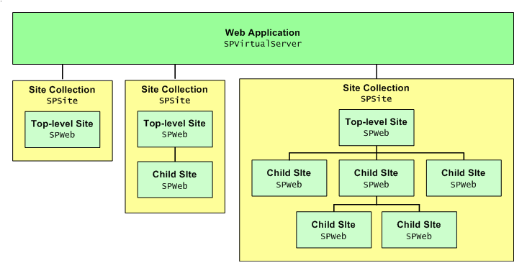
Figure 28. Windows SharePoint Services Object Model

All object model changes in Windows SharePoint Services have been made with an emphasis on high backward compatibility with Windows SharePoint Services 2.0 SP2. So even though you may have a completely refactored area of the object model, such as Administration, your code should still work with Windows SharePoint Services. However, you should be aware that although your old code will compile, it may not do what you expect with the new object-model hierarchy.
Feature Framework
Windows SharePoint Services contains a new structure called a “feature.” A feature packages SharePoint elements that help a user accomplish a particular goal or task. A feature contains one or more elements. An element is an atomic Windows SharePoint Services concept. Windows SharePoint Services features provide an entire framework that you can leverage as a developer to provide custom functionality for Windows SharePoint Services solutions. Features also provide administrators with an easy way to add or remove packaged pieces of functionality.
For example, a feature might be named “My Favorite Items" and contain:
- A custom list that stores a list of each user’s favorite items. (This list is created as a single hidden list per workspace when a feature is enabled.)
- A custom menu item, named “Add to Favorites,” that is attached to all lists and adds an item to the Favorites list.
- A Web Part that shows the user the top 10 favorites, with usage and link tracking to propagate true favorites to the top.
Each of these individual elements, by themselves, may not be useful, but when you enable all of them on a site they become a complete feature that solves a particular task.

In Windows SharePoint Services, a SharePoint site definition is transformed into a list of features plus a layout page and a master page. The goal is that any templated SharePoint site can be transformed into another templated SharePoint site simply by having the administrator toggle features on the site and possibly switch the layout page or master page.
The feature is defined in an XML format, similar to other existing SharePoint structures. Each feature definition is a set of XML files. Many items that were previously contained within a site definition in Windows SharePoint Services 2.0 SP2 are now able to fit as an element.
The following example shows how to define a Feature.xml file, scoped at the Web level.
<?xml version="1.0" encoding="utf-8" ?>
<Feature Id="A894A1A3-9FD0-4501-AE76-79063037D8B5"
Title="Feature Title"
Description="Feature description"
Version="1.0.0.0"
Scope="Web"
xmlns="http://schemas.microsoft.com/sharepoint/">
<ElementManifests>
<ElementManifest Location="FeatureManifest.xml" />
</ElementManifests>
</Feature>
The following code shows an example manifest file for a feature:
<?xml version="1.0" encoding="utf-8" ?>
<Elements xmlns="http://schemas,microsoft.com/sharepoint/">
<ListTemplate Name="Custom Announcements List"
Type="104"
BaseType="0"
OnQuickLaunch="TRUE"
SecurityBits="11"
DisplayName="Displayed Name"
Description="Create an announcements list when you want a place to share news, status, and other short bits of information."
Image="/_layouts/images/itann.gif">
</ListTemplate>

Element. An element is an atomic unit within a “feature.” There are several types of elements—for example, a custom menu hook or an event handler.
Site Feature. A site feature is one that is defined at the Web level. Note that scoping of a feature is determined by the feature developer implicitly by the elements he or she packages into the feature.
Site Collection Feature. A site collection feature is a feature that is scoped at the site collection level. Typically, a site collection feature contains items that are intended to apply to the site collection as a whole, such as Web Parts or content types that are global to the site collection.
Farm Feature. A farm feature is a feature that is scoped globally for the entire farm. For this reason, farm features are also known as “global features.” Unlike other types of features, a global feature is activated by default in the farm. A farm feature contains a number of elements that are critical for implementing applications and logic.
Web Application Feature. A Web application feature is a feature scoped to the Web application level. A Web application feature can be activated and deactivated. A Web application can contain the following types of elements:
- Web application assemblies
- Web application administrative links
- New callbacks
Features support the following callbacks:
- FeatureInstalled/FeatureUninstalled. Can be installed through the object model or the command line
- FeatureActivated. Post-sync feature activation event on Web
- FeatureDeactivating. Pre-sync feature deactivation event on Web

Developer Scenarios
This section describes a few scenarios and provides code snippets that can help you evaluate specific parts of Windows SharePoint Services.
Site Columns
Site columns provide a central, reusable model for column definition. When you create a site column, each list that uses this column has the same definition, and you do not have to do the tedious work of reproducing the column in each list. Additionally, site columns provide you with the simplicity of a single maintenance point. For instance, you can create a status site column, which may contain multiple choices of an enterprise's specific statuses, and implement the column in dozens of project master lists across the site collection. If you add a new status, you can modify the site column instead of having to modify each list that contains a status column.
The following code sample adds a field to a site:
SPSite mySite;
SPWeb myWeb;
SPFieldCollection mySiteFields;
SPField myField;
mySite = new SPSite("http://servername/default.aspx");
myWeb = mySite.OpenWeb();
mySiteFields = myWeb.Fields;
mySiteFields.Add("Field Title", SPFieldType.Text, true);
SPField newField = mySiteFields["Field Title"];
newField.Description = "Field Description";
newField.DefaultValue ="Field Default Value";
newField.Update();
In certain situations, however, you might want to modify the column for a specific list. For this reason, you still have the option of one-off customization of columns at the list level. For instance, suppose all projects within your company's IT department have an additional status of complete. You could add this status to the column within the IT department's master project list.
The following code sample adds a field to a list:
SPSite mySite;
SPWeb myWeb;
mySite = new SPSite("http://servername/default.aspx");
myWeb = mySite.OpenWeb();
SPList list = myWeb.Lists[new Guid(2A750330-96B6-4484-9B89-4408CD4F945E)];
string fieldName = "New Column";
string field = list.Fields.Add ("Field Title", SPFieldType.Text, true);

Folder Metadata
One of the interesting new features of folders is the ability to assign metadata to a folder. This creates a rich content holder that contains child content, while appearing as more than a container. Essentially, this means the folder can function as a separate, but fully functional, item type. An example of this can be seen in Windows SharePoint Services discussion boards. Each top-level discussion is, in fact, a folder with metadata, containing one-to-many child objects. By modifying the appearance of the folder, a user can visualize the folder as another list item rather than as a container. You can use this model in custom lists to create a dynamic parent/child list.
Many business applications require rich container objects, for which a parent object has both important data concerning itself, and one-to-many children with similar data. Traditionally, you would have had to deal with this challenge by using lists in which a parent, or master, list selection drives the display of a child, or detail, list. Because you can now assign metadata to folders in a SharePoint list, you can achieve similar functionality with a single list.
Consider an Orders list, for example. You could provision a folder as an order, and then assign metadata to it. By doing so, you can make the folder mimic the master list functionality. You can then fill the folder with list items, each with its own metadata. Now you have the rich functionality of a master/detail list within a single list.
List Indexing
Integral to the idea of using Windows SharePoint Services as a platform is the ability to use its storage containers, specifically lists and document libraries, for application storage. However, a number of limitations restricted the true use of these containers in Windows SharePoint Services 2.0 SP2. One of the problems was the inability to handle large lists. As lists began to grow, both in metadata and list items, the mechanisms built into lists became inefficient.
A key goal within Windows SharePoint Services was to fix these restrictions and create a rich storage model with performance capable of supporting both external applications and those built on Windows SharePoint Services. One of the key ways that Windows SharePoint Services solves this issue is to include indexing on columns. By indexing a column and storing it as a simple name/value pair in a separate database, access to specific items in large lists is significantly improved. These kinds of performance improvements help SharePoint lists to become true data stores, capable of supporting external applications as well as simple team sites.
For example, with an Orders list, you could provision a folder as an order and then assign metadata to it. Consider that by indexing the column, access to specific items in the list by an external request becomes significantly cheaper.
Another scenario is an external application with hundreds of thousands of records. Previously, your Web application could not use a SharePoint list as a storage device. With the performance improvements that result from column indexing, this is now practical. By using Windows SharePoint Services storage, the standard features of the platform, such as views, alerts, and RSS, can now be used as a data store explorer for internal use in simple team sites.
Cross-List Queries
Another improvement that makes more effective use of Windows SharePoint Services storage is cross-list queries. Cross-list queries enable you to use the SPQuery object to query all the lists within a Web site or site collection. Previously, you had to enumerate through the parent objects to obtain a collection of SPLists, query the list to return the items, and then build your own collection of list items from the multiple lists. This exercise was not only tedious and redundant but expensive. With cross-list queries, you can take advantage of the efficiencies built into the SPQuery functionality in a number of additional scenarios.
Cross-list queries provide a rich querying capability, similar to SQL queries, within Windows SharePoint Services. Among the many possible scenarios this functionality enables is the numerous aggregation scenarios commonly requested by users.
List Items
Several improvements in Windows SharePoint Services are implemented on the item level rather than on the entire list. For example, list items now support per-item security, and all lists items now support versioning. As a developer, you can incorporate these improvements into your custom solutions.
Workflows
In Windows SharePoint Services, a workflow enables you to attach a business process to items in SharePoint Products and Technologies. This process can control almost any aspect of an item in SharePoint Products and Technologies, including the life cycle of that item. For example, you could create a simple workflow that routes a document to a series of users for approval.
Workflows can be as simple or complex as your business processes require. You can create workflows that the user initiates, or workflows that SharePoint Products and Technologies automatically initiate based on some event, such as when an item is created or changed.
In addition, your workflows can interact directly with the user through workflow forms. Workflow forms enable you to gather information from the user at each stage of the workflow. You can create your workflow to interact with the user through the standard SharePoint Products and Technologies browser-based interface, through workflow forms in Microsoft Office system client applications such as Office Word and Office Excel, or even through your own custom applications.
Workflows are available to users at the list or document library level. Workflows can also be added to content types. Multiple workflows might be available for an item. In addition, multiple workflows can run simultaneously on the same item, but only one instance of a specific workflow type can run on a specific item at any given time. For example, you might have two workflows, "SpecReview" and "LegalReview," available for a specific content type, "Specification." Although both workflows can run simultaneously on a specific item of the "Specification" content type, you can't have two instances of the "LegalReview" workflow running on the same item at the same time.
Property Bags
Property Bags are now exposed on several major objects: SPWeb, SPFile, SPFolder, and SPListItem. All values are stored in a simple hash table. A call to the Update method on the object persists the values. All values can be stored and retrieved via SOAP methods.
Web Service Enhancements
Windows SharePoint Services expands several existing Web Services, increasing the number of methods provided through the Lists, SiteData, UserGroup, WebPartPagesWebService, and Webs Web Services. The Lists and Webs Web Services, for example, both include new methods for content type integration, and the Lists service provides new methods for working with files in document libraries. In addition, Windows SharePoint Services introduces several new Web Services, including ones for portal search, messaging application synchronization, content publishing, and workflow.
Change Log
The Change Log feature in Windows SharePoint Services will be used by multiple partners to synchronize with SharePoint sites. For example, in Windows SharePoint Services 2.0 SP2, a search often required a full crawl of the site, which resulted in greater latency of search results and higher bandwidth and CPU costs. In Windows SharePoint Services, search is based on precise indexing of changed objects. This provides results more quickly and with lower overhead.
Change Log Functionality
The change log returns a list of SPChange objects for changes that happened to the following:
- Items/files/folders
- List metadata
- Web metadata
- Security
The change log does not record changes to the following:
- Web application configuration
- Global administration settings
- Binary deployment
- Web Parts and safe controls
- Web, site, content database, or Web application configuration
The change log contains information about the type of change:
- Add
- Update
- Delete
- Rename
- MovedAway
- MovedInto
The change log can be accessed at the following, progressively inclusive, scopes:
- SPList
- SPWeb
- SPSite
- SPContentDatabase
Change Log Security
The change log is not security trimmed based on the caller’s privileges; information disclosure is avoided by returning only IDs in the change log. Notice, however, that when executing front-end object model code on behalf of a user whose permission to view an item was revoked, the change log provides a way to track items by ID. Consumers of the change log should issue queries against lists by using SPQuery to help ensure that security-trimmed enumerations are returned.
Change Log Freshness
Callers should not expect the change log to return items of precise freshness. In some cases, the change log returns only items up to a particular point in the past. Callers receive a token for the time up to which the change log returns items.
In order to correctly surface moves, the change log will do the following:
Folder move: MovedAway event on the source list, MovedInto event on the destination list
Web move: MovedAway event on the source site, MovedInto event on the destination site
The change log is a physical table in each content database. Each transaction writes to the change log. The change log can be accessed through a Web Service to get the changes made after a given point in time.
Event Enhancements
Events are crucial in transforming Windows SharePoint Services into a true developer platform. Events enable developers to hook into Windows SharePoint Services behaviors and override default behaviors.
Events fall into two major categories:
- List events—Core events, including changes, additions, and removals of list items and list columns (schema changes)
- Simple site events—Deletion of sites and site collections
Events are either synchronous “before” events, denoted by the “XYZing” name format, or asynchronous “after” events, denoted by the “ABCed” name format.
Event receivers can be registered, using “Features,” with an Item, a List, a Web, or a Content Type. For example, an event receiver that helps ensure a document always has a copyright in the footer can be associated with a central Content Type and pushed down to all document libraries associated with that type.
As they do in Windows SharePoint Services 2.0 SP2, developers can override and extend the event handler method. A new sequence number parameter means they can control the firing order of multiple events.
Work Items and Timer
The Job service in Windows SharePoint Services enables you to set up a timed job that executes:
- After delaying for a definable interval.
- During a certain time in the hour, day, week, month, or year.
The Job service also enables you to distribute work among servers in a farm; for example, based on a request to create a site (which originates on a Web front end), a one-time job may run as soon as is reasonable on an indexing server. The main objects for the Job service are SPJobDefinition and SPWorkItem.
- SPJobDefinition: Admin-side timer
One-time or simple recurring schedules
Set schedule, implement Execute
The following code sample shows how to override the Execute method:
public class myClass : SPJobDefinition
{
…
public override void Execute(Guid targetInstanceId)
{
//Provide your logic here
base.Execute(targetInstanceId);
}
…
}
- SPWorkItem: Content-side jobs
One-time execution
Process batches in admin timer job

For More Information
- The Windows SharePoint Services Web site at http://www.microsoft.com/technet/windowsserver/sharepoint/default.mspx has the latest news and information about Windows SharePoint Services, including feature information, case studies, white papers, information about related technologies, and more.

- Windows SharePoint Services 3.0 is available for download at http://www.microsoft.com/technet/windowsserver/sharepoint/download.mspx.

- White papers and articles covering topics that are relevant to developers, such as creating solutions using the Microsoft Office system and Windows SharePoint Services, can be found at the MSDN Web site (http://msdn2.microsoft.com/en-us/sharepoint/default.aspx).

- White papers and articles covering topics that are relevant to IT professionals, such as architecting, sizing, and managing Windows SharePoint Services, can be found in the Technical Library (http://technet2.microsoft.com/windowsserver/WSS/en/library/).
Appendix A—Hardware and Software Requirements
The following list contains the recommended hardware and software required to install and run Windows SharePoint Services for evaluation purposes:
Operating Systems:
- Windows Server 2003 SP1 or the 64-bit versions of Windows Server 2003 or Windows Small Business Server 2003; all versions (32-bit and 64-bit) of Windows Server 2008 (Standard, Enterprise, and DataCenter) and Windows Web Server 2008.
Additional Software and Services
- The Microsoft .NET Framework 3.0
- Internet Information Services (IIS) 6.0 with common files (Windows Server 2003) or IIS 7.0 (Windows Server 2008), Simple Mail Transfer Protocol (SMTP) service, and World Wide Web service
Hardware:
- Single-Server Installation
  - Processor speed of at least 2.5 gigahertz (GHz)
  - RAM capacity of 1 gigabyte (GB) minimum, 2 GB recommended
  - Disk space up to 2 GB for installation, and 5 GB or more for data storage
- Farm Deployment-
  - Web server with a processor speed of at least 2.5 GHz and a RAM capacity of 1 GB minimum (2 GB recommended)
  - SQL Server 2000 SP3 (or later) or SQL 2005 system with dual processors of 2.5 GHz and 2 GB RAM.
  - Disk space up to 2 GB for installation, 5 GB or more for data storage
Internet Connection
- Broadband connection, 128 kilobits per second or greater, for download and activation of products
Appendix B—Application Templates for Windows SharePoint Services 3.0
The following application templates for Windows SharePoint Services are available for download at: http://www.microsoft.com/sharepointapps
Each template represents a solution that can be used right away or tailored to address the needs and requirements for specific business processes or sets of tasks for organizations of any size.
The following application templates are available for download:

Site Admin Templates
- Board of Directors
- Business Performance Reporting
- Case Management for Government Agencies
- Classroom Management
- Clinical Trial Initiation and Management
- Competitive Analysis Differentiation Site
- Discussion Database
- Disputed Invoice Management
- Employee Activities Site
- Employee Self-Service Benefits
- Employee Training Scheduling and Materials
- Equity Research
- Integrated Marketing Campaign Tracking
- Manufacturing Process Management
- New Store Opening
- Product and Marketing Requirements Planning
- Request for Proposal
- Sports League
- Team Work Site
- Timecard Management

Server Admin Templates
- Absence Request and Vacation Schedule Management
- Budgeting and Tracking Multiple Projects
- Bug Database
- Call Center
- Change Request Management
- Compliance Process Support Site
- Contacts Management
- Document Library and Review
- Event Planning
- Expense Reimbursement and Approval Site
- Help Desk
- Inventory Tracking
- IT Team Workspace
- Job Requisition and Interview Management
- Knowledge Base
- Lending Library
- Physical Asset Tracking and Management
- Project Tracking Workspace
- Room and Equipment Reservations
- Sales Lead Pipeline

Appendix C—Considerations in the Evaluation of Windows SharePoint Services 3.0 under Windows Server 2008
Windows SharePoint Services 3.0 is supported under Windows Server 2003 and Windows Server 2008. From the perspectives of end users and administrators, Windows SharePoint Services 3.0 will be functionally equivalent in both systems; no changes will be visible in site and central administration pages. However, from the perspectives of developers and server administrators, Windows Server 2008 presents a number of new features that can add considerable enhancements to development and deployment processes in SharePoint technology deployments.
Manageability
One of the most immediately evident changes in Windows Server 2008 is improved facilities for managing the server platform. This is visually evident in the new Server Manager:
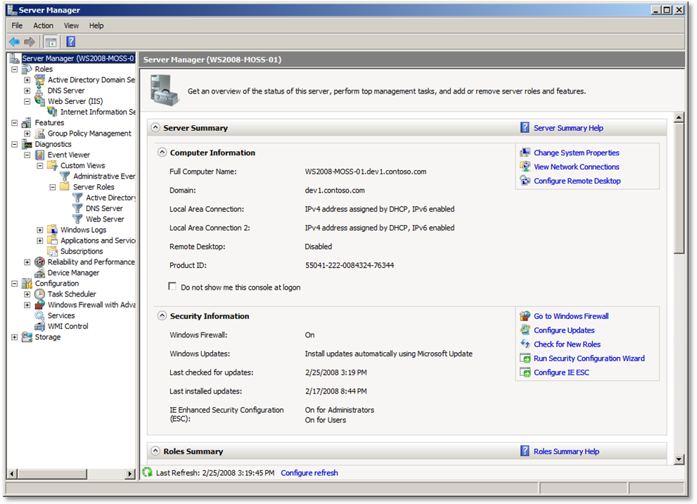
Figure 29. Windows 2008 Server Manager
The Server Manager presents a consolidated, task-oriented interface to all roles, functions, and services required to configure and manage the server. Windows Server 2008 is initially configured with a minimum of roles and functions present; the server administrator adds those roles and functions according to the requirements of the server. Windows SharePoint Services 3.0 requires the Web Server role, as well as a number of features (such as the .Net Framework 3.0) that will be automatically selected when the administrator adds the web server role.
Internet Information Services 7.0
A key element of the new web server role is that Internet Information Services (IIS) 7.0 is enabled. For Windows SharePoint Services 3.0 to run under IIS 7.0, Windows SharePoint Services 3.0 Service Pack 1 (SP1) must be installed.
The implementation of IIS 7.0 brings a number of new management improvements. A new IIS Manager interface (which is accessible under Server Manager or can be selected from the Start menu under Administrative Tools) is completely rewritten to present a more task-oriented interface enabling the administrator to proceed directly to those aspects of the server that require configuration, reducing the number of dialogs and property displays to perform any task. As well, IIS 7.0 provides a new Command Line Interface (CLI), which allows full access to the IIS configuration from a command prompt, enabling advanced scripting. One simple example of a new CLI feature is the ability to recycle application pools and web sites.
Another important addition to scripting capabilities is the availability of a new .NET Windows Management Interface (WMI) namespace for IIS 7.0. This namespace exposes a complete set of objects, methods, and properties for IIS administration, and can be accessed from .NET applications including Windows PowerShell. It is now possible to create PowerShell scripts and custom .NET applications that access the WMI and SharePoint namespaces to perform advanced SharePoint server configuration and deployment tasks. This can be particularly valuable in environments which may have unique or complex integration and deployment requirements for their Windows SharePoint Services 3.0 applications.
IIS 7.0 comes equipped with new capabilities to perform extensive tracing of HTTP requests (via the Failed Request Tracing feature), and capabilities for request filtering are integrated within IIS 7.0 (formerly available through the URLScan extension in IIS 6.0).
A greatly improved aspect of IIS 7.0 is that most configuration changes take place as soon as they are implemented in the configuration, without requiring the recycling of application pools, web sites, or IIS itself. This helps to minimize outage time when changes must be made on the fly. In those cases where recycles are still required, application pools can be individually (and quickly) recycled via the CLI, as mentioned above.
IIS 7.0 Modular Architecture
A key element of the new IIS 7.0 implementation is its modular architecture. Any capability or feature that is required by an IIS application (including Windows SharePoint Services applications) is implemented by enabling specific modules (assemblies) in the IIS configuration. In IIS 7.0, only those modules that are required for web applications are enabled in the configuration files. For example, if a web application has no need for forms authentication, the forms authentication module is not registered in the IIS configuration. This reduces the maintenance footprint of the web server, as well as reducing its potential attack surface from a security perspective.
Virtualization with Hyper-V
Windows Server 2008 offers Hyper-V, a new hypervisor-based virtualization server role that allows for hosting of multiple virtual machines on a single physical server. This role includes a large number of enhancements over previous virtualization environments, particularly in the simplification of configuration and management. A Windows Server 2008 machine running Hyper-V needs only a minimal server configuration to which the Hyper-V role is added, thus ensuring the maximum efficiency of the host machine, as well as reduced application surface area.
For multiple-server Windows SharePoint Services deployments, this new server role can be employed to set up complete development environments that architecturally mirror physical web farms, enabling the full development and testing of inter-server deployment processes. An especially powerful benefit of a Hyper-V implementation of a Windows SharePoint Services development environment is the ability to create single, point-in-time snapshots of the complete development environment.
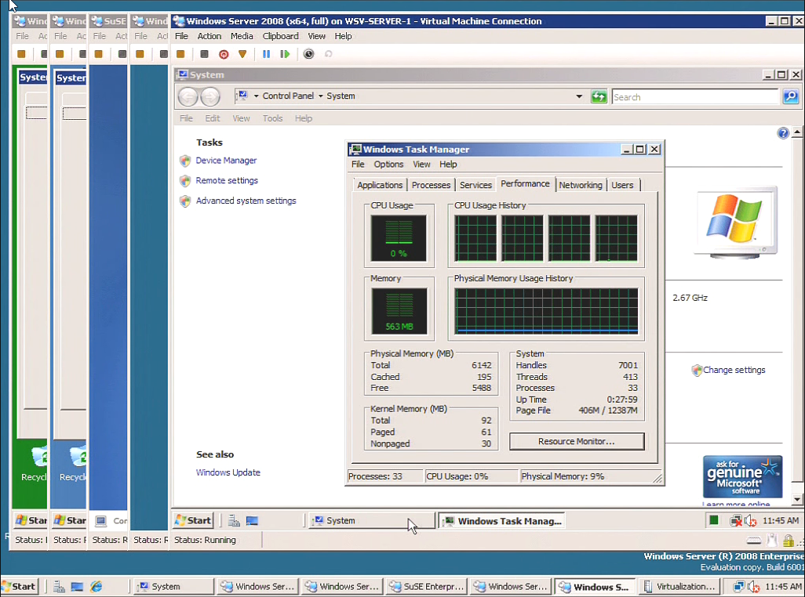

Figure 30. A Windows Server 2008 server with Hyper-V running multiple guest operating systems, and the Task Manager displaying support for multiple core CPU activity within a guest OS.
The use of virtualization in managing a Windows SharePoint Services development environment enables high levels of flexibility in the allocation and management of resources to each member of the server farm. With a suitably-provisioned host machine, having the entire collection of required virtual images active on a single physical platform will help to keep development infrastructure costs to a minimum.
Security
As mentioned in the previous section, one of the most important new features of server configuration in Windows Server 2008 is in managing the enablement of roles and features according to the requirements of each server in a web application deployment. Minimizing the installed features reduces the maintenance footprint and presents a minimized attack surface. If individual binaries are not required, they will simply not exist on the server and therefore cannot be compromised by an attacker.
Windows Server 2008 is also equipped with a new version of the Windows Firewall to further assist in the effective hardening of server security. A newly simplified Security Configuration Wizard (SCW) works from the installed roles and features to lock down a server quickly and effectively.
The new version of Group Policy Management in Windows Server 2008 uses enhanced wizards to speed the development of group policies, significantly reducing the number of steps required to model and build security policies. With these improvements, security administrators can now undertake the development and implementation of more complex security features without needing additional staff to perform these tasks.
In SharePoint deployments, additional security rules can be quickly defined through simplified rule creation wizards that will harden the security infrastructure of the servers in those deployments. In particular, improvements in the configuration of IPsec security dramatically reduce the number of rules required to implement IPsec protection over previous versions of Windows. And security policies can be exported from a server for import to another, eliminating the need to re-build rules across multiple machines.
The combination of these enhanced security features with the security infrastructure in Windows SharePoint Services will provide the most secure SharePoint deployments.
Performance and Reliability – Enhancements and Management
Windows Server 2008 incorporates a wide range of changes to improve the efficiency and reliability of the operating system, particularly in how it handles networking. A notable improvement is in the implementation of the TCP/IP stack, which has been extensively modified and optimized. Performance gains can be expected in the way that Windows Server 2008 handles networks where latency values tend to be high. This can be a common situation, particularly in complex networks that include multiple routers connecting broadband WAN links. The new TCP/IP implementation in Windows Server 2008 contains optimization for high-latency networks, and significant performance improvements should be seen over previous versions of Windows networking. In networks that are particularly constrained by latency, this should be a welcome enhancement.
As mentioned earlier, IPsec negotiation has been enhanced to improve performance, almost to the level of unprotected traffic. This makes IPsec a more feasible option for improving the security of SharePoint deployments.
The ability to optimize the overall service profile and footprint of any server will help to maximize performance and reliability by eliminating the overhead of services that are not required, and reducing the number of sources of resource contention. At the same time, it is essential to be able to monitor these aspects of server activity to ensure that expected levels of service are being met.
For overall performance and reliability management, Windows Server 2008 provides a new Reliability and Performance Manager: From this console it is possible to monitor the performance of hardware resources and applications in real time. Data sources for performance and reliability can be customized through the console, as well as the generation of standard and custom reports. It is possible to set thresholds on performance metrics and define automated actions when these thresholds are reached or exceeded. Historical data can also be reviewed, as seen in the following figure showing the daily trend in system stability.
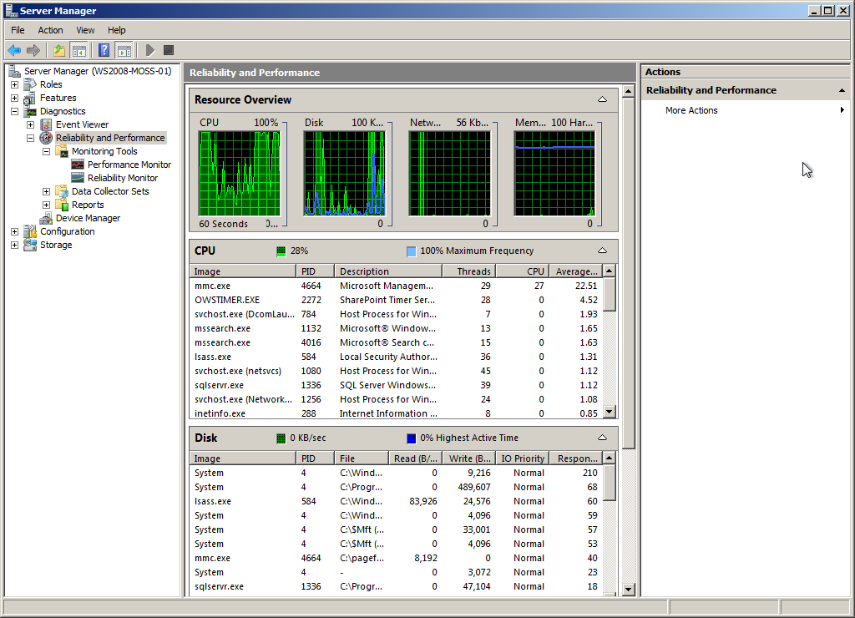
Figure 31. Reliability and Performance Manager showing Resource Overview with CPU and disk activity expanded
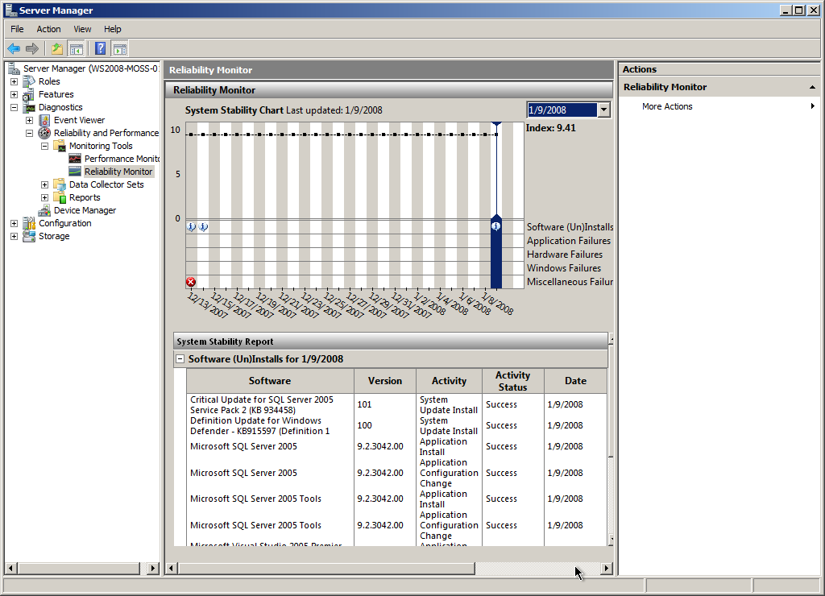
Figure 31. The Reliability Monitor showing system stability trend.

These new features in Windows Server 2008 provide enhanced performance and reliability management capabilities for servers in SharePoint deployments. The instrumentation of performance analysis has been enhanced to show different aspects of system activity (that is, CPU, disk, network, and memory activity levels) and the contribution of individual processes to overall workload. This can assist in identifying possible performance issues that may warrant further attention.
Another significant new capability is the Reliability Monitor, which shows an overall stability trend graph. A stability index is computed and plotted over time, based on events that can affect availability and performance. Changes in this index can be correlated with system changes, such as software installs (or uninstalls), or specific application errors which may affect server reliability.
In addition to these important features in reliability and performance management, the event logs in Windows Server 2008 can extended with custom views that can filter events by source. For example, if an administrator needs notification whenever a certain type of application error occurs, a custom event view can be created that will trigger a specific program, issue a message, or send an SMTP email to be sent to server administrators with the details of the triggering event.
This combination of historical perspective and immediate notification provides server administrators with a more comprehensive basis on which to manage the platforms to deliver high-availability applications employing SharePoint Products and Technologies.
Summary
The following table summarizes the principal feature benefits that can be realized when deploying SharePoint Products and Technologies on Windows Server 2008.
Functional Area | Feature | Notes
Manageability | Server Manager | - Consolidated task-oriented interface providing a single source for all management information and actions
 | IIS 7.0 | - New IIS Manager with improved and simplified task-oriented work flow and increased functionality  - New CLI to configure IIS from command prompt or batch files  - New .NET Windows Management Interface (WMI), allowing IIS configuration from PowerShell scripts and/or custom .NET applications  - Request Tracing features to aid in diagnostics  - Improved availability through immediate configuration changes without requiring site downtime  - Modular Architecture where only those modules required by the applications are actually present – reduces maintenance complexity
 | Custom Event Log Views | - Create custom views of logged events to automatically filter events (by source, severity, etc.) to expedite troubleshooting  - Assign tasks to events (e.g. notifications and/or custom program actions) when specific events occur, prompting timely action on problems
Manageability (continued) | Hyper-V | - Advanced virtualization technology for hosting multiple logical platforms under a single, minimally-configured server  - Consolidated environment, particularly for development and testing of multi-server SharePoint farms  - Enable point-in-time snapshots of development environments, enhancing recoverability  - Reduce resource costs by minimizing the number of physical servers required for development
Security | Roles and Features | - Minimizing the deployment footprint by tailoring roles, services and features installed, thereby reducing the attack surface  - New Windows Firewall, enhancing individual server security  - New Security Configuration Wizard (2.0) that enables role- and feature-based security hardening, simplified from earlier versions  - Enhanced Group Policy Management using wizards to simplify the creation and maintenance of group policies
Reliability & Performance | Roles & Features | - Tailored configuration through the use of required roles and features reduces overall footprint and ensures that unneeded services and processes are not present, ensuring that resources are dedicated exclusively to required services
 | New TCP/IP Stack | - Support for IPv4 and IPv6  - Improved performance for high-latency networks
 | IPsec Enhancements | - Improved performance almost to level of unprotected traffic
 | Reliability & Performance Manager | - New console for monitoring performance and reliability both in real time and historically  - Set thresholds for performance metrics that result in custom actions (e.g. alerts)  - Stability index correlates significant system events with server reliability as an aid in troubleshooting problems that evolve over time

