
Windows Server 2008 R2 SP1 Reviewers Guide, Beta Release

Published: June 2010

© 2009 Microsoft Corporation. All rights reserved. This document is developed prior to the product’s release to manufacturing, and as such, we cannot guarantee that all details included herein will be exactly as what is found in the shipping product. The information contained in this document represents the current view of Microsoft Corporation on the issues discussed as of the date of publication. Because Microsoft must respond to changing market conditions, it should not be interpreted to be a commitment on the part of Microsoft, and Microsoft cannot guarantee the accuracy of any information presented after the date of publication. The information represents the product at the time this document was printed and should be used for planning purposes only. Information subject to change at any time without prior notice. This whitepaper is for informational purposes only. MICROSOFT MAKES NO WARRANTIES, EXPRESS OR IMPLIED, IN THIS SUMMARY.

Microsoft, Active Directory, Aero, BitLocker, Forefront, Excel, Hyper-V, MSDN, SQL Server, Visual Studio, Windows, Windows Media, Windows PowerShell, the Windows logo, Windows 7, Windows Vista, and Windows Server are either registered trademarks or trademarks of Microsoft Corporation in the United States and/or other countries.

All other trademarks are property of their respective owners.

Summary
The Windows Server® 2008 R2 SP1 Reviewers Guide provides a technical overview of the incremental features and functions found in the Service Pack 1 Beta release for Windows Server 2008 R2 and Windows 7. While SP1 includes several new incremental enhancements, it also introduces two important new features for customers using the Windows Server virtualization stack:

Dynamic Memory
Dynamic Memory is a new feature within Windows Server 2008 R2 SP1 Beta’s Hyper-V. It allows customers to achieve increased density when they’re consolidating physical servers into a virtual realm, providing them with predictable performance and linear scalability. With Dynamic Memory, IT administrators are able to pool available memory on a physical host and then dynamically dole that memory out to virtual machines running on the host, based on current workload needs

RemoteFX
RemoteFX, a key feature of Remote Desktop Services (RDS) lets IT administrators deliver a rich graphics experience to end-users through virtualized desktops. Using new protocol enhancements between Windows Server 2008 R2 and Windows 7, end users can now access virtual machines on a wide variety of target devices and still get a rich graphics experience with server-side graphics processing.

This Reviewers Guide is aimed at providing an evaluation experience for these two features.

Table of Contents
Improved User Experience with RemoteFX 1
RemoteFX Evaluation System Requirements 1
Evaluate RemoteFX User Experience 2
Step 1: Prepare Windows Server 2008 R2 SP1 for Evaluating RemoteFX 2
Step 2: Install and Configure Windows 7 SP1 in a Virtual Machine 5
Step 3: Enable RemoteFX 3D Video Adapter Support on Windows 7 Virtual Machine 5
Step 4: Evaluate RemoteFX User Experience 6
Step 5: Evaluate RemoteFX USB Support 11
Dynamic Allocation of Virtual Machine Memory 16
Dynamic Memory Evaluation System Requirements 17
Evaluate Dynamic Memory User Experience 17
Step 1: Prepare Windows Server 2008 R2 SP1 for Evaluating Dynamic Memory 18
Step 2: Install and Configure Windows 7 SP1 in the Virtual Machine 18
Step 3: Enable Dynamic Memory Support on Windows 7 Virtual Machines 18
Step 4: Evaluate Dynamic Memory User Experience 19

Improved User Experience with RemoteFX
RemoteFX allows users to run Windows 7 and applications in a virtualized environment and yet have a similar user experience as installing Windows 7 and the applications on a physical computer with a 3D accelerated graphics display adapter. The Remote Desktop Virtualization Host role service in Windows Server 2008 R2 SP1 provides support for RemoteFX in Windows 7 SP1 guest operating system in Hyper-V.

RemoteFX Evaluation System Requirements
To evaluate the RemoveFX feature in Windows Server 2008 R2 SP1, you need to have the system requirements listed in the following table in addition to those in the “System Requirements” section in the “Getting Started” section, earlier in this guide.
Table 1: RemoteFX Evaluation System Requirements
Computer | Description and system resources
W2K2R2SP1 | This is a physical computer that can be a standalone server or a member of a domain. This computer runs Windows Server 2008 R2 SP1 with the following server roles, role services, and features installed:  - Hyper-V server role  - Remote Desktop Services server role  - Core Services role service  - Virtualization host role  - RemoteFX role service  The system resources of this computer are as follows:  - Video display adapter that supports 3D hardware acceleration.  - Two or more processor cores running at 1.6 gigahertz (GHz) or faster  - 4 gigabytes (GBs) or more of physical memory  - One disk partition that has 250 GB or more of available disk space.
WIN7-01 | This is a virtual computer that can be a standalone computer or a member of a domain. This computer runs Windows 7 Enterprise or Ultimate SP1 with the following system resources:  - One or more virtual processors running at 1.6 gigahertz (GHz) or faster  - 1 GB or more of memory  - One virtual hard disk that is 120 GB or larger.  - .
 | WIN7-02 – separate physical machine, running any Windows 7 edition with SP1 installed and requiring only the general Windows 7 hardware installation minimums. This machine will be used to forward local resources to the Windows 7 virtual machine using RemoteFX.

Evaluate RemoteFX User Experience
Evaluate how RemoteFX enhances Remote Desktop user experience by performing the following steps:
- Prepare Windows Server 2008 R2 SP1 for evaluating RemoteFX by installing the appropriate server roles and role services, and also verifying the appropriate video display device drivers are being used.
- Install Windows 7 Enterprise or Ultimate SP1 in a virtual machine and configure Remote Desktop connections for Windows 7.
- Enable RemoteFX 3D Video Adapter Support on the Windows 7 virtual machine.
- Verify enhanced user Remote Desktop experience in Windows 7 using RemoteFX.
- For the full end-to-end RDS experience please refer to the Deployment Guide for Connection Broker. The scope of this document is to provide only an evaluation experience for a RemoteFX host server and guest VM as well as leveraging the RemoteFX connection between them.

Step 1: Prepare Windows Server 2008 R2 SP1 for Evaluating RemoteFX
Prepare the physical computer running Windows Server 2008 R2 SP1 for evaluating RemoteFX by performing the following steps:
- Install Windows Server 2008 R2 SP1 on the computer.
- Install the Hyper-V server role.
For more information about installing the Hyper-V server role, see “Installing Hyper-V” in the Hyper-V Planning and Deployment Guide available at http://www.microsoft.com/downloadS/details.aspx?FamilyID=5da4058e-72cc-4b8d-bbb1-5e16a136ef42&displaylang=en.
- Install the Remote Desktop Services server role with the following role services, as illustrated in the following figure:
- Remote Desktop Virtualization Host
- Core Services
- RemoteFX
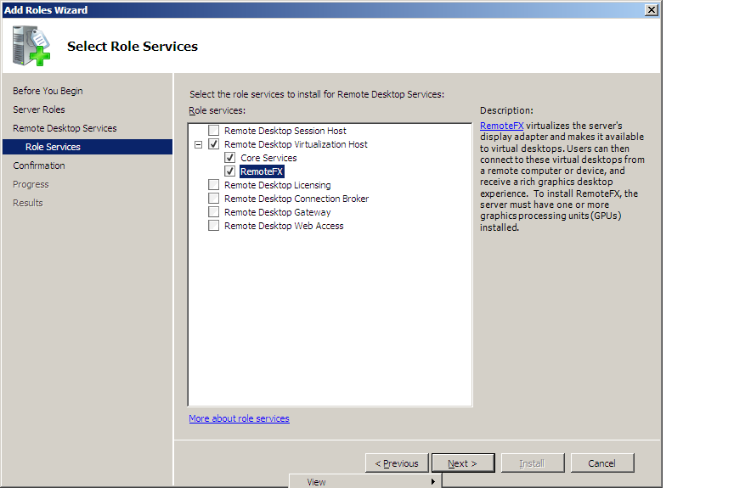
Figure 1: Remote Desktop Virtualization Host role services
For more information about installing the Remote Desktop Virtualization Host role service, see “Install the Remote Desktop Virtualization Host Role Service” available at http://technet.microsoft.com/en-us/library/dd759143.aspx.
- Verify that the appropriate device drivers have been installed for the 3D accelerated video display adapter.
Unless the appropriate device drivers are installed for the 3D accelerated video display adapter, you cannot start the Windows 7 virtual machine with the RemoteFX 3D Video Adapter Support enabled.
- On the Win7-02 machine; enable USB support for Remote FX in the Remote Desktop Client by performing the following steps:
Note: For the purposes of these steps, the Local Group Policy Editor is used. However, the same policy can be set using Group Policy in Active Directory Domain Services (AD DS).
- Start Gpedit.exe.
- In Local Group Policy Editor, in the navigation page, go to Computer Configuration | Administrative Templates | Windows Components | Remote Desktop Services | Remote Desktop Connection Client | RemoteFX USB Device Redirection.
- In the details pane, right-click Allow RDP redirection of other supported RemoteFX USB devices from this computer, and then click Edit.
- In the Allow RDP redirection of other supported RemoteFX USB devices from this computer dialog box, click Enabled.
- In the Allow RDP redirection of other supported RemoteFX USB devices from this computer dialog box, in RemoteFX USB Redirection Access Rights, select Administrators and Users.
The Allow RDP redirection of other supported RemoteFX USB devices from this computer dialog box should be configured as illustrated in the following figure.
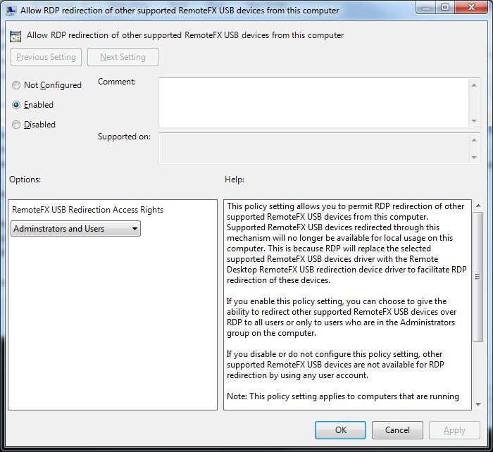
Figure 1: RemoteFX USB device policy settings
- In the Allow RDP redirection of other supported RemoteFX USB devices from this computer dialog box, click OK.
- From a command prompt, type gpupdate.exe /force.
- Restart the computer for the group policy settings to take effect.

Step 2: Install and Configure Windows 7 SP1 in a Virtual Machine
Windows 7 SP1 is installed on a virtual machine running in Hyper-V by performing the following steps:
- Install Windows 7 SP1 using the default installation options.
- Enable Remote Desktop connections for the account you will use to log on to Windows 7 SP1.
For more information about enabling Remote Desktop connections in Windows 7, see “What types of Remote Desktop connections should I allow?” in Windows 7 Help.
- Verify that you can connect to Windows 7 SP1 by using the Remote Desktop Connection client in Windows Server 2008 R2 SP1.
- Shutdown the Windows 7 virtual machine.

Step 3: Enable RemoteFX 3D Video Adapter Support on Windows 7 Virtual Machine
The RemoteFX 3D Video Adapter Support must be added to the Windows 7 virtual machine by performing the following steps on the computer running Windows Server 2008 R2 SP1:
- Start Hyper-V Manager.
- In Hyper-V Manager, select the Windows 7 virtual machine and in the Actions pane click Settings.
- In the navigation pane, under the Hardware section, click Add Hardware.
- Add the adapter; start the virtual machine; verify that the adapter is installed and then restart the machine.
- In the properties pane, click RemoteFX 3D Video Adapter, and then click Add.
The RemoteFX 3D Video Adapter appears in the list of hardware in the Hardware section as show in the following figure.
- Start the virtual machine; verify that you can login and that you have loaded the driver. The VM will ask to be restarted at this point, perform the restart.
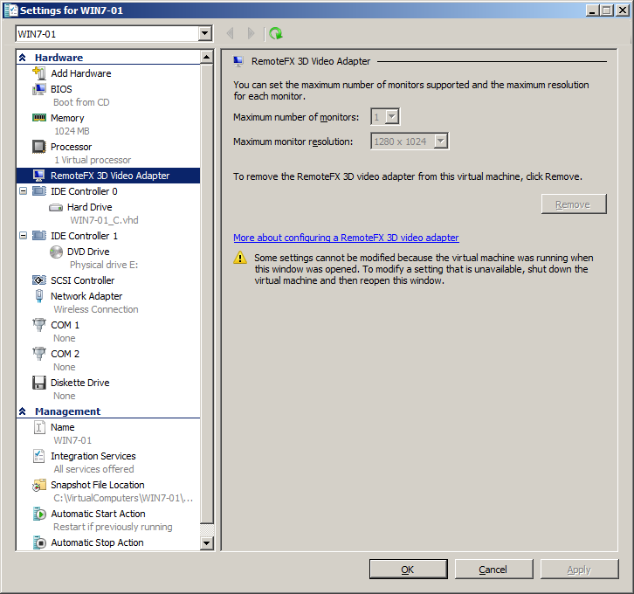
Figure 2: RemoteFX 3D Video Adapter in virtual machine settings

Step 4: Evaluate RemoteFX User Experience
To verify that RemoteFX is properly installed and configured and to evaluate the RemoteFX user experience, perform the following steps:
- Start the virtual machine running Windows 7 SP1.
Win7-01 enable remote
- Establish a Remote Desktop session with Windows 7 SP1 by using the Remote Desktop Connection client in Windows Server 2008 R2 SP1 with the following options enabled:
On the Local Resources tab, in Apply Windows key combinations, select one of the following, as shown in the following figure:
- Only when using full screen. Select this option if you are going to run the Remote Desktop session in full screen.
- On the remote computer. Select this option if you are going to run the Remote Desktop session in a window.
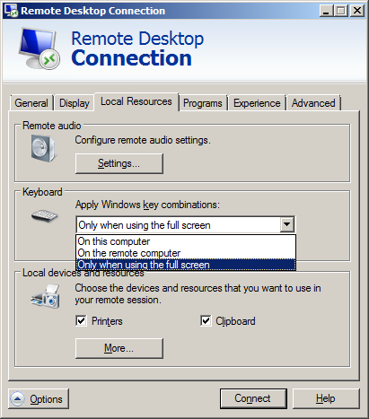
Figure 3: Local Resources tab options for Remote Desktop client
On the Experience tab, in Performance section, select LAN (10Mbps or higher) and verify that all the check boxes are selected, as shown in the following figure:
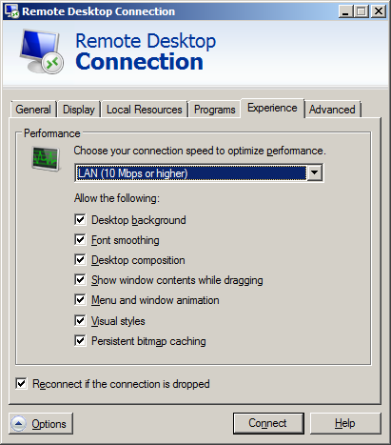
Figure 4: Experience tab options for Remote Desktop client
- Log on using an account that is a member of the local Administrators group on Windows 7 SP1.
- Change the theme for the Windows 7 to use an Aero theme.
The desktop theme should appear with all the Aero features, such as transparency, as shown in the following figure.
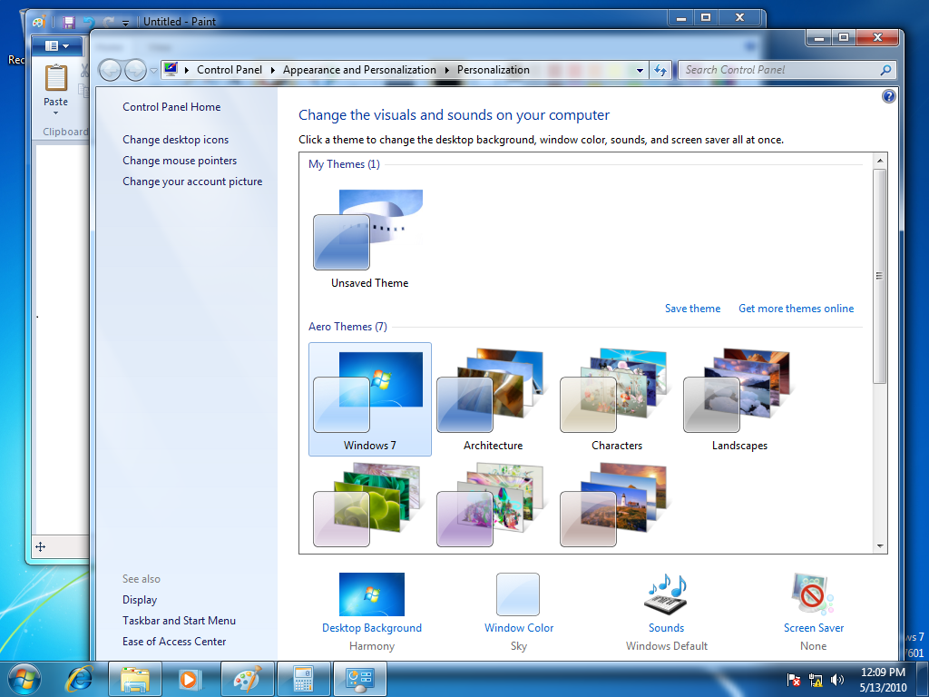
Figure 5: Remote Desktop session with Aero theme enabled
- Start Calculator.
- Start Paint.
- Start Windows Explorer.
- Use Aero peek to view a program, as shown in the following figure.
Tip: To use Aero peek, over the mouse pointer over an item on the task bar.
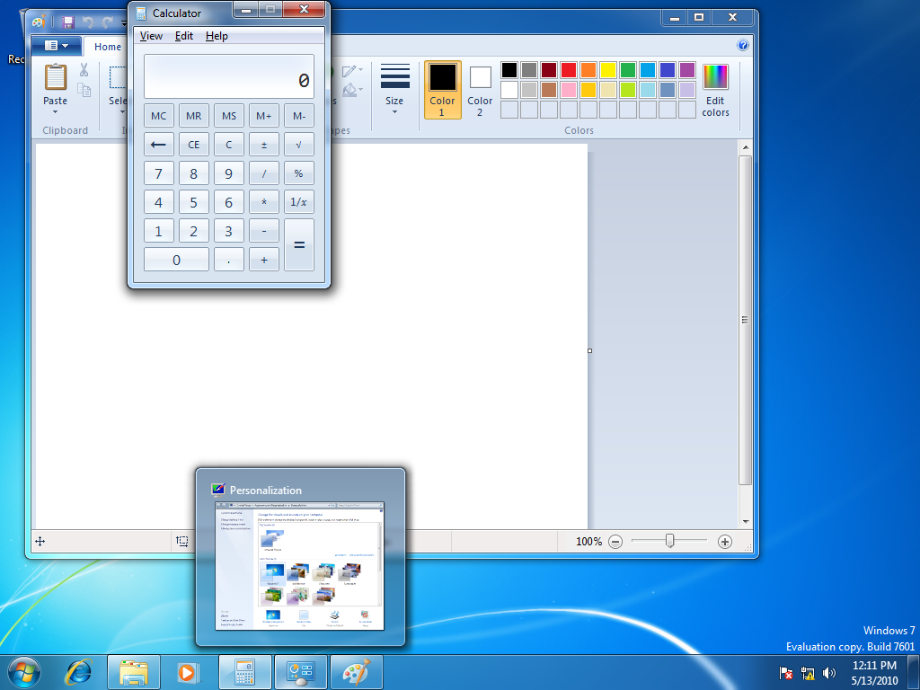
Figure 6: Remote Desktop session with Aero peek
- Use Aero flip to rotate through the programs, as shown in the following figure.
Tip: To use Aero flip, simultaneously press the Windows Key and Tab.
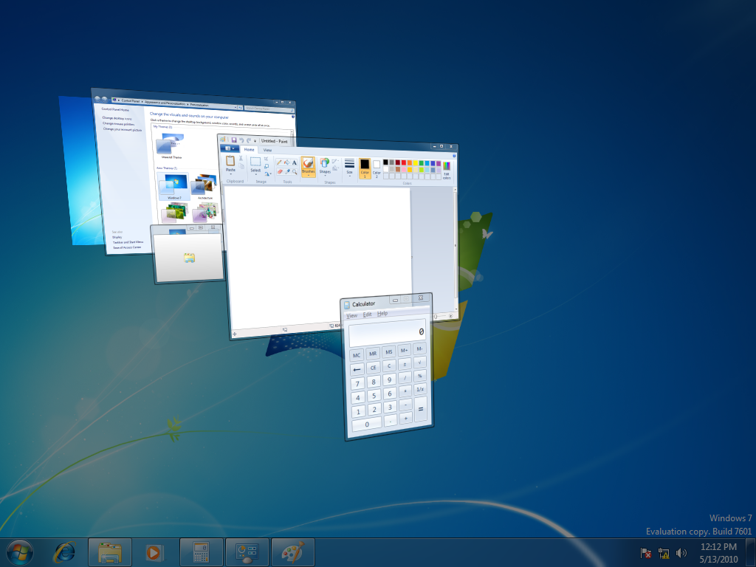
Figure 7: Remote Desktop session with Aero flip
- Play one of the sample videos in Windows 7 using Windows Media Player.
Tip: The sample videos are stored in the Libraries\Videos\Sample Videos folder for each user.
- Log off the Remote Desktop session.

Step 5: Evaluate RemoteFX USB Support
To verify that RemoteFX is properly installed and configured and to evaluate the RemoteFX USB support, perform the following steps:
- Start the virtual machine running Windows 7 SP1.
- On the computer running Windows Server 2008 R2 SP1, insert a USB device.
Note: For the purposes of these steps, a USB camera is used.
- Start the Remote Desktop Connection client.
- In the Remote Desktop Connection dialog box, click Options.
- On the Local Resources tab, click More.
- In the Local devices and resources section, expand Other supported RemoteFX USB devices, and then selected the USB devices you inserted in step 2, as illustrated in the following figure, and then click OK.
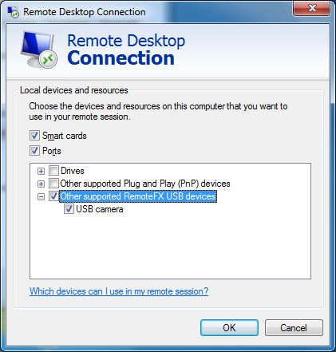
Figure 7: Remote Desktop Connection enable USB device support
- In the Remote Desktop Connection dialog box, click Connect.
- Establish a Remote Desktop session with Windows 7 SP1.
- In the Windows 7 SP1 Remote Desktop session, start Device Manager.
- In Device Manager, look for the USB device that you inserted in step 2.
If the device driver has not been installed for the USB device, then the USB device will appear in Device Manager as show in the following figure.
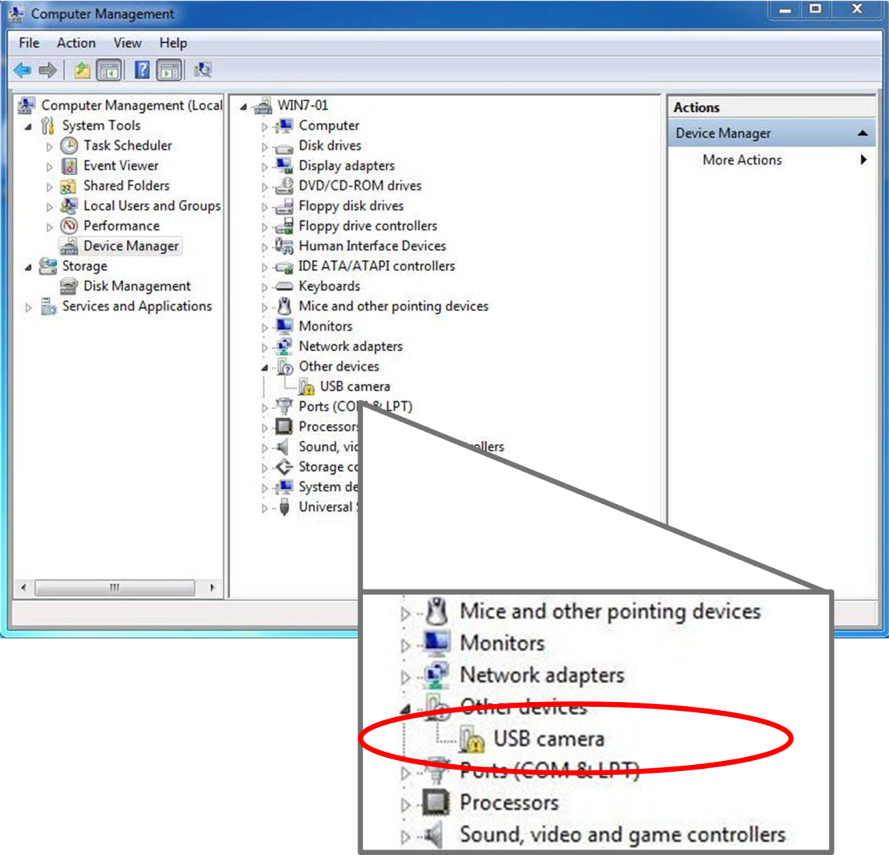
Figure 7: USB device in RemoteFX Remote Desktop session prior to device driver installation
If the device driver has been installed for the USB device, then the USB device will appear in Device Manager as show in the following figure.
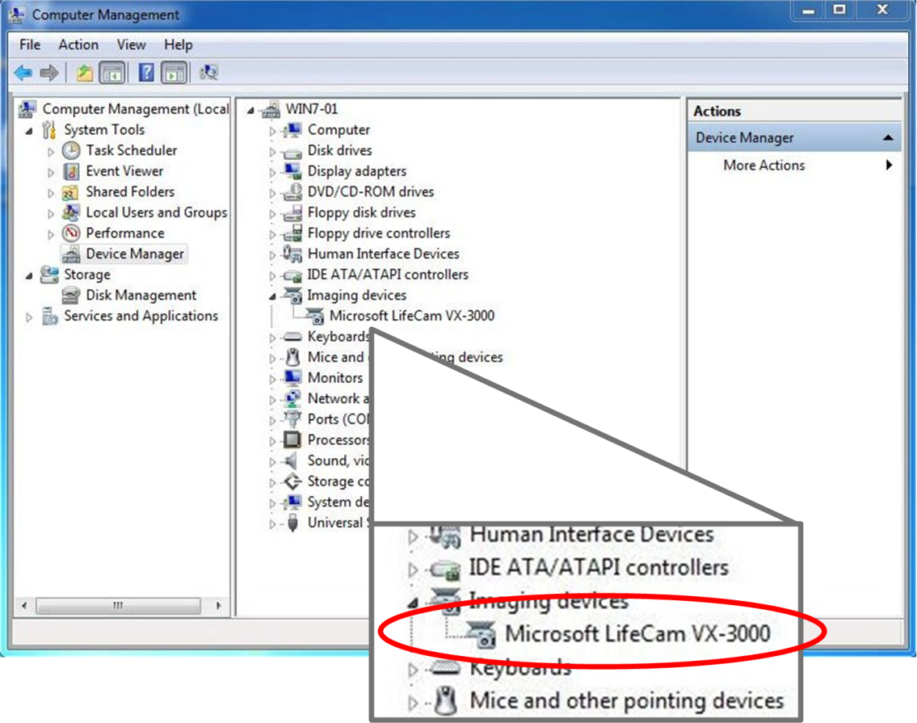
Figure 7: USB device in RemoteFX Remote Desktop session after to device driver installation
After the device drivers for the USB device are installed in Windows 7 SP1, the device can be used normally.
- In Device Manager, expand System Devices, and notice the Remote Desktop USB Hub device, as illustrated in the following figure.
The Remote Desktop USB Hub device acts as a virtual USB hub for all the USB devices that are redirected from the Remote Desktop Connections client.
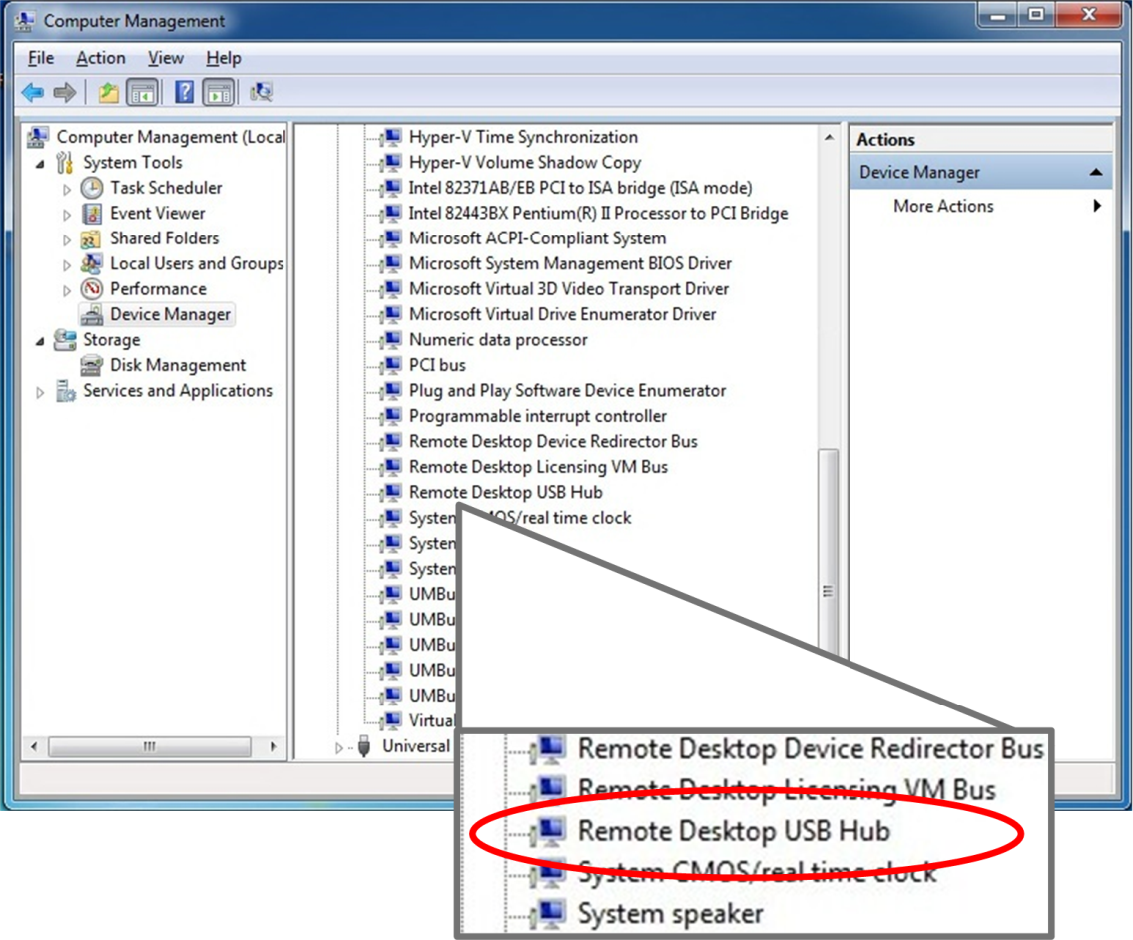
Figure 7: RemoteFX USB device driver in Windows 7 SP1
- On the computer running Windows Server 2008 R2 SP1, start Devices and Printers.
- In the Devices and Printers console, under Unspecified, notice the USB devices is redirected, as illustrated in the following figure.
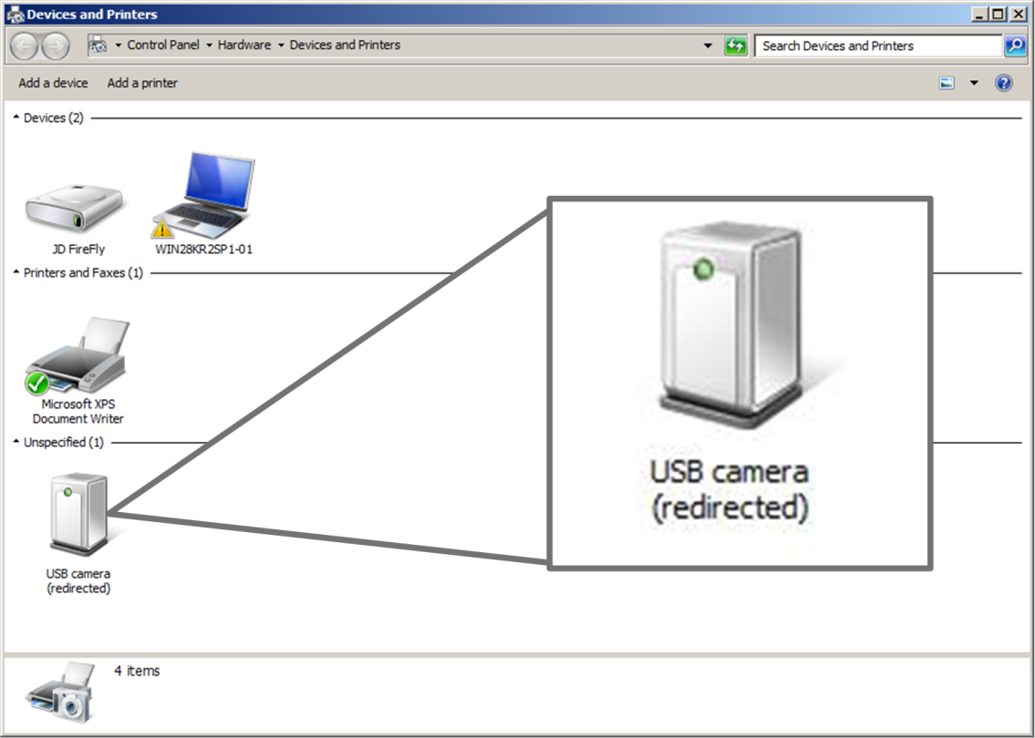
Figure 7: Redirected USB device in Devices and Printers console
- Logoff the Windows 7 SP1 session.
In summary, the RemoteFX feature allows Windows 7 SP1 and applications running in virtual machines to provide the same user experience as though they were running on a physical computer. The Remote FX feature The RemoteFX feature also allows remote users to redirect local USB devices to their Remote Desktop sessions. The proceeding steps help show how RemoteFX improves the user experience when running Windows 7 and applications in a virtualized environment.

Dynamic Allocation of Virtual Machine Memory
The Dynamic Memory feature in Hyper-V in Windows Server 2008 R2 SP1 allows users to run Windows 7 SP1 and applications in a virtualized environment that can dynamically allocate memory for virtual machines. The Dynamic Memory feature allows IT administrators to specify starting value and a maximum value for virtual machine memory allocation. Because virtual machine memory can be dynamically allocated, the system resources are utilized more efficiently and are automatically adjusted based on the needs of each virtual machine.

Dynamic Memory Evaluation System Requirements
To evaluate the Dynamic Memory feature of Hyper-V in Windows Server 2008 R2 SP1, you need to have the system requirements listed in the following table in addition to those in the “System Requirements” section in the “Getting Started” section, earlier in this guide.
Table 1: Dynamic Memory Evaluation System Requirements
Computer | Description and system resources
W2K2R2SP1 | This is a physical computer that can be a standalone server or a member of a domain. This computer runs Windows Server 2008 R2 SP1 with the Hyper-V server role installed. The system resources of this computer are as follows:  - Two or more processor cores running at 1.6 gigahertz (GHz) or faster  - 4 gigabytes (GBs) or more of physical memory  - One disk partition that has 250 GB or more of available disk space.
WIN7-02 | This is a virtual computer that can be a standalone computer or a member of a domain. This computer runs Windows 7 SP1 with the following system resources:  - One or more virtual processors running at 1.6 gigahertz (GHz) or faster  - 1 GB or more of memory  - One virtual hard disk that is 120 GB or larger.

Evaluate Dynamic Memory User Experience
Evaluate how the Dynamic Memory feature in Hyper-V enhances user experience by performing the following steps:
- Prepare Windows Server 2008 R2 SP1 for evaluating the Dynamic Memory feature in Hyper-V by installing the Hyper-V server role.
- Install Windows 7 SP1 in a virtual machine running in Hyper-V.
- Enable the Dynamic Memory feature in Hyper-V on the Windows 7 virtual machines.
- Verify enhanced user experience for running additional programs in Windows 7 using Dynamic Memory.

Step 1: Prepare Windows Server 2008 R2 SP1 for Evaluating Dynamic Memory
Prepare the physical computer running Windows Server 2008 R2 SP1 for evaluating RemoteFX by performing the following steps:
- Install Windows Server 2008 R2 SP1 on the computer.
- Install the Hyper-V server role.
For more information about installing the Hyper-V server role, see “Installing Hyper-V” in the Hyper-V Planning and Deployment Guide available at http://www.microsoft.com/downloadS/details.aspx?FamilyID=5da4058e-72cc-4b8d-bbb1-5e16a136ef42&displaylang=en.

Step 2: Install and Configure Windows 7 SP1 in the Virtual Machine
Install Windows 7 SP1 in a virtual machine running in Hyper-V by using the default installation options. No additional software or device drivers are necessary in Windows 7 SP1 to evaluate the Dynamic Memory feature in Hyper-V.

Step 3: Enable Dynamic Memory Support on Windows 7 Virtual Machines
The Dynamic Memory feature must be configured for the Windows 7 virtual machine by performing the following steps on the computer running Windows Server 2008 R2 SP1:
- Start Hyper-V Manager.
- In Hyper-V Manager, select the first Windows 7 virtual machine and in the Actions pane click Settings.
- In the navigation pane, under the Hardware section, click Memory.
- In the properties pane, click Dynamic.
- In Startup RAM, type 512.
- In Maximum RAM, type 3192.
The Dynamic Memory settings are configured as show in the following figure.
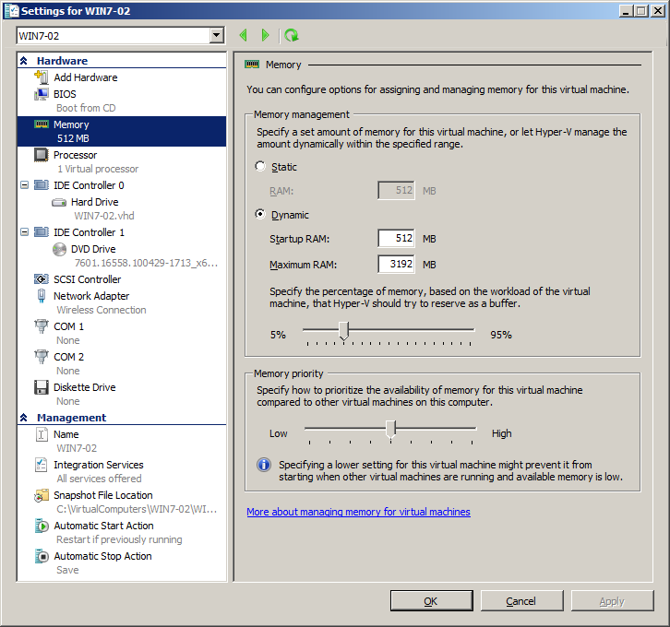
Figure 2: Dynamic Memory configuration in virtual machine settings
- In the virtual machine settings dialog box, click OK.

Step 4: Evaluate Dynamic Memory User Experience
To verify that Dynamic Memory is properly installed and configured and to evaluate the Dynamic Memory user experience, perform the following steps:
- Connect to the virtual machine running Windows 7 SP1 using Hyper-V Manager.
- Start the virtual machine running Windows 7 SP1.
- Log on using an account that is a member of the local Administrators group on Windows 7 SP1.
- Start Task Manager.
- On the Performance tab, view the amount of memory currently available to Windows 7 SP1.
Tip: The total amount of available memory is displayed in Total under the Physical Memory (MB) section.
The amount of memory is close to the 512 MB value specified for Startup RAM in the virtual machine settings, as illustrated in the following figure.
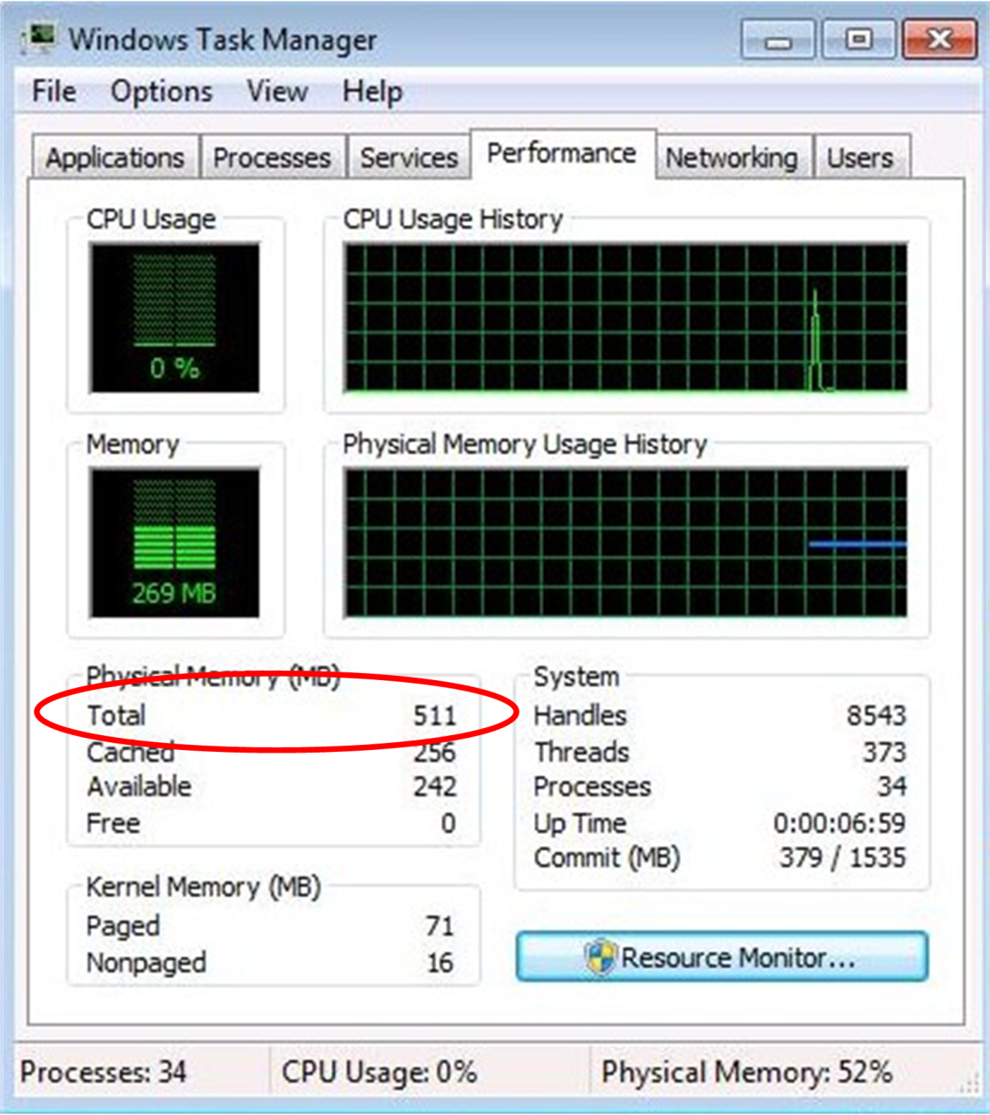
Figure 5: Initial memory available to Windows 7

- Start Calculator.
- Start Paint.
- Start WordPad.
- Start Windows Explorer.
- Start XPS Viewer.
- Start Command Prompt.
- Start Windows Media Player.
- Start Windows Update.
- Start Computer Management
- Minimize all programs except Task Manager.
- In Task Manager, on the Performance tab, view the amount of memory currently available to Windows 7 SP1.
Tip: The total amount of available memory is displayed in Total under the Physical Memory (MB) section.
The amount of memory available is now larger than the 512 MB value specified for Startup RAM in the virtual machine settings, as illustrated in the following figure.
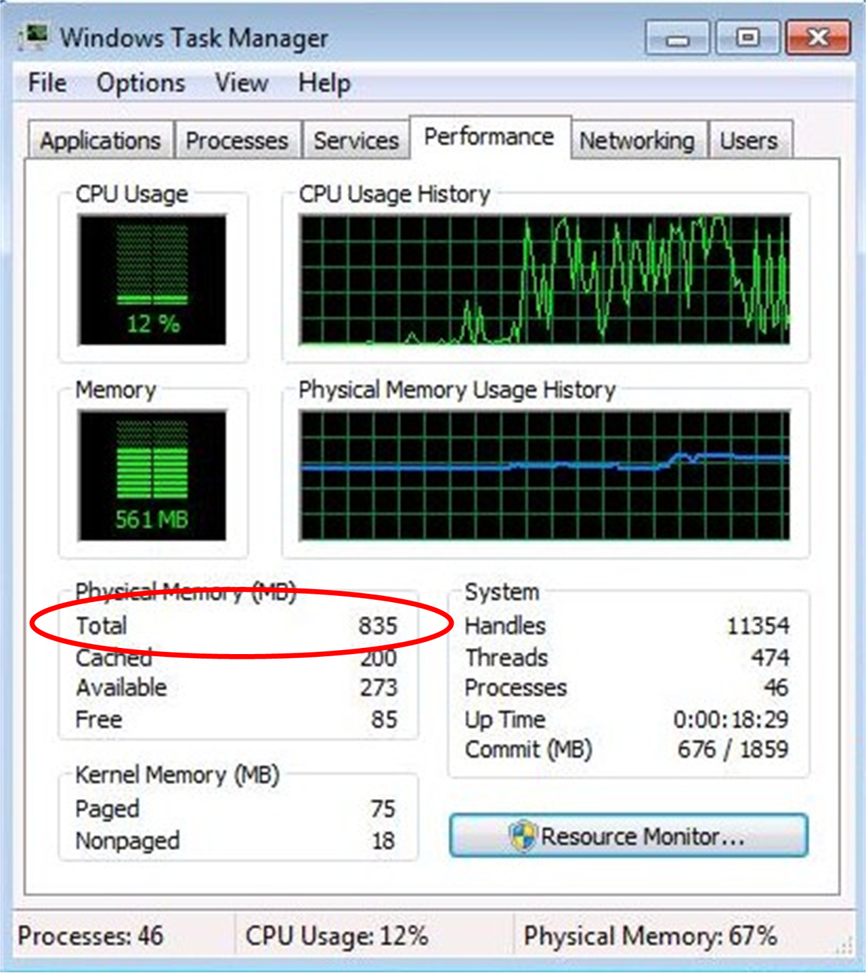
Figure 5: Memory available to Windows 7 after running a few programs

In summary, the Dynamic Memory feature in Hyper-V in Windows Server 2008 R2 SP1 allows Windows 7 SP1 and applications running in virtual machines to dynamically allocate memory on demand. The starting amount of memory and the maximum amount of memory allocated to a virtual machine can be configured on a per virtual machine basis, allowing granular control over memory allocation for all virtual machines.

