

Improving Sales Proposals Using the Microsoft Office System
Technical Discussion Guide

The information contained in this document represents the current view of Microsoft Corporation on the issues discussed as of the date of publication. Because Microsoft must respond to changing market conditions, it should not be interpreted to be a commitment on the part of Microsoft, and Microsoft cannot guarantee the accuracy of any information presented after the date of publication.
This document is for informational purposes only. MICROSOFT MAKES NO WARRANTIES, EXPRESS OR IMPLIED, AS TO THE INFORMATION IN THIS DOCUMENT.
Complying with all applicable copyright laws is the responsibility of the user. Without limiting the rights under copyright, no part of this document may be reproduced, stored in or introduced into a retrieval system, or transmitted in any form or by any means (electronic, mechanical, photocopying, recording, or otherwise), or for any purpose, without the express written permission of Microsoft Corporation.
Microsoft may have patents, patent applications, trademarks, copyrights, or other intellectual property rights covering subject matter in this document. Except as expressly provided in any written license agreement from Microsoft, the furnishing of this document does not give you any license to these patents, trademarks, copyrights, or other intellectual property.
Unless otherwise noted, the example companies, organizations, products, domain names, e-mail addresses, logos, people, places and events depicted herein are fictitious, and no association with any real company, organization, product, domain name, e-mail address, logo, person, place or event is intended or should be inferred.
© 2005 Microsoft Corporation. All rights reserved.
Microsoft, Active Directory, InfoPath, MSDN, SharePoint, Visual Studio, Windows, and Windows Server are either registered trademarks or trademarks of Microsoft Corporation in the United States and/or other countries.
All other trademarks are property of their respective owners.

1 Executive Summary 4
Purpose of This Guide 4
2 Business Challenges and Solutions 6
Business Challenges 6
Addressing the Challenges 6
Proposals Solutions Using the Microsoft Office System 7
Benefits 8
3 Architectural Overview 10
Solution Architecture 10
A Sample Proposals Solution in Action 11
4 Infrastructure Considerations 17
Software Considerations 17
Scalability and Operations Considerations 18
Windows SharePoint Services Capacity Guidelines 18
Integration with SharePoint Portal Server 19
Security Considerations 19
Information Bridge Security 19
SharePoint Products and Technologies 20
5 A Developer's Perspective 21
Customizing Windows SharePoint Services 21
Using InfoPath Forms 22
Adding Functionality Through Word 22
Developing Proposal Schemas 22
Using Information Bridge in Solutions 23
6 Next Steps 24
Resource and Skill Considerations 24
Business Analyst 24
Case Study 25
Potential Partner Solutions 25
Solution Showcase for the Microsoft Office System 26
7 Appendix 27
General Resources 27
Developer Resources 27
Product Training 27
Security Information 28

1 Executive Summary
Proposals that companies submit to secure new business must be accurate and up-to-date in addition to being compelling. To operate efficiently and remain competitive, a company must:
● Reduce the time teams spend preparing a proposal and invest that time in interacting with customers.
● Focus its effort on the most promising leads, based on a systematic evaluation of risk and return.
● Prepare proposals that comply with their customers' standards and with government regulations.
● Submit additional proposals without additional resources.
This guide describes an example of a software solution that can be used to support and manage the preparation of sales proposals. The sample solution is based on features in Microsoft® SharePoint® Products and Technologies, Microsoft Office Word 2003, and Microsoft Office InfoPath® 2003. The operations and capabilities that these applications provide are integrated through an implementation of the Microsoft Office Information Bridge Framework, a technology that enables developers to expand the tasks and data collection that can be performed within a single Office application. Windows SharePoint Services document libraries store proposal content and can be searched and updated while a user works in Microsoft Word. Collaborative work assignments can also be managed through actions initiated in Word. InfoPath forms are used to collect information about sales opportunities. The information captured in the InfoPath forms can be used for analysis and reviewed in standard SharePoint lists.
Businesses that can benefit the most from a proposals management solution include medium to large firms that sell complex capital goods (such as construction, engineering, or telecommunication equipment companies) or service businesses involved in outsourcing human resource and accounting services, providing financial or telecommunication services, or in developing information technology and other software solutions.

Purpose of This Guide
This guide is intended to help decision makers assess and recommend information technology solutions designed to help manage the preparation of sales proposals. It summarizes challenges faced by businesses that regularly create proposals and describes how a Microsoft Office System solution can address those challenges. This guide does not describe the steps required to set up a complete solution.
This guide also covers the following topics:
● The architecture and operations of a sample proposals solution
● Issues to consider with respect to scalability, security, and other operational needs
● Resources and skills related to implementing and maintaining a solution
● Additional resources for information about Microsoft software products and technologies and Microsoft partners who develop proposals solutions

2 Business Challenges and Solutions
This chapter highlights challenges that businesses face in preparing sales proposals. It explains how a solution built with the Microsoft Office System can address these challenges and describes the benefits that an Office-based solution provides.

Business Challenges
A study by AMR Research indicates that inefficiencies in a business's proposal development processes can lead to lost revenue. In some cases, the time required to create proposals results in a business submitting fewer proposals than is optimal. Locating content that proved effective in previous proposals can be time-consuming, for example, as is ensuring that information is accurate and up-to-date. Proposals will not be successful if the quality of the information they contain is inconsistent or if they do not comply with applicable customer or government requirements.
The timing, accuracy, and quality of proposals are affected by business challenges such as the following:
● Proposal teams spend unproductive time searching for and re-creating content because they lack systematic and centralized access to data, including company-approved boilerplate, customer guidelines, and industry regulations.
● Proposal authors cannot use a single application for research and preparation. They often use a Web browser for research, a word processing program to write a proposal, an e-mail client to coordinate reviews and assignments, and the desktop operating system to locate related files and information. As a result, teams spend significant time coordinating tasks and reviews and gathering information from data sources and programs that aren't integrated with the application used to create a proposal.
● Proposals are created for unqualified leads without a business evaluating opportunities to ensure that the business pursues projects with the least risk and the highest return on investment.

Addressing the Challenges
To create successful proposals, a sales team needs to manage lengthy, multipart documents; coordinate work among contributors; and have access to company-approved content in addition to government and customer requirements. This guide describes an example of a Microsoft Office-based solution that can help proposal teams do the following:
● Shorten the proposal timeline by facilitating collaboration among team members, managing roles and responsibilities, and decreasing the number of review phases
● Speed content creation by enabling a user to prepare and manage a proposal—performing such tasks as research and writing, importing standard content, and sending notifications to team members—while working in a single application
● Evaluate opportunities by using Office System tools and templates to analyze the costs and benefits of alternative projects
The example described in this guide uses a Microsoft Windows® SharePoint Services content library to store proposal documents. The library also stores standard proposal sections, information about government and customer requirements, and content that has been approved for past proposals and used in successful bids. The library can be searched for relevant content, and matching items can be imported into a proposal that is being prepared. New content or updated sections can be published to the library as a proposal is written. Proposal teams can also use a Windows SharePoint Services site to view the status of documents, manage timelines, and help manage reviews. Each proposal site can be defined to follow a standard layout so that when users come to a site, they can easily locate shared documents and other project information.
Proposal writing and other document assembly tasks can be initiated from the task pane in Word 2003. The task pane is customized through metadata defined in the Information Bridge Framework and provides the means to search for, view, and import items from the Windows SharePoint Services content library. Proposal authors can quickly find or create proposal sections, assign sections to team members and subject matter experts, and send notifications to team members while working in Word.
A business can also define InfoPath form templates to gather information that is used to analyze the risk and return of business opportunities. The information collected in the InfoPath forms can be viewed in the SharePoint site to help sales teams and managers conduct their evaluation. The information can also be incorporated with a broad range of business processes because InfoPath supports customer-defined XML schemas and integrates with Web services.

Proposals Solutions Using the Microsoft Office System
The Microsoft Office System is a widely adopted platform on which a business can base a solution for creating and managing proposals. SharePoint Products and Technologies provides features for managing documents, user access, and workgroup communication and collaboration. Web-based SharePoint sites can display an array of information to site users and provide a location at which teams can view project announcements, schedules, and task assignments.
InfoPath forms are often easier to build than Web applications. The InfoPath user interface provides tools for working with repeated groups of data and optional fields. Users of InfoPath can work with XML documents without needing to work directly with XML. They can create and modify documents in an environment that provides rich-text formatting, table and image support, and automatic correction. Users can define custom properties and add optional and repeating elements without changing the schema. Individual elements from an InfoPath XML document can be presented as Windows SharePoint Services library columns so that users can view that data without opening a document.
The primary integration point between SharePoint Products and Technologies and InfoPath is a type of document library called a form library, which stores XML documents and can also contain an InfoPath form template that defines instructions for rendering and editing XML files. Access to each library can be granted to specific users.
The Microsoft Office Information Bridge Framework enables developers and solution providers to take advantage of the XML support in Microsoft Office System applications to define actions that a user can take from the task pane. Users are able to use familiar applications to view and edit business information that is stored in enterprise systems in the context of their work with e-mail messages, Word documents, Microsoft Office Excel spreadsheets, and InfoPath forms, for example. The actions defined for the task pane can be based on a user's role or authentication credentials through integration with the Microsoft Active Directory® directory service.

Benefits
A Microsoft Office–based proposals solution can reduce turnaround time by automating manual repetitive tasks and lessening the time proposal teams require to find relevant information and assemble a document. It enables proposal authors to work within a single application and provides a Web-based portal that promotes collaboration and efficient reviews.
Specific benefits of a proposals solution based on Office technologies include the following:
● Creating a content library that stores historical proposal content, market information, customer data, and approved boilerplate content.
● Facilitating the proposal authoring process and improving the accuracy and validity of a proposal’s content by enabling repeated use of existing content assets stored in the content library.
● Promoting collaboration among writers and other team members to generate proposals more quickly.
● Controlling proposal costs by using fewer resources, reusing proven content, and shortening the time required to prepare a proposal.
● Enabling information exchange across applications and data sources through support for XML.
● Providing an extensible proposal platform that enables integration into an organization’s opportunity pipeline management applications. Examples of integration include linking content management applications to proposal libraries, incorporating cost analysis procedures with the proposal document, converting a proposal to a contract or a purchase order, and automating proposal archiving.
● Providing higher adoption rates because it is based on tools such as Word that proposal writers are accustomed to using.
● Providing a central storage facility and a framework for protecting sensitive documentation through Windows SharePoint Services and Microsoft Windows 2003.
● Providing a text retrieval search engine (Microsoft SQL Server™ 2000 using the Microsoft Search service as a full-text indexing and search engine) for searching and retrieving content.
Overall, with a proposals solution developed with the Office System, a business can increase its revenue by creating more accurate and up-to-date proposals, reduce the time its sales teams spend on developing proposals and invest this time in customer interactions, submit a greater number of proposals with limited available resources, focus efforts on the most promising leads, and ensure that proposals comply with customer standards and government regulations.
An array of partners is available to help build solutions. For more information about Microsoft partners and proposal solutions, see Chapter 6, "Next Steps," later in this guide.

3 Architectural Overview
This chapter describes an example of a proposals management solution. It outlines a basic solution architecture and highlights operations such as creating a proposal using material from a content library and assigning document sections to contributors.

Solution Architecture
Figure 3.1 shows the basic architecture for a proposals solution that runs on Microsoft Windows Server™ 2003. The solution is built with SQL Server, SharePoint Products and Technologies, the Information Bridge Framework, Word 2003, and InfoPath 2003. Its operations are implemented through Web services developed on the Microsoft .NET Framework.
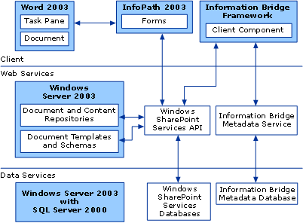
Figure 3.1
Basic architecture of a proposals solution
The sample solution's components are deployed in a three-tier architecture. The client layer includes Microsoft Windows XP, Word 2003, InfoPath 2003, and the Information Bridge Framework client component. Information Bridge provides mechanisms for managing metadata and for communication between a client computer and the underlying services that are part of the sample solution. The Information Bridge Framework client component calls a Web service that in turn accesses the content library through the Windows SharePoint Services application programming interface (API). Content can be published to the content library through a similar process.
The middle layer implements Web services supported by Windows Server™ 2003 and ASP.NET. The Windows SharePoint Services API interacts with the Windows SharePoint Services repositories, and the Information Bridge Framework metadata service exposes a custom Information Bridge solution driven by the metadata stored in the Information Bridge Framework database. Essentially, Information Bridge builds on the XML capabilities in Office 2003 to provide a document action task pane in Word 2003 that is used for team collaboration across proposal document sections, importing content from the Windows SharePoint Services content library, and publishing content to the library.
The data services layer consists of the Windows SharePoint Services configuration and content databases and the Information Bridge Framework database installed on SQL Server 2000.

A Sample Proposals Solution in Action
In the sample proposals solution, Windows SharePoint Services provides Web site management operations and supports document creation and content management. Word 2003 incorporates features of the Information Bridge Framework to provide tools for preparing and editing a proposal document and for building a content library. The client and server components of the Information Bridge Framework manage the communication between client computers and Web services through which users gain access to the content library and to the solution's collaborative features.
Teams use a central Windows SharePoint Services site to view a list of proposal libraries (arranged by customer, for example) and to create additional proposal libraries as opportunities arise. Proposal teams also use the SharePoint site for document management functionality such as version control, team discussions, and viewing schedules and contact lists. Figure 3.2 shows an example of a proposal site that includes a timeline, status information (including a list of team members responsible for each section), and a list of shared documents.
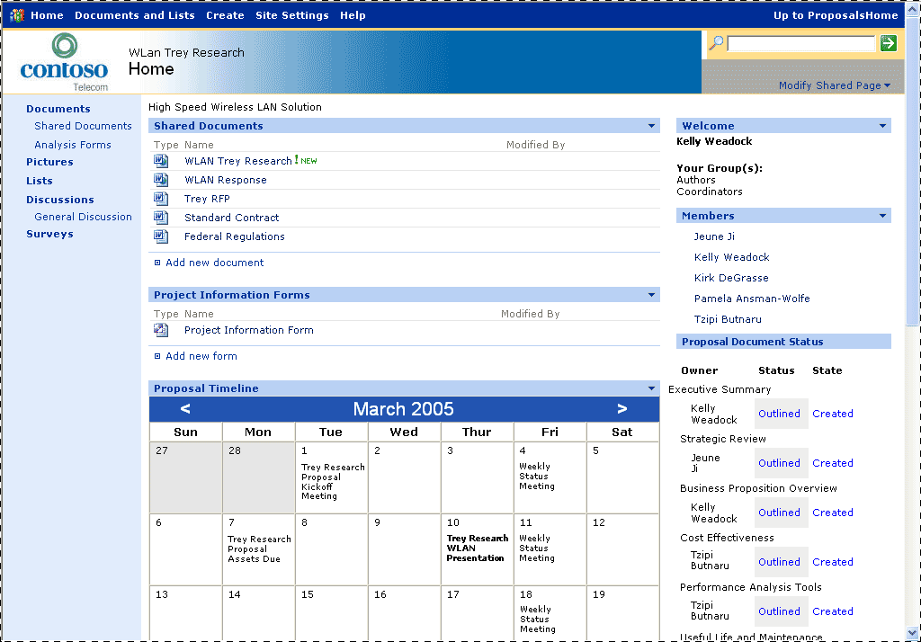
Figure 3.2
A sample proposals solution SharePoint site
A proposal document is opened from the library in the SharePoint site and is then assembled and edited in Word 2003 using controls in the Document Actions task pane. Figure 3.3 shows the task pane displaying the controls used for managing different sections of a proposal.
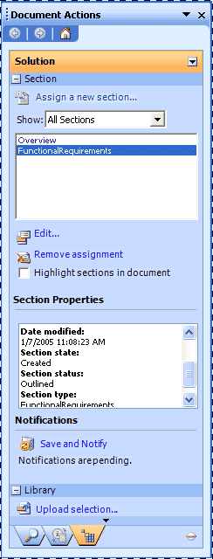
Figure 3.3
The Solution pane of the Document Actions task pane is generated by the Information Bridge Framework client component.
The Information Bridge Framework client component populates the task pane through Web service calls that obtain metadata from the Information Bridge Framework metadata service. This service is installed on a server computer and retrieves metadata from a SQL Server database.
The task pane provides controls by which the authors of a proposal can perform all the operations required to create and manage the document. For example, a Section region could provide controls with which a user assigns a section to a contributor, views document sections and section properties, removes assignments, edits the content of a section, and sends notifications. A proposal author could assign a document section to any user who is a member of the SharePoint site.
Figure 3.4 shows an example of a dialog box that a team member coordinating preparation of a proposal could use to assign sections of a proposal to other team members or to subject matter experts.
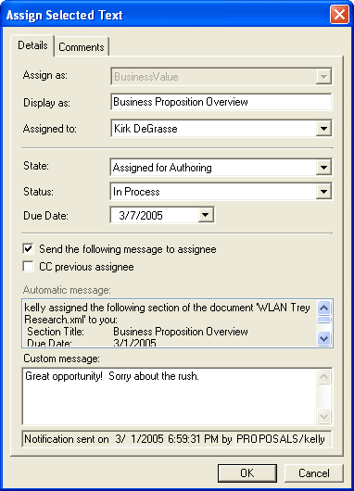
Figure 3.4
The Assign Selected Text dialog box
A Library region in the task pane could provide controls with which a user works with the content libraries that are part of the Windows SharePoint Services site. A user could publish selected content to a content library (providing keywords and other information about the content), search for content in a library, view the properties associated with an item of content, and import content from the library into the open document. Search capability is provided through Windows SharePoint Services, and results can be sorted by properties such as date, author, or company. Figure 3.5 shows an example of previewing an item of content that was retrieved by searching the content library from the task pane. The ease of locating content through an operation such as this saves time because document sections can be populated while working in the authoring application. New or updated content that is published to the library is immediately available for use in other proposals.
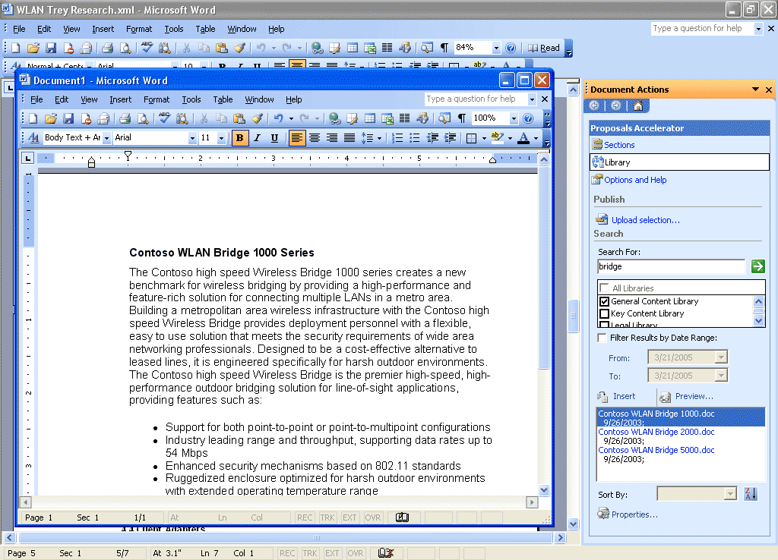
Figure 3.5
Standardized content or proposal sections that have proved successful in previous proposals can be located quickly by searching a content library.
InfoPath forms are integrated with the solution as a tool for collecting data used to evaluate sales opportunities. These forms can be opened and completed from the SharePoint site. Information in the form can be summarized in different views on the site so that other users can view the information without opening the document. Figure 3.6 shows an example of information that could be summarized in an InfoPath form.
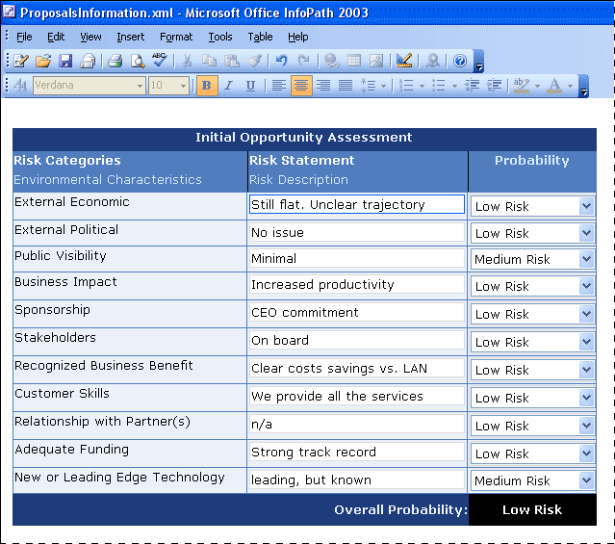
Figure 3.6
InfoPath forms can be used to collect information that is used to evaluate the risk and return of a sales opportunity.
The sample solution described in this chapter is one approach to using the Microsoft Office System as a platform for a proposals management solution. A central SharePoint site provides content libraries and project information. The Word task pane, customized by metadata defined in the Information Bridge Framework, supports content searches, task assignments, and notifications. Support for XML in InfoPath enables accurate and structured data capture while the InfoPath user interface offers users familiar tools and features. The sample solution is an example of how a business can extend its use of Microsoft Office applications to gain more from its information technology investments.

4 Infrastructure Considerations
This chapter identifies topics that an organization should consider with respect to its information technology infrastructure when evaluating the deployment of a proposals solution. These topics include which Microsoft software products can be used to build a solution, issues related to the scalability of a solution, and operations and security considerations.

Software Considerations
This section lists the Microsoft products and technologies that can be used to create a sales proposals solution using the Microsoft Office System.
For client computers, the following products can be used:
● Microsoft Windows XP Professional
http://www.microsoft.com/windowsxp/pro/evaluation/sysreqs.asp
● Microsoft Internet Explorer
http://www.microsoft.com/windows/ie/
● Microsoft Windows SharePoint Services
http://www.microsoft.com/sharepoint/
● Microsoft Office Professional Enterprise Edition 2003
http://www.microsoft.com/office/prodinfo.mspx
● Microsoft Word 2003
http://www.microsoft.com/office/word/prodinfo/default.mspx
● Microsoft Office InfoPath 2003
http://office.microsoft.com/infopath
● Information Bridge Framework client component
http://msdn.microsoft.com/library/default.asp?url=/library/en-us/odc_ibf2003_ta/html/odc_ibfintro.asp

For server computers, the following products can be used:
● Microsoft Windows Server 2003
http://www.microsoft.com/windowsserver2003/evaluation/sysreqs/default.mspx
● Internet Information Services (IIS) 6.0 with Microsoft ASP.NET
http://www.microsoft.com/windowsserver2003/iis/default.mspx
● Microsoft SharePoint Products and Technologies
http://www.microsoft.com/sharepoint/
● Microsoft SQL Server 2000 SP3a or later
http://www.microsoft.com/sql/
● Information Bridge Framework server component
http://msdn.microsoft.com/library/default.asp?url=/library/en-us/odc_ibf2003_ta/html/odc_ibfintro.asp

Scalability and Operations Considerations
A Microsoft Office-based proposals solution can be implemented on various hardware configurations, whether a single server, two servers, or a large network of clustered servers such as a server farm. For example, a company hosting only a few proposal sites could run Windows SharePoint Services on a single server, using the same content database for all sites.
For deploying a solution, consider scalability issues such as the following:
● One server: Using a single server reduces the cost of ownership, but this configuration limits the amount of storage and is a factor in future scalability. This approach could be used by a business that wants to build a pilot solution for testing.
● Two servers: Using SQL Server on one server to store data and using a second server to host the proposals site provides more options for storage and is a configuration that can be scaled up to include other servers if they are needed in the future.
● Server farm: A server farm is suitable for companies that have a server farm already, those in which clustering is in use, and those that are planning to incorporate them at the same time they are setting up a solution. A company that needs the capacity of a server farm would most likely require several content databases in which to store site data for each virtual server.

Windows SharePoint Services Capacity Guidelines
Important issues to consider when evaluating an Office-based proposals solution are the two kinds of capacity guidelines for Windows SharePoint Services: throughput limits and scale limits. This information should be taken into account in planning for hardware purchases and server configuration.

Throughput Limits
Throughput limits are the approximate number of transactions per second that a given server configuration can handle. Throughput limits help determine how many simultaneous users can use a given server resource without negatively affecting performance.

Scale Limits
Scale limits provide a guideline for the approximate number of objects that can be created in a given scope, for example, the number of documents per folder. This guideline helps you determine the server configuration required to host a given number of objects.
For more information about Windows SharePoint Services capacity, see the article “Capacity Planning for Windows SharePoint Services” at:
http://www.microsoft.com/technet/treeview/default.asp?url=/technet/prodtechnol/windowsserver2003/technologies/sharepoint/wssadmin/stsb07.asp

Integration with SharePoint Portal Server
A proposals management solution that includes a site built on Windows SharePoint Services can be integrated with an enterprise portal application such as Microsoft SharePoint Portal Server. SharePoint Portal Server makes available additional features, such as cross-site indexing, enhanced search capabilities, document classification, and others.
SharePoint Portal Server 2003 provides centralized access to multiple systems, including Office applications, business intelligence and project management systems, and line-of-business applications. The portal also features search technology developed by Microsoft Research that enables users to search file shares, Web servers, Microsoft Exchange Server public folders, Lotus Notes, and Windows SharePoint Services sites without customization.

Security Considerations
In-depth discussions of security, secure deployment, and secure coding practices can be found on the Microsoft Web site by searching using the keyword security. The following sections describe security considerations related to Information Bridge and SharePoint Products and Technologies.

Information Bridge Security
In a solution that uses Information Bridge, the security of business information can be enhanced with a secure connection to the metadata service through Secure Sockets Layer (SSL) encryption and support for Hypertext Transfer Protocol Secure (HTTPS) encryption between the metadata service and the client and for all SOAP calls between the client and Web services. Information Bridge also encrypts its local cache on a per-user basis.
An Information Bridge Framework component known as the Context and Action Service (CAS) Engine runs on a client computer and executes requests by using the credentials of the user currently logged on to the computer. Information Bridge always uses Windows credentials when communicating with the metadata service. Access to metadata and line-of-business data can be controlled by using role-based access privileges. Integration with the Windows Server 2003 Authorization Manager and Groups/Roles in Active Directory ensures that users have access only to metadata that they have permission to see.
For more information, see the section "Security Overview" in the Information Bridge Framework Planning and Architecture Guide, available at:
http://msdn.microsoft.com/office/understanding/ibframework/techarticles/default.aspx

SharePoint Products and Technologies
SharePoint Products and Technologies provides a security layer for defining and managing user permissions. Permissions can be configured per site to use unique permissions or permissions can be inherited from a top-level site. Although document by document (or line item) security is not available within a SharePoint site, unique permissions enable an administrator to manage users and site groups separately from a parent site. If unique permissions are used for a proposals subsite, user accounts and site groups will need to be added for each Web site for which the users and groups need access.

5 A Developer's Perspective
This chapter describes some of the areas that developers can explore to extend and customize a proposals management solution that is built with SharePoint Products and Technologies, InfoPath 2003, and the Information Bridge Framework.

Customizing Windows SharePoint Services
Windows SharePoint Services includes an object model and Web services programming interfaces that can be used to manage templates, lists, and Web site data; customize Web Part views; and administer a top-level site or subsite. The object model is integrated with Microsoft ASP.NET, which means that developers can use Microsoft Visual Studio® .NET to create custom Web applications or to customize Web Parts.
Windows SharePoint Services exposes list and library events that can be called whenever an event is triggered. For example, an event handler can be called whenever a site configuration document is modified to create new form libraries, update user permissions, or create columns in the Windows SharePoint Services list used for reporting or analysis.
A business might have hundreds or thousands of files that need to be added to a proposals content library, and these documents need to be classified to return precise search results. One means of classifying documents is to define custom document properties. Windows SharePoint Services can display customized document properties in columns if those columns are defined in a view of a SharePoint list when the document is loaded. However, manually classifying the content of documents to match a specific taxonomy is a tedious task that requires opening each document. If the documents are stored as XML files or can be converted in bulk to WordML, an XML parser can be used to set properties programmatically. Third-party tools can provide more sophisticated loading capabilities, such as signifying tags for a document based on the document’s content.
One important step in developing Windows SharePoint Services sites is to create Web Parts or customize built-in Web Parts. With the Data View Web Part, for example, a developer can connect to a data source such as a Web service, a form library, or a document library. Calling a Windows SharePoint Services Web service from inside the Data View Web Part, you can connect to properties of the current site or to other subsites, providing information that would not be available otherwise. Custom Web Parts can also be used to automate a process. For example, when a sales team has completed a proposal document, it might want to create a Portable Document Format (PDF) file, convert the file from WordML to a Word document, or apply digital rights management to the document. A Web Part could be developed to help manage one or more of these processes.
Adding an Office Web Component to a SharePoint site enables reports that plot and summarize data related to proposals and sales opportunities. For example, a graph could show proposal wins and loses, product sales, or customer purchase patterns. Information in SharePoint lists can also be presented and summarized to help analyze whether the expected return from an opportunity is sufficient.

Using InfoPath Forms
InfoPath forms can be integrated deeply within a proposals management solution. For example, a developer could write a program that takes information from an InfoPath form (data used to qualify an opportunity, for example) and, through calls to the Windows SharePoint Services APIs or to Web services, provision a proposal site with the data without additional user intervention.
Because the contents of InfoPath forms are saved in XML, developers can use XML Path Language (XPath) to pull out specific values from a form or an Extensible Stylesheet Language Transformation (XSLT) to work with the structured data. For example, specific data can be used to generate a new proposal document, pulling data for sections such as customer and project information, team resources, project schedule parameters, and required section titles.
Individual elements from an InfoPath XML document can be presented in Windows SharePoint Services form libraries so that users can view that data without needing to open the InfoPath document itself. A solution can use this capability to promote properties and status information from documents into form library views.

Adding Functionality Through Word
In a proposals solution such as the example described in this guide, developers can provide additional functionality by customizing features in Word. For example, a developer could create a Web service that is used to search content within the Research task pane. Word also provides a means to lock the formatting or restrict the editing of sections within a document. Finally, an InfoPath form or questionnaire could serve as the source of WordML content that can then be used to create a Word document.

Developing Proposal Schemas
Proposal documents can be associated with an XML schema that defines elements such as the sections within the document. Attributes can be associated with each element to identify information such as the user currently assigned to the section or when the section was last changed. Attributes could also be defined to indicate section type (for example, reference material) or the amount of time spent preparing a specific section. You can develop schemas with elements that correspond to sections required by specific customers or government agencies. These schemas would then be associated with specific documents when proposals are prepared.

Using Information Bridge in Solutions
Information Bridge can consume any Web Services Interoperability (WS-I) compliant Web service or common language runtime (CLR) service. Information Bridge metadata describes the data and methods in the service and defines how to expose them in the correct context in the task pane.
Task pane regions can display data from a variety of data sources. Businesses might want to consider including this functionality in proposals solutions to provide information from customer relationship management (CRM) or enterprise resource planning (ERP) systems that would be useful for preparing proposals. You would need to change the metadata to support any new user interface that is displayed.
One advantage of using Information Bridge is that the functionality it provides exists as metadata. Solutions built with Information Bridge are deployed to the metadata service without having to be installed on client computers. This highly efficient and simple deployment method is achieved because the Information Bridge Framework client component, once it is installed on a client computer, can host any number of customized Information Bridge Framework solutions based on the metadata that is published to the server. Further, modifications to a solution, after the modifications are published to the metadata service, are reflected in client sessions without needing to update client computers.
Another advantage to the Information Bridge Framework solution architecture is that a single solution can be used within all the Office applications that support Information Bridge without cross-application customizations.
For more information about designing reusable Web services that comply with Information Bridge Framework guidelines, see the Information Bridge Framework technical documentation at:
http://msdn.microsoft.com/office/understanding/ibframework/techarticles/default.aspx

6 Next Steps
This chapter reviews steps that businesses can take if they decide to pursue the implementation of a proposals management solution built with the Microsoft Office System. The topics described include resources and skills required to develop, implement, and maintain a solution and information about case studies and Microsoft partners.

Resource and Skill Considerations
A business that implements a proposals solution needs personnel to fill roles such as business analyst, project manager, technical architect, developer, and system administrator. Depending on a business's situation, a solution provider or partner might fill some or all of these roles.
One of the first steps in implementing a proposals solution is to perform the business analysis required to identify processes, template needs, user access, and site configuration. Some of the other functions performed by a business analyst and other important roles are described in the following sections.

Business Analyst
The functions and skills related to the work of the business analyst's role in a proposals solution include the following:
● Functions: Analyzes business processes and defines the rules and behaviors required within the process. Helps determine how the proposals site will be structured. Creates prototypes of document templates.
● Skills: Knowledge of organization's proposal creation processes. General knowledge of business process analysis procedures.

Developer
Developers working with a proposals solution will need to understand and have experience with a number of different technologies. A developer will need to work with XML, InfoPath, Web Parts, and the Information Bridge Framework metadata designer. Web service and ASP.NET development are other important areas, as is experience with SQL Server table design and stored procedures.
● Functions: Implements the business processes defined by the business analyst. Defines XML schemas for the document templates. Creates InfoPath forms. Might design SQL Server databases for storage.
● Skills: InfoPath forms design techniques. Familiarity with Windows Server 2003, SQL Server 2000, ASP.NET, and the .NET Framework. XML expertise.
Administrator
An organization's system administrator will be involved during the planning and deployment of a solution. The following are among the functions and skills required of the administrator of a proposals solution:
● Functions: Sets up communication among the components specified by the developer. Deploys Internet Information Services and Windows SharePoint Services as required. Might create and maintain SQL Server databases.
● Skills: Knowledge of InfoPath 2003 implementations. Familiarity with Windows Server 2003, SQL Server 2000, Windows SharePoint Services, and the .NET Framework.

Case Study
Microsoft Office System Customer Solution case studies provide insights into why businesses choose Office as the platform for their information technology solutions. The case studies offer highlights into development approaches, partner value, and results. A case study of NCMIC Insurance, a business that implemented a Microsoft Office-based solution for creating proposals, is documented at:
http://www.microsoft.com/resources/casestudies/CaseStudy.asp?CaseStudyID=1502
4
The benefits of this solution identified by NCMIC include:
● 30 percent productivity increase
● Payback on pilot investment after only six projects
● Cost savings of up to $7,500 per policy project
● Avoidance of costly law suits as a result of policy incompliance

Potential Partner Solutions
Microsoft industry partners can play an important role in developing a solution that helps a business improve its sales proposals. A partner can provide subject matter expertise and deployment support, customize a solution by adding Web Parts and other tools, enhance the workflow and security of a solution, and assist in automating the bulk import of content and documents.
More information about proposal solutions developed by Microsoft partners is available in the case study described in the previous section. You can also find more information about partner solutions at:
http://directory.partners.extranet.microsoft.com/

Solution Showcase for the Microsoft Office System
The Solution Showcase for the Microsoft Office System highlights how leading organizations solve business problems using the Microsoft Office System. The Solution Showcase provides information about how Microsoft customers can obtain more value from their investments in the Microsoft Office System.
For more information about the Solution Showcase, see:
http://www.microsoft.com/office/showcase/default.mspx
7 Appendix
The sections that follow list a variety of resources about Microsoft software products. The resources include information about the Microsoft products that can be used to build a proposals management solution and links to sites that provide product documentation, technical articles, and training resources.

General Resources
Association of Proposal Management Professionals
http://www.apmp.org/

Developer Resources
For information about developing a proposals management solution, see the following Web sites:
● Microsoft Office Developer Center
http://www.msdn.microsoft.com/office/
● SharePoint Products and Technologies Software Development Kit (SDK)
http://www.microsoft.com/downloads/details.aspx?familyid=AA3E7FE5-DAEE-4D10-980F-789B827967B0&displaylang=en
● InfoPath Developer Center
http://msdn.microsoft.com/library/default.asp?url=/library/en-us/dnanchor/html/odc_ancInfo.asp?frame=true
● Information Bridge Framework technical articles in the MSDN Library
http://msdn.microsoft.com/library/default.asp?url=/library/en-us/odc_2003_ta/html/odc_landibf03_ta.asp
● Information Bridge Framework 1.0 Solution Development Guide
http://www.microsoft.com/technet/itsolutions/cits/iwp/ibf/soldev/moibf1_sdg_01.mspx

Product Training
For information about product training, see the following Web sites:
● InfoPath Online Training
http://www.msdn.microsoft.com/office/understanding/infopath/training/default.aspx
● SQL Server Training
http://www.microsoft.com/sql/techinfo/training/
● Windows Server 2003 Training
http://www.microsoft.com/windowsserver2003/techinfo/training/default.mspx
● Windows SharePoint Services Administrator's Guide
http://www.microsoft.com/downloads/details.aspx?FamilyID=a637eff6-8224-4b19-a6a4-3e33fa13d230&displaylang=en

Security Information
For security information, see the following Web sites:
● SharePoint Products and Technologies Security Center: Product and technology guidance that will help you protect your platforms, networks, desktops, and data.
http://www.microsoft.com/technet/security/prodtech/sharept/default.mspx
● Windows SharePoint Services Administrator’s Guide: Guide for installing, configuring, managing, and maintaining Windows SharePoint Services.
http://www.microsoft.com/downloads/details.aspx?FamilyID=a637eff6-8224-4b19-a6a4-3e33fa13d230&DisplayLang=en
● MSDN Security Developer Center: In-depth technical content, community resources, downloads, product information, and more for developers interested in writing secure code and using security APIs.
http://msdn.microsoft.com/library/default.asp?url=/library/en-us/dnanchor/html/securityanchor.asp
● Microsoft Security: Comprehensive and up-to-date information on virus alerts, security bulletins, technical information, and events.
http://www.microsoft.com/security/
● Security Tools on TechNet: Tools to assess vulnerabilities and strengthen security.
http://www.microsoft.com/technet/treeview/default.asp?url=/technet/security/tools/default.asp
● Microsoft Baseline Security Analyzer V1.2: Scans for common incorrect configurations and missed updates.
http://www.microsoft.com/technet/security/tools/mbsahome.mspx
● Microsoft SQL Server 2000 SP3 Security Features and Best Practices: Guide to best practices.
http://www.microsoft.com/technet/prodtechnol/sql/2000/maintain/sp3sec00.mspx
● Windows Server 2003 Security Guide: Provides guidance, tools, and templates that help secure Windows Server 2003 in many environments.
http://www.microsoft.com/technet/security/prodtech/win2003/w2003hg/sgch00.mspx/
● Improving Web Application Security: Threats and Countermeasures: Provides information about designing, building, and configuring secure ASP.NET Web applications.
http://msdn.microsoft.com/library/default.asp?url=/library/en-us/dnnetsec/html/threatcounter.asp

Bois, Robert. “Quoting Complex Products Across Multiple Sales Channels—A Sales Configuration Vendor Landscape.” AMR Research. October 2004.

