

Introduction to Windows Small Business Server 2003 for Enterprise IT Pros
Microsoft Corporation
Published: September 2005 (Version 1)
Author: Stephen Oliver

Abstract
This paper begins with a brief survey of the Windows SBS 2003 design philosophy. It continues with the Top 10 must-know facts that Enterprise IT Pros unfamiliar with Windows SBS often miss, it highlights the Top 10 cool features of Windows SBS, and then it concludes with a quick look at some of the standard scenarios that you’re likely to find in many Windows SBS installations. The goal of this paper is to familiarize you—the Enterprise IT Pro—with Windows SBS 2003.
For the most up-to-date product documentation for Windows SBS 2003, see the Microsoft Web site (http://go.microsoft.com/fwlink/?LinkId=33326).

The information contained in this document represents the current view of Microsoft Corporation on the issues discussed as of the date of publication. Because Microsoft must respond to changing market conditions, it should not be interpreted to be a commitment on the part of Microsoft, and Microsoft cannot guarantee the accuracy of any information presented after the date of publication.
This White Paper is for informational purposes only. MICROSOFT MAKES NO WARRANTIES, EXPRESS, IMPLIED OR STATUTORY, AS TO THE INFORMATION IN THIS DOCUMENT.
Complying with all applicable copyright laws is the responsibility of the user. Without limiting the rights under copyright, no part of this document may be reproduced, stored in or introduced into a retrieval system, or transmitted in any form or by any means (electronic, mechanical, photocopying, recording, or otherwise), or for any purpose, without the express written permission of Microsoft Corporation.
Microsoft may have patents, patent applications, trademarks, copyrights, or other intellectual property rights covering subject matter in this document. Except as expressly provided in any written license agreement from Microsoft, the furnishing of this document does not give you any license to these patents, trademarks, copyrights, or other intellectual property.
© 2005 Microsoft Corporation. All rights reserved.
Microsoft, Active Directory, Outlook, SharePoint, Windows, and Windows Server are either registered trademarks or trademarks of Microsoft Corporation in the United States and/or other countries.
UPnP™ is a certification mark of the UPnP™ Implementers Corporation.
All other trademarks are property of their respective owners.

Contents
Introduction to Windows Small Business Server 2003 for Enterprise IT Pros 5
The Design Philosophy of Windows SBS 2003 5
"All-in-one" server solution for small businesses 5
Familiar…But Different 6
Active Directory 7
DHCP 7
DNS design 8
Top 10 Gotchas 8
The domain can have only one machine running Windows SBS 8
You can't establish trusts with other domains 9
You can’t create child domains 10
Only 75 users, computers, or devices can connect to the server at one time 10
Finish installing Windows SBS before you customize it 10
Use the Windows SBS wizards, not MMC snap-ins 11
Windows SBS client-access licenses are all that client computers need to access Windows SBS 12
Terminal Server runs only in Remote Administration mode 12
Leave the default Active Directory structure as is 13
Know the Windows SBS hardware maximums 13
Top 10 Cool Features 14
Server Management Console 14
Configure E-mail and Internet Connection Wizard (CEICW) 15
Add User Wizard 17
Add Computer Wizard 19
Set Up Server Computer Wizard 21
The http://companyweb Web site 22
Backup 23
Monitoring 24
Remote Web Workplace 26
Standard Edition vs. Premium Edition 27
Common Scenarios 28
Multi-homed vs. single adapter 28
Internet connectivity 28
Static IP 28
Additional Server 29
Related Links 30

Introduction to Windows Small Business Server 2003 for Enterprise IT Pros
Welcome to the Microsoft® Windows® Small Business Server 2003 (Windows SBS) server software! Is your main work environment a Windows–based network of hundreds or maybe thousands of servers, spanning several physical locations, providing computing services to hundreds or thousands of users, all managed by you and the rest of a dedicated information systems staff? If so, you are an Enterprise Information Technology Professional (Enterprise IT Pro). And if you are an Enterprise IT Pro who is installing or supporting Windows SBS 2003 for the first time or who just wants to know more about it, this paper is for you!
This paper begins with a brief survey of the Windows SBS 2003 design philosophy. It then continues with the Top 10 must-know facts that Enterprise IT Pros unfamiliar with Windows SBS often miss, it highlights the Top 10 cool features of Windows SBS, and then it concludes with a quick look at some of the standard scenarios that you’re likely to find in many Windows SBS installations. The goal of this paper is to familiarize you—the Enterprise IT Pro—with the basics of Windows SBS 2003 so that you can approach your first installation or support issue with confidence.
Note
If you’re really in a hurry and don’t have time for the entire paper, at least read the Top 10 Gotchas. There you’ll find the "wish-I-had-knowns" gained from the experience of Windows SBS customers, most valuable professionals (MVPs), partners, Windows SBS enthusiasts, and especially Enterprise IT Pros like yourself, who wish they had had an introduction like this before they touched their first machine running Windows SBS!
To download the most recent version of this documentation, visit the Microsoft Web site at http://go.microsoft.com/fwlink/?LinkId=52145.

The Design Philosophy of Windows SBS 2003

"All-in-one" server solution for small businesses
Make no mistake about it—Windows SBS was designed from the ground up with small businesses in mind. Consider your average small business: few staff and limited resources. Because of their size, small businesses typically don’t employ a full-time IT person to manage their network. Usually, the network (if it even exists) is managed by one of the small business’ other employees (who typically has limited computer expertise) as an "additional duty." The result is most often a less-than-robust computing experience. And yet, despite this limitation, small businesses have the same technology needs as mid-size or enterprise-level businesses: file and printer sharing, e-mail, and Internet access, to name a few. This is where Windows SBS comes to the rescue!
Windows SBS 2003 provides many of the same technology "bells and whistles" that larger organizations with dedicated IT staff enjoy, but at a much lower cost to install and maintain. Windows SBS 2003 does this by bringing together several powerful Microsoft server applications into one installation that sits on a single computer and topping it all off with a simple, easy-to-use management console.

Familiar…But Different
To make it all work just right, Windows SBS changes some of the configuration of the core services running in the included server applications—like the Microsoft Windows Server™ 2003 operating system, Exchange Server 2003, and the Windows SharePoint® Services. And to make this system easy to manage, Windows SBS takes many of the everyday network and server management tasks that Enterprise IT Pros are used to doing in Windows Server with Microsoft Management Console (MMC) snap-ins and exposes them as wizards. The wizards are a lot easier for non-professionals to understand and to use, and they do the work of customizing certain settings—"tuning" them for the small-business environment.
For some management areas, related tasks are grouped into a single wizard that completes the tasks "under the hood," making it even easier to manage Windows SBS. When Windows SBS administrators walk through a wizard, in some cases they've accomplished what would take several different snap-ins in Windows Server—one for each task. Clearly, this isn't the case in the enterprise world that IT Pros like you live in, where typically one person armed with an MMC snap-in is responsible for creating a user account, another for creating the Exchange mailbox for that user account, another for…well, you get the picture!
As an Enterprise IT Pro, you probably know the pieces of Windows SBS very well, but you might be surprised by some of the differences that result from bringing all those pieces together on one machine. These differences show up both as you install and as you manage Windows SBS, and you should know about them before you begin.
Specifically, let's look at some of the differences with the Active Directory® directory service, the Dynamic Host Configuration Protocol (DHCP), and the Domain Name Service (DNS). You probably work with these technologies every day, so let’s finish our brief discussion of the Windows SBS design philosophy with a quick look at the differences you can expect to find in each of them.

Active Directory
In the world of Windows SBS, there isn’t much need for the administrator to devote a lot of time to configuring or managing Active Directory. Active Directory is configured right out of the box at installation time, with a few options available, to function specifically for a Windows SBS network, so there really isn’t a reason to customize it further.
What's important here is that the design of Windows SBS 2003 places the server at the root of the Active Directory forest, where it holds the operations master roles. This is non-negotiable. A server running Windows SBS is absolutely the root of the forest, and it won’t transfer the operations master roles—no matter how hard you try—to any other machines in the Windows SBS network. The Active Directory structure in Windows SBS is a forest with one tree and one domain—the Windows SBS domain.

DHCP
You can host DHCP either on the server running Windows SBS (the recommended option) or on an external router in the Windows SBS network. If you host DHCP on the server, Windows SBS 2003 Setup binds the DHCP service only to the internal network card (if you are multi-homed). That way, there aren't any conflicts with the Internet service provider (ISP) and it's more secure. When you use your server running Windows SBS as your DHCP server, Setup defines these pre-set DHCP scope options for DHCP client computers:

003 | Router | The computer running Windows SBS.
006 | DNS Server | The computer running Windows SBS.
015 | DNS Domain Name | The internal domain of the network. If you follow the suggested default, this is the ".local" domain name.
044 | Windows Internet Name Service (WINS) Server | The computer running Windows SBS.
046 | WINS Node Type | "H-node"

DNS design
Because DNS is required for Active Directory, and because the computer running Windows SBS is always installed as a domain controller, the DNS service is always installed and running. Windows SBS operates on the assumption that there are no other DNS servers on the network, so that the computer running Windows SBS handles DNS services alone.
When you think about how Windows SBS implements DNS, you should keep this overall point in mind: the DNS service running on Windows SBS is intended to resolve internal network names only. The DNS service is set to listen on the internal network card only, but it passes on requests for host names that it doesn’t recognize to a DNS forwarder. The forwarders in this case are the ISP’s DNS servers.
This concludes our quick tour of the basic design philosophy of Windows SBS 2003. It's time to turn our attention to some of the commonly missed differences between Windows Server in the enterprise network and Windows SBS 2003. Some Enterprise IT Pros, unaware of these differences, have jumped in to their first Windows SBS installation or support issue only to run into roadblocks that they could have easily avoided "if only they had known." The next section about the Top 10 "gotchas" helps you learn from their mistakes!

Top 10 Gotchas

The domain can have only one machine running Windows SBS
I mentioned earlier in the discussion about Active Directory design that Windows SBS 2003 Setup places the machine running Windows SBS at the root of an Active Directory forest. The end result is that there can be one and only one server running Windows SBS in a Windows SBS domain.
Many Enterprise IT Pros have stumbled right here, thinking that Windows SBS is like Windows Server, Standard or Enterprise Editions, on this point. They assume that they can install Windows SBS 2003 on a server and then drop that server on to an existing Windows Server domain as another replica domain controller on the network with no issue. But they can't! The server running Windows SBS always sits at the root of the domain. This obviously means that you can have only one server running Windows SBS on a network.
I feel the need to repeat this, so here it is: there can be only one machine running Windows SBS in a domain! Also, the Windows SBS computer must be the root of the forest so you can’t add another Windows Server machine to a Windows SBS network as the primary domain controller. (You can add extra machines running Windows Server to a Windows SBS domain as replica domain controllers, line-of-business (LOB) application servers, or servers that have Windows Server 2003 Terminal Server enabled, but we’ll cover that later in the "Common Scenarios" section of this paper.)

You can't establish trusts with other domains
Another surprise for the Enterprise IT Pro who is familiar with Windows Server only in the enterprise space is that Windows SBS domains cannot establish trusts with any other domains—period. No if-ands-or-buts about it; a Windows SBS domain stands alone. You can’t establish a trust between a Windows SBS domain and a Windows Server domain, and you can’t establish trusts between Windows SBS domains.
Note
The End-User License Agreement (EULA) for Windows SBS specifically prohibits "hacking" the system in order to work around the "no trusts" rule. So not only is Windows SBS configured to not allow trusts, but you also break your licensing agreement if you try!
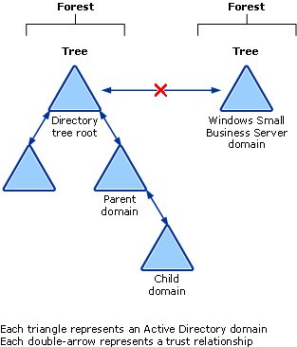

Some Enterprise IT Pros have recommended Windows SBS for a small business under the mistaken notion that they could tie the Windows SBS domain into another Windows Server domain using trusts, only to find out they couldn’t—after they purchased Windows SBS and installed it at the small business!

You can’t create child domains
Following on the second gotcha, you need to know that Windows SBS does not allow child domains. That is, you can’t create a child domain (or sub-domain) beneath the initial Windows SBS domain that you create during Setup. Unlike Windows Server 2003, Standard, Enterprise, or Datacenter Editions, Windows SBS doesn’t allow you to further subdivide your domain namespace hierarchically by creating child domains.
For example, if the small business you're assisting is the Contoso company, and the root domain name is contoso.local (".local" is the default domain root suggested by Windows SBS Setup for the internal domain), you can't add child domains accounting.contoso.local or payroll.accounting.contoso.local. This makes sense when you consider that a typical small business employs a small number of staff and operates out of a single location. The small size of the average small business just doesn’t call for the division of the namespace into child domains.

Only 75 users, computers, or devices can connect to the server at one time
In contrast to Windows Server, where users connecting to the server can number into the thousands, Windows SBS 2003 handles the upper end of the average small business—75 users or devices (including computers) at the most. This is the fourth gotcha for Enterprise IT Pros!
Because you're probably used to working with Windows Server, Enterprise Edition, or even with Windows Server, Datacenter Edition, in which thousands of users and devices are common, you should keep this limit in mind when you're helping a small business decide whether to install Windows SBS 2003 on their network. A business that has more than 75 users or devices should consider other editions of Windows Server 2003.

Finish installing Windows SBS before you customize it
You can think of a Windows SBS installation as happening in two phases: the first phase is the installation of the operating system that drives Windows SBS, and the second phase is the installation of the Windows SBS application. When the first phase is finished, you have an operating system; when the second phase is finished, you have all of Windows SBS 2003. A full installation isn't finished until both phases are finished.
There is a point during installation when the operating system has been installed and the user is returned to the desktop. Some Enterprise IT Pros have been tempted to pause here and tweak the operating system before they install the rest of Windows SBS. But a word of caution: don’t do it!
The second phase of the installation does a great deal of configuration of the underlying operating system. Setup prompts the administrator to make configuration decisions for areas like Internet connectivity, DHCP, and DNS. The end result is that if you did tweak the operating system between phases, the changes that you made after Phase 1 might be overwritten during Phase 2, and those changes that weren’t overwritten might cause problems for the rest of the installation.
Now having said that, let me add that it is a good practice to take a quick look at Device Manager once the first phase is finished. You should check Device Manager to ensure that the operating system correctly recognized your server hardware. If it didn't, this is the time to get the right drivers installed—before you press on to Phase 2.
Aside from that one exception, don’t try to customize between phases. Finish the entire installation, and make the appropriate configuration changes only when Setup prompts you to do so.

Use the Windows SBS wizards, not MMC snap-ins
Probably the biggest misstep for Enterprise IT Pros who know Windows Server only in an enterprise network happens right here: Windows SBS wizards vs. Microsoft Management Console (MMC) snap-ins. Enterprise IT Pros often, mistakenly, jump to the familiar MMC snap-ins instead of using the Server Management console wizards. A good rule of thumb here is this: if the Windows SBS Server Management console provides a wizard, use it!
Windows SBS is filled with handy wizards that take the place of the MMC snap-ins that most Enterprise IT Pros use to modify or manage their servers. Many common management tasks, like adding a new user—something you might usually do with the Active Directory Users and Computers snap-in—shouldn't be done with an MMC snap-in. In Windows SBS, you really should use the wizards provided in the Server Management console.
Here's why: the Windows SBS wizards do customizations behind the scenes that make the product work best for a typical small-business environment. And, as I mentioned earlier, some Windows SBS wizards perform several tasks at once, so that changes you make in one place cause changes behind the scenes in other places. For example, the Add User Wizard creates a user account in Active Directory, creates a mailbox for the user in Exchange, and sets access permissions for the user on the company intranet, to name just a few! The MMC snap-ins aren't all connected that way, and they haven’t been customized for small-business use, so if you use the snap-ins instead of the wizards, you might actually break some Windows SBS functionality. In Windows SBS, Enterprise IT Pros should let the wizards do the magic!

Windows SBS client-access licenses are all that client computers need to access Windows SBS
In a way, licensing is fairly simple with Windows SBS. Instead of having to purchase separate client-access licenses (CALs) for each server application running on the Windows SBS machine—for example, one for Windows Server 2003, one for Exchange 2003, and one for SQL Server™ 2000—Windows SBS requires only one CAL per user or device. With this one CAL, the user or device can access the services provided by the server applications that Windows SBS includes. You should take special note that the CALs for Windows SBS are not the same as the CALs for Windows Server or for Exchange. You can't add a standard Windows Server CAL to Windows SBS; Windows SBS requires Windows SBS CALs.
Also, if you add a computer running Windows Server as a member server in a Windows SBS domain, you don't need any extra licenses for the client computers to access the member server; the Windows SBS CAL covers that, too! But be advised: if you have a member server running applications that require their own licenses—for example, Terminal Server, or a line-of-business application with a SQL Server backend—then you might need to buy additional licenses for those applications. Check the licensing requirements for the application.
And a final tip: SBS CALs are sold in increments of 5 or 20, so keep that in mind if you're advising a small business about the cost of licensing for a Windows SBS network.

Terminal Server runs only in Remote Administration mode
Windows SBS includes Terminal Server, but you can run it only in Remote Administration mode. As you no doubt recall, Terminal Server can run in either of two modes: Application Server mode, and Remote Administration mode. On a server running Windows SBS, Terminal Server runs only in Remote Administration mode. This is one of the big gotchas!
If you want to make Terminal Server in Application Server mode available in a Windows SBS network, you have to add an additional server to the network running Windows Server and Terminal Server in Application Server mode. Because this isn't hard to do (as you'll see in the later section, "Set Up Server Computer Wizard"), it's a quick task for the administrator. Just be aware that client computers connecting to Terminal Server on the additional server need Terminal Server CALs in addition to the Windows SBS CALs.
Bottom line? Windows SBS provides Terminal Server only in Remote Administration mode, so you can't provide Terminal Server in Application Server mode for network users. But if you want to provide Terminal Server in Application Server mode for a Windows SBS network, you can easily do this if you add an additional server running Windows Server and you configure it to provide Terminal Server for your users.

Leave the default Active Directory structure as is
Windows SBS provides a default installation experience that doesn’t require a lot of work by the administrator. And when you do need to make changes to your server, Windows SBS provides easy wizards for most tasks. This holds true for the default Active Directory structure.
For example: by default, when users are added to the Windows SBS network using the Add User Wizard, user objects are placed in the ServerName.local.MyBusiness.Users.SBSUsers organizational unit (OU) in Active Directory (where ServerName is the name of the server running Windows SBS). Other functions in Windows SBS expect to find the network users in that OU. Moving users out of the OU or renaming the OU might cause these other functions to fail.
The crucial point here is that you should leave the default Active Directory structure as is, or else proceed with extreme caution.

Know the Windows SBS hardware maximums
While it’s true in general that the stronger the hardware, the better the performance of the operating system, you should know just how much you can upgrade the hardware that runs Windows SBS.
Take a look at the following table, which compares the hardware maximums of Windows SBS 2003 to those of other Windows Server editions. Keep this table in mind when you're thinking about what hardware to buy to run Windows SBS 2003. The hardware maximums are different than those of other Windows Server operating systems, especially Enterprise and Datacenter Editions:
Table 1 Comparison of Windows Server hardware maximums

Server Product | Maximum Amount of Memory | Maximum Number of Physical Processors | Platforms
Windows Small Business Server 2003 | 4 gigabytes (GB) | 2 | x86
Windows Server 2003, Standard Edition | 4 GB | 4 | x86
Windows Server 2003, Enterprise Edition | 32 GB with x86  64 GB with x64 | 8 | x86  x64
Windows Server 2003, Datacenter Edition | 512 GB | 32, 64, or 128 | x64

And while we're on the topic of hardware, a good practice is to connect all of the hardware on the server before running Windows SBS Setup, because Setup makes some configuration choices depending on what's installed.
So now we've covered the Top 10 gotchas that you should know about before you work with Windows SBS. But that’s not all you should know. The next section covers the Top 10 cool features that Enterprise IT Pros will love!

Top 10 Cool Features

Server Management Console
One of the coolest features of Windows SBS is the easy-to-use Server Management console, which is unique to Windows SBS. Instead of using several separate consoles accessed from several different places, Windows SBS has a handy one-stop-shopping management console where you can find everything you need to manage a server running Windows SBS.
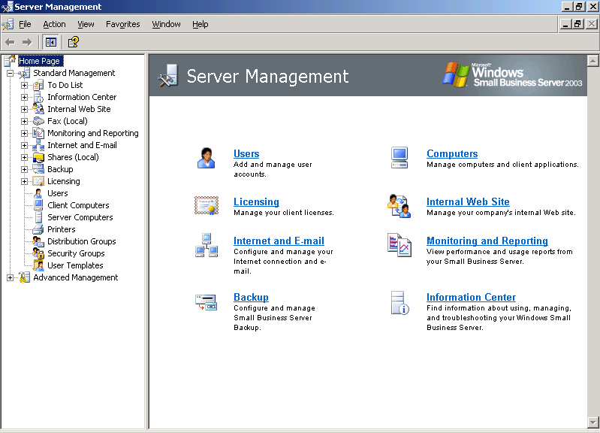

Using the Server Management console, you can easily do common tasks, like adding users, adding computers, or adding licenses, as well as slightly harder tasks, like configuring My Documents Redirection or assigning applications to computers. The console has two nodes—Standard Management and Advanced Management. Almost all common tasks are under the Standard Management node. Other management tasks are under the Advanced Management node. In short, everything you need to manage your server and network is right here in the Server Management console.

Configure E-mail and Internet Connection Wizard (CEICW)
The Configure E-mail and Internet Connection Wizard (CEICW) is a big hit with Windows SBS customers. It reduces some of the most complex networking configurations down to a simple wizard. When you run the CEICW, you connect your server to the Internet, you configure your external firewall device (if it's a UPnP™ certified device) or your basic firewall on your server (if you have two network cards on your server), and you configure the e-mail setup for your network.
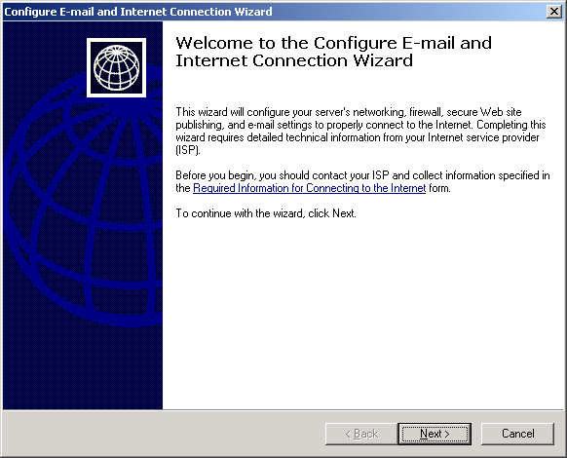

For example, instead of having to manually configure Exchange, Internet Security and Acceleration (ISA) Server 2004 (if you are using Windows Small Business Server, Premium Edition), and then Internet Information Services (IIS) in order to offer Outlook® Web Access to the Windows SBS network users, you can just run the CEICW and you're set!
The last thing I'll mention in connection with the CEICW is the self-signed certificate that the CEICW creates for you (if you want it to). When the certificate is created, the expiration date is set to 5 years. The CEICW then saves the certificate in the Clientapps\SBScert folder on the server running Windows SBS so that when you set up your client computers using the Client Setup Wizard, the certificate is automatically installed. This does not prevent you from buying an SSL certificate from one of the commercial certification authorities if you want to.

Add User Wizard
The great thing about the Add User Wizard is how it brings together several tasks concerning a user’s account into one wizard. You can set the user’s Active Directory placement, domain name, e-mail alias, password, home folder, disk quota, security group associations, e-mail distribution group memberships, and intranet access level, and you can even set up a computer for them—all by completing just one wizard.
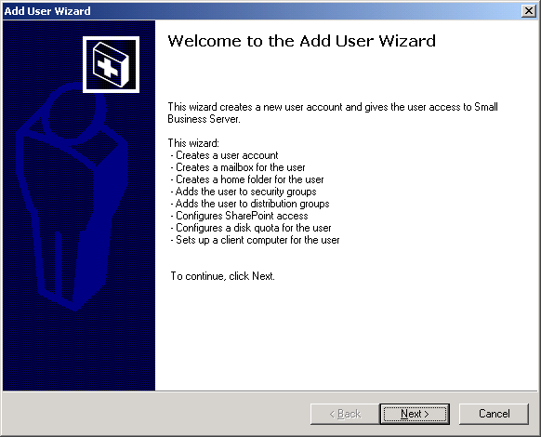

And don’t miss the neat feature that allows you to use templates to create user accounts. With templates, you can create user accounts based on common ways that users use the Windows SBS network. The pre-defined templates are:
• User: Accounts based on the User template have access to shared folders, printers, faxes, e-mail, the company intranet, and the Internet. They also have access to Remote Web Workplace and to Outlook Web Access, if the administrator makes them available using the CEICW.
• Mobile User: Accounts based on the Mobile User template have all of the User permissions, plus they can connect to the server over dial-up or virtual private network (VPN) connections.
• Power User: Accounts based on the Power User template have all of the Mobile User permissions, plus they can manage users, groups, printers, shared folders, and faxes. Power users can log on remotely to the server, but they can’t log on locally. These accounts are designed as a "helper administrator" account for users that assist the administrator with common management tasks, but who don't have full administrator rights. When these users log on to the server, they see a limited version of the Server Management console, which is called Server Management Console for Power Users.
• Administrator: Accounts based on the Administrator template have unrestricted access to the server and the domain.
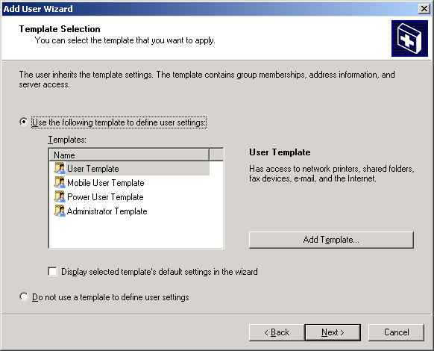

When you add a user using one of these templates, the Add User Wizard works in the background to add the user account to whatever security groups are necessary to give the account the permissions associated with that template.
And if these pre-defined templates don't work for you, you can create your own custom templates using the Add Template Wizard, which is available inside the Add User Wizard.
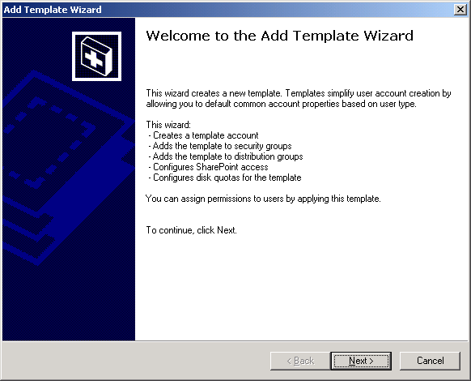

Add Computer Wizard
A favorite feature in the Windows SBS community is the ability to add an existing client computer to a Windows SBS network just by logging on to the client computer, navigating to a Web page on the server, and then running a short wizard.

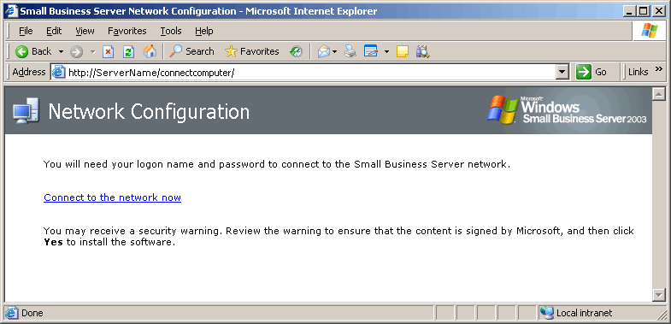

Like all the wizards in Windows SBS, client-computer setup using http://ServerName/ConnectComputer (where ServerName is the name of the server running Windows SBS) does most of the heavy lifting in the background. All the administrator has to do is run the wizard. When you connect using http://ServerName/ConnectComputer, you're actually starting the Small Business Server Network Configuration Wizard, which sets up the client computer to be a part of the Windows SBS network and configures it with certain preset options for ease of use, like pre-populating My Network Places with new Windows SBS locations, and configuring Internet Explorer Favorites as follows:
• The default browser home page points to My Company (http://companyweb).
• Several links related to Windows SBS are added to the Favorites menu in Internet Explorer.
• My Network Places is configured to show personal and shared folders on the server running Windows SBS, as well as document libraries on the http://companyweb Web site.
The Small Business Server Network Configuration Wizard also configures client machines by:
• Installing the Shared Fax client software.
• Putting the printers that are published in Active Directory into Printers and faxes.
A really cool aspect of the Small Business Server Network Configuration Wizard is how it sets up applications on the client computer automatically. Before you use http://ServerName/ConnectComputer to connect the client computer, you need to complete the Set Up Client Computers Wizard. This is where you can tell Windows SBS the computer name of the client computer you want to add, what applications you want added to the client computer (for example, Outlook 2003, Internet Explorer 6, Shared Fax client software, and the latest operating system service packs as of shipping time), and what advanced configuration options you want to set (for example, Outlook profile configuration). When you then log on to the client computer and use http://ServerName/ConnectComputer, the Small Business Server Network Configuration Wizard sets up the machine by using the configuration options you chose in the Set Up Client Computers Wizard.

Set Up Server Computer Wizard
Even though you can have only one server in your domain running Windows SBS, there are situations where you might want or need an additional server in your domain running Windows Server. For example, a small business might have a line-of-business application that needs to run on a dedicated server other than the server running Windows SBS. If the additional server is running Windows 2000 Server or Windows Server 2003, you can add it to the network using another of the wizards available in Windows SBS—the Set Up Server Computer Wizard.
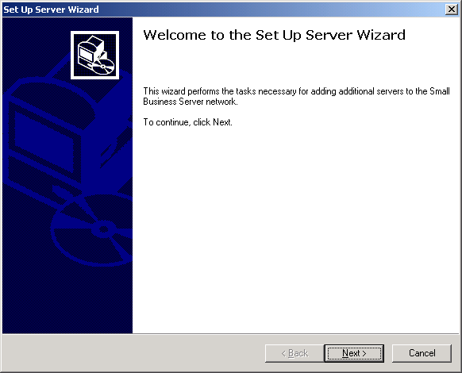

When you add the server to the Windows SBS network, the wizard also configures My Network Places and Internet Explorer (see the list above in "Add Computer Wizard").
After you have added the server, you can manage it along with the server running Windows SBS by using Manage Server Computers in the Server Management console.

The http://companyweb Web site
Another very popular feature in Windows SBS 2003 is Windows SharePoint Services. By default, Windows SBS installs a first-rate intranet presence for the small business called "http://companyweb," which is driven by Windows SharePoint Services. Using http://companyweb, network users have a ready-made intranet Web site that they can use to share and store Microsoft Office documents (and files of almost any type), store faxes, and create workspaces where they can work together on specific projects.
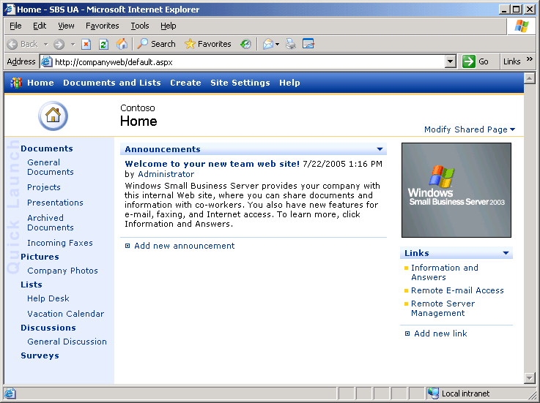

And when you connect a client computer to the network using http://ServerName/ConnectComputer (as previously described in "Add Computer Wizard"), Windows SBS adds a link to the http://companyweb intranet site to the client computer’s Internet Explorer Favorites menu and sets it as the home page.
Like with all Web sites based on Windows SharePoint Services, you can customize http://companyweb by using Web parts, and you can set permissions for users based on the pre-set roles that you associate users with. If you have the Premium Edition of Windows SBS 2003, you can upgrade the WMSDE database that is behind http://companyweb to full SQL Server 2000, and you can enable full-text searching so that users can search any Microsoft Office documents on the site.
Setting up an intranet site doesn’t get any easier than this!

Backup
Backing up a server can sometimes be a tough task for an IT Pro, not to mention a non-professional computer user. That’s why Windows SBS has really simplified backup—so administrators of a small-business network don’t have to master the complexities of backing up a Windows domain controller. Instead, they can take advantage of the simple Backup Configuration Wizard to set up their backup details once and then have it run when scheduled. By default, all the files you need to restore the server are included in the basic Windows SBS Backup. And using the excellent monitoring feature, administrators can also monitor the success of backups in the Server Performance Report.
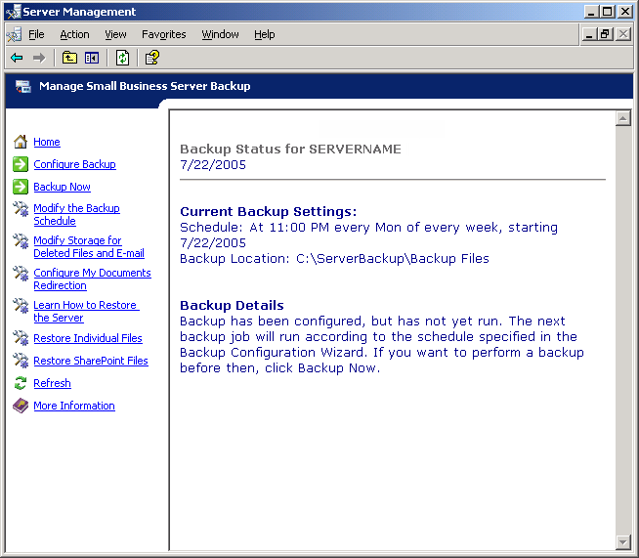

Monitoring
Because monitoring the health of a server or a network is such an important but sometimes complex task, Windows SBS includes an easy and powerful feature that makes monitoring the server a snap.
From Monitoring and Reporting in the Server Management console, you can view a server-performance report, walk through the Set Up Monitoring and Reports and Alerts Wizard, and change the settings for server-status reports.
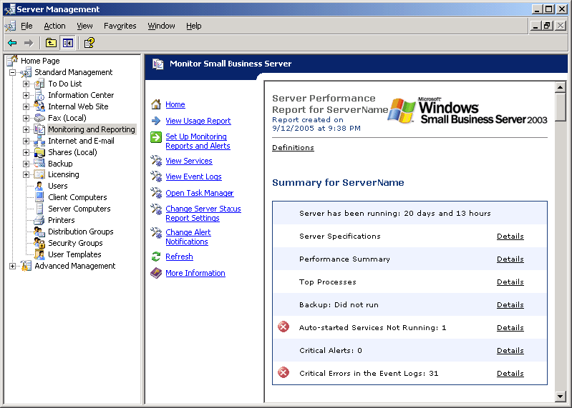

You can view how the network is being used via the Server Usage Report. This report gives information about network usage, like the number of e-mails sent and by whom, mailbox sizes for each network user, and even Outlook Web Access usage.
With the Server Performance Report, you can see how the server is performing in areas like the top processes running, the number of Auto-started services not running, the amount of free disk space left on the server drives, and the number of critical alerts.
When you top off these great monitoring features with the fact that administrators can have the reports e-mailed to anyone they choose as often as every day, or can view the reports remotely from the Web, you can see why this is one of the most popular features of Windows SBS 2003.

Remote Web Workplace
No list of cool features in Windows SBS would be complete without mentioning Remote Web Workplace. This terrific feature makes it almost effortless to offer remote access for users on a Windows SBS network.
With Remote Web Workplace, users can access the Windows SBS network from any Internet location through a secure Web address, https://FQDN/remote, where FQDN is the fully qualified domain name of the server running Windows SBS.
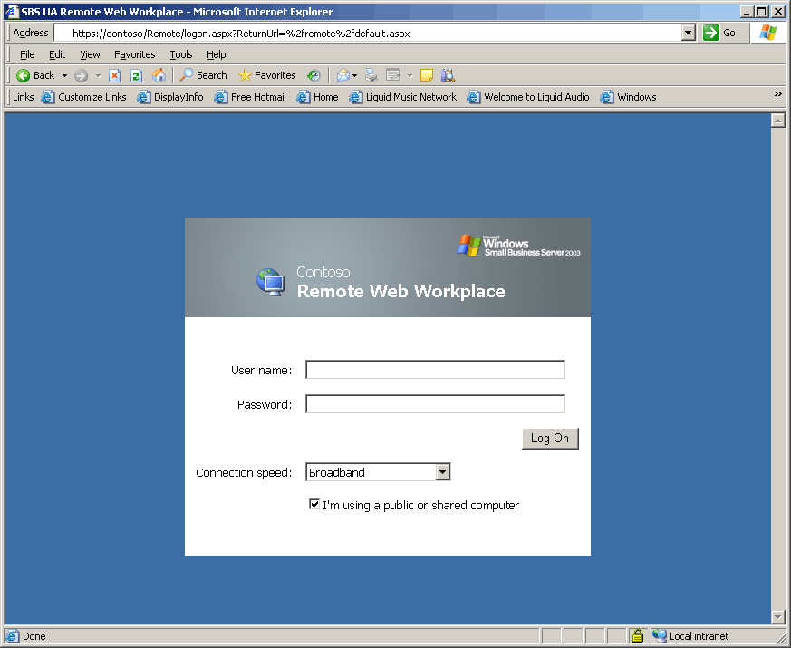

The Configure E-mail and Internet Connection Wizard that you read about earlier in this paper takes care of the work required to make Remote Web Workplace available from the Internet, so the administrator doesn’t have to do anything but run the wizard.
With Remote Web Workplace, users can check e-mail and calendars, connect to their work computers using Remote Desktop, use shared applications, access the intranet, or even join a computer to the Windows SBS network using Connection Manager. Everything an information worker needs to be productive from a remote location is available through Remote Web Workplace!
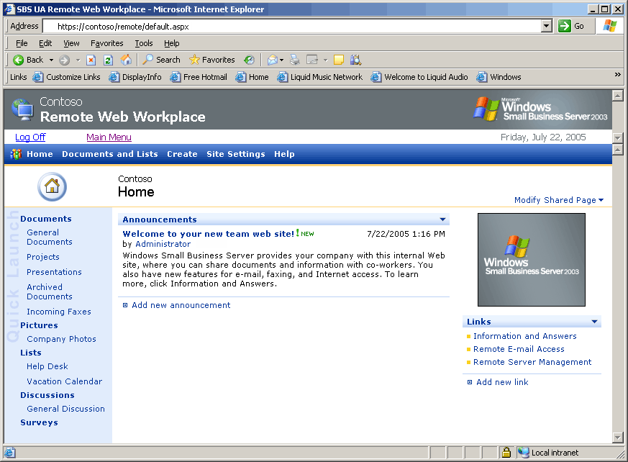

Standard Edition vs. Premium Edition
With previous versions of Windows SBS, all customers received the same applications whether they needed them all or not. But with Windows SBS 2003, customers can opt for either Standard Edition or Premium Edition. Standard Edition includes the following: the operating system, Exchange 2003 Standard, and Windows SharePoint Services 2.0. Premium Edition includes all that plus the following: the Microsoft FrontPage® 2003 Web site creation and management tool (for a single computer on the network), ISA Server 2004, and SQL Server 2000 with Service Pack 4.
Many customers like Premium Edition because it comes with the full versions, not "reduced" versions, of SQL Server 2000 and ISA Server 2004, with all the power of those applications.

Common Scenarios

Multi-homed vs. single adapter
A popular configuration for Windows SBS is a multi-homed server with one network card for the internal network and the other card facing the Internet. In this setup, DNS, DHCP, WINS, and File and Print services are all bound to the internal network card to prevent conflicts with the ISP and to make the network more secure. Using this configuration, Windows SBS can create a basic firewall for the network without needing a separate firewall device (although one is recommended).
Windows SBS can handle multi-homed or single-adapter scenarios, but in the single-adapter scenario, you absolutely must use a dedicated firewall device between the server and the Internet or else the server is wide open for hacking. A multi-homed server is by far the more common configuration for Windows SBS.

Internet connectivity
For many small businesses, Internet connectivity at the bandwidth levels needed for an enterprise is way too much. For small businesses, it’s often the case that DSL or cable provides plenty of bandwidth to handle Internet connectivity. You'll probably find that most of the Windows SBS customers you talk to are using one of these two options.

Static IP
A possible downside of using cable or DSL is that, in some cases, ISPs require their cable or DSL customers to use dynamic IP addresses and static IP addresses are not even available unless the customer gets a "business line," which usually comes with a higher price tag.
Of course dynamic IP addresses mean users can't connect remotely, because the Internet host name of the server doesn’t have a static IP address to resolve to. To work around this, some Windows SBS administrators obtain the services of ISPs that support the DNS dynamic update protocol which is used to keep the server's IP address updated in the DNS zone file for the company’s domain name.
Of course, even with dynamic DNS IP services in place, if the IP address for the server running Windows SBS changes, you might lose e-mail messages between the time the server IP address change and the time the DNS servers are updated with the new IP address for the server. Some Windows SBS customers handle that problem with one of the following options:
• Use POP3 to have mail delivered from your service provider to your Exchange server.
• Use ETRN or TURN after authentication to deliver e-mail from your ISP host to your Exchange server.
You can use the Configure E-mail and Internet Connection Wizard to configure your e-mail retrieval method to use either of these methods.
Although these are adequate workarounds for the problem of dynamic Internet IP addresses, the default scenario for Windows SBS assumes that the network is using a static IP address for the external network adapter for the server running Windows SBS. If at all possible, small businesses running Windows SBS should use a static IP address.

Additional Server
Earlier in this paper, I mentioned that there are reasons why you might want an additional server on the Windows SBS network. By far, the most common reason is to offer Terminal Server to network users.
Because the server running Windows SBS can provide Terminal Server only in Remote Administration mode, small businesses that want to offer Terminal Server in Application Server mode have to go another route. That's where the additional server comes in.
You can place a server running Windows 2000 Server or Windows Server 2003 on the Windows SBS network as an additional server for the sole purpose of offering Terminal Server in Application Server mode. Network users can connect to the additional server and have all the normal functionality of Terminal Server in Application Server mode.
Another reason to add an additional server is for redundancy. You can add a computer running Windows 2000 Server or Windows Server 2003 as a replica domain controller to a local or remote office for redundancy in the event that the server running Windows SBS is unavailable. Replication with the server running Windows SBS keeps Active Directory up-to-date on the additional domain controller even in the remote-office scenario, provided there is a link between the offices. Users can then log on to the network normally until the server running Windows SBS is brought back online.
And finally, there is one more reason to add an additional server to a Windows SBS network: line-of-business (LOB) applications. LOB applications that can't or shouldn't run on the server running Windows SBS can be installed on an additional server running Windows Server and placed on the network. If you find yourself in this scenario, just make certain that you've covered the licensing requirements (if any) for the LOB applications. The additional server doesn't require any new licenses for network users to access it.

Related Links
For more information about technical resources for Windows SBS, see the Microsoft Web site (http://go.microsoft.com/fwlinks/?LinkId=29938).
For updated product documentation for Windows SBS, see the Microsoft Web site (http://go.microsoft.com/fwlinks/?LinkId=19041).
For more information about the community for Windows SBS, see the Microsoft Web site (http://go.microsoft.com/fwlinks/?LinkId=16919).

