**Installation Readme Addendum for Microsoft .NET Framework 4 Beta 2 and Visual Studio 2010 Beta 2**

Table of Contents

How to read this document 1

Section 1 - The following steps are applicable to all Visual Studio 2010 Beta 1 users. 2

Section 2 - The following steps are applicable to users who have installed Visual Studio 2010 Beta 1 on Windows Vista RTM & SP1, or Windows Server 2008 RTM & SP1 3

# How to read this document

This document has required steps to uninstall Visual Studio 2010 Beta 1 and then install Visual Studio 2010 Beta 2.

It describes two issues which could apply. You might need to refer only to section 1 or to both sections 1 and 2.

Section 1 applies to everyone.

Section 2 applies to only those users who installed Visual Studio 2010 Beta 1 2 on Windows Vista RTM or SP1 or Windows Server 2008 RTM or SP1 and want to install Visual Studio Beta.

**NOTE: Before installing Visual Studio 2010 Beta 2 or .NET Framework 4 Beta 2, you must completely remove Visual Studio 2010 Beta 1 and .NET Framework 4 Beta 1 from your machine.**

# Section 1 - The following steps are applicable to all Visual Studio 2010 Beta 1 users.

All pre-release versions **must be removed in the correct order** BEFORE installing Visual Studio 2010 Beta 2. It is recommended that you start by uninstalling the main product first (*Microsoft Visual Studio 2010*). This uninstalls a majority of the components. Then, uninstall other supporting products which might be left after uninstalling the main product. Use the following procedure to uninstall Visual Studio:

1. Go to Control panel and double-click Programs and Features
2. Uninstall all instances of *Visual Studio 2010* products (for instance, Microsoft Visual Studio 2010 Team Suite).

If you receive a prompt for the source of Team Foundation System (TFS) object model, or setup fails with the following entry in %TEMP%dd_install_vs_vstsscore_100.txt:

***ERRORLOG EVENT*** : Error: Installation failed for component TFS Object Model

Uninstall TFS Object Model before uninstalling Visual Studio 2010.

1. Uninstall other remaining supporting products that may be present on your machine, in the specified order. Ignore items that are not present on your machine.
   1. Uninstall Microsoft .NET Framework 4.0 following the steps in Section 2.
   2. Uninstall "Microsoft Visual C++ 2010 Redistributable"
2. Restart the computer when prompted during any of the steps above.

User-generated assets, such as project files and custom settings, are not removed or affected by uninstalling Visual Studio.

# Section 2 - The following steps are applicable to users who have installed Visual Studio 2010 Beta 1 on Windows Vista RTM & SP1, or Windows Server 2008 RTM & SP1

Use the following procedure to uninstall Visual Studio.

1. Go to Control panel and double-click Programs and Features.
2. Uninstall Visual Studio 2010 Beta 1 (see section 1)
3. Uninstall .NET Framework 4 Beta 1
   1. Uninstall Microsoft .NET Framework 4 Extended Language pack Beta 1 (Only applicable if you installed a localized version of Beta 1)
   2. Uninstall Microsoft .NET Framework 4 Client Profile Language pack Beta 1 (Only applicable if you installed a localized version of Beta1)
   3. Uninstall Microsoft .NET Framework 4 Extended Beta1
   4. Uninstall Microsoft .NET Framework 4 Client Profile Beta1

**If you install Visual Studio 2010 Beta 2 without uninstalling .NET Framework 4 Beta 1, Visual Studio 2010 Beta 2 setup will show the following Microsoft Windows Error reporting dialog in the middle of the installation.**

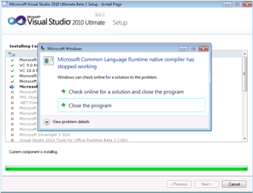

**If you encounter this situation:**

1. Select ‘Close the program’ for any Microsoft Windows Error reporting dialogs.
2. After the end of Visual Studio setup, repair Visual Studio.

Steps to repair Visual Studio:

1. Go to Control panel and double-click Programs and Features.
2. Find the appropriate entry for the version of Visual Studio 2010 that you have just installed, and select it. For example, for Visual Studio 2010 Ultimate, select Microsoft Visual Studio 2010 Ultimate Beta 2 – ENU
3. Click Uninstall/Change to start Setup.
4. Select the option to repair the Visual Studio installation.

**Note: If you do not repair Visual Studio 2010 and then start Visual Studio, you will see the following message about package load failures. If you see this message, you must repair Visual Studio by following the preceding steps.**

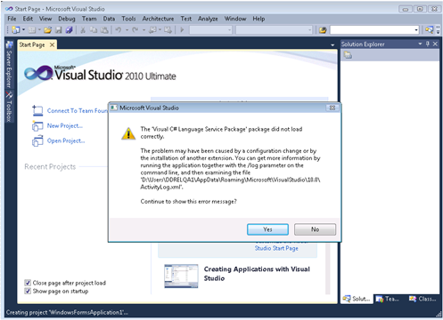

**If you install .NET Framework 4 Beta 2 without uninstalling .NET Framework 4 Beta 1, Applications using .NET Framework 4 Beta 2 will not function properly. Please note that Setup will not report any failures.**

**How to find out if your computer is in this state.** You can verify whether your computer is in this state by checking the version of c:\windows\system32\mscoree.dll. If the version of mscoree.dll is 4.0.20428.1, you must repair.NET Framework 4 Beta 2.

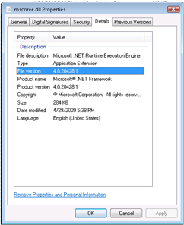

Steps to repair .NET Framework 4 Beta 2:

1. Go to Control Panel and double-click Programs and Features.
2. Find the entry for Microsoft .NET Framework 4 Client Profile Beta 2 and click Uninstall/Change to start Setup.
3. Select the option to repair .NET Framework 4 Client Profile Beta 2.
4. Find the entry for Microsoft .NET Framework 4 Extended Beta 2 and click Uninstall/Change to start Setup.
5. Select the option to repair .NET Framework 4 Extended Beta 2.