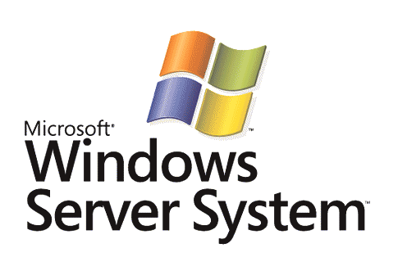

System Definition Model Overview

Microsoft Corporation
Published: April 2004

Abstract
The Dynamic Systems Initiative (DSI) is an industry effort led by Microsoft to enhance the Microsoft® Windows® platform and deliver a coordinated set of solutions that dramatically simplify and automate how businesses design, deploy, and operate distributed systems. The System Definition Model (SDM) is a key technology component of the DSI product roadmap that provides a common language or meta-model that is used to create models that capture the organizational knowledge relevant to entire distributed systems.



The information contained in this document represents the current view of Microsoft Corporation on the issues discussed as of the date of publication. Because Microsoft must respond to changing market conditions, it should not be interpreted to be a commitment on the part of Microsoft, and Microsoft cannot guarantee the accuracy of any information presented after the date of publication.
This White Paper is for informational purposes only. MICROSOFT MAKES NO WARRANTIES, EXPRESS, IMPLIED OR STATUTORY, AS TO THE INFORMATION IN THIS DOCUMENT.
Complying with all applicable copyright laws is the responsibility of the user. Without limiting the rights under copyright, no part of this document may be reproduced, stored in or introduced into a retrieval system, or transmitted in any form or by any means (electronic, mechanical, photocopying, recording, or otherwise), or for any purpose, without the express written permission of Microsoft Corporation.
Microsoft may have patents, patent applications, trademarks, copyrights, or other intellectual property rights covering subject matter in this document. Except as expressly provided in any written license agreement from Microsoft, the furnishing of this document does not give you any license to these patents, trademarks, copyrights, or other intellectual property.
Unless otherwise noted, the example companies, organizations, products, domain names, e-mail addresses, logos, people, places, and events depicted herein are fictitious, and no association with any real company, organization, product, domain name, email address, logo, person, place, or event is intended or should be inferred.
© 2004 Microsoft Corporation. All rights reserved.
Microsoft, Active Directory, BizTalk, SQL Serer, Visual Studio, Windows, Windows Server, and Windows Server System are either registered trademarks or trademarks of Microsoft Corporation in the United States and/or other countries.
The names of actual companies and products mentioned herein may be the trademarks of their respective owners.
Contents
Introduction 1
Administrative Challenges of Distributed Systems 2
Using Models to Simplify Administration 3
System Definition Model 6
SDM Basics 6
Types, Configurations, and Instances 7
Types 7
Building Configurations from Classes and Relationships 9
Constraints 11
Instances 12
Putting It All Together 13
The SDM and Separation of Concern 14
Packages and Versioning 17
SDM Core Models 17
Design for Operations 17
Health, Task, and State Models 19
Partner Opportunities and Contributions 21
Call to Action 21
Summary 23
Related Links 24

Introduction
The evolution of application software from client-server architectures to multitier architectures, and more recently to Web services, has led to the creation of increasingly distributed, service-oriented applications. At the same time, low-cost, high-volume, industry-standard hardware components—such as load balancers, switches, servers and centralized storage—have become common building blocks for, and an integral part of, these applications. The result is an IT environment in which the definition of a distributed application has evolved to include much more than just the software.
The nature of these distributed systems, and the associated interdependencies between hardware and software, have resulted in dramatically increased complexity throughout the entire IT life cycle. The design and implementation of new systems requires considerable time and cross-team coordination. The deployment of new systems requires the acquisition of new hardware and involves multiple iterations with the design and development teams to optimize the system. The manual nature of much of this process and of ongoing operations requires some customers to spend as much as 70 to 80 percent of their IT budget on maintaining their existing systems. While many of these problems are experienced more acutely by large, enterprise customers, small and medium-sized businesses are also facing the challenges of increasing complexity in their IT infrastructures.
The Dynamic Systems Initiative (DSI) is an industry effort led by Microsoft to enhance the Microsoft® Windows® platform and deliver a coordinated set of solutions that dramatically simplify and automate how businesses design, deploy, and operate distributed systems. Microsoft is investing heavily in software research and development and working with partners to deliver end-to-end solutions integrated across application development tools, operating systems, applications, hardware, and management tools that will result in reduced costs, improved reliability, and increased responsiveness throughout the entire IT life cycle. DSI solutions will not only address the complexity of enterprise IT infrastructures, but also deliver enterprise-like capabilities to small and medium-sized businesses in a simple and cost-effective way.
The Microsoft Dynamic Systems Initiative Overview white paper provides a thorough description of this broad industry initiative, combined with a high-level overview of one component of the DSI, the System Definition Model (SDM). A more detailed description of SDM is presented in this document.

Administrative Challenges of Distributed Systems
Consider the situation of an IT administrator at a medium-sized business. He wants to set up a highly available file share service that allows users to download and install software. To do this, he needs to understand a variety of techniques and technologies, such as Distributed File System (DFS) configurations, file sharing and caching options, disaster tolerance, Active Directory® interactions, and so on. This means that, just to get started, he needs to read a broad range of documentation, such as server help files, resource kits, deployment guides, and knowledge base articles. At the end of this process, he formulates a topology, configuration, and deployment strategy, which he may or may not choose to document.
As an example, assume that the administrator specifies the following configuration.
- The DFS namespace is \\products\public, which will point to multiple replicated file shares.
- Individual file servers and shares are at \\productsXX\public$ and are replicated using File Replication Service (FRS).
With this information in hand, the administrator starts to manually configure the different technologies, either through Terminal Server or by remotely accessing the servers through the Microsoft Management Console (MMC). The complete process involves various MMC snap-ins and wizards. Eventually, after some false starts and fix-ups, the administrator arrives at an acceptable configuration. When he has tested the configuration and made sure that it is working, he announces the new software distribution service to the company employees.
The new service is a success, but as more people make use of it and as new employees are hired, the load on the share increases steadily. Users occasionally complain about unavailability but not enough to cause the administrator much worry.
Several months later, the administrator goes on vacation and a temporary administrator fills in. The temporary administrator gets an increasing number of complaints about the performance and availability of the file share and decides to investigate. She concludes that the load is significant and that another server should be added. She looks around on the network, and seeing that \\accounting is not getting much use, she decides to add that server to the pool. She creates a new file share \\accounting\public$ and adds it to the FRS replication set as well as to the DFS namespace. Following this change, the availability problem appears to be fixed.
When the administrator returns from vacation, he is told about the problem with \\products\public and how it was fixed by adding another server to the pool. The administrator is not surprised, based on what he had been seeing, and because the problem was fixed, he puts the issue in the back of his mind, resolving to give the matter further thought after he recovers from his vacation backlog.
A few days later, the end of the quarter arrives, and accounting applications start processing numbers to complete the books. These applications create large numbers of temporary files on the \\accounting server, and out-of-disk-space failures begin to occur frequently. In the middle of the night, the administrator is called to investigate. The rest is left to the reader’s imagination.
While the specifics may vary, situations like this occur in all IT environments, especially where multiple administrators cooperate to manage an end-to-end solution. As the applications involved becomes more complex—such as a highly available mail and messaging system or a complex line-of-business application—the problem is compounded. The scenario illustrates several broad challenges in managing distributed end-to-end solutions:
- Systems are complex and often assembled from multiple interrelated software and hardware elements. Often, the interdependencies between these elements are not well defined.
- There is a significant gap between the level at which administrators think and the toolset with which they operate. In the preceding scenario, the administrator had to use a myriad of tools and technologies to create the file share solution. Few of the tools employed were designed to work in a manner consistent with the administrator’s generally high-level view of the system.
- Changes in one part of a system can have significant effects on the overall environment. The intent of the administrator and the dependencies among the various components could not be determined by looking at how the resources were deployed in the environment.
- Administrators are the only points of integration across different subsystems. System configuration rules often reside only in someone’s head. There are typically no formal records of either the configuration itself or of the changes that have been made to it.
- Any coordination or consistency is achieved through social processes. Administrators have hallway conversations, send e-mail, or write on sticky notes to remind each other of issues, changes, and so on.
What does all of this mean? Typically, it means that administrators must have a broader understanding than is normally realized of a range of complex technologies, how the technologies relate, and the impacts and history of changes.

Using Models to Simplify Administration
What an administrator normally wants is to be able to deploy a set of services or applications in much the same way as one might use an appliance such as a TV, a digital camera, or a DVD player: The administrator wants a high-level view of a service or business process, wants to be able to operate on that service using abstract operations, and wants to not have to deal with the low-level details of the technologies employed. When troubleshooting, or when doing low-level planning, the specifics of the individual technologies become important. In such a case, a more detailed view—of the servers being used, of the current load, and so on—must also be available. When a system is deployed, the administrator wants to concentrate on business needs. Although the technologies employed in the system may have a myriad of options, topologies, and configuration alternatives, the administrator typically wants to deploy a well-defined or a prescriptive configuration, along with best practices that are enforced throughout the lifetime of the deployment.
This is where the notion of a system model comes into play. A system model provides a level of abstraction for administrators similar to what a blueprint provides to an architect or a prototype provides to an automotive designer. But for a dynamic and distributed software environment, a static model or blueprint is insufficient. The model must be a live, dynamic blueprint that captures knowledge about a complete distributed system in terms of its structure, behavior, and characteristics. Consider the experience provided when pressing the gas pedal in an automobile. The user, in this case the driver, has a high-level, abstract view that maps to his desired behavior, such as making the automobile go faster. Behind the simple operation of pressing the gas pedal, the system—in this case the automobile control system—takes care of adjusting the fuel intake timing, exhaust valve timing, gear selection, and so on, taking into account constraints such as engine speed and air pressure.
The model should also contain contextual knowledge about administrators’ intent: prescriptive configurations and best practices that the administrator wants to apply, as well as operational policies, constraints, and rules. Administration would then be done through the model by applying a change request to the model that would allow the change to be simulated within the model, and constraints and policies validated. Depending on the level of knowledge captured in the model—for example, events, monitoring and response rules, and indicators that show whether an application is healthy or not—unanticipated changes in system state could be automatically and intelligently detected and repaired, or alerts could be generated to notify systems staff.
Clearly, then, the model needs to be created at a high-level of abstraction and needs to capture key attributes of the entire system, from top to bottom and from end to end. In short:
- The model must cover the system “from top to bottom” with regard to all layers of hardware and software at each machine. This includes the hardware (desktop computers, network, servers, storage, and so on), the operating system, configuration, hosting components (such as Internet Information Server and Microsoft SQL Server™), and application components (such as Microsoft Office, ASP.NET pages, and stored procedures).
- The model must cover the system “from end to end” with regard to the separation of responsibility among various administrators involved in providing the service (such as desktop, network, Active Directory, application, and database administrators) and various end-users consuming the service.
After a model is in place, management of the complete system is done through the model. By providing this level of indirection, the model provides the means to coordinate the activities of multiple administrators. It allows the separation of management tasks—even those spanning organizational boundaries—while providing a level of control that ensures that incompatible changes or changes that have large impacts can be monitored, tracked, and controlled, thus helping to preserve service level agreements and policies.
What are the benefits of this approach?
- The system model captures the entire system’s composition in terms of all interrelated software and hardware components.
- The system model captures knowledge as prescriptive configurations and best practices, allowing the effects of changes to the system to be tested before the changes are implemented.
- The infrastructure that holds the system model captures and tracks the configuration state so that administrators do not need to maintain it in their heads. The software works to maintain the desired state so that humans do not need to.
- Administrators do not need to operate directly on the real world systems but rather can model changes before committing them. This allows “what if” questions to be tried out without impacting the business.
- The system model is a living model that evolves throughout the life of the system. When the system is developed, basic rules and configurations are defined. As the system is deployed, the details of the configuration and environmental constraints or requirements are added. As operational best practices are developed or enhanced, they can be incorporated into the model, providing a feedback loop between the operations staff and the model.
- The system model becomes the point of coordination and consistency across administrators who have separate but interdependent responsibilities.
- The modeling system becomes the integrated platform for design and development tools that enable the authoring of system models. It is also becomes the platform for operational management and policy-driven tools used for capacity planning, deployment, configuration update, inventory control, and so on.

System Definition Model
The System Definition Model (SDM) is a language or a meta-model that is used to create models of distributed systems. A distributed system is a set of related software or software and hardware resources running on one or more computers that are working together to accomplish a common function. Multitier line-of-business applications, Web services, e-commerce sites, and enterprise data centers are examples of distributed systems. Using SDM, vendors, system integrators, and administrators can create a live, dynamic blueprint of an entire system: a system model. This model can be created and manipulated with various software tools. It is used to define system elements and to capture data pertinent to development, deployment, and operations of the system, making it relevant for the entire life of the system as follows.
- Using SDM for design: Development tools built on SDM are used to model a system composed of software and hardware resources. This model contains all of the information necessary to deploy and operate a distributed system, including required resources, configuration, operational features, policies, and so on.
- Using SDM for deployment: During deployment, the same definition is used to automatically deploy the system by dynamically allocating and configuring software and hardware resources (server, storage, and network). A system can be deployed to different environments and to different scales.
- Using SDM for operations: Throughout operations, the SDM Service (the runtime service responsible for maintaining the system model) provides a system-level view that can be used for managing the distributed system, based on its model. This enables new management tools to drive resource allocation, configuration management, upgrades, and process automation from the perspective of the system. As operational best practices are refined over the life of the system, these changes can be incorporated into the model to improve the operational efficiency of the system.
An SDM system model is a real-world application. It can be generated in the same way that a new software application is built, using tools designed to create system models. A model of an existing system can also be created using SDM authoring tools. After the model is created and deployed, the SDM Service maintains the model, ensuring consistency between the model and the real-world system. The SDM Service also provides a central point of management for changes to the model.

SDM Basics
An SDM model captures the structure of a system from end to end and from top to bottom, including all of the various pieces of a system and how they relate to one other. Some pieces of a system have explicit relationships, such as a front-end Web server that communicates using a given protocol to a mid-tier application server that executes business logic. Other relationships are more subtle, such as a database that is available for use only if the database service is running on a given server.
An SDM model also captures behavior—the set of operational tasks, rules, and policies that are applicable to a system. Simple, high-level behavioral terms (“start”, “stop”, “add user”) used to describe operations in a system model are at a level of abstraction appropriate to the everyday needs of an administrator. Constraints, rules, and policies describe a set of invariants that must remain true throughout the operational life of the system: for example, users must always have access to their personal file shares or a single server can support a maximum of 1,000 users.
End-to-end models of systems can be built from basic building blocks (representing a computer or a single user, for example) or from more complex building blocks (such as a block representing a Web server). For example, a highly available file share service could be built from a set of interrelated building blocks representing file servers, DFS servers, replication services, and so on. Each of these blocks would, in turn, be built from a physical server running the Windows operating system configured in a specific way to ensure a secure, reliable environment.
In an SDM model, types represent the basic building blocks and relationships that are assembled to model complete end-to-end systems.
A class is a type that provides an abstract representation of a real-world, physical object that can be managed—a computer or a user, for example. Classes can be used together, allowing larger configurations to be built up from smaller units, such as a highly available file share environment built up from a set of file shares running on a set of computers running the Windows operating system configured in a particular way. Classes capture the behavior, desired configuration state, and constraints or policies for a given resource or system and are defined in a scale-invariant way. In other words, a class representing a configuration does not define or prescribe how many of each component piece should be deployed; instead, the model defines how the pieces of the system are composed and the rules for scaling. In some cases there are cardinality requirements that are represented in the model. For example, a file share configuration may require a file server for user data and a separate file server for common data. Although this is not a policy that describes how a file server should scale, it provides context for such things as different security requirements.
Relationships represent dependencies, communications paths, or other relationships among the different classes or configurations.
SDM instances, which are created from configurations or classes, are specific representations of real-world resources—such as servers, databases, and Web sites—that make up the system.

Types, Configurations, and Instances
As a meta-model or meta-schema, SDM defines a type system that enables a designer to specify the behavior and end-to-end structure of a system in complete detail, including system resources, relationships between resources, and the policies and operations that can be applied to the system.

Types
Value types are used to represent properties and attributes associated with real-world objects. SDM defines basic types such as integers, values, strings, and Booleans as intrinsic types.
Enumerations are ordered sets of named elements.
A struct is a structure into which basic types can be grouped.
A class is a type representing a real-world resource, a reusable building block, or an end-to-end system to be modeled.
SDM classes have the following attributes:
- Properties are value types or other embedded classes that represent the knobs and dials of a given real-world object or the constituent pieces making up a system. Properties are implicitly related to the class that contains them. An SDM system model does not necessarily contain all of the properties of a real-world resource. Rather, an SDM system model contains those properties that need to be reasoned about or that represent the invariant state of the model. In other words, a class contains those properties of the system that the developer, system designer, or administrator want to be managed or to remain constant during the life of the system. These properties can be used in validation during design time, or exposed and consumed via management tools throughout the life cycle of the system.
- Methods represent either tasks that can be performed on a real-world resource or high-level deployment and operational tasks (also known as behaviors) that can be performed on a system composed of several pieces. On a class representing a computer, methods might include “power on” and “power off”. For a complex line-of-business application, a method might represent a high-level management operation, such as “add a new user to the system” or “back up the system.” By using the SDM to model these behaviors, basic tasks can be automated within the infrastructure or via SDM-enabled management tools.
- Constraints on or between properties capture the invariant requirements of the system being modeled. For example, the startup type of a Windows service can only be set to “boot” if the Windows service represents a Windows driver. Modeling this information is valuable at design-time, when the developer must validate/test a new application against the target environment.
- Connectors are instances of relationships that define the relationship between the properties of a class. For example, for a file service with a file share and a file server as properties, a connector could be defined between the file share and the file server to model that the file share must be hosted on or exported from the file server.
A relationship is a type that represents a relationship between two or more classes. In a system model, relationships can be sub-classed and extended to represent any type of relationship. For example:
- A communication relationship represents communication between instances of classes or configurations. The relationship may have attributes, such as the protocol being used, the port numbers for TCP/IP, and the message schema.
- A reference relationship represents a resource that a class needs but does not control, such as a file share service that requires Windows Active Directory to authenticate users.
- A hosting relationship represents a run-time dependency, such as a Web service that is hosted on Internet Information Server, which is in turn hosted on the Windows operating system, which is hosted on a two-processor server.
The following image illustrates a file share modeled as a class and the relationship to the file server on which the file share is hosted. The pseudo-syntax shown is for illustrative purposes only and does not represent the actual syntax of an SDM document.
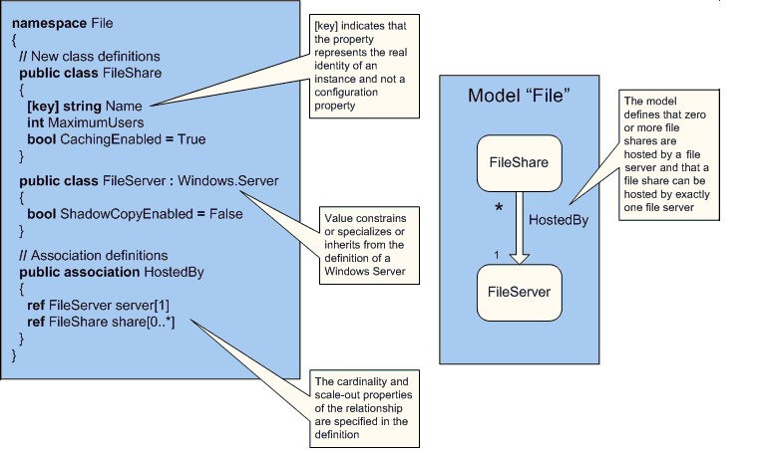
Figure 1: A File Share and the File Server on Which It Is Hosted
In the example in Figure 1, the FileShare class is defined as a class with three properties: Name, MaximumUsers, and CachingEnabled.
The FileServer class is a class that inherits from or is a special case of the Windows.Server configuration, which is a generic class representing a server running Microsoft Windows. The FileServer class specializes or refines the generic Windows.Server configuration by fixing the ShadowCopyEnabled property.
To complete this simplified model of a file share, the relationship HostedBy is defined as a relationship between a FileServer instance and a set of FileShare instances. In other words, a file server can host zero or more file shares.

Building Configurations from Classes and Relationships
Classes and relationships are used to define the basic components of a system and their interactions. However, an end-to-end system is typically deployed and managed as a single unit. The System Definition Model allows complex classes to be built up to represent the composite set of classes and relationships that model a reusable unit or a complete solution. Composing classes and relationships into larger units that represent reusable building blocks or complete end-to-end system models is a fundamental part of the System Definition Model. These reusable composite building blocks allow developers and ISVs to quickly and reliably write applications using standard components, and allow best practices/solution patterns to be used for rapidly designing and deploying new systems.
As described previously, a class can contain properties. Properties are sets of values or classes that represent the knobs and dials of a real-world resource, or the constituent parts making up the larger system.
A class type property can be specified by value or by reference:
- By value: The constituent resource is owned and controlled by the configuration—for example, a file server configuration that fully controls the constituent file share resources.
- By reference: The constituent resource is required for the configuration but not owned by it. For example, a file server configuration is dependent on the definition of a user in the environment. Users are added to the Active Directory infrastructure that is required for the file server system to operate, but the definition and lifetime of a user in the environment are not controlled by the file server configuration.
Properties, connectors, methods, behaviors, and constraints have an implicit containment relationship to the configuration that defines them. In other words, the scope of the properties and connectors is limited by the definition of the configurations. A part or connector can be defined as public or private to determine the visibility when a configuration is used as a part in another, more abstract, or higher-level configuration. Methods and constraints are limited to the scope of—and can operate only on—the parts and connectors defined in their context.
The following image illustrates a file service definition containing three parts: a UserFileShare class and a CommonFileShare class—each derived from the FileShare class—and a MyFileServer class derived from the FileServer class. The pseudo-syntax shown is for illustrative purposes only and does not represent the actual syntax of an SDM document.
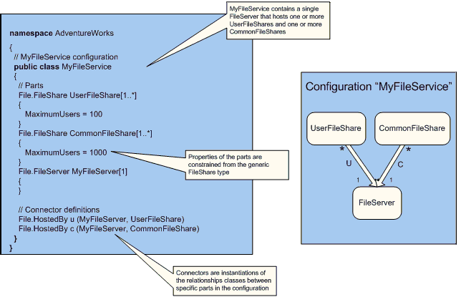
Figure 2: A File Service Definition
Figure 2 shows an example of a file service configuration that builds upon the classes and relationship defined previously.
The configuration is defined to contain one or more UserFileShare instances in which the MaximumUsers property is defined as being set to 100. The configuration is further defined as being one or more CommonFileShare instances in which the MaximumUsers property is set to 1000. Connectors define the specific relationships between MyFileServer and the file share types.
A class that represents an end-to-end configuration does not only define the structure of a system by describing its classes, internal configurations, and relationships; the class also defines system-wide and system-specific behavior. In other words, a class may also define a set of high-level operational tasks that can be performed on the system. These operations are implemented by code that makes use of the methods and properties associated with the individual members making up the configuration. For example, a complex line-of-business application may have an “add user” operational task that is exposed to the administrator. The implementation of that behavior may involve a number of steps, such as adding the user to a database and setting security configuration on files. All of the individual steps of the “add user” task are captured in the behavior, so the administrator can think about the high-level tasks rather than individual components. When a behavior is executed by the administrator, the SDM Service, which maintains the system model, orchestrates the sequence of steps—potentially across multiple machines—in a reliable and predictable way.

Constraints
Classes may define a set of policies or constraints between the properties or parts of the definition. Constraints are used in a number of different ways to capture operational aspects of a configuration. A constraint may represent a rule about the correctness of a system. In a previous example, a Windows service could only be set to “boot” startup mode if the service represented a device driver. This is an example of a constraint that describes the restrictions imposed by the Windows implementation.
Constraints may also represent policies that are applied to a particular system. For example, when defining a file server configuration, a particular deployment may require that each user have a unique folder with a name derived from the user name, and that the security of the folder and file share be set up appropriately.
In other cases, constraints may influence how a system scales to stay within best practices. For example, a constraint could limit a file share to 1,000 users; if the number of users exceeds 1,000, then the constraint requires that additional file shares be deployed.
Generally speaking, constraints represent rules and policies set at the time that the application is developed, and as part of the prescriptive configurations and best practices of companies or operations staff. The composition model provided by configurations allows specialization of configurations, allowing rules and policies to be applied at all stages of the application life cycle. The composition model also allows rules and policies to be refined and modified as best practices, procedures, and data center policies change or are enhanced.
The following diagram illustrates a driver startup constraint. The pseudo-syntax shown is for illustrative purposes only and does not represent the actual syntax of an SDM document.
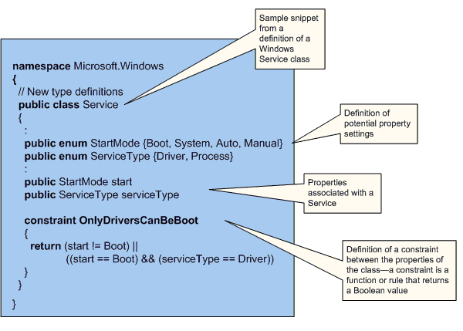
Figure 3: Example Driver Startup Constraint
Note that SDM Service is responsible for evaluating the driver startup constraint to ensure that it is always satisfied. If the constraint is not satisfied, a constraint violation is raised. When managing the system via the system model, an administrator will not be able to make changes to the model that violate this constraint. It is possible, though, that the administrator could unwittingly make a change directly to the real-world server that violates the constraint. In this case, SDM Service would detect and correct the real-world system setting so that it matches the model and so that no constraints are violated.

Instances
Types (classes, relationships) are used to define or model systems, their allowed topologies, constraints, tasks, and so on. Instances are unique deployments of a modeled system in the real world. For example, Figure 2 shows the configuration of a file server environment. Though several of these file server infrastructures may be deployed in different departments of a company, they are all instances of the MyFileServer configuration. All of the configuration, behavior, constraints, and policies are applicable to each instance; SDM Service, which maintains the model, validates and enforces the policies at the instance level.
The System Definition Model supports the notion that the identity-related properties of each instance will vary and are bound at deployment or at run time. These properties are marked as either dynamic values or values that represent the identity of a class or configuration in the definition.
The set of instances maintained by SDM Service is the instance space. This is the space on which administration and management tools operate. The set of behaviors that are defined in the configuration space are exposed by the management tools as tasks that can be performed on specific instances: for example, adding a user to the engineering file server instance of MyFileServer in Figure 4.

Putting It All Together
The following diagram is intended to show concepts and does not necessarily represent the models that will be created. For example, a “computer” may not be represented as a core SDM model. Instead, it may be represented as a class that is composed of memory, CPUs, network adapters, and so on. More details of the core classes can be found in the “SDM Core Models” section that follows.
Figure 4 shows a set of core classes provided by Microsoft, plus additional types provided by partners. These core models represent fundamental building blocks—such as registry key, file, and computer—of SDM. Below the core classes, a set of configurations have been built. Some of these configurations represent generic systems, such as the file server with its dependencies and relationships. Below these generic configurations, more constrained custom configurations and prescriptive configurations have been derived from the generic configurations. Then the prescriptive or custom configurations are instantiated in the real world. There is one instance of a configuration for each real-world system.
Classes, with their structure, behaviors, and constraints, are fundamental to modeling systems and are used to capture operational knowledge, best practice topologies, and the administrators’ operational intent for the system. The simple example in Figure 2 shows that at the Adventure Works file server environment, each file server must have one or more user file shares and one or more common file shares. Figure 4 further reveals how best-practice configurations, high-level operational tasks, and organization-specific policies can be described and enforced by modeling requirements and operational procedures. SDM is designed as an open, flexible, and extensible modeling language that enables Microsoft, partners, end-user administrators, and architects to capture the requirements, policies, and procedures of an IT environment.
The configuration is the unit that allows an administrator to define how a system should be deployed; the configuration contains the constraints, rules, and policies specific to the environment. Different systems—such as file servers, Web sites, and complex line-of-business applications—typically have many different options for each component making up the system. Different pieces can be deployed in different ways, with different levels of security, different protocols with different characteristics, and so on. Selecting the best configuration for a given situation is often a daunting and error-prone task. At best, it requires an intimate knowledge of the individual technologies used in the solution. Best-practice white papers, knowledge-base articles, and other resources provide some of the data required for this process, but not in a form that can be used to deploy a solution automatically or to validate that a configuration is set up correctly.
Figure 4: Overview of SDM Concepts and Their Implementation
By defining SDM configurations for best-practice deployments, Microsoft and partners can bring operational knowledge and best practices to administrators in a form that helps to ensure consistent, repeatable, and error-free deployment and management. Consulting companies, value-added resellers (VARs), system integrators, and others can customize configurations for a given market segment, adding additional value and reducing complexity.

The SDM and Separation of Concern
The Microsoft Dynamic Systems Initiative white paper describes the concept of layers in SDM. This concept can be used to show different views of the system model, and from that how differing administrative responsibilities can be isolated. For example, a server administrator may have access and permissions to make changes only at the hardware layer in a system model. Note, however, that the notion of a layer is not something that is built into the SDM meta-model.
The hosting relationship is used to represent the real-world idea of “contains” or “is running in the context of.” For example, a file share is hosted on or runs in the context of a file server. A file server is itself hosted on or contained in the Windows operating system, which in turn is hosted on or runs on a physical server. The hosting relationship allows a hierarchical view of the system from top to bottom—from the application down to the hardware and physical resources being used in the data center. Different organizations have operational staff or groups with different responsibilities and consequently will have different requirements regarding what can be seen or managed in a given environment. The hosting relationship is not explicitly defined in the SDM meta-model.
Figure 5 shows the operational responsibilities for a simple file server environment. The individual business groups (payroll, for example) have ownership of the application. In this case, the configuration of the file server service and administration of the file shares are exposed. The platform group manages the Windows operating system and the hardware, making sure that the servers are connected to the network, TCP/IP is configured, disks are backed up, and patches are applied.
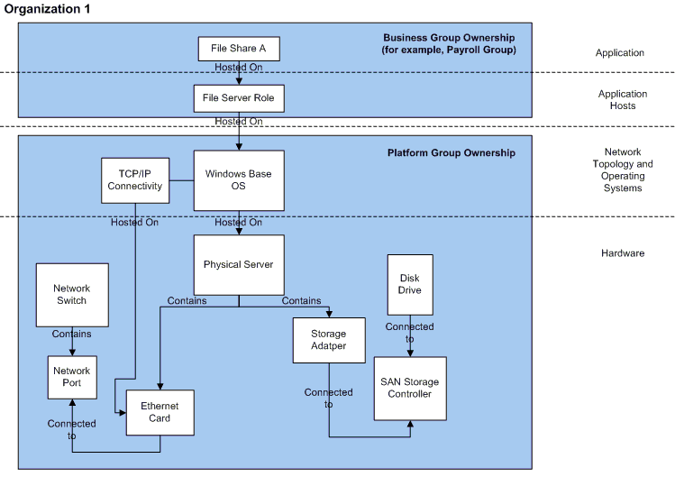
Figure 5: Operational Responsibilities in a File Server Environment (Organization 1)
Figure 6 show exactly the same model as Figure 5, except that the separation of roles is very different. In this example, the Networks Operations Group is responsible for the network infrastructure (including the TCP/IP configuration of the server) and the Storage Operations Group is responsible for the storage infrastructure.
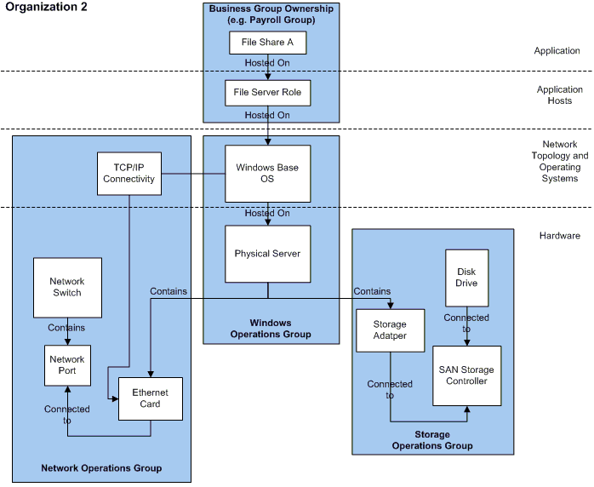
Figure 6: Operational Responsibilities in a File Server Environment (Organization 2)
The concept of layers helps to give a hierarchical view of the configurations, but it does not provide boundaries for operational roles. In Figure 6, the Network Operations Group has responsibility for making sure that the network configuration of a given server is correct and is maintained, but it does not have responsibility for the rest of the Windows operating system components. Separation of concern or responsibility is a key aspect of the operational environments, and SDM Service provides an inherent, role-based security model that can be used to isolate different operations staff from parts of a configuration. Such isolation can be in terms of ability to view and make changes. Individual roles can be assigned to operations staff or groups of operations staff that define their scope of responsibility, from what they can view to what they can manipulate within the model.
In the example shown in Figure 6, the Network Operations Group can configure and change TCP/IP settings, but they cannot change other Windows operating system properties. Through the flexible meta-model of SDM, which is not tied to the fixed idea of layers, a model can be built with sufficient detail to capture the diverse nature of operational roles.

Packages and Versioning
Versioning, upgrades, and updates are all critical parts of operational management and must be considered in any model that covers the full life cycle of a system.
SDM defines the concept of a package that can contain a set of types and configurations. A package has a unique name associated with it that identifies not only the package, but the version of the package. The package is the indivisible unit that has a version number associated with it. In other words, all of the types and configurations defined in a package are identified as a single unit and updated together. Packages can contain references to types and configurations in other packages, and the specific versions of those referenced packages are recorded in the package metadata. By ensuring strict references and associated versions, SDM Service can maintain a guarantee of the consistency of any given model, including all the constituent types and configurations.
Packages can be updated, enhanced, and have updates applied to them to repair issues, add new behavior, and enhance best practices and operational knowledge. As versions change, policies can be applied to allow existing configurations to reference newer versions of packages.
As packages are updated and enhanced, the new configurations that result may need to be applied to the real-world deployment. SDM Service does not only allow configurations and configuration references to be updated; it also enables one version of a configuration to be rolled forward to a new version. This allows the changes or enhanced best practices to be rolled out across an environment in a controlled and reliable way, maintaining service level agreements and availability requirements. All changes to configurations and instances are recorded so that administrators have the full history of the environment.

SDM Core Models
Modeling a complex line-of-business application or an end-to-end Web site is challenging if it has to be done from scratch, modeling such basic types as computer, user, and file. Building from scratch is not only tedious; it can also lead to the use of multiple, disparate models for the same physical resource. Disparate models, in turn, result in operational confusion because in one model an instance of the type representing, for example, a user may have one set of properties and behaviors, while in another model, an instance representing the same user may have a different type with a different definition of properties, methods, and so on.
To avoid this repetition and confusion, SDM defines not only a meta-model, but also a set of core models that represent basic physical-world resources. These basic models, like building blocks, simplify the design process and help to ensure consistency in the basic properties and behaviors associated with a resource.
The set of core SDM models, which can be derived from and enhanced, includes such types as computer, user, file, and registry key. The SDM core models will be published in conjunction with industry partners to ensure that there is consistency, as well as to ensure that the core models are sufficiently extensible for vendors to provide unique added value.

Design for Operations
Decisions made during the design of an application can have a profound effect on the deployment and operation of a distributed system. The experience gained from the operation and use of the system should, of course, guide improvements to the system design over time. SDM was created to facilitate an efficient transfer of system knowledge between all phases of the IT life cycle, and from the desktop to the data center. This includes knowledge of system structure, deployment requirements, operational behavior and environment, and the service level observed by the end user.
SDM will enable solutions that bring developers and operations staff closer together, enabling them to share knowledge and ensure that systems are “Designed for Operations.” “Design for Manufacturability” studies once revealed that while typically only 8 percent of a product’s budget was spent by the time a product was designed, design decisions locked in 80 percent of the cost of the product. The manufacturing industry learned from this and began to have production workers participate in the design process to ensure that design included manufacturing concerns. Essentially, with SDM, the same level of discussion is enabled between IT operations and application development—facilitated and enforced with SDM-compliant tools.
With the release of Visual Studio® .NET 2003, Microsoft has begun to deliver on this strategy by offering a range of enhancements for enterprise developers. This version of Visual Studio software includes improved support for working with XML Web services and the ability to easily implement .NET–connected applications in design-time for optimal manageability in operations.
For server applications such as BizTalk® Server, SQL Server, and Exchange Server, Microsoft is distributing management packs for Microsoft Operations Manager (MOM) that provide ready-to-use “knowledge” specifically for monitoring and managing these applications. The management packs provide predefined computer groups and processing rules, such as filters, alerts, performance sampling, and threshold rules. The management packs also provide predefined computer attributes, providers, scripts, and links to the Microsoft Knowledge Base, public views, and default notification groups. The management packs are an early result of the application developers at Microsoft adopting the “Design for Operations” principles and providing operationally relevant information to improve management.
In the future, investments across a range of Microsoft products using the SDM will result in improved manageability of individual applications and distributed systems. These investments include the following:
- Enhancements to the management infrastructure in Windows. Features are now in development for delivery in the next major release of the Windows operating system that will provide scalable infrastructures for events, instrumentation, tracing, automation, distribution, and configuration.
- New capabilities in Visual Studio to ease creation of well instrumented, deployable applications. To ensure the most manageable enterprises possible, Microsoft recommends that application developers follow the best practices outlined in this and related documents and use future infrastructures as they become available. Development tools planned for future release will provide additional support to make following best practices even simpler.
With the next major release of the Microsoft Visual Studio development tools, Microsoft will deliver a service-oriented application designer tool that will help architects visually translate their requirements into distributed services-based applications and systems. The designer tools in Microsoft Visual Studio will provide modeling support for describing these applications and systems, along with corresponding policies for security, protocols, and more.
- Adoption of these best practices in our own applications to further the work we have started with MOM management packs. In addition to creating management packs for Microsoft operating system components and server applications, Microsoft is deeply integrating the processes and infrastructures described here in the next major version of the Windows operating system.

Health, Task, and State Models
Before manageability can be coded into services or applications, it is necessary to define the basis of manageability. Designers should consider what an administrator’s experience of the planned system will be and should provide the means to help administrators perform necessary tasks and manage the system proactively.
Microsoft has developed three models as the basis for implementing management within a service or application: the Health Model, the Task Model, and the State Model. The models are meant to provide a prescriptive and iterative way to ensure that management is built into every service and application, and that the management is aligned with the needs of the administrator who will be running the service.
It is important to see the relationship between these models and the SDM definition. The Health, Task, and State Models are part of the definition of the components of a system and are included in (and carried with) the SDM system model. The Design for Operations: Building Health, Task, and State Models white paper provides much more detail about these models.
The Health Model
The Health Model defines what it means for a system to be healthy or unhealthy, and defines how a system moves in and out of these states. Good information about a system’s health is necessary for the maintenance and diagnosis of running systems. The contents of the health model become the basis for system events and instrumentation on which monitoring and automated recovery are built. All too often, system information is supplied in a way that has meaning for developers but does not help the administrator know what is going on in the system. The Health Model helps to define both what kinds of information should be provided and how the administrator and the system should respond.
The Task Model
The Task Model enumerates the activities that are performed when managing a system. These may be maintenance tasks performed on a routine basis, such as backup; event-driven tasks, such as adding a user; or diagnostic tasks performed to correct system failures. Defining these tasks guides the development of administration tools and interfaces and becomes the basis for automation. Used in conjunction with the Health Model and instrumentation planned for the future, the Task Model also drives self-correcting systems.
The State Model
The State Model catalogs the state and settings associated with an application and defines the scope and type of each. State may be associated with the computer or the user, may be temporary or permanent, and may be user data or operational parameters. Having a strict association for every state entity with its scope and category allows the administrator flexibility in deployment and provides a powerful tool for control. This means that an administrator can separately store user data, move a user easily from one computer to another, and replicate a computer configuration across a data center.
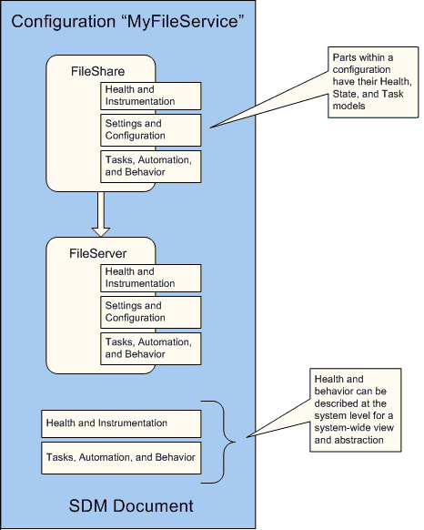
Figure 7: SDM Health, State, and Task Models

Partner Opportunities and Contributions
Clearly, an initiative of the magnitude of DSI is more than Microsoft can undertake alone. SDM and DSI as a whole can only be successful within a broad partner ecosystem. Microsoft will work closely with partners across a broad range of categories to ensure that the full potential of the SDM can be realized.
To stimulate conversation and discussion, the following section attempts to provide some examples of how partners can leverage the SDM and collaborate with Microsoft around our platform and solution investments. The list is by no means exhaustive.
Management tool solution providers:
- Build on SDM and the SDM Service that will be exposed in Windows as a common way to manage end-to-end solutions. Focus on providing added value at a high level, such as capacity planning and change control. Build on the core infrastructure.
- Provide solutions that involve creating models for other non–Windows components as part of a management tool for heterogeneous environments.
Line-of-business application providers:
- Provide SDM system models that describe the end-to-end solution, its relationships, and its dependencies on other parts of the infrastructure.
- Enhance the models with best practices and operational procedures that provide an abstract and high-level user experience rather than focusing on individual component technologies.
- Provide prescriptive architecture guidance and target specific vertical solutions or scalability points, reducing the number of combinations of solutions in the marketplace that need to be supported. Simplify the choices for the administrator by providing targeted models.
Hardware vendors:
- Provide models of underlying physical components such as the specifics of a given server platform, a chassis or rack, a network switch, or storage components.
- Define prescriptive models for multi-server solutions such as clusters to reduce the complexity and the number of support calls.
- Provide models to enable utility computing environments to provide the platform on which applications can be deployed and managed.
System integrators and value-added resellers:
- Enhance models provided by vendors to specialize them for specific target segments.
- Create models for existing end-to-end solutions, allowing existing applications to be managed in the SDM world.

Call to Action
In the near term, the common models provided for the development tools will be able to be extended and enhanced. This will provide a way for vendors to represent their components or applications in a way that will show up as objects that can dragged and dropped onto the design surfaces of the development tools, just like the set of types shipped with Microsoft Visual Studio. In addition, Microsoft will work with vendors who wish to investigate additional capabilities, such as deployment tools that are built around SDM.
In the future, Microsoft expects all development, deployment, and operational management on the Windows platform to be through SDM models. To facilitate this, we expect a set of core types and building blocks to provide a rich experience that can be used to provide an abstract management model and to lower the cost of ownership by driving operational complexity into models that encapsulate best practices and prescriptive architectures. This will be an industry effort. We encourage partners to provide feedback and guidance about what the important building blocks are, what common properties and behaviors need to be provided, and—equally important—what areas should remain open for other solution providers to add unique value.
The mailto:SDMFeed@microsoft.com alias has been set up to allow vendors to provide feedback and suggestions regarding the System Definition Model and its related tools. We will continue to provide detailed technical information, ongoing reviews, and other partner engagements to ensure that partners are kept fully informed and involved as this initiative develops, and can provide unique added value.

Summary
- SDM captures in a self-contained model all of the invariant aspects of a system, including the desired configuration, policies, and behaviors.
- SDM enables functional decomposition of systems through configurations and classes.
- SDM encourages the creation of reusable, prescriptive models with embedded best practices, resulting in deployment and operations with reduced complexity.
- SDM helps to close the gap between how administrators think and how they operate. In SDM, behavior is defined in terms of operational tasks, but the underlying system model is fully described from the highest level down to the physical components, allowing detailed knowledge and control of the system when desired.
- The SDM system model provides a single point of integration, coordination, and policy enforcement across a distributed, end-to-end system. With SDM Service maintaining the system model, different administrators can be given different access rights to pieces of the model to maintain separation of roles and function within an organization.
- A system model aids in a design’s deployment and management and is a live model that can evolve and be enhanced during the life of the design.

Related Links
See the following resources for further information:
- Design for Manufacturability, Optimizing Cost, Quality and Time-to-Market, Second ed., by David M. Anderson, CIM Press, 2001.
- Dynamic Systems Initiative Web site at http://go.microsoft.com/fwlink/?LinkId=25410
- Design for Operations: Building Health, Task, and State Models white paper on the Windows Server 2003 Web site at http://www.microsoft.com/windowsserver2003/techinfo/overview/designops.mspx

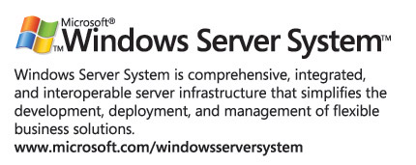
For the latest information about Windows Server System, see the Windows Server System Web site at http://www.microsoft.com/windowsserversystem.

David M. Anderson, Design for Manufacturability, Optimizing Cost, Quality and Time-to-Market, Second ed., CIM Press, 2001.
David M. Anderson, Design for Manufacturability, Optimizing Cost, Quality and Time-to-Market, Second ed., CIM Press, 2001.

