Step 3 – Microsoft Windows Quality Online Services
Setting up a Windows Quality Online Service Account is the second step in the .NET Connected Logo process. Complete this step only after you have obtained a VeriSign ID.

Note
- To complete the following steps, you will need the following information:
- Contact information for one primary and one secondary account administrator. Only account administrators can add or remove users, and change user and company information.
- Billing information for your company. This information is for contact purposes only; no bill will be sent.

A. Creating a Qualification Service Account with Microsoft
- Go to https://winqual.microsoft.com/
- Under Not a Member Yet, click Establish an Account.
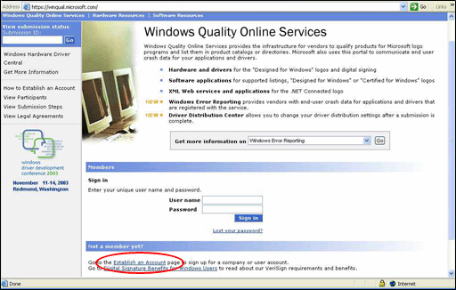

- Under Select Company, click Not Listed, and then click Continue.
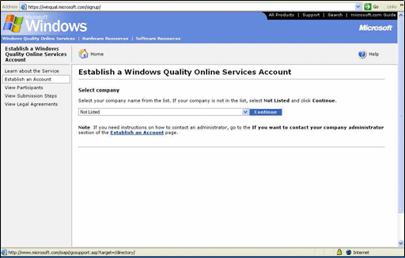
- Complete the Account requirements page as follows:
Note: You will already have obtained your VeriSign ID before testing, therefore skip Step 1 and go directly to Step 2 below

Step 1 – If you haven't already done so, obtain your VeriSign code-signing ID.
Step 2 – Download the WLPQS.exe File and the Authenticode Code-Signing Tools, then code-sign the WLPQS.exe file with your VeriSign Class 3 code-signing ID. The WLPQS.exe file is used, in part, to demonstrate that your company has a VeriSign ID. When asked, "Would you like to open the file or save it to your computer?" click Save.
To download codes signing tool directly go to: http://download.microsoft.com/download/b/e/f/bef2551b-401d-4311-ab8f-13d3892b8154/codesigningx86.exe
Directions on how to use the tool which can be found at: http://msdn.microsoft.com/library/default.asp?url=/library/enus/cptools/html/cpgrffilesigningtoolsigncodee.e.asp
Or at VeriSign’s site http://www.verisign.com/developers/whitepapers/authenticode/#9

Step 3 – Provide contact information for two account administrators at your company.
NOTE: Be sure to record the user names and passwords when they appear on-screen; you will not have the ability to retrieve them later.
Step 4 – Provide billing information for your company.
NOTE: This information is for contact purposes only; you will not be billed for the Qualification Service Account.

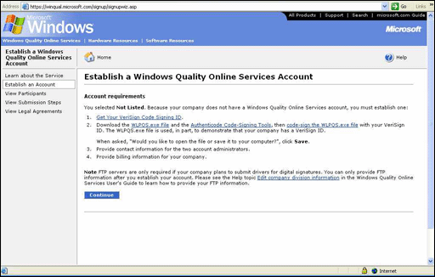

Application Submission and Account Administration
Note
Steps 2 -12 must be repeated for each application for which you wish to receive the logo.
- Go to https://winqual.microsoft.com/
- Under Sign in, type your information in the User name and Password fields, and then click Sign in.
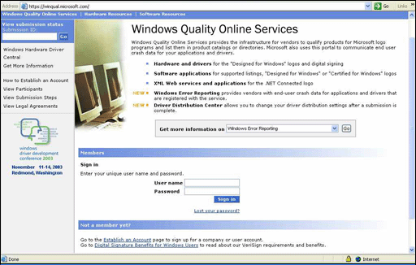
- Click the Create a new submission link in the left column.
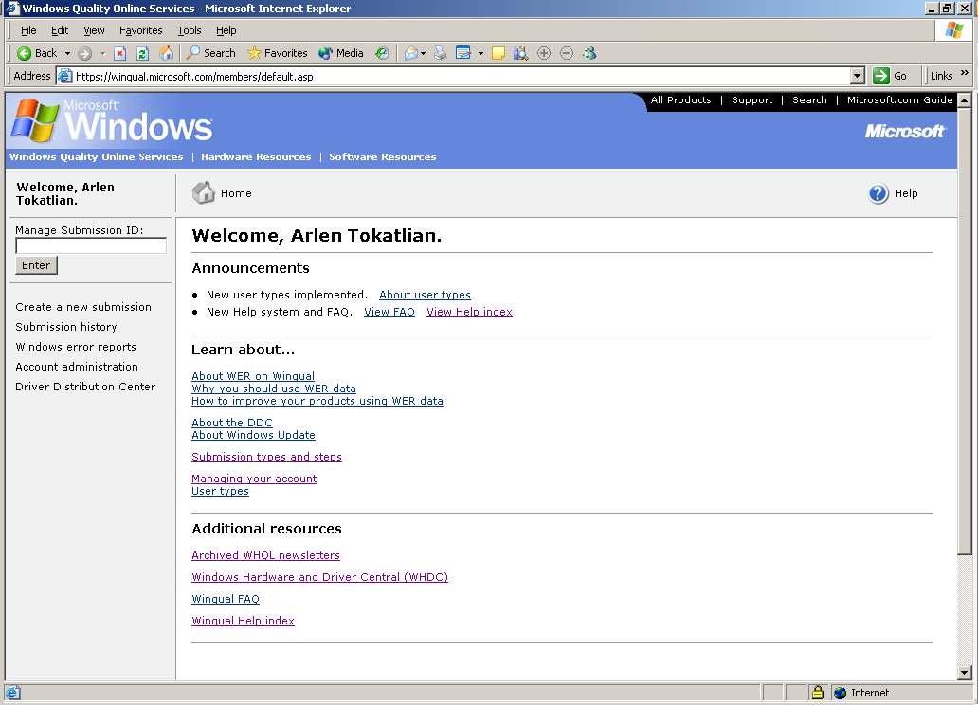

- On the Select Submission Type page, select .NET Connected Logo Program, near the bottom of the page, and then click Next.
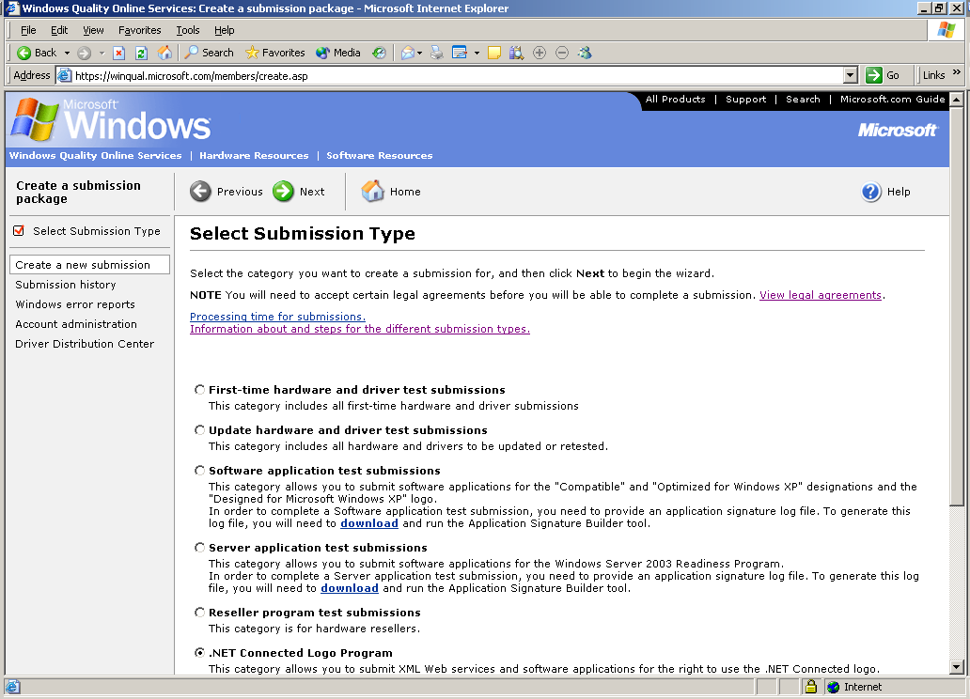

- On the .NET Connected Type page, select exposes an XML Web Service or consumes an XML Web service and then click Next.
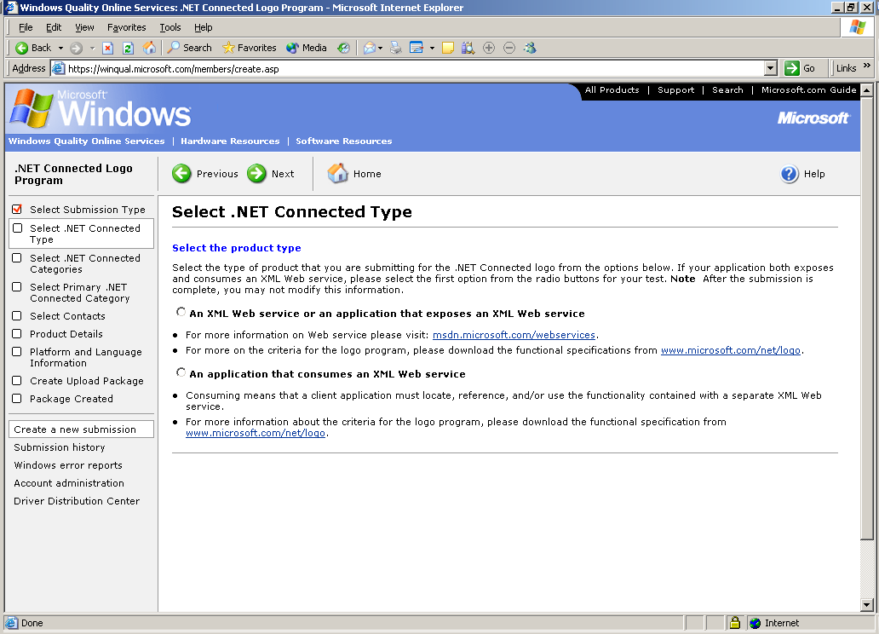

- On the .NET Connected Categories page, select up to six categories that apply to your application, and then click Next.
NOTE: These category selections determine how your product will appear in the .NET Connected Directory.
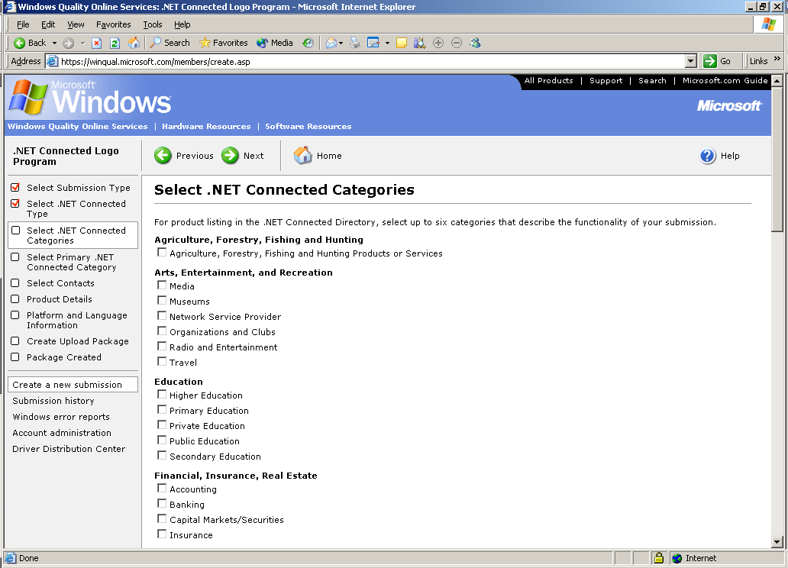

- On the Select Primary .NET Connected Category page select the category that best describes your application, then click Next.

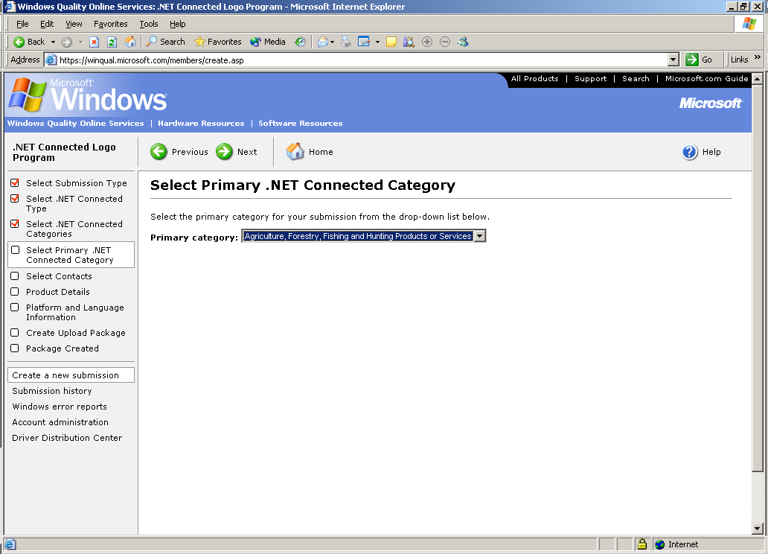

- On the Select Contacts page, select the contacts who will receive e-mail information about the submission. When you are finished, click Next.
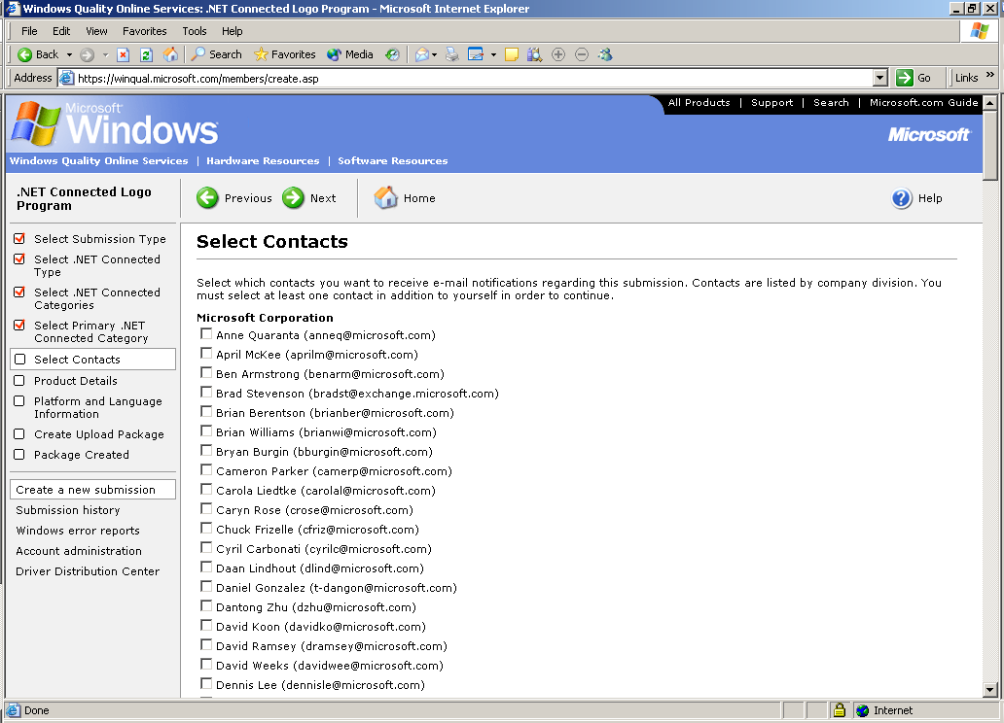

- On the Product Details page, complete the required fields with your product information. When you are finished, click Next.
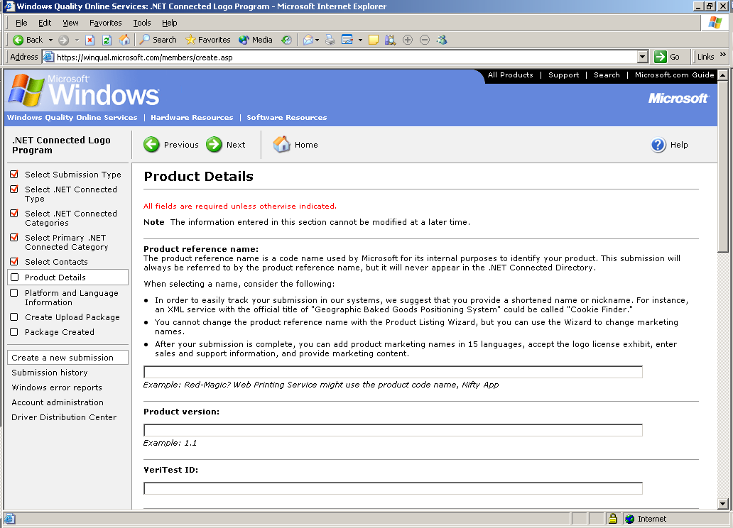
NOTE: You must complete the Product release date field with the Announcement date of your product. If you leave this field blank, your product will not appear in the .NET Connected Directory.
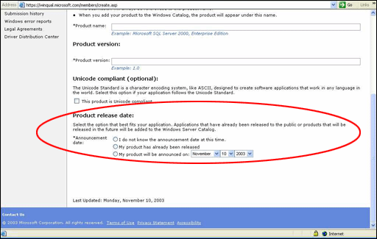
- On the Platform and Language Information page, select all that are supported in the application, and then click Next.
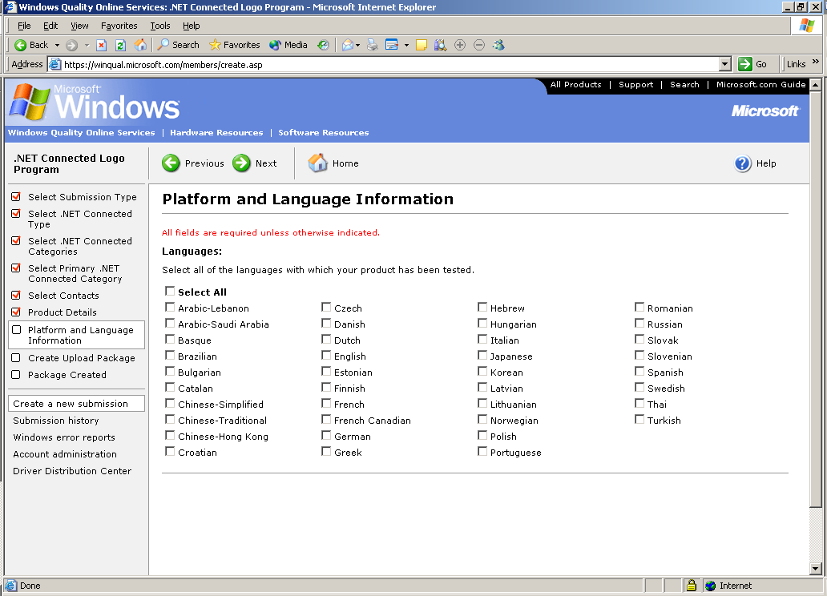
- When the Create Upload package page is displayed click Next to create an upload of your submission data.
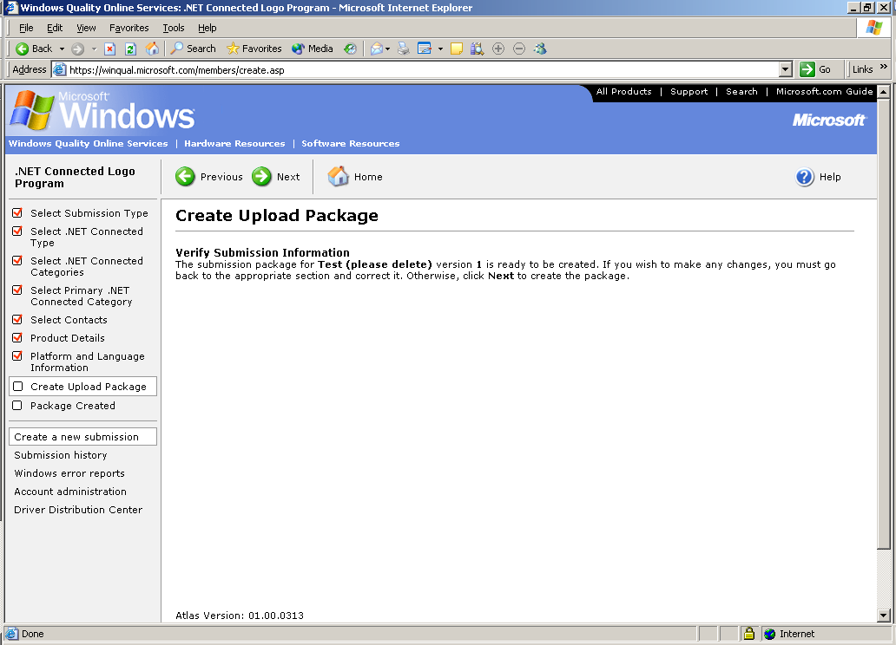

- A pop-up window will appear. Select the location to which you want to locally save your Submission, and then click OK.
Repeat steps 2-12 for each product you wish to register.
The final submission screen will have your Submission ID for each product. You may also find this on the Submission History page.
Your submission will be reviewed by WinQual and approved within 1-3 business days. Once you have received the e-mail informing you of the approval you can move on to the next step, entering your product information into the Product Listing Wizard

While waiting for your approval we invite you to complete the legal agreements portion of the process which you will need to sign before you are allowed to download the .NET Connected Logo.

Legal Agreements for use of the .NET Connected Logo
- Open the Windows Quality Online Services at https://winqual.microsoft.com/members/legal_agreements.asp
- Click Account Administration, and then click Legal Agreements.

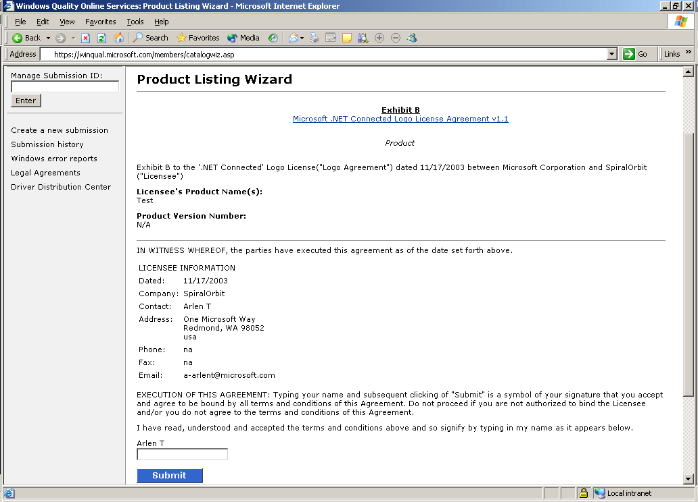
- Read and sign the following agreement at the bottom of the page:

