Overview  Country or Region: Switzerland  Industry: Transportation  Customer Profile  Swiss International Air Lines, based in Basel and with 6,500 employees, is one of Europe’s largest commercial air carriers.  Business Situation  SWISS needed to increase the revenues and reduce the costs of its most profitable sales channel—its online e-commerce site.  Solution  SWISS migrated from a solution based on Linux, Java, and Oracle to one based on the Microsoft® Windows Server® 2003 Enterprise Edition, Microsoft .NET Framework, and Microsoft SQL Server™ 2005.  Benefits  - Agility up 400 percent  - Responsiveness up 300 percent  - Online revenue up 30 percent  - Unplanned downtime slashed 10 percent  - Projected costs cut U.S.$600,000 annually |  |  | “The move to Windows Server meant we had a more stable and responsive online booking solution, one that ensured our customers got the ‘SWISS’ experience from the moment they visited our site.”  Frank Meyer, Chief Information Officer, Swiss International Air Lines
 |  |  | Swiss International Air Lines (SWISS) needed to gain every revenue increase and cost reduction possible from its most profitable sales channel—its e-commerce Web site. Thanks to a migration from Linux technologies to Microsoft® Windows Server® 2003 with Internet Information Services 6.0, the Microsoft .NET Framework, and the Microsoft server product portfolio, SWISS is meeting that goal. Agility, as measured by the frequency of software updates to meet business requirements, is up 400 percent. Responsiveness on the site is up 300 percent and unplanned downtime is cut 90 percent, giving customers a more natural and enjoyable experience. These changes helped to support a 30 percent increase in online revenue last year—and did so while putting SWISS on the flight path to save U.S.$600,000 per year in reduced operation costs.
 |  |  | 

Situation
When you’re working to turn a billion dollar loss into a profit, you get serious about cutting costs and boosting revenues. That’s the challenge facing Swiss International Air Lines (SWISS), a member of the STAR Alliance. The company was formed after the grounding of Swissair out of the former Crossair, and is now owned by Lufthansa. In 2006, SWISS posted a profit of 263 million Swiss francs (U.S.$210 million).
“Moving from our Linux-based applications to applications based on Windows Server and .NET give us not only great savings, but also better performance and faster time to market with updates and enhancements.”
Lothar Heintel, Director, IT Development and Architecture, Swiss International Air Lines

“For the past few years, it’s all been about bringing costs down to acceptable levels wherever we can,” says Frank Meyer, Chief Information Officer, SWISS. “That’s not just a challenge for us in IT, but for our entire business. We continue to face pressure from low-price carriers to reduce our unit costs.”

One of the key opportunities for both increased revenues and reduced costs was the company’s e-commerce Web site, www.swiss.com.

“Online booking is extremely important to us at SWISS,” says Meyer. “It’s the most efficient selling channel we have so it’s important to move as many sales through the Web site as possible. We can use the Web site to offer self-service and attract new customers. And we can use it to sell seats that we can’t otherwise sell, and do so very cost effectively.”

But as important as the e-commerce site was to SWISS, Meyer and his colleagues knew that it could be an even bigger contributor to SWISS revenues—and a more cost-effective one. For example, uptime for the solution was 99.0 percent but, given that customers expected to access the site at any time, the SWISS executives wanted it to be higher. The Web site could take three or more seconds to return pages—not an eternity, perhaps, but, “the Web site had to reflect the brand of SWISS,” says Meyer. “We are a friendly, responsive airline. Our Web site couldn’t be anything less.”

Meyer and his colleagues had what Meyer calls “a huge number of ideas” to increase the site’s usefulness and friendliness to the company’s customers. But implementing those enhancements, as well as getting new marketing offers and promotions on the site, was a costly and time-consuming process. Updates to the site software went into production perhaps once every two or three months. New marketing offers went up once or twice a week. SWISS wanted to improve those numbers.

At issue was the technology behind the e-commerce site. The site had four key components:

- A customer-facing Web application running on Obtree C4 (now called Open Text LiveLink ECM) software and the Red Hat Enterprise Linux 4.0 operating system
- A content management system supporting static content on the site, such as information on travel regulations, special promotions, and the airline’s operations, and also based on Obtree Oracle database software, and Linux
- A booking engine to manage online reservations and purchases, running on Linux and a Java-based application called Mercado.
- A database for storing information used during the booking process and for the customer datastore, based on Oracle.

The Linux-based applications mixed application and presentation code in a way that made it difficult for developers to quickly implement updates or enhancements. The Java-based development environment was inherently time-consuming to develop in, according to Lothar Heintel, Director, IT Development and Architecture at SWISS. The Linux servers didn’t manage their loads efficiently and Linux expertise was difficult and expensive to acquire, adds Meyer.

Solution
To address these issues, SWISS is moving the entire e-commerce Web site infrastructure from Linux to one based on the Microsoft application platform, including the Microsoft® Windows Server® 2003 Enterprise Edition operating system, Microsoft server product portfolio, and the Microsoft .NET Framework.
Figure 1: The migration of the SWISS online e-commerce site from Linux to Windows Server will enable the airline to reduce its Web server and content management server count by 60 percent. The eliminated servers are shown in red, below.
The customer-facing Linux Web servers were migrated in 2005 and 2006 to Microsoft Windows Server Internet Information Services (IIS) 6.0. The content management system, with approximately 1,000 pages of content, is being migrated in the first part of 2007 to Microsoft Office SharePoint® Server 2007 and SQL Server 2005.

In 2005, SWISS kicked off this process with a more physical migration of its e-commerce solution: The solution was outsourced, moved from within the SWISS datacenter in Basel, Switzerland, to the facilities of technology services provider Swisscom IT Services, based in Berne. The airline reservations system—with which the booking solution communicates—is hosted at EDS.

“Reliability was one of the reasons we decided to outsource our infrastructure,” says Meyer. “We concluded that we didn’t have the critical size needed to justify the expense of a high availability infrastructure. We turned to outsourcers who could provide that reliability more cost-effectively. And we manage the reliability through our service delivery organization.”
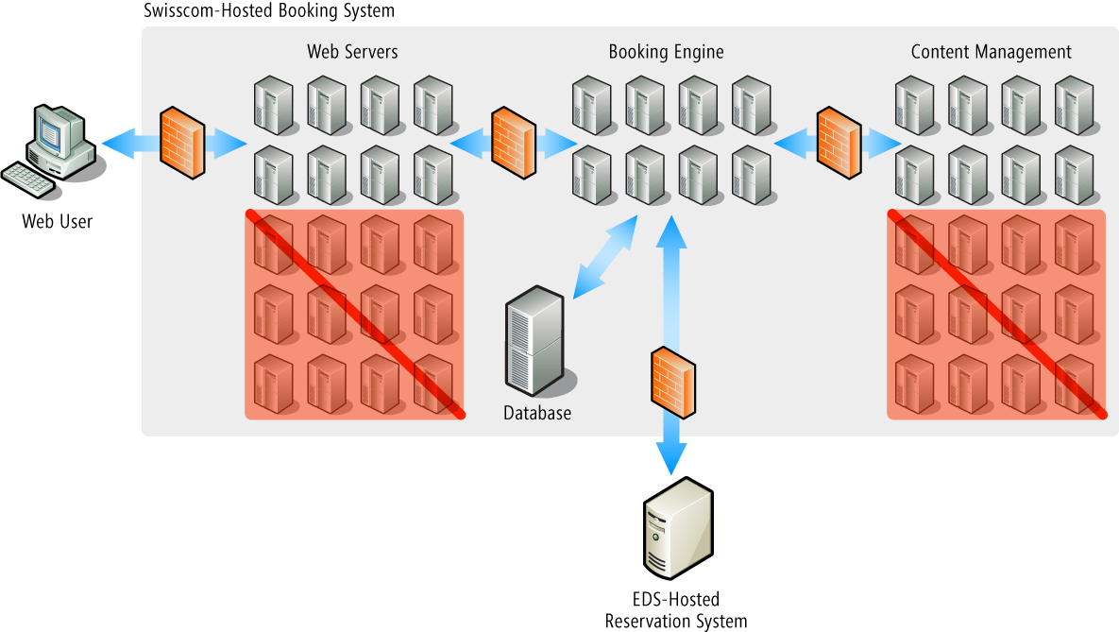

Once the original infrastructure was physically relocated to Swisscom IT Services, the technology provider worked with the airline to implement a series of changes. The Web front-end to the e-commerce solution was rewritten using Microsoft C# technology, introducing object-oriented programming to what had formerly been a script-based solution and enabling the solution to be updated and expanded more easily in response to business requirements. The application was rehosted on a consolidated environment with 4 Windows Server IIS 6.0-based computers replacing the 10 computers that had hosted the former Linux version, for a net consolidation of 60 percent.

The new solution architecture takes advantage of Windows®- and .NET-based technologies to replace the mixed presentation and application layers of the Linux-based version with a true n-tier architecture with fully separate presentation and application logic.

The content management solution migration to SharePoint Server is being accomplished along with a server consolidation similar to the one achieved in the Web-serving portion of the solution. The 10 computers in the content management solution are being consolidated to 4, with SharePoint Server eliminating the need for a pair of search servers, a pair of staging servers, and a pair of content servers. With a similar reduction in the development and test environment, the 60 percent consolidation of the content management solution is eliminating 12 servers. In all, the combined savings is 18 servers.

Benefits
With the migration of its online booking solution to Windows Server, SWISS gains increased IT agility, enabling it to better support the company’s business needs, as well as to lower its costs.

Software Updates Released Four Times Faster
With the first stage of its Linux-to-Windows Server migration complete, SWISS is already benefitting from the increased agility enabled by Windows Server and the Microsoft .NET Framework. Where SWISS formerly managed a new release of software to its Web site every two to three months, it now implements such releases every two to three weeks, an increase of 400 percent. Updated promotions and marketing offers used to be implemented once or twice a week. Now, they’re implemented up to six times per week.
“When we need a new capability or promotion implemented on the site, we can make it a reality in a timely way. We couldn’t do that before.”
Lothar Heintel, Director, IT Development and Architecture, Swiss International Air Lines

“Release management is more efficient in the Windows Server environment so implementing updates to the solution is less complex and the quality of the updates is better,” says Heintel. “The result is that we in IT do a better job of aligning with the business side of the company to support its needs. When we need a new capability or promotion implemented on the site, we can make it a reality in a timely way. We couldn’t do that before.”

For example, Meyer points to the “upsell capability” recently implemented on the site. When an online customer books a low-priced fare, the site automatically gives the customer the option to upgrade to a higher class or to add the flexibility to rebook or cancel a reservation for a modest additional fee.

“We’re already seeing that become a significant revenue generator,” says Meyer. “We would have envisioned the functionality without the move to Windows—but how quickly would we have implemented it?”

Online Revenue up 30 Percent
Meyer and his colleagues also wanted to ensure that the performance of the Web site matched—and enhanced—the brand reputation of SWISS. They say that with the migration to Windows Server IIS 6.0, it does.

Unplanned downtime has been slashed by 90 percent, giving the site more than “three nines”—99.9 percent—availability. Responsiveness is up too. Pages that took three seconds to deliver are now delivered in one, giving customers a more natural and comfortable interaction with the site.

Despite the reduction in Web servers, the solution is now rated to serve more concurrent users than it supported previously. “With Windows Server IIS 6.0 and .NET, we gain the scalability to support continued growth of the Web site throughout the foreseeable future,” says Heintel. “We didn’t have that with Apache.”

And that growth is already taking place. Thanks in part to the enhancement of the Web site, SWISS last year saw a 30 percent increase in online bookings—its most profitable bookings.

“The move to Windows Server meant we had a more stable and responsive online booking solution, one that ensured our customers got the ‘SWISS’ experience from the moment they visited our site,” says Meyer. “That in turn supported our revenue growth.”

Savings to Exceed $600,000 Annually
SWISS has also achieved significant cost savings from its migration from Linux to Windows Server. The reduction in Web servers saves the company $150,000 per year, with the outsourcing of the solution contributing another $50,000 in savings, according to Heintel. Replicating the consolidation in the content management portion of the solution should triple the savings to $600,000 per year, he estimates.
And the savings will grow. With the migration to SharePoint Server, SWISS eliminates a second platform for content management so it and its outsourcer need only manage a single environment. SWISS expects the SharePoint Server-based system to deliver content twice as quickly as its Linux predecessor. The reduction if not elimination of Linux in its environment similarly reduces the burden of managing multiple operating systems and frees SWISS from having to locate what Meyer sees as relatively scarce and expensive Linux expertise.

Developing the solution for the .NET Framework also resulted in faster and more cost-effective development than SWISS would have seen had it used Java, Heintel estimates. The Web server portion of the solution took three months and $120,000 to develop; had SWISS used Java, Heintel estimates, the solution would have taken 50 percent more time and money.

“Moving from our Linux-based applications to applications based on Windows Server and .NET give us not only great savings, but also better performance and faster time to market with updates and enhancements,” says Heintel.

Microsoft Server Product Portfolio
For More Information
For more information about Microsoft products and services, call the Microsoft Sales Information Center at (800) 426-9400. In Canada, call the Microsoft Canada Information Centre at (877) 568-2495. Customers who are deaf or hard-of-hearing can reach Microsoft text telephone (TTY/TDD) services at (800) 892-5234 in the United States or (905) 568-9641 in Canada. Outside the 50 United States and Canada, please contact your local Microsoft subsidiary. To access information using the World Wide Web, go to: www.microsoft.com

For more information about Swisscom IT Services products and services, call (+41) 31 - 342 13 38 or visit the Web site at: www.swisscom.com

For more information about Swiss International Air Lines, call (+41) 61 - 582 00 00 or visit the Web site at: www.swiss.com

This case study is for informational purposes only. MICROSOFT MAKES NO WARRANTIES, EXPRESS OR IMPLIED, IN THIS SUMMARY.

Document published June 2007

Software and Services  - Microsoft Server Product Portfolio  - Microsoft Windows Server 2003, Enterprise Edition  - Microsoft Office SharePoint Server 2007  - Microsoft SQL Server 2005  - Microsoft Visual Studio 2005 | - Technologies  - Microsoft .NET Framework 3.0  - Microsoft Visual C#  - Microsoft ASP.NET 2.0  - IIS 6.0  Partner  - Swisscom

For more information about the Microsoft server product portfolio, go to:
www.microsoft.com/servers/default.mspx

